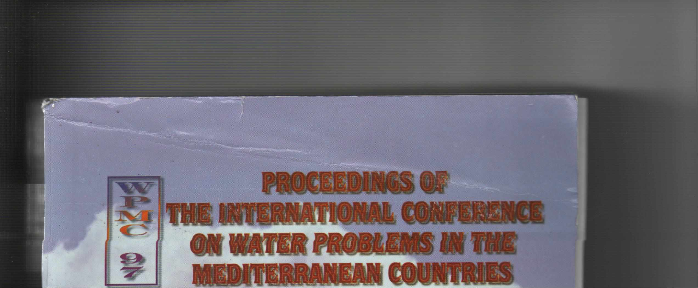
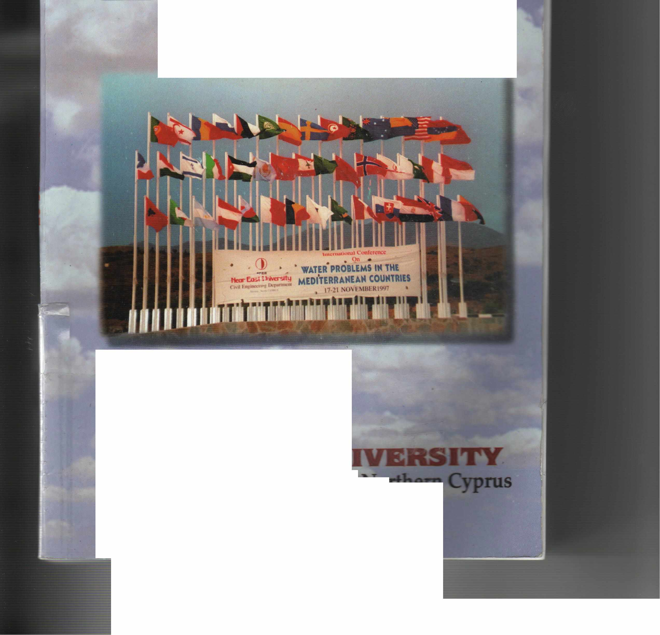
Hüseyin GÖKÇEKUŞ • Editor
Volume 11

1988
NEAR EAST UN
Lefkoşa, Turkish Republic of No:..~
17 - 21 November 1¹

PROCEEDINGS OF
THE INTERNATIONAL CONFERENCE
1
ON WATER PROBLEMS iN
MEDITERRANEAN
VOLUME 1
Hüseyin GÖKÇEKUŞ • Editor
1988

NEAR EAST UNIVERSDY LEFKOŞA, Turkish Republic of Northern Cyprus 17-21 NOVEMBER 1997

il
JS book is published under the auspices of the Embassy ofthe Republic ofTıırkey
d the Ministry for Defence and Foreign Affairs of the Turkislı Repııblic of Northern Cyprus.

lnternational Conf erence on
Water Problems in the Mediterranean Countries
Hüseyin GÖKÇEKUŞ • Editor
WPMC' 97
Civil Engineering Departrnent, Near East University,
Lefkoşa, Turkish Republic ofNorthem Cyprus.
Novernber 17-21, 1997
Volume il
Organized and Sponsored by: Near East University
Co-sponsors of Conference:
- The Scientific and Technical Research council of Turkey (TUBIT AK)
- Turkish National Committee on Water Pollution Research and Control
(SKATMK)
- International Research & Application Center for Karst Water
Resources (UKAM)
- International Association of Engineeting Geology Turkish National
Committee (MJTMK)
- Turkish National Cornmittee on Coastal Zone Management (KAY)
- ....•

Published By:
EDUCATIONAL FOUNDATION OF NEAR EAST UNIVERSITY, Near East University, P.O. Box: 670 Lefkoşa, Turkish Republic of Northern Cyprus.
Tel!Fax: 0090 392 223 5427
Tel: 0090 392 236 6464
Fax: 0090 392 236 6461 e-mail: ghuseyin@kktc.net
Copyright:
WPMC' 97.
Reproduction of this publication for educatiorıal or other non-commercial purposes is authorized without prior permission from the copyright holder. Reproduction for resale or other commercial purposesis prohibited without prior - written permission of the copyright holder.
Citation:
Gökçekuş H. (Editor), 1998. Proceedings of the International Conference on Water Problems in the Mediterranean Countries, WPMC' 97, vols. 1 and 2 Educational Foundation of Near East University, Near East University. P.O. Box: 670 Lefkoşa, Turkish Republic of Northern Cyprus, 1354p.
975-8359-00-2 (Complete set of two volumes) 975-8359-•H-O (Volume 1)
ISBN:
Disclamier:
While every eff ort has been made to ensure the accuracy of the information, contained in this publication, the EDUCATIONAL FOUNDATION of NEAR EAST UNIVERSITY will not assume liability for any use made thereof the proceedings and the presentation of the a participating organisations concerning the legal status of any country, territory, or area, or of its authorites, or concerning the delimitation of its frontiers or boundaries.
Printed by:
Near East University Press.

lR O.
rn
j
FOREWORD
As bcing a member of water suffering countries in Mediterranean region, North Cyprus is welcomc for an İnternational Conference on Water Problerns in the Mediterranean Countries. Thc conference, held in Near East University, Nicosia, North Cyprus, 17-21 Novcmber 1997, brought together more than 300 scientists from 42 countries with different approaches in 182 excellent presentations.
The conference aimed to be honored by specialists, administrators or other interested participants to provide a forum for discussions and exchange of experience and the information ofa variety of aspects related to the Water Problems in the Mediterranean Countries. Water resources and hydrology, wastewater management and treatment, surface water and management , groundwater modeling and management, salt water intrusion, water quality, limnology, oceanography, and environmental quality have been discussed in the sessions of the conference.
From ıhe discussions at the conference, it is concluded that the Mediterranean region suffers from an imbalance between the demand for fresh water and its supply. it is to be expected that this imbalance will increase unless certain measures, aiming at the sustainability of the water resources, are implemented. This aim will be served by supplying potable water, monitoring and performance assessment of ali water uses, increasing the efficiency of irrigation methods, appropriate use of quality assured models.
It is well known that the never-ending water problems of Mediterranean countries cannot be solved by individual studies. In the face of this, the participants are expressed the wish that such an important initiative should not be isolated but should be repeated in the future with the aim of continuing the collaboration to solve the most urgent water problems. As being the initiative of such.an event, we would be very excited and honored
to see the succeeding conferences arv' ·· ·~d to support such courageous attempts.
The success of the conference is boun, '.JY the self-sacrificing studies ofa large number of peoplc and institutions. Special thanks are given to the members of the technical and organization committee, the scientific committee, the invited speakers, and participants for their invaluable contributions to the first International Conference on Water Problems in the Mediterranean Countries.
21 December 1998, .Near East University, Nicosia, North Cyprus.
Assoc. Prof. Dr. Hüseyin Gökçekuş Chairman

TECHNICAL & ORGANIZING COMMITTEE
Honorary Chairınan Dr. Suat İ. GÜNSEL
President, Near East University, Nicosia - NORTH CYPRUS
Chairman
Assoc. Prof. Dr. Hüseyin GÖKÇEKUŞ
Head, Civil Engineering Department, Near East University, Nicosia - NORTH CYPRUS
Meınbers
Prof. Dr. DOYURAN, V.,
Head, Geological Engineering Deparıment, Middle East Technical University,
Ankara - TURKEY
Prof. Dr. SALİHOGLU, İ Institutc of Marine Sciences, Middlc East Tcchnical Univcrsity, Erdemli - İçel - TURKEY
Prof. Dr. ORHON, D.,
Chairrnan, Turkislı Naıional Cornrnittce on Water Pollution Rcscarclı
and Coııtrol & Hcacl, Environmcntal Enginccring Dcpartmcnt, İstanbul Tcchnical Urıivcrsity, İstanbul - TURKEY
Prof. Dr. CHENG, A.,
Civil Enginccring Dcpartmcnt, Dclawarc Univcrsiıy, Ncwark, Dclawarc - USA
Prof. Dr. HASSAN, Ü.,
Vicc Prcsiclcnı, Ncar East University, Nico~ia - NORTH CYPRUS
Assoc. Prof. Dr. BEKTAŞ, Ş.,
Vicc Prcsidcııt, Ncar East Universiıy, Nicosia - NORTH CYPRUS
Asst. Prof. ı». ATALAR, C.,
Civil Eııginccriııg Dcpartmerıt, Ncar East Univcrsity, Nicosia - NORTH CYPRUS
Asst, Prof. Dr. OKA YGÜN, M.,
Civil Eııgiııccring Departmcnı, Ncar r-' ' TJııivcrsity, Nicosia - NORTH CYPRUS

SCIENTIFIC COMMITTEE
Prof. Dr. AL TINBİLEK, D.,
General Director, General Directorate of State Hydraulic Works Republic of Turkey Ministry of Energy and Natura! Resources, Ankara - TURKEY
Prof. Dr. AL - TURBAK, A.,
Civil Engineering Department, College of Engineering , King Saud University, Riyadh - SAUDI ARABIA
Assoc. Prof. Dr. AVCI, C.,
Civil Engineering Department, Boğazici University, İstanbul - TURKEY
Prof. Dr. BARROCU, G., Department of Tcrritorial Engineering,
Sector of Engineering Geology and Geophysics University of Cagliari, Cagliari - ITALY
Assoc. Prof. Dr. BERNDTSSON, R.,
Department of Waıer Resources Engineering, Lund University, Lund - SWEDEN
Prof. Dr. BREUCK, W.,
Head, Laboraıory of Applied Geology and Hydrogeology, University of Gent, Gent - BELGIUM
Prof. Dr. CHENG, A.,
Civil Engineering Department, Delaware University, Newark, Delaware - USA
Prof. Dr. DAM, J.C. VAN., Delft University of Technology, Delft - THE NETHERLANDS
Prof. Dr. DOYURAN, V.,
Head, Geological Engincering Department, Middle East Tcchnical University, Ankara - TURKEY
Prof. Dr. EROSKA Y, O.,
Geological Engineering Departrnent, İstanbul University, İstanbul - TURKEY
Prof. Dr. ERTUNÇ, A.,
Hcad, Geological Engincering Department, Çukurova University, Adana - TURKEY

Dr. GARAI, G.,
Head, North Budapest Sewage Treatment Plant, Budapest Municipal Sewerage Company Ltd., Budapest - HUNGARY
Prof. Dr. GÖGÜŞ, M.,
Head, Hydraulic Division, Civil Engineering Department, Middle East Technical University,
Ankara - TURKEY
Assoc. Prof. Dr. GÖKÇEKUŞ, H., Head, Civil Engineering Department, Near East University,
Nicosia - NORTH CYPRUS
Dr. GUIGUER, N.,
President, Waterloo Hydrogeologic Inc., Waterloo University, Ontario - CANADA
Prof. Dr. GÜNAY, G.,
General Direcıor, Inıernational Rcsearch and Applicaıion Centcr for Karst Watcr Resources, Hacettepe University, Ankara - TURKEY
Prof. Dr. GÜLER, E.,
Head, Environınental Science Institute, Boğaziçi University İstanbul - TURKEY
KANAREK, A.,
Project Director, Mekorot Water Co. Ltd., Tel-A viv - ISRAEL.
Prof. Dr. KARPUZCU, M., Vice President, Gebze University, Kocaeli -TURKEY
Assoc. Prof. Dr. KHATER, A.,
Head, Water Resources Research, Bahrain Centre for Studies & Rcsearch, Manama - BAHRAIN
Prof. Dr. LEGOVICH, T.,
Center of Marine Research, Rudjer Boskovic Institude. Zagreb - CROATIA
Dr. LUJAN, C.,
Prcsident of HGQ Consultores, Caracas - VENEZUELLA

Dr. McNAUGHTON, E.,
Unitcd Statcs Environmental Protection Agency, San Francisco, CA - USA
Dr. NOLAN, R.
Associatc Director, Environrncntal Science Lab.,
Brooklyn Collegc of thc City University of Ncw York, Brooklyn, New York - USA
Prof. Dr. ORHON, D.,
Chairman, Turkish National Committee on Water Pollution Rcsearch and Control & Hcad ofThc Environmcntal Engineering Dcpt., İstanbul Tcchnical Univcrsity,
İstanbul -TURKEY
Dr. SOULSllY. C.
Dcpartrncnı ol' Gcography. Uııivcrsiıy of Abcrclccıı. Scoılund - UK
Prof. Dr. ORON, G.,
The Water Rcsourccs Ccntcr.
The Jacob Blaustcin Institute for Dcsert Research, Ben-Gurion Univcrsity of thc Negev,
Sedc-Boker Carnpus - ISRAEL
Prof. Dr. ÖZHAN, E.,
Civil Engineering Departmcnt,
Miclcllc Eası Tcchnical University ancl Chairrnan of MEDCOAST
Ankara - TURKEY
Prof. Dr. SALİHOGLU, İ.,
lnstitute ol' Marinc Scicnccs, Miclcllc East Tcchnical Uni vcrsiıy,
Erdemli - İçel - TURKEY
Prof. Dr. SAYDAM, C.,
Chairrnan, Earth Marinc Atmosphcrical Scicııccs
aııd Eııviroıımcııtal Rcscarchcs Granl Group of ıhc Scientific ancl Tcchnical Rcscarch Couııci 1.
Ankara - TURKEY
Dr. SEDARATY, A.,
Prcsiclcnt of Proccss Dynarnics Engineering Ltd, Ilford - UK
Dr. SHAHIN, M.,
Intcrnatioııal Iııstituıc Ior Infrastrucıural, Hydraulic aııd Eııviroıımcntal Engiııccriııg, Dcllt - THE NETHERLANDS

Prof. Dr. SPILOTRO, G.,
Dept. of Structural and Geotechnical Eng. and Engineering Geology,
- University ofBasilicata, · Potenza - iT AL Y
Prof. Dr. ŞEN, Z.,
Head, Meteorology Department, İstanbul Technical University, İstanbul - TURKEY
Prof. Dr. ŞİMŞEK, Ş.,
Geological Engineering Department, Hacettepe University, Ankara - TURKEY
Prof.Dr. TULIPANO, L.
Istituto Di. Geologia Applicata e Geotecnica, Facolta Di Ingegneria, Politecnico Di Bari, Bari- ITALY
Prof. Dr. TÜRKMAN, A.,
Environmental Engineering Department, 9 Eylül University, İzmir - TURKEY
Dr. YURTSEVER, Y.,
Department of Research and Isotopes, Division of Physical and Chemical Sciences, lnternational Atomic Energy Agency, Vienna - AUSTRIA
Prof. Dr. YÜZER, E.,
Geological Engineering Department, İstanbul Technical University, İstanbul - TURKEY
Prof. Dr. VERNIER, A.,
Department ofTerritorial Engineering, University of Cagliary, Cagliary, Cagliary - ITAL Y
Prof. Dr. W ALRAEVENS, K.,
Lab. Applied Geology and Hydrogeology, University of Gent, Gent - BELGIUM
Prof. Dr. WARD, R. F.,
Paper Science and Engineering Department, Miami University, Oxford, Ohio - USA
Prof. Dr. WICHMANN, K.
Teclınische Universitat, Hamburg - Harburg, Hamburg - GERMANY
/

WATER SUPPLY . VOLUME il
················································· 635
Ancient Water Systems of the Mediterranean-Emphasis on Cyprus,
D. W. HENDRICKS USA ·· 67
Hydroelectric Energy Potential of Turkey and its Development SPASİN and HDOGAN ALTINBİLEK
Tıırkey......................................................................................................... 665
Water Transportation by Towed Waterbags-Hydrodynarnic Parameters,
D. ÜNSALAN North Cyprus 68)1
Public Drinking Water and Waste Disposal Issue,
F. R. WARD USA 691
Future Water Supply and Demand Predictions in Saudi Arabia,
A. S. AL-TURBAK Saudi Arabia...................................................................... 7r
Models for Water Consumption and Water Unaccountcd in Turkey, il QASEM. and H D ALTINBİLEK
North Cyprus-Turkey .
""" 715
Results of Disinfcction Monitoring of Long Distribution Systcms,
J. KRIS, O. CERMAK. M. CERMAKOVA. K TOTHOVA aııd F. BISKUP
Slovakia 723
An Approach to Construct the Boundary ofa Groundwater Rechargc Area (GRAB) in a Tilted Unit
t. YILMAZEI? aııd Ö. YILMA ZER Ankara, Turkey 733
Water Rcsources tor Drinking Watcr Supply - Protection Against Pollution and Rchabilitation,
U.ROTT Germany 739
An Ovcrview of the Global Watcr Issues,
A.R.KHATEI? Bahrain 7--
On thc Search of Optimum Managemcnt of Istanbul Water Supply System,
ı. DUl?ANYILDIZ. /J. ÖNÖZ aııd 13 OGUZ Turkcy 763
Watcr Managcmcnt and Transfcrs of Tcchnology: Evidcncc From . the Case of Tunisia,
H. M'HENN! Tunisia 169
GROUND WATER MODELLING AND MANAGEMENT .
Groundwater Budget for thc Güzelyurt Aquifcr (Turkish Rcpublic of Northcrn Cyprus) an Examplc for an Overdraft,
H GÖKÇEKUŞ, and V DOYURAN North Cyprus-Turkey .....................................• _

Supply Ways of Coasting Aquifer System of Annaba-Bouteldja, A. HANI. L. DJABRI, J. MANiA aııd J. MUDRY
Algeria-France 789
Groundwater Quality Problems for Domestic Use,
Ş. ABACI Turkcy 799
Assessment of Regional Groundwater System with Pumbing Test in Denizli Plain,Turkey,
H. M. ÖZLER Turkey 805
Use of Groundwater Three-Dimensional Flow Models For Aquifer Management and Environmental Impact Assessment: The Example
ofa Closcd Valley Volcano-Sedimcntary Aquifer in Southern Peru, D.GOMES,N.CUICUER.R.ROJAS,C.PALZA. O. AVALLOS S.& L. ARACUAS
Canada - Peru 813
Isotopic und Chcmical Trends in Chaj Doab Area, Pakistan,
N. AHMAD aııd Z. ŞEN Turkey - Pakistan 827
Groundwater Utilization for Irrigation Purposes in Arid Regions. A Case Study,
it'. ALI. Germany 835
Groundwatcr Pollution and Control in İzmir,
A. TÜRKMAN Turkey 843
Managemcnt of Scarce Resources,
A. HAMDY mu/ C.LACIRICNOLA Italy 851
Some Considerations on Firıite Element Solution Of The Unsteady Convection Diffusion Equation and Application on Water Pollution,
S. OSMAN! Albania 863
Growing Dcmarıds on the Groundwater Resources and Land Use in the Perth Mctropolitan Arca Western Australia and Their Hydrogcological Implicatiorıs,
A. Q. RATHUR aııd S.SHARAFI Australia 871
INDUSTRIAL WATER & WASTEWATER MANAGEMENT •......•.......•.•........•••.......••• 885
Mercury Pollution of the River Nura in Central Kazakstan,
A. KARAZHANOVA, E. P. YANIN. M. A. ILYUSHCHENKO, T. W.
TANTON aııd S.HEA VEN Kazakstan .; 887
Quulity Asscsmcnt for Lcather Tanning Wastcwaters, D O!U!Oı\. LJ/CENCEU. C. YIL/JIZ and E.AVC!OCLU
Turkey , 895
Removal of Hcavy Metal Ions From Aqueous Solutions by Chitin:
Kinctic and Upıakc Pararncters,
H. BENA!SSA. aııd P. OZIL Algcria-France 903
Industrial Watcr Proccssing Technologics and Flow Schemes lmproving Economics and Excluding Environmcnt Contamination,
H. FEVZ!YEV, A.A.JA VADOVA mu! G.H.FEYZIYEVA Azcrhaijan 911

A Review of Microbial Systems for the Dcgradation of Glyphosate in Industrial Waste Water and the Development ofa New Single Process Approach,
S.GLENWR!GHT. aıul R.1.G. EDYVEAN UK 917
Anaerobic Digestion of Organics in Aqueous Phases Obtained from Liquefaction of Cotton Stalk with Acetic Acid and Sodium Hydroxide at 5 MPa,
F.TANER, F.FÖZTÜRK. T.ÖNCELandA.ÜNYAYAR Turkey 925
Design of Adsorption Systems for thc Treatment of Coloured Aqueous Eflluents,
A. J. SMITH. C. J. WILLIAMS aııd R .. J. G. EDYVEAN UK 933
Thermocheınical Treatment of Sea-Grass with Sodium Hydroxide and Anaerobic Biodegradation of Compounds in Aqueous Phases
F.TANER.F.F ÖZTÜRK, T.ÖNCEL aııd A.ÜNYAYAR Turkey 941
Extraction and Separation of Ni(II), Cu(Il) and Zn (il) on Activated Carbon: Application to Wastewater Treatment,
Y. BAL, aıul K.E. BAL Algeria ................•....................................................... 949
Pollutant Loads from Industries in Elmalı Watershed Area
F GERMİRLİ J3 .. lf3UJ\'.1I.. S. Ml:.RİÇ aıul O. TÜNAY Turkey 955
Soil Contaıniııalioıı und Plaııt Growth Dcprcssion Under Irrigation witlı Polluted River \Vatcr,
il. Çı\ K ıu Turkey ..............................•.•........•...•.•......•.................................. 963
Applicatiun o!'Matcrials Textilc Tcchnic "Aqua-Textiles" for Scparation of Polyplıasic Fluids,Treatment Waste Water Individual Domcsric: Tlıc Possibilitics and Hydraulic Properties,
K. E. BAL. and D. SIGL!. Algeria. Francc.... 969
Control of Wastc Watcr Gcncration in Chcmical Proccsscs by Pinch and Mathcmatical Approaclı,
S. CESUR. Z. Ö'1-(.TLIK. !'. ÖL.ÇEUK. aııd 13. KURYEL Turkcy 977
Investigation of Opcrational Prohlcnıs in Wastcwatcr Trcatmcnt of Tcxtile Industry,
N. TÜFEKÇİ, İ TC,\OZ. M. DUIVIN aııd Y. SılHİN Turkey '. 985
SALT WATER INTRUSION ......................•...•.•.....•.......................•.•...........•..... 993
Simulation of Sea-Water lntrusion lnto lnhomogcncous Mcdia:
Layered Aquifers and Subsurfacc Barrier,
M. G. KHUBLARYAN, A. P. FROLOV, ı. O. YUSIJMANOV
aıul O. N. VELICIJKINA Russia 995
Salt Water Intrusion and Arlilicial Rccharge Modclling in the Coastal Aquifers System of Capotcrra (Southcrn Sardlna).
G. BARROCU. M.G. SCIABICA, G. URAS, A. CORTIS. aııd
E. VERNIER Italy 1001

Salt Water Intrusion into Microtidal Estuaries and Environmental Consequences. The Algerian Example,
H. PAUC France 1009
Salinization of Groundwater in Mediterranean Coastal Aquifers of Morocco, K. WALRAEVENS. N. EL HALIM/, A. CHAOUNI AL!A, A. LAMRINI.
E. BEEUWSAFRT aııd W. DE BREUCK Bclgium l 021
Modclling of Seawatcr Intrusion in the Coastal Carbonate Mesozic Aquifcr ol" Murgia (Puglia Southern Italy), Ensuing Deep Recharge With Trcatcd Wastc Water,
G. SPILOTRO aııd F. CAPORALE Italy 1029
WATER RECLAMATION & REUSE •..............................•..•.•.•.•.•.•................... 1037
Utilization of Wastewaters for Agricultural Irrigation Purposes,
L l:'RENLER 1111<1 E. A VCIOGLU Gcrmany-Turkey l 039
Thc Estimation of the Nonrcturnablc Consumption of Water in Irrigation Agriculture,
N. A. SHUMOYA Russia 1047
Irrigation Applications in Southeastcrn Anatolian Project (GAP),
A. ATAÇ aııd F. VOLKAN Turkey 1055
Comprchensive Considcrations in Eftlucnt Reusc for Crop Irrigation,
G. OIWN, L GILLERMAN, 111. SALGOT, C. CAMPOS, aııd L. KATS lsrael-Spain 1063
Ground Water Quality Degradation in Coastal Aquilers, Case Study:
OUED Nudor and OUED Mazafran Aquifcrs, ALGIERS Region,
M.MESSAHEL. A. BOUDJADJA, 13. HADJ-KADDOUR aııd R. M. KHOUL! Algeria 1071
The Equipmcnt for Dcsalination of Sea Watcr Through Reverse Osmosis,
N. PERiDE aııd T. POPA .Romania ...,, l 08v
Tlıc Use of Yortical Ejectors in Desalination Equipmerıt,
T POPA. aııd K. Ô. IZET Romania 1085
Applicatioıı of Solar Stills for the Purilication of Sca Water at
North Cyprus Environmerıt, . /
M. A. YÜKSELEN Turkey 1089Y ,
Multi El'fcct Solar Dcsalination,
M. M. MISELLA Ti, S. A. ALGARYANI aııd A. A. HOWARS
Libya 1095
A Fcasibility Study on the Dcsalination of Sea Water in the Turkish '/
Republic of Norlhcrn Cyprus, ~
IJ. 1131?:1!/IM UK 1103

The Influence of the Specific Weight of the Sea Water Concerning the Ship Stability,
M.CHITU-GRET! and R. 7AGAN Romania 1111
WATER QUALITY ................•........................................................................ 1119
About the Water Demand in North Cyprus, , /
H GÖKÇEKUŞ North Cyprus 112v
The 1996 Protocol Amending the London Dumping Convention 1972,
J.J. RUIZ Spain 1135
Land - Based Sources Pollution: Recent Legal Trends for the Mediterranean Sea Area,
M. BADANES Spain 1139
A Comprchcnsivc Mathematical Model for Coastal Watcr Pollution Studics,
L. f!APOGLU-BALAS. aııd E. ÖZHAN Turkey 1149
Prcvcntion of Offshorc Pollution in the Mediterranean Sea,
V. BOU Spain 1157
Pollution of Watcr
H.ATUN Nortlı Cyprııs 116~
Water Quality Modeling and Management of Nilüfer River,
A. PALA Turkey 1173
Turkish Laws Rclatcd with Coastal Zoncs and Thcir lmplemcntations,
A. NURAY Turkey 1187
L!MNOLOGY OCEANOGRAPHY COASTAL PJWCESSES
AND ENVIRONMENTAL QUALITY ...............................•.....•.................•........ 1195
Oceanography of the Cilician Basin,
i. SALİHOGLU and A. YILMAZ Turkey 1197
Water Conservation Programmes in thc Eastern EQSl.3 Section of lzmit-Kocaeli Industrial Zone,
S. AYBERK,M. TÜRKEL, A. KABATEPE aııd K.OKTOR Turkey 1207
Hcalth Statc of Agadır Bay Ecosystcms Evaluated by thc lliomarkers of Pollution,
MOUKRIM,A.BOUHAIMI, A. LAGHBOURI aııd A. ZEKHNINI Morocco 1211
Nutrimcnts Watcr Pollution of the Oucd Scybousc and the Guelma, Bouchcgouf and Annaba Aquifcrs (Eastern Algeria),
L. !JJAIJRI. J.MANIA. D. MESSADI. A. HANI a11d
S. /J/:NHARKAT Algcria-Francc 1:!:!5

Towards a Clean İlzmit Bay,
E. MORKOÇ,O. S.OKAY.L.EGESEL,V.TÜFEKÇi,HTÜFEKÇi
& T.LEGO VICH Turkey-Croatia...... .. . .. . . . . . . . . . . . . . . . . ... . .. .. .. .. .. . . . . . .. .. .. . . . . . . . . .. . . . . 12 37
Optimum Control ofEutrophication in the İzmit Bay,
T. LEGOVICH Croatia : 1245
Environmental Evaluation ofa Highly Urbanized and lndustrialized Catchment area: A Case Study From Turkey,
A. TANIK, B. BELER BAYKAL aııd E. GÖNENÇ Turkey 1249
Morphological Effects on Coastal Environment,
Y.YÜKSEL. E ÇEViK, Y, ASARandT. BOSTAN Turkey 1259
Contamination Problems in Coastal Aquifers,
Ö. 1\I. )'AVA( Turkey .' 1265
Coastal Pollution by Polynuclear Aromatic Hydrocarbons (PAHs) in thc Eastern Mediterranean,
F. TELLi KARA KOÇ. A.F. GAINES. D. PHILLIPS. G. YÜREG}R
aııd 1. SALİI10GLU Turkey 1273
Coral Growth in Terms of Dynamic Systems,
Z. KIZNER and L. V AKY Israel. 1281
Alga) and Microbial Variation in Lakes of Cordoba (Argcntina), C. RODRIGUEZ, M. MANCINI. A. WEYERS, M. ALCANTU
aııd C. PROSPERI Argentina 1285
Design Aspccts Ior the Sea Outfall of Mersin City-Turkey,
M. OGUZ aıul H. MUHAMMETOGLUTurkey ...............••.......•.•.•.•.•....•...••....•... 1291
Pcriodicity and Toxin Production by Cyanobactcria in an Argcntinian Lake,
R. D'ANGELO. A. RUl/JAL CONTI, D. LERDA aıul C. PROSPERI
Argcntina 1299
Evaluation of Domcstic and Agricultural Quality of the
Güzelyurt Groundwatcr Basin (Turkish Republic of Northern Cyprus), /
il. GÖKÇI:KUS. aııd V DOYURAN Turkey 1305 V
Nitrate Conccııtration in Groundwater in thc Northern West Bank,
A. MAREI aııd M. HADDAD Palestine................. 1315
Chcmical Asscssment of the Groundwater Pollution of the Shallow Aquifer of Thc Northern West Bank,
Q.1-J.A/JDUL-JABER. S.HUSARY,S. WISHAHl,S.RIHAN &
A .. ALIEWI Palestine - UK 1323
Solutions fora Coast Urıder Threat,
A. TERFOUS, A.IJOUANANI aııd M. IJENSLIMANE Algeria ....
.................... 1337
Water and Wastcwatcr Treatmcnt by Natura! Systcms
L.AKCA, 1-J./JAYHAN,D.A.ALTAY aııd S.ÖVEZ. Turkey 1343
CONCLUSSION AND RECOMENDATIONS
OF \VPıHC'97 CONFERENCE .
............................ 1351

