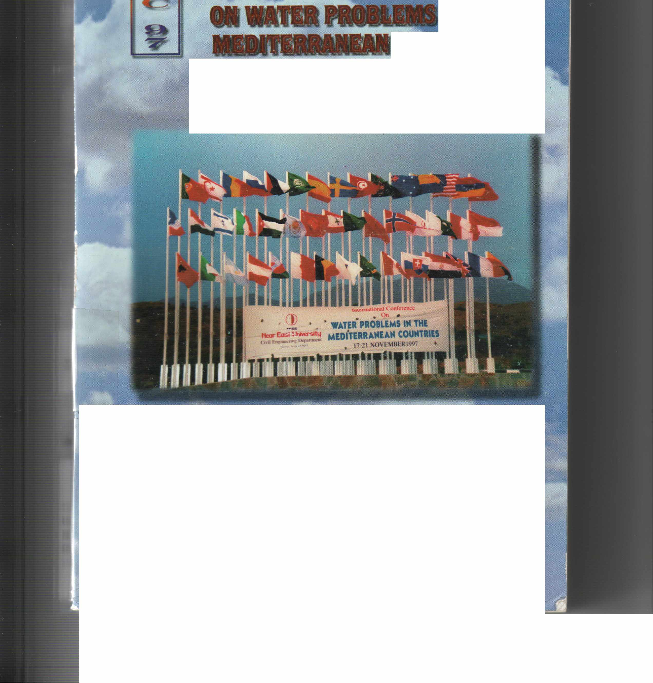
' ~ ~l -~, . :."
. . .
·-
' .
~ f '. : · • _ .1 _I -_·1'
Hüseyin GÖKÇEKUŞ • Editor
Volumel
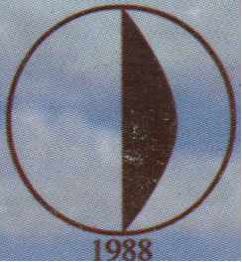

NEAR EAST UNIVERSITY Lefkoşa, Turkish Republic of Northem Cyprus
.,
17 - 21 November 1997

PROCEEDINGS OF
THE INTERNATIONAL CONFERENCE
1
ON WATER PROBLEMS iN
MEDITERRANEAN
VOLUME 1
Hüseyin GÖKÇEKUŞ • Editor
1988

NEAR EAST UNIVERSDY LEFKOŞA, Turkish Republic of Northern Cyprus 17-21 NOVEMBER 1997

il
JS book is published under the auspices of the Embassy ofthe Republic ofTıırkey
d the Ministry for Defence and Foreign Affairs of the Turkislı Repııblic of Northern Cyprus.

International Conf erence ·on
Water Problems in the Mediterranean Countries
Hüseyin GÖKÇEKUŞ • Editor
WPMC' 97
Civil Engineering Departmerıt, .. ear East University,
Lefkoşa, Turkish Republic of Northern Cyprus. November 17-21, 1997
Volume 1
Organized and Sponsored by: Near East University
Co-sponsors of Conference:
- The Scientific and Technical Research council of Turkey (TUBIT AK)
- Turkish National Committee on Water Pollution Research and Control (SKATMK)
- International Research & Application Center far Karst Water Resources (UKAM)
- lnternational Association of Engineering Geology Turkish National Committee (MJTMK)
- Turkish National Committec on Coastal Zone Management (KAY)

Published By:
EDUCATIONAL FOUNDATION OF NEAR EAST UNIVERSITY, Near East University, P.O. Box: 670 Lefkoşa, Turkish Republic of Northern Cyprus.
Tel!Fax: 0090 392 223 5427
Tel: 0090 392 236 6464
Fax: 0090 392 236 6461 e-mail: ghuseyin@kktc.net
Copyright:
WPMC' 97.
Reproduction of this publication for educatiorıal or other non-commercial purposes is authorized without prior permission from the copyright holder. Reproduction for resale or other commercial purposesis prohibited without prior - written permission of the copyright holder.
Citation:
Gökçekuş H. (Editor), 1998. Proceedings of the International Conference on Water Problems in the Mediterranean Countries, WPMC' 97, vols. 1 and 2 Educational Foundation of Near East University, Near East University. P.O. Box: 670 Lefkoşa, Turkish Republic of Northern Cyprus, 1354p.
975-8359-00-2 (Complete set of two volumes) 975-8359-•H-O (Volume 1)
ISBN:
Disclamier:
While every eff ort has been made to ensure the accuracy of the information, contained in this publication, the EDUCATIONAL FOUNDATION of NEAR EAST UNIVERSITY will not assume liability for any use made thereof the proceedings and the presentation of the a participating organisations concerning the legal status of any country, territory, or area, or of its authorites, or concerning the delimitation of its frontiers or boundaries.
Printed by:
Near East University Press.

FOREWORD
As bcing a member of water suffering countries in Mediterranean region, North Cyprus is welcomc for an İnternational Conference on Water Problerns in the Mediterranean Countries. Thc conference, held in Near East University, Nicosia, North Cyprus, 17-21 Novcmber 1997, brought together more than 300 scientists from 42 countries with different approaches in 182 excellent presentations.
The conference aimed to be honored by specialists, administrators or other interested participants to provide a forum for discussions and exchange of experience and the information ofa variety of aspects related to the Water Problems in the Mediterranean Countries. Water resources and hydrology, wastewater management and treatment, surface water and management , groundwater modeling and management, salt water intrusion, water quality, limnology, oceanography, and environmental quality have been discussed in the sessions of the conference.
From ıhe discussions at the conference, it is concluded that the Mediterranean region suffers from an imbalance between the demand for fresh water and its supply. it is to be expected that this imbalance will increase unless certain measures, aiming at the sustainability of the water resources, are implemented. This aim will be served by supplying potable water, monitoring and performance assessment of ali water uses, increasing the efficiency of irrigation methods, appropriate use of quality assured models.
It is well known that the never-ending water problems of Mediterranean countries cannot be solved by individual studies. In the face of this, the participants are expressed the wish that such an important initiative should not be isolated but should be repeated in the future with the aim of continuing the collaboration to solve the most urgent water problems. As being the initiative of such.an event, we would be very excited and honored
to see the succeeding conferences arv' ·· ·~d to support such courageous attempts.
The success of the conference is boun, '.JY the self-sacrificing studies ofa large number of peoplc and institutions. Special thanks are given to the members of the technical and organization committee, the scientific committee, the invited speakers, and participants for their invaluable contributions to the first International Conference on Water Problems in the Mediterranean Countries.
21 December 1998, .Near East University, Nicosia, North Cyprus.
Assoc. Prof. Dr. Hüseyin Gökçekuş Chairman

TECHNICAL & ORGANIZING COMMITTEE
Honorary Chairınan Dr. Suat İ. GÜNSEL
President, Near East University, Nicosia - NORTH CYPRUS
Chairman
Assoc. Prof. Dr. Hüseyin GÖKÇEKUŞ
Head, Civil Engineering Department, Near East University, Nicosia - NORTH CYPRUS
Meınbers
Prof. Dr. DOYURAN, V.,
Head, Geological Engineering Deparıment, Middle East Technical University,
Ankara - TURKEY
Prof. Dr. SALİHOGLU, İ Institutc of Marine Sciences, Middlc East Tcchnical Univcrsity, Erdemli - İçel - TURKEY
Prof. Dr. ORHON, D.,
Chairrnan, Turkislı Naıional Cornrnittce on Water Pollution Rcscarclı
and Coııtrol & Hcacl, Environmcntal Enginccring Dcpartmcnt, İstanbul Tcchnical Urıivcrsity, İstanbul - TURKEY
Prof. Dr. CHENG, A.,
Civil Enginccring Dcpartmcnt, Dclawarc Univcrsiıy, Ncwark, Dclawarc - USA
Prof. Dr. HASSAN, Ü.,
Vicc Prcsiclcnı, Ncar East University, Nico~ia - NORTH CYPRUS
Assoc. Prof. Dr. BEKTAŞ, Ş.,
Vicc Prcsidcııt, Ncar East Universiıy, Nicosia - NORTH CYPRUS
Asst. Prof. ı». ATALAR, C.,
Civil Eııginccriııg Dcpartmerıt, Ncar East Univcrsity, Nicosia - NORTH CYPRUS
Asst, Prof. Dr. OKA YGÜN, M.,
Civil Eııgiııccring Departmcnı, Ncar r-' ' TJııivcrsity, Nicosia - NORTH CYPRUS

SCIENTIFIC COMMITTEE
Prof. Dr. AL TINBİLEK, D.,
General Director, General Directorate of State Hydraulic Works Republic of Turkey Ministry of Energy and Natura! Resources, Ankara - TURKEY
Prof. Dr. AL - TURBAK, A.,
Civil Engineering Department, College of Engineering , King Saud University, Riyadh - SAUDI ARABIA
Assoc. Prof. Dr. AVCI, C.,
Civil Engineering Department, Boğazici University, İstanbul - TURKEY
Prof. Dr. BARROCU, G., Department of Tcrritorial Engineering,
Sector of Engineering Geology and Geophysics University of Cagliari, Cagliari - ITALY
Assoc. Prof. Dr. BERNDTSSON, R.,
Department of Waıer Resources Engineering, Lund University, Lund - SWEDEN
Prof. Dr. BREUCK, W.,
Head, Laboraıory of Applied Geology and Hydrogeology, University of Gent, Gent - BELGIUM
Prof. Dr. CHENG, A.,
Civil Engineering Department, Delaware University, Newark, Delaware - USA
Prof. Dr. DAM, J.C. VAN., Delft University of Technology, Delft - THE NETHERLANDS
Prof. Dr. DOYURAN, V.,
Head, Geological Engincering Department, Middle East Tcchnical University, Ankara - TURKEY
Prof. Dr. EROSKA Y, O.,
Geological Engineering Departrnent, İstanbul University, İstanbul - TURKEY
Prof. Dr. ERTUNÇ, A.,
Hcad, Geological Engincering Department, Çukurova University, Adana - TURKEY

Dr. GARAI, G.,
Head, North Budapest Sewage Treatment Plant, Budapest Municipal Sewerage Company Ltd., Budapest - HUNGARY
Prof. Dr. GÖGÜŞ, M.,
Head, Hydraulic Division, Civil Engineering Department, Middle East Technical University,
Ankara - TURKEY
Assoc. Prof. Dr. GÖKÇEKUŞ, H., Head, Civil Engineering Department, Near East University,
Nicosia - NORTH CYPRUS
Dr. GUIGUER, N.,
President, Waterloo Hydrogeologic Inc., Waterloo University, Ontario - CANADA
Prof. Dr. GÜNAY, G.,
General Direcıor, Inıernational Rcsearch and Applicaıion Centcr for Karst Watcr Resources, Hacettepe University, Ankara - TURKEY
Prof. Dr. GÜLER, E.,
Head, Environınental Science Institute, Boğaziçi University İstanbul - TURKEY
KANAREK, A.,
Project Director, Mekorot Water Co. Ltd., Tel-A viv - ISRAEL.
Prof. Dr. KARPUZCU, M., Vice President, Gebze University, Kocaeli -TURKEY
Assoc. Prof. Dr. KHATER, A.,
Head, Water Resources Research, Bahrain Centre for Studies & Rcsearch, Manama - BAHRAIN
Prof. Dr. LEGOVICH, T.,
Center of Marine Research, Rudjer Boskovic Institude. Zagreb - CROATIA
Dr. LUJAN, C.,
Prcsident of HGQ Consultores, Caracas - VENEZUELLA

Dr. McNAUGHTON, E.,
Unitcd Statcs Environmental Protection Agency, San Francisco, CA - USA
Dr. NOLAN, R.
Associatc Director, Environrncntal Science Lab.,
Brooklyn Collegc of thc City University of Ncw York, Brooklyn, New York - USA
Prof. Dr. ORHON, D.,
Chairman, Turkish National Committee on Water Pollution Rcsearch and Control & Hcad ofThc Environmcntal Engineering Dcpt., İstanbul Tcchnical Univcrsity,
İstanbul -TURKEY
Dr. SOULSllY. C.
Dcpartrncnı ol' Gcography. Uııivcrsiıy of Abcrclccıı. Scoılund - UK
Prof. Dr. ORON, G.,
The Water Rcsourccs Ccntcr.
The Jacob Blaustcin Institute for Dcsert Research, Ben-Gurion Univcrsity of thc Negev,
Sedc-Boker Carnpus - ISRAEL
Prof. Dr. ÖZHAN, E.,
Civil Engineering Departmcnt,
Miclcllc Eası Tcchnical University ancl Chairrnan of MEDCOAST
Ankara - TURKEY
Prof. Dr. SALİHOGLU, İ.,
lnstitute ol' Marinc Scicnccs, Miclcllc East Tcchnical Uni vcrsiıy,
Erdemli - İçel - TURKEY
Prof. Dr. SAYDAM, C.,
Chairrnan, Earth Marinc Atmosphcrical Scicııccs
aııd Eııviroıımcııtal Rcscarchcs Granl Group of ıhc Scientific ancl Tcchnical Rcscarch Couııci 1.
Ankara - TURKEY
Dr. SEDARATY, A.,
Prcsiclcnt of Proccss Dynarnics Engineering Ltd, Ilford - UK
Dr. SHAHIN, M.,
Intcrnatioııal Iııstituıc Ior Infrastrucıural, Hydraulic aııd Eııviroıımcntal Engiııccriııg, Dcllt - THE NETHERLANDS

Prof. Dr. SPILOTRO, G.,
Dept. of Structural and Geotechnical Eng. and Engineering Geology,
- University ofBasilicata, · Potenza - iT AL Y
Prof. Dr. ŞEN, Z.,
Head, Meteorology Department, İstanbul Technical University, İstanbul - TURKEY
Prof. Dr. ŞİMŞEK, Ş.,
Geological Engineering Department, Hacettepe University, Ankara - TURKEY
Prof.Dr. TULIPANO, L.
Istituto Di. Geologia Applicata e Geotecnica, Facolta Di Ingegneria, Politecnico Di Bari, Bari- ITALY
Prof. Dr. TÜRKMAN, A.,
Environmental Engineering Department, 9 Eylül University, İzmir - TURKEY
Dr. YURTSEVER, Y.,
Department of Research and Isotopes, Division of Physical and Chemical Sciences, lnternational Atomic Energy Agency, Vienna - AUSTRIA
Prof. Dr. YÜZER, E.,
Geological Engineering Department, İstanbul Technical University, İstanbul - TURKEY
Prof. Dr. VERNIER, A.,
Department ofTerritorial Engineering, University of Cagliary, Cagliary, Cagliary - ITAL Y
Prof. Dr. W ALRAEVENS, K.,
Lab. Applied Geology and Hydrogeology, University of Gent, Gent - BELGIUM
Prof. Dr. WARD, R. F.,
Paper Science and Engineering Department, Miami University, Oxford, Ohio - USA
Prof. Dr. WICHMANN, K.
Teclınische Universitat, Hamburg - Harburg, Hamburg - GERMANY

TABLE OF CONTENTS
VOLUMEI
Pages WATER RESOURCES AND HYDROLOGY .....•.....................................•.................• 1
An Overview of Southeastern Anatolia Project (GAP),
O. TEKİNEL Turkey 3
Eff'ect of Trends in Extreme Rainfall Series on Hydraulic Design,
S. PAGLIARA,B. GOZZINI F. MENEGUZZO aııd M. NICCOLAI Italy 13
Regional Wet and Dry Period Statistics of Libyan Rainfall,
A. G. ELJADID aıul Z. ŞEN Turkey 23
Autoregressive Modeling of Annual and Monthly Streamflows,
C. KARABORK aııd E. KAHYA Turkey 33
Tu-Rernosens Project and Development of an lnfrastructure to Observe thc Water Potential in an Upper Catchment of Euphrates,
C. SAYDAM, Ü. SORMAN, E. TUNALI aııd İ. KAYA Turkey .43
Gamına Distribution of Libyan Rainfall Records,
A. G. ELJADID aıul Z. ŞEN Turkey 53
An Estimation Method for Annual Runoff,
H. ÖZGÜLER. aııd N. USUL Turkey "61
A Study of Water Problems Based on Meteorological Pararneters for T.R.N.C ..
M. ALTUNÇ North Cyprus... .. .. .. .. .. .. .. .. .. .. .. .. 7.v"'
Trerıds in Turkish Precipitation Data,
M. KAD!OGLU Turkey 79
An Evaluatiorı of Lower Seyhan lrrigation Project of Adana - Turkey,
O. TEKİNEL and ki. .L AKSU Turkey 87
An Approach for Physically Based and Distributed Hydrological Modclling,
P. MAISON, A. A. P/NHEIRO aııd 13. CAUSSADE France - Brazil. 99
River Basin Modclling in thc Watcr Rcsourccs Managcmerıt,
N. KELOGLU Turkcy 107
Asscssment of the Mcteorological Network of the Wcst Bank,
S. HUSARY. S. W/SHAHI, Q. ABDUL-JABER. S. RIHAN aııd A. ALIEWI
P:ılcstinc-UK 113

Isotope Technique in Hydrological Modeling of Güvenç Basin,
H. QASEM, A. GÜNYAKT! and fi. D. ALTINBiLEK North Cyprus-Turkey 123
Sedimentation Problems in Jordanian Dams,
A. !. H. MALKA WI aııd F. A. ABDULLA Jordan 133
The Dependency Analysis of Annual Peak Flows of Streams in Konya Basin,
N. BÜYÜKKARAÇJGAN and E. KAHYA Turkey 141
A Study on Vulnerable Flood Areas in the Major Basins of Turkey,
Z. KULCA Turkey 149
Water Resources and Hydro - Agricultural Development in Algeria for Year 2010,
M. MESSAHEL, B. HA.Dl- KADDOUR aııd A. BOUDJADJA Algeria 157
The Possibility of Applying Cloud Seeding Over Cyprus,
M. TAYANÇ Turkey .................•....................................................................... ıw
Present Water Uses and Their Evolution in the Framework of National Water Strategy for Albania,
A.H. SELENICA, Albania 173
Precipitation and Runoff Characteristics of the Kumdere Basin in Merkez - Edirne,
S. AKBAYand F. BAKANOGULLARI Turkey ..............................................•........... 181
HYDRA ULICS, HYDROLOGY AND HYDROGEOLOGY 189
Hydrogeology of Sakaryabası Karst Springs, Turkey,
G.GÜNAY, M. EKMEKÇJ, F. GÜVEN, andT. YÜRÜR Turkey 191
Study of the Gas Discharges in the Denizli-Pamukkale Geothermal Area (SW Turkey),
B. AKAN (SELÇUK) and Ş. ŞiMŞEK Turkey 207
Tag Inadslide triggered by an artesian pressure beneath the unit caliche : a case study,Turkey
/. YILMAZER. aııd Ö. YILMAZER Turkey ...............................................•............. 217
Hydrodynamics of Groundwater Flow in Karstic Aquifers and Hydrothermal Effects in the Çürüksu Graben System-Türkiye,
H.M. ÖZLER Turkcy 225
Hydrogcochcmical Observations on Some Springs of the Sarrabus-Gerrei Mountains in South Eastern Sardinia,
A. VERNIER. F. ARDAU,M.CASU and E. VERNIER ltaly 233

Ilytlrogcology of tlıe Easlcrıı Militlj:ı aud Plniu (Algerlu),
Al. IJENZ!ı\/Jtl, aııd J. MtlN!tl Algcri:ı - France 241
llytlrogcology of tlıc Kırkgözlcr Spriııgs, Aıılaly:ı, Turkcy,
L. TEZCtlN aııd G. GÜNı\Y Turkcy 261
Dislribulioıı of Gypsuın Aqulfcrs iıı Norllıcnı Cyprus :ıııd Jrrig:ılioıı:ıl Us:ıhlc of lliglı Sıılphalc and Chloridc llc:ıriııg Watcrs,
ti. İNCi:· aııd 1\1. Nl:'CDET Norllı Cypnıs.......... 277/
IJyılr:ıulic Dcsigıı Coıısidcr:ılioııs for Waslc Coııl:ıiıııııcııl Syslcıııs,
C.IJ. /\ \ICI. /\.1\KSOY aııd !~.GÜN İM Tıırkcy 283
Watcr Rcscrvolr Dcvelopnıcnt in Nnrtlı Cyprus, /
il. GÖKÇEK US. c. ;\ Tı\Li\R aıııl M. Sl/Jı\L Norllı Cyprus 293v
Morplıologic:ıl Iııılicalioııs uf Karst Evaluutlon in aıı Eoccnc Liıııcsloııc Arca, NE Tlır:ıcc, Turkey,
1\l. l:'Kı\ll'.'KÇİıı11dG. GÜNı\Y Turkey 311
An lnsighl IJyılrogcolugy of llıc Wcsl B:ııık, Pnlcstinc,
/\.S. ı\LIE\l'/,S. wısıısııı. S.llUSı\NY,S. uıııs» & Q.;\/Jl)UL-.IAIJER.
UK- l':ılcslinc 319
llyılrogcologic:ıl Iuvcstigufion uf Uluçuınr (ılr.rnz) Plain,
N. YA \!UZ, mu/ ı\. t:'/rt'lJNÇ Turkey 329
Opliıııiz:ılioıı ufa S:ııııpliııg Wcll Nctwork Ilnscd oıı
tlıe Gcostatistical Analysis of Ilydruclıcmical Par:ııııclcrs,
I'. /J' ı\GOSTINO, G. l'ı\SSı\RELLI\, aııdM, \!Ul?IW Ituly .•.•...•................................ 333
l lyılrogcoclıcıııic:ıl Clı:ır:ıctcrizaliuıı of Scawatcr lnlnısiuıı in NW Libya,
S. ti. S.·l/JF.G aııd N. Kıll?ıl!IANOGLU Lihy:ı-Turkcy 341
Expcrlmcntal :ıııd l\f:ıllıcııı:ılic:ıl Model of Systcnı witlı W:ılcr Pump - Pipe,
ti. LONIJO ı\lbani:ı 349
ll'ı\ST!llVJ\TER MANJ\GliMENTilND TRfü\JllJRNT 355
Opliıııizalion of I'article Scpcr:ıtiuıı iıı tlıc I'rinıary'I'rcauhcnt Bcforc Co:ıslal Disclı:ırgcs,
il. O/J/:'Gı\tll?IJ Norw:ıy 357
Opcrution of l':ıck:ıgc 'I'rcatnıcut l'l:ıııls iıı Northcru Cyprus,
7'. ıtrı; Z. KINMIZI, N. ÖZNF:L, mu/ Af. OKı\ J'GÜN Norllı Cyprus 371 V
Wastcwuter Clı:ırnclcrizalioıı and Approprinle Trc:ılıııcııt Tcclıııulogics in Coastul lloliday Rcgioııs,
S. SOZ!'.'N, ı: G0NG0N, E. U. ÇOKGÖN. aıul IJ. ONllON 'I'urkey 381

Upgrading Options for Ammonia Rcmoval in Activated Sludge or Trickling Filters,
:\1. SARJOGLU Turkey 389
A Comparative Study of Different Types of Wastewater Treatment Plants, Jordan Case,
M. S. AL-SHERIADEH Jordan 395
Sequencing Batch Reactors as an Alternative for Enhanced Biological Poshphorus Rcmoval in Sensitive Coastal Areas,
R. 't:4(LI, J\'. ARTAN, aııd D. ORHON Turkey 403
Modclling of W:ıtcr Treatmcnt Processes the Spectrum of Approaches,
D. \V.HENDRICKS USA 4(1'
Nonlincar Multiv:ıriablc Prcdictivc Control fora Wastewater Treatment Proccss,
F. NE.IJARI, A. BENHAMMOU, aııd 13. DAHHOU ROUX Morocco-France .............•......... 435
Oxid:ıtion of ınicropollutants (2,4 - D Acid and 2,4-DCP) by Ozone,
T 'lVl?ilN EIU:IŞ aııd 1. TALINLI Turkey 443
Activ:ıted Sludgc Process Versus Sequential Batch Process,
Z. KIRMIZI. T. EFE, N. ÖZNEL, aııd M.OKAYGÜN North Cyprus r
Usc ofTurkish Fly Ashes in Wastewater Treatment,
13. BAYAT, O. BAYAT, aıul B. SARI Turkey 459
lnvcstigation of Opcrational Problems and Thcir Solutions in Nicosia Wastcwuter Treatrnent Plant,
N. ÖZNEL, T. EFE, Z. KIRMIZI, aııd M. OKAYGÜN North Cyprus 4fjY'
Asscssmcnt of Mcthane Emissions From lndustrial and Municipal Wastewatcr Trcatment Plants in Jordan,
F. A. AJJDULLA aııd Z. D. AL-GHAZZA WI Jordan 477
Asscsmcnt of CH4 Emissions From Sanitary Landfills arıd Raw Sewage Water Dumping Ponds in Jordan,
Z. D. AL-GHAZZA \VI aııd F. A. ABDULLA Jordan 485
Evolution of Physical-Chemical Parametcrs and Helminth Eggs During Wastcwater Trc:ıtnıcnt by Inliltration percolation on Sand in Ben Sergao (South of Morocco),
O. TOUYO?, A. MOUKRJM, aııd A. ZEKHNINI Morocco 493
Effcct of Alkalinity on Volatilc Acid Conccntrations and Pcrformancc of the Anacrobic Rcactor,
G. KANAT Turkey 501
Wastcwater Treatment and Groundwater Rechargc for Reuse in Agriculture-DAN Region Reclamation Project (Sh:ıfdan),
N. ICEKSON - TAL and R.BLANC Israel. 509

The Effect of Waste Product of Fertilizer Factory and Ilrimstone Plant in Reclamation of Saline - Alkali Soils,
M. BEYAZGÜL, A. GİRGİN aııd C. KÖSE Turkey 515
Bioaccumulation and Distribution of Pcsticides arıd PCB'S in the Marine Environment
O. ZEREN. H. KUM.BUR. and K. YILMAZ Mersin Turkey 521
SURFACE l-VATER & MANAGEMENT 529
World Fresh Water Crisis and the Situation in the Middle East,
Z. ŞEN Turkey : 531
Watcr Resourccs and Climatic Change in the Middle East,
M. SHAHIN The Nctherlands 435
Raising Public Awarcness on Wise Use of Watcr in thc Wcst Bank, S. RIHAN, Q. ABDUL-JAIJER, S.HUSARY, S. WISHAH! & A. AL!EIVI
Palestine -UK 549
Watcr Resourccs in Jordan,
O. DHAIMAT Jordan 557
Watcr and Land Rcsources Potential of Turkish Rcpublic of Northcrn Cyprus (TRNCJ,
F. TURAN Turkey V'
Watcr Productivity in Egyptian Agriculture: Sccnarios for More Sustainablc Use,
M. A. KISHK aııd J. LUNDQUVIST
Egypt-Swcdcn ...........................................•.... : ; 571
The Usc of Gcogr:ıphic lııformation Systcms in Civil Engineering,
N. USUL Turkey 579
M:.ınagcmcnt of thc Grcat Man Made Rivcr Water for Irrigation in Libya,
A. GHAZALI. O. A. IJASHIR aııd J. O. El-SHEIKH ALI
Libya 597
Dcsign of an Optimal Releasc Mcchanism in Surf:.ıcc Watcrs,
AI. PIASECKI Lchanon 605
Intcrrclation bctwccn hydrogcological and gcological modcls : case studies
!. YILMAZD?wıdÖ. Y!LMAZl:'R Ank:.ıra-Turkcy 613
lnvcstig:ıtioıı of Flow Structurc f'or Intakc Structures on River Bend,
il. .·IGAÇC!OCUJ aııd Y. YÜKSEL Turkcy 621
Expcrimcnt:ıl Invcstigation of Flow Charactcristic Ovcr a Triangular Side Wcir on Curvcd Channel,
ıl. COSAR. il. ılGAÇCIOGLU, aııd S ÜÇ Turkcy 634

