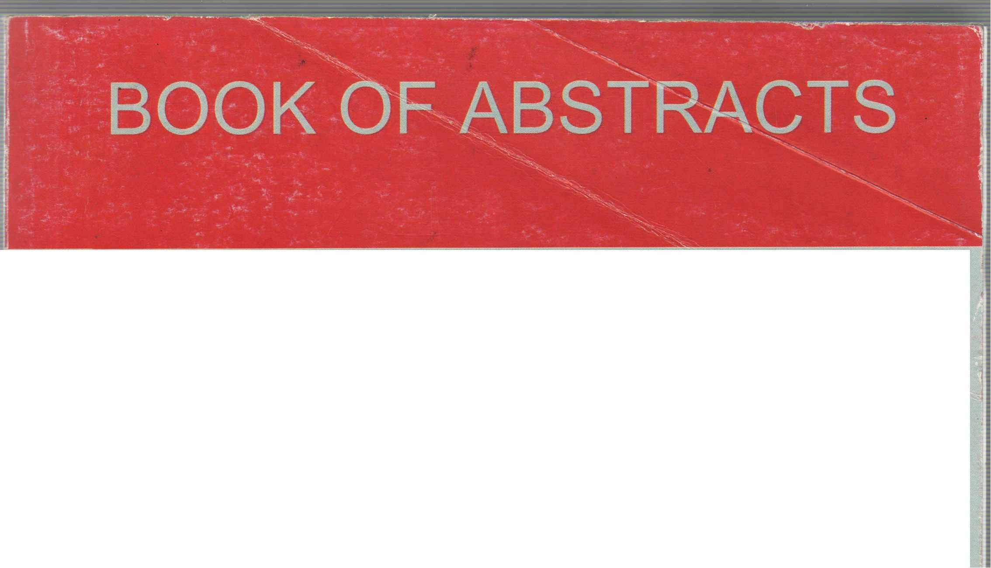
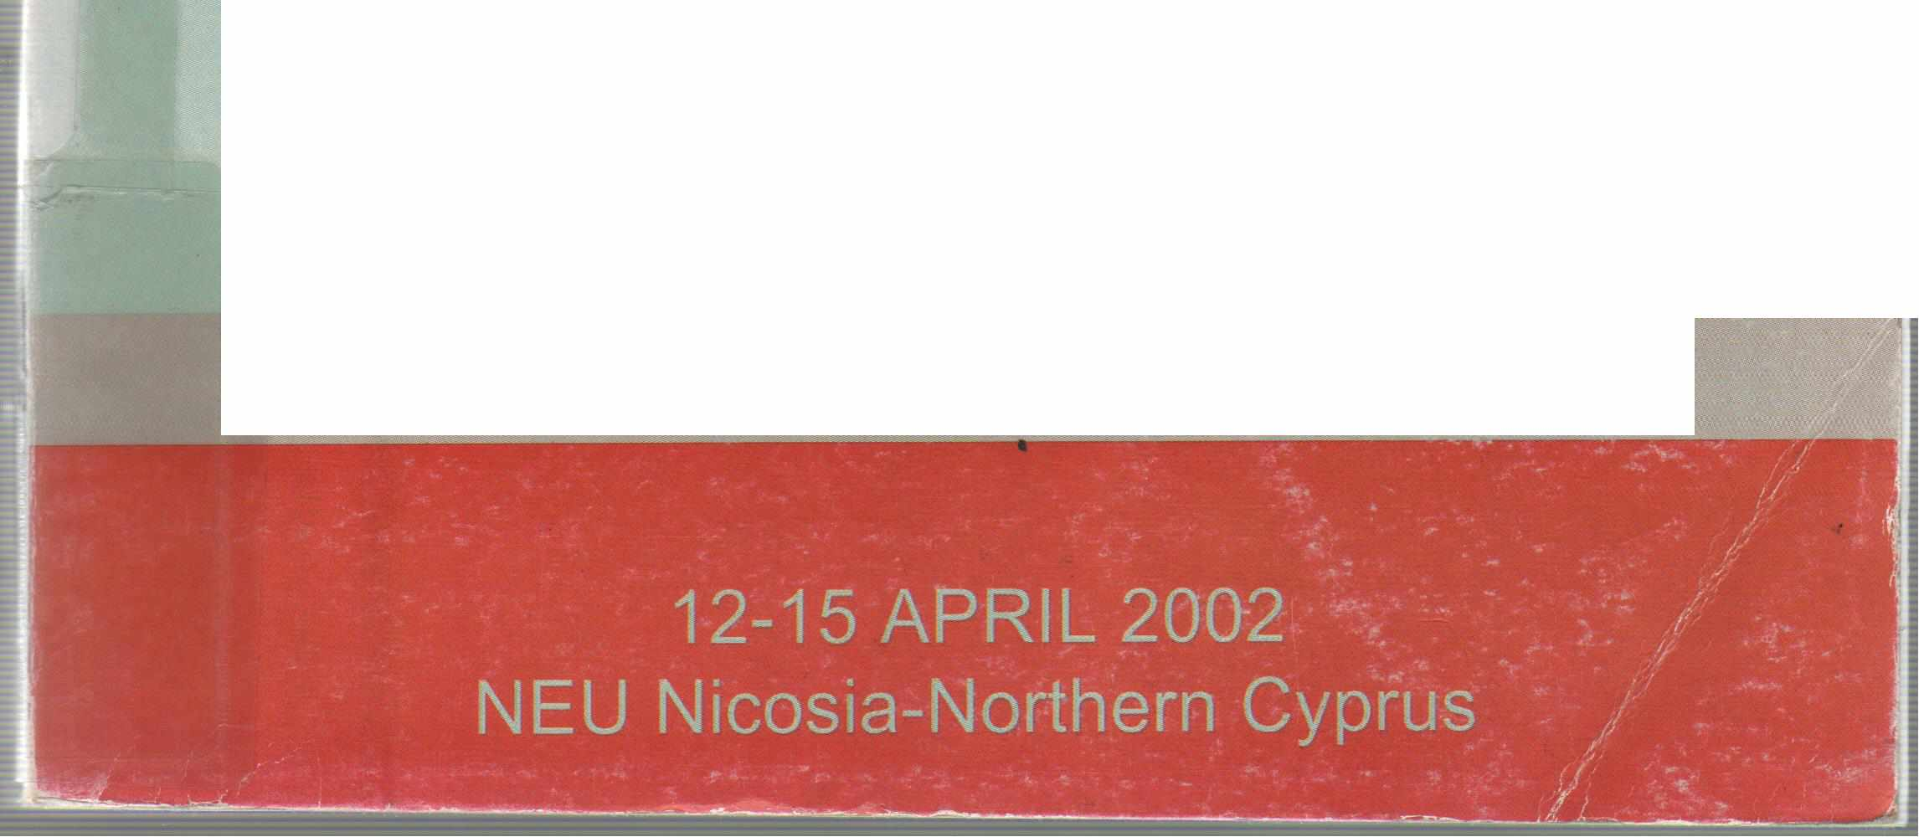
EPMR-2002
INTERNATIONAL CONFERENCE
ENVIRONMENTAL PROBLEMS OF
E THE MEDITERRANEAN REGION
d
i
t
e
d
b v
H.
G
ö k ç e
k u ş
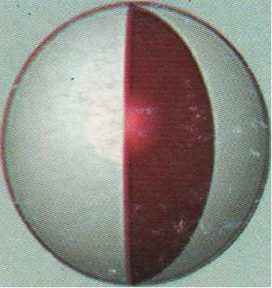
1988
Organized by: NEAR EAST UNIVERSITY
a

' ı

ı, 1
'. [.

EPMR-2002
INTERNATİONAL CONFERENCE
E d i t e d
ENVIRONMENTAL PROBLEMS OF THE MEDITERRANEAN REGION
G ö k ç e k LJ s
b y
H.
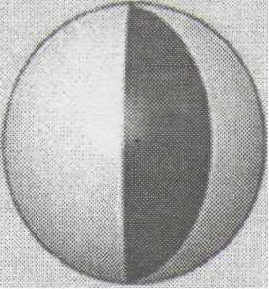
1988
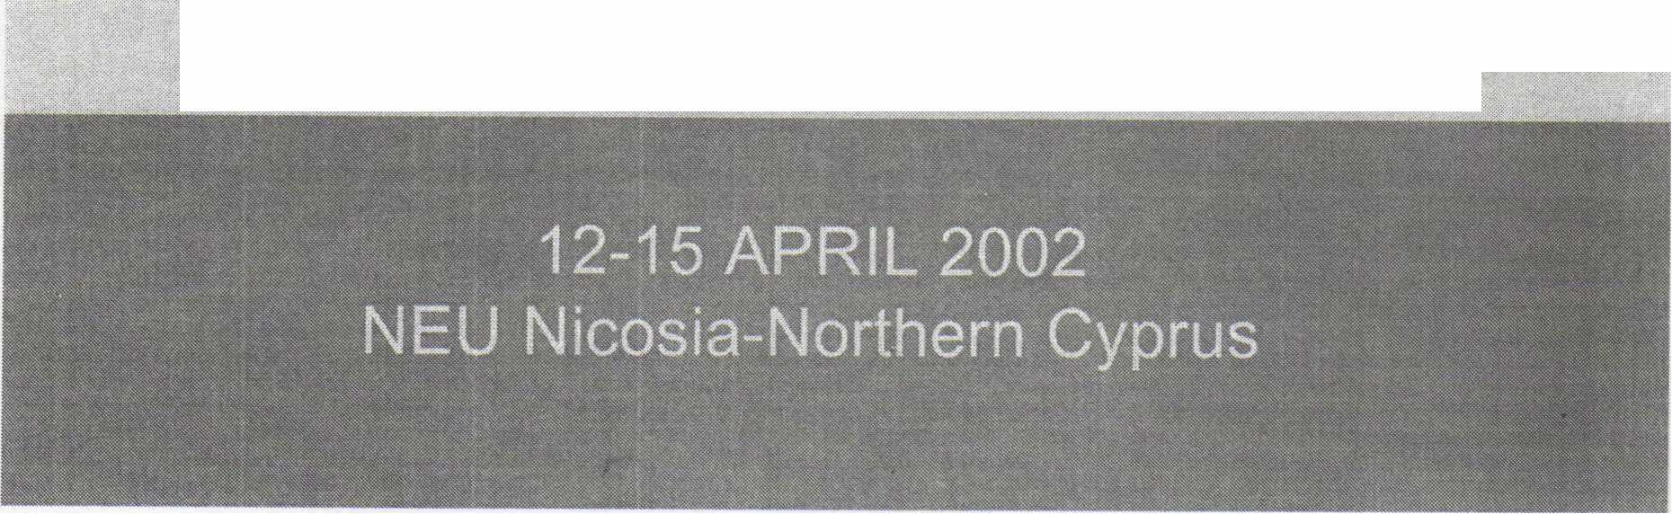
Organized by: NEAR EAST UNIVERSITY

International Conference on the Environmental Problems of the Mediterranean Region
12-15 April, 2002
Near East University, Nicosia, TRNC
Organized by: Near East University Sponsored by:
Near East University
Ministry of Tourism and Environment

TABLE OF CONTENTS
Pages
Messaqe from the Honorary Chairman of the Conference Message from Chairman of the Conference
Technical and Organizing Committee
Scientific Committee Members
Contents of Abstracts
Some lnformation About Turkish Republic of Northem Cyprus Near East University
111 v
Vll Xlll 435 437

Message from the Honorary Chairman of the Conference

I feel excited to witness yet another international conference at the Near East University and deeply honoured for acting as your host for the distinguished scientists from different countries of the world coming to Northern Cyprus in a join effort to contribute to the advancement of science for the prosperity of al/ humanity.

The objectives of the international conference on the Environmental Problems in the Mediterranean Region include perhaps the most urgent issues in need for scientific examination for the sake of the future generations and the world's environment that is getting increasingly fragile. I believe that your contributions to be made at the Conference will not only serve as solutions to the problems of the Region but also shed a light for further investigations into global environmental problems.

I am a strong believer in the saying that "The environment is what we have borrowed from our ehi/dren, we must ensure to hand it back to them - unharmed!"
l look forward to welcoming you al/ in Northern Cyprus. Yours truly,
Dr. Suat 1. GÜNSEL
Founding President of the Near East University

Message from the Chairman of the Technical and Organizing Committee
Dear Co/leagues,

it gives me utmost pleasure in welcoming you ali at the lnternational Conference on the Environmental Problems of the Mediterranean Region, here in Northern Cyprus at the Near East University between 12fh
and 15fh April 2002.

The Mediterranean is perhaps the o/dest inhabited /andscape in the world, and it is here that mankind has /eft most continuous, detailed, and abundant evidence of its activities. More recently, the forests have been stripped from the /and .-Qth fire, and the waters polluted by oil spills and sewage. There is the contamination from mines and the ugly side of the quarries. Yet even after so much destruction, natura/ life stili manages to survive in some parts in extra ordinary richness. What has happened here in the past millennia is, e/sewhere on earth, just beginning, and by studying its current environmental problems we may obtain a better idea of where our natura/ world and civilizations are headed.

The /ove of the Mediterranean is behind the reason why we wish to organize a conference on its environmental problems. We would /ike to contribute to the understanding of the current and future environmental issues facing the region in general, and Cyprus in particular. We feel exited about hosting you ali from related environmental disciplines ranging from environmental engineeritJg, earth sciences, agriculture, civil engineering, forestry, chemistry, and biology together with psychology,
economics and /aw.
We/come to Northern Cyprus.
Yours truly,

Prof. Dr. Hüseyin GÖKÇEKUŞ Secretary General, Near East University

MEMBERS Ahmet Ertugan,
Committee Secretary, Near East University
Doğan Sahir
Near East University
Fahrettin Mamedov Near East University
Şenol Bektaş
Near East University
Tahir Çelik
Near East University
Levent Köker
Near East University
Kadri Bürüncük Near East University
Doğan İbrahim
Near East University

TECHNICAL AND ORGANIZATION COMMITTEE
HONORARY CHAIRMAN Suat İ. GÜNSEL
Founding President, Near East University
CHAIRMAN
Hüseyin GÖKÇEKUŞ Secretary General, Near East University
Erdal Güryay
Near East University
Doğan Haktanır Near East University
Tolga Günal
Near East University
UğurH.Can
Near East University
Temel Rıza
Near East University
Sibel Aktunç
Near East University
İmge Saracoğlu Near East University

