

E-Commerce Project

User's Guide

Nameer Talal Momani

Table of Contents
Title | Page Number
Introduction | 3
Home Page | 4
Available Products | 5
How to Buy | 6
Buy Now Example | 6
Add to Cart Example | 10
Administration Page | 12
Validation | 13
Technology Used | 14

Introduction

This project is an E-Commerce project which is dedicated to sell notebooks, personal computers and monitors, these products can be from different manufacturers (brands), the user can navigate through the website and take a look at the available products, after that the user can add a specific product to his shopping cart and after specific period he can check out the products in his cart or he can choose the Buy Now option which allows him to immediately buy specific product, the user can customize his product by choosing from different available options (Customization), and for each option there is different price, before the user checks out or confirms his order he can review the order , change it, he can change the shipment and payment information, and he can update the quantity for any product to a new value which is less than or equal the quantity available in the stock for that product, also in this project there is an administration page which allows the administrator to add new product, update or delete specific product, show new messages for each user according to his orders (Personalization), the administrator also can read the users' feedback from his page .

Home Page

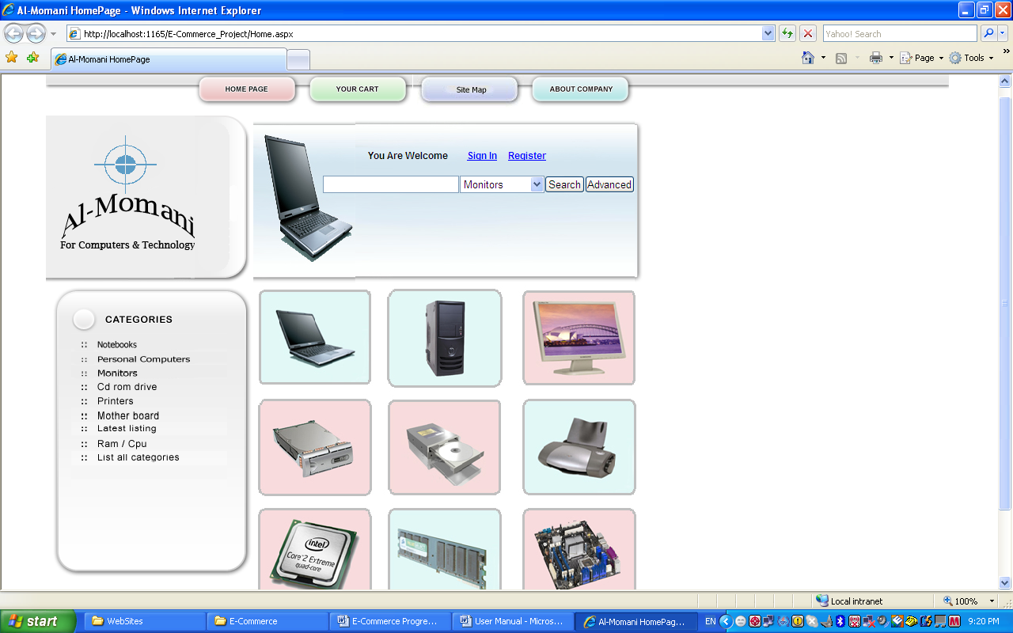

From the home page the user can do any of the following:-

- Search for a specific product by choosing from the category dropdown list (Monitors, Notebooks, or PCs) and entering key words into the blank text box and then clicking the Search button.
- Advanced Search, by clicking on the advanced button three options will be available category, brand, and price starting at, the user can choose any combinations of these.
- Navigate available notebooks by clicking on the notebook picture or by clicking on the notebook link on the lift side.

- Navigate available personal computers by clicking on the personal computer picture, or by clicking on the personal computers link on the lift side.
- Navigate available monitors by clicking on the monitor picture, or by clicking on the monitors link on the lift side.
- Register or create a new account.
- Signs in for his account.
- Views his shopping cart.
- Views the site map, to view the website structure.

Available Products

When the user clicks on any product picture or link (Notebooks, Personal Computers, or Monitors) a list of available products will be shown and the order for these products will be according to the newest product added, so the latest product added will be shown first, for example when the user clicks on the monitors link, available monitors page will be shown like the one below.

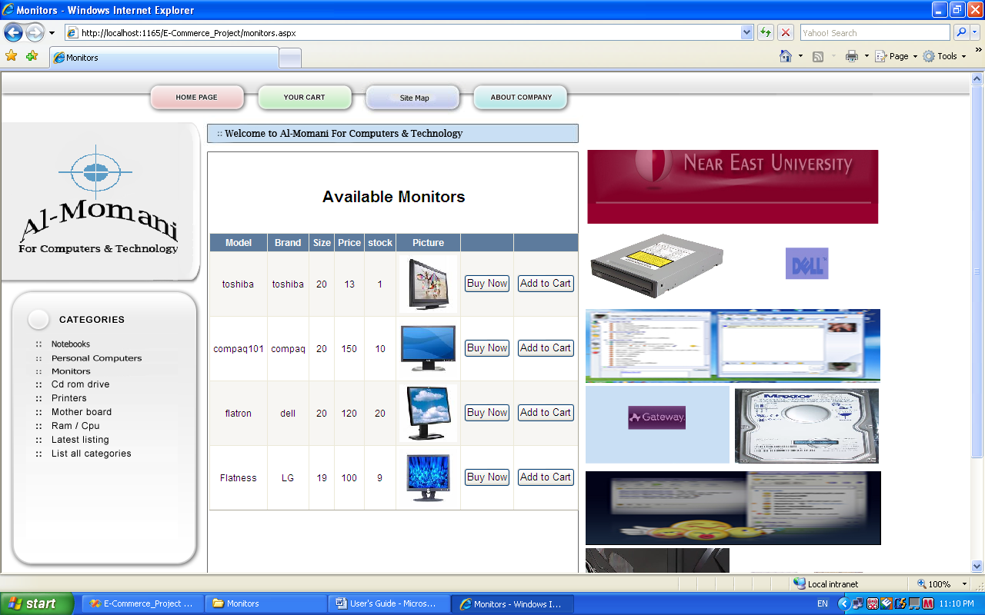

How to Buy

The user has two options to buy a product which are:-

- Buy Now
- Add to Cart

Buy Now Example:-

We assume here that the customer will buy a notebook using this option
When the user clicks on the notebooks link this page will be displayed, this page will contain the available notebooks.

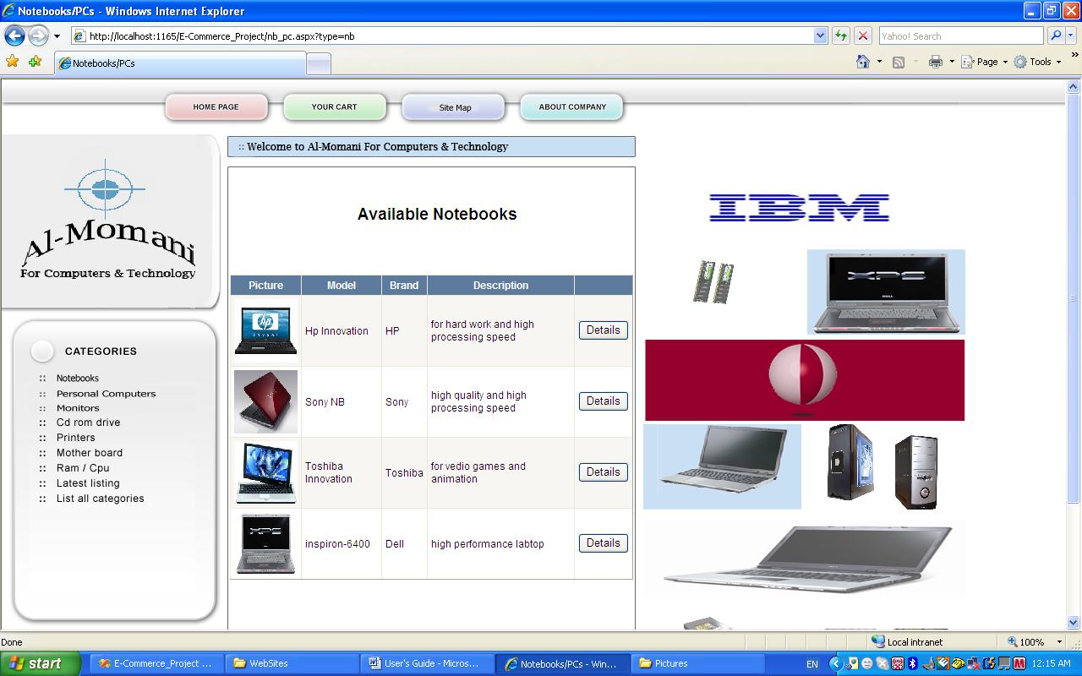

Now if the user wants to view the details for this product he simply clicks the details button, after the user clicks the details button the details for the selected notebook will be shown, like the page below.

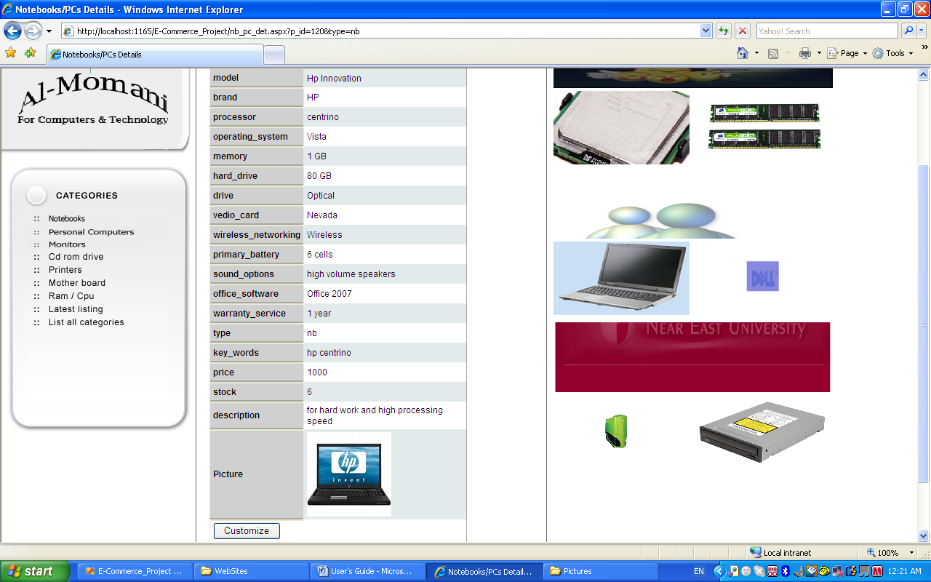

In this page at the end of the details there is a customize button, this button will transfer the user to the customization page like the page below.

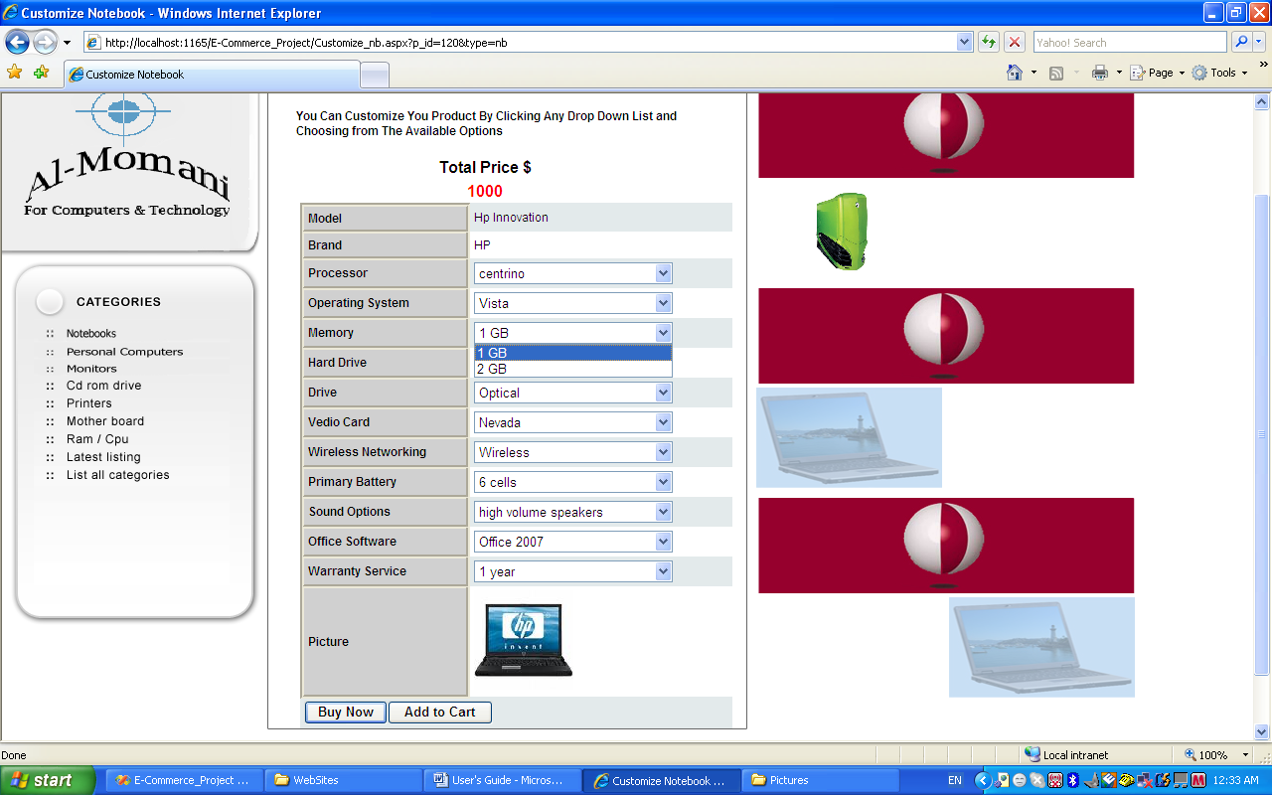

In this page the user will see a dropdown list for each of the specifications, for example the user might want to choose 2 GB of memory instead of 1 GB so the user can click on the list beside the memory and change the memory from 1 GB to 2 GB after that the total price will be changed accordingly, as show in the page below.

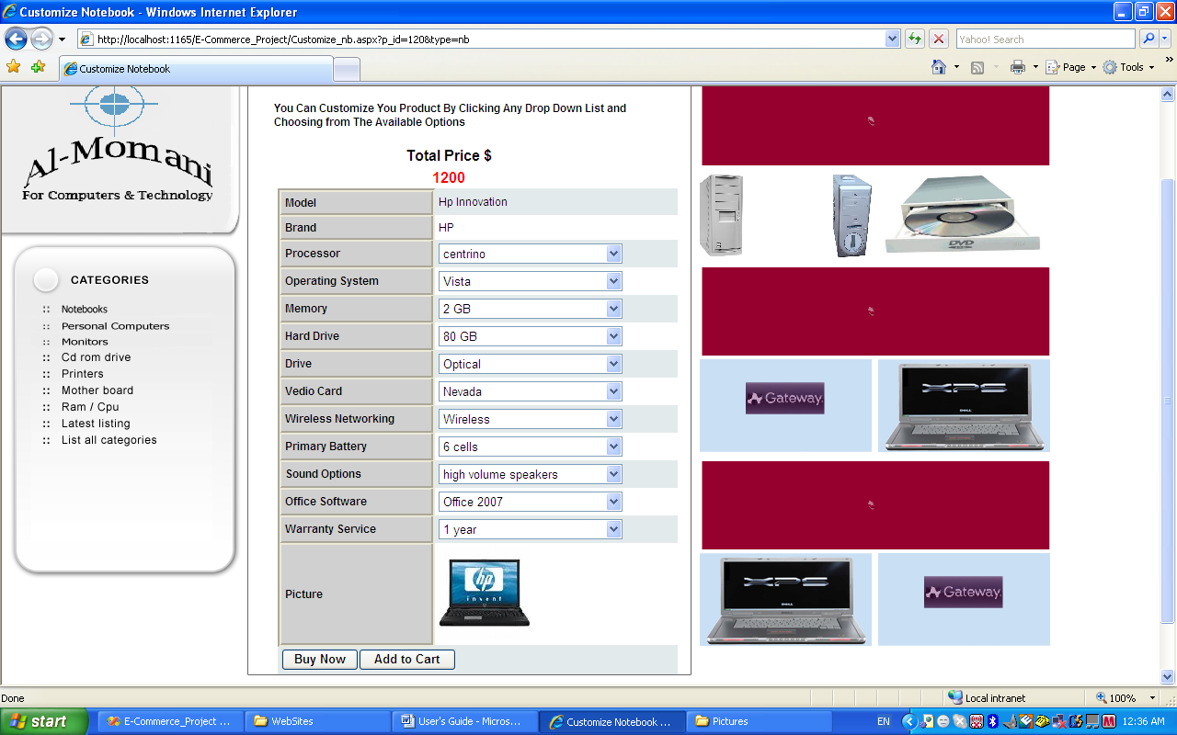

Now in the above page there are two buttons at the end of the page, our purpose in this example is to show how to Buy Now, when the user clicks on this button, the user will be transferred to step 1, as shown below, if the user is registered then he can click the Sign In link, otherwise the user can creates his new account by filling the form shown in the page.

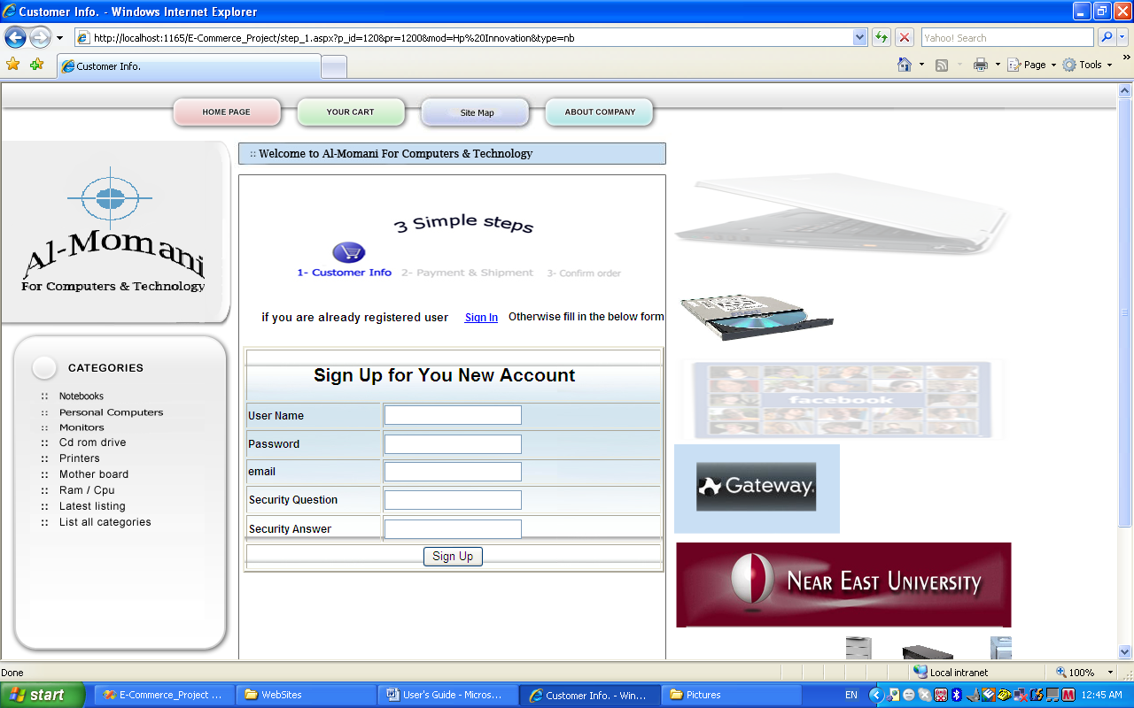
After the user signs in the user will be transferred to step 2 which Payment & Shipment as shown below, in this page the user can fill his payment method, his address, and his shipment period.

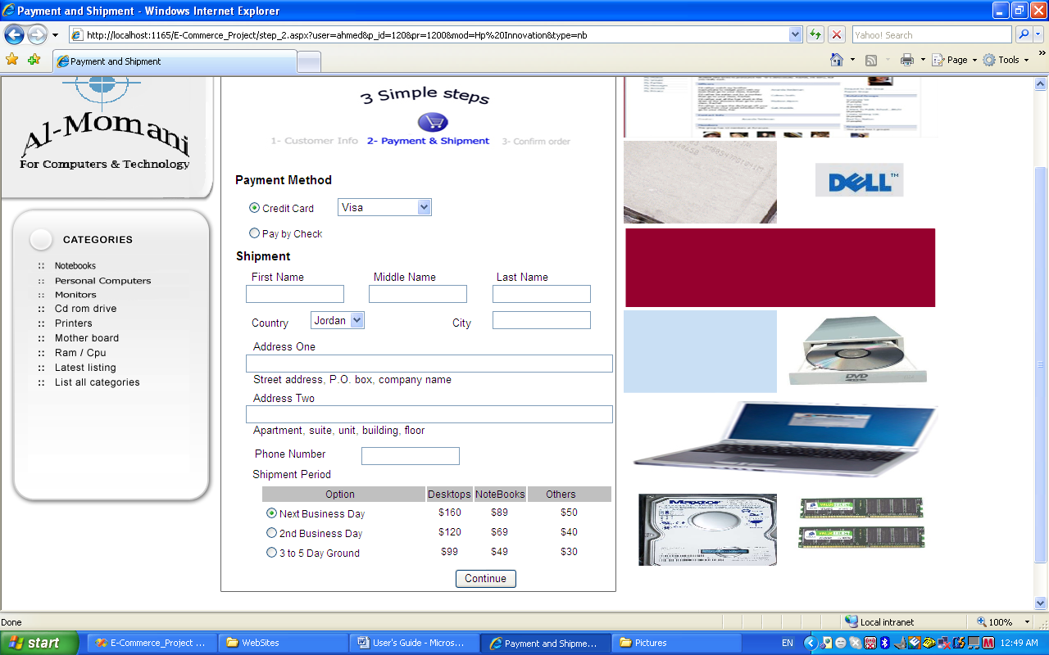

When the user clicks the continue button he will be transferred to the final step which is confirm order as shown below, from this page the user can update his item by clicking on the item button, update his payment and shipment by clicking on the Payment & Shipment button, and update the quantity by clicking on the quantity button, after doing the necessary modifications the user can click the confirm button to confirm his Order.

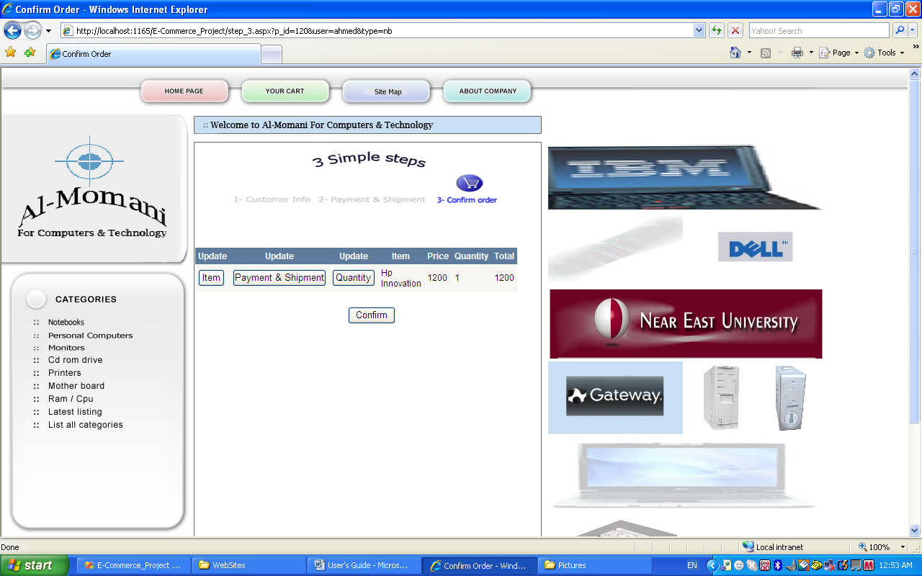
Add to Cart Example:-

Lets assume that the user wants to add a notebook to his cart, in the below page the user simply clicks the Add to Cart button.

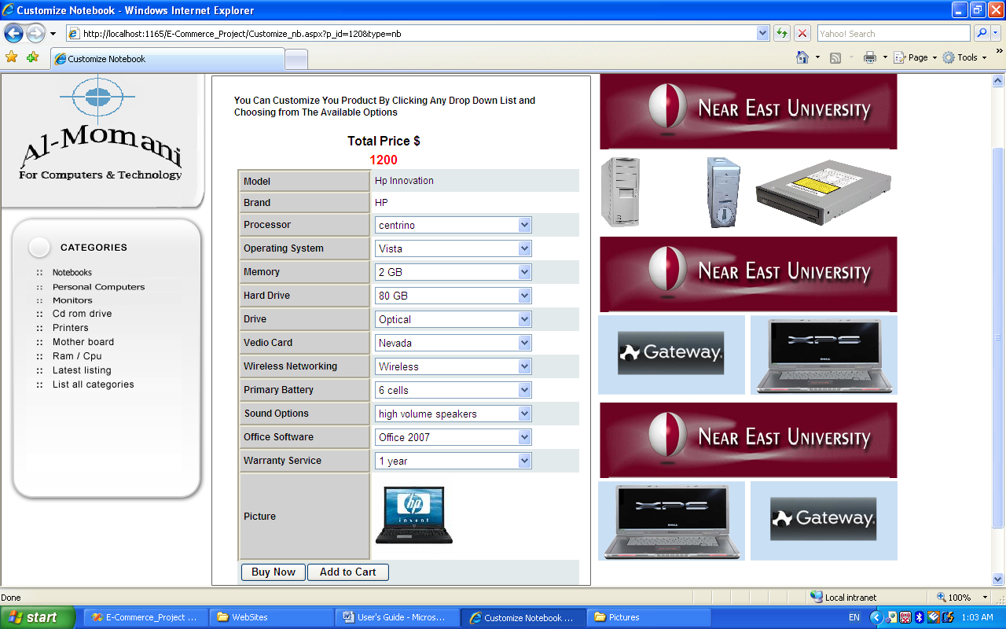

After that the user will be transferred to the Sign In page as in the previous example but here after the user signs in he will be transferred to his shopping cart as shown below.

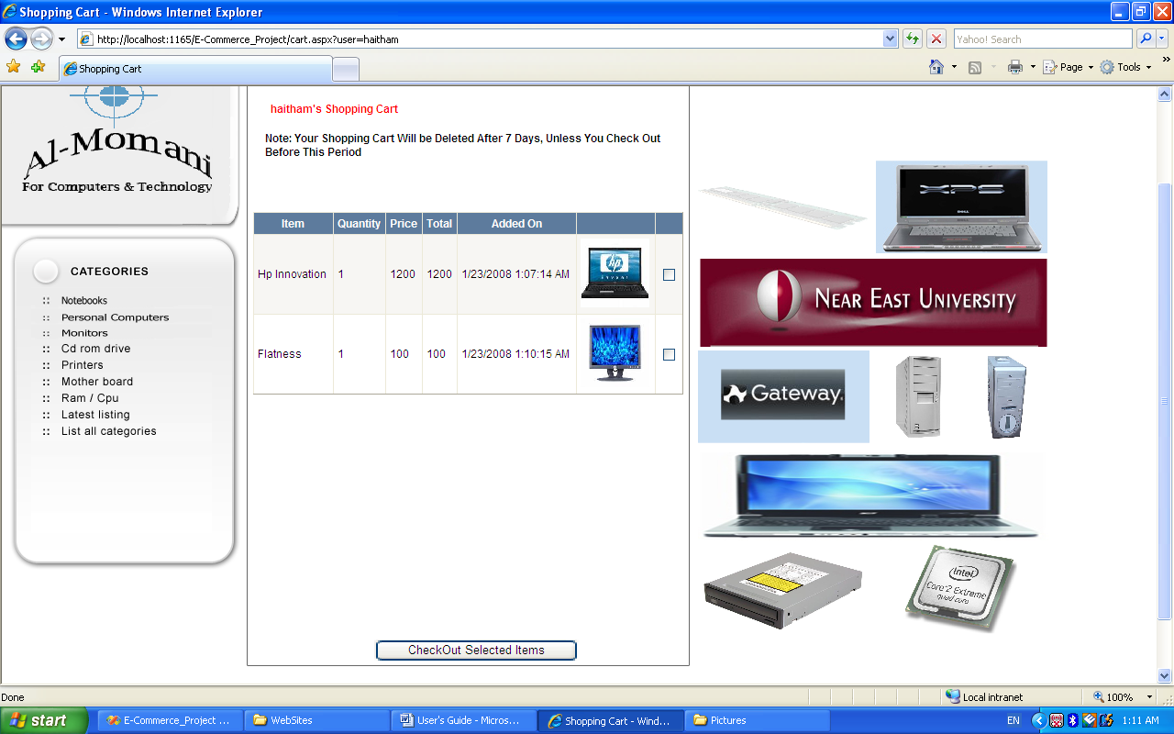

Now the user can check the items he wants to check out and then pressing the Checkout Selected Items button, after that the user will be transferred to step 2 (Payment & Shipment) and then to step 3 (Confirm order) but with one difference here, that in step 3 the user can create one Payment Method and one Shipment Address for all the products if he wants to, and that can be done by clicking the create button as shown below.

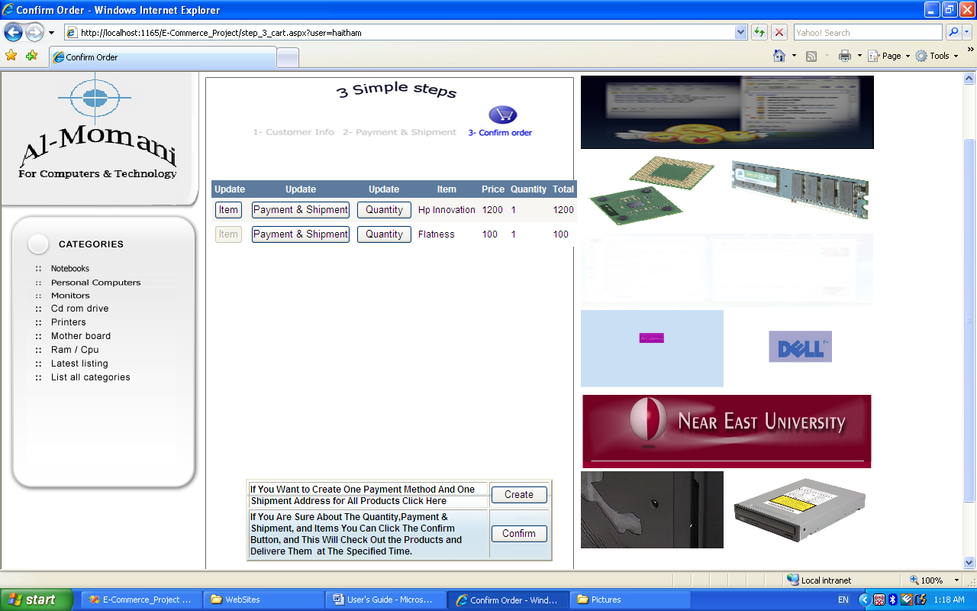

Administration Page

The administration page as the name implies is for administrators and its look like the page below.

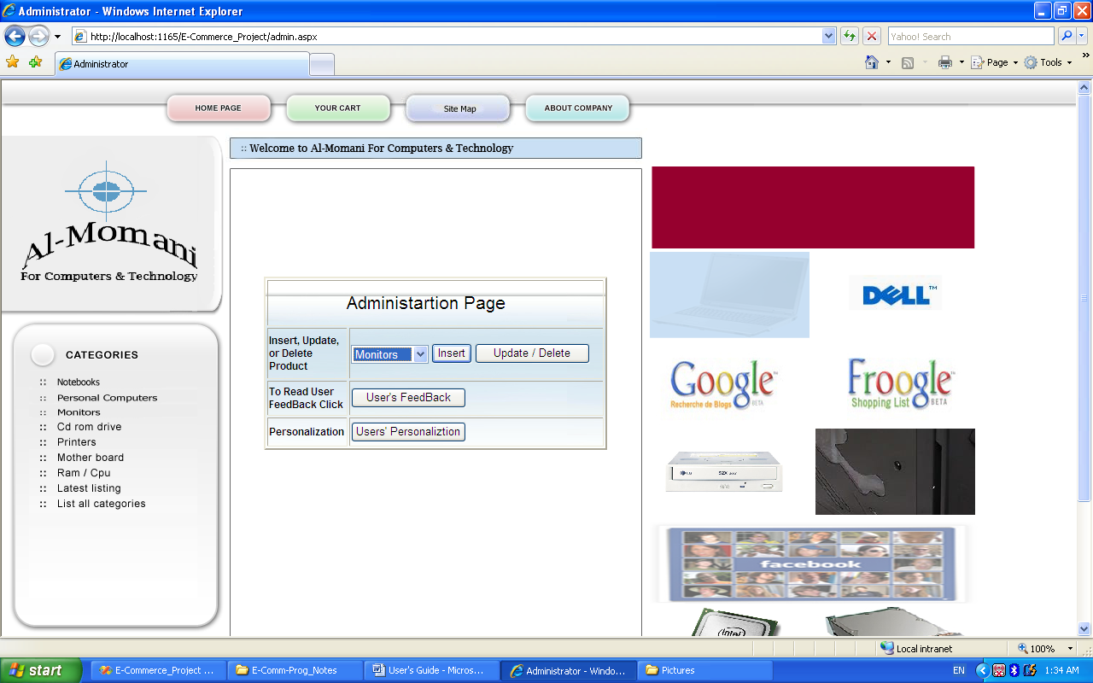

From this page the admin can insert, update or delete a product depending on the selected value in the dropdown list, the administrator also can view the user's feedback, and also the administrator can create a new message for a specific user depending on his orders (Personalization).

Validation

In order to this website to work properly the website has many validations which are:-

- No two users are allowed to have the same user name.
- The user cannot add the same item to his cart instead he can update the quantity for his product.
- The quantity updated by the user cannot exceed the quantity available in the stock.
- In the administration page the admin cannot add the same option for any specification
- The lifetime for shopping cart cannot exceed seven days, after that if the user does not check out items in his shopping cart his products will be deleted, and he will be given notification message.

Technology Used

The server side code will be implemented using
- ASP.net 2 under Visual Basic.net language using Visual Studio 2005
The database tables and DML operations will be implemented using
- SQL Server 2005
The website design and animation will be implemented using
- Adobe Photoshop
- FlashMX
- DreamWeaver

