CHAPTER ONE INTRODUCTION

1.1 Background of study
“The concept of an historic monument embraces not only the single architectural work but also the urban or rural setting in which is found the evidence of a particular civilization, a significant development or an historic event. This applies not only to great works of art but also to more modest works of the past which have acquired cultural significance with the passing of time” (The Venice charter 1964).
Historic buildings are old buildings, not built in present time, unique, have value, and endure time. They are aesthetically pleasing, convey a unique sense of community and tell the stories of our past. They make up our collective community memory. They attract tourists because visitors want an authentic and unique experience, distinctive from anywhere that just shows modern buildings without value. However the Preservation of these existing historical buildings is the epitome of sustainability and the only way that has kept them alive centuries after their construction.
Preserving our historic resources affords the opportunity to interpret and appreciate the values and ways of life of those who lived and worked before us, establishes a sense of place to which each of us can connect, and reveals what we as a community value, and through dedicated individuals and property owners working together in the community create a tangible link from the past, through the present to the future.
This historical building provides us with a strong sense of history and identity, reinforces civic pride, and yields real economic benefits. Local awareness and involvement in preservation is needed to prevent the deterioration of historic and cultural resources that usually occurs through the accumulation of many seemingly insignificant minor changes.
Most of the historic buildings have been the best symbols and records of a city development in the past (Chin, 2004, pp1). In Cyprus just as is the case in most parts of the world, the rapid transformation of economy and society had not merely led to de-memorize historic buildings spaces, but also increasingly made residents lose valuable space of history. The historic buildings always constitute as the declined area in the cities, because they represent a historic development of cities. Beautiful ancient buildings that attract tourists, and which are a wonderful national heritage, are bulldozed down to provide space for skyscraper blocks of flats and hotels. In the end, every city will look the same; canyons of steel, glass and concrete. It is only recently, that the tourist departments of many countries have begun to realise that the preservation of ancient monuments and buildings is one of the principal assets for tourist attraction.
Having said that, the master Thesis “An overview on façade characteristics of some historical houses in the walled city of Lefkosa” is related with other papers dealing with identifying and discussing historical buildings as well as their characteristics.
The thesis presents a detailed synthesis of the historical buildings in the old city of Lefkosa, and emphasizing particularly on civil buildings based on materials obtained from various sources as well as a physical survey carried out to evaluate these buildings.
This is a vast area and needs a multi-disciplinary approach. Therefore, as a result of the extreme vast nature of this topic, it needs to be stated that the topic cannot be extensively treated in this master thesis. The thesis makes an analysis of certain buildings selected, with the method of choice based primarily on the availability of research materials in analyzing the buildings selected.
During the survey work, the houses of the walled city of Lefkosa are realized to have originated from different periods. These periods are the Lusignan, Venetia, Ottoman and the British (colonial) periods. The Lusignan and British periods are primarily political periods which did not really have any architectural character. The Lusignan period which is named after the Lusignan family who originated from France and bought the island when it was virtually destitute (Doratli, 2002, pp117). The architectural character of this period as shall be seen later in the thesis is borrowed medieval architecture elements such as pointed arches and gothic windows (Enlart, 1897 pp82-114). The Venetia and Ottomans whom also borrowed some elements of Medievaland Baroque architecture had more original character of its own to which the borrowed character was added. However in the case of the English colonial period it is a political presence period, and not an accepted architectural period. As shall be seen in the course of the write up it was an eclectic, mixed period from architectural point of view, blended by continental styles and other eclectic effects. The process of development of these periods as well as their characters shall be looked at in details in chapter four.
The thesis aims at becoming a useful tool for architects and other specialists involved in the historical building domain for some useful information and for further research on the subject area.

1.2 Aim of study
The philosophy of careful planning in every work and problem is to achieve objectives through logical planning and removing the obstacles. A discussion about historical buildings and their various characteristics shows that they are a great asset in the sense that through that the identity of the place can be exploited and understood clearly.
The thesis shall aim at highlighting and discussing some of the historical houses of the old city of Lefkosa, it shall outline the history and historical background of these houses and through a method of choice, the facade characteristics of these houses shall be analyzed. The analysis of course shall be restricted to civil buildings.

1.3 Scope of study
The thesis used some historical houses from certain streets in the old city of Lefkosa. These buildings selected shall be analyzed based on them being buildings of different periods and architectural style. Criteria to be used here include, architectural style, date of construction, building technique used, as well as alterations and additions done on the buildings. In doing so however, the thesis shall restrict itself to analyzing only the physical elements of these buildings.
The facade characteristics of the houses to be analyzed will be categorized into symbolic and physical elements.

1.4 Research methodology
In writing the thesis, both primary and secondary research methods are used. The primary method involves the data used for the thesis that does not exist. This data is obtained through detailed survey carried out and extensive interaction with experts on the field. Secondary method used includes the summary, collation and/or synthesis of existing research and documented data all on the subject area. The methodology is comprised of two phases which are:
- Background research
- Field work

1.4.1 Background research
Background research includes literature search. The Antiquities Department established by the Lefkosa municipality also helped in providing interesting and valuable information. Local experts, professionals and scholars did also provide required guidance and help.
This helped in the choice of buildings selected for the study and ensured that important structures representing the different periods are used. The background research has helped to identify historic areas; as well as the existing features located within the surroundings.

1.4.2 Field work
In carrying out field work a reliable foot map of the area and its various constituents was used. As known field work requires a lot of leg work to observe the heritage properties and valuable information for each house and this was carried out. This comprises of physically inspecting the historical houses as well as meeting local people such as owners of the houses, talking to other residents and knowledgeable residents and representatives of institutions. By doing so, facts were gathered. These facts include, physical characteristics of the houses, the date of construction, style of construction, design characteristics etc., and by conducting dialogue with the residents, the changes to the houses over time became clearer, ownership details, historic functions and activities and the role of the house in local, regional or national history. Photographs have also been taken to give a pictorial view of the data collected.

CHAPTER 2 HISTORY OF CYPRUS, LEFKOSA AND THE WALLED CITY LEFKOSA

2.1 A Brief history of Cyprus
It is not possible to say when first inhabitants of Cyprus lived, but it is believed possible that as long ago as 8.500 B.C. there were settlements on Cyprus (Harry, 1995, pp24).
Cyprus has had many names, but the name we use now is believed to have come from the word copper of which there was, and possibly still is, an abundance of on the island. An alternative theory is that its name comes from the word Kypros (the Greek for henna) of which there was also abundance (Cobham, 1969).
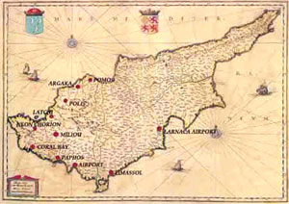
Fig 2.1 Cyprus map dated back to 14th century (Lornado, 1978 pp54)
Cyprus is the third largest island in the Mediterranean and is located basically on 35°N meridian. It is 65km away from Turkey, 95 km from Syria, 350 km from Egypt and 750 km from Greece. Mainly there are two rows of mountains on the island. Besparmak (Turkish meaning of “Five fingers”) mountains are situated on the northern part along the coast. They extend for 150 kilo meters from Girne to Karpaz. The other range of mountains, known as Troodos, is located at the south part between Guzelyurt and Magusa; they extend for 120 kilo meters from east to west (Nazife, 2005, pp1).
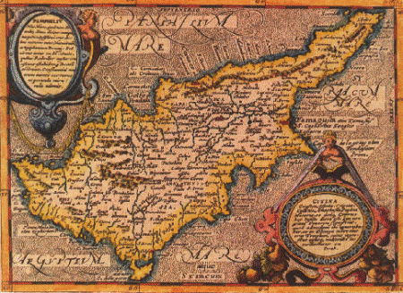
Fig 2.2 Cyprus map dated back to 1513(Lornado, 1978 pp54)
Cyprus has had a troubled history. The abundance of copper, timber and the strategic location between East and West resulted in repeated invasions, changes of rulers, and strive for the inhabitants (ww.nicosia.org.cy/english/lefkosia).
Before the annexation to Rome in 58 B.C. Phoenicians, Archaeans, Assyrians, Egyptians, Persians, and Greeks colonized Cyprus. The history of Cyprus can be arranged under different periods(www.cypnet.co.uk/ncyprus/history) It is highlighted thus:
- 7000-3900 BC NEOLITHIC AGE
Remains of the oldest known settlements in Cyprus date from this period. This civilization developed along the North and South coasts. First, only stone vessels were used. Pottery appeared at a second phase after 5000 BC.

- 3900-2500 BC CHALCOLITHIC AGE
Transitional period between the Stone Age and the Bronze Age. Most Chalcolithic settlements are found in Western Cyprus, where a fertility cult developed. Copper is being discovered and exploited on a small scale.
- 2500-1050 BC BRONZE AGE
Copper is more extensively exploited bringing wealth to Cyprus. Trade develops with the Near East, Egypt and the Aegean, where Cyprus is known under the name of Alasia. After 1400 BC Mycenaeans reached the island as merchants. During the l2th and 11th centuries, mass waves of Achaean Greeks come to settle on the island spreading the Greek language, belief and customs. They gradually took control over Cyprus and establish the first city-kingdoms of Paphos, Salamis, Kition and Kourion. The Hellenisation of the island is now in progress.
- 1050-750 BC GEOMETRIC PERIOD
Cyprus is now a Greek island with ten cities. Remains of the oldest known settlements in Cyprus date from this period. This civilization developed along the North and South coasts. First, only stone vessels were used.

- 750-325 BC ARCHAIC AND CLASSICAL PERIOD
The era of prosperity continues, but the island falls prey to several conquerors. Cypriot Kingdoms become successively tributary to Assyria, Egypt and Persia . King Evagoras of Salamis (who ruled from 411-374 BC) unifies Cyprus and makes the island one of the leading political and cultural centers of the Greek world. 333-325 BC the city-kingdoms of Cyprus welcome Alexander the Great, King of Macedonia, and Cyprus becomes part of his empire.

- 325-58 BC HELLENISTIC PERIOD
After the rivalries for succession between Alexander's generals, Cyprus eventually comes under the Hellenistic state of the Ptolemies of Egypt, and belongs from now onwards to the Greek Alexandrine world. The Ptolemies abolish the city-kingdoms and unify Cyprus. Paphos becomes the capital.
- 58 BC - 330 AD ROMAN PERIOD
Cyprus comes under the dominion of the Roman Empire. During the missionary journey of Saints Paul and Barnabas, the Proconsul Sergius Paulus is converted to Christianity and Cyprus becomes the first country to be governed by a Christian. Destructive earthquakes occur during the 1st century BC and the 1st century AD and cities are rebuilt. In 313 the Edict of Milan grants freedom of worship to Christians and Cypriot bishops attend the Council of Nicaea in 325.
- 330 -1191 AD BYZANTINE PERIOD
After the division of the Roman Empire Cyprus comes under the Eastern Roman Empire, known as Byzantium, with Constantinople as its capital. Christianity becomes the official religion. Empress Helena visits Cyprus and founds the Stavrovouni Monastery. New earthquakes during the 4th century AD completely destroy the main cities. New cities arise; Constantia is now capital, and large basilicas are built from the 4th to 5th century AD. In 488, after the tomb of St. Barnabas is found, Emperor Zenon grants the Church of Cyprus full autonomy and gives the Archbishop the privileges of holding a scepter instead of a pastoral staff, wearing a purple mantle and signing in red ink. In 647 Arabs invade the island under Muawiya. For three centuries Cyprus is constantly under attack by Arabs and pirates until 965, when Emperor Nikiforos Fokas expels Arabs from Asia Minor and Cyprus Kingdoms. The cult of the Goddess Aphrodite flourishes at her birthplace Cyprus. Phoenicians settle at Kition. The 8th century AD is a period of great prosperity.

- 1191-1192 RICHARD THE LIONHEART AND THE TEMPLARS
Isaac Komnenus self proclaimed 'Emperor' of Cyprus behaves discourteously to survivors of a shipwreck involving ships of Richard's fleet on their way to the Third Crusade. Richard in revenge defeats Isaac, and takes possession of Cyprus marrying Berengaria of Navarre in Limassol where she is crowned Queen of England. A year later he sells the island for 100,000 dinars to the Knights of Templar who resold it at the same price to Guy de Lusignan, deposed King of Jerusalem.
- 1192-1489 FRANKISH (LUSIGNAN) PERIOD
Cyprus is ruled on the feudal system and the Catholic Church officially replaces the Greek Orthodox. This though under severe suppression manages to survive. The city of Ammochostos is now one of the richest in the Near East. It is during this period that the historical names of Lefkosia, Ammochostos and Lemesos are being referred to as Nicosia, Famagusta and Limassol respectively. The era of the Lusignan dynasty ends when the last queen Caterina Cornaro cedes Cyprus to Venice in 1489.

- 1489-1571 VENETIAN PERIOD
Venetians view Cyprus as a last bastion against the Ottomans in the east Mediterranean and fortify the island, tearing down lovely buildings in Nicosia to reduce the boundaries of the city within fortified walls. They also build impressive walls around Famagusta, which were considered at the time as works of military architecture.
- 1571-1878 OTTOMAN PERIOD
In 1570 Ottomans took over Cyprus, captured Lefkosa, and laid siege to Famagusta for a year. After a fairly long defense by Venetian commander Marc Antonio Bragadin, Famagusta falls to the Ottoman commander Lala Mustafa Pasa. On annexation to the Ottoman Empire the Latin leadership is expelled or converted to Islam and the Greek Orthodox Church restored; in time, the Archbishop, as leader of the Greek Orthodox Church becomes the Greek people's representative to the Sultan. The Muslim population during the Ottoman period eventually acquires a Cypriot identity.

- 1878-1960 BRITISH COLONIAL PERIOD
Under the 1878 Cyprus Convention, Britain assumes administration of the island. It remains formally part of the Ottoman Empire until the latter enters the First World War on the side of Germany, and Britain in consequence annexes Cyprus in 1914. In 1923 under the Treaty of Lausanne, Turkey relinquishes all rights to Cyprus. In 1925 Cyprus is declared a Crown colony. In 1940 Cypriot volunteers serve in the British Armed Forces throughout the Second World War. Hopes for self-determination being granted to other countries in the post-war period are shattered by the British who consider the island vitally strategic. After all means of peaceful settling of the problem are exhausted, a national liberation struggle is launched in 1955 against colonial rule and for union of Cyprus with Greece, which lasts until 1959.
- 1960 REPUBLIC OF CYPRUS
According to the Zurich-London Treaty. Cyprus becomes an independent republic on l6th August 1960. It is a member of the United Nations the Council of Europe the Commonwealth and the Non-Aligned Movement. According to the above treaty. Britain retains two Sovereign Bases (158.5 sq. km) on the island at Dhekelia and Akrotiri- Episkopi.
- AFTER 1960 TO DATE
In 1963 a political tussle arose between the Greek and Turkish Cypriots, it went on for some time leading to mass attacks, slaughtering and torture on each other. This led to Turkish interference in 1974, they took over the Northern part of the island inhibited mainly by Turkish Cypriots and later declared self independence and formed the Turkish Republic of Northern Cyprus which remains an unrecognized state around the world with the exception of Turkey. The Greek Cypriots kept the southern part which is now known as the Republic of Cyprus. So till date the island is divided into Northern Turkish part and the Southern Greek part with the border in between them passing amidst the Lefkosa’s walled city. Thus the city is divided among the two civilizations with the North’s capital being Lefkosa and the South having Nicosia as its capital.

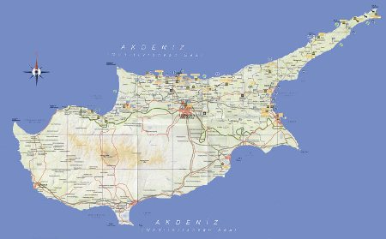
Fig 2.3 Modern map of Cyprus showing the settlements in the Northern Part (www.northcyprusonline.com).
2.2 History of Lefkosa
Lefkosa is the capital and the largest city of Northern Cyprus. It is located at 35°10' north, 33°21' east, roughly in the centre of the island. Lefkosa is the political, economic and cultural centre of the country. It is the seat for the main government offices and headquarters. Its population is more than 60,000 people, which is almost doubled during the working days.
Lefkosa is currently the only divided capital city in the world, with the northern (Turkish) and southern (Greek) parts divided by the "Green Line", a demilitarized zone maintained by the United Nations (www.turkishcy name prus.com/about-trnc-capital-city).

2.2.1 Origin of the name
The Greek name of Nicosia, "Lefkosia", probably comes from Lefkos, son of Ptolemy I of Egypt, who rebuilt the city in the 3rd century B.C. Another possibility is that the name originated from the white poplar (lefki) which was abundant in the bed of the city's river. The city also bore the name of Lefkothea (“white Goddess”).
The name "Nicosia" appeared in the end of the 12th century A.D., when the city was under rule of the Knights Templar. The Crusaders conquerors could not pronounce the name Kallinikisis, as the city was called at that time, and they tended to say "Nikosia", which they spelled as "Nicosia" (Cobham 1969, pp8).
Referring to another source the modern name of Nicosia arose in the 19th century when an English soldier corrupted the word, because he did not listen carefully to the inhabitants' pronunciation. However, it was also believed that the name Nicosia was used in the middle Ages (Cattling, 1964)
More so, a wide variety of writers in the 14th century were quoted, they include the Italian monk, Jacobus de Verona, writing in Latin in 1335, who uses "Nicosia"; the German priest Ludolf von Suchen who uses the slight spelling variation "Nycosia" when writing in 1341 also in Latin; the English knight, Sir John Maundeville, writing in French in I 356, and the Italian lawyer, Nicolai de Martoni, writing in Latin in 1394, who both use "Nicosia". There is no need to go on into later centuries, but this evidence points clearly to the conclusion that "Nicosia" was the standard Latin name for the city at the time when it had its closest links with the countries of Western Europe before the later l9th century. And Latin was of course the language of scholarship for those countries throughout the medieval period (William, 1981, pp33).
This brings up the interesting point that for the past four hundred years every town and many of the villages in Cyprus have each had three names in common usage, usually but not always versions of one another, Greek, Latin and Turkish (William, 1981, pp41).
It seems to have been the policy of the British Administration between 1878 and 1960 to adopt the Latin forms as the English names and these have now become standard in English. Thus bringing the divided capital to have two separate name with the Northern part calling it Lefkosa and the southern part adopting the English name Nicosia.
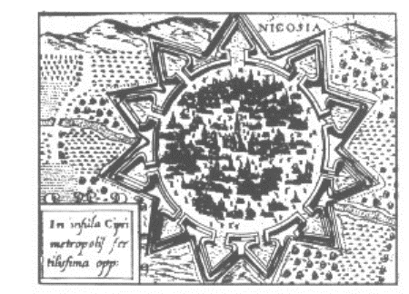
Fig 2.4 Plan of Nicosia taken from traveler’s guide in 1590 (Lornado, 1978, pp122)
2.2.2 Development of Lefkosa
It is believed that Lefkosa is about 2250 years old and dates back to the original settlement of Ledra (also spelled as Ledrae or Ledron). Moreover, archaeological finds have shown that modern Nicosia was inhabited already in 5000 B.C.
During the first millennium B.C., when Cyprus was divided into city-kingdoms, Lefkosa was a small town while other kingdoms prospered due to their coastline position. Only in the 4th century A.D., after the dissolution of the city-kingdoms, Lefkosa started exploiting its natural resources and geographical location, in the centre of the island.
After the Arab raids in the 6th century A.D. on the coastal cities, the population moved to the centre of the island. Lefkosa probably became the centre of administration and the island's capital city in either the 9th or the 10th century. During the Byzantine period, it was the seat of the Byzantine governor of Cyprus. The last Byzantine governor was Isaac Komnenos.
In 1191 Richard the Lionheart defeated Isaac and became the ruler of the island. But soon he sold it to the Templars who made Lefkosa their residence. In this period, the city expanded culturally (Strand, 1993, pp38).
Guy de Lusignan, King of Jerusalem, bought Cyprus from the Templars and brought many noble men from France, Jerusalem, Tripoli, the principality of Antioch and Kingdom of Armenia, to the island. Due to the destruction of Salamis and Famagusta, the Archbishop obtained the Pope's permission to move to Nicosia. Thus Nicosia was established as the capital city of the Kingdom of Lusignans. Under the rule of Lusignans the capital city expanded architecturally: it saw the erection of a number of palaces, mansions, churches and monasteries. The first Lusignan castle was built in 1211, during the reign of King Henry I. Peter II fortified the entire city by building the new walls with many gates.
During Venetian rule from 1489 to 1571, Lefkosa was the administrative centre and the seat of the Venetian Governor. Feeling the threat from the Ottomans the Venetians decided to fortify the city in 1567. Julio Savorgnano, an architect and engineer, designed new fortifications for the capital city according to contemporary defence methods. The new walls had the shape of a star with eleven bastions. The walls had three gates: the North Kyrenia Gate, the west Paphos Gate and the east Famagusta Gate. The heart shape design of the bastion was more suitable for the new artillery and a better control for the defenders.
However, the new walls could not protect the capital city from the Ottomans. In 1570 they marched towards Lefkosa and started the attack on the bastions. After the siege the city was deserted, the main Latin churches were converted into mosques. Lefkosa became the seat of the Pasa, the Greek Archbishop, the Dragoman and the Kadi.
The British gained control over the island in 1878, leaving Lefkosa the colony's capital. At the time of the British occupation, Lefkosa was still developing within its walls (Peter, 1995, pp12). A series of openings in the walls provided direct access to areas beyond the walls as they grew in importance. The opening at the Kyrenia Gate took place in 1931 after one of Lefkosa's first buses proved too high to go through the original gate. Many more openings followed.
During the post-war period the villages around Lefkosa began to expand. The old city was given over to shops and workshops, turning into a lower income area.
Nicosia Cyprus, as the seat of government, constituted the main place of political conflicts during the period of liberation from the British rule in 1955-1959. In 1960 Nicosia became the capital city of the Republic of Cyprus, whose constitution was based on the co-operation of the island's two communities, Greek and Turkish, in a ratio of seven to three.
After 1974 Nicosia was divided in two parts by the Green Line (Alostos, 1976, pp12).

2.3 The walled city of Lefkosa

The walled city of Lefkosa is unique and definitely the place of a rich history. Encircled by strong fortress walls built by the Venetians in the 16th century, the enchanting old city is scattered with buildings and monuments of historical interest as well as little shops, cafés and restaurants. To walk through the old city is to step backwards in time. Narrow streets and old houses with ornate balconies jut from weather beaten sandstone walls, smell of jasmine flowers in those long summer evenings, and craftsmen in small workshops practice trades unchanged for centuries. As earlier said, for over a thousand years, Lefkosa was a walled city, just like the majority of towns in the middle ages. Unlike the majority, however, Lefkosa’s city walls remain standing. This is in the main because of their construction, an earth rampart with stone facings, meaning there was not a lot of material for recycling as the city expanded and defensive walls became less relevant (www.whatson-northcyprus.com).

There were originally three gates through the Venetian city walls. The Famagusta gate was in the east, and the Paphos gate in the west. The Kyrenia gate is the arched northern entry into old Lefkosa. Built by the Venetians around 1562, it used to be called "Porta del Proveditore", named after the Venetian proveditore (city guard) Francesco. The Venetians fitted it with a portcullis and a still-visible lion of St Mark. After their victory, the Ottomans added an inscription lauding Allah as the "Opener of Gates". The gate would open with the Morning Prayer call, and close with the evening prayer. During the Ottoman times, the gate was known as "Edirne Gate".

In 1821, the Ottomans repaired the gate, and added the square building on top, surrounded by a dome. This was used as a guard room. The gate has been kept in perfect condition throughout the years, and still remains one of the most attractive and well preserved historic monuments in Lefkosa (www.northcyprusonline).

On the walls of the gate are inscriptions from Venetian, Ottoman and British times. The roads on either side of the gate, which were built by the British in 1931, are still considered to be the main entry points into the old walled city of Lefkosa, thus the Kyrenia Gate maintains its importance to this day.

Following the Kyrenia Street from the Venetian Column towards the green line, one will intersect the pedestrianised Arasta Street.

The word Arasta originates from the Persian word Araste, which was the name given to the part of the mosque where traders were allowed to conduct their business. Over time it was used to represent any market area.

Arasta Street is encircled by the Sarayonu, Asmaalti and Selimiye areas of old Lefkosa. It is close to the Buyuk Han, the Kumarcilar Han and the Bandabuliya. One of the most important architectural works of the Ottoman period, the Buyuk Han (The Great Inn) is located in the traditional market centre within the City Walls (Ghurkan, 1987, pp11).
The Han, which was built to provide accommodation for travellers from Anatolia and other parts of Cyprus, was originally named "Alanyalilar's Han". Later when a new inn, the Kumarcilar Han (proposed Gamblers' Inn) was built nearby in the 17th century, as a result of the comparison made by the public between the two Hans, it was referred to as the Buyuk Han (Big Inn or Great Inn). The Han is similar to all the other Hans which can be found in the city centres of various Anatolian cities, although the Buyuk Han is unusual in having two entrances. It is worth noting, however, that there is a special strong resemblance between the Buyuk Han and the Koza (Cacoon) Han in Bursa, Turkey which was built around 1490 (www.whatson-northcyprus.com).
Externally, the Han resembles a fortress. Indeed during the old colonial days, the British used the Han as Lefkosa Central Prison. The windows of Hans were always high up, partially to deter marauders who saw the rich merchants staying at the Hans as a source of easy riches, and partially because glass was very expensive.

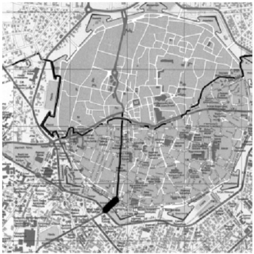
Fig 2.5 An aerial map of the walled city showing divided capital city (www.cyprus_city/maps)

Chapter 3 HISTORICAL EVOLUTION OF THE BUILT ENVIRONMENT AND ARCHITECTURAL CHARACTER OF THE WALLED CITY OF LEFKOSA
3.1 The historical process of the walled city of lefkosa
As defined in the introduction, historical buildings are old buildings, not built in present time, unique, have value, and endure time. The old walled city of Lefkosa is unique and full of history, this is evident in the built environment found in this unique settlement, documents and physical evidences shows the process of the development of the old and there remains today a cultural and aesthetic “eclecticism” which manifests itself in the rich variety of styles and influences apparent in the buildings which stand as the monolithic legacies of these different periods.
The historical environments of Lefkosa with many elements (social, economical, cultural, technological, aesthetical and religion) reflects the various features of the periods they were established (Karadaya, 2004, pp15-78).
Lefkosa is a unique city with distinctive physical environmental characteristics giving it a strategic significance through history. Its distinctive culture is a clear reflection of the periods of rule it passed through under different empires (Demi, 1990, pp5).
Lefkosa was settled in far more ancient times but the period of Roman colonization undoubtedly represents the most influential era of urban structure formation is concerned. The Byzantines who came after the Romans, ruled the island for the longest period, they built their castle in the most favourable position the land morphology could offer. This gave them an advantageous defense viewpoint which allowed them to have the best control of the cross roads of routes converging on Lefkosa (Demi, 1990, pp13). This selected spot was at the edge of the table land system coming from the south, at the point where the ancient river bed turned to the east. The location provided a better view of the route system from the lower plains leading up to the north mountain range pass, which was the only way to get to the Kyrenia harbor, the main coastal pole in the region.
The Byzantine world seemed to prefer the North – South direction to control Cyprus’ territorial system. This choice is understandable if we consider the island’s position in relation with that of Byzantium, the new eastern capital of the recently subdivided Roman territorial organism. Bearing this in mind, it is obvious that their defense system, created along the north coast (Saint Hilarion, Buffavento, and Kantara castles), aimed at keeping the main access route to the island under strong control. This entire defence system, not needed to the same degree during Roman times, is organized to protect the inland core, where the settlement of Lefkosa is chosen as the island capital, to host the functions of the previous Roman administration which focused instead on the coastal towns. Nicosia’s Byzantine castle was built as part of this defense system (Demi, 1990, pp15).
The position of the castle, historically proven is further confirmation of the second hypothesis made about the Roman castrum location (the same position of the town core during the middle ages). In fact a castle, by its very nature a sort of ‘anti – polarity’ to the town, could not have been built inside the existing urban settlement (as the first hypothesis would have it) but instead it was separated and independent from it, as its construction testifies. By this time the ancient castrum should have lost entirely its initial purpose as a military garrison, and been totally transformed into a small urban settlement, in line with its vocational purpose – with public buildings inside the demolished garrison fence and an expanded residential area all round it. The Byzantine castle’s ‘anti – urban’ character is also evident in a later reuse such as a castle by Knights Templar and as the Lusignan residence later on, during the first period of their kingdom and before the construction of the Royal palace inside the feudal town (Demi, 1990, pp15).
The latest fortified complex contained a monastery as well as churches located around it. Like the church called in Greek ‘Castelliotissa’, meaning ‘Madonna of the castle’ or ‘the Holy Virgin’, still stands today although parts of the building have been destroyed over the years. The name, which has also survived to this day, is an indication of the special function acquired by the area.

3.2 Lusignan period 1192 – 1489
The Lusignan family whom originates from France owned the island between 1192 and 1489. When the Lusignans took possession Cyprus was virtually destitute. However during the Lusignan period the island became the leading market for trade in silk, leather, spices, and the other exotic merchandize of the Near East. At the time of the Lusignans Lefkosa was the capital of the whole island (Mukaddas, 2004, pp170-1)
The town had presented an extremely articulated structure, consisting of public buildings (cathedrals, churches, archbishop palace, the chapter house, loggias and government palaces) as well as market, Cathedral Square and royal palace square and various types courtyard houses.
They built massive walls around Nicosia. It is argued that the city walls which probably functioned more as a bordering urban component than a fortification wall for defense had almost a rectangular slope (Numan, 1996, pp21). Lefkosa was three times larger than it is today and dominated by many buildings that have disappeared (Enlart, 1897, pp13).
However even as at present the two monumental cathedrals, the St. Sophia and St. Catherine completes the urban layout of the old city of Lefkosa. They were also built in the Lusignan period and the areas served the core of the whole settlement. The Lusignan royal palace was also constructed in the period (Luke, 2004, pp2).
The strong will of urban inner cohesion during the late medieval times led to the creation of a unitary circle of walls to defend and restrict what from now on was to be considered as civic space, in contrast to anything outside the walls- the non civic area, the country side (Demi, 1990, pp34).
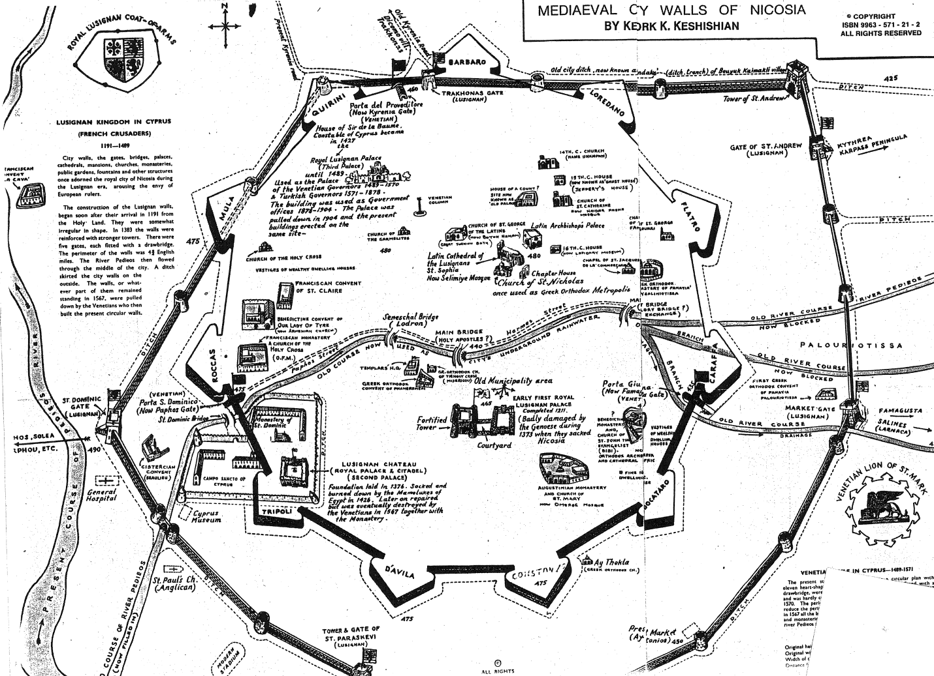
Fig 3.1 Diagram showing the Lusignan and Venetian walls overlapping each other (From the collection of the Antiquities department, Lefkosa)
Lusignan architecture is divided into several phases and detected four main stream of outside influence. The architecture is divided into the following periods: an early phase, which for some reasons he did not really count, associated with the first Lusignan years after 1192, and only to be found at the cathedral of St. Sophia at Lefkosa. This was influenced by French architecture of the second half of the twelfth century. The first measurable phase lasted from c. 1209 to c. 1280: this was inspired from Northern France, with up to date knowledge of decoration, but some archaic methods of construction. Phase two form the mid thirteenth century to c. 1350, was for Enlart the apogee of Cypriot Gothic; in this phase he detected influences from the Midi, Provence, and the Champagne region, in particular the church of St. Urbain at Troyes. During the third phase from c. 1360 onwards, the influence of the Midi, especially Provence, became more pronounced, but by the late fourteenth century a fourth phase had begun which lasted through the fifteenth. This according to Enlart was inferior both in style and workmanship; it contained a strong Catalan influence which then gave way to the impact of the Venetian Renaissance, but even here there was a strong mixture of Byzantine, Romanesque and Inferior Gothic (Enlart, 1897, pp5).
The Lusignan rule for about three centuries saw the beginning of urban development in Nicosia which greatly affected the architecture of the town (the French Gothic style important to the island was adjusted into a very particular local style) and its entire urban structure.
The Lusignan period gave a big boost to urban development given a functional articulation never seen before. It brought the way empty spaces among the byzantine religion poles were being organized through the application of an allotment system based on farming schemes and therefore still influenced by rural and urban structures a feature which did not last for long (Demi, 1990, pp24).
The introduction of tissue of some mature urban elements typical of a consolidated European feudal town more emphasized by the need to set up all of the states administrative functions and also provide suitable space to the various communities settled in the island (Armenians, Syrians, Italians, Jews, etc) which carried out a flourishing trade with the Near East.
Many areas within the town walls for sometime maintained a rural character, despite being part of an urban system. This applied both to the religious poles and to those belonging to important feudal families focusing on the Lusignan court. A building – farming allotment system similar in structure and functions to the Byzantine religious poles was used to fill those empty areas inside the existing tissue. The size of these allotments varied according to their position in the infrastructure network, and most probably also according to the socio – economic importance of the land owners (Demi, 1990, pp24).
More so, when discussing urban tissue one must take into account a very important component witnessed during Lusignan times; a sort of fenced neighborhood or urban entity built with the concept of the pole – courts in mind but forming a more complex system like an autonomous settlement within the town itself. During the Lusignan era we see the court yard house becoming a permanent feature in building types growing in size and diversifying in functionality. A first floor was added to the most important and ancient part of the building the one facing the south. This increase in dimensions of the courtyard – house is not a general characteristic of this type of construction, but is limited to important buildings and is related to the family of the owner and their privileged social status. Large court yard houses are those located within the centers of large estates along planned roads, and important urban axis or at main cross roads. All of them are built as tow story houses or acquire a second storey at a later stage visible in the continuity of construction techniques and the material used.
3.2.1 Architectural character of Lusignan period
The architectural character of Lusignan is mostly reflected on church buildings. The buildings used Gothic style architecture thought to be borrowed from France (Enlart, 1897, pp401). Its architectural character was mainly shown in its importation of French ecclesiastical style of 13th and 14th century (Given, 2005, pp406). In sighting the cathedral of Ayia Sophia (Selimiye Mosque) in Lefkosa, built by French clerics, masons, sculptors, and even some workmen (Enlart, 1897, pp82-6). The plan and most of the structure is what Gunnis called ‘the purest early French pointed style’, and the early 14th century west porch has its best parallels in Rheims cathedral (Gunnis, 1936, pp49). On the face of the building there would seem to be no doubt that the building was ethnically French (Enlart, 1897, pp125-7).
Lusignan period used stone as its major building material, this is seen on major Lusignan church buildings like the Ayia Sophia cathedral (Selimiye Mosque), St. Catherine (Haydar Pasha Mosque), the Bedestan all in Nicosia and the St. Peter and Paul church Sinan Pasha Mosque) in Famagusta. On the Ayia Sophia a specific feature seen is the three doors in the 14th century west porch are flanked by pair of niches with elaborately carved brachets and borders, too shallow to hold statues but possibly for paiting of saints (Enlart, 1897, pp117-8). This was copied on other churches and an example can be seen on the Bedestan which lies just south of Ayia Sophia. Gothic (and especially the pointed) arches was frequently used (Enlart, 1897, pp137). With this as a model, the flanking niches later worked their way into Cypriot vernacular architecture and were frequently used in Nicosia town houses of the late 19th and early 20th centuries both Turkish and Greek Cypriots ( Given, 2005, pp406).
Medieval domestic architecture in the kingdom of Cyprus cannot be strictly distinguished from religious architecture. On the one hand private chapels built on to Lefkosa cathedral has two windows in the style of a domestic building of the thirteenth century and same is probably true of the chapel at Prygra; on the other hand houses built in Lefkosa in the fourteenth and sixteenth century often have doorways and mullioned windows whose carved hood – moulds could well have adorned similar openings in churches. In Cyprus as in Spain and Italy straight external staircases are used, whereas in France where it is borrowed from both internal and external staircases are used indifferently.
Houses almost invariably have flat roofs, but in some rare cases steep roof which is an identity of the French Gothic buildings are reflected, an example is the St. Hilarion castle at kirenia.
Doors mostly have a semi circular arch without tympanum as seen in other Mediterrean islands and Spain. Their colonettes and voussoirs are moulded and carved. Windows of houses are different typed both arched and rectangular, sometimes with solid and also with opening work tympana and sometimes with cross bracing – they can be single or double. They have stone benches and there embrasures example of which are seen at the great hall at St. Hilarion and the upper room in the chapel added to St. Sophia at Nicosia (Enlart, 1897, pp377-8).
Another feature is small rectangular windows with no decorations except for a flatterned rib can be seen on the ground floors and top floors of many domestic building examples are seen on some houses in Lefkosa and the palace at Famagusta, this is also seen on buildings in France at that period.

3.3 Venetian period 1489 – 1570
Venetians view Cyprus as a last bastion against the Ottomans in the east Mediterranean and fortify the island, tearing down lovely buildings in Lefkosa to reduce the boundaries of the city within fortified walls. They also build impressive walls around Ammochostos which were considered at the time as works of art of military architecture. The presence of Venetians lasted for about a century (a relatively short time compared with the rest). “The Venetians constructed a perfect circular wall; three kilometers long with eleven unique bastions at regular intervals and three monumental gates. They demolished the built structure out of their proposed city walls and used their materials for the city wall (Mukaddas, 2004, pp172). From this a palmanova like town was born. Palmanova is a word used to describe a planned town built in the Renaissance by the Republic of Venice to defend the eastern border of their Italian mainland. This symbolizes the Renaissance ideal model of a totally planned new city. It was constructed not for the need of urban planning but the purpose of giving Lefkosa an immediate defense (Demi, 1990, pp,38).
For the Venetians, Cyprus was first and foremost a useful trading post and strategic military outpost in the battle to contain the encroaching Muslim holders, which everywhere threatened her overseas possession. Following that West-East axis became a commercial activity center and hosted urban facilities a continuous series of craftsmen and merchants workshops, bazaars, hostel, caravans, warehouses and stores. Today the Venetian walls are still standing around the city in a good form.

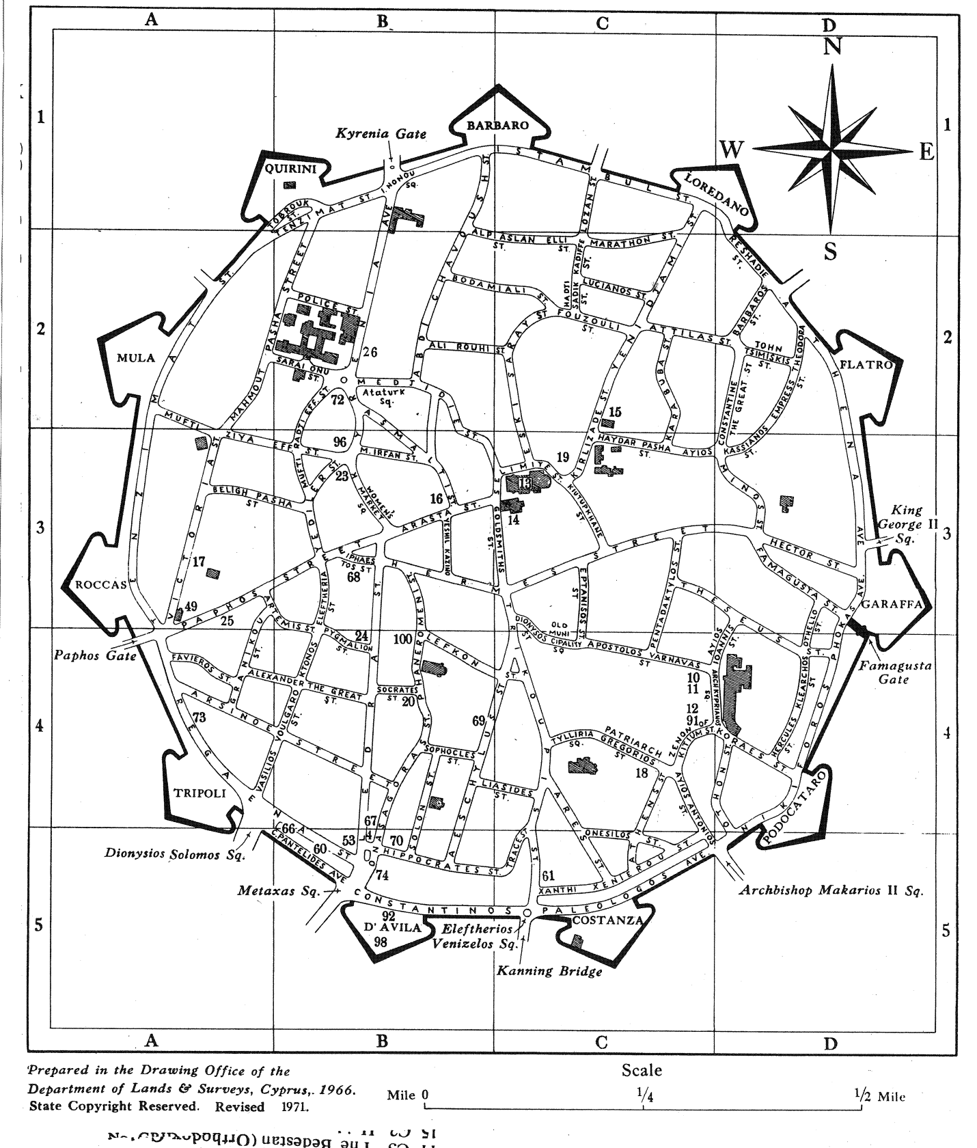
Fig 3.2 The Venetian walls showing the street pattern inside the walled city (From the collection of the Antiquities department, Lefkosa)
According to travelers and historians of that period, the urban area of Lefkosa inherited by the Venetians was much wider than the one which remained after the construction of the new walls. They in fact reduced the dimensions of the town to only one third of its original size, while part of the town outside the city walls was transformed for defense purposes into a completed cleared area all kind of buildings existing in the surrounding area before. This drastic intervention was also extended to the Lusignan walls, a nine mile circuit dividing the civic area from the countyside. It is therefore very difficult to determine the original location of these walls although their general outline can be interpreted from ancient cartographic representations – long, vertical, high walls before the so – called- gun powder revolution with multi – storey square towers at regular intervals some of which contained the town gates. It is suprising to find a further circle of defensive construction seen on some engravings showing the Ottoman siege of 1570 and clearly Medieval, located inside the recently built Venetian walls (Demi, 1990, pp38).
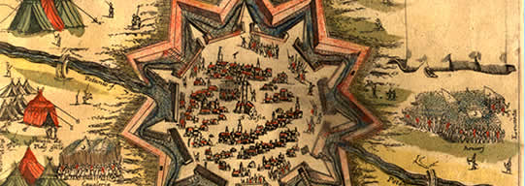
Fig 3.3 Picture of wood cut of Venetian fortress dated 1570 to the year when Turks attacked (Lonardo, 1978, pp68)
3.3.1 Architectural character of Venetian period
The architectural character of the Venetian period is that of Renaissance style (Perbillini, 1988, pp13). They bequeathed the island a handful of Renaissance. The few survivals include a two storey wing added to St. Mary’s church in the late 16th century, and three round arches from the imperative façade of the Prevveditore’s palace in Famagusta complete with Tuscan columns, their shafts taken from Roman Salamis (Enlart, 1897, pp468). Cut stone was the main building material.
However the most famous structure which regularly receives the epithet ‘Venetian’ consists of the city walls of Nicosia, built in the late 1560s in the face of an immenent Ottoman invasion. Although the earthen core of the walls was completed, only part of the stone facing had been done by the invasion in 1570 the upper half of the walls being faced with turf (Perbillini, 1988, pp37). The walls around the cities of Nicosia and a similar one at Famagusta are strong testament to the talent of their military engineers and architects. The Venetians erected huge earthworks with dressed stone facings, interspersed at intervals with bastions from which to direct their cannon power.
On buildings they used elements of Gothic style earlier with the following:
Elegant arches in Istrian stone, fine tracery, giving a lace-like appearance, pointed arches, carved window heads. However at the beginning of the 16th century they turned to Renaissance, often built in sandstone, and based on Classical Architecture with an emphasis on harmonious symmetry, typically included motifs from ancient Greece and Rome, fluted columns with, Corinthian capitals, semi-circular arches, bold projecting roof cornices, lavish stone carvings which none but the rich could afford, the wide use of Lion statues carved on buildings and a simplified court of arms (Wofflin, 1984).

3.4 Ottoman period 1571-1878
After the Venetians came the Ottomans. The Ottomans ruled the island for more than three centuries. The Ottomans adopted their architectural and urban characteristics to the city pattern. They did not demolish any previous architecture. They used the remains – footings or walls of the Lusignans and the Venetian buildings and constructed their architecture as well. In that period wide and straight street pattern diminished and became organic. Streets were defined by the building blocks and the garden walls. Ottoman expanded its commercial quarters along east to west axis. In Nicosia east to west urban axis invented by Venetians, but implemented by the Ottomans as a unifying infrastructure for the entire city (Mukaddas, 2004, pp173).
. From this period, apart from times of crisis and flourishing periods, Lefkosa would exercise a strong influence on the infrastructure and residential aspect of the town in order to transform itself into a modern capital city. As part of this goal, it saw the creation of new public structures, not just for state administration but also for the needs of the population; public baths for men and women, aqueducts to bring water into town, libraries and hostels, all in line with the new Ottoman habits and culture. Parallel to these innovations, pre existing buildings were transformed to serve better the requirements of the new society and its way of life (Demi, 1990, pp45).
The town’s commercial center and related facilities were concentrated along this axis, caravansaries, covered roads called ‘arasta’, open porticos with shops underneath and workshops and markets of various kinds. The most important cathedral (St. Sophia cathedral) in Lefkosa was converted into a mosque and its square was used as an open market area, while the nearby St. Nicholas orthodox cathedral became a covered market or Bedestan. The effect of economic crises due to shifting of the world’s commercial axis towards the western Mediterranean and Atlantic routes, this led the Ottomans to increase productivity level and thus importing labour. This population increase had very important repercussions on Lefkosa’s urban development, marked by several bursts of growth. The first period following the conquest of the island, characterized by a re use and completion of the urban structure already organized by the Venetians, was infact succeeded by several phases of intense urbanization with great building production, land allotment and therefore also further development of the types of buildings used (Demi, 1990, pp45).
3.4.1 Architectural character of the Ottoman period
The architectural character of Ottoman period is seen on buildings based on their types and purpose.
The religious buildings implored the use of domes mostly on square plans and multi columns. There were the balancing of the open and the closed part, a harmony between the interior and the exterior, addition of courtyard to the main mosque with a portico and the use of various attempts at the solution of problem of space (Godfrey, 1993)
Thus the Islamic architecture of Cyprus is all from the Ottoman period and is closely linked to the Ottoman architecture of Anatolia. There are, however, distinctive features in Cypriot Islamic architecture which may be traced to the fact that the Ottomans converted many of the existing Gothic buildings into mosques or palaces leaving the Greek Orthodox churches untouched. The most spectacular examples of this are the Selimiye Cami in Lefkosa and the Lala Mustafa Pasha Cami in Famagusta which are both converted Gothic cathedrals. The Selimiye in Nicosia was a thirteenth-century cathedral (Ayia Sofia) which was converted to a mosque in 1570 by removing the choir and altars and changing the arrangement of windows and doors so that the main entrance was from the north, At some later date a cylindrical Ottoman minaret was built on to the projecting corner buttresses (Given, 2005, pp407). The Lala Mustapha Mosque on Famagusta was built in the fourteenth century as the cathedral of St. Nicholas; it was badly damaged during the conquest of 1570 and converted into a mosque in 1571 after being stripped of all its internal decoration. Like the Selimiye, the Lala Mustapha Mosque had a minaret added to its west end at a later date. The same procedure was adopted with the Lusignan Palace which was converted into the governor's palace by the addition of a new Ottoman reception room (diwan). Some buildings were converted for different uses, thus the fourteenth-century church of St George of the Latins was converted into the Buyuk Hammam of Nicosia by adding an Ottoman-style porch with niches and thickening the walls.
On civil buildings they mainly used mud bricks; they usually have plans that are rectilinear in shape and contain rooms opening to the courtyard.
There are two fundamental elements forming the structure of an Ottoman house. These are the “rooms” and the “sofa”. The sofa is the feature which principally distinguishes the Ottoman from the European house. The position and form of the sofa is the determining factor in the evolution of different plan types. The role of the sofa in interior spatial organization is to connect and gather the rooms. In other words, it is the common area providing access between the various rooms. As well as providing a passageway inside the house, it also serves as a meeting ground and the space around the traffic area was adapted for seating (Stanley, 1993).
However on the exterior the three most obvious characteristics are broad eaves, the bay window and projecting kiosks, the projecting kiosks are usually distinctly made of wood.

3.5 British colonial period 1878 – 1960
One of the reasons behind Britain's occupation of Cyprus had been that it should constitute a base for safeguarding the newly opened Suez Canal. But military operations of 1882, led by Sir Garnet Wolseley, brought Egypt under the military control of Britain, and this meant that the strategic importance of Cyprus became substantially less. In the late Victorian and Edwardian period, Cyprus remained an anomaly. The island had not ceased to be part of the Ottoman Empire. According to the treaty, surplus revenues were paid to Turkey, so that there was no longer any question of the island being a money making concern for its administrators. On the contrary, after the annual payment was made to Turkey, expenditure was in excess of revenue (www.greenparadisehomes.com/history/BRITISH_RULE). However, the national income was boosted by British funds and the country benefited considerably. It is true to say that the British regime, though not disinterested, was the first one in the whole history of Cyprus to be in any way benevolent, and this is admitted by even the most fanatical anti-British factions which arose after the First World War. Much money was spent on trade, public works, a forestation, agriculture and antiquities. At the same time the island was not governed by consent or according to the expressed wish of the people (Chagalli, 1962, pp43-67). The British occupation was something which had occurred solely through the pressure of international politics. And the Greeks of Cyprus continued to look towards Greece, a country to which they considered themselves bound through race, language, religion and culture. The movement for Enosis, or union with Greece, was ardently fostered by the Greek Orthodox Church of Cyprus. The outbreak of war in 1914 brought a great change. When Turkey came in on the German side Britain annexed Cyprus, putting an end to the arrangement made in 1878. The island was now completely at the disposal of the United Kingdom (www.greenparadisehomes.com/history/BRITISH_RULE). This led to the British period being divided into British period 1 and British period 2.
During the first British period there were few changes on the urban level as they maintained the pre existing buildings, traditions and culture of the locals. On the revolutionary physical changes in the development of the walled city took place at the beginning of the British period (1880). New openings were cut on two sides of Kyrenia gate to ease traffic flow and some public buildings were built outside the walls encouraging the inhabitants to leave the walled city (Mukaddas, 2004, pp176).
However radial changes occurred in the architectural and urban identities of the city during the second British period. The British character became more evident as it became the dominant determining factor of architecture and the urban development. Consequently the new urban patterns and architectural elements developed in the walled city. In 1905, the ancient Lusignan palace dating back to the 14th century which served as Government house for Venetians and Turks afterwards was pulled down and a new block of office buildings was erected with British characteristics (Ghurkan, 1987, pp24).
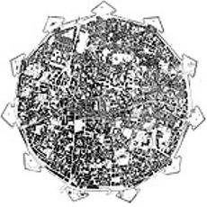
Fig 3.4 Plan of Lefkosa showing the growth and development of the walled city during the British Rule (Lonaro, 1978, pp337)

3.5.1 Architectural character during the British colonial period
This British colonial period was very harmful to former architectural and cultural assests of Lefkosa, this is because most of the historical buildings they inherited from previos were demolished in other to erase the traces of those periods. They developed an architectural character that can be said to combine a western classical architecture, a transformation of past period styles and an element of modernity. This led to a type of style referred to as the Greek revival style which is a mixture of Greek style and the Cypriot vernacular architecture. Its character included using imposing Ionic facades and verandas (Given, 2005, pp409). In the 1920’s and 1930’s saw a huge number of houses built with more or less schematic classical facades. They took the use of stone from the Lusignan and Venetian periods; also the Gothic pointed arches from Lusignan and used quoins on buildings. The Evkaf headquarters in Nicosia, built in 1928 has a façade broken by flat, schematic classical pilasters and moulding; added to that are large doorways set in Gothic pointed arches and flanked by Renaissance rusticated quoins (Keshishian, 1993, pp217). Another example of the period embracing changes and modernity is seen in 1946 when the British administration issued the street and buildings regulation which has been, and still remain the legal and administrative means of enrolling the physical development of Cyprus. Street widening under this law was also issued in 1946 and effected in the walled city. “Accordingly the continuous building lines were partially street widened without considering the historic organic historical tissue. The purpose of this regulation was to increase the capacity of the narrow streets in the walled city (Mukaddas, 2004, pp176). It is also important to note that the use of arcades as an architectural element in British colonial architecture was also very common.

3.6 The walled city survey of 1991
According to a survey that was carried out in 1991 showing the total number of buildings as 3182, this comprises of both historic and non historic buildings (Doratli, 2002, pp157). When considering the period of construction distribution of the buildings according to the period of construction, it is as follows:
Lusignan Period – 0.1%
The only remains from this period are several churches, and ground floors of several buildings which were rebuilt during Ottoman.
Venetia Period – 0.2%
Aside from the fortification similar to the previous period there are only few examples from Venetian period.
Ottoman Period – 7.8%
Although the number of buildings from this period is comparably smaller than later periods, the urban pattern which is developed during this period, which has been preserved until today, reflects traces of this period
British colonial period – period 1: 53.8%, period 2:23.4%
Others 14.7%
Vast majority of the buildings in the walled city today were built during the first British colonial period.

CHAPTER 4 EXPLORING THE MEANING AND ELEMENTS OF FAÇADE
4.0 Defining Monument and Civil building
A monument is a type of structure either explicitly created to commemorate a person or important event or which has become important to a social group as a part of their remembrance of past events. They are frequently used to improve the appearance of a city or location.
Functional structures made notable by their age, size or historic significance can also be regarded as monuments. This can happen because of great age and size, as in the case of the Great Wall of China, or because an event of great import occurred there such as the village of Oradour-sur-Glane in France. Many countries use Ancient monument or similar terms for the official designation of protected structures or archeological sites which may originally have been ordinary domestic houses or other buildings.
Monuments are also often designed to convey historical or political information. They can be used to reinforce the primacy of contemporary political power, such as the column of Trajan or the numerous statues of Lenin in the Soviet Union. They can be used to educate the populace about important events or figures from the past.
Monuments have been created for thousands of years, and they are often the most durable and famous symbols of ancient civilizations. The Egyptian Pyramids, the Greek Parthenon, and the Moai of Easter Island have become symbols of their civilizations. In more recent times, monumental structures such as the Statue of Liberty and Eiffel Tower have become iconic emblems of modern nation-states. The term monumentality relates to the symbolic status and physical presence of a monument.
From the 1991 survey about 2.3% of buildings at the old city of Lefkosa are monumental building (Doratli, 2002, pp157) the same survey could not provide an actual figure for civil buildings as they are not classified as civil buildings singly but adopted under different criteria that mixes them with other buildings that are not really of historic value.
A civil building is a dwelling that serves as living quarters for one or more families, in other words a civil building is another term used for describing a residential house. It is strictly residential as such that buildings such as schools, palaces and office buildings cannot be called civil buildings. A part from serving as residences, some civil buildings can also be of historical value just as the case in the walled city of Lefkosa. Historical civil buildings in the walled city have different style and geometry depending on the period of its construction. While very few still have the character of the original period when they were constructed, most of them appear to be changing over time as a result of undergoing transformations, whether they are transferred from one ethnic or social group to another, or whether they are keeping pace with social development over time (wordnet.princeton.edu/perl/webwn). However the same survey carried out in 1991 on the walled city’s buildings could not provide a figure for the number of civil buildings in the walled city.
4.1 Survey work and laying the analysis
A thorough survey as part of the research methodology was carried out on the historical buildings within the walled city. Due to size of the walled city the survey was carried on selected districts with the view of getting a knowledge of the various periods within which this settlement was developed. Thus efforts were made at surveying buildings to cover the historical period ranging from Lusignan to British colonial periods (the periods which constitutes for the erection and development of these buildings). The survey was mainly focused on civil buildings which is the focus of the thesis.
The survey was aided by an Architect and a conservator (Mrs. Ilkay Feridum) who was part of a much wider and detailed survey carried out in 1991 of the entire wall buildings in the walled city by the Antiquities Department which though not published as a report but documented. However during the cause of the physical survey some monumental buildings were also looked at so as to make reference with them during analyzing the selected civil buildings as they may share the same period of construction and thus have similar characteristics.
The survey work is a prelude to laying a ground for the analysis of the buildings with emphasis on their physical elements. It also important to note that during the course of this analysis it was realized that most of these buildings have lost their original character as a result of modifications and transformations from one period to another.
4.2 Method of choice taken for buildings analysed
During the cause of the survey work, quite a number of buildings were being looked at, it gave the opportunity to decide on which of the buildings are going to be part of the analysis. To much extends, a factor that played a vital role in choosing the four buildings is the fact over all the number of historical buildings over different periods in the walled city are not evenly distributed, that is to say while some historical periods like the Ottoman and British colonial periods are represented with a lot of buildings (this could be attributed to the fact that they are constructed during the later periods) when compared to the Lusignan and Venetian periods which are sparse (this could be because of the evidence showing most of these buildings were demolished by the later periods that came after them). More so, even in rare cases where civil buildings from these earlier periods are found they are realized to have been either modified or totally transformed leaving them with obvious elements of architectural character of later periods.
It is also important to note that as in the case of the Lusignan house (Lusignan Evi) which is one of the selected buildings to be analyzed, it is said to be one of only two civil buildings from this period in the walled city with the other one located on the Greek side of the walled city.
4.3 FAÇADE
A façade or façade is generally one side of the exterior of a building, especially the front, but also sometimes the sides and rear (www.alphadictionary.com). The word comes from the French language, literally meaning "frontage" or "face".
In architecture, the facade of a building is often the most important member from a design standpoint, as it sets the tone for the rest of the building. Many facades are historic, and local zoning regulations or other laws greatly restrict or even forbid their alteration.
The façade of a building is the countenance that a home offers to the outside world, demarcating the transition between the public and the private. In addition to being a crucial component in the delineation of an architectural style, a building’s façade also offers clues to the functions of the rooms behind it. The height of a façade and its proportional relationship to the roof are principle components of an architectural style. The façade and roof form should communicate the style of the building (www.hillsborough.net/planning/historical_design).
The composition of all facades of a building usually follows the principle of an architectural style. The balance and placement of openings on a façade communicates the building floor plan and the structural logic of the building (www.hillsborough.net/planning/historical_design).

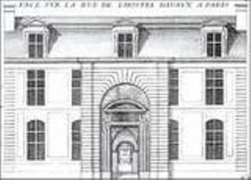
Fig 4.1 A Symmetrical façade (www.mahj.org/en/1_musee)

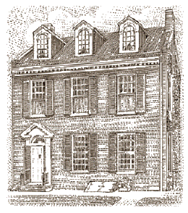
Fig 4.2 An asymmetrical façade (www.pdxhomes.com/architecture)

4.4 Elements of analysis of Façade
The façade elements are characteristics that make up the components of the façade (Pool, 1909, pp11-15). The façade characteristics are being grouped under symbolic and physical elements.
4.4.1 Symbolic Elements
The symbolic elements are those elements that are composed of special architectural features. These features are used to give the façade a unique appearance, also enhancing its aesthetics value. These symbolic elements vary from one particular style to another. For example the medieval architecture is known for the use of its trefoils on openings (Enlart, 1897, pp401). Symbolic elements are the motifs and other decorative elements.
4.4.1.1 Motif
A motif is a design or figure that consists of recurring shapes or colors, as in architecture or decoration. The motifs are used for ornamenting the buildings. This is done either on the exterior or the interior or even in both cases depending on the architectural style. For example Ottoman religious designs such as mosques, have motifs, this is a general characteristic of Islamic architecture regardless of the style. The motifs come in different forms, designs and patterns, ranging from flowers to inscriptions, and from one style to another. An example is seen on the Selimiye Mosque which is a masterpiece of Ottoman architecture. It’s uniquely identified by its use of cosmic motifs and elements like “mandala” and “the throne” in perfect harmony (www.muslimheritage.com).

4.4.1.2 Other Decorative elements
Decorative elements are a number of elements that can be used to communicate design style. These elements should be used as appropriate to a specific style, they include:
Pilasters; pilasters are vertical components of a façade that can be structural or applied to the façade. They can help to communicate a specific design style and can break a façade into smaller components. Pilasters do not belong on many styles and is not artificially applied (www.architecture.about.com).

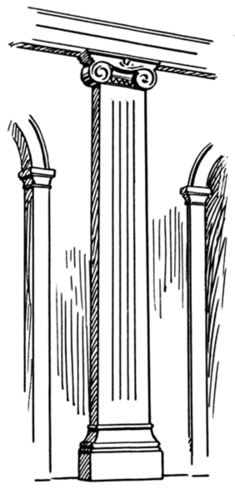
Fig 4.3 Pilaster (www.artscool.cfa.cmu.edu)

Belt course; a belt course or horizontal band, delineates the first floor of a building from the upper floor(s). It can be the transition line between differing façade materials. Its presence as well as its detailing is specific to a certain architectural style.

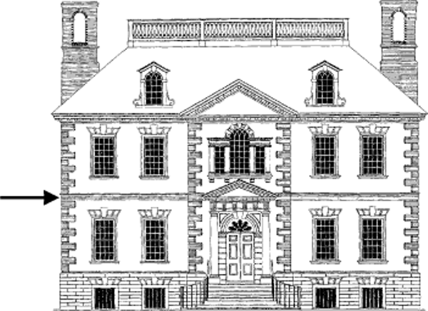
Fig 4.4 An arrow showing the belt course (www.historical_residence)

4.4.2 Physical elements
The physical elements are divided into geometric elements, functional elements and materials. Geometric elements are proportion, scale and dimensions.

4.4.2.1 Proportion
Proportion is the relation between elements and a whole. Proportion refers to the proper or harmonious relation of one part to another or to the whole (Doremus, 1994 p23). It is that something, indefinable to the unprofessional eye, which gives repose and distinction to a place or room: in its origin a matter of nice mathematical calculation, of scientific adjustment of voids and masses, but in its effects as intangible as that all pervading essence which the ancients called the soul (www.encarta.org/proportion)

“Proportion is a correspondence among the measures of the members of an entire work, and of the whole to a certain part selected as standard. From this result the principles of symmetry. Without symmetry and proportion there can be no principles in the design of any temple; that is, if there is no precise relation between its members as in the case of those of a well shaped man” (Vitruvius, 1960, pp3).
Proportion is the comparison of dimensions or distribution of forms. It is the relationship in scale between one element and another, or between a whole object and one of its parts. Differing proportions within a composition can relate to different kinds of balance or symmetry, and can help establish visual weight and depth. In the below examples, it can be seen how the smaller elements seem to recede into the background while the larger elements come to the front.
Fig 4.5 Shapes showing proportion

In architecture the whole is not just a building but the set and setting of the site. The things that make a building and its site "well shaped" include the orientation of the site and the buildings on it to the features of the grounds on which it is situated. Light, shade, wind, elevation, choice of materials, all should relate to a standard and say what is it that makes it what it is, and what is it that makes it not something else.
Architectural practice has often used proportional systems to generate or constrain the forms considered suitable for inclusion in a building. In almost every building tradition there is a system of mathematical relations which governs the relationships between aspects of the design. These systems of proportion are often quite simple; whole number ratios or easily constructed geometric shapes (such as the vesica piscis or the golden ratio).
Generally the goal of a proportional system is to produce a sense of coherence and harmony among the elements of a building.
Good Harmony Lack of Harmony
Fig 4.6 Demonstrating harmony within elements using shapes
Proportion is usually not even noticed until something is out of proportion. When the relative size of two elements being compared seems wrong or out of balance it is said to be "out of proportion". For example if a person has a head larger than their entire body, then it would say that they were out of proportion. However using some existing buildings, proportioning can be seen when taking into consideration any or all of the following:
- Height to width ratio of the façade of a specific building
- Proportion in sub masses of a façade
- Same proportion in window or typical façade element
Proportional analysis on the four houses is carried out using quotient points from a higher standing building structure to a simple house. The quotient system will be such it will be done on the height to width ratio, with a fractional value pointing to a higher building, while a whole number points to a simple house, the smaller the fraction the higher the building. For example a building with width to height ratio of 1:4, this means that the height of the building is four times higher than its width; it gives a quotient of 0.25. Using this classification system this shows it is a higher building, this indicates that the height to width dimension grows wider, while a quotient of as much as 1.0 leans towards a simple house and this means that the height to width dimension is same. The figure below demonstrate this with the use of solid shapes. The shapes represent buildings of different ratio in relation to its height to width.

A Square A Rectangle with the length longer
A Rectangle with the height longer
Fig 4.7 Proportion between the height and width of different dimensions
The figure shows the proportion between the height and width of different shapes which are assumed as houses of different heights and width.
The first case is a square with the height and width equal, the diagonal as can be seen gives the same angle on both sides proving they are same in dimension, thus assuming the height is 1, the width will also be 1 and the height to width proportion will be 1:1 which is equal to 1 and using the explained quotient system it gives a quotient of 1 and points to a simple house. If the angle is to be used it will be 45:45 which affirms the quotient 1.
In the second case the building is a rectangle with the length twice the height of the building, it can be seen here that the diagonal gives a bigger angle on the width, it gives an angle of 60:30 and this gives a quotient of 2 which is a simple building. The third case is same as the second case with the only difference being the height twice the length. Thus this case the angle gives a ratio of 30:60 which is 1:2 and gives a quotient of 0.5 pointing to a high rise building.
4.4.2.2 Scale
Scale can be defined as a consistency of relationship between the size of a building’s elements (windows, porches, entrances) with each other and with adjacent buildings, trees, etc., as perceived by a person from ground level. While proportion pertains to an ordered set of mathematical relationships among the dimensions of form or space, scale refers to how we perceive or judge something in relation to something else. (Francis, 1996, pp313-7)
Of particular interest to designers is the notion of visual scale, which refers not to the actual dimensions of things, but rather to how small or large something appears to be in relation to its normal size or to the size of other things in its context.
When we say something is small-scale or miniature, we usually mean that thing appears to be smaller than its usual size. Likewise something that is large scale is perceived as being larger than what is normal or expected. We speak of urban scale when we refer to the size of a project in the context of a city, or neighbourhood scale when we judge a building appropriate to its locale within a city, or street scale when we note the relative sizes of elements fronting a roadway.
At the scale of a building, all elements, no matter how plain or unimportant they may be, have a certain size. Its dimension may be predetermined by the manufacturer, or they may be selected by the designer from a range of choices. Nevertheless, we perceive the size of each element in relation to other parts or to the whole of a composition. For example, the size and proportion of windows in a building façade are visually related to one another as well as to the spaces between them and the overall dimension of the façade. If the windows are all of the same size and shape, they establish a scale relative to the size of the façade.
If however, one of the windows is larger than the others, it would create another scale within the composition of the façade. The jump in scale could indicate the size or significance of the space behind the window, or it could alter our perception of the size of the other windows or the overall dimension of the façade.
Many building elements have sizes and characteristics that are familiar and which is used to gauge the sizes of other elements around them. Such elements as residential window units and doorways help give us an idea of how large a building is and how many stories it has. Stairs and certain modular materials such as brick and concrete block, help measure the scale of a space. Because of their familiarity, these elements, if oversized can also be used to deliberately alter our perception of the size of a building form or space.
Some buildings have two or more scales operating simultaneously. For example the entrance portico of the library at the university of Virginia, modeled after the pantheon in Rome, is scaled to the overall building form, while the doorway and windows behind it are scaled to the size of the spaces within the building.
The recessed entry portals of Reims cathedral are scaled to the dimensions of the façade and can be seen and recognized at a distance as the entrances to the interior space of the church (www.NotreDamedeReims.com). As we get closer, however, we see that the actual entrances are really simple doors within the larger portals and are scaled to our dimensions, to a human scale.
However human scale in architecture is based on the dimensions and proportions of the human body. It should be noted that human dimension varies from individual to individual and should not be used as an absolute measuring device. We can, however gauge a space whose width is such that we can reach up and touch the ceiling plane overhead. Once we can no longer do these things, we must rely on visual rather than tactile clues to give us a sense of the scale of a space.
For these clues we can use elements that have human meaning and whose dimensions are related to the dimensions of our posture, pace, reach or grasp. Such elements as a table or chair, the riser and treads of a stairway, the sill of a window, and the lintel over a doorway, not only help us judge the size of a space but also give it a human scale.
While something that is monumental in scale makes us feel small in comparison, a space that is intimate in scale describes an environment in which we feel comfortable, in control or important. Intimate settings of tables and lounge chairs in a large hotel lobby tell us something about the expansiveness of the space as well as define comfortable, human scale areas within it. A stairway leading up to a second story balcony or loft can give us an idea of the vertical dimension of a room as well as suggest a human presence. A window in a blank wall conveys something about the space behind it and also leaves the impression that it is inhabited.
4.4.2.3 Dimension
Dimensions are the measure of a distance. It can also be defined as the magnitude of something in a particular direction (especially length or width or height).
4.4.3 Functional elements
The following are the elements that make up the functional elements of a façade:
- Walls
- Windows
- Doors
- Cantilevers
- Eaves
- Arches
- Columns
- Porches
- Railings

4.4.3.1 Wall
A wall is a usually solid structure that defines and sometimes protects an area. Most commonly, a wall delineates a building and supports its superstructure, separates space in buildings into rooms, or protects or delineates a space in the open air. Walls usually comes in different widths depending on the functions they serve, it also depends on the building material used as the thickness of a masonry wall is not the same with that of a mud wall.
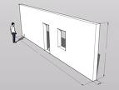
Fig 4.8 A wall (architecture.about.com/buildingparts/wall)
4.4.3.2 Window
A window is a transparent opening in a wall (or other solid and opaque surface) that allows the passage of light and, if not closed or sealed, air and sound. Windows are held in place by frames, which prevent them from collapsing in.
Windows usually comes in different types, from wooden windows to glazed ones, transparent windows to iron ones. Their type and material are determined by the type of building and what is it meant for. For example you hardly see glazed window on a historical building except in cases of modification, wood is mostly used in such cases unlike in modern buildings where wooden windows are seen as outdated, replaced by glazed and translucent windows.
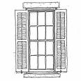
Fig 4.9 A window (www.pallensmith.com)
4.4.3.3 Door
A Door is a moveable barrier used to cover an opening. Doors are used widely and are found in walls or partitions of a building or space, furniture such as cupboards, cages, vehicles, and containers. A door can be opened to give access and closed more or less securely using a combination of latches and locks. Doors are nearly universal in buildings of all kinds, allowing passage between the inside and outside, and between internal rooms. When open, they admit ventilation and light.
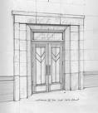
Fig 4.10 The door (www.architecture.about.com/buildingparts/door)
The door is used to control the physical atmosphere within a space by enclosing it, excluding air drafts, so that interiors may be more effectively heated or cooled. Doors are significant in preventing the spread of fire. They also act as a barrier to noise.
They are also used to screen areas of a building for aesthetic purposes, keeping formal and utility areas separate. Doors also have an aesthetic role in creating an impression of what lies beyond.
4.4.3.4 Cantilever
A cantilever is a beam supported on only one end. The beam carries the load to the support where it is resisted by moment and shear stress. Cantilever construction allows for overhanging structures without external bracing. Cantilevers can also be constructed with trusses or slabs.
This is in contrast to a simply supported beam such as those found in a post and lintel system. A simply supported beam is supported at both ends with loads applied between the supports.
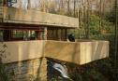
Fig 4.11 Frank Lloyd Wright’s Kaufman house showing its cantilever (www.architecture.about.com/buildingparts/cantilever)
4.4.3.5 Eave
An eave is the edge of a roof. Eaves usually project beyond the side of the building generally to provide weather protection. Some buildings, such as Craftsman bungalows, have very wide eaves with decorative brackets.
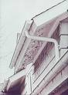
Fig 4.12 The eave of a building (www.architecture.about.com/od/buildingparts/eave)
The word eave can also refer to the lower part of a sloping roof which projects beyond the wall or the soffit.
4.4.3.6 Arches
Arched doors, windows or façade openings are used in many architectural styles. Facades of historical buildings are usually made of arch shape and proportion that is peculiar to a certain style or sometimes a mixture of different styles. Some of the common used arches are illustrated below:
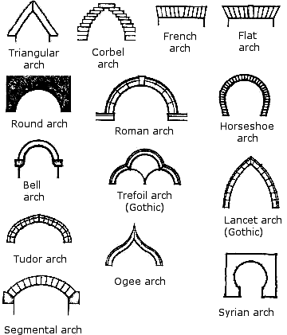
Fig 4.13 A sample of different types of aches (www.hadrians.com)
These arches are usually placed using a number of techniques that ensures proper placement on a façade including a common spring line for the arches and identical ratios for arched openings of different sizes. In developing a good composition, the use of arches is not overdone.

4.4.3.7 Columns
Columns are placed on facades of buildings usually as a means to support the roof of a porch. Columns have a number of properties that should be true to the architectural style of the building. These include height and width, column base, column top or capital, and the proportion of all of these elements together (www.historical houses_facade_composition).
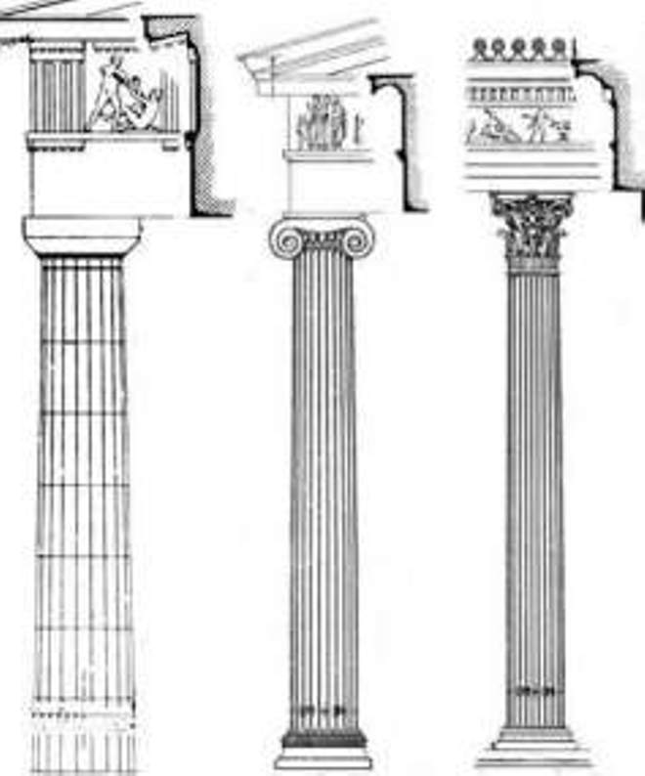
Fig 4.14 The Greek Orders: Doric, Ionic and Corinthian columns (www.atheism.about.com)

4.4.3.8 Porches
A porch is a transitional space on the building façade between the external and environments of the home. Porches although a significant feature of many architectural styles, its root in architecture is in places with weather conditions.
Porches are primarily of two forms. They are either inset into the primary mass of a building or built outside the main building as a separate volume that helps mediate the building mass consistent with the building’s architectural style. Porches usually follow basic principles of an architectural style, which is determined by an inset porch or external to primary massing, horizontal percentage of façade covered, and roof form over porch (Doremus, 1994, pp67).

4.4.3.9 Railings
Railings are used on porches, balconies, and upper level windows or door openings, they are usually carefully considered as a component of an architectural style. When properly applied, well designed and properly detailed railings are an opportunity to reinforce specific characteristics of the selected architectural style. The materials used for railings are usually part of an appropriate palette of materials for the architectural style of the building.

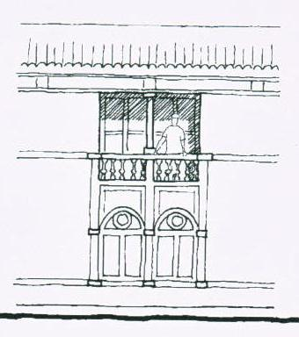
Fig 4.15 Railing (www.historical houses_facade_composition)

Building façades frames a street. In so doing, they put shops and architectural elements directly adjacent to the pedestrian’s path, and well within the street level cone of vision. As such, additional features and greater detailing of the façade are provided at the street level for the interest and comfort of the pedestrian. In addition, buildings should provide a visual, and perhaps structural, framework for the orderly presentation of street level businesses and shops. This sense of rhythm will both modulate and syncopate pedestrian travel along the street, providing discrete visual fields of focus. Modulate façades with breaks, setbacks, and other elements in building façades.
In general, if a street’s built environment is to remain of interest to the pedestrian, architectural forms and features need to be clear enough to make the whole building easily comprehensible. Within the close view the pedestrian has from the street, however, the provision of detail and the layering of its presentation is essential to invite repeated daily viewings from passersby. These standards are meant to encourage conservative building designs. Toward this end, overall façade proportions as well as the proportions of individual elements (doors, windows, columns, and moldings, belt courses, frieze panels, cornices, etc.) and the character and texture of materials will need to be considered.
Façade design should not be overly complicated or monotonous and should respect the functions of the area and the region. Designs reflecting traditional proportions and elements are encouraged. False façades typical of “themed buildings” are not acceptable.
4.4.4 Building Materials
Building material is any material which is used for a construction purpose. Many naturally occurring substances, such as clay, sand, wood and rocks, even twigs and leaves have been used to construct buildings. Apart from naturally occurring materials, many man-made products are in use, some more and some less synthetic. The manufacture of building materials is an established industry in many countries and the use of these materials is typically segmented into specific specialty trades, such as carpentry, plumbing, roofing and insulation work. This reference deals with habitats and structures including homes.
Mud, stone, and fibrous plants are the most basic building materials, aside from tents made of flexible materials such as cloth or skins. People all over the world have used these three materials together to create homes to suit their local weather conditions. In general stone and/or brush are used as basic structural components in these buildings, while mud is used to fill in the space between, acting as a type of concrete and insulation.
However in historical buildings the most common of building materials used are discussed below:
4.4.4.1 Wood
Wood is a very common building material used for buildings generally and especially for historical buildings. Wood is a relatively inexpensive, renewable, and versatile material that can be used for building structure, siding, roofing, and ornament.
Wood retains architectural features such as siding, cornices, brackets, window hoods, columns and verge boards. These are an essential pan of a building's character and appearance (Owen, 2001).
4.4.4.2 Brick and Masonry
Brick is a combination of cement, sand, and aggregate which is formed and oven fired to give it a hard exterior. Bricks come in many colors, textures, and sizes. It is a durable, low maintenance, and attractive building material. Mortar is a mix of cement, sand, water, and sometimes lime, which bonds the bricks together to form a wall. The "fired" surface of brick and solid mortar joints are what keeps water out of a masonry wall. It is therefore essential to prevent damage to the brick surface and to maintain the mortar joints.
Brick masonry retains original masonry and mortar whenever possible without the application of any surface treatment.
4.4.4.3 Stone
Humans from the early periods of antiquity recognized the need for their protection from the various meteorological phenomena (rains, snow, storms, floods etc), wild animals and raids of hostile tribes. As a result, they used the stones as primary building material, initially in natural form (rubble stone), i.e. as they are found in nature. Later on, humans started cutting and carving the stones (ashlar stone), thus this ashlar stone became the basic building material for most of the historical and traditional buildings. In all prehistoric and historic periods of Cyprus, the building stone that was used was extracted mainly from the surrounding environment of the settlements.
In the earliest periods of antiquity (prehistoric period), the buildings were constructed by rubble stones such as gravels and pebbles of various types and forms with or without mortar. In these structures, a wide range of sedimentary rocks such as chalks, reef limestone, calcarenite, silicified chalks (chert) along with igneous rocks (diabase, gabbro etc) was used.
The building and decorative stones excavated and used today in Cyprus (Cyprus Geological Survey, 2004) are:
- Gypsum
- Massive chalks
- Silicified chalks
- Chalks,
- Calcarenites
- Pebbles and gravels
- Diabase and reef and
- Other limestones

CHAPTER 5 ANALYSIS OF SELECTED HISTORICAL HOUSES

In this chapter four historical houses were selected, and they are analysed thus:
5.1 Lusignan House
This mansion dates from the 15th century, and is a well preserved example of Lusignan architecture. Its Gothic arched main entrance and the Lusignan coats of arms above it are magnificent. During the Ottoman period, decorated wooden ceilings were added.
The mansion has a typical inner courtyard of the period. It is two storied, and built from cut stone. Additions during the Ottoman period were made from lath and plaster.
The upstairs rooms and wooden veranda are reached from the ground floor round-stone pillared veranda by stone stairs. On the east side of the rectangular courtyard are the remains of stone arches. These have been filled in, which lead us to believe that the building was once extended in that direction.
Records show that in the 1870s a Turkish Family was using the mansion. In 1958, a Russian family who had been using the building as a residence and weaving workshop, bequeathed it to the Cyprus Government.
After the troubles of the 1960s, the building was partitioned and used to house refugees. By the late 1980's, however, the building was empty. After renovation, the house was opened to the public in 1997. The house has been furnished with authentic furniture from the Ottoman and Lusignan periods.
5.1.1 Symbolic Elements
The Lusignans unlike later periods did not really use symbolic decorations on civil buildings. They mainly decorated the monumental buildings which are mostly cathedrals (Enlart, 1897, pp391). As a result the Lusignan house originally did not have very obvious symbolic elements. The decoration on its entrance which is symbolic is a designed element which documents could not trace any meaning to it. The decorations on the interior of this house are additions during the Ottoman. These are mainly ceiling decorations made from wood.

The door is a large doorway; on the door is a shield surrounded by the collar of an order immediately above the finial and above that a moulding which forms a sort of small square hood mould.
The collar consists of a string of florets and the shield is suspended by a strap. To the left and right of the finial at a small distance are two blocks each carved into smaller shields, suspended by two straps (Enlart, 1897, pp406).
5.1.2 Physical Elements
The Lusignan house is a rectangular building whose proportion can be looked at differently. Looking it as a single building as it originally is, its width to height ratio is around 3:1, this when using the quotient system described earlier in chapter two when talking about proportion, it gives a quotient value of 3 which points to a simple house, which it actually is.

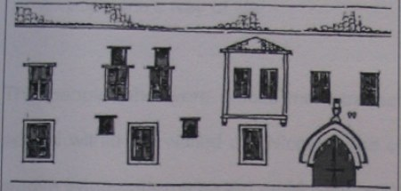
A
Fig 5.1 The height to length ration of the building as a whole (Hifsiye, 2002, pp87)
However the same building when looked at Fig 5.2 shows the same building when partitioned into three segments could appear different from the first case we saw.

a b c
Fig 5.2 The height to width ratio of different segments within the building (Hifsiye, 2002, pp87)

It is divided into ax, bx, and cx, with x taken as the height of the building. Part ax’s width to height ratio is about 1.5:1 with the width just a bit more than the height in terms of height, its quotient value is 1.5 and this points to a simple house.
Taking the case of bx the width to height ratio is obviously different; it appears 1:3 in this case giving a quotient value of 0.34, this gives a value for a higher building.
The segment cx has a width to height ratio of 1:2; this gives a quotient of 0.5 which is a higher building.
The building’s scale is of a historical house with a human scale. The two storeyed building has openings that are of same scale; however the building is located where its historical pattern is distorted with some modern buildings erected of concrete. This affects the unity and harmony of the building with its surrounding elements.
The total dimension of the Lusignan house is 23.8meters in length and 10.8meters wide. This however does not add to the courtyard area of the building, which appears more as a demarcation than an integral part of the Lusignan house.
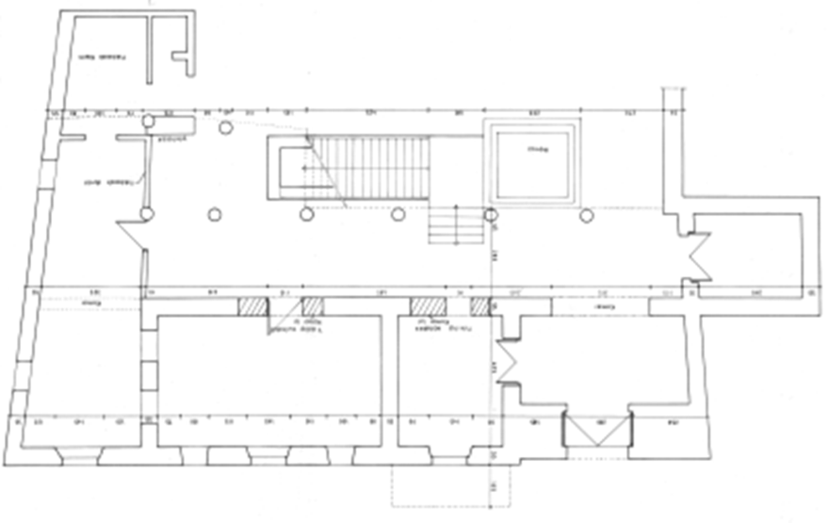
Fig 5.3 The floor plan drawing with width of 28.3 and length 10.8meters without the courtyard area

5.1.3 Functional elements
The thickness of the walls is of two types, the area entrance wall which holds the entrance door is 1.5meters thick. The thickness of this wall is thought to be because of its strategic location as the entrance and thus the main source of protection (Enlart, 1897, pp407). The other walls of this building including the partition walls are 0.55meters thick, they are all stone walls.
The windows of the building are of two types. The main windows are the large ones measuring 1.25meters in width and 2meters in height; they are single fold wooden windows in wooden frames. The smaller ones which serve the purpose of lighting are 0.8meters in width and 1.1 meters in height, they are five in number with two on the ground floor and three on the first floor. The two on the ground floor are believed to be originally designed when building the house, the three on the first floor are recent additions during restoration carried out in 1996 (Bagiskan, 2005, pp367). They are copied from the ones on the ground floor but are a bit thinner in width and taller in height than the original ones. This is in fact the latest transformation this building has gone through. The likely original windows found on this building also have folds; they may not be as wide as they are presently but with wood designs covering the whole opening as seen in Fig 5.4 which is an old Lusignan house found on the east of Ayia Sophia (Selimiye Mosque). (Plate 5)
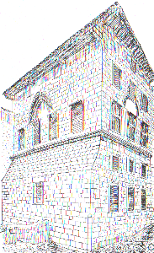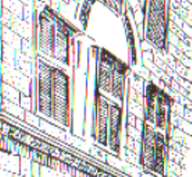
Fig 5.4 Original Lusignan windows on the first floor and house east of Ayia Sophia (Enlart, 1897, pp407)
On the front façade there is a single door. This is the entrance door which is an original gothic styled (Lusignan period) character (Enlart, 1897, pp407). This is similar to a curved decoration seen on a ruined house between Ayia Sophia and Augustinian house which is a confirmed Lusignan building. (Plate 8)
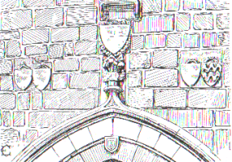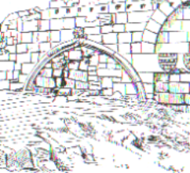
Details of the doorway of the Lusignan house A similar design on a Lusignan building close to Selimiye mosque
Fig 5.5 The design on the doorway of the Lusignan house in comparison to a Lusignan building dating back to 16th century (Enlart, 1897, pp407)

The entrance has a pointed arch labeled as the finest of the door entrances of Lusignan period in the walled city. On the door there is a shield surrounded by collar of an order immediately above the finial and above that a moulding which forms a sort of small, square load mould. The device has been obliterated but it was certainly quartered because two cross lines, barely, divisible, divide it into four. The collar consists of a string of florets and the shield is suspended by a strap (Enlart, 1897, pp402). The door entrance measures 2.1meters in length and 2.0 meters in height. Plate 1 showing present state of the door
The façade of the building does not have columns, (as can be seen from plate 15) it is made up of walls, openings and the (Ottoman) cantilever.
The columns found on the building are on the rear façade o the building which has eight circular columns of the same size. Six are fee standing holding the timber floor of the first floor and the other two supporting the partitioned room at the extreme right of the building. The columns are 0.45meters in diameter and made from stone.
The only arch found on the front façade of the building is the described Gothic pointed arch at the entrance of the building. Its originality is further supported by the entrance arch of the Lapidary meseum which is also believed to be constructed in medieval times (Caroe, 1993, pp51). Plates 8 and 18 shows the Lusignan house and the Lapidary museum doors respectively.
On the façade of the building there is a cantilever on the first floor. The cantilever is a later addition by the Ottomans (plate 7). The cantilver called “Cumba” is a distinct element in Ottoman architecture. It is made from lath, timber and plaster (Ghurkan, 1987, pp24). It is believed to have been added during the Ottoman period. The addition of such a structurally heavy room can lead us to suppose that in the past this part of the house had windows, which were more easily replaceable without the static problem which a solid masonry wall might have (Demi, 1990, pp43).
This theory can be supported using an old house in Lefkosa as example. The house with a mixture of Renaissance and Medieval character, believed to be constructed in the second part of the 15th century (Enlart, 1897, pp405). This building up till date has never been transformed (Demi, 1990, pp43), Renaissance double-mullion windows can be seen on the first floor, should the building undergo transformation, the mullion windows can be easily removed and replaced with the cantilever with the use of the structural support used for the existing windows.
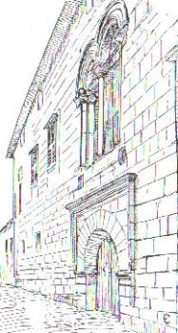
Fig 5.6 The house with mullioned windows (Enlart, 1897, pp409)
During the latest restoration on this building carried out in 1996, the cantilever was completely removed and replaced (plates 9 and 10). From the closest to original period till present state, the building does not have long eaves. The eaves are short, most likely only for drainage purpose. On the house east of Ayia Sophia (Selimiye Mosque), attempt was made at using long eaves.
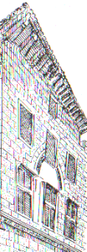
Fig 5.7 Long roof eaves of house east of Ayia Sophia (Chapter house)
They did not like the appearance and so they stuck with the famous short eaves (Caroe, 1993, pp49). The building despite its different phases of transformation with the roof changed over time but the eave was never extended.
However, the Ottoman cantilever has a long eave which is a common feature associated with the cantilever, it serves the multiple purpose of aesthetics and shading device for the window below the eave. Plates 7 and 16 shows the similarities between the cantilever on the Lusignan house and the one on the Arch Bishop palace west of Selimiya mosque (Ayia Sophia cathedral)
The Lusignan house does not have a porch or railings; it only has an entrance foyer.
5.1.4 Building material
In building the Lusignan house originally, stone was primarily used. This at the time was the main building material used for construction; evidence can be seen on the few Lusignan buildings found to date in the walled city. These include monumental buildings such as the Selimiye mosque (Ayia Sophia cathedral), as well as civil buildings such as the Arch Bishop’s house west of Selimiye mosque and the chapter house. However later additions by the Ottoman’s on this building led to the use of wood, mud, lath and plaster (plate 10).

5.2 The Venetian house (Lapidary Museum)
This is a museum of stone fragments taken from the demolition of ancient buildings. It is situated a few hundred yards from the Selimiye mosque (St. Sophia) and the building is believed to be a Venetian house or could be a renovated mediaeval building. Seen on the building are pieces of stone work taken from ancient palaces and Gothic churches. Recently it has been re-arranged by the Department of Antiquities. The outstanding exhibit is a magnificent Gothic window from a Lusignan palace demolished by the British colonial masters (Ghurkan, 1987, pp11-24). It is shown in fig. 16. This kind of flowing tracery is known as the flamboyant style, and was in common use in the French cathedrals of the 15th century (Enlart, 1897, pp399). Mediaeval stone masons were employed by the church usually on a full time basis and they often lampooned bishops, priests, friars and fellow workmen in their stone carving. Notice the stone faces on the left and right side of this window; very often they would represent the reigning king and queen.
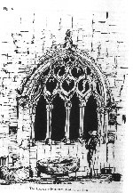
Fig 5.8 The Large Gothic window in lapidary museum, originally from Lusignan palace (www.stwing.upenn.edu)
The water spout of a cathedral is known as the gargoyle and is the throat into which the roof water pours. The sculptors enjoyed themselves in making gargoyles in the form of monsters, demons or some local character. Of all places in a cathedral, the gargoyle got the worst of the weather, so that after several hundred years their stone figures became even more grotesque. In the centre of the courtyard is a large marble carving of the Lion of St. Mark, the main symbol of
Venetian rule which is so often seen on the walls of Famagusta and Kyrenia castle. Many other fragments are lying around, all taken from demolished buildings and it is a reminder that 14th century Nicosia was resplendent with palaces and churches.
During British colonial rule, many interesting works of stone and marble were housed in this museum, which in those days was known as the Jeffrey Museum. These architectural pieces included insignias, tombs and columns which had accumulated from medieval times. The Turkish name for this museum is TAS ESERLER MÜZESÌ, or museum of ancient stones. It is also known to tourists as the Lapidary museum.

5.2.1 Symbolic elements
The motifs found on the Lapidary museum (Venetia House) are the Venetian coats of Arms and statues, notably the Lion of St. Mark. The coat of Arms on this building is made up of three eagles signifying noble nature, strength, bravery and alertness (Perbillini, 1988, pp9).
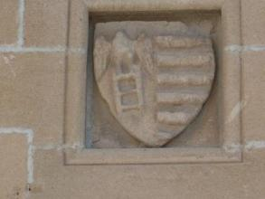
Fig 5.9 Coat of Arms on the Lapidary museum
The lion statue which is found on several places on the building and on some other Venetian buildings in the walled city with some showing only the head while others showing the Lion fully, the statue is called the Lion of St. Mark. Attempts at tracing the history of the significance of the Lion of St. Mark could not give a definitive reason, however in the process this theory was quoted.
On 9th May AD 1000, it was Ascension day. The Doge heard mass in the cathedral of St. Pietro Di Castello, and received from the Bishop of Ohvolo a consecrated standard, this banner bore the first time the now familiar Venetian emblem of the Lion with open book in its pairs. It is to be named the Lion of St. Mark from St. Mark’s association with Venice (www.crwflags.com/FOTW).
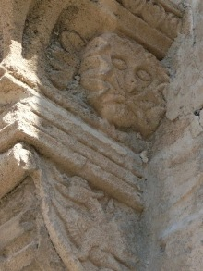
Fig 5.10 The Lion of St. Mark on Venetian buildings

5.2.2 Physical Elements
Despite its transformation from the original form looks in coherent proportion within its elements. This could have been assisted with its symmetry. The Gothic entrance and the windows above it on the first floor are proportional; however this is not its original state as seen in fig 5.11
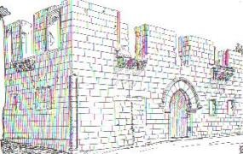
Fig 5.11 The Lapidary meseum mutilated as seen in the 18th century (Enlart, 1897, pp402)
Its cause of mutilation could not be ascertained; theories suggest it is most likely as a result of change from one period to the other. Drapper writing in 1702 reports that the Turks since they became masters of the city pulled some of the palaces and beautiful houses to pieces in the hope of finding some hidden treasure or at least selling the stones and other materials for use in some other buildings (Enlart, 1897, pp402).
Fig 3.49 shows the building without the roof, the Venetian court of arms, and the windows on the first floor are not in place, the figure though affirms their originality. It is described to have been built in the second half of the 15th century, this evidence casts doubt on it being a Venetian building, this is because Lusignan was reigning in the beginning of the second half of the 15th century, thus since the precise period was not mentioned it could have been built before the Venetians took over in 1489. Another evidence that questions it being Venetian is that in the same fig 3.49 Venetian characters such as the Venetian coat of arms and the Lion of St. Mark could not be seen.
However, distinct characters that gives the building Venetian identity is its Renaissance identity, from its symmetric appearance, to good proportioning between the openings (the windows and the entrance door), to the bracket decoration at the base of the window of the first floor. The Venetian coat of arms and the Lion of St. Marks found on the building is evidence that even if it is not originally Venetian it had indeed being the residence of a representative of the Venetian republic (Enlart, 1897, pp391).
Overall the width to height ratio of the building is about 2:1, referring to the proportioning system; it gives a quotient of 2 which points to a simple house.
The Lapidary museum is to human scale, there are two window types seen from the sketch on Fig 3.49, two on the first floor and two smaller ones on the ground floor which appear to have been built initially but blocked later, the proportion of the small windows on the ground floor to the large ones on the first floor is 1:4. The blocked small windows give the impression that they could have been used to ventilate a portioned area from the entrance on the left side of the building. Also to the right of the building appears a large blocked entrance placed directly under the first floor window, this gives an assumption that the Gothic entrance might possibly not have been the original entrance to the building.
Lapidary museum has a symmetrical balance with the weight equally distributed on both sides of the central axis (which is the center of the arched entrance). It creates a secure, safe feeling and a sense of solidity.
The Lapidary museum is in 12.6meters in length, 16.3meters wide (including the courtyard), and 6.0 meters high.
5.2.3 Functional Elements
The walls of the building are 0.50meters thick made of stone, this is very similar to the Lusignan house walls and can also be seen as an argument that they are buildings of the same period. However the Lapidary museum unlike the Lusignan house does not have partitions on the inside and thus the continuity of the wall thickness could not be observed.
As already pointed out, the windows of this building are two types. The windows on the first floor and the smaller blocked ones on the ground floor are rectangular and of medium size are decorated with a plain bead moulding round the edges, those on the first floor have also a deep sill carried on brackets, forming a kind of small, unbalustraded balcony. The brackets have volutes of a Renaissance type; their lateral faces are carved with grosteque figurines in low relief in a rather coarse Italian style (Enlart, 1897, pp405). Comparing this building’s character to the Augustinian which is also thought to have been built in the second half of the 15th century, they are both two storeyed building both have two windows on the first floor, both sets of windows are carried on Renaissance brackets, this leads to the assumption that the windows on the first floor of the Lapidary museum most have had pediments above them like those of the Augustinian building where the bases are of the same design.
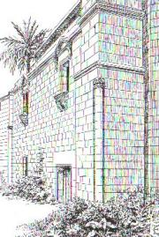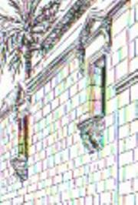
Augustinian building windows on the Augustinian building
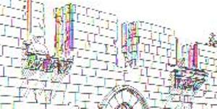
Mutilated windows of the Lapidary museum in 17th century (Enlart, 1897, pp402)
Fig 5.12 Similarities between the Lapidary museum window and Augustinian
The present state shows the window designed with wood and glass and held between mullions and transoms (plate17). A special window worth mentioning is the Gothic window with trefoils on it believed to have been originally from the Lusignan palace and transferred to the Lapidary museum by the British after they destroyed the Lusignan place (Ghurkan, 1987, pp14). This window can be seen on the façade once the entrance door is open (plate 18).
The entrance to the building is a pointed doorway under a hood mould, the arch being entirely plain resembles houses in Catalonia, Aragon and Sicily (Enlart, 1897, pp405). It measures 1.5meters in length and 2.1meters high. This entrance is similar to that on the Lusignan house, with its arch and capping very much Gothic. This entrance however may not be original as left to it is what must have been a large rectangular door. The stone used in covering this opening could not hide the lintel, a further proof of it being a door. This supposed blocked door entrance also looks similar to the entrance door on the Augustinian building.
To the extreme on the left of the building is a single column which extends only on the ground floor, this circular column is made of stone and looks more to be serving the purpose of aesthetics more than functionality. Same types of columns are seen on the Augustinian building.
The only arch found on this building is the one on the entrance, other functional elements such as cantilevers, eaves, porch and railings appear to be nonexistent. It is of importance to note that at a point during various periods of transforming this building, the windows on the first floor had iron railings round them on the bracket forming a balustered balcony (plate 25).
5.2.4 Building material
The lapidary museum just like the Lusignan house is built in cut stone, this being the building material used by both Lusignans and Venetians. Some examples of other Venetian buildings where stone was used in construction are the Augustinian building and the city walls itself.

5.3 The Sacakli Ev (Eaved House)
The Eaved House is situated to the south of the Sultan Mahmut Library in the Selimiye district of the old walled city. This L-shaped two storey building encloses a square inner courtyard and is named from the large eaves, supported by pillars, of the main reception hall hanging over the street.
Although the construction date is not known with any certainty, evidence based on traces found on the front facade, and the Gothic arch discovered in the ground floor arched gallery during renovations, indicate that the date of construction stretches back to the middle ages.
The house which was further developed during the Ottoman period bears features of Ottoman residential architecture as far as planning, construction techniques and building materials are concerned.
The house went through major repairs in 1932, and the main door, and large window with the stone frame on the front facade date back to this time.
The house has three rooms on each floor, access to the first floor being by a steep wooden staircase situated in the arched gallery. The main reception room on the first floor was constructed using timber-frame techniques, while the other rooms were built with stone and mud-bricks.
Over time, the rooms on the ground floor were converted into shops with individual entrances to the front. However because of bad construction techniques, over time the main reception hall began to subside towards the inner courtyard.
In 1986, the building was nationalized by the Department of Antiquities and museums, and renovations took place between 1994 and 1996. In order to restore the original features of the house, more recent extensions were demolished and removed.
The Eaved House has been renovated to serve as a Cultural and Arts Centre where people and institutions involved with culture and art can display artwork, organise meetings, conferences and other similar activities.
5.3.1 Symbolic Elements
On the façade, the Sacakli Ev does not have symbolic elements, this is not surprising because Ottoman architecture mostly use symbolic elements on religious buildings such as Mosques, Tekkes and Khans. In most cases town houses have this symbolic elements on the interior ranging from designed ceiling finishing’s to carvings.
The Sacakli is a typical Ottoman house. Seen on it are elements of a Turkish house which includes having entrances opening to a hall, and a steep staircase, however on the faced the most obvious characteristics of Ottoman domestic architecture are the broad eaves and the projecting kiosk called the Cumba in Turkish (Given, 2005, pp408). These elements as will be analysed are both obvious on the Sacakli Ev.
Other decorative elements seen on this house is the belt course separating the ground floor from the first floor. The belt course is made of yellow stone and is about 0.25meters in thickness. It runs through the entire façade (plate 39).
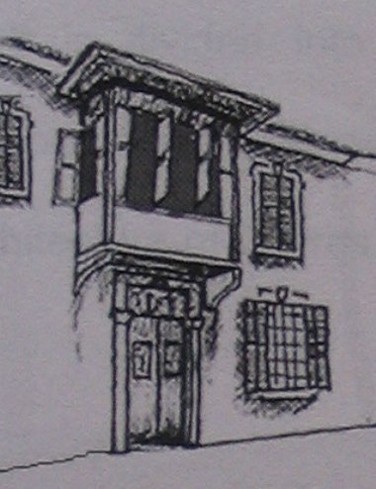
Fig 5.13 The Ottoman Cantilever and broad eaves (Hifsiye, 2002, pp75)

5.3.2 Physical Elements
The Sacakli is a historical Ottoman building with human scale. It is a two storeyed asymetrical building whose proportion can be looked at from different points of view on the front façade
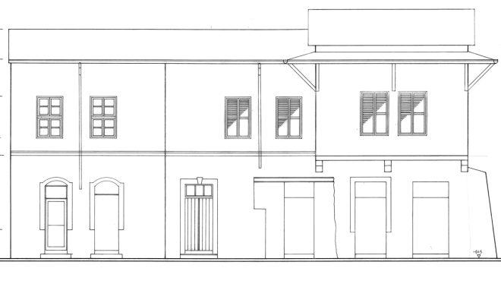
a b c
Fig 5.14 The proportion within different segments of the Sacakli Ev

A
Fig 5.15 The proportion showing the width to height ratio of the Sacakli Ev
From the figures above the proportion of the Sacakli Ev can be seen clearer. The figure is from the survey drawings carried out before its latest restoration in 2003. It should be noted that the survey drawings is used for analyzing the proportion because elements like its height and length are not affected by the restoration, the only changes being on the openings. In fig 5.14 the proportion of the building divided into the three segments as seen on the façade. Segment a is the extreme end to the left which is a bit tilted at an angle. It stretches from the beginning of the building on the left to the end of the tilted area which is just before the only entrance door presently, this segment as seen on the old survey drawing shows the height to width proportion at about 1:2 with the diagonal dividing it to a 30:60. This part on the old survey drawings two small doors on the ground floor and two windows on the first floor, at present it has the two small doors converted to windows and the windows on the first floor retained.
Segment b is the middle part of the front façade; it is the point from the end of the tilted area through the present entrance door stretching to where the Cumba (cantilever) starts. This segment is almost same with a giving 1:2 with the diagonal giving 30:60 degrees. This part at present has the entrance door on the ground floor, the door next to it turned to a window, and the two windows on the first floor retained. Segment c covers the cantilever area, it has two ground floor doors and two windows on the cantilever. The segments diagonal cuts a tighter angle than the 30-60 degrees cut on the previous two segments, the proportion tends more towards 1:2.5, and this when made reference to the quotient system gives a quotient of 0.4 thus pointing to a higher building.
Fig 5.15 shows the proportion for the whole building, the diagonal gives a height to width ratio of 1:2 with angles like segments a and b, and this as does a and b gives quotient of 0.5 which is not a simple house and pointing towards a high building.
Its present state points more towards a historically styled building than a historical building. This is because it is transformed to an extent that almost the whole building is replaced from the original one. Some old pictures obtained shows complete changes incorporated. This includes the Cumba (cantilever), the roof, the doors on the front façade, and the wide pointed arches found on the courtyard façade.
The Cumba in exhibiting an Ottoman character also shows emphasis which is an element associated with proportion. Emphasis is achieved on the Sacakli Ev with the Cumba and its long eaves a center of interest or the focal point of the building. The Cumba area is the most dominant part of the building visually with all other areas contributing but subordinate. It stands out from the rest of the façade with its protrusion.

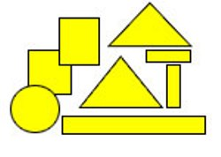 | 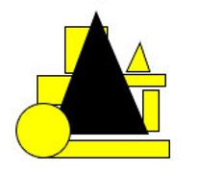
Without emphasis With emphasis
Fig 5.16 Arrangement of shapes demonstrating the phenomenon of emphasis

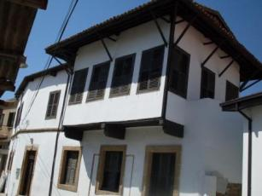
Fig 5.17 Showing the Cumba as the most visually dominant part of the Sacakli Ev
However in relation to the surrounding the Sacakli Ev lacks harmony, this can be seen with the building sandwiched between a recently completed single storey building and a detached modern higher building that is to urban scale.
It should be noted that the total dimension of the front faced is 20.75 meters, with the tilted part from the left part covering 6.6meters, while the remaining façade measuring 14.15meters.

5.3.3 Functional Elements
The walls of the front façade is 0.60meters thick, this thickness is the case with most Ottoman buildings as mud is the building material, it is important to note that in the interior 0.30 meter walls are used for the partition.
On the front façade there are thirteen windows, five of these windows are on the ground floor with the remaining eight on the first floor. All except two of these windows are same in dimension; the other two are same in dimension and were originally small doors on the extreme left of the building. They measure 0.95meters in width and 1.8meters in height. The other eleven windows are 1.2meters wide and 1.8meters high. The windows are made of wood with a single fold on wooden frame. This window type is a transformation of the original Ottoman windows which have two folds. On the windows on the ground floor are stone decorations on the edges, they measure 0.2meters in thickness. This with the single fold windows are British colonial period character.
The only door on the front façade is the entrance door (plate 29). It is 1.4meters long and 2.4meters high, it is a wooden double door opening inwards and has stone decorations similar to the ones on the ground floor windows; these decorations are on the edges of the door. Also on the entrance door is boldly written 1932 (plate 30), this is believed to be the period when the British colonial era carried out restoration on the Sacakli Ev after taking over from the Ottomans.
The only cantilever on the Sacakli Ev is the earlier described Cumba. It extends about 1meter outwards and is 6.8meters wide. It is built on wooden base with lath and plaster (plate 37). The Cumba area is the reception room. It has the longest eaves on the building which is about 0.9meters long. The eave length of the other areas on the façade is about 0.5meters.
The Sacakli Ev’s front façade does not have columns, arches, porch and railings.

5.3.4 Building material
The Sacakil Ev was built with mud, wood, lath and plaster. The building walls were constructed with mud which is the primary building material used by the Ottomans during their reign. Wood was used for constructing elements such as the stair case, the Cumba and the interior decoration. Lath and plaster was used for constructing the Cumba (cantilever).

5.4 The Samanbahce housing project
The original name of Samanbahce is Saban Bahce which means Saban’s garden in Turkish. So, originally, Samanbahce or "straw field" is thought to have been one of several gardens used for growing fruits and vegetables for the residents of the Walled City of Nicosia until 1890.
As the demands for housing grew, Samanbahce was developed into a social housing complex. Samanbahce was partially built and functioning as social housing. Although the exact date is not known, records show that by 1894 since it is mentioned in the Silahtar water document. In the said document, it is mentioned that the amount of water given to Samanbahce housing estate is insufficient and should be increased. From this information it was deduced that the first phase of houses sixty in number were completed in the early 1890’s and needy people were inhabited in these houses. In 1949 four more houses were built and in 1955 eight more houses were added to the project , from this we can see the construction was done in phases and was completed in 1955. Samanbahce was just one of the gardens used for this purpose. Other gardens were the Tekke Garden, Karakas Garden and Ircirli Garden
The Samanbahce area covers about 2000 square metres, and is located on the northern edge of the walled city of Lefkosa very close to Kyrenia Avenue and the Bastion of Quirini. It is a unique neighbourhood with much defined geometric narrow roads. The units are of strong mud-brick construction with red tile roofs.
Samanbahce was the first known social housing to have been constructed in Cyprus, and consists of 72 separate units along 5 rows parallel to Kyrenia Avenue. Being the oldest known social housing estate in Nicosia, Samanbahce has been transformed into a charming traditional neighbourhood. A large fountain is located in the centre of the estate, and a large open space, used for parking and a children's playground, can be found in the northern corner.
The Sahmanbahce project has 72 housing units with practical the same plan arrangement except for four which are located around the water fountain. They are sort of different from the other because of the fact that they are recessed to create adequate pedestrian walk around the water fountain and also link with the other housing units. So for that reason, the Samanbahce houses have two different types of plan. They are:
Plan 1: The first plan is that which are not recessed and located on the horizontal axis of the housing unit. They are nine units assembled in a row but broken into two. There are six units arranged together then a space to create the vertical movement at the same time break the monotony of these units. Then on the first two rows are three units repeated on both sides separated by a common courtyard each of the two housing units share.
Plan 2: The second plan types are four in number and are found around the water fountain. They are recessed to provide adequate vertical movement from the fountain to reach the remaining units behind the fountain.
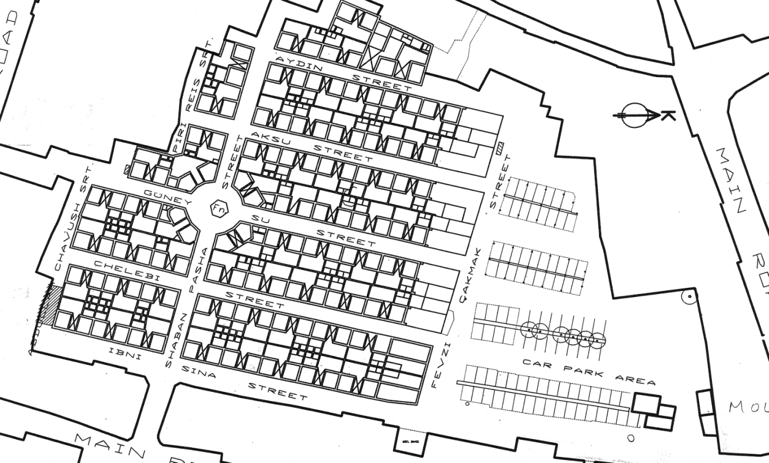
Fig 5.18 The Samanbahce plan showing the entire housing units, the water fountain, the plan 2 units located around the fountain and the parking spaces.
One way of identifying a Turkish house is recognized by its elements and/or plan types. The elements include stories of the house, the provision of halls, and the stairs. The plan types include the house without a hall, with a hall, with an inner hall and with a central hall, and it is this latter element that can be seen on the eclectic elements of the samanbahce housing project.
The samanbahce housing project reflects a Turkish house with an inner hall. Houses with inner halls are one of the most widespread in Turkey. This plan which is called two sided was developed by the addition of another row of rooms on the side of the hall, the houses with the inner hall is a development on the house with the outer hall, but both types continued to exist side by side for a long time but from the 18th century and particularly 19th century onwards the plan with the inner hall superseded the other plan in most of the bigger towns. Research shows that the reason for the preference of the houses with inner halls is mostly economic and hygienic. One fact is that there is a gain in hall space as well as the economy of outer walls when the rooms are placed on both sides of the hall. In additions as can be seen on the samanbahce the hall becomes more sheltered and communication between the rooms more easy, another advantage of the inner hall in the samanbahce is its closeness to nature and the garden which is as a result of it being near the courtyard, this is not the case with the original houses with inner courtyard as the nearness to nature and garden is lost because of the rooms surrounding the hall on all sides.
One fact is that this type of house occupies less space, and this makes it very suitable for the development of a social housing project like the samanbahce, making it possible for the erection of many housing units for low income families with a relatively small piece of land. However the planning also shows elements of urbanization.

5.4.1 Symbolic Elements
The Samanbahce does not have special symbolic elements. The only symbolic element seen on this building is the Arabic calligraphy on the entrance which indicates the numbering of the housing units (plates 52). The Arabic numbering is a very common Ottoman character which shows its association with Islam (Caroe, 1993, pp54). Also seen are stone decorations on the edges of the entrance doors, this material can be traced back right from Lusignan times which used stone as its main building material (plate 51).
All of these show the eclectic style the British colonial period combined in developing its architectural style.

5.4.2 Physical Element
On the face of a housing unit is a door to either side of which is a window. Each unit measures 9.3 meters in length and 3.3 meters in height. This gives a width to height ratio of about 3:1; its quotient of 3 is of a simple house. It is human scaled. It is a small unit just repeated, it is arranged in such a way that it appears secluded with the high rise buildings which surrounds the building looks more like a barrier that shields it.
Fig 5.19 The arrangement of a block in the Samanbahce housing project

5.4.3 Functional Elements
The wall of the front façade of Samanbahce houses is made from mud. It is 0.40meters thick, while the wall partitioning the kitchen, bathrooms, toilet and the party wall with courtyard on either side is 0.30meters thick. The height of this mud wall is 3.30meters.
The front façade has two windows as seen on Fig 5.19 each of the windows measures 1.20meters wide and 2.0meters high, they are single fold wooden window shutters, also believed to be a window style modified by the British colonial period from Ottoman period whose windows had double fold (Given, 2005, pp411). The modification was such that the overall dimension of the window is not affected but the width of the folds which became larger by reducing one of the folds.
The faced has a wooden double door. It has a dimension of 1.3meters wide and 2.4meters high. The door is similar to the door types used during Venetian period on domestic houses (Enlart, 1897, pp405), these doors are recent additions from the restoration works carried out in 2003 and so they are more of historically styled doors than historical doors. Having said that, from the survey drawings which were carried out before the restoration, some of the doors are similar to the present door while others are iron doors.
The housing unit has eaves. They are 0.60meters wide. This is the dimension for eaves of a modern building (De Charia, 1990), it shows the building’s element of modernity.
The housing unit does not have columns, arches, porch and railings; this is most likely because it is a very small housing unit.

5.4.4 Building Material
On the Samanbahce Stone and mud bricks were used for its construction. Stone was used in raising the foundation of the housing unit, while mud brick was used in was used for its foundation and mud brick is used for the walls.

5.5 Pictures of the four selected houses
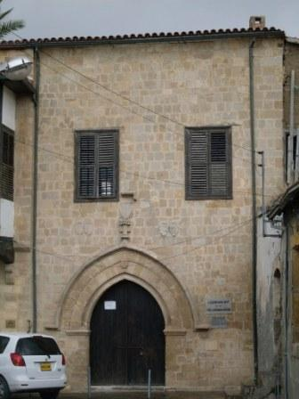  PLATE 1: The entrance door of the Lusignan house, showing the Gothic pointed arch and the wooden door | 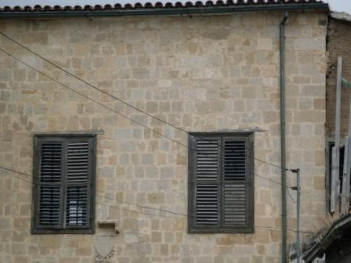  PLATE 2: The wooden windows of the English colonial on the upper floor of the Lusignan house right above the entrance door with the Lusignan coart of arms between the windows and the entrance
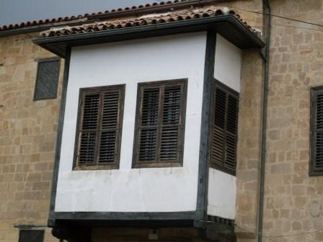  PLATE 3: The Ottoma Kiosk (known as Cumba) a later addition to the Lusignan house. | 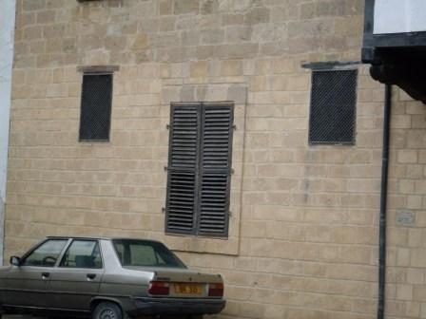  PLATE 4: The wooden window further left, on the ground floor, with two small lighting windows which are thought to be original.

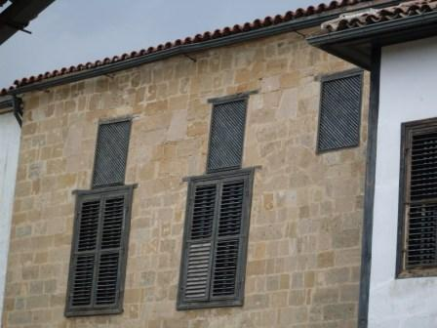  PLATE 5: Three small lighting windows on the first floor, which are added to resemble the ones on the ground floor during restoration work in 1996 | 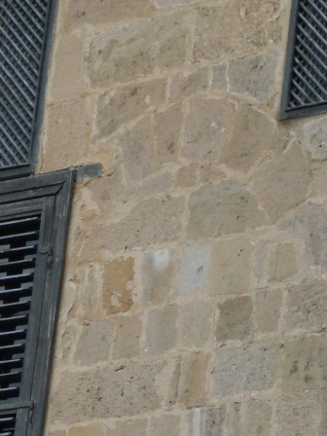  PLATE 6: Trace of an opening at a point in time which was blocked.
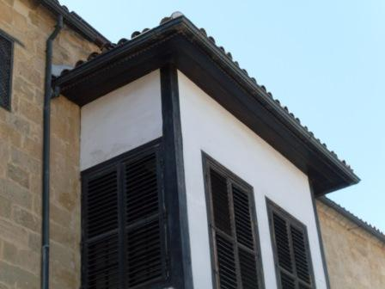  PLATE 7: The wooden eave of the Lusignan house, also seen are the wooden corner boards | 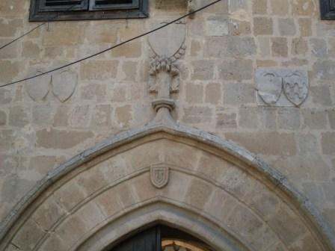  PLATE 8: The Entrance to the Lusignan house at present unchanged from the one described by Camille Enlart

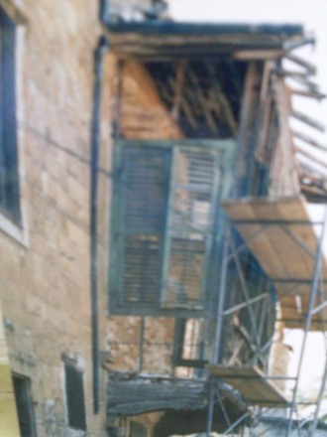  PLATE 9: The reconstruction of the Cumba during restoration in 1996 | 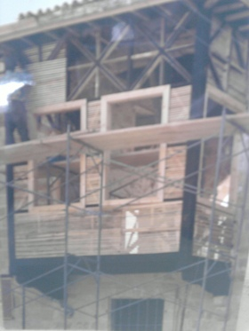  PLATE 10: A closer view the cumba during the restoration work in 1996
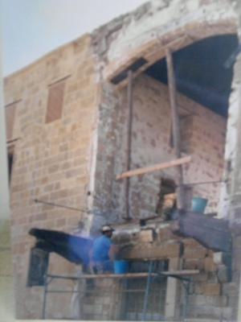  PLATE 11: During the restoration work carried out in 1996, it can be seen that the cumba was removed and replaced | 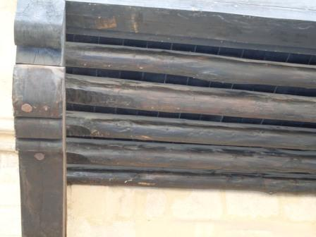  PLATE 12: A view of the base of the Cumba at the Lusignan house which is made of wood

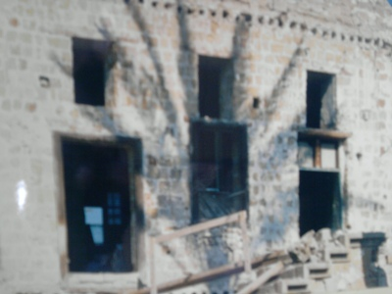  PLATE 13: During the same restoration work, three small windows for lighting were added on the first floor. | 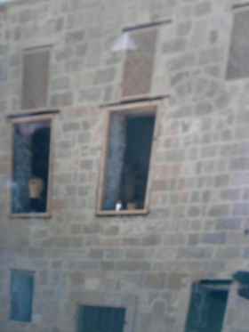  PLATE 14: The material and finishing of the added lighting windows on the first floor.
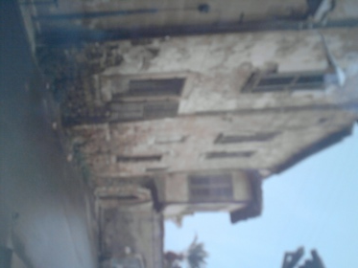  PLATE 15: The Lusignan house built in stone, with mud and wood later used by the Ottomans before restoration in 1996 | 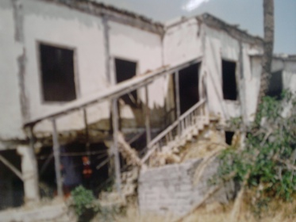  PLATE 16: A view of the rear façade of the Lusignan house before restoration.

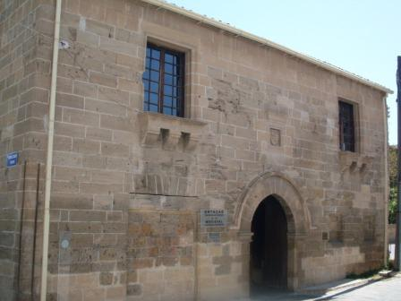  PLATE 17: The western façade showing the symmetry of the Venetian House. | 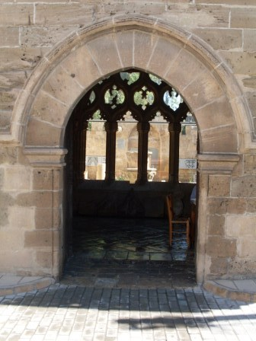  PLATE 18: The pointed gothic arched door with capping on both sides of the door frame and a stone decoration above
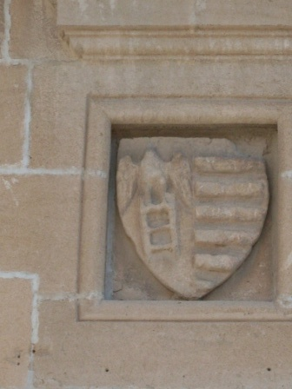  PLATE 19: The Venetian court of arm found above the Gothic styled entrance of the Venetian house | 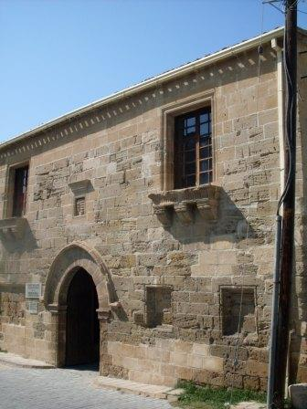  PLATE 20: The two windows on the first floor which have a deep sill carried on brackets

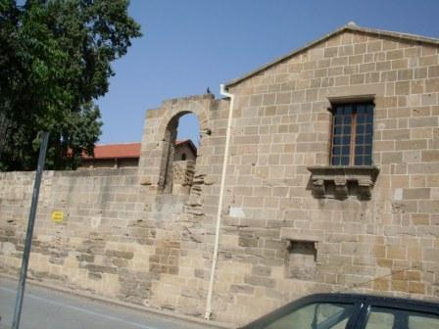  PLATE 21: The southern façade shows he gallery window, the blocked window on the ground floor and the semi circular arch opening | 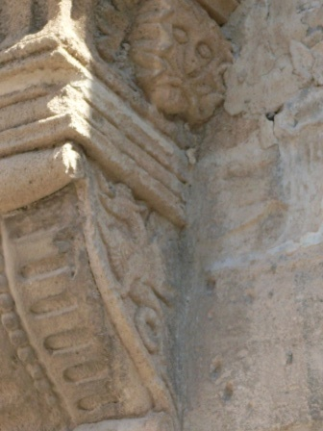  PLATE 22: The head of the Venetian lion carved on the window bracket found on the western façade.
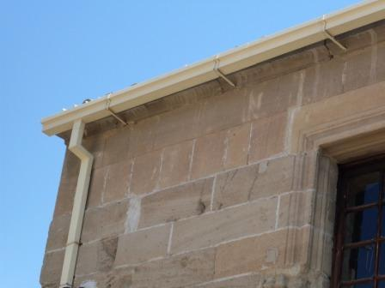  PLATE 23: The eave of the Lapidary museum, with modern addition of aluminium drainage | 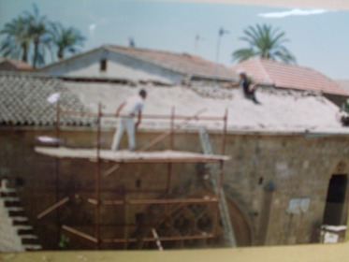  PLATE 24: The Roof of the Lapidary Museum being removed to be replaced during its restoration in 2003.

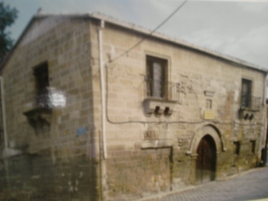  PLATE 25: The western (front) façade of the Lapidary museum before its restoration showing iron railings on the first floor windows. | 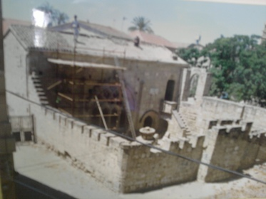  PLATE 26: Restoration work carried out in 2003 on the Lapidary museum.
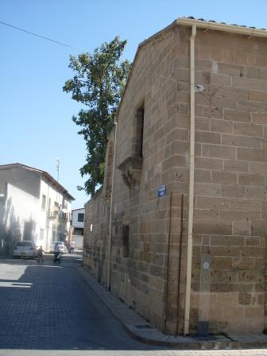  PLATE 27: The Lapidary museum in to its sorounding buildings | 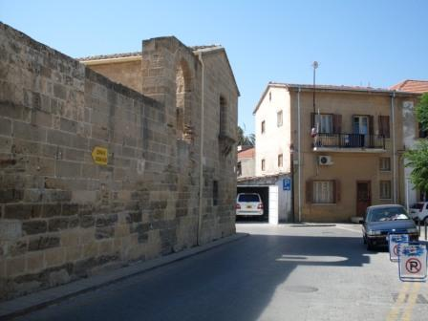  PLATE 28: Another view showing the building in relation to its surrounding.

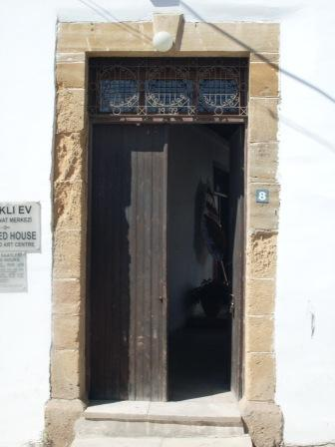  PLATE 29: The entrance door to the Sacakli Ev showing the stone decoration at the edges. | 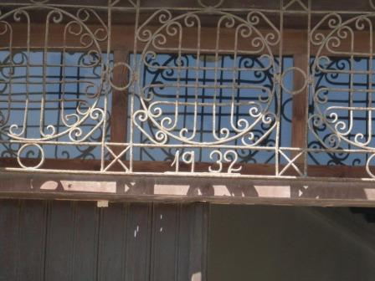  PLATE 30: The entrance to Sacakli Ev showing 1932, believed to be the period the British colonial era renovated the house.
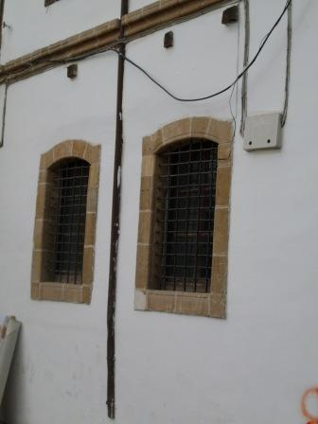  PLATE 31: Two smalls doors transformed to windows on the front façade | 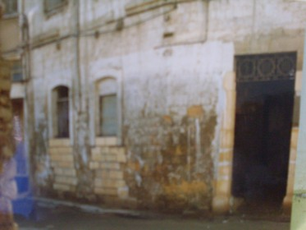  PLATE 32: The two small doors on the front façade at the time when they are turned to windows.

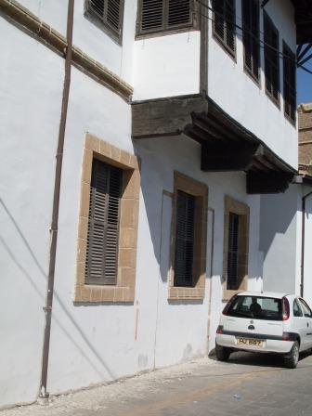  PLATE 33: The three windows under the Cumba were all doorways but transformed to windows during the restoration work in 1994. | 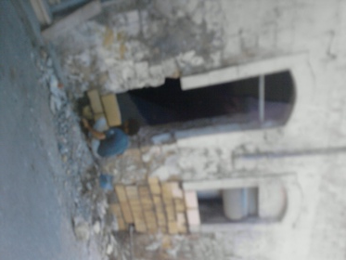  PLATE 34: Two of the three doors in plate 33, at the time when they were turned to windows.
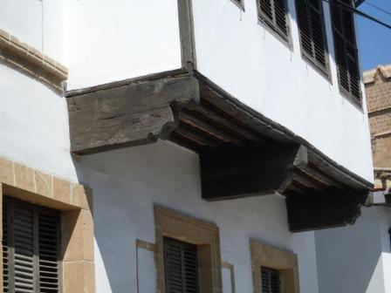  PLATE 35: The cumba of the Sacakli, also seen are the wooden corner boards | 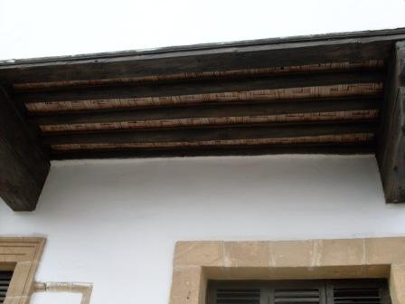  PLATE 36: The wooden construction of the base of the cumba at Sacakli Ev.

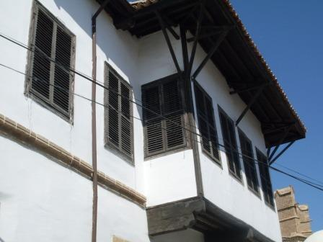  PLATE 37: The Cumba of the Sacakli Ev | 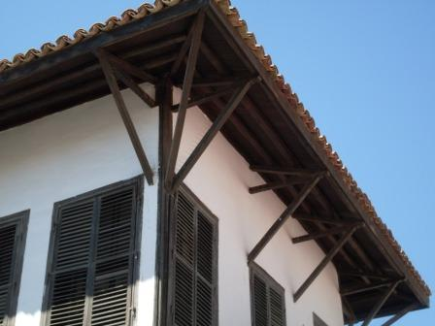  PLATE 38: The long Eaves of the Sacakli Ev made of wood.
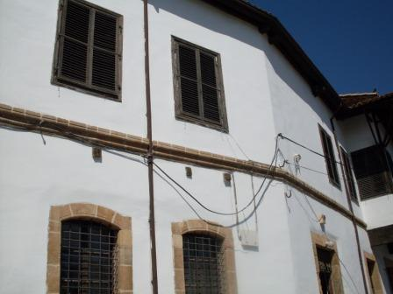  PLATE 39: The belt course on the Sacakli Ev deparating the ground floor from the first floor. The belt course is made of stone. | 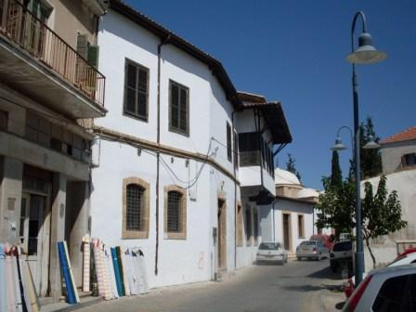  PLATE 40: The Sacakli Ev in relation to its surrounding.

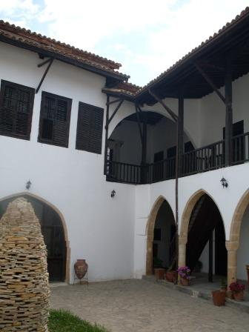  PLATE 41: Part of the southern façade showing the upper balcony, and the wooden balustrade. | 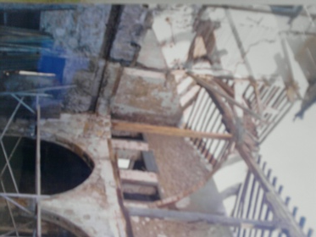  PLATE 42: Part of the southern façade during the restoration work carried out in 1994
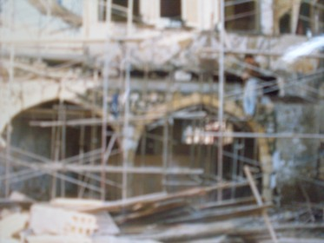  PLATE 43: The southern façade during restoration work in 1994. | 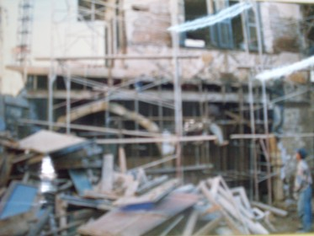  PLATE 44: The southern façade showing the construction of the pointed arches.

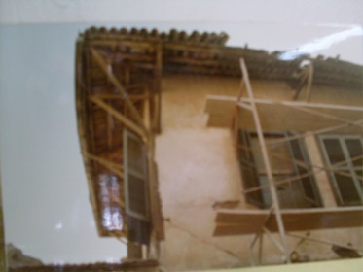  PLATE 45: The long eaves of the cumba are before the restoration work. | 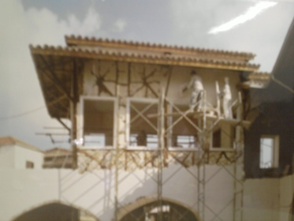  PLATE 46: The long eaves of the cumba area during the restoration work.
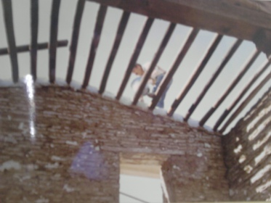  PLATE 47: The Sacakli Ev’s wooden roof structure during its restoration. | 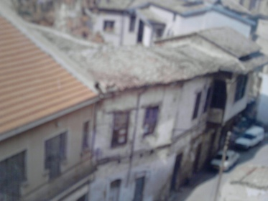  PLATE 48: The Sacakli Ev before its restoration in 1994 showing its dilapidated state.

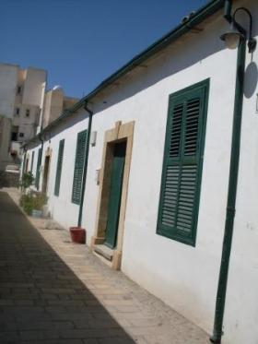  PLATE 49: The front façade of a block of the Samanbahce housing project. | 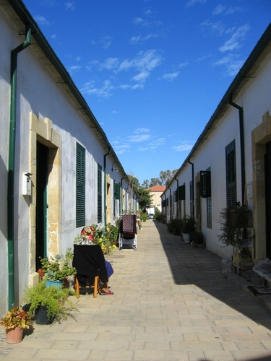  PLATE 50: A view showing two front facades facing each other, separated by pedestrian walk way
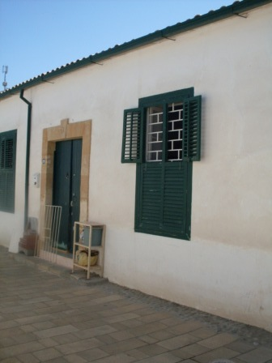  PLATE 51: A unit of the Sahmanbahce housing project | 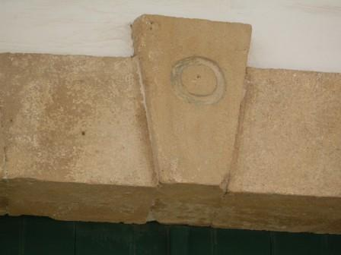  PLATE 52: Clearly seen at the top of the entrance to the house is its number in Arabic

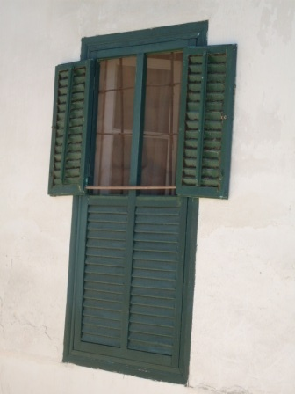  PLATE 53: The modified British window which has a single fold adopted from the Ottoman style which uses two folds | 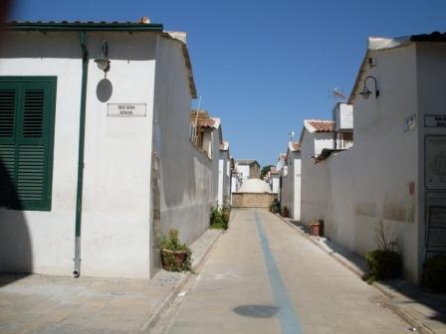  PLATE 54: The walkway through the housing project.
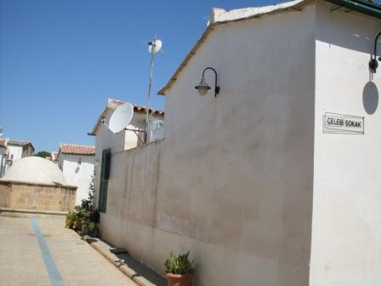  PLATE 55: The side façade, also showing is the low pitched roof. | 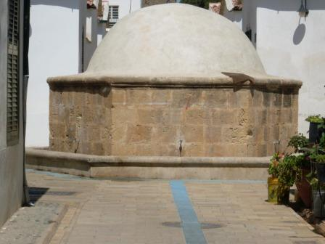  PLATE 56: The water fountain located at the middle of the sahmanbahce, it is believed to be the meeting point of the neighbourhood

Chapter 6 SUMMARY OF FINDINGS, CONCLUSION AND RECOMMENDATION

6.1 Summary of findings
The walled city of Lefkosa is a unique settlement located within the Cyprus capital city. This is a settlement which is in many ways unique, its closed walls, the historic buildings and monuments makes it a real center point not only showcasing the rich history of the island but also its high tourism potentials, thus giving it the ability to attract tourists in large numbers all year round.
The walled city started its noticeable settlement patterns right from Roman period through to Byzantine, the historical evolution of this developing this settlement through organization continued to the Lusignan period through to British occupation period and till date, however some of these historical buildings have been brought down and replaced with modern buildings, some because they have turned ruins while others just demolished without any strong reason.
Thus evidences from documents, research works, and physical surveys shows that the settlements elements which are the buildings making up the settlement shows the existence from Lusignan period (1192 – 1489) through to British colonial period (1880 – 1960).
During the Lusignan period the strong will of urban inner cohesion led to the creation of a unitary circle of walls to defend and separate civic space, in contrast to anything outside the walls- referred to as the non civic area. They did so by giving a big boost to urban development given a functional articulation never seen before. It brought the way empty spaces among the byzantine religion poles were being organized through the application of an allotment system based on farming schemes and therefore still influenced by rural and urban structures.
The Venetians however reduced the dimensions of the town to only one third of its original size, while part of the town outside the city walls was transformed for defense purposes into a completed cleared area all kind of buildings existing in the surrounding area before. This also led them to change the Lusignan walls by demolishing them and erecting the circular walls which is present to date.
The Ottomans brought a strong influence on the infrastructure and residential aspect of the town in order to transform itself into a modern capital city. It saw the creation of new public structures, not just for state administration but also for the needs of the population.
During the British colonial period radial changes occurred in the architectural and urban identities of the city. The British character became more evident as it became the dominant determining factor of modernity.
Having said that looking at the present state of buildings in the walled city, over time from the Lusignan to the British colonial period they are represented by buildings ranging from monumental structures to civil buildings. While the Lusignans are known for the construction of church buildings which are still used in present times though converted to mosques during the Ottoman period and maintained till present time), the Venetians are known for their military architecture, an evidence is the construction of the city walls, from which the settlements name - The walled city is derived. The Ottomans are known with building mosques, baths and khans, a demonstration of their strong Islamic belief, whereas the British period is littered with mostly administrative buildings. It should be noted that this period’s buildings look much more modern when compared to previous periods before it.
The Lusignans were an independent kingdom based on a feudal system of administration. The taxes they levied on people or on a flourishing trade were kept in Cyprus with which they were able to build their capital to their taste. Thus there appeared cathedrals, churches, palaces, mansions, monasteries, convents, chapels, castles and city walls. All this buildings were built in Gothic style of the day. Built in cut stone these buildings were much different from those which were in traditional Cypriot or oriental style (Ghurkan, 1987, pp11-24).
To this the church buildings (an example is the St. Sophia cathedral) constructed during the Lusignan period which are evident to date are strong indications of the Christian belief of this period and most of the historic buildings are linked in one way or the other to religious buildings which was an area which the Lusignans used in demonstrating their architectural character.
The main mark of the Venetians was the city walls which were built towards the end of this period. Seeing a Turkish attack imminent and the Venetians were stepping up the islands defenses and in doing so they felt they needed to defend the town. Thus they felt erecting the circular walls replacing the rectangular ones by the Lusignans. This is a very unique evidence of their defense minded architecture.
The coming of the Ottomans brought about a shift which saw the massive construction of mosques, baths and khans in the city, and the conversion of Gothic and Latin churches to mosques (an example is the St. Catherine cathedral now Haydar Pasha mosque) and this buildings survived to our time. Also during this period other buildings that were spared for public use as covered market or for similar purposes were also preserved.
The British colonial period brought about elements of changes through eclectic styles which largely brought elements of modernity as well. This was started by the very first years of their occupation by cutting openings on the city walls for easy flow of traffic and building settlements outside the walled city with the hope of encouraging people to come out of the walled city. They also demolished a lot of old buildings within the walled city and erected new shops, houses, and other buildings. Most notable of the old buildings demolished was the former Lusignan royal palace for the Lusignan kings and afterwards as government for Venetians and Ottomans. They were also to enact the street widening Regulation Law in 1946. The impact of this law was continuous building lines were partially widened without considering the organic historical tissue. The purpose of this regulation was to increase the capacity of the narrow streets in the walled city.
It should be noted that over the cause of these periods, different architectural characters were evolved. They were mostly borrowed and mixed in some cases with the vernacular architecture. From the medieval Gothic style adopted by the Lusignans to the Renaissance style of the Venetians, and a mixture of these styles by the Ottomans to the continental style used by the British colonial masters whose style can by and large be classified as eclectic. Thus through these periods, elements of transformations can be noticed over time from one period to another which continued to borrow existing ideas and develop them in some cases while in other they are used in their borrowed state.
Also, noticed on all these analysed buildings is the courtyard. Due to climate, outdoor spaces have a great impact on the life of Cypriots. Through history outdoor spaces in houses have consciously been designed to efficiently used by the residents as a part of daily life in Lefkosa.
6.2 Conclusions
The historic, cultural and architectural value of the walled city of Lefkosa justifies the claim that this area, with its surrounding ensemble of the Venetian walls, the moat and the bastions, should be considered as a rare specimen of international heritage (UNDP, Nicosia Master Plan, 1989, pp13).
The walled city is an example of history and its gradual evolution over time. Through it its historically development can be seen physically. The historical buildings found here represent its multi dimensional identity.
These buildings however have undergone transformation from one period to the other and the remains of these buildings to date can hardly be traced to a single past period. This is because with every passing period, the period succeeding it embraces theses buildings and transforms them, incorporating its character and style to fit its purpose and use, it doing so some elements of the earlier periods on these buildings that suits its desires and thus incorporating it with its added style and character, through this the building is left with mixed characters and styles thus making it difficult for the building to be traced to the original period it belongs except in rare cases where authentic documents are left.
The elements used by the periods ranges from French Gothic architecture by the Lusignans, the Venetians used Renaissance style; products of this style include elegant arches in isterian stone, fine tracery and the use of symmetry in design. The Ottomans used the bay windows, the cumba and the projecting eaves while the British colonial period used a form of style which is eclectic in nature, the most common elements being the arcades and the quoins.
In the analysis the façade characteristics of the selected four historical houses they are realized to combine architectural character of more than a single period. These obviously were additions made to transform them after the original period when they were constructed. In the Lusignan house the most obvious additions seen are the cantilever (cumba) on the entrance façade, this was done by the Ottomans with mud and timber and not stone which is the material used for constructing the building by the Lusignans.
In the Lapidary museum (Venetia house), additions seen here include the timber floor at the gallery, the large Gothic styled window which is believed to have been originally on the demolished Lusignan palace and transferred to the lapidary museum after the British demolished the Lusignan place (Ghurkan, 1987, pp11-24).
At the Sahmanbahce which is constructed during British colonial period, Ottoman architectural character can be clearly seen right from the plan shape, to the functional arrangement within each house and to the use of Ottoman opening styles both for doors and windows and even to the use of Arabic numerals in numbering the houses, a very common of the Ottoman architectural character.
The Eaved house (Sacakli Evi) is an Ottoman building with Ottoman architectural characters written all over it. These include its long eaves (thought to be an element adopted by the Ottoman from East Asia), the Cumba (the cantilever on the upper floor forming part of the reception room also called the kiosks) and the building’s rooms designed to open to the courtyard. These are all elements of Ottoman architectural character. However there are evidences tracing the buildings origins to even have existed before the Ottoman period. Even after the Ottoman period the building went through transformation under the British colonial masters, elements of which can be seen; the use of stone decorations on the edges of the windows and entrance door on the ground floor, the windows changed from the traditional two folds widows used by the Ottomans to a modification made by the British which turned them to single folds. Another evidence of British transformation on this building is the date 1934 written boldly on the entrance which is believed to be the period when the British transformed this building.
6.3 Recommendations
During the cause of the thesis, some observations were made and thus the following recommendations:
There is the need to preserve this historic settlement in its original state and thus there is a need for awareness on making efforts at keeping each and every historical building in its original form and not to be altered during restoration as observed on all of the analysed buildings which is the case with almost all historical buildings in the walled city.
Some parts of the walled city is in a state of ruins, and this affects the general view of this settlement, walls dilapidated, roofs in ruins etc, efforts should be made at restoring these ruined parts to their original architectural character so as to maintain its overall character, this however should be done in strict accordance with the Nicosia master plan draft.
Effort should be made making a proper documentation of all historical buildings in the walled city, this can be done through gathering physical evidences and survey, the documentation kept with the Antiquities Department for references during study and otherwise.
Efforts should be made at stopping the demolition of these historic buildings which is becoming rampant and replacement with new ones as this affects the overall character of the settlement.

REFERENCES

- Alostos D, (1976), Cyprus in History, Kraus, Warsaw

- Ak I, Hasan B, Ozlem C, (2005), “Assessment of material use in relation to climate in historical buildings” (a published article)

- Bagiskan, T. A., (2005), Kibris’ta Osmanli – Turk Eserleri (Northern Cyprus Ottoman – Turkish Works), Mani Basin yayin Ltd, Lefkosa

- Brady, T. A., (1937), Ancient Cyprus, Its Art and Archeology, Metheun & Co, London.

- Caroe, A. D. R.,( 1993), “Cyprus architecture: the fusion of Byzantine, Western and Mohammedan architectural styles in Cyprus”. (Journal of the Royal Institute of British Architects 40), p45-56

- Cattling, H. W.,(1976), Cyprus in the Neolithic and Bronze Age periods, Longman, London

- Chagalli, G., (1962) Cyprus under British rule Nicosia, Phonitis Kyprou, Nicosia

- Chin, W, H., (2004) “Issues of historic buildings in Taiwan” (a published article)

- Cobham, D. C., (1969), Excerpta Cypria, material for a history of Cyprus, Kraus Reprint, Nicosia

- De Charia, C., (1990), Time Saver Standards for Building Types 3rd edition, McGraw Hill Publishing, New York

- Demi D., (1997), The walled city of Nicosia; typology study, UNDP, Nicosia

- Doratli N., “A Model for conservation and revitalization of historic urban quarters in Northern Cyprus” (unpublished PHD thesis), Faculty of Architecture, Eastern Mediterranean University

- Doremus, T., (1994), Classical Styles in modern Architecture, John Wiley and Sons inc., New Jersey

- Enlart C., (1897), Gothic Art and The Renaissance in Cyprus, Trigraph, London

- Enkefried, K. and TOMAN, R., (1998), Baroque Architecture, sculpture, painting, Konemann, Cologne

- Fasli M., “A Model for sustaining city identity, case study: Lefkosa (Nicosia) in Northern Cyprus” (unpublished PHD thesis), Faculty of Architecture, Eastern Mediterranean University

- Francis, D. K., (1996), Architecture, form, space and order (2nd edition), Van Nostrand Reinhold, Amsterdam

- Gazioglu, C. A, (1990), The Turks in Cyprus, Context Typesetting system Ltd, Lefkosa

- Given M., (2005) “Architectural styles and ethnic identity in Medieval to modern Cyprus”, Levent, London

- Godecki L., (1978), History of world Architecture; Gothic Architecture, Rizzoli International Publications (published article)

- Godfrey G., (1993), Sinan: Ottoman Architecture and its values today, Saqi Books, Istanbul

- Gunnis, R., (1936), Historic Cyprus: A guide to its Towns and Villages, Monastries and Castles, Methuen, London.

- Gurkan H. M., (1987), A glance at historic Nicosia; a description of ancient monuments, old houses, and garden of walled town of Nicosia, Gelisim, Lefkosa

- Harry L., (1995), Cyprus; a portrait and an appreciation, Havvap

- Hifsiye, P., (2002) “Analysis of solid-void relationships as design and organization principle in the traditional houses of Nicosia”, (unpublished PHD thesis), Faculty of Architecture, Eastern Mediterranean University.

- Hugh B., (1985), The story of English Architecture, Faber and Faber, London

- Karadaya, G., karadaya, A., “Continuity of urban Identity and visual impact assessment “via” Liveable environments and Architectural International congress” 4-7 June, Karadeniz Technical University, Trabzon

- Keshishian, K. K., (1993), Nicosia: Capital of Cyprus then and now (second edition), Mouflon Book and Art center, Nicosia

- Kidsonspeter, (1969), A history of English Architecture, Penguin Books, London

- Lance P., (2005), Twelve times in Nicosia: Nicosia Cyprus 1192 – 1570; topography, architecture and urban experience in a diversified capital city, Cyprus Research Center, Nicosia

- Lewis, D., (1998), Classical styles in modern Architecture, Simon and Schuster inc, New York

- Lonaro N., (1978), Maps of Cyprus: from the collections of the Bank of Cyprus cultural foundation, Bank of Cyprus cultural foundation, Nicosia

- Lstrom, P, Cyprus: Its Ancient Sites, Tombs and Temples, A Narrative of Researches & Excavations during ten years’ Residence as American Consul in that island, John Murray, London, 1877.

- Malcolm, (2001), Design with stone, Everbest printing, New Jersey

- Maria P., (2004), “Traditional urban architecture of Cyprus” (a published presentation)

- Nazife, O., (2005), “A comparative study of climatically responsive house design at various periods of Northern Cyprus architecture”, Elsevier

- Numan Et al, (1996), “The Reflections of the social changes in the physical and functional forms of the walled city of Nicosia”, (Architecture and planning journals), A publication of Architecture and planning center, Vol2,No1, p19-26

- Luke W., (2004), “Saint Peter and Paul Church (Sinan Pasha Mosque), Famagusta: A Forgotten Gothic Moment in Northern Cyprus” (a published article)

- Owen M., (2001), “Preserving building material for historical buildings” (a published article)

- Peter B., (1997), The Renaissance, St. Martin’s Press, Paris

- Peter, O., (1995), Cyprus; Yesterday and today, University of Texas, Texas

- Perbillini, G., (1988), The Venetian Defences of Cyprus, Fort, Fortress study group, p7-44

- Pool, T., (1909), The catholic encyclopedia Volume 5, Robert Appleton company, New York

- Rolf T., (1999), The Art of Gothic: Architecture, Sculpture, Painting, Frontispece, New York

- Salvatore, G., (1873), Venice Art and Architecture Vol. II, Konemann, Cologne

- Salvatore, L., (1983), Lefkosa the capital city of Cyprus, Trigraph, London

- Schmidt, R. and Worsely, B., (1991), North Cyprus, Pilot Publications London

- Stanley, I., and William, B, (1993), “The Ottoman House” (a published article), Elsevier

- Stewart D. Et al, (1984), Nicosia Master Plan final report, UNDP

- Strand W. E., (1993) Voices of stone: the history of ancient Cyprus, Nicosia

- Taylor, L. D., (1994), Classical styles in modern Architecture, Van Nostrand Reinhold, Amsterdam

- UNDP, “Nicosia Master Plan Final Report”, (1984), Nicosia

- Vitruvius, (1960), The Ten Books on Architecture, Dover, New Jersey

- Volckman C., (2006), Renaissance, Miramax, London

- William, D., (1981), The antiquities of Turkish Nicosia, Triagraph, London

- Wofflin, H., (1984), Renaissance and Baroque, Harper Collins, New York

- Yetkin S. K, (1965), Turkish Architecture, Ankara University, Ankara

WEBSITES:
- www.alphadictionary.com/directory/Specialty_Dictionaries/Architecture/
- www.architecture.about.com/library/bl-glossary.htm
- www.cypnet.co.uk/ncyprus/history/index.html
- www.cyprus_city/maps
- www.images.google.com/imgres?imgurl
- www.greenparadisehomes.com/history/BRITISH_RULE.php
- www.hillsborough.net/depts/planning/residential_design_guidelines.asp
- www.historical_residence
- www.muslimheritage.com/topics/default.cfm
- www.nicosia.org.cy/english/lefkosia_istoria.shtm
- www.northcyprusonline.com/North-Cyprus-Online-Historical-Places-Nicosia.php
- www.northcyprusonline.com/North-Cyprus-Online-Tourist
- www.pdxhomes.com/architecture.asp
- www.wordnet.princeton.edu/perl/webwn
- www.turkishcy name prus.com/about-trnc-capital-city.html
- www.whatson-northcyprus.com/interest/nicosia/north_nicosia/

Appendix

The study is primarily based on survey, interaction with experts and secondarily on documented but limited research material.
Eclecticism is a kind of mixed style in the fine arts: "the borrowing of a variety of styles from different sources and combining them" (Hume 1998, 5). Significantly, Eclecticism hardly ever constituted a specific style in art: it is characterized by the fact that it was not a particular style
During the survey Mrs. Ilkay Feridun told me that there is a theory that a building existed on the Sacakli site right from Lusignan period but it is not known if it’s the same building that is transformed to present Sacakli Ev or it was totally brought down to make way for the Present building.

