APPENDIX H
STUDENTS’ REFLECTION ON KEEPING DIARY

15th May 2006
Name:…………………………………..
Surname:………………………………
Number:……………………………….
_____________________________________________________________________________________

1.Günlük tutmanın size yararı oldu mu? Olduysa ne gibi yararları oldu? Açıklayınız.

2. Günlük Tutarken zorluk yaşadınız mı? Zorluğu nasıl çözmeye çalıştınız?

APPENDIX I
DIARY INPUTS

Student: Mevlidiye Atagül

Date: 25th February

Today what you learned “adjective and adverb”.
Satuday the least enjoy plays questions enjoy. No enjoy hard questions.
See studies. I didn’t ask a quesitons. Study participant because stdy I understand.
Class today.Most successful Mevlidiye. Study you should do practice todays topic study.

Date: 23th March

I learned “Exercises” today.
The most enjoyable part of the lesson was questions.
The lesson was easy.
I asked one questions. Can I clean the board? I didnt participate. I didn’t know the qustions.
I should do revision to practise the leson.
Yesterday after school I did my homework. I didn’t go to cinema. I played basketball. I watched television got dressed.

Date: 26th April

I will go to Turkish. I will play basketball. I will go to grandmother and grandfather. I will go for a picnic. I will go to sea. I will go to shopping.

I won’t write a letter. You will learn English next year. He won’t take the books. I will homework, got dressed. I won’t go to school.

Date: 25th May (Last entry)

I learned “My Self” today, the most enjoyable part of the lesson was questions. The lesson was easy. I asked teacher “can you come here” The teacher answer was no. I didn’t know the answer. I didn’t answer because participate.

She wakes up seven o’clock. She likes wathing TV. She likes eating pizza. She is sleeping. She does housework. He wakes up at 6 o’clock. He likes watching television. He likes spaghetti. He is sleeping. He works as a policeman.

Student: Selma Korkmaz

Date:25th February

I learned “Dates” The most enjoyable parts of the lesson was talking class didn’t silent.the passage least enjoyable of the lesson was quiz it was diffiult.answered questions The most. Successfull student in the class. Müge was ansthe questions. We should make practises at home answer the questions.

Date:22nd March

I learned expressions, examples, exercise, in, on,at today .The most enjoyable parts of the lesson passage. The most boring was write. It was difficult. I didn’t ask ay questions. I did participate. Yeterday after school everyday I do my homework , I go to school , go to slep, I play volleyball, I watch TV. I should do revision to practice the lesson.

Date: 26th April

I learned compositin. This week. The most enjoyable part of the esson.The most boring was questions in the notebook.I wasn’t easy.I didn’t ask any questions. I should do revision to practice the lesson.

Last entry:

My teacher’s name is Mürüde. She is thirty years old. But very very young. the students 2B class very like. She is job is Computer teacher.I like she. She is very very beautiful. Her lesson very like. She hairs are black. She is beautiful eyes. She best friends are Canev, Fatoş... She is tall. She lives is Beyarmudu. She is verry gets dress.She is my private. all day her lesson I am not fed up with.Becasuse her leson enjoyable. Her lesson successful student. Her lesson funny. Her had a good. She is small her everyday like.

Student: Bahar Özyakup

Date: 25th February

I learned adverb and adjectives. Adjectives is used before noun. Also adverb becoming at to verb.
I like to write but I don’t like, when the teacher ask something. My lecture wasn’t hard for me. I asked question but I didn’t take any answer today. I go to lecture, because just I wont learn.
I must successful in our class. Because I am study to much. Whe I wore from school. I study . I do repaid.

Date: 23th March

We learned “Geneal Question”. We use in years months, rooms and exercises=in the morning. On, for days use at for buildings, for time and at the weekend use. The most enjoyable was “General Question” The least enjoyable wasn’t. I learned was easy. I asked any question. It was “can I clean the board.” It was “yes I can.” I was participate. Everyday after chool, I go to bus. I eat cook. I do homework. I was study. I go to shop.

Date: 28th April

If I become a teacher , I will go to picnic. My will students play football. I will cook food. I will discuss. I will go to library. I will go to forest. I will I will love them. I and they will go to Girne picnic.

Last entry

My favourite teachers actually all. I want to explain Guliz Bozkurt. She is from Lefkosa. She is an English teacher. She is engaged. Her father’s name is Hasan. Her mother’s name is Pembe and brothers names are Hüseyin and Mehmet. She is beautiful. She likes playing basketball and volleyball. She is a teacher at Akdoğan Polatpaşa Lisesi. She has brown eyes. She has blonde hair. She is long.

Student: Kübra Yüceli

Date: 25th February

I learned “The Simple Past Tense” yesterday. The monst Simple Past Tense. It is easy. I didn’t any questions. I lesson active. Naciye and Şerife lesson active. I lesson again.

Date: 22th March

We answered the questions in the students book. The most enjoyable part of the lesson was student book. The lesson was easy. I didn’t ask any questions. I should do revision to practice the lesson. Every day after school I;
- I do my homework.
- I lesson to music.
- I go shopping.
- I wash heir.
- I read a magazine.

Date: 26th April

I go to Turkey. I will go to Lunapark Turkey. I will play basketball. I will eat spagetti. I will go to zoo. I will to join chair. I will go to rarl. I ill go to good forest I will go to river. I will go to shoes shop. I will go to barber.

Last entry :

When I become 30 years old, I will be a teacher. I will go to Turkey. I will have brown eyes. I will have brown hair.I will go to Cyprus. I will not has a blalk car. I will have a red car.

Student: Muazzez İmam

Date: 25th February

We made praktices in class.We learned Tenses.
The most enjoyable parts of the lesson was talking. Because class didn’t silent. The least enjoyable parts of the lesson was quiz.
It was difficult.
I answered questions.
Yes
The most sucesful studend in the class Esra.She answer all questions.
We should make practice at home answer questions.

Date: 25th March

I learned Telling the time and Tenses Today.The most enyable part of the lesson was Passage.The most bring write.It wasn’t very difficets.

Yesterday after school I didn’t homework, I played volleyball. I went to Akdoğan. I shoped.

Date: 25th April

My father name is Sami. My father suname is İmam. My father is a policeman. My ather thirty-seven years old. My father’s hair clour is black. My father’s eyes clour is brown. My father’s favourite cooks are chicken, pizza or hamburger.He’s dont’t like to it bens or cips. He’s favourite juices are cola, cafe,milk or orince jus. My father’s and favourite pop-star is Ahmet Kaya. My father’s favourite pop-star Müslüm Gürses. My father’s favourite team is Fenerbahçe. He’s answerd faourite team is Galatasaray. My father like football play computer. My faher don’t like to clean garden. My father and are family happy.

Last entry:

A and Selma go to travelling. They airport go to Turkey, America, Australia, Atina,Londra and Paris. They are today Turkey hotel will America one days .I swimming pool but Selma eat lunch.Latter go to airport America two days hotel I and Selma breakfast I spors but Selma swimming pool. Lunch, diner.They sleeping. They go to ariport Lodra oen days hotel I and Selma ice-cream eat. They go to airport one days hotel. Later Londra later Paris. Wortrvelling very good. Very good.

Student: Nurevşan Sülük

Date: 25th February

I learned revision today. Wos the most adverd and adjective ask it easy. Today I didn’t ask quesion. I didn’t succestiful lesson. Most Bahar today. Suld you do to protice sutudy todas topic and hard-working someone.

Date:22th March

Today is I learned “Present simple Tense” and “write the following in the past Tense form”. Today most Student Book. Today class to talk. Raveld questions difficult. I asked a qestions to teacher. The questions wos about “where do you live” The teachers answer wos “I live in Akdogan”. answer to you questions.

Date: 26th April

I will go to sutudy and to rest. We go to eat and Book read will. I wil go to 10:00 to go to bed. I wil go to school tomorrow. I will not go for a picnic next weekend. I will write a late. I will not clean your room. I won’t go swimming.

Date: 26th May (Last entry)

We are having picnic near te river. I am playing volleyball with my friends. My father is drinking coffee and eating a sandwich. My mother is talking to her friend and washing the dishes. My sister is swimming in the river. My brothers are sutudying their lesson under a tree. My little sleeping soundly. We are having a nice time at present.

Student: Esra Kasap

Date: 25th February

I learned “The Simple Past Tense” today. We answered the questions today. The most abundance love lessons English talk. The most didn’t lessons to undo small piece. Lessons is easy. My english teacher didn’t questions. My lessons to be out of breath one student. Lessons the most successful student is Nezif. Nezif went to write board lesson to be out of breath. Today subject to repeat intensive by reason of to study needed.

Date: 23th March

I learned “present simple present continuous. Past tense today. The lesson enjoyable is present simple answer. The lesson didn’t enjoyable is Past tense. The lesson is particpate. The lesson was is easy. I sould study.

I am family going to Akdogan. My father going to Lefkoşa. My mother house work. My brother going to Magosa going to school.

Date: 26th April

I will play football and wolleyball. I will go to Turkey and Magosa. I ll go to grandmother and grandfather. I will go to cinema. I will aet ice-cream. I will watch TV. I will read book. I will not buy a bicheI will not go to school. I will not homework.

Last entry

Last week, I went to school. I went to the cinema. I went to grand father and grand mather. I played volleball and basketball. I read book. I read homework last week, school we learned preposition. I went to cafeteria. I read book.

Student: Kemal Hoca

Date: 25th February
I learned “The Present simple tense” Today most amusement “The Present Simple tense. It was easy. Teacher didn’t question answer get Lesson. Participant today class successfu student is kemal. Today subject practive study tobe neces.

Date: 24th March
I learned “question” today. The lesson was enjoyable and the lessons least enjoyable part was “question” Today. It was easy. I didn’t ask question to my teacher. I school do revisoun to pracetive teh lesson. I am played football. I am played computer. I am writed, book.

Date: 26th April:
I will go to Turkey. I will play football. I want go to picnic. I will go to deniz. I will play computer, I will play basketball. I will go to Hotel. I will go to animals garden.

Last entry:
I did workbook , question and student’s book last week. The lesson was enjoyable and the lesson least enjoyable part part was students book last week. It was easy. I didn’t ask question to my teacher. Last week house I played football, played basketball. I played computer games and studied.
Student: Meryem Ördekçi

Date: 25th February

Today I learned studat boots today. Study the least enjoylays quetions entay. No enjoy hard questions see studaeas. I didn’t askd any questions studay participant because study I unday stop class today. Most succesful Meryem. You shald do practice tudy tapic studay.

Date: 24th March

I learned example today. The must enjoyable port of the lesson was questions. The lessan was easy I asked one question Can I clean the board? I didn’t participate. I didn’t to now the questions I shauld do Revision to practice the lesson. Yesterday; after school, I did my homework. I didn’t go to cinema I played basketball. I watched television got to rest.

Date: 26th April

I will go to Turkey. I will play basketball. I will go to my grandmother and grandfather. I will go for a picnic. I will go to sea I will go shopping I won’t write a letter. I will learn engilish next year. I will do homework get the rest I won’t go to school.

Date:23th May (Last entry)

Last week at school and at home last wend at school homawork, study reading book. W had a good laught teachers is question to ask. I and best friend to answer. Passage read last week. At home she does her community work every Saturday. I watches television she is gör basketball match. I went to theatre yesterday. She is reading book. She is watering the flowers now. I studay last week.

Student: Doğcan Kırgeç

Date: 25th February

Dear daily, We didn’t learn English lesson today. English teacher did quiz to us. The subject of quiz was dates in words and past form of the verbs. It was easy. My exam was well.

Date: 22th March

Dear diary, we learned new Vocabulary today. The most enjoyable. The lesson was easy. I didn’t ask any questions to my teacher. I was an active participant. We should do practice and repeat today’s topic at home. Everyday after school I go home by bus. I change my clothes and have my lunch. Then I do my homework. After that, I watch TV. I have my dinner at seven o’clock and watch the news on TV. I study my lessons and go to bed at ten o’clocks

Date: 26th April

Dear diary, I will visit my grandmother in july. I’ll go to Turkey. I’ll go to see. I’ll go for a picnic. I’ll clean your room. I’ll go to supermarket. I’ll go to Nicosia. I’ll go to my friend. I’ll go to Kyrenia. I’ll go to festival.

Date: 24th May (Last entry)

Dear diary, my favourite team is Galatasaray. Galatasaray is famous team all over the world. Galatasaray club was established at 1905. They were most succesfull until today. They got most of cup in Turkey. Galatasaray got UEFA cup and SUPER cup too. They took an other cup in this year. Galatasaray technics director is George Hagi now. Hagi was most famous footballer in Galatasaray before. F.Ribery is most famous footballer now. The goalkeeper is Mondragon and Hasan Kabze is now transfer in Galatasaray. They go to football matches by plain at the weekend. My favourite footballer is Hasan Şaş. I like Galatasaray very much.

Student: Ayşenur Ünlü

Date: 25th February

I learne Revision today. Was the mast adverb adjective. Ask it easy I didn’t ask question. I didn’t active succesful lesson most Esra today. Sould you do to protice study today’s topic.

Date: 22th March

I learned “Expressions” today. We did exorcises aboat part of speech. The questions were easy. I didn’t ask any questions.

Yesterday, after school, I went home. I sdied. After I watched TV.

Date: 26th April

I am will go to Gazi Mağusa. I will swim. I wake up at ten o’clock. I wash my face and combed my hair. I brush my teeth. Then, I have my have my breakfast . I were my will shirt, earring, cop, bag,bracelet, headband, ring and glasses. I will go to sea.

Last entry

We did Revision today. We hd a quiz it was easy. I didn’t ask question. I wose active, successful in the lesson The most successful student was Müge today. I sould do practive to study today’s topic.

Student: Aylin Akın

Date: 25th February

I learned “Date” today. Lesson is most “Date” Easy. I didn’t ask any questions. Yes lesson to take part in. Lesson succesful student “ESRA”. Lesson to take part in superfluous. Today’s subject again continuous, read book.

Date: 22th March

I learned “Expressions” today. The most enjoyable part of the lesson was “Expressions”. The lesson wasn’t very difficult. I didn’t ask any questions. I didn’t participate because I shoul do revision to practice the lesson.

Everyday, after school, I like ate potato. I like homework. I like watch T.V. I like dinner. I like read book. I like school-bag. I like milk.

Date: 26th April

I will go to Turkey. I will play tennis. I will play basketball. I will swim. I will go to Lefkoşa. I will ride a bicycle . I wil go to grandmother. I will read a book. I will play brother. I will a slept.

Date: 26th May (Last entry)

This week we learned Prepositions. The most enjoyable part of the lesson was Prepositions. The lesson was easy. I didn’t ask any questions. I participate because I should revision to practise the lesson. At the moment my mother is sleeping. My father is working. My brother is riding bike.

Student: Meliz Kalkaner

Date: 25th February

Today dates learn dates first, months knonw necossity months january, february, march, april, may, june, july, august, september, october, nowember, december, these lesson most enjoyable part question stant up isn’t enjoyable homework write lesson lesson easy like don’t question ask sometimes participation lesson easy diffucult don’t participation class success she Selma is every thing be addred today subject be repeated for daily work do.

Date: 22th March

Today we did page 12 also a passage.
The most enjoyable part of the lesson was questions to untie.
Lesson wasn’t boring today on the centrary many amusing and today to pic again wont do.
Today school to come.
I am ate.
She is Gaye with to show around and my sister is lesson work. I am evening homework does.

Date: 26th April

Intelligence most beatiful today school ex car sition today morning stant up school go to after bus to get on excursition place go to and ate after excursition and to have a good time or on the frenoon house come.

Date:26th May (Last entry)

Last week school 19 may week and my morning stand up break fast after to get dressed or tooth brush and go to zone but 19 my work go to house. I am ate I and sister must lesson work after wath tv I and family go to cinema after go to house I must play basketball night sleep.

Student: Müge Gündüz

Date: 25th February

I learned Revision today. Was the most adverb, adjective. Ask it easy. I didn’t ask questions. I didn’t active succesfull lesson. Most Esra today. Sould you do to practice study today’s topic.

Date: 18th March

I learned Telling The Time. The most of enjoyable part of the lesson was passage. The lesson grade diffuculty. I didn’t ask any questions. I was participate today. I was write from the board.

I should do revision to practice the lesson. I was active. I wasn’t passive in the lesson.

Yesterday I went to the school. I to eats. I go to the in the afternoon I came house. I do homework. I watched television.

After school, I came house. I to eats. I went to the course. I came house. I watched television.

Date: 27th April

I will go to the Istanbul. I will be next to uncle, grandmother, aunt and cousin. I will go to sea. I swimming. I will at twelve sleeping. I eat every ice-cream. I see friend.

Their I will come Cyprus. I go to the Nicosia officer’s club. I be left once a week. I will swimming. I to have fun in the evening. I to stroll historial opus Cyprus. Later I spin house.

Date: 25th May (Last entry)

I learned examples today. The most of enjoyable part of the lesson .I wasn’t passage. The lesson was very difficult. I didn’t ask any questions. I wasn’t participant today. I wasn’t write from the board.

I should do revision to pratice the lesson. I wasn’t active. I was passive in the lesson.

Student: Okan Gündüz

Date: 25th February

I learned Adjective, Adverbs, Dates today.
Was most Dates you was joyable Adverb was easy difficult questions.
I lesson active Doğcan and Mehmet Ali lesson active.

Date: 22th March

I learned Expressions, Examples, Exercises today.
I understood Exercises. I was enjoyable Expression.
I was very difficult. I was an active participant.

Date: 26th April

Next summer holiday I will go to Karşıkaya. I will see my friend and I will go to summer school. There will swimming pool and see perhaps there will swimming pool and see.

Last entry

This week I learned future Tense (+), (-), (?) answered very questions seasons months and days. Make these sentences in English example.

APPENDIX J
SAMPLE PAGES FROM DIARIES

Student: Aylin Akın

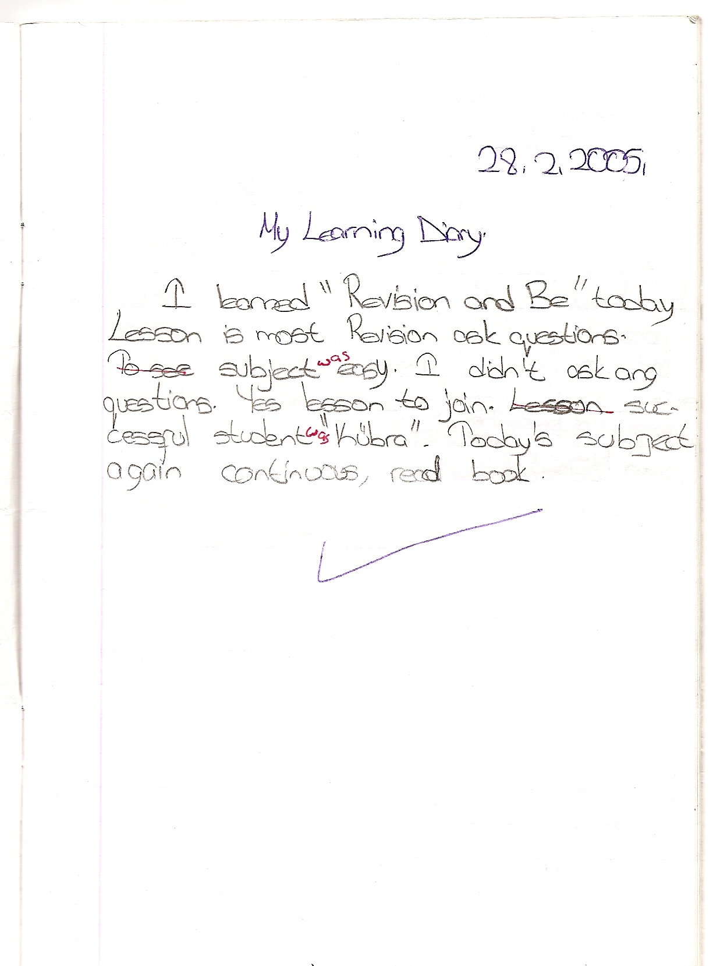

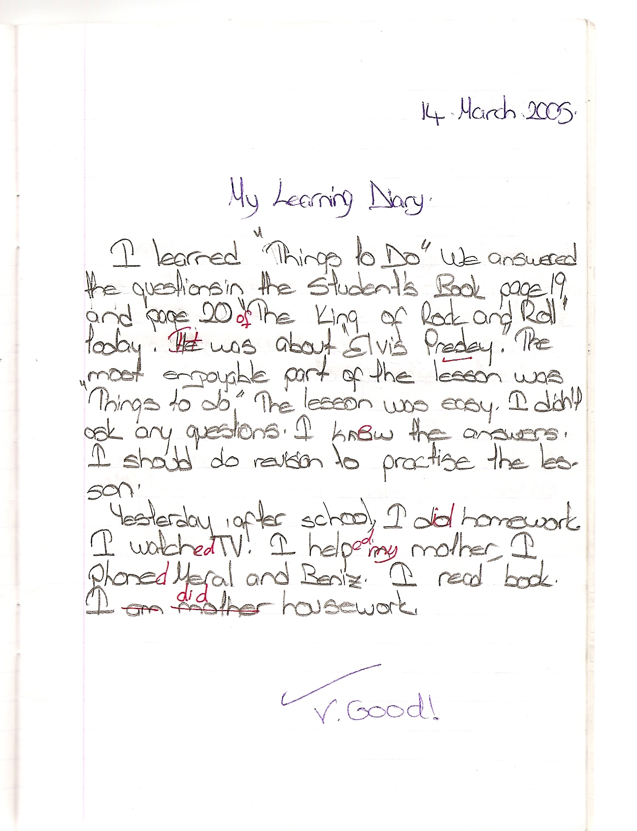

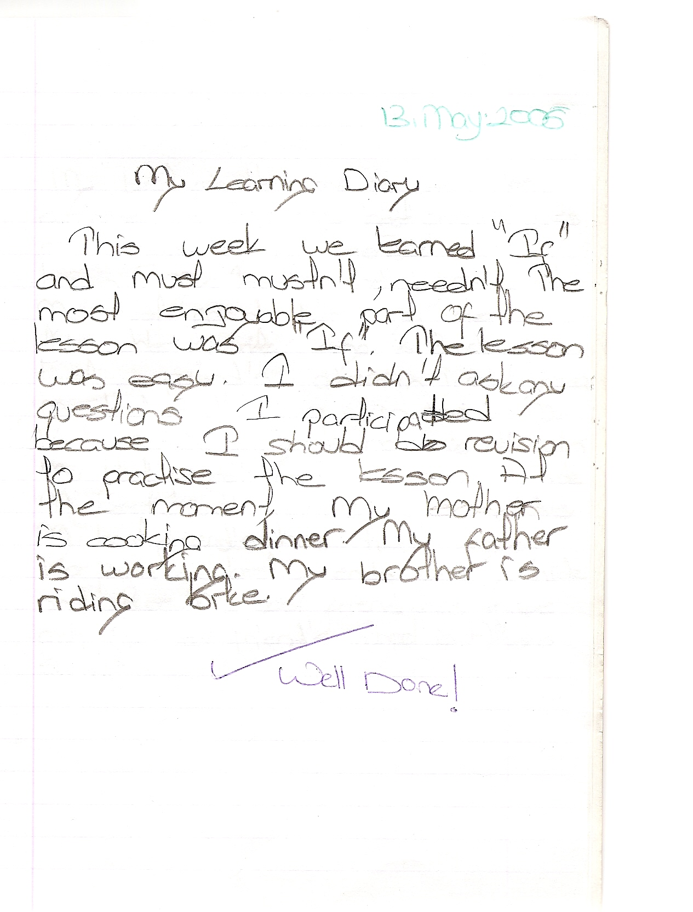

SAMPLE PAGES FROM DIARIES

Student: Esra Kasap
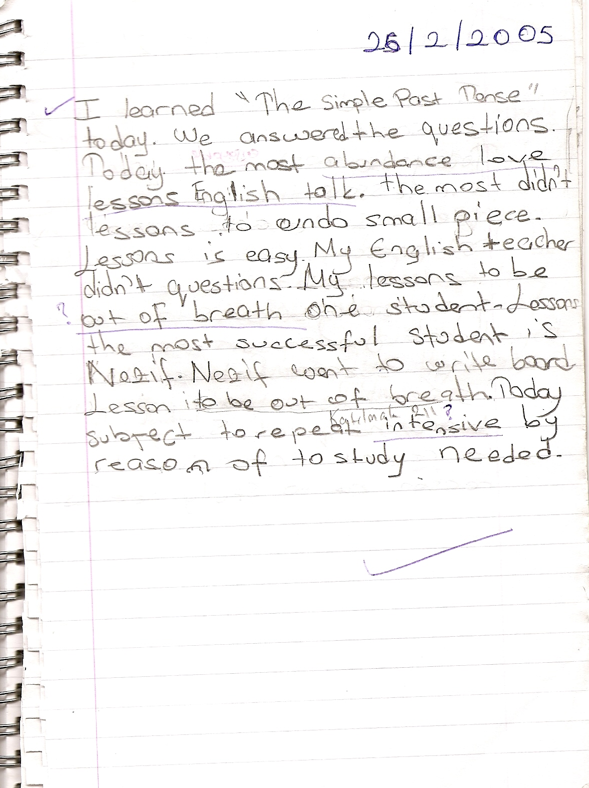

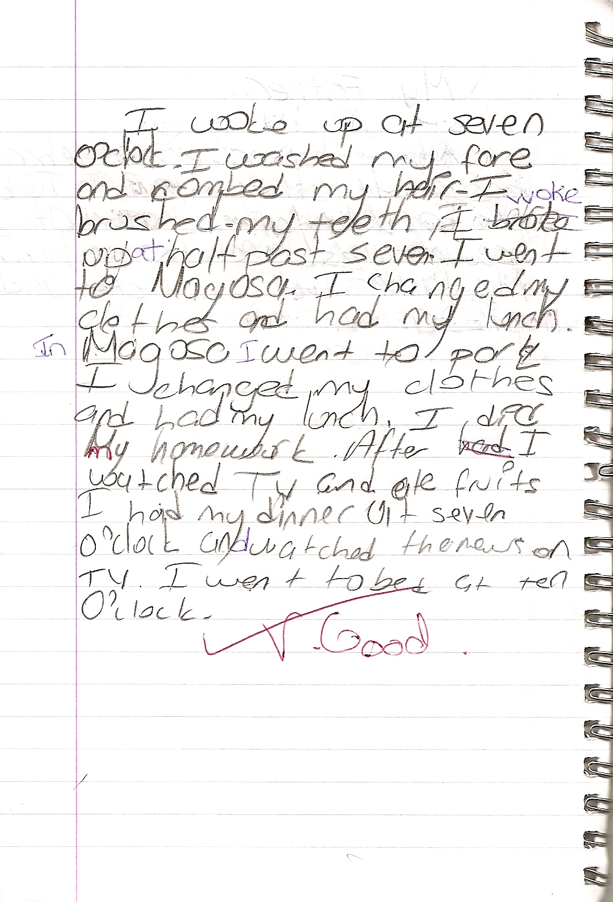

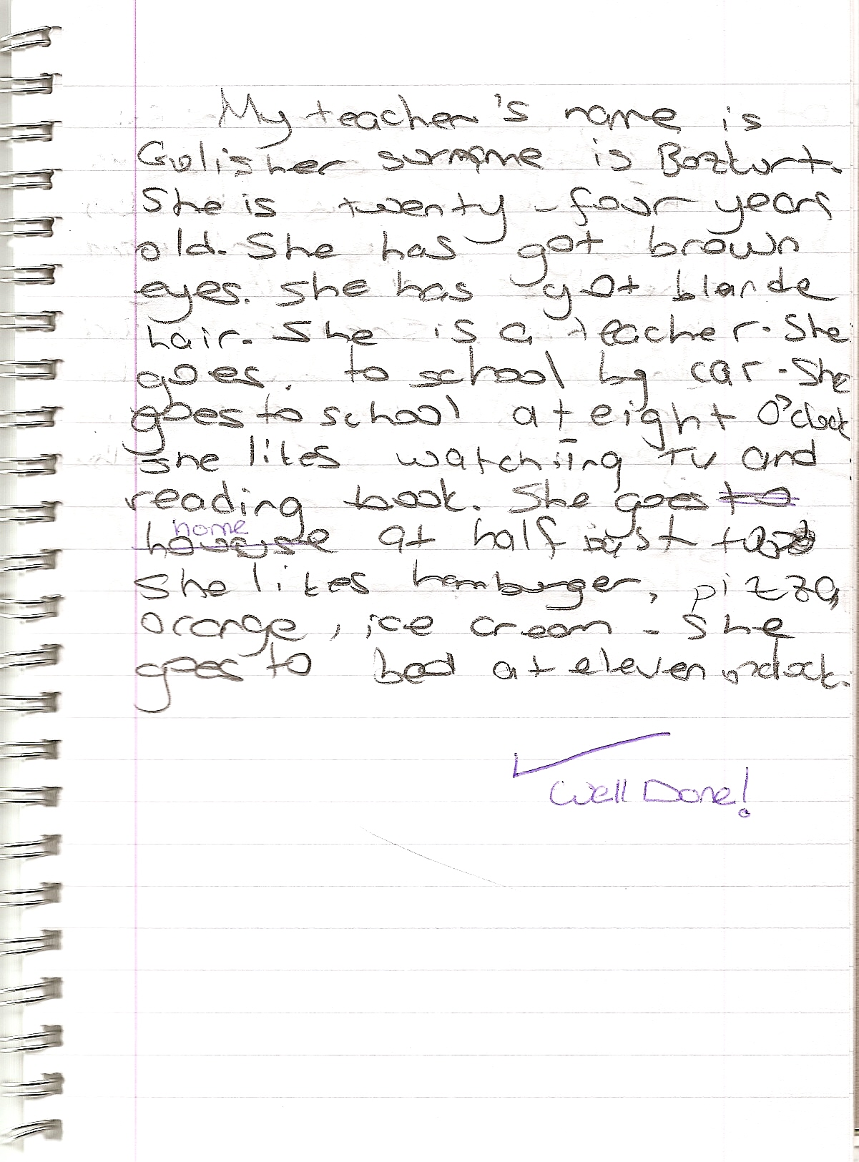

SAMPLE PAGES FROM DIARIES

Student: Kübra Yüceli

