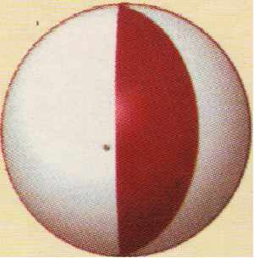
INTERNATIONAL CONFERENCE ON
ısss NEW DEVELOPMENTS iN
SOIL MECHANICS AND GEOTECHNICAL ENGINEERING
Organised by the
Turkish National Committee of Soil Mechanics and Foundation Engineering
and
Near East University
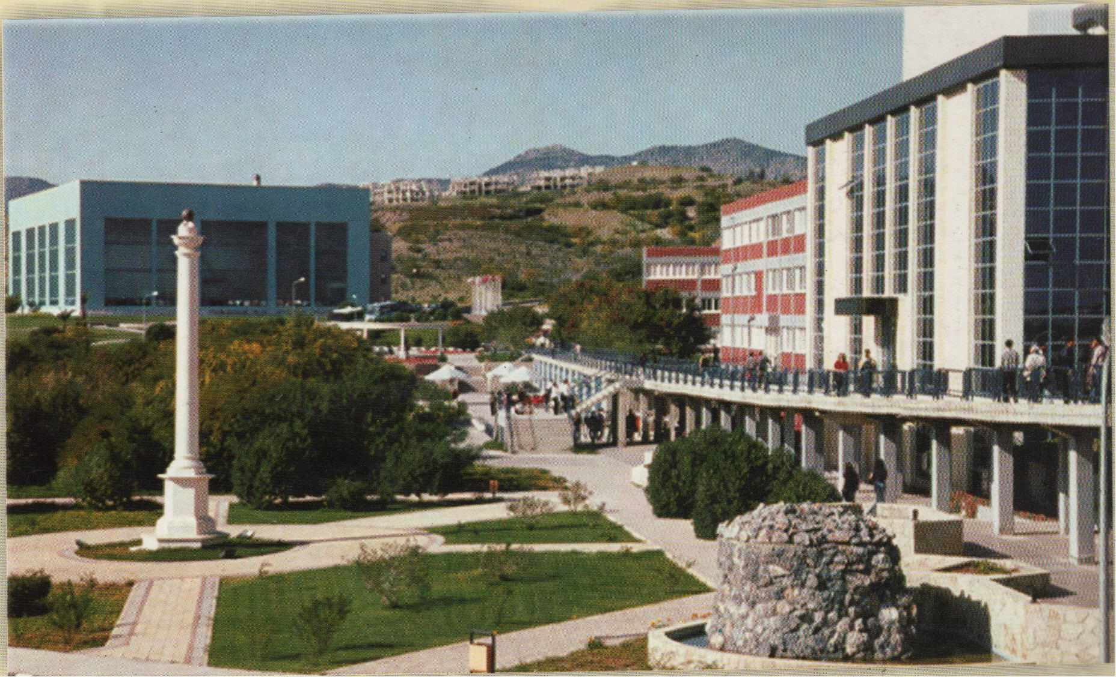
Editors
C. Atalar, B. M. Das, A. Sağlamer, E. Toğrol
Volume 2
Near East University
Lefkoşa, North Cyprus, May 29-31, 2003

Proceedings of the
International Conference on
New Developments in Soil Mechanics and Geotechnical Engineering
29 - 31May2003
Near East University Atatürk Cultural & Congress Centre Lefkoşa, N orth Cyprus
Organised by the
Turkish N ational Committee of Sot! Mechanics and Foundation Engineering
and
Near East University
Volume 2
Editors
C. Atalar, B.M. Das, A. Sağlamer, E. Toğrol
Near East University Press

Suat İ. GÜNSEL Honorary Chair
Founding President, Near East University
Ümit HASSAN Chair
President, Near East University
Organising Conıınittee
Co-Chairs
Ergün TOÔROL President, TNCSMFE
Cavit ATALAR Near East University
Şenol BEKTAŞ, Vice President NEU Altay BİRAND, TNCSMFE
Feyza ÇİNİCİOÔLU, Member TNCSMFE Braja M. DAS, Dean, CSUS, USA
Turan DURGUNOÔLU, Member TNCSMFE Ufuk ERGUN, TNCSMFE
Erol GÜLER, TNCSMFE
Kutay ÖZAYDIN, TNCSMFE Fahreddin M. SADIKOÔLU, Vice President NEU Ahmet SAGLAMER, Secretary, TNCSMFE Doğan SAHİR, NEU
International Advisory Board Atilla ANSAL (Turkey) Zhusupbekov ASKAR (Kazakhstan) Mustafa AYTEKİN (Turkey) Frans BARENDS (The Netherlands) Tuncer EDİL (USA) Moustafa K. EL-GHAMRA WY (Egypt) Michel GAMBIN (France) Robert D. HOLTZ (USA)
Rolf KATZENBACH (Germany) Suzanne LACASSE (Norway) Akıp ÖNALP (Turkey)
Kemal ÖZÜDOÔRU (Turkey) Pedro Seco e PINTO (Portugal) lvan V ANICEK (Czech Republic)
William F. VAN IMPE (Belgium) Yıldız WASTI (Turkey) Thomas ZIMMIE (USA)
Technical Conıınittee Onur Taha CANANER Süne! GAZİ Mohammed Ahmed MUSTAFA Ahmet SAV AŞAN
Recep TEKDEMİR Osman TEKİN

KEYNOTES
TABLE OF CONTENTS

1.

An overview on the estimation of bearing capacity of shallow foundations on
geogrid-reinforced sand (keynote) 01
B.M. Das
Design methods of pile foundations (keynote) 23
P.S. Seco E Pinto
Importance of stress-strain behaviour in planning soil investigation (keynote) 41
E. Toğrol
New developments in geotechnical engineering based on large scale field tests in connection
with optimised ground improvement techniques (keynote) 49
R. Kaızenbach, A. Fehsenfeld, M. Ittershagen
2. FOUNDA TIONS AND SLOPE STABILITY
Bearing capacity consideration for embankments on sands 61
S.F. Cinicioglu, E. Uzman, C. Oser
The problems of estimation of bearing capacity of driven piles 69
A.Zh. Zhusupbekov, A.S. Zhakulin, A.A. Zhakulin, A. U. Mamin, S. Intepe
Analysis of foundations on coarse-grained soils 77
E. Çeçen, O. Sivrikaya
3. SOIL CHARACTERISATION
Instrinsic properties of recent clays on the south-east of Tehran plain in
site investigation interpretation 85
Esmail Aftaki
Application of soil-water characteristic models to soils of North Cyprus 93
Ş. Öncü, H Bilse!
Application of soil suction measurement techniques to soils of North Cyprus 99
E. Çelik, H. Bilsel
4. EARTHQUAKE GEOTECHNICAL ENGINEERING
The effects of subsoil on the dynamic response of rectangular tanks 105
Adem Doğangün, Ramazan Livaoğlu
The effect of foundation flexibility ofa shear wall-frame system in dynamic analysis 111
K.B. Bozdoğan, E. Kaya, A. Sezer, G. İnan, P. Aklık
(

5. NEW METHODS iN GEOTECHNICAL ENGINEERING
Recent integrated knowledge based systems developed for geotechnical
engineering purpose . . . . . . . . . . . . . . . . . . . . . . . . . . . . . . . . . . . . . . . . . . . . . . . . . . . . . . . . . . . . . . . . . . . . . . . . . . . . . . . . . . . . . . . . . . . . . . . . . . . . . . . . . . . . . . . . . . . . . . . . . . 1 19
J. C. Martin, B. Hatipoğlu, M İncecik, D. G. Tol!
The effects of earthquake input mechanisms on the stochastic dynamic response
of gravity dams 127
A. Bayraktar, E. Hançer
6. PRESENTATIONS ONLY
Failure of old small earth dams during floods by domino effect 133
/. Vanicek
Mitigation of liquefaction by means of high modulus columns 135
H T. Durgunoğlu
Geotechnical investigations of the landslide at Taşova urban area (Amasya, Turkey) 137
R.P. Bilgehan, K. Ulamis, Ayhan Koçbay, R. Kilic
Swelling potential of expansive soils in north Cyprus 139
C. Atalar
Soil-water characteristic curves of the unsaturated swelling clays of Cyprus 141
H. Bilse/
Foundation problems of constructions on expansive soils and rocks in north Nicosia 143
A. Acar, C. Atalar, M. Necdet, H Kaşer

