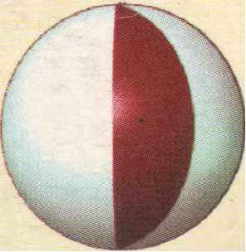
1988
INTERNATIONAL CONFER~NCE ON NEW DEVELOPMENTS iN
SOIL MECHANICS AND GEOTECHNICAL ENGINEERING
Organised by the
Turkish National Committee of Soil Mechanics and Foundation Engineering
and
Near East University
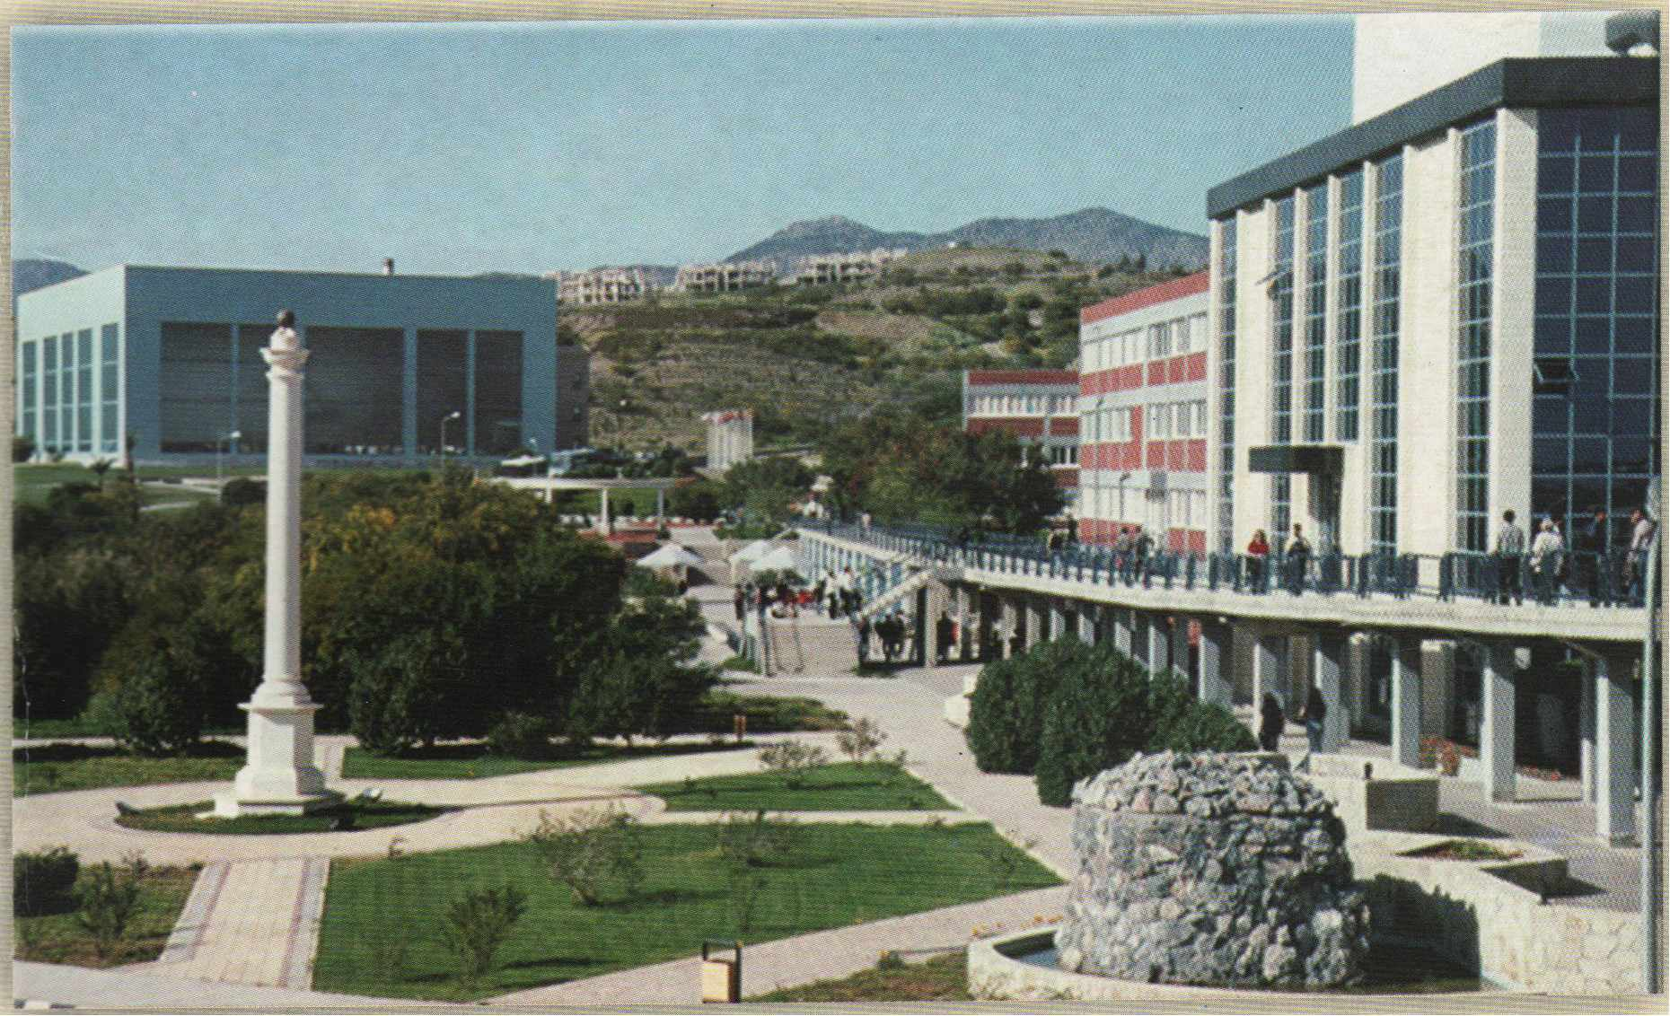
Editors
C. Atalar, B. M. Das, A. Sağlamer, E. Toğrol
Volume 1
Near East University
Lefkoşa, North Cyprus, May 29-31, 2003

eedings of the temational Conference on
Developments in Soil Mechanics and Geotechnical Engineering
29 - 31May2003
Near East University Atatürk Cultural & Congress Centre Lefkoşa, North Cyprus
Organised by the
Turkish National Committee öf Soil Mechanics and F oundation Engineering
and
Near East University
Volume 1
Near East University Press

Suat 1. GÜNSEL Honorary Chair
Founding President, Near East University
Ümit HASSAN Chair
President, Near East University
Organising Committee
Co-Chain
Ergün TOOROL President, TNCSMFE
Cavit ATALAR Near East University
Şenol BEKTAŞ, Vice President NEU Altay BIRAND, TNCSMFE
Feyza ÇINICIOÖLU, Member TNCSMFE Braja M. DAS, Dean, CSUS, USA
Turan DURGUNOOLU, Member TNCSMFE Ufuk ERGUN, TNCSMFE
Erol GÜLER, TNCSMFE
Kutay ÔZA YDIN, TNCSMFE Fahreddin M. SADIKOGLU, Vice President NEU Ahmet SAGLAMER, Secretary, TNCSMFE Doğan SAHiR, NEU
lnternational Advisory Board Atilla ANSAL (Turkey) Zhusupbekov ASKAR (Kazakhstan) Mustafa A YTEKJN (Turkey) Frans BARENDS (The Netherlands) Tuncer EDiL (USA) Moustafa K. EL-GHAMRA WY (Egypt) Michel GAMBIN (France) Robert D. HOL TZ (USA)
Rolf KA TZENBACH (Germany) Suzanne LACASSE (Norway) Akın ÔNALP (Turkey)
Kemal ÔZÜDOÖRU (Turkey) Pedro Seco e PINTO (Portugal) lvan V ANICEK (Czech Republic)
William F. VAN IMPE (Belgium) Yıldız W ASTI (Turkey) Thomas ZIMMIE (USA)
Technical Committee Onur Taha CANANER Sünel GAZI Mohammed Ahmed MUSTAFA Ahmet SAV AŞAN
Recep TEKDEMIR Osman TEKiN

PREFACE

ıtains the Proceedings of the Papers submitted by 11 May 2003 of the Conference on New Developments in Soil Mechanics and Foundation which has been organised by the Turkish National Committee on Soil
'' ' "esand Foundation Engineering and Near East University, Lefkoşa, North Cyprus.
of 37 papers on a wide variety of subjects were reviewed and accepted for s 'W Alioo.and presentation. This includes four keynote lectures given by Prof. Dr. B.M.
SA), Prof. Dr. P. Pinto (Portugal), Prof. Dr. E. Togrol (Turkey) and Prof. Dr. R.
~bach (Germany).
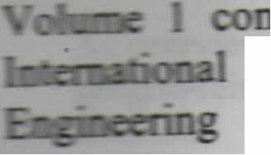
olume 2 of the Proceedings will be published shortly after the conference.
Tbe contributed papers have been divided into four major groups as follows:
•:• Foundations and Slope Stability 9 papers

+ Soil Characterisations . . . . . . . . . . . . . . . . . . . . . . . . . . . . . . . . . . . . . . . . . . . . . . . . . . 1 O papers Earthquake and Geotechnical Engineering.. ... . .. . .. . . . . . . . 12 papers ew Methods in Geotechnical Engineering .. . . .. .. . .. . . . . . 6 papers

Tbe papers in all four groups have a balance between theoretical analyses and experimental observations. It is expected that these papers will contribute to vigorous constructive ctiscussion for future development in various areas of geotechnical engineering.

1banks are due to the Intemational Advisory Board members and fellow colleagues for reviewing the abstracts followed by full papers submitted for presentation.
e would also like to thank the Founding President of Near East University, Dr. Suat İ.
Günsel, the President Prof. Dr. Ümit Hassan, Vice Presidents Prof. Dr. Şenol Bektaş and Prof. Dr. Fahreddin M. Sadıkoğlu for their support and assistance.
Editors
C. Atalar, B.M. Das, A. Sağlamer, E. Toğrol

TABLE OF CONTENTS
iew on the estimation of bearing capacity of shallow foundations on
~inforced sand (keynote) O 1
&Jıl. Das
Dcsign methods of pile foundations (keynote) 25
P.S. Seco E Pinto
A deformation-based method to estimate actual lateral loading on anchored walls 45
S.F. Çinicioğlu 1. Bozbey, F. Koçyiğit
Stability analysis and field monitoring of geotextile tube in east coast in Korea 53
E.C. Shin, J.I. Kim, Y.I. Oh
Computer-assisted jet grout parameter selection 61
H. Çanakçı, B. Mahmutluoğlu
Stress-strain behaviour of soft soils under embankment loading 67
S. Öztoprak; S.F. Çinicioğlu
Reinforcement of existing slopes using high strength geotextiles with drainage capability 75
T.F. Zimmie, A. Pamuk, K Adalier and MB. Mahmud
umerical analysis of settlement of piled foundations 83
E. Çeçen, S. Sert, A. önalp
A new approach for predicting the swelling behaviour of expansive clays in tunnelling 89
M Barla, S. Ferrero, G. Barla
SOIL CHARACTERISATION
lmportance of stress-strain behaviour in planning soil investigation (keynote) 97
E. Toğrol
Relationship between soil water characteristics curve and some properties of Siran-1
(Turkey) clay 105
M. Aytekin.E. Nas, B. ikizler
Geotechnical properties ofthe Quatemaıy alluvium at the south of Bolu Province, Turkey 113
K Ulamis, R. Kılıç
Jhe effect of pollution on microstructural and physical properties of heated clays 121
G. Yılmaz, E. Toğrol
porosity on hydraulic conductivity in sand-clay mixtures 129
Mh6C. E. Vallejo
ofkaolinite/zeolite tiners for landfills 137
_ 6-q, H Koyuncu, G. Yılmaz

1
·-
Estimating the compressive and shear strength parameters of cohesive soils from P-wave
velocity 145
S. Kahraman, Y. Bay, O. Günaydın, M Fener
Improvement ofa sand matrice using biopolymer-forming bacteria 151
H. Çanakcı, A.F. Çabalar
A new approach to soil classification by the use of CPTU test 157
E. Bol, A. Özocak, A. Önalp
Fly ash - cement - foam mixture as a lightweight fiil material 163
LH Aksoy, ME. Hasal
3.
EARTHQUAKE GEOTECHNICAL ENGINEERING
Evaluation of earthquake hazards on buried pipelines 169
A. Sağlamer, E. Yılmaz, M Balkaya
Behaviour of soft riva clay under high cyclic stresses 177
M Kalafat, Ç. Emrem, H T. Durgunoğlu
Effects of confıning pressure on cyclic behaviour of sand during principal stress axes rotate 185
S. Altun, A.M Ansal
Foundations on geogrid-reinforced soil subjected to cyclic loading 191
B.M Das, C. Atalar
Seismic pressures acting on earth retaining structures 199
A.Doğangün, M Aytekin
The impact of topography on Çay small scale industrial complex earthquake damages
intlicted by 03.02.2002 Eber (Sultandağı) and Çay earthquakes 207
S. Pampal, Ü Soygur, A.H Mutlu
Laboratory model studies to investigate the effect ofbuilding planning on the liquefaction
related failures 213
M Mollamahmutoğlu, Y. Yılmaz
Foundation flexibility effects on nonlinear earthquake response of arch dams 219
M Akkôse, A.A. Dumanoğlu
Numerical analysis of geosynthetic reinforced soil walls with cohesive backfill under
seismic loads 225
E. Güler, MM Demirkan
Harmonic wavelet analysis approach to experimental data 23 l
B. Teymur, S.P. G. Madabhushi ı•
A new approach for dynamic compaction 239
H. Arslan, O. Ertaş, G. Baykal
lnvestigation into the boundary effects of equivalent shear beam container 245
B. Teymur
ii
r
.1
1
-----
---

----

Mı:TBOD iN GEOTECHNICAL ENGINEERING
developments in geotechnical engineering based on large scale field tests in connection
- - Oflbmised ground improvement techniques (keynote) 25 l
Katzenbach, A. Fehsenfeld, M lttershagen
stepped blade revisited 263
A.8irond
f.slimation suction capacity using artifıcial neural network 267
. Kes/cin, H Yıldırım, S. Uzundunikan, T.S. Göksan
n.e effect of reservoir on the earthquake response of concrete-faced rocktill (CFR) dams 273
A. Bayraktar, HB. Başağa, K Hacıefendioğlu
hastic response of suspension bridges for different soils 279
S. At/onur, A.A. Dumanoğlu, M Akköse
Artifıcial neural networks to estimate the shear strength of compacted soil samples 287
S.. Akbulu; E. Kalkan, S. Çelik

