Proceedings

Volume 6
International Conference on Environment : Survival and Sustainability

Organized by Near East University

Published By: EDUCATIONAL FOUNDATION OF NEAR EAST UNIVERSITY
Near East University, tefkosa, Turkish Republic of Northern Cyprus Tel: +90 392 223 64 64
Fax: +90 392 223 64 61
e-mail: info@neu.edu.tr
web: www.neu.edu.tr
Citation: Gok~eku~, H., 2009 (Editor) Proceedings of the International Conference on Environment: Survival and Sustainability. Nicosia (Lefkosa),
Turkish Republic of Northern Cyprus: Educational Foundation of
Near East University. 10 volumes, LXXVI, 5498, XIV pages.
Copyright: Reproduction of this Publication for Educational or other non-commercial purposes is authorized without prior permission from the copyright holder. Reproduction for resale or other commercial purposes prohibited without prior written permission of the copyright holder.
ISBN: Volume 1: 978-975-8359-53-0
Disclaimer: While every effort has been made to ensure the accuracy of the information contained in this publication, the EDUCATIONAL FOUNDATION of the NEAR EAST UNIVERSITY will not assume liability for any use made of the proceedings and the presentation of the participating organisations concerning the legal status of any country, territory, or area, or of its authorities, or concerning the delimitation of its frontiers or boundaries.
Printed by: Near East University Tel: +90 392 223 64 64 Fax: +90 392 223 64 61

Editor: Prof. Dr. Huseyin GOKCEKUS Near East University
Lefkosa,
Turkish Republic of Northern Cyprus ghuseyin@neu.edu. tr. gokcekushuseyin@gmail.com Tel/Fax: 00 90 392 223 54 27
Members of the Editorial Board:
AnwarNASIM
Aysel YONT AR Cyro Do VALLE Derin ORHON
Elchin KHALILOV Giovanni BARROCU Gunnar TELLNES JimLAMEROX
Pakistan TRNC Brasil Turkey Azerbaijan Italy Norway USA
Konstantin V. SUDAKOV Russia
Luc HENS Belgium
Mtmur OZTURK Turkey
Reinhold STEINACKER Austria
Tarzan LEGOVIC Ulric ROTT UmutTURKER Omit HASSAN Vedat DOYURAN Walter KOFLER Zekai SEN
III
Crotia Germany TRNC TRNC Turkey Austria Turkey

International Conference on Environment: Survival and Sustainability 19-24 February 2007 Near East University, Nicosia-Northern Cyprus
CONTENTS
Pages
Editor/Members of the Editorial Board III
Preface VII
Acknowledgments VIII
Organizing Committee Members IX
International Advisory Board Members X
Scientific Committee Members XIII
Messages XVII
·Message from Dr. Suat i.Gunsel, Honorary President of the Conference ·Message from Prof.Dr. Huseyin Gokcekus, President of the Conference
Opening Speeches XIX
·Prof. Dr. Dmit Hassan, Rector of Near East University, TRNC
·Prof.Dr. Huseyin Gokcekus, President of the Conference & Organizing Committee, TRNC ·Rahmi Ko9, Honorary Chairman & Founding Member ofTURMEPA, TURKEY
-Esref Cerrahoglu, Chairman of Executive Board ofTURMEPA, TURKEY
·Cemal Bulutoglulan, Mayor, Turkish Municipality of Lefkosa, TRNC
-Asim Vehbi, Minister of Environment and Natural Resources, TRNC
·Tahsin Ertugruloglu, Leader of the National Unity Party(UBP), TRNC
·Assoc. Prof.Dr. Turgay Avci, Deputy Prime Minister & Minister of Foreign Affairs ofTRNC -Turkekul Kurttekin, Turkish Ambassador to Lefkosa, TRNC
·Ferdi Sabit Soyer, Prime Minister ofTRNC
·Prof. Dr. Ekmeleddin Ihsanoglu, OIC Secretary General ·Mehmet Ali Talat, President of TRNC
Final Report of the International Conference On Environment: Survival and
Sustainability XXXIX
v

International Conference on Environment: Survival and Sustainability 19-24 February 2007 Near East University, Nicosia-Northern Cyprus
1986
List of Papers and Posters XLIII
Papers and Posters
Volume 1: MT-1: Business and Environment: Redefining Interests 1
Volume 2: MT-2: Conservation and Management of Biodiversity 187
Volume 3: MT-3: Cultural Heritage and Environmental Factors 769
Volume 4: MT-4: Economics, Development and Sustainability 1043
Volume 5: MT-5: Energy and Development: New and Renewable Energy 1673
MT-6: Environment and Health 1953
Volume 6: MT-7: Environmental Awareness, Education, and Lifelong Leaming 2369
MT-8: Environmental Knowledge and Information Systems 2615
MT-9: Environmental Law and Ethics 2807
MT-10: Environmental Organizations: Roles, Problems and Prospects 2895
Volume 7: MT -11: Environmental Science and Technology 2923
MT-12:Global Warming: How Much of A Threat? 3607
Volume 8: MT 13 -Green Factor In Politics 3785
MT-14: Integrated Water Resources Management. 3847
Volume 9: MT-15: International Relations and Environmental Issues 4367
MT-16: Literature and Environmental Awareness 4527
MT-17: Natural and Man-Made Disasters: Emerging Link and Challenges 4587
MT-18: Pesticides In The Environment and Food Commodities 4741
MT-19: The Role of Media: Problems and Challenges 4809
Volume 10: MT-20: Seas, Ecological Balance, and Sustainable Environment. 4915
MT-21: Social and Psychological Dimensions of Environmental Issues 5117
Index I
Brief Information About Near East University XI
Brief Information About Turkish Republic of Northern Cyprus XV
VI

International Conference on Environment: Survival and Sustainability 19-24 February 2007 Near East University, Nicosia-Northern Cyprus
1998
PREFACE
Creating a sustainable and a healthy environment is one of the most important global issues facing mankind today. Therefore, serious consideration should be given to environmental problems and concerted efforts should be made worldwide in order to respond and prevent present and future environmental risks and challenges.
The International Conference on Environment: Survival and Sustainability (ESS 2007) organized by the Near East University between the dates 19 and 24 February 2007 was held in Lefkosa, Turkish Republic of Northern Cyprus. The main objective of this multidisciplinary conference was to gather scientists from all over the world to discuss the overall issue of the environment, to find out sustainable solutions for environmental problems and to identify areas for future collaboration in this matter. The conference brought together 2,052 participants from 108 different countries. During the conference a total of 1,463 papers were presented under 21 different subtopics, representing various scientific disciplines. The topics included environmental law and ethics, environmental knowledge, technology and information systems, media, environmental awareness, education and lifelong learning, the use of literature for environmental awareness and the effects of the green factor in politics and in international relations.
The Scientific Committee of International Conference ESS2007 evaluated all of the 1,463 papers and selected among them 610 papers to be included in The Proceedings of Environment: Survival and Sustainability. The readers will notice the wide range of topics represented by the papers included in the Conference Proceedings.
It is hoped that this book will serve to contribute to increase in awareness towards various environmental issues as well as drawing more attention to the urgency of international cooperation and collaboration in pursuing sustainable environmental management.
Prof. Dr. Huseyin Gokcekus
President of the Conference and the Organizing Committee Vice Rector of the Near East University
Lefko~a-TRNC
18 February 2009
VII

International Conference on Environment: Survival and Sustainability 19-24 February 2007 Near East University, Nicosia-Northern Cyprus
1988
ACKNOWLEDGMENTS
The Organizing Committee of the ESS2007 Conference would like to extend its sincere appreciation to Dr. Suat Gi.insel, the Founding Rector of the Near East University, to Prof. Dr. Ekmeleddin lhsanoglu, General Secretary of the Organization of Islamic Conference and to Prof. Dr. Walter W. Kofler, President of ICSD/IAS for their significant support and encouragement in the conference.
Appreciation is also extended to the chairpersons, the keynote speakers and the presenters of papers in the conference.
We are deeply grateful for the members of the editorial board who have carefully read and recommended the papers for publishing.
We also wish to express our gratitude to numerous individuals for their valuable contribution to the editing process.
Prof. Dr. Hi.iseyin Gokcekus
President of the Conference and the Organizing Committee Vice Rector of the Near East University
Lefko~a-TRNC
VIlI

International Conference on Environment: Survival and Sustainability 19-24 February 2007 Near East University, Nicosia-Northern Cyprus
19!lf!
ORGANIZING COMMITTEE MEMBERS
Honorary President
Dr. Suat i. GUNSEL, Founding Rector of the Near East University
President
Prof. Dr. Hiiseyin GOK<;EKUS, Vice Rector of the Near East University
Members
Prof. Dr. Umit HASSAN, Rector of the Near East University Prof. Dr. Aysel YONTAR
Dr. Hatice GOK<;EKUS (M.D.) Asst. Prof. Dr. Umut TURKER Asst. Prof. Dr. Mesut YAL VA<; Asst. Prof. Dr. Rifat RESATOGLU Asst. Prof. Dr. Mehmet OKCAN Asst. Prof. Dr. Dudu OZKUM Asst. Prof. Dr. Salih GUCEL
irfan GUNSEL
Giirdal HUDAOGLU
Havva ARSLANGAZi
Tiimer GARiP
AlpOZERK
Ahmet SA V ASAN
Nesrin MENEMENCi
Sakir ALEMDAR
Zebra BASARAN
Temel RIZZA
Emel TOZLU ASLAN Sifa ABiK
IX

International Conference on Environment: Survival and Sustainability 19-24 February 2007 Near East University, Nicosia-Northern Cyprus
INTERNATIONAL ADVISORY BOARD MEMBERS
A. I., OLAYINKA A., JAGADEESH Abdul, KHA.KEE
Abdullahi Elmi, MOHAMED
Agustin Gonzales Fontes de, ALBORNOZ Ajmal, KHAN
Aleh, RODZKIN
Alex, CHENG
Ayman Abou, HADID Ane, DONMEZER Aziz, ERTUN<;
Belay, TEGENE Cagatay, GULER Dana, KOLEVSKA Ed, BOLES
Elizabeth, GONZALEZ Elizabeth, THOMAS-HOPE Ersi, ABACI KALFOGLU Filiz, DILEK
Furkat, KHASSANOV Gaudelia A., REYES George, CONSTANTINOU George, PETRIDES Giinay, KOCASOY
Guntis, BRUMELIS Halime, PAKSOY Hallvard, ODEGAARD
Nigeria India Germany Somalia
Spain Pakistan Belarus
USA Egypt Turkey Turkey Ethiopya Turkey Macedonia Belize
Uruguay
Jamaica
Turkey Turkey Uzbekistan Philippines Cyprus Cyprus Turkey Latvia
Turkey Norway
x

Turkey
Turkey
Bahrain
Qatar
Turkey
Belgium
Namibia
Malawi
Morocco
Malaysia
Turkey
Jordan
Spain
Netherland
Zimbabwe
Guyana
Iran
Jordan
Lebanon
Turkey
Turkey
Turkey
Turkey
Palestine
Palestine
Austria
Armenia
Ireland
Turkey
Turkey
XI
International Conference on Environment: Survival and Sustainability 19-24 February 2007 Near East University, Nicosia-Northern Cyprus
l98~
Hasan, ERTEN Hunay, EVLIYA
Ibrahim Abdel Gelil Said, ABDULA Ibrahlm S., ALNAIMI
irfan, GUNEY
Jaco, V ANGRONSVELD Joe, LEWIS
John, SAKA
Lyoussi, BADIAA
M. Nasir, SHAMSUDIN Mahmut Parlak, TUNA Mannar, FAYYAD Manuel Benito, CRESPO Marcel, STIVE Margaret, ZIMBA
Mark, BYNOE
Mohsen, HOSSEINI Moneef R., ZOU'BI Mutasem, EL-FADEL Neset, KILIN<;ER Nilkhet, TURGUT Orban, ALT AN
Peyman, Y AL<;IN Qasem Abdul, JABER Ramzi, SANSUR Reinhold, STEINACKER Renee, RICHER Richard, MOLES
Safak, URAL
Selim, KAPUR

International Conference on Environment: Survival and Sustainability 19-24 February 2007 Near East University, Nicosia-Northern Cyprus
1968
Serpil, OPPERMAN | Turkey
Seval, SOZEN | Turkey
Sevgi, SARYAL | Turkey
Skender, OSMAN! | Albania
Songiil A., V AIZOGLU | Turkey
Tarzan, LEGOVIC | Croitia
Tetsuo, YUHARA | Japan
Tuluhan, YILMAZ | Turkey
Turan, OZTURAN | Turkey
Umit, ERDEM | Turkey
Valentina, Y ANKO-HOMBACH | Canada
Waleed Khalil, ZUBARI | Bahrain
Yigal, RONEN | Israel
Zekai, SEN | Turkey
Zohra Ben, LAKHDAR | Tunisia
XII

International Conference on Environment: Survival and Sustainability 19-24 February 2007 Near East University, Nicosia-Northern Cyprus
1Q8H
SCIENTIFIC COMMITTEE MEMBERS
Ferid, MURAD - Nobel Laureate Richard R., ERNST - Nobel Laureate Yuan T., LEE - Nobel Laureate
USA
Switzerland
Taiwan
A.H.,ZAKRI
Ahmad, MARRAKCHI Alexey Arkady, VOINOV Andrea E., RIZZOLI Andrew, BROOKES
Anne, BUTTIMER Anthony J., JAKEMAN Anwar, NASIM
Barry W., WILSON
Bjarne Bruun, JENSEN Branimir, JOV ANCICEVIC Charles N ., ALPERS
Dan C.C., GALERIU
David A., ST AH
Derin, ORHON
Elchin, KHALILOV
Eric, JOHNSON
Esteban G., JOBBAGY Fabian M., JAKSIC
Farhat M., ALI Frederick.LB., KAY AN JA Gabriele, VOIGT Galip,AKAY
G-C.,FANG
Malaysia Tunisia
USA
Switzerland Australia
Ireland Australia Pakistan
USA
Denmark
Serbia and Montenegro USA
Romania
USA
Turkey Azerbaijan Switzerland Argentina Chile
Pakistan
Uganda Austria
UK
Taiwan
XIII

International Conference on Environment: Survival and Sustainability 19-24 February 2007 Near East University, Nicosia-Northern Cyprus
l9!J8
Geoff, BERTRAM George G., LUNT Gerald, LALOR Germano, MW ABU Giovanni, BARROCU Girja K., SHUKLA Gopal B., THAPA Hanwant B., SINGH Hartmut, FRANK Heila, LOTZ-SISITKA Helen, SCHNEIDER Hillel S., KOREN Hiromi, YAMASHITA Holmes, ROLSTON Hruska, JAKUB
Irena, TW ARDOWSKA Isfaq, AHMAD J.F.Santos, OLIVEIRA James, DEVILLERS Jaroslav, BOHAC Jennifer, BROWN Jianping, WU
Jim C., BRIDEN
John, DAISH
John, GREGORY
John, HOSKINS
Judith T., ZELIKOFF Jyrki, LIESIVUORI Kaku,NOKOE
Kenneth N., TIMMIS
New Zealand
UK
Jamaica
Kenya
Italy
India
Thailand
USA
Germany
South Africa
South Africa
USA
UK
USA
Chezch Republic
Poland
Pakistan
Portugal
France
Chezch Republic
New Zealand
China
UK
New Zealand
UK
U.K
USA
Finland
Ghana
Germany
XIV

International Conference on Environment: Survival and Sustainability 19-24 February 2007 Near East University, Nicosia-Northern Cyprus
Kristine, W ALRAEVENS Kyaw Tha, PAW U Kyoung-Woong, KIM Luc, HENS
M. Shamsher, ALI Mamdouh, NOUH Manzoor, QADIR Marcel, ARNOULD Marcial, BLONDET Martha C., MONROE Mary, SEELY Mehmet, ERGIN Michael, WILHELM Miiniir, OZTURK Muthana, SHANSHAL Nairn H., AFGAN
Nicholas, MASCIE-TAYLOR Nicholas, ORNSTON Norhayati Mohd, TAHIR Pall, HERSTEINSSON Patricia, MAURICE
Paul W., JOWITT
Paulo B., LOURENCO
Peter, BRIMBLECOMBE Peter, KRUMBIEGEL
Peter, NOV AK
Philip E., LAMOREAUX Philip M., FEARNSIDE Ravi, JAIN
Richard, ROBINS
Belgium
USA
Korea
Belgium
Bangladesh
UAE
Syria
France
Peru
USA
Namibia
Turkey
Germany
Turkey
Iraq
Portugal
UK
USA
Malaysia
Iceland
UK
UK
Portugal
UK
Germany
Slovenia
USA
Brazil
Australia
France
xv

International Conference on Environment: Survival and Sustainability 19-24 February 2007 Near East University, Nicosia-Northern Cyprus
1988
Robert J., LETCHER | Canada
Robert, GIFFORD | Canada
Roberto, DANOV ARO | Italy
Saffa B., RIFFAT | UK
Sam,KACEW | Canada
Sandor,.KERE.KES | Hungary
Scott, SLOVIC | USA
Sevket, DURUCAN | UK
Shafiqul I., BHUIYAN | Bangladesh
Shahamat U., KHAN | USA
Shian-chee, WU | Taiwan
Siaka, SIDIBE | Mali
Stephen P., MCCARTHY | USA
Tarzan, LEGOVIC | Croatia
Tomasz, ZYLICZ | Poland
Ulric, ROTT | Germany
Vedat, DOYURAN | Turkey
Victor G., PRIETO | USA
Walid A., ABDERRAHMAN | Saudi Arabia
Walter, KOFLER | Austria
William.J., MANNING | USA
Wiranto, ARISMUNANDAR | Indonesia
Zhihong, XU | Australia
XVI

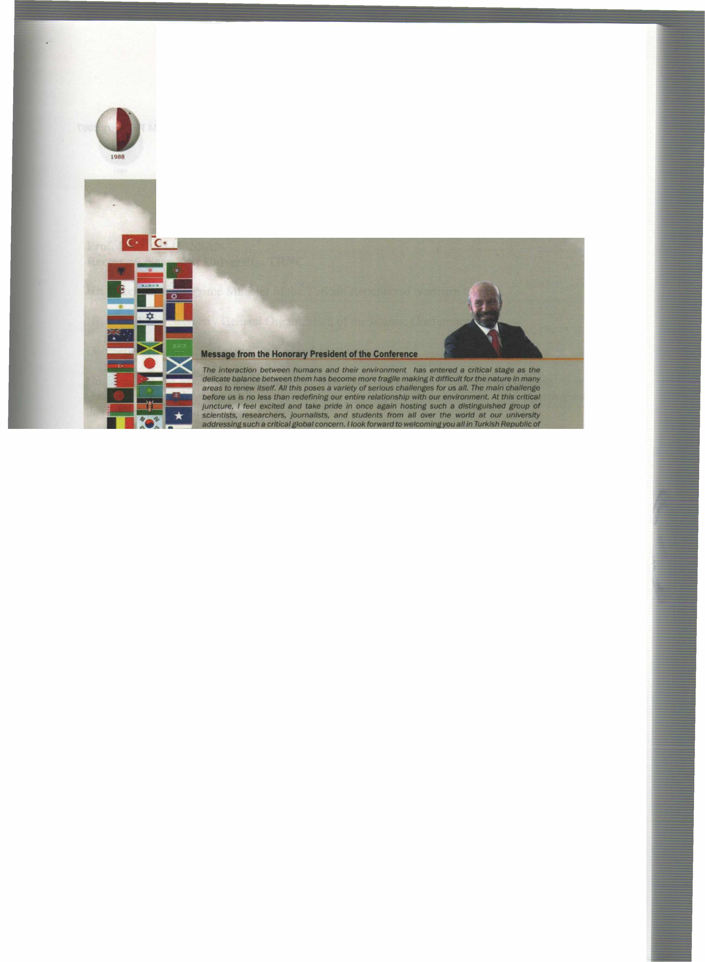
International Conference on Environment: Survival and Sustainability 19-24 February 2007 Near East University, Nicosia-Northern Cyprus
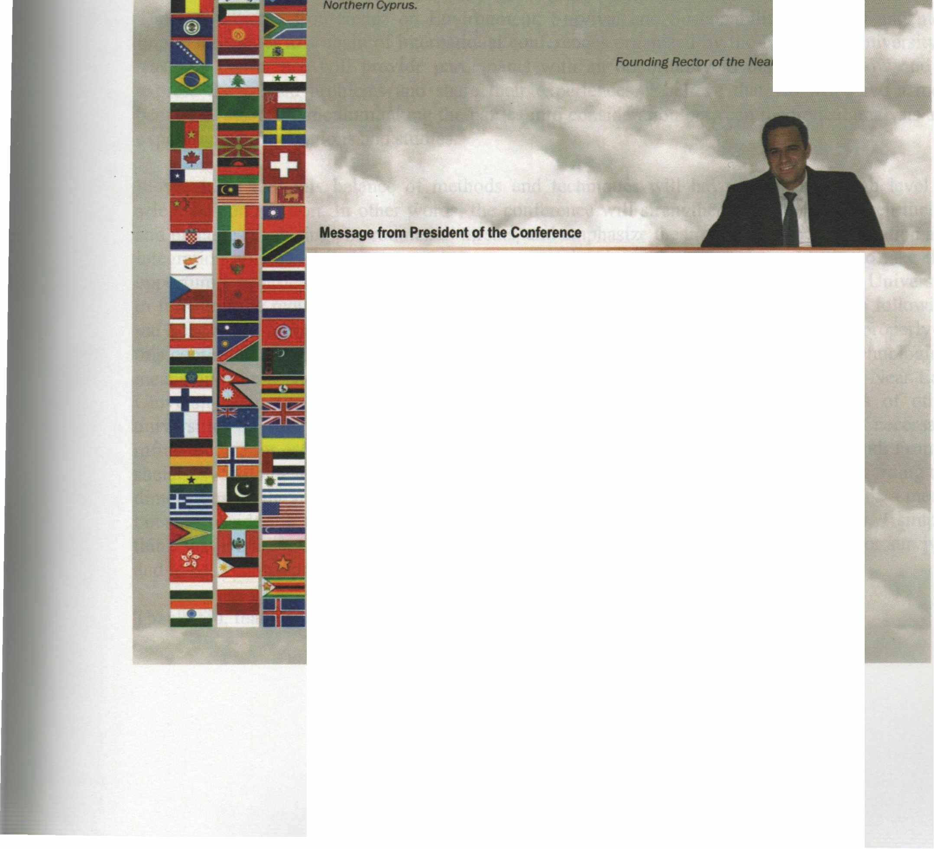

It gives me the utmost pleasure in welcoming you all to the lflflemational Conference • Environment: Survival and Sustainability" here at the Near East Unltlerslty In Tlllf<Jsh Republic of Northern C)'ptus ID be held at 19-24 February 2007.
The c:onl8f'elice aimed at brlnflfllt together more than 2,000 scholars and researchers from over 90 countries lllOUlld the world IO discuss envlt'onlnental issues from a variety of perspectives; iindetllne rtNtImportance of the need for UIJ(enCy in taking steps by the intemationat Of.......,..., --. local authorlries and non-governmental organizations to move to a sustelnable 8flWDr.menVdellelopmentmodel; and thereby makes Its contribution to worldwide debate effort on .,.,_,,..,,llilfChe brldfe .between tlleot)I and practJce In meeting environmental threats/challenges.
Since our last lnlematlonal cordMNICe on environment. "EIMtonmentel Problems of the Mediterranean Regions•, worldwldaetMrorlmental disasters• well• local-~ mu/flplled and environmental degradation and polluflon has continued. Whlle majorltrides INMI a-n made In the world In analyzing. understandiflll and Informing the pub/le 8llout Ille ~ cllaHenges we are facing. we st/II have a IOnilf way to go. Our way at life Is still far from• 8Ultaltlllble model and our environment continues to degrade and deteriorate due to human activities. The consequences can be seen In worldwide environmental disasters as well as locally In our dally /Ives.
This Is fOlfll to be our third lntematiollal conference on Environment organized by our youn.r university since It was estBblished In 1988.
Yours sincerely, Pref.Dr . .....,...~ Jlice Rector of the Near East Universitv
XVII

International Conference on Environment: Survival and Sustainability 19-24 February 2007 Near East University, Nicosia-Northern Cyprus
\J
l96H
VOLUME6
MT-7: ENVIRONMENTAL AWARENESS, EDUCATION, AND LIFELONG LEARNING
ENVIRONMENTAL AWARENESS, EDUCATION AND LIFE-LONG LEARNING BANGLADESH
M Shamsher Ali - BANGLADESH (Invited) 2369
SEEKING ENVIRONMENT AL AWARENESS IN POSTMODERN FICTIONS
Serpil Opperman -TURKEY (Invited) 2375
ENVIRONMENTAL EDUCATION IN BOSNIA AND HERZEGOVINA STATUS, VISIONS AND NEEDS
: Azra Jaganjac, Sanda Midzic-Kurtagic, Paul Ravn Jepsen, Zalkida Hadzibegovic -
DENMARK, BOSNIA AND HERZEGOVINA (Oral) 2387
I
VOCATIONAL EDUCATION AND SUSTAINABLE DEVELOPMENT: EXPLORING THE CONNECTIONS
Alberto Arenas - USA (Oral) 2395
ENVIRONMENTAL AW ARNESS, EDUCATION AND LIFE LEARNING
Devrim. Y. Besim - NORTHERN CYPRUS (Oral) 2417
UNIVERSITY STUDENTS' VIEWS ABOUT A COURSE ON THE SUSTAINABLE DEVELOPMENT: RESULTS OF A NEED ANALYSIS STUDY
Mehmet Erdogan, Gaye Tuncer-TURKEY (Oral) 2421
USING OUTDOOR THEATRE FOR ENVIRONMENTAL AWARENESS, EDUCATION AND LIFELONG LEARNING AT THE MOUNT CAMEROON ECO-REGION, CAMEROON
Edwin Njeba Nganji - CAMEROON (Oral) 2435
A PROPOSAL FOR AN ENVIRONMENTAL EDUCATION MODEL AIMING AT SUSTAINABLE DEVELOPMENT
Oguz Ozdemir, Muammer Tuna - TURKEY (Oral) 2441
UNITED NATIONS DECADE OF EDUCATION FOR SUSTAINABLE DEVELOPMENT (2005-2014): THE INITIATIVES OVERSEEN BY THE ITALIAN NATIONAL COMMISSION
Anna Re- ITALY (Oral) 2451
IMBIBING ENVIRONMENT AL AWARENESS IN SOCIETIES
Beyza Sat Gungor-TURKEY (Oral) 2461
F. NIETZSCHE AND MARTIN HEIDEGGER: BUILDING UP AN ECOPHILOSOPHICAL OUTLOOK
Ayten Sururi - NORTHERN CYPRUS (Oral} 2471
ECOLOGISTS' TRAINING IN FUEL ENERGY AND CHEMISTRY TECHNOLOGY SPHERE IN AZERBAIJAN STATE OIL ACADEMY
Qarayev Si ya vu sh F arkhad, Akhmedov Zaur Musa - AZERBAIJAN (Oral) 24 79
PERCEPTION OF ECOLOGICAL RISKS AS AN ESSENTIAL ASPECT OF ECOLOGICAL CONSCIOUSNESS
Smolova Lidia- RUSSIA (Oral) 2485
AGENTS OF SUSTAINABILITY AND ISSUES IN IMPLEMENTATION OF SUSTAINABILITY PROJECTS
Nerkis Kura! -TURKEY (Oral) 2497
STUDENTS' USAGE LEVEL OF ENVIRONMENT AL ATTITUDES AND USAGE LEVEL OF ENVIRONMENT AL COGNITIVE KNOWLEDGE IN FIFTH GRADE OF THE TURKISH BASIC SCHOOLS
Tugrul Ural, Eren Sankaya - TURKEY (Oral) 2505
LVIII

International Conference on Environment: Survival and Sustainability 19-24 February 2007 Near East University, Nicosia-Northern Cyprus
THE EFFECTIVENESS OF ENVIRONMENTAL EDUCATION ON ENVIRONMENTALLY- SENSITIVE BEHAVIORS
Gamze Yucel Isildar, Feriha Y1ldmm-TURKEY (Oral) 2517
A STUDY ON THE UTILIZATION OF THE TECHNOLOGICAL MATERIALS USED IN SCIENCE CLASSES BY TEACHERS IN ELEMENTARY SCHOOLS
Mahmut San-TURKEY (Oral) 2527
THE RELATIONSHIP BETWEEN THE PLACES WHERE PEOPLE LIVE AND THEIR QUALITY OF LIVING IN TRNC
Hakan Atamtilrk- NORTHERN CYPRUS (Oral) 2533
THE EVALUATION OF ENVIRONMENT AL PERCEPTIONS OF THE STUDENTS AND TEACHERS OF A SECONDARY SCHOOL IN ANKARA
F. Sevencan, F. Temel, G. Boztas, S. Vaizoglu -TURKEY (Oral) 2539
EDUCATION FOR SUSTAINABLE DEVELOPMENT: TRANSFORMING LEARNING INTO REAL LIFE ACTIONS:
EXPERIMENTING ACTION-BASED LEARNING MODEL (ALM) AT ELEMENT ARY SCHOOL LEVEL IN THE CONTEXT OF PAKISTAN
Qamar Shahid Siddiqui - P AKI ST AN (Oral) 2543
CHILDREN'S CURIOSITY ON ENVIRONMENTAL ISSUES: TURKISH CASE
Mehmet Erdogan, Murat Aydemir -TURKEY (Oral) 2549
PROMOTION OF NURSERY SCHOOL TEACHER AND JUNIOR GRADE TEACHER EDUCATION FOR ENVIRONMENT AND SUSTAINABLE DEVELOPMENT IN CROATIA
Vinka Uzelac, Aleksandra Pejcic, Dunja Andie - CROATIA 2559
LIFELONG LEARNING AS NEW PARADIGM OF EDUCATION FOR ENVIRONMENT AND SUSTAINABLE DEVELOPMENT WITHIN THE CONTEXT OF PROFESSIONAL IMPROVEMENT OF TEACHERS ORIENT A TED TOW ARDS DIRECT RESEARCH OF EDUCATIONAL PRACTICE
Lidija Vujicic - CROATIA (Oral) 2569
STANDPOINTS OF PARENTS AND EDUCATORS TOW ARDS TASKS OF ENVIRONMENTAL EDUCATION IN KINDER GAR TEN
Jurka Lepicnik Vodopivec - SLOVENIA (Oral) 2575
ECOLOGICAL EDUCATION IN INTERRELATION WITH EDUCATION FOR SUSTAINABLE DEVELOPMENT
Gagik Torosyan -ARMENIA (Oral) 2585
A COMPARATIVE STUDY OF TEACHER'S ATTITUDES TOWARDS ENVIRONMENTAL ISSUES
Cem Birol, Zafer Bekirogullari, Ceren Paralik- NORTHERN CYPRUS (Oral) 2591
EVALUATION OF THE ENVIRONMENT PROTECTION EDUCATION PROJECTS IN THE SPECIALLY PROTECTED AREAS
Nairn Uzun, Funda Varnaci - TURKEY (Poster) 2603
CHILDREN EDUCATION: FOUNDATION FOR GREEN FUTURE
Maryam Salek Zamani, Ali Salek Zamani, Yagub Salek Zamani - IRAN (Poster) : 2613
__ ___.,
LIX

International Conference on Environment: Survival and Sustainability 19-24 February 2007 Near East University, Nicosia-Northern Cyprus
1986
MT-8; ENVIRONMENTAL KNOWLEDGE AND INFORMATION SYSTEMS
SURVEY OF NATURAL RESOURCES IN THE BASIN OF KUFRINJA VALLEY AND INVESTMENT BY USING TECHNIQUE OF REMOTE SENSING
Aiad Ashor Altaay, Ali Abdual'Zeahrah Alwaily, Mohammad Yousif al Hity - IRAQ (Oral) 2615
----
AUTOMATED VERSUS MANUAL LINEAMENT ANALYSIS .•.
Gulcan Sarp, Vedat Toprak-TURKEY (Oral) 2631
EFFECTS OF TELECOMMUTING ON SUSTAINABLE URBAN DEVELOPMENT AND ENVIRONMENT
Filiz Alkan Me~hur-TURKEY (Oral) 2647
HISTORICAL DEVELOPMENT OF THE MERIC RIVER DEL TA: FROM 16TH CENTURY TO PRESENT
Cankut Ormeci, Semih Ekercin -TURKEY (Oral) 2657
MUL TITEMPORAL CHANGE DETECTION AT THE SALT LAKE IN TURKEY USING REAL-TIME SPOT IMAGERY AND IN-SITU SPECTRAL MEASUREMENTS
Cankut Ormeci, Semih Ekercin - TURKEY (Oral) 2667
AN INTELLIGENT SYSTEM FOR INTEGRATED SOLID WASTE MANAGEMENT
Latifah Abd Manaf- MALAYSIA (Oral) 2675
GIS BASED RISK QUALITY OBSERVATION ANALYSIS AT GEDIZ BASIN IN IZMIR METROPOLITAN MUNICIPALITY BOUNDARY
Vildan Gundogdu, Mi.inevver Elele, Gozde Akgi.in -TURKEY (Oral) 2687
REHABILITATION OF ASBESTOS M~G WASTE: A REHABILITATION PRIORITISATION INDEX (RPI) FOR SOUTH AFRICA
L. van Rensburg, S. Claassens, J.J. Bezuidenhout, P.J. Jansen van Rensburg - SOUTH AFRICA (Oral) 2701
A CASE STUDY ON OPTIMAL LAND USE OF SELCUK (IZMIR) AND ITS ARROUND
Emine Zaimoglu, Umit Erdem-TURKEY (Oral) 2711
DEFINING LAND COVER TYPE OF EDREMIT REGION IN TURKEY BY USING OPTICAL AND RADAR FUSED IMAGES
Y. Kurucu, F. Balik Sanli, M.T. Esetlili -TURKEY (Oral) 2727
SOIL CLASSIFICATION STUDY USING GEOMORPHOLOGIC BASED METHOD CASE STUDY: ZIDASHT REGION, IRAN
Mohsen Maleki, Marzieh Mosayebi- IRAN (Oral) 2739
A NATIONAL MONITORING SYSTEM FOR RANGE ASSESSMENT IN IRAN
H. Arzani, M. Frahpour, M. Azimi, H. Mirdavodi, M.Borhani, J. Abdollahi- IRAN (Oral) 2747
AIRBORNE HYPERSPECTRAL IMAGING SYSTEM FOR MANAGEMENT AND CONSERVATION OF MOUNTAIN FOREST PARK IN KELANTAN, MALAYSIA
Kamaruzaman Jusoff, Dahlan Taha - MALAYSIA (Oral) 2761
STUDY OF ENVIRONMENTAL DEGRADATION AROUND THE JAJRUD RIVER USING GEOGRAPHICAL INFORMATION SYSTEM AND REMOTE SENSING
Ammar Rafiei Emam- IRAN (Oral) 2769
PROPOSED STRATEGY FOR EST AB LIS HING A TURKISH ENVIRONMENT AL INFORMATION EXCHANGE NETWORK
Mehmet Karaoglan , Mustafa Aydin, Ozlern Esengin -TURKEY (Oral) 2775
A DECISION SUPPORT SYSTEM FOR WATER RESOURCES MANAGEMENT
D. Ouazar, M. Touji, M.D. Hasnaoui- MOROCCO (Oral) 2785
LX

International Conference on Environment: Survival and Sustainability 19-24 February 2007 Near East University, Nicosia-Northern Cyprus
ENVIRONMENTAL INSITE: AN ENVIRONMENTAL INFORMATION SYSTEM USED FOR ASSESSING GROUNDWATER QUALITY IN MERSIN
Zeynel Demi rel, Zafer Ozer, Olcay Gulcicek, Aylin Kaya - TURKEY (Poster) 2793
MT-9: ENVIRONMENTAL LAW AND ETHICS
THE EUROPEAN HUMAN RIGHTS COURT AND ENVIRONMENTAL PROTECTION
Niikhet Yilmaz Turgut - TURKEY (Invited) 2807
ENVIRONMENT AL LAW AND FOREST LEGISLATION IN IRAN
S. Mohsen Hosseini, Moslem Akbarinia - IRAN (Invited) 2823
LIABILITY OF THE POLLUTANT: CRIMINAL & CIVIL
Emel Badur, Burcu Ertem -TURKEY (Oral) 2833
ENVIRONMENTAL RIGHT IN TURKISH CONSTITUTIONAL LAW
Funda Cetindag, llker Kihc - TURKEY (Oral) 2845
WHY DO WE CARE? ETHICS AND HONESTY ABOUT ENVIRONMENTAL ISSUES
Sevda Caliskan -TURKEY (Oral) 2853
EVALUATION OF RECENT AMENDMENTS IN ENVIRONMENT LAW
Huriye Kubilay, Meltem Kutlu Giirsel, Muhlis Ogiitr;:ii-TURKEY (Oral) 2863
SUSTAINABLE DEVELOPMENT AND ENVIRONMENTAL JUSTICE
Mahir Fisunoglu, Berna Baler Izgi -TURKEY (Oral) 2869
ENVIRONMENTAL LAW AND ETHICS
Ghorban Elmi - IRAN (Oral) 2879
ASSESSING ENVIRONMENT AL IMP ACT ASSESSMENT AN INDIAN CRITIQUE
Nawneet Vibhaw - INDIA (Oral) 2889
MT-10: ENVIRONMENTAL ORGANIZATIONS: ROLES, PROBLEMS AND PROSPECTS
HOW THE ENVIRONMENTAL PROFESSIONALS IN TURKEY PERCEIVE THE "ENVIRONMENT'' AND ACT?
Gamze Yiicel I~ildar-TURKEY (Oral) 2895
THE ROLE OF NON GOVERNMENT AL ORGANIZATIONS IN REALIZATION OF SUSTAINABLE DEVELOPMENT:
TURKISH CASE
ElifKarakurt Tosun, Canturk Caner-TURKEY (Oral) 2907
ENVIRONMENTAL ESTABLISHMENTS AND ORGANIZATION
Aylin Cincinoglu Salici, Nurgiil Konakli, Onur Boyacigil, Faruk Altunkasa -TURKEY (Oral) 2917

LXI

Near East University - TRNC Tel: +90 392 223 6464/460 Tel/Fax: +90 392 223 5427 info@neu.edu.tr - www.neu.edu.tr
VOL 6: ISBN 978-975-8359-58-5
International Conference on
Environment: Survival and Sustainability

