Proceedings

Volume 2
International Conference on Environment : Survival and Sustainability

Organized by Near East University

Published By: EDUCATIONAL FOUNDATION OF NEAR EAST UNIVERSITY
Near East University, Lefkoşa, Turkish Republic of Northern Cyprus Tel: +90 392 223 64 64
Fax: +90 392 223 64 61
e-mail: info@neu.edu.tr
web: www.neu.edu.tr
Citation: Gökçekuş, H., 2009 (Editor) Proceedings of the lnternational Conference on Environment: Survival and Sustainability. Nicosia (Lefkoşa),
Turkish Republic of Northern Cyprus: Educational Foundation of
Near East University. 10 volumes, LXXVI, 5498, XIV pages.
Copyright: Reproduction of this Publication for Educational or other non-commercial purposes is authorized without prior permission from the copyright holder. Reproduction for resale or other commercial purposes prohibited without prior written permission of the copyright holder.
ISBN: Volume 1: 978-975-8359-53-0
Disclaimer: While every effort has been made to ensure the accuracy of the information contained in this publication, the EDUCATIONAL FOUNDATION of the NEAR EAST UNIVERSITY will not assume liability for any use made of the proceedings and the presentation of the participating organisations concerning the legal status of any country, territory, or area, or of its authorities, or concerning the delimitation of its frontiers or boundaries.
Printed by: Near East University Tel: +90 392 223 64 64 Fax: +90 392 223 64 61

Editor: Prof. Dr. Hüseyin GÖKÇEKUŞ Near East University
Lefkoşa,
Turkish Republic ofNorthem Cyprus ghuseyin@neu.edu. tr. gokcekushuseyin@gmail. cam Tel/Fax: 00 90 392 223 54 27
Members of the Editorial Board:
AnwarNASIM
Aysel YONT AR Cyro Do V ALLE Derin ORHON
Elchin KHALILOV Giovanni BARROCU Gunnar TELLNES JimLAMEROX
Pakistan TRNC Brasil Turkey Azerbaijan Italy Norway USA
Konstantin V. SUDAKOV Russia
Luc HENS Belgium
Münür ÖZTÜRK Turkey
Reinhold STEINACKER Austria
Tarzan LEGOVIC Ulric ROTT
Umut TÜRKER Ümit HASSAN Vedat DOYURAN Walter KOFLER Zekai ŞEN
III
Crotia Germany TRNC TRNC Turkey Austria Turkey

International Conference on Environment: Survival and Sustainability 19-24 February 2007 Near East University, Nicosia-Northern Cyprus
CONTENTS
Pages
Editor/Members of the Editorial Board 111
Preface VII
Acknowledgmen ts VIII
Organizing Committee Members IX
lnternational Advisory Board Members X
Scientific Committee Members XIII
Messages XVII
·Message from Dr. Suat İ.Günsel, Honorary President of the Conference ·Message from Prof.Dr. Hüseyin Gökçekuş, President of the Conference
Opening Speeches XIX
·Prof. Dr. Ümit Hassan, Rector of Near East University, TRNC
·Prof.Dr. Hüseyin Gökçekuş, President ofthe Conference & Organizing Committee, TRNC ·Rahmi Koç, Honorary Chairman & Founding Member ofTURMEPA, TURKEY ·EşrefCerrahoğlu, Chairman ofExecutive Board ofTURMEPA, TURKEY
·Cemal Bulutoğluları, Mayor, Turkish Municipality of Lefkoşa, TRNC
·Asım Vehbi, Minister ofEnvironment and Natural Resources, TRNC
·Tahsin Ertuğruloğlu, Leader of the National Unity Party(UBP), TRNC
·Assoc. Prof.Dr. Turgay Avcı, Deputy Prime Minister & Minister of Foreign Affairs ofTRNC ·Türkekul Kurttekin, Turkish Ambassador to Lefkoşa, TRNC
·Ferdi Sabit Soyer, Prime Minister ofTRNC
·Prof. Dr. Ekmeleddin İhsanoğlu, OIC Secretary General ·Mehmet Ali Talat, President of TRNC
Final Report of the International Conference On Environment: Survival and
Sustainability XXXIX
v

International Conference on Environment: Survival and Sustainability 19-24 February 2007 Near East University, Nicosia-Northern Cyprus
1986
List of Papers and Posters XLIII
Papers and Posters
Volume 1: MT-1: Business and Environment: Redefıning Interests 1
Volume 2: MT-2: Conservation and Management ofBiodiversity 187
Volume 3: MT-3: Cultural Heritage and Environmental Factors 769
Volume 4: MT-4: Econornics, Development and Sustainability 1043
Volume 5: MT-5: Energy and Development: New and Renewable Energy 1673
MT-6: Environment and Health 1953
Volume 6: MT-7: Environmental Awareness, Education, and Lifelong Leaming 2369
MT-8: Environmental Knowledge and Information Systems 2615
MT-9: Environmental Law and Ethics 2807
MT-10: Environmental Organizations: Roles, Problems and Prospects 2895
Volume 7: MT -11: Environmental Science and Technology 2923
MT-12:Global Warming: How Much of A Threat? 3607
Volume 8: MT 13 -Green Factor In Politics 3785
MT-14: Integrated Water Resources Management. 3847
Volume 9: MT-15: Intemational Relations and Environmental Issues 4367
MT-16: Literature and Environmental Awareness 4527
MT-17: Natural and Man-Made Disasters: Emerging Link and Challenges 4587
MT-18: Pesticides In The Environment and Food Coınınodities 4741
MT-19: The Role of Media: Problems and Challenges 4809
Volume 10: MT-20: Seas, Ecological Balance, and Sustainable Environment. 4915
MT-21: Social and Psychological Dimensions of Environmental Issues 5117
lndex I
Brief Information About Near East University XI
Brief Information About Turkish Republic of Northern Cyprus XV
VI

International Conference on Environment: Survival and Sustainability 19-24 February 2007 Near East University, Nicosia-Northern Cyprus
1998
PREFACE
Creating a sustainable and a healthy enviromnent is one of the most important global issues facing mankind today. Therefore, serious consideration should be given to enviromnental problems and concerted efforts should be made worldwide in order to respond and prevent present and future enviromnental risks and challenges.
The Intemational Conference on Enviromnent: Survival and Sustainability (ESS 2007) organized by the Near East University between the dates 19 and 24 February 2007 was held in Lefkosa, Turkish Republic of Northem Cyprus. The main objective of this multidisciplinary conference was to gather scientists from all over the world to discuss the overall issue of the enviromnent, to find out sustainable solutions for enviromnental problems and to identify areas for future collaboration in this matter. The conference brought together 2,052 participants from 108 different countries. During the conference a total of 1 ,463 papers were presented under 21 different subtopics, representing various scientific disciplines. The topics included enviromnental law and ethics, enviromnental knowledge, technology and information systems, media, enviromnental awareness, education and lifelong learning, the use of literature for enviromnental awareness and the effects of the green factor in politics and in intemational relations.
The Scientific Committee of Intemational Conference ESS2007 evaluated all of the 1 ,463 papers and selected among them 61 O papers to be included in The Proceedings of Enviromnent: Survival and Sustainability. The readers will notice the wide range of topics represented by the papers included in the Conference Proceedings.
it is hoped that this book will serve to contribute to increase in awareness towards various enviromnental issues as well as drawing more attention to the urgency of intemational cooperation and collaboration in pursuing sustainable enviromnental management.
Prof. Dr. Hüseyin Gökçekuş
President of the Conference and the Organizing Committee Vice Rector of the Near East University
Lefkoşa-TRNC
18 February 2009
VII

International Conference on Environment: Survival and Sustainability 19-24 February 2007 Near East University, Nicosia-Northern Cyprus
1988
ACKNOWLEDGMENTS
The Organizing Committee of the ESS2007 Conference would like to extend its sincere appreciation to Dr. Suat Günsel, the Founding Rector of the Near East University, to Prof. Dr. Ekmeleddin İhsanoğlu, General Secretary of the Organization of Islamic Conference and to Prof. Dr. Walter W. Kofler, President of ICSD/IAS for their significant support and encouragement in the conference.
Appreciation is also extended to the chairpersons, the keynote speakers and the presenters of papers in the conference.
We are deeply grateful for the members of the editorial board who have carefully read and recommended the papers for publishing.
We also wish to express our gratitude to numerous individuals for their valuable contribution to the editing process.
Prof. Dr. Hüseyin Gökçekuş
President of the Conference and the Organizing Committee Vice Rector of the Near East University
Lefkoşa-TRNC
VIlI

International Conference on Environment: Survival and Sustainability 19-24 February 2007 Near East University, Nicosia-Northern Cyprus
ısaa
ORGANIZING COMMITTEE MEMBERS
Honorary President
Dr. Suat İ. GÜNSEL, Founding Rector ofthe Near East University
President
Prof. Dr. Hüseyin GÖKÇEKUŞ, Vice Rector of the Near East University
Members
Prof. Dr. Ümit HASSAN, Rector ofthe Near East University Prof. Dr. Aysel YONTAR
Dr. Hatice GÖKÇEKUŞ (M.D.) Asst. Prof. Dr. Umut TÜRKER Asst. Prof. Dr. Mesut YALVAÇ Asst. Prof. Dr. Rifat REŞATOGLU Asst. Prof. Dr. Mehmet OKCAN Asst. Prof. Dr. Dudu ÖZKUM Asst. Prof. Dr. Salih GÜCEL
İrfan GÜNSEL
Gürdal HÜDAOGLU
Havva ARSLAN GAZİ
Tümer GARİP
Alp ÖZERK
Ahmet SAV AŞAN
Nesrin MENEMENCİ
Şakir ALEMDAR
Zehra BAŞARAN
Temel RIZZA
Emel TOZLU ASLAN Şifa ABİK
IX

Jnternational Conference on Environment: Survival and Sustainability 19-24 February 2007 Near East University, Nicosia-Northern Cyprus
INTERNATIONAL ADVISORY BOARD MEMBERS
A. 1., OLAYINKA A., JAGADEESH Abdul, KHAKEE
Abdullahi Elmi, MOHAMED
Agustin Gonzales Fontes de, ALBORNOZ Ajmal, KHAN
Aleh, RODZKIN
Alex, CHENG
Ayman Abou, HADiD Ayşe, DÖNMEZER Aziz, ERTUNÇ
Belay, TEGENE Çağatay, GÜLER Dana, KOLEVSKA Ed,BOLES
Elizabeth, GONZALEZ Elizabeth, THOMAS-HOPE Ersi, ABACI KALFOGLU Filiz, DiLEK
Furkat, KHASSANOV Gaudelia A., REYES George, CONSTANTINOU George, PETRIDES Günay, KOCASOY
Guntis, BRUMELIS Halime, PAKSOY Hallvard, ODEGAARD
Nigeria India Gerrnany Somalia
Spain Pakistan Belarus
USA Egypt Turkey Turkey Ethiopya Turkey Macedonia Belize
Uruguay
Jamaica
Turkey Turkey Uzbekistan Philippines Cyprus Cyprus Turkey Latvia
Turkey Norway
x

Turkey
Turkey
Bahrain
Qatar
Turkey
Belgium
Namibia
Malawi
Morocco
Malaysia
Turkey
lordan
Spain
Netherland
Zimbabwe
Guyana
Iran
lordan
Lebanon
Turkey
Turkey
Turkey
Turkey
Palestine
Palestine
Austria
Armenia
Ireland
Turkey
Turkey
XI
lnternational Conference on Environment: Survival and Sustainability 19-24 February 2007 Near East University, Nicosia-Northern Cyprus
l98~
Hasan, ERTEN Hunay, EVLiYA
Ibrahim Abdel Gelil Said, ABDULA İbrahim S., ALNAIMI
İrfan, GÜNEY
Jaco, V ANGRONSVELD Joe, LEWIS
John, SAKA
Lyoussi, BADIAA
M. Nasir, SHAMSUDIN Mahmut Parlak, TUNA Mannar, FAYYAD Manuel Benito, CRESPO Marcel, STIVE Margaret, ZIMBA Mark,BYNOE
Mohsen, HOSSEINI Moneef R., ZOU'BI Mutasem, EL-FADEL Neşet, KILINÇER Nükhet, TURGUT Orhan, ALT AN
Peyman, YALÇIN Qasem Abdul, JABER Ramzi, SANSUR Reinhold, STEINACKER Renee, RICHER Richard, MOLES
Şafak, URAL
Selim, KAPUR

International Conference on Environment: Survival and Sustainability 19-24 February 2007 Near East University, Nicosia-Northern Cyprus
1968
Serpil, OPPERMAN | Turkey
Seval, SÖZEN | Turkey
Sevgi, SARYAL | Turkey
Skender, OSMAN! | Albania
Songül A., V AIZOGLU | Turkey
Tarzan, LEGOVIC | Croitia
Tetsuo, YUHARA | Japan
Tuluhan, YILMAZ | Turkey
Turan, ÖZTURAN | Turkey
Ümit, ERDEM | Turkey
Valentina, Y ANKO-HOMBACH | Cana da
Waleed Khalil, ZUBARI | Bahrain
Yigal, RONEN | Israel
Zekai, ŞEN | Turkey
Zohra Ben, LAKHDAR | Tunisia
XII

International Conference on Environment: Survival and Sustainability 19-24 February 2007 Near East University, Nicosia-Northern Cyprus
1Q8H
SCIENTIFIC COMMITTEE MEMBERS
Ferid, MURAD - Nobel Laureate Richard R., ERNST - Nobel Laureate Yuan T., LEE - Nobel Laureate
USA
Switzerland
Taiwan
A.H.,ZAKRI
Ahmad, MARRAKCHI Alexey Arkady, VOINOV Andrea E., RIZZOLI Andrew, BROOKES
Anne, BUTTIMER Anthony J., JAKEMAN Anwar, NASIM
Barry W., WILSON
Bjarne Bruun, JENSEN Branimir, JOV ANCICEVIC Charles N ., ALPERS
Dan C.C., GALERIU
David A., ST AH
Derin, ORHON
Elchin, KHALILOV
Eric, JOHNSON
Esteban G., JOBBAGY Fabian M., JAKSIC
Farhat M., ALI Frederick.I.B., KAY AN JA Gabriele, VOIGT
Galip, AKAY
G-C.,FANG
Malaysia Tunisia
USA
Switzerland Australia
Ireland Australia Pakistan
USA
Denrnark
Serbia and Montenegro USA
Romania
USA
Turkey Azerbaijan Switzerland Argentina Chile
Pakistan
Uganda Austria
UK
Taiwan
XIII

International Conference on Environment: Survival and Sustainability 19-24 February 2007 Near East University, Nicosia-Northern Cyprus
l9!J8
Geoff, BERTRAM George G., LUNT Gerald, LALOR Germano, MW ABU Giovanni, BARROCU Girja K., SHUKLA Gopal B., THAPA Hanwant B., SINGH Hartmut, FRANK Heila, LOTZ-SISITKA Helen, SCHNEIDER Hillel S., KOREN Hiromi, Y AMASHITA Holmes, ROLSTON Hruska, JAKUB
Irena, TW ARDOWSKA lsfaq, AHMAD J.F.Santos, OLIVEIRA James, DEVILLERS Jaroslav, BOHAC Jennifer, BROWN Jianping, WU
Jim C., BRIDEN
John, DAISH
John, GREGORY
John, HOSKINS
Judith T., ZELIKOFF Jyrki, LIESIVUORI Kaku,NOKOE
Kenneth N., TIMMIS
New Zealand
UK
Jamaica
Kenya
Italy
India
Thailand
USA
Germany
South Africa
South Africa
USA
UK
USA
Chezch Republic
Poland
Pakistan
Portugal
France
Chezch Republic
New Zealand
China
UK
New Zealand
UK
U.K
USA
Finland
Ghana
Germany
xıv

International Conference on Environment: Survival and Sustainability 19-24 February 2007 Near East University, Nicosia-Northern Cyprus
Kristine, W ALRAEVENS Kyaw Tha, PAW U Kyoung-Woong, KiM Luc, HENS
M. Shamsher, ALI Mamdouh, NOUH Manzoor, QADIR Marcel, ARNOULD Marcial, BLONDET Martha C., MONROE Mary, SEELY Mehmet, ERGiN Michael, WILHELM Münür, ÖZTÜRK Muthana, SHANSHAL Naim H., AFGAN
Nicholas, MASCIE-TAYLOR Nicholas, ORNSTON Norhayati Mohd, TAHiR Pall, HERSTEINSSON Patricia, MAURICE
Paul W., JOWITT
Paulo B., LOURENCO
Peter, BRIMBLECOMBE Peter, KRUMBIEGEL
Peter, NOV AK
Philip E., LAMOREAUX Philip M., FEARNSIDE Ravi, JAIN
Richard, ROBINS
Belgi um
USA
Korea
Belgium
Bangladesh
UAE
Syria
France
Peru
USA
Namibia
Turkey
Germany
Turkey
Iraq
Portugal
UK
USA
Malaysia
Iceland
UK
UK
Portugal
UK
Germany
Slovenia
USA
Brazil
Australia
France
xv

International Conference on Environment: Survival and Sustainability 19-24 February 2007 Near East University, Nicosia-Nortbern Cyprus
1988
Robert J., LETCHER | Canada
Robert, GIFFORD | Can ada
Roberto, DAN OV ARO | Italy
Saffa B., RIFFAT | UK
Sam,KACEW | Canada
Sandor,.KERE.KES | Hungary
Scott, SLOVIC | USA
Sevket, DURUCAN | UK
Shafiqul 1., BHUIYAN | Bangladesh
Shahamat U., KHAN | USA
Shian-chee, WU | Taiwan
Siaka, SIDIBE | Mali
Stephen P., MCCARTHY | USA
Tarzan, LEGOVIC | Croatia
Tomasz, ZYLICZ | Poland
Ulric, ROTT | Germany
Vedat, DOYURAN | Turkey
Victor G., PRIETO | USA
Walid A., ABDERRAHMAN | Saudi Arabia
Walter, KOFLER | Austria
William.J., MANNING | USA
Wiranto, ARISMUNANDAR | Indonesia
Zhihong, XU | Australia
XVI

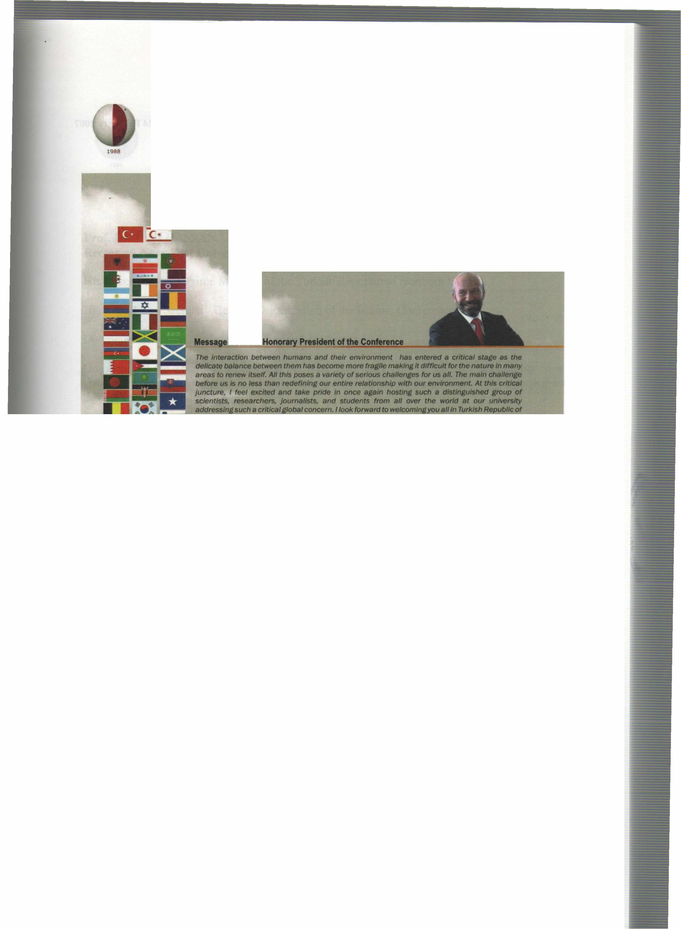
International Conference on Environment: Survival and Sustainability 19-24 February 2007 Near East University, Nicosia-Northern Cyprus
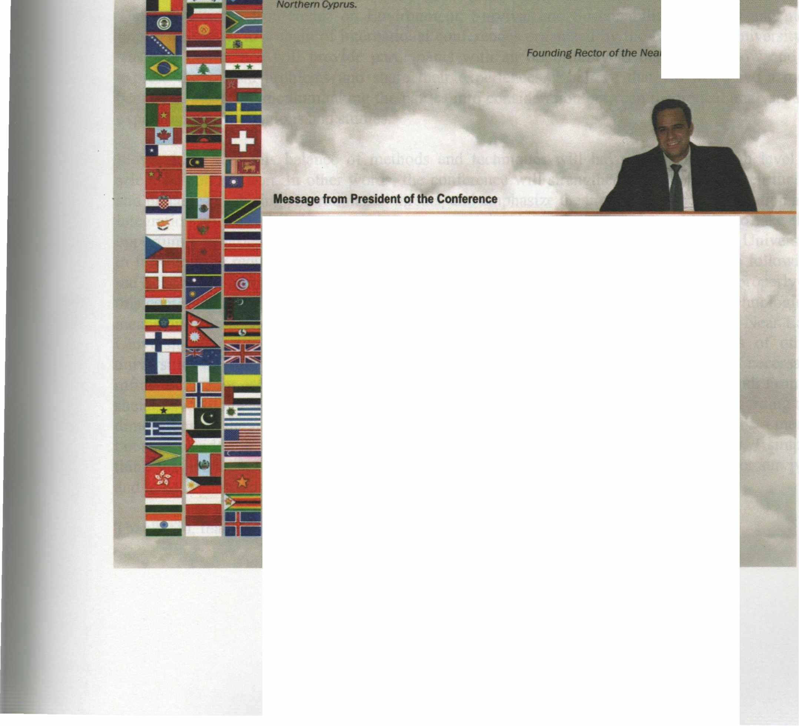
fnımthe

.••••• truly, Dr. lıİlıt ı. Günsel ._ University
it g/ves me the utmost pleasure in welcomlng you al/ to tile lntemational Conference • Etwlronment: Survlva/ and Sustainability" here at the Near East Unlılerslty in Tlllf<Jsh Republic of Norttıem Cyptus ıo be tıeld at 19-24 February 2007.
Trıe c:onllııreııce almed at brlnflng ıogether more than 2,000 scho/ars and researchers from over 90 countrles lllOUlld ttıe world IO dlscuss envlt'onlnental ıssues from a varlety of perspectives; iİndetllne ttıe lmportatıce ot tile need for UIJ(enCy in taklng steps by the intemationat Of.......,..., --. loca/ auttıorlries and non-govemmental organ/zat/ons to move to a sustelnable erMnr.menVdeııelopmentmodel; and thereby makes lts conıribution to worldwide debate effort on .,.,_,,..ılılılfrtıe tırldfe .between tlleot)I and practJce in meeting envfronmentat threafS/challenges.
Since our ıast lntematlonal conftw'elıce on envtronment. "EIMtonmente/ Problems of Uıe Medltenanean Regıons•, worldwldaetMrorımental disasters • well • local-"- muıtlplled and envlronmentat degradation and po/fuflon has contlnued. Whlle majorltrides ,,_ ı-n made in ttıe world in analyzing. understandinf and lnfonnlng the publlc ..,.,.. ille ~ clıaHenges we are facing. we st/11 have a IOtlılf way to go. Our way ot life ıs stil/ far from • 8Ultalnllble model and our envlronment contlnues to degrade and deterioraıe due to human activltles. The consequences can be seen in worldwlde environmental disasters as well as locally in our daily //ves.
Thls ıs fOlfll to be our thlrd lnıemıttiollal conference on Envlronment organlzed by our youn.r unlversltysJnce it was estBblished in 1988.
Yours sJnc:erely, ""'· Dr • .....,... 8ilıçelıııt Vıce Recıor of the Near Eası Universitv
XVII

International Conference on Environment: Survival and Sustainability 19-24 February 2007 Near East University, Nicosia-Northern Cyprus
1988
VOLUME2
MT-2: CONSERVATION AND MANAGEMENT OF BIODIVERSITY
.. - ~
DATA INVENTORY AND MONITORING IN THE COAST AL DUNES OF KAZANLI/ TÜRKİYE A CASE STUDY FOR CONSERVATION PLANNING
K. Tuluhan Yılmaz, Süha Berberoğlu, Halil Çakan, Hakan Alphan, Yüksel İzcankurtarai'ı-TURKEY (lnvited) 187
SEASONAL GROWTH EFFECT ON HYDRAULIC CHARACTERISTICS OF THE MANGROVE EXOECARIA SP IN BA TTICALOA, SRI LANKA
Printhan Manoharan, V. Nimie - SRI LANKA (Oral) 199
CUL TURAL PERSPECTIVE AND BIODIVERSITY CONSERVATION IN UPLAND MOUNTAINS ECOSYSTEMS OF WESTERN GHATS OF INDIA: CHALLENGES & OPPORTUNITIES
Archana Godbole - INDIA (Oral) 221
A POPULATION STUDY OF JOHANNESTEIJSMANNIA LANCEOLATA (ARECACEAE) IN MALA YSIA
Rozainah Mohamad Zakaria - MALA YSIA (Oral) 231
PHYSIOLOGICAL GENETIC BASIS OF RESISTANCE OF SOME DURUM WHEAT (T.DURUM DESF.) V ARIETIES TO DROUGHT
Mehraj Abbov - AZERBAIJAN (Oral) 237
CONSERVATION AND MANAGEMENT OF CROCUS spp.
Hasan Vurdu, İ. Sevinç Kravkaz-TURKEY (Oral) 241
SUSTAINABILITY OF THE LIVE BIRD TRADE IN TANZANIA: QUOTAS AND HARVESTS
Thade Clamsen, Charles Mlingwa - T ANZANIA (Oral) 249
BIODIVERSITY CONSERVATION ISUES IN ANTHROPIZED MARSHLANDS A TWO YEAR STUDY OF INSULA MARE A BRAILEI
Liliana Vasiliu-Oromulu, V. Sanda, Viorica Honciuc, Sanda Maican, Minodora Stanescu, M. Faka, Cristina Munteanu,
Cristina Fiera, M. Dumitru, Daniela Raducu - ROMANIA (Oral) 255
NATIONAL APPROACH TO THE CONVENTION ON BIOLOGICAL DIVERSITY
Ş. Doğanay Yayım -TURKEY (Oral)...................................................................................................................................... 263
SCRUTINIZING THE GEOPHYTES IN TERMS OF BIODIVERSITY
Nilüfer Seyidoğlu, Murat Zencirkıran -TURKEY (Oral) 271
VEGETATION AS A BIOTIC INDICATOR OF SOIL AND WA TER QUALITY IN AKARCA Y BASIN (TURKEY)
Ahmet Serteser, Yılmaz Icaga -TURKEY (Oral) 277
SHORT TERM EFFECTS OF ROY AL JELL YON SPERM QUALITY IN OF JUVENILE RAINBOW TROUT (ONCORHYNCHUS MYKISS W., 1792).
Faruk Aral, Erdinç Şahinöz ,Zafer Doğu-TURKEY (Oral) 287
EVALUA TION OF ALGAL FLORA OF THE INFRALITTORAL ZONE ATA NORTH CYPRUS MARINE ECOSYSTEM
Mehmet Öztürk , Ergün Taşkın, Oğuz Kurt, Salih Güce! TURKEY, NORTHERN CYPRUS - (Oral) ................................•.... 295
DETERMINATION OF SOME REPRODUCTION CHARACTERISTICS IN MAST ACEMBELUS MAST ACEMBELUS (Bank & Solender, 1794) LIVING IN ATATURK DAM LAKE.
Erdinç Şahinöz, Zafer Doğu, Ramazan Şevik, Fara! Aral -TURKEY (Oral) 305
XLIV

International Conference on Environment: Survival and Sustainability 19-24 February 2007 Near East University, Nicosia-Northern Cyprus
CONSERVATION OF BIODIVERSITY IN AGRICUL TURAL LANDSCAPE BY SUSTAINABLE LAND USE IN CONDITIONS OF SW SLOV AKIA
Alexander Feher - SLOV AKIA (Oral) 313
SOME ECOLOGICAL CHARACTERISTICS OF AGROPYRON TRICHOPHORUM IN SUMMER RANGELANDS IN THE NORTH OF IRAN (MAZANDARAN)
Ghasem ali Dianati Tilaki - IRAN (Oral) 325
THE PHYLOGENETIC AND BIOGEOGRAPHIC ANAL YSIS OF HERACLEUM L. (UMBELLIFERAE) OBSERVED FROM ITS DNA SEQUENCE DAT A
Meltem Maras, Aysel Kekıllıoglu -TURKEY (Oral) 329
CITRIC-ACID AND WATER-PRESOAKING ENHANCE SEED GERMINATION OF SCOTS AND ANATOLIAN BLACK PINE
Derya EŞEN, Oktay Yıldız, Aslıhan Kabtan -TURKEY (Oral) 339
ANAL YSIS OF POL YMORPHISM AT THREE MILK PROTEIN GENES IN NATIVE CATTLE BREEDS OF TURKEY AND THEIR USE FOR MANAGEMENT
Havva Dine, Evren Koban, Ebru Saatci, Emel Ozkan, Mesude Iscan, Inci Togan -TURKEY (Oral) 345
THE USE OF CAMERA TRAPS FOR DETERMINING THE PRESENCE OF MEDIUM AND LARGE SIZED MAMMALS IN MARMARIS, TURKEY
Anıl Soyumert, Oksal Macar, Behzat Gürkan -TURKEY (Oral) 353
THE EFFECTS OF LAND USE ON BIOMASS AND CAT ABOLIC DIVERSITY OF SOIL MICROBIAL COMMUNITIES
Mohammad Asghari Pour, A. Rahmani - IRAN (Oral) 359
CONSERVATION AND MANAGEMENT OF BIODIVERSITY: AN INDIAN PERSPECTIVE
Pranav Vyas, Subramanya Sirish Tamvada - INDIA (Oral) 369
EFFECT OF CONSERVATION ON PLANT DIVERSITY IN SEMIARID REGION OF IRAN H.R.
Naseri, Gh. Zehtabian, H. Azarnivand, S. Yousefi Khangah- IRAN (Oral) 379
THE RECOGNITION OF PLANT ASSOCIATIONS AND COMPOSITION ELEMENTS OF SANGCHAL FORESTS OF MAZANDARAN, IRAN
Rouhi-Moghaddarn Einollah, Moslem Akbarinia, Seyed Gholamali Jalali, Seyed Mohsen Hosseini - IRAN (Oral) 387
THE LANDSCAPE IMPLEMENTA TIONS THREA TENING BIODIVERSITY IN URBAN AREAS: SOME SAMPLES OF EASTERN BLACK SEA REGION
Mustafa Var, Emrah Yalçınalp, Müberra Pulatkan -TURKEY (Oral) 393
THE EFFECTS OF PLANT A TION ON BIODIVERSITY AND REGENERA TION OF WOODY SPECIES
Leila Vatani, Moslem Akbarinia- IRAN (Oral) .
399 MAPPING THE BIODIVERSITY OF LAND SNAILS IN TURKEY: A PRELIMINARY STUDY
Ümit Kebapçi, M. Zeki Yildirim - ~y (Oral) 411
A DISCUSSION PAPER ON PROBLEMS, ROOT CAUSES AND SUSTAINABLE USEOF PAKISTAN WETLAND'S BIODIVERSITY
Muhammad Naeem Khan, Zulfiqar Ali, Muhammad Akhtar- PAKISTAN (Oral) : .421
THE MANAGEMENT OF THE MARINE BIODIVERSITY IN GALLIPOLI PENINSULA NA TIONAL HISTORICAL PARK, CANAKKALE-TURKEY
Şükran Cirik, Yeşim Büyükateş, Mehmet Akbulut, Herdem Aslan, Özgür Emek İnanmaz, Ekrem Şanver Çelık, Suat Ateş, Özgür Cengız, emine ş. Okudan, İlknur Ak, Ali İşmen, Çiğdem Yığın, Füsun Erkan Yurdabak, Muhammet Türkoğlu, Uğur Özekıncı, Özcan Özen, Deniz Anıl Odabaşı, Fikret Çakır, Pınar İşmen, Sezginer Tunçer, Mustafa Alpaslan, Alkan Öztekın, Serkan Özden
-TURKEY (Oral) .439
XLV

lnternational Conference on Environment: Survival and Sustainability 19-24 February 2007 Near East University, Nicosia-Northern Cyprus
19!38
SALINITY EFFECTS ON GROWTH AND STOMAT AL BERA VIOUR IN STRA WBERR Y PLANTS
Ece Turhan, Atilla Eris -TURKEY (Oral) 453
ANTIOXIDATIVE ENZYME AC'TJVITIES IN ONION (ALLJUM CEPA L.) GENOTYPES
Ece Turhan, Hatice Gulen,Ahmet ipek, Atilla Eris -TURKEY (Oral) .459
CLUSTERING OF SOME LOCAL COMMON BEAN PHASEOLUS VULGARIS.L.) GENOTYPES BASED ON CARBOHYDRA TE MET ABOLISM
Nezihe Koksal, Ece Turhan, Ahmet ipek, Hatice Gulen, Atilla Eris -TURKEY (Oral) .467
THE NEED FOR CONSERV ATION OF AFROMONTANE RAINFORESTS WITH THE OCCURRENCE OF WILD COFFEA ARABICA POPULA TIONS IN ETHIOPIA
Feyera Senbeta, Tadesse Woldemariam, Manfred Denich, Sebsebe Deınissew - ETHİOPİA (Oral) .4 75
DOCUMENTING AND COMPARING PLANT SPECIES DIVERSITY BY USING NUMERICAL AND PARAMETRIC METHODS IN KHAJE KALAT, NE IRAN
H. Ejtehadi, R. Soltani, H. Zahedi Pour- IRAN (Oral) 487
ENVIRONMENT EFFECT ON HETEROSIS EXPRESSION
M. Sehabi, L. Mekliche -ALGERİA (Oral) 493
EXPERIENCES WITH F AST GROWING FOREST TREE SPECIES
S. Ayan, A. Sıvacıoğlu -TURKEY (Oral) 501
FRAMEWORK FOR EV ALUA TION OF BIODJVERSITY SERVICES: PROBLEMS AND PROSPECTS
Nandkishor More- INDIA (Oral) 515
CONSERVATION OF BIOLOGICAL DIVERSITY IN THE WORLD ANDIN TURKEY
Zuhal Dilaver-TURKEY (Oral) 521
SHOULD (EUROPEAN) TREES HAVE STANDING? IMPROVING ACCESS TO THE COMMUNITY JUDJCATURE THROUGH IMPLEMENTATION OF THE AARHUS CONVENTION
Grainne Gilmore - IRELAND (Oral) 529
IN VITRO SHOOT REGENERATION OF IRONWORT (SIDERITIS STRICTA BOISS & HELDR.)
Dudu Özkum, Rukiye Tıpırdamaz - NORTHERN CYPRUS, TURKEY (Oral) 537
BIODIVERSITY OF THE SPECIES BELONGING TO TRJGONELLA L.
Z. 1. Mammadova - AZERBAJJAN (Oral) 545
ALLELOPATHIC PROCLIVITIES OF TREE LEAF EXTRACTS ON SEED GERMINATION AND GROWTH OF WHEAT AND WILD OATS
Muhammad Azim Khan- PAKiSTAN (Oral) 551
PLANT DIVERSITY AND SUSTAINABLE USE OF GRASSLANDS IN ÇANAKKALE-TURKEY AND THEIR ROLE IN EROSION CONTROL
Hakan Hakyemez, Altıngül Özaslan Parlak, Sezgin Çelik, Ahmet Gökkuş
TURKEY (Poster) 557
ECOLOGY OF CENTAUREA SOLSTITIALIS SUBSP. SOLSTITIALIS L.
Sezgin Çelik, Kürşat Özkan, Ersin Yücel - TURKEY (Poster) 565
INVESTIGA TION ON GROWING UP OF HELIANTHUS ANNUUS L SEEDS WHICH WERE EXPOSED BY MAGNETIC FIELD
Sevil Yalçın, Ersin Karabacak, İsmet Uysal-TURKEY (Poster) 571
THE FIRST RECORD OF MACROBRACHJUM NIPPONENSE
Saeid Gorgin - IRAN (Poster) 581
XLVI

International Conference on Environment: Survival and Sustainability 19-24 February 2007 Near East University, Nicosia-Northern Cyprus
BI_~LOGICAL CONTROL OF AQUATIC PLANTS USING GRASS CARP: IMPLEMENTATIONS iN TURKEY
Mıne Uzbılek Kırkagac - TURKEY (Poster) 587
INTERACTIONS BETWEEN DROUGHT STRESS AND LEAF ROLLING OF CTENANTHE SETOSA (ROSC) EICHLER
Neslihan Saruhan, Asım Kadioglu, Rabiye Terzi, Aykut Sağlam, Nihal Kutlu - TURKEY (Poster) 595
THE FLORISTIC AND F AUNISTIC (LEPIDOPTERA) INVESTIGATION OF ANAMUR HIGHPLA TEAUS (ABANOZAKPINAR)
Ayşe Everest, YusufHüseyinoğlu - TURKEY (Poster) 611
A KARYOLOGICAL STUDY ONMA TTHIOLA
Esra Martin, Ahmet Duran, Murat Ünal, Ayşe Özdemir -TURKEY (Poster) 621
TRAGACANTHIC ASTRAGALUSES, A GOOD CUSHION PLANT iN ENVIRONMENTAL SUST AINABILITY AND RURAL DEVELOPMENT
Mohammad Reza Naghavizadeh - IRAN (Poster) 627
CYTOTAXONOMIC INVESTIGATIONS ON THE SPECIES C. CHRYSANTHUS(HERBERT) HERBERT
Feyza Candan, Teoman Kesercioğlu - TURKEY (Poster) 637
NUTRITION (N.P.K) OF OAK (Q.CASTANEIFOLIA) SEEDLING iN DIFFERENT LIGHT INTENSITIES
Gh. A. Jalali, M. Ghanbari Motlagh, M. Tabari - IRAN (Poster) 641
NA TURAL OR MANMADE RESTORATIONS OF PLANT COVER OF SPOIL MATERIALS iN ROMANIA
Mihaela Pauca-Cornanescu, Marilena Onete - ROMANIA (Poster) 645
ECOTOXICOLOGAL EFFECT OF SOME DIFFERENT ALKALiNE METAL SALTS (NACL, KN03) AND STRONG ACID (HCL, H2S04) CONCENTRATION ON GERMINATION OF CEDRUS LIBANI SEEDS
Ersin Yücel,Kürşat Özkan, Semra Soydam - TURKEY (Poster) 651
AN INVESTIGATION ON COMPARISON OF ECOLOGICAL AND BIOLOGICAL PROPERTIES OF TWO ENDEMIC CENTAUREA SPECIES FOR TURKEY (CENT AUREA L YCIA AND CENTAUREA LUSCHANIANA)
Yavuz Bülent Köse, Ersin Yücel - TURKEY (Poster) 659
AN INVESTIGATION OF THE EFFECT OF PLANT DENSITY iN INTERCROPPING BETWEEN MAIZE AND BEAN ON YIELD AND COMPONENT OF YIELD iN EAST AZARBIJAN, IRAN.
Farhad Farahvash, Habib Amir- Halaji, Farhad Jafari - IRAN (Poster) 671
EV ALUA TION OF ALF ALFA, CLOVER, AND SAINFOIN DIVERSITY iN EAST AZARBAIJAN, IRAN
R. Kanani, Mohammadian M. B. Khorshidi - IRAN (Poster) 675
THE POTENTIALS AND CHALLENGES FOR COMMERCIAL TREE PLANTING iN UGANDA: EXPERIENCES FROM NANSEGA FORESTS AND RESORTS
Florence Nangendo, James Seggane .o! UGANDA (Poster) 689
OBSERVATIONS ON THE URBAN FLORA OF IST ANBUL (TURKEY)
C. Yarcı, M. Serın, V. Altay, N. Şahin, E. Osma, P. Mutlu, B. Eskın -TURKEY (Poster) 695
DESERTVEGETATION OF THE MiL PARTOF KURA-ARAKS LOWLAND ., ~ -~
E. M. Gurbanov, K. A. Ibayeva - AZERBAIJAN (Poster) ~ 749
CARBOHYDRA TE MET ABOLISM iN PEPPER (CAPSICUM ANNUM L.) SEEDLINGS UNDER HIGH TEMPERA TURE STRESS
Ahmet Ipek, Ece Turhan, Nezihe Koksal, Hatice Gulen, Atilla Eris -TURKEY (Poster) 753
RAPD-PCR ANAL YSE OF HYPERACCUMULATOR PLANTS
Selcen Babaoğlu, Leyla Açık, Nezaket Adıgüzel, Şebnem Ellialtıoğlu - TURKEY (Poster) 761
XLVII

Near East University - TRNC Tel: +90 392 223 6464/460 Tel/Fax: +90 392 223 5427 info@neu.edu.tr - www.neu.edu.tr
VOL 2: ISBN 978-975-8359-54-7

