Proceedings

Volume 3
International Conference on Environment : Survival and Sustainability

Organized by Near East University

Published By: EDUCATIONAL FOUNDATION OF NEAR EAST UNIVERSITY
Near East University, Lefkoşa, Turkish Republic of Northern Cyprus Tel: +90 392 223 64 64
Fax: +90 392 223 64 61
e-mail: infa@neu.edu.tr
web: www.neu.edu.tr
Citation: Gökçekuş, H., 2009 (Editor) Proceedings of the lnternational Conference on Environment: Survival and Sustainability. Nicosia (Lefkoşa),
Turkish Republic of Northern Cyprus: Educational Foundation of
Near East University. 10 volumes, LXXVI, 5498, XIV pages.
Copyright: Reproduction of this Publication far Educational or other non-commercial purposes is authorized without prior permission from the copyright holder. Reproduction far resale or other commercial purposes prohibited without prior written permission of the copyright holder.
ISBN: Volume 3: 978-975-8359-55-4
Disclaimer: While every effort has been made to ensure the accuracy of the infarmation contained in this publication, the EDUCATIONAL FOUNDATION of the NEAR EAST UNIVERSITY will not assume liability far any use made of the proceedings and the presentation of the participating organisations concerning the legal status of any country, territory, or area, or of its authorities, or concerning the delimitation of its frontiers ar boundaries.
Printed by: Near East University Tel: +90 392 223 64 64 Fax: +90 392 223 64 61

Editor: Prof. Dr. Hüseyin GÖKÇEKUŞ Near East University
Lefkoşa,
Turkish Republic ofNorthem Cyprus ghuseyin@neu.edu. tr, gokcekushuseyin@gmail.com Tel/Fax: 00 90 392 223 54 27
Members of the Editorial Board:
AnwarNASIM
Aysel YONTAR Cyro Do V ALLE Derin ORHON
Elchin KHALILOV Giovanni BARROCU Gunnar TELLNES JimLAMEROX
Pakistan TRNC Brasil Turkey Azerbaijan ltaly Norway USA
Konstantin V. SUDAKOV Russia
Luc HENS Belgium
Münür ÖZTÜRK Turkey
Reinhold STEINACKER Austria
Tarzan LEGOVIC Ulric ROTT
Umut TÜRKER Ümit HASSAN Vedat DOYURAN Walter KOFLER Zekai ŞEN
III
Crotia Germany TRNC TRNC Turkey Austria Turkey

International Conference on Environment: Survival and Sustainability 19-24 February 2007 Near East University, Nicosia-Northern Cyprus
1986
CONTENTS
Pages
Editor/Members of the Editorial Board HI
Preface VII
Acknowledgments .................................................................................•........ VIII
Organizing Committee Members IX
International Advisory Board Members X
Scientific Committee Members XIII
Messages XVII
·Message from Dr. Suat İ.Günsel, Honorary President of the Conference ·Message from Prof.Dr. Hüseyin Gökçekuş, President of the Conference
Opening Speeches XIX
·Prof. Dr. Ümit Hassan, Rector of Near East University, TRNC
·Prof.Dr. Hüseyin Gökçekuş, President ofthe Conference & Organizing Committee, TRNC ·Rahmi Koç, Honorary Chairman & Founding Member ofTURMEPA, TURKEY ·EşrefCerrahoğlu, Chairman ofExecutive Board ofTURMEPA, TURKEY
•Cemal Bulutoğluları, Mayor, Turkish Municipality of Lefkoşa, TRNC
•Asım Vehbi, Minister of Environment and Natural Resources, TRNC
·Tahsin Ertuğruloğlu, Leader of the National Unity Party(UBP), TRNC
•Assoc. Prof.Dr. Turgay Avcı, Deputy Prime Minister & Minister of Foreign Affairs ofTRNC ·Türkekul Kurttekin, Turkish Ambassador to Lefkoşa, TRNC
•Ferdi Sabit Soyer, Prime Minister of TRNC
·Prof. Dr. Ekmeleddin İhsanoğlu, OIC Secretary General ·Mehmet Ali Talat, President ofTRNC
Final Report of the International Conference On Environment: Survival and
Sustainability XXXIX
v

Jnternational Conference on Environment: Survival and Sustainability 19-24 February 2007 Near East University, Nicosia-Nortbern Cyprus
List of Papers and Posters XLIII
Papers and Posters
Volume 1: MT-1: Business and Environment: Redefıning Interests 1
Volume 2: MT-2: Conservation and Management ofBiodiversity 187
Voluıiıe 3: MT-3: Cultural Heritage and Environmental Factors 769
Volume 4: MT-4: Economics, Development and Sustainability 1043
Volume 5: MT-5: Energy and Development: New and Renewable Energy 1673
MT-6: Environment and Health 1953
Volume 6: MT-7: Environmental Awareness, Education, and Lifelong Leaming 2369
MT-8: Environmental Knowledge and Information Systems 2615
MT-9: Environmental Law and Ethics 2807
MT-10: Environmental Organizations: Roles, Problems and Prospects 2895
Volume 7: MT - 1 1: Environmental Science and Technology 2923
MT-12:Global Warming: How Much of A Threat? 3607
Volume 8: MT 13 -Green Factor In Politics 3785
MT-14: Integrated Water Resources Management. 3847
Volume 9: MT-15: Intemational Relations and Environmental Issues 4367
MT-16: Literature and Environmental Awareness 4527
MT-17: Natural and Man-Made Disasters: Emerging Link and Challenges 4587
MT-18: Pesticides In The Environment and Food Commodities 4741
MT-19: The Role of Media: Problems and Challenges 4809
Volome 10: MT-20: Seas, Ecological Balance, and Sustainable Environment. 4915
MT-21: Social and Psychological Dimensions of Environmental Issues 5117
Index I
Brief lnformation About Near East University XI
Brief Information About Turkish Republic of Northern Cyprus ~ XV
vı

International Confereııce on Environment: Survival and Sustainability 19-24 February 2007 Near East University, Nicosia-Northern Cyprus
1988
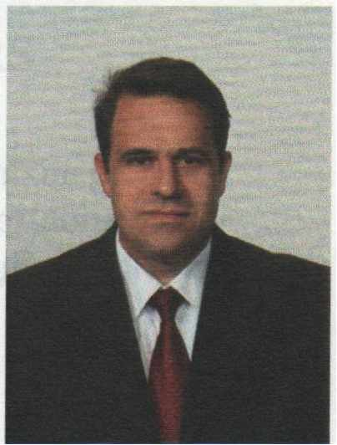
PREFACE
Creating a sustainable and a healthy environment is one of the most impoıtant global issues facing mankind today. Therefore, serious consideration should be given to environmental problems and concerted efforts should be made worldwide in order to respond and prevent present and future environmental risks and challenges.

The Intemational Conference on Environment: Survival and Sustainability (ESS 2007) organized by the Near East University between the dates 19 and 24 February 2007 was held in Lefkosa, Turkish Republic of Northem Cyprus. The main objective of this multidisciplinary conference was to gather scientists from all over the world to discuss the overall issue of the environment, to find out sustainable solutions for environmental problems and to identify areas for future collaboration in this matter. The conference brought together 2,052 participants from 108 different countries. During the conference a total of 1 ,463 papers were presented under 21 different subtopics, representing various scientific disciplines. The topics included environmental law and ethics, environmental knowledge, technology and information systems, media, environmental awareness, education and lifelong learning, the use of literature for environmental awareness and the effects of the green factor in politics and in intemational relations.
The Scientific Committee of Intemational Conference ESS2007 evaluated ali of the 1,463 papers and selected among them 610 papers to be included in The Proceedings of Environment: Survival and Sustainability. The readers will notice the wide range of topics represented by the papers included in the Conference Proceedings.
it is hoped that this book will serve to contribute to increase in awareness towards various environmental issues as well as drawing more attention to the urgency of intemational cooperation and collaboration in pursuing sustainable environmental management.
Prof. Dr. Hüseyin Gökçekuş
President of the Conference and the Organizing Committee Vice Rector of the Near East University
Lefkoşa-TRNC
18 February 2009
VII

VIII
International Conference on Environment: Survival and Sustainability 19-24 February 2007 Near East University, Nicosia-Northern Cyprus
1988
ACKNOWLEDGMENTS
The Organizing Committee of the ESS2007 Conference would like to extend its sincere appreciation to Dr. Suat Günsel, the Founding Rector of the Near East University, to Prof. Dr. Ekmeleddin İhsanoğlu, General Secretary of the Organization of Islamic Conference and to Prof. Dr. Walter W. Kofler, President of ICSD/IAS for their significant support and encouragement in the conference.
Appreciation is also extended to the chairpersons, the keynote speakers and the presenters of papers in the conference.
We are deeply grateful for the members of the editorial board who have carefully read and recommended the papers for publishing.
We also wish to express our gratitude to numerous individuals for their valuable contribution to the editing process.
Prof. Dr. Hüseyin Gökçekuş
President of the Conference and the Organizing Committee Vice Rector of the Near East University
Lefkoşa-TRNC

IX
International Conference on Environment: Survival and Sustainability 19-24 February 2007 Near East Uoiversity, Nicosia-Northern Cyprus
ORGANIZING COMMITTEE MEMBERS
Honorary President
Dr. Suat i. GÜNSEL, Founding Rector of the Near East University
President
Prof. Dr. Hüseyin GÖKÇEKUŞ, Vice Rector ofthe Near East University
Members
Prof. Dr. Ümit HASSAN, Rector ofthe Near East University Prof. Dr. Aysel YONTAR
Dr. Hatice GÖKÇEKUŞ (M.D.) Asst. Prof. Dr. Umut TÜRKER Asst. Prof. Dr. Mesut YALVAÇ Asst. Prof. Dr. Rifat REŞATOGLU Asst. Prof. Dr. Mehmet OKCAN Asst. Prof. Dr. Dudu ÖZKUM Asst. Prof. Dr. Salih GÜCEL
İrfan GÜNSEL
Gürdal HÜDAOGLU
Havva ARSLAN GAZİ
Tümer GARİP
Alp ÖZERK
Ahmet SAV AŞAN
Nesrin MENEMENCİ
Şakir ALEMDAR
Zehra BAŞARAN
Temel RIZZA
Emel TOZLU ASLAN Şifa ABİK

International Conference on Environment: Survival and Sustainability 19-24 February 2007 Near East University, Nicosia-Northern Cyprus
1986
INTERNATIONAL ADVISORY BOARD MEMBERS
A. 1., OLAYINKA A., JAGADEESH Abdul, KHAKEE
Abdullahi Elmi, MOHAMED
Agustin Gonzales Fontes de, ALBORNOZ Ajmal, KHAN
Aleh, RODZKIN
Alex, CHENG
Ayman Abou, HADiD Ayşe, DÖNMEZER Aziz, ERTUNÇ
Belay, TEGENE Çağatay, GÜLER Dana, KOLEVSKA Ed, BOLES
Elizabeth, GONZALEZ Elizabeth, THOMAS-HOPE Ersi. ABACI KALFOGLU Filiz. DiLEK
Furkat, KHASSANOV Gaudelia A., REYES George. CO~ST ANTINOU George, PETRIDES Günay, KOCASOY
Guntis, BRUMELIS Halime, PAKSOY Hallvard, ODEGAARD
Nigeria lndia Germany Somalia
Spain Pakistan Belarus
USA Egypt Turkey Turkey Ethiopya Turkey Macedonia Belize
Uruguay Jamaica
Turkey Turkey Uzbekistan Philippines Cyprus Cyprus Turkey Latvia
Turkey Norway
x

International Conference on Environment: Survival and Sustainability 19-24 February 2007 Near East University, Nicosia-Northern Cyprus
Hasan, ERTEN Hunay, EVLiYA
Ibrahim Abdel Gelil Said, ABDULA İbrahim S., ALNAIMI
İrfan, GÜNEY
Jaco, V ANGRONSVELD Joe, LEWIS
John, SAKA
Lyoussi, BADIAA
M. Nasir, SHAMSUDIN Mahmut Parlak, TUNA Mannar, FAYYAD Manuel Benito, CRESPO Marcel, STIVE Margaret, ZIMBA Mark,BYNOE
Mohsen, HOSSEINI Moneef R., ZOU'BI Mutasem, EL-FADEL Neşet, KILINÇER Nükhet, TURGUT Orhan, ALT AN
Peyman, YALÇIN
Qasem Abdul, JABER Ramzi, SANSUR Reinhold, STEINACKER Renee, RICHER Richard, MOLES
Şafak, URAL
Selim, KAPUR
Turkey
Turkey
Bahrain
Qatar
Turkey
Belgi um
Namibia
Malawi
Morocco
Malaysia
Turkey
Jordan
Spain
Netherland
Zimbabwe
Guyana
Iran
Jordan
Lebanon
Turkey
Turkey
Turkey
Turkey
Palestine
Palestine
Austria
Armenia
Ireland
Turkey
Turkey
XI

International Conference on Environment: Survival and Sustainability 19-24 February 2007 Near East University, Nicosia-Northern Cyprus
1988
Serpil, OPPERMAN | Turkey
Seval, SÖZEN | Turkey
Sevgi, SARYAL | Turkey
Skender, OSMAN! | Albania
Songül A., V AIZOGLU | Turkey
Tarzan, LEGOVIC | Croitia
Tetsuo, YUHARA | Japan
Tuluhan, YILMAZ | Turkey
Turan, ÖZTURAN | Turkey
Ümit, ERDEM | Turkey
Valentina, YANKO-HOMBACH | Canada
Waleed Khalil, ZUBARI | Bahrain
Yigal, RONEN | Israel
Zekai, ŞEN | Turkey
Zohra Ben, LAKHDAR | Tunisia

International Conference on Environment: Survival and Sustainability 19-24 February 2007 Near East University, Nicosia-Northern Cyprus
l9B8
SCIENTIFIC COMMITTEE MEMBERS
Ferid, MURAD - Nobel Laureate Richard R., ERNST - Nobel Laureate Yuan T., LEE - Nobel Laureate
USA
Switzerland
Taiwan
A.H.,ZAKRI
Ahmad, MARRAKCHI Alexey Arkady, VOINOV Andrea E., RIZZOLI Andrew, BROOKES
Anne, BUTTIMER Anthony J., JAKEMAN Anwar, NASIM
Barry W., WILSON
Bjarne Bruun, JENSEN Branimir, JOV ANCICEVIC Charles N ., ALPERS
Dan C.C., GALERIU
David A., STAH
Derin, ORHON
Elchin, KHALILOV
Eric, JOHNSON
Esteban G., JOBBAGY Fabian M., JAKSIC
Farhat M., ALI Frederick.I.B., KAY ANJA Gabriele, VOIGT
Galip, AKAY
G-C.,FANG
Malaysia Tunisia
USA
Switzerland Australia Ireland Australia Pakistan
USA
Denmark
Serbia and Montenegro USA
Romania
USA
Turkey Azerbaijan Switzerland Argentina Chile
Pakistan
Uganda Austria
UK
Taiwan
XIII

International Conference on Environment: Survival and Sustainability 19-24 February 2007 Near East University, Nicosia-Northern Cyprus
Geoff, BERTRAM George G., LUNT Gerald, LALOR Germano, MW ABU Giovanni, BARROCU Girja K., SHUKLA Gopal B., THAPA Hanwant B., SINGH Hartmut, FRANK Heila, LOTZ-SISITKA Helen, SCHNEIDER Hillel S., KOREN Hiromi, Y AMASHITA Holmes, ROLSTON Hruska, JAKUB
Irena, TW ARDOWSKA lsfaq, AHMAD J.F.Santos, OLIVEIRA James, DEVILLERS Jaroslav, BOHAC Jennifer, BROWN Jianping, WU
Jim C., BRIDEN
John, DAISH
John, GREGORY
John, HOSKINS
Judith T., ZELIKOFF Jyrki, LIESIVUORI Kaku,NOKOE
Kenneth N ., TIMMIS
New Zealand
UK
Jamaica
Kenya
Italy
India
Thailand
USA
Germany
South Africa
South Africa
USA
UK
USA
Chezch Republic
Poland
Pakistan
Portugal
France
Chezch Republic
New Zealand
China
UK
New Zealand
UK
U.K
USA
Finland
Ghana
Germany
XIV

lnternational Conference on Environment: Survival and Sustainability 19-24 February 2007 Near East University, Nicosia-Northern Cyprus
Kristine, W ALRAEVENS Kyaw Tha, PAW U Kyoung-Woong, KiM Luc,HENS
M. Shamsher, ALI Mamdouh, NOUH Manzoor, QADIR Marcel, ARNOULD Marcial, BLONDET Martha C., MONROE Mary, SEELY Mehmet, ERGiN Michael, WILHELM Münür, ÖZTÜRK Muthana, SHANSHAL Naim H., AFGAN
Nicholas, MASCIE-TAYLOR Nicholas, ORNSTON Norhayati Mohd, TAHiR Pall, HERSTEINSSON Patricia, MAURICE
Paul W., JOWITT
Paulo B., LOURENCO
Peter, BRIMBLECOMBE Peter, KRUMBIEGEL
Peter, NOV AK
Philip E., LAMOREAUX Philip M., FEARNSIDE Ravi, JAIN
Richard, ROBINS
Belgium
USA
Korea
Belgi um
Bangladesh
UAE
Syria
France
Peru
USA
Namibia
Turkey
Germany
Turkey
Iraq
Portugal
UK
USA
Malaysia
Iceland
UK
UK
Portugal
UK
Germany
Slovenia
USA
Brazil
Australia
France
xv

International Conference on Environment: Survival and Sustainability 19-24 February 2007 Near East University, Nicosia-Northern Cyprus
lCJBA
Robert J., LETCHER | Canada
Robert, GIFFORD | Canada
Roberto, DAN OV ARO | Italy
Saffa B., RIFF AT | UK
Sam,KACEW | Canada
Sandor,I(ER.EI(ES | Hungary
Scott, SLOVIC | USA
Sevket, DURUCAN | UK
Shafıqul 1., BHUIYAN | Bangladesh
Shahamat U., KHAN | USA
Shian-chee, WU | Taiwan
Siaka, SIDIBE | Mali
Stephen P., MCCARTHY | USA
Tarzan, LEGOVIC | Croatia
Tomasz, ZYLICZ | Poland
Ulric, ROTT | Germany
Vedat, DOYURAN | Turkey
Victor G., PRIETO | USA
Walid A., ABDERRAHMAN | Saudi Arabia
Walter, KOFLER | Austria
William.J., MANNING | USA
Wiranto, ARISMUNANDAR | Indonesia
Zhihong, XU | Australia
XVI

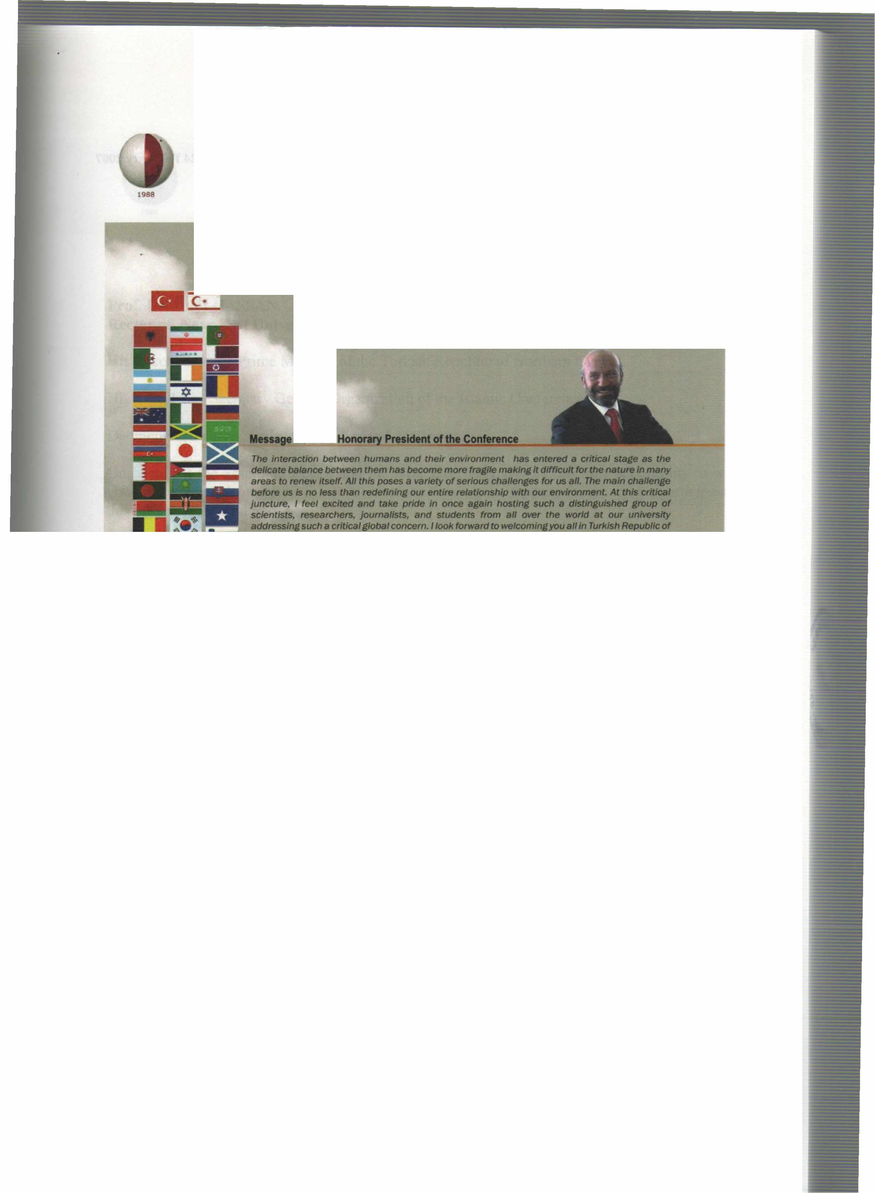
International Conference on Environment: Survival and Sustainability 19-24 February 2007 Near East University, Nicosia-Northern Cyprus
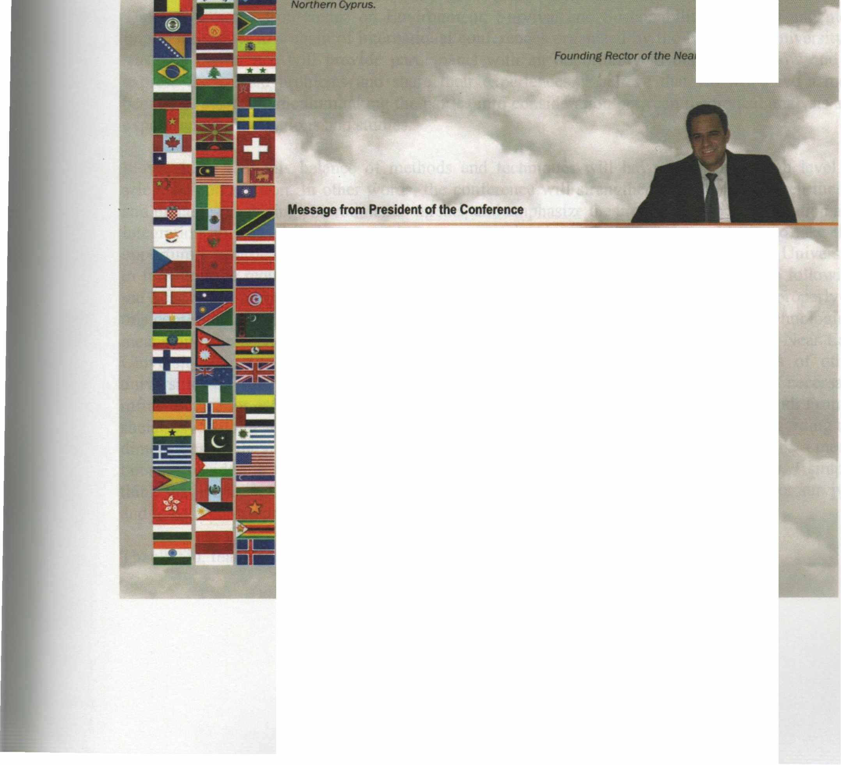
it g/ves me the utmost pleasure in welcomlng you al/ to tile lntemational Conference • Etwlronment: Survlva/ and Sustainability" here at the Near East Unlılerslty in Tlllf<Jsh Republic of Norttıem Cyptus ıo be tıeld at 19-24 February 2007.
Trıe c:onllııreııce almed at brlnflng ıogether more than 2,000 scho/ars and researchers from over 90 countrles lllOUlld ttıe world IO dlscuss envlt'onlnental ıssues from a varlety of perspectives; iİndetllne ttıe lmportatıce ot tile need for UIJ(enCy in taklng steps by the intemationat Of.......,..., --. loca/ auttıorlries and non-govemmental organ/zat/ons to move to a sustelnable erMnr.menVdeııelopmentmodel; and thereby makes lts conıribution to worldwide debate effort on .,.,_,,..ılılılfrtıe tırldfe .between tlleot)I and practJce in meeting envfronmentat threafS/challenges.
Since our ıast lntematlonal conftw'elıce on envtronment. "EIMtonmente/ Problems of Uıe Medltenanean Regıons•, worldwldaetMrorımental disasters • well • local-"- muıtlplled and envlronmentat degradation and po/fuflon has contlnued. Whlle majorltrides ,,_ ı-n made in ttıe world in analyzing. understandinf and lnfonnlng the publlc ..,.,.. ille ~ clıaHenges we are facing. we st/11 have a IOtlılf way to go. Our way ot life ıs stil/ far from • 8Ultalnllble model and our envlronment contlnues to degrade and deterioraıe due to human activltles. The consequences can be seen in worldwlde environmental disasters as well as locally in our daily //ves.
Thls ıs fOlfll to be our thlrd lnıemıttiollal conference on Envlronment organlzed by our youn.r unlversltysJnce it was estBblished in 1988.
Yours sJnc:erely, ""'· Dr • .....,... 8ilıçelıııt Vıce Recıor of the Near Eası Universitv
XVII

International Conference on Environment: Survival and Sustainability 19-24 February 2007 Near East University, Nicosia-Northern Cyprus
VOLUME3
MT-3: CULTURAL HERITAGE AND ENVIRONMENTAL FACTORS
THE VERNACULAR T ARSUSr!OUSES AS A SAMPLE FOR CUL TURAL HERITAGE
Fehime Yeşim Gürani-TURKEY (Oral) ......................................................................••............................................................. 769
ASSESSMENT OF WOOD AS A BUILDING MA TERIAL IN TURKEY IN TERMS OF ENVIRONMENT AL SUST AINABILITY
Saadet Toker, Armağan Korkmaz, Hasan Ş. Haştemoğlu -TURKEY (Oral) 781
NEIGHBOURHOOD SUSTAINABILITY: A COMPARATIVE ANALYSIS IN THE NORTHERN AND SOUTHERN SECTORS OF NICOSIA
Derya Oktay, Can Kara - NORHERN CYPRUS (Oral) 789
VISUAL POLLUTION DUE TO FUNCTIONAL TRANSFORMATIONS AT EKINCILER STREET IN DIY ARBAKIR, TURKEY
Sule Elhakan, Iclal Aluclu. Fuat Toprak-TURKEY (Oral) 823
AN ANAL YSIS OF THE URBAN MET AMORPHOSIS IN T ARLABASI DISTRICT AND ITS IMPACTS ON THE CULTURAL FORMATION
Özlem Şenyiğit, N. Ferah Akıncı -TURKEY (Oral) 829
THE DETERIORATION REASONS AND REHABILITA TION SUGGESTIONS OF DIY ARBAKIR HISTORICAL HOUSES IN THE CONCEPT OF CUL TURAL HERIT AGE
F. Demet Aykal, Y. Berivan Ozbudak-TURKEY (Oral) 839
EFFECTS OF THE ENVIRONMENT AL FACTORS TO CUL TURAL AND NA TURAL HERITAGE OF PAMUKKALE
Ş. Gülin Beyhan, Mehmet Beyhan -TURKEY (Oral) 851
ECO-DESIGN APPROACH IN FURNITURE DESIGN
Tülay Özdemir - TURKEY (Oral) 861
A NEW APPROACH TO INTEGRA TED APPLICATIONS IN CUL TURAL HERITAGE DOCUMENTATION
Z. Duran, G. Toz -TURKEY (Oral) 871
AN ANATOLIAN ANCIENT CUL TURAL HERITAGE, THE MIDAS MONUMENT: AN OVERVIEW
Mustafa Dursun Çaglar, Nazmi Oruç - TURKEY (Oral) 881
REHABILIT ATI ON OF HISTORICAL BUILDINGS OF ODUNP AZARI - ESKİŞEHİR - TURKEY
Burhan Sakallı, Hüsnü Kaptan, Aslı Tunçol, Ayşen Aksu, Saye Nihan Çabuk, Nazmi Oruç - TURKEY (Oral) 889
AN URBAN OPEN SPACE MODEL FOR MODERN TURKISH REPUBLIC: GAZI FOREST F ARM IN ANKARA
A. Duygu Kaçar - TURKEY (Oral) 903
PRE-HISTORICAL LANDSCAPES AND CUL TURAL HERIT AGE OFFSHORE OF THE BAL TIC SEA IN LITHUANIA
Vladas Zulkus - LITHUANIA (Oral) 911
THE EXAMINATION OF MADRASA BUILDINGS IN KONYA IN ENVIRONMENT AL, USAGE AND STRUCTURAL LEVEL
Esra Yaldiz, Bahtiyar Eroğlu, Süheyla Siramkaya Büyükşahin - TURKEY (Oral) • 917
SECOND HOMES IN A COASTAL AREA-MAHMUTLAR SAMPLE
Elif Gündüz, Rahmi Erdem-TURKEY (Oral) 931
XLVIII

International Conference on Environment: Survival and Sustainability 19-24 February 2007 Near East University, Nicosia-Northern Cyprus
1988
THE IMPORTANCE OF CUL TURE TOURISM IN OWNING HISTORICAL CUL TURE HERIT AGE - KILISTRA SETTLEMENT (TURKEY) CASE
Ü.Gülsüm Ter, Dicle Aydin, Yusuf Ziya Ter-TURKEY (Oral) 941
IZNIK CITY WITH ITS HISTORICAL LANDSCAPE PROPERTIES
Murat E. Yazgan, Canan Cengiz - TURKEY (Oral) 955
ARCHAEOLOGICAL SITE PRESENTATION AS AN APPROPRIA TE AND USEFUL MANAGEMENT TOOL: THE EXAMPLE OF UMAN TEPE PRESERVATION AND SITE MANAGEMENT MODEL, IZMIR, TURKEY
Müge Bahçeci -TURKEY (Oral) 963
RELATIONSHIP BETWEEN URBAN REVIATLIZA TION AND SUSTAINABILITY IN HISTORIC URBAN QUARTERS: TOWARDS A SUSTAINABLE URBAN REVITALIZATION APPROACH
Şebnem Önal Hoşkara, Beser Oktay Vehbi- NORHERN CYPRUS (Oral) 977
COMP ARISON OF THE INTEGRA TED AND NON-INTEGRA TED PA TTERNS IN A SPATIO-TEMPORAL DIMENSION IN THE CONTEXT OF AN ISLAND
Murat ŞAHIN, - TURKEY (Oral) 987
ECONOMETRIC ANAL YSIS OF WORLD HERITAGES' INFLUENCE ON TOURISM DEMANDS
Sukhong YOON, Maengsem KİM, Seunghoe CHOI- KOREA (Oral) 997
THE PHRYGIAN ROCK-CUT ALT ARS AND THEIR RE STORA TION AND CONSERV ATION PROPOSALS
Rahşan TAMSÜ, YusufPOLAT-TURKEY (Oral) 1005
AMA TEUR ARCHAEOLOGY AND ARCHAEOLOOlCAL \'ARK MODEL Al I'EDASA·. THE MAIN SlTE OF THE LELEGIAN CIVILISA TION, ON BODRUM PENINSULA
Adnan DiLER-TURKEY (Oral) 1015
INTEGRA TION OF HISTORICAL MONUMENTS INTO MODERN ENVIRONMENT AND LANDSCAPE IN GERMANY
Marko KIESSEL- TRNC (Oral) 1021
THE INTERACTION DYNAMICS OF WATER AND THE ENVIRONMENT
Mohammad Esmaeil Asadi - IRAN (Oral) 1033

XLIX

Near East University - TRNC Tel: +90 392 223 6464/460 Tel/Fax: +90 392 223 5427 info@neu.edu.tr - www.neu.edu.tr

