Proceedings

Volume 4
International Conference on Environment : Survival and Sustainability

Organized by Near East University

Published By: EDUCATIONAL FOUNDATION OF NEAR EAST UNIVERSITY
Near East University, Lefkoşa, Turkish Republic of Northern Cyprus Tel: +90 392 223 64 64
Fax: +90 392 223 64 61
e-mail: info@neu.edu.tr
web: www.neu.edu.tr
Citation: Gökçekuş, H., 2009 (Editor) Proceedings of the lnternational Conference on Environment: Survival and Sustainability. Nicosia (Lefkoşa),
Turkish Republic of Northern Cyprus: Educational Foundation of
Near East University. 10 volumes, LXXVI, 5498, XIV pages.
Copyright: Reproduction of this Publication for Educational or other non-commercial purposes is authorized without prior permission from the copyright holder. Reproduction for resale or other commercial purposes prohibited without prior written permission of the copyright holder.
ISBN: Volume 1: 978-975-8359-53-0
Disclaimer: While every effort has been made to ensure the accuracy of the information contained in this publication, the EDUCATIONAL FOUNDATION of the NEAR EAST UNIVERSITY will not assume liability for any use made of the proceedings and the presentation of the participating organisations concerning the legal status of any country, territory, or area, or of its authorities, or concerning the delimitation of its frontiers or boundaries.
Printed by: Near East University Tel: +90 392 223 64 64 Fax: +90 392 223 64 61

Editor: Prof. Dr. Hüseyin GÖKÇEKUŞ Near East University
Lefkoşa,
Turkish Republic ofNorthem Cyprus ghuseyin@neu.edu. tr. gokcekushuseyin@gmail. cam Tel/Fax: 00 90 392 223 54 27
Members of the Editorial Board:
AnwarNASIM
Aysel YONT AR Cyro Do V ALLE Derin ORHON
Elchin KHALILOV Giovanni BARROCU Gunnar TELLNES JimLAMEROX
Pakistan TRNC Brasil Turkey Azerbaijan Italy Norway USA
Konstantin V. SUDAKOV Russia
Luc HENS Belgium
Münür ÖZTÜRK Turkey
Reinhold STEINACKER Austria
Tarzan LEGOVIC Ulric ROTT
Umut TÜRKER Ümit HASSAN Vedat DOYURAN Walter KOFLER Zekai ŞEN
III
Crotia Germany TRNC TRNC Turkey Austria Turkey

International Conference on Environment: Survival and Sustainability 19-24 February 2007 Near East University, Nicosia-Northern Cyprus
CONTENTS
Pages
Editor/Members of the Editorial Board 111
Preface VII
Acknowledgmen ts VIII
Organizing Committee Members IX
lnternational Advisory Board Members X
Scientific Committee Members XIII
Messages XVII
·Message from Dr. Suat İ.Günsel, Honorary President of the Conference ·Message from Prof.Dr. Hüseyin Gökçekuş, President of the Conference
Opening Speeches XIX
·Prof. Dr. Ümit Hassan, Rector of Near East University, TRNC
·Prof.Dr. Hüseyin Gökçekuş, President ofthe Conference & Organizing Committee, TRNC ·Rahmi Koç, Honorary Chairman & Founding Member ofTURMEPA, TURKEY ·EşrefCerrahoğlu, Chairman ofExecutive Board ofTURMEPA, TURKEY
·Cemal Bulutoğluları, Mayor, Turkish Municipality of Lefkoşa, TRNC
·Asım Vehbi, Minister ofEnvironment and Natural Resources, TRNC
·Tahsin Ertuğruloğlu, Leader of the National Unity Party(UBP), TRNC
·Assoc. Prof.Dr. Turgay Avcı, Deputy Prime Minister & Minister of Foreign Affairs ofTRNC ·Türkekul Kurttekin, Turkish Ambassador to Lefkoşa, TRNC
·Ferdi Sabit Soyer, Prime Minister ofTRNC
·Prof. Dr. Ekmeleddin İhsanoğlu, OIC Secretary General ·Mehmet Ali Talat, President of TRNC
Final Report of the International Conference On Environment: Survival and
Sustainability XXXIX
v

International Conference on Environment: Survival and Sustainability 19-24 February 2007 Near East University, Nicosia-Northern Cyprus
1986
List of Papers and Posters XLIII
Papers and Posters
Volume 1: MT-1: Business and Environment: Redefıning Interests 1
Volume 2: MT-2: Conservation and Management ofBiodiversity 187
Volume 3: MT-3: Cultural Heritage and Environmental Factors 769
Volume 4: MT-4: Econornics, Development and Sustainability 1043
Volume 5: MT-5: Energy and Development: New and Renewable Energy 1673
MT-6: Environment and Health 1953
Volume 6: MT-7: Environmental Awareness, Education, and Lifelong Leaming 2369
MT-8: Environmental Knowledge and Information Systems 2615
MT-9: Environmental Law and Ethics 2807
MT-10: Environmental Organizations: Roles, Problems and Prospects 2895
Volume 7: MT -11: Environmental Science and Technology 2923
MT-12:Global Warming: How Much of A Threat? 3607
Volume 8: MT 13 -Green Factor In Politics 3785
MT-14: Integrated Water Resources Management. 3847
Volume 9: MT-15: Intemational Relations and Environmental Issues 4367
MT-16: Literature and Environmental Awareness 4527
MT-17: Natural and Man-Made Disasters: Emerging Link and Challenges 4587
MT-18: Pesticides In The Environment and Food Coınınodities 4741
MT-19: The Role of Media: Problems and Challenges 4809
Volume 10: MT-20: Seas, Ecological Balance, and Sustainable Environment. 4915
MT-21: Social and Psychological Dimensions of Environmental Issues 5117
lndex I
Brief Information About Near East University XI
Brief Information About Turkish Republic of Northern Cyprus XV
VI

International Conference on Environment: Survival and Sustainability 19-24 February 2007 Near East University, Nicosia-Northern Cyprus
1998
PREFACE
Creating a sustainable and a healthy enviromnent is one of the most important global issues facing mankind today. Therefore, serious consideration should be given to enviromnental problems and concerted efforts should be made worldwide in order to respond and prevent present and future enviromnental risks and challenges.
The Intemational Conference on Enviromnent: Survival and Sustainability (ESS 2007) organized by the Near East University between the dates 19 and 24 February 2007 was held in Lefkosa, Turkish Republic of Northem Cyprus. The main objective of this multidisciplinary conference was to gather scientists from all over the world to discuss the overall issue of the enviromnent, to find out sustainable solutions for enviromnental problems and to identify areas for future collaboration in this matter. The conference brought together 2,052 participants from 108 different countries. During the conference a total of 1 ,463 papers were presented under 21 different subtopics, representing various scientific disciplines. The topics included enviromnental law and ethics, enviromnental knowledge, technology and information systems, media, enviromnental awareness, education and lifelong learning, the use of literature for enviromnental awareness and the effects of the green factor in politics and in intemational relations.
The Scientific Committee of Intemational Conference ESS2007 evaluated all of the 1 ,463 papers and selected among them 61 O papers to be included in The Proceedings of Enviromnent: Survival and Sustainability. The readers will notice the wide range of topics represented by the papers included in the Conference Proceedings.
it is hoped that this book will serve to contribute to increase in awareness towards various enviromnental issues as well as drawing more attention to the urgency of intemational cooperation and collaboration in pursuing sustainable enviromnental management.
Prof. Dr. Hüseyin Gökçekuş
President of the Conference and the Organizing Committee Vice Rector of the Near East University
Lefkoşa-TRNC
18 February 2009
VII

International Conference on Environment: Survival and Sustainability 19-24 February 2007 Near East University, Nicosia-Northern Cyprus
1988
ACKNOWLEDGMENTS
The Organizing Committee of the ESS2007 Conference would like to extend its sincere appreciation to Dr. Suat Günsel, the Founding Rector of the Near East University, to Prof. Dr. Ekmeleddin İhsanoğlu, General Secretary of the Organization of Islamic Conference and to Prof. Dr. Walter W. Kofler, President of ICSD/IAS for their significant support and encouragement in the conference.
Appreciation is also extended to the chairpersons, the keynote speakers and the presenters of papers in the conference.
We are deeply grateful for the members of the editorial board who have carefully read and recommended the papers for publishing.
We also wish to express our gratitude to numerous individuals for their valuable contribution to the editing process.
Prof. Dr. Hüseyin Gökçekuş
President of the Conference and the Organizing Committee Vice Rector of the Near East University
Lefkoşa-TRNC
VIlI

International Conference on Environment: Survival and Sustainability 19-24 February 2007 Near East University, Nicosia-Northern Cyprus
ısaa
ORGANIZING COMMITTEE MEMBERS
Honorary President
Dr. Suat İ. GÜNSEL, Founding Rector ofthe Near East University
President
Prof. Dr. Hüseyin GÖKÇEKUŞ, Vice Rector of the Near East University
Members
Prof. Dr. Ümit HASSAN, Rector ofthe Near East University Prof. Dr. Aysel YONTAR
Dr. Hatice GÖKÇEKUŞ (M.D.) Asst. Prof. Dr. Umut TÜRKER Asst. Prof. Dr. Mesut YALVAÇ Asst. Prof. Dr. Rifat REŞATOGLU Asst. Prof. Dr. Mehmet OKCAN Asst. Prof. Dr. Dudu ÖZKUM Asst. Prof. Dr. Salih GÜCEL
İrfan GÜNSEL
Gürdal HÜDAOGLU
Havva ARSLAN GAZİ
Tümer GARİP
Alp ÖZERK
Ahmet SAV AŞAN
Nesrin MENEMENCİ
Şakir ALEMDAR
Zehra BAŞARAN
Temel RIZZA
Emel TOZLU ASLAN Şifa ABİK
IX

Jnternational Conference on Environment: Survival and Sustainability 19-24 February 2007 Near East University, Nicosia-Northern Cyprus
INTERNATIONAL ADVISORY BOARD MEMBERS
A. 1., OLAYINKA A., JAGADEESH Abdul, KHAKEE
Abdullahi Elmi, MOHAMED
Agustin Gonzales Fontes de, ALBORNOZ Ajmal, KHAN
Aleh, RODZKIN
Alex, CHENG
Ayman Abou, HADiD Ayşe, DÖNMEZER Aziz, ERTUNÇ
Belay, TEGENE Çağatay, GÜLER Dana, KOLEVSKA Ed,BOLES
Elizabeth, GONZALEZ Elizabeth, THOMAS-HOPE Ersi, ABACI KALFOGLU Filiz, DiLEK
Furkat, KHASSANOV Gaudelia A., REYES George, CONSTANTINOU George, PETRIDES Günay, KOCASOY
Guntis, BRUMELIS Halime, PAKSOY Hallvard, ODEGAARD
Nigeria India Gerrnany Somalia
Spain Pakistan Belarus
USA Egypt Turkey Turkey Ethiopya Turkey Macedonia Belize
Uruguay
Jamaica
Turkey Turkey Uzbekistan Philippines Cyprus Cyprus Turkey Latvia
Turkey Norway
x

Turkey
Turkey
Bahrain
Qatar
Turkey
Belgium
Namibia
Malawi
Morocco
Malaysia
Turkey
lordan
Spain
Netherland
Zimbabwe
Guyana
Iran
lordan
Lebanon
Turkey
Turkey
Turkey
Turkey
Palestine
Palestine
Austria
Armenia
Ireland
Turkey
Turkey
XI

lnternational Conference on Environment: Survival and Sustainability 19-24 February 2007 Near East University, Nicosia-Northern Cyprus
l98~
Hasan, ERTEN Hunay, EVLiYA
Ibrahim Abdel Gelil Said, ABDULA İbrahim S., ALNAIMI
İrfan, GÜNEY
Jaco, V ANGRONSVELD Joe, LEWIS
John, SAKA
Lyoussi, BADIAA
M. Nasir, SHAMSUDIN Mahmut Parlak, TUNA Mannar, FAYYAD Manuel Benito, CRESPO Marcel, STIVE Margaret, ZIMBA Mark,BYNOE
Mohsen, HOSSEINI Moneef R., ZOU'BI Mutasem, EL-FADEL Neşet, KILINÇER Nükhet, TURGUT Orhan, ALT AN
Peyman, YALÇIN Qasem Abdul, JABER Ramzi, SANSUR Reinhold, STEINACKER Renee, RICHER Richard, MOLES
Şafak, URAL
Selim, KAPUR

International Conference on Environment: Survival and Sustainability 19-24 February 2007 Near East University, Nicosia-Northern Cyprus
1968
Serpil, OPPERMAN | Turkey
Seval, SÖZEN | Turkey
Sevgi, SARYAL | Turkey
Skender, OSMAN! | Albania
Songül A., V AIZOGLU | Turkey
Tarzan, LEGOVIC | Croitia
Tetsuo, YUHARA | Japan
Tuluhan, YILMAZ | Turkey
Turan, ÖZTURAN | Turkey
Ümit, ERDEM | Turkey
Valentina, Y ANKO-HOMBACH | Cana da
Waleed Khalil, ZUBARI | Bahrain
Yigal, RONEN | Israel
Zekai, ŞEN | Turkey
Zohra Ben, LAKHDAR | Tunisia
XII

International Conference on Environment: Survival and Sustainability 19-24 February 2007 Near East University, Nicosia-Northern Cyprus
1Q8H
SCIENTIFIC COMMITTEE MEMBERS
Ferid, MURAD - Nobel Laureate Richard R., ERNST - Nobel Laureate Yuan T., LEE - Nobel Laureate
USA
Switzerland
Taiwan
A.H.,ZAKRI
Ahmad, MARRAKCHI Alexey Arkady, VOINOV Andrea E., RIZZOLI Andrew, BROOKES
Anne, BUTTIMER Anthony J., JAKEMAN Anwar, NASIM
Barry W., WILSON
Bjarne Bruun, JENSEN Branimir, JOV ANCICEVIC Charles N ., ALPERS
Dan C.C., GALERIU
David A., ST AH
Derin, ORHON
Elchin, KHALILOV
Eric, JOHNSON
Esteban G., JOBBAGY Fabian M., JAKSIC
Farhat M., ALI Frederick.I.B., KAY AN JA Gabriele, VOIGT
Galip, AKAY
G-C.,FANG
Malaysia Tunisia
USA
Switzerland Australia
Ireland Australia Pakistan
USA
Denrnark
Serbia and Montenegro USA
Romania
USA
Turkey Azerbaijan Switzerland Argentina Chile
Pakistan
Uganda Austria
UK
Taiwan
XIII

International Conference on Environment: Survival and Sustainability 19-24 February 2007 Near East University, Nicosia-Northern Cyprus
l9!J8
Geoff, BERTRAM George G., LUNT Gerald, LALOR Germano, MW ABU Giovanni, BARROCU Girja K., SHUKLA Gopal B., THAPA Hanwant B., SINGH Hartmut, FRANK Heila, LOTZ-SISITKA Helen, SCHNEIDER Hillel S., KOREN Hiromi, Y AMASHITA Holmes, ROLSTON Hruska, JAKUB
Irena, TW ARDOWSKA lsfaq, AHMAD J.F.Santos, OLIVEIRA James, DEVILLERS Jaroslav, BOHAC Jennifer, BROWN Jianping, WU
Jim C., BRIDEN
John, DAISH
John, GREGORY
John, HOSKINS
Judith T., ZELIKOFF Jyrki, LIESIVUORI Kaku,NOKOE
Kenneth N., TIMMIS
New Zealand
UK
Jamaica
Kenya
Italy
India
Thailand
USA
Germany
South Africa
South Africa
USA
UK
USA
Chezch Republic
Poland
Pakistan
Portugal
France
Chezch Republic
New Zealand
China
UK
New Zealand
UK
U.K
USA
Finland
Ghana
Germany
xıv

International Conference on Environment: Survival and Sustainability 19-24 February 2007 Near East University, Nicosia-Northern Cyprus
Kristine, W ALRAEVENS Kyaw Tha, PAW U Kyoung-Woong, KiM Luc, HENS
M. Shamsher, ALI Mamdouh, NOUH Manzoor, QADIR Marcel, ARNOULD Marcial, BLONDET Martha C., MONROE Mary, SEELY Mehmet, ERGiN Michael, WILHELM Münür, ÖZTÜRK Muthana, SHANSHAL Naim H., AFGAN
Nicholas, MASCIE-TAYLOR Nicholas, ORNSTON Norhayati Mohd, TAHiR Pall, HERSTEINSSON Patricia, MAURICE
Paul W., JOWITT
Paulo B., LOURENCO
Peter, BRIMBLECOMBE Peter, KRUMBIEGEL
Peter, NOV AK
Philip E., LAMOREAUX Philip M., FEARNSIDE Ravi, JAIN
Richard, ROBINS
Belgi um
USA
Korea
Belgium
Bangladesh
UAE
Syria
France
Peru
USA
Namibia
Turkey
Germany
Turkey
Iraq
Portugal
UK
USA
Malaysia
Iceland
UK
UK
Portugal
UK
Germany
Slovenia
USA
Brazil
Australia
France
xv

International Conference on Environment: Survival and Sustainability 19-24 February 2007 Near East University, Nicosia-Nortbern Cyprus
1988
Robert J., LETCHER | Canada
Robert, GIFFORD | Can ada
Roberto, DAN OV ARO | Italy
Saffa B., RIFFAT | UK
Sam,KACEW | Canada
Sandor,.KERE.KES | Hungary
Scott, SLOVIC | USA
Sevket, DURUCAN | UK
Shafiqul 1., BHUIYAN | Bangladesh
Shahamat U., KHAN | USA
Shian-chee, WU | Taiwan
Siaka, SIDIBE | Mali
Stephen P., MCCARTHY | USA
Tarzan, LEGOVIC | Croatia
Tomasz, ZYLICZ | Poland
Ulric, ROTT | Germany
Vedat, DOYURAN | Turkey
Victor G., PRIETO | USA
Walid A., ABDERRAHMAN | Saudi Arabia
Walter, KOFLER | Austria
William.J., MANNING | USA
Wiranto, ARISMUNANDAR | Indonesia
Zhihong, XU | Australia
XVI

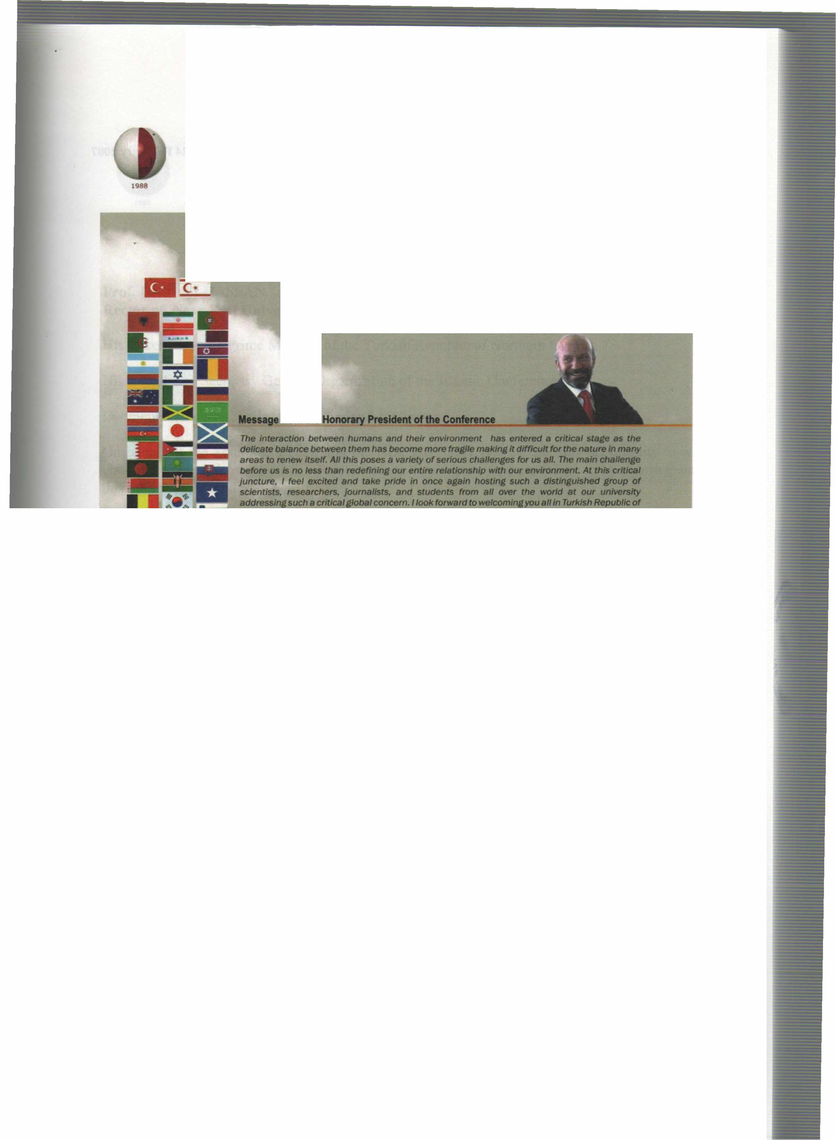
International Conference on Environment: Survival and Sustainability 19-24 February 2007 Near East University, Nicosia-Northern Cyprus
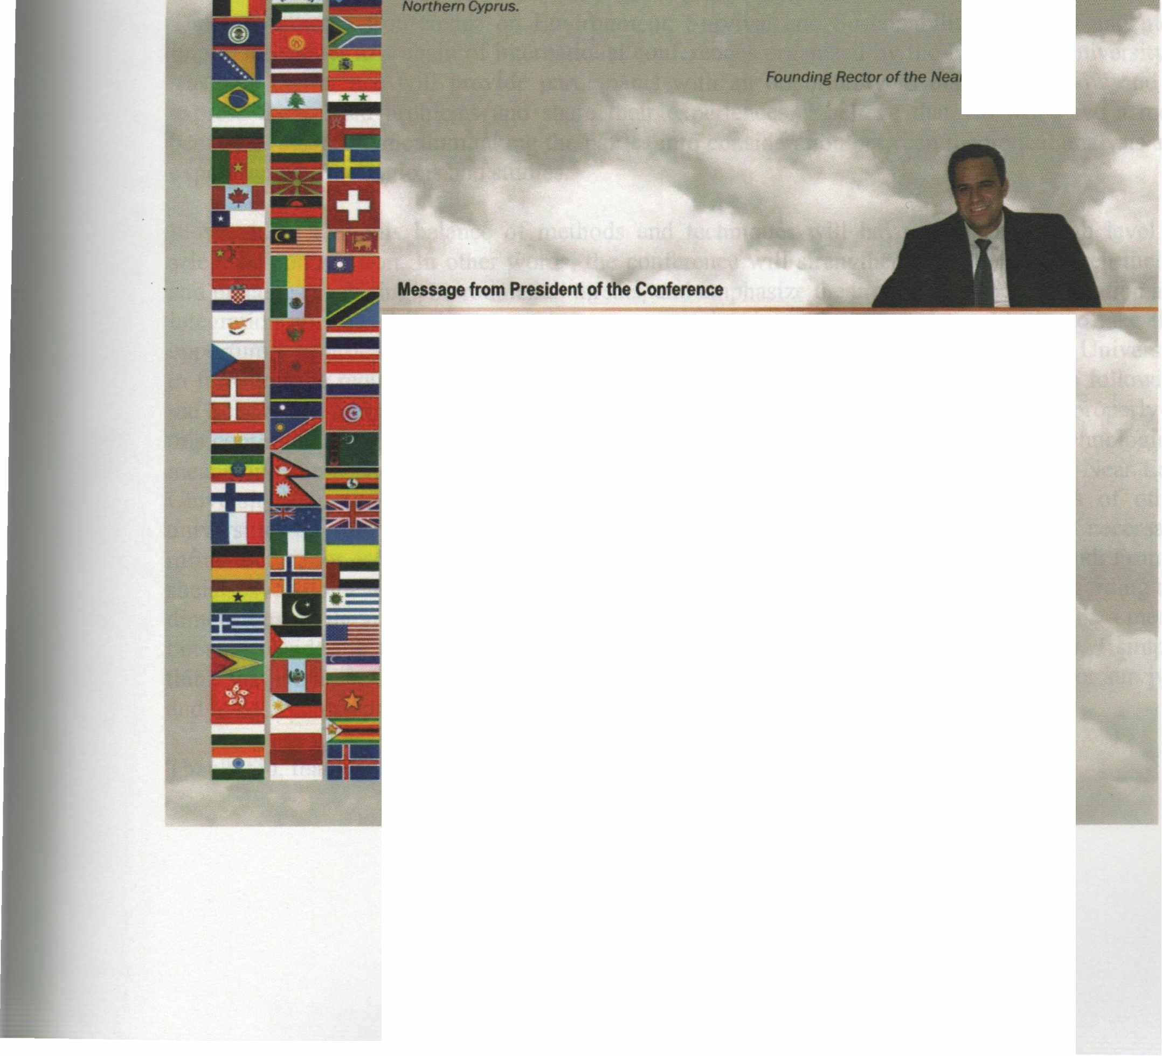
fnımthe

it g/ves me the utmost pleasure in welcomlng you al/ to tile lntemational Conference • Etwlronment: Survlva/ and Sustainability" here at the Near East Unlılerslty in Tlllf<Jsh Republic of Norttıem Cyptus ıo be tıeld at 19-24 February 2007.
Trıe c:onllııreııce almed at brlnflng ıogether more than 2,000 scho/ars and researchers from over 90 countrles lllOUlld ttıe world IO dlscuss envlt'onlnental ıssues from a varlety of perspectives; iİndetllne ttıe lmportatıce ot tile need for UIJ(enCy in taklng steps by the intemationat Of.......,..., --. loca/ auttıorlries and non-govemmental organ/zat/ons to move to a sustelnable erMnr.menVdeııelopmentmodel; and thereby makes lts conıribution to worldwide debate effort on .,.,_,,..ılılılfrtıe tırldfe .between tlleot)I and practJce in meeting envfronmentat threafS/challenges.
Since our ıast lntematlonal conftw'elıce on envtronment. "EIMtonmente/ Problems of Uıe Medltenanean Regıons•, worldwldaetMrorımental disasters • well • local-"- muıtlplled and envlronmentat degradation and po/fuflon has contlnued. Whlle majorltrides ,,_ ı-n made in ttıe world in analyzing. understandinf and lnfonnlng the publlc ..,.,.. ille ~ clıaHenges we are facing. we st/11 have a IOtlılf way to go. Our way ot life ıs stil/ far from • 8Ultalnllble model and our envlronment contlnues to degrade and deterioraıe due to human activltles. The consequences can be seen in worldwlde environmental disasters as well as locally in our daily //ves.
Thls ıs fOlfll to be our thlrd lnıemıttiollal conference on Envlronment organlzed by our youn.r unlversltysJnce it was estBblished in 1988.
Yours sJnc:erely, ""'· Dr • .....,... 8ilıçelıııt Vıce Recıor of the Near Eası Universitv
XVII

International Conference on Environment: Survival and Sustainability 19-24 February 2007 Near East University, Nicosia-Northern Cyprus
VOLUME4
MT-4: ECONOMICS, DEVELOPMENT AND SUSTAINABILITY
BOTTOM - UP POLICIES AND RURAL DEVELOPMENT PEMBROKESHIRE LEADER+ EXPERIENCE
Antonio Prestia - IT AL Y (Oral) 1043
THE EFFECTS OF B AMENDED IRRIGATION WA TERS ON COTTON YIELD ANÔ B ACCUMULATION iN SOIL AND LEAF TISSUES
Sabri Sener, Fidan Akbas -TURKEY (Oral) 1057
AN APPROACH FOR ENABLING SUST AINABLE ACCESS TO URBAN LAND AND LAND TENURE iN THE SOUTHERN AFRICAN COUNTRY OF NAMIBIA
Jane Gold - NAMIBIA (Oral) 1071
A QUALIT ATIVE APPROACH iN ENVIRONMENT AL V ALUA TION METHOD
Kamran Zendehdel, Wim De Keyser, Guido Van Huylenbroeck- BELGIUM (Oral) 1081
LANDSCAPE PLANNING AND MANAGEMENT STRA TEGIES FOR ZIR V ALLEY NEAR ANKARA iN TURKEY
Şükran Şahin, Ülgen Bekişoğlu-TURKEY (Oral) 1101
CUL TURAL COLLISION AND P ARTTERN RECONSTRUCTION OF NATIONAL FOREST PARK iN METROPOLIŞ A CASE STUDY iN ZIJIN MOUNTAIN, NANJING, CHINA
Li Ming-yang- CHINA (Oral) 1113
GEONOMICS: BOOTSTRAP DEVELOPMENT FORA SUST AINABLE PLANET
Jeffery J. Smith - USA (Oral) 1125
AN ANAL YSIS OF RURAL DEVELOPMENT-NA TURAL RESOURCE INTERACTION iN TURKEY
Ayten Erol, YusufSerengil - TURKEY (Oral) 1133
ECO-FRIENDL Y AGRI-PRODUCTION FOR GLOBAL SURVIV AL AND SUSTAINABILITY
P. S. Shehrawat - INDIA (Oral) 1141
ECONOMICS, ENVIRONMENTAL PROTECTION AND SUSTAINABILITY
Halil Seyidoğlu -TURKEY (Oral) 1155
AN ASSESSMENT OF THE COMMERCIAL VIABILITY AND SUSTAINABLE DEVELOPMENT OF SELECTED NONALCOHOLIC INDIGENOUS BEVERAGES iN SOUTH AFRICA
Isaac Rampedi- SOUTH AFRICA (Oral) 1161
CROP PRODUCTION PLANNING THROUGH EFFICIENT USE OF NA TURAL RESOURCES FOR SUSTAINABLE AGRICUL TURE
DharmPal Malik - INDIA (Oral) 1179
STEERING TOWARDS A DYNAMIC EQUILIBRIUM OF DEVELOPMENT AND ENVIRONMENTAL SUSTAINABILITY: A DEVELOPING NATION'S PERSPECTIVE
P. K. Gogoi, D. K. Chakraborty- INDIA (Oral) 1195
LIFE CYCLE ASSESSMENT (LCA) METHOD iN THE BUILDING SECTOR
Arzuhan Burcu Gültekin, Gülser Çelebi -TURKEY (Oral) : 1207
COMP ARA TIVE ANAL YSIS OF IMF POLICIES FOR FINANCIAL CRISES iN TURKEY AND ARGENTINA
Nihal Yıldırım-Mızrak, Mustafa Özer-TURKEY (Oral) 1219
ANAL YSIS OF THE RELATIONSHIP BETWEEN ECONOMIC GROWTH AND ENVIRONMENT iN TRNC
Hüseyin Özdeşer-NORTHERN CYPRUS (Oral) 1243
L

International Conference on Environment: Survival and Sustainability 19-24 February 2007 Near East University, Nicosia-Northern Cyprus
ENVIRONMENT AL DIMENSIONS IN DEVELOPING NEWL Y RECLAIMED DESERT LANDS
Salah Y. Awadalla- EGYPT (Oral) 1255
ENDANGERED NATIONAL PARK: MUNZUR - TURKEY
Özgür Yılmazer, Özlem Yılmazer, Servet Armac, İlyas Yılmazer, Yasemin Leventeli -TURKEY (Oral) 1275
URBAN AGRICUL TURE: AN INSTRUMENT FOR SUSTAINABLE URBAN DEVELOPMENT IN THE METROPOLITAN CITY OF ISTANBUL
Ulas Akın - TURKEY (Oral) 1281
USER DEMANDS FOR SUSTAINABLE HOMESERVICES AN AUSTRIAN SURVEY
Thomas Madritsch -AUSTRIA (Oral) 1293
ECONOMIC DEVELOPMENT WITH FLEXIBLE EXCHANGE RA TE REGIME: TURKISH EXPERIENCE
Ayhan Aytac, Fatma Cesur -TURKEY (Oral) 1303
ELECTRONIC WASTE - CURRENT STA TUS AND MANAGEMENT PRACTICE
Suresh Chandra Saxena - INDIA (Oral) 1313
THE NATIONAL PARK OF KARABURUN-A POSSIBILITY TO PROTECT THE MARINE BIODIVERSITY, AND SUSTAINABLE DEVELOPMENT OF TRUISM IN ALBANIA
Liljana Elmazi, Evelina Hazini, Ada Kertusha-ALBANIA (Oral) 1323
DEPENDENCE OF GRAIN QUALITY ON FERTILIZATION, CROP ROTATION AND TILLAGE
Nadejda Tododrova,Svetla Bachvarova, Dafına Nikolova, Staika Stratieva - BULGARIA (Oral) 1331
HOW CAN WE COPE ENVIRONMENTAL SUSTAINABILITY WITH TOURISM-BASED ECONOMIC DEVELOPMENT?BEACH NOURISHMENT PROJECTS AS A WA Y TO REHABILIT ATE OUR COASTS AND CONTRIBUTION TO TOURISM
Ozlem Una!, Kemal Birdir - IT AL Y, TURKEY (Oral) 1339
IN THE CUL TURE-ENVIRONMENT RELATIONSHIP FRAMEWORK
Solmaz Karabaşa - TURKEY (Oral) 1357
A SUST AINABLE WASTE WATER MANAGEMENT PROJECT: MEDA W ARE
Filiz Dilek, İpek İmamoğlu, Gülerman Sürücü, Celal F Gökçay-TURKEY (Oral) 1365
CONSUMERS' A TTITUDES ABOUT ENVIRONMENT AL SENSIVITY
Cengiz Yilmaz, Tuncer Özdil, Beran Gülçiçek, İdil Altiparmakoğullari -TURKEY (Oral) 1379
THE EST ABLISHMENT OF RURAL PRODUCTIVE UNITS
Juan Guzman, Martin Cervantes, Adrian Mendoza- MEXICO (Oral) 1393
ANAL YZING OF RELA TIONSHIPS BETWEEN TRADE AND ENVIRONMENT: ECONOMIC AND SOCIAL LINKS
Nuray Terzi -TURKEY (Oral) .........................................................................................•.......................................................... 1399
A STUDY ON THE POTENTIALS OF BEYŞEHIR NATIONAL PARK WITHIN THE ERAMEWORK OF ENVIRONMENTSENSITIVE TOURISM (ECOTOURISM) APPROACHES
Ü. Gülsüm Ter,Kadriye (Deniz) Topçu,SedefEryiğit-TURKEY (Oral) : 1411
ENVIRONMENTAL IMPACT ASSESSMENT AND SUSTAINABLE TOURISM. THE CASE OF ALBANIA
Liljana Elmazi, Mirela Mersini-ALBANIA (Oral) 1427
PRE-TREATMENT OF INDUSTRIAL WASTEWATER: ISKI'S APPROACH IN TURKEY
Ahmet Samsunlu -TURKEY (Oral) 1437
LI

International Conference on Environment: Survival and Sustainability 19-24 February 2007 Near East University, Nicosia-Northern Cyprus
1988
OLIVE OTL AND ITS EXP ANSI ON: SUSTAINING CUL TURAL V ALUES BY DES!GN
Ece Ariburun -TURKEY (Oral) 1449
ADMINISTRA TIVE, MANAGEMENT AND ECONOMICAL EV ALUATION OF MUNICIP AL SOLID WASTE COLLECTION SERVICES AND RECYCLING ACTIVITIES IN ISTANBUL METROPOLITAN
D. Karadag, S. Sakar, H. Bayhan -TURKEY (Oral) 1463
. __ ...•
THE GREEN BUILDING INDUSTRY
Suat Gunhan - TURKEY (Oral) 1473
BLUEFIN TUNA (Thunnus thynnus L. 1758) FISHERY, F ARMING AND MANAGEMENT IN THE MEDITERRANEAN SEA
Işık Oray, F. Saadet Karakulak- NORTHERN CYPRUS, TURKEY (Oral) 1481
COMMUNITY BASED ECO-TOURISM POTENTIALS AT THE DIPKARPAZ NATIONAL PARK AREA:
OPPORTUNITIES AND THREATS
Dervis Yuksel - NORTHERN CYPRUS (Oral) 1491
ECOSAN ASA RECYCLING/RECOVERY/REUSE APPROACH ANDA SUGGESTION FOR THE PROCESSING OF SEP ARA TEL Y COLLECTED URINE FOR AGRICUL TURAL USE
Bilsen Beler Baykal - TURKEY (Oral) 1505
SUST AINABLE CRITERIA IN MINERAL PROCESSING
M. Zeki Doğan, A.Ekrem Yüce, Caner Zan bak - TURKEY (Oral) 1515
ENVIRONMENTAL ETHICS IN RELA TION TO MINING ACTIVITIES
M. Z. Doğan, Ali Güney-TURKEY (Oral) 1521
ORIENT A TION OF THE TOURISM SECTOR TOW ARD AN EMPHASIS ON ENVIRONMENT ALISM AND ECOFRIENDL Y ISSUES
Frank Bates, Türkay Yildiz, Işık Özge Yumurtaci-TURKEY (Oral) 1527
TURKEY'S ENVIRONMENTAL POLICIES FOR AGRICULTURAL POLLUTION
H.Ece SALALI, Ela ATIŞ, Nurdan ERDOÔAN- TURKEY (Oral) 1535
THE EFFECTS OF ECONOMIC GROWTH AND EDUCATION LEVEL ON AIR-WA TER POLLUTION IN OECD COUNTRIES: A PANEL TIME SERIES ANALYSIS
Ercan Saridoğan, Sinan Sarisoy, M. Kemal Beşer-TURKEY (Oral) 1549
QUALITY APPROACH IN PURSUE OF SUSTAINABLE MOBILITY
Dalia Susniene, A. Valackiene - LITHUANIA (Oral) 1563
ACHIEVING GREEN PRODUCTION VIA INTEGRATING MANAGEMENT SYSTEMS
Maryam Salek Zamani, Ali Salek Zamani, Yagub Salek Zamani - IRAN (Oral) 1573
FOR INCREASING ENVIRONMENTAL SUST AINABILITY ECO LABELLING AND IMPLEMENTATION IN TURKEY
Reha SAYDAN, Sima Nart- TURKEY (Oral) 1575
ANAL YSIS OF SUST AINABILITY THEORIES
Sabri Azgun, Murat Taşdemir- TURKEY (Oral) 1589
TOWARDS ACHIEVING SUST AINABILITY IN DEVELOPMENT: A CASE OF V ARANASI CITY, INDIA
D. Mohan ,Saumya Sarkar- INDIA (Oral) 1597
SYSTEM PROBLEMS FOR REGION SUST AINABLE DEVELOPMENT:
THE INDICATORS AND INDICES BUILDING
M. Zgurovskiy, G. Statyukha- UKRAINE (Oral) 1609
LII

International Conference on Environment: Survival and Sustainability 19-24 February 2007 Near East University, Nicosia-Northern Cyprus
ENVIRONMENTAL ENRICHMENT BY WA TER
VivekP. Kapadia, Mukesh B. Joshi- INDIA (Oral) 1617
RESERVES AND ECONOMICAL EVALUA TION OF CONSTRUCTION MATERIALS IN THE LAND OF AZERBAIJAN REPUBLIC
Tevfik Ismailov, Ruhangiz Ismailova - TURKEY, AZERBAIJAN (Poster) 1633
EV ALUATION OF THE Y ACHT SLIPWA Y PLANTS IN TERMS OF ENVIRONMENT AL PROBLEMS AND SOLUTIONS:
A CASE STUDY OF FETHIYE-TURKIYE
Remzi Karagüzel , Mahmut Mutlutürk, Raşit Altindağ, Rafet Kistir -TURKEY (Poster) 1641
ECOLOGICAL CONDITION OF THE ISSYK-KUL REGION
Tynybekov Azama! - KYRGYZ REPUBLIC (Poster) 1657
MONITORING URBAN GROWTH IN TURKEY: CURRENT TRENDS AND FUTURE PROJECTIONS FOR SUST AINABLE URBAN PLANNING
Nükhet Günbeyaz, N. Gamze Turan -TURKEY (Poster) 1665
VOLUMES
MT-5: ENERGY AND DEVELOPMENT: NEW AND RENEWABLE ENERGY
THE ASSESSMENT OF THE ENVIRONMENT AL BENEFIT OF F AST-GROWING ENERGY WILLOW CUL TIV ATED FOR RENEW ABLE BIOMASS SUPPLYING
Aleh Rodzkin, Siarhei Pazniak, Cheslav Romanovsky- BELARUS (lnvited) 1673
SEWAGE BIOGAS USED FOR ENERGY GENERA TION
Suani Teixeira Coelho, Silvia Maria Stortini Gonzalez Velazquez, Orlando Cristiano Silva, Vanessa Pecora, Femando Castro
Abreu - BRASIL (Oral) 1685
SOUTH ASIA AND MANAGEMENT OF ENERGY SECURITY
Musarrat Jabeen - P AKIST AN (Oral) 1695
HYDROPOWER ENERGY SOURCE COMBINING WITH OTHER RENEWABLES, IN THE TERITORY OF KOSOV A
Zekirija Idrizi, Isak Idrizi, Farudin Hoxha, Kujtim Zena- MACEDONIA, ALBANIA, KOSOVA (Oral) 1725
EV ALUA TION OF ENERGY EFFICIENCY IN APRICOT GARDENS OF WEST AZERBAIJAN PROVINCE /IRAN Naser Akhondi, Abdollah Hasanzadeh Gurttapeh, Mohsen Roshdi, Asal Roohisalari, Abdollah Fatollah Zade -
IRAN (Oral) : 1737
DEVELOPMENT AND APPLICA TION OFA NOVEL SORBENT PRODUCTION TECHNIQUE FOR DETERMINATION AND EMPLOYMENT OF THORIUM AS GREEN NUCLEAR ENERGY FUEL R.
Esra Demirdogen -TURKEY (Oral/ 1747
THE FIELD TRIP ABOUT SOLAKENERGY AND APPLICATIONS OF THE EFFECTS OF STUDENT'S
A TTITUDE AND ACHIEVEMENT __ ..,
H. S. Tortop, N. Ç. Bezir, N. Özek, M. Uzunkavak -TURKEY (Oral) ···································-·················································· 1767
BRAZILIAN BIOMASS GASIFICA TION TECHNOLOGY FOR RURAL ELECTRIFICATION AT AMAZON STA TE - GASEIBRAS PROJECT
Suani Teixeira Coelho, MSilvia Velazquez, Sandra M. Apolinario, Beatriz Lora - BRASIL (Oral) 1777
TRANSBORDER COOPERA TION IN THE POWER GENERATION AMONG SOUTH ASIAN COUNTRIES:
OPPORTUNITIES AND THREATS
Syed Muzammiluddin - INDIA (Oral) 1781
LIII

Near East University - TRNC Tel: +90 392 223 6464/460 Tel/Fax: +90 392 223 5427 info@neu.edu.tr - www.neu.edu.tr
VOL 4: ISBN 978-975-8359-56-1

