Proceedings

Volume 7
International Conference on Environment : Survival and Sustainability

Organized by Near East University

Published By: EDUCATIONAL FOUNDATION OF NEAR EAST UNIVERSITY
Near East University, tefkosa, Turkish Republic of Northern Cyprus Tel: +90 392 223 64 64
Fax: +90 392 223 64 61
e-mail: info@neu.edu.tr
web: www.neu.edu.tr
Citation: Gok~eku~, H., 2009 (Editor) Proceedings of the International Conference on Environment: Survival and Sustainability. Nicosia (Lefkosa),
Turkish Republic of Northern Cyprus: Educational Foundation of
Near East University. 10 volumes, LXXVI, 5498, XIV pages.
Copyright: Reproduction of this Publication for Educational or other non-commercial purposes is authorized without prior permission from the copyright holder. Reproduction for resale or other commercial purposes prohibited without prior written permission of the copyright holder.
ISBN: Volume 1: 978-975-8359-53-0
Disclaimer: While every effort has been made to ensure the accuracy of the information contained in this publication, the EDUCATIONAL FOUNDATION of the NEAR EAST UNIVERSITY will not assume liability for any use made of the proceedings and the presentation of the participating organisations concerning the legal status of any country, territory, or area, or of its authorities, or concerning the delimitation of its frontiers or boundaries.
Printed by: Near East University Tel: +90 392 223 64 64 Fax: +90 392 223 64 61

Editor: Prof. Dr. Huseyin GOKCEKUS Near East University
Lefkosa,
Turkish Republic of Northern Cyprus ghuseyin@neu.edu. tr. gokcekushuseyin@gmail.com Tel/Fax: 00 90 392 223 54 27
Members of the Editorial Board:
AnwarNASIM
Aysel YONT AR Cyro Do VALLE Derin ORHON
Elchin KHALILOV Giovanni BARROCU Gunnar TELLNES JimLAMEROX
Pakistan TRNC Brasil Turkey Azerbaijan Italy Norway USA
Konstantin V. SUDAKOV Russia
Luc HENS Belgium
Mtmur OZTURK Turkey
Reinhold STEINACKER Austria
Tarzan LEGOVIC Ulric ROTT UmutTURKER Omit HASSAN Vedat DOYURAN Walter KOFLER Zekai SEN
III
Crotia Germany TRNC TRNC Turkey Austria Turkey

International Conference on Environment: Survival and Sustainability 19-24 February 2007 Near East University, Nicosia-Northern Cyprus
CONTENTS
Pages
Editor/Members of the Editorial Board III
Preface VII
Acknowledgments VIII
Organizing Committee Members IX
International Advisory Board Members X
Scientific Committee Members XIII
Messages XVII
·Message from Dr. Suat i.Gunsel, Honorary President of the Conference ·Message from Prof.Dr. Huseyin Gokcekus, President of the Conference
Opening Speeches XIX
·Prof. Dr. Dmit Hassan, Rector of Near East University, TRNC
·Prof.Dr. Huseyin Gokcekus, President of the Conference & Organizing Committee, TRNC ·Rahmi Ko9, Honorary Chairman & Founding Member ofTURMEPA, TURKEY
-Esref Cerrahoglu, Chairman of Executive Board ofTURMEPA, TURKEY
·Cemal Bulutoglulan, Mayor, Turkish Municipality of Lefkosa, TRNC
-Asim Vehbi, Minister of Environment and Natural Resources, TRNC
·Tahsin Ertugruloglu, Leader of the National Unity Party(UBP), TRNC
·Assoc. Prof.Dr. Turgay Avci, Deputy Prime Minister & Minister of Foreign Affairs ofTRNC -Turkekul Kurttekin, Turkish Ambassador to Lefkosa, TRNC
·Ferdi Sabit Soyer, Prime Minister ofTRNC
·Prof. Dr. Ekmeleddin Ihsanoglu, OIC Secretary General ·Mehmet Ali Talat, President of TRNC
Final Report of the International Conference On Environment: Survival and
Sustainability XXXIX
v

International Conference on Environment: Survival and Sustainability 19-24 February 2007 Near East University, Nicosia-Northern Cyprus
1986
List of Papers and Posters XLIII
Papers and Posters
Volume 1: MT-1: Business and Environment: Redefining Interests 1
Volume 2: MT-2: Conservation and Management of Biodiversity 187
Volume 3: MT-3: Cultural Heritage and Environmental Factors 769
Volume 4: MT-4: Economics, Development and Sustainability 1043
Volume 5: MT-5: Energy and Development: New and Renewable Energy 1673
MT-6: Environment and Health 1953
Volume 6: MT-7: Environmental Awareness, Education, and Lifelong Leaming 2369
MT-8: Environmental Knowledge and Information Systems 2615
MT-9: Environmental Law and Ethics 2807
MT-10: Environmental Organizations: Roles, Problems and Prospects 2895
Volume 7: MT -11: Environmental Science and Technology 2923
MT-12:Global Warming: How Much of A Threat? 3607
Volume 8: MT 13 -Green Factor In Politics 3785
MT-14: Integrated Water Resources Management. 3847
Volume 9: MT-15: International Relations and Environmental Issues 4367
MT-16: Literature and Environmental Awareness 4527
MT-17: Natural and Man-Made Disasters: Emerging Link and Challenges 4587
MT-18: Pesticides In The Environment and Food Commodities 4741
MT-19: The Role of Media: Problems and Challenges 4809
Volume 10: MT-20: Seas, Ecological Balance, and Sustainable Environment. 4915
MT-21: Social and Psychological Dimensions of Environmental Issues 5117
Index I
Brief Information About Near East University XI
Brief Information About Turkish Republic of Northern Cyprus XV
VI

International Conference on Environment: Survival and Sustainability 19-24 February 2007 Near East University, Nicosia-Northern Cyprus
1998
PREFACE
Creating a sustainable and a healthy environment is one of the most important global issues facing mankind today. Therefore, serious consideration should be given to environmental problems and concerted efforts should be made worldwide in order to respond and prevent present and future environmental risks and challenges.
The International Conference on Environment: Survival and Sustainability (ESS 2007) organized by the Near East University between the dates 19 and 24 February 2007 was held in Lefkosa, Turkish Republic of Northern Cyprus. The main objective of this multidisciplinary conference was to gather scientists from all over the world to discuss the overall issue of the environment, to find out sustainable solutions for environmental problems and to identify areas for future collaboration in this matter. The conference brought together 2,052 participants from 108 different countries. During the conference a total of 1,463 papers were presented under 21 different subtopics, representing various scientific disciplines. The topics included environmental law and ethics, environmental knowledge, technology and information systems, media, environmental awareness, education and lifelong learning, the use of literature for environmental awareness and the effects of the green factor in politics and in international relations.
The Scientific Committee of International Conference ESS2007 evaluated all of the 1,463 papers and selected among them 610 papers to be included in The Proceedings of Environment: Survival and Sustainability. The readers will notice the wide range of topics represented by the papers included in the Conference Proceedings.
It is hoped that this book will serve to contribute to increase in awareness towards various environmental issues as well as drawing more attention to the urgency of international cooperation and collaboration in pursuing sustainable environmental management.
Prof. Dr. Huseyin Gokcekus
President of the Conference and the Organizing Committee Vice Rector of the Near East University
Lefko~a-TRNC
18 February 2009
VII

International Conference on Environment: Survival and Sustainability 19-24 February 2007 Near East University, Nicosia-Northern Cyprus
1988
ACKNOWLEDGMENTS
The Organizing Committee of the ESS2007 Conference would like to extend its sincere appreciation to Dr. Suat Gi.insel, the Founding Rector of the Near East University, to Prof. Dr. Ekmeleddin lhsanoglu, General Secretary of the Organization of Islamic Conference and to Prof. Dr. Walter W. Kofler, President of ICSD/IAS for their significant support and encouragement in the conference.
Appreciation is also extended to the chairpersons, the keynote speakers and the presenters of papers in the conference.
We are deeply grateful for the members of the editorial board who have carefully read and recommended the papers for publishing.
We also wish to express our gratitude to numerous individuals for their valuable contribution to the editing process.
Prof. Dr. Hi.iseyin Gokcekus
President of the Conference and the Organizing Committee Vice Rector of the Near East University
Lefko~a-TRNC
VIlI

International Conference on Environment: Survival and Sustainability 19-24 February 2007 Near East University, Nicosia-Northern Cyprus
19!lf!
ORGANIZING COMMITTEE MEMBERS
Honorary President
Dr. Suat i. GUNSEL, Founding Rector of the Near East University
President
Prof. Dr. Hiiseyin GOK<;EKUS, Vice Rector of the Near East University
Members
Prof. Dr. Umit HASSAN, Rector of the Near East University Prof. Dr. Aysel YONTAR
Dr. Hatice GOK<;EKUS (M.D.) Asst. Prof. Dr. Umut TURKER Asst. Prof. Dr. Mesut YAL VA<; Asst. Prof. Dr. Rifat RESATOGLU Asst. Prof. Dr. Mehmet OKCAN Asst. Prof. Dr. Dudu OZKUM Asst. Prof. Dr. Salih GUCEL
irfan GUNSEL
Giirdal HUDAOGLU
Havva ARSLANGAZi
Tiimer GARiP
AlpOZERK
Ahmet SA V ASAN
Nesrin MENEMENCi
Sakir ALEMDAR
Zebra BASARAN
Temel RIZZA
Emel TOZLU ASLAN Sifa ABiK
IX

International Conference on Environment: Survival and Sustainability 19-24 February 2007 Near East University, Nicosia-Northern Cyprus
INTERNATIONAL ADVISORY BOARD MEMBERS
A. I., OLAYINKA A., JAGADEESH Abdul, KHA.KEE
Abdullahi Elmi, MOHAMED
Agustin Gonzales Fontes de, ALBORNOZ Ajmal, KHAN
Aleh, RODZKIN
Alex, CHENG
Ayman Abou, HADID Ane, DONMEZER Aziz, ERTUN<;
Belay, TEGENE Cagatay, GULER Dana, KOLEVSKA Ed, BOLES
Elizabeth, GONZALEZ Elizabeth, THOMAS-HOPE Ersi, ABACI KALFOGLU Filiz, DILEK
Furkat, KHASSANOV Gaudelia A., REYES George, CONSTANTINOU George, PETRIDES Giinay, KOCASOY
Guntis, BRUMELIS Halime, PAKSOY Hallvard, ODEGAARD
Nigeria India Germany Somalia
Spain Pakistan Belarus
USA Egypt Turkey Turkey Ethiopya Turkey Macedonia Belize
Uruguay
Jamaica
Turkey Turkey Uzbekistan Philippines Cyprus Cyprus Turkey Latvia
Turkey Norway
x

Turkey
Turkey
Bahrain
Qatar
Turkey
Belgium
Namibia
Malawi
Morocco
Malaysia
Turkey
Jordan
Spain
Netherland
Zimbabwe
Guyana
Iran
Jordan
Lebanon
Turkey
Turkey
Turkey
Turkey
Palestine
Palestine
Austria
Armenia
Ireland
Turkey
Turkey
XI
International Conference on Environment: Survival and Sustainability 19-24 February 2007 Near East University, Nicosia-Northern Cyprus
l98~
Hasan, ERTEN Hunay, EVLIYA
Ibrahim Abdel Gelil Said, ABDULA Ibrahlm S., ALNAIMI
irfan, GUNEY
Jaco, V ANGRONSVELD Joe, LEWIS
John, SAKA
Lyoussi, BADIAA
M. Nasir, SHAMSUDIN Mahmut Parlak, TUNA Mannar, FAYYAD Manuel Benito, CRESPO Marcel, STIVE Margaret, ZIMBA
Mark, BYNOE
Mohsen, HOSSEINI Moneef R., ZOU'BI Mutasem, EL-FADEL Neset, KILIN<;ER Nilkhet, TURGUT Orban, ALT AN
Peyman, Y AL<;IN Qasem Abdul, JABER Ramzi, SANSUR Reinhold, STEINACKER Renee, RICHER Richard, MOLES
Safak, URAL
Selim, KAPUR

International Conference on Environment: Survival and Sustainability 19-24 February 2007 Near East University, Nicosia-Northern Cyprus
1968
Serpil, OPPERMAN | Turkey
Seval, SOZEN | Turkey
Sevgi, SARYAL | Turkey
Skender, OSMAN! | Albania
Songiil A., V AIZOGLU | Turkey
Tarzan, LEGOVIC | Croitia
Tetsuo, YUHARA | Japan
Tuluhan, YILMAZ | Turkey
Turan, OZTURAN | Turkey
Umit, ERDEM | Turkey
Valentina, Y ANKO-HOMBACH | Canada
Waleed Khalil, ZUBARI | Bahrain
Yigal, RONEN | Israel
Zekai, SEN | Turkey
Zohra Ben, LAKHDAR | Tunisia
XII

International Conference on Environment: Survival and Sustainability 19-24 February 2007 Near East University, Nicosia-Northern Cyprus
1Q8H
SCIENTIFIC COMMITTEE MEMBERS
Ferid, MURAD - Nobel Laureate Richard R., ERNST - Nobel Laureate Yuan T., LEE - Nobel Laureate
USA
Switzerland
Taiwan
A.H.,ZAKRI
Ahmad, MARRAKCHI Alexey Arkady, VOINOV Andrea E., RIZZOLI Andrew, BROOKES
Anne, BUTTIMER Anthony J., JAKEMAN Anwar, NASIM
Barry W., WILSON
Bjarne Bruun, JENSEN Branimir, JOV ANCICEVIC Charles N ., ALPERS
Dan C.C., GALERIU
David A., ST AH
Derin, ORHON
Elchin, KHALILOV
Eric, JOHNSON
Esteban G., JOBBAGY Fabian M., JAKSIC
Farhat M., ALI Frederick.LB., KAY AN JA Gabriele, VOIGT Galip,AKAY
G-C.,FANG
Malaysia Tunisia
USA
Switzerland Australia
Ireland Australia Pakistan
USA
Denmark
Serbia and Montenegro USA
Romania
USA
Turkey Azerbaijan Switzerland Argentina Chile
Pakistan
Uganda Austria
UK
Taiwan
XIII

International Conference on Environment: Survival and Sustainability 19-24 February 2007 Near East University, Nicosia-Northern Cyprus
l9!J8
Geoff, BERTRAM George G., LUNT Gerald, LALOR Germano, MW ABU Giovanni, BARROCU Girja K., SHUKLA Gopal B., THAPA Hanwant B., SINGH Hartmut, FRANK Heila, LOTZ-SISITKA Helen, SCHNEIDER Hillel S., KOREN Hiromi, YAMASHITA Holmes, ROLSTON Hruska, JAKUB
Irena, TW ARDOWSKA Isfaq, AHMAD J.F.Santos, OLIVEIRA James, DEVILLERS Jaroslav, BOHAC Jennifer, BROWN Jianping, WU
Jim C., BRIDEN
John, DAISH
John, GREGORY
John, HOSKINS
Judith T., ZELIKOFF Jyrki, LIESIVUORI Kaku,NOKOE
Kenneth N., TIMMIS
New Zealand
UK
Jamaica
Kenya
Italy
India
Thailand
USA
Germany
South Africa
South Africa
USA
UK
USA
Chezch Republic
Poland
Pakistan
Portugal
France
Chezch Republic
New Zealand
China
UK
New Zealand
UK
U.K
USA
Finland
Ghana
Germany
XIV

International Conference on Environment: Survival and Sustainability 19-24 February 2007 Near East University, Nicosia-Northern Cyprus
Kristine, W ALRAEVENS Kyaw Tha, PAW U Kyoung-Woong, KIM Luc, HENS
M. Shamsher, ALI Mamdouh, NOUH Manzoor, QADIR Marcel, ARNOULD Marcial, BLONDET Martha C., MONROE Mary, SEELY Mehmet, ERGIN Michael, WILHELM Miiniir, OZTURK Muthana, SHANSHAL Nairn H., AFGAN
Nicholas, MASCIE-TAYLOR Nicholas, ORNSTON Norhayati Mohd, TAHIR Pall, HERSTEINSSON Patricia, MAURICE
Paul W., JOWITT
Paulo B., LOURENCO
Peter, BRIMBLECOMBE Peter, KRUMBIEGEL
Peter, NOV AK
Philip E., LAMOREAUX Philip M., FEARNSIDE Ravi, JAIN
Richard, ROBINS
Belgium
USA
Korea
Belgium
Bangladesh
UAE
Syria
France
Peru
USA
Namibia
Turkey
Germany
Turkey
Iraq
Portugal
UK
USA
Malaysia
Iceland
UK
UK
Portugal
UK
Germany
Slovenia
USA
Brazil
Australia
France
xv

International Conference on Environment: Survival and Sustainability 19-24 February 2007 Near East University, Nicosia-Northern Cyprus
1988
Robert J., LETCHER | Canada
Robert, GIFFORD | Canada
Roberto, DANOV ARO | Italy
Saffa B., RIFFAT | UK
Sam,KACEW | Canada
Sandor,.KERE.KES | Hungary
Scott, SLOVIC | USA
Sevket, DURUCAN | UK
Shafiqul I., BHUIYAN | Bangladesh
Shahamat U., KHAN | USA
Shian-chee, WU | Taiwan
Siaka, SIDIBE | Mali
Stephen P., MCCARTHY | USA
Tarzan, LEGOVIC | Croatia
Tomasz, ZYLICZ | Poland
Ulric, ROTT | Germany
Vedat, DOYURAN | Turkey
Victor G., PRIETO | USA
Walid A., ABDERRAHMAN | Saudi Arabia
Walter, KOFLER | Austria
William.J., MANNING | USA
Wiranto, ARISMUNANDAR | Indonesia
Zhihong, XU | Australia
XVI

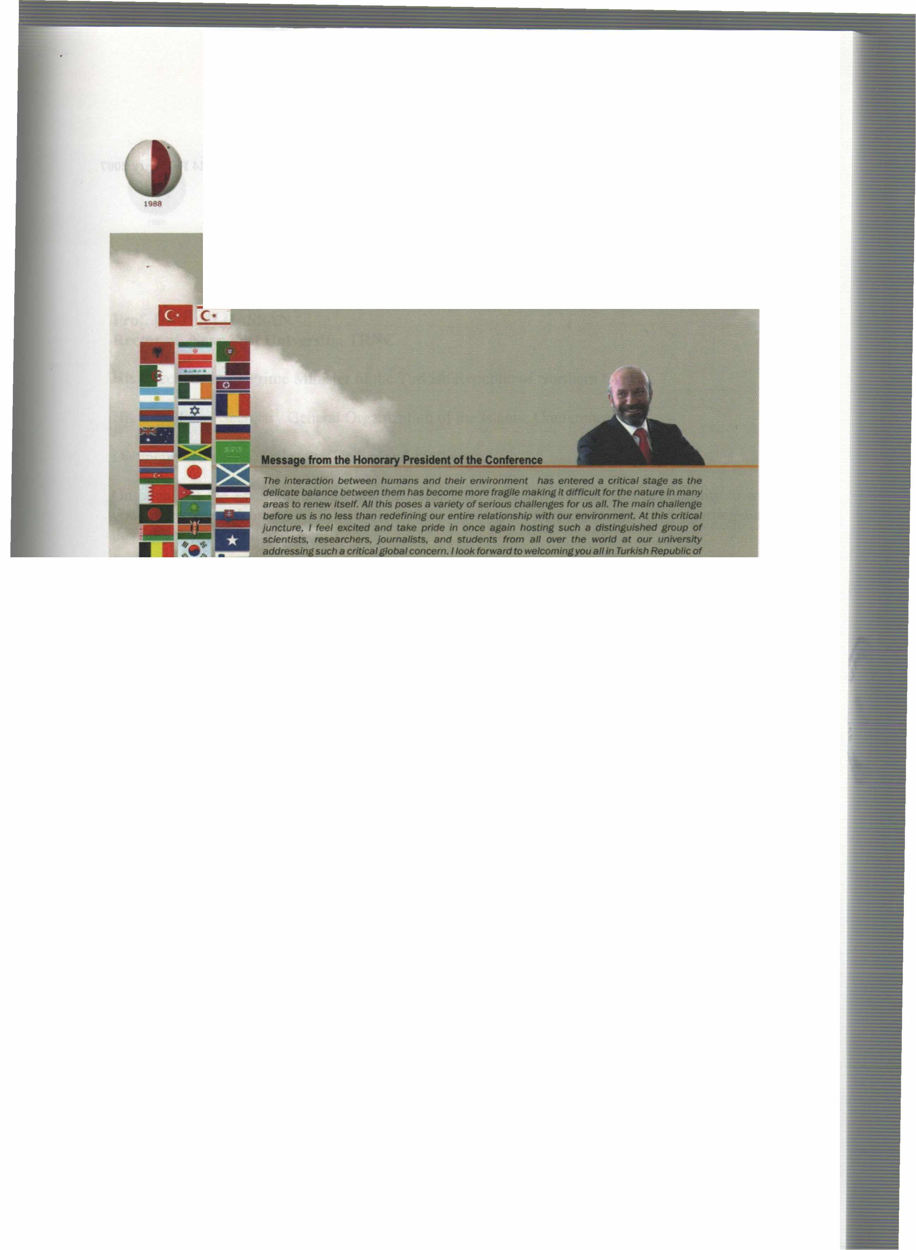
International Conference on Environment: Survival and Sustainability 19-24 February 2007 Near East University, Nicosia-Northern Cyprus
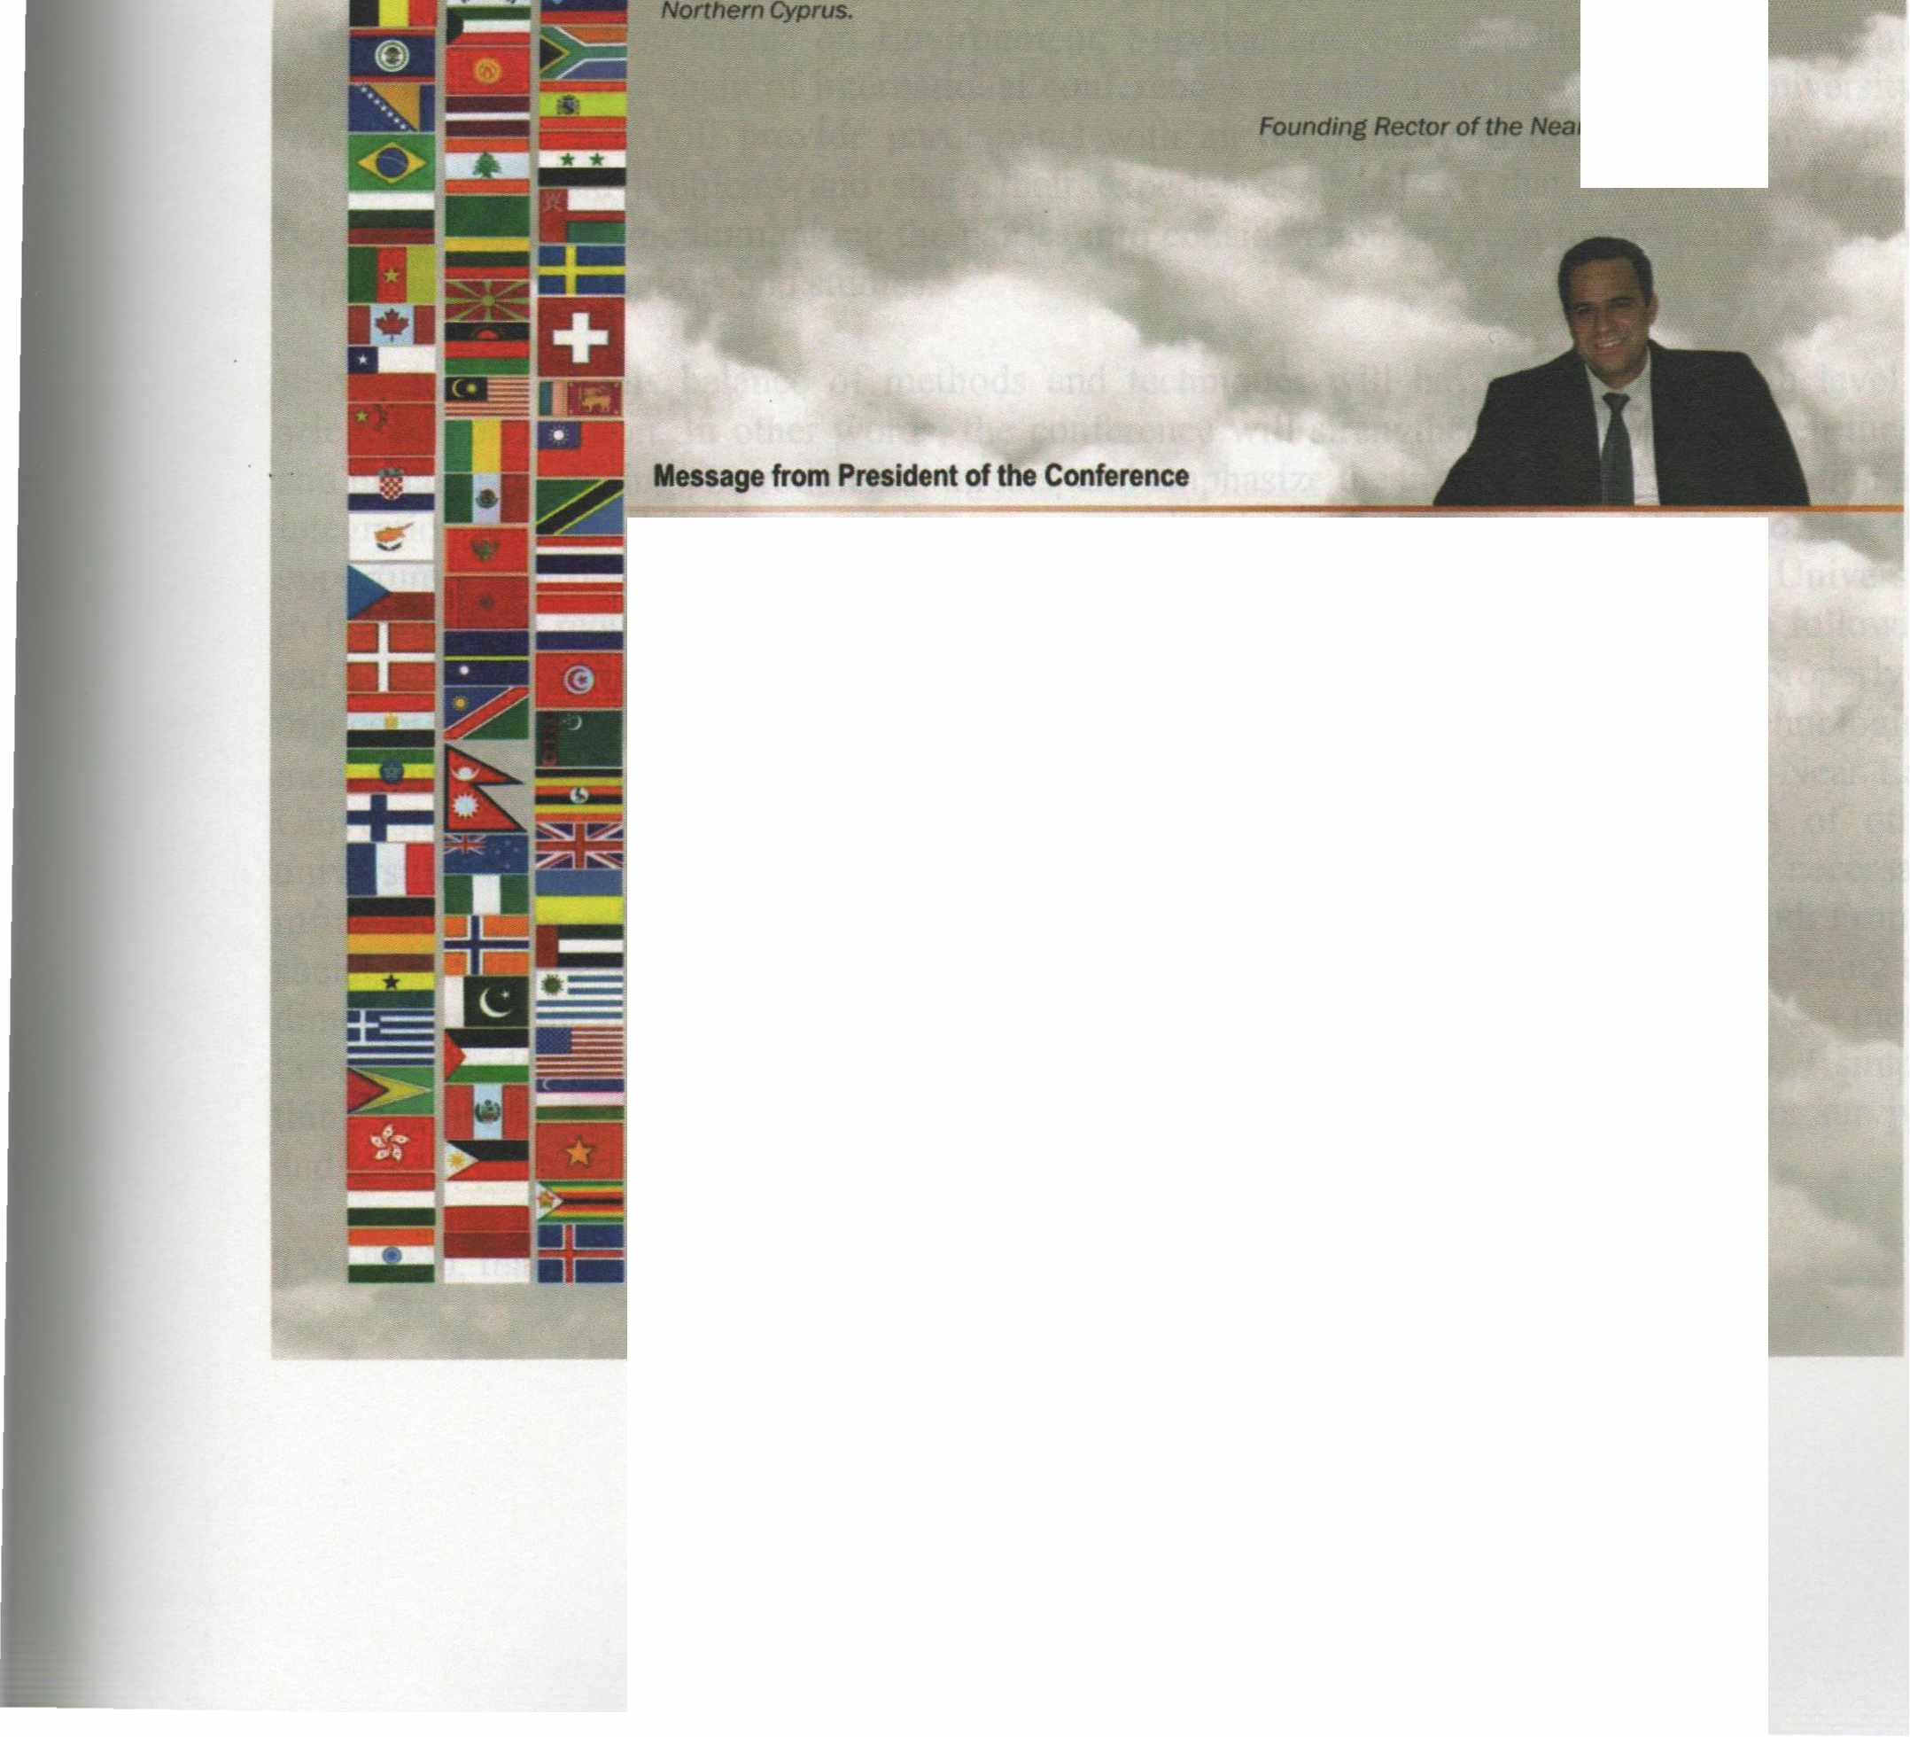
It gives me the utmost pleasure in welcoming you all to the lflflemational Conference • Environment: Survival and Sustainability" here at the Near East Unltlerslty In Tlllf<Jsh Republic of Northern C)'ptus ID be held at 19-24 February 2007.
The c:onl8f'elice aimed at brlnflfllt together more than 2,000 scholars and researchers from over 90 countries lllOUlld the world IO discuss envlt'onlnental issues from a variety of perspectives; iindetllne rtNtImportance of the need for UIJ(enCy in taking steps by the intemationat Of.......,..., --. local authorlries and non-governmental organizations to move to a sustelnable 8flWDr.menVdellelopmentmodel; and thereby makes Its contribution to worldwide debate effort on .,.,_,,..,,llilfChe brldfe .between tlleot)I and practJce In meeting environmental threats/challenges.
Since our last lnlematlonal cordMNICe on environment. "EIMtonmentel Problems of the Mediterranean Regions•, worldwldaetMrorlmental disasters• well• local-~ mu/flplled and environmental degradation and polluflon has continued. Whlle majorltrides INMI a-n made In the world In analyzing. understandiflll and Informing the pub/le 8llout Ille ~ cllaHenges we are facing. we st/II have a IOnilf way to go. Our way at life Is still far from• 8Ultaltlllble model and our environment continues to degrade and deteriorate due to human activities. The consequences can be seen In worldwide environmental disasters as well as locally In our dally /Ives.
This Is fOlfll to be our third lntematiollal conference on Environment organized by our youn.r university since It was estBblished In 1988.
Yours sincerely, Pref.Dr . .....,...~ Jlice Rector of the Near East Universitv
XVII

International Conference on Environment: Survival and Sustainability 19-24 February 2007 Near East University, Nicosia-Northern Cyprus
VOLUME7
MT-11: ENVIRONMENTAL SCIENCE AND TECHNOLOGY
ALTERNATIVE PATH ON SEWERAGE SYSTEM; CONDOMINIAL METHOD AND ITS APPLICATION
Umut Turker, Majed Hamad Abu Zahrah, Hiiseyin Gokcekus - NORTHERN CYPRUS (Oral) 2923
SALINITY-ALKALINITY & POLLUTION PROBLEMS IN THE GEDIZ BASIN~TURKIYE
Munir Ozturk, Serda! Sakcah, Hakan Bahadir, Guven Gork, Miisliim Beyazgiil - TURKEY (Invited) 2935
AMBIENT AIR PA TTICULA TE DRY DEPOSITION POLL UT ANTS (METALLIC ELEMENTS, IONIC SPECIES) STUDY IN TAIWAN
Guor-Cheng Fang - TAIWAN (Invited) 2943
SOLID WASTE MANAGEMENT IN THE DEVELOPING COUNTRIES: A CASE STUDY IN TURKEY
Giinay Kocasoy-TURKEY (Invited) 2971
MANAGEMENT OF HAZARDOUS ROAD DERIVED RESPIRABLE PARTICULATES USING MAGNETIC PROPERTIES OF TREE LEA YES.
K. Prajapati, B.D. Tripathi- INDIA (Oral} 2983
RAPID MEASURMENT OF APPLE VINEGAR'S ADDED SODIUM MET AB I SULFITE BY A NEW ULTRASONIC METHOD
Gokhan Savaroglu, Filiz Savaroglu -TURKEY (Oral) 2989
RECLAMATION OF SODIC SOILS THROUGH VERMITECHNOLOGY
Abdullah Adil Ansari - TURKEY (Oral) 3003
USING OF THE LIGNOSULFONATES: FERTILIZERS
Ali Riza Dernirkrran -TURKEY (Oral) 3013
MODELING THE AEROBIC BIO-OXIDATION STAGE OF AN INDUSTRIAL WASTEWATER TREATMENT PLANT USING ANFIS AS A SOFTWARE SENSOR
G. Civelekoglu, A. Perendeci, N.O. Yigit, M. Kitis-TURKEY (Oral) 3019
REMOVAL OF COBALT ION FROM AQUEOUS SOLUTIONS BY LIGNOSELLULOSICS MODIFIED WITH PAN
Mustafa Karaboyaci, Fethiye Gode, Aziz Sencan, Mustafa Cengiz - TURKEY (Oral) 3027
A STUDY ON APPLICATION OF DIFFERENT DI SOLVED OXYGEN (DO) VARIATIONS IN SEQUENCING BATCH REACTOR
Engin Giirtekin, Nusret Sekerdag - TURKEY (Oral) 3037
MICROALGAE REMOVAL FROM SYNTHETIC WASTEWATER BY TILAPIA (OREOCHROMIS NILOTICUS AND OREOCHROMIS AUREUS)
Ahmet Yuceer, Olcayto Keskinkan - TURKEY (Oral) 3043
BIOREMEDIATON OF CD(II)-CONTAMINATED KAOLINE BY RHAMNOLIPID BIOSURFACTANT
Yeliz A~91, Macid Nurbas, Yesim Sag Acikel - TURKEY (Oral) 3051
PROPOSAL FOR A SOLID WASTE MANAGMENT SCHEME FOR THE TURKISH REPUBLIC OF NORTHERN CYPRUS
Selnur Ucaroglu, Mustafa YILDIRIM, Ipek Yilmaz, Orhan Kucukgul, Biilent Topkaya - NORTHERN CYPRUS (Oral) · 3059
A STUDY ON RECOVERY AND RECYCKLING OF USEFUL MATERIAL IN LEATHER TANNING INDUSTRY
Hafiz Moghira Badar, Ahmad Khan, Fatima Batool - PAKISTAN (Oral) 3069
LXII

International Conference on Environment: Survival and Sustainability 19-24 February 2007 Near East University, Nicosia-Northern Cyprus
COMPARISON OF THE METALS CONCENTRATIONS IN ATLANTIC HORSE MACKEREL, TRACHURUS TRACHURUS, FROM COASTAL WATERS OF TURKEY
Aysun Turkrnen, Yalcin Tepe, Mustafa Tiirkmen, Alpaslan Ates, Kutalmis Gokkus -TURKEY 3081
EFFECT OF TOTAL AMMONIA NITROGEN CONCENTRATION AND pH ON GROWTH RA TES OF LEMNA MINOR
Yalcm Tepe, Mustafa Tiirkmen, Yalcm Tore, ElifKuzu -TURKEY (Oral) 3089
SEQUENTIAL (ANAEROBIC- AEROBIC) TREATMENT OF CHEESE WHEY
Cansu Filik lscen, Semra Ilhan -TURKEY (Oral) 3097
DECADES OF TIN MINING IN JOS PLATEAU NIGERIA AND A LEGACY OF IMPOVERISHED AGRICULTURAL LAND AND HIGH RADIOACTIVE ELEMENTS: AN OVERVIEW OF INFRASTUCTRAL NEGLIGENCE
N.N. Jibiri- NIGERIA (Oral) 3105
PARTICULATE MATTER AND P AH POLLUTION IN ON INDUSTRIAL TOWN: DILOV ASI CASE
Aytug Sivashgil, Pmar Kus -TURKEY (Oral) 3119
AN INTEGRATED PREVENTIVE PRODUCTION PLANNING PROGRAM WITH WASTE MINIMIZATION
SedefElker, Sibel Uludag-Demirer-TURKEY (Oral) 3127
LEVELS OF HEAVY METALS IN WATER AND FISH (CARASOBARBUS LUTEUS HECKEL, 1843) WERE SAMPLED FROM GOLBASI LAKE, HATA Y, TURKEY.
Ayse Bahar Yilmaz, Mustafa Dogan - TURKEY (Oral) 3139
IMPACTS OF SOLUTION PH ON ARSENIC REMOVAL BY NANOFIL TRA TION AND TIGHT-UL TRAFIL TRATION MEMBRANES
Evrim Celik, Jaeweon Cho, Zhang Yang, Eunkyung Lee, Sungyun Lee, Mehmet Kitis -TURKEY, KOREA, KOREA, KOREA,
TURKEY (Oral) 3149
NONDESTRUCTIVE TEST TO TACK POLL UT ANT TRANSPORT INTO LANDFILL LINERS
A. Bezzar, F. Ghomari, H. Q. Wang-ALGERIE, FRANCE (Oral) 3157
INVESTIGATION OF BIOACCUMULATION OF COPPER AND NICKEL IONS BY RHIZOPUS DELEMAR
Dosal Acikel, Tugba Alp - TURKEY (Oral) 3169
COMPARISON OF BIOACCUMULATION AND BIOSORPTION OF COPPER IONS BY CANDIDA LIPOLYTICA
Dosal Acikel, Tugba Alp-TURKEY (Oral) 3177
ENVIRONMENTAL IMPACTS OF FLY ASHES FROM THERMAL POWER STATION
S.A. Kadioglu, A. Balci, A. Demirak, E. Tilkan - TURKEY (Oral) 3187
PLANTS, BRYOPHYTES, EPIPHYTIC MICROORGANISMS AND FUNGI AS BIOINDICATORS OF AIR POLLUTION
Marilena Onete, Mihaela Pauca-Comanescu, Joana Gomoiu, Sorin Stefanu], Daniela Sincu > ROMANIA (Oral) 3197
IMPORTANCE OF RAPID MIXING 1IME ON SLUDGE DEWA-TERING PROPERTIES
S. Sam, M.A. Yukselen - TURKEY (Oral) 3213
TOLUENE INHIBITION OF AN ANAEROBIC REACTOR SLUDGE IN TERMS OF ACTIVITY AND COMPOSITION OF
ACETOCLASTIC METHANOGENS - - .,
O.Ince,M.Kolukirik, Z.<;::etecioglu, O.Eyice, N. Ayman Oz, Ozgul Inceoglu, B.Ince -TUR:KEY""(Oral) 3227
CLEAN DYEING TECHNOLOGY WITH BASIC NATURAL DYE ON COTTON FABRICS USING ULTRASONIC TECHNIQUE
M.M Kamel, H.F. Mansour, H. M. Mashaly, A.A.Haroun - EGYPT (Oral) 3237
ADDRESSING SYNERGIES BETWEEN CHEMICAL SAFETY AND SUSTAINABLE PRODUCTION AND USE OF CHEMICALS
Sulejma Cehic - SLOVENIA (Oral) 3251
LXIII

International Conference on Environment: Survival and Sustainability 19-24 February 2007 Near East University, Nicosia-Northern Cyprus
ACUTE TOXICITY OF MERCURIC CHLORIDE ON RAINBOW TROUTS AND CHUBS
Billent Verep, E. Sibel Besli, llhan Altinok, Cengiz Mutlu -TURKEY (Oral) 3267
REMOVAL OF COLOUR FROM INDUSTRIAL WASTEWATER
D. Mohan, S. Sarkar, K. Ankur "- INDIA (Oral) 3279
•... - -·
APPLICABILITY OF PHOTOCA T AL YTIC OXIDATION PROCESS TO EFFLUENT"OF THE COMBINED WAS TEW ATER TREATMENT PLANT
Ayla Arslan -TURKEY (Oral) 3291
TRACE ELEMENT CONCENTRATIONS OF LICHENS NEAR SEYITOMER COAL-FIRED POWER PLANT
Filiz Gur, Gunseli Yaprak-TURKEY (Oral) 3301
REMOVAL OF TOXIC COPPER AND MANGANESE IONS FROM LEFKE-GEMIKONAGI DAM WATER
Selahattin Gokmen, Nilay Taser -TURKEY, NORTHERN CYPRUS (Oral) 3313
DEVELOPMENT AND ENVIRONMENTAL POLLUTION IN TURKEY AND IN KOCAELi
Savas Ayberk - TURKEY (Oral) 3319
ZOOPLANKTON COMPOSITION AND WATER QUALITY OF LAKE GOLBASI (HATAY-TURKEY)
Yalcm Tepe, Ahmet Bozkurt-TURKEY (Oral) 3325
THE SUSTAINABILITY OF WASTE DISPOSAL: POLLUTION OF UNDERGROUND WATER BY LEACHATES FROM OLD BURDENS (DUMPSITE)
Sokefun Olusola Bolarinwa - NIGERIA(Oralj 3343
NOISE AS AN INFLUENTIAL ENVIRONMENTAL PROBLEM.CASE STUDY: LEVELS OF DISTURBANCE BY ROAD TRAFFIC NOISE IN THE CITY OF NIGDE.
Lale Guremen, Cahit Tagi Celik - TURKEY (Poster) 3353
RECOVERY OF ZINC FROM QUARTZ BY RHAMNOLIPID BIOSURFACTANT
Yeliz A~91, Macid Nurbas, Yesim Sag Acikel -TURKEY (Poster) 3359
DRAINAGE GEOCHEMISTRY AND ENVIRONMENTAL IMPACT OF THE WHITTLE COALFIELD AREA, NORTHERN UK
Leyla Kalender - TURKEY (Poster) 3365
PROTECTION OF MARBLE USING BIODEGRADABLE POLYMERS
Yilmaz Ocak, Aysun Cakan Sofuoglu, Funda Tihmmhoglu, Basak Ipekoglu, Hasan Boke -TURKEY (Poster) 3393
SOLID WASTE MANAGEMENT AT THE SOUTH-EASTERN BLACK SEA COASTLINE
Egemen Aras, Mehmet Berkun - TURKEY (Poster} 3401
UTILIZATION OF THE RESIDUAL BRINES OF WATER DEMINERALIZERS
N.A.Salimova, F.M.Sultanova, L.V.Huseynova - AZERBAIJAN (Poster) 3411
BIODEGRADATION OF AZO DYES
Jonstrup Maria, Blanques Paqui, Guieysse Benoit- SWEDEN (Poster) 3415
PLANT SPECIES OF CMC MINING WASTE AREA AND HEAVY MET AL ACCUMULATION
Gulriz Baycu - TURKEY (Poster) 3419
GALVANIC WASTE WATER TREATMENT WITH CHELATING MACROPOROUS COPOLYMER AT ST A TIC AND DYNAMIC CONDITIONS
Aleksandra Nastasovic, Antonije Onjia, Zvjezdana Sandie, Ljiljana Malovic, Sladjana Kljajevic, Dragana Dordevic, Dragica
Jakovljevic - SERBIA (Poster) 3423
LXIV

International Conference on Environment: Survival and Sustainability 19-24 February 2007 Near East University, Nicosia-Northern Cyprus
1988
THEORETICAL SUB ST ANITA TION OF PROCESS OF RECTIFICATION OF OIL-POLLUTED SOIL.
Hasanov G. S, Abdullaev F. Z, Latifov F.I. - AZERBAIJAN (Poster) 3433
THE USE OF PURIFICATION SLUDGE OF PAPER INDUSTRY IN AGRICULTURE
Gumus Funda Goki;:e - TURKEY (Poster) 3443
DETERMINATION OF SEA POLLUTION IN ALIAGA BAY, IZMIR, TURKEY:7-ETHOXYRESORUFIN 0-DEETHYLASE (EROD) INDUCTION IN LEAPING MULLET (LIZA SALIENS).
0. K. Ulutas, A. Sen, B. Tutuncu, t. Cok - TURKEY (Poster) 3459
EXAMINATION OF SOME PARAMETERS FOR ECOLOGICAL GROWTH OF MAIZE IN PELIC VERTISOL
I.Stoimenova, St. Alexieva, S. Stratirva, E. Djonova, A.Taleva, N. Kaloyanova - BULGARIA (Poster) 3465
DECOLORIZATION OF TEXTILE DYES BY A FILAMENTED FUNGUS ASPERGILLUS ORYZAE
Hatice Atacag Erkurt, Mustafa Ozyurt, Ayla Ozer-TURKEY (Poster) 3471
ADSORPTION OF CHROMIUM (VI) BY WOOL
Nilgiin Balkaya, Nilden Bektas -TURKEY (Poster) 3481
REMOVAL OF LEAD FROM AQUEOUS SOLUTIONS BY PHOSPHOGYPSUM TREATED WITH LIME
Nilgiin Balkaya, Hasan Cesur - TURKEY (Poster) 3495
DECOLORIZATION OF DRIMARENE BLUE K2-RL BY FUNALiA TROGII ATCC 200800 CULTURE FILTRATE IMMOBILIZED IN ALGINATE BEADS
Emrah A. Erkurt, Mehmet A. Mazmanci, Hatice A. Erkurt, Ali Unyayar -TURKEY (Poster) 3509
ZETA POTENTIAL: A NEW WATER TREATMENT AND THE ALUMINUM INDUSTRY
Luiz Antonio Ferrari, Romeu Rovai Filho - BRAZIL (Poster) 3517
SIMULATION OF AN ACTIVATED SLUDGE TREATMENT SYSTEM USING ASM AND ANFIS MODELS
G. Civelekoglu, N.O. Yigit, 0. Cinar, M. Kitis -TURKEY (Poster) 3523
TOXICITY ASSESSMENT OF METHYL TERT-BUTYL ETHER, TERT-BUTYL ALCOHOL AND FORMALDEHYDE USING REDUCED INHIBITION CONSTANTS
W. Cho, K. S. Cho, H. W. Ryu - SOUTH KOREA (Poster) 3533
A GRAPHICAL APPLICATION IN TREATMENT OF RESIDENT AL WASTEWATER BY THE ACTIVATED SLUDGE PROCESS
S. Serkan Nas, Adem Bayram-TURKEY (Poster) 3541
INVESTIGATION OF RADON RISK IN WELL WATER
Akkurt, H.A. Yalim, H. Akyildmrn.A. Akkurt, F.B. Ozdemir, R. Una!, A. Sandikcioglu -TURKEY (Poster) 3551
THE EFFECT OF SOLAR - COSMIC RAYS ON THE BACKGROUND RADIATION
L Akkurt, N.<;.Bezir, B. Mavi, H. Akyrldmrn, C.Yali;:m, F. Kulah -TURKEY (Poster) 3555
SEASONAL AND SPATIAL DISTRIBUTIONS OF THE METALS IN THE WATER, "SEDIMENT AND AFRICAN CATFISH, CLARIAS GARIEPINUS, FROM THE RIVER ASI (ORONTES) IN SOUTHERN EAST MEDITERRANEAN AREA OF TURKEY
Mustafa Tiirkmen, Evren Cahskan - TURKEY 3559
GEOSYNTHETIC MATERIALS USED IN WASTE CONTAINMENT SYSTEMS
Pelin Aklik-TURKEY (Poster) 3577
RADIONUCLIDE EMISSION FROM THE SEYiTOMER COAL-FIRED POWER PLANT AND THE POPULATION EXPOSURE TO EXTERNAL RADIATION IN ITS VICINITY
Filiz Gur, Giinseli Yaprak-TURKEY (Poster) 3585
LXV

International Conference on Environment: Survival and Sustainability 19-24 February 2007 Near East University, Nicosia-Northern Cyprus

1988
BIOMONITORING OF TRACE ELEMENTS OF ZINK AND MANGANESE POLLUTION BY THE BARK OF TURKISH RED PINE (PINUS BRUTIA) IN WESTERN ANATOLIA
Y. Dogan, N. Durkan, S. Baslar, H.Aydin - TURKEY (Poster) 3595
INDUSTRIAL SOLID Wf>.STE MANAGEMENT IN TURKEY ··
Basak Mesci, Osman Nuri Ergun -TURKEY (Poster) 3601
MT-12:GLOBAL WARMING: HOW MUCH OF A THREAT?-
DEVELOPING COUNTRIES AND THE CHALLENGE OF CLIMATE CHANGE
Ishfaq Ahmad - PAKISTAN (Invited) 3607
GLOBAL WARMING THREAT ON WATER RESOURCES AND ENVIRONMENT
Zekai Sen - TURKEY (Invited) 3623
TRENDS AND V ARIA TIO NS OF AIR TEMPERATURE AND PRECIPITATION SERIES IN NORTHERN CYPRUS
Murat Turkes, Faize Saris - TURKEY (Oral) 3657
CONTROL OF GHG EMISSIONS RESULTING FROM THE TRANSPORT SECTOR IN TURKEY
Cem Sorusbay, Metin Ergeneman, M. Aydm Pekin - TURKEY (Oral) 3669
REGIONAL CLIMATE CHANGE AND ITS IMPACTS FOR TURKEY
Mehmet Karaca, Ozan M. Gokturk, Omer Lutfi Sen, Baris Ono!, Tayfun Kmdap, Nuzhet Dalfes - TURKEY (Oral) 3679
GLOBAL WARMING AND CLIMATIC CHANGES IN PAKISTAN
Abdul Razzaq Ghumman, Muhammad Ali Shamim, Raza Ali - PAKISTAN (Oral) 3687
WHO PAYS THE BILL? - THE IMP ACT OF CLIMATE CHANGE ON REAL ESTA TE MARKETS
Sven Bienert Mrics - GERMANY (Oral) 3 707
SIGNAL AND TREND ANALYSIS OF TEMPERATURE SERIES: A TURKISH CASE
Mete Tayanc, Murat Dogruel, Ulas Im, Mehmet Karaca-TURKEY (Oral) 3723
INTERNATIONAL CLIMATE CHANGE POLICIES AND TURKEY
Deniz Babus, Muzaffer Yiicel - TURKEY (Oral) 3 735
EVALUATIONS ON FOREST RESOURCES MANAGEMENT OF NORTHERN CYPRUS AND NEW PLANNING APPROACH IN ACCORDANCE WITH SUSTAINABILITY AND CLIMATE CHANGE RISK
Said Dagdas, Riistem Kins -TURKEY (Oral) 3747
GLOBAL WARMING: HOW FAR A PROBLEM
Somlata Sharma - INDIA (Oral) 3759
MODELING METHANE EMISSION FROM <;ANAKKALE OPEN DUMPSITE AND ITS EFFECT ON GLOBAL WARMING: A LANDGEM USE APPROACH
Edip Avsar, Hasan Griksel Ozdilek-TURKEY (Oral) 3767
INTEGRATED APPROACH IN SEARCHING SUSTAINABLE DEVELOPMENT OPPORTUNITIES
Giuseppe Fumarola, Aniello Russo Spena - IT ALY (Oral) 3 777
LXVI

ear East University - TRNC Tel: +90 392 223 6464/460 Tel/Fax: +90 392 223 5427 infnlmno11.edu.tr-www.neu.edu.tr
VOL 7: ISBN 978-975-8359-59-2

