Proceedings

Volume 5
International Conference on Environment : Survival and Sustainability

Organized by Near East University

Published By: EDUCATIONAL FOUNDATION OF NEAR EAST UNIVERSITY
Near East University, tefkosa, Turkish Republic of Northern Cyprus Tel: +90 392 223 64 64
Fax: +90 392 223 64 61
e-mail: info@neu.edu.tr
web: www.neu.edu.tr
Citation: Gok~eku~, H., 2009 (Editor) Proceedings of the International Conference on Environment: Survival and Sustainability. Nicosia (Lefkosa),
Turkish Republic of Northern Cyprus: Educational Foundation of
Near East University. 10 volumes, LXXVI, 5498, XIV pages.
Copyright: Reproduction of this Publication for Educational or other non-commercial purposes is authorized without prior permission from the copyright holder. Reproduction for resale or other commercial purposes prohibited without prior written permission of the copyright holder.
ISBN: Volume 1: 978-975-8359-53-0
Disclaimer: While every effort has been made to ensure the accuracy of the information contained in this publication, the EDUCATIONAL FOUNDATION of the NEAR EAST UNIVERSITY will not assume liability for any use made of the proceedings and the presentation of the participating organisations concerning the legal status of any country, territory, or area, or of its authorities, or concerning the delimitation of its frontiers or boundaries.
Printed by: Near East University Tel: +90 392 223 64 64 Fax: +90 392 223 64 61

Editor: Prof. Dr. Huseyin GOKCEKUS Near East University
Lefkosa,
Turkish Republic of Northern Cyprus ghuseyin@neu.edu. tr. gokcekushuseyin@gmail.com Tel/Fax: 00 90 392 223 54 27
Members of the Editorial Board:
AnwarNASIM
Aysel YONT AR Cyro Do VALLE Derin ORHON
Elchin KHALILOV Giovanni BARROCU Gunnar TELLNES JimLAMEROX
Pakistan TRNC Brasil Turkey Azerbaijan Italy Norway USA
Konstantin V. SUDAKOV Russia
Luc HENS Belgium
Mtmur OZTURK Turkey
Reinhold STEINACKER Austria
Tarzan LEGOVIC Ulric ROTT UmutTURKER Omit HASSAN Vedat DOYURAN Walter KOFLER Zekai SEN
III
Crotia Germany TRNC TRNC Turkey Austria Turkey

International Conference on Environment: Survival and Sustainability 19-24 February 2007 Near East University, Nicosia-Northern Cyprus
CONTENTS
Pages
Editor/Members of the Editorial Board III
Preface VII
Acknowledgments VIII
Organizing Committee Members IX
International Advisory Board Members X
Scientific Committee Members XIII
Messages XVII
·Message from Dr. Suat i.Gunsel, Honorary President of the Conference ·Message from Prof.Dr. Huseyin Gokcekus, President of the Conference
Opening Speeches XIX
·Prof. Dr. Dmit Hassan, Rector of Near East University, TRNC
·Prof.Dr. Huseyin Gokcekus, President of the Conference & Organizing Committee, TRNC ·Rahmi Ko9, Honorary Chairman & Founding Member ofTURMEPA, TURKEY
-Esref Cerrahoglu, Chairman of Executive Board ofTURMEPA, TURKEY
·Cemal Bulutoglulan, Mayor, Turkish Municipality of Lefkosa, TRNC
-Asim Vehbi, Minister of Environment and Natural Resources, TRNC
·Tahsin Ertugruloglu, Leader of the National Unity Party(UBP), TRNC
·Assoc. Prof.Dr. Turgay Avci, Deputy Prime Minister & Minister of Foreign Affairs ofTRNC -Turkekul Kurttekin, Turkish Ambassador to Lefkosa, TRNC
·Ferdi Sabit Soyer, Prime Minister ofTRNC
·Prof. Dr. Ekmeleddin Ihsanoglu, OIC Secretary General ·Mehmet Ali Talat, President of TRNC
Final Report of the International Conference On Environment: Survival and
Sustainability XXXIX
v

International Conference on Environment: Survival and Sustainability 19-24 February 2007 Near East University, Nicosia-Northern Cyprus
1986
List of Papers and Posters XLIII
Papers and Posters
Volume 1: MT-1: Business and Environment: Redefining Interests 1
Volume 2: MT-2: Conservation and Management of Biodiversity 187
Volume 3: MT-3: Cultural Heritage and Environmental Factors 769
Volume 4: MT-4: Economics, Development and Sustainability 1043
Volume 5: MT-5: Energy and Development: New and Renewable Energy 1673
MT-6: Environment and Health 1953
Volume 6: MT-7: Environmental Awareness, Education, and Lifelong Leaming 2369
MT-8: Environmental Knowledge and Information Systems 2615
MT-9: Environmental Law and Ethics 2807
MT-10: Environmental Organizations: Roles, Problems and Prospects 2895
Volume 7: MT -11: Environmental Science and Technology 2923
MT-12:Global Warming: How Much of A Threat? 3607
Volume 8: MT 13 -Green Factor In Politics 3785
MT-14: Integrated Water Resources Management. 3847
Volume 9: MT-15: International Relations and Environmental Issues 4367
MT-16: Literature and Environmental Awareness 4527
MT-17: Natural and Man-Made Disasters: Emerging Link and Challenges 4587
MT-18: Pesticides In The Environment and Food Commodities 4741
MT-19: The Role of Media: Problems and Challenges 4809
Volume 10: MT-20: Seas, Ecological Balance, and Sustainable Environment. 4915
MT-21: Social and Psychological Dimensions of Environmental Issues 5117
Index I
Brief Information About Near East University XI
Brief Information About Turkish Republic of Northern Cyprus XV
VI

International Conference on Environment: Survival and Sustainability 19-24 February 2007 Near East University, Nicosia-Northern Cyprus
1998
PREFACE
Creating a sustainable and a healthy environment is one of the most important global issues facing mankind today. Therefore, serious consideration should be given to environmental problems and concerted efforts should be made worldwide in order to respond and prevent present and future environmental risks and challenges.
The International Conference on Environment: Survival and Sustainability (ESS 2007) organized by the Near East University between the dates 19 and 24 February 2007 was held in Lefkosa, Turkish Republic of Northern Cyprus. The main objective of this multidisciplinary conference was to gather scientists from all over the world to discuss the overall issue of the environment, to find out sustainable solutions for environmental problems and to identify areas for future collaboration in this matter. The conference brought together 2,052 participants from 108 different countries. During the conference a total of 1,463 papers were presented under 21 different subtopics, representing various scientific disciplines. The topics included environmental law and ethics, environmental knowledge, technology and information systems, media, environmental awareness, education and lifelong learning, the use of literature for environmental awareness and the effects of the green factor in politics and in international relations.
The Scientific Committee of International Conference ESS2007 evaluated all of the 1,463 papers and selected among them 610 papers to be included in The Proceedings of Environment: Survival and Sustainability. The readers will notice the wide range of topics represented by the papers included in the Conference Proceedings.
It is hoped that this book will serve to contribute to increase in awareness towards various environmental issues as well as drawing more attention to the urgency of international cooperation and collaboration in pursuing sustainable environmental management.
Prof. Dr. Huseyin Gokcekus
President of the Conference and the Organizing Committee Vice Rector of the Near East University
Lefko~a-TRNC
18 February 2009
VII

International Conference on Environment: Survival and Sustainability 19-24 February 2007 Near East University, Nicosia-Northern Cyprus
1988
ACKNOWLEDGMENTS
The Organizing Committee of the ESS2007 Conference would like to extend its sincere appreciation to Dr. Suat Gi.insel, the Founding Rector of the Near East University, to Prof. Dr. Ekmeleddin lhsanoglu, General Secretary of the Organization of Islamic Conference and to Prof. Dr. Walter W. Kofler, President of ICSD/IAS for their significant support and encouragement in the conference.
Appreciation is also extended to the chairpersons, the keynote speakers and the presenters of papers in the conference.
We are deeply grateful for the members of the editorial board who have carefully read and recommended the papers for publishing.
We also wish to express our gratitude to numerous individuals for their valuable contribution to the editing process.
Prof. Dr. Hi.iseyin Gokcekus
President of the Conference and the Organizing Committee Vice Rector of the Near East University
Lefko~a-TRNC
VIlI

International Conference on Environment: Survival and Sustainability 19-24 February 2007 Near East University, Nicosia-Northern Cyprus
19!lf!
ORGANIZING COMMITTEE MEMBERS
Honorary President
Dr. Suat i. GUNSEL, Founding Rector of the Near East University
President
Prof. Dr. Hiiseyin GOK<;EKUS, Vice Rector of the Near East University
Members
Prof. Dr. Umit HASSAN, Rector of the Near East University Prof. Dr. Aysel YONTAR
Dr. Hatice GOK<;EKUS (M.D.) Asst. Prof. Dr. Umut TURKER Asst. Prof. Dr. Mesut YAL VA<; Asst. Prof. Dr. Rifat RESATOGLU Asst. Prof. Dr. Mehmet OKCAN Asst. Prof. Dr. Dudu OZKUM Asst. Prof. Dr. Salih GUCEL
irfan GUNSEL
Giirdal HUDAOGLU
Havva ARSLANGAZi
Tiimer GARiP
AlpOZERK
Ahmet SA V ASAN
Nesrin MENEMENCi
Sakir ALEMDAR
Zebra BASARAN
Temel RIZZA
Emel TOZLU ASLAN Sifa ABiK
IX

International Conference on Environment: Survival and Sustainability 19-24 February 2007 Near East University, Nicosia-Northern Cyprus
INTERNATIONAL ADVISORY BOARD MEMBERS
A. I., OLAYINKA A., JAGADEESH Abdul, KHA.KEE
Abdullahi Elmi, MOHAMED
Agustin Gonzales Fontes de, ALBORNOZ Ajmal, KHAN
Aleh, RODZKIN
Alex, CHENG
Ayman Abou, HADID Ane, DONMEZER Aziz, ERTUN<;
Belay, TEGENE Cagatay, GULER Dana, KOLEVSKA Ed, BOLES
Elizabeth, GONZALEZ Elizabeth, THOMAS-HOPE Ersi, ABACI KALFOGLU Filiz, DILEK
Furkat, KHASSANOV Gaudelia A., REYES George, CONSTANTINOU George, PETRIDES Giinay, KOCASOY
Guntis, BRUMELIS Halime, PAKSOY Hallvard, ODEGAARD
Nigeria India Germany Somalia
Spain Pakistan Belarus
USA Egypt Turkey Turkey Ethiopya Turkey Macedonia Belize
Uruguay
Jamaica
Turkey Turkey Uzbekistan Philippines Cyprus Cyprus Turkey Latvia
Turkey Norway
x

Turkey
Turkey
Bahrain
Qatar
Turkey
Belgium
Namibia
Malawi
Morocco
Malaysia
Turkey
Jordan
Spain
Netherland
Zimbabwe
Guyana
Iran
Jordan
Lebanon
Turkey
Turkey
Turkey
Turkey
Palestine
Palestine
Austria
Armenia
Ireland
Turkey
Turkey
XI
International Conference on Environment: Survival and Sustainability 19-24 February 2007 Near East University, Nicosia-Northern Cyprus
l98~
Hasan, ERTEN Hunay, EVLIYA
Ibrahim Abdel Gelil Said, ABDULA Ibrahlm S., ALNAIMI
irfan, GUNEY
Jaco, V ANGRONSVELD Joe, LEWIS
John, SAKA
Lyoussi, BADIAA
M. Nasir, SHAMSUDIN Mahmut Parlak, TUNA Mannar, FAYYAD Manuel Benito, CRESPO Marcel, STIVE Margaret, ZIMBA
Mark, BYNOE
Mohsen, HOSSEINI Moneef R., ZOU'BI Mutasem, EL-FADEL Neset, KILIN<;ER Nilkhet, TURGUT Orban, ALT AN
Peyman, Y AL<;IN Qasem Abdul, JABER Ramzi, SANSUR Reinhold, STEINACKER Renee, RICHER Richard, MOLES
Safak, URAL
Selim, KAPUR

International Conference on Environment: Survival and Sustainability 19-24 February 2007 Near East University, Nicosia-Northern Cyprus
1968
Serpil, OPPERMAN | Turkey
Seval, SOZEN | Turkey
Sevgi, SARYAL | Turkey
Skender, OSMAN! | Albania
Songiil A., V AIZOGLU | Turkey
Tarzan, LEGOVIC | Croitia
Tetsuo, YUHARA | Japan
Tuluhan, YILMAZ | Turkey
Turan, OZTURAN | Turkey
Umit, ERDEM | Turkey
Valentina, Y ANKO-HOMBACH | Canada
Waleed Khalil, ZUBARI | Bahrain
Yigal, RONEN | Israel
Zekai, SEN | Turkey
Zohra Ben, LAKHDAR | Tunisia
XII

International Conference on Environment: Survival and Sustainability 19-24 February 2007 Near East University, Nicosia-Northern Cyprus
1Q8H
SCIENTIFIC COMMITTEE MEMBERS
Ferid, MURAD - Nobel Laureate Richard R., ERNST - Nobel Laureate Yuan T., LEE - Nobel Laureate
USA
Switzerland
Taiwan
A.H.,ZAKRI
Ahmad, MARRAKCHI Alexey Arkady, VOINOV Andrea E., RIZZOLI Andrew, BROOKES
Anne, BUTTIMER Anthony J., JAKEMAN Anwar, NASIM
Barry W., WILSON
Bjarne Bruun, JENSEN Branimir, JOV ANCICEVIC Charles N ., ALPERS
Dan C.C., GALERIU
David A., ST AH
Derin, ORHON
Elchin, KHALILOV
Eric, JOHNSON
Esteban G., JOBBAGY Fabian M., JAKSIC
Farhat M., ALI Frederick.LB., KAY AN JA Gabriele, VOIGT Galip,AKAY
G-C.,FANG
Malaysia Tunisia
USA
Switzerland Australia
Ireland Australia Pakistan
USA
Denmark
Serbia and Montenegro USA
Romania
USA
Turkey Azerbaijan Switzerland Argentina Chile
Pakistan
Uganda Austria
UK
Taiwan
XIII

International Conference on Environment: Survival and Sustainability 19-24 February 2007 Near East University, Nicosia-Northern Cyprus
l9!J8
Geoff, BERTRAM George G., LUNT Gerald, LALOR Germano, MW ABU Giovanni, BARROCU Girja K., SHUKLA Gopal B., THAPA Hanwant B., SINGH Hartmut, FRANK Heila, LOTZ-SISITKA Helen, SCHNEIDER Hillel S., KOREN Hiromi, YAMASHITA Holmes, ROLSTON Hruska, JAKUB
Irena, TW ARDOWSKA Isfaq, AHMAD J.F.Santos, OLIVEIRA James, DEVILLERS Jaroslav, BOHAC Jennifer, BROWN Jianping, WU
Jim C., BRIDEN
John, DAISH
John, GREGORY
John, HOSKINS
Judith T., ZELIKOFF Jyrki, LIESIVUORI Kaku,NOKOE
Kenneth N., TIMMIS
New Zealand
UK
Jamaica
Kenya
Italy
India
Thailand
USA
Germany
South Africa
South Africa
USA
UK
USA
Chezch Republic
Poland
Pakistan
Portugal
France
Chezch Republic
New Zealand
China
UK
New Zealand
UK
U.K
USA
Finland
Ghana
Germany
XIV

International Conference on Environment: Survival and Sustainability 19-24 February 2007 Near East University, Nicosia-Northern Cyprus
Kristine, W ALRAEVENS Kyaw Tha, PAW U Kyoung-Woong, KIM Luc, HENS
M. Shamsher, ALI Mamdouh, NOUH Manzoor, QADIR Marcel, ARNOULD Marcial, BLONDET Martha C., MONROE Mary, SEELY Mehmet, ERGIN Michael, WILHELM Miiniir, OZTURK Muthana, SHANSHAL Nairn H., AFGAN
Nicholas, MASCIE-TAYLOR Nicholas, ORNSTON Norhayati Mohd, TAHIR Pall, HERSTEINSSON Patricia, MAURICE
Paul W., JOWITT
Paulo B., LOURENCO
Peter, BRIMBLECOMBE Peter, KRUMBIEGEL
Peter, NOV AK
Philip E., LAMOREAUX Philip M., FEARNSIDE Ravi, JAIN
Richard, ROBINS
Belgium
USA
Korea
Belgium
Bangladesh
UAE
Syria
France
Peru
USA
Namibia
Turkey
Germany
Turkey
Iraq
Portugal
UK
USA
Malaysia
Iceland
UK
UK
Portugal
UK
Germany
Slovenia
USA
Brazil
Australia
France
xv

International Conference on Environment: Survival and Sustainability 19-24 February 2007 Near East University, Nicosia-Northern Cyprus
1988
Robert J., LETCHER | Canada
Robert, GIFFORD | Canada
Roberto, DANOV ARO | Italy
Saffa B., RIFFAT | UK
Sam,KACEW | Canada
Sandor,.KERE.KES | Hungary
Scott, SLOVIC | USA
Sevket, DURUCAN | UK
Shafiqul I., BHUIYAN | Bangladesh
Shahamat U., KHAN | USA
Shian-chee, WU | Taiwan
Siaka, SIDIBE | Mali
Stephen P., MCCARTHY | USA
Tarzan, LEGOVIC | Croatia
Tomasz, ZYLICZ | Poland
Ulric, ROTT | Germany
Vedat, DOYURAN | Turkey
Victor G., PRIETO | USA
Walid A., ABDERRAHMAN | Saudi Arabia
Walter, KOFLER | Austria
William.J., MANNING | USA
Wiranto, ARISMUNANDAR | Indonesia
Zhihong, XU | Australia
XVI

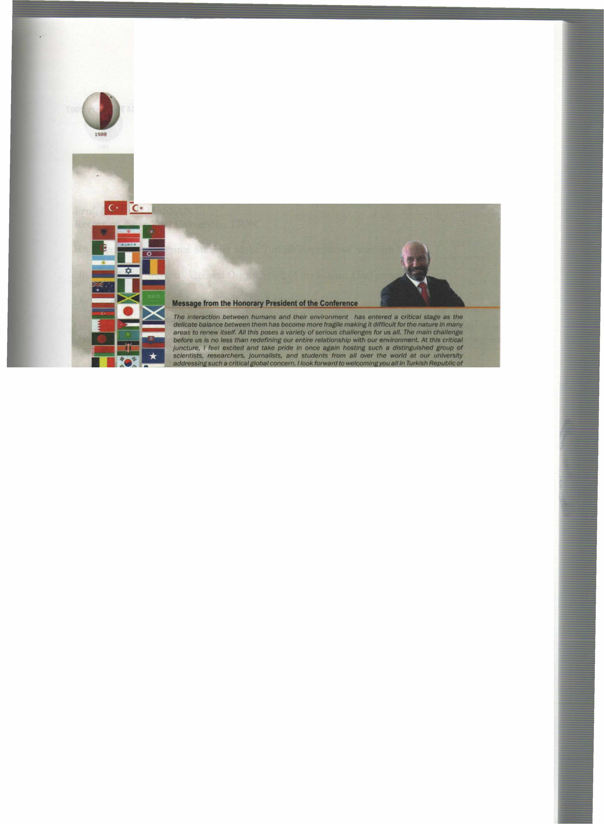
International Conference on Environment: Survival and Sustainability 19-24 February 2007 Near East University, Nicosia-Northern Cyprus
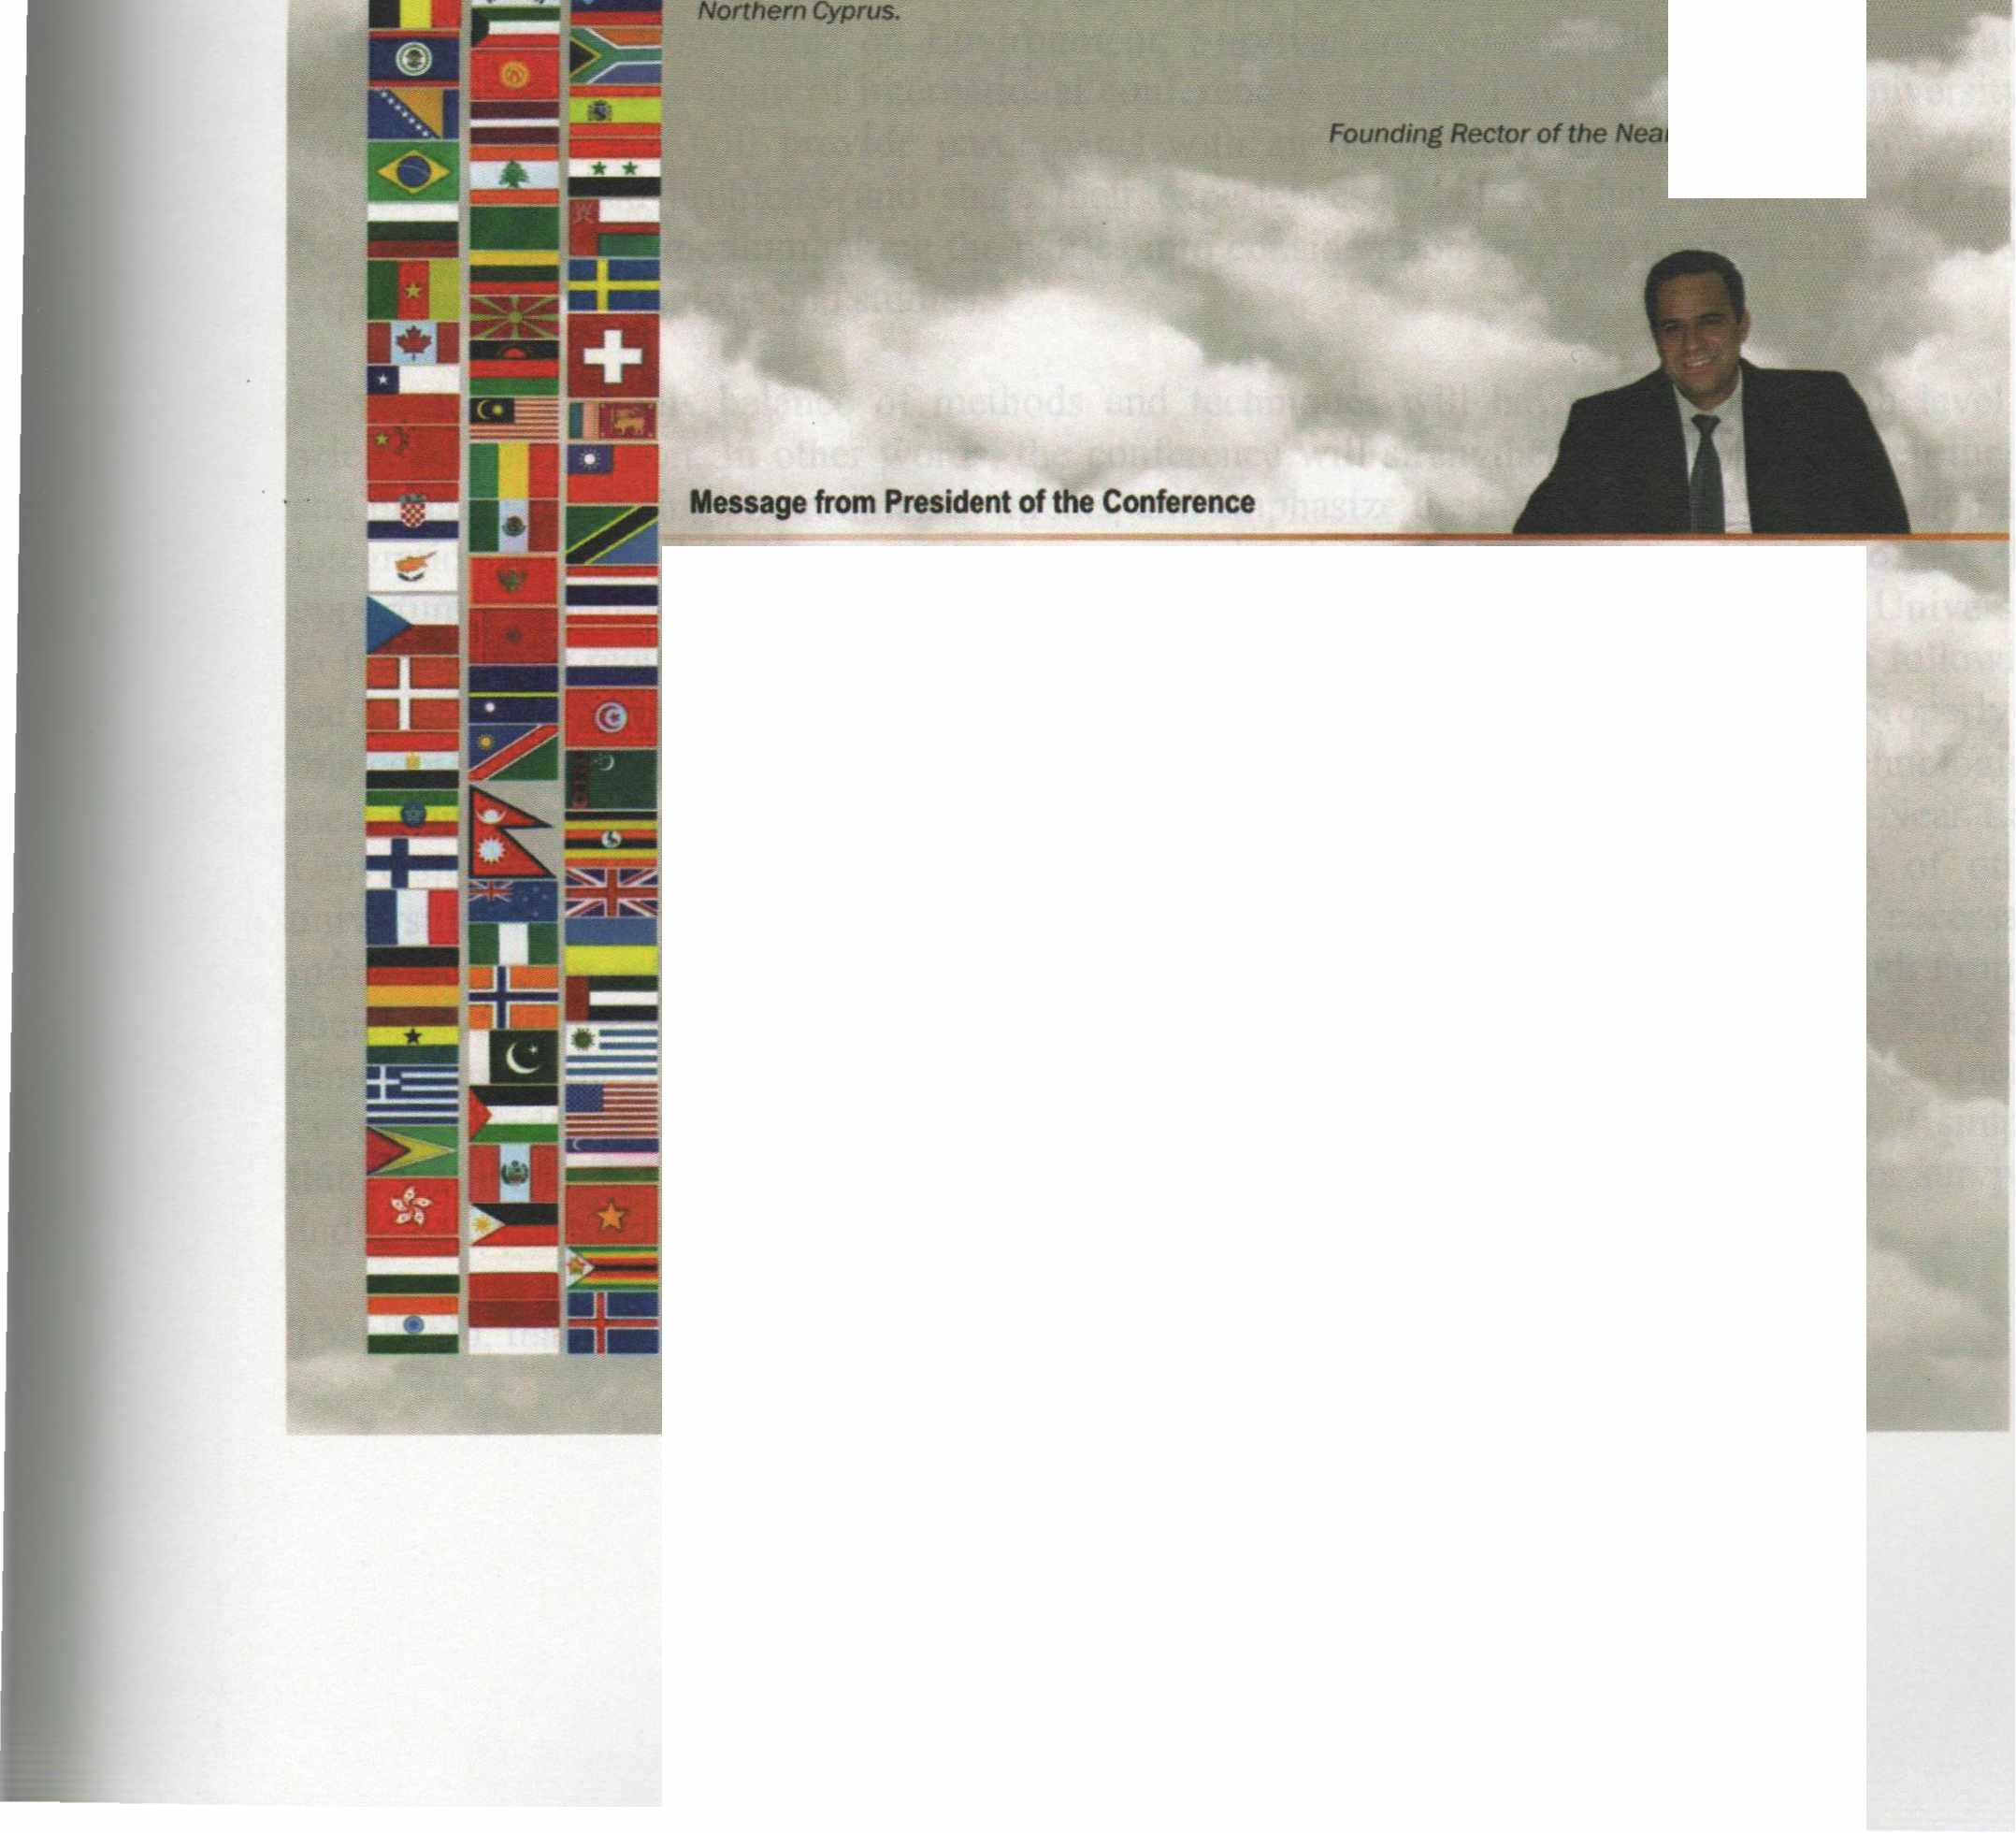

It gives me the utmost pleasure in welcoming you all to the lflflemational Conference • Environment: Survival and Sustainability" here at the Near East Unltlerslty In Tlllf<Jsh Republic of Northern C)'ptus ID be held at 19-24 February 2007.
The c:onl8f'elice aimed at brlnflfllt together more than 2,000 scholars and researchers from over 90 countries lllOUlld the world IO discuss envlt'onlnental issues from a variety of perspectives; iindetllne rtNtImportance of the need for UIJ(enCy in taking steps by the intemationat Of.......,..., --. local authorlries and non-governmental organizations to move to a sustelnable 8flWDr.menVdellelopmentmodel; and thereby makes Its contribution to worldwide debate effort on .,.,_,,..,,llilfChe brldfe .between tlleot)I and practJce In meeting environmental threats/challenges.
Since our last lnlematlonal cordMNICe on environment. "EIMtonmentel Problems of the Mediterranean Regions•, worldwldaetMrorlmental disasters• well• local-~ mu/flplled and environmental degradation and polluflon has continued. Whlle majorltrides INMI a-n made In the world In analyzing. understandiflll and Informing the pub/le 8llout Ille ~ cllaHenges we are facing. we st/II have a IOnilf way to go. Our way at life Is still far from• 8Ultaltlllble model and our environment continues to degrade and deteriorate due to human activities. The consequences can be seen In worldwide environmental disasters as well as locally In our dally /Ives.
This Is fOlfll to be our third lntematiollal conference on Environment organized by our youn.r university since It was estBblished In 1988.
Yours sincerely, Pref.Dr . .....,...~ Jlice Rector of the Near East Universitv
XVII

International Conference on Environment: Survival and Sustainability 19-24 February 2007 Near East University, Nicosia-Northern Cyprus
ENVIRONMENTAL ENRICHMENT BYWATER
VivekP. Kapadia, Mukesh B. Joshi- INDIA (Oral) 1617
RESERVES AND ECONOMICAL EVALUATION OF CONSTRUCTION MATERIALS IN THE LAND OF AZERBAIJAN REPUBLIC
Tevfik Ismailov, Ruhangiz Ismail ova - TURKEY, AZERBAIJAN (Poster) 1633
EVALUATION OF THEY ACHT SLIPWAY PLANTS IN TERMS OF ENVIRONMENT AL PROBLEMS AND SOLUTIONS:
A CASE STUDY OF FETHIYE-TURKIYE
Remzi Karaguzel , Mahmut Mutluturk, Rasit Altindag, Rafet Kistir -TURKEY (Poster) 1641
ECOLOGICAL CONDITION OF THE ISSYK-KUL REGION
Tynybekov Azamat - KYRGYZ REPUBLIC (Poster) 1657
MONITORING URBAN GROWTH IN TURKEY: CURRENT TRENDS AND FUTURE PROJECTIONS FOR SUSTAINABLE URBAN PLANNING
Niikhet Giinbeyaz, N. Gamze Turan -TURKEY (Poster) 1665
VOLUMES
MT-5: ENERGY AND DEVELOPMENT: NEW AND RENEWABLE ENERGY
THE ASSESSMENT OF THE ENVIRONMENT AL BENEFIT OF FAST-GROWING ENERGY WILLOW CULTIVATED FOR RENEW ABLE BIOMASS SUPPLYING
Al eh Rodzkin, Siarhei Pazniak, Cheslav Romanovsky- BELARUS (Invited) 1673
SEWAGE BIOGAS USED FOR ENERGY GENERATION
Suani Teixeira Coelho, Silvia Maria Stortini Gonzalez Velazquez, Orlando Cristiano Silva, Vanessa Pecora, Fernando Castro
Abreu - BRASIL (Oral) 1685
SOUTH ASIA AND MANAGEMENT OF ENERGY SECURITY
Musarrat Jabeen - PAKISTAN (Oral) 1695
HYDROPOWER ENERGY SOURCE COMBINING WITH OTHER RENEW ABLES, IN THE TERITORY OF KOSOV A
Zekirija Idrizi, Isak Idrizi, Farudin Hoxha, Kujtim Zena- MACEDONIA, ALBANIA, KOSOVA (Oral) 1725
EVALUATION OF ENERGY EFFICIENCY IN APRICOT GARDENS OF WEST AZERBAIJAN PROVINCE /IRAN Naser Akhondi, Abdallah Hasanzadeh Gurttapeh, Mohsen Rashdi, Asal Roohisalari, Abdallah Fatollah Zade -
IRAN (Oral) : 1737
DEVELOPMENT AND APPLICATION OF A NOVEL SORBENT PRODUCTION TECHNIQUE FOR DETERMINATION AND EMPLOYMENT OF THORIUM AS GREEN NUCLEAR ENERGY FUEL R.
Esra Demirdogen -TURKEY (Oral/ 1747
THE FIELD TRIP ABOUT SOLAKENERGY AND APPLICATIONS OF THE EFFECTS OF STUDENT'S
ATTITUDE AND ACHIEVEMENT __ ..,
H. S. Tortop, N. C, Bezir, N. Ozek, M. Uzunkavak -TURKEY (Oral) ···································-·················································· 1767
BRAZILIAN BIOMASS GASIFICATION TECHNOLOGY FOR RURAL ELECTRIFICATION AT AMAZON STA TE - GASEIBRAS PROJECT
Suani Teixeira Coelho, MSilvia Velazquez, Sandra M. Apolinario, Beatriz Lora - BRASIL (Oral) 1777
TRANSBORDER COOPERATION IN THE POWER GENERATION AMONG SOUTH ASIAN COUNTRIES:
OPPORTUNITIES AND THREATS
Syed Muzammiluddin - INDIA (Oral) 1781
LIU

International Conference on Environment: Survival and Sustainability 19-24 February 2007 Near East University, Nicosia-Northern Cyprus
LIV
1988
A NUCLEAR PLANTS DEA TH AND BIRTH: ENERGY INFRASTRUCTURE COMMEMORATED INTO CULTURAL HERITAGE
Annelie Sjolander-Lindqvist, Petra Adolfsson - SWEDEN (Oral) 1793
WIND POWER PLANTS UPDATED- SITUATION IN TURKEY AS RENEW ABLE ENERGY
Levent Yilrnaz -TURKEY (OrolT 1801
THE DESIGN OF SOLAR COOKER AND PRODUCE OF ITS PROTOTYPE
Ercan Kose, Gokhan Ozdemir, Ali Keskin, Funda Kahraman - TURKEY (Oral) 1817
ENERGY SAVING BY USING HEAT RECOVERY DEVICES AT DIFFERENT CLIMATIC REGIONS IN TURKEY
Derya Burcu Ozkan, Handan Cubuk, Ozden Agra - TURKEY (Oral) 1821
ENERGY DISSIPATION AND HYDRAULIC JUMP CHARACTERISTICS IN THE FLOWS OVER THE STEPPED CHANNELS
Gokcen Bombar, M. Sukru Giiney- TURKEY (Oral) 1833
AN ALTERNATIVE POWER SOURCE: BIOFUEL AND ITS POSITION IN TURKEY
Hilmi Erda!, Giilistan Erda!, Kemal Esengiln - TURKEY (Oral) 1849
THE POTENTIAL BIOGAS PRODUCTION FROM LIVESTOCK MANURES: A CASE STUDY FOR GAP REGIONSANLTURFA
Bulent Armagan, S. Batgi - TURKEY (Oral) 1859
ENVIRONMENTAL POTENTIALS IN IRAN FOR DEVELOPING THE RENEW ABLE ENERGY RESOURCES
Hassan Zolfaghari - IRAN (Oral) ( 1869
ENVIRONMENT AL RENOVATION OF THE SOLAR HOUSE IN MIDDLE EAST TECHNICAL UNIVERSITY WITH COMPUTER BASED ANALYSIS AND DESIGN TECHNIQUES
Omer Tugrul Karagiizel -TURKEY (Oral) 1881
NO CHOICE BUT ENERGY TRANSITION
Andrew McKillop -USA (Oral) 1903
PEAK OIL AND PEAK GAS: RATIONAL ENERGY UTILISATION AND INTERNATIONAL ENERGY TRANSITION
Andrew Mckillop- USA (Oral) 191 I
THE EVALUATION OF ENERGY BALANCE OF EGG-PLUM IN WEST AZERBAIJAN PROVINCE Dabdollah Hassanzadeh Gorttapeh, Farmik Vali Mohamadi, Mahnaz Zahedmanesh, Parisa Nikzad,Hosin Ranji -
IRAN (Poster) 1925
BIOMASS RESOURCES AND MAINLY USING AREAS IN TURKEY
Ibrahim Bektas, M. Hakki Alma, Alaaddin Yiiksel, Murat Ertas - TURKEY (Poster) 1931
AN APPROACH BIOMASS FOR FUEL
Giilnur Mertoglu-Elmas -TURKEY (Poster) 1941
ANALYSIS OF SOLAR RADIATION DAT A INCIDENT HORIZANTAL AND TILTED SURF ACE CASE STUDY FOR ISP ART A, TURKEY
N. C. Bezir, H. S.Tortop, N. Ozek -TURKEY (Poster) 1947

International Conference on Environment: Survival and Sustainability 19-24 February 2007 Near East University, Nicosia-Northern Cyprus
1968
MT-6: ENVIRONMENT AND HEALTH
ENERGY METABOLISM - AS A GENERAL PRINCIPLE - FOR MODELLING THE TRANSFER OF CARBON AND TRITIUM ACROSS ANIMALS
D. Galeriu, A. Melintescu, N. A. Beresford - ROMANIA, UK, USA (Invited) l 953
HEAL TH EFFECTS FROM LOW LEVEL AND ENVIRONMENTAL EXPOSURE TO CHRYSOTILE
John A. Hoskins - UK (Invited) 1965
ENVIRONMENTAL HEAL TH ASSESSMENT OF A PRIMARY SCHOOL IN ANKARA, TURKEY
S. A. Vaizoglu, F. Temel, C. E. Oguz, 0. Sunger, N. 0. Azizoglu, A. E. Akgun, C. Guler -TURKEY (Invited) 1975
PAIN KILLERS FROM CONUS SPECIES
Cem Hami, Laika Gokcekus - NORTHERN CYPRUS, UK (Oral) 1983
HEALTHCARE WASTE MANAGEMENT IN SAUDI ARABIA. A CASE STUDY
Khalid S. Al-shallash, Mohamed M. Shereif - SAUDI ARABIA (Oral) 1989
BIOPIRACY AND SENSITIVE ISSUES OF ENVIRONMENT AL ETHICS AND INDIGENOUS MECHANISM OF BIODIVERSITY CONSERVATION IN TRIBAL VILLAGES OF BAST AR: AN ANTHROPOLOGICAL APPRAISAL
Rabindra Nath Pa ti - INDIA (Oral) 1995
INVESTIGATION OF THE CONT AMIN ANTS IN DRINKING WATER DISTRIBUTION SYSTEM OF iZMiT
Ayla Arslan, Sibel Alioglu -TURKEY (Oral) 2005
TRENDS AND CURRENT LEVELS OF ORGANOCHLORINE POLLUTANTS IN HUMANS AND ENVIRONMENT IN TURKEY
E. Durmaz, i. <;ok-TURKEY (Oral) 2015
FATTY ACID COMPONENTS AND ANTIMICROBIAL ACTIVITY OF SEEDS OF ACANTHUS HIRSUTUS BOISS
Nazh Boke, Levent Sik, N. Ulkii Karabay Yavasoglu, Siiheyla Kirmizigiil -TURKEY (Oral) 2029
MATERNAL CARE AMONG REPRODUCTIVE WOMEN IN SLUMS IN GREATER MUMBAI
Vijay M. Sarode - INDIA (Oral) 2037
THALASSEMIA IN NORTH CYPRUS RELATIONS WITH MALARIA AND THE RESULTS OF THALASSEMIA PREVENT A TI ON PROGRAMME
Giilsen Bozkurt- NORTHERN CYPRUS (Oral) 2055
WATER POLLUTION EPIDEMIOLOGY, WATER HYGIENE AND PUBLIC HEAL TH
6. Faruk Tekbas -TURKEY (Oral) 2063
HEAVY METALS
Sennur Dabak -TURKEY (Oral) :: ~ 2075
PRESERVATION OF THERMAL WATER RESOURCES AND SUSTAINABLE EXPLOITATION FOR THERAPEUTIC TOURISM
Suleyman Kocbas -TURKEY (Oral) .. :; 2085
MYCOTOXINS AS ENVIRONMENTAL CONTAMINANTS
F. Yesim Ekinci, Aytul Sofu, Sarni Ozcelik-TURKEY (Oral) 2091
HOW VOLATILE ORGANIC COMPOUNDS EFFECT FREE RADICAL AND ANTIOXIDANT ENZYME ACTIVITES IN TEXTILE WORKERS
Sibel Bayil, Iclal Geyikli (Meram), Ahmet Celik, Hui ya Ci eek - TURKEY (Oral) 2099
LV

~ - -
..
International Conference on Environment: Survival and Sustainability 19-24 February 2007 Near East University, Nicosia-Northern Cyprus
l98A
A TIJRKISH EXAMPLE ON BREASTFEEDING CHARACTERISTICS OF 0-11 MONTHS OF AGE INFANTS
Fehminaz Temel, Dilek Asian, Vinil Akbulut, Filiz Bulut, Sabri Raza, Guler Tepe - TIJRKEY (Oral) 2105
PUBLIC HEAL TH IMPORTANCE OF RECREATION WATER
Zarema Obradovic, I. Cesir -Skoro, E. Colakovic, Edina Colakovic - BOSNIA AND HERZEGOVINA (Oral) 2115
HUMAN HEAL TH AND THE ENVIRONMENT. CASE OF ALBANIA
Liljana Elmazi, Elsa Gega - ALBANIA (Oral) 2123
ANTIOXIDANT VITAMINS (VITAMIN E AND C) IN ACTIVE AND PASSIVE MALE NIGERIAN CIGARETTE SMOKERS
0. M. Akinosun, 0. G. Arinola, 0. 0. Oyetayo - NIGERIA (Oral) 2133
MICRONUCLEUS INDUCTION AND AL TERA TIO NS ON BODY WEIGHT IN THE MICE EXPOSED TO LEAD AND MERCURY HEAVY MET AL IONS
Kultigin Cavusoglu, Emine Yalcm, Meltem Maras -TIJRKEY (Oral) 2139
IN VITRO ORAL BIOAVAILABILITY TESTING IN HUMAN HEALTH RISK ASSESSMENT OF METAL CONTAMINATED SOILS: A SHORT REVIEW
Gerald J. Zagury- CANADA (Oral) 2149
NOISE HAZARD AND HEARING IMPAIRMENT IN AN URBAN COMMUNITY IN IBADAN, SOUTHWEST NIGERIA
Folashade 0. Omokhodion - NIGERIA (Oral) 2157
ECONONOMIC VALUE OF IZMIR CULTURE PARK
Nurdan Erdogan, H. Ece Salali, Ela Atis, Biilent Miran-TURKEY (Oral) 2163
DETERMINATION OF EXPOSURE LEVELS TO UV AND THE KNOWLEDGE OF THE PEOPLE ABOUT PREVENTIVE MEASURES IN TURKISH REPUBLIC OF NORTHERN CYPRUS
Fehminaz Temel, Funda Sevencan, Songiil Vaizoglu.Didem Evci, Faruk Tekbas, Cagatay Giller-TURKEY (Oral) 2173
ASSESSING THE OCCUPATIONAL ENVIRONMENT OF ANESTHESIOLOGY DOCTORS FROM COGNITIVE ERGONOMICS PERSPECTIVE
Sarp Uner, Ayca Telatar, Tahsin Gokhan Telatar, Alev Yucel-TURKEY (Oral) 2187
SPATIAL DISTRIBUTION OF WELLS AND THE OCCURRENCE OF CHOLERA IN OUALA: THE CASE OF SOME NEIGHBOURHOODS IN THE CITY OF DOUALA CAMEROON
Epule Terence Epule - CAMEROON (Oral) 2195
A STUDY ON THE KNOWLEDGE, OPINION AND BEHAVIOURS ABOUT CRIMEAN-CONGO HAEMORRHAGIC FEVER AMONG HEALTH CENTER ATTENDANTS
Fehminaz Temel, Hakan Altmtas , Nesrin Cilingiroglu -TURKEY (Oral) 2205
ATMOSPHERIC POLLUTERS RELEASED FROM INDUSTRIAL PLANTS FACTORS OF RISK PERTAINING TO CANCER
Biserka Dimiskovska, Katerina Biseva- MACEDONIA (Oral) 2213
INFLUENCE OF HIGH ENVIRONMENTAL TEMPERATURE ON THE LEVEL OF SOME HORMONES IN RA TS
T. Gjyladin (Isai), S. Dinevska, B. Miova, M. Ismaili, A. Abazi - MACEDONIA (Oral) 2225
HEAL TH STATUS OF PRE-SCHOOL CHILDREN LIVING IN UST-KAMENOGORSK BIOGEOCHEMICAL PROVINCE N. Khussainova, A. Savinkov, L. V. Lim, S. A. Utelbayeva, G. M. Kulniyazova, V. V. Kozhanov, G. A. Urazova, A. L.
Salpynova - KAZAKHSTAN (Oral) : 2233
BACILLUS SUBTILIS MZ- 7 WITH ANTAGONISTIC ACTIVITY AGAINST NOSOCOMIAL CLINICAL ISOLA TES
Muaaz Mutaz Al-Ajlani, Shahida Hasnain - PAKISTAN (Oral) 2243
LVI

Near East University - TRNC Tel: +90 392 223 6464/460 Tel/Fax: +90 392 223 5427 info@neu.edu.tr - www.neu.edu.tr
VOL 5: ISBN 978-975-8359-57-8

