1988
NEAR EAST UNIVERSITY FACULTY OF ENGINEERING
GENERALCHEMISTRY LABORA TORY MANUAL
Third Edition

Prepared by
FİLİZ ALSHANABLEH

TABLE OF CONTENTS
LABORATORYRULES 1
LABORATORY EQUIPMENT .. . .. 2
EXP.I 11IlNK1N"G METRIC 5
EXP.II SEPARATIONOF
CHEMICAL SUBST ANCES : 9
EXP.ID IDENTIFYING SUBST ANCES
BY THEIR PROPERTIES . . . . . . . . . . . . . . . ... . . . . . . . . . . . . . . .. . . . . 13
EXP.IV THE LA W OF DEFINITE PROPORTION . . .. . . . . . . . . ... . . . 17
EXP.V THE STOICHIOMETRY OF REACTION . . . . . . . . . . . . . . . . . . 21
EXP.VI ELECTRICITY IN CHEMISTRY............................. 25
EXP.VII PRESSURE-VOLUME RELATIONSHIP
FORA GAS 31
EXP.VID THERMOCHEMISTRY 35

LABORA TORY RULES
- Only authorized experiments may be conducted.
- Report all accidents, even rninor ones, to your lab asistants.
- Wear a laboratory coat to protect your clothes from corrosive chernicals.
- Never taste or smell chernicals unless instructed to do so. When you must smell, take a small sniff, do not inhale.
- If corrosive chernicals touch your skin, wash immediately with plenty of water.
- Use care when handling acids and bases. When pouring them down the sink, flush with plenty of
water. Never pour water into concentrated acids and bases; always add acid or base to water.
- When heating, never look directly down a test tube and never point its open end at another person.
- Never handle two substances with the same spatula.
- Always maintain a clean work area in the laboratory. At the end of each period, wash glassware with water and a cleaner if needed.
10. Do not put matches, paper, broken glass, or insoluble materials into the sinks.

1

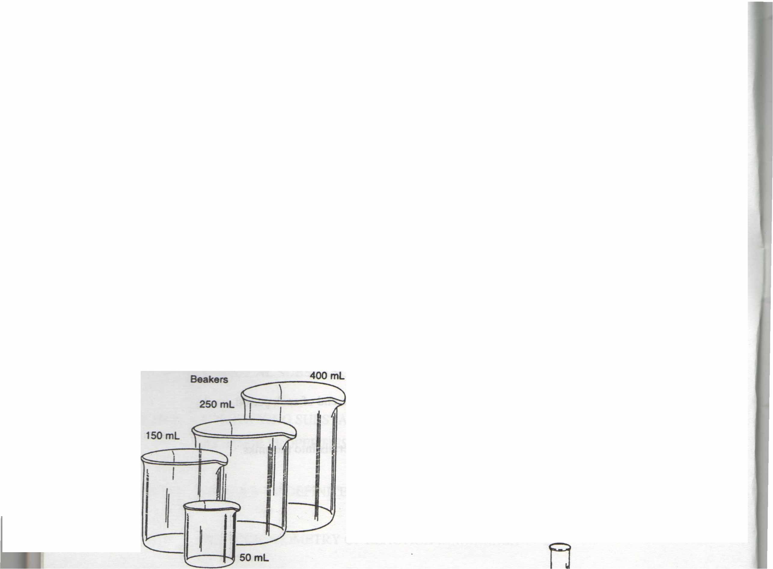
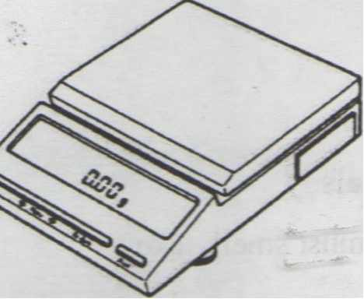
Top loading balance
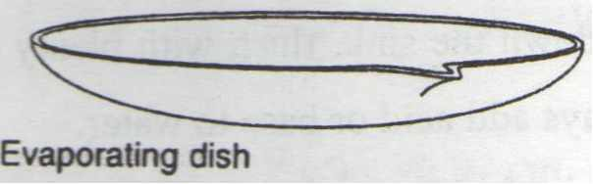
LABORATORY EQUIPMENT
Erfenmeyer flasks
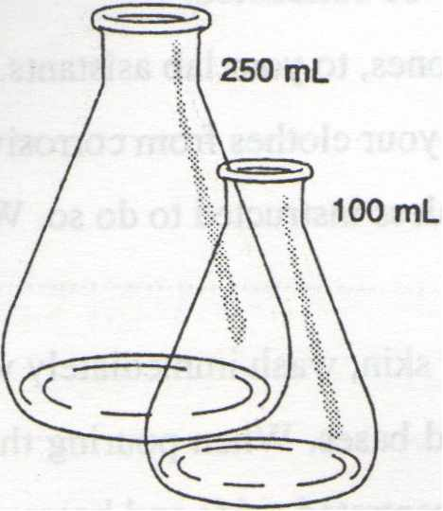
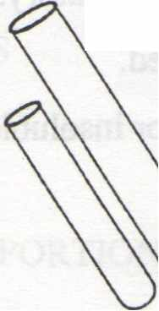
Test tubes
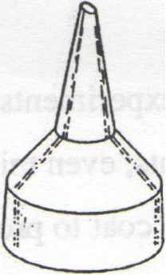

Büchner funnel
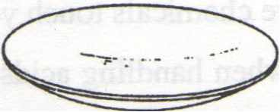
Watch glass
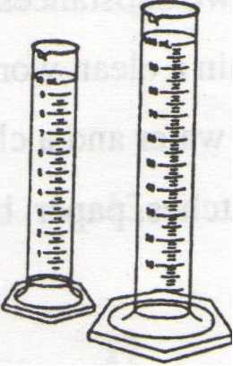
Graduated cylinders
Volumetric flask
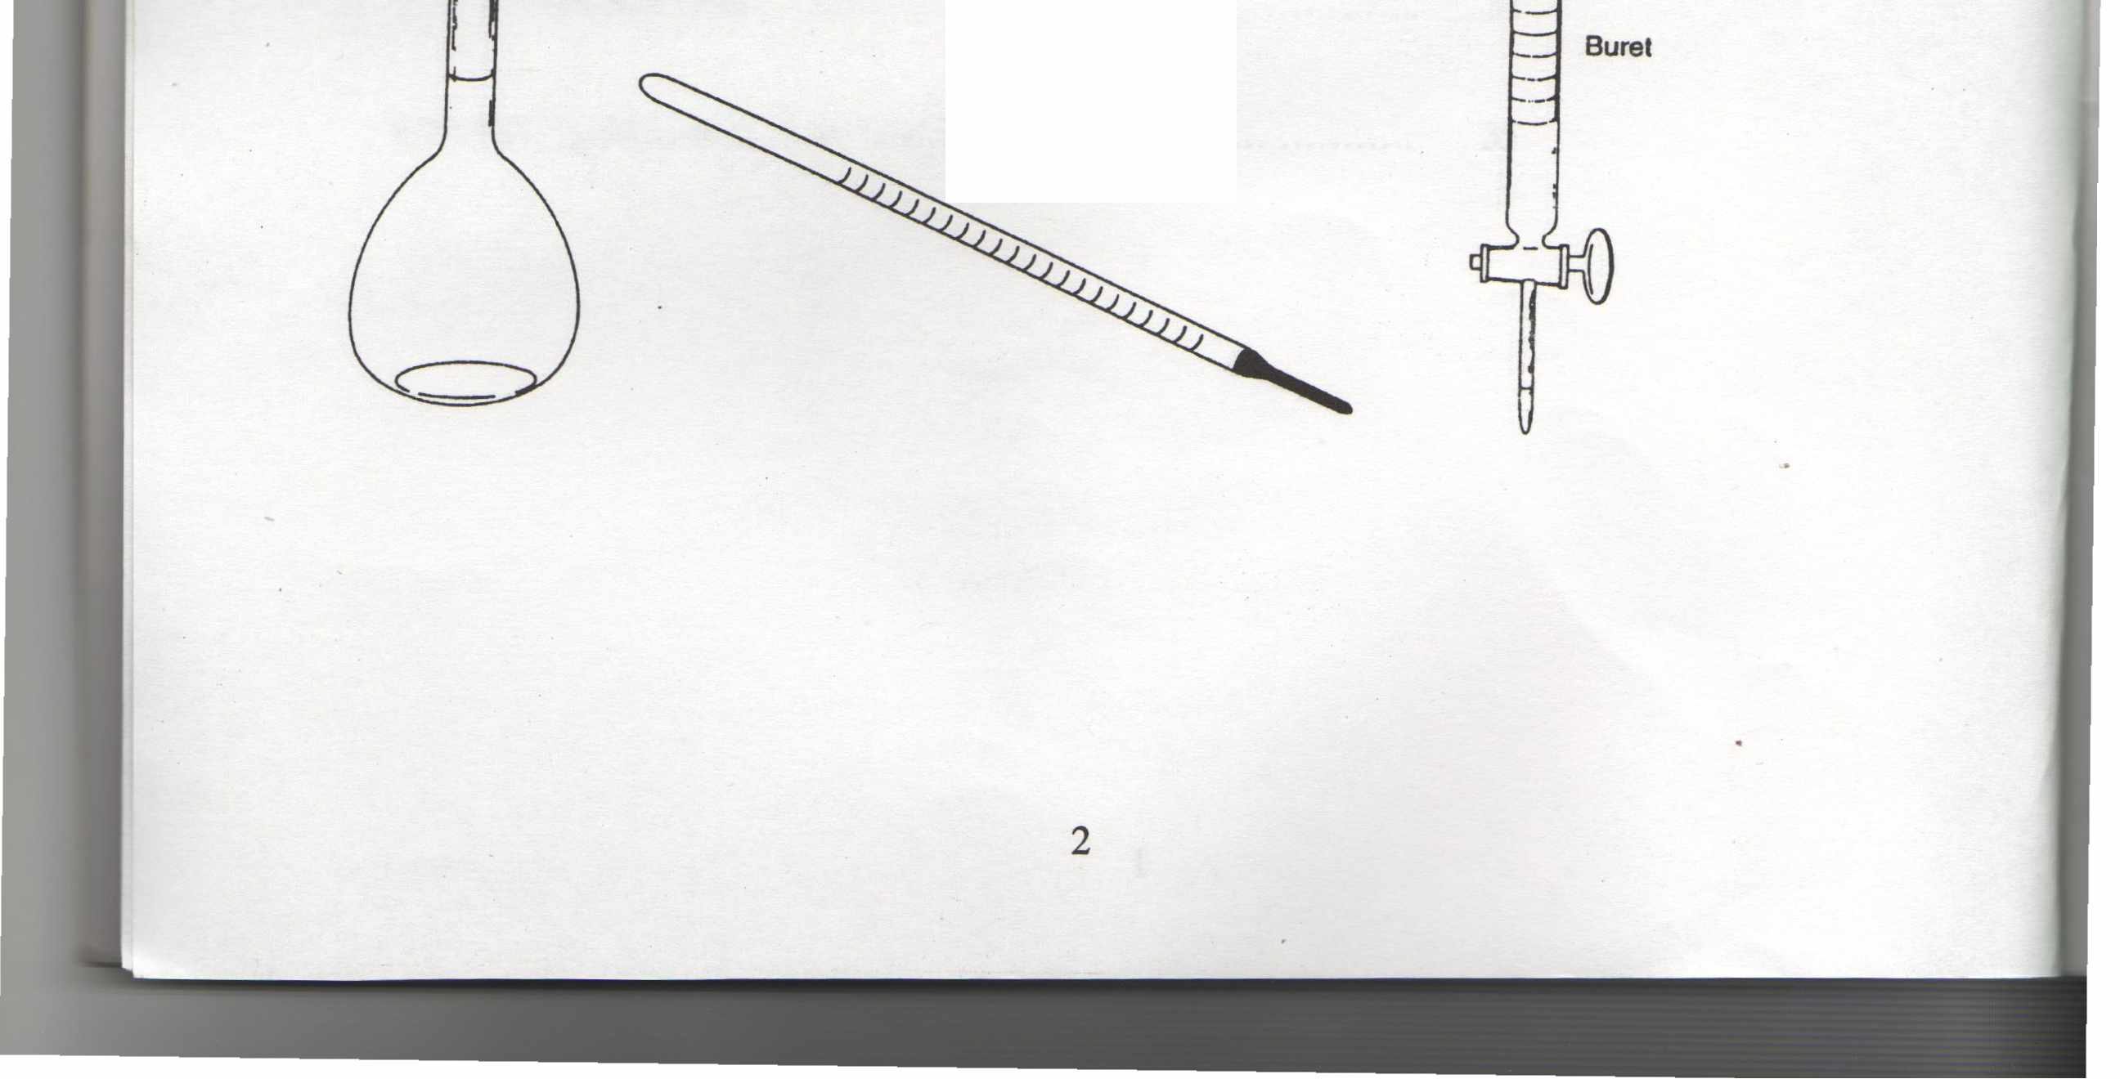
Crucible with cover
Thermometer

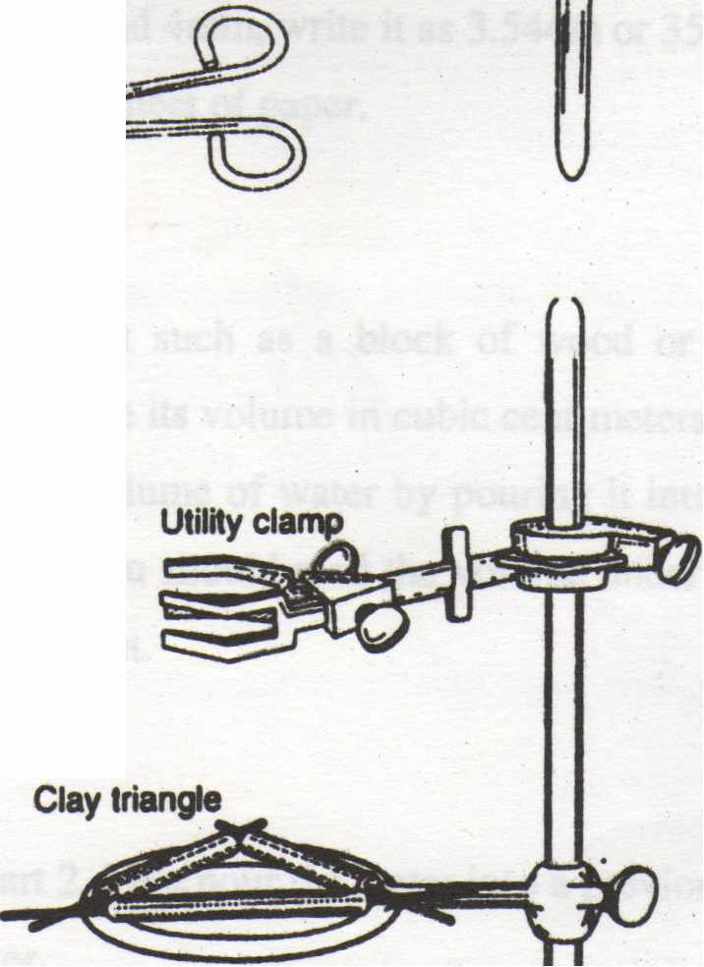
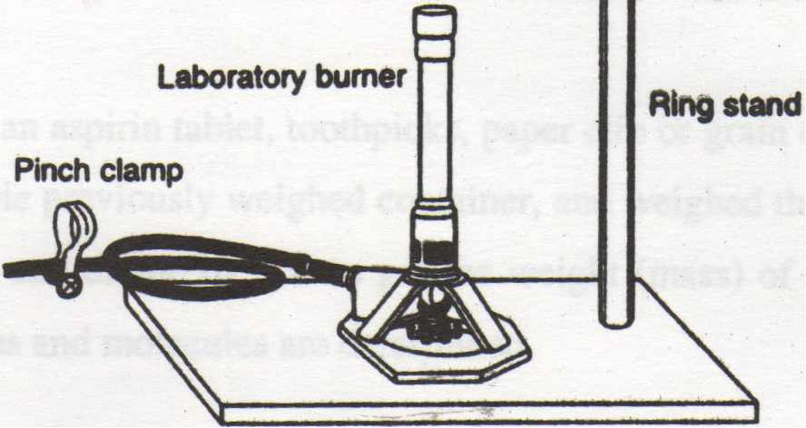
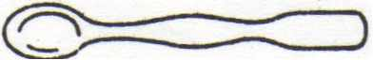
- illi-·-
Triangular file
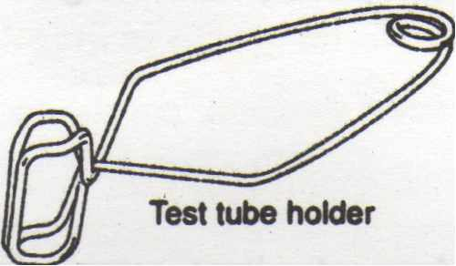
Stirring rod
o
~-:/)
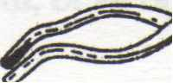
Cru<:ible tonga
Bottle brush
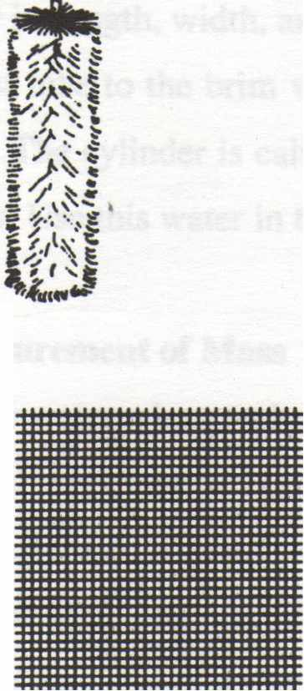
Medlclne dropper
Wlregauze
ıron ring
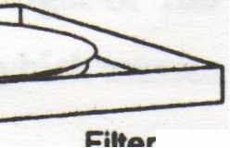
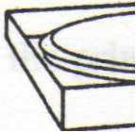
3
1
1
1
I
lı p~

