CHAPTER III

CONTEXTUAL FACTORS
YAYLA REGION

3.1. Introduction
This section describes Yayla region, supported by pictures, as the case region and the contextual factor of this study. The aim is to give the reader insight information on the resources of the Region from a touristic point of view:

  - Yayla Region
Cyprus (35°00'N., 33°00'E.), one of the largest islands in the Mediterranean, has about 400 miles of coastline. The terrain consists of two mountainous areas which are divided by a plain. These plain trends in a general E to W direction across the Northern part of the island between Famagusta Bay and Morphou Bay. The greater part of the coast is backed by mountains. Olympus, the summit of the island, rises in the Western half of the island (Maryland, 2003).

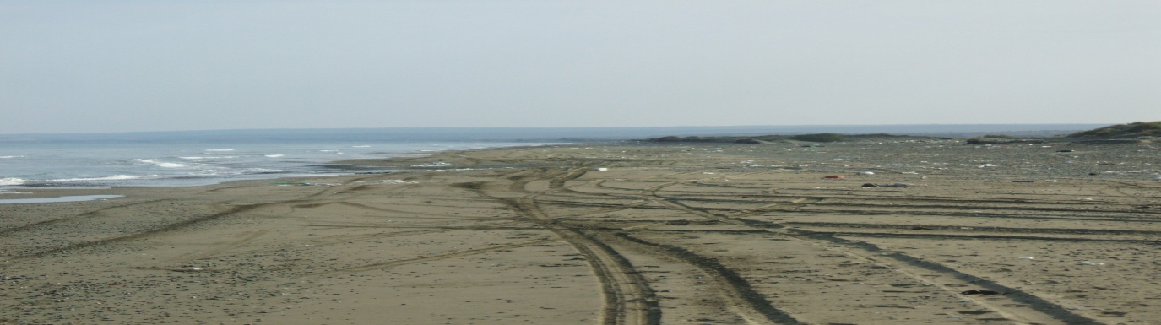
Yayla (Syrianokhori, Kumköy) is situated on the west of Northern Cyprus. It is regarded as the most popular place of Güzelyurt Bay by the locals. Where established on the smoothness of Güzelyurt Bay, it is about 22 km by road from the capital town, Lefkoşa. The village meets the Westerly Winds coming from the Atlantic Ocean sweeping the Mediterranean in a West to East direction bringing the most welcomed wet and warm weather in winter months. The village coast line is characterised with its long sandy beach running almost for 5 kilometres until the neighbouring village of Akdeniz.

Yayla village has a population of 800 people comprised of 250 households (SPO, 2006 Census). The traditional produce at Yayla Village includes citrus fruits, barley, animal husbandry, hellim (Cypriot Cheese), and honey and hand-crafted works such as basket-weaving and sieve-making.
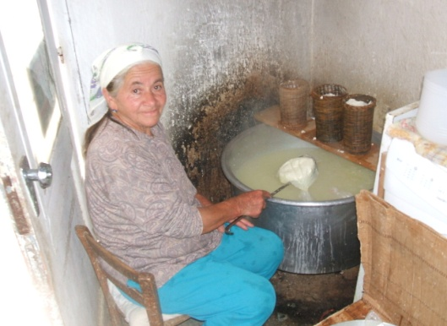
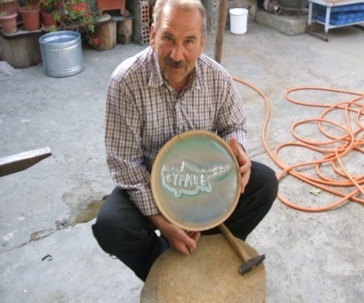

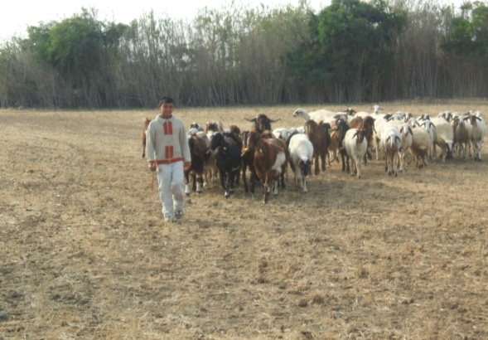
The following statistics were also made available by SPO (1996) regarding the land type and use at Yayla area on a land measure of 1000 square meters;
- Agricultural: 4,196 (49.28%)
- Forest: 105 (1.25%)
- Deserted: 1,860 (21.84%)
- Not used: 2,353 (27.63%)

3.3. Places of interest
“Places of interest” is a concept that describes one of the major ingredients of a tourist product. It is generally agreed that the design of a tourist product is only completed when the main ingredients of transport, accommodation, catering, entertainment, and places of interest are blended into the design.

“Places of interest” is one of the ingredients that Yayla Village has abundant. Similar to other parts of Cyprus it enjoys many historical and natural sites in its near vicinity. One of these places of interest is Soli or as it’s also called the Solomon’s city. Soli is an ancient settlement located at the north-western part of Cyprus and only a few kilometres away from Yayla Village Village. Soli is an ancient settlement, one of the ten ancient kingdoms of Cyprus, and is located in the north-western part of the island, just outside the village of Gemikonagi, on the coast near Lefke. Its history can be dated back to the 11th century BC. It was probably established here because of a good water supply, fertile soil, an abundance of copper deposits, and a protected harbour.

The city we can see today, was built around the 6th century BC, and is thought to have been named after the Greek philosopher, Solon. Soli was one of the most important capitals of Cyprus because of its port facilities and fertile soil. In 498BC, the people of Soli joined the other kingdoms in the Ionian Revolution against the Persians, but the Persians took the city. The city was liberated in 449BC, and during the Roman period, Soli became a prosperous city, expanding towards the sea. Over time, however, the city lost its importance. The copper mines were closed in the 4th century, and the harbour gradually silted up. The city was finally destroyed during the Arab raids of the 7th century.

As with many ancient ruins, the stones of Soli were re-cycled, those of the theatre being used by the British, for the construction of Port Said in Egypt in the second half of the 19th century.

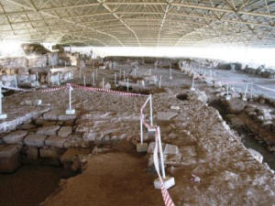
Soli Church
Excavations at Soli in the 1920s have unearthed a theatre, temples, palace ruins, agora, church and necropolis. After the excavation of the theatre building, the Isis, Aphrodite and Serapis temples were unearthed. The Aphrodite temple is situated on a hill above the theatre, but is not accessible by the public. A sculpture of Aphrodite dating back to the 1st century was found here, and is now exhibited at the Museum of Cyprus in South Cyprus. The palace buildings from the Helenistic period are also on this hill.

Excavations continued in the 1960s by Canadian archaeologists. They unearthed the early Christian church, and tombs from the Geometric and Roman periods. they also unearthed the city agora with the remains of a marble fountain, shops dating back to the early Roman period, and ruins from the Helenistic period.

Most recently, excavations by TRNC archaeologists in 2005 have unearthed more tombs. One tomb that was carved into the rocks is famous for its three tomb architecture, and is thought to have belonged to a noble. This tomb housed a golden throne, diadem and gold jewellery as well as other metal cups, which are exhibited at the Güzelyurt Museum of Archaeology.

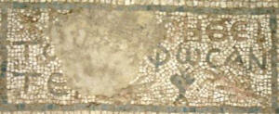
Mosaic Inscription
The theatre that can be seen today, is a Roman structure, built on top of a Greek theatre facing the sea. It dates back to the end of the 2nd century AD. The stage was in two stories, covered with marble paneling and decorated with statues. The seats for the spectators were carved in a semicircle on the rocks of the hill, and the entrance to both those and the orchestra was by two side entrances. The audience was separated from the orchestra in the middle by a limestone wall (now part of Port Said harbour). The theatre had a capacity of 4000, and has been restored to half its height. Some of the original masonry can be seen in the orchestra section.

The restored theatre is still used for the occasional concert.

During the early days of Christianity, Soli became an important Orthodox centre. In 325AD it had been represented by three bishops in the Nicean council, and 12 bishops in the Sardes council.

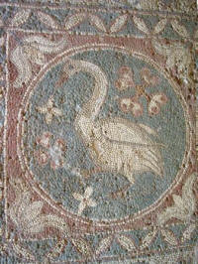 | 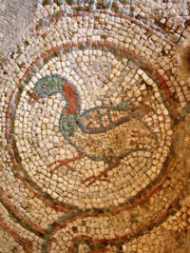
Bird Mosaics
According to Christian tradition, Soli is believed to be the place where St Mark was baptised by St Auxibus, A Roman Christian who later became the first bishop of the church of Soli.

The church was built in many different stages. The first building was a five nave church, and a coin found here dates the church back to the 4th century AD. Later in the 6th century, the church was turned into a three nave church. The three naves were separated by twelve columns, and the large columns are still standing today.

Mosaics, dating back to the 4th century, were found on the floor. These are decorated geometric patterns, as well as animals such as birds and bulls. Among the animal figures were vines and a swan. In the apse, there is writing decorated with geometric figures. The writing says "Jesus! Protect those who built these mosaics".

St Mamas Monastry, another local attraction, named after the Byzantine folk figure of Mamas who was regarded as the “protector of tax avoiders”. There are twelve more churches around the Island dedicated to his name. The monastry of St Mamas is situated in Güzelyurt, a kilometre away fro Yayla village, was built in the 18th century.

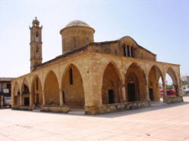
St Mamas Church
The church in the monastery was originally a Byzantine building, built on the site of an Aphrodite temple. It has been reconstructed at various times over the centuries, with most of the buildings dating to the 18th century when the large central dome was added. However, the side portals and columns of the nave survive from an earlier Gothic church built by the Lusignans.

It is said that Mamas was a Christian saint from Anatolia who was killed on religious grounds. His family, aided by Jesus Christ, placed Mamas in a coffin and buried him at sea. The coffin, swept away by the tide, made its way to the Gulf of Morphou (now Guzelyurt), where it was found by a humble man who lived in the area. The man returned to his house and gathered two oxen and called for his four sons to accompany him to the place where the coffin had landed. Tying a rope to it, they tried to pull the coffin away. However, the man, realising the coffin was heavier than he had initially thought, called for help. The coffin was eventually taken with great difficulty and effort, and when the coffin could be carried no further, a church was built round it.
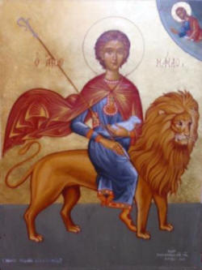
St Mamas on his lion
Another legend has Mamas as a 12th century saint who lived in a cave near Guzelyurt. the Byzantine duke of the time demanded taxes from the local population. Mamas refused to pay the taxes as he lived in a cave. The Duke commanded two of his soldiers to arrest Mamas and bring him to Lefkosa. As the soldiers brought Mamas to the city to be punished, their paths were crossed by an aggressive lion which was ready to pounce on ant tear apart a lamb. Mamas, witnessed by the terrified soldiers, saved the lamb from the lion's paws and continued the rest of the journey, entering the city on the back of the lion, carrying the lamb in his arms. On seeing this sight, the Byzantine authorities were so impressed that they decided to exempt him from paying taxes for the rest of his life. Since then, St mamas has been the patron saint of tax avoiders.

The tomb of St Mamas, which is on the left as you enter by the north door, is surrounded by votive offerings, many in the shape of ears. It is said that during the Ottoman rule, believing there was treasure hidden in the coffin, they bored holes into its side, at which a sort of nectar oozed out. This balm which appeared at irregular intervals was said to give protection against earache (as well as the ability to calm stormy seas).

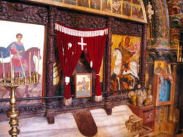
St Mamas' tomb
The icon section of the church dates back to the Lusignan and Venetian periods. On the four Venetian pillars are carved grape, fig and shield figures, as well as the Venetian coat of arms. The pulpit was built in 1711, and the oldest icon to around 1745.

Outside the church, the monastery buildings are to the north and east, and records show them as being built in 1779. Architecturally, the arches on the front of the northern buildings are quite different to those on the eastern side. The northern buildings reflect the traditional style of the complex. On the eastern side, there is a resemblance in style to 18th century Ottoman inns, with stone columns on the ground floor and timber balconies on the second.

The monastery buildings are now used for business purposes, ranging from lawyers to a television office. Pause for a while at the small coffee shop in the south eastern corner and a and soak up the atmosphere. Admire the proprietor's match stick model for the mosque opposite and you have a friend for life.

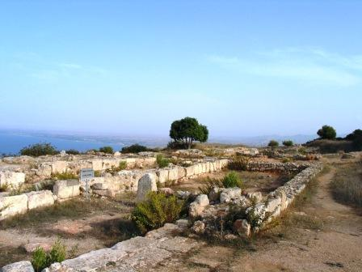
Vouni Palace
The other main place of interest around Yayla Village is the Vounni Palace. Around 600BC, the city-states of Cyprus were split between those that leant towards the east and the Phoenicians, and those that were more Greek supporting. During the great wars between the Greeks and the Persians, the city-states of Cyprus were politically divided. The Phoenicians supported the Persians, and this resulted in battles between the island's kingdoms.
Battles on land and sea were waged, and in 500BC a pro-Persian city, Marion, not only besieged Soli, but kept an eye on it by establishing a settlement on a nearby hill. This settlement was Vouni.
In 449BC, however, the Persians were defeated by the Greeks, and the pro-Persian inhabitants of Vouni were replaced by Solians. In 391BC, Evagoras seized the kingdom of Salamis, and attempted to extend his control to the entire island. Soli and some other cities had to ask for help from the Persians to fight against Evagoras. With the help of the Persians, Soli regained its political power.

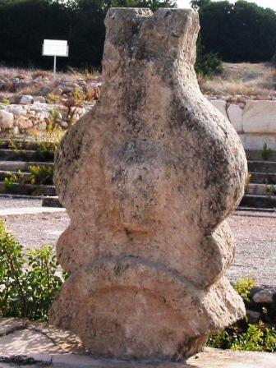
Stone Stele
In 380BC, the palace which had been a continuous threat to Soli was mysteriously destroyed by fire, and the inhabitants evacuated. Hence the history of Vouni lasts only 120 years.
In the beginning, the palace was little more than a military settlement, but after 449BC, when Greek rule was established, the ruler of Marion was replaced by a pro-Greek prince, and Vouni became a royal palace.

Excavations have shown that there were four different construction periods. The first construction was in 500BC when the core of the palace was built. It consisted of state apartments, large store rooms and bathrooms. During the Persian period, between 500 and 450BC, some minor changes were made.
During the Greek rule between 450 and 390BC, there were major alterations, and a second story with mud brick walls was added. Further minor alterations were made between 390 and 380BC.
The palace complex you see today is made up of three terraces. The highest point has the Athena shrine, however, very little remains of this.

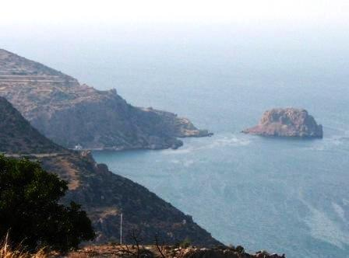
Petra Tou Limnidi
The middle terrace has the palace and religious buildings. The palace is believed to have had 137 rooms. There is a fountain in the middle of the courtyard, which is surrounded on three sides by rooms. The water needs of the palace were fulfilled by storing rain water in numerous cisterns which dot the site.

The large standing stone stele standing by the cistern in the courtyard was designed to hold a windlass, and is believed to have been brought here from elsewhere. This stone has become the symbol of Vouni. There are also food storage rooms where amphorae were found. Most of the rooms on the eastern side are used for storage, but baths were also found on this side. These baths are some of the earliest examples of fully equipped Roman baths.
The lower terrace faces the sea, and contains houses with stone bases and mud brick upper storeys which housed most of the residents. The excavations in the 1920s unearthed a baked clay cup, blackened by the fire which destroyed the palace. In addition, gold and silver bracelets, silver bowls, and hundreds of coins bearing the stamps of Marion, Kiton, Lapithos and Paphos were discovered.
From the palace, you can see the small island of Petra Tou Limnidi. This is one of the oldest places in Cyprus to be inhabited, and was excavated at the same time as Vouni. Archaeologists found items going back to the Neolithic age, consisting of bone needles, stone utensils, farming tools , and sculptures.

Until recently the ascent to Vouni would have needed a 4x4 vehicle, or a long hike. However the track has recently been surfaced and although steep and narrow, is easy. Even if you have no interest in ancient remains, the trip is well worth it for the views alone.

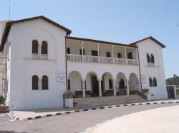
Guzelyurt museum
There are other places of interest around Yayla Village. This study has only focused on a few. Finally, here is a report on the museum in Güzelyurt, next to Yayla Village. The museum of nature and archaeology is situated next to St Mamas monastery. The building was originally the palace of the Bishop of Morphou, and up to 1974 housed town offices. It was opened as a museum in 1979 after restoration.

The ground floor displays a collection of stuffed animals native to Cyprus. The upper floors of the museum houses the archaeology section with displays from the Neolithic and bronze ages. In the second and third rooms there is a display of finds from the Tumba Tou Skuru settlement. Outside, items from the Classical, Helenistic and Roman periods are on exhibition.

3.4. Natural resources
As described at the beginning of the study, Yayla Village is situated in an area where one can enjoy swimming, and other sea sports at the long sandy beach of the village. The south of the Village is backed by the Trodos Mountains and is covered with citrus gardens and pine trees.

3.4.1. Hotel Accommodation and restaurants
Yayla Village and vicinity has no real investment made in hotels or touristic restaurants. Despite the nearby University of Lefke, the region stayed over dominantly agricultural in character. The aim of this study is to explore whether it is feasible to make such investments by the state or private individuals but preserving the local culture and nature at the same time.

3.4.2. Human resources
Yayla villagers seem to have volatile skills and they are well equipped for ecotourism. An organised tripped to the village was arranged by the Near East University students during the investigations of this study. A report was published on the University Website revealed that the village was reach in the skills needed for ecotourism.
Almost all the young people at the village are university educated constituting a high calibre workforce for the future.

3.5. Conclusion
This section has provided a description of Yayla Region, as the case region of this study supported by pictures.

