ANALYSIS OF THE HARMONIC PROBLEMS IN THREE PHASE TRANSFORMERS AND SOLUTION USING PASSIVE FILTERS

A THESIS SUBMITTED TO THE GRADUATE SCHOOL OF APPLIED SCIENCES
OF
NEAR EAST UNIVERSITY

By

Ibrahim M. RASHID

In Partial Fulfillment of the Requirements for
the Degree of Master of Science
In
Electrical and Electronic Engineering

NICOSIA 2013

I hereby declare that all information in this document has been obtained and presented in accordance with academic rules and ethical conduct. I also declare that, as required by these rules and conduct, I have fully cited and referenced all material and results that are not original to this work.

Name, Last name : Ibrahim M. Rashid Samin
Signature :
Date:

ABSTRACT

In recent years different harmonic-reduction techniques have been proposed and applied among those techniques, passive harmonic filters are still considered to be the most effective and viable solution for harmonic mitigation.

The current industry practice is to combine filters of different topologies to achieve a certain harmonic filtering goal.

In this thesis a combination of three tuned harmonic filters have been designed and used for the mitigation of harmonic distortions in three phase transformer which is generated by nonlinear load (three phase full wave bridge rectifier used as nonlinear load). Two types of filters are used, C-type filters to eliminate or to reduce the effects of $5^{th}$ and $7^{th}$ harmonics, and one double-tuned filter to eliminate or to reduce the effects of ${11}^{th}$ and ${13}^{th}$ harmonics.

The tuned harmonic filters have been designed depending on a new method based on resonance frequency. It does not need to solve equations, so it reduces the amounts of computation when compared to traditional methods.

Analytical study of combination of three tuned harmonic filters technique for proposed filter circuits shows a drastic minimization of $5^{th}$, $7^{th}$, ${11}^{th}$, and ${13}^{th}$ harmonic components of the input current.

Tuned harmonic filters are designed to reduce harmonic distortions to locate within the IEEE 519 harmonic voltage and current limits. The results of the proposed filters are analyzed to evaluate the effectiveness of the filter design

Key words: Three phase transformer, nonlinear load, harmonic, passive filter , simulation.

To my mother,
who always support me in all aspects of my life
to my wife
for her patience and support in my study
to my children
Aryar, Avesta, Mohammed, Ahmed, Hazhar, and Zhyar
To my friends

ACKNOWLEDGEMENTS

I thank the almighty ALLAH for his mercy and grace, which enabled me to complete this work.

First and foremost I would like to express my deep appreciation, sincere thanks and gratitude to my supervisor Assoc. Prof. Dr. Özgür Özerdem who has shown plenty of encouragement, patience, and support as he guided me through this endeavor fostering my development as a graduate student.

I am also thankful for the contributions and comments of the teaching staff of the Department of Electric and Electronic Engineering.

Very special thanks are due to my family for their effort, encouragement and patience during the years of study.

Finally, thanks are extended to all my friends specially my friends in Kalar Technical Institute (Mr. Hayder & Mr. Salar) and those who helped me one way or the other.

CONTENTS

ABSTRACT ii
ACKNOWLEDGEMENTS iii
CONTENTS iv
LIST OF TABLES. vii
LIST OF FIGURES viii
LIST OF SYMBOLS xi
ABBREVIATIONS USED xiii
CHAPTER 1, INTRODUCTION 1
1.1 Backrground of the Study 1
1.2 Estimation of Harmonic load methods.. 2
1.2.1 Total Harmonic Distortion (THD) 2
1.2.2 K-Factor Rated Transformers 3
1.2.3 Crest- factor Method 4
1.3 Three Phase Transformer with Linear Load... 4
1.3.1 Resistive Load... 5
1.3.2 Inductive Load 5
1.3.3 Capacitive Load.. 6
1.4 Three Phase Transformer with NonLinear Loads 7
1.5 Thermal Effects on Transformer… 9
1.6 Review on Transformer Losses in Harmonic Loads.. 10
1.6.1 No Load Loss...... 10
1.6.2 Load Loss........ 10
1.6.2.1 Ohmic Loss 11
1.6.2.2 Eddy Current Loss in Windings 11
1.6.2.3 Other Stray Loss.... 12
1.7 Harmonic Current Effect on no-Load Losses. 12
1.8 Harmonic Current Effect on Load Losses. 13
1.8.1 Effect of Harmonics on DC Losses... 13
1.8.2 Effect of Harmonics on Eddy Current Losses. 14
1.8.3 Effects of Harmonics on Other Stray Losses. 14
1.9 Literature Review........ 15
1.10 Objective and Organization.. 17
1.10.1 The Aim of the Thesis.......... 17
1.10.2 Thesis Organization. 17
CHAPTER 2, THEORETICAL ANALYSIS FOR THE SYSTEM 18
2.1 Harmonic Analyses of Three Phase Full Wave Bridge Rectifier. 18
2.2 Mathematical Structure..... 21
2.3 Proposed System Configuration for Harmonic Cancellation 22
2.4 Harmonic Impedance Plot for the Proposed Harmonic Filter. 23
2.5 Harmonic Standards and recommendation. 24
2.6 Harmonic distortion effects on plant equipment. 25
2.7 Harmonic Mitigating Techniques 26
2.8 Passive Harmonic Mitigation Techniques. 27
2.8.1 Effect of Source Reactance. 27
2.8.2 Series Line Reactors 27
2.8.3 Tuned Harmonic Filters... 28
2.8.3.1Shunt passive filters 28
2.8.3.2 Series Passive Filter....... 29
2.8.3.3 Higher Pulse Converters 30
2.8.3.4 Zigzag Grounding Filter 30
2.8.4 Active Harmonic Mitigation Techniques 31
2.8.4.1 Parallel Active Filters 32
2.8.4.2 Series Active Filters 32
2.8.5 Hybrid Harmonic Mitigation Techniques 33
CHAPTER 3, DESIGNING AND PARAMETER CALCULATION OF HARMONIC TUNED FILTERS 34
3.1 Passive Harmonic Filters 34
3.2 Circuit Configurations 35
3.3 Single Tuned Filters 37
3.4 Designing Double-tuned Filter 38
3.5 The Parameters Calculation of Double-Tuned Filter 40
3.6 Designing C-type Filter 43
3.7 The Parameters Calculation of C-type Filter for 5th order harmonic 45
3.8 The Parameters Calculation of C-type Filter for 7th order harmonic 46
3.9 Frequency-Respons 47
3.10 Harmonic Impedance Plot for the Proposed Harmonic Filter 48
CHAPTER 4, SIMULATION RESULTS OF CIRCUIT CONFIGURATION 50
4.1 Introduction 50
4.2 Simulation Results of Three Phase Transformer under Linear Load 50
4.2.1 Simulation Results of Three Phase Transformer under Resistive Load 51
4.2.2 Simulation Results of Three Phase Transformer under Inductive Load 53
4.2.3 Simulation Results of Three Phase Transformer under Capacitive Load 55
4.3 Simulation Results of $3∅$ Transformer under Nonlinear Load without Filter 57
4.4 Simulation Results of Three Phase Transformer under Nonlinear Load with Tuned Harmonic Filter from Simulation Power Systems Blocks Elements 59
4.5 Simulation Results of $3∅$ Transformer under Nonlinear Load with Proposed Tuned Harmonic Filter 61
4.6 Comparison between results of designed filter and the filter from (Simulation Power Systems Blocks Elements) 64
4.7 The waveforms of Sourse current and Source Voltage without Filter 66
4.8 The waveforms of Sourse current and Source Voltage with Filter 67
CHAPTER 5, CONCLUSIONS 68
5.1 CONCLUSIONS 68
5.2 FUTURE WORK 70
REFRENCES 71
APPENDICES 75

LIST OF TABLES

Page

Table 1.1 Examples of Linear Loads 7
Table 1.2 Examples of Some Non- Linear Loads 8
Table 2.1Per Unit Harmonic Currents for a Three Phase Full Wave Bridge Rectifier 20
Table 2.2 Per Unit Harmonic Currents for Three Phase Full Wave Bridge Rectifier the Relationship of the Theoretical Values to Typical Values due the Trapezoidal Waves 20
Table 2.3 Categorization of Harmonic Reduction Methods 26
Table 3.1.Parameters of Double-Tuned Filter for 11th and 13th Harmonic Reduction 43
Table 3.2 Parameters of C-Type-Tuned Filter for 5th Harmonic 45
Table 3.3 Parameters of C-type-Tuned Filter for 7th Harmonic 46
Table 4.1Harmonic Currents for a $3∅$full wave bridge rectifier without filter analytically64
Table 4.2 Harmonic Currents for a $3∅$ Full Wave Bridge Rectifier Without Filter 64
Table 4.3Harmonic Currents for a $3∅$ Full Wave Bridge Rectifier with Filter Analytically 64
Table 4.4 Harmonic Currents for a $3∅$ Full Wave Bridge Rectifier with Filter 64
Table 4.5 Designed filter and Traditional Filter Input Current Harmonic 65

LIST OF FIGURES

Figure 1.1 Three phase transformer with linear load..................................................... 4
Figure 1.2 Relation between voltages, current in a purely resistive load………………. 5
Figure 1.3 Current harmonic bar chart of phase A at linear resistive load 5
Figure 1.4 Relation between voltage, current in inductive load.... 6
Figure 1.5 Current harmonic bar chart of phase A at linear inductive load 6
Figure 1.6 Relation between voltage, current in capacitive load. 6
Figure 1.7 Current harmonic bar chart of phase A at linear capacitive load 7
Figure 1.8 three phase transformer under nonlinear load. 8
Figure 1.9 Voltage and current waveforms of full wave bridge rectifier.. 8
Figure 1.10 Current harmonic bar chart of phase A at nonlinear load 8
Figure 2.1 Three phase transformer with nonlinear load 18
Figure 2.2 (a) Waveforms of Va, Vb, Vc (b) Phase -a-current waveform for high inductive Load 19
Figure 2.3 Distorted waveform composed of fundamental and 5𝑡ℎ, 7𝑡ℎ, 11 th and 13 th harmonics 19
Figure 2.4 Theoretical and typical values of harmonic current for a three phase full wave bridge rectifier 20
Figure 2.5 Proposed system configuration 22
Figure 2.6 Proposed system configuration with filters 23
Figure 2.7 Harmonic impedance characteristics of the proposed harmonic filter 24
Figure 2.8 Duplex reactor 28
Figure 2.9 Shunt passive filters 29
Figure 2.10 Series passive filter 29
Figure 2.11 parallel twelve-pulse rectifier connections 30
Figure 2.12 Zigzag autotransformer connected to three-phase nonlinear loads 31
Figure 2.13 parallel active filters 32
Figure 2.14 Series active filter 32
Figure 2.15 Hybrid connections of active and passive filters 33
Figure 3.1 Topologies of passive harmonic filters 34
Figure 3.2 Proposed passive harmonic filters scheme 36
Figure 3.3 passive harmonic filters (two C-type filters and one double-tuned filter) 37
Figure 3.4 Single tuned filter 37
Figure 3.5 Double-tuned filter and two single-tuned filter 38
Figure 3.6 Double-tuned filter configuration and impendence frequency characteristic curve 39
Figure 3.7 Impedance-frequency curve of series and parallel branch a) Series resonance Circuit b) Parallel resonance circuit 40
Figure 3.8 Parallel single tuned filter 40
Figure 3.9 Three phase double-tuned filters for 11th and 13th harmonic reduction 42
Figure 3.10 C-type filter diagram 43
Figure 3.11 Three phase C-type tuned filter for 5th harmonic reduction 45
Figure 3.12 Three phase C-type tuned filter for7th harmonic reduction 46
Figure 3.13 The system 47
Figure 3.14 The overall frequency responses of the system 47
Figure 3.15 Harmonic impedance characteristics of the proposed harmonic filter tuned exactly at the desired frequency 48
Figure 3.16 Harmonic impedance characteristics of the proposed harmonic filter tuned at a frequency slightly lower than the desired frequency 49
Figure 4.1 three phase transformer under linear load 50
Figure 4.2 Simulated three phase transformer under resistive load 51
Figure 4.3 Current and voltage waveforms of $3∅$transformer under resistive load 52
Figure 4.4 Harmonic spectrum of resistive load 52
Figure 4.5 Simulated three phase transformer under Inductive Load 53
Figure 4.6 Current and voltage waveforms of $3∅$ transformer under inductive load 54
Figure 4.7 Harmonic spectrum of inductive load 54
Figure 4.8 Simulated three phase transformer under capacitive load 55
Figure 4.9 Current and voltage waveform of$3∅$ transformer under capacitive load 56
Figure 4.10 Harmonic spectrum of capacitive load 56
Figure 4.11 Three phase transformer under nonlinear load 57
Figure 4.12 Simulated three phase transformer under nonlinear load without filter 57
Figure 4.13 Current and voltage waveform of three phase transformer under nonlinear load without filter 58
Figure 4.14 Harmonic spectrum of nonlinear load ($3∅$ bridge rectifier) without Filter 58
Figure 4.15 $3∅$Transformer under nonlinear load with tuned harmonic filter 59
Figure 4.16 Simulated $3∅$ttransformer under nonlinear load with tuned harmonic filter……………………………………………………………………………………..60 Figure 4.17 Current and voltage waveform of $3∅$transformer under nonlinear load with Filter 60
Figure 4.18 Harmonic spectrum of nonlinear load ($3∅$ bridge rectifier) with Filter 61
Figure 4.19 $3∅$ Transformer under nonlinear load with proposed filter 62
Figure 4.20 Simulated $3∅$transformer under nonlinear load with proposed filter 62
Figure 4.21 Current and voltage waveform of $3∅$transformer under nonlinear load with proposed filter 63
Figure 4.22 Harmonic spectrum of nonlinear load ($3∅$ bridge rectifier) with proposed Filter 63
Figure 4.23Simulatio block diagram for measuring THD and PF 65
Figure 4.24 Load current without filter 66
Figure 4.25 filter current 66
Figure 4.26 Load current with filter 66
Figure 4.27 Source Current (Ia, Ib,Ic) and Source voltage (Vab, Vbc, Vca) waveforms of $3∅$transformer under nonlinear load without Filter 67
Figure 4.28 Harmonic spectrum of source current without Filter 67
Figure 4.29 Source current (Ia, Ib, Ic) and Source voltage (Vab, Vbc, Vca) waveforms of $3∅$transformer under nonlinear load with filter 68
Figure 4.30 Harmonic spectrum of source current with filter 68

LIST OF SYMBOLS

$I_{r.m.s}$ Ampere (A) Root mean square values of all current harmonics
$I_{hr.m.s}$ Ampere (A) Root mean square value of current harmonic in order h
$V_{r.m.s}$ Volt (V) Root mean square values of all voltage harmonics
$V_{hr.m.s}$ Volt (V) Root mean square value of voltage harmonic in order h
$I_{1}$ Ampere (A) Fundamental current
$I_{h}$ Ampere (A) Load current at the harmonic h
$I_{h pu}$ Ampere (A) Load current at the harmonic h, expressed in a per-unit basis
$I_{s}$ Ampere (A) Supply current
$V_{s}$ Volt (V) Supply voltage
$I_{L}$ Ampere (A) Load current
$V_{L}$ Volt (V) Load Voltage
$P_{NL}$ Watt (W) No load loss
$P_{LL}$ Watt (W) Load loss
$P_{T}$ Watt (W) Total loss
$P_{DC}$ Watt (W) Loss due to resistance of windings
$P_{EC}$ Watt (W) Windings eddy current loss
$P_{OSL}$ Watt (W) Other stray losses
$P_{TSL}$ Watt (W) Total stray losses
$P_{h}$ Watt (W) Hysteresis losses
$i_{a}$ Ampere (A) Input current to the bridge rectifier
$h$ Harmonic order
$q$ Pulse number of circuit
$k$ Any integer number
$ω$ Rad/s Angular frequency
$ω_{h}$ Rad/s Resonant angular frequency of the single tuned filter
$C_{a}$ Farad Capacitance of the single tuned filter
$L_{a}$ Henery Inductance of the single tuned filter
$R_{a}$ Ohm (Ω) Resistance of the single tuned filter
$Q$ Quality factor
$Q_{f}$ Watt (W) Reactive power of the single tuned filter
$U_{1}$ Volt (V) Voltage of system bus at fundamental frequency
$N_{1}$ Order of harmonic to restrain
$L_{1}$ Henery Inductance of the double tuned filter series circuit
$C_{1}$ Farad capacitance of the double tuned filter series circuit
$L_{2}$ Henery Inductance of the double tuned filter of parallel circuit
$C_{2}$ Farad Capacitance of the double tuned filter of parallel circuit
$ω_{s }$ Rad/s Series resonant angular frequency
$ω_{p }$ Rad/s Parallel resonant angular frequency
$Z$ Ohm (Ω) Impedance of double-tuned filter
$Z_{S}$ Ohm (Ω) Impedance of series resonance circuit
$Z_{P}$ Ohm (Ω) Impedance of parallel resonance circuit
$Z_{ab}$ Ohm (Ω) Impedance of two parallel single tuned filters
$ω_{a }$ Rad/s Resonant angular frequency of one branch of two parallel
Single tuned filters
$ω_{b }$ Rad/s Resonant angular frequency of one branch of two parallel
Single tuned filters
$ω_{0}$ Rad/s Nominal angular frequency of the system
$ω_{n}$ Rad/s Tuning frequency
$Z_{f}$ Ohm (Ω) Impedance of C-type filter $\dot{C_{1}}$ Farad Capacitance of C-type filter
$\dot{C_{2}}$ Farad Capacitance of C-type filter
$\dot{L_{1}}$ Henery Inductance of C-type filter
$\dot{R_{2}}$ Ohm (Ω) Resistance of C-type filter

ABBREVIATIONS USED

RMS Root Mean Square
THD Total Harmonic Distortion
KVA Kilo Volt Ampere
${THD}_{V}$ Total Harmonic Distortion of Voltage
${THD}_{I}$ Total Harmonic Distortion of Current
$Cf$ Crest factor
UPS Uninterruptible power supply
DC Direct Current
AC Alternating current
KVAr Kilo Volt Ampere reactive
IEC International Electrotechnical Commission
PCC Point of Common Coupling
VSD Variable Speed Drives
SCR Silicon Controlled Rectifiers
PHF Passive Harmonic Filters
AHF Active Harmonic Filters
IGBT Insulated Gate Bipolar Transistors
HHF Hybrid harmonic filter
PWM Pulse Width Modulate

CHAPTER 1

INTRODUCTION

  - Background of the Study
Harmonic voltage and currents affect normal operation of a three-phase transformer. As iron and copper losses increase depending on the level of harmonic and distortion, the transformer is not loaded with nominal power, thus its efficiency decreases significantly. As the efficiency of the transformer working under nominal power, operational expenses will increase, which is bad for the economy. In general transformers are designed to supply sinusoidal loads in their nominal frequencies. However, mostly transformers supply non-linear loads and these non-sinusoidal currents lead to excessive heating of the transformer, which in turn cause distortion in its power quality [1].

This problem has been studied since the 1980s. This procedure is presented in IEEE-C57-110 document by supposing that eddy current losses change with harmonic level and the square of the current [2, 3].

In recent years, there has been an increased concern about the effects of nonlinear loads on the electric power system. Nonlinear loads are any loads which draw current that is not sinusoidal and include such equipment as fluorescent lamp, gas discharge lighting, solid state motor drives, diodes, transistors and the increasingly common electronic power supply causes generation of harmonics [4].

Transformers are one of the component and usually the interface between the supply and most non-linear loads. They are usually manufactured for operating at the linear load under rated frequency.

Nowadays the presence of nonlinear load results in producing harmonic current [5]. Increasing in harmonic currents causes extra loss in transformer winding and thus, leads to increase in temperature, reduction in insulation life, increase to higher losses and finally reduction of the useful life of the transformer. There are three effects that result in increased transformer heating when the load current includes harmonic components.

- RMS current: If the transformer is sized only for the kVA requirements of the load, harmonic currents may result in the transformer RMS current being higher than its capacity;
- Eddy-current losses: These are induced currents in a transformer caused by the magnetic fluxes.
- Core losses: The increase in nonlinear core losses in the presence of harmonics will be dependent under the effect of the harmonics on the applied voltage and design of the transformer core [6].

  - Estimation of Harmonic load methods
The measurement of a transformer’s losses and calculation of its efficiency is applied in the power and distribution transformer. Three methods of estimating harmonic load content are; the harmonic factor (percent total harmonic distortion- %THD), K-Factor and Crest Factor.

    - Total Harmonic Distortion (THD)
The ratio of the root mean square of the harmonic content to the RMS value of the fundamental quantity, expressed as a percent of the fundamental.

The THD is a measure of the effective value of the harmonic components of a distorted waveform. That is, it is the potential heating value of the harmonics relative to the fundamental. This index can be calculated for either voltage or current. The percentage of the total harmonic distortion (%THD) can be written as

$${THD}_{V}=\frac{\sqrt{\sum_{h=2}^{n}{V_{hr.m.s}^{2}}}}{V_{r.m.s}^{2}}×100\% (1.1)$$

$${THD}_{I}=\frac{\sqrt{\sum_{h=2}^{n}{I_{hr.m.s}^{2}}}}{I_{r.m.s}^{2}}×100\% (1.2)$$
Where $I_{hr.m.s}$is the amplitude of the harmonic component of order h and$I_{r.m.s}$is the r.m.s values of all the harmonics that can be represented as

$$I_{r.m.s}=\sqrt{\sum_{h=1}^{n}{I_{hr.m.s}^{2}}} (1.3)$$

1.2.2 K-Factor Rated Transformers.

K-factor is a means of rating a transformer with respect to the harmonic magnitude and frequency of the load. It is an alternate technique for transformer de-rating which considers load characteristics. It is a rating optionally applied to a transformer indicating its suitability for use with loads that draw non-sinusoidal currents. It is an index that determines the changes in conventional transformers must undergo so that they can dissipate heat due to additional iron and copper losses because of harmonic currents at rated power. Hence the K-factor can be written as,

$$K-facter=\frac{\sum_{h=1}^{∞}{h^{2}{\left(\frac{I_{h}}{I_{1}}\right)}^{2}}}{\sum_{h=1}^{∞}{{\left(\frac{I_{h}}{I_{1}}\right)}^{2}}}=\sum_{h}^{∞}{{{(I}_{h pu})}^{2}h^{2} (1.4)}$$

Where $I_{h pu}$is the load current at the harmonic h, expressed in a per-unit basis such that the total RMS current equals one ampere, i.e.

$$\sum{I_{h}^{2}=1.0} (1.5)$$

A K-Factor of 1.0 indicates a linear load (no harmonics). The higher K-Factor, the greater the effect of harmonic heating.

K-factor transformers are designed to supply non-sinusoidal loads and there are used smaller, insulated, secondary conductors in parallel to reduce skin effect but that is more expensive than conventional transformers [7].
1.2.3 Crest- factor Method.

Crest-factor methods used to determine the maximum load that may be safely placed on a transformer that supplies harmonic loads.

$$Cf=\frac{\sqrt{2 }true rms of the phase current}{peak of the phase current} (1.6)$$

By definition, a perfect sine wave current or voltage will have a crest factor of 1.414 and any deviation of this value represents a distorted waveform [8].

  - Three Phase Transformer with Linear Load
Circuit diagram shown in Figure 1.1 is a configuration of delta/star three phase transformer with linear load, the linear loads are a combinations of resistance, capacitance, and inductance or individually, or any other loads subject to Ohm's law.

$We can express P_{in} as=\sqrt{3}I_{s}V_{s} Watt (1.7)$
$$P_{out}=\sqrt{3}I_{L}V_{L} Watt (1.8)$$
$$P_{TOT}=P_{NL}+P_{LL} (1.9)$$
Where $P_{NL}$is No load loss, $P_{LL}$is Load loss

$Efficiency=\frac{P_{in}}{P_{out}} (1.10)$

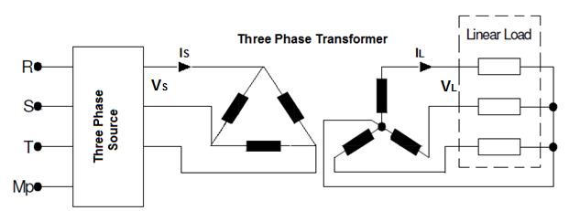
Figure1.1 Connection of the three phase transformer with linear load [1]
    - Resistive Load

Fig.1.2 presents the relation between voltage, and current in one phase of three phase transformer with purely linear resistive load. Both waveforms are inphase and there is no waveform distortion will take place. Total harmonic distortion THD=0.03% as shown in Fig.1.3

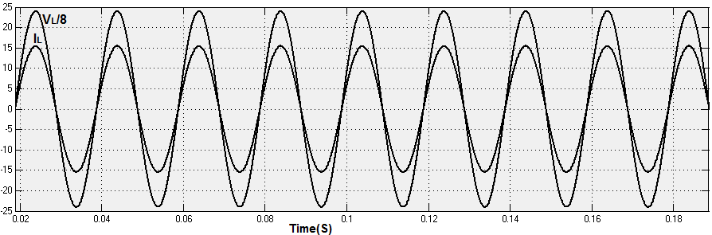Figure 1.2 Relation between voltages, current in a purely resistive load [9].

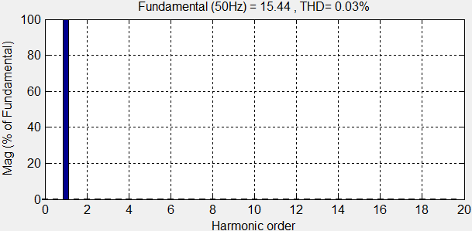
Figure 1.3 Current harmonic spectrum of the linear resistive load at phase a

    - Inductive Load
In this case the current lags the voltage as shown in Figure1.4 which shows the relation between voltage, and current, in one phase of three phase transformer with linear inductive load. The two waveforms will be out of phase.

However, no waveform distortion will take place and the total harmonic distortion (THD) =0.02% as shown in Fig.1.5
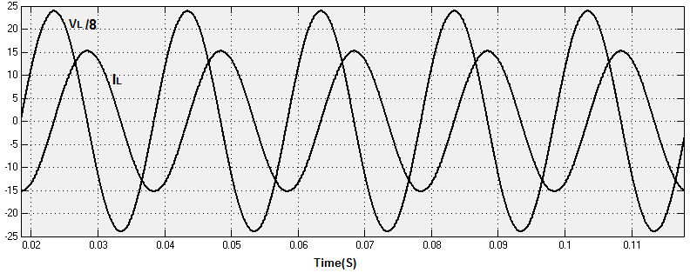Figure 1.4 Relation between voltage, current in inductive load [9]

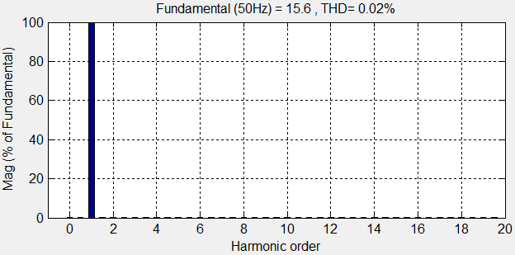
Figure 1.5 Current harmonic spectrum of the linear inductive load at phase a

    - Capacitive Load
In this case the current leads the voltage as shown in Figure1.6 which shows the relation between voltage, and current in one phase of three phase transformer with capacitive load. The two waveforms will be out of phase from one another. However, no waveform distortion will take place and total harmonic distortion (THD) = 0.02% as shown in Fig.1.7 and Table1.1 shows examples of linear loads

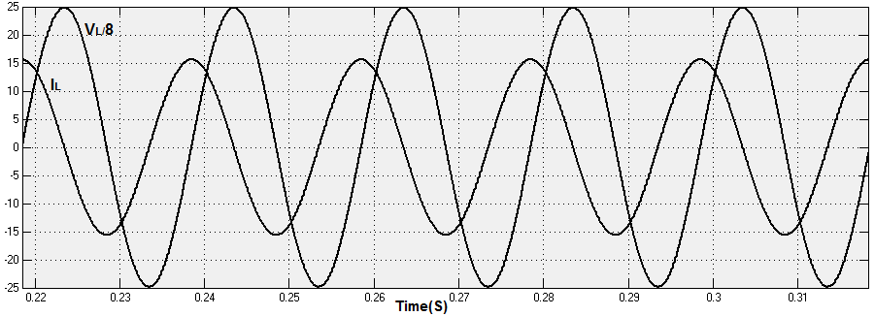
Figure 1.6 Relation between voltage, current in capacitive load [9]
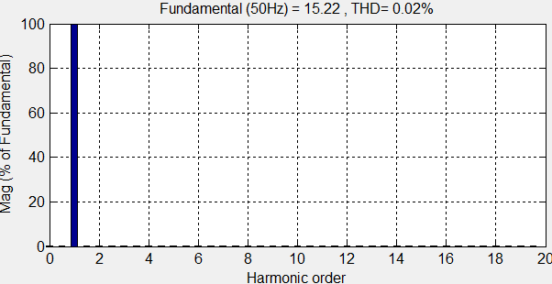

Figure 1.7 Current harmonic spectrum of the linear capacitive load at phase a

Table 1.1 Examples of linear loads.

Resistive elements | Inductive elements | Capacitive elements
• Incandescent lighting  • Electric heaters | • Induction motors  • Current limiting reactors  • Induction generators  (wind mills)  • Damping reactors used  to attenuate harmonics  • Tuning reactors in  harmonic filters | • Power factor correction  capacitor banks  • Underground cables  • Insulated cables  • Capacitors used in  harmonic filters

  - Three Phase Transformer with Non-Linear Loads
Nonlinear loads are loads in which the current waveform does not resemble the applied voltage waveform due to a number of reasons, for example, the use of electronic switches that conduct load current only during a fraction of the power frequency period. Therefore, we can conceive nonlinear loads as those in which Ohm’s law cannot describe the relation between V and I. Among the most common nonlinear loads in power systems are all types of rectifying devices like those found in power converters, power sources, uninterruptible power supply (UPS) units, and arc devices like electric furnaces and fluorescent lamps [9].Table1.2 shows some examples of nonlinear loads. Fig.1.8 presents delta/star configuration of three phase transformer under nonlinear load (three phase Full wave bridge rectifier). As shown in Figure1.9 the voltage VL and current IL waveforms are distorted and total harmonic distortion (THD) = 21% as shown in Figure1.10 and the Table1.2 shows some examples of nonlinear loads.
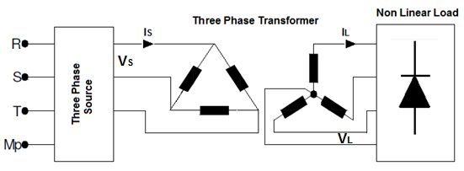
Figure 1.8 connection of the three phase transformer with nonlinear load[1]

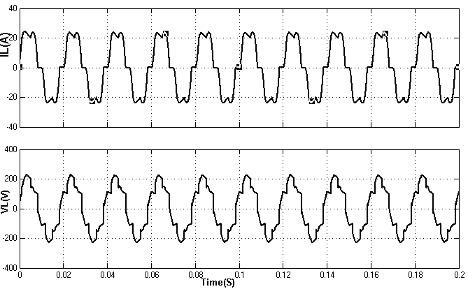

Figure 1.9 Current and Voltage waveforms of Full wave bridge rectifier

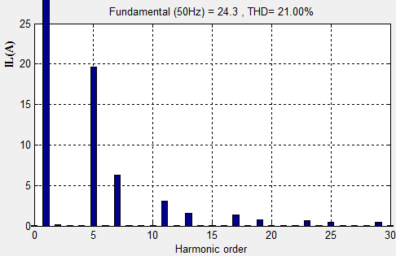
Figure 1.10 Current harmonic spectrum of the nonlinear load at phase a [9]
Power electronics | ARC devices
• Power converters  • Variable frequency drives  • DC motor controllers  • Cycloconverters  • Cranes  • Elevators  • Steel mills  • Power supplies  • UPS  • Battery chargers  • Inverters | • Fluorescent lighting  • ARC furnaces  • Welding machines
Table 1.2 Examples of some non- linear loads.

  - Thermal Effects on $3∅$Transformer
Modern industrial and commercial networks are increasingly influenced by significant amount of harmonic currents produced by a variety of nonlinear loads like variable speed drives, electric and induction furnaces, and fluorescent lighting. Add to the list uninterruptible power supplies and massive numbers of home entertaining devices including personal computers. All of these currents are sourced through service transformers. A particular aspect of transformers is that, under saturation conditions, they become a source of harmonics. Delta–wye- or delta–delta-connected transformers trap zero sequence currents that would otherwise overheat neutral conductors. The circulating currents in the delta increase the rms value of the current and produce additional heat. This is an important aspect to watch. Currents measured on the high-voltage side of a delta-connected transformer will not reflect the zero sequence currents but their effect in producing heat losses is there [9].
In general, harmonics losses occur from increased heat dissipation in the windings and skin effect; both are a function of the square of the RMS current, as well as from eddy currents and core losses. This extra heat can have a significant impact in reducing the operating life of the transformer insulation. Transformers are a particular case of power equipment that has experienced an evolution that allows them to operate in electrical environments with considerable harmonic distortion. Here we only stress the importance of harmonic currents in preventing conventional transformer designs from operating at rated power under particular harmonic environments. In industry applications in which transformers are primarily loaded with nonlinear loads, continuous operation at or above rated power can impose a high operating temperature, which can have a significant impact on their lifetime.
  - Review of Transformer Losses in Harmonic Loads
In general, transformer loss is divided into two groups, no load and load loss [10].

$$P_{T}=P_{C}+P_{LL} (1.11)$$

Where No load loss or core loss is${ P}_{C }$, $P_{LL}$is Load loss, and $P_{T}$is total loss

    - No Load Loss
No load loss or core loss (iron loss) appears because of time variable nature of electromagnetic flux passing through the core and its arrangement is affected by the amount of this loss. Since distribution transformers are always under service, considering the number of this type of transformer in network, the amount of no load loss is high but constant(constant losses) this type of loss is caused by hysteresis phenomenon and eddy currents into the core. These losses are proportional to frequency and maximum flux density of the core and are separated from load currents.

    - Load Loss
Load losses consist of $P_{DC}=I^{2}R$ loss, eddy loss, and stray loss, or in equation form

$$P_{LL}=P_{DC}+P_{EC}+P_{OSL} (1.12)$$

$P_{DC}$Is loss due to resistance of windings, $P_{EC}$is Windings eddy current loss, $P_{OSL}$is other stray losses in structural parts of transformer such as tank, clamps [11].

The sum of $P_{EC}$and $P_{OSL}$is called total stray loss. According to Eq. (1.13), we can calculate its value from the difference of load loss and Ohmic loss:

$$P_{TSL}=P_{EC}+P_{OSL}=P_{LL}-P_{DC} \left(1.13\right)$$

There is no test method mentioned for the process of separating windings eddy loss and other stray loss yet [11].
      - Ohmic Loss (copper Loss):
This loss can be calculated by measuring winding dc resistance and load current. If RMS value of the load current increases due to harmonic component, this loss will increase by square of RMS of load current [3]. The winding copper loss under harmonic condition is shown in Eq. (1.14)

$$P_{dc}=R_{dc}×I^{2}=R_{dc}×\sum_{h=1}^{h_{max}}{I_{h_{max}}^{2}} (1.14)$$

      - Eddy Current Loss in Windings:

Eddy Current Loss is caused by time variable electromagnetic flux that covers windings. Skin effect and proximity effect are the most important phenomenon in creating these losses in transformers, in comparison to external windings, internal windings adjacent to core have more eddy current loss. The reason is the high electromagnetic flux intensity near the core that covers these windings.

Also, the most amount of loss is in the last layer of conductors in winding, which is due to high radial flux density in this region [12].

$$P_{EC}=\frac{πτ^{2}μ^{2}}{3ρ}f^{2}×H^{2}∝f^{2}×I^{2} (1.15)$$

Here:
$τ=$ A conductor width perpendicular to field line
$ρ=$ Conductor’s resistance

$${P_{EC}∝f}^{2}×I^{2} (1.16)$$

The impact of lower-order harmonics on the skin effect is negligible in the transformer windings.
1.6.2.3 Other Stray Loss:

A voltage induces in the conductor Due to the linkage between electromagnetic flux and conductor, and this will lead to producing eddy current produces loss and rise temperature.

Other stray loss is a part of eddy current loss which is produced in structural parts of transformers (except in the windings) different factors such as size of core, class of voltage of transformer and construction of materials used to build tank and clamps. To calculate the effect of frequency on the value of other stray loss, different tests have been achieved. Results shown that the AC resistance of other stray loss in low frequency (0-360Hz) is equal to:

$$R_{AC}^{if}=0.00129{(\frac{f_{h}}{f_{1}})}^{0.8} (1.17)$$

The frequencies in the range of (420-1200 Hz), resistance will be calculated by:

$$R_{AC}^{if}=0.33358{(\frac{f_{h}}{f_{1}})}^{-1.87} (1.18)$$

Thus$P_{EC}$ loss is proportional to the square of the load current and the frequency to the power of 0.8

$$P_{EC}∝I^{2}∝f^{o.8} (1.19)$$

For calculating the other stray loss the equation below can be used

$$P_{OSL}=P_{TSL}-P_{EC} (1.20)$$

  - Harmonic Current Effect on no-Load Losses
According to Faraday’s law the terminal voltage determines the transformer flux level, i.e.
$$N\frac{d_{∅}}{d_{t}}=V\left(t\right) (1.21)$$

Transferring this equation into the frequency domain shows the relation between the voltage harmonics and the flux components:

$$Nj\left(hw\right)=V_{h} (1.22)$$

This equation shows that flux magnitude is directly proportional to the harmonic voltage and inversely proportional to the harmonic order h. Furthermore, within most power systems, the harmonic distortion of the system voltage THD is well below 5% and the magnitudes of the voltage harmonic components are small compared to fundamental components. Hence neglecting the effect of harmonic voltage will only give rise to an insignificant error. Nevertheless, if THDv is not negligible, losses under distorted voltages can be calculated based on ANSI-C.27-1920 standard.

$$P=P_{M}\left[P_{h}+P_{EC}{\left(\frac{V_{hrms}}{V_{rms}}\right)}^{2}\right] (1.23)$$
Where,
$V_{hrms}$and $V_{rms}$are the RMS values of distorted and sinusoidal voltages, PM and P are no-load losses under distorted and sinusoidal voltages, $P_{h}$and $P_{EC }$are hysteresis and eddy current losses, respectively [13].

  - Harmonic Current Effect on Load Losses
According to [3], in most power systems, current harmonics are of more significance. It causes increase losses in the windings and other structural parts of the distribution transformer

    - Harmonic Current Effect on DC Losses
$$P_{dc}=R_{dc}×I^{2}=R_{dc}×\sum_{h=1}^{h_{max}}{I_{h_{max}}^{2}} (1.24)$$
    - Harmonic Current Effect on Eddy Current Losses$P_{EC}$
Eddy current loss of windings is proportional to square of current and square of harmonic frequency in harmonic condition.

$$P_{EC}=P_{EC-R}×\sum_{h=1}^{h=h_{max}}{h^{2}[}{\frac{I_{h}}{I_{R}}]}^{2} (1.25)$$

Where, $P_{EC-R}$is Rated eddy current loss of windings, $I_{h}$is the current related $h^{th}$harmonics $I_{R}$is Rated load current, h is the Order of harmonics[3].

    - Harmonic Loss Factor for other stray losses
The other stray losses are assumed to vary with the square of the RMS current and the harmonic frequency to the 0.8 power [3]:

$$P_{OSL}=P_{OSL-R}×\sum_{h=1}^{h=h_{max}}{h^{0.8}[}{\frac{I_{h}}{I_{R}}]}^{2} (1.26)$$

1.9 Literature Review

The techniques developed so far to clear the harmonic pollution in nonlinear load can be classified in three groups

- Passive filter
- Active filter
- Hybrid filter

There are many papers proposed for minimizing current distortion in nonlinear load as follow:

F. Z. Peng, H. Akagi and A. Nabae (1990) proposed a new approach to compensate for harmonics in power systems. It is a combined system of a shunt passive filter and a small rated series active filter. The compensation principle is described, and some interesting filtering characteristics are discussed in detail theoretically. Excellent practicability and validity to compensate for harmonics in power systems are demonstrated experimentally [14].

Elham B. Makram, and E. V. Subramaniam (1993) presented a study of harmonic filters design to minimize harmonic distortion caused by a harmonic source such as drives. Several types of shunt harmonic filters are presented. The analysis includes the basic principles, the application of the 2-bus method and the economic aspects for harmonic filter design[15].

S. kim, P. Enjeti (1994) proposed a new approach to improve power factor and reduce current harmonics of a three-phase diode rectifier using the technique of the line injection. The proposed approach is passive and consists of a novel interconnection of a star-delta transformer between the AC and DC sides of the diode rectifier. A circulating third harmonic current is automatically generated, and injected to the AC side lines of the rectifier. The resulting input current is near sinusoidal in shape with a significant reduction in supply current harmonics. The disadvantage of this approach is the additional cost of the star-delta transformer which is rated about 43% of the rectifier output power [16].
J. Carlos and A.H. Samra (1998) discussed a novel approach of zigzag transformer connected between AC and DC sides of UCC. They showed by simulation using Electromagnetic Transient Program, that the generated circulating current drastically reduces the supply current harmonics. No practical results are presented [17].

P. Pejovic and Z. Janda (1999) proposed a low harmonic three phase diode rectifier that applies near optimal current injection. The rectifier utilizes a novel passive current injection network consists of three resistors and three nondissipative filters. The injection network consists of thirteen elements [18].

C. J. Choo, and C.W. Lio (2000) proposed the optimal planning of large passive-harmonic-filters set at high voltage level based on multi-type and multi-set of filters, from which, the types, set numbers, capacities and the important parameters of filters are well determined to satisfy the requirements of harmonic filtering and power factor. Four types of filters, namely single-tuned filter, second-order, third-order and C-type damped filters are selected for the planning. The characteristics of filters are analyzed [19].

Basil. M. S and Hussein.I.Z (2006) proposed a new concept and a novel passive resonant network, which is connected between the AC and DC sides of the Three-phase rectifier, analyses and simulated by PSPICE program. The result show that the shape of line current becomes nearly sinusoidal and the THD of the AC supply current can be reduced from 32% to 5% [20].

Babak. Badrzadeh, Kenneth S. Smith (2011) presented the results of harmonic analysis and harmonic filter design for a grid-connected aluminum smelting plant. Harmonic-penetration-analysis studies are carried out to determine the system resonance frequencies and the individual and total harmonic voltage distortions for a wide range of possible system operating conditions. A conceptual harmonic-filter-design procedure for the filters required for the smelting plant is presented. The suitability and robustness of the proposed harmonic filter configuration in terms of the filter’s component current and voltage ratings and corresponding rms values are investigated[21].

1.10 Objective and Organization

1.10.1 Aim of the Thesis

The aim of this thesis is to reduce current harmonics in a Three-phase transformer under linear and nonlinear load based on harmonic tuned filters technique in order to get current waveform near to sinusoidal waveform. For this purpose combination of two types of filters (double tuned filter and c-type filter) have been used and proposed. Therefore the broad objectives of this thesis are:
- Studying three phase transformer under linear and nonlinear load.
- Analyzing the tuned harmonic filter technique for the system under nonlinear load in order to minimize harmonic distortion.
- Mathematical analysis of the passive harmonic filter network in order to get the equations of elements to design passive filters circuit.
- Simulating the circuit configuration with and without tuned harmonic filter, using (Matlab Simulink) program, and comparing the results.

    - Thesis Organization
This thesis is organized in five chapters,
In which chapter one is an introduction to the three phase transformer under linear and nonlinear load.

The second chapter generally deals with the harmonic spectrum analysis in the system under linear and nonlinear load.

Chapter three provides parameter calculation and designing tuned harmonic filter for harmonic reduction.

Chapter four shows the simulation results for circuit configuration with and without filters.

The fifth and final chapter provides the concluding remarks that summarize the research results and gives future work recommendations on subjects related to the thesis.

CHAPTER 2

THEORETICAL ANALYSIS FOR THE SYSTEM

2.1 Harmonic Analyses of Three Phase Full Wave Bridge Rectifier

The circuit arrangement as shown in Fig. 2.1, where the three phase full wave bridge rectifier is used as a nonlinear load the input current(ia) waveform of these bridge rectifier is a series of equally spaced rectangular pulses alternately positive and negative as shown in Fig. 2.2. Fourier analysis of such a waveform shows that it contains a converging series of superimposed harmonic components have frequencies of 5, 7, 11, 13,as shown in Fig. 2.3 and in general $(6q±1)$ each 6n harmonic in the DC voltage requires harmonic currents of frequencies of 6n+ 1 and 6n-1 in the AC line. The magnitude of the harmonic current is essentially inversely proportional to the harmonic number [22], Expressed as:
$h=kq±1 (2.1)$
$$I_{h}={I_{1}}/h (2.2)$$
Where
h = harmonic number
k = any integer
q= pulse number of circuit
$I_{1}$= fundamental current
$I_{h}$= harmonic current

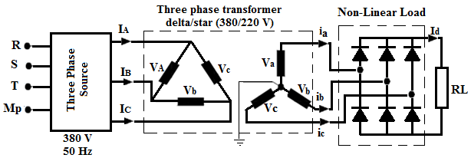
Figure 2.1 Three Phase Transformer with Nonlinear Load [1]
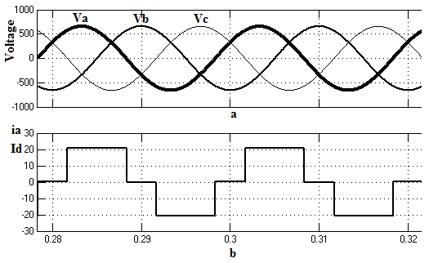
Figure 2.2 (a) Waveforms of Va, Vb, Vc (b) Phase -a-current waveform for high inductive
Load [20]

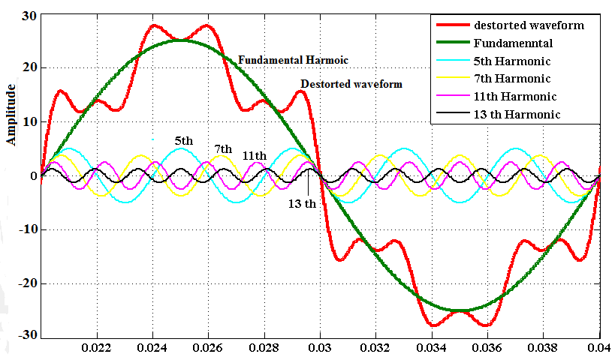

Figure 2.3 Distorted Waveform Composed of Fundamental and $5^{th}, 7^{th}, {11}^{th},and {13}^{th}$ Harmonics [9]

Therefore, for a three phase full wave bridge rectifier, the per unit harmonic currents in the AC power supply would theoretically be:
Table 2.1 per unit harmonic currents for a three phase full wave bridge rectifier [22]
h | 5 | 7 | 11 | 13 | 17 | 19 | 23 | 25
$$I_{h}$$ | 0.200 | 0.143 | 0.091 | 0.077 | 0.059 | 0.053 | 0.043 | 0.040

These values apply for k= 1 to 4. Because the harmonic currents are essentially zero for values of k above 4, it is customary only to analyze for k values up through 4. Rigorous treatment would require extending the range of k.

The switching elements of a three phase full wave bridge rectifier are diodes. They will start conducting as soon as a voltage is applied in the forward or current carrying direction. The switching elements of a phase controlled rectifier or converter are thyristors. Table2.2 and Fig.2.4 show the relationship of the theoretical values to typical values due the trapezoidal waves.

Table 2.2 per unit harmonic currents for three phase full wave bridge rectifier the relationship of the theoretical values to typical values due the trapezoidal waves [22]
h | 5 | 7 | 11 | 13 | 17 | 19 | 23 | 25
Theory$I_{h}$ | 0.200 | 0.143 | 0.091 | 0.077 | 0.059 | 0.053 | 0.043 | 0.040
Typical$I_{h}$ | 0.175 | 0.111 | 0.045 | 0.029 | 0.015 | 0.010 | 0.009 | 0.008

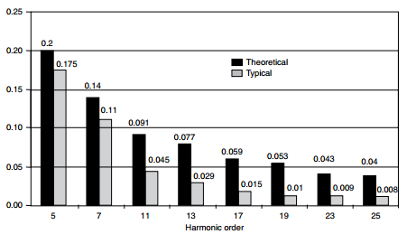

Figure 2.4 Theoretical and Typical Values of Harmonic Current For a three phase full wave bridge rectifier [22]
2.2 Mathematical Structure

In general, a non-sinusoidal waveform$f(t)$ repeating with an angular frequency$ω$ can be expressed as in equation (2.3) [9].

$$f\left(t\right)=\frac{a_{o}}{2}+\sum_{n=1}^{∞}{(a_{n}cos\left(nωt\right)+b_{n}sin(n}ωt)) (2.3)$$

Where
$$a_{n}=\frac{1}{π}\int_{0}^{2π}{f\left(t\right)cos⁡(nωt)dωt} (2.4)$$

And

$$b_{n}=\frac{1}{π}\int_{0}^{2π}{f\left(t\right)sin\left(nωt\right)dωt (2.5)}$$

Each frequency component$n$ has the following value

$$f_{n}\left(t\right)=a_{n}cos\left(nωt\right)+b_{n}\sin\left(nωt\right) (2.6)$$

$f_{n}\left(t\right)$Can be represented as a phasor in terms of its RMS value as shown in equation (2.7)

$$F_{n}=\sqrt{\frac{a_{n}^{2}+b_{n}^{2}}{2}} e^{jφn} (2.7)$$

Where
$$φ_{n}=\tan^{-1}\frac{-b_{n}}{a_{n}} (2.8)$$

Fourier series of $i_{La}$

$$a_{n}=\frac{1}{π}\int_{0}^{2π}{I_{d}\cos\left(nωt\right)dωt}$$
$=\frac{1}{π}\left(\int_{π/6}^{{5π}/6}{I_{d}\cos\left(nωt\right)dωt}+\frac{1}{π}\int_{7π/6}^{{11π}/6}{I_{d}\cos\left(nωt\right)dωt}\right)=0 (2.9)$

$b_{n}=\frac{1}{π}\int_{0}^{2π}{I_{d}sin⁡(nωt)dωt}=\frac{1}{π}\left(\int_{π/6}^{{5π}/6}{I_{d}\sin\left(nωt\right)dωt}+\frac{1}{π}\int_{7π/6}^{{11π}/6}{I_{d}\sin\left(nωt\right)dωt}\right)$
$=\frac{2}{nπ}I_{d}\left[cos\left(\frac{nπ}{6}\right)-sin\left(\frac{nπ}{6}\right)\right] (2.10)$

$i_{La}=\frac{2\sqrt{3}}{π}I_{d}\left(\sin\left(ωt\right)-\frac{1}{5}\sin\left(5ωt\right)-\frac{1}{7}\sin\left(7ωt\right)+\frac{1}{11}\sin\left(11ωt\right)+ \frac{1}{13}\sin\left(13ωt\right).\right)$(2.11)

2.3 Proposed System Configuration for Harmonic Cancellation

Due to the rapid development of electronic and semiconductor devices, harmonic problems have become a major concern for present day engineer the harmonic filtering is one of the solutions to prevent the troublesome harmonics from entering the rest of the system passive filter components are passive elements such as resistor, inductor, and capacitor, Among the passive filters, there are two approaches to suppress undesired harmonic currents; a) using a series impedance to block them, b) diverting them by means of a low impedance shunt path[15]. Fig. 2.5 shows a proposed system consisting of a shunt passive filter which are a combination of three tuned filters, two C-type filters to eliminate or to reduce the effects of 5th and7th harmonics, and one double-tuned filter to eliminate or to reduce the effects of 11th and 13th harmonics as shown in Fig. 2.6. The reactive power of each filter is 1KVAr, and the nominal voltage of capacitance is 220V which is connected in parallel with the system. It is installed in parallel with a harmonic-producing load, that is, a three-phase bridge rectifier of rating 10 kVA.

The filtering performance of the ‘C’ type filter lies in between the second and third order types. The main advantage in the ‘C’ type filter is a considerable reduction in fundamental frequency losses, the double tuned filter can eliminate two harmonics and its equivalent impedance is the same as two parallel single tuned filters. This filter has the advantage of reducing the power losses at fundamental frequency as compared with two single tuned filters.

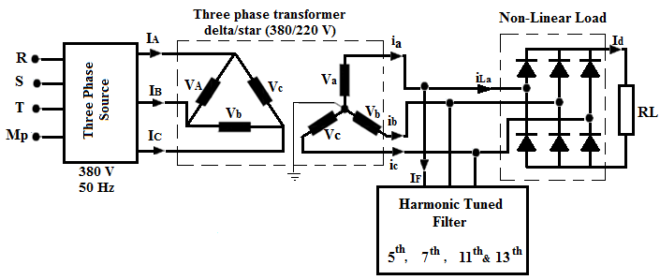

Figure 2.5 Proposed system configuration
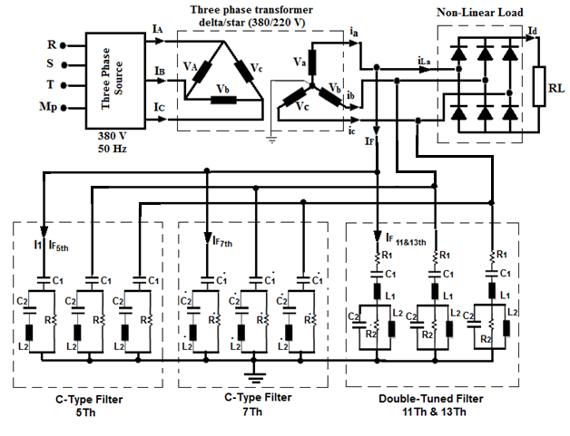
Figure 2.6 Proposed system configuration with filters

2.4 Harmonic Impedance Plot for the Proposed Harmonic Filter

If shunt harmonic filters are not selected carefully, they can resonate with existing electrical components and cause additional harmonic currents. In order to ensure that the proposed harmonic filter does not cause any new resonance point on the system, a harmonic impedance sensitivity plot for the filter was produced, as shown in Fig. 2.7
Harmonic filter banks are typically tuned to approximately 2%–10% below the desired harmonic frequency [21]. If a filter is tuned exactly at the frequency in concern, an upward shift in the tuned frequency will result in a sharp increase in impedance, as seen by harmonics. In order to mitigate the low-order 5th and 7th harmonics, a two c-type filter tuned at the 4.8th, and 6.8th harmonics was initially investigated, To mitigate the 11th and 13th harmonics, it was observed that the filter design can be simplified by using double tuned filter at the 10.8th, and 12.8th harmonics. The quality factor of this tuned harmonic filter is set to 10.
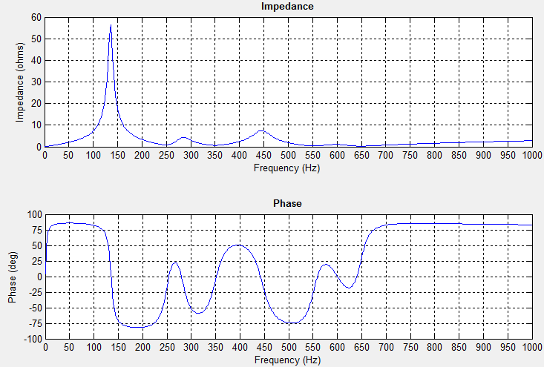
Figure 2.7 Harmonic impedance characteristics of the proposed harmonic filter.

2.5 Harmonic Standards and recommendation

The most widespread standards for harmonic control worldwide are due to IEEE in the U.S. and IEC (International Electrotechnical Commission) in the European Union. In 1981, the IEEE issued Standard 519-1981, which aimed to provide guidelines and recommended practices for commutation notching, voltage distortion, telephone influence, and flicker limits produced by power converters. The standard contended with cumulative effects but did little to consider the strong interaction between harmonic producers and power system operation [9].

The IEC, which governs the European Union, adopted a philosophy of requiring manufacturers to limit their products’ consumption of current harmonics in their standard IEC 61000-3-2. This standard applies to all single-phase and three-phase loads rated at less than 16 A per phase. Products must be tested in approved laboratories to insure they meet the standard. 61000-3-2 took effect on January 1, 2001, although enforcement seems to be limited [23].

2.6 Harmonic distortion effects on plant equipment [24]

High levels of harmonic distortion can lead to problems for the utility's distribution system, plant distribution system and any other equipment serviced by that distribution system. Effects can range from spurious operation of equipment to a shutdown of important plant equipment, such as machines.
Harmonics can lead to power system inefficiency. Some of the negative ways that harmonics may affect plant equipment are listed below:

Conductor Overheating: a function of the square RMS current per unit volume of the conductor. Harmonic currents on undersized conductors or cables can cause a “skin effect”, which increases with frequency and is similar to a centrifugal force.

Capacitors: can be affected by heat rise increases due to power loss and reduced life on the capacitors. If a capacitor is tuned to one of the characteristic harmonics such as the 5th or 7th, overvoltage and resonance can cause dielectric failure or rupture the capacitor.

Fuses and Circuit Breakers: harmonics can cause false or spurious operations and trips, damaging or blowing components for no apparent reason.
Transformers: have increased iron and copper losses or eddy currents due to stray flux losses. This causes excessive overheating in the transformer windings.

Generators: have similar problems to transformers. Sizing and coordination is critical to the operation of the voltage regulator and controls. Excessive harmonic voltage distortion will cause multiple zero crossings of the current waveform. Multiple zero crossings affect the timing of the voltage regulator, causing interference and operation instability.

Utility Meters: may record measurements incorrectly, result in higher billings to consumers.

Drives/Power Supplies: can be affected by disoperation due to multiple zero crossings. Harmonics can cause failure of the commutation circuits, found in DC drives and AC drives with silicon controlled rectifiers (SCRs).
2.7 Harmonic Mitigating Techniques

Several different solutions are proposed for harmonic mitigation. The right choice is always dependent on a variety of factors, such as the activity sector, the applicable standards, and the power level. Several solutions are relative to Variable Speed Drives, as this type of electrical equipment represents a large part of the installed power in industrial installations and the most significant power harmonic current generators.
According to Hussein A. Kazem (2013) harmonic mitigation techniques classified into three categories: passive techniques, active techniques, and hybrid harmonic reduction techniques using a combination of active and passive methods as shown in Table 2.3.

Table 2.3 Categorization of harmonic reduction methods

Passive Filters

Active Filters

Harmonic Current Reduction Methods

Using Filter
Injection Current
Through Capacitors
Neutral Injection
Line Injection

Through delta/star
Or delta /zigzag Transformer

Injecting with external triple frequency current source
Injecting with self-generated 3rd harmonic current

2.8 Passive Harmonic Mitigation Techniques

Many passive techniques are available to reduce the level of harmonic pollution in an electrical network, including the connection of series line reactors, tuned harmonic filters, and the use of higher pulse number converter circuits such as 12-pulse, 18-pulse, and 24-pulse rectifiers. In these methods, the undesirable harmonic currents may be prevented from flowing into the system by either installing a high series impedance to block their flow or diverting the flow of harmonic currents by means of a low-impedance parallel path [25].

2.8.1 Effect of Source Reactance

Typical AC current waveforms in single-phase and three-phase rectifiers are far from a sinusoid. The magnitude of harmonic currents in some nonlinear loads depends greatly on the total effective input reactance, comprised of the source reactance plus any added line reactance. For example, given a 6-pulse diode rectifier feeding a DC bus capacitor and operating with discontinuous DC current, the level of the resultant input current harmonic spectrum is largely dependent on the value of AC source reactance and an added series line reactance; the lower the reactance, the higher the harmonic content . Other nonlinear loads, such as a 6-pulse diode rectifier feeding a highly inductive DC load and operating with continuous DC current, act as harmonic current sources. In such cases, the amount of voltage distortion at the PCC is dependent on the total supply impedance, including the effects of any power factor correction capacitors, with higher impedances producing higher distortion levels [26].

2.8.2 Series Line Reactors

The use of series AC line reactors as shown in Fig. 2.8 is a common and economically means if increasing the source impedance relative to an individual load, for example, the input rectifier used as part of a motor drive system. The harmonic mitigation performance of series reactors is a function of the load; however, their effective impedance reduces proportionality as the current through them is decreased [27].
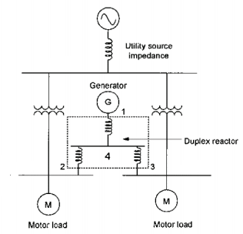
Figure 2.8 Duplex reactors [27]

2.8.3 Tuned Harmonic Filters

Passive harmonic filters (PHF) involve the series or parallel connection of a tuned LC and high-pass filter circuit to form a low-impedance path for a specific harmonic frequency. The filter is connected in parallel or series with the nonlinear load to divert the tuned frequency harmonic current away from the power supply. Unlike series line reactors, harmonic filters do not attenuate all harmonic frequencies but eliminate a single harmonic frequency from the supply current waveform [28]. Eliminating harmonics at their source has been shown to be the most many types of harmonic filters are commonly employed, including the following:

2.8.3.1 Shunt passive filters

Passive LC filters tuned to eliminate a particular harmonic are often used to reduce the level of low-frequency harmonic components like the 5th and 7th produced by three-phase rectifier and inverter circuits. The filter is usually connected across the line as shown in Fig. 2.9 if more than one harmonic is to be eliminated, and then a shunt filter must be installed for each harmonic. Care must be taken to ensure that the peak impedances of such an arrangement are tuned to frequencies between the required harmonic frequencies to avoid causing high levels of voltage distortion at the supply’s PCC because of the presence of an LC resonance circuit [28].

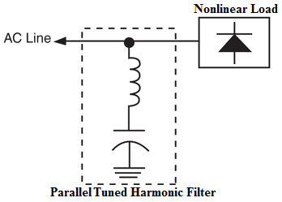
Figure 2.9 Shunt passive filters [24]

2.8.3.2 Series Passive Filter

A series passive filter is connected in series with the load. The inductance and capacitance are connected in parallel and are tuned to provide high impedance at a selected harmonic frequency. The high impedance then blocks the flow of harmonic currents at the tuned frequency only.
At fundamental frequency, the filter would be designed to yield low impedance, thereby allowing the fundamental current to follow with only minor additional impedance and losses. Fig.2.10 shows a typical series filter arrangement [28].

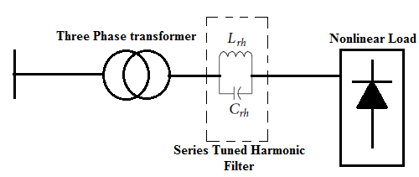
Figure 2.10 Series passive filter [28]

2.8.3.3 Higher Pulse Converters

Three phases, 6-pulse static power converters, such as those found in variable speed drives (VSD), generate low frequency current harmonics. Predominantly, these are the 5th, 7th, 11th, and 13th with other higher orders harmonics also present but at lower levels. With a 6-pulse converter circuit, harmonics of the order 6𝑘 ± 1, where 𝑘 = 1, 2, 3, 4, and so forth, will be present in the supply current waveform.

In high-power applications, AC-DC converters based on the concept of multi pulse, namely, 12, 18, or 24 pulses, is used to reduce the harmonics in AC supply currents. They are referred to as a multi pulse converters. They use either a diode bridge or Thyristor Bridge and a special arrangement of phase shifting magnetic circuit such as transformers and inductors to produce the required supply current waveforms [29]. A parallel 12-pulse arrangement is shown in Fig. 2.11 Parallel connections require special care to ensure adequate balance between the currents drawn by each bridge.

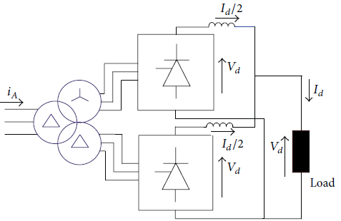
Figure 2.11 parallel twelve-pulse rectifier connections [40]

2.8.3.4 Zigzag Grounding Filter

By integrating phase shifting into a single or multiphase transformer with extremely low zero-sequence impedance, substantial reduction of 3rd, 5th, and 7th harmonics can be achieved. This method provides an alternative to protect the transformer neutral conductor from triple harmonics by canceling these harmonics near the load. In this method, an autotransformer connected in parallel with the supply can provide a zero sequence current path to trap and cancel triple harmonics as shown in Fig. 2.12 [16].

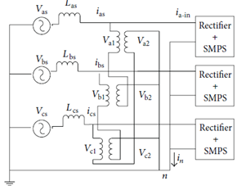

Figure 2.12 Zigzag autotransformer connected to three-phase nonlinear loads[40].

2.8.4 Active Harmonic Mitigation Techniques

When using active harmonic reduction techniques, the improvement in the power quality came from injecting equal but- opposite current or voltage distortion into the network, thereby canceling the original distortion. Active harmonic filter (AHF) utilizes fast-switching insulated gate bipolar transistors (IGBTs) to produce an output current of the required shape such that when injected into the AC lines, it cancels the original load-generated harmonics.

The heart of the AHF is the controller part. The control strategies applied to the AHF play a very important role on the improvement of the performance and stability of the filter. AHF is designed with two types of control scheme, the first performs fast Fourier transforms to calculate the amplitude and phase angle of each harmonic order. The power devices are directed to produce a current of equal amplitude but opposite phase angle for specific harmonic orders. The second method of control is often referred to as full spectrum cancellation in which the full current waveform is used by the controller of the filter, which removes the fundamental frequency component and directs the filter to inject the inverse of the remaining waveform [30]. The AHF classified as parallel or series AHF according to the circuit configuration.

2.8.4.1 Parallel Active Filters
This is the most widely used type of AHF (more preferable than series AHF in terms of form and function). As the name implies, it is connected in parallel to the main power circuit as shown in Fig. 2.13 the filter is operated to cancel out the load harmonic currents leaving the supply current free from any harmonic distortion. Parallel filters have the advantage of carrying the load harmonic current components only and not the full load current of the circuit [31]
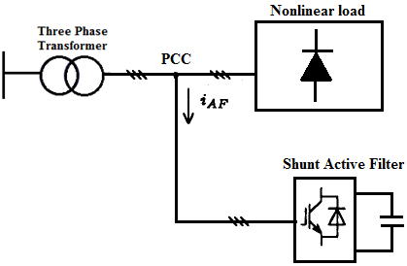
Figure 2.13 parallel active filters [33]

2.8.4.2 Series Active Filters

Series AHF is shown in Fig. 2.14 The idea here is to eliminate voltage harmonic distortions and improve the quality of the voltage applied to the load. This is achieved by producing a sinusoidal pulse width modulated (PWM) voltage waveform across the connection transformer, which is added to the supply voltage to counter the distortion across the supply impedance and present a sinusoidal voltage across the load. Series AHF has to carry the full load current increasing their current ratings and losses compared with parallel filters, especially across the secondary side of the coupling transformer [32].

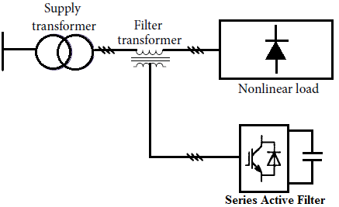
Figure 2.14 Series active filter [33]

2.8.5 Hybrid Harmonic Mitigation Techniques

Hybrid connections of AHF and passive harmonic filter PHF are also employed to reduce harmonics distortion levels in the network. The PHF with fixed compensation characteristics is ineffective to filter the current harmonics. AHF overcomes the drawbacks of the PHF by using the switching-mode power converter to perform the harmonic current elimination. However, the AHF construction cost in an industry is too high. The AHF power rating of power converter is very large. These bound the applications of AHF used in the power system. Hybrid harmonic filter (HHF) topologies have been developed [33] to solve the problems of reactive power and harmonic currents effectively. Using low cost PHF in the HHF, the power rating of active converter is reduced compared with that of AHF. HHF retains the advantages of AHF and does not have the drawbacks of PHF and AHF. Fig. 2.15 shows a number of possible hybrid combinations. Fig. 2.15(a) is a combination of shunt AHF and shunts PHF. Using a combination of PHF will make a significant reduction in the rating of the AHF. As a result, no harmonic resonance occurs, and no harmonic current flows in the supply. Fig. 2.15(b) shows a combination of AHF series with the supply and a shunt PHF, Fig. 2.15(c) shows an AHF in series with a shunt PHF.

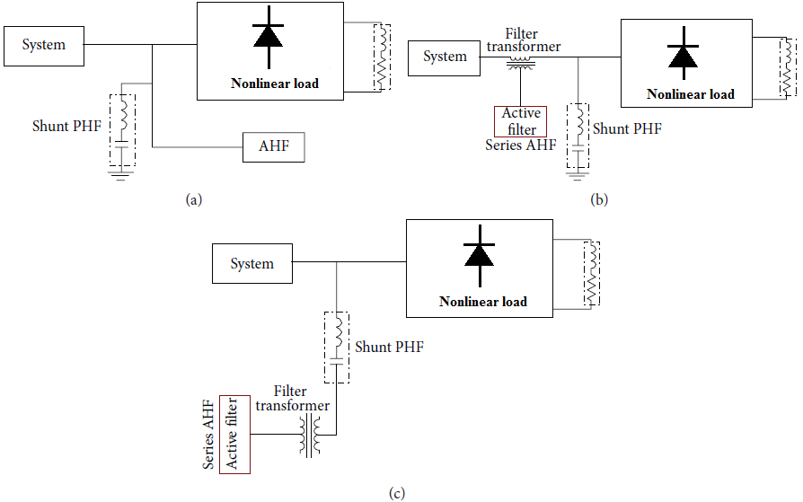
Figure 2.15 Hybrid connections of active and passive filters [40].

CHAPTER 3

DESIGNING AND PARAMETER CALCULATION OF HARMONIC TUNED FILTERS

3.1 Passive Harmonic Filters

In recent years various harmonic-mitigation techniques have been proposed and applied. Among those techniques, passive harmonic filters are still considered to be the most effective and viable solution for harmonic reduction. The passive filters have several topologies as shown in Fig. 3.1 that give different frequency response characteristics. The current industry practice is to use the combination of several different topologies of filters to achieve desired harmonic filtering performance [34].

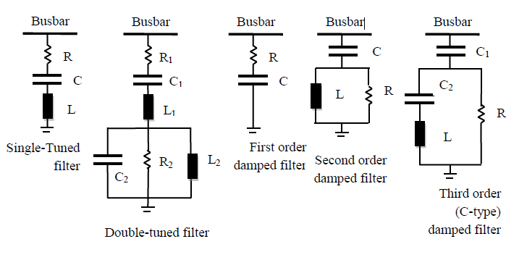Figure 3.1 Topologies of passive harmonic filters

Precautionary solutions are not generally sufficient to eliminate the harmonics in power system, so we should use harmonic filters to eliminate or to reduce the effects of one or more orders of harmonic components. Passive filters are capacitance, inductance, and resistance elements configured and tuned to control harmonics. Passive filtering techniques that make use of
- Single-tuned filter or double-tuned filters providing low impedance path to harmonic currents at certain frequencies, or
- High or band-pass filters (damped filters) that can filter harmonics over a certain frequency bandwidth.
Passive filters are relatively inexpensive compared with other methods for eliminating harmonic distortion. However, they have the disadvantage of potentially interacting adversely with the power system, and it is important to check all possible system interactions when they are designed.
Passive filters work efficiently when they are located closer to harmonic generators (nonlinear loads). The resonant frequency must be safely away from any significant harmonic or other frequency component that may be produced by the load. Filters are commonly tuned slightly lower than the harmonic frequency for safety.

Passive filter design must take into account expected growth in harmonic current sources or load reconfiguration because it can otherwise be exposed to overloading, which can rapidly develop into extreme overheating and thermal breakdown. The design of a passive filter requires a precise knowledge of the harmonic-producing load and of the power system. A great deal of simulation work is often required to test its performance under varying load conditions or changes in the topology of the network.

3.2 Circuit Configurations

Passive filters consisting of capacitors, inductors and resistors can be classified into tuned filters and high-pass filters. They are connected in parallel with nonlinear loads such as diode/thyristor rectifiers, AC electric arc furnaces [35], and so on. Fig. 3.2 and 3.3 showed the circuit configurations of the passive filters, the combination of three tuned filters, two C-type filters to eliminate or to reduce the effects of 5th and7th harmonics, and one double-tuned filter to eliminate or to reduce the effects of 11th and 13th harmonics. The reactive power of each filter is 1KVAr, and the nominal voltage of capacitance is 220V.
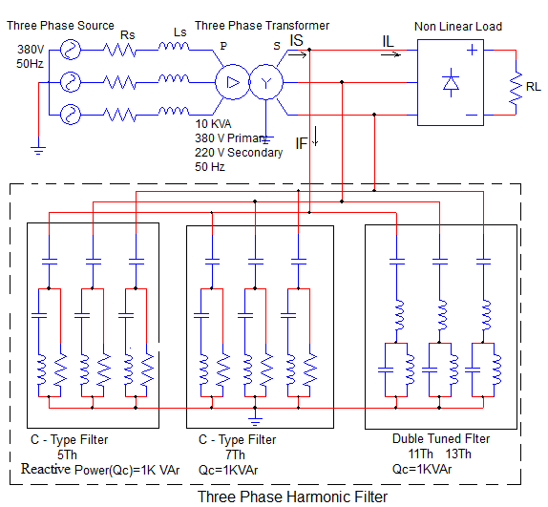
Figure 3.2 Proposed passive harmonic filters scheme

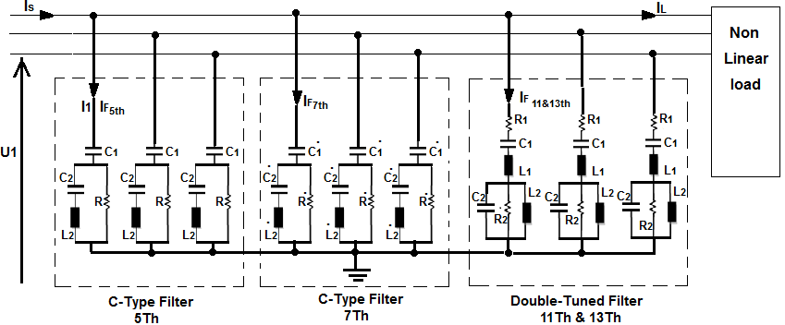
Figure 3.3 passive harmonic filters (two C-type filters and one double-tuned filter)

3.3 Single Tuned Filters

To design double-tuned filter we must start with Single Tuned Filters, Capacitor $C_{a}$ , Inductance $L_{a}$and resistance $R_{a}$ are connected in series to construct a single tuned filter as shown in Fig. 3.4.

A series tuned filter is designed to trap a certain harmonic by adding a reactor to an existing capacitor. According to [36] design steps of the following single-tuned series filter are as follows.

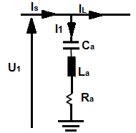
Figure3.4. Single Tuned filter

The resonant angular frequency of the single tuned filter is expressed as:

$$ω_{h}=\frac{1}{\sqrt{L_{a}C_{a}}} (3.1)$$
The quality factor is expressed as:
$$Q=\frac{ω_{h}L_{a}}{R_{a}} (3.2)$$
Ignoring the effect of resistance, with the symbols of the order of harmonic to restrain $N_{1}$ , the voltage of system bus at fundamental frequency $U_{1}$ , the current $I_{1}$ , the capacitor of the filter $C_{a}$ , the inductance $L_{a}$ , and the output reactive power of the single tuned filter is shown as:
$$Q_{f}=U_{1}I_{1} (3.3)$$
Because
$$I_{1}=\frac{U_{1}}{\frac{1}{{ωC}_{a}}-{ωL}_{a}} (3.4)$$
So,
$$Q_{f}=U_{1}I_{1}=I_{1}=\frac{U_{1}^{2}}{\frac{1}{{ωC}_{a}}-{ωL}_{a}}{=ωC}_{a}\frac{N_{1}^{2}}{N_{1}^{2}-1}U_{1}^{2} (3.5)$$
The parameters of filters are calculated according to the bus voltage ${ U}_{1}$ , the order of harmonic $N_{1}$ , the requirement of reactive power $Q_{1}$
$$C_{a}=\frac{Q_{1}(N_{1}^{2}-1)}{ωN_{1}^{2}U_{1}^{2}} (3.6)$$
$$L_{a}=\frac{1}{ω^{2}N_{1}^{2}C_{a}} (3.7)$$
the reactor resistance for a specified quality factor,
$R=\frac{X_{n}}{Q} (3.8$)

  - Designing Double-tuned Filter

According to [36], a new method of designing double-tuned filter is proposed based on resonance frequency, by using the relationship that the impedance of double-tuned filter and two parallel single tuned filters are equal and the resonance frequency of single tuned filter is the zero of the impedance of double-tuned filter. Fig. 3.5 show double-tuned filter and two single-tuned filters.

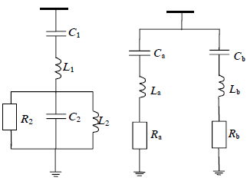
Figure 3.5 double-tuned filter and two single-tuned filter [36]
The conventional double-tuned filter is composed of series resonance circuit and parallel resonance circuit. The structure and frequency impedance characteristic curve of traditional double-tuned filter are shown in Fig. 3.6. Series resonance circuit ($L_{1}$,$C_{1}$) and parallel resonance circuit（$L_{2}$,$C_{2}$) respectively have resonance frequencies $ω_{s }$and${ ω}_{p}$. They can be expressed as:

$$\left[\begin{aligned}ω_{s} \\ ω_{p}\end{aligned}\right]=\left[\begin{aligned}1/{\sqrt{L_{1}C_{1}}} \\ 1/{\sqrt{L_{2}C_{2}}}\end{aligned}\right] (3.9)$$

The impedance of double-tuned filter shown in Figure 3.6 is
$$Z=jωL_{1}+\frac{1}{jωC_{1}}+{(jωC_{2}+\frac{1}{jωL_{2}} )}^{-1}=\frac{\left(1-\frac{ω^{2}}{ω_{s}^{2}}\right)\left(1-\frac{ω^{2}}{ω_{p}^{2}}\right)-ω^{2}L_{1}C_{1}}{jωC_{1}(1-\frac{ω^{2}}{ω_{p}^{2}})} (3.10)$$

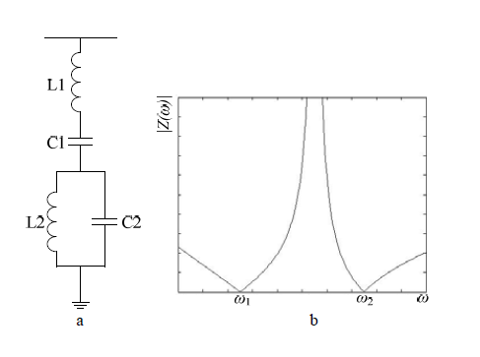
Figure 3.6 Double-tuned Filter Configuration and Impendence frequency Characteristic Curve

Where ω is the angular frequency in radians
The impedance of series resonance circuit can be expressed as
$$Z_{s}=jωL_{1}+\frac{1}{jωC_{1}} (3.11)$$
$Z_{s}$Has a zero$ω_{s }$. When ω<$ω_{s }$, the impedance is capacitive; when ω>$ω_{s }$, it is inductive. The Impedance of parallel resonance circuit can be expressed as
$${Z_{p}=(jωC_{2}+\frac{1}{jωL_{2}} )}^{-1} (3.12)$$
$Z_{p }$Has a pole${ ω}_{p}$. When ω<${ ω}_{p}$, the impedance is inductive; when ω>${ ω}_{p}$, it is capacitive. Their frequency impedance characteristic curves are shown in Fig. 3.7. At the two tuned frequencies, the total impedance of the filter is zero, so double-tuned filter can filter two different frequency harmonics [36].

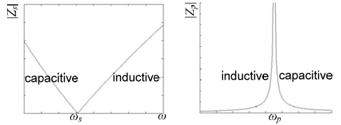
Figure 3.7 Impedance-frequency Curve of Series and Parallel Branch a) Series Resonance Circuit b) Parallel Resonance Circuit

3.5 The Parameters Calculation of Double-Tuned Filter

Two parallel single tuned filters are shown in Fig. 3.8. Their resonance frequencies respectively can be expressed as:
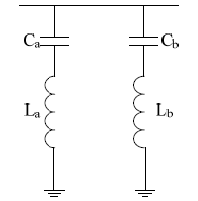

Figure 3.8 Parallel Single Tuned Filter
$$\left[\begin{aligned}ω_{a} \\ ω_{b}\end{aligned}\right]=\left[\begin{aligned}1/{\sqrt{L_{a}C_{a}}} \\ 1/{\sqrt{L_{b}C_{b}}}\end{aligned}\right] (3.13)$$

The impedance of two parallel single tuned filters can be expressed as:

$$Z_{ab}={({\left(jωL_{a}+\frac{1}{jωC_{a}}\right)}^{-1}+{\left(jωL_{b}+\frac{1}{jωC_{b}} \right)}^{-1})}^{-1}=\frac{\left(1-\frac{ω^{2}}{ω_{a}^{2}}\right)\left(1-\frac{ω^{2}}{ω_{b}^{2}}\right)}{jωC_{a}\left(1-\frac{ω^{2}}{ω_{b}^{2}}\right)+jωC_{b}\left(1-\frac{ω^{2}}{ω_{a}^{2}}\right)} (3.14)$$

Two parallel single tuned filters and double-tuned filter are equivalent, so their impedance are equal${ Z=Z}_{ab},$ Z has two zeros: $ω_{a }$and$ω_{b}$. Formula (3.10) and (3.14) have the same constant term of 1, so their molecular and denominator is equal respectively. First of all, a set is defined as S= {a,b}. After analyzing the coefficient of$ω_{4}$, we can gain an equation based on frequency, that is:
$ω_{a}ω_{b}=ω_{s}ω_{p } (3.15)$
Analyzing the coefficient of $ω$ we can find out the equation of
$$C_{1}=C_{a}+C_{b}=\sum_{i∈s}{C_{i}} (3.16)$$
Analyzing the coefficient of $ω_{3}$ we can find out that
$$C_{b}\frac{1}{ω_{a}^{2}}+C_{a}\frac{1}{ω_{b}^{2}}=C_{1}\frac{1}{ω_{p}^{2}} (3.17)$$
The parameter of L1 can be calculated from (3.9)
$$L_{1}=\frac{1}{C_{a}ω_{a}^{2}+C_{b}ω_{b}^{2}}=\frac{1}{\sum_{i∈s}{C_{i}ω_{i}^{2}}} (3.18)$$

Using$L_{1}$,$C_{1}$, series resonance frequency $ω_{s}$ can be calculate and parallel resonance frequency $ω_{p} can be calculate$ , their frequencies can be obtained:
$ω_{s}=\frac{1}{\sqrt{L_{1}C_{1}}} (3.19)$
$$ω_{p}=\frac{ω_{a}ω_{b}}{ω_{s}} (3.20)$$
Since$ω_{a}$ is the zero of double-tuned filter impedance, so Z ($ω_{a}$) =0. The equation to solve L2 is as follow:
$$\left(1-\frac{ω^{2}}{ω_{b}^{2}}\right)\left(1-\frac{ω^{2}}{ω_{a}^{2}}\right)-ω_{a}^{2}L_{2}C_{1}=0 (3.21)$$
Equation (3.21) can be simplified to get the value of${ L}_{2}$.
$$L_{2}=\frac{\left(1-\frac{ω^{2}}{ω_{b}^{2}}\right)\left(1-\frac{ω^{2}}{ω_{a}^{2}}\right)}{C_{1}ω_{a}^{2}} (3.22)$$

We also can solve $L_{2}$by using$ω_{b}$. The two results are the same. Using equation (3.20), and (3.22), the value of $C_{2}$can be obtained.
$$C_{2}=\frac{1}{L_{2}ω_{p}^{2}} (3.23)$$
the parameters of filters are calculated according to the bus voltage $U_{1}$ , the order of harmonic $N_{1}$ , the requirement of reactive power $Q_{1}$the three Phase double-tuned filter parameters L1,C1,L2 and C2 as shown in fig.3.9. Are calculated and tabulated in the table1.

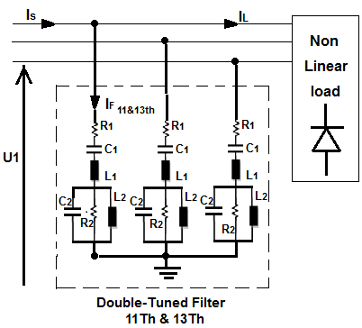
Figure 3.9 three Phase double-tuned filters for 11th and 13th harmonic reduction
Table3.1.parameters of double-tuned filter for 11th and 13th harmonic reduction
Reactive Power(Q VAr) | 200 | 400 | 600 | 800 | 1000 | 2000
Capacitance C1$(μF)$ | 26 | 52 | 78.3 | 104.4 | 130.4 | 260.8
Capacitance C2$( μF)$ | 22 | 44 | 64 | 90.8 | 113 | 222.7
Inductance L1(mH) | 2.7 | 1.35 | 0.9 | 0.67 | 0.54 | 0.27
Inductance L2(mH) | 3.2 | 1.6 | 1.1 | 0.79 | 0.63 | 0.32

The value of $\dot{R2}$ calculated when the quality factor (Q) =10

  - Designing C-type Filter
The first step in designing a C-type harmonic filter as shown in Fig. 3.10 is to determine the individual component values, $C_{1}$, $C_{2}$, $L_{2}$and $R_{T}$, based on specified tuning frequency, required VAr output at rated voltage and quality factor, Q. The filter parameters can be determined from relations given in [28]. The value of $C_{1}$ (total capacitance of main capacitor section) is based on the required reactive power output of the filter at rated voltage and frequency, and can be determined using equation (3.24)

$$C_{1}=\frac{Q_{f}}{ω_{0}U^{2}} (3.24)$$

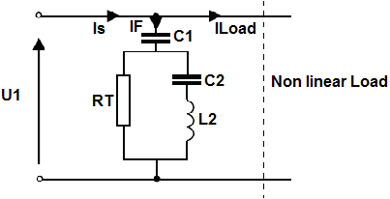
Figure 3.10 C-type filter diagram
Where, $ω_{0}$is the nominal system frequency (rad/sec), $U_{1}$is the rated line-to-line voltage of the filter bank and $Q_{f }$is the rated three-phase output of the filter. The tuning frequency, $ω_{n}$, of the filter is defined by equation (3.25)
$$ω_{n}=\frac{1}{\sqrt{L_{2}\frac{C_{1}C_{2}}{C_{1}+C_{2}}}} (3.25)$$
In transmission applications, the tuning frequency is normally selected to be below the lowest expected resonant frequency of the system. This generally results in either a 3rd harmonic or 5th harmonic filter [37]. Another criterion that must be satisfied is that the tuning section components ($C_{2}$and$L_{2}$) are series resonant at fundamental frequency,
$$ω_{0}L_{2}=\frac{1}{ω_{0}C_{2}} (3.26)$$
There for,
$$L_{2}=\frac{1}{ω_{0}^{2}C_{2}} (3.27)$$
Substituting (3.27) into (3.25) and solving for $C_{2}$results in (3.28)

$$C_{2}=C_{1}\left(h^{2}-1\right) (3.28)$$

Where h is the tuning frequency of the filter bank or${{ ω}_{n}}/{ω_{0}}$. Once the values of $C_{1}$and $C_{2}$have been determined, the inductance, $L_{2}$ of the tuning reactor can be computed using (3.27). Lastly, the damping resistance value, R, can be found using equation (3.29)

$$R_{T}=\frac{ω_{n} L_{2}}{Q} (3.29)$$
Where, Q is the quality factor of the filter. The optimum value of R will be a compromise between the damping needed and the level of harmonic losses it absorbs [38].
The filter impedance is given by:

$$Z_{f}=\frac{(jwL_{2}-j\frac{1}{ωC_{2}})R_{T}}{R_{T}+jωL_{2}-j\frac{1}{ωC_{2}}}-j\frac{1}{ωC_{1}} (3.30)$$

$$Z_{f}=\frac{jR_{T}(ω^{2}-ω_{1}^{2})}{R_{T}ωω_{1}^{2}C_{2}+j(ω^{2}-ω_{1}^{2})}-j\frac{1}{ωC_{1}} (3.31)$$
  - Parameters Calculation of C-type Filter for 5th order harmonic

The parameters of filters are calculated according to the bus voltage ${ U}_{1}$ , the order of harmonic $N_{1}$ , the requirement of reactive power $Q_{1,}$the three Phase C-type tuned filter for 5th order harmonic parameters, C1, L2 and C2 as shown in Fig.3.11 are calculated and tabulated in the Table 3.2.

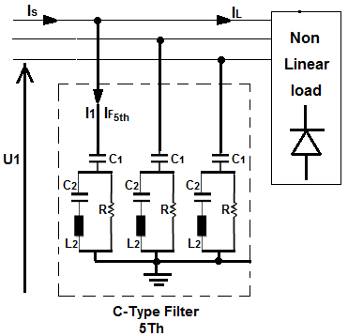

Figure 3.11 Three Phase C-type tuned filter for 5th harmonic reduction

Table3.2. Parameters of c-type-tuned filter for 5th harmonic
Reactive Power(Q VAr) | 200 | 400 | 600 | 800 | 1000 | 2000
Capacitance C1$(μF)$ | 13.15 | 26.3 | 39.5 | 52.6 | 65.7 | 131.5
Capacitance C2$( mF)$ | 0.32 | 0.63 | 0.95 | 1.25 | 1.58 | 3.156
Inductance L1(mH) | 31.6 | 16 | 10.6 | 8.1 | 6.4 | 3.2
Resistance R(Ω) | 5 | 2.5 | 1.65 | 1.25 | 1 | 0.5

The value of $\dot{R2}$ calculated when the quality factor (Q) =10
  - Parameters Calculation of C-type Filter for 7th order harmonic

the parameters of filters are calculated according to the bus voltage $U_{1}$ , the order of harmonic $N_{1}$ , the requirement of reactive power $Q_{1,}$the three Phase C-type tuned filter for 7th order harmonic parameters,$\dot{C1}$ ,$\dot{C}2,\dot{R2}$ and $\dot{L}2$ as shown in Fig. 3.12 are calculated and tabulated in the Table 3.3.

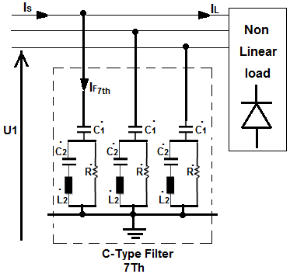
Figure 3.12 three Phase C-type tuned filter for7th harmonic reduction

Table 3.3 Parameters of C-type-tuned filter for 7th harmonic
Reactive Power(Q VAr) | 200 | 400 | 600 | 800 | 1000 | 2000
Capacitance $\dot{C1} (μF)$ | 13 | 26.3 | 39.5 | 52.6 | 65.7 | 131.5
Capacitance $\dot{C}2 ( μF)$ | 0.624 | 1.26 | 1.9 | 2.5 | 3.15 | 6.3
Inductance $\dot{L}2$ (mH) | 16 | 8 | 5.3 | 4 | 3.2 | 1.6
Resistance $\dot{R2}$ (Ω) | 3.5 | 1.76 | 1.2 | 0.88 | 0.7 | 0.35

The value of $\dot{R2}$ calculated when the quality factor (Q) =10
3.9 Frequency-Response

The overall frequency responses of the system, Fig. 3.13 are shown in Fig. 3.14. It is calculated from the system frequency response with the filters installed and is obtained from the values of the frequency scan at the 5th, 7th, 11th, 13th, harmonic. The filter tuning frequency is set to a value slightly below the harmonic frequency to avoid possible harmonic amplification due to resonance effects [39].

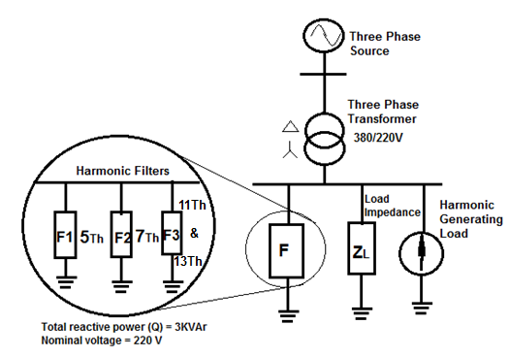Figure3.13The system

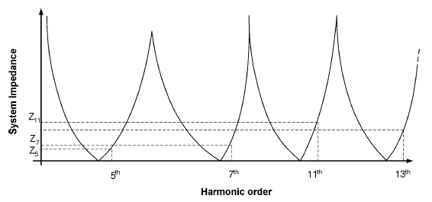
Figure 3.14 the Overall Frequency Responses of the System
3.10 Harmonic Impedance Plot for the Proposed Harmonic Filter

If shunt harmonic filters are not selected carefully, they can resonate with existing electrical components and cause additional harmonic currents. In order to ensure that the proposed harmonic filter does not cause any new resonance point on the system, a harmonic impedance sensitivity plot for the filter was produced, as shown in Fig. 3.15.

Harmonic filter banks are typically tuned to approximately 2%–10% below the desired harmonic frequency as shown in Fig. 3.16. If a filter is tuned exactly at the frequency of concern, an upward shift in the tuned frequency will result in a sharp increase in impedance.as explained in chapter 2 page 23 tuning the harmonic filter at a frequency slightly lower than the desired frequency allows for the operation of the filter bank in the event of the removal of a few capacitor units.

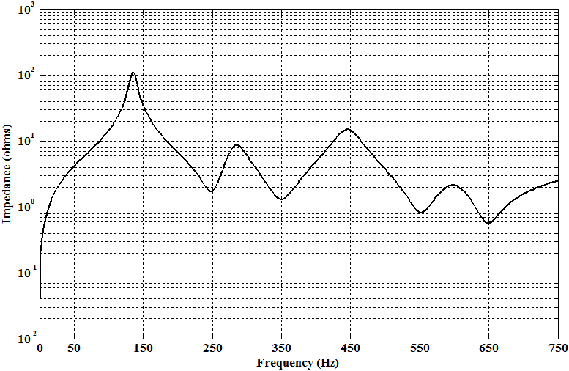

Figure 3.15 Harmonic impedance characteristics of the proposed harmonic filter tuned exactly at the desired frequency

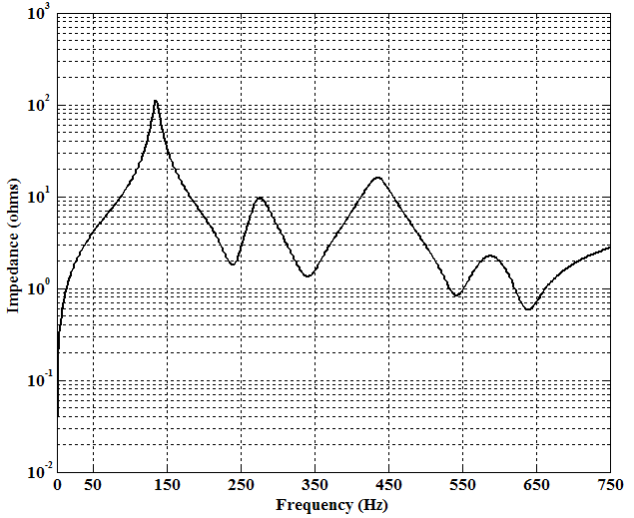

Figure 3.16 Harmonic impedance characteristics of the proposed harmonic filter tuned at a frequency slightly lower than the desired frequency

CHAPTER 4

SIMULATION RESULTS OF CIRCUIT CONFIGURATION

4.1 Introduction
In this chapter, the three phase transformer under linear load (resistive, inductive, and capacitive) and nonlinear load (three phase full wave bridge rectifier) are simulated on Matlab Simulink program.

Simulation results under linear and nonlinear load conditions are presented. The waveforms of the voltage and current with its spectrum for various conditions of operation are presented.

4.2 Simulation Results of Three Phase Transformer under Linear Load

Fig. 4.1 shows three phase transformer under linear load (resistive, inductive, and capacitive) and simulation results of three phase transformer under linear load (resistive load 15 Ω, inductive load$40 mH$, and capacitive load$100 μF$) source voltage 380 V, frequency of the source 50 Hz, source resistance 0.1 Ω, source reactance$5 mH,$ primary voltage of the three phase transformer 380 V, and secondary voltage 220 V are arranged as below:

Figure 4.1 three phase transformer under linear load
4.2.1 Simulation Results of Three Phase Transformer under Resistive Load

Fig. 4.2 shows simulated three phase transformer under resistive load and Fig. 4.3 presents the waveforms of the voltage and current in three phase transformer with linear purely resistive load.

Both waveforms are inphase and no waveform distortion takes place. Total harmonic distortion THD=0.02% as shown in Fig. 4.4

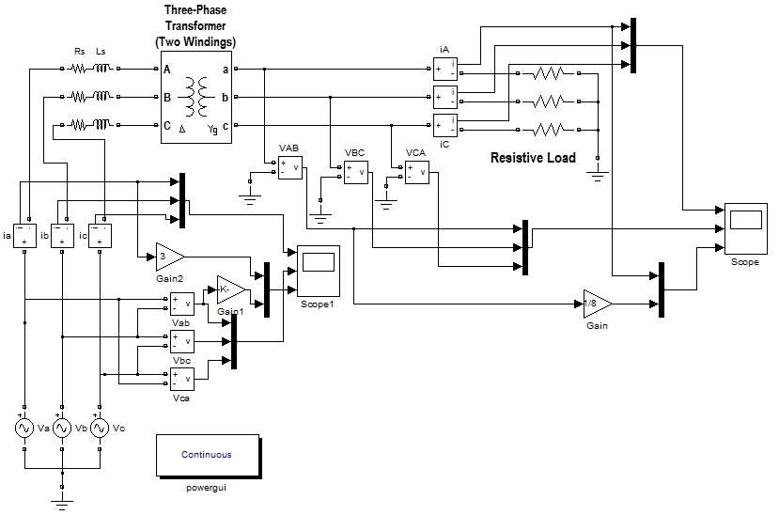

Figure 4.2 Simulated three phase transformer under resistive load
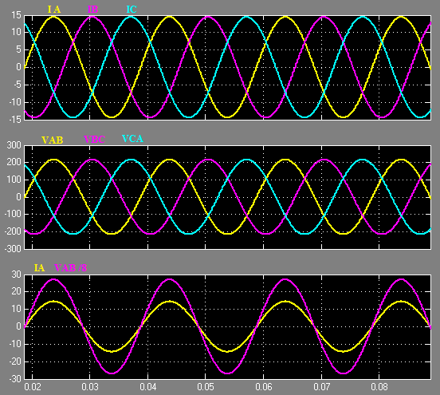
Figure 4.3 Current and voltage waveforms of $3∅$ transformer under resistive load

Figure 4.4 Harmonic spectrum of resistive load
4.2.2 Simulation Results of Three Phase Transformer under Inductive Load

Fig. 4.5 shows simulated three phase transformer under inductive load and Fig. 4.6 presents the waveforms of the voltage and current in three phase transformer with linear purely inductive load, in this case the current lags the voltage which Fig. 4.6 shows the relation between voltage, and current, in three phase transformer with linear inductive load. The two waveforms will be out of phase from one another.

However, no waveform distortion will take place and total harmonic distortion (THD) =0.02% as shown in Fig. 4.7.

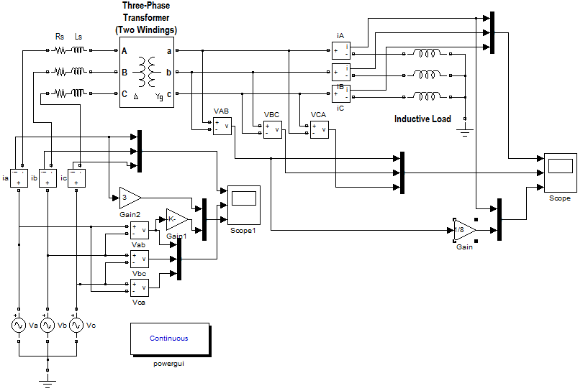

Figure 4.5 Simulated Three Phase Transformer under Inductive Load
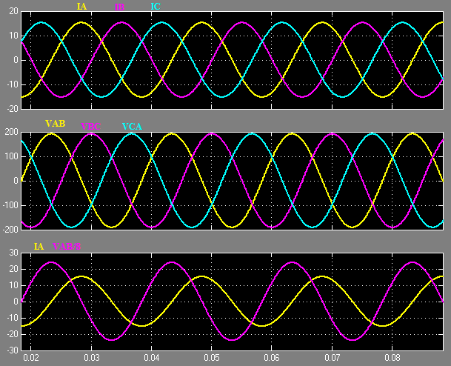

Figure 4.6 Current and voltage waveforms of $3∅$ transformer under inductive load

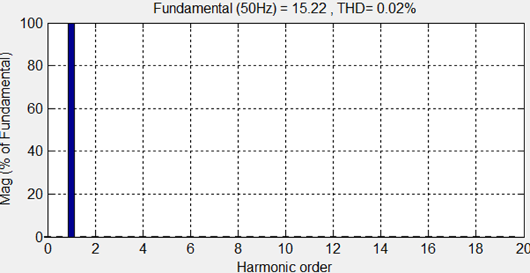

Figure 4.7 Harmonic spectrum of inductive load
4.2.3 Simulation Results of Three Phase Transformer under Capacitive Load

Figure 4.8 shows simulated three phase transformer under capacitive load In this case the current leads the voltage as shown in Fig. 4.9 which shows the relation between voltage, and current in three phase transformer with capacitive load.

The two waveforms will be out of phase from one another. However, no waveform distortion will take place and total harmonic distortion (THD) = 0.02% as shown in Fig. 4.10

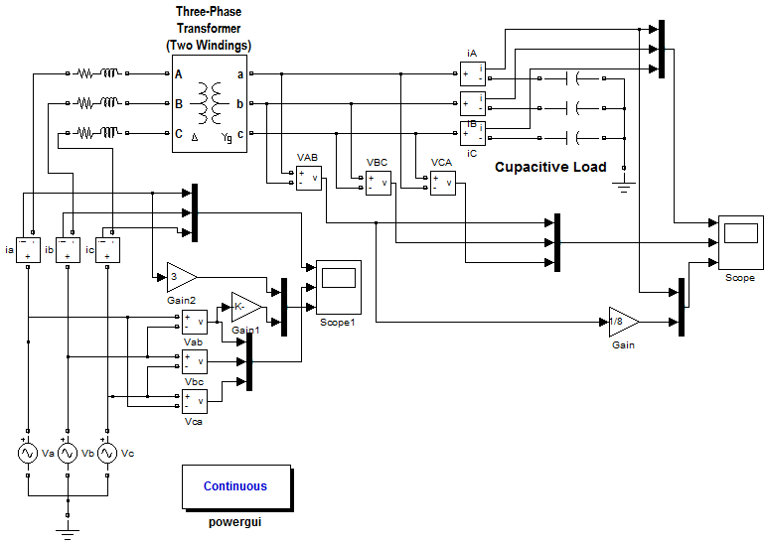

Figure 4.8 Simulated Three Phase Transformer under capacitive Load
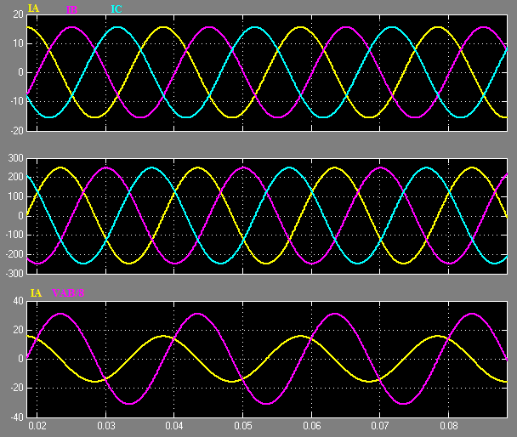

Figure 4.9 Current and voltage waveform of$3∅$ transformer under capacitive load

Figure 4.10 Harmonic spectrum of capacitive load
4.3 Simulation Results of $3∅$ Transformer under Nonlinear Load without Filter

Fig. 4.11 presents delta/star configuration of three phase transformer (380V/220V) under nonlinear load (three phase Full wave bridge rectifier). Fig. 4.12 shows simulated three phase transformer under nonlinear load.

The voltage VL (load voltage) and current IL (load current) waveforms are distorted as shown in Fig. 4.13 and total harmonic distortion (THD) = 18.51% as shown in Fig. 4.14

Figure 4.11 Three phase transformer under nonlinear load

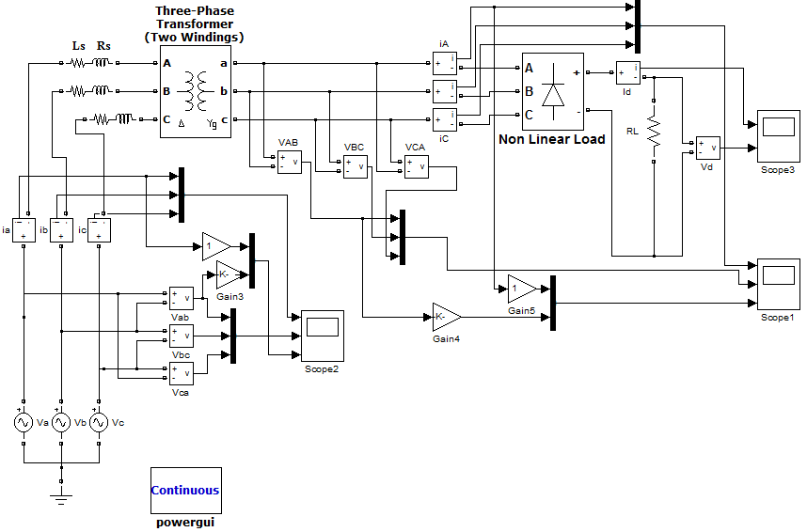Figure 4.12 Simulated Three Phase Transformer under Nonlinear Load without filter

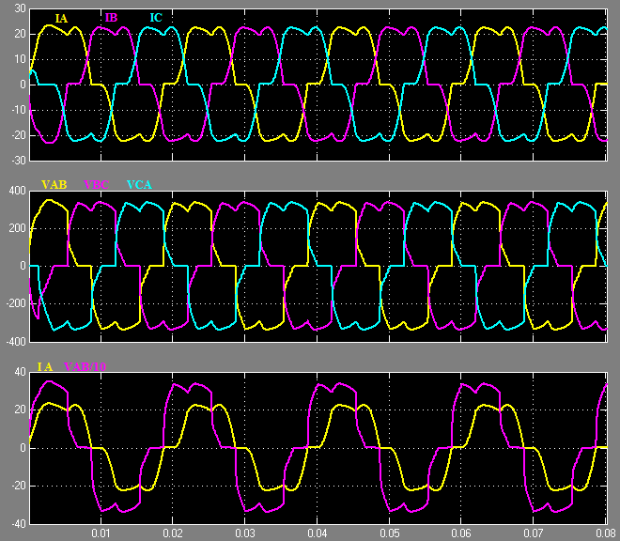
Figure 4.13 Current and voltage waveform of three phase transformer under nonlinear load without Filter
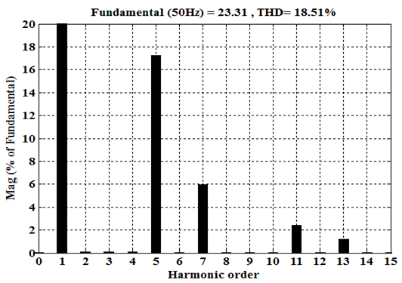
Figure 4.14 Harmonic spectrum of nonlinear load ($3∅$ bridge rectifier) without Filter
4.4 Simulation Results of Three Phase Transformer under Nonlinear Load with Tuned Harmonic Filter from Simulation Power Systems Blocks Elements.

Fig. 4.15 presents delta/star configuration of three phase transformer (380V/220V) under nonlinear load (three phase Full wave bridge rectifier). Fig. 4.16 shows simulated three phase transformer under nonlinear load with tuned harmonic filter from simulation power systems blocks elements, the circuit configurations of the passive filters are also showed among them, the combination of three tuned filters, two C-type filters to eliminate or to reduce the effects of 5th and 7th harmonics, and one double-tuned filter to eliminate or to reduce the effects of 11th and 13th harmonics. The reactive power of each filter is 1kVAr, and the nominal voltage of capacitance is 220V. Fig. 4.17 shows the Matlab simulated results obtained, using circuit given in Figure 4.16. See appendix (B) for Overall Circuit diagram.

The near sinusoidal wave shape of the input current ($I_{A}$) and a drastic reduction in current harmonic is therefore obtained. The THD in this case is reduced significantly to ~2%, as shown in Fig. 4.18 the effective power factor is increased.

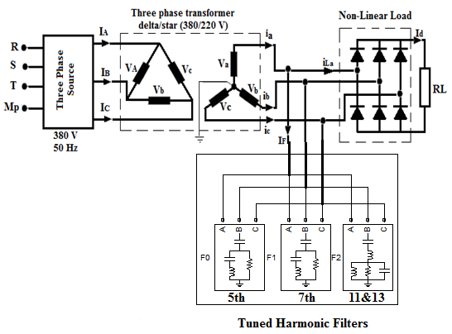
Figure 4.15 $3∅$Transformer under Nonlinear Load with tuned harmonic filter
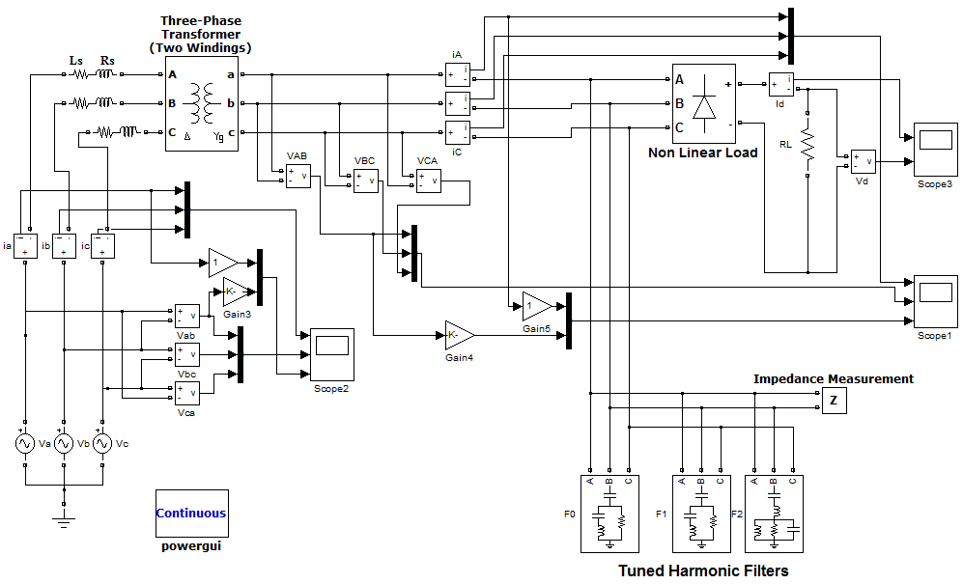
Figure 4.16 Simulated $3∅$Ttransformer under Nonlinear Load with tuned harmonic filter

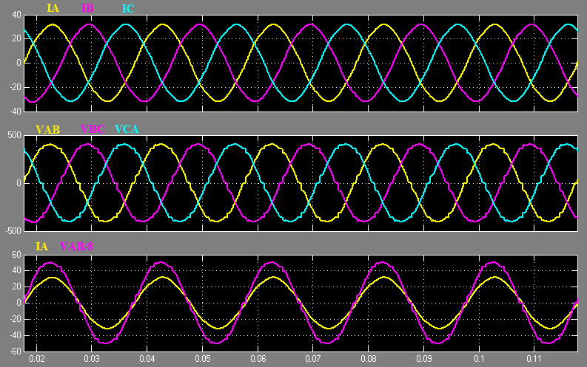
Figure 4.17 Current and voltage waveform of $3∅$transformer under nonlinear load with Filter
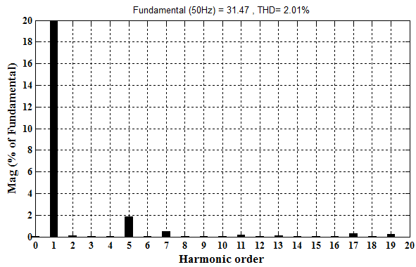

Figure 4.18 Harmonic spectrum of nonlinear load current ($3∅$ bridge rectifier) with Filter

4.5 Simulation Results of $3∅$ Transformer under Nonlinear Load with proposed Tuned Harmonic Filter

Fig. 4.19 shows the proposed system consisting of a shunt passive filter which is a combination of three tuned filters, two C-type filters to eliminate or to reduce the effects of 5th and7th harmonics, and one double-tuned filter to eliminate or to reduce the effects of 11th and 13th harmonics. The reactive power of each filters are 1kVAr, and the nominal voltage of capacitance is 220V which is connected in parallel with the system. It is installed in parallel with a harmonic-producing load, that is, a three-phase bridge rectifier of rating 20 kVA. Figure 4.20 shows simulated three phase transformer under nonlinear load with designed tuned harmonic filter. Fig. 4.21 shows the Matlab simulated results obtained, using circuit given in Fig. 4.20. See appendix (A) for Overall Circuit diagram.

The near sinusoidal wave shape of the input current and a drastic reduction in current harmonic is therefore obtained. The THD in this case is reduced significantly to ~2.65%, as shown in Fig. 4.22
Figure 4.19 $3∅$ Transformer under Nonlinear Load with proposed filter

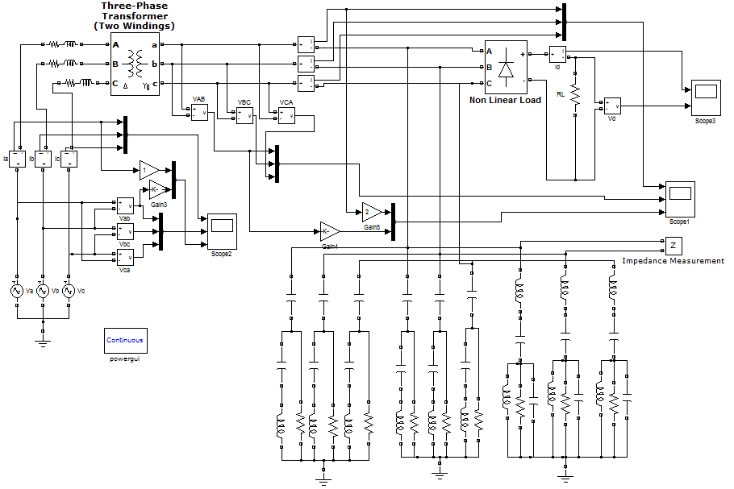
Figure 4.20 Simulated $3∅$Transformer under Nonlinear Load with proposed filter
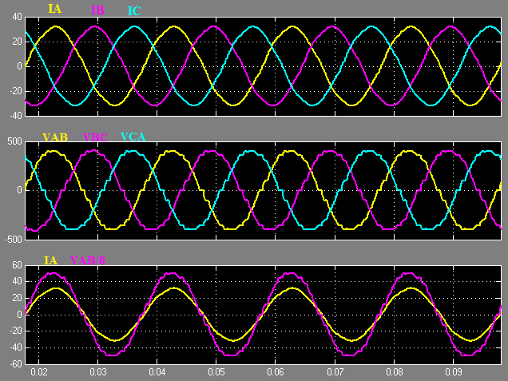

Figure 4.21 Current and voltage waveform of $3∅$Transformer under nonlinear load with proposed Filter
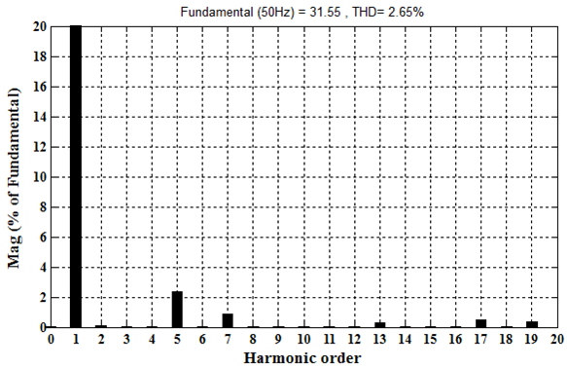
Figure 4.22 Harmonic spectrum of nonlinear load ($3∅$ bridge rectifier)with proposed Filter

4.6 Comparison between results of designed filter and the filter from (Simulation Power Systems Blocks Elements)

Tables 4.1, 4.2, 4.3 and 4.4 give a comparison of the percentage harmonics of the input current with filter and without filter. It is obvious from these tables that:

- The THD and percentage harmonics of the input current are significantly reduced.
- The power factor is significantly improved.
Fig. 4.23 shows Simulation block diagram for measuring THD and PF
The is defined as:
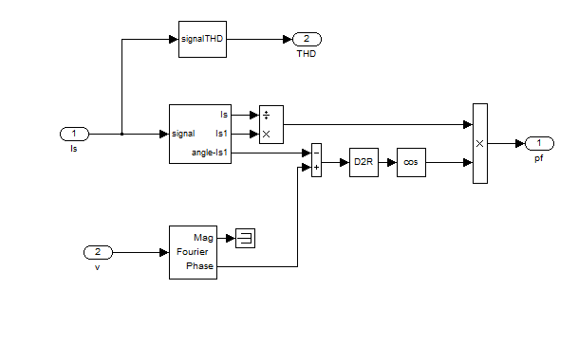

Figure 4.23 Simulation block diagram for measuring THD and PF

Table 4.1 Harmonic Currents for a $3∅$Full Wave Bridge Rectifier without Designed Filter
Fundamental  50Hz | h5  250Hz | h7  350Hz |  | h11  550Hz |  | h13  650Hz
24.2 | 4.3 | 1.5 |  | 0.8 |  | 0.45
100% | 17.76% |  | 6.19% |  | 3.3% | 1.85%

Table 4.2 Harmonic Currents for a $3∅$ Full Wave Bridge Rectifier without Filter
Fundamental  100Hz | h5  250Hz | h7  350Hz |  | h11  550Hz |  | h13  650Hz
23.31 | 4.02 | 1.39 |  | 0.56 |  | 0.28
100% | 17.235% |  | 5.985% |  | 2.40% | 1.20%

Table 4.3 Harmonic Currents for a $3∅$ Full Wave Bridge Rectifier with Designed Filter
Fundamental  50Hz | H5  250Hz | H7  350Hz | H11  550Hz | H13  650Hz
31.55 | 0.75 | 0.27 | 0.02 | 0.09
100% | 2.38% | 0.85% | 0.05% | 0.3%

Table 4.4 Harmonic Currents for a $3∅$ Full Wave Bridge Rectifier with Filter
Fundamental  100Hz | H5  250Hz | H7  350Hz | H11  550Hz | H13  650Hz
31.47 | 0.59 | 0.16 | 0.05 | 0.02
100% | 1.86% | 0.50% | 0.17% | 0.07%

Appendix (C) for comparing THD with the Results in Table 4.5

Table 4.5 Designed filter and Traditional Filter Input Current Harmonic
Harmonic order | Without filter |  | With filter
 | Designed Filter | Traditional Filter | Designed Filter | Traditional Filter
5th | 17.76% | 17.35% | 2.38% | 1.86%
7th | 6.19% | 5.95% | 0.85% | 0.50%
11th | 3.3% | 2.4% | 0.05% | 0.17%
13th | 1.85% | 1.2% | 0.3% | 0.07%
THD | 18.95% | 18.51% | 2.65% | 2%
PF | 0.75 | 0.71 | 0.967 | 0.997
Fig. 4.24 shows the input current to the three phase bridge rectifier without filter, Fig. 4.25 shows the current of the filter and Fig. 4.26 shows the input current to the three phase bridge rectifier with filter.

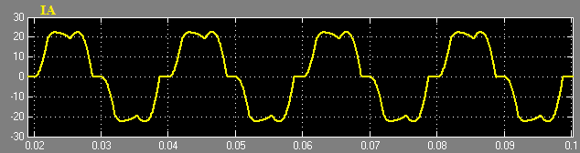

Figure 4.24 Load current without filter

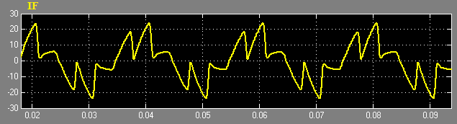

Figure 4.25 filter current

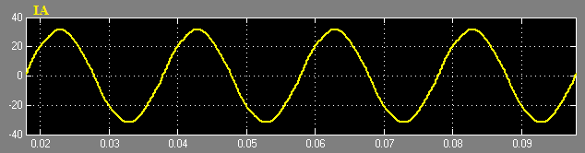

Figure 4.26 Load current with filter

4.7 The waveforms of Sourse current and Source Voltage with out Filter

Fig. 4.27 present the three phase waveform of the source current and the three phase waveform of the source voltage. The voltage $V_{ab}$ (source voltage) waveforms are not distorted as shown below but $I_{a}$ (source current) waveforms are distorted and total harmonic distortion (THD) = 14.41% as shown in Fig. 4.28.

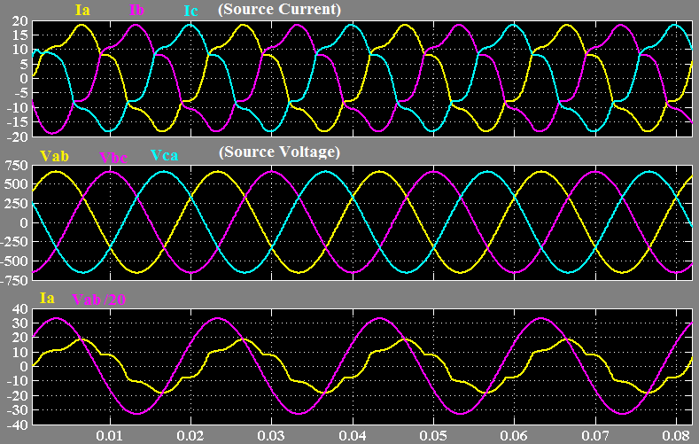

Figure 4.27 Source Current ($I_{a}$, $I_{b}$, $I_{c}$) and Source voltage ($V_{ab}$, $V_{bc}$, $V_{ca}$) waveforms of $3∅$transformer under nonlinear load without Filter

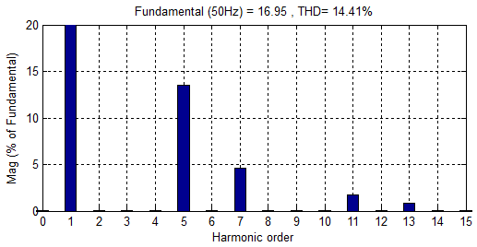
Figure 4.28 Harmonic spectrum of source current without filter
4.8 The waveforms of Sourse current and Source Voltage with Filter
Fig. 4.29 present the three phase waveform of the source current and the three phase waveform of the source voltage with filter. The near sinusoidal wave shape of the source current and a drastic reduction in current harmonic is therefore obtained. The THD in this case is reduced significantly to ~1.61%, as shown in Fig. 4.30

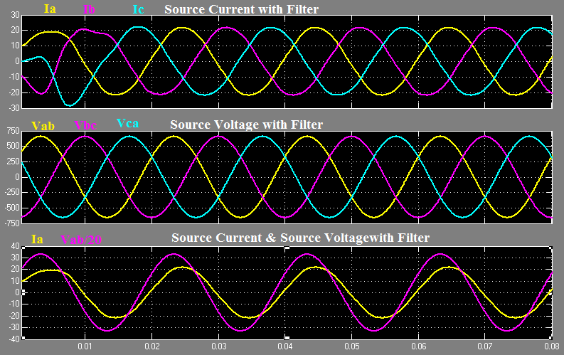
Figure 4.29 Source Current ($I_{a}$,$I_{b}$,$I_{c}$) and Source voltage $V_{ab}$, $V_{bc}$, $V_{ca}$) waveforms of $3∅$transformer under nonlinear load with Filter

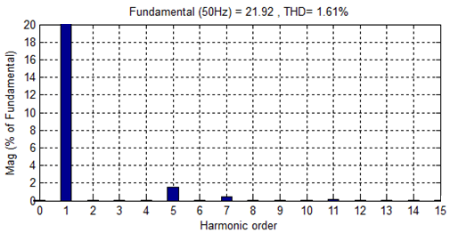
Figure 4.30 Harmonic spectrum of source current with filter

CHAPTER 5

CONCLUSIONS AND SUGGESTIONS FOR FUTURE WORK

5.1 Conclusions

In this thesis, filter technique is used to reduce harmonic distortion of the input current in three phase transformer and full wave bridge rectifier is used as nonlinear load and it’s simulated by computer using (Matlab Simulink) program. The proposed passive filter is analyzed, designed and its results are compared.

Based on the theoretical analysis and simulation results, the following points are observed:

- Depending on new method for designing double tuned filter and c-type filter Simulation results show that the designed filter in this method works well when compared to traditional methods according to the results shown in table 4.5.

- A new method is proposed based on resonance frequency. It does not need to solve equations, so it reduces the amounts of computation when compared to traditional methods.

- From the results of a designed filter, we notice that the near sinusoidal wave shape of the input current and a drastic reduction in current harmonic is obtained.

- Tuned harmonic filter must be selected carefully to avoid resonance with the existing electrical components which cause additional harmonic currents.

- When the filter tuned exactly at the desired frequency, an upward shift in the tuned frequency will result in a sharp increase in impedance.

- The filter must be tuned slightly 2%–10% below the desired harmonic frequency to avoid possible harmonic amplification due to resonance effects.
- Passive filters are relatively inexpensive compared with other methods for eliminating harmonic distortion.

- Passive filter design must take into account expected growth in harmonic current sources or load reconfiguration because it can otherwise be exposed to overloading, which can rapidly develop into extreme overheating and thermal breakdown.

- The double tuned filter can eliminate two harmonics and its equivalent impedance is the same as two parallel single tuned filters. This filter has the advantage of reducing the power losses at fundamental frequency as compared with two single tuned filters, Double-tuned filter cost less than two parallel single tuned filters.

- The main advantage in the ‘C’ type filter is a considerable reduction in fundamental frequency losses.

- When three phase transformers are loaded by pure resistive load the voltage and current waveforms are inphase and there is no waveforms distortion. Total harmonic distortion THD=0.02%.

- When three phase transformers loaded by pure inductive load the voltage and current waveforms will be out of phase from one another. However, no waveform distortion will take place and total harmonic distortion (THD) =0.02%.

- When three phase transformers loaded by pure capacitive load the voltage and current waveforms will be out of phase from one another. However, no waveform distortion will take place and total harmonic distortion (THD) = 0.02%.

5.2 FUTURE WORK

As many works have been accomplished in this thesis, several future investigations are interesting. Some topics for future studies are listed in the following.

- To verify the simulation results documented in this thesis, Practical tests should be carried out. With the verification work, the proposed passive filter and harmonic mitigation strategies could be improved.

- Using two single tuned filters instead of double tuned filter as in our case with the same parameters, to compare the results in both cases to a statement whichever is the most efficient filter

- In this work the nonlinear load was uncontrollable three phase rectifier for the future work can be extend to controllable three phase rectifier and studying the effect of firing angle on THD and power factor.

Preferences

[1] M. Yagci, and A. Urkmez,“The effects of linear and non-linear loads on three phase transformers supplied from different sources,” Scientific Research and Essays Vol. 6(26), pp. 5513-5522, 9 November, 2011.

[2] A. D. Kline, “ Transformers in SCR converter circuits, ” Conference Record of the Industry Applications Society, IEEE, 1981 Annual Meeting, New York, pp. 456–458

[3] IEEE Standard, “Recommended practice for establishing transformer capability when supplying non-sinusoidal load currents,” ANSI/IEEE C57.110, February 1998.

[4] A. Gupta, and R. Singh, “Computation of transformer losses under the effects nonsinusoidal currents,” An International Journal (ACIJ), Vol.2, No.6, November 2011

[5] S. N. Makarov, A. E. Emanuel, “Corrected Harmonic Loss Factor For Transformers supplying Non-sinusoidal Load current” Proc. of IEEE 9th International conference on Harmonics and Power Quality, vol. 1, Oct.2000, pp.87-90.

[6] S. B. Sadati, A. Tahani, Darvishi, B., Dargahi, M., Yousefi, H., “Comparison of distribution transformer losses and capacity under linear and harmonic loads,” Power and Energy Conference, PEC on, 2008. IEEE 2nd International, 1-3 Dec. 2008 pp. 1265 – 1269

[7] Sanjay A. Deokar, Laxman M. Waghmare,“Computation of transformer losses under the effects nonsinusoidal currents,” ISSN 2250-2459, Volume 1, Issue 2, December 2011.
[8] M.W. Gregory, “Estimation methods for power system harmonic effects on power distribution transformers,” IEEE Trans. Industry Appl., 30: 2. 1994.

[9] Francisco C. de la Rosa, “Harmonics and Power Systems”, the Electric Power
Engineering Series, Published in 2006 by CRC Press Taylor & Francis Group.

[10] Sharifian, M.B.B., Faiz, J., Fakheri, S.A. and Zraatparvar, A. (2003). , “Derating of Distribution Transformers for Non-Sinusoidal Load Currents Using Finite Element Method,” ICECS 2003. Proceedings of the 2003, 10th IEEE International Conference on Electronics, Circuits and Systems. 14-17 December. Iran: IEEE, 754-757.

[11] W. P. Linden,“ Transformer Design and Application Considerations for non-sinusoidal Load Currents,” IEEE Transactions on Industry Applications, vol.32, no. 2, pp. 633-645, May/June 1996.

[12] E. F. Fuchs, D. Yildirim, W.M. Grady, “Measurement of eddy current loss coefficient PEC-R, derating of single phase transformers, and comparison with K-factor approach,” IEEE Transaction on Power Delivery, vol. 15, no. 1, pp-148-154, January-2000.

[13] D.S. Takach, “Distribution Transformer No Load Losses,” IEEE Trans. on PAS, Vol. 104, No. 1, 1985, pp. 181-193.
[14] F. Z. Peng, H. Akagi and A. Nabae, “A New Approach to Harmonic Compensation in Power System A Combined System of Shunt Passive and Series Active Filter”, IEEE Trans. On Industry Applications, Vol. 27, No. 6, pp. 983-990, 1990.

[15] Elham B. Makram, E. V. Subramaniam, Adly A. Girgis, and Ray Catoe, “Harmonic Filter Design Using Actual Recorded Data,” IEEE Transactions on Industry Applications, vol. 29, no. 6, pp. 1176- 1183, 1993.

[16] S. Kim, P. Enjeti. P. Packebush and I.J. Pital, “A new approach to Improve Power Factor and Reduce Harmonic in Three-phase Diode Rectifier type Utility Interface ”, IEEE Trans. On Industry Applications, Vol. 30, No. 6, PP. 1557-1564, November/December 1994.

[17] J. Carlos and A.H. Samra, “A new Technique to Reduce Line Current harmonics Generated by a three phase bridge Rectifier”, IEEE, PP. 345-359, 1998.

[18] P. Pejovic and Z. Janda, “Low Harmonic Three-phase Rectifier Applying Current Injection”, IEEE Proc.-Electric Power Appl., Vol. 146. No. 5, PP. 545-551, September 1999.

[19] C. J. Choo, C.W. Lio, J.Y. Lee, and K. D. Lee, “Optimal Planning of Large Passive-Harmonic-Filters Set at High Voltage Level,” IEEE Transactions on Power Systems, vol. 15, no. 1, pp. 433–441, 2000.

[20] Basil M. Saied and Hussein I.Zynal, “Minimizing Current Distortion of a Three-Phase Bridge Rectifier on line Injection Technique”, IEEE Trans. On power Electronics, Vol. 26, No. 6, November 2006.

[21] Babak. Badrzadeh, Kenneth S. Smith, and Roddy C. Wilson, “Designing Passive Harmonic Filters for an Aluminum Smelting Plant,” IEEE Transactions on Industry Applications, vol. 47, no. 2, 973–983, 2011

[22] IEEE Std. 519-1981: IEEE Guide for Harmonic Control and Reactive Compensation of Static Power Converters.

[23] Ward Jewell and Daniel J. Ward, “Single Phase Harmonic Limits”, PSERC EMI, Power Quality and Safety Workshop, April 18-19, 2002.

[24] SQUARE D, Product Data Bulletion, “Power System Harmonics Causes and Effects
Of Variable Frequency Drives Related to the IEEE 519-1992 Standard”,Bulleti No.8803PD9402, Raleigh, No, USA, August 1994.

[25] B. Singh, B. N. Singh, A. Chandra, K. Al-Haddad, A. Pandey, and D. P. Kothari, “A review of three-phase improved power quality AC-DC converters,” IEEE Transactions on Industrial Electronics, vol. 51, no. 3, pp. 641–660, 2004.

[26] R. E. Owen, M. F. McGranghan, and J. R. Vivirito, “Distribution system harmonics: controls for large power converters,” IEEE Transactions on Power Apparatus and Systems, vol. 101, no. 3, pp. 644–652, 1982.

[27] J. C. Das, Power System Analysis, Short-Circuit Load Flow and Harmonics, Marcel Dekker, New York, NY, USA, 2002.

[28] Dugan R., McGranaghan M., Electrical power systems quality, McGraw-Hill, 2002.

[29] S. Choi, P. N. Enjeti, and I. J. Pitel, “Poly phase transformer arrangements with reduced kVA capacities for harmonic current reduction in rectifier-type utility interface,” IEEE Transactions on Power Electronics, vol. 11, no. 5, pp. 680–690, 1996.

[30] J. R. Johnson, “Proper use of active harmonic filters to benefit pulp and paper mills,” IEEE Transactions on Industry Applications, vol. 38, no. 3, pp. 719–725, 2002.

[31] G. W. Chang and T. C. Shee, “A novel reference compensation current strategy for shunt active power filter control,” IEEE Transactions on Power Delivery, vol. 19, no. 4, pp. 1751–1758, 2004.

[32] H. Fujita and H. Akagi, “A practical approach to harmonic compensation in power systems—series connection of passive and active filters,” IEEE Transactions on Industry Applications, vol. 27, no. 6, pp. 1020–1025, 1991

[33] H. Akagi, “New trends in active filters for power conditioning,” IEEE Transactions on Industry Applications, vol. 32, no. 6, pp.1312–1322, 1996.

[34] A. B. Nassif, W. Xu, and W. Freites, “An Investigation on the Selection of Filter Topologies for Passive Filter Applications,” IEEE Trans. Power Del., vol. 24, no. 3, pp. 1710–1718, Jul. 2009

[35] H. AKAGI, “Modern active filters and traditional passive filters” Bull. Pol. Ac.: Tech., Vol. 54, No. 3, pp. 255–269, 2006.

[36] H. Y.HONG, and S. HENG, “A New Method of Designing Double-tuned Filter,” ICCSEE, , pp. 206–209,2013

[37] R. Horton, R. Dugan, and D. Hallmark, “Novel Design Methodology for C-type Harmonic Filter Banks Applied in HV and EHV Networks,”978-1-4673-1935-5/12/$31.00 ©2012 IEEE

[38] P. S. Bodger, G.D. Irwin, D.A. Woodford,“ Controlling Harmonic Instability of HVDC Links Connected to Weak AC Systems”, IEEE Transactions on Power Delivery, Vol. 5, No. 4, November 1990.

[39] J. C. Das, “Passive filters—Potentialities and limitations,” IEEE Trans. Ind. Appl., vol. 40, no. 1, pp. 232–241, Jan. 2004.
[40] H. A. Kazem, “Harmonic Mitigation Techniques Applied to Power Distribution Networks,” Hindawi Publishing Corporation, Volume 2013, Article ID 591680, 10 pages, 2013. http://dx.doi.org/10.1155/2013/591680.

Appendix (A)
Overall Circuit diagram of Simulated $3∅$Transformer under Nonlinear Load with proposed filter

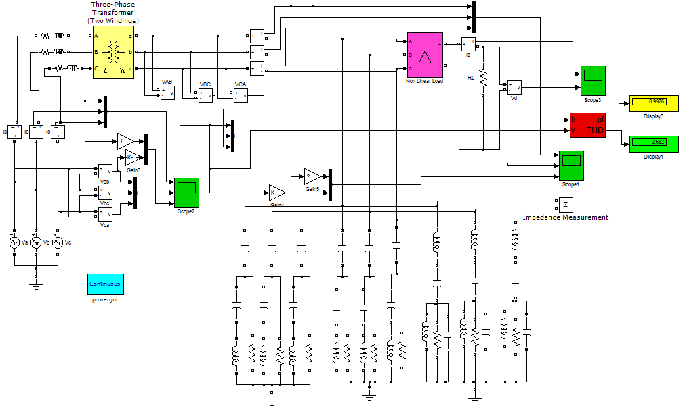

Fig .A Overall Circuit diagram of Simulated $3∅$Ttransformer under Nonlinear Load with Proposed tuned harmonic filter.
Appendix (B)

Overall Circuit diagram of Simulated $3∅$Ttransformer under Nonlinear Load with tuned harmonic filter.
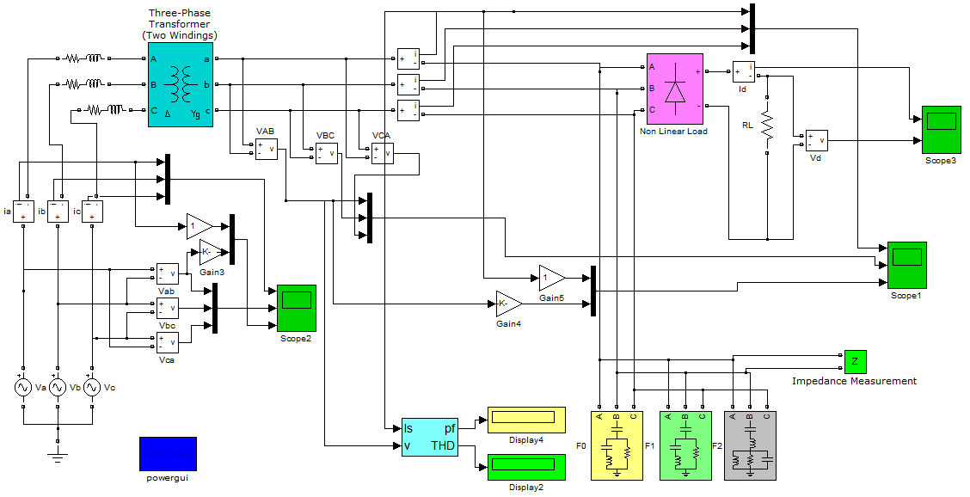
Fig .B Overall Circuit diagram of Simulated $3∅$Ttransformer under Nonlinear Load with tuned harmonic filter.

Appendix (C)

