ABSTRACT

Measurement and control of temperature and relative humidity has significant appliance in industry, science, healthcare agriculture and controlling technological processes. These two environmental parameters strongly influence each other and it is critical in some application to measure them in paralel.The traditional Temperature-humidity measurement adopted the method of measuring the temperature and humidity separately, which can not well get rid of the interference of temperature when measuring humidity.
This Project discusses advantages of SHT series sensors that measure temperature and humidity together. This sensor is ideal for developing distributed embedded systems for monitoring environmental parameters.It uses a microcontroller with integrated web server to organize the communication and management of sensors.
The aim of this project is to monitor change of temperature and humidity using the PIC microcontroller. Temperature and humidity sensors are investigated for this purpose. Sensing these two variables to monitor temperature and humidity, SHT11 is used together with PIC 18F87K22.
Keywords: PIC Microcontroller,SHT11 Sensor,Temperature and Humidity Measurement

ÖZ

Sıcaklık ve nem ölçümü ve kontrolünün endüstri , bilim , sağlık ,tarım ve teknolojik uygulamalarda önemli bir rolü vardır. Bu iki çevresel parametre birbirini fazlasıyla etkilemektedir ve buna paralel olarak bazı uygulamalarda kritiktir. Geleneksel kabul edilen sıcaklık , nem ölçüm teknikleri iki parametrenin ayrı ayrı ölçümü üzerinedir ve bu yöntem nem ölçülürken sıcaklığın nem ölçümü üzerindeki etkisini engelleyemez.
Bu proje sıcaklık ve nemi birlikte ölçen SHT sensörünün diğer sensörlere göre avantajlarını anlatacaktır. Bu sensör çevresel parametrelerin izlenmesi için gömülü sistemler geliştirmek adına idealdir. Bu sensörlerin iletişim ve yönetimini düzenlemek için entegre web sunucusu ile bir mikroişlemci kullanır.
Mikroelektronik teknolojisindeki son gelişmelerden dolayı mikrodenetleyiciler endüstride kontrol amaçlı olarak yaygın olarak kullanılmaktadır. PIC mikrodenetleyiciler az sayıda komuta sahip olmalarına rağmen, hızlıdır ve programlama esnekliği sağlarlar. Proseslerin kontrolü mikrodenetleyicilerle yapıldığında, yapılan işlerdeki proses değişkenleri üzerinde işlem yapabilme olanağı ve yapılan işlemi PIC programına bağlı olarak değiştirebilme avantajı sağlarlar
Bu projenin amacı sıcaklık ve nemin kontrolünü PIC mikroişlemci kullanarak sağlamaktır. Sıcaklık ve nem sensörü de bu amaca yaklaşmak için araştırılmıştır. Bu iki parameterenin ölçümü için ise SHT11 sensörü ile birlikte PIC 18F45K22 mikroişlemcisi kullanılmıştıır.
Anahtar kelimeler : PIC mikroişlemci ,SHT11 sensör , Sıcaklık ve Nem Ölçümü

Acknowledgement

I would like to express my special thanks of gratitude to my teachers Asist. Prof. Dr. Terin ADALI and Prof. Dr. Doğan İBRAHİM as well as our supervisor Prof. Dr. Doğan İBRAHİM who gave me the golden opportunity to do this teoretical and also experimantal project on the topic of measuring temperature and humidity, who also helped me in doing a lot of research and I come to know about so many new things. I am really thankful to them.
Secondly I would also like to thank my friends who helped me a lot in finishing this project within the limited time.
I am making this project not only for getting good marks but to also increase my knowledge . THANKS AGAIN TO ALL WHO HELPED ME.

CONTENTS

LIST OF TABLES 10
LIST OF FIGURES 11
1. INTRODUCTION 13
2. TEMPERATURE AND HUMIDITY MEASUREMENT TECHNIQUES 14
2.1. Thermocouple 14
2.1.1. Principle of operation 15
2.1.2. Properties of thermocouple circuits 16
2.1.3. Voltage–temperature relationship 16
2.1.4. Cold junction compensation 17
2.1.5. Grades 17
2.1.6. Types 18
2.1.6.1. K 18
2.1.6.2. E 19
2.1.6.3. J 19
2.1.6.4. N 19
2.1.6.5. Platinum types B, R, and S 20
2.1.6.6. B 20
2.1.6.7. R 20
2.1.6.8. S 20
2.1.6.9. T 21
2.1.6.10. C 21
2.1.6.11. M 21
2.1.6.12. Chromel-gold/iron 21
2.1.7. Aging of thermocouples 21
2.1.8. Thermocouple Comparison 22
2.1.9. Applications 22
2.2. Thermistor 23
2.2.1. Basic operations 23
2.2.2. Stain-Hart equation 24
2.2.3. B or β parameter equation 25
2.2.4. Conduction model 26
2.2.4.1. NTC 26
2.2.4.2. PTC 26
2.2.5. Self-heating effects 27
2.2.6. Application 28
2.3. Resistance Thermometer 30
2.3.1. R vs T relationships of various metals 30
2.3.2. Calibration 32
2.3.3. Element types 32
2.3.4. Function 35
2.3.5. Advantages and Limitations 35
2.3.6. Construction 37
2.3.7. Wiring Configuration 38
Two-wire configuration 38
Three-wire configuration 38
Four-wire configuration 39
2.3.8. Classification of RTDs 39
2.3.9. Applications 40
2.3.10. Values for various popular resistance thermometers 42
2.4. Pyrometer 42
2.4.1. Principle of operation 43
2.4.2. Applications 44
Smelter Industry 44
Over-the-bath Pyrometer 44
Tuyère Pyrometer 44
Steam boilers 45
Hot Air Balloons 45
2.5. Langmuir Probe 45
2.5.1. I-V characteristics of the Debye sheath 46
Ion saturation current density 46
Exponential electron current 47
Floating potential 48
Electron saturation current 48
2.5.2 Effects of the bulk plasma 49
Pre-sheath 49
Resistivity 50
Sheath expansion 50
Magnetized plasmas 51
2.5.3. Practical Considerations 52
2.6. Infrared 53
2.6.1. Thermography 55
2.7. Thermometer 55
2.7.1. Physical Principles of Thermometry 56
2.7.2. Thermometric Materials 57
2.7.3. Constant volume thermometry 59
2.7.4. Radiometric Thermometry 59
2.7.5. Applications 59
2.8. Humidity Measurement 60
2.8.1. Natural Measurement of Humidity 61
2.8.2. Measurement 61
2.9. Hygrometer 62
2.9.1. Types of Hygrometers 62
2.9.1.1. Metal-paper coil type 62
2.9.1.2. Hair tension hygrometers 62
2.9.1.3. Chilled mirror dewpoint hygormeters 62
2.9.1.4. Capacitive Humidity Sensors 63
2.9.1.5. Resistive Humidity Sensors 63
2.9.1.6. Thermal conductivity humidity sensor 63
2.9.2. Applications 63
3. THE DESIGNED SYSTEM 65
3.1. The block diagram 65
Figure 3.2: Block Diagram of the designed system 65
3.2. The SHT11 Sensor 65
Features 67
3.2.1. Dimensions 67
3.2.2. Sensor Performance 67
3.2.3. Operating Conditions 68
3.2.4. Storage Conditions and Handling Instructions 69
3.2.5. Reconditioning Procedure 69
3.2.6. Temperature Effect 69
3.2.7. Light 70
3.2.8. Membranes 70
3.2.9. Interface Specifications 70
3.2.10. Start up sensor 73
3.2.11. Sending a command 73
3.3. Ready for PIC Kit 74
3.3.1 The PIC18F45K22 Microcontroller 77
3.3.1.1 Properties Of PIC18F86K22 77
3.3.1.2 Low Power Features 77
3.3.1.3 CPU 78
3.3.1.3 Peripherals 78
3.3.1.4 Other Specıal Features 80
3.3.2. Oscillator Module (With Fail-Safe Clock Monitor) 93
3.3.3. Power-Managed Modes 95
3.3.3.1. Selecting Power Managed Mode 96
3.3.3.2. Clock Sources 96
3.3.3.4. Multiple Functıons of the Sleep Command 97
3.3.3.5. Run Modes 98
3.3.3.6. Pri_Run Mode 98
3.3.3.7. Sec_Run Mode 98
3.3.4. Memory Organızation 98
3.3.5. Flash Program Memory 99
4. THE SOFTWARE 101
4.1. Codes 101
4.2. MicroC 107
4.3. Basic Flow Diagram 108
5. TESTING AND RESULTS 109
6. CONCLUSION 110
7. FUTURE WORK 111
8. REFERENCES 112

LIST OF TABLES
- Table 2.1 Table of comparison of thermocouples 22
- Table 2.2 Table of values of various popular resistance thermometers 42
- Table 3.1 SHT1x pin assignment, NC remain float 90
- Table 3.2 SHT1x DC characteristics 72
- Table 3.3 SHT1x list of commands 73
- Table 3.4 MCU block diagram 83
- Table 3.5 PIC18(L)F2XK22 pinout I/O discriptions 84
- Table 3.6 PIC18(L)F2XK22 pinout I/O discriptions 85
- Table 3.7 PIC18(L)F2XK22 pinout I/O discriptions 86
- Table 3.8 PIC18(L)F2XK22 pinout I/O discriptions 87
- Table 3.9 PIC18(L)F2XK22 pinout I/O discriptions 87
- Table 3.10 PIC18(L)F4XK22 pinout I/O discriptions 88
- Table 3.11 PIC18(L)F4XK22 pinout I/O discriptions 89
- Table 3.12 PIC18(L)F4XK22 pinout I/O discriptions 90
- Table 3.13 PIC18(L)F4XK22 pinout I/O discriptions 91
- Table 3.14 PIC18(L)F4XK22 pinout I/O discriptions 92
- Table 3.15 PIC18(L)F4XK22 pinout I/O discriptions 93
- Table 3.16 Power – Managed Modes 97

LIST OF FIGURES
- Figure 1.1 Cold junction 17
- Figure 2.1 Thermistor 23
- Figure 2.2 Thermistor symbol 24
- Figure 2.3 Thin film element 33
- Figure 2.4 Wired - wound element 34
- Figure 2.5 Coil element 34
- Figure 2.6 Construction of an RTD 37
- Figure 2.7 Two wire configuration of an RTD 38
- Figure 2.8 Three wire configuration of an RTD 39
- Figure 2.9 Four wire configuration of an RTD 39
- Figure 2.10 Four wire Kelvin connection of an RTD 39
- Figure 2.11 An optical pyrometer 43
- Figure 2.12 A sailor checking the temperature of a ventilation system 44
- Figure 2.13 Pyrometer 45
- Figure 2.14 Langmuir Probe 46
- Figure 2.15 False colour image 54
- Figure 2.16 Thermal Image of a dog 55
- Figure 2.17 Mercury laboratory thermometer 56
- Figure 2.18 Various thermometers from the 19th century 57
- Figure 2.19 Bimetallic steam thermometer 59
- Figure 2.20 Tropical Forest 61
- Figure 2.21 Pine cone after released its spores 61
- Figure 2.22 Electronic hygrometer 63
- Figure 3.1 The Designed System 65
- Figure 3.2 Block Diagram of the designed system 65
- Figure 3.3 Max. accuracy limits for RH and T 67
- Figure 3.4 Dimensions of SHT11 67
- Figure 3.5 Max. RH tolerance and max. T tolerance 68
- Figure 3.6 Operation Conditions 68
- Figure 3.7 Top view of mounted SHT1X 70
- Figure 3.8 Schematics SHT11 71
- Figure 3.9 Logic Values 72
- Figure 3.10 Transmission Start sequence 73
- Figure 3.11 Ready for PIC Board 74
- Figure 3.12 Power suppyly schematics 75
- Figure 3.13 Connected USB - UART 75
- Figure 3.14 USB – UART schematics 76
- Figure 3.15 Proto area usage 76
- Figure 3.16 Connection Pads 77
- Figure 3.17 Schmatics of pin headers and connection pads 77
- Figure 3.18 18(L)F4XK22 Pins 78
- Figure 3.19 Simplified oscillator system block diagram 95
- Figure 4.1 Flow diagram 109

1. INTRODUCTION
Measurement and control of temperature and relative humidity has significant appliance in industry, science, healthcare agriculture and controlling technological processes. Some methods measure only temperature or only humidity but these two environmental parameters strongly influence each other and it is critical in some application to measure them in parallel. Using modern technologies it is possible to combine temperature measurement element, humidity measurement element, amplifier, ADC, digital interface, calibration memory and CRC calculation logic in a single chip with very small size. Other single measurement methods are useful when we want to know only one parameter and there are different types of methods to measure them.
Using modern technologies it is possible to combine temperature measurement element, humidity measurement element, amplifier, ADC, digital interface, calibration memory and CRC calculation logic in a single chip with very small size. Using intelligent sensors of this kind can shorten the development time and cost.
Integrating ADC and amplifier into sensor’s chip allow developers to optimize sensor elements for accuracy and long-term stability. And that is not all – integrating digital interface logic simplifies connectivity and management of sensors. These advantages can reduce whole time-to-market time and even price.
In this project we use SHT11 intelligent sensor from Sensirion as an example and present its advantages and measurement procedures. An example application is also presented to demonstrate its work in real conditions. This application is realized and tested. We use also PIC microocontroler with SHT11 sensor.

2. TEMPERATURE AND HUMIDITY MEASUREMENT TECHNIQUES
The Perfect Temperature Sensor:
- Has no effect on the medium it measures
- Is precisely accurate
- Responds instantly (in most cases)
- Has an easily conditioned output
The perfect humidity sensor
- • Accuracy
- • Repeatability
- • Interchangeability
- • Long-term stability
- • Ability to recover from condensation
- • Resistance to chemical and physical contaminants
- • Size
- • Packaging
- • Cost effectiveness

2.1. Thermocouple
A thermocouple consists of two dissimilar conductors in contact, which produce a voltage when heated. The size of the voltage is dependent on the difference of temperature of the junction to other parts of the circuit. Thermocouples are a widely used type of temperature sensor for measurement and control and can also be used to convert a temperature gradient into electricity. Commercial thermocouples are inexpensive, interchangeable, are supplied with standard connectors, and can measure a wide range of temperatures. In contrast to most other methods of temperature measurement, thermocouples are self powered and require no external form of excitation. The main limitation with thermocouples is accuracy; system errors of less than one degree Celsius (°C) can be difficult to achieve.
Any junction of dissimilar metals will produce an electric potential related to temperature. Thermocouples for practical measurement of temperature are junctions of specific alloys which have a predictable and repeatable relationship between temperature and voltage. Different alloys are used for different temperature ranges. Properties such as resistance to corrosion may also be important when choosing a type of thermocouple. Where the measurement point is far from the measuring instrument, the intermediate connection can be made by extension wires which are less costly than the materials used to make the sensor. Thermocouples are usually standardized against a reference temperature of 0 degrees Celsius; practical instruments use electronic methods of cold-junction compensation to adjust for varying temperature at the instrument terminals. Electronic instruments can also compensate for the varying characteristics of the thermocouple, and so improve the precision and accuracy of measurements.
Thermocouples are widely used in science and industry; applications include temperature measurement for kilns, gas turbine exhaust, diesel engines, and other industrial processes.

2.1.1. Principle of operation
In 1821, the German–Estonian physicist Thomas Johann Seebeck discovered that when any conductor is subjected to a thermal gradient, it will generate a voltage. This is now known as the thermoelectric effect or Seebeck effect. Any attempt to measure this voltage necessarily involves connecting another conductor to the "hot" end. This additional conductor will then also experience the temperature gradient, and develop a voltage of its own which will oppose the original. Fortunately, the magnitude of the effect depends on the metal in use. Using a dissimilar metal to complete the circuit creates a circuit in which the two legs generate different voltages, leaving a small difference in voltage available for measurement. That difference increases with temperature, and is between 1 and 70 microvolts per degree Celsius (µV/°C) for standard metal combinations.
The voltage is not generated at the junction of the two metals of the thermocouple but rather along that portion of the length of the two dissimilar metals that is subjected to a temperature gradient. Because both lengths of dissimilar metals experience the same temperature gradient, the end result is a measurement of the difference in temperature between the thermocouple junction and the reference junction.

2.1.2. Properties of thermocouple circuits
The behavior of thermoelectric junctions with varying temperatures and compositions can be summarized in three properties:
- Homogeneous material—a thermoelectric current cannot be sustained in a circuit of a single homogeneous material by the application of heat alone, regardless of how it might vary in cross section. In other words, temperature changes in the wiring between the input and output do not affect the output voltage, provided all wires are made of the same materials as the thermocouple.
- Intermediate materials—the algebraic sum of the thermoelectric EMFs in a circuit composed of any number of dissimilar materials is zero if all of the junctions are at a uniform temperature. So if a third metal is inserted in either wire and if the two new junctions are at the same temperature, there will be no net voltage generated by the new metal.
- Successive or intermediate temperatures—if two dissimilar homogeneous materials produce thermal EMF1 when the junctions are at T1 and T2 and produce thermal EMF2 when the junctions are at T2 and T3, the EMF generated when the junctions are at T1 and T3 will be EMF1 + EMF2, provided T1<T2<T3.

2.1.3. Voltage–temperature relationship
For typical metals used in thermocouples, the output voltage increases almost linearly with the temperature difference (ΔT) over a bounded range of temperatures. For precise measurements or measurements outside of the linear temperature range, non-linearity must be corrected. The nonlinear relationship between the temperature difference (ΔT) and the output voltage ( a few mV) of a thermocouple can be approximated by a polynomial:
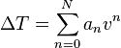
The coefficients a_{n} are given for n from 0 to between 5 and 13 depending upon the metals. In some cases better accuracy is obtained with additional non-polynomial terms. A database of voltage as a function of temperature, and coefficients for computation of temperature from voltage and vice-versa for many types of thermocouple is available online here:
http://srdata.nist.gov/its90/main/
In modern equipment the equation is usually implemented in a digital controller or stored in a look-up table; older devices use analog circuits.

2.1.4. Cold junction compensation
Thermocouples measure the temperature difference between two points, not absolute temperature. To measure a single temperature one of the junctions—normally the cold junction—is maintained at a known reference temperature, and the other junction is at the temperature to be sensed.
Having a junction of known temperature, while useful for laboratory calibration, is not convenient for most measurement and control applications. Instead, they incorporate an artificial cold junction using a thermally sensitive device such as a resistance thermometer, thermistor or diode to measure the temperature of the input connections at the instrument, with special care being taken to minimize any temperature gradient between terminals. Hence, the voltage from a known cold junction can be simulated, and the appropriate correction applied. This is known as cold junction compensation. Some integrated circuits are designed for cold junction temperature compensation for specific thermocouple types.
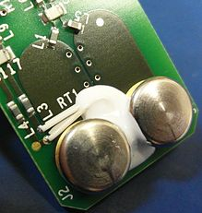
Figure 1.1: Cold Junction Compensation inside a Fluke CNX t3000 temperature meter. Note the thermistor to measure the junction temperature. And the large pads and large thermal mass contacts.Via Wikipedia.com

2.1.5. Grades
Thermocouple wire is available in several different metallurgical formulations per type, typically, in decreasing levels of accuracy and cost: special limits of error, standard, and extension grades.
Extension grade wires made of the same metals as a higher-grade thermocouple are used to connect it to a measuring instrument some distance away without introducing additional junctions between dissimilar materials which would generate unwanted voltages; the connections to the extension wires, being of like metals, do not generate a voltage.
In the case of platinum thermocouples, extension wire is a copper alloy, since it would be prohibitively expensive to use platinum for extension wires. The extension wire is specified to have a very similar thermal coefficient of EMF to the thermocouple, but only over a narrow range of temperatures; this reduces the cost significantly.
The temperature-measuring instrument must have high input impedance to prevent any significant current draw from the thermocouple, which would in turn produce an undesired resistive voltage drop across the wire and/or junction. Changes in metallurgy along the length of the thermocouple (such as termination strips or changes in thermocouple type wire) will introduce another thermocouple junction which affects measurement accuracy.

2.1.6. Types
Certain combinations of alloys have become popular as industry standards. Selection of the combination is driven by cost, availability, convenience, melting point, chemical properties, stability, and output. Different types are best suited for different applications. They are usually selected on the basis of the temperature range and sensitivity needed. Thermocouples with low sensitivities (B, R, and S types) have correspondingly lower resolutions. Other selection criteria include the inertness of the thermocouple material and whether it is magnetic or not. Standard thermocouple types are listed below with the positive electrode first, followed by the negative electrode.

2.1.6.1. K
Type K (chromel {90% nickel and 10% chromium}—alumel {95% nickel, 2% manganese, 2% aluminum and 1% silicon}) is the most common general purpose thermocouple with a sensitivity of approximately 41 µV/°C, chromel positive relative to alumel. It is inexpensive, and a wide variety of probes are available in its −200 °C to +1250 °C / -330 °F to +2460 °F range. Type K was specified at a time when metallurgy was less advanced than it is today, and consequently characteristics may vary considerably between samples. One of the constituent metals, nickel, is magnetic; a characteristic of thermocouples made with magnetic material is that they undergo a deviation in output when the material reaches its Curie point; this occurs for type K thermocouples at around 350 °C . Wire color standard is yellow (+) and red (-).

2.1.6.2. E
Type E (chromel–constantan) has a high output (68 µV/°C) which makes it well suited to cryogenic use. Additionally, it is non-magnetic. Wide range is −50 to 740 °C and Narrow range is −110 to 140 °C. Wire color standard is purple (+) and red (-).

2.1.6.3. J
Type J (iron–constantan) has a more restricted range than type K (−40 to +750 °C), but higher sensitivity of about 55 µV/°C.^{[2]} The Curie point of the iron (770 °C) causes an abrupt change in the characteristic, which determines the upper temperature limit. Wire color standard is white (+) and red (-).

2.1.6.4. N
Type N (Nicrosil–Nisil) (nickel-chromium-silicon/nickel-silicon) thermocouples are suitable for use between −270 °C and 1300 °C owing to its stability and oxidation resistance. Sensitivity is about 39 µV/°C at 900 °C, slightly lower compared to type K.
Designed at the Defence Science and Technology Organisation (DSTO), Australia, by Noel A Burley, type N thermocouples overcome the three principal characteristic types and causes of thermoelectric instability in the standard base-metal thermoelement materials:
1. A gradual and generally cumulative drift in thermal EMF on long exposure at elevated temperatures. This is observed in all base-metal thermoelement materials and is mainly due to compositional changes caused by oxidation, carburization or neutron irradiation that can produce transmutation in nuclear reactor environments. In the case of type K, manganese and aluminium elements from the KN (negative) wire migrate to the KP (positive) wire resulting in a down-scale drift due to chemical contamination. This effect is cumulative and irreversible.
2. A short-term cyclic change in thermal EMF on heating in the temperature range ca. 250–650 °C, which occurs in types K, J, T and E thermocouples. This kind of EMF instability is associated with structural changes like magnetic short range order.
3. A time-independent perturbation in thermal EMF in specific temperature ranges. This is due to composition-dependent magnetic transformations that perturb the thermal EMFs in type K thermocouples in the range ca. 25-225 °C, and in type J above 730 °C.
Nicrosil and Nisil thermocouple alloys show greatly enhanced thermoelectric stability relative to the other standard base-metal thermocouple alloys because their compositions substantially reduces the thermoelectric instability described above. This is achieved primarily by increasing component solute concentrations (chromium and silicon) in a base of nickel above those required to cause a transition from internal to external modes of oxidation, and by selecting solutes (silicon and magnesium) that preferentially oxidize to form a diffusion-barrier, and hence oxidation inhibiting films.

2.1.6.5. Platinum types B, R, and S
Types B, R, and S thermocouples use platinum or a platinum–rhodium alloy for each conductor. These are among the most stable thermocouples, but have lower sensitivity than other types, approximately 10 µV/°C. Type B, R, and S thermocouples are usually used only for high temperature measurements due to their high cost and low sensitivity.

2.1.6.6. B
Type B thermocouples use a platinum–rhodium alloy for each conductor. One conductor contains 30% rhodium while the other conductor contains 6% rhodium. These thermocouples are suited for use at up to 1800 °C. Type B thermocouples produce the same output at 0 °C and 42 °C, limiting their use below about 50 °C.

2.1.6.7. R
Type R thermocouples use a platinum–rhodium alloy containing 13% rhodium for one conductor and pure platinum for the other conductor. Type R thermocouples are used up to 1600 °C.

2.1.6.8. S
Type S thermocouples are constructed using one wire of 90% Platinum and 10% Rhodium (the positive or "+" wire) and a second wire of 100% platinum (the negative or "-" wire). Like type R, type S thermocouples are used up to 1600 °C. In particular, type S is used as the standard of calibration for the melting point of gold (1064.43 °C).

2.1.6.9. T
Type T (copper – constantan) thermocouples are suited for measurements in the −200 to 350 °C range. Often used as a differential measurement since only copper wire touches the probes. Since both conductors are non-magnetic, there is no Curie point and thus no abrupt change in characteristics. Type T thermocouples have a sensitivity of about 43 µV/°C.

2.1.6.10. C
Type C (tungsten 5% rhenium – tungsten 26% rhenium) thermocouples are suited for measurements in the 0 °C to 2320 °C range. This thermocouple is well-suited for vacuum furnaces at extremely high temperatures. It must never be used in the presence of oxygen at temperatures above 260 °C.

2.1.6.11. M
Type M thermocouples use a nickel alloy for each wire. The positive wire (20 Alloy) contains 18% molybdenum while the negative wire (19 Alloy) contains 0.8% cobalt. These thermocouples are used in vacuum furnaces for the same reasons as with type C. Upper temperature is limited to 1400 °C. It is less commonly used than other types.

2.1.6.12. Chromel-gold/iron
In chromel-gold/iron thermocouples, the positive wire is chromel and the negative wire is gold with a small fraction (0.03–0.15 atom percent) of iron. It can be used for cryogenic applications (1.2–300 K and even up to 600 K). Both the sensitivity and the temperature range depend on the iron concentration. The sensitivity is typically around 15 µV/K at low temperatures and the lowest usable temperature varies between 1.2 and 4.2 K.

2.1.7. Aging of thermocouples
Thermoelements are often used at high temperatures and in reactive furnace atmospheres. In this case the practical lifetime is limited by aging. The thermoelectric coefficients of the wires in a thermocouple that is used to measure very high temperatures change with time, and the measurement voltage accordingly drops. The simple relationship between the temperature difference of the joints and the measurement voltage is only correct if each wire is homogeneous. As thermocouples age in a process their conductors can lose homogeneity due to chemical and metallurgical changes caused by extreme or prolonged exposure to high temperatures. If the inhomogeneous section of the thermocouple circuit is exposed to a temperature gradient the measured voltage will differ resulting in error. For this reason, aged thermocouples cannot be taken out of their installed location and recalibrated in a bath or test furnace to determine error. This also explains why error can sometimes be observed when an aged thermocouple is pulled partly out of a furnace—as the sensor is pulled back, inhomogenous sections may see exposure to increased temperature gradients from hot to cold as the inhomogeneous section now passes through the cooler refractory area, contributing significant error to the measurement. Likewise, an aged thermocouple that is pushed deeper into the furnace might sometimes provide a more accurate reading if being pushed further into the furnace causes the area of inhomogeneity to be located in an area of the furnace where it is no longer exposed to a temperature gradient.

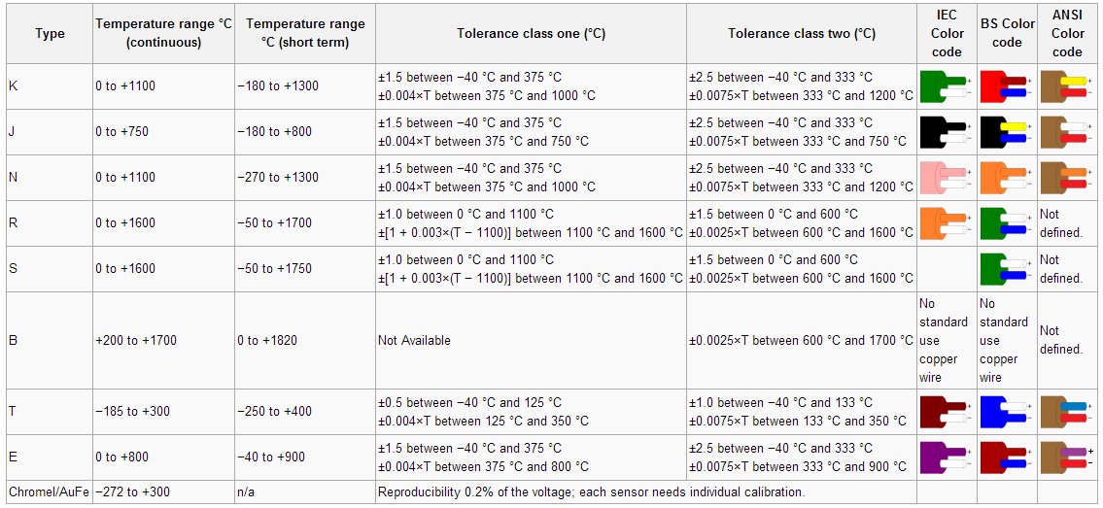
2.1.8. Thermocouple Comparison
Table 2.1: Table of Comparison of thermocouples via Wikipedia.com
Table 1 describes properties of several different thermocouple types. Within the tolerance columns, T represents the temperature of the hot junction, in degrees Celsius. For example, a thermocouple with a tolerance of ±0.0025×T would have a tolerance of ±2.5 °C at 1000 °C.

2.1.9. Applications
Thermocouples are suitable for measuring over a large temperature range, up to 2300 °C. Applications include temperature measurement for kilns, gas turbine exhaust, diesel engines, and other industrial processes. They are less suitable for applications where smaller temperature differences need to be measured with high accuracy, for example the range 0–100 °C with 0.1 °C accuracy. For such applications thermistors, silicon bandgap temperature sensors and resistance temperature detectors are more suitable.

2.2. Thermistor
A thermistor is a type of resistor whose resistance varies significantly with temperature, more so than in standard resistors. The word is a portmanteau of thermal and resistor. Thermistors are widely used as inrush current limiters, temperature sensors, self-resetting overcurrent protectors, and self-regulating heating elements.
Thermistors differ from resistance temperature detectors (RTD) in that the material used in a thermistor is generally a ceramic or polymer, while RTDs use pure metals. The temperature response is also different; RTDs are useful over larger temperature ranges, while thermistors typically achieve a higher precision within a limited temperature range, typically −90 °C to 130 °C.
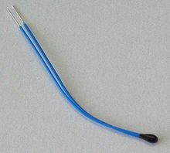
Figure 2.1: Negative temperature coefficient (NTC) thermistor, bead type, insulated wires via Wikipedia.com

2.2.1. Basic operations
Assuming, as a first-order approximation, that the relationship between resistance and temperature is linear, then:
where
= change in resistance
= change in temperature
= first-order temperature coefficient of resistance

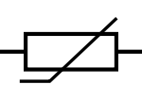
Figure 2.2: Thermistor symbol
Thermistors can be classified into two types, depending on the sign of . If is positive, the resistance increases with increasing temperature, and the device is called a positive temperature coefficient (PTC) thermistor, or posistor. If is negative, the resistance decreases with increasing temperature, and the device is called a negative temperature coefficient (NTC) thermistor. Resistors that are not thermistors are designed to have a as close to zero as possible, so that their resistance remains nearly constant over a wide temperature range.
Instead of the temperature coefficient k, sometimes the temperature coefficient of resistance (alpha sub T) is used. It is defined as
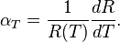

2.2.2. Stain-Hart equation
In practice, the linear approximation works only over a small temperature range. For accurate temperature measurements, the resistance/temperature curve of the device must be described in more detail. The Steinhart–Hart equation is a widely used third-order approximation:
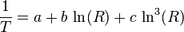
where a, b and c are called the Steinhart–Hart parameters, and must be specified for each device. T is the temperature in kelvin and R is the resistance in ohms. To give resistance as a function of temperature, the above can be rearranged into:
where
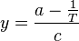and 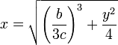
The error in the Steinhart–Hart equation is generally less than 0.02 °C in the measurement of temperature over a 200 °C range. As an example, typical values for a thermistor with a resistance of 3000 Ω at room temperature (25 °C = 298.15 K) are:

2.2.3. B or β parameter equation
NTC thermistors can also be characterised with the B (or β) parameter equation, which is essentially the Steinhart Hart equation with
, and ,
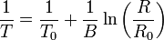
Where the temperatures are in kelvin and R₀ is the resistance at temperature T₀ (25 °C = 298.15 K). Solving for R yields:
or, alternatively,
where
.
This can be solved for the temperature:
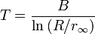
The B-parameter equation can also be written as
.
This can be used to convert the function of resistance vs. temperature of a thermistor into a linear function of vs. . The average slope of this function will then yield an estimate of the value of the B parameter.

2.2.4. Conduction model

2.2.4.1. NTC
Many NTC thermistors are made from a pressed disc or cast chip of a semiconductor such as a sintered metal oxide. They work because raising the temperature of a semiconductor increases the number of electrons able to move about and carry charge - it promotes them into the conduction band. The more charge carriers that are available, the more current a material can conduct. This is described in the formula:
= electric current (amperes)
= density of charge carriers (count/m³)
= cross-sectional area of the material (m²)
= velocity of charge carriers (m/s)
= charge of an electron ( coulomb)
The current is measured using an ammeter. Over large changes in temperature, calibration is necessary. Over small changes in temperature, if the right semiconductor is used, the resistance of the material is linearly proportional to the temperature. There are many different semiconducting thermistors with a range from about 0.01 kelvin to 2,000 kelvins (−273.14 °C to 1,700 °C).

2.2.4.2. PTC
Most PTC thermistors are of the "switching" type, which means that their resistance rises suddenly at a certain critical temperature. The devices are made of a doped polycrystalline ceramic containing barium titanate (BaTiO₃) and other compounds. The dielectric constant of this ferroelectric material varies with temperature. Below the Curie point temperature, the high dielectric constant prevents the formation of potential barriers between the crystal grains, leading to a low resistance. In this region the device has a small negative temperature coefficient. At the Curie point temperature, the dielectric constant drops sufficiently to allow the formation of potential barriers at the grain boundaries, and the resistance increases sharply. At even higher temperatures, the material reverts to NTC behaviour. The equations used for modeling this behaviour were derived by W. Heywang and G. H. Jonker in the 1960s.
Another type of PTC thermistor is the polymer PTC, which is sold under brand names such as "Polyswitch" "Semifuse", and "Multifuse". This consists of a slice of plastic with carbon grains embedded in it. When the plastic is cool, the carbon grains are all in contact with each other, forming a conductive path through the device. When the plastic heats up, it expands, forcing the carbon grains apart, and causing the resistance of the device to rise rapidly. Like the BaTiO₃ thermistor, this device has a highly nonlinear resistance/temperature response and is used for switching, not for proportional temperature measurement.
Yet another type of thermistor is a silistor, a thermally sensitive silicon resistor. Silistors employ silicon as the semiconductive component material. In contrary to the "switching" type thermistor, silistors have an almost linear resistance-temperature characteristic.

2.2.5. Self-heating effects
When a current flows through a thermistor, it will generate heat which will raise the temperature of the thermistor above that of its environment. If the thermistor is being used to measure the temperature of the environment, this electrical heating may introduce a significant error if a correction is not made. Alternatively, this effect itself can be exploited. It can, for example, make a sensitive air-flow device employed in a sailplane rate-of-climb instrument, the electronic variometer, or serve as a timer for a relay as was formerly done in telephone exchanges.
The electrical power input to the thermistor is just:
where I is current and V is the voltage drop across the thermistor. This power is converted to heat, and this heat energy is transferred to the surrounding environment. The rate of transfer is well described by Newton's law of cooling:
where T(R) is the temperature of the thermistor as a function of its resistance R, is the temperature of the surroundings, and K is the dissipation constant, usually expressed in units of milliwatts per degree Celsius. At equilibrium, the two rates must be equal.
The current and voltage across the thermistor will depend on the particular circuit configuration. As a simple example, if the voltage across the thermistor is held fixed, then by Ohm's Law we have and the equilibrium equation can be solved for the ambient temperature as a function of the measured resistance of the thermistor:
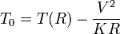
The dissipation constant is a measure of the thermal connection of the thermistor to its surroundings. It is generally given for the thermistor in still air, and in well-stirred oil. Typical values for a small glass bead thermistor are 1.5 mW/°C in still air and 6.0 mW/°C in stirred oil. If the temperature of the environment is known beforehand, then a thermistor may be used to measure the value of the dissipation constant. For example, the thermistor may be used as a flow rate sensor, since the dissipation constant increases with the rate of flow of a fluid past the thermistor.
The power dissipated in a thermistor is typically maintained at a very low level to ensure insignificant temperature measurement error due to self heating. However, some thermistor applications depend upon significant "self heating" to raise the body temperature of the thermistor well above the ambient temperature so the sensor then detects even subtle changes in the thermal conductivity of the environment. Some of these applications include liquid level detection, liquid flow measurement and air flow measurement.

2.2.6. Application
- PTC thermistors can be used as current-limiting devices for circuit protection, as replacements for fuses. Current through the device causes a small amount of resistive heating. If the current is large enough to generate more heat than the device can lose to its surroundings, the device heats up, causing its resistance to increase, and therefore causing even more heating. This creates a self-reinforcing effect that drives the resistance upwards, reducing the current and voltage available to the device.
- PTC thermistors were used as timers in the degaussing coil circuit of most CRT displays. When the display unit is initially switched on, current flows through the thermistor and degaussing coil. The coil and thermistor are intentionally sized so that the current flow will heat the thermistor to the point that the degaussing coil shuts off in under a second. For effective degaussing, it is necessary that the magnitude of the alternating magnetic field produced by the degaussing coil decreases smoothly and continuously, rather than sharply switching off or decreasing in steps; the PTC thermistor accomplishes this naturally as it heats up. A degaussing circuit using a PTC thermistor is simple, reliable (for its simplicity), and inexpensive.
- PTC thermistors were used as heater in automotive industry to provide additional heat inside cabin with diesel engine or to heat diesel in cold climatic conditions before engine injection.
- NTC thermistors are used as resistance thermometers in low-temperature measurements of the order of 10 K.
- NTC thermistors can be used as inrush-current limiting devices in power supply circuits. They present a higher resistance initially which prevents large currents from flowing at turn-on, and then heat up and become much lower resistance to allow higher current flow during normal operation. These thermistors are usually much larger than measuring type thermistors, and are purposely designed for this application.
- NTC thermistors are regularly used in automotive applications. For example, they monitor things like coolant temperature and/or oil temperature inside the engine and provide data to the ECU and, indirectly, to the dashboard.
- NTC thermistors can be also used to monitor the temperature of an incubator.
- Thermistors are also commonly used in modern digital thermostats and to monitor the temperature of battery packs while charging.
- Thermistors are also used in the hot ends of 3D printers, they produce heat and keep a constant temperature for melting the plastic filament.
- NTC thermistors are used in the Food Handling and Processing industry, especially for food storage systems and food preparation. Maintaining the correct temperature is critical to prevent food borne illness.
- NTC thermistors are used throughout the Consumer Appliance industry for measuring temperature. Toasters, coffee makers, refrigerators, freezers, hair dryers, etc. all rely on thermistors for proper temperature control.

2.3. Resistance Thermometer
Resistance thermometers, also called resistance temperature detectors (RTDs), are sensors used to measure temperature by correlating the resistance of the RTD element with temperature. Most RTD elements consist of a length of fine coiled wire wrapped around a ceramic or glass core. The element is usually quite fragile, so it is often placed inside a sheathed probe to protect it. The RTD element is made from a pure material, platinum, nickel or copper. The material has a predictable change in resistance as the temperature changes; it is this predictable change that is used to determine temperature.
They are slowly replacing the use of thermocouples in many industrial applications below 600 °C, due to higher accuracy and repeatability.

2.3.1. R vs T relationships of various metals
Common RTD sensing elements constructed of platinum, copper or nickel have a unique, and repeatable and predictable resistance versus temperature relationship (R vs T) and operating temperature range. The R vs T relationship is defined as the amount of resistance change of the sensor per degree of temperature change. The relative change in resistance (temperature coefficient of resistance) varies only slightly over the useful range of the sensor.
Platinum is a noble metal and has the most stable resistance-temperature relationship over the largest temperature range. Nickel elements have a limited temperature range because the amount of change in resistance per degree of change in temperature becomes very non-linear at temperatures over 572 °F (300 °C). Copper has a very linear resistance-temperature relationship, however copper oxidizes at moderate temperatures and cannot be used over 302 °F (150 °C).
Platinum is the best metal for RTDs because it follows a very linear resistance-temperature relationship and it follows the R vs T relationship in a highly repeatable manner over a wide temperature range. The unique properties of platinum make it the material of choice for temperature standards over the range of -272.5 °C to 961.78 °C, and is used in the sensors that define the International Temperature Standard, ITS-90. Platinum is chosen also because of its chemical inertness.
The significant characteristic of metals used as resistive elements is the linear approximation of the resistance versus temperature relationship between 0 and 100 °C. This temperature coefficient of resistance is called alpha, α. The equation below defines α; its units are ohm/ohm/°C.

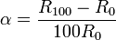

the resistance of the sensor at 0°C
the resistance of the sensor at 100°C

Pure platinum has an alpha of 0.003925 ohm/ohm/°C and is used in the construction of laboratory grade RTDs. Conversely two widely recognized standards for industrial RTDs IEC 60751 and ASTM E-1137 specify an alpha of 0.00385 ohms/ohm/°C. Before these standards were widely adopted several different alpha values were used. It is still possible to find older probes that are made with platinum that have alpha values of 0.003916 ohms/ohm/°C and 0.003902 ohms/ohm/°C.
These different alpha values for platinum are achieved by doping; basically carefully introducing impurities into the platinum. The impurities introduced during doping become embedded in the lattice structure of the platinum and result in a different R vs. T curve and hence alpha value.

2.3.2. Calibration
To characterize the R vs T relationship of any RTD over a temperature range that represents the planned range of use, calibration must be performed at temperatures other than 0°C and 100°C. Two common calibration methods are the fixed point method and the comparison method.
- Fixed point calibration, used for the highest accuracy calibrations, uses the triple point, freezing point or melting point of pure substances such as water, zinc, tin, and argon to generate a known and repeatable temperature. These cells allow the user to reproduce actual conditions of the ITS-90 temperature scale. Fixed point calibrations provide extremely accurate calibrations (within ±0.001°C). A common fixed point calibration method for industrial-grade probes is the ice bath. The equipment is inexpensive, easy to use, and can accommodate several sensors at once. The ice point is designated as a secondary standard because its accuracy is ±0.005°C (±0.009°F), compared to ±0.001°C (±0.0018°F) for primary fixed points.
- Comparison calibrations, commonly used with secondary SPRTs and industrial RTDs, the thermometers being calibrated are compared to calibrated thermometers by means of a bath whose temperature is uniformly stable. Unlike fixed point calibrations, comparisons can be made at any temperature between –100°C and 500°C (–148°F to 932°F). This method might be more cost-effective since several sensors can be calibrated simultaneously with automated equipment. These electrically heated and well-stirred baths use silicone oils and molten salts as the medium for the various calibration temperatures.

2.3.3. Element types
There are three main categories of RTD sensors; Thin Film, Wire-Wound, and Coiled Elements. While these types are the ones most widely used in industry there are some places where other more exotic shapes are used, for example carbon resistors are used at ultra low temperatures (-173 °C to -273 °C).^{[6]}
- Carbon resistor elements are widely available and are very inexpensive. They have very reproducible results at low temperatures. They are the most reliable form at extremely low temperatures. They generally do not suffer from significant hysteresis or strain gauge effects.
- Strain free elements use a wire coil minimally supported within a sealed housing filled with an inert gas. These sensors are used up to 961.78 °C and are used in the SPRT’s that define ITS-90. They consisted of platinum wire loosely coiled over a support structure so the element is free to expand and contract with temperature, but it is very susceptible to shock and vibration as the loops of platinum can sway back and forth causing deformation.
- Thin film elements have a sensing element that is formed by depositing a very thin layer of resistive material, normal platinum, on a ceramic substrate; This layer is usually just 10 to 100 angstroms (1 to 10 nanometers) thick.^{[7]} This film is then coated with an epoxy or glass that helps protect the deposited film and also acts as a strain relief for the external lead-wires. Disadvantages of this type are that they are not as stable as their wire wound or coiled counterparts. They also can only be used over a limited temperature range due to the different expansion rates of the substrate and resistive deposited giving a "strain gauge" effect that can be seen in the resistive temperature coefficient. These elements work with temperatures to 300 °C.
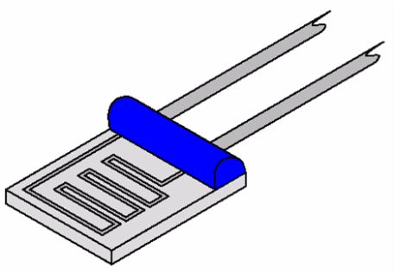
Figure 2.3: Thin film element
Wire-wound elements can have greater accuracy, especially for wide temperature ranges. The coil diameter provides a compromise between mechanical stability and allowing expansion of the wire to minimize strain and consequential drift. The sensing wire is wrapped around an insulating mandrel or core. The winding core can be round or flat, but must be an electrical insulator. The coefficient of thermal expansion of the winding core material is matched to the sensing wire to minimize any mechanical strain. This strain on the element wire will result in a thermal measurement error. The sensing wire is connected to a larger wire, usually referred to as the element lead or wire. This wire is selected to be compatible with the sensing wire so that the combination does not generate an emf that would distort the thermal measurement. These elements work with temperatures to 660 °C.
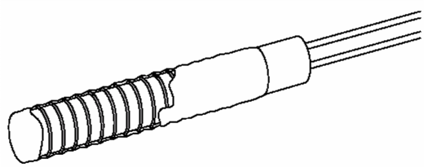
Figure 2.4: Wire-wound element
Coiled elements have largely replaced wire-wound elements in industry. This design has a wire coil which can expand freely over temperature, held in place by some mechanical support which lets the coil keep its shape. This “strain free” design allows the sensing wire to expand and contract free of influence from other materials; in this respect it is similar to the SPRT, the primary standard upon which ITS-90 is based, while providing the durability necessary for industrial use. The basis of the sensing element is a small coil of platinum sensing wire. This coil resembles a filament in an incandescent light bulb. The housing or mandrel is a hard fired ceramic oxide tube with equally spaced bores that run transverse to the axes. The coil is inserted in the bores of the mandrel and then packed with a very finely ground ceramic powder. This permits the sensing wire to move while still remaining in good thermal contact with the process. These Elements works with temperatures to 850 °C.
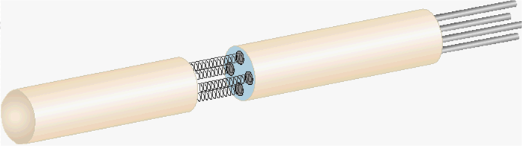
Figure 2.5: Coil element
The current international standard which specifies tolerance and the temperature-to-electrical resistance relationship for platinum resistance thermometers is IEC 60751:2008, ASTM E1137 is also used in the United States. By far the most common devices used in industry have a nominal resistance of 100 ohms at 0 °C, and are called Pt100 sensors ('Pt' is the symbol for platinum). The sensitivity of a standard 100 ohm sensor is a nominal 0.385 ohm/°C. RTDs with a sensitivity of 0.375 and 0.392 ohm/°C as well as a variety of others are also available.

2.3.4. Function
Resistance thermometers are constructed in a number of forms and offer greater stability, accuracy and repeatability in some cases than thermocouples. While thermocouples use the Seebeck effect to generate a voltage, resistance thermometers use electrical resistance and require a power source to operate. The resistance ideally varies linearly with temperature.
The platinum detecting wire needs to be kept free of contamination to remain stable. A platinum wire or film is supported on a former in such a way that it gets minimal differential expansion or other strains from its former, yet is reasonably resistant to vibration. RTD assemblies made from iron or copper are also used in some applications. Commercial platinum grades are produced which exhibit a temperature coefficient of resistance 0.00385/°C (0.385%/°C) (European Fundamental Interval). The sensor is usually made to have a resistance of 100 Ω at 0 °C. This is defined in BS EN 60751:1996 (taken from IEC 60751:1995). The American Fundamental Interval is 0.00392/°C, based on using a purer grade of platinum than the European standard. The American standard is from the Scientific Apparatus Manufacturers Association (SAMA), who are no longer in this standards field. As a result the "American standard" is hardly the standard even in the US.
Measurement of resistance requires a small current to be passed through the device under test. This can cause resistive heating, causing significant loss of accuracy if manufacturers' limits are not respected, or the design does not properly consider the heat path. Mechanical strain on the resistance thermometer can also cause inaccuracy. Lead wire resistance can also be a factor; adopting three- and four-wire, instead of two-wire, connections can eliminate connection lead resistance effects from measurements; three-wire connection is sufficient for most purposes and almost universal industrial practice. Four-wire connections are used for the most precise applications.

2.3.5. Advantages and Limitations
The advantages of platinum resistance thermometers include:
- High accuracy
- Low drift
- Wide operating range
- Suitability for precision applications.
Limitations: RTDs in industrial applications are rarely used above 660 °C. At temperatures above 660 °C it becomes increasingly difficult to prevent the platinum from becoming contaminated by impurities from the metal sheath of the thermometer. This is why laboratory standard thermometers replace the metal sheath with a glass construction. At very low temperatures, say below -270 °C (or 3 K), because there are very few phonons, the resistance of an RTD is mainly determined by impurities and boundary scattering and thus basically independent of temperature. As a result, the sensitivity of the RTD is essentially zero and therefore not useful.
Compared to thermistors, platinum RTDs are less sensitive to small temperature changes and have a slower response time. However, thermistors have a smaller temperature range and stability.
Sources of error:
The common error sources of a PRT are:
- Interchangeability: the “closeness of agreement” between the specific PRT's Resistance vs. Temperature relationship and a predefined Resistance vs. Temperature relationship, commonly defined by IEC 60751.
- Insulation Resistance: Error caused by the inability to measure the actual resistance of element. Current leaks into or out of the circuit through the sheath, between the element leads, or the elements.
- Stability: Ability to maintain R vs T over time as a result of thermal exposure.
- Repeatability: Ability to maintain R vs T under the same conditions after experiencing thermal cycling throughout a specified temperature range.
- Hysteresis: Change in the characteristics of the materials from which the RTD is built due to exposures to varying temperatures.
- Stem Conduction: Error that results from the PRT sheath conducting heat into or out of the process.
- Calibration/Interpolation: Errors that occur due to calibration uncertainty at the cal points, or between cal point due to propagation of uncertainty or curve fit errors.
- Lead Wire: Errors that occur because a 4 wire or 3 wire measurement is not used, this is greatly increased by higher gauge wire.
  - 2 wire connection adds lead resistance in series with PRT element.
  - 3 wire connection relies on all 3 leads having equal resistance.
- Self Heating: Error produced by the heating of the PRT element due to the power applied.
- Time Response: Errors are produced during temperature transients because the PRT cannot respond to changes fast enough.
- Thermal EMF: Thermal EMF errors are produced by the EMF adding to or subtracting from the applied sensing voltage, primarily in DC systems.

2.3.6. Construction
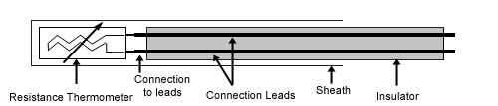
Figure 2.6: Construction of an RTD (Wikipedia.org)
These elements nearly always require insulated leads attached. At temperatures below about 250 °C PVC, silicon rubber or PTFE insulators are used. Above this, glass fibre or ceramic are used. The measuring point, and usually most of the leads, require a housing or protective sleeve, often made of a metal alloy which is chemically inert to the process being monitored. Selecting and designing protection sheaths can require more care than the actual sensor, as the sheath must withstand chemical or physical attack and provide convenient attachment points.

2.3.7. Wiring Configuration

Two-wire configuration
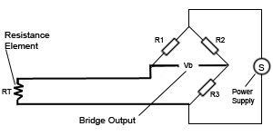
Figure 2.7: Two-wire configuration of an RTD
The simplest resistance thermometer configuration uses two wires. It is only used when high accuracy is not required, as the resistance of the connecting wires is added to that of the sensor, leading to errors of measurement. This configuration allows use of 100 meters of cable. This applies equally to balanced bridge and fixed bridge system.

Three-wire configuration
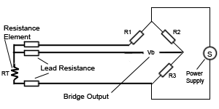
Figure 2.8: Three-wire configuration of an RTD
In order to minimize the effects of the lead resistances, a three-wire configuration can be used. Using this method the two leads to the sensor are on adjoining arms. There is a lead resistance in each arm of the bridge so that the resistance is cancelled out, so long as the two lead resistances are accurately the same. This configuration allows up to 600 meters of cable.

Four-wire configuration
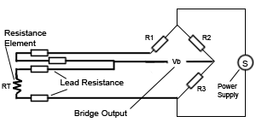
Figure 2.9: Four-wire configuration of an RTD
The four-wire resistance thermometer configuration increases the accuracy and reliability of the resistance being measured: the resistance error due to lead wire resistance is zero. In the diagram above a standard two-terminal RTD is used with another pair of wires to form an additional loop that cancels out the lead resistance. The above Wheatstone bridge method uses a little more copper wire and is not a perfect solution. Below is a better configuration, four-wire Kelvin connection. It provides full cancellation of spurious effects; cable resistance of up to 15 Ω can be handled.
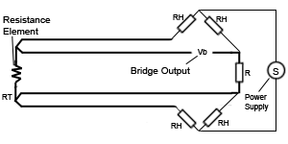
Figure 2.10: Four-wire Kelvin connection of an RTD

2.3.8. Classification of RTDs
The highest accuracy of all PRTs is the Standard platinum Resistance Thermometers (SPRTs). This accuracy is achieved at the expense of durability and cost. The SPRTs elements are wound from reference grade platinum wire. Internal lead wires are usually made from platinum while internal supports are made from quartz or fuse silica. The sheaths are usually made from quartz or sometimes Inconel depending on temperature range. Larger diameter platinum wire is used, which drives up the cost and results in a lower resistance for the probe (typically 25.5 ohms). SPRTs have a wide temperature range (-200°C to 1000°C) and approximately accurate to ±0.001°C over the temperature range. SPRTs are only appropriate for laboratory use.
Another classification of laboratory PRTs is Secondary Standard platinum Resistance Thermometers (Secondary SPRTs). They are constructed like the SPRT, but the materials are more cost-effective. SPRTs commonly use reference grade, high purity smaller diameter platinum wire, metal sheaths and ceramic type insulators. Internal lead wires are usually a nickel based alloy. Secondary SPRTs are limited in temperature range (-200°C to 500°C) and are approximately accurate to ±0.03°C over the temperature range.
Industrial PRTs are designed to withstand industrial environments. They can be almost as durable as a thermocouple. Depending on the application industrial PRTs can use thin film elements or coil wound elements. The internal lead wires can range from PTFE insulated stranded nickel plated copper to silver wire, depending on the sensor size and application. Sheath material is typically stainless steel; higher temperature applications may demand Inconel. Other materials are used for specialized applications.

2.3.9. Applications
Sensor assemblies can be categorized into two groups by how they are installed or interface with the process: immersion or surface mounted.
- Immersion sensors take the form of an SS tube and some type of process connection fitting. They are installed into the process with sufficient immersion length to ensure good contact with the process medium and reduce external influences. A variation of this style includes a separate thermowell that provides additional protection for the sensor. These styles are used to measure fluid or gas temperatures in pipes and tanks. Most sensors have the sensing element located at the tip of the stainless steel tube. An averaging style RTD however, can measure an average temperature of air in a large duct. This style of immersion RTD has the sensing element distributed along the entire probe length and provides an average temperature. Lengths range from 3 to 60 feet.
- Surface mounted sensors are used when immersion into a process fluid is not possible due to configuration of the piping or tank, or the fluid properties may not allow an immersion style sensor. Configurations range from tiny cylinders to large blocks which are mounted by clamps, adhesives, or bolted into place. Most require the addition of insulation to isolate them from cooling or heating effects of the ambient conditions to insure accuracy.
Other applications may require special water proofing or pressure seals. A heavy-duty underwater temperature sensor is designed for complete submersion under rivers, cooling ponds, or sewers. Steam autoclaves require a sensor that is sealed from intrusion by steam during the vacuum cycle process.
Immersion sensors generally have the best measurement accuracy because they are in direct contact with the process fluid. Surface mounted sensors are measuring the pipe surface as a close approximation of the internal process fluid.

2.3.10. Values for various popular resistance thermometers
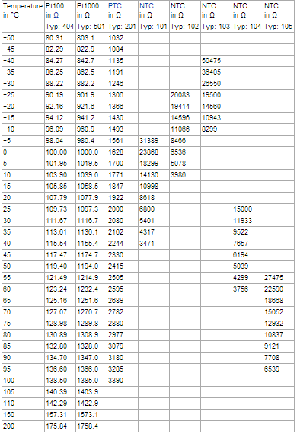
Table 2.2: Table of Values for various popular resistance thermometers (Wikipedia.org)

2.4. Pyrometer
A pyrometer is a non-contacting device that intercepts and measures thermal radiation, a process known as pyrometry. This device can be used to determine the temperature of an object's surface.
The word pyrometer comes from the Greek word for fire, "πυρ" (pyro), and meter, meaning to measure. Pyrometer was originally coined to denote a device capable of measuring temperatures of objects above incandescence (i.e. objects bright to the human eye).
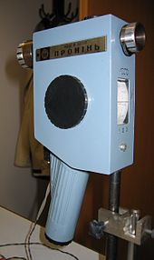
Figure 2.11: An optical pyrometer (Wikipedia.org)

2.4.1. Principle of operation
A pyrometer has an optical system and a detector. The optical system focuses the thermal radiation onto the detector. The output signal of the detector (temperature T) is related to the thermal radiation or irradiance j* of the target object through the Stefan–Boltzmann law, the constant of proportionality σ, called the Stefan-Boltzmann constant and the emissivity ε of the object.
This output is used to infer the object's temperature. Thus, there is no need for direct contact between the pyrometer and the object, as there is with thermocouples and resistance temperature detectors (RTDs

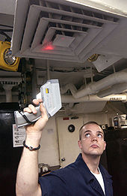
Figure 2.12: A sailor checking the temperature of a ventilation system(Wikipedia.org)

2.4.2. Applications
Pyrometers are suited especially to the measurement of moving objects or any surfaces that can not be reached or cannot be touched.

Smelter Industry
Temperature is a fundamental parameter in metallurgical furnace operations. Reliable and continuous measurement of the melt temperature is essential for effective control of the operation. Smelting rates can be maximized, slag can be produced at the optimum temperature, fuel consumption is minimized and refractory life may also be lengthened. Thermocouples were the traditional devices used for this purpose, but they are unsuitable for continuous measurement because they rapidly dissolve.

Over-the-bath Pyrometer
Salt bath furnaces operate at temperatures up to 1300 °C and are used for heat treatment. At very high working temperatures with intense heat transfer between the molten salt and the steel being treated, precision is maintained by measuring the temperature of the molten salt. Most errors are caused by slag on the surface which is cooler than the salt bath.

Tuyère Pyrometer
The Tuyère Pyrometer is an optical instrument for temperature measurement through the tuyeres which are normally used for feeding air or reactants into the bath of the furnace.

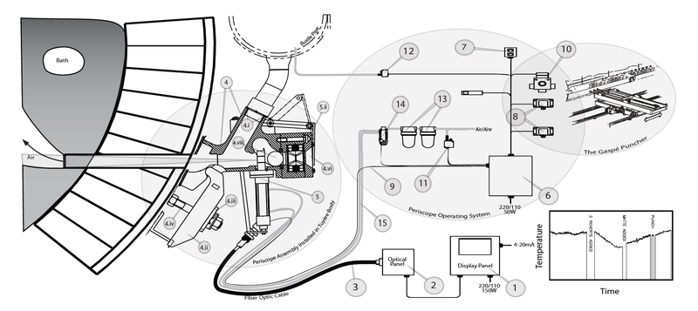
Figure 2.13: (1) Display.(2) Optical.(3) Fibre optic cable and Periscope. (4) Pyrometer tuyère adapter having:i. Bustle pipe connection. ii. Tuyère clamp iii. Clamp washer iv. Clamp stud c/w and fastening hardware v. Gasket vi. Noranda Tuyère Silencer vii. valve seat viii. ball (5) Pneumatic Cylinder: i. Smart Cylinder Assembly with Internal proximity switch ii. Guard Plate Assembly iii. Temporary Flange Cover Plate used to cover periscope entry hole on tuyère adapter when no cylinder is installed on the tuyère. (6) Operator station panel (7) Pyrometer light station (8) Limit switches (9) 4 conductor cab tire (10) Ball Valve (11) Periscope Air pressure switch. (12) Bustle Pipe Air pressure switch. (13) Airline filter/regulator (14) Directional control valve, Sub-plate, silencer and speed control mufflers. (15) 2" nom. low pressure air hose, 40m length

Steam boilers
A steam boiler may be fitted with a pyrometer to measure the steam temperature in the superheater.

Hot Air Balloons
A hot air balloon is equipped with a pyrometer for measuring the temperature at the top of the envelope in order to prevent overheating of the fabric.

2.5. Langmuir Probe
A Langmuir probe is a device named after Nobel Prize winning physicist Irving Langmuir, used to determine the electron temperature, electron density, and electric potential of a plasma. It works by inserting one or more electrodes into plasma, with a constant or time-varying electric potential between the various electrodes or between them and the surrounding vessel. The measured currents and potentials in this system allow the determination of the physical properties of the plasma.

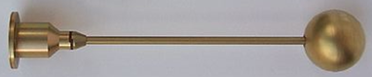
Figure 2.14: One of two Langmuir probes from the Swedish Institute of Space Physics in Uppsala on board ESA's space vehicle Rosetta, due for a comet. The probe is the spherical part, 50 mm in diameter and made from titanium with a surface coating of titanium nitride. This specific Langmuir probe is on a mission to study the space around the comet.

2.5.1. I-V characteristics of the Debye sheath
The beginning of Langmuir probe theory is the I-V characteristic of the Debye sheath, that is, the current density flowing to a surface in a plasma as a function of the voltage drop across the sheath. The analysis presented here indicates how the electron temperature, electron density, and plasma potential can be derived from the I-V characteristic. In some situations a more detailed analysis can yield information on the ion density (), the ion temperature, or the electron energy distribution function (EEDF) or .

Ion saturation current density
Consider first a surface biased to a large negative voltage. If the voltage is large enough, essentially all electrons (and any negative ions) will be repelled. The ion velocity will satisfy the Bohm sheath criterion, which is, strictly speaking, an inequality, but which is usually marginally fulfilled. The Bohm criterion in its marginal form says that the ion velocity at the sheath edge is simply the sound speed given by
.
The ion temperature term is often neglected, which is justified if the ions are cold. Even if the ions are known to be warm, the ion temperature is usually not known, so it is usually assumed to be simply equal to the electron temperature. In that case, consideration of finite ion temperature only results in a small numerical factor. Z is the (average) charge state of the ions, and is the adiabatic coefficient for the ions. The proper choice of is a matter of some contention. Most analyses use , corresponding to isothermal ions, but some kinetic theory suggests that , corresponding to one degree of freedom, is more appropriate. For and , using the larger value results in the conclusion that the density is times smaller. Uncertainties of this magnitude arise several places in the analysis of Langmuir probe data and are very difficult to resolve.
The charge density of the ions depends on the charge state Z, but quasineutrality allows one to write it simply in terms of the electron density as .
Using these results we have the current density to the surface due to the ions. The current density at large negative voltages is due solely to the ions and, except for possible sheath expansion effects, does not depend on the bias voltage, so it is referred to as the ion saturation current density and is given by
where the plasma parameters, in particular the density, are those at the sheath edge.

Exponential electron current
As the potential drop in the Debye sheath is reduced, the more energetic electrons are able to overcome the potential barrier of the electrostatic sheath. We can model the electrons at the sheath edge with a Boltzmann distribution, i.e.,
,
except that the high energy tail moving away from the surface is missing, because only the lower energy electrons moving toward the surface are reflected. The higher energy electrons overcome the sheath potential and are absorbed. The mean velocity of the electrons which are able to overcome the potential drop of the sheath is
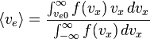,
where the cut-off velocity for the upper integral is
.
is the potential drop across the Debye sheath, that is, the potential at the sheath edge minus the potential of the surface. For a potential drop large compared to the electron temperature, the result is
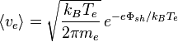.
With this expression we can write the electron contribution to the current to the probe in terms of the ion saturation current as
,
valid as long as the electron current is not more than two or three times the ions current.

Floating potential
The total current, of course, is the sum of the ion and electron currents:
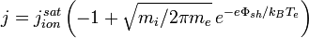.
We are using the convention that current from the surface into the plasma is positive. An interesting and practical question is the potential of a surface to which no net current flows. It is easily seen from the above equation that
.
If we introduce the reduced ion mass , we can write
Since the floating potential is the experimentally accessible quantity, the current (below electron saturation) is usually written as
.

Electron saturation current
When the electrode potential is equal to or greater than the plasma potential, then there is no longer a sheath to reflect electrons, and the electron current saturates. Using the Boltzmann expression for the mean electron velocity given above with and setting the ion current to zero, the electron saturation current density would be
Although this is the expression usually given in theoretical discussions of Langmuir probes, the derivation is not rigorous and the experimental basis is weak. The theory of double layers typically employs an expression analogous to the Bohm criterion, but with the roles of electrons and ions reversed, namely
where the numerical value was found by taking T_{i}=T_{e} and γ_{i}=γ_{e}.
In practice, it is often difficult and usually considered uninformative to measure the electron saturation current experimentally. When it is measured, it is found to be highly variable and generally much lower (a factor of three or more) than the value given above. Often a clear saturation is not seen at all. Understanding electron saturation is one of the most important outstanding problems of Langmuir probe theory.

2.5.2 Effects of the bulk plasma
Debye sheath theory explains the basic behavior of Langmuir probes, but is not complete. Merely inserting an object like a probe into a plasma changes the density, temperature, and potential at the sheath edge and perhaps everywhere. Changing the voltage on the probe will also, in general, change various plasma parameters. Such effects are less well understood than sheath physics, but they can at least in some cases be roughly accounted.

Pre-sheath
The Bohm criterion requires the ions to enter the Debye sheath at the sound speed. The potential drop that accelerates them to this speed is called the pre-sheath. It has a spatial scale that depends on the physics of the ion source but which is large compared to the Debye length and often of the order of the plasma dimensions. The magnitude of the potential drop is equal to (at least)
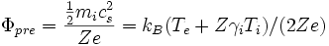
The acceleration of the ions also entails a decrease in the density, usually by a factor of about 2 depending on the details.

Resistivity
Collisions between ions and electrons will also affect the I-V characteristic of a Langmuir probe. When an electrode is biased to any voltage other than the floating potential, the current it draws must pass through the plasma, which has a finite resistivity. The resistivity and current path can be calculated with relative ease in an unmagnetized plasma. In a magnetized plasma, the problem is much more difficult. In either case, the effect is to add a voltage drop proportional to the current drawn, which shears the characteristic. The deviation from an exponential function is usually not possible to observe directly, so that the flattening of the characteristic is usually misinterpreted as a larger plasma temperature. Looking at it from the other side, any measured I-V characteristic can be interpreted as a hot plasma, where most of the voltage is dropped in the Debye sheath, or as a cold plasma, where most of the voltage is dropped in the bulk plasma. Without quantitative modeling of the bulk resistivity, Langmuir probes can only give an upper limit on the electron temperature.

Sheath expansion
It is not enough to know the current density as a function of bias voltage, since it is the absolute current which is measured. In an unmagnetized plasma, the current-collecting area is usually taken to be the exposed surface area of the electrode. In a magnetized plasma, the projected area is taken, that is, the area of the electrode as viewed along the magnetic field. If the electrode is not shadowed by a wall or other nearby object, then the area must be doubled to account for current coming along the field from both sides. If the electrode dimensions are not small in comparison to the Debye length, then the size of the electrode is effectively increased in all directions by the sheath thickness. In a magnetized plasma, the electrode is sometimes assumed to be increased in a similar way by the ion Larmor radius.
The finite Larmor radius allows some ions to reach the electrode that would have otherwise gone past it. The details of the effect have not been calculated in a fully self-consistent way.
If we refer to the probe area including these effects as (which may be a function of the bias voltage) and make the assumptions
- ,
- , and
- ,
and ignore the effects of
- bulk resistivity, and
- electron saturation,
then the I-V characteristic becomes
,
where
.

Magnetized plasmas
The theory of Langmuir probes is much more complex when the plasma is magnetized. The simplest extension of the unmagnetized case is simply to use the projected area rather than the surface area of the electrode. For a long cylinder far from other surfaces, this reduces the effective area by a factor of π/2 = 1.57. As mentioned before, it might be necessary to increase the radius by about the thermal ion Larmor radius, but not above the effective area for the unmagnetized case.
The use of the projected area seems to be closely tied with the existence of a magnetic sheath. Its scale is the ion Larmor radius at the sound speed, which is normally between the scales of the Debye sheath and the pre-sheath. The Bohm criterion for ions entering the magnetic sheath applies to the motion along the field, while at the entrance to the Debye sheath it applies to the motion normal to the surface. This results in a reduction of the density by the sine of the angle between the field and the surface. The associated increase in the Debye length must be taken into account when considering ion non-saturation due to sheath effects.
Especially interesting and difficult to understand is the role of cross-field currents. Naively, one would expect the current to be parallel to the magnetic field along a flux tube. In many geometries, this flux tube will end at a surface in a distant part of the device, and this spot should itself exhibit an I-V characteristic. The net result would be the measurement of a double-probe characteristic; in other words, electron saturation current equal to the ion saturation current.
When this picture is considered in detail, it is seen that the flux tube must charge up and the surrounding plasma must spin around it. The current into or out of the flux tube must be associated with a force that slows down this spinning. Candidate forces are viscosity, friction with neutrals, and inertial forces associated with plasma flows, either steady or fluctuating. It is not known which force is strongest in practice, and in fact it is generally difficult to find any force that is powerful enough to explain the characteristics actually measured.
It is also likely that the magnetic field plays a decisive role in determining the level of electron saturation, but no quantitative theory is as yet available.

2.5.3. Practical Considerations
For laboratory and technical plasmas, the electrodes are most commonly tungsten wires several thousandths of an inch thick, because they have a high melting point but can be made small enough not to perturb the plasma. Although the melting point is somewhat lower, molybdenum is sometimes used because it is easier to machine and solder than tungsten. For fusion plasmas,graphite electrodes with dimensions from 1 to 10 mm are usually used because they can withstand the highest power loads (also sublimating at high temperatures rather than melting), and result in reduced bremsstrahlung radiation (with respect to metals) due to the low atomic number of carbon. The electrode surface exposed to the plasma must be defined, e.g. by insulating all but the tip of a wire electrode. If there can be significant deposition of conducting materials (metals or graphite), then the insulator should be separated from the electrode by a meander to prevent short-circuiting.
In a magnetized plasma, it appears to be best to choose a probe size a few times larger than the ion Larmor radius. A point of contention is whether it is better to use proud probes, where the angle between the magnetic field and the surface is at least 15°, or flush-mounted probes, which are embedded in the plasma-facing components and generally have an angle of 1 to 5 °. Many plasma physicists feel more comfortable with proud probes, which have a longer tradition and possibly are less perturbed by electron saturation effects, although this is disputed. Flush-mounted probes, on the other hand, being part of the wall, are less perturbative. Knowledge of the field angle is necessary with proud probes to determine the fluxes to the wall, whereas it is necessary with flush-mounted probes to determine the density.
In very hot and dense plasmas, as found in fusion research, it is often necessary to limit the thermal load to the probe by limiting the exposure time. A reciprocating probe is mounted on an arm that is moved into and back out of the plasma, usually in about one second by means of either a pneumatic drive or an electromagnetic drive using the ambient magnetic field. Pop-up probes are similar, but the electrodes rest behind a shield and are only moved the few millimeters necessary to bring them into the plasma near the wall.
A Langmuir probe can be purchased off the shelf for on the order of 15,000 U.S. dollars, or they can be built by an experienced researcher and/or technician. When working at frequencies under 100 MHz, it is advisable to use blocking filters, and take necessary grounding precautions.
In low temperature plasmas, in which the probe does not get hot, surface contamination may become an issue. This effect can cause hysteresis in the I-V curve and may limit the current collected by the probe. A heating mechanism or a glow discharge plasma may be used to clean the probe and prevent misleading results.

2.6. Infrared
Infrared (IR) light is electromagnetic radiation with longer wavelengths than those of visible light,extending from the nominal red edge of the visible spectrum at 0.74 micrometres (µm) to 0.3 mm. This range of wavelengths corresponds to a frequency range of approximately 430 down to 1 THz, and includes most of the thermal radiation emitted by objects near room temperature. Infrared light is emitted or absorbed by molecules when they change their rotational-vibrational movements. The existence of infrared radiation was first discovered in 1800 by astronomer William Herschel.
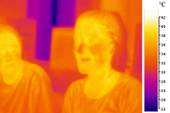
Figure 2.15: A false color image of two people taken with mid-infrared ("thermal") light.
Much of the energy from the Sun arrives on Earth in the form of infrared radiation. Sunlight at zenith provides an irradiance of just over 1 kilowatt per square meter at sea level. Of this energy, 527 watts is infrared radiation, 445 watts is visible light, and 32 watts is ultraviolet radiation. The balance between absorbed and emitted infrared radiation has a critical effect on the Earth's climate.
Infrared light is used in industrial, scientific, and medical applications. Night-vision devices using infrared illumination allow people or animals to be observed without the observer being detected. In astronomy, imaging at infrared wavelengths allows observation of objects obscured by interstellar dust. Infrared imaging cameras are used to detect heat loss in insulated systems, to observe changing blood flow in the skin, and to detect overheating of electrical apparatus.
Infrared imaging is used extensively for military and civilian purposes. Military applications include target acquisition, surveillance, night vision, homing and tracking. Non-military uses include thermal efficiency analysis, environmental monitoring, industrial facility inspections, remote temperature sensing, short-ranged wireless communication, spectroscopy, and forecasting. Infrared uses sensor-equipped telescopes to penetrate dusty regions of space, such as molecular clouds; detect objects such as planets, and to view highly red-shifted objects from the early days of the universe.
Humans at normal body temperature radiate chiefly at wavelengths around 10 μm (micrometers), as shown by Wien's displacement law.
At the atomic level, infrared energy elicits vibrational modes in a molecule through a change in the dipole moment, making it a useful frequency range for study of these energy states for molecules of the proper symmetry. Infrared spectroscopy examines absorption and transmission of photons in the infrared energy range, based on their frequency and intensity.

2.6.1. Thermography
Infrared radiation can be used to remotely determine the temperature of objects (if the emissivity is known). This is termed thermography, or in the case of very hot objects in the NIR or visible it is termed pyrometry. Thermography (thermal imaging) is mainly used in military and industrial applications but the technology is reaching the public market in the form of infrared cameras on cars due to the massively reduced production costs.
Thermographic cameras detect radiation in the infrared range of the electromagnetic spectrum (roughly 900–14,000 nanometers or 0.9–14 μm) and produce images of that radiation. Since infrared radiation is emitted by all objects based on their temperatures, according to the black body radiation law, thermography makes it possible to "see" one's environment with or without visible illumination. The amount of radiation emitted by an object increases with temperature, therefore thermography allows one to see variations in temperature (hence the name).
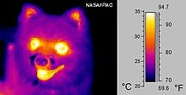
Figure 2.16: Image of a dog

2.7. Thermometer
A thermometer (from the Greek θερμός, thermos, meaning "hot" and μἐτρον, metron, "measure") is a device that measures temperature or temperature gradient using a variety of different principles. A thermometer has two important elements: the temperature sensor (e.g. the bulb on a mercury-in-glass thermometer) in which some physical change occurs with temperature, plus some means of converting this physical change into a numerical value (e.g. the visible scale that is marked on a mercury-in-glass thermometer).
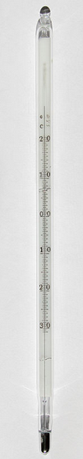
Figure 2.17: Mercury laboratory thermometer

2.7.1. Physical Principles of Thermometry
Thermometers may be described as empirical or absolute. Absolute thermometers are calibrated numerically by the thermodynamic absolute temperature scale. Empirical thermometers are not in general necessarily in exact agreement with absolute thermometers as to their numerical scale readings, but to qualify as thermometers at all they must agree with absolute thermometers and with each other in the following way: given any two bodies isolated in their separate respective thermodynamic equilibrium states, all thermometers agree as to which of the two has the higher temperature, or that the two have equal temperatures. For any two empirical thermometers, this does not require that the relation between their numerical scale readings be linear, but it does require that relation to be strictly monotonic. This is a fundamental character of temperature and thermometers.
As it is customarily stated in textbooks, taken alone, the so-called "zeroth law of thermodynamics" fails to deliver this information, but the statement of the zeroth law of thermodynamics by James Serrin in 1977, though rather mathematically abstract, is more informative for thermometry: "Zeroth Law – There exists a topological line which serves as a coordinate manifold of material behaviour. The points of the manifold are called 'hotness levels', and is called the 'universal hotness manifold'." To this information there needs to be added a sense of greater hotness; this sense can be had, independently of calorimetry, of thermodynamics, and of properties of particular materials, from Wien's displacement law of thermal: the temperature of a bath of thermal radiation is proportional, by a universal constant, to the frequency of the maximum of its frequency spectrum; this frequency is always positive, but can have values that tend to zero. Another way of identifying hotter as opposed to colder conditions is supplied by Planck's principle, that when a process of isochoric adiabatic work is the sole means of change of internal energy of a closed system, the final state of the system is never colder than the initial state; except for phase changes with latent heat, it is hotter than the initial state.
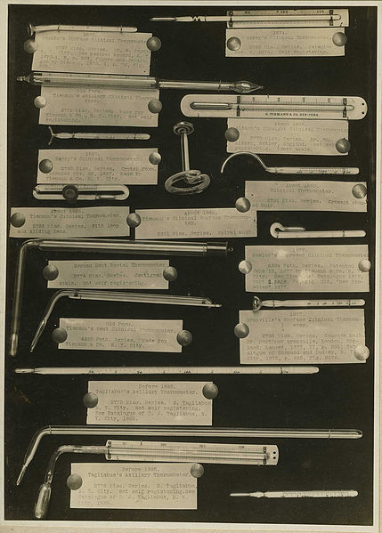
Figure 2.18: Various thermometers from the 19th century. (Wikipedia.org)

2.7.2. Thermometric Materials
There are various kinds of empirical thermometer based on material properties.
Many empirical thermometers rely on the constitutive relation between pressure, volume and temperature of their thermometric material. For example, mercury expands when heated.
If it is used for its relation between pressure and volume and temperature, a thermometric material must have three properties:
(1) Its heating and cooling must be rapid. That is to say, when a quantity of heat enters or leaves a body of the material, the material must expand or contract to its final volume or reach its final pressure and must reach its final temperature with practically no delay; some of the heat that enters can be considered to change the volume of the body at constant temperature, and is called the latent heat of expansion at constant temperature; and the rest of it can be considered to change the temperature of the body at constant volume, and is called the specific heat at constant volume. Some materials do not have this property, and take some time to distribute the heat between temperature and volume change.
(2) Its heating and cooling must be reversible. That is to say, the material must be able to be heated and cooled indefinitely often by the same increment and decrement of heat, and still return to its original pressure, volume and temperature every time. Some plastics do not have this property;
(3) Its heating and cooling must be monotonic. That is to say, throughout the range of temperatures for which it is intended to work, (a) at a given fixed pressure, either (α) the volume increases when the temperature increases, or else (β) the volume decreases when the temperature increases; not (α) for some temperatures and (β) for others; or (b) at a given fixed volume, either (α) the pressure increases when the temperature increases, or else (β) the pressure decreases when the temperature increases; not (α) for some temperatures and (β) for others.
At temperatures around about 4 °C, water does not have the property (3), and is said to behave anomalously in this respect; thus water cannot be used as a material for this kind of thermometry for temperature ranges near 4 °C.
Gases, on the other hand, all have the properties (1), (2), and (3)(a)(α) and (3)(b)(α). Consequently, they are suitable thermometric materials, and that is why they were important in the development of thermometry.

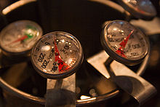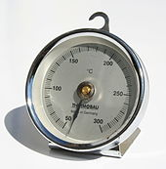
Figure 2.19: Bi-metallic stem thermometers used to measure the temperature of steamed milk(left) and Bi-metallic thermometer for cooking and baking in an oven(right)

2.7.3. Constant volume thermometry
According to Preston (1894/1904), Regnault found constant pressure air thermometers unsatisfactory, because they needed troublesome corrections. He therefore built a constant volume air thermometer. Constant volume thermometers do not provide a way to avoid the problem of anomalous behaviour like that of water at approximately 4 °C.

2.7.4. Radiometric Thermometry
Planck's law very accurately quantitatively describes the power spectral density of electromagnetic radiation, inside a rigid walled cavity in a body made of material that is completely opaque and poorly reflective, when it has reached thermodynamic equilibrium, as a function of absolute thermodynamic temperature alone. A small enough hole in the wall of the cavity emits near enough blackbody radiation of which the spectral radiance can be precisely measured. The walls of the cavity, provided they are completely opaque and poorly reflective, can be of any material indifferently. This provides a well-reproducible absolute thermometer over a very wide range of temperatures, able to measure the absolute temperature of a body inside the cavity.

2.7.5. Applications
Thermometers utilize a range of physical effects to measure temperature. Temperature sensors are used in a wide variety of scientific and engineering applications, especially measurement systems. Temperature systems are primarily either electrical or mechanical, occasionally inseparable from the system which they control (as in the case of a mercury-in-glass thermometer). Thermometers are used in roadways in cold weather climates to help determine if icing conditions exist. Indoors, thermistors are used in climate control systems such as air conditioners, freezers, heaters, refrigerators, and water heaters. Galileo thermometers are used to measure indoor air temperature, due to their limited measurement range.
Alcohol thermometers, infrared thermometers, mercury-in-glass thermometers, recording thermometers, thermistors, and Six's thermometers are used in meteorology and climatology in various levels of the atmosphere and oceans. Aircraft use thermometers and hygrometers to determine if atmospheric icing conditions exist along their flight path. These measurements are used to initialize weather forecast models. Thermometers are used in roadways in cold weather climates to help determine if icing conditions exist and indoors in climate control systems.
Bi-metallic stemmed thermometers, thermocouples, infrared thermometers, and thermistors are handy during cooking in order to know if meat has been properly cooked. Temperature of food is important because if it sits in environments with a temperature between 5 and 57 °C (41 and 135 °F) for four hours or more, bacteria can multiply leading to foodborne illnesses. Thermometers are used in the production of candy.
Medical thermometers such as mercury-in-glass thermometers, infrared thermometers, pill thermometers, and liquid crystal thermometers are used in health care settings to determine if individuals have a fever or are hypothermic.
Thermochromic liquid crystals are also used in mood rings and in thermometers used to measure the temperature of water in fish tanks.
Fiber Bragg grating temperature sensors are used in nuclear power facilities to monitor reactor core temperatures and avoid the possibility of nuclear meltdowns.
A thermometer constructed for probing stored food is also called a "temperature wand".

2.8. Humidity Measurement
Humidity is the amount of water vapor in the air. Water vapor is the gas phase of water and is invisible. Humidity indicates the likelihood of precipitation, dew, or fog. Higher humidity reduces the effectiveness of sweating in cooling the body by reducing the rate of evaporation of moisture from the skin. This effect is calculated in a heat index table, used during summer weather.
Figure 2.20: Tropical forests often have high humidity.

2.8.1. Natural Measurement of Humidity
One of nature’s hygrometers: pine cones open at low humidity to release their spores.
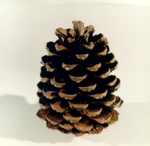
Figure 2.21: Pine cone after released its spores.

2.8.2. Measurement
There are various devices used to measure and regulate humidity. A device used to measure humidity is called a psychrometer or hygrometer. A humidistat is a humidity-triggered switch, often used to control a dehumidifier.
Humidity is also measured on a global scale using remotely placed satellites. These satellites are able to detect the concentration of water in the troposphere at altitudes between 4 and 12 kilometers. Satellites that can measure water vapor have sensors that are sensitive to infrared radiation. Water vapor specifically absorbs and re-radiates radiation in this spectral band. Satellite water vapor imagery plays an important role in monitoring climate conditions (like the formation of thunderstorms) and in the development of future weather forecasts.

2.9. Hygrometer
A hygrometer is an instrument used for measuring the moisture content in the environment. Humidity measurement instruments usually rely on measurements of some other quantity such as temperature, pressure, mass or a mechanical or electrical change in a substance as moisture is absorbed. By calibration and calculation, these measured quantities can lead to a measurement of humidity. Modern electronic devices use temperature of condensation, or changes in electrical capacitance or resistance to measure humidity differences.

2.9.1. Types of Hygrometers

2.9.1.1. Metal-paper coil type
The metal-paper coil hygrometer is very useful for giving a dial indication of humidity changes. It appears most often in very inexpensive devices, and its accuracy is limited, with variations of 10% or more. In these devices, humidity is absorbed by a salt-impregnated paper strip attached to a metal coil, causing the coil to change shape. These changes (analogous to those in a bimetallic thermometer) cause an indication on a dial.

2.9.1.2. Hair tension hygrometers
These devices use a human or animal hair under tension. The length of the hair changes with humidity and the length change may be magnified by a mechanism and/or indicated on a dial or scale. The traditional folk art device known as a weather house works on this principle.

2.9.1.3. Chilled mirror dewpoint hygormeters
Dewpoint is the temperature at which a sample of moist air (or any other water vapor) at constant pressure reaches water vapor saturation. At this saturation temperature, further cooling results in condensation of water. Chilled mirror dewpoint hygrometers are some of the most precise instruments commonly available. These use a chilled mirror and optoelectronic mechanism to detect condensation on the mirror surface. The temperature of the mirror is controlled by electronic feedback to maintain a dynamic equilibrium between evaporation and condensation on the mirror, thus closely measuring the dew point temperature. An accuracy of 0.2 °C is attainable with these devices, which correlates at typical office environments to a relative humidity accuracy of about ±0.5%. These devices need frequent cleaning, a skilled operator and periodic calibration to attain these levels of accuracy.
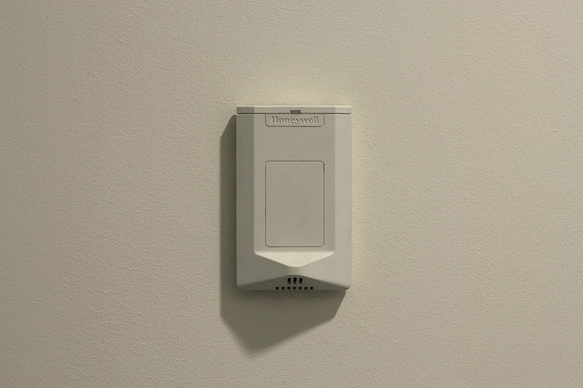
Figure 2.22: Electronic hygrometer

2.9.1.4. Capacitive Humidity Sensors
For applications where cost, space, or fragility are relevant, other types of electronic sensors are used, at the price of a lower accuracy. In capacitive humidity sensors, the effect of humidity on the dielectric constant of a polymer or metal oxide material is measured. With calibration, these sensors have an accuracy of ±2% RH in the range 5–95% RH. Without calibration, the accuracy is 2 to 3 times worse. Capacitive sensors are robust against effects such as condensation and temporary high temperatures. Capacitive sensors are subject to contamination, drift and aging effects, but are suitable for many applications.

2.9.1.5. Resistive Humidity Sensors
In resistive humidity sensors, the change in electrical resistance of a material due to humidity is measured. Typical materials are salts and conductive polymers. Resistive sensors are less sensitive than capacitive sensors - the change in material properties is less, so they require more complex circuitry. The material properties also tend to depend both on humidity and temperature, which means in practice that the sensor must be combined with a temperature sensor. The accuracy and robustness against condensation vary depending on the chosen resistive material. Robust, condensation-resistant sensors exist with an accuracy of up to ±3% RH.

2.9.1.6. Thermal conductivity humidity sensor
In thermal conductivity humidity sensors, the change in thermal conductivity of air due to humidity is measured. These sensors measure absolute humidity rather than relative humidity.

2.9.2. Applications
Besides greenhouses and industrial spaces, hygrometers are also used in some incubators (egg), saunas, humidors and museums. They are also used in the care of wooden musical instruments such as guitars and violins which can be damaged by improper humidity conditions. In residential settings, hygrometers are used to aid humidity control (too low humidity damages human skin and body, while too high humidity favours growth of mildew and dust mite). Hygrometers are also used in the coating industry because the application of paint and other coatings may be very sensitive to humidity and dew point. With a growing demand on the amount of measurements taken the psychrometer is now replaced by a dewpoint gauge known as a dewcheck. These devices make measurements a lot faster but are often not allowed in explosive environments.

3. THE DESIGNED SYSTEM
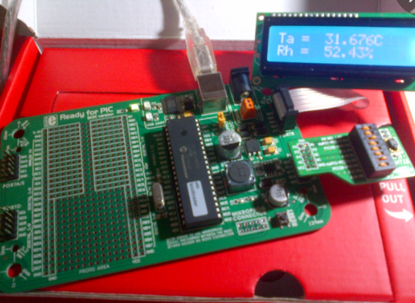
Figure 3.1: The Designed System

3.1. The block diagram
Development Board
Ready for PIC
R & T sensor
SHT11
2 x 16 LCD

PC

Figure 3.2: Block Diagram of the designed system

3.2. The SHT11 Sensor

For hundreds of years, scientists have measured weather-related phenomena. Two of the earliest aspects of weather that they measured were temperature and humidity. Although temperature is generally thought of as being a measure of how hot or cold something is, it actually refers to molecular activity. When temperatures rise, molecules become more active, and when temperatures fall, they become less active. Humidity, on the other hand, refers to how much water vapor the air contain.
Temperature and relative humidity are two very important ambient parameters that are directly related to human comfort. Sometimes, you may be able to bear higher temperatures, if there is a lower relative humidity, such as in hot and dry desert-like environment. However, being in a humid place with not very high temperature may make you feel like melting. This is because if there is high relative humidity, sweat from our body will evaporate less into the air and we feel much hotter than the actual temperature. Humidifiers and dehumidifiers help to keep indoor humidity at a comfortable level.
Sensirion's family of relative humidity and temperature sensors have become established as the industry standard - mainly due to their high performance and integration (CMOSens® Technology) in a miniature format. The capacitive humidity and temperature sensors provide digital and fully calibrated output which allows for easy integration without the need for additional calibration. The excellent long term stability has been very well perceived and the cutting edge low energy consumption is unrivalled and makes them the right choice for any remote application.
The digital humidity sensors are provided in different packaging types: SMD type (SHT1x series), pin type (SHT7x series) and the new DFN type (SHT2x series). The SHT1x and SHT2x are reflow solderable while pin type humidity sensors are used for devices where flexible integration is crucial or easy exchange is necessary. The three series are subdivided further according to different accuracy levels of humidity reading.
In our Project we will discuss about Sensirion SHT series of digital sensors, more specifically SHT11 , which are capable of measuring both temperature and relative humidity and provide fully calibrated digital outputs. We will interface SHT11 sensors to PIC18F45K22 microcontroller. We will cover all the details regarding the sensors, including their specification, interface, and communication protocol.Also we will be more focussed on the circuit diagram, implementation of the communication protocol with PICMicro, and the results

Features
- Energy consumption:  - RH operating range:  - T operating range:  - RH respnse time:  - Output: | 80uW (at 12bit, 3V, 1 measurement /s)  0 - 100% RH  -40 - +125°C (-40 - +257°F)  8 sec (tau63%)  digital (2-wire interface)
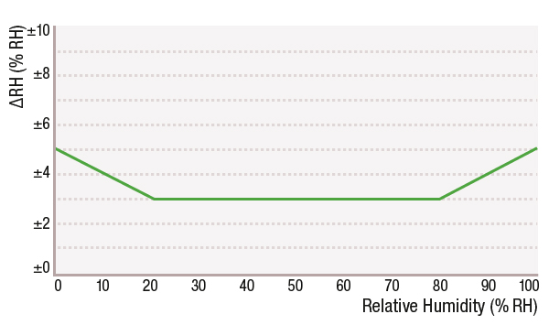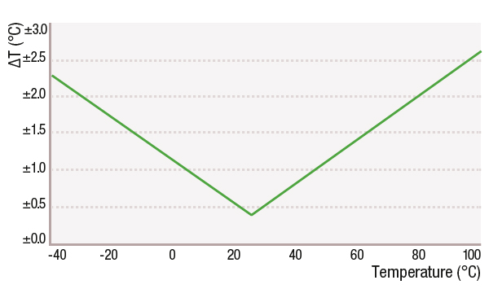
Figure 3.3: Shows the maximal accuracy limits of the sensor

3.2.1. Dimensions
The dimensions of the sensor is shown in figure 3.4
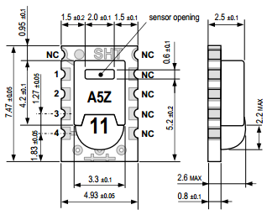
Figure 3.4: Dimensions of SHT11

3.2.2. Sensor Performance
The sensor performans is shonw in figure in figure 3.5
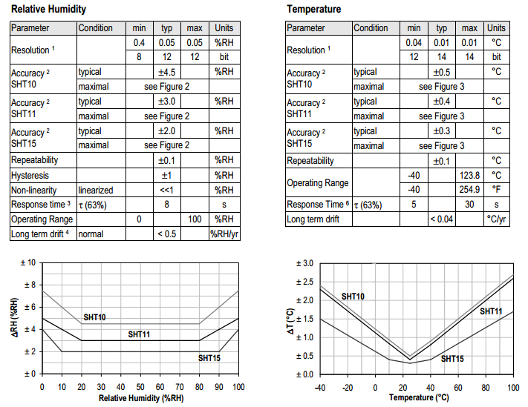
Figure 3.5: Maximal RH-tolerance at 25°C per sensor type and Maximal T-tolerance per sensor type.

3.2.3. Operating Conditions
Sensor works stable within recommended normal range – see Figure 3.6. Long term exposures to conditions outside normal range, especially at humidity >80%RH, may temporarily offset the RH signal (+3 %RH after 60h). After return to normal range it will slowly return towards calibration state by itself. Prolonged exposure to extreme conditions may accelerate ageing.
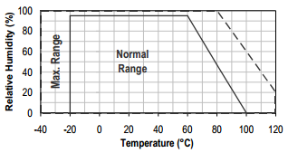
Figure 3.6: Operating Conditions

3.2.4. Storage Conditions and Handling Instructions
It is of great importance to understand that a humidity sensor is not a normal electronic component and needs to be handled with care. Chemical vapors at high concentration in combination with long exposure times may offset the sensor reading.
For these reasons it is recommended to store the sensors in original packaging including the sealed ESD bag at following conditions: Temperature shall be in the range of 10°C – 50°C (0 – 125°C for limited time) and humidity at 20 – 60%RH (sensors that are not stored in ESD bags). For sensors that have been removed from the original packaging we recommend to store them in ESD bags made of metal-in PE-HD.
In manufacturing and transport the sensors shall beprevented of high concentration of chemical solvents and long exposure times. Out-gassing of glues, adhesive tapes and stickers or out-gassing packaging material such as bubble foils, foams, etc. shall be avoided. Manufacturing area shall be well ventilated.

3.2.5. Reconditioning Procedure
As stated above extreme conditions or exposure to solvent vapors may offset the sensor. The following reconditioning procedure may bring the sensor back to calibration state:
Baking: 100 – 105°C at < 5%RH for 10h
Re-Hydration: 20 – 30°C at ~ 75%RH for 12h

3.2.6. Temperature Effect
Relative humidity reading strongly depends on temperature. Therefore, it is essential to keep humidity sensors at the same temperature as the air of which the relative humidity is to be measured. In case of testing or qualification the reference sensor and test sensor must show equal temperature to allow for comparing humidity readings.
If the SHT1x shares a PCB with electronic components that produce heat it should be mounted in a way that prevents heat transfer or keeps it as low as possible. Measures to reduce heat transfer can be ventilation, reduction of copper layers between the SHT1x and the rest of the PCB or milling a slit into the PCB around the sensor (see Figure 3.7).
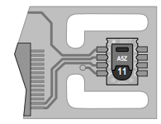
Figure 3.7: : Top view of example of mounted SHT1x with slits milled into PCB to minimize heat transfer.

3.2.7. Light
The SHT1x is not light sensitive. Prolonged direct exposure to sunshine or strong UV radiation may age the housing.

3.2.8. Membranes
SHT1x does not contain a membrane at the sensor opening. However, a membrane may be added to prevent dirt and droplets from entering the housing and to protect the sensor. It will also reduce peak concentrations of chemical vapors. For optimal response times the airvolume behind the membrane must be kept minimal.

3.2.9. Interface Specifications
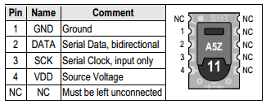
Table 3.1: SHT1x pin assignment, NC remain float

The supply voltage of SHT1x must be in the range of 2.4 – 5.5V, recommended supply voltage is 3.3V. Power supply pins Supply Voltage (VDD) and Ground (GND) must be decoupled with a 100 nF capacitor – see Figure 29. The serial interface of the SHT1x is optimized for sensor readout and effective power consumption. The sensor cannot be addressed by I2C protocol; however, the sensor can be connected to an I2C bus without interference with other devices connected to the bus. The controller must switch between the protocols.
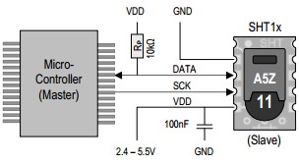
Figure 3.8: Typical application circuit, including pull up resistor RP and decoupling of VDD and GND by a capacitor.
SCK is used to synchronize the communication between microcontroller and SHT1x. Since the interface consists of fully static logic there is no minimum SCK frequency.
The DATA tri-state pin is used to transfer data in and out of the sensor. For sending a command to the sensor, DATA is valid on the rising edge of the serial clock (SCK) and must remain stable while SCK is high. After the falling edge of SCK the DATA value may be changed. For safe communication DATA valid shall be extended TSU and THO before the rising and after the falling edge of SCK, respectively – see Figure 3.9. For reading data from the sensor, DATA is valid TV after SCK has gone low and remains valid until the next falling edge of SCK.
To avoid signal contention the microcontroller must only drive DATA low. An external pull-up resistor (e.g. 10kΩ) is required to pull the signal high – it should be noted that pull-up resistors may be included in I/O circuits of microcontrollers.
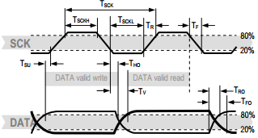
Figure 3.9: Bold DATA line is controlled by the sensor, plain DATA line is controlled by the micro-controller. Note that DATA valid read time is triggered by falling edge of anterior toggle.
The electrical characteristics such as power consumption, low and high level input and output voltages depend on the supply voltage. Table 4 gives electrical characteristics of SHT1x with the assumption of 5V supply voltage if not stated otherwise.
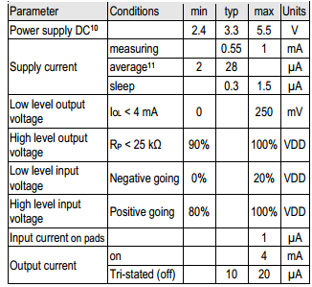
Table 3.2: SHT1x DC characteristics. RP stands for pull up resistor, while IOL is low level output current.
Absolute maximum ratings for VDD versus GND are +7V and -0.3V. Exposure to absolute maximum rating conditions for extended periods may affect the sensor reliability (e.g. hot carrier degradation, oxide breakdown). For proper communication with the sensor it is essential to make sure that signal design is strictly within the limits given in Table 3 and Figure 30.

3.2.10. Start up sensor
As a first step the sensor is powered up to chosen supply voltage VDD. The slew rate during power up shall not fall below 1V/ms. After power-up the sensor needs 11ms to get to Sleep State. No commands must be sent beforethat time.

3.2.11. Sending a command
To initiate a transmission, a Transmission Start sequence has to be issued. It consists of a lowering of the DATA line while SCK is high, followed by a low pulse on SCK and raising DATA again while SCK is still high – see Figure 3.10.
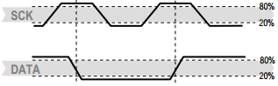
Figure 3.10: "Transmission Start" sequence.
The subsequent command consists of three address bits (only ‘000’ is supported) and five command bits. The SHT1x indicates the proper reception of a command by pulling the DATA pin low (ACK bit) after the falling edge of the 8th SCK clock. The DATA line is released (and goes high) after the falling edge of the 9th SCK clock.
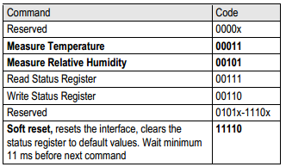
Table 3.3: SHT1X list of commands

3.3. Ready for PIC Kit

Why we use PIC microcontroller in this project?

PIC Microcontrollers are quickly replacing computers when it comes to programming robotic devices. These microcontrollers are small and can be programmed to carry out a number of tasks and are ideal for school and industrial projects. A simple program is written using a computer, it is then downloaded to a microcontroller which in turn can control a robotic device. PIC is a family of Harvard architecture microcontrollers made by Microchip Technology. The name PIC initially referred to "Peripheral Interface Controller".
PICs are popular with both industrial developers and hobbyists alike due to their low cost, wide availability, large user base, extensive collection of application notes, availability of low cost or free development tools, and serial programming (and re-programming with flash memory) capability.

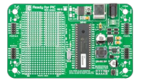
Figure 3.11: Ready for PIC Board
The board is equipped with the MCU that is placed in DIP 40 socket and contains male headers and connection pads for all available microcontroller ports. The pins are grouped according to their functions, which is clearly indicated on the silkscreen. The MCU comes pre programmed with mikroBootloader, but it can also be programmed with mikroProg™ programmer. The board also contains USB-UART module, prototyping area and a power supply circuit.
Ready for PIC® board can be powered in three different ways: via USB connector (CN1), via adapter connector using external adapters (CN2) or via additional screw terminals (CN46). The USB connection can provide up to 500mA of current which is more than enough for the operation of every on-board module and the microcontroller as well. If you decide to use external power supply, voltage values must be within 7-23V AC or 9-32V DC range. Power LED ON (GREEN) indicates the presence of power supply. Use only one of suggested methods for powering the board. If you use MCU with a 5V power supply place jumper J1 in the 5V position. Otherwise, it should be placed in the 3.3V position.
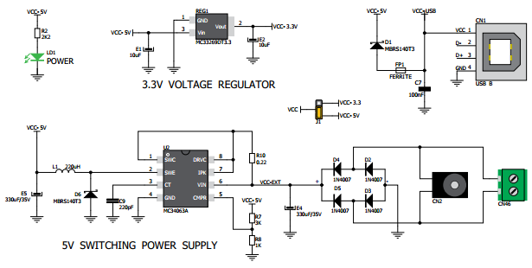
Figure 3.12: Power supply schematics
Fast on-board FTDI® chip allows to communicate with a PC or other UART devices using USB-UART connection. USB-B connector (CN1) is used for connecting the USB cable. RX (receive) and TX (transmit) LEDs will indicate communication status. Before connecting the board to a PC, make sure that you have the appropriate FTDI drivers installed on your operating system.
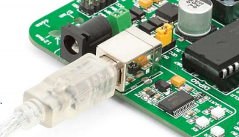
Figure 3.13: Connected USB-UART
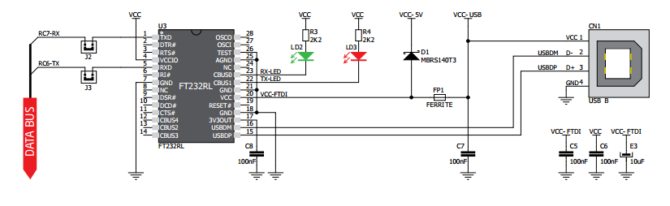
Figure 3.14: USB-UART schematic
Proto area allows you to expand Ready for PIC® board with additional functionality. It can be done by placing additional components on available prototyping area. Pads are arranged in standard 100mils distance form factor. There are 30 groups of 6 connected pads, two groups of 13 connected power pads (GND and VCC) and 186 unconnected pads.
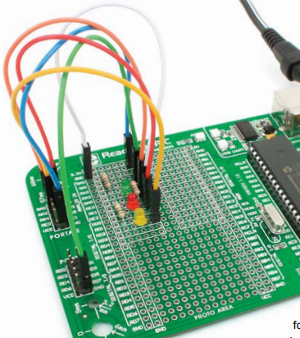
Figure 3.15: Proto area usage
Each microcontroller pin is available for further connections through four on-board 2x5 connection headers and two 1x28 connection pads. Pins are grouped in four PORT groups (2x5 male headers) as well as per their functions (1x28 connection pads), which makes development and connections much easier. Everything is printed on the silkscreen, so that there will be no need of using microcontroller data sheet while developing.
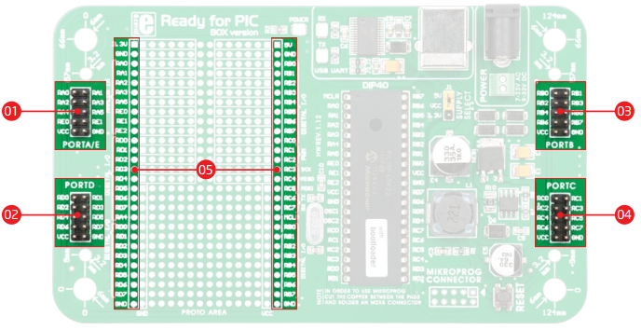
Figure 3.16: Connection pads

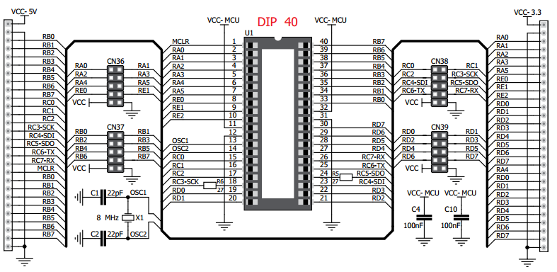
Figure 3.17: Schematics of pin headers and connection pads

3.3.1 The PIC18F45K22 Microcontroller

3.3.1.1 Properties Of PIC18F86K22

3.3.1.2 Low Power Features
  - nanoWatt XLP technology for low sleep, RTCC, LCD and WDT currents
  - Low-Power BOR
  - Ultra Low-Power Wake-Up
  - Fast Wake-Up
  - Low Input Leakage Currents

3.3.1.3 CPU
  - Up to 16 MIPS Performance
  - Operating Speed up to 64 MHz
  - Operating Voltage Range: 1.8 to 5.5V
  - 8 X 8 Single-Cycle Hardware Multiplier
  - Three Internal Oscillators: 31 kHz, 500 kHz, 16 MHz

3.3.1.3 Peripherals
  - Charge Time Measurement Unit for mTouch Sensing
  - A/D Converter
  - 12-bit Resolution
  - 24 Channels
  - Ten CCP/ECCP Modules
  - Eleven 8/16-bit Timer/Counter Modules
  - Three Analog Comparators
  - Hardware Real-Time Clock and Calendar (RTCC)
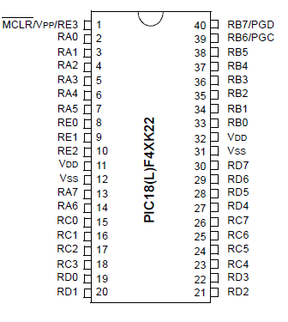
  - Two Master Synchronous Serial Port Modules

Figure 3.18: 18(L)F4XK22 Pins

This family offers the advantages of all PIC18 microcontrollers – namely, high computational performance at an economical price – with the addition of high-endurance, Flash program memory. On top of these features, the PIC18(L)F2X/4XK22 family introduces design enhancements that make these microcontrollers a logical choice for many highperformance, power sensitive applications.

All of the devices in the PIC18(L)F2X/4XK22 family incorporate a range of features that can significantly reduce power consumption during operation. Key items include:

• Alternate Run Modes: By clocking the controller from the Timer1 source or the internal oscillator block, power consumption during code execution can be reduced by as much as 90%.
• Multiple Idle Modes: The controller can also run with its CPU core disabled but the peripherals still active. In these states, power consumption can be
reduced even further, to as little as 4% of normal operation requirements.
• On-the-fly Mode Switching: The power managed modes are invoked by user code during
operation, allowing the user to incorporate power saving ideas into their application’s software design
• Low Consumption in Key Modules: The power requirements for both Timer1 and the Watchdog Timer are minimized.
All of the devices in the PIC18(L)F2X/4XK22 family offer ten different oscillator options, allowing users a wide range of choices in developing application hardware. These include:

• Four Crystal modes, using crystals or ceramic resonators
• Two External Clock modes, offering the option of using two pins (oscillator input and a divide-by-4 clock output) or one pin (oscillator input, with the second pin reassigned as general I/O)
• Two External RC Oscillator modes with the same pin options as the External Clock modes
• An internal oscillator block which contains a 16 MHz HFINTOSC oscillator and a 31 kHz
LFINTOSC oscillator, which together provide eight user selectable clock frequencies, from 31 kHz to 16 MHz. This option frees the two oscillator pins for use as additional general purpose I/O.
• A Phase Lock Loop (PLL) frequency multiplier, available to both external and internal oscillator modes, which allows clock speeds of up to 64 MHz. Used with the internal oscillator, the PLL gives users a complete selection of clock speeds, from 31 kHz to 64 MHz – all without using an external crystal or clock circuit. Besides its availability as a clock source, the internal
oscillator block provides a stable reference source that gives the family additional features for robust operation:

- Fail-Safe Clock Monitor: This option constantly monitors the main clock source against a reference signal provided by the LFINTOSC. If a clock failure occurs, the controller is switched to the internal oscillator block, allowing for continued operation or a safe application shutdown.

- Two-Speed Start-up: This option allows the internal oscillator to serve as the clock source from Power-on Reset, or wake-up from Sleep mode, until the primary clock source is available.

3.3.1.4 Other Specıal Features

• Memory Endurance: The Flash cells for both program memory and data EEPROM are rated to last for many thousands of erase/write cycles – up to 10K for program memory and 100K for EEPROM. Data retention without refresh is conservatively estimated to be greater than 40 years.

• Self-programmability: These devices can write to their own program memory spaces under internal software control. By using a bootloader routine located in the protected Boot Block at the top of program memory, it becomes possible to create an application that can update itself in the field.

• Extended Instruction Set: The PIC18(L)F2X/4XK22 family introduces an optional extension to the PIC18 instruction set, which adds eight new instructions and an Indexed Addressing mode.
This extension, enabled as a device configuration option, has been specifically designed to optimize re-entrant application code originally developed in high-level languages, such as C.

• Enhanced CCP module: In PWM mode, this module provides 1, 2 or 4 modulated outputs for controlling half-bridge and full-bridge drivers. Other features include:

- Auto-Shutdown, for disabling PWM outputs on interrupt or other select conditions
- Auto-Restart, to reactivate outputs once the condition has cleared
- Output steering to selectively enable one or more of four outputs to provide the PWM signal.

• Enhanced Addressable EUSART: This serial communication module is capable of standard RS-232 operation and provides support for the LIN bus protocol. Other enhancements include automatic baud rate detection and a 16-bit Baud Rate Generator for improved resolution. When the microcontroller is using the internal oscillator block, the EUSART provides stable operation for applications that talk to the outside world without using an external crystal (or its accompanying power requirement).

• 10-bit A/D Converter: This module incorporates programmable acquisition time, allowing for a channel to be selected and a conversion to be initiated without waiting for a sampling period and thus, reduce code overhead.

• Extended Watchdog Timer (WDT): This enhanced version incorporates a 16-bit
postscaler, allowing an extended time-out range that is stable across operating voltage and
temperature.
Devices in the PIC18(L)F2X/4XK22 family are available in 28-pin and 40/44-pin packages. The block diagram for the device family is shown in Figure below.
The devices have the following differences:

1. Flash program memory
2. Data Memory SRAM
3. Data Memory EEPROM
4. A/D channels
5. I/O ports
6. ECCP modules (Full/Half Bridge)
7. Input Voltage Range/Power Consumption

Table 6: 18(L)F4XK22

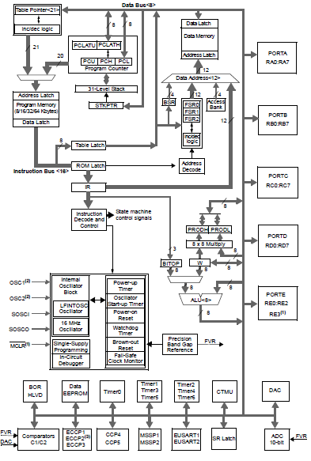
Table 3.4: MCU block diagram
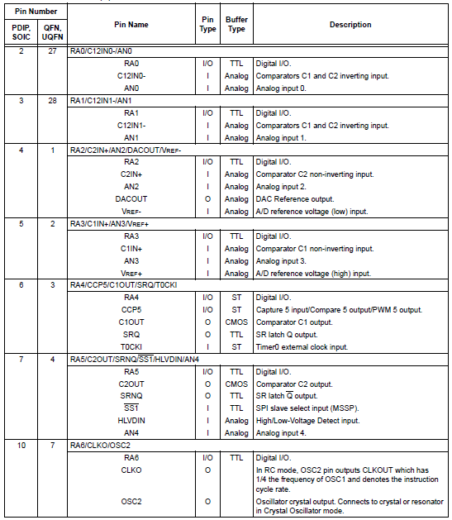
Table 3.5: PIC18(L)F2XK22 Pinout I/O Descriptions
Figure 26: 18(L)F4XK22 Schmatic

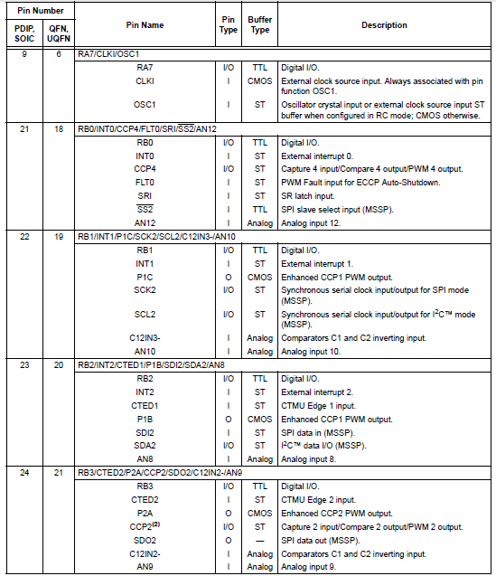
Table 3.6: PIC18(L)F2XK22 Pinout I/O Descriptions (Continued)

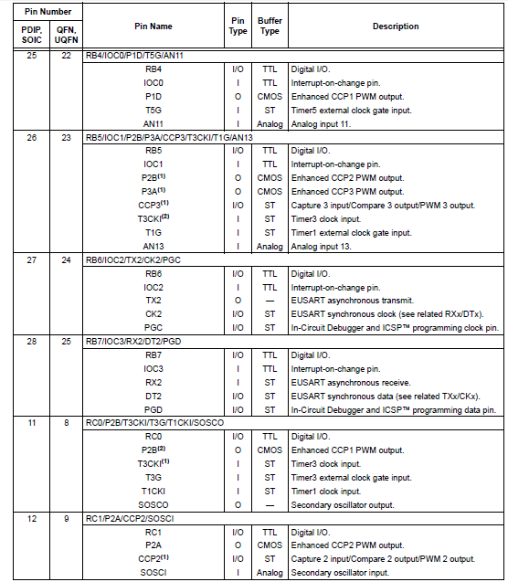
Table 3.7: PIC18(L)F2XK22 Pinout I/O Descriptions (Continued)
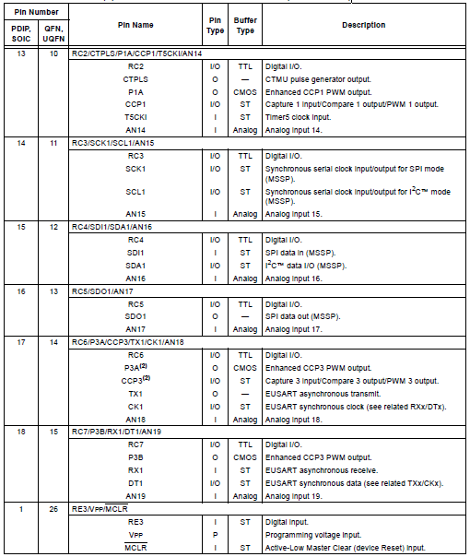
Table 3.8: PIC18(L)F2XK22 Pinout I/O Descriptions (Continued)
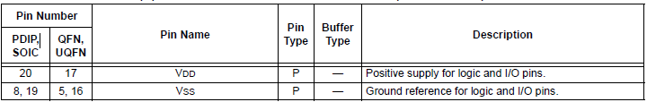
Table 3.9: PIC18(L)F2XK22 Pinout I/O Descriptions (Continued)

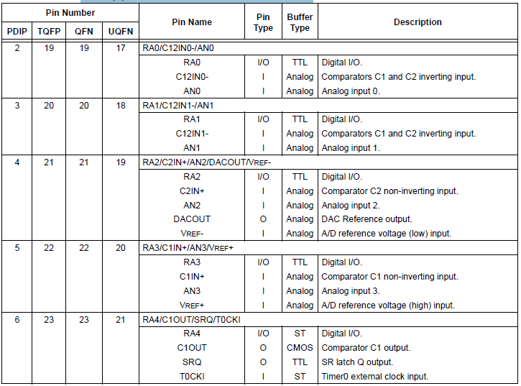
Table 3.10: PIC18(L)F4XK22 Pinout I/O Descriptions

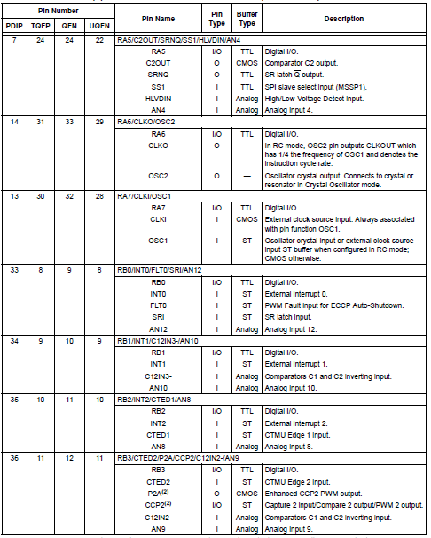
Table 3.11: PIC18(L)F4XK22 Pinout I/O Descriptions (Continued)

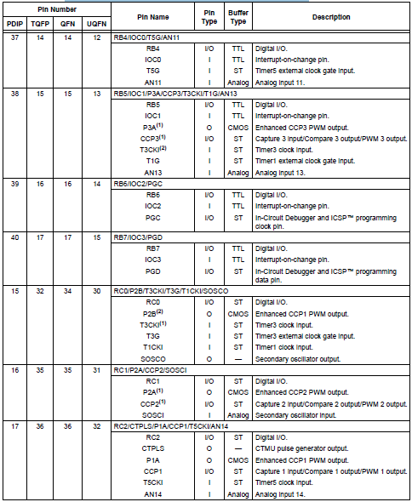
Table 3.12: PIC18(L)F4XK22 Pinout I/O Descriptions (Continued)

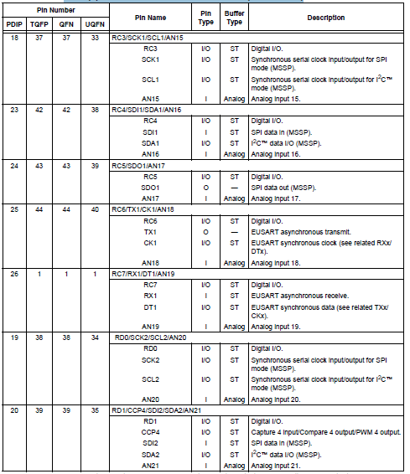
Table 3.13: PIC18(L)F4XK22 Pinout I/O Descriptions (Continued)

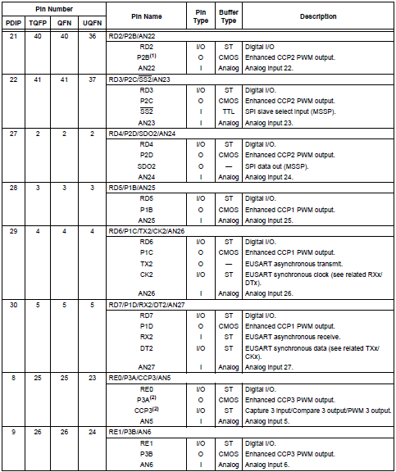
Table 3.14: PIC18(L)F4XK22 Pinout I/O Descriptions (Continued)
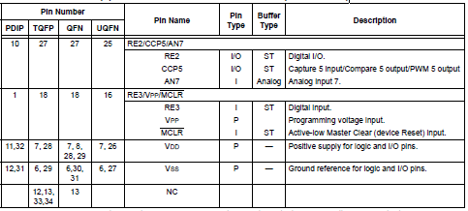
Table 3.15: PIC18(L)F4XK22 Pinout I/O Descriptions (Continued)

3.3.2. Oscillator Module (With Fail-Safe Clock Monitor)

The oscillator module has a wide variety of clock sources and selection features that allow it to be used in a wide range of applications while maximizing performance
and minimizing power consumption.Figure illustrates a block diagram of the oscillator module. Clock sources can be configured from external oscillators, quartz crystal resonators, ceramic resonators and Resistor-Capacitor (RC) circuits. In addition, the system clock source can be configured from one of three internal oscillators, with a choice of speeds selectable via
software. Additional clock features include:

• Selectable system clock source between external or internal sources via software.
• Two-Speed Start-up mode, which minimizes latency between external oscillator start-up and
code execution.
• Fail-Safe Clock Monitor (FSCM) designed to detect a failure of the external clock source (LP,
XT, HS, EC or RC modes) and switch automatically to the internal oscillator.
• Oscillator Start-up Timer (OST) ensures stability of crystal oscillator sources.
The primary clock module can be configured to provide one of six clock sources as the primary clock.

1. RC External Resistor/Capacitor
2. LP Low-Power Crystal
3. XT Crystal/Resonator
4. INTOSC Internal Oscillator
5. HS High-Speed Crystal/Resonator
6. EC External Clock

The HS and EC oscillator circuits can be optimized for power consumption and oscillator speed using settings in FOSC<3:0>. Additional FOSC<3:0> selections enable RA6 to be used as I/O or CLKO (FOSC/4) for RC, EC and INTOSC Oscillator modes. Primary Clock modes are selectable by the FOSC<3:0> bits of the CONFIG1H Configuration register. The primary clock operation is further defined by these Configuration and register bits:

1. PRICLKEN (CONFIG1H<5>)
2. PRISD (OSCCON2<2>)
3. PLLCFG (CONFIG1H<4>)
4. PLLEN (OSCTUNE<6>)
5. HFOFST (CONFIG3H<3>)
6. IRCF<2:0> (OSCCON<6:4>)
7. MFIOSEL (OSCCON2<4>)
8. INTSRC (OSCTUNE<7>)
The HFINTOSC, MFINTOSC and LFINTOSC are factory calibrated high, medium and low-frequency oscillators, respectively, which are used as the internal clock sources.
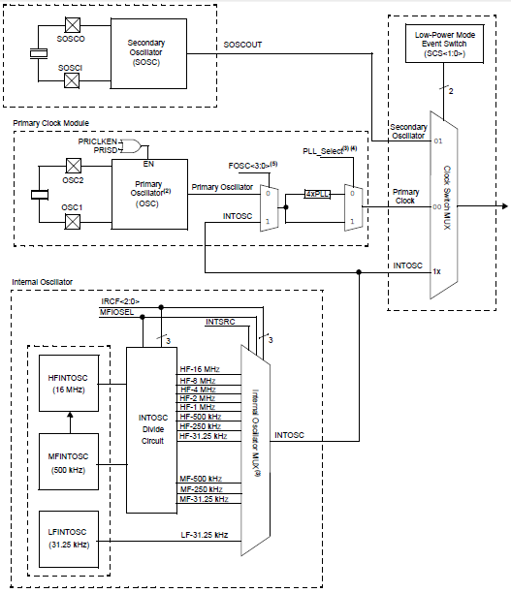

Figure 3.19: Simplified Oscillator System Block Diagram

3.3.3. Power-Managed Modes

PIC18(L)F2X/4XK22 devices offer a total of seven operating modes for more efficient power management. These modes provide a variety of options for selective power conservation in applications where resources may be limited (i.e., battery-powered
devices). There are three categories of power-managed modes:

• Run modes
• Idle modes
• Sleep mode
These categories define which portions of the deviceare clocked and sometimes, what speed. The Run and Idle modes may use any of the three available clock
sources (primary, secondary or internal oscillator block). The Sleep mode does not use a clock source. The power-managed modes include several powersaving features offered on previous PIC® microcontroller devices. One of the clock switching features allows the
controller to use the secondary oscillator (SOSC) in place of the primary oscillator. Also included is the Sleep mode, offered by all PIC® microcontroller devices, where all device clocks are stopped.

3.3.3.1. Selecting Power Managed Mode

Selecting a power-managed mode requires two decisions:

• Whether or not the CPU is to be clocked
• The selection of a clock source

The IDLEN bit (OSCCON<7>) controls CPU clocking, while the SCS<1:0> bits (OSCCON<1:0>) select the clock source. The individual modes, bit settings, clock sources and affected modules are summarized.

3.3.3.2. Clock Sources

The SCS<1:0> bits allow the selection of one of three clock sources for power-managed modes. They are:
• the primary clock, as defined by the FOSC<3:0>

Configuration bits
• the secondary clock (the SOSC oscillator)
• the internal oscillator block

3.3.3.3. Entering Power-managed Modes
Switching from one power-managed mode to another begins by loading the OSCCON register. The SCS<1:0> bits select the clock source and determine which Run or Idle mode is to be used. Changing these bits causes an immediate switch to the new clock source, assuming that it is running. The switch may also be subject to clock transition delays. Entry to the power-managed Idle or Sleep modes is triggered by the execution of a SLEEP instruction. The actual mode that results depends on the status of the IDLEN bit. Depending on the current mode and the mode being switched to, a change to a power-managed mode does not always require setting all of these bits. Many transitions may be done by changing the oscillator select bits, or changing the IDLEN bit, prior to issuing a SLEEP instruction. If the IDLEN bit is already configured correctly, it may only be necessary to perform a SLEEP instruction to switch to the desired mode.
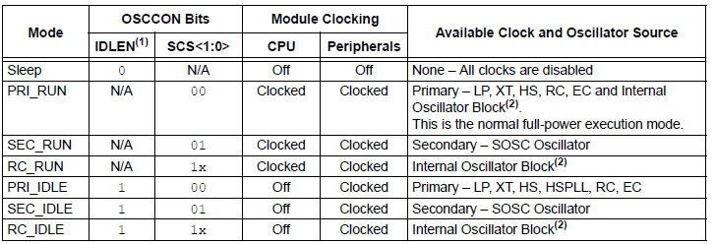
Table 3.16: Power-managed modes

3.3.3.4. Multiple Functıons of the Sleep Command

The power-managed mode that is invoked with the SLEEP instruction is determined by the value of the IDLEN bit at the time the instruction is executed. If IDLEN = 0, when SLEEP is executed, the device enters the Sleep mode and all clocks stop and minimum power is consumed. If IDLEN = 1, when SLEEP is executed, the device enters the IDLE mode and the system clock continues to supply a clock to the peripherals but is disconnected from the CPU.

3.3.3.5. Run Modes
In the Run modes, clocks to both the core and peripherals are active. The difference between these modes is the clock source.

3.3.3.6. Pri_Run Mode
The PRI_RUN mode is the normal, full-power execution mode of the microcontroller. This is also the default mode upon a device Reset, unless Two-Speed Start-up is enabled. In this mode, the device is operated off the oscillator defined by the FOSC<3:0> bits of the CONFIG1H Configuration register.

3.3.3.7. Sec_Run Mode
In SEC_RUN mode, the CPU and peripherals are clocked from the secondary external oscillator. This gives users the option of lower power consumption while still using a high accuracy clock source. SEC_RUN mode is entered by setting the SCS<1:0> bits to ‘01’. When SEC_RUN mode is active, all of the following are true:

• The device clock source is switched to the SOSC oscillator
• The primary oscillator is shut down
• The SOSCRUN bit (OSCCON2<6>) is set
• The OSTS bit (OSCCON2<3>) is cleared

3.3.4. Memory Organızation
There are three types of memory in PIC18 Enhancedmicrocontroller devices:
• Program Memory
• Data RAM
• Data EEPROM
As Harvard architecture devices, the data and program memories use separate buses; this allows for concurrent access of the two memory spaces. The data EEPROM, for practical purposes, can be regarded as a peripheral device, since it is addressed and accessed through a set of control registers. PIC18 microcontrollers implement a 21-bit program counter, which is capable of addressing a 2-Mbyte program memory space. Accessing a location between the upper boundary of the physically implemented memory and the 2-Mbyte address will return all ‘0’s (a NOP instruction).
• PIC18(L)F25K22, PIC18(L)F45K22: 32 Kbytes of Flash Memory, up to 16,384 single-word instructions.

3.3.5. Flash Program Memory

The Flash program memory is readable, writable and erasable during normal operation over the entire VDD range. A read from program memory is executed one byte at a time. A write to program memory is executed on blocks of 64 bytes at a time. Program memory is erased in blocks of 64 bytes at a time. A bulk erase operation cannot be issued from user code.
Writing or erasing program memory will cease instruction fetches until the operation is complete. The program memory cannot be accessed during the write or erase, therefore, code cannot execute. An internal programming timer terminates program memory writes and erases.
A value written to program memory does not need to be a valid instruction. Executing a program memory location that forms an invalid instruction results in a NOP.

3.3.6. Data Eeprom Memory

The data EEPROM is a nonvolatile memory array, separate from the data RAM and program memory, which is used for long-term storage of program data. I is not directly mapped in either the register file or program memory space but is indirectly addressed through the Special Function Registers (SFRs). The EEPROM is readable and writable during normal operation over the entire VDD range.
Four SFRs are used to read and write to the data EEPROM as well as the program memory. They are:
• EECON1
• EECON2
• EEDATA
• EEADR
• EEADRH
The data EEPROM allows byte read and write. When interfacing to the data memory block, EEDATA holds the 8-bit data for read/write and the EEADR:EEADRH register pair hold the address of the EEPROM location being accessed.
The EEPROM data memory is rated for high erase/write cycle endurance. A byte write automatically erases the location and writes the new data (erase-before-write).The write time is controlled by an on-chip timer; it will vary with voltage and temperature as well as from chipto- chip.

3.3.7. I/O Ports

Depending on the device selected and features enabled, there are up to five ports available. All pins of the I/O ports are multiplexed with one or more alternate functions from the peripheral features on the device. In general, when a peripheral is enabled, that pin may not be used as a general purpose I/O pin.
Each port has five registers for its operation. These registers are:
• TRIS register (data direction register)
• PORT register (reads the levels on the pins of the
device)
• LAT register (output latch)
• ANSEL register (analog input control)
• SLRCON register (port slew rate control)
The Data Latch (LAT register) is useful for read-modifywrite operations on the value that the I/O pins are driving.

4. THE SOFTWARE
In this project, to write the codes microC is used and microbootloader is used to upload codes to microcontroller. microC is the platform that allows to user coding and microbootloader provide uploading codes into microcontroller. Every adjustments can be done with these programs.

4.1. Codes
The program listing of the Project is giving below:

// LCD module connections
sbit LCD_RS at LATB2_bit;
sbit LCD_EN at LATB3_bit;
sbit LCD_D4 at LATB4_bit;
sbit LCD_D5 at LATB5_bit;
sbit LCD_D6 at LATB6_bit;
sbit LCD_D7 at LATB7_bit;

sbit LCD_RS_Direction at TRISB2_bit;
sbit LCD_EN_Direction at TRISB3_bit;
sbit LCD_D4_Direction at TRISB4_bit;
sbit LCD_D5_Direction at TRISB5_bit;
sbit LCD_D6_Direction at TRISB6_bit;
sbit LCD_D7_Direction at TRISB7_bit;
// End LCD module connections

//SHT11 connections
sbit SDAbit at RC4_bit; // Serial data pin
sbit SCLbit at RC3_bit; // Serial clock pin

sbit SDAbit_Direction at TRISC4_bit; // Serial data direction pin
sbit SCLbit_Direction at TRISC3_bit; // Serial clock direction pin

// Constants for calculating temperature and humidity
const unsigned int C1 = 400; // -4
const unsigned int C2 = 405; // 0.0405 (405 * 10^-4)
const unsigned short C3 = 28; // -2.8 * 10^-6 (28 * 10^-7)
const unsigned int D1 = 4000; // -40
const unsigned short D2 = 1; // 0.01

unsigned short i, j;
long int temp, k, SOt, SOrh, Ta_res, Rh_res;
char Ta[16] = "Ta = 000.00 ";
char Rh[16] = "Rh = 000.00 ";

void Setup_Delay()
{
Delay_ms(20);
}

void SHT_Reset() {
SCLbit = 0; // SCLbit low
SDAbit_Direction = 1; // define SDAbit as input
for (i = 1; i <= 18; i++) // repeat 18 times
{
SCLbit = 1;
Delay_us(1);
SCLbit = 0;
Delay_us(1);
}
}

void Transmission_Start() {
SDAbit_Direction = 1; // define SDAbit as input
SCLbit = 1; // SCLbit high
Delay_us(1); // 1us delay
SDAbit_Direction = 0; // define SDAbit as output
SDAbit = 0; // SDAbit low
Delay_us(1); // 1us delay
SCLbit = 0; // SCLbit low
Delay_us(1); // 1us delay
SCLbit = 1; // SCLbit high
Delay_us(1); // 1us delay
SDAbit_Direction = 1; // define SDAbit as input
Delay_us(1); // 1us delay
SCLbit = 0; // SCLbit low
}

// MCU ACK
void MCU_ACK() {
SDAbit_Direction = 0; // define SDAbit as output
SDAbit = 0; // SDAbit low
SCLbit = 1; // SCLbit high
Delay_us(1); // 1us delay
SCLbit = 0; // SCLbit low
Delay_us(1); // 1us delay
SDAbit_Direction = 1; // define SDAbit as input
}

// This function returns temperature or humidity, depends on command
long int Measure(short num) {
j = num; // j = command (0x03 or 0x05)
SHT_Reset(); // procedure for reseting SHT11
Transmission_Start(); // procedure for starting transmission
k = 0; // k = 0
SDAbit_Direction = 0; // define SDAbit as output
SCLbit = 0; // SCLbit low
for(i = 1; i <= 8; i++) { // repeat 8 times
if (j.F7 == 1) // if bit 7 = 1
SDAbit_Direction = 1; // define SDAbit as input
else { // else (if bit 7 = 0)
SDAbit_Direction = 0; // define SDAbit as output
SDAbit = 0; // SDAbit low
}
Delay_us(1); // 1us delay
SCLbit = 1; // SCLbit high
Delay_us(1); // 1us delay
SCLbit = 0; // SCLbit low
j <<= 1; // move contents of j one place left
}

SDAbit_Direction = 1; // define SDAbit as input
SCLbit = 1; // SCLbit high
Delay_us(1); // 1us delay
SCLbit = 0; // SCLbit low
Delay_us(1); // 1us delay
while (SDAbit == 1) // while SDAbit is high, do nothing
Delay_us(1); // 1us delay

for (i = 1; i <=16; i++) { // repeat 16 times
k <<= 1; // move contents of k one place left
SCLbit = 1; // SCLbit high
if (SDAbit == 1) // if SDAbit is high
k = k | 0x0001;
SCLbit = 0;
if (i == 8) // if counter i = 8 then
MCU_ACK(); // MCU acknowledge
}
return k; // returns contents of k
}

void main()

{
ANSELB = 0; // Configure AN pins as digital
ANSELC = 0;

TRISC = 0;

SCLbit_Direction = 0; // SCLbit is output
Setup_Delay();
LCD_Init(); // init LCD on PORTB (for EasyPIC3 or lower)
LCD_Cmd(_LCD_CURSOR_OFF); // turns of LCD cursor

LCD_Out(1, 1, "CEM GEGA"); // write text on first row, seventh column
LCD_Out(2, 1, "PROJECT"); // write text on second row, second column
Delay_ms(2000); // delay 2 sec
LCD_Cmd(_LCD_CLEAR); // clear LCD

Ta[11] = 178; // If you see greek alpha letter try typing 178 instead of 223
Ta[12] = 'C'; // 'C' character

Rh[11] = '%'; // '%' character

while (1) {
// Measuring temperature
SOt = Measure(0x03); // function for measuring (command 0x03 is for temperature)

// Measuring humidity
SOrh = Measure(0x05); // function for measuring (command 0x05 is for humidity)

// Calculating temperature
// Ta_res = D1 + D2 * SOt
if(SOt > D1) // if temperature is positive
Ta_res = SOt * D2 - D1; // calculate temperature
else // else (if temperature is negative)
Ta_res = D1 - SOt * D2; // calculate temperature

// Calculating humidity
// Rh_res = C1 + C2 * SOrh + C3 * SOrh^2
temp = SOrh * SOrh * C3 / 100000; // calculate humidity
Rh_res = SOrh * C2 / 100 - temp - C1; // calculate humidity

// Preparing temperature for LCD
Ta[5] = Ta_res / 10000 + 48; //
Ta[6] = Ta_res % 10000 / 1000 + 48; //
Ta[7] = Ta_res % 1000 / 100 + 48; //
Ta[9] = Ta_res % 100 / 10 + 48; //
Ta[10] = Ta_res % 10 + 48; //

// Preparing humidity for LCD
Rh[5] = Rh_res / 10000 + 48; //
Rh[6] = Rh_res % 10000 / 1000 + 48; //
Rh[7] = Rh_res % 1000 / 100 + 48; //
Rh[9] = Rh_res % 100 / 10 + 48; //
Rh[10] = Rh_res % 10 + 48; //

// delete unnecessary digits (zeros)
if (Ta[5] == '0') // if Ta[5] = '0' then
Ta[5] = ' '; // insert blank character to Ta[5]
if (Ta[5] == ' ' && Ta[6] == '0') // if Ta[5] is blank and Ta[6] = '0' then
Ta[6] = ' '; // insert blank character to Ta[6]

if (Rh[5] == '0') // if Ta[5] = '0' then
Rh[5] = ' '; // insert blank character to Ta[5]
if (Rh[5] == ' ' && Rh[6] == '0') // if Ta[5] is blank and Ta[6] = '0' then
Rh[6] = ' '; // insert blank character to Ta[6]

// Display temperature on LCD
Lcd_Out(1, 1, Ta); // display temperature on first row, i column

// Display humidity on LCD
Lcd_Out(2, 1, Rh); // display humidity on second row, i column
Delay_ms(700); // delay 700ms }}

4.2. MicroC

MicroC is a graphical software design and implementation tool that supports the development of embedded real-time software for micro-controllers. The focus of the tool is to support the process of developing software pieces while targeting small micro-controllers. The support to design-level debugging, testing – both interactively and in batch mode and analysis of runs is implemented through various instrumentation of the generated code. The output of the tool is a compact, readable ANSI C code, with support to local extensions of the standard C, as well as automatically generated design documentation. MicroC uses an Operating System Implementation (OSI) definition to describe the implementation of the software and hardware target environment for a given design. Any one OSI might support only a subset of the design concepts referred to above. As a general rule, the tool tries to make use of any such design aspect/concept it encounters in the model. If the given OSI has no support for that design aspect/concept, an error message is produced.

It is designed to provide the programmer with the easiest possible solution to developing applications for embedded systems, without compromising performance or control.

Features
- Write your C source code using the built-in Code Editor (Code and Parameter
- Assistants, Code Folding, Syntax Highlighting, Auto Correct, Code Templates,
and more.)
- Use included mikroC PRO for PIClibraries to dramatically speed up the devel
opment: data acquisition, memory, displays, conversions, communication etc.
- Monitor your program structure, variables, and functions in the Code Explorer.
- Generate commented, human-readable assembly, and standard HEX compati
ble with all programmers.

4.3. Basic Flow Diagram
The flow diagram of the program is shown in figure 4.1:
START

CALCULATIONS OF T&RH
INPUT T&RH
OUTPUT OF T&RH

Figure 4.1: Flow diagram

5. TESTING AND RESULTS
With the support of mikroe and mikroC library, we construct the program. At the beginning of testing the output was not proper. After some sort of researching solution come to light. Pins of SHT11 are not determined correctly. The correct codes are given below:

sbit SDAbit at RC4_bit; // Serial data pin
sbit SCLbit at RC3_bit; // Serial clock pin

sbit SDAbit_Direction at TRISC4_bit; // Serial data direction pin
sbit SCLbit_Direction at TRISC3_bit; // Serial clock direction pin

The designed system was tested in the laboratory and the result were satisfactory. Both the temperature and the humidity were measured very accurately over the specified ranges.
With these codes, serial data pin, serial clock pin, serial data direction pin and serial clock direction pin are defined. End of these process, output gives us correct values according to other measurement devices.

6. CONCLUSION
Intelligent sensors with their advantages like combining temperature and humidity sensing elements, integrating ADC, amplifiers and serial interface make development of measurement systems easier. These advantages also decrease development time and cost and the size of the product. One application where these sensors find place are distributed measurement and monitoring systems like meteorological stations, HVAC systems, automotive temperature control and many others. The SHT11 has an address of 3bits, which in present sensors cannot be changed from “000”. This address can be used for future applications like sensor networks and adhoc sensor networks which are leading tendencies in automation and control technologies.
The system that we constructed can be innovated. GSM communication layer can be added. These GSM layers supports GSM/GPRS 850/900/1800/ 1900 MHz Quad-band frequency. Thus, the system can be communicated some points that programmed. It can be used by emergency services, fire stations or central air condition staffs’ cell phones.

7. FUTURE WORK
Temperature and humidity measurement has important role in lots of industrial area and also medical industry area. Especially these two parameters are used in production of laboratory devices. (oven , medical freezer , incubator and etc. ) SHT series sensors might be used in medical industry.
In the future aspect of this work we think that for some of devices (like growth chamber) , SHT11 sensor can be used with heating technology. For example to store some of the plant that are used in medical researches chambers are used. These chambers stimulate normal humidity and temperature conditions to keep these plants stable. Before using these devices we must adjust set value for each application and this process takes lots of time. If we use SHT11 sensor with heat and humidity mechanism, we can register these parameter in devices and consecuently adjust the temperature and humidity automatically. We can use SHT11 type sensors to measure heat and humidity. The sensor can either be used in monitoring or in control mode. In monitoring mode the temperature and humidity are measured and then displayed. In control mode, the temperature and humidity of a plant are controlled as required.
In conclusion SHT series of sensor, and MicroC programming techniques can lead better automation and control technology.

8. REFERENCES
1. İbrahim Doğan (2011). Microcontroller for Students – The Theory.
2. İbrahim Doğan (2011). Microcontroller for Students – Practicals.
3. mikroelektronika microC pro for PIC user manual
4.http://fett.tusofia.bg/et/2004/Papers/Electronic%20Systems%20in%20Measurement%20and%20Control/Paper-Gr_Spasov.pdf
5. www.wikipedia.org
6.http://www.npl.co.uk/upload/pdf/Beginner's%20guide%20to%20humidity%20measurement%20(draft%20for%20comment).pdf
7. http://www.asknature.org/strategy/1ebbd861249e5657c8c21b4fabe0d0f4
8. www.sensirion.com
9. www.mikroe.com
10. http://www.yzxz.com/images/upfile/2009-9/200992418744.pdf
11. http://www.meas-spec.com/downloads/Temperature_Sensor_Advantages.pdf
12. http://www.ehow.com/info_8324988_temperature-humidity-instruments.html
13.http://publib.boulder.ibm.com/infocenter/rsdp/v1r0m0/topic/com.ibm.help.download.statemate.doc/pdf/microc_programming_style_guide.pdf

