**Near East University**



**Faculty of Engineering**

**Biomedical Engineering**

Graduation Project **Muscular Bio-stimulator**

Prepared by:  
**Ahmad J. A. ELTALMAS (20102881)  
Fetih NURCIN (20071453)  
Ismail KEMER (20082238)**

Supervised by : **Dr.**[**Zafer TOPUKCU**](http://neu.edu.tr/en/node/2579)

Year: **2012 – 2013  
  
Nicosia**

**Dedicated to our beloved families , our fathers that gave us the power to continue our universities , our mothers that gave us all big meanings in this life , and the steadfast Palestine, with profound craving and sincerity…**

**To our respected university with honor and deep appreciation, as will as we will always be grateful to our teachers, especially Dr. Zafer, who handed us with their priceless knowledge and set me to the future success.**

**Table of Contents**

Human anatomy 6

-Introduction 7

-Approaches 8  
  
- Regional groups 8

### Organ systems that interfer with the work of Bio-Muscular Stimulator 9

### - Superficial anatomy 10

Biopotentials 11

- Human Biopotentials 11

-Intracellular Concentration 13

Electricty in Human Body 14

Structure of muscles 15

- General components of muscle fibers 17

- Thick and thin filaments 18

**The**"Sliding-Filament Theory of Muscle Action***"* 18**

**- Neuromuscular Junction Actions 21**

**Types of Muscle Contractions 21**

Electrical Muscle Stimulation 24

- Introduction 24

- History 25

- Theory 26

- Benefits of EMS (Electronic Muscle Stimulation) 26

- How does Muscular Stimulator work? 26

- Use 27

# - What EMS can and can't Do 27

# - Why do we use EMS? 28

# - EMS and TENS 28

# - Choosing an EMS device 28

*-*Electrotherapy and Chronic Pain 30

Transcutaneous electrical nerve stimulation (TENS) 31

## - Medical uses 31

- Safety 31

Examples 33

Circuit 33  
 - Design Elements of Muscle Stimulators 33

- Types of Pulses that Produce a Waveform 34

- Summary 37

- Diagram of our circuit 39

- Electrical parts of our circuit 39

- Practical steps 41

### Electronic muscle stimulator timer circuit 47

Effects of Electrical Stimulation on Body (workshop) 48

Current Concepts in Electronic Stimulaiton 58

Nerve Membrane Thresholds 62

- Refractory Period(s) 63

Pulse Shape and Duration 64

References 65

**Human anatomy**

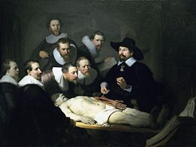

Human anatomy is primarily the scientific study of the [morphology](http://en.wikipedia.org/wiki/Morphology_(biology)) of the [human body](http://en.wikipedia.org/wiki/Human_body).[Anatomy](http://en.wikipedia.org/wiki/Anatomy) is subdivided into gross anatomy and microscopic anatomy. Gross anatomy is the study of anatomical structures that can be seen by the naked eye.

Microscopic anatomy is the study of minute anatomical structures assisted with [microscopes](http://en.wikipedia.org/wiki/Microscope), which includes [histology](http://en.wikipedia.org/wiki/Histology) , and [cytology](http://en.wikipedia.org/wiki/Cell_(biology)) .[Anatomy](http://en.wikipedia.org/wiki/Anatomy" \o "Anatomy),[human physiology](http://en.wikipedia.org/wiki/Human_physiology" \o "Human physiology) (the study of function), and [biochemistry](http://en.wikipedia.org/wiki/Biochemistry) (the study of the chemistry of living structures) are complementary basic medical sciences that are generally together (or in tandem) to students studying [medical sciences](http://en.wikipedia.org/wiki/Health_science).

The human body consists of [biological systems](http://en.wikipedia.org/wiki/Systems_biology), that consist of [organs](http://en.wikipedia.org/wiki/Organ_(anatomy)), that consist of [tissues](http://en.wikipedia.org/wiki/Tissue_(biology)), that consist of [cells](http://en.wikipedia.org/wiki/Cell_(biology)) and [connective tissue](http://en.wikipedia.org/wiki/Connective_tissue).

[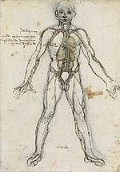](http://en.wikipedia.org/wiki/File:Anatomical_Male_Figure_Showing_Heart,_Lungs,_and_Main_Arteries.jpg)

## *Approaches*

### *Regional groups*

* [Head](http://en.wikipedia.org/wiki/Human_head) and [neck](http://en.wikipedia.org/wiki/Neck) – includes everything above the [thoracic inlet](http://en.wikipedia.org/wiki/Superior_thoracic_aperture).
* [Upper limb](http://en.wikipedia.org/wiki/Upper_limb) – includes the [hand](http://en.wikipedia.org/wiki/Hand), [wrist](http://en.wikipedia.org/wiki/Wrist), [forearm](http://en.wikipedia.org/wiki/Forearm), [elbow](http://en.wikipedia.org/wiki/Elbow), [arm](http://en.wikipedia.org/wiki/Arm), and [shoulder](http://en.wikipedia.org/wiki/Shoulder).
* [Thorax](http://en.wikipedia.org/wiki/Chest) – the region of the chest from the [thoracic inlet](http://en.wikipedia.org/wiki/Superior_thoracic_aperture) to the [thoracic diaphragm](http://en.wikipedia.org/wiki/Thoracic_diaphragm).
* [Human abdomen](http://en.wikipedia.org/wiki/Human_abdomen) to the [pelvic brim](http://en.wikipedia.org/wiki/Pelvic_brim) or to the pelvic inlet.
* The [back](http://en.wikipedia.org/wiki/Human_back) – the [spine](http://en.wikipedia.org/wiki/Spine_(human_anatomy)) and its components, the [vertebrae](http://en.wikipedia.org/wiki/Human_vertebra), [sacrum](http://en.wikipedia.org/wiki/Sacrum), [coccyx](http://en.wikipedia.org/wiki/Coccyx), and [intervertebral disks](http://en.wikipedia.org/wiki/Intervertebral_disk).
* [Pelvis](http://en.wikipedia.org/wiki/Human_pelvis) and [Perineum](http://en.wikipedia.org/wiki/Perineum) – the pelvis consists of everything from the [pelvic inlet](http://en.wikipedia.org/wiki/Pelvic_inlet) to the [pelvic diaphragm](http://en.wikipedia.org/wiki/Pelvic_diaphragm). The perineum is the region between the [sex organs](http://en.wikipedia.org/wiki/Sex_organs) and the anus.
* [Lower limb](http://en.wikipedia.org/wiki/Lower_limb) – everything below the [inguinal ligament](http://en.wikipedia.org/wiki/Inguinal_ligament), including the [hip](http://en.wikipedia.org/wiki/Hip), the [thigh](http://en.wikipedia.org/wiki/Thigh), the [knee](http://en.wikipedia.org/wiki/Knee), the leg, the [ankle](http://en.wikipedia.org/wiki/Ankle), and the foot.

### Internal organs (by region)

-Head and neck

* [Brain](http://en.wikipedia.org/wiki/Human_brain)
* [Eyes](http://en.wikipedia.org/wiki/Human_eye) (2, non-vital)
* [Pineal](http://en.wikipedia.org/wiki/Pineal_gland) [gland](http://en.wikipedia.org/wiki/Endocrine_gland)
* [Pituitary](http://en.wikipedia.org/wiki/Pituitary_gland) gland
* [Thyroid](http://en.wikipedia.org/wiki/Thyroid) gland
* [Parathyroid](http://en.wikipedia.org/wiki/Parathyroid_gland) glands (4 or more)

-Thorax

* [Heart](http://en.wikipedia.org/wiki/Human_heart)
* [Lungs](http://en.wikipedia.org/wiki/Human_lung) (2)
* [Esophagus](http://en.wikipedia.org/wiki/Esophagus)
* [Thymus](http://en.wikipedia.org/wiki/Thymus) gland
* [Pleura](http://en.wikipedia.org/wiki/Pleura)

-Abdomen and pelvis (both sexes)

* [Adrenal](http://en.wikipedia.org/wiki/Adrenal_gland) glands (2)
* [Appendix](http://en.wikipedia.org/wiki/Vermiform_appendix) (non-vital)
* [Bladder](http://en.wikipedia.org/wiki/Urinary_bladder)
* [Gallbladder](http://en.wikipedia.org/wiki/Gallbladder) (non-vital)
* [Large intestine](http://en.wikipedia.org/wiki/Large_intestine)
* [Small intestine](http://en.wikipedia.org/wiki/Small_intestine)
* [Kidneys](http://en.wikipedia.org/wiki/Kidney) (2)
* [Liver](http://en.wikipedia.org/wiki/Liver)
* [Pancreas](http://en.wikipedia.org/wiki/Pancreas) - gland
* [Spleen](http://en.wikipedia.org/wiki/Spleen) (non-vital)
* [Stomach](http://en.wikipedia.org/wiki/Stomach)

-Male pelvis

* [Prostate](http://en.wikipedia.org/wiki/Prostate) gland (non-vital)
* [Testes](http://en.wikipedia.org/wiki/Testes) - glands (2,non-vital)

-Female pelvis

* [Ovaries](http://en.wikipedia.org/wiki/Ovary) - glands (2, non-vital)
* [Uterus](http://en.wikipedia.org/wiki/Uterus) (non-vital)

### Organ systems that interfer with the work of bio muscular Stimulator:

* [*Musculoskeletal system*](http://en.wikipedia.org/wiki/Musculoskeletal_system): [muscles](http://en.wikipedia.org/wiki/Muscle) provide movement and a [skeleton](http://en.wikipedia.org/wiki/Skeleton) provides structural support and protection with [bones](http://en.wikipedia.org/wiki/Bone), [cartilage](http://en.wikipedia.org/wiki/Cartilage), [ligaments](http://en.wikipedia.org/wiki/Ligament), and [tendons](http://en.wikipedia.org/wiki/Tendon).
* [*Nervous system*](http://en.wikipedia.org/wiki/Nervous_system): collecting, transferring and processing information with [brain](http://en.wikipedia.org/wiki/Human_brain), [spinal cord](http://en.wikipedia.org/wiki/Spinal_cord) and [nerves](http://en.wikipedia.org/wiki/Nerve)
* [*Circulatory system*](http://en.wikipedia.org/wiki/Circulatory_system): pumping and channeling [blood](http://en.wikipedia.org/wiki/Blood) to and from the body and lungs with [heart](http://en.wikipedia.org/wiki/Heart), [blood](http://en.wikipedia.org/wiki/Blood), and [blood vessels](http://en.wikipedia.org/wiki/Blood_vessel).
* [*Integumentary system*](http://en.wikipedia.org/wiki/Integumentary_system): [skin](http://en.wikipedia.org/wiki/Human_skin), [hair](http://en.wikipedia.org/wiki/Hair) and [nails](http://en.wikipedia.org/wiki/Nail_(anatomy))
* [*Vestibular system*](http://en.wikipedia.org/wiki/Vestibular_system): contributes to our balance and our sense of spatial orientation.

### *Superficial anatomy*

Superficial anatomy or surface anatomy is important in human anatomy being the study of anatomical landmarks that can be readily identified from the contours or other reference points on the surface of the body. With knowledge of superficial anatomy, [physicians](http://en.wikipedia.org/wiki/Physician) gauge the position and anatomy of deeper structures.

Common names of well known parts of the human body, from top to bottom:

* [Head](http://en.wikipedia.org/wiki/Human_head)  – [Forehead](http://en.wikipedia.org/wiki/Forehead)  – [Jaw](http://en.wikipedia.org/wiki/Human_mandible)  – [Cheek](http://en.wikipedia.org/wiki/Cheek)  – [Chin](http://en.wikipedia.org/wiki/Chin)
* [Neck](http://en.wikipedia.org/wiki/Neck) – [Shoulder](http://en.wikipedia.org/wiki/Shoulder)
* [Arm](http://en.wikipedia.org/wiki/Arm)  – [Elbow](http://en.wikipedia.org/wiki/Elbow-joint)  – [Wrist](http://en.wikipedia.org/wiki/Wrist)  – [Hand](http://en.wikipedia.org/wiki/Hand)  – [Finger](http://en.wikipedia.org/wiki/Finger)  – [Thumb](http://en.wikipedia.org/wiki/Thumb)
* [Spine](http://en.wikipedia.org/wiki/Spine_(human_anatomy))  – [Chest  – Thorax](http://en.wikipedia.org/wiki/Chest)
* [Abdomen](http://en.wikipedia.org/wiki/Human_abdomen)  – [Groin](http://en.wikipedia.org/wiki/Groin)
* [Hip](http://en.wikipedia.org/wiki/Hip_(anatomy))  – [Buttocks](http://en.wikipedia.org/wiki/Buttocks)  – [Leg](http://en.wikipedia.org/wiki/Human_leg)  – [Thigh](http://en.wikipedia.org/wiki/Thigh)  – [Knee](http://en.wikipedia.org/wiki/Knee)  – [Calf](http://en.wikipedia.org/wiki/Calf_(anatomy))  – [Heel](http://en.wikipedia.org/wiki/Heel)  – [Ankle](http://en.wikipedia.org/wiki/Ankle)  – [Foot](http://en.wikipedia.org/wiki/Foot)  – [Toe](http://en.wikipedia.org/wiki/Toe)
* [Eye](http://en.wikipedia.org/wiki/Human_eye), [ear](http://en.wikipedia.org/wiki/Ear), [nose](http://en.wikipedia.org/wiki/Human_nose), [mouth](http://en.wikipedia.org/wiki/Human_mouth), [teeth](http://en.wikipedia.org/wiki/Human_teeth), [tongue](http://en.wikipedia.org/wiki/Tongue), [throat](http://en.wikipedia.org/wiki/Throat), [adam's apple, breast, penis, scrotum, clitoris, vulva ,navel are also superficial strcutures.](http://en.wikipedia.org/wiki/Adam%27s_apple" \o "Adam's apple)

**Biopotentials**

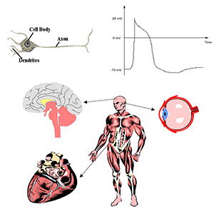

The human body is beautifully complex consisting of mechanical, electrical, and chemical systems that allow us to live and function.

An example of a mechanical system in the body is the actin and myosin filaments found in muscles that allow them to contract.

Chemical systems include the neurotransmitters that are released by neurons for communication with other cells.

Finally, electrical systems include the electrical potentials that propagate down nerve cells and muscle fibers. These potentials are responsible for brain function, muscle movement, cardiac function, eye movement, sensory function, and many other events in the body .These electrical potentials are created by the flow of ions in and out of cells. The flow of these charged ions creates potential differences between the inside and outside of cells.

These potential differences are called biopotentials. Biopotentials can be measured with electrodes and electronic instrumentation to provide insight into the functioning of various biological systems.

*Human Biopotentials*

A typical nerve cell is made up of a cell body, an axon, and dendrites .The cell body contains the nucleus or command center of the cell, the axon, which is responsible for transmitting the action potential along the cell, and the dendrites, which are responsible for receiving inputs to the cell in the form of neurotransmitters.

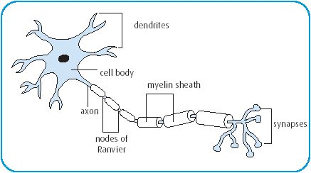

Nerve and muscle cells in the body communicate with each other via action potentials.

Action potentials are voltage impulses that propagate along a nerve or muscle and may cause neurotransmitter release when the action potential reaches a specific area of the nerve cell. A typical action potential recorded from a muscle is shown down.

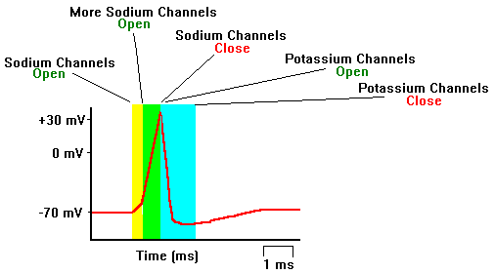

These voltage impulses arise from tiny currents in the nerve or muscle cells. These currents are a result of charged ions flowing in and out of voltage-gated channels in the membrane of the cells.

Kirchoff’s Law from basic circuits tells us that V=IR, where V is a measured voltage, I is a current, and R is a resistance. The cell membrane has a specific resistance.

A typical resting potential at -70 mV.

The lipid membrane separates the inner structures of the cell from the rest of the body. There are specific concentrations of ions inside and outside of the cell including sodium (Na+), potassium (K+), and chloride (Cl-). These ions are either positively or negatively charged. Therefore, a separation of charge exists across a cell membrane. The standard convention used in neurology is that the potential of the cell is the relative potential inside the cell with respect to the outside of the cell.

*Intracellular Concentration*

The resting potential of a cell is determined by the resting ion channels, the concentration of ions inside and outside of a cell, and the potential difference across the cell membrane.

The concentration gradient causes positively charged potassium to flow out of the cell and causes the outside of the cell to become more positive. The potential that is created is governed by Nernst’s equation. Nernst’s equation describes the relationship between the concentration of an ion outside and inside of a cell and the cellular potential (V).

Nernst’s equation is:

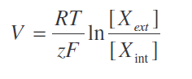

Where R is the gas constant, T is temperature in Kelvin, F is Faraday’s constant, z is the valence of the ion, and [X] is the ionic concentration, externally and internally.

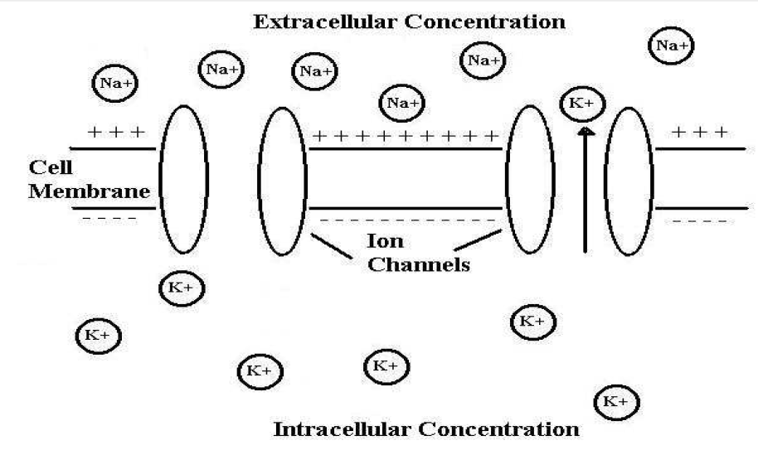

Another way to understand the membrane voltage and ionic current from the action potential is to look at an equivalent circuit of a nerve cell . Part of the cell membrane can be modeled as a capacitor since it separates charges on the inside and outside of the cell. At the same time, there are gates in the membrane that control the conductance of various ions.

This conductance can be directly translated to resistance, since conductance is simply the inverse of resistance. So, the cell membrane is modeled as a resistor and capacitor in parallel. In addition, the cytoplasm inside the cell represents another source of resistance.

The extracellular fluids and tissues present a finite resistance to the flow of action currents, creating the extracellular potential gradients that form the basis of most electrophysiological methods. However for most models, the outside of the membrane is usually represented as a shorted wire. Researchers have used this model to better understand how an action potential propagates down a nerve cell.



**Electricty in Human Body**

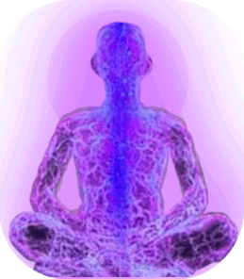

*Electricity* is flow of electric charges ,(and electric charges come at negative or positive variety, and they are at atomic level) kind of electricity we are familiar with electricity is that we plug into wall to suck it to get, that electricty is not the electricty that found in our body because that electrity flow through copper wires,obviously there is no copper wires ,we are not set up for kind of electricty .

What we have in body is nerves and nerves carry electric current and electric charges in human body ,electric charge in human body are present on charges atoms, we call charges atoms ion,those charges can be either positive or negative,.

What happens is

* when we eat food we supply energy to our bodies, energy is partly used to seperate positive and negative ions in the nerves in the body and then when nerves want to conduct electricty or fire.
* Nerves causes positive and negative charges to come together and flows of those charges coming together constitutes the electric current in the body in the nerves
* And that pulsed electricty travels down the nerves from brain to hand and telling hand to move.
* So this is how electricty works in body in basic way and we get that electricty by eating , by getting food and that causes energetic process uses in the body

In Batteries ions are moving and the way we store charge in the battery is by charging battery and when we want to use them we connect them up to an object that we want to receive electrity and allow the electrity flow out of the battery and battery discharges.

**Structure of muscles**

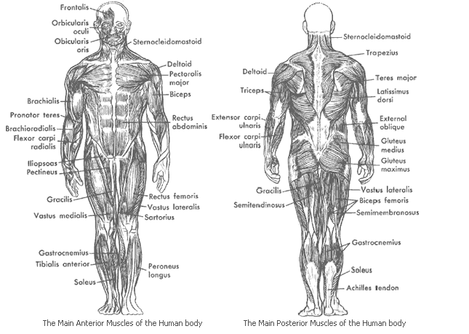

Skeletal muscles consist of 100,000s of muscle cells that are also known as "muscle fibres". These cells act together to perform the functions of the specific muscle of which they are a part.

This is only possible due to the integration of the muscle with the other tissues and structures of other associated body systems - especially the bones ([skeletal system](http://www.ivy-rose.co.uk/HumanBody/Skeletal/Skeletal_System.php)) or, in the cases of [facial muscles](http://www.ivy-rose.co.uk/HumanBody/Muscles/FacialMuscles.php), the [skin](http://www.ivy-rose.co.uk/HumanBody/Skin/Structure_of_Skin.php) (integumentary system), and also the nerves ([nervous system](http://www.ivy-rose.co.uk/HumanBody/Nerves/PartsofCentralNervousSystem.php)).

*Periosteum*: is the outer layer of bone

*Tendons*:  **attach muscle to bone.**

*Tendon Sheath*: Their purpose is to minimise friction associated with movement at the join, and to facilitate movement of the joint.

***Fascia*:** A fascia is a structure of [connective tissue](http://en.wikipedia.org/wiki/Connective_tissue) that surrounds muscles, groups of muscles, blood vessels, and nerves, binding some structures together.

*Skeletal muscle*: The type of muscle that causes movement of the skeletal system (especially limbs), and of skin in the cases of the muscles of facial expression in the head and neck area has many names

*Perimysium*: is a fibrous sheath that surrounds and protects bundles of muscle fibres.

*Epimysium* : is fibrous elastic tissue that surrounds muscle.

*Fascicle* : refers to a "bundle", such as a bundle of muscle fibres

*Endomysium*: is the name of the fine connective tissue sheath that surrounds/covers each single/individual muscle fibre.

*Muscle Fibre*: muscle cells are special cells that are able to contract, thereby causing movement - of other tissues/parts of the body.  
There are three types of muscle: striated/skeletal muscle (causing the movement of bones/limbs), smooth muscle (surrounding organs and blood vessels), and cardiac muscle (forming the walls of the heart).

*Myofibrils* :are small contractile filaments located within the cytoplasm of striated muscle cells. These filaments cause the distinctive appearance of skeletal=voluntary=striated muscle because they consist of bands of alternating high and low refractive index.

*General components of muscle fibres*

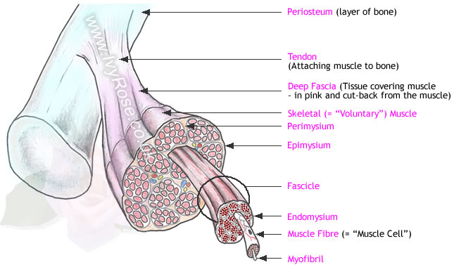

Each muscle fibre ("muscle cell") is covered by a plasma membrane sheath which is called the sarcolemma.

Tunnel-like extensions from the sarcolemma pass through the muscle fibre from one side of it to the other in transverse sections through the diameter of the fibre. These tunnel-like extensions are known as transverse tubules ("T Tubules") - not shown in diagram above.

The nuclei of muscle fibres ("muscle cells") are located at the edges of the diameter of the fibre, adjacent to the sarcolemma. A single muscle fibre may have many nuclei.

Cytoplasm is present in all living cells.

The cytoplasm present is muscle fibres (muscle cells) is called sarcoplasm.

The sarcoplasm present in muscle fibres contains very many mitochondria, which are the energy-producing units within the cell

Sarcoplasmic reticulum is a network of membrane-enclosed tubules similar to smooth endoplasmic reticulum (SER). Sarcoplasmic reticulum is present in muscle fibres/cells and extends throughout the sarcoplasm of the cell. The function of the sarcoplasmic reticulum is to store calcium ions, which are necessary for muscle contraction.

Myoglobin is also present in the sarcoplasm of muscle fibres/cells. This is a reddish pigment that not only results in the distinctive colour of skeletal muscle, but also stores oxygen - until it is required by the mitochondria for the production of ATP.

Each **muscle cell** (also known as a "**muscle fibre**") contains many specialised components of a muscle cell. Key functional components within muscle cells include [myofibrils](http://www.ivy-rose.co.uk/References/glossary_entry648.htm), which consist of two types of **protein filaments** called "[thick filaments](http://www.ivy-rose.co.uk/References/glossary_entry659.htm)", and "[thin filaments](http://www.ivy-rose.co.uk/References/glossary_entry660.htm)".

These two types of filament have different structures that enable then to work together.

*Thick Filaments*  
Thick filaments are formed from a protein called [myosin](http://www.ivy-rose.co.uk/References/glossary_entry666.htm) which has important properties of elasticity and contractibility.   
The shape of the myosin molecules has the apperance of two "hockey sticks" or "golf clubs" twisted together. This is illustrated in the diagram above - indicating the two parts of the **myosin molecule** referred to in [Advanced Textbooks about Muscles](http://www.amazon.co.uk/exec/obidos/redirect?link_code=ur2&camp=1634&tag=lessthanapoun-21&creative=6738&path=external-search%3Fsearch-type=ss%26keyword=Muscles%26index=books-uk)http://www.assoc-amazon.co.uk/e/ir?t=lessthanapoun-21&l=ur2&o=2  
These are the **myosin tail**, and the **myosin heads**, or "**crossbridges**" .

*Thin Filaments*  
The main component of the thin filaments is a protein called [actin](http://www.ivy-rose.co.uk/References/glossary_entry667.htm). Actin molecules join together forming chains twisted into a helix configuration. These molecules are very important to the contraction mechanism of muscles because each actin molecule has a single "**myosin-binding site**" (not illustrated above).  The other two protein molecules that form the **thin filaments** are called [troponin](http://www.ivy-rose.co.uk/References/glossary_entry668.htm) and [tropomyosin](http://www.ivy-rose.co.uk/References/glossary_entry669.htm). The molecules of **tropomyosin** cover the **myosin-binding sites** on the **actin** molecules when the muscle fibres are relaxed.

**Myosin** and **actin** form the main contractile elements of muscles.  
This is because it is the binding of the **thick filaments** to the **thin filaments** - and in particular the positions of these points of attachment - that controls the state of contraction/relaxation of the muscle of which they are apart.

**The** "Sliding-Filament Theory of Muscle Action**"**

**The**Sliding-Filament Theory of Muscle Action**explains how the movement of thick- and thin-filaments relative to each other leads to the contraction and relaxation of whole muscles** - hence ultimately to the movement of the limbs or tissues attached to those muscles:

As we said before there are two physical units that are important for the action of muscles. They are [thick filaments](http://www.ivy-rose.co.uk/References/glossary_entry659.htm) and [thin filaments.](http://www.ivy-rose.co.uk/References/glossary_entry660.htm)

Muscle tissue can be described in terms of units called [sacromeres](http://www.ivy-rose.co.uk/References/glossary_entry661.htm). These units are defined in terms of groups of overlapping filaments (the thin and thick filaments previously described). **Sacromeres are arrangements of thick and thin filaments**.

The length of a sacromere and the zones ([H zone](http://www.ivy-rose.co.uk/References/glossary_entry665.htm), [I band](http://www.ivy-rose.co.uk/References/glossary_entry664.htm) and [A band](http://www.ivy-rose.co.uk/References/glossary_entry663.htm)) within each sacromere, are determined by the positions of the thick and thin filaments relative to each other. This is illustrated in the three diagrams below - showing the relative length and configuration of two sacromeres of **relaxed muscle** (top), **partially contracted muscle** (centre) and **fully contracted muscle**(lower diagram).

|  |  |  |  |  |  |  |  |  |  |  |
| --- | --- | --- | --- | --- | --- | --- | --- | --- | --- | --- |
| http://www.ivy-rose.co.uk/HumanBody-Images/Muscles/slfilth/spacer.gif | http://www.ivy-rose.co.uk/HumanBody-Images/Muscles/slfilth/spacer.gif | http://www.ivy-rose.co.uk/HumanBody-Images/Muscles/slfilth/spacer.gif | http://www.ivy-rose.co.uk/HumanBody-Images/Muscles/slfilth/spacer.gif | http://www.ivy-rose.co.uk/HumanBody-Images/Muscles/slfilth/spacer.gif | http://www.ivy-rose.co.uk/HumanBody-Images/Muscles/slfilth/spacer.gif | http://www.ivy-rose.co.uk/HumanBody-Images/Muscles/slfilth/spacer.gif | http://www.ivy-rose.co.uk/HumanBody-Images/Muscles/slfilth/spacer.gif | http://www.ivy-rose.co.uk/HumanBody-Images/Muscles/slfilth/spacer.gif | http://www.ivy-rose.co.uk/HumanBody-Images/Muscles/slfilth/spacer.gif | http://www.ivy-rose.co.uk/HumanBody-Images/Muscles/slfilth/spacer.gif |
| http://www.ivy-rose.co.uk/HumanBody-Images/Muscles/slfilth/Sliding-Filament-Theory_r1_c1.png | | http://www.ivy-rose.co.uk/HumanBody-Images/Muscles/slfilth/Sliding-Filament-Theory_r1_c3.png | http://www.ivy-rose.co.uk/HumanBody-Images/Muscles/slfilth/Sliding-Filament-Theory_r1_c4.png | | | | | | http://www.ivy-rose.co.uk/HumanBody-Images/Muscles/slfilth/Sliding-Filament-Theory_r1_c10.png | http://www.ivy-rose.co.uk/HumanBody-Images/Muscles/slfilth/spacer.gif |
| http://www.ivy-rose.co.uk/HumanBody-Images/Muscles/slfilth/Sliding-Filament-Theory_r2_c3.png | | | | | | http://www.ivy-rose.co.uk/HumanBody-Images/Muscles/slfilth/Sliding-Filament-Theory_r2_c9.png | http://www.ivy-rose.co.uk/HumanBody-Images/Muscles/slfilth/spacer.gif |
| http://www.ivy-rose.co.uk/HumanBody-Images/Muscles/slfilth/Sliding-Filament-Theory_r3_c3.png | | http://www.ivy-rose.co.uk/HumanBody-Images/Muscles/slfilth/Sliding-Filament-Theory_r3_c5.png | | | | | | http://www.ivy-rose.co.uk/HumanBody-Images/Muscles/slfilth/spacer.gif |
| http://www.ivy-rose.co.uk/HumanBody-Images/Muscles/slfilth/Sliding-Filament-Theory_r4_c1.png | | http://www.ivy-rose.co.uk/HumanBody-Images/Muscles/slfilth/spacer.gif |
| http://www.ivy-rose.co.uk/HumanBody-Images/Muscles/slfilth/Sliding-Filament-Theory_r5_c1.png | http://www.ivy-rose.co.uk/HumanBody-Images/Muscles/slfilth/Sliding-Filament-Theory_r5_c2.png | | | | | http://www.ivy-rose.co.uk/HumanBody-Images/Muscles/slfilth/Sliding-Filament-Theory_r5_c7.png | | | | http://www.ivy-rose.co.uk/HumanBody-Images/Muscles/slfilth/spacer.gif |
| http://www.ivy-rose.co.uk/HumanBody-Images/Muscles/slfilth/Sliding-Filament-Theory_r6_c2.png | | | | http://www.ivy-rose.co.uk/HumanBody-Images/Muscles/slfilth/Sliding-Filament-Theory_r6_c6.png | | http://www.ivy-rose.co.uk/HumanBody-Images/Muscles/slfilth/Sliding-Filament-Theory_r6_c8.png | | |  |

***What happens ?***

**During Muscle Contraction**:   
http://www.ivy-rose.co.uk/spacer.gif The [myosin](http://www.ivy-rose.co.uk/References/glossary_entry666.htm) heads on the thick filaments "hook" onto, and so pull, the thin filaments towards the centre (labelled "M-line") of each sacromere. The appearance of this action is shown above as the transistion from "relaxed" to "fully contracted" muscle. As the thin filaments slide over the thick filaments, the [I bands](http://www.ivy-rose.co.uk/References/glossary_entry664.htm) and [H zones](http://www.ivy-rose.co.uk/References/glossary_entry665.htm) becomes narrower and narrower until they disappear when the muscle reaches its fully contracted state.

**During Muscle Relaxation**:  
http://www.ivy-rose.co.uk/spacer.gif When the [myosin](http://www.ivy-rose.co.uk/References/glossary_entry666.htm) heads on the thick filaments relax they release their hold on the thin filaments, thereby allowing them to slide back to their "relaxed" positions in which the [I bands](http://www.ivy-rose.co.uk/References/glossary_entry664.htm) and [H zones](http://www.ivy-rose.co.uk/References/glossary_entry665.htm) appear again.

***Necessary Conditions****:*

This sliding filament mechanism can only occur when there are sufficient calcium ions (Ca2+) and sufficient [ATP](http://www.ivy-rose.co.uk/References/glossary_entry654.htm) is also available.

|  |  |  |  |  |  |
| --- | --- | --- | --- | --- | --- |
|  |  |  |  |  |  |
|  |  | | | |  |
|  | | | |  |
|  | |  | |  |
|  | | |  |  |
|  |  |
|  | | |  |
|  |  | | |  |
|  | http://www.ivy-rose.co.uk/HumanBody-Images/Muscles/nmj02/spacer.gif | http://www.ivy-rose.co.uk/HumanBody-Images/Muscles/nmj02/spacer.gif | http://www.ivy-rose.co.uk/HumanBody-Images/Muscles/nmj02/spacer.gif | http://www.ivy-rose.co.uk/HumanBody-Images/Muscles/nmj02/spacer.gif | | http://www.ivy-rose.co.uk/HumanBody-Images/Muscles/nmj02/spacer.gif |
| http://www.ivy-rose.co.uk/HumanBody-Images/Muscles/nmj02/NMJ-Actions_r1_c1.jpg | http://www.ivy-rose.co.uk/HumanBody-Images/Muscles/nmj02/NMJ-Actions_r1_c2.jpg | | | | | http://www.ivy-rose.co.uk/HumanBody-Images/Muscles/nmj02/spacer.gif |
| http://www.ivy-rose.co.uk/HumanBody-Images/Muscles/nmj02/NMJ-Actions_r2_c2.jpg | | | | | http://www.ivy-rose.co.uk/HumanBody-Images/Muscles/nmj02/spacer.gif |
| http://www.ivy-rose.co.uk/HumanBody-Images/Muscles/nmj02/NMJ-Actions_r3_c2.jpg | | http://www.ivy-rose.co.uk/HumanBody-Images/Muscles/nmj02/NMJ-Actions_r3_c4.jpg | | | http://www.ivy-rose.co.uk/HumanBody-Images/Muscles/nmj02/spacer.gif |
| http://www.ivy-rose.co.uk/HumanBody-Images/Muscles/nmj02/NMJ-Actions_r4_c2.jpg | | | http://www.ivy-rose.co.uk/HumanBody-Images/Muscles/nmj02/NMJ-Actions_r4_c5.jpg | | http://www.ivy-rose.co.uk/HumanBody-Images/Muscles/nmj02/spacer.gif |
| http://www.ivy-rose.co.uk/HumanBody-Images/Muscles/nmj02/NMJ-Actions_r5_c1.jpg | http://www.ivy-rose.co.uk/HumanBody-Images/Muscles/nmj02/spacer.gif |
| http://www.ivy-rose.co.uk/HumanBody-Images/Muscles/nmj02/NMJ-Actions_r6_c2.jpg | | | http://www.ivy-rose.co.uk/HumanBody-Images/Muscles/nmj02/spacer.gif |
| http://www.ivy-rose.co.uk/HumanBody-Images/Muscles/nmj02/NMJ-Actions_r7_c2.jpg | http://www.ivy-rose.co.uk/HumanBody-Images/Muscles/nmj02/NMJ-Actions_r7_c3.jpg | | | |  |

***Neuromuscular Junction Actions:***

1. **Release of ACh**  
   When a nerve pulse reaches a synaptic end bulb, it triggers release of the neurotransmitter **acetylcholine (ACh)** from**synaptic vesicles** that contain acetylcholine (ACh). ACh then **diffuses across the synaptic cleft** between the motor neurone and the motor end plate - as shown above.  
   http://www.ivy-rose.co.uk/spacer.gif
2. **Activation of ACh receptors**  
   The motor end plate contains receptors onto which the free ACh binds after diffusing across the synaptic cleft.  
   This binding of ACh to ACh receptors in the motor end plate causes **ion channels** to open & so allow the sodium (**Na+**) ions to flow across the membrane into the muscle cell.  
   (Although the movement of sodium (Na+) ions is mentioned an illustrated, the opening of the ion channel does also allow other cations to pass across the membrane. A cation is a positively-charged ion, which has fewer electrons than protons, is known as a "cation" because it is attracted to cathodes. In the case of a simple description of actions at a neuromuscular junction it is generally sufficient to remember the movement of sodium (Na+) ions .)   
   http://www.ivy-rose.co.uk/spacer.gif
3. **Generation of muscle action potential**  
   The flow of sodium (Na+) ions across the membrane into the muscle cell generates a **muscle action potential**.   
   This action potential then travels along the [sarcolemma](http://www.ivy-rose.co.uk/References/glossary_entry650.htm) and through the [T-Tubules](http://www.ivy-rose.co.uk/References/glossary_entry658.htm). (Action Potentials and how they are generated and transmitted is a topic usually covered in further detail as part of study of the Nervous System.)   
   http://www.ivy-rose.co.uk/spacer.gif
4. **Breakdown of ACh**  
   The ACh that is released at Step (1.) is only available to take part in step (2.) for a short time before it is broken down by an enzyeme called **acetylcholinesterase (AChE)**. This breakdown of ACh occurs within the synaptic cleft.

# Types of Muscle Contractions

### List of types of muscle contraction

* Isotonic (of which there are two types:   
  concentric and eccentric)
  + **Concentric** muscle contraction
  + **Eccentric** muscle contraction
* Isometric muscle contraction,   
  and
* Isokinetic muscle contraction.

|  |  |
| --- | --- |
| Isotonic Muscle Contraction: meaning "**same tension**" | Isotonic muscle contractions are the common muscle contractions that enable people (and other animals) to move about generally. There are two types of isotonic muscle contraction: |
| http://www.ivy-rose.co.uk/Images/spacer.gif | * Concentric muscle contraction, and * Eccentric muscle contraction. |
| Concentric Muscle Contraction: | Muscle **shortens** as tension in the muscle increases, as when **lifting** a weight. |
| Explain: | **Muscles shorten as muscle fibres contract**. |
|  | For example when lifting an object by holding it in the right hand then contracting the[biceps brachii](http://www.ivy-rose.co.uk/Define/Biceps_Brachii) muscles of the right-arm concentrically the [elbow joint](http://www.ivy-rose.co.uk/HumanBody/Skeletal/Joints/Elbow-Joint.php) [flexes](http://www.ivy-rose.co.uk/Define/Flexion), moving the lower-arm and so the hand and object held in it upwards. |
| Eccentric Muscle Contraction: | Muscle **lengthens** as tension in the muscle increases, as when slowly lowering a weight. |
| Explain: | Although the actin and myosin filaments within the muscle fibres contract (to produce the force needed) **the fibres themselves also slide alongside each other resulting in the overall lengthening of the muscle**. |
|  | Continuing the above example of an object that has been moved upwards by contraction of the right biceps brachii to flex the right elbow, the object may then be lowered in a steady controlled way by contracting the [biceps brachii](http://www.ivy-rose.co.uk/Define/Biceps_Brachii) muscles of the right-arm eccentrically to[extend](http://www.ivy-rose.co.uk/Define/Extension) the [elbow joint](http://www.ivy-rose.co.uk/HumanBody/Skeletal/Joints/Elbow-Joint.php), lowering the lower-arm together with the hand and object held in the hand. |
| http://www.ivy-rose.co.uk/Images/spacer_006600.gif | |
| Isometric Muscle Contraction: meaning "**same distance**",  i.e. static | In isometric muscle contraction the muscle **maintains the same length** as tension in the muscle increases, as when **holding a weight in a static position** for an extended period of time.  That is, there is no change in the length of the contracting muscle during isometric muscle contraction. The amount of force a muscle can produce during an isometric contraction depends on the length of the muscle at the point of contraction. Each muscle has an optimum length at which the maximum isometric force can be produced. |
| Explain: | The force of the contraction occurs in the muscle fibre but the **muscle fibres themselves do not move relative to each other**, so the overall length of the muscle doesn't change. |
|  | For example when holding or gripping an object such that there is a downward force on the object (due to gravity) which the muscles oppose in order to hold the object in a static position (holding) and/or to maintain steady contact with the object e.g. with fingers wrapped around a handle (gripping). The hand/arm are not moving but the muscles are contracted in order not to release/drop the object. |
| Isokinetic Muscle Contraction: meaning "**same speed**" | As in isotonic contractions (see above), in isokinetic muscle contraction the muscle**changes length** during the contraction. In isokinetic muscle contraction the muscle contracts maximally throughout its full range of movement. The defining characteristic of isokinetic muscle contractions is that they result in movements of a constant speed. A piece of equipment called an **Isokinetic Dynamometer** is used to measure the (constant) speed of isokinetic muscle contraction. Such equipment is not common in all schools, colleges, leisure centres and gyms but tends to be used in rehabilitation centres and specialist sports training facilities. |
| Explain: | The changes in overall length of the whole muscle depend on the combined effects of contraction (shortening) of muscle fibres and movement of individual muscle fibres alongside each other (potentially increasing overall muscle length). |

**Electrical Muscle Stimulation**

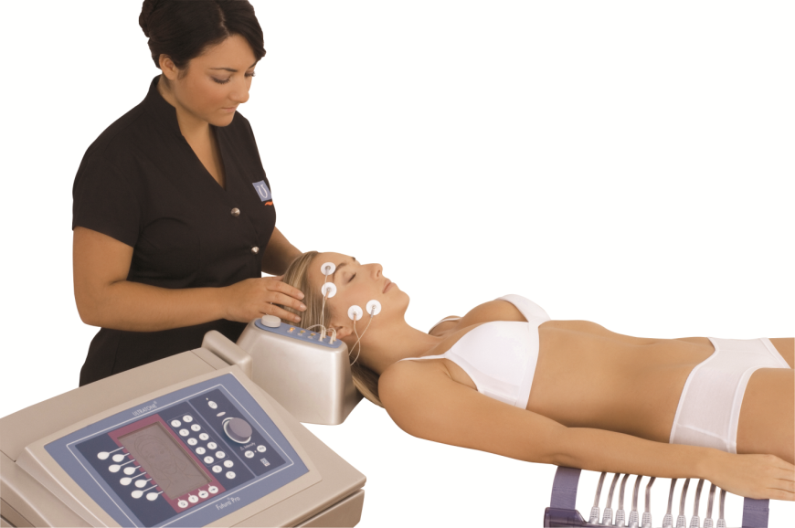

*Introduction*

Electrical Muscle Stimulation is an internationally accepted and proven way of treating muscular injuries. It works by sending electronic pulses to the muscle needing treatment; this causes the muscles to exercise passively. It is a product derived from the square waveform, originally invented by John Faraday in 1831. Through the square wave pattern it is able to work directly on muscle motor neurons.  
  
This is being widely used in hospitals and sports clinics for the treatment of muscular injuries and for the re-education of paralyzed muscles, to prevent atrophy in affected muscles ,improving muscle tone and blood circulation or to reduce the pain in some specific areas.

Electrical muscle stimulation (EMS), also known as “ Neuromuscular electrical stimulation (NMES) or electromyostimulation “ , is the elicitation of muscle contraction using electric impulses. EMS has received increasing attention in the last few years, because it has the potential to serve as: a strength training tool for healthy subjects and athletes

*History*

o 1780 – Italian anatomist Luigi Galvani found that an electrical current would cause the muscle in a detached frog’s leg to contract.

o Early 1800s – Attempts were made to use electricity to re-animate hanged criminals.

o 1880s – Devices began appearing that used electrical stimulation of muscle tissue to aid in exercise.

o 1900s.- Late 1800s to Early 1900s – Researchers investigated the effects of electricity on the heart.

o 1931 – First pacemaker

o Late 1950s to 1960s – Doctors applied principles of electrical stimulation to regulate heart rhythm and re-start the heart.

o 1960s and 1970s – Devices were developed to reduce or block pain signals. These involve internal and external stimulation to the spinal cord and peripheral nerves.

- TENS Devices (Transcutaneous Electrical Nerve Stimulators)

o 1960s and 1970s (Soviet Sports Research) – Soviet exercise physiologists began experimenting with electrical muscle stimulation to increase muscle size and strength.

o 1980s to Today :

- Pulsed Galvanic Stimulation - Found to promote the dilation of blood vessels and speed up the healing of wounds.

- Electrical Stimulation of Bone Tissue .

- Electrodes in the Brain .

- Electro-stimulation devices now have full FDA approval for a wide variety of applications.

*Theory:*

Electrical muscle stimulation (EMS) has been a mainstay of physical therapy practice for many years as a method to rehabilitate muscles after an injury or surgery. In the early 1960s it was often used in an attempt to prevent the atrophy that occurs when skeletal muscle is denervated.

*What are benefits of EMS (Electronic Muscle Stimulation)*  
  
1. Relaxation of muscle spasms  
2. Prevention or retardation of disuse atrophy  
3. Increasing local blood circulation  
4. Muscle re-education  
5. Immediate post-surgical stimulation of calf muscles to prevent venous thrombosis  
6. Maintaining or increasing range of motion

*How does Muscular Stimulator work?*  
  
 The EMS units send comfortable impulses through the skin that stimulate the nerves in the treatment area. Because the stimulation of nerves and muscles may be accomplished by electrical pulses this modality can help prevent disuse atrophy. Accordingly, incapacitated patients can receive therapeutic treatment to create involuntary muscle contractions thereby improving and maintaining muscle tone without actual physical activity.  
  
The EMS Muscle Stimulator is an easy-to-use system. A marvel of miniaturized electronics the lightweight power unit transmits electrical pulses through the skin surface and stimulates motor units (nerve and muscles). The electrical impulses are "ramped" so that they closely emulate natural muscle contractions.  
  
EMS is helpful in conditions where the reduction of physiological range of motion is due to or the result of fractures with consequent immobilization, operative intervention, or arthroscopy, in shoulders, knees, and backs.  
  
EMS units are used to treat a number of medical conditions that require muscle stimulation. The most common are: long-term disuse after fracture or prolonged bed rest, progressive strengthening for joint and muscle injury, immoblized limbs, atrophy prevention , stress incontinence, muscle weakness, improving muscle tone after weight loss or childbirth, muscle spasticity following a stroke.  
  
Most common uses: Prevent or retard disuse atrophy, strengthening programs, reeducate muscles, postop orthopedic surgery, joint replacement, gait training, shoulder subluxation and reduction of muscle spasms.

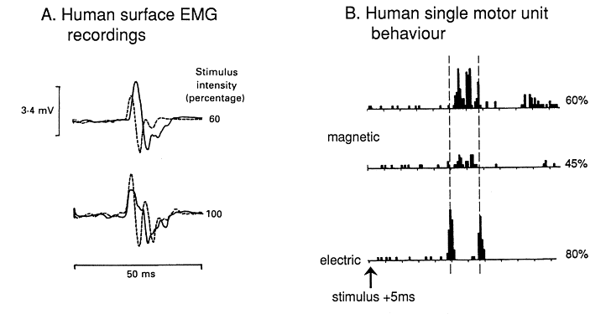

*Use*

EMS can be used both as a training, therapeutic, and [cosmetic](http://en.wikipedia.org/wiki/Electrotherapy_%28cosmetic%29#Faradic_treatment) tool.  
In medicine EMS is used for rehabilitation purposes, for instance in [physical therapy](http://en.wikipedia.org/wiki/Physical_therapy) in the prevention of disuse muscle atrophy which can occur for example after [musculoskeletal injuries](http://en.wikipedia.org/wiki/Musculoskeletal_injury), such as damage to bones, joints, muscles, ligaments and tendons. This is distinct from [Transcutaneous Electrical Nerve Stimulation](http://en.wikipedia.org/wiki/Transcutaneous_Electrical_Nerve_Stimulation) (TENS), in which an electric current is used for pain therapy.

# *What EMS Can and Can't Do*

Like any technology, it's important to understand what it can and can't do.

* **Does not cause discomfort.** EMS is generally well tolerated and does not cause discomfort. (EMS units have intensity controls, and increasing the intensity to high can be painful.)
* **Does Increase strength.** Many studies have shown that EMS can increase strength. For instance one study showed an increase in quad strength by over 20% in untrained subjects. (As an aside, this study trained only one leg with EMS, and the other untrained leg gained 15% strength. This effect, where training one limb increases the strength in the other, has been known about since at least 1894 and is called the Contralateral Strength Training Effect. )
* **Does Increase** [Muscle Recruitment](http://fellrnr.com/wiki/Muscle_Recruitment)**.** Studies indicate that EMS increases muscular recruitment and that this may be the underlying mechanism for some of the strength gains.
* **Does Increase Blood flow.** EMS can increase the flow of blood to a muscle. (Lower frequencies of around 7-9Hz seem to be optimal.)
* **Does Not Reduce Weight.** EMS does not help with weight reduction or fat loss. In 2002 the FTC charged three companies with false claims about weight loss from EMS devices.
* **Can Cause DOMS.** It's not a surprise given that EMS is a form of strength training, but EMS can cause [Delayed Onset Muscle Soreness](http://fellrnr.com/wiki/Delayed_Onset_Muscle_Soreness). (EMS may also help relieve DOMS.)
* **Endurance - Unclear**. There are few studies on the use of EMS for endurance. A study of sedentary subjects showed a 10% increase in [V̇O2max](http://fellrnr.com/wiki/VO2max), but this study used an unusually large level of EMS over an unusually large area.
* **Can Activate Deep Muscles.** It was generally thought that EMS tends to activate fibers nearer to the surface, but MRI scans have shown that even low levels can activate deep muscles. This may be because EMS is stimulating superficial nerves that control deeper muscles.
* **Can Help with** [Knee Pain](http://fellrnr.com/wiki/Knee_Pain)**.** Studies have shown that EMS of the [VMO](http://fellrnr.com/wiki/VMO) (part of the quad near the knee on the inside of the thigh) can help reduce [Knee Pain](http://fellrnr.com/wiki/Knee_Pain). The recommendation is for eight weeks of EMS consisting of 20 min. sessions twice a day (18 sec stimulation and 25 sec rest).
* **May improve muscle recovery.** There is some limited evidence that EMS may help with recovery from [DOMS](http://fellrnr.com/wiki/Delayed_Onset_Muscle_Soreness), probably due to increased blood flow.

# *Why do we use EMS?*

The main reasons to use EMS are around injury treatment and rehabilitation. EMS may be able to directly help with Headache and [Knee Pain](http://fellrnr.com/wiki/Knee_Pain) as well as reducing the loss of muscle strength (atrophy) that can occur while injured.

# *EMS and TENS*

EMS is similar to TENS ([Transcutaneous Electrical Nerve Stimulation](http://en.wikipedia.org/wiki/Transcutaneous_electrical_nerve_stimulation)), and many other devices . The difference between the two is that EMS is intended to activate muscle fibers, where TENS is used at a lower intensity with the goal of reducing pain.

# *Choosing an EMS device*

EMS devices vary wildly in price, from less than $50 to over $800, it appears that they have generally similar capabilities:

* Max current: ~100mA
* Frequency range: 1-150Hz
* Pulse width: 50-400us

Different devices had two to eight electrodes (one to four channels), and some devices had a TENS mode for pain reduction. Some devices had preset programs for different body parts or for different effects, while others allowed you to set the specific parameters such as current, frequency, pulse width.

# *Replacement Pads*

The sticky electrode pads are reusable and last for 5-20 uses. The sticky surface on the pads degrades quite slowly, so how many times you use them may depend on the location you're trying to stick them to. Flat, smooth locations like the quad are easy to stick to, where attaching them to the end of the VMO (subdivision of one of the four quadriceps muscles) requires a little more adhesion.

# *Important Cautions*

* Do not apply to the chest area if you have any heart conditions.
* If you have a pacemaker, do not use EMS anywhere on your body.
* Do not apply EMS to the [Carotid sinus](http://en.wikipedia.org/wiki/Carotid_sinus) area of the neck, as this could affect heart rate or blood pressure.
* Do not apply through your head.
* Do not apply through cancerous tissue.
* Applying to EMS through broken or irritated skin will cause discomfort.
* Do not apply to protruding metal such as surgical staples or pins.
* Be careful applying high intensity EMS directly over superficial bones, as this can be painful.
* Applying EMS over thick areas of fat may require painfully high intensity to reach the underlying muscle.
* Avoid applying EMS near the uterus if you are pregnant.

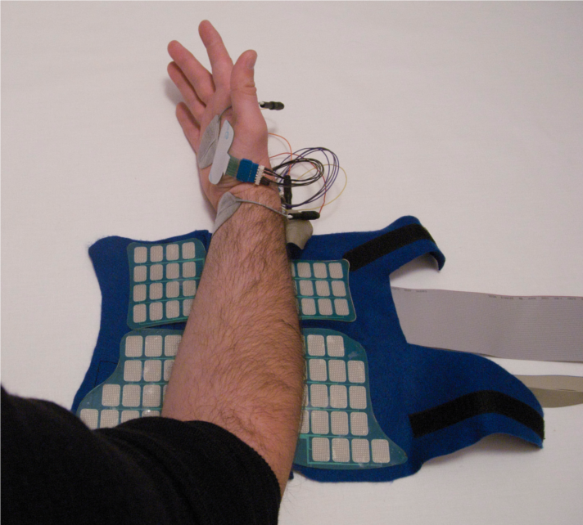  
NEMS

*Electrotherapy and Chronic Pain*  
  
Electrotherapy can help relieve and manage chronic pain. This kind of pain is usually the result of an accident or other injury, perhaps to the lower back or a joint in the hand or knee. If it lasts long enough, the pain itself becomes a disease. The most common forms of chronic pain are back pain and arthritis.  
  
Chronic pain is often treated with over-the-counter painkillers and prescription drugs. These drugs may have unwanted side effects and can be very expensive.  
  
LGMedSupply has an excellent selection of Muscle Stimulators and TENS/EMS Combo Units. These are our top selling units. One is digital meaning you push buttons to make your adjustments on the screen, one is analog meaning you turn the dial to make your adjustments, change programs and settings, and also you see our DUAL COMBINATION Unit which is both a TENS and EMS in ONE!  
  
All units come complete and new with hard carrying case, 9 Volt battery, 45 inch lead wires, and 4 electrodes which last 20-30 times.

Examples:What is an EMS Muscle Stimulator Unit  and How Does It Work? (Click Here)

[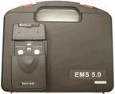](http://www.lgmedsupply.com/ems200.html)

## [LG 5.0 Electronic Muscle Stimulator Unit with Hard Carrying Case,...](http://www.lgmedsupply.com/ems200.html)

[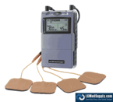](http://www.lgmedsupply.com/twstteandems.html)

## ["COMBO UNIT" "LG-TEC" DIGITAL Dual Combo Professional TENS Unit ...](http://www.lgmedsupply.com/twstteandems.html)

**Transcutaneous electrical nerve stimulation (TENS)**

Transcutaneous electrical nerve stimulation is the use of electric current produced by a device to stimulate the nerves for therapeutic purposes. TENS by definition covers the complete range of transcutaneously applied currents used for nerve excitation although the term is often used with a more restrictive intent, namely to describe the kind of pulses produced by portable stimulators used to treat pain.

The unit is usually connected to the skin using two or more electrodes. A typical battery-operated TENS unit is able to modulate pulse width, frequency and intensity. Generally TENS is applied at high frequency (>50 Hz) with an intensity below motor contraction (sensory intensity) or low frequency (<10 Hz) with an intensity that produces motor contraction.[[2]](http://en.wikipedia.org/wiki/Transcutaneous_electrical_nerve_stimulation#cite_note-2) The benefit of TENS for pain is controversial.

## *Medical uses*

### Pain TENS is a non-invasive, low-risk nerve stimulation intended to reduce [pain](http://en.wikipedia.org/wiki/Pain), both acute and chronic. Controversy exists as to its effectiveness in the treatment of chronic pain.

### Labour pain A significant number of TENS machine brands have been targeted for use for labour pain.

|  |  |
| --- | --- |
| *Safety* |  |

TENS electrodes should never be placed:

* Over the eyes due to the risk of increasing [intraocular pressure](http://en.wikipedia.org/wiki/Intraocular_pressure)
* Transcerebrally
* On the front of the neck due to the risk of an acute hypotension (through a [vasovagal reflex](http://en.wikipedia.org/wiki/Vasovagal_reflex)) or even a [laryngospasm](http://en.wikipedia.org/wiki/Laryngospasm)
* Through the chest using an anterior and posterior electrode positions, or other transthoracic applications as "across a thoracic diameter"; this does not preclude coplanar applications
* Internally, except for specific applications of dental, vaginal, and anal stimulation that employ specialized TENS units
* On broken skin areas or wounds, although it can be placed around wounds.
* Over a [tumour](http://en.wikipedia.org/wiki/Tumour)/[malignancy](http://en.wikipedia.org/wiki/Malignancy) (based on [in vitro](http://en.wikipedia.org/wiki/In_vitro) experiments where electricity promotes cell growth)
* Directly over the spinal column
* TENS should not be used across an artificial [cardiac pacemaker](http://en.wikipedia.org/wiki/Artificial_pacemaker)
* On areas of numb skin/decreased sensation TENS should be used with caution because it's likely less effective due to nerve damage. It may also cause skin irritation due to the inability to feel currents until they are too high.
* 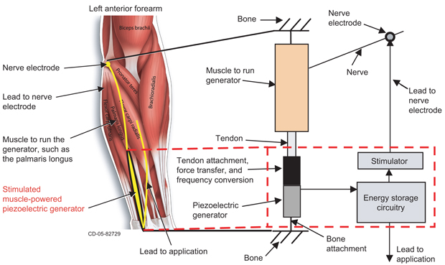

Concept for an implanted, **stimulated muscle**-powered generator

*Examples of such devices :*

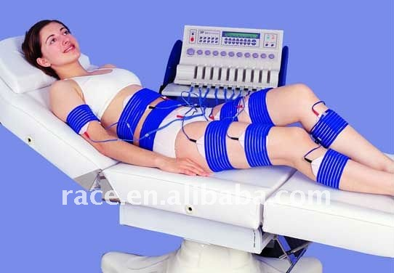  
Electric **Muscle Stimulation** body building

**Circuit**

**Design elements of muscle stimulators**

Due to the wide variety of electrical stimulation units that are available and the numerous combinations of design elements, many practitioners are confused as to what electrical stimulation really is. This is not surprising because researchers and manufacturers have used different terminology to discuss similar systems.

There are several parameters that define the different types of electrical stimulation units. These parameters can be combined in a variety of ways and it is essential that the correct combination be used to obtain a system that is effective and comfortable.

The following information discusses the parameters that are involved in developing electric stimulation systems.

**CURRENT TYPE**

There are **two types of currents** used in electrical stimulation

**AC or alternating current**

* Continuous, two directional flow of current (positive and negative)
* This is the form used in household appliances
* Sometimes incorrectly referred to as Faradic in literature
* A 120 current obtains it’s name because the current reverses direction 120 times per second, completing 60 full cycles
* In physical therapy, this current is generally preferred because of greater patient comfort

**DC or direct current**

* Continuous, one directional flow of current, the direction is determined by the polarity selected
* Can be positive or negative
* This is the form found in a battery or DC generator
* Sometimes incorrectly referred to as Galvanic in literature
* Since the charge is one-directional, electrolysis at the electrode/tissue contact could occur because there is a non-zero net charge. Therefore, ions accumulate at electrodes, causing excessive accumulation of corrosion at an electrode. This can be more of a problem with denervated  
  muscle stimulation and for implanted electrodes.

**OTHER DESIGN ELEMENTS**

There are several other parameters that define the different types of electrical stimulation units that are available. These parameters can be combined in a variety of ways and it is essential that the correct combination be used to obtain a system that is effective and comfortable.

These different parameters include:

**CURRENT FLOW**

Current or flow can be used to describe both an alternating current (AC) and a direct current (DC). The term flow is sometimes interchanged with the term “current”. This can be confusing because a “continuous current” is the same as direct current (DC), but a “continuous flow” can describe both a direct (DC) or alternating current (AC).

*Continuous flow (current)*  
No interruption of the current flow

*Pulsed flow (current)*  
Pulsed flow (current) also referred to as Intermittent flow (current)   
Periodic interruption of the current flow (interpulse interval)  
Allows for an adjustment of frequency and phase

**WAVEFORMS**

Different waveforms produce different contraction intensities and different levels of fatigue. The “waveform is an important consideration in the choice of an appropriate muscle stimulation regimen” (Laufer et al, 2001)

Three basic criteria are used to evaluate the appropriate stimulation waveform:

1. The mean stimulation current required to achieve the desired muscle contraction tension
2. The subjective comfort of the stimulation
3. The physiological responses to the electrical stimulation (tissue injury)

Waveforms are the change of the current from zero. The value of zero is called the baseline.

*Symmetrical*

* The same signal is repeated
* The signal can be above the baseline (+) or below the baseline (-)

*Asymmetrical*

* Different signals are used in one pulse duration

**Types of Pulses that Produce a Waveform**

**Monophasic** (Unidirectional)

* Each pulse contains one phase that deviates from the baseline in one direction only
* Can be positive or negative

**Biphasic**

* Each pulse contains two phases that deviates from the baseline in two directions
* Positive and negative pulse
* Balanced Biphasic (Bidirectional) where both pulse deviations are equal

**Polyphasic** (each pulse contains three or more phase deviations)

* Also called: Burst AC
* Medium-frequency stimulation
* Carrier-frequency stimulation

**Waveform Shapes**

Examples of some waveforms include:

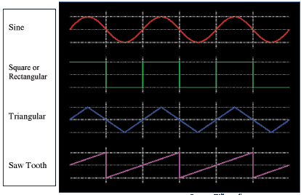

Source: Wikepedia

Etc…  
Combinations of several different waveforms are also used

**PULSE DURATION**

Pulse Duration is the length of time the current is flowing.

Nerve tissue responds quickly to current  
Sensory nerves respond to the duration of a constant pulse of 100 microseconds or shorter

Muscle tissue responds slowly, therefore longer duration stimuli are used.  
Motor nerves respond to the duration of a constant pulse of 500 microseconds or shorter

In electrical stimulation units a single pulse generally produces a short-lived muscle twitch of not more than 250ms. If the pulse duration is longer than this, the muscle does not have time to relax between stimuli and eventually tetanic (continuous) contraction occurs.

**FREQUENCIES OF PULSE**

The Frequency of the Pulse is the period of time the current flow is active.  
Generally the following is used as a guideline, however variations are used to elicit different responses:

* Nerve tissue responds to high frequencies over short durations.
* Sensory nerves respond to 100-150 Hz (cycles per second).
* Muscle tissue responds to a lower frequency, therefore longer duration stimuli are used.
* Motor nerves respond to 25 Hz (cycles per second).

The higher the stimulation frequency, the faster the muscle fatigues

In electrical stimulation units (FES) used for controlling limb movement, a compromise frequency is generally used. This compromise frequency creates a smooth response that does not quickly fatigue the tissue.

EMG values obtained by electrical stimulation look similar to contractions recorded from voluntary movement, however this does not prove true in the clinical setting. If motor neurons are innervated voluntarily in an asynchronous manner, tetany is achieved at much lower rates of 5-25 Hz.

**RAMPING OF CURRENT FLOW**

The Ramping of the Current Flow is the time the waveform takes to reach maximum amplitude.

Nerve tissue responds quickly to current, but requires a current that rises rapidly to maximum intensity.  
Muscle tissue responds with very slowly rising currents

The rate of rise of the pulse is also important for function and comfort.  
Too slow of a rise time results in changes in the tissue membrane known as accommodation.  
Accommodation gradually elevates the threshold required for the nerve to fire.

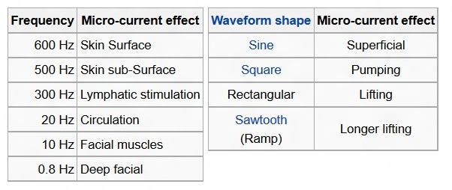

**SUMMARY**

Nerve and muscle tissue responds to electric stimulation in different ways.

The threshold change necessary for eliciting a muscle fiber action potential is generally much greater than the threshold necessary to activate the neurons of nerves.

Nerve tissue responds quickly to a current that rises rapidly to maximum intensity.

Muscle tissue responds very slowly to a current that rises gradually at a lower frequency, therefore longer duration stimuli are used.

Different electrical stimulation parameters must be used for muscle and nerve stimulation.

Electrical stimulation can be placed on different areas of the body to elicit different responses. The two different types of sites used for stimulation are motor points and sensory points.

Motor points are stimulated to mimic the same signal that the brain sends to the muscle therefore evoking actual muscle contractions.

Sensory points are stimulated to mimic nerve responses.

A comparison of the general differences between the responses of muscle and nerve tissue:

|  |  |  |
| --- | --- | --- |
| Nerves |  |  |
|  | Pulse Duration | long |
|  | Frequency | high |
|  | Ramping | quick |
|  |  |  |
| Muscles |  |  |
|  | Pulse Duration | long |
|  | Frequency | low |
|  | Ramping | slow |

FES uses a compromise of stimulation parameters to activate both muscle and nerve tissue requiring highly sophisticated control of the stimulation parameters.

Over the last several decades, research to find the appropriate combination of design elements has produced an effective and comfortable FES modality.

## In our device we have 2 circuits : 1- DIY Electronic muscle stimulation circuit 2- Electronic muscle stimulator timer circuit

## DIY Electronic muscle stimulation circuit diagram: ( A typical circuit diagram of a TENS device )

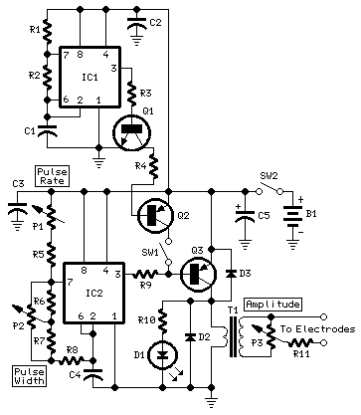

### *Parts:*

* Resistors:

R1:560K 1/4W Resistor   
R2:68K 1/4W Resistor   
R3,R4:10K 1/4W Resistors   
R5:22K 1/4W Resistor  
R6,R7:4K7 1/4W Resistors   
R8:330R 1/4W Resistor   
R9:2K2 1/4W Resistor   
R10:470R 1/4W Resistor   
R11:47R 1/4W Resistor

* Potentiometers:

P1:100K Linear Potentiometer   
P2,P3:10K Linear Potentiometers

* Capacitors:

C1:1µF 63V Polyester Capacitor   
C2,C3:100nF 63V Polyester or Ceramic Capacitors   
C4:220nF 63V Polyester Capacitor   
C5:220µF 25V Electrolytic Capacitor

* LEDs:

D1:LED (Any dimension, shape and color)   
D2,D3:1N4148 75V 150mA Diodes

* Transistors:

Q1:BC547 45V 100mA NPN Transistor

Q2,Q3:BC327 45V 800mA PNP Transistors

* Integrated circuits:

IC1,IC2:7555 or TS555CN CMos Timer ICs

* T1:230V Primary, 12V Secondary 1.2VA Mains transformer
* SW1,SW2:SPST Toggle or Slide Switches
* B1:3V to 9V Batteries

#### Circuit operation:

- IC1 generates 150µSec. pulses at about 80Hz frequency.

-The amplitude of the output pulses is set by P1 and approximately displayed by the brightness of LED D1.

-A small mains transformer 220 to 12V @ 100 or 150mA. It must be reverse connected i.e. the 12V secondary winding across Q2 Collector and negative ground, and the 220V primary winding to output electrodes.

-Output voltage is about 60V positive and 150V negative but output current is so small that there is no electric-shock danger.

-Tape the electrodes to the skin at both ends of the chosen muscle and rotate P1 knob slowly until a light itch sensation is perceived. Each session should last about 30 - 40 minutes.

#### Notes:

* T1 is a small mains transformer 220 to 12V @ 100 or 150mA. It must be reverse connected i.e. the 12V secondary winding across Q2 Collector and negative ground, and the 220V primary winding to output electrodes.
* Output voltage is about 60V positive and 150V negative but output current is so small that there is no electric-shock danger.
* In any case P1 should be operated by the "patient", starting with the knob fully counter-clockwise, then rotating it slowly clockwise until the LED starts to illuminate. Stop rotating the knob when a light itch sensation is perceived.
* Best knob position is usually near the center of its range.
* In some cases a greater pulse duration can be more effective in cellulite treatment. Try changing R2 to 5K6 or 10K maximum: stronger pulses will be easily perceived and the LED will shine more brightly.
* Electrodes can be obtained by small metal plates connected to the output of the circuit via usual electric wire and can be taped to the skin. In some cases, moistening them with little water has proven useful.
* SW1 should be ganged to P1 to avoid abrupt voltage peaks on the "patient's" body at switch-on, but a stand alone SPST switch will work quite well, provided you remember to set P1 knob fully counter-clockwise at switch-on.
* Current drawing of this circuit is about 1mA @ 3V DC.
* Some commercial sets have four, six or eight output electrodes. To obtain this you can retain the part of the circuit comprising IC1, R1, R2, C1, C2, SW1 and B1. Other parts in the diagram (i.e. P1, R3, R4, D1, D2, Q2 & T1) can be doubled, trebled or quadrupled. Added potentiometers and R3 series resistors must be wired in parallel and all connected across Emitter of Q1 and positive supply.
* Commercial sets have frequently a built-in 30 minutes timer. For this purpose you can use the [Timed Beeper](http://www.redcircuits.com/Page7.htm) the [Bedside Lamp Timer](http://www.redcircuits.com/Page4.htm) or the [Jogging Timer](http://www.redcircuits.com/Page32.htm) circuits available on this Website, adjusting the timing components to suit your needs.

*Be careful :*

The use of this device is forbidden to Pace-Maker bearers and pregnant women.

-Do not place the electrodes on cuts, wounds, injuries or varices.

**Practical Steps**

First step:  
- We bought circuit’s components and collect them together with wires (resistors , capacitors and transistors).

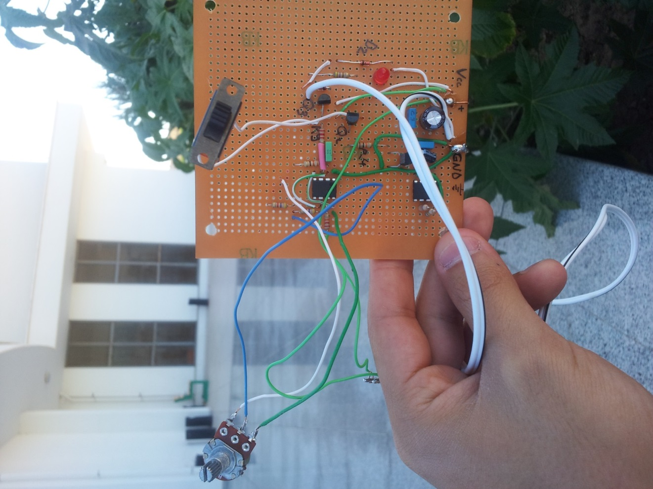

* Second step:  
  We connect our circuit with transformers and potentiometers (pulse rate – pulse width) to power supply .

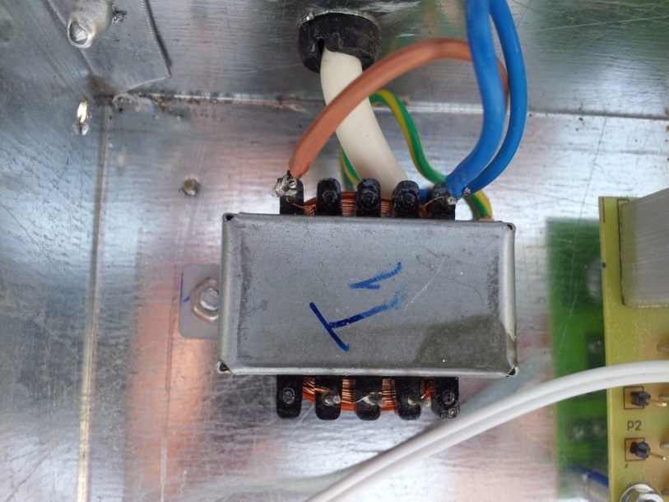

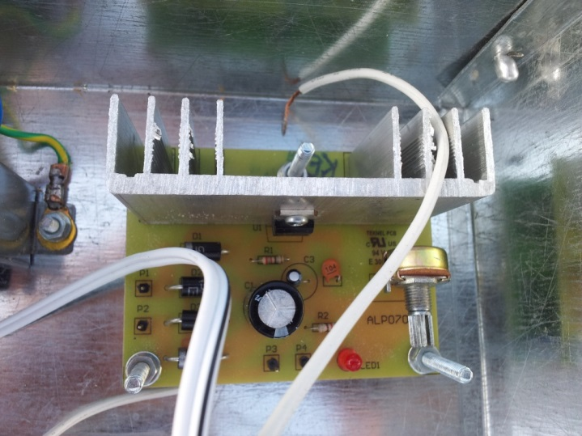

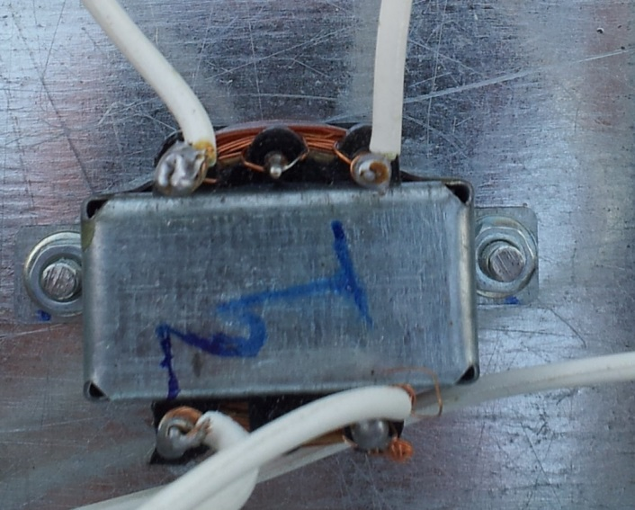

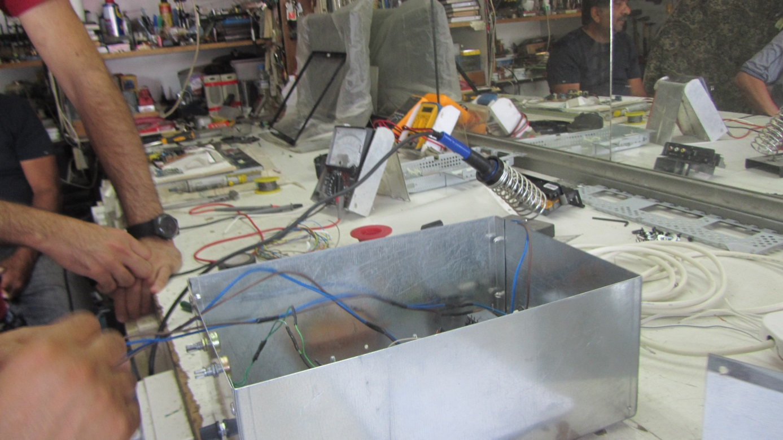

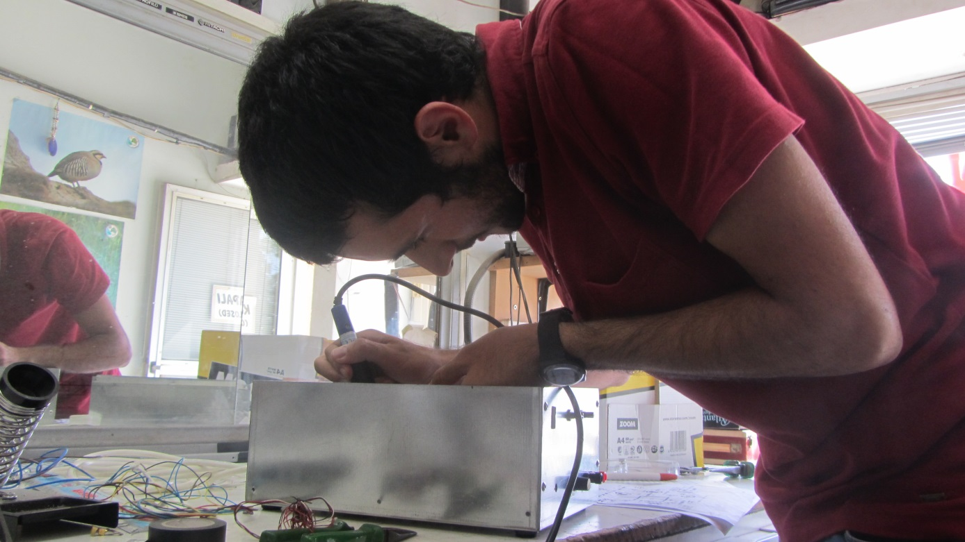

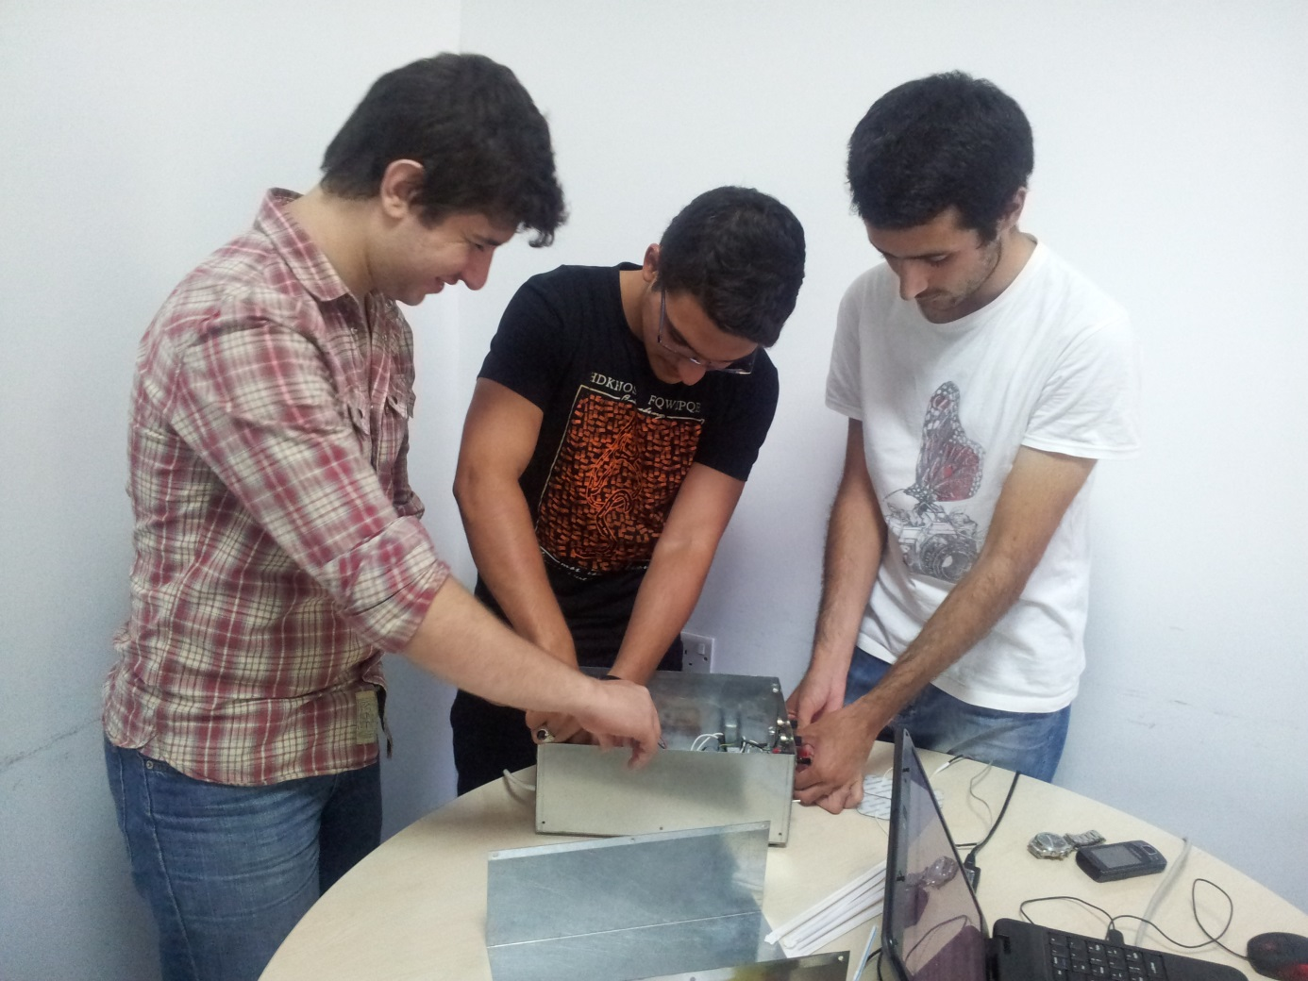

Third step:  
-All components are connected together in the box .

-We inserted buttons for on-off and potentiometers .

-We connect the circuit to power supply.

-We connect the probe

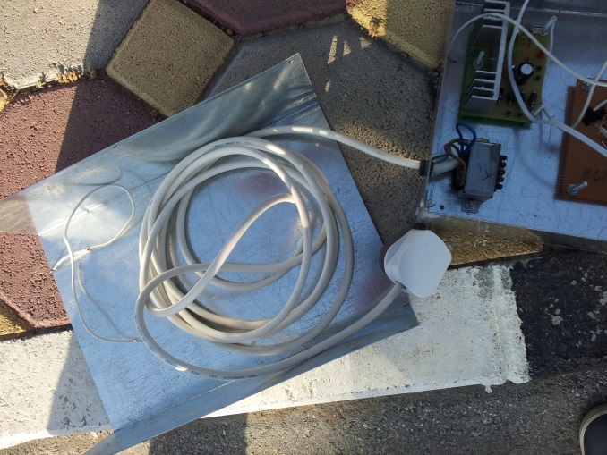

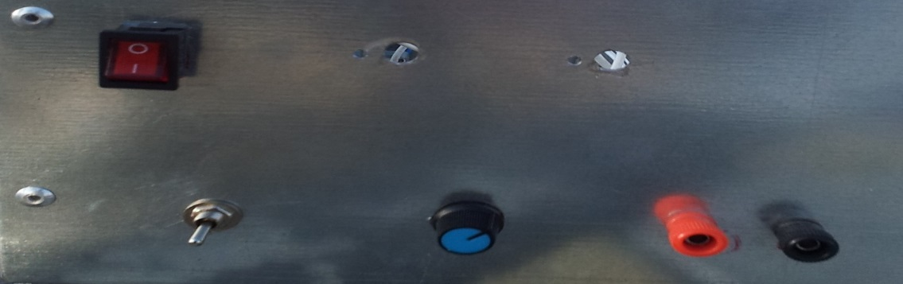

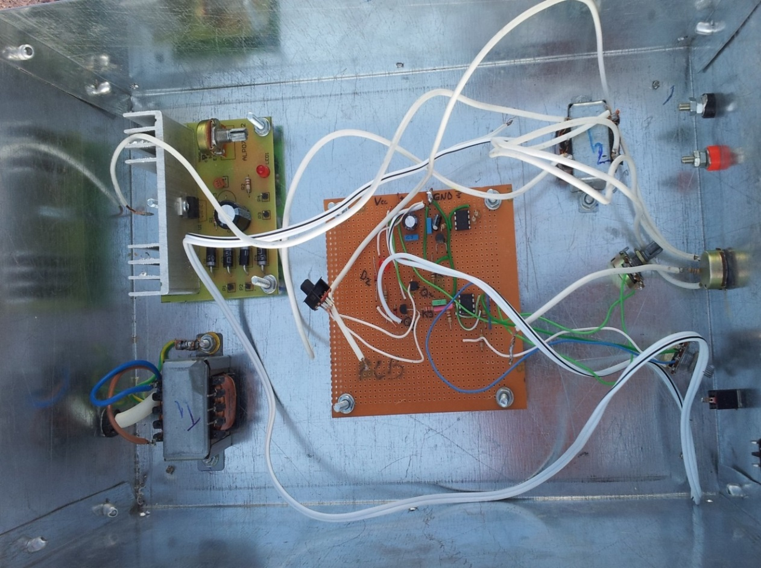

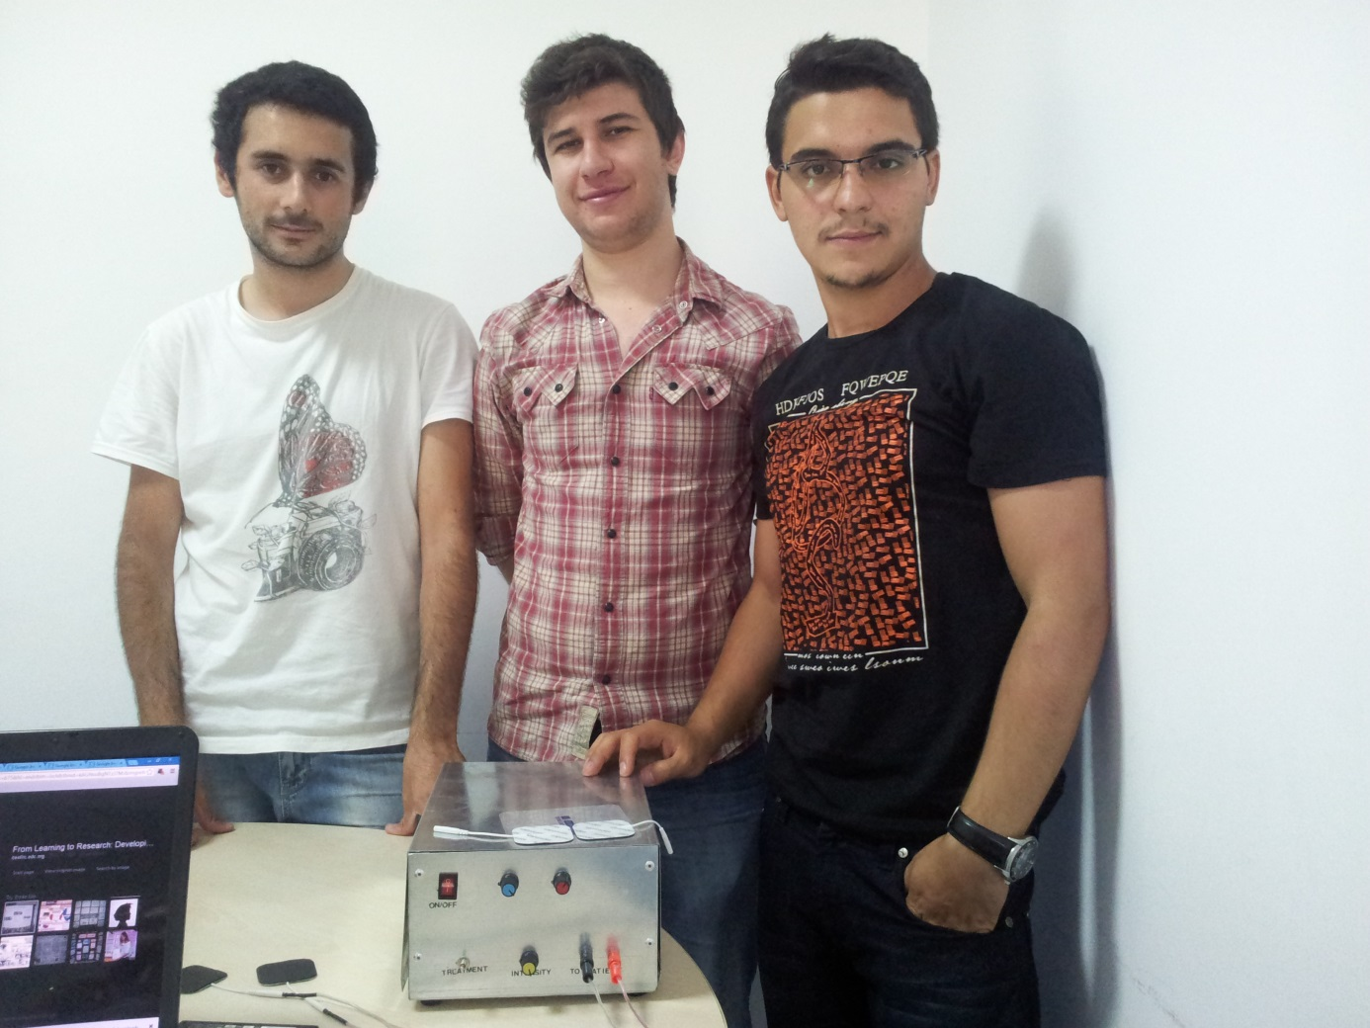

Top of Form

#### Device purpose:

This is a small, portable set, designed for those aiming at look improvement. The Bio-Stimulator provides muscles' stimulation and invigoration but, mainly, it could be an aid in removing celluli.  
Tape the electrodes to the skin at both ends of the chosen muscle and rotate P1 knob slowly until a light itch sensation is perceived. Each session should last about 30 - 40 minutes.

### Electronic muscle stimulator timer circuit

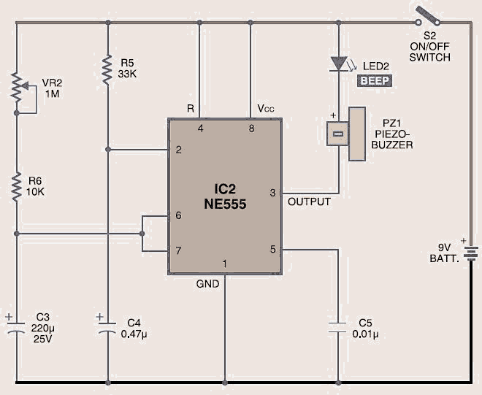

Assemble the timer with a separate switch and a 9V DC battery in the same cabinet as the stimulator. Tape the electrodes to the skin at opposite ends of the chosen muscle and rotate VR1 knob slowly until you sense light itching when the **muscle stimulation circuit** is powered on. At the same time, flip switch S2 to start the timer for counting the time. At the end of the timing cycle, the piezobuzzer beeps. Each session should last about 10 minutes.

**Effects of Electrical Stimulation on Body**

Electrical muscle stimulation (EMS) became one of main branch of physical therapy for long time as a method to heal muscles after an in­jury or surgery. About the 1960s it was often used in an attempt to prevent the atrophy that occurs when skeletal muscle is harmed. As more sophisticated stimulation devices were developed, it became a pop­ular treatment technique for patients that had sus­tained central nervous system impairment secondary to a stroke or spinal cord injury. Because of these developments, the EMS more common in patients undergoing lower extremity orthopedic surgery, especially the anterior cruciate ligament reconstructive surgery has been used to promote strength gains.

Improved capacity unit EMS, to stimulate the muscles ignited interest in its use as a training for healthy individuals without neuromuscular disease. At the beginning of studies by Kotz in the Soviet Union suggested that the EMS was more effective than exercise alone in strengthening skeletal muscle in elite athletes The proposed advantage of using EMS is that the recruitment order is reversed relative to volitional exercise. During volitional activi­ty, the central nervous system first activates the small­est alpha motoneurons. With increasing levels of re­quired force, progressively larger motoneurons are ac­tivated. This recruitment order, dependent on the size of the alpha motoneuron, has been termed the ‘‘size principle’’ of motor unit recruitment. The size of alpha motoneurons is related to the type of muscle fiber in­nervated by the motoneuron. Slow oxidative (SO) mus­cle fiber types are typically recruited first, whereas fast glycolitic (FG) are the most difficult to recruit during volitional activation. The order of muscle fiber recruit­ment is reversed when the muscle is activated via elec­trical stimulation, with the largest-diameter muscle fi­bers (FG) being recruited first and the smaller-diam­eter (SO) muscle fibers being recruited later.

At present, the potential benefits of the EMS, have been marketed to the public as yet another'' get fit in a hurry'' trick. '' The building rock-hard abs'' or'' strengthening the flab in the buttocks and thighs'' while working on the computer or watching TV, without the need to carry out, is an attractive lure for many people. While some over-the-counter electrical stimulation units sold to the public, claims support to the EMS, however in the general population it has never been verified. Previous researchers have studied the benefits of EMS, usually 1 or 2 stimulated isolated muscle groups, ie, quadriceps or thigh or both. The advantages of using EMS for the whole body to achieve full body conditioning program had not been considered. Thus, the aim of this study was to determine if the EMS can increase muscle strength, weight loss and fat and increase muscle hardness and tone (as claimed by manufacturers) in healthy individuals using over-the-counter EMS device is sold to the public.

***Subjects***

29 apparently healthy, college-aged volun­teers served themselves as subjects for this experiment. Subjects en­gaged in a formal exercise program during the pre­vious six months were excluded from the study. Subjects were randomly assigned to either a control or EMS group. Initially, 17 subjects were in the EMS group and 12 were in the control group. More subjects were placed in the EMS group at the start of the study be­cause we anticipated a higher drop-out rate in that group (because of the potentially uncomfortable na­ture of the stimulation). Over the course of the study, 1 subject dropped out of the control group (due to an injury unrelated to the study) and 1 subject dropped out of the EMS group (because of time constraints). All subjects who completed the study were paid $100.

*Testing*

Both groups of subjects underwent an identical battery of tests before and after the 8-week training program. The pre- and posttests included measurement of body weight, skinfolds, girths, muscle strength of the biceps, triceps, quadriceps, and hamstrings at a fixed joint an­gle (isometric maximal contraction) and at 60°-s~1 (iso-kinetic maximal contraction); photographs from the front, side, and back with the subject in a standard position; and Leikert rating scales for muscle strength, firmness, and tone.

*Body Weight.* Body weight was measured using a standard Health-O-Meter laboratory scale.

*Skinfolds and Girths.* All skinfolds and girths were measured by the same examiner. Skinfold thicknesses (fat folds) were each measured 3 times at the following 10 sites on the body using Lange calipers; biceps, tri­ceps, subscapular, pectoral, mid-axilla, iliac crest, su-praspinale, abdominal, thigh, and calf. The mean of the 3 measurements for each site was used in the cal­culation. Percentage of body fat was estimated from the sum of 7 skinfolds (chest, mid-axilla, subscapular, triceps, abdominal, iliac crest, and thigh) as described by Pollock et al.

Girth measurements (circumferences) were made at 10 sites using a spring-loaded steel tape measure. Measurement sites included the upper arm (flexed), forearm, wrist, chest, waist, hips, upper thigh, mid-thigh, and calf. Absolute girth measurements include both the circumference of the muscle as well as the subcutaneous fat layer. "Corrected" girths, which rep­resent the circumference of the muscle and bone, were calculated using the O-scale method, whereby the fat layer is subtracted from the circumference of the re­spective body part , allowing calculation of effective lean limb girth.

*Isometric and Isokinetic Strength.* Isometric strength of the biceps, triceps, quadriceps, and biceps femoris on the subjects' right side was measured on a Cybex-340 dynamometer. For each exercise, 5 repetitions were performed, sampling at 100 Hz at 6°s~1. Peak torque data was corrected for gravitation torque for each of the isokinetic testing positions. The strength testing protocol measured the peak torque during concentric contractions for opposing muscle groups (biceps-tri­ceps and quadriceps-hamstrings). The peak torque output for the maximum repetition of the 5 maximal repetitions was used in the statistical analysis.

For the biceps-triceps measurements, subjects were in the supine position with the elbow flexed to 90°. For the measurement of isometric strength, the dynamom­eter arm was locked in position so that no joint move­ment could take place. For the measurement of isoki­netic maximal strength, subjects stayed in the same po­sition and the dynamometer was set at 60°-s~: of joint movement. For the quadriceps-biceps femoris measure­ments, subjects were in a sitting position, with the hip flexed to 90°. Again, for the isometric and isokinetic measurements the speed on the Cybex were set at (f-s"1 and 60°-s~1, respectively. For all trials, the best of the 3 trials was recorded as the subject's maximal strength.

*Photographs.* Subjects were photographed from the front, side, and back using a digital camera. Men were clothed in a trunk-style swimming suit and women were clothed in a 2-piece swimsuit. All photographs were reviewed and graded for firmness and tone by 1 of the researchers using a 1-10 Leikert-type scale (with 10 being highly firm and toned and 1 being least firm and toned).

*Self-Perception Questionnaire.* All subjects completed a 9-item questionnaire to measure their perception of their strength, muscle tone, and muscle firmness at the end of weeks 2, 4, 6, and 8. Subjects rated their agree­ment with each of the items (Table 1) by marking on a 10-cm line. The far left side of the line represented strong disagreement with the statement and the far right side indicated strong agreement. The distance in centimeters from the left side of the line to the subject's

**Table 1.** Items included in self-perception questionnaire.

1. My arms feel stronger.
2. My legs feel stronger.
3. My abdomen feels stronger.
4. My arms feel more toned and firm.
5. My legs feel more toned and firm.
6. My abdomen feels more toned and firm.
7. People have commented that my arms look more toned  
   and firm.
8. People have commented that my legs look more toned  
   and firm.
9. People have commented that my abdomen looks more  
   toned and firm.

mark was measured and recorded as the score. Sub­jects' responses to the 3 items related to strength (arms, legs, and abdomen) were averaged to create a single strength score. The same procedure was fol­lowed for the 3 items related to muscle tone and the 3 items related to appearance.

*Training*

Subjects in both the EMS and control groups under­went electrical stimulation 3 times per week for 8 weeks. Before the initiation of the training program, 5 sets of lead wires, supplied by the manufacturer, were cut and repaired so that they appeared to be fully functioning leads. However, they did not transmit any electrical current. These tampered leads were used by subjects in the control group, whereas subjects in the stimulation group used the standard leads. Both groups of subjects used identical electrical stimulators, electrodes, and stimulation parameters. The only dif­ference between the 2 groups was the type of lead used. The subjects in the control group were told that we were using an electrical current with a lower am­plitude that should be less noticeable than the stan­dard stimlation protocol.

The stimulation unit used was the Bodyshapers model BM1012BI. This unit was selected because it was representative of the quality and price of over-the-counter units typically marketed to consumers. It was also a unit that was readily available for purchase over the Internet.

The electrical stimulation unit comes equipped with reusable carbon electrodes and a single small sponge to moisten the electrodes before application. However, this method resulted in a small superficial burn under the electrode when the investigators pilot­ed the stimulation protocol on themselves. The inves­tigators hypothesized that simply moistening the elec­trode by wiping across it with a sponge resulted in a small amount of water in 1 area of the electrode. The electrical current concentrated in this area and pro­duced the subsequent superficial burn. To minimize any dermal damage and increase the comfort of the stimulation, the investigators elected to place a damp sponge between the electrode and the skin to uniform­ly transmit the electrical current. Sponges were dis­infected after each use. No dermal injury was noted throughout the study using this method.

All subjects attended an orientation session before initiation of the electrical stimulation training pro­gram. The proper location and application of the elec­trodes was demonstrated and subjects also received written instructions on how to apply the stimulation electrodes and operate the stimulator. All electrical stimulation sessions for both groups were conducted in the physical therapy department of the UW-La Crosse Student Health Center. Investigators were pre­sent to answer questions during each subject's initial stimulation session and to assure that the electrodes were applied properly and the stimulation unit was adjusted appropriately. Subsequent stimulation ses­sions were scheduled by the subjects at their conve­nience, 3 times per week for 8 weeks. All subjects com­pleted a total of 24 stimulation sessions.

The bilateral biceps, triceps, quadriceps, ham­strings, and abdominal muscles were stimulated dur­ing each stimulation session. While piloting the stim­ulation protocol on themselves, the investigators also found that it was very difficult to independently apply the electrodes using the Velcro straps supplied with the stimulation unit, particularly to the biceps-triceps muscle groups and the quadriceps-hamstrings muscle groups. The investigators had Lycra sleeves custom-sewn to fit the subjects' upper arms and thigh areas. Subjects typically wore shorts and tank tops during the stimulation session. They applied the Lycra sleeve to either the upper arm or thigh and then slipped the damp sponge and electrode under the Lycra sleeve to the appropriate position on the muscle.

Because the stimulator had only 6 channels, a sin­gle training session required 2 cycles of stimulation. During the first cycle, subjects applied 3 sets of elec­trodes (using 3 channels) to the abdominal area and 1 set to the biceps and triceps of both arms (1 channel each). Electrode placement at each site is shown in Fig­ures 1 and 2. Subjects then completed 10 maximal elec­trical contractions using 5 channels simultaneously on the stimulation unit with the following parameters: frequency of 45 pulsess1, biphasic waveform, 10 sec­onds on and 35 seconds off, stimulation (vs. tapping) mode, normal (vs. alternate) mode.

Subjects were instructed to adjust the amplitude of each channel to the maximum that could be comfort­ably tolerated.

For the second cycle of stimulation, subjects moved the electrodes to the locations illustrated in Figures 3 and 4. One set of electrodes was placed on the quad­riceps and 1 set was placed on the hamstrings of each leg (2 channels per leg). Subjects then completed the second set of 10 maximal contractions using 4 chan­nels on the stimulation unit simultaneously.

Subjects used the previously outlined stimulation parameters for the first 4 weeks of the study. Follow­ing the manufacturer's recommendation for increasing muscle tone, the parameters were adjusted as follows during weeks 5 and 6 of the training program: fre­quency increased from 45 to 110 pulsess1, on time increased from 10 to 30 seconds, and off time de­creased from 45 to 30 seconds.

During the final weeks of the training program (weeks 7 and 8), the parameters were readjusted as follows: frequency further increased from 110 to 150 pulsess1, time increased from 30 to 45 seconds, and off time further decreased from 30 to 15 seconds.

In addition, the electrically elicited maximal iso­metric contraction tolerated by each subject was com­pared with the subject's volitional maximal isometric contraction using an Orthotron dynamometer during the first and final weeks of the training program. On each of these occasions, the subjects applied the elec­trodes and sponges over the right vastus lateralis and medialis and connected the lead wire to the stimulator. The investigator then aligned the axis of the dyna­mometer with the subject's right knee and stabilized the subject on the unit in a seated position using the thigh, chest, and ankle straps. The knee was flexed to 90° and the speed was set at 0. The subject was asked to try to straighten the knee.

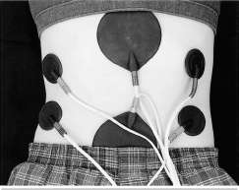

**Picture 1.** One pair of 1.5-in. circular electrodes was ap­plied over the right internal and external obliques and a second pair was applied over the left internal and external obliques. Two 3.5-in. circular electrodes were applied over the rectus abdominus. These electrodes were secured with elastic straps during the stimulation protocol. The straps have been removed for the photograph.

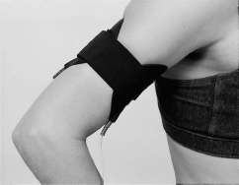

**Picture 2.** One pair of 3.5-in. electrodes was used to stim­ulate the biceps/triceps of each arm by placing the elec­trode over each muscle belly.

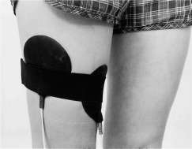

**Picture 3.** One 3.5-in. electrode was placed over the vastus lateralis and vastus medialis on the anterior side of each leg.

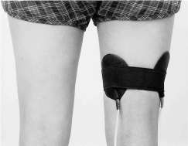

**Picture 4.** One 3.5-in. electrode was placed over the medi­al and lateral hamstrings on the posterior side of each leg.

The best of 3 trials was recorded in newton-meters of torque. Subjects were also asked to relax and then adjust the amplitude of the stimulation unit to the highest tolerable level. The highest torque gener­ated during 3 electrically elicited contractions was re­corded. Test order (volitional or electrically elicited) was randomized. The Orthotron could not accurately record torque output less than 40.7 nm. Thus, values less than this level were recorded as 0.

**Table 2.** Descriptive characteristics of the subjects at the beginning of the study.

|  |  |  |  |  |
| --- | --- | --- | --- | --- |
| *N* | Age (y) | Ht. (cm) | Wt. (kg) | % Body fat |
| Control Women (5) Men (6) Overall (11) | 19.4 ± 0.55 20.6 ± 0.52 19.8 ± 0.54 | 165.8 ± 3.22 181.3 ± 5.25 173.3 ± 9.39 | 60.0 ± 4.67 82.3 ± 14.61 71.7 ± 15.50 | 23.4 ± 3.99 15.1 ± 7.42 18.8 ± 7.27 |
| EMS* Women (9) Men (7) Overall (16) | 19.3 ± 0.71 19.7 ± 1.13 19.4 ± 0.88 | 166.2 ± 2.21 184.8 ± 3.68 174.3 ± 13.56 | 61.7 ± 7.80 85.2 ± 15.97 72.8 ± 16.30 | 22.8 ± 3.54 16.1 ± 8.16 19.9 ± 6.82 |

* EMS = electrical muscle stimulation.

|  |  |  |  |  |  |  |  |  |  |  |
| --- | --- | --- | --- | --- | --- | --- | --- | --- | --- | --- |
| **Table** | **3.** | Changes | **in** | body | composition | of the | course of the | study. |  |  |
|  |  |  |  |  |  | Control |  |  |  | EMS* |
|  |  |  |  |  | Pre |  | Post |  | Pre | Post |

Sum of 7 skinfolds (mm) 119.4 ± 45.77

Body weight (kg) 71.7 ± 15.5

% Fat 18.8 ± 7.27

Fat weight (kg) 13.5 ± 6.53

Lean body mass (kg) 58.2 ± 13.06

117.6 ± 44.94 71.1 ± 15.90

1. ± 7.70  
   13.3 ± 6.74
2. ± 13.25

122.4 ± 46.46

1. ± 16.30
2. ± 6.69  
   14.4 ± 7.05  
   58.4 ± 13.50

123.5 ± 44.02 72.8 ± 16.81

1. ± 6.40  
   14.6 ± 6.70
2. ± 13.39

* EMS = electrical muscle stimulation.

**Table 4.** Changes in girths (cm) over the course of the study.

Control

EMS*

|  |  |  |  |  |  |  |  |
| --- | --- | --- | --- | --- | --- | --- | --- |
|  |  | Pre | Post |  | Pre |  | Post |
| Arm | 31.5 | ± 4.05 | 31.2 ± 4.37 | 31.2 | ± 4.43 | 31.8 | ± 4.45 |
| Arm corrected | 27.4 | ± 4.35 | 27.2 ± 4.42 | 26.0 | ± 4.44 | 26.8 | ± 4.28 |
| Waist | 80.4 | ± 11.77 | 79.3 ± 10.16 | 78.0 | ± 11.01 | 78.6 | ± 10.58 |
| Thigh | 56.5 | ± 7.05 | 55.0 ± 6.21 | 57.1 | ± 5.57 | 56.1 | ± 5.06 |
| Thigh corrected | 49.5 | ± 6.60 | 48.2 ± 5.94 | 50.2 | ± 6.19 | 49.2 | ± 5.46 |

*Statistical Analyses*

Comparisons between groups and from pre- to post-testing were analyzed using a 2-way analysis of vari­ance with repeated measures. Tukey's post hoc tests were used to isolate pairwise differences when there was a significant F ratio. a was set at *p* < 0.05.

Results

The physical characteristics of the 11 subjects in the control group (5 women and 6 men) and the 16 sub­jects in the EMS group (9 women and 7 men) who completed the study are presented in Table 2. The groups were not different *(p >* 0.05) in terms of age, height, weight, or percentage of body fat at the begin­ning of the study.

Changes in body composition over the course of the study are summarized in Table 3. There were no sig­nificant (p > 0.05) changes in the sum of 7 skinfolds, body weight, percentage of body fat, fat weight, or lean body weight from pre- to posttesting in either group.

Girth data are presented in Table 4. Only girths over the muscles that were stimulated are presented, since no change would be expected in the nonstimulated ar­eas. There were no statistically significant (p > 0.05) changes in arm, waist, or thigh girths in either group over the course of the study. The corrected arm and thigh girths purportedly estimate the circumference of the muscle and bone in those areas. There were no sig­nificant (p > 0.05) changes in corrected arm or thigh girths over the course of the study in either group.

Changes in the skinfold data are summarized in Ta­ble 5. Again, only the skinfolds over the stimulated mus­cles are presented. There were no significant (p > 0.05) differences in the biceps, triceps, abdominal, or thigh skinfolds over the course of the study in either group.

Changes in isometric and isokinetic strength over the course of the study are presented in Table 6. There were significant (p < 0.05) changes from pre- to post-testing in both groups for several of the measures; however, there were no significant (p > 0.05) differ­ences between groups. For instance, the isometric strength of the biceps decreased in both groups from pre- to posttesting, whereas there was a slight increase in biceps and triceps isokinetic strength measured at 60°-s~1 in both groups over the course of the study.

**Table 5.** Changes in skinfolds (mm) over the course of the study.

|  |  |  |  |  |  |  |  |
| --- | --- | --- | --- | --- | --- | --- | --- |
|  |  | Control |  |  |  | EMS* |  |
|  | Pre |  | Post |  | Pre |  | Post |
| Biceps Triceps Abdomen Thigh | 8.6 ± 3.65 16.5 ± 6.29 25.2 ± 11.50 23.4 ± 10.08 |  | 9.1 ± 3.63 16.5 ± 6.99 24.9 ± 10.08 22.5 ± 9.29 | *9.7* 18.3 24.3 22.3 | ± 4.16 ± 5.54 ± 12.85 ± 7.71 |  | 10.1 ± 4.87 18.8 ± 6.29 24.9 ± 11.88 22.6 ± 8.50 |

* EMS = electrical muscle stimulation.

The clinical significance of these changes is negligible and is probably unrelated to the stimulation, since both groups (EMS and control) changed in the same direction.

The photograph evaluation data are presented in Table 7. On a scale of 1 to 10, subjects were generally in the range of 6, indicating that they were not very toned or firm and had room for improvement. How­ever, there were no significant (p > 0.05) changes in the appearance of firmness or tone in either group from pre- to posttesting.

The results of the questionnaires completed by the subjects at the end of the second, fourth, sixth, and eighth week of the study are presented in Table 8. All of the scores for the EMS group were significantly (p < 0.05) higher than for the control group. There were no significant (p > 0.05) changes for either group over the course of the study.

**Current Concepts in Electronic Stimulaiton**

Main principles of electrical stimulation is based on the common model of electrotherapy outlined in the diagram below.

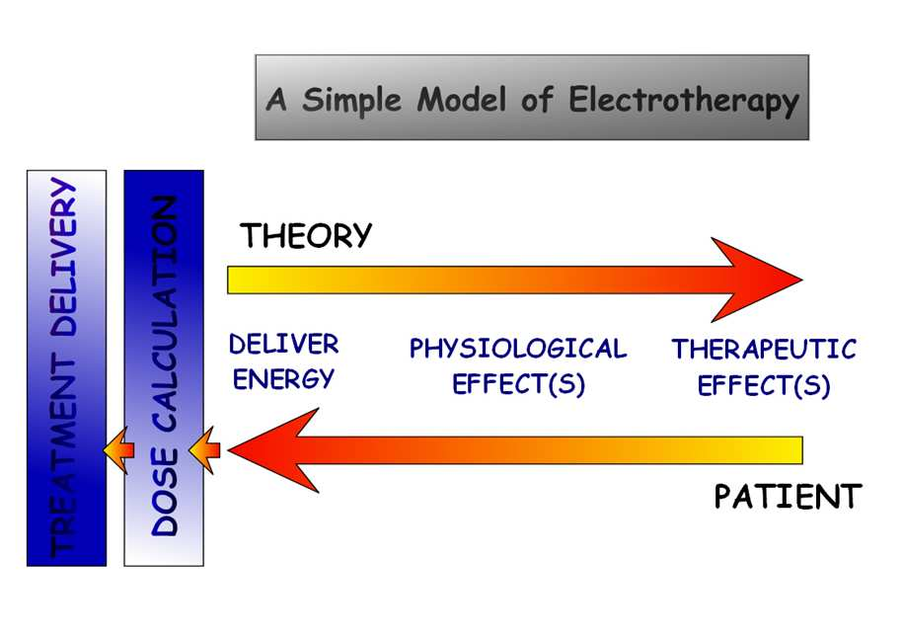

**Figure 1 : General Model of Electrotherapy**

t

ec el

y.

erap

The delivery of energy to the tissues (in this case a form of electric current) will bring about physiological changes in the tissues (nerve stimulation) and thereby achieve therapeutic benefit. The critical issues are to ‘set’ the machine in such as way as to stimulate the target nerves as effectively and as efficiently as possible. Stimulation of sensory nerves will achieve a sensory outcome, similarly, stimulation of motor nerves will bring about a motor effect. Clearly it is not possible to ONLY stimulate one type of nerve or another, BUT it is possible to primarily have an effect on a nerve type by setting appropriate parameters on the stimulation device.

Electrotherapy machines (TENS) in this area are specific and dedicated to a particular task whilst others offer numerous different stimulation modes, and a selection can be made typically from a menu system.

There is a growing number of studies that with the influence of electrical interference stimulation of physiological processes, in addition to nerve stimulation (for example, micro-current therapy to improve tissue repair), but this will mark the introduction of the principles of nerve stimulation.

**Nerve Membrane Potentials**

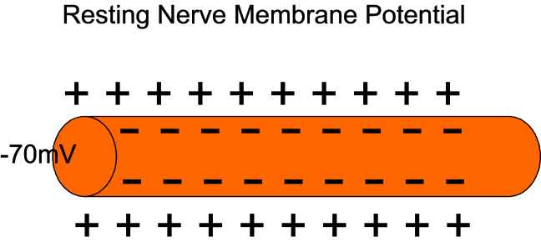

**Figure 2 : Resting nerve membrane potential**

Nerves, as we all know have a ‘resting’ membrane potential – such that the nerve membrane is effective polarised (or charged up) even in its resting (quiescent) state. This polarisation of the membrane is achieved by the unequal movement (pumping) of ions across the membrane, and clearly therefore takes energy to create and to maintain this state.

As a result, the polarization is that the nerves are always ready to "fire" - that is, to run / transmission capacity deystviya.Potentsial action (nerve impulse) is effectively a temporary change of the nervous membrane sequentially along its length, which is achieved by changing the pump and activity of membrane ion channels . There is a huge amount of information on how this is accomplished, and control, and it is not the intention to try to explain it here.

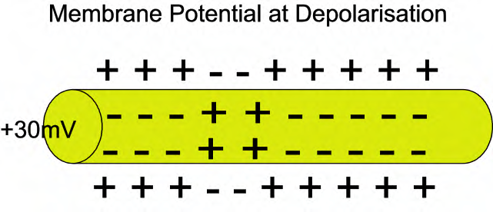

**Figure 3 : Nerve membrane depolarisation**

The main components in the fact that the nerve impulse is initiated (sensory nerve endings or the anterior horn cells, for example), and then, once started, must be 'all or nothing' behavior, with the impulse to reach the destination

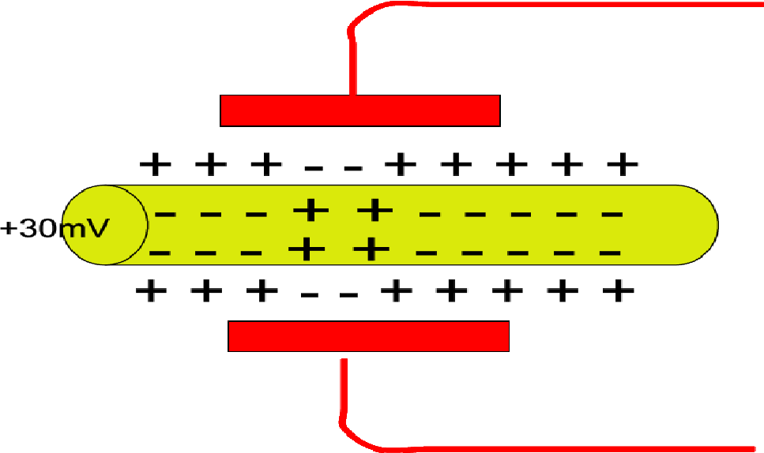

**Figure 4 : Electrical pulse (stimulation) as an initiator of the action potential**

This is related to the treatment and electrical stimulation, given the action potential only real difference 'forced' or someway that evoked along the length of the nerve. Electric current (or electric pulse) external stimulus that initiates an action potential. , The initiation comes from outside the body, but once started - it (see below) is large enough to overcome the threshold Assuming, then the action potential as a result of electrical stimulation of the 'natural' is not any different result is the same one that launched.

There are some interesting issues developing with regards antidromic conduction (action potentials travelling the ‘wrong way’ along a stimulated nerve, but that is really a development in progress, and something to watch out for rather than concrete information that we can use in the clinical setting now.

**Nerve Membrane Thresholds**

It was identified (belov) that the nerve will ‘fire’ so long as the applied stimulus is sufficient to push the membrane potential over its threshold value. There is little point worrying about numbers in this context as although we know the levels of thresholds in various types of nerves, these are values for the nerves in situ and do not relate directly to an applied clinical stimulation. What is relevant clinically. Is that one would need to apply a sufficiently large stimulus in order to achieve nerve activation. If a subthreshold stimulus is applied, the nerve threshold is not reached and although there are membrane changes, no action potential will result.

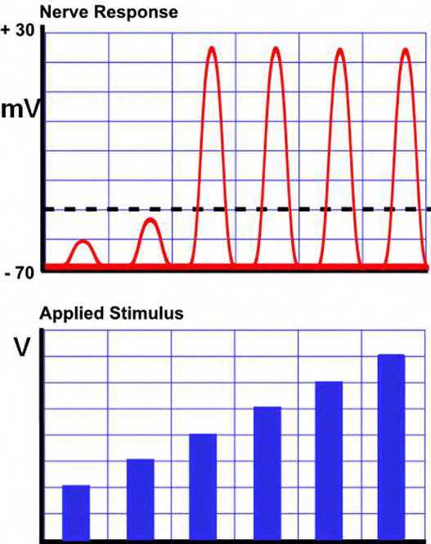 **Figure 5 : Effect of applying subthreshold and suprathreshold stimuli on action potentials**

Once the threshold has been exceeded, it does not matter (in fact), but makes a strong stimulus, the nerve will either shoot or not ('all or nothing' bit of the law), and therefore, an increase in strength of the stimulus can increase the amount of fiber, which will shoot, but will not directly affect the magnitude of the action potential. The case shown in the adjacent diagram.

**Refractory Period(s)**

Following action potential it is not possible for the nerve to carry another potential for a minimal amount of time (the ABSOLUTE refractory period) which is usually around 1ms though it varies between nerve types. Subsequently, there is a RELATIVE refractory period during which the nerve can be stimulated, but will require a higher stimulus strength than usual to initiate the action potential (effectively, the nerve threshold is temporarily raised). It is of variable duration, but typical is about 10-15ms (Figure 6).

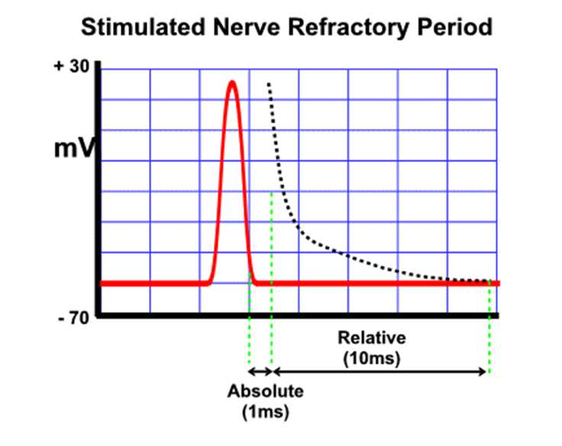

**Figure 6 : Absolute and Relative Refractory Periods**

Nerves can not (at least theoretically) be stimulated more than [+ action potential absolute refractory period]. If you take a quick action potential of nerve to 0.5 ms and the absolute refractory period of 1 ms, the combined cycle is 1.5 ms, and therefore faster, nerve can "always fire" will be 1000/1.5 = 666 Hz. Although this is a simplified calculation is illustrated by the fact thatis a limit how fast you can make the nerves fire, that a machine that you have.

**Pulse Shape and Duration**

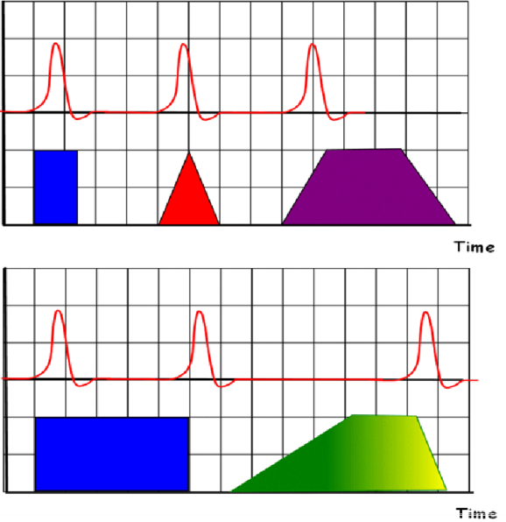

**Figure 7 : The effect of pulse ‘shape’ on nerve action potentials initiated**

"Shape" delivers an electrical pulse will have the effect, or the behavior of the excited nerve. Nerve membranes generally respond to rapid changes in the voltage and adjust to the slowly varying voltages.

Pulses in the bottom row illustrate several other issues. First, the duration of the rectangular pulse (bottom left) will initiate depolarization of the initial growth or action potential in the steady state (no change of the applied voltage), but further possible action at the "far end" of the pulses (due to the rapid change of the applied voltage - it just happens to be in the opposite direction). This assumes, of course, that the time between the initial increase in pulse and fall more refractory periods for this nerve.

Somewhat odd pulses (bottom right corner) is a hybrid switching type with slow growth (and therefore no action potential), stable phase (potential actions), and the rapid decline (action potential idea) - it is not something that we will use clinically, I simply illustrates the point ..

You can look at any number of combinations, but the basis of the question is that for normal nerve itself, this rate of change of the applied voltage (V), which is the main (but not only) the determinant of whether the nerves will fire or not.

**FINISH**

**References**

http://en.wikipedia.org/wiki/Human_anatomy

Google Pictures //

http://biomed.engr.sc.edu/bme_lab/lab%20reports/29)%20BioPotential%20Basics.pdf

http://www.youtube.com/watch?v=RwBG2L1WBFE

http://www.ivy-rose.co.uk/HumanBody/Muscles/Muscle_Structure.php

http://en.wikipedia.org/wiki/Electrical_muscle_stimulation

http://speedendurance.com/2011/11/23/ems-nmes-electrical-muscle-stimulation-benefits/

http://www.google.ps/search?q=Electrical+Muscle+Stimulation&hl=ar&tbo=u&tbm=isch&source=univ&sa=X&ei=tin3UMLONo_DtAb3m4CYBQ&ved=0CFYQsAQ&biw=1366&bih=597

http://www.dentistrytoday.info/content/tens-trans-cutaneous-electrical-nerve-stimulation

http://electroschematics.com/2083/electronic-muscle-stimulator/

http://www.redcircuits.com/Page42.htm

http://www.frankshospitalworkshop.com/equipment/documents/electrotherapy/wikipedia/Electrical_muscle_stimulation.pdf

http://www.electrotherapy.org/downloads/Modalities/Current%20Concepts%20in%20Electrical%20Stimulation%20may%202010.pdf

http://www.articlesbase.com/health-articles/electrical-muscle-stimulation-and-its-functions-2151808.html

http://www.hindawi.com/journals/ccrp/2012/432752/

http://kirkham.tamu.edu/426Docs/Electrical%20Muscle%20Stimulation.pdf

http://speedendurance.com/2011/11/23/ems-nmes-electrical-muscle-stimulation-benefits/

https://wiki.engr.illinois.edu/pages/viewpage.action?pageId=49747069

http://www.wisegeek.com/what-is-electrical-muscle-stimulation.htm

http://www.tens-store.com/ems/BodyStim.htm