**CHAPTER 1**

**INTRODUCTION**

The human vision system is one of the most complex systems in the central nervous system. The visual system includes the eyes, the connecting pathways through to the visual cortex and other parts of the brain, which will receive the reflected light from the surrounding things and configure the image. The presence of any defect in any part of the visual system can cause visual impairment or sometimes blindness. Blindness is defined as visual acuity of less than 3/60 (0.05) or corresponding visual field loss in the better eye with best possible correction (visual impairment categories 3, 4 and 5 in ICD-10). This corresponds to loss of walk about vision [1]. 285 million people are visually impaired worldwide: 39 million are blind and 246 million people have low vision and are at great risk of becoming blind[2]. cataract (47.9%) remains the leading cause of visual impairment in all areas of the world, except for developed countries. Other main causes of visual impairment in 2002 are glaucoma (12.3%), age-related macular degeneration (AMD) (8.7%), corneal opacities (5.1%), diabetic retinopathy (4.8%), childhood blindness (3.9%), trachoma (3.6%), and onchocerciasis (0.8%)[43]. Blindness and visual impairment are mainly due to birth defects and uncorrected refractive errors. In the first case, most of the causes are in the brain rather than in the eye while in the second one, they are conditions that could have been prevented if diagnosed and corrected with glasses or refractive surgery on time [11]. It is estimated that by the year 2020, all blind-related numbers will double [9]. The main reason that attracted the researchers to invent various technologies is the increasing number of people with vision disabilities in the world. It is hoped that these technologies can assist people in carrying out their every-day tasks like normal people. One of the main problems of the visually impaired is that most of them have lost their physical integrity, also they do not have confidence in themselves and they find themselves challenging to go out independently. Blind issue has become a sensitive issue and influential in the community in terms of economic and social loss. The economic loss due to un-accommodated blind people increased from $29 billion (2010) to $50 billion come (2013) [3]. Visually impaired people use their sense of hearing to compensate for their reduced eye sight, for instance they can recognize sound sources. Human spatial hearing was analyzed by many authors (Blauert 1999: More 1997) who established that both monaural and binaural attributes of the ear input signal contribute to forming the position of the auditory event [7]. The blind person in most cases uses the white cane to navigate the markings on the floor inside a building to find their way. This traditional method is not effective in all circumstances because the blind person must know their way, and if they fail to find the marking they may face some problems. It would be more complicated in the case if the blind person had problems in sensory organs. In addition, the white cane requires the user to actively scan the small area ahead of him/her. The white cane is also not suited for detecting potentially dangerous obstacles at head level. The traditional navigation method may not be sufficient for the blind person in these cases. The guide dog may be a solution, but the dog must be trained at least two years and trained guide dogs cost between $12,000 to $20,000 (In developed countries), and they are only useful for about five years [6], and the expense is unaffordable for many people. The growth of information technology plays a vital role in the recent development almost in all the fields, so the active navigation method may be helpful for the blind but it is important to appreciate as much as possible the needs and requirements of this community before starting to create devices for them. In today's society of social independence, the visually impaired like everyone else deserve independence. They require assistive devices for navigation, for reading signs and text to be independent. In particular, outdoor and indoor navigation has always been a challenging problem for their mobility. This navigation concern restricts the visually impaired right access to many buildings, precludes their use of public transit and makes their integration into local communities difficult [8]. Innumerable attempts have been made to leverage technology to supplement or replace these two "low-tech" aids. The resulting devices are commonly known as electronic travel aids (ETAS). In 1971 Dr Leslie Kay from New Zealand became the first engineer to invent a device for fish finding, a divers sonar and ultrasound device to listen to the heart moving and an ultrasound imaging system to look into metal [11]. Sonar techniques namely frequency modulation (FM) and pulsed echo techniques have been wildly used in ultrasonic blind mobility aids, because they are well suited for localizing objects. They use reflection as a key principal to determine the distance from an object.

**The Purpose of the Thesis**

The main objective of this work is to help blind or visually impaired people to navigate safely and quickly among obstacles and other hazards. In order to do this an innovative approach based on the integration of electronic components on the textile structures have been investigated. With this approach, the design of a new wearable obstacle detection system that is flexible and comfortable for the human body has been developed.

The proposed system provides three services, the first one provides a voice warning of obstacles and facilitates the selection of the clear path by using a helmet containing ultrasound sensors in its surrounding. The sensors send ultrasound signals which can be reflected by obstacles and receive the reflected waves. Secondly, the developed system helps blind people to sense and estimate the distance between them and anything that can be harmful, by using a vibration based bandage worn on the hand. Thirdly, a GPS (Global Positioning System) is used to support the communication system and determine the location of the blind person.

**Functional Description**

During operation, the user wears the helmet system on the head, and wears the bandage around his/her wrist. So while walking the user can make his/her hand move forward and turn in different directions to the left or right setting the direction of the sensor to a lower level to detect the area nearer the ground. The helmet position is fixed on the head and it senses the higher level of the human body. The same function allows the user to find a passable way, for example, the door opening. With these functions it is possible to guide the bind to travel safely and not to come into contact with any obstacles.

Chapter 1 is the introduction. Chapter 2 provides a literature search on the topic. Chapter 3 is about the hardware design of the system developed by the author. Chapter 4 is about the software details of the system. Chapter 5 provides the test results and discussions about the system. Finally, Chapter 6 is the conclusion.

**CHAPTER 2**

**LITERATURE REVIEW**

It is important for the visually impaired to be comfortable and hands free during their navigation, thus the usable electronic aid would work best by being embedded into wearable fabrics. The research that has been done on this with regards to the implementation of electronic components into textile structures is not detailed, however they consider attaching the component on to the wearable fabrics[5].

This review comprises devices developed from the Second World War, when the development of sensors played an important role in the human life, until nowadays. The background and history of ETA (electronic travel aids) started In, TVSS (Tactile Vision substitution System) are studied at Smith-Ketlewell Labs. L.KAY’ s Sonic Torch is produced as the first practical ETA device and continues in following famous commercial models, MOWAT sensor, Laser Cane, and so on. These ETA devices are basically surrounding distance transfer device, which gives distance information along pointed direction back to user with converted tone, sound modulation or mechanical vibrations. In addition, not only portable device, there exists travel guidance system in building as functional welfare facility, which gives voice announce about the important location and attribute information to the visually impaired by detecting sensor under the floor or street with electric cane[39].

**2.1 GuideCane**

The Guide Cane: is a device designed to help blind or visually impaired users navigate safely and quickly among obstacles and other hazards. During operation, the user pushes the lightweight Guide Cane forward. When the Guide Cane’s ultrasonic sensors detect an obstacle, the embedded computer determines a suitable direction of motion that steers the Guide Cane and the user around it. The steering action results in a very noticeable force felt in the handle, which easily guides the user without any conscious effort on his/her part [12].

**2.2 Bionic Eyeglass**

A bionic eyeglass is a device that helps blind and visually impaired people by converting visual information into speech. The indoor and outdoor situations and tasks have been selected by a technical committee consisting of blind and visually impaired persons, considering their most important needs and potential practical benefits that an audio guide can provide. Two types of cellular wave computing algorithms are used: general spatial-temporal event detection by analogic subroutines, and recently developed multi-channel mammalian retinal model followed by a classifier The basic idea is to mimic the way the nervous system discriminates relevant information from the irrelevant - namely realize an attention model. Typical indoor and outdoor event detection processes are considered and explained through examples. We present advances in adaptive color processing and number recognition [14].  **.**

**2.3 Wheelchair(1980)**

This device utilizes ultrasonic and laser technology to provide wheelchair users with information about obstacles in their path. The aid consists of two units, a Master and a Slave. The two units slide onto brackets mounted on clamps to the sides of the wheelchair. Having a unit on each side enhances the ability of the unit to detect drop offs as well as forward and side obstacles. The Slave unit emits a high pitched signal; the Master has a lower tone. The controls are on the Master unit. The system includes a rechargeable nickel cadmium battery and a low powered gallium arsenide solid state injection laser. The ultrasonic portion can be set for a range of 4 feet or 8 feet. When an obstacle is detected, alarms on both the Master and Slave units are activated. WEIGHT: Each unit weighs less than a pound [40].

**2.4 Sonic Pathfinder(1984)**

The Sonic Pathfinder is similar to the (SonicGuide) but pre-processes the sensor data and presents “only that information which is of immediate practical interest to the moving pedestrian. The information is presented as simplified audio signals which are less likely to interfere with environmental sounds. Despite its simplicity training was still shown to be critical for correct use [15].

**2.5 K' Sonar**

The 'K' Sonar is a small electronic travel device in the size of cell - phone. It sends out from the upper transducer a spreading beam of high frequency sound that the human ear cannot detect. This sound spreads out something like the light from an ordinary torch. Any object in that beam will reflect some of the sound back to the sonar and the lower transducer will transform the sound echo into tiny electrical signals, which will be amplified and processed. This is so that, eventually they can be used to produce sound in the earpiece, which will now be audible to the human ear [16].

**2.6 Trisensor (1978)**

but is now known as the KASPA system (Kay's Advanced Spatial Perception Aid). KASPA represents object distance by pitch, but also represents surface texture through timbre. Use is made of echo location through frequency-modulated (FM) signals. The improved, but still modest, resolution probably positions Kay's work somewhere between obstacle detection and environmental imaging. The best angular resolution is about one degree in the horizontal plane (azimuth detection) for the central beam, which is quite good, but vertical resolution (elevation) is poor - making the ``view'' somewhat similar to constrained vision with binocular viewing through a narrow horizontal slit [14].

**2.7 Sonic Torch (1965)**

A battery operated hand held device basically operates by transmitting the ultrasound in the forward direction and receiving the reflected sound beam from the nearest object(s) [41].

**2.8 Mowat Sensor (1973)**

It is a light weight, hand held, pocket size device. Like a sonic torch a Mowat sensor also detects nearby object by sending high frequency ultrasound and receiving the reflected beam. The user can identify the distance of the object by the rate of vibration that is produced by the device[17].

**2.9 Smart Cane**

Smart Cane is one invention which was originally the creation of a common blind cane but it is equipped with a sensor system. This invention resembles Guide Cane where this invention has a number of ultrasonic sensors and servo motors. This invention is designed with the aim at helping the blind in navigating. Ultrasonic sensors need to detect and avoid obstacles or objects located in front of the user. Meanwhile the fuzzy controller is required to determine the instructions that will be executed for example to turn right, left or stop. Like Guide Cane, this invention also has a control button on the handle, and the button has four different directions. This invention has the same weaknesses as the Guide Cane where there will be a problem to save space or to place the smart cane [4].

**2.10 Miniguide Holder(1980)**

The Miniguide holder allows the aid to be attached to canes, walking frames and wheel chairs. The diameter of the cane can range from 12mm to 25mm (half inch to one inch). The angle of the Miniguide can be adjusted by releasing the cam lever [42].

**2.11 UltraCane**

The Ultra Cane gives mobility assistance to blind and partially-sighted people by emitting ultrasonic waves, just like the echolocation system used by bats and dolphins. In fact, it was from the knowledge and understanding of bats that the Ultra Cane was first developed. The bat emits an ultrasonic pulse and times how long it takes for the echo to return. By its implicit knowledge of the velocity of sound in air, the bat is able to calculate the distance to the object. This knowledge has been transferred to the Ultra Cane, which works in a similar way[18].

**2.12 Indoor Navigation and Object Identification System**

The basic aim of our research is to allow object identification for the blind and to improve their indoor navigation abilities using local sensor information in combination with 3D models of the environment. The components of the architecture will be described in detail in the following subsections. Color is an important object feature for the blind, even though this may not be easily understandable for people with normal vision. But when considering clothes, food, traffic lights or weather conditions it becomes obvious why the blind frequently talk about color - even those who have never seen any color. A lot of object features, such as the size of an object or its surface structure, are accessible to different senses. The problem with color for the blind is that this object feature is only available to the sense of vision. In contrast, the size or the weight of objects are also accessible to our tactile sense. But there is no other means for the perception of color except seeing. Perhaps this is the reason why color is so important and also fascinating for the blind. A lot of objects and materials have a characteristic color or their color is within a typical range, like for example the colors of skin, metals and fruit. This suggests the use of color for the detection of objects [55].

**2.13 Real-time path and obstacle detection**

system designed to help the visually impaired through the use of a navigation aid. This system helps the blind to navigate indoor and outdoor, such that the users can be warned of obstacles on the path where they walk. Although the proposal of the Smart Vision project aimed at detecting obstacles at a distance between 2 and 5 meters, we have increased the distance to 8 meters, as this allows to warn to the user sooner, and the algorithms perform as well up to 8 meters. The implemented system has shown a robust performance, both in- and outdoor. When no clear path is present in the image, it is difficult to find useful borders. However, in this case a default window in front of the user is applied. This does not interfere with the user’s navigation, as in an open space he can walk freely, and possible obstacles in front can still be detected. For example, corners can be a problem, although even if the path borders are only partially present in the image, the obstacle detection algorithms will perform very well. Path detection will only look for straight lines, but this can also be improved. Although it performs well on moderately curved sidewalks, the performance in case of very curved sidewalks can be improved in future work. The performance on homogeneous grounds is very good, but there is a need for improving the results on pavements with multiple textures, although in most of the test sequences the system worked fine [56].

**2.14 Real–Time Assistance Prototype**

new prototype for being used as a travel aid for blind people. The system is developed to complement traditional navigation systems such as white cane and guide dogs. The system consists of two stereo cameras and a portable computer for processing the environment AL information. The aim of the system is to detect the static and dynamic objects from the surrounding environment and transform them into acoustical signals. Through stereophonic headphones, the user perceives the acoustic image of the environment, the volume of the objects, moving object direction and trajectory, its distance relative to the user and the free paths in a range of 5m to 15m. The acoustic signals represent short train of delta sounds externalized with non-individual Head- Related Transfer Functions generated in an anechoic chamber. Experimental results show that users were able to control and navigate with the system safety both in familiar and unfamiliar environments [57].

**2.13 Drishti: An Integrated Indoor/Outdoor Blind Navigation System**

Drishti uses a precise position measurement system, a wireless connection, a wearable computer and a vocal communication interface to guide blind users and help them travel in familiar and unfamiliar environments independently and safely. Outdoors, it uses DGPS as its location system to keep the user as close as possible to the central line of sidewalks of campus and downtown areas; it provides the user with an optimal route by means of its dynamic routing and rerouting ability. The user can switch the system from an outdoor to an indoor environment with a simple vocal command. An OEM ultrasound positioning system is used to provide precise indoor location measurements. Experiments show an in-door accuracy of 22 cm. The user can get vocal prompts to avoid possible obstacles and step-by-step walking guidance to move about in an indoor environment. This paper describes the Drishti system and focuses on the indoor navigation design and lessons learned in integrating the indoor the outdoor system [58].

**2.14 Prototype of assistive device offering to Blind People**

Assistance devices designed to aid visually impaired people need to deal with two different

issues: at first they need to capture contextual information (distance of an obstacle, position of the user, environment around the user), at second they need to present the user with this information. Presentation method must be adapted to blind users and must be suitable for a continuous use. It generally means that the system should be fast in order to cut user from obstructions, information have not to be too much detailed in order to keep user’s perception channels free and finally passing of the information must be well pronounced [59].

**CHAPTER 3**

**DESING OF THE ULTRASONIC BLIND AID**

Two related but independent systems have been developed: a helmet based system, and a hand based system. The helmet based system helps the blind person to navigate and then guides him/her in the direction where there are no obstacles. This information is given to the person as an audio signal through a headphone.

The hand based system on the other hand helps the blind person to touch an object or avoid it by using a vibrator mounted inside the bandage that increases its intensity when the hand is close to an object.

Both systems are described in detail in this section.

**3.1The HelmetSystem**

The block diagram of the helmet system is shown in Figure 3.1. The actual helmet is shown in Figure 3.2. The system basically consists of a standard helmet with ultrasonic sensors mounted on all of its sides. In addition, a speaker is attached to the helmet so that the person can hear the navigational information sent by the system.

As shown in the block diagram in Figure 3.1, the helmet system consists of six components: ultrasound sensors, processors, relays, sound players, GPS, and speakers. There are four sensors mounted on the helmet and facing the back, front, and the two sides. All the sensors are connected to a microcontroller system which forms the heart of the system. The microcontroller calculates the distance to obstacles in four directions as the blind person walks and this information is sent to the speaker so that the blind person knows in which direction the obstacles are and in which direction to move to avoid these obstacles.

The main processing element of the system is a powerful Arduino type microcontroller, operating at 16MHz clock and mounted on an Arduino development board. The main advantage of using a the Arduino development board instead of a customized microcontroller board is its easy and powerful development environment. The Arduino microcontroller can easily be hooked up to a PC or a laptop computer. It can even be connected to an external LCD display. The programmer simply writes the code on the and then transfer the executable code to the program memory of the microcontroller.

The second major tool in the helmet system are the ultrasonic sensors. In this thesis, the DYP-ME007 sensors are used as each sensor assembly consists of a pair of ultrasonic transmitter and receiver pair and it makes the program development and calculation of the distances to the obstacles relatively easy. All the sensors are controlled by the Arduino microcontroller which calculates the distance to the obstacles in four directions, away from the helmet.

The hardware components used in the system are described in detail in the remaining parts of this Chapter.

**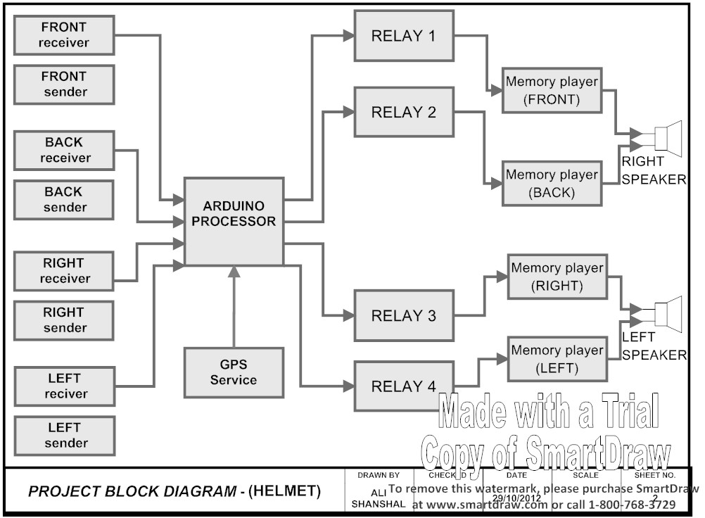**

Figure3.1: Block Diagram (Helmet)

.**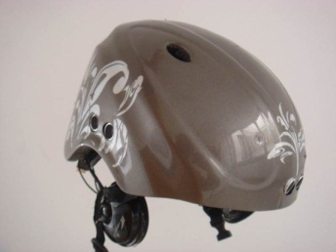 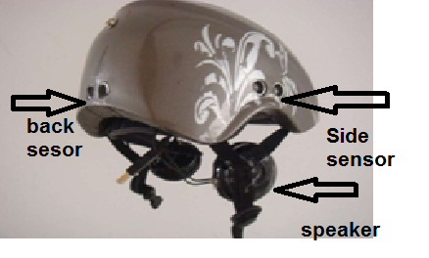**

Figure 3.2: Helmet System Back-Side View

**3.2.1 DYP-ME007 Ultrasonic Sensors**

DYP-ME007 ultrasonic ranging module is a high performance, cost-effective non-contact distance measurement module, incorporating temperature compensation. The measuring range of these sensors in standard air conditions is 0.02 ~ 5.00m, with an accuracy of 1cm, which is enough for the type of application used in this thesis. The sensors give reliable and consistent measurements at different air temperatures and different air densities [19]. Figure 3.3 shows the DYP-ME007 ultrasonic sensor assembly used in the system and also the way they are connected to the helmet assembly (in this figure only the side sensor is shown).

 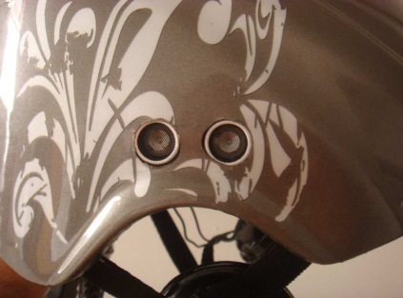

Figure 3.3 : The ultrasound sensor (DYP-ME007)[35]

**3.2.2 The Arduino Board**

Arduino is an open-source single-board microcontroller, descendant of the open-source Wiring platform, designed to make the process of using electronics in multidisciplinary projects more accessible. The hardware consists of a simple open hardware design for the Arduino board with an Atmel AVR processor and on-board input/output support. The software consists of a standard programming language compiler and the boot loader that runs on the board [21]. Figure 3.4 shows the basic Arduiono microcontroller development board used in the system. Notice that there are two connectors at either ends of the board where the input-output signals are terminated and external interface to the board is through these. The actual development board has been embedded (hidden) inside the helmet and is not visible.

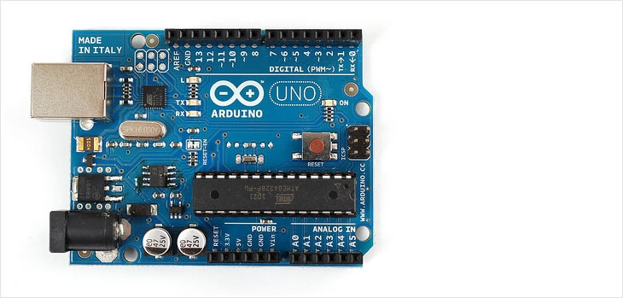 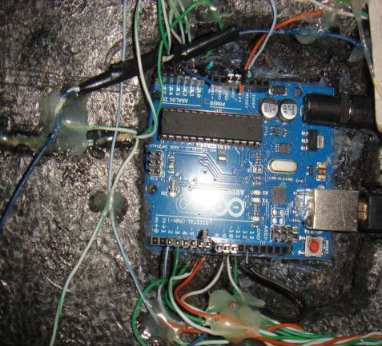Figure 3.4: Arduino Development Board [25]

**3.2.3 Memory Sound Player**

A memory sound player module is used in the design to provide audio output to speakers so that the blind person can hear information about the exact locations of the surrounding obstacles.

The memory sound player (see Figure 3.5) is based on the MP3 file format [22] and plays pre-recorded messages through a pair of speakers mounted on the helmet assembly. The actual module is embedded (hidden) inside the helmet assembly and is not visual from outside. The messages to be played are pre-recorded by the author to the memory sound player module.

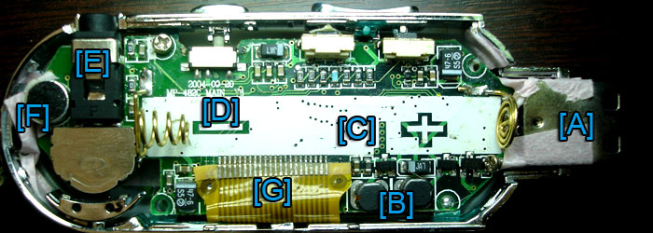

Figure 3.5: Memory Sound Player [22]

**3.2.4 GPS Device**

The Global Positioning System (GPS) is a space-based satellite navigation system that provides location and time information in all weather, anywhere on or near the Earth, where there is an unobstructed line of sight to four or more GPS satellites. It is maintained by the United States government and is freely accessible to anyone with a GPS receiver [25]. The GPS system provides the geographical co-ordinates of the blind person to the system. Figure 3.6 shows the actual GPS module used in the system and also how it is mounted on the helmet. Notice that the GPS module operates with an external antenna as it requires to see the satellites and because of this a small hole is made on the helmet to receive the signals

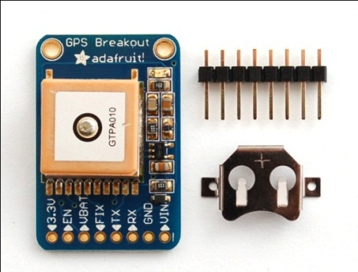 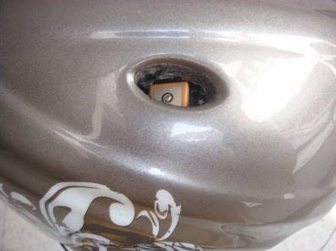 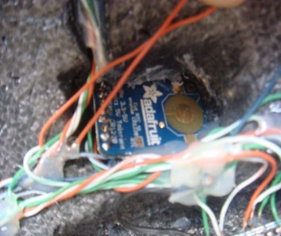

Figure 3.6: GPS Device inside The Helmet[25]

**3.2.5 The Mini Relays**

A relay is an electrically operated switch by use an electromagnet to operate a switching mechanism mechanically. Relays are used where it is necessary to control a circuit by a low-power signal [23]. Miniature relays are used in the system as shown in Figure 3.7.

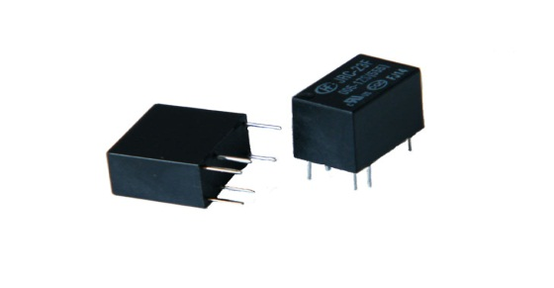

Figure 3.7 : Mini Relays [23]

**3.2.6 The Headphone Speaker**

Headphones are a pair of small loudspeakers that are designed to be held in place close to a user's ears. Headphones either have wires for connection to a signal source such as an audio amplifier, radio, CD player, portable media player or mobile phone [24]. Figure 3.8 shows the headphones (or speakers) used in the system. The headphones are mounted on the helmet so that the blind person can received navigational information in audio form through the headphones.

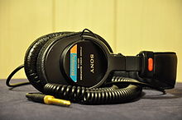

Figure 3.8: Headphones [24]

The system operates with a 9V battery, mounted inside the helmet assembly. In addition, an on/off switch is provided on the helmet so that the system can be turned off to save battery life when not in use.

**3.3 The Bandage System**

The bandage system is the second device designed and developed by the author. This device is simply a bandage worn on the wrist by a blind person. The device incorporates an electronic vibrator and control circuitry. Figure 3.9 shows the block diagram of the bandage system. The actual physical device designed by the author is shown in Figure 3.10. Here, a pair of ultrasonic sensors are mounted in-front of the bandage system. These sensors detect the distance to an object as the hand is moved near an object. An Arduino microcontroller controls the ultrasonic sensors and a small vibrator. As the hand moves closer to an object, the intensity of the vibration is increased. Thus, a blind person can detect for example a cup and then touch it and hold it.

**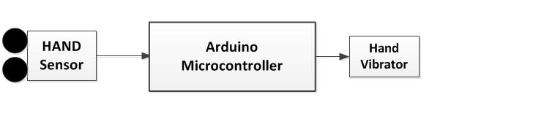**

Figure 3.9: Block Diagram (hand bandage system)

**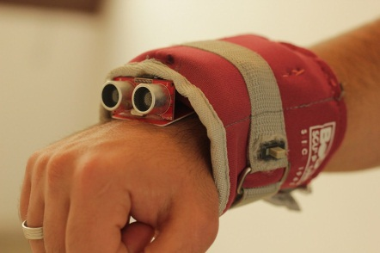**

Figure 3.10 : Bandage system

The bandage system includes the following hardware components:

1-Arduiono development board

2-DYP-ME007 ultrasonic sensors

3-A small electronic vibrator [27]

4-A power transistor to activate the vibrator[26]

5-On/off switch to turn the bandage system on and off

**3.4 Sensing Echolocation**

Autonomous operation of the helmet and bandage systems is made possible by the ability to sense the differences between what is expected in the environment and what is actually there. The two primary sensing mechanisms in this design are ultrasonic ranging. The two systems provide same types of information, and are used in conjunction with each other in very specific instances, such as checking elevator doors.

Echolocation is the perception of objects and their location from the echoes of chirps of ultrasonic energy off those objects. Bats use it to navigate in the dark and in restricted spaces, such as in forests and inside buildings. It is a sense of perception that human's don't normally poses. Because God had make echo locating bats we would believe it possible to recognize objects and navigate using ultrasonic sound waves. We are surprised by the ability of blind people to learn to use mobility aids based on ultrasonic sensing systems [50].

**3.4.1 Principle Operation Of Helmet System**

The helmet system basically depends on two units, ultrasonic sensors (DYP-ME007) and the microcontroller development board (Arduino). DYP-ME007 basically consists of a pair of ultrasonic sensors and an IC that works by sending an ultrasound pulse at around 40Khz. It then waits and listens for the pulse to echo back which is reflected by an object. The sensor receives this signal and converts it to an electric signal.

Arduino processor's main duty is to calculate the time between the transmitted wave and the reflected wave, which is taken in microseconds (1 microsecond = 1.0 × 10-6 seconds). Using the simple formula (Distance = Speed x Time), and knowing the speed of the sound in the air, the Arduino processor can measure the distance of the duration from the second pulse, which is equal to the time taken by the ultrasound, to travel to the object and back to the sensor. This time can be converted to distance by dividing by 58, which is the time in microseconds, for a pulse to be sent and received in air.

The Arduino board sends a short pulse to trigger the four sensors, which is distributed in the four directions, around the helmet (Front -Back-Right-Left) as shown in Figure(1-2) and detect the distance between the helmet and any obstacles surrounding. When the distance of the closest object in front of the sensor, or one of the directional sensors, reaches a certain value which is selected in Arduino software, the Arduino board will send a signal to the one of the four relays. Each one is responsible for operating one of four memory players, which contain the warning voice message for one direction, and play it by speakers placed in the form of a headphone. Also the system contains a GPS (The Global Positioning System) which is connected directly by the Arduino board.

Further details about the operation of the helmet system are given in the following sections.

**3.4.2 Principle Operation Of Bandage System**

The bandage sensor system consists of a bandage around the wrist with a pair of ultrasonic sensors (DYP-ME007 ) and processor (arduino), that were used in the previous system . The sensor mounted in the frontal position as shown in Figure (3.13). A vibrator mounted inside the bandage increases its intensity when the hand is close to an object, By the same principle the Arduino processor measures the distance between a sensor and an object in front of it, and vibrates at different speeds depending on the location of that obstacle . When the obstacle is close the intensity of the vibrations increase, this provides more benefit to the blind person because there are more obstacles at ground level than the higher level and also help him/her to catch. Thus, for example, as the person attempts to locate and lift a cup the increasing intensity helps to position the hand such that the cup can be grabbed and lifted.

### 3.5 Nature of Ultrasound

### Ultrasound uses high frequency (above 20 kHz) mechanical vibrations or pressure waves that the human ear cannot detect. Typical diagnostic sonographic scanners operate in the frequency range of 2 to 18 megahertz, hundreds of times greater than the limit of human hearing. The choice of frequency is a trade-off between spatial resolution of the image and imaging depth: lower frequencies produce less resolution but image deeper into the body.  Superficial structures such as muscles, tendons, testes, breast and the neonatal brain are imaged at a higher frequency (7-18 MHz), which provides better axial and lateral resolution. Deeper structures such as liver and kidney are imaged at a lower frequency 1-6 MHz with lower axial and lateral resolution but greater penetration [53].

**3.5.1 Ultrasonic Wave's Characteristics**

As an ultrasound wave passes through a medium, it transports energy through the medium. The rate of energy transport is known as “power.” Medical ultrasound is produced in beams that are usually focused into a small area, and the beam is described in terms of the power per unit area, defined as the beam’s “intensity. The velocity of an ultrasound wave through a medium varies with the physical properties of the medium. In low-density media such as air and other gases, molecules may move over relatively large distances before they influence neighboring molecules. In these media, the velocity of an ultrasound wave is relatively low. The velocity of the ultrasound in the air is 331 m/sec. As an ultrasound beam penetrates a medium, energy is removed from the beam by absorption, scattering, and reflection. the term *attenuation* refers to any mechanism that removes energy from the ultrasound beam. Ultrasound is “absorbed” by the medium if part of the beam’s. Constructive and destructive interference effects characterize the echoes from no specular reflections. Because the sound is reflected in all directions, there are many opportunities for waves to travel different pathways. The wave fronts that return to the transducer may constructively or destructively interfere at random. With a large impedance mismatch at an interface, much of the energy of an ultrasound wave is reflected, and only a small amount is transmitted across the inter-face. Intensity of reflected echoes and the transmitted pulse depends on the incident intensity at a boundary and the impedances of the media on either side [49].

Impedance is the relationship between acoustic pressure and the speed of particle vibration. Equal to density of a medium multiplied by propagation speed.one of the ultrasound characteristics is Refraction , A change in the direction of sound when crossing a boundary. Refraction induces lateral position errors on an image. Rule of thumb: If speed increases 1% as sound enters medium 2, the transmission angle will be ~1% greater that incident angle. If perpendicular incidence, then there is no refraction. If boundary is smooth, reflections are specular. If reflecting object is the size of the wavelength or smaller, or if boundary is rough then incident sound will be scattered. Backscatter intensities vary with frequency and scatterer size, and as the frequency increases, so does the intensity [48].

**3.5.2 Pulsed Ultrasound**

Frequency, period, wavelength and propagation speed are sufficient to describe continuous-wave (cw) ultrasound. Cycles repeat indefinitely. Sonography uses pulsed ultrasound, i.e. a few cycles of ultrasound separated in time with gaps of no signal as shown in Figure (3.11).

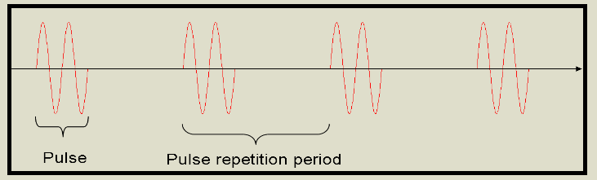

Figure 3.11 : ultrasound pulse repetition period[48]

We need to define new parameters: pulse-repetition frequency, pulse-repetition period, pulse duration, duty factor, spatial pulse length. Pulse repetition frequency (PRF): Number of pulses occurring in 1 s. Usually expressed in kHz. Pulse repetition period (PRP): Time from the beginning of one pulse to the beginning of the next. Usually expressed in microseconds (µs). PRP decreases as PRF increases. More pulses occur in a second, less time from one to the next. PRF is controlled automatically in sonographic instruments. Pulse duration: Time it takes for one pulse to occur = period times the number of cycles in the pulse. Expressed in ms. Sonographic pulses ~ 2-3 cycles long, Doppler pulses ~ 5-20 cycles long. Pulse duration decreases if number of cycles in a pulse is decreased or if frequency is increased. Operator chooses frequency. Duty factor: Fraction of time that pulsed US is on. Longer pulses increase the duty factor because the sound is on more of the time. Higher PRF increase duty factor because there is less "dead" time between pulses. Duty Factor = Pulse Duration (microseconds) / PRP (microseconds) [48].

### 3.5.3 Generating the Ultrasonic Signal

Ultrasound is most commonly generated as a direct conversion from electrical energy. This is accomplished by applying a rapidly oscillating electrical signal to a [piezoelectric crystal](http://www.sensorwiki.org/doku.php/sensors/piezoelectric_ceramic_film) attached to a mounting. The charge causes the crystal to expand and contract with the voltage, thereby generating an acoustic wave. The waves are later detected by a piezoelectric receiver, which converts the waves back into voltage using the same method. The signal may also be generated by consumer electronics products, but great care must be taken to ensure that the signal is not attenuated in this range. Speakers typically have filter circuits to prevent ultrasonic propagation, and the frequency response of many microphones roll off in this range. This is partly because of the amount of ultrasound present in our daily life; percussive sounds and metallic ringing both contain ultrasonic frequencies [46].

**3.6 Ultrasound Sensor (DYP\_ME007)**

DYP\_ME007 sensor is a device you can use with the BASIC Stamp to measure how far away an object is. With a range of 2 centimeters to 5 meters, it's a shoe-in for any number of robotics and automation projects. It's also remarkably accurate, easily detecting an object's distance down to the half centimeter (see Figure 3.12)

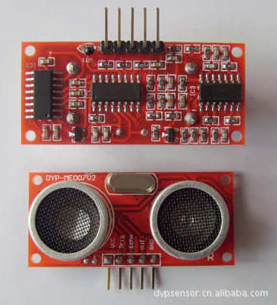

Figure 3.12: Front And Back view of The Sensor [43]

**3.6.1 Sensor's Specification**：

Working Voltage : 5V(DC)

Working Current : max 15 ma

Working frequency : 40HZ

Output Signal : 0-5V (Output high when obstacle in range)

Sentry Angle : max 15 degree

Sentry Distance : 2cm - 500cm

High-accuracy : 0.3cm

Input trigger signal : 10us TTL impulse

Echo signal : output TTL PWL signal

**3.6.2 Sensor Accuracy in Work Area**

In theory the sensor output y[V ] should increase linearly with the measured distance x[mm], according to equation 3.1. A microprocessor integrated with the sensors performs this calculation for every distance measurement [54].

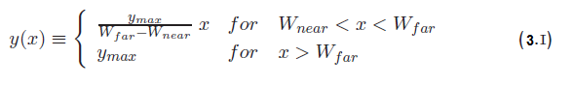

Y max maximal value of sensor output [V ]

W near near window margin [mm]

W far far window margin [mm]

This implies that the sensor output is not defined for x < W near. This is correct, since distances smaller than the near window margin cannot be determined when the near window margin is set to the boundary of the blind zone. The blind zone can be artificially extended by increasing the near window margin. The output will then be suppressed to 0V in the area between the blind zone boundary and the near window margin. Eq. 2.1 can easily be inverted to calculate the distance x from sensor output .y which results in Eq. 3.2. The distance must be corrected by the size of the blind zone b[mm]. The quotient (W far –W near)/y max is also referred to as the *sensor slope* [54].

X(y) = $\frac{W far -W near }{Y max}+y+b with 0<y <y max (3.2)$

**3.6.3 Object Positioning**

The (DYP-ME007) sensor cannot accurately measure the distance to an object that: a) is more than 4 meters away, b) that has its reflective surface at a shallow angle so that sound will not be reflected back towards the sensor, or c) is too small to reflect enough sound back to the sensor as shown in Figure(3.13). In addition, if (DYP-ME007) sensor is mounted low on your device, may detect sound reflecting off of the floor [44].

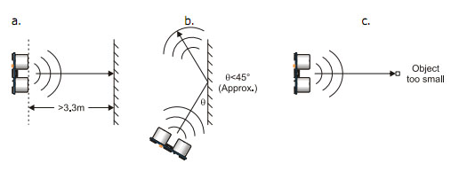

Figure 3.13: Cases Cause un Accurately In Detecting [44]

**3.6.4 Target Object Material**

In addition, objects that absorb sound or have a soft or irregular surface, such as a stuffed animal, may not reflect enough sound to be detected accurately. The DYP-ME007 sensor will detect the surface of water, however it is not rated for outdoor use or continual use in a wet environment. Condensation on its transducers may affect performance and lifespan of the device [44].

**3.6.5 Air Temperature**

Temperature has an effect on the speed of sound in air that is measurable by the sensor DYP-ME007. If the temperature (°C) is known, the formula is:

C air = 331.5+ 0.6 ( ) × TC m/s (3.3)

The percent error over the sensor’s operating range of 0 to 70 ° C is significant, in the magnitude of 11 to 12 percent [44].

**3.6.6 Sensor Hardware**

The DYP-ME007 sensor sends a brief chirp with its ultrasonic speaker and makes it possible for the BASIC Stamp to measure the time it takes the echo to return to its ultrasonic microphon

Module Working Principle.

1- IO trigger Pin(2) should be given HIGH LEVEL pulses of at least 10us.

2-The module then starts sending ultrasonic sound of 40khz frequency and receives the pulses if there is any obstacle nearby.

3-If there is signals returning, then the ECHO pin output high level pulses and the following formula is to used to calculate the distance of obstacle as shown in Figure (3.14) [19]

Test distance = (high level time \* sound velocity ) / 2

where sound velocity= 340m/sec[19]

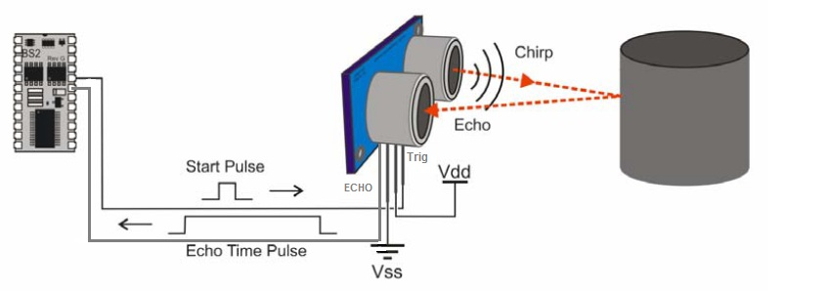

Figure 3.14: Principle Of Sensor Work [33]

**3.7 The Arduino Hardware**

Amicro-controller is a small computer (see Figure 3.15) on a single integrated circuit containing a processor core, memory, and programmable input /output peripherals. The important part for us is that amicro-controller contains the processor (which all computers have) and memory, and some input/output pins that you can control. (often called GPIO –

General Purpose Input Output Pins) [30].

Arduino hardware is programmed using a Wiring-based language (syntax and libraries), similar to C++ with some slight simplifications and modifications, and a Processing-based integrated development environment [21].

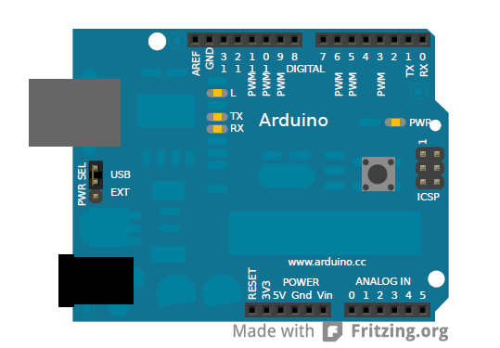

Figure 3.15: Arduino Board [21]

Arduino can sense the environment by receiving input from a variety of sensors and can affect its surroundings by controlling lights, motors, and other actuators. The microcontroller on the board is programmed using the Arduino programming language (based on Wiring) and the Arduino development environment (based on Processing). Arduino projects can be stand-alone or they can communicate with software running on a computer (e.g. Flash, Processing, MaxMSP) Arduino is an open-source physical computing platform based on a simple i/o board and a development environment that implements the Processing/Wiring language [31].

The code that you write is executed in The processor of Arduino board. The board can only control and respond to electricity, so speciﬁc components are attached to it to enable it to interact with the real world. These components can be sensors, which convert some aspect of the physical world to electricity so that the board can sense it, or actuators which get electricity from the board and convert it into something that changes the world. Examples of sensors include switches, accelerometers, and ultrasound distance sensors. Actuators are things like lights and LEDs, speakers, motors, and displays There are a variety of official boards that you can use with Arduino software and a wide range of Arduino-compatible boards produced by members of the community. The most popular boards contain a USB connector that is used to provide power and connectivity for uploading your software onto the board [10].

**3.7.1 Arduino Components**

Figure 3.16 shows the basic Arduino board.

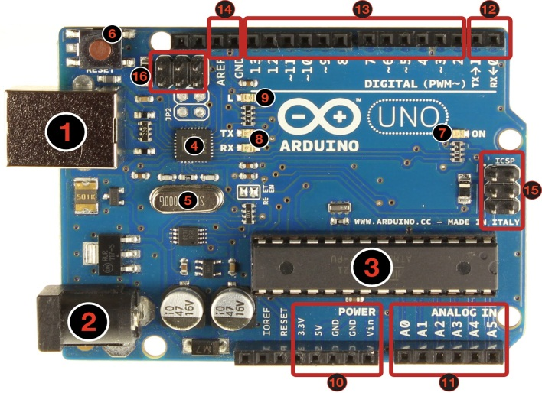

Figure 3.16: Parts of Arduino Board [32]

The board consists of the following components:

1- USB jack

2- power jack,

3- processor

4- communication chip

5- 16 mhz crystal

6- reset button

7- On led

8- TX/NX leds

9- Led

10- Power pins

11- Analog Inputs

12- TX and RX pins

13- Digital Inputs/outputs. The "~" in front of the numbers are for PWM outputs.

14- Ground and AREF pins.

15-ICSP for Atmega328

16- ICSP for USB interface [32].

**3.7.2 Power and Connection**  
  
The board can work connected to a computer with an USB cable. In that case, the board works with 5V tension and the max current of 50 mA. If the components of the circuit works with that tension and current, you can use only the power that comes from the USB cable. But, if you want the board running alone, you have to connect a external electrical source [32].

**3.7.3 Power Pins**  
The power pins which are number 10 in the Figure (3.21) consists of  
  
3.3V: 3.3Volts out  
5V: 5 Volts out  
GND: 2 Grounds  
VIN: The input voltage to the Arduino board when it's using an external power source (as opposed to 5 volts from the USB connection or other regulated power source). You can supply voltage through this pin, or, if supplying voltage via the power jack, access it through this pin.  
  
3.3V pin apply the current of 3.3V.  
5V pin apply the current of 5V.

GND is the reference point in an electrical circuit from which other voltages are measured.  
VIN apply the voltage and resistance that comes from a external source. For example, if you connect a source of 9V and 300mA, this is the tension and current that you achieve from this pin [32].

**3.7.4 Analog Pins**

Analog pins which are number 11 in the Figure (3.21) are inputs where you connect analogue components like potentiometers and other sensors. While the digital inputs/outputs work only with 0 and 1 values, the analog imputs works with a values from 0 to 1023 [32].

**3.7.5 Digital Pins**

Digital pins which are number 13 in the Figure (3.21) can work as inputs or outputs and you define how it will operate with the function pinMode(). The pins that have the "~" in front of the numbers are PWM (Pulse Width Modulation) out, and they can emulate analog output with analogWrite() function. When you use this function, the board modulates the pulse width, varying the frequency of max and low pulses (0 or 1), emulating an analog pulse [32].

An Arduino board consists of an 8-bit Atmel AVR microcontroller with complementary components to facilitate programming and incorporation into other circuits. An important aspect of the Arduino is the standard way that connectors are exposed, allowing the CPU board to be connected to a variety of interchangeable add-on modules known as shields. Some shields communicate with the Arduino board directly over various pins, but many shields are individually addressable via an I²C serial bus, allowing many shields to be stacked and used in parallel. Official Arduinos have used the megaAVR series of chips, specifically the ATmega8, ATmega168, ATmega328, ATmega1280, and ATmega2560. A handful of other processors have been used by Arduino compatibles. Most boards include a 5 volt linear regulator and a 16 MHz crystal oscillator (or ceramic resonator in some variants), although some designs such as the LilyPad run at 8 MHz and dispense with the onboard voltage regulator due to specific form-factor restrictions. An Arduino's microcontroller is also pre-programmed with a boot loader that simplifies uploading of programs to the on-chip flash memory, compared with other devices that typically need an external programmer. At a conceptual level, when using the Arduino software stack, all boards are programmed over an RS-232 serial connection, but the way this is implemented varies by hardware version. Serial Arduino boards contain a simple inverter circuit to convert between RS-232-level and TTL-level signals. Current Arduino boards are programmed via USB, implemented using USB-to-serial adapter chips such as the FTDI FT232. Some variants, such as the Arduino Mini and the unofficial Boarduino, use a detachable USB-to-serial adapter board or cable, Bluetooth or other methods.(When used with traditional microcontroller tools instead of the Arduino IDE, standard AVR ISP programming is used).The Arduino board exposes most of the microcontroller's I/O pins for use by other circuits. The Diecimila, Duemilanove, and current Uno provide 14 digital I/O pins, six of which can produce pulse-width modulated signals, and six analog inputs. These pins are on the top of the board, via female 0.1 inch headers. Several plug-in application shields are also commercially available. The Arduino Nano, and Arduino-compatible Bare Bones Board and Boarduino boards may provide male header pins on the underside of plugged into solderless breadboards [21].

**3.8 The Audio System**

The Helmet System is an auditory guidance system, for the blind, using ultrasonic-to-audio signal transformation. The Blind Navigator will detect objects and guide the blind person with use of audio instructions. The system gather data about the environment, using ultrasonic sensors, and extracts the visual information from that data. This visual information is then transformed into an audio signal. The function of transforming the visual information to an audio signal is needed. An auditory sensory system can be the fastest method for a visually impaired person to get external information which is conveyed by earphone with audio information as shown in Figure (3.17). When an obstacle comes into the path of the signal it then will reflected from that obstacle and be received at the receiver which will give high voltage to the Arduino board and according to which program will execute. Followed by this the stored message is activated and the audio message is conveyed by earphone. MIC is used for recording the message to the chip.

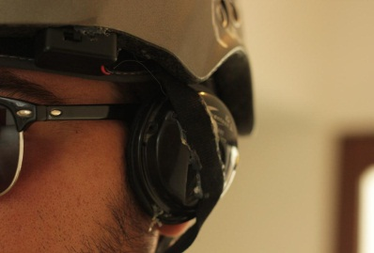

Figure 3.17: Headphones System in Helmet

The speech synthesizer is activated by pulses from the microcontroller to the memory player through the relays . The output represents the conditions realized to be taken (e.g. road right turn, left turn... ). The speech synthesizer circuit with small speakers tells then the blind person about travelled distance, present location and decisions to make. Information about the route is stored in the memory in the form of a digital map of the device to guide the user to his destination via the planned routes. Memory players use solid-state memory. A sound player is no more than a data-storage device with an embedded software application that allows users to transfer MP3 files to the player. Specific components may vary, but here are the basic parts of a typical MP3 player:

1-Data port 7- Audio port

2-Memory 8- Amplifier

3-Microprocessor 9-Power supply

4-Digital signal processor (DSP)

5-Display

6-Playback controls

When the signal comes from the arduino board, which means one condition is realized, the signal will make the relay (short) and The electronic circuit will close, which will lead to running the memory player and play an audio clip for this case. Also the same principle with remaining cases. Each direction will have a special relay and memory player to the certain audio clip in the case.

**3.9 The GPS System**

Global Positioning System satellites transmit signals to equipment on the ground. GPS receivers passively receive satellite signals; they do not transmit. GPS receivers require an unobstructed view of the sky, so they are used only outdoors and they often do not perform well within forested areas or near tall buildings. GPS operations depend on a very accurate time reference, which is provided by atomic clocks at the U.S. Naval Observatory. Each GPS satellite has atomic clocks on board [37].

Each GPS satellite transmits data that indicates its location and the current time. All GPS satellites synchronize operations so that these repeating signals are transmitted at the same instant. The signals, moving at the speed of light, arrive at a GPS receiver at slightly different times because some satellites are farther away than others. The distance to the GPS satellites can be determined by estimating the amount of time it takes for their signals to reach the receiver. When the receiver estimates the distance to at least four GPS satellites, it can calculate its position in three dimensions .There are at least 24 operational GPS satellites at all times. The satellites, operated by the U.S. Air Force, orbit with a period of 12 hours. Ground

stations are used to precisely track each satellite's orbit [37].

**3.9.1 Determining Position**

* The GPS receiver determines the position of the earth. It compares the moment the signal is sent by the satellite with the moment the signal was received. This time difference calculates the distance between the satellite and the receiver. If there is data from another satellite, and this is also taken into account, the position can be measured by trilateration (this is the determination of a distance from three points). At least three satellites are needed to pinpoint the position of the GPS receiver on the surface of the earth. Calculating a position from three satellite signals is called 2D position fix, or two dimensional position determination). It is two dimensional because the receiver would calculate that it is located somewhere on the surface of the earth (on a planwo dimensional surface). If there are four or more satellites, an absolute position in a three dimensional space could be determined. A 3D position fix would also give the height above the surface of the earth if needed. In simple terms, the position by means of a GPS works on the same principle as timing the distance of thunderstorms. The time is measured between the lightning and the thunder which follows. The speed of light is so fast that the delay between the time when the flash hits the ground and the time the person sees the flash can be neglected. The speed of sound in the atmosphere of the earth is usually around 340 m/s. This would work out that a difference of 3 seconds between the lightning and thunder would correspond to around 1 km distance to the thunderstorm [47].

**3.9.2 GPS Accuracy**

The accuracy of a position determined with GPS depends on the type of receiver. Most hand-held GPS units have about 10-20 meter accuracy. Other types of receivers use a method called Differential GPS (DGPS) to obtain much higher accuracy. DGPS requires an additional receiver fixed at a known location nearby. Observations made by the stationary receiver are used to correct positions recorded by the roving units, producing an accuracy greater than 1 meter. When the system was created, timing errors were inserted into GPS transmissions to limit the accuracy of non-military GPS receivers to about 100 meters. This part of GPS operations, called Selective Availability, was eliminated in May 2000 [37].

**3.10 General Interface And The Electronic Circuitry**

The connection between the microcontroller and various other parts in the system are described in detail in this section.

**3.10.1 Connect Ultrasound Sensor (DYP-ME007) with Arduino Board In Helmet and Bandage System.**

Adding the DYP-ME007 to the Arduino is very easy, only 4 pins to worry about. (Power, Ground, Trigger and Echo) no need to connect (OUT) pin. Since it needs 5V and Arduino provides 5V to power it. Below is a diagram of my DYP-ME007, showing the pins. There are 2 sets of 5 pins, 1 set you can use, the other is for programming the PIC chip so don’t use it.

This will be same in helmet and bandage system.

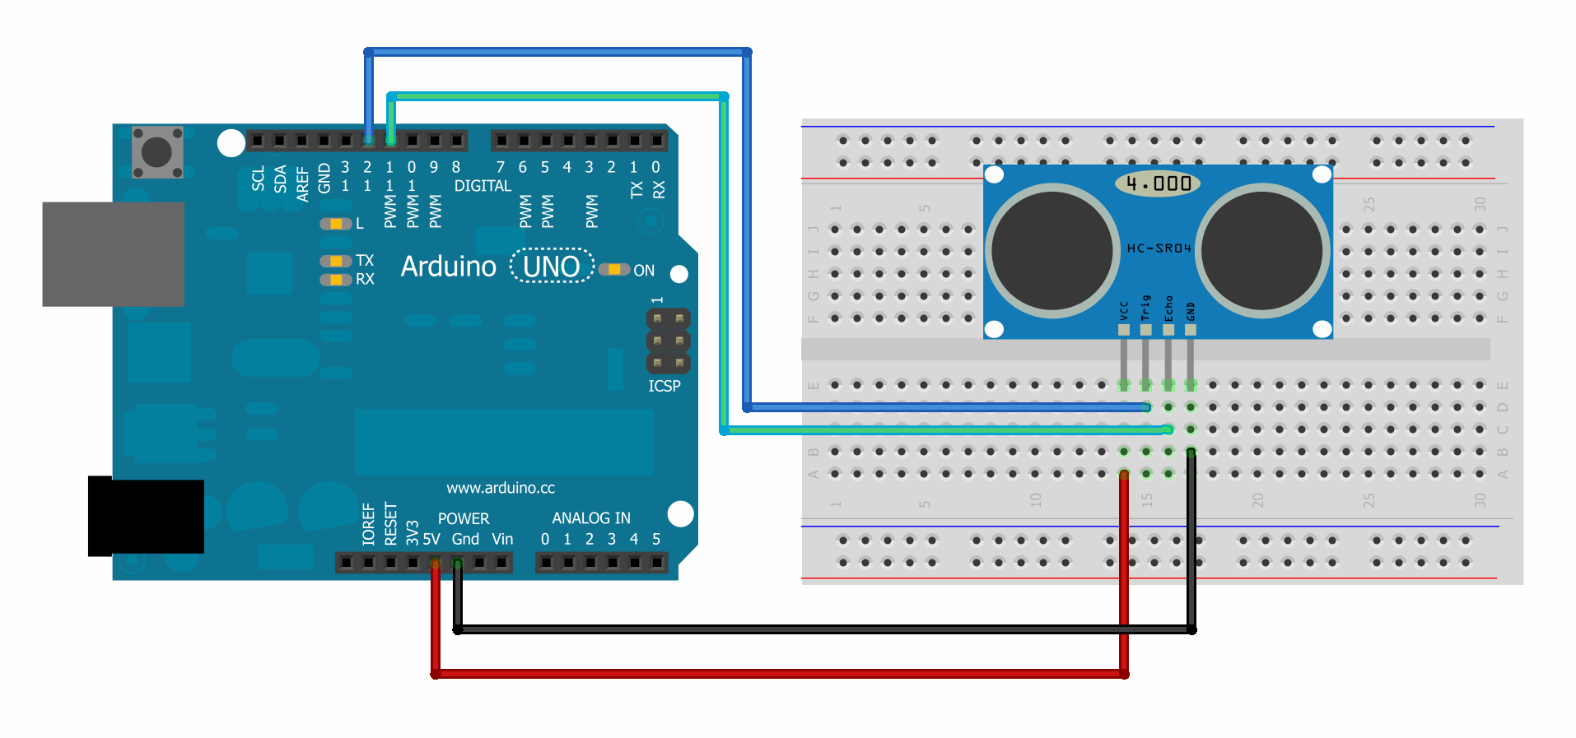

Figure 3.18: Connect Sensor With Arduino Board [34]

As shown in Figure (3.18) the connections between the DYP-ME007 sensor and the arduino are particularly simple. Firstly connect the ground and 5V power to the corresponding DYP-ME007 pins. Then connect the sensor signal pin (Echo) to one of the digital (I/N) of the Arduino. The (Trig) pin will connect to one of the digital I/O) of Arduino. The same goes for the three other sensors, each sensor takes two pins of arduino board except (power and GND).

**3.0.2 Connect The Audio System With Arduino Board in Helmet System**

Audio system consist of three units, Relay ,memory sound player and speaker. The relay connect with arduino board by two pins, signal pins(I/O Pins) and (GND) as shown in Figure 3.19. When the signal comes from the arduino board, which means one condition is realized, the signal will make the relay (short) and The electronic circuit will close, Relays are components which allow a low-power circuit to switch a relatively high current on and off, or to control signals that must be electrically isolated from the controlling circuit itself. To make a relay in the helmet system operate, it should pass a suitable pull-in ’

current (DC) through its coil. And generally relay coils are designed to operate from a low supply voltage which is 5V from arduino (out put pins) to control the circuit by of or on. which will lead to running the memory player and play an audio clip for this case. Also the same principle with remaining cases. Each direction of helmet or every sensor will have a special relay and memory player to the certain audio clip for that case.

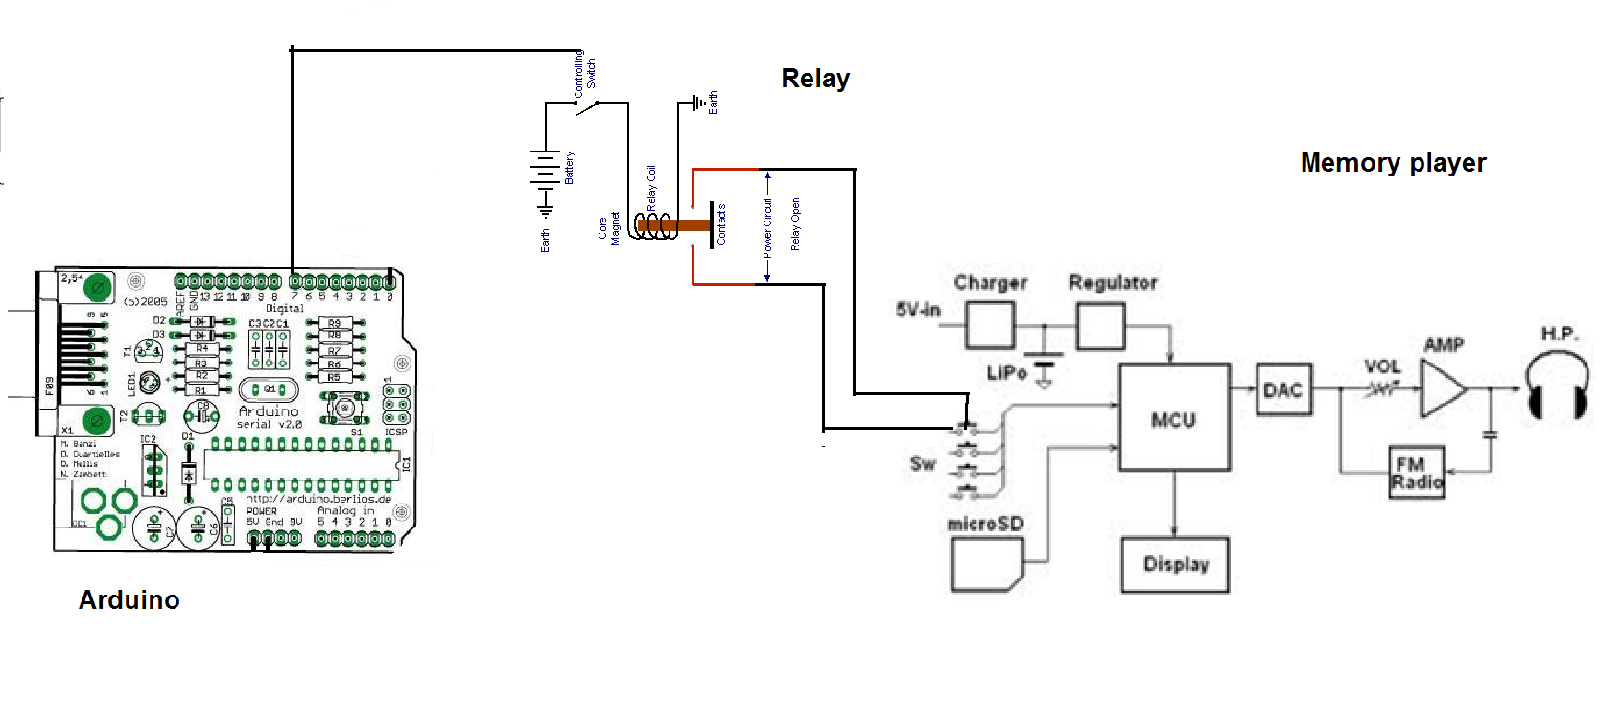

Figure 3.19: Connect Relay And Memory Player With Arduino

**3.10.3 Connect GPS With Arduino Board in Helmet System**

The ultimate GPS system consist of 8 pins, four of them connect with Arduino board which are (Tx, Rx, Vin and Gnd) as shown in Figure(3.24) .no need to use battery if (vin) pins is connect to 3.3v of Arduino board.(Tx) pins connect to the pin number 1 in Arduino board which for transmit the data to the satellite and (Rx) pins connect to the pin number 2 in Arduino board as shown in Figure 3.20 which is for receive the data from satellite.

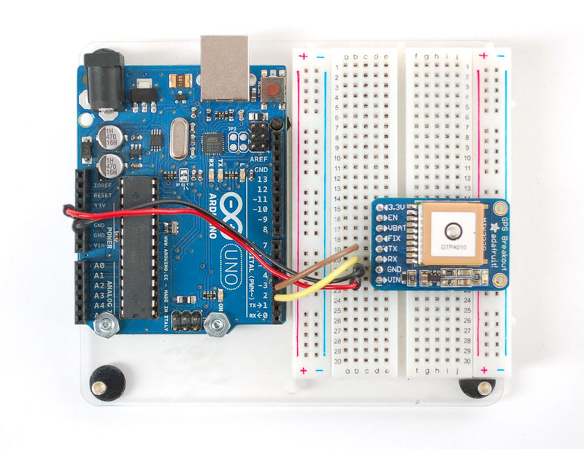

Figure 3.20: Connect The GPS To The Ports of Arduion Board [24]

**3.11 Electronic Circuitry Inside Helmet System**

Helmet system which is designed to assist and support the blind is an integration of these four units (processor, sensors , audio system and GPS ), as shown Figure 3.21 where connecting four sensors on the helmet to Arduino board which feed the sensors and analysis the signal coming from. The pins can be exploited in arduino board, as mention before that arduino board have twenty pins. Six of them is analog pins, which there is no need to use them in the helmet system. Arduino board has many options, one of the options can be changing the analog pins to digital pins by software instruction. As shown in Figure (3.26) three sensors connected to analog pins after changed to digital pins. (A0) as an output signal for (trigger) and A1 as an input signal for receiving (echo) from a sensor and so on the other three sensors. Each sensor supply with 5 v (dc) from arduino board and (GND) also. There are 4 relays connected to arduino board from 4 signal (I/O) pins. The relays connected directly with memory, which are run when a signal comes from an arduino board and makes relays switch on. Memory players connected with two speakers play the clips for each case when realized. The specially pins for GPS system which is (TX) and (RX) to transmit and receive data from satellite. To link any device with Alardino board it is important to know the loud current of that device to not cause any damage in an arduino board.

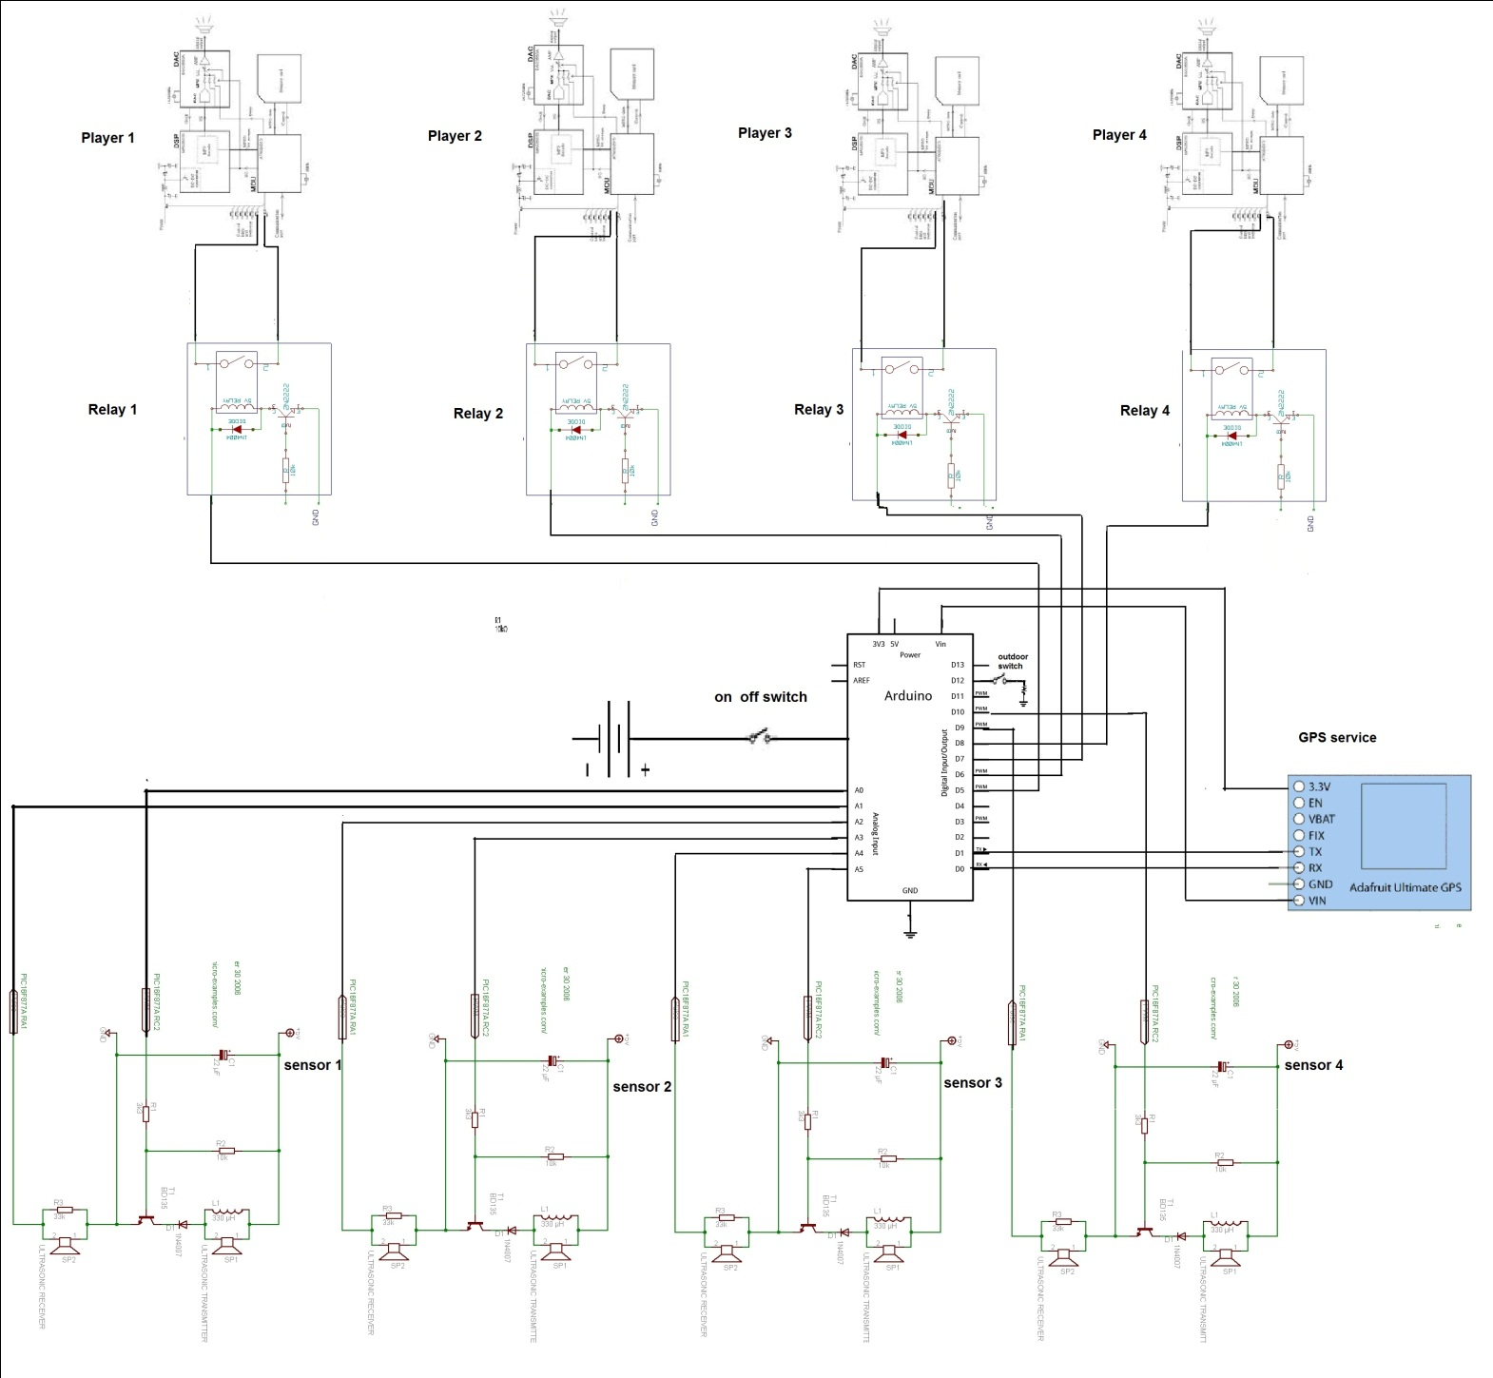

Figure 3.21: Electronic Circuit For Helmet System

**3.12 Electronic Circuit For the Bandage System**

The bandage system, which is designed to protect the blinds from obstacles that are located in the lower part of the system. Like furniture, holes in the ground, or stairs, the bandage system in similar to the helmet system, in terms of determining the distance of the barriers by ultrasound sensors (DYP-ME007), but the result in this system is in the form of vibration. The intensity represents nearing the barrier, from the device. A vibrator is a mechanical device which generates vibrations. The vibration is often generated by an electric motor with an unbalanced mass on its driveshaft. To link the vibrator with the arduino board that needs to power transistor. It can be used with an arduino to drive motors and other high power gadgets.

The TIP120 acts as a power broker or gatekeeper between the Arduino realm and the high power realm composed of the PC fan and its battery pack. The Arduino can tell the TIP120 how much power to pass from the external battery pack to the PC fan but the Arduino does not share any of its power or share pins with the PC fan or its batteries. The TIP120 is the go in between The TIP120 has three pins. One is called Base, which we will connect to any of the Arduino PWM pins. Through the Base pin, the Arduino can tell the TIP120 how much power to supply to the motor from the external battery pack . That's it. The TIP120 does the heavy lifting while Arduino sits back and gives orders through one of its PWM pins to the TIP120 Base pin telling it how much power to pass to the motor. The poor TIP120 has to then pass the requested power from the external power to the motor based on Arduino's request [36].

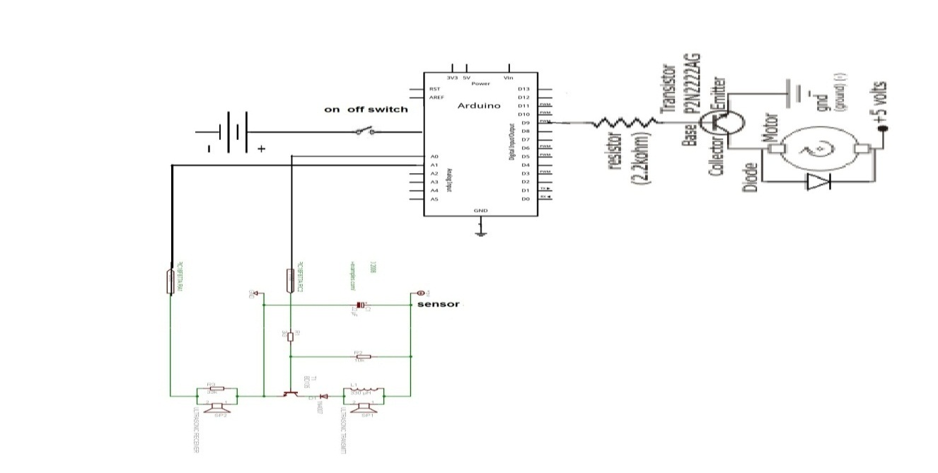Figure 3.22: Electronic circuit for bandage system

**CHAPTER 4**

**SYSTEM SOFTWARE**

**4.1 Arduino Software**

The Arduino IDE is a cross-platform application written in Java, and is derived from the IDE for the Processing programming language and the Wiring project. It is designed to introduce programming to artists and other newcomers unfamiliar with software development. It includes a code editor with features such as syntax highlighting, brace matching, and automatic indentation, and is also capable of compiling and uploading programs to the board with a single click. There is typically no need to edit make files or run programs on a command-line interface. Although building on command-line is possible if required with some third-party tools such as Ino [21].

The Arduino IDE comes with a C/C++ library called "Wiring" (from the project of the same name), which makes many common input/output operations much easier. Arduino programs are written in C/C++, although users only need define two functions to make a runnable program:

setup() – a function run once at the start of a program that can initialize settings

loop() – a function called repeatedly until the board powers off. It is a feature of most Arduino boards that they have an LED and load resistor connected between pin 13 and ground, a convenient feature for many simple tests. The above code would not be seen by a standard C++ compiler as a valid program, so when the user clicks the "Upload to I/O board" button in the IDE, a copy of the code is written to a temporary file with an extra include header at the top and a very simple main() function at the bottom, to make it a valid C++ program. The Arduino IDE uses the GNU tool chain and AVR Libc to compile programs, and uses avrdude to upload programs to the board. As the Arduino platform uses Atmel microcontrollers Atmel’s development environment, AVR Studio or the newer Atmel Studio, may also be used to develop software for the Arduino. For educational purposes there is third party graphical development environment called Minibloq available under a different open source license [21].

**4.2 Theory of Operation**

The DYP-ME007 sensor detects objects by emitting a short ultrasonic burst and then "listening" for the echo. Under control of a host microcontroller (trigger pulse), the sensor emits a short 40 kHz (ultrasonic) burst. This burst travels through the air at about 1130 feet per second, hits an object and then bounces back to the sensor as shown in Figure 4.1. The DYP-ME007 sensor provides an output pulse to the host that will terminate when the echo is detected, hence the width of this pulse corresponds to the distance to the target [35]. The microcontroller gathers the information from the ultrasonic sensors as PWM signal directly proportional to the distance of the nearest obstacle. Afterwards, it measures the width of the transmitted pulses and converts it into empiric distance [52].

In reflection mode (also known as “echo ranging”), an ultrasonic transmitter emits a short burst of sound in a particular direction. The pulse bounces off a target and returns to the receiver after a time interval **t**. The receiver records the length of this time interval, and calculates the distance travelled **r** based on the speed of sound **c**:

**r = c \* t**[2](http://www.sensorwiki.org/doku.php/sensors/ultrasound" \l "fn__2) (4.1)

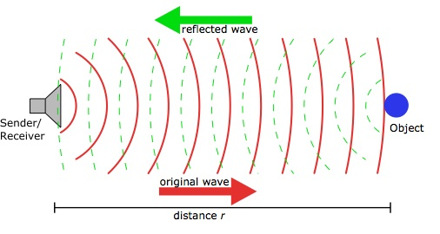

Figure 4.1 : The Wave Of Ultrasound sensor [46]

Very often, separate transmitting and receiving transducers are placed immediately next to each other, housed as a single unit. DYP-ME007 Range Finder, Omega flow meter and Migatron high-accuracy sensor below are all designed this way.) In these cases, the distance calculated will be twice the distance from the sensor to the target. Using proper coordination, a single transducer can be used for both emitting the pulse and receiving the echo. Note that it takes time for the transducer to change modes, presenting a challenge to short-distance measurement [46].

**4.3 Algorithms and Flowcharts**

The algorithm of the system represents the software program which will upload to the micro-controller after decoding to machine language . There are some differences in the system's algorithm for a helmet or a bandage system according to the special conditions for each one.

**4.3.1 The Helmet System**

A flowchart diagram of the software task execution is presented in Chart 4.1. The task goes in its infinite loop, After the system sends and receives the ultrasound waves, the distance of the barriers will know for the four directions around the helmet. The condition is determined by the user. There is a button that determines one of two position that system works in( External and internal) because The system covers two ranges, short and long, which may be selected whilst the cane is in use. If the external position is selected or for wider distance, firstly front sensor will check the distance of the obstacles in the case of the presence of an obstacle at a distance of less than (400m)The first condition will be realized and this will lead to run the (memory player) and display the audio clip for this case.

If there are no obstacles in the forward, the processor will move to check the second condition, which is the presence of an obstacle in the back but at a distance of less than (300). If the condition is realized this will lead to run the second memory player which is special to this case. In the same way the remaining sides are checked (right and left)and in the same limit distance (300m). The fasting of the Processing appear to the user that all sensors are working together if two conditions are realized at the same time.

However, if the user selects the second position of the system (internal) or in small rooms by button, the same previous steps will be applied sequentially and, also respectively but, the difference in this position is the formula of the condition and the limit distance which is to determine the Realization. The first condition in this position is to move forward. This condition will be realized in the absence of obstacles tile (350m) of distance. Then gives signal to relay to run the memory player and play the special clip for this case(go ahead). The rest of the directions work with the same principle of the first position, with a different in determine the distance to realize the condition (back :50cm - right: 150cm – left: 150 cm) Considering that the rooms is small.

All the voice messages warm to presence obstacles on certain directions accept the forward message which allow to passable way. That arduino speed gives a great benefit, which is checking all directions in short time and imperceptible . The operation of voice messages almost spontaneous, in case of presence case more than one condition realized.

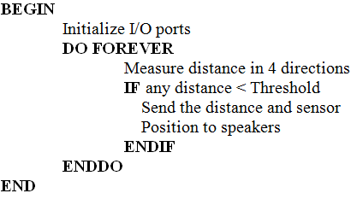

Chart 4.1: Operation of the Helmet

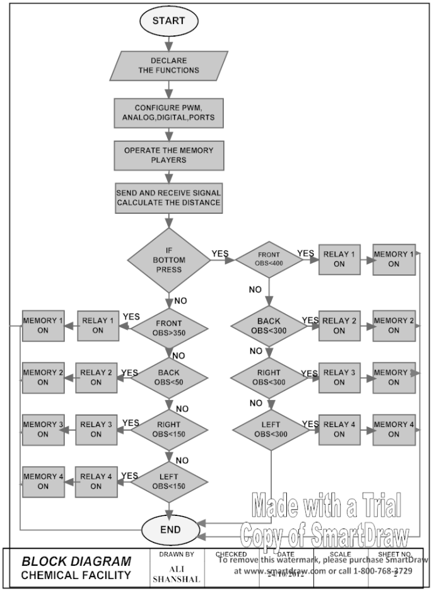

Chart 4.2 : Flow Chart Of Helmet System sensors

**4.4 The Bandage System**

As shown in Chart 4.3 bandage system is similar to helmet system bandage system with the principle of working which is account distance of barriers or obstacles but in bandage system there is just one sensor measures the distances in front of it only in the area of around ​​the wrist. Hand movement in all directions and altitudes give great benefit to blind person to detect obstacles specially at few altitude of the ground which is the helmet cannot be detect because it is just in head level. .

This system also helps the blinds to grasp things and left it in the appropriate place by differences in the intensity of vibration whenever the thing is approached increased the intensity not by voice messages as it was in the helmet system

In this system there are three conditions, The first one realized when obstacle or thing be less than 75cm far from the sensor result in weak vibration indication that the body away. If either obstacle or thing be in less than 43cm the processor will move to realize second condition which results in average vibration indication that the obstacle had more approached and if the obstacle be at 25cm which is third condition in the flow chart the Vibration will be tougher and that mean accessing to the thing or obstacle.

Bandage system is similar to the helmet system. Bandage system, with the principle of working, is an account of the distance of barriers or obstacles. In the bandage system there is just one sensor which measures the distances in front of it , around the wrist. Hand movements go in all directions and altitudes and it gives great benefit for the blind to detect obstacles, especially at a little altitude off the ground, which the helmet cannot detect because it is just at head level. This system also helps the blind to grasp thing and is to be left in the appropriate place. Through the distinction between the different intensity levels of vibration, whenever the system is approached it increases the intensity. Not by voice messages as that was in the helmet system.

In this system there are three conditions. The first one is realized when an obstacle or thing is less than 75cm away from the sensor, resulting in a weak vibration. Indicating that the body is further away. If either an obstacle or thing is less than 43cm away, then the processor will move to realize the second condition which results in an average vibration, indicating that the obstacle is approaching. Lastly, if the obstacle is at 25cm away which is the third condition in the flow chart , The vibration will be stronger and that means accessing the thing or obstacle.

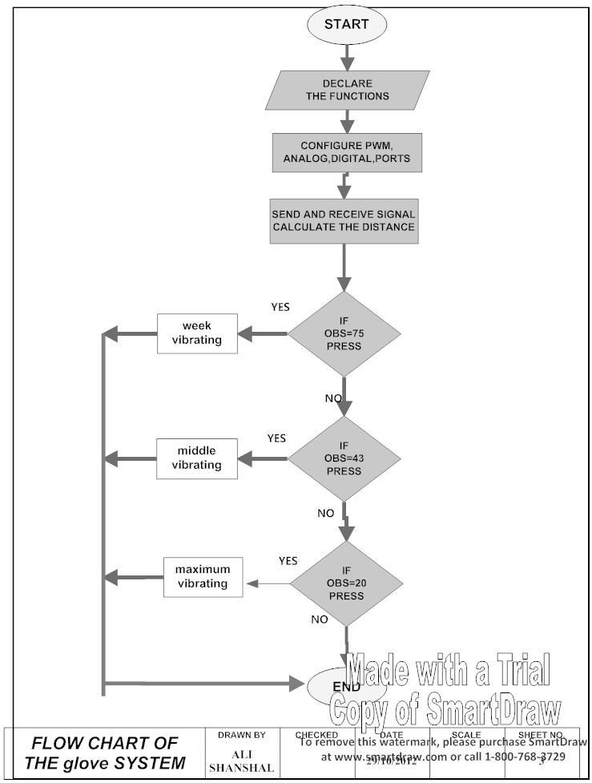

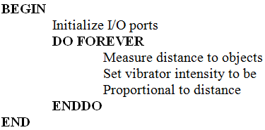

Chart 4.3: flow chart of bandage system Chart 4.4: Operation of the bandage sens

**CHAPTER 5**

**TESTING THE SYSTEM AND DISCUSSIONS**

Many interviews were carried out with many blind people in order to know their life requirements before designing the device. The device was designed in accordance with these requirements and it was tested by several blind people after being trained on how to use and success has been achieved with high efficiency.

There are two categories of experiments which were achieved using the designed devices.

The first is how fast the device can measure the distance of obstacles and the second is the efficiency in the case when the device is used continuously by blind people.

It has been observed that the system has good ability to identify and measure the distance of the obstacles in a time period not exceeding one second.

Although the sensor's ability to measure the distance is very quick and does not exceed about 100ms, the process of converting the speech signal from digital format to audio format requires additional time delay. This was the case with the helmet system, but in the bandage system there was no practical delay to measure the distance. This is because the process of activating the electronic vibrator does not require a long time.

It was observed that there were no problems in operating the helmet for very long times. The bandage system had the problem that the battery needed changing after some time. This was because the bandage system uses an electronic vibrator and vibrators consume rather large amount of energy.

According to the sensor documentation, obstacles are only detected within the working area. This area has a three dimensional cone shape as depicted in Figure (5.1). The shape of the cone is dependent on the object geometry. Small and narrow objects will be difficult to detect compared to large plates. The detection cone for a cylinder will be smaller than for a large plate. Some measurements are performed here to check the size of the detection cone. Especially the minimal angle between the acoustic axis of the sensors and the object surface will be examined. This will be done for plates and human legs. With the results of these measurements it is possible to compare the performance of the sensors in practice against the specifications. The tip of the detection cone does not start at the sensor surface. The distance between the cone tip and sensor surface is referred to as the *blind zone*. The sensor output is undefined when objects are present inside the blind zone [54].

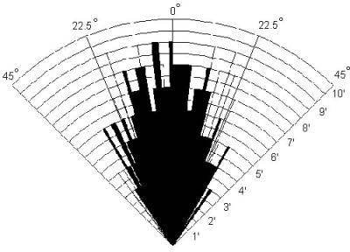

Figure 5.1: Propagating of sensor's waves [24]

**5.1 Helmet System Experiments**

There are eight cases which give different voice messages in the helmet system to alert the blind person to avoid obstacles while walking. The helmet system detects the obstacles in all four directions and then alerts the blind person accordingly.

The helmet system was tested in both small rooms and in large rooms and the actual tests and the test results are given in the following sections. .

**5.1.1 Forward Case**

This test is shown in Figure 5.2 where the blind person is required to go out of the door in a room. In this test the blind person is expected to move forwards out of the door and avoid any barriers. The door was a standard door with a width of 875mm. Here, the system tells the user to go ahead and thus avoid the door which is an obstacle.

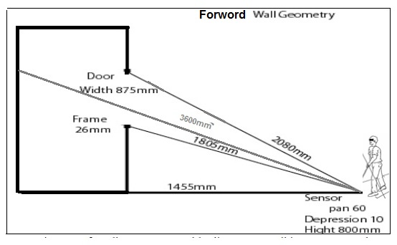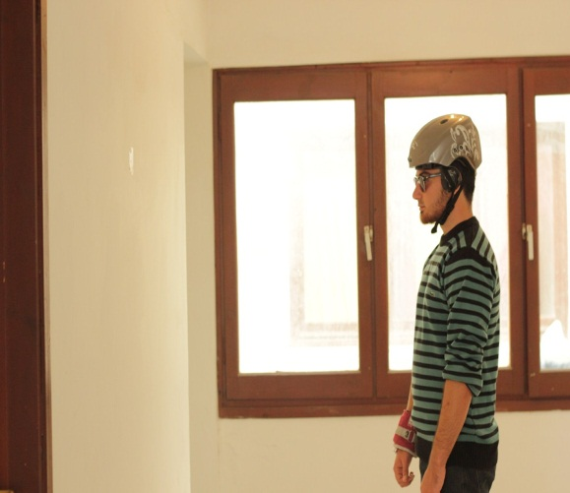

Figure 5.2: Experiment of helmet for front barriers

**5.1.2 Right and Left Cases**

Avoiding the barriers and obstacles in a side direction (right, left) helps the blind a lot during the process of walking, especially in unfamiliar places. When the distance between the blind and any wall are less than 150cm in the first position (small rooms) and 300cm in the second position (big rooms), then the system will give a voice message warning the blind about the existence of the barrier on the right or left as shown in Figure 5.3. In case (B), the voice message is “something on the right”, or “something on the left” .

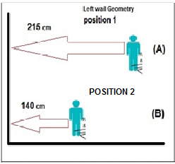 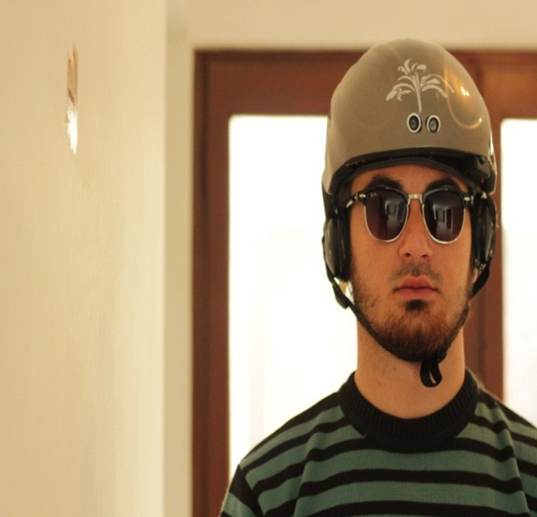

Figure 5.3: Experiment of side barriers

**5.1.3 Back Case**

It may not be required for the blind person to be warned that there is obstacle or wall at the back while walking, but the presence of this characteristic helps the blind to avoid a collision if they want to move when sitting or refer to the back while walking. If the helmet becomes less than 80cm in the first position (A) as shown in Figure 5.4, or less than 40cm in the second position (B) in case of a big room, the system will give voice message “something behind you”.

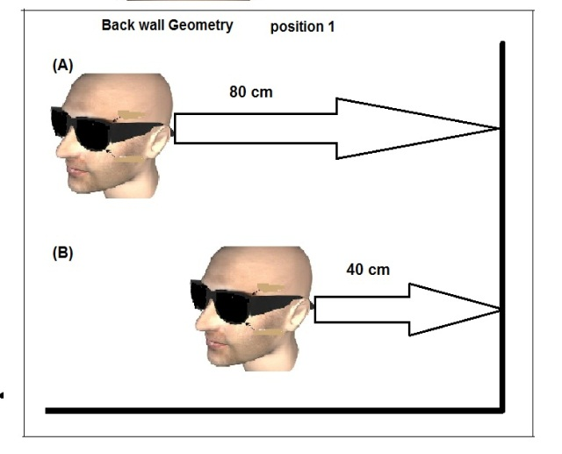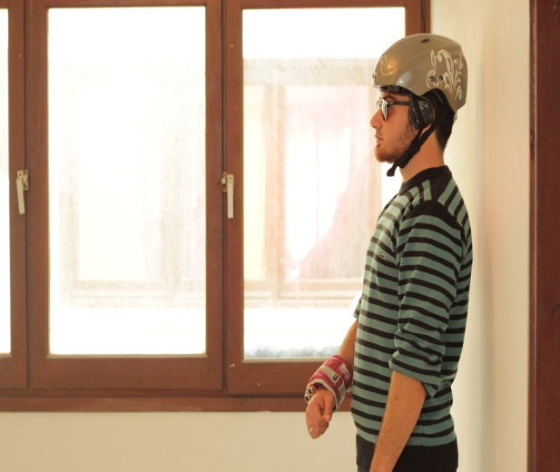

Figure 5.4: Experiment of Back Barriers

**5.2 Bandage System Experiments**

The Bandage System is complimentary to the helmet system to measure the distance to an object and then activates the vibrator. The intensity increases when the hand is closer to things and experiments showed that the effectiveness of this system is very useful to avoid obstacles with low heights which cannot be done by helmet sensors. Many experiments have been done with this system with the blind, and it gave positive results especially in unfamiliar places, for example as the person attempts to locate and lift a cup the increasing intensity helped to position the hand so that the cup could be grabbed and lifted or for to detect holes and stairs as shown in Figure 5.5. The object distance limits the intensity of the vibrator as shown in the Figure 5.6 by three levels of vibration according to the object location to the bandage.

The blind especially have problems with stairs, all kinds of steps, elevators, revolving doors,

and doors with an automatic opener, since they all may cause serious injuries. Furthermore, blind people prefer not to walk in the center of a room because there is normally no orientation line for their cane and because they try to avoid crowds of people. When walking in the center of a room or in a crowd, the orientation sense of a blind person is easily misled [55].

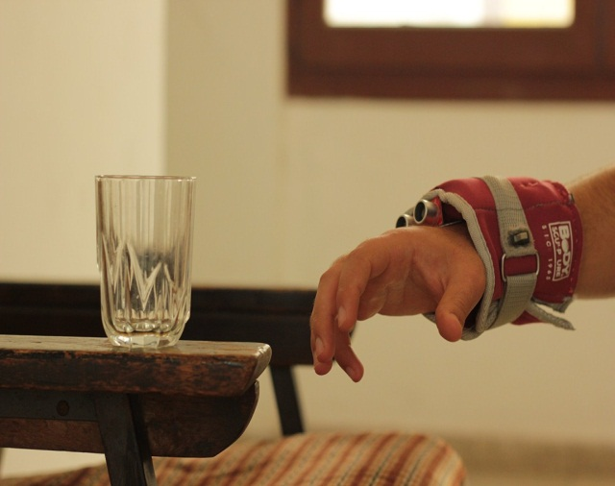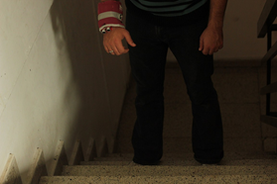

Figure 5.5: experiments of the bandage system

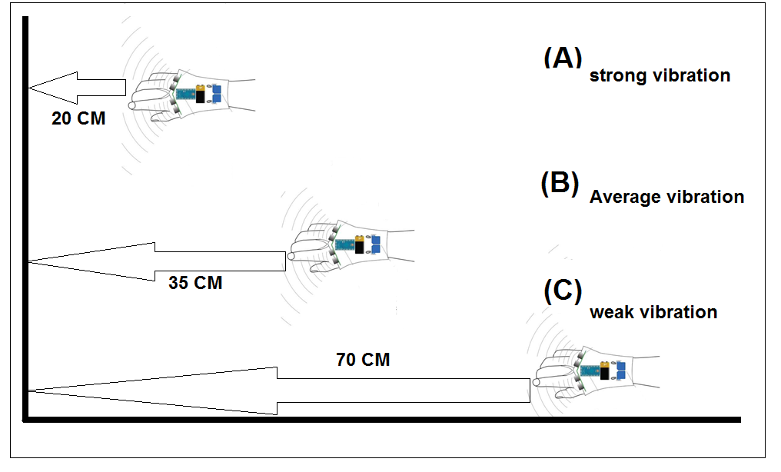

Figure 5.6: The limit Distance of Bandage System Work

**5.3 Detecting A Corridor**

A horizontal scan of the environment is used to detect the edges of a path or the walls of a corridor. The scan is in front of the person and it synchronizes the movement in a horizontal sweep from left to right to explore the space that will be occupied. The path sensing works on the principle that the path does exist and is clear of objects. When the sensor is held horizontally it scans the area. When it is held horizontally at about thigh height, information about the space at thigh height is recorded. If the sensor is tilted down below the horizontal, this brings the scanned area closer to ground level. When walking the blind person seeks assurance that the ground level is ok (down steps are dangerous), so he seeks echoes from the ground. The more acute the tilt angle below the horizon, the more dominant the ground echo will become. If it is set to short range the K-sonar will render the ground as a gentle swishing sound at 20 below the horizon. The sweep movement is determined by the scan objective. A clear path for walking only requires a sweep wide enough to accommodate the user. A sweep of 15 every 2 seconds is enough to make the path wide enough. A more acute sweep angle is required to sweep the full width of a corridor. This angle would depend on the width of the corridor [51].

Table 5.1 : Taxonomy of scanning sweeps (path/corridor navigation)

relative to the user’s body. Scanner is held thigh high in either right

or left hand[51].

|  |  |  |  |  |
| --- | --- | --- | --- | --- |
| Oval  scan | Vertical  Scan motion  (About the  Horizon) | Horizontal  Scan Angle  / Sweep  Period | Horizontal  Tilt Angle |  |
|  | + 0° to +5° | ± 15° / 2sec | -20° | Narrow Path |
|  |  | ± 25° / 3sec | -20° | Path to edges |
|  |  | ±15° to ±90°  / 3 sec | -20° | Door (contact  to entry) |
|  |  | ± 15° / 3sec | -20° | Low obstacle |
|  | -15° to -20° |  |  | Low obstacle  Height |
| Full  Sweep | +15° to -20° | ± 15° |  | Overhanging  Obstacles  (stationary) |
|  | +15° to -20° |  |  | Overhanging  /tall Obstacles |

**5.4 Real-Time Testing**

During this evaluation, the complete ETA system was tested and evaluated by a blind folded and visually impaired person. Three different routes have been chosen to test the performance and reliability of the system. The designed system has been tested inside a building with rooms and corridors, as shown in Figure 5.7. Five different paths have been chosen to test the performance and reliability of the system. The testing was on the first floor of a hospital building where there were corners of the wall and obstacles. The blind was unfamiliar with the place. It is found that the system helped blind people to walk without having the fear of hitting any obstacles on their way. During this evaluation, the complete Helmet-Bandage system was tested and evaluated by two persons the first one is the designer who have normal ability to vision but with eyes closing and the second person is blindfolded and visually impaired.

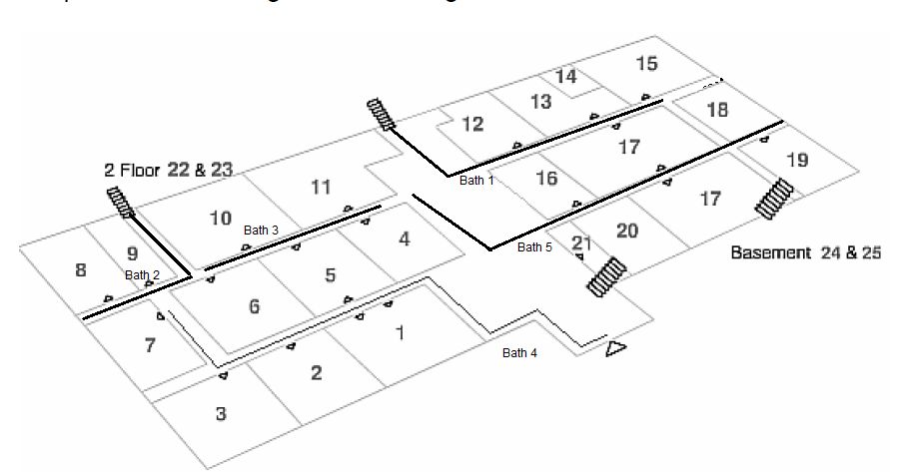

Figure 5.7 : The Building Map Of Hospital showing the paths

A comparative performance with white cane is shown in Table 5.2 first test was with the designer . The total length of the route was 61.4m and was covered at a speed of 0.57 m/s with white cane by the designer test.

Table 5.2: Route 1 of normal Testing Helmet and bandage system

|  |  |  |  |  |  |
| --- | --- | --- | --- | --- | --- |
| **With** **Whit can**  **Speed(m/s)** | **With** **Whit can**  **Time(sec)** | **With H,B system Speed(m/s)** | **With H,B system**  **Time(sec)** | **Length(m)** | **Path** |
| **0.74** | **21** | **0.44** | **35** | **15,5** | **A** |
| **0.84** | **27** | **0.58** | **39** | **22,7** | **B** |
| **0.83** | **40** | **0.66** | **50** | **33,2** | **C** |

The result might show that white cane has outperformed the helmet and bandage system in the first testing.

By repeating the same test with real blind person as shown in table 5.3 ,it found with helmet and bandage system speed is approximate 0.63m/s . The result might show that white cane has outperformed the helmet and bandage system, because the blind almost familiar with this type of building where just corridors no room or furniture. However, familiarity with this device would certainly improve the situation.

Table 5.3: Route 1 of Testing Helmet System

|  |  |  |  |  |  |
| --- | --- | --- | --- | --- | --- |
| **With** **Whit can**  **Speed(m/s)** | **With** **Whit can**  **Time(sec)** | **With H,B system Speed(m/s)** | **With H,B system**  **Time(sec)** | **Length(m)** | **Path** |
| **0.81** | **29** | **0.49** | **43** | **15,5** | **A** |
| **0.92** | **38** | **0.67** | **50** | **22,7** | **B** |
| **0.89** | **47** | **0.73** | **63** | **33,2** | **C** |

The second route (route 2) was again tested on two cases, one with the designer and second one with the blind person. The route was created by putting several different obstacles randomly on the way of the person. The obstacles include chairs, rod, polystyrene and tables. The test was carried out for three times by changing the orientation and number of obstacles for both (helmet, bandage) the system and walking cane as shown Table 5.4.

Table 5.4 : The Second Route of Testing

|  |  |  |  |  |  |  |
| --- | --- | --- | --- | --- | --- | --- |
| **Time(sec)** | **With H,B system**  **%** | **With H,B system**  **No. of**  **Collisions** | **Time(sec)** | **With** **White cane**  **%** | **With** **White cane**  **No. of**  **Collisions** | **Total**  **Obstacles** |
| **110** | **28.5** | **6** | **180** | **52.4** | **11** | **21** |
| **70** | **26.6** | 4 | **125** | **66.6** | **10** | **15** |
| **51** | **33.3** | **3** | **83** | **55.5** | **5** | **9** |
| **170** | **36** | **11** | **255** | **63.3** | **19** | **30** |
| **140** | **33.3** | **8** | **205** | **58.8** | 14 | **24** |

By repeating the same test with real blind person with helmet and bandage system in the second rout as shown in table 5.5 .

Table 5.5 : The Second Route of blind Testing

|  |  |  |  |  |  |  |
| --- | --- | --- | --- | --- | --- | --- |
| **Time(sec)** | **With H,B system**  **%** | **With H,B system**  **No. of**  **Collisions** | **Time(sec)** | **With** **White cane**  **%** | **With** **White cane**  **No. of**  **Collisions** | **Total**  **Obstacles** |
| **119** | **38.5** | **8** | **190** | **76.1** | **16** | **21** |
| **79** | **40** | 6 | **132** | **86.6** | **13** | **15** |
| **61** | **55.5** | **5** | **97** | **77.7** | **7** | **9** |
| **182** | **46.6** | **14** | **270** | **73.3** | **22** | **30** |
| **155** | **40.6** | **10** | **225** | **70.8** | 17 | **24** |

The third route was the same as the second route but the testing was also with wearing the bandage system together with the helmet system. The aim of the experiment was to see the benefit that can be obtained, especially as the second route would contain many obstacles located at a lower level. This would cause many collisions while walking and wearing the helmet system. The first test was for the designer to know the efficiency of the system only Table 5.6 shows the test result.

TABLE 5.6: The Second Route of Real Testing with normal person

|  |  |  |  |  |  |  |  |  |  |
| --- | --- | --- | --- | --- | --- | --- | --- | --- | --- |
| **Time**  **(sec)** | **%** | **with H,B**  **And**  **bandage system No. of Collisions** | **Time (sec)** | **%** | **With H,B system**  **No. of**  **Collisions** | **Time**  **(sec)** | **%** | **With White can**  **No. of**  **Collisions** | **Total**  **Obstacles** |
| **105** | **10** | **2** | **110** | **28.5** | **6** | **180** | **52.4** | **11** | **21** |
| **73** | **7.5** | **2** | **70** | **26.6** | **4** | **125** | **66.6** | **10** | **15** |
| **48** | **9** | **1** | **51** | **33.3** | **3** | **83** | **55.5** | **5** | **9** |
| **175** | **5** | **4** | **170** | **36** | **11** | **255** | **63.3** | **19** | **30** |
| **137** | **4.6** | **3** | **140** | **33.3** | **8** | **205** | **58.8** | **14** | **24** |

By repeating the same test with real blind person with helmet and bandage system in the second rout as shown in table 5.7 . it found that the blind person have more ability to used the systems than the normal person.

TABLE 5.7: The Second Route of Real Testing with real blind person

|  |  |  |  |  |  |  |  |  |  |
| --- | --- | --- | --- | --- | --- | --- | --- | --- | --- |
| **Time**  **(sec)** | **%** | **with H,B**  **And**  **bandage system No. of Collisions** | **Time (sec)** | **%** | **With H,B system**  **No. of**  **Collisions** | **Time**  **(sec)** | **%** | **With White can**  **No. of**  **Collisions** | **Total**  **Obstacles** |
| **115** | **25** | **4** | **119** | **38.5** | **8** | **190** | **76.1** | **16** | **21** |
| **85** | **23** | **3** | **79** | **40** | **6** | **132** | **86.6** | **13** | **15** |
| **55** | **28** | **2** | **66** | **55.5** | **5** | **97** | **77.7** | **7** | **9** |
| **180** | **31** | **7** | **182** | **46.6** | **14** | **270** | **73.7** | **22** | **30** |
| **144** | **29** | **5** | **155** | **40.6** | **10** | **225** | **70.8** | **17** | **24** |

Figure 5.8 shows the number of collisions and the corresponding times the first test was oon the designer to cheek the benefit of the system while testing. It shows the five curves of the paths with three cases; the first point is by the white cane and it is located always at the top of each curve. This means that the walking test takes the longest time and has the most collisions. The second point is with the helmet system, and the curve clearly shows the drop of the time and the number of collision values. The best point in the curve for all the paths is with the helmet and bandage systems. The curves show the decreased collisions and time compared to the last two cases according to the number of obstacles in each path. These results are very interesting as the number of collisions has decreased.

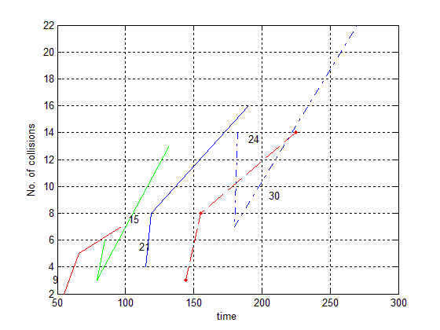

Figure 5.8: Curves Of Each Obstacles Paths While First Test

By ploting the blind testing data it was found that there is closing in the result throught matching the carves with the perivous figure which is represent the Preliminary examination on the normal person and with the real blind pesrson. Figure 5.9 show the curves with same coller of the previous methode but with some differents in value .

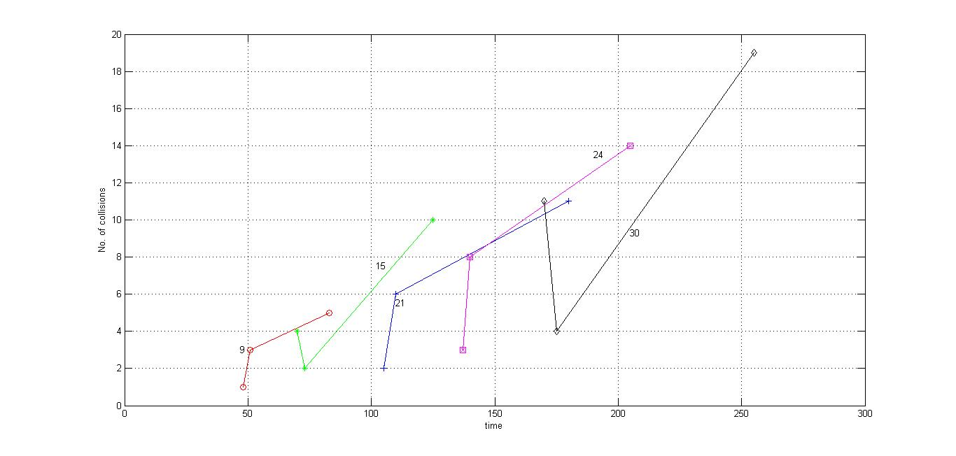

Figure 5.9: Curves Of Each Obstacles paths

Figure 5.10 shows three curves for the testing of the Preliminary examination with normal person, each one representing one of the three cases. The blue graph represents the stick and it takes longer time and has more collisions occurring. The red graph represents both the helmet and bandage system and clearly it takes less time and also has less number of collisions. From these curves it can be observed that as long as the number of obstacles increases, the benefit of the designed device will increase also because the ability of the blind becomes less when the paths become longer and especially in unfamiliar places

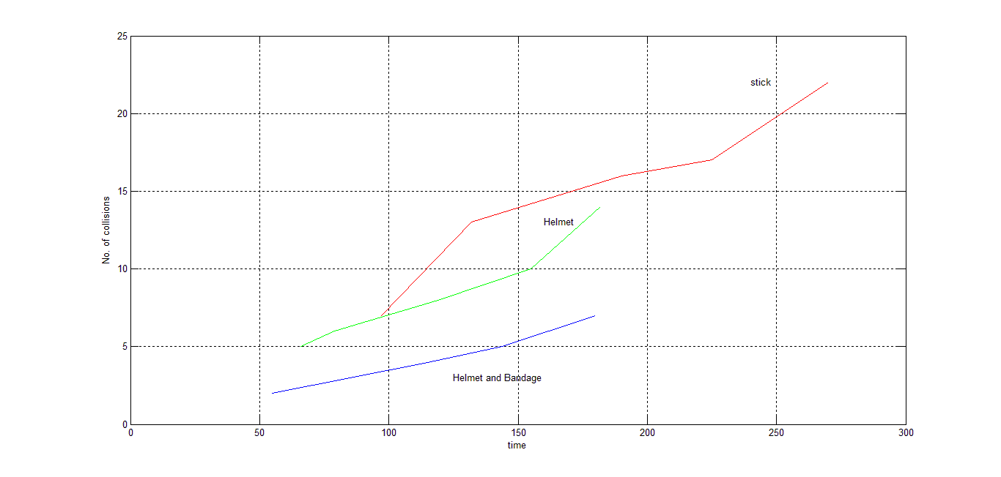

Figure 5.10: Curves of The Three Cases of Testing

The Figure 5.11 shows the curves of the three cases with real blind testing.It is clear from the figure that the result with the real blind person were much better than the results obtained with the author.

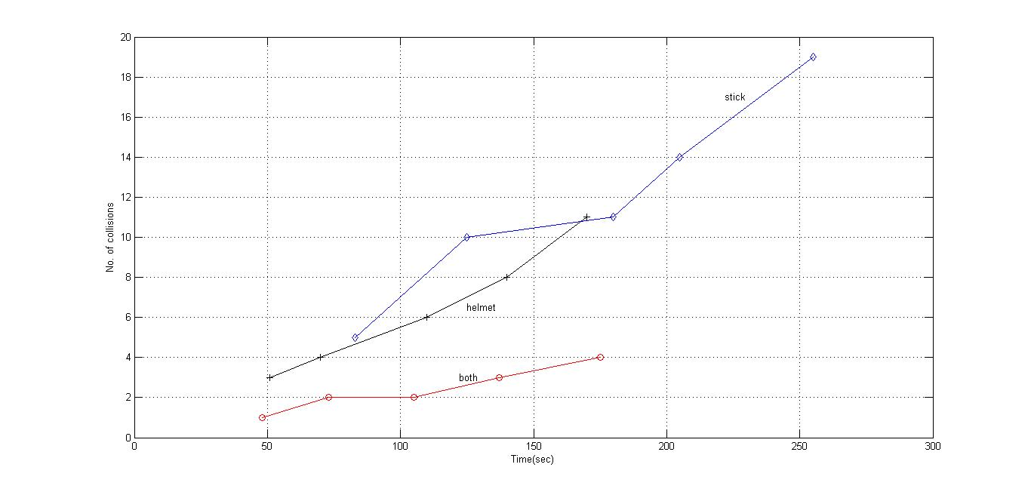Figure 5.11: Curves of The Three Cases of real Testing

**CHAPTER 6**

**CONCLUSION**

The thesis has described the design of an ultrasonic system to help the blind to navigate in closed spaces such as inside buildings. The designed device has been tested successfully and it eliminates the need for a blind person to carry a walking stick by specially designed helmet with ultrasonic sensors and a hand-tool again equipped with ultrasonic sensors. The sensors are in the form of ultrasonic transmitters and receivers, and are configured to measure the distance to obstacles in-front of the sensor pair which is can detect the objects or the obstacles and feeds warning back tile (5m), In the form of voice messages and vibration. The main functions of this system are the clear path indication and the environment recognition.

The time and speed testing shows that the ability of the blind to walk in places where there are no obstacles can be faster with the white cane than with the helmet system and bandage system. This is especially true when these places are familiar to the blind as shown in Table (3). The most important goal is to help and support the blind in new and unfamiliar places, and increase the ability to walk in paths that contain a number of obstacles. In these circumstances it was found that the helmet and bandage system will give great benefits in improving the process of walking with safety and confidence. This means that the blind will be able to move faster compared to the white cane, and there are several reasons, the most important one is detecting the distance greater than the distance sticks area which does not exceed 100cm. With the helmet system the detecting range reaches to 500cm, allowing the blind to move freely on the road without obstructions. The second table shows the decreasing number of collisions when using the device compared to the white cane. The percentage of collisions using just the helmet system is about an average of 30% and in the case of the stick it was 55%. In addition, it was found that using both the helmet and bandage the system was 10% more efficient (see Table 7). The benefit is greater, especially over a long distance which may contain many obstacles, and this in turn provides comfort to the blind person and does not cause physical fatigue. In addition the time factor decreases by 38% as shown in Table 7.

The system also has other advantages which include sensing objects from behind and it can also detect when a door is opened. All these factors lead to improved walking for the blind, especially when adding the bandage system. The main reason for incorporating it is because if a problem is found with the system it can only detect obstacles with a height at least as tall as the person using the system since the sensors are mounted on a helmet worn by on head. The system can be improved further by incorporating sensors at lower parts of the body, such as at the waist level.

Choosing the ultrasound waves for object detection provides more powerful and accurate detection than the current detection mechanisms available in the market. Other important features of the designed system are:

1. The size of the ultrasonic transmitter is very small (2cm in diameter). This is an acceptable size to be installed in a typical helmet and bandage.
2. Since the system operates with 40kHz, which is non-audible signal, it cannot cause any discomfort to the user.
3. The system is free of electrical noise since it operates at a very low frequency of 40kHz.

**Suggestion For Future Work**

The device, as it stands today can be developed to make it more useful and beneficial for the blind people by adding parts and other accessories. High precision parts can also be used to increase the efficiency and the range of the device. One of the most important parts that can be incorporated into the system is the Global Positioning System (GPS). This can be attached to the existing helmet assembly of the system. Although a GPS is attached to the system, it has not been activated and is not used in this thesis. The GPS device will help the blind person significantly to determine his/her actual geographical co-ordinates. For example, with the help of the GPS it would be possible to guide the blind person easily from a given co-ordinate to another co-ordinate by giving him/her audio directions through the existing speakers. When travelling from one city to another it would also provide the blind with some information such as the speed of movement and the time and date as well while avoiding any obstacles with the help of the ultrasonic system.

Other types of ultrasound sensors having greater sensitivities and greater ranges could also be used in the system. Such a modification will enable the blind to sense the obstacles from a greater distance and take necessary steps earlier in order to avoid these obstacles.

Additionally, it is possible to use special sensors that can recognize and distinguish the physical materials of the obstacles. This will help the blind person to be aware of the nature of the obstacles around him/her. Also, it is possibly increases the efficiency of the device to detect and sense moving obstacles around the blind person, using the well-known Doppler phenomenon.

On a hardware level, the biggest challenge is to reduce the size and weight of the device to the minimum level so that it does not cause any inconvenience while using it. This would be done by reducing the size of the processor and sensors and other parts comprising the overall system. Furthermore, a new technology of using artificial muscles which has not been suggested yet in the literature can be applied. In this concept, artificial muscle can be used as an actuator instead of the vibration or audio feedback to guide the visually impaired [5]. All these requirements must be taken into account as well as the financial cost of the device before the device can be commercialized and becomes available for use by the blind people.

**References**

[1] Atif B Mohamed Ali1\*, Lakho A Klalil2(2011).The quality of visual acuity and common causes of low vision in Khartoum. Khartoum Medical Journal Vol. 04, No. 01, pp. 596 – 602 ,(2011)

[2]- world health organization .Visual impairment and blindness <http://www.who.int/mediacentre/factsheets/fs282/en> (WHO Media center  Fact Sheet N°282 June 2012

[3] Professor Kevin Frick & Professor Allen Foster. The Magnitude and Cost of Global Blindness:An Increasing Problem that can be Alleviated. American J Ophthalmology 2003; 135: 471-476(2003)

[4]-Mohd. Helmy Abd Wahab, Amirul A. Talib, Herdawatie A. Kadir, Ayob Johari, A. Noraziah, Roslina M. Sidek, Ariffin A. Mutalib

Smart Cane: Assistive Cane for Visually-impaired People, IJCSI International Journal of Computer Science Issues, Vol. 8, Issue 4, No 2, July 2011

[5]Senem KURŞUN, *Wearable Obstacle Detection System Integrated with Conductive Fibers for Blinds,* ,Textile Technologies and Design Faculty, Inonu cd. No.65, Gumussuyu-Taksim ISTANBUL, 34437 TURKEY(2009)

[6]Montr´eal, Qu´ebec, Canada. Blindness. Technology and Haptics. Vincent L´evesque,TR-CIM-05.08(2007)

[7] Bitjoka Laurent\* and Takougang Noupowou Alain Christian.( 2007). A sonar system modeled after spatial hearing and echolocating bats for blind mobility aid

Department of Electrical Engineering, Energetic and Automatics ENSAI, The University of Ngaoundéré. P.O Box 455 Ngaoundéré, Cameroon.( 2007).

[8]Senem KURŞUN, *Wearable Obstacle Detection System Integrated with Conductive Fibers for Blinds*. Istanbul Technical University (ITU), Textile Technologies and Design Faculty, Inonu cd. No.65, Gumussuyu-Taksim ISTANBUL, 34437 TURKEY.(2009)

[9] R. Velázquez. Wearable Assistive Devices for the Blind.

Wearable and Autonomous Biomedical Devices and Systems for Smart Environment Issues and Characterization, LNEE 75, Springer, pp 331-349,(2010)

[10]- Michael Margolis, Arduino Cookbook, Published by O’Reilly Media, Inc., 1005 Gravenstein Highway North, Sebastopol, CA 95472. (2011)

[11]Dr Dr Leslie Kay. See the world with sound . [http://www.batforblind.co.nz/history.php#](http://www.batforblind.co.nz/history.php) (USA. Advanced Technologies.2006)

[12]Johann Borenstein and Iwan Ulrich. The GuideCane — A Computerized Travel Aidfor the Active Guidance of Blind Pedestrians. The University of Michigan, Advanced Technologies Lab, 1101 Beal Avenue, Ann Arbor, MI 48109-2110. (1997)

[13]S. Shoval, J. Borenstein, and Y. Koren, “The NavBelt - A Computerized Travel Aid For,The Blind Based On Mobile Robotics Technology,” IEEE Trans. Biomedical Engineering, vol. 45, no. 11, pp. 1376-1386, November 1998

*[14]Kristóf Karacs, Anna Lazar, Róbert Wagner Dávid Bálya, Tamas Roska.* *Mihály Szuhaj.* Bionic eyeglass: an audio guide for visually impaired. Faculty of Information Technology, Pazmany University and Analogic and Neural Computing Laboratory,SZTAKI, Hungarian Academy of Sciences… ONR N00014-02-1-0884 and and (ii) bio-inspired RET Szentagothai Tudaskozpont 2005

[15]Steven La Grow, EdD. The use of the Sonic Pathfinder as a secondary mobility aid for travel in business environments: a single-subject design. Journal of Rehabilitation Research and Development Vol. 36 No. 4, October 1999

[16] Leslie Kay OBE. Ph D. FRSNZ. 'K' SONAR Dealing with the Process of Using"Sound To See With"For Blind and Visually Impaired Persons. Advanced Technologies Ltd Suite 31, 7 St Vincent Avenue Remuera Auckland 1005 New Zealand.2002

[17]Manoj Badoni1and Sunil Semwal1.

Discrete Distance and Water Pit Indicator using AVR ATmega8 in Electronic Travel Aid for Blind. International Journal of Disaster Recovery and Business Continuity Vol. 2, November, 2011

[18] The UltraCane - an award winning mobility aid , <http://ultracane.com/about_the_ultracane> ,( Sound Foresight Technology Ltd.2010)

[19] NSK Electronics .DYP-ME007 V2 Ultrasonic sensor,<http://www.nskelectronics.in/dyp-me007_v2_ultrasonic_sensor.html> (banglore(india). NSK Electronics.)

[20] 40Hz Ultrasonic Range Detection Sensor <http://snootlab.com/attachment.php?id_attachment=68>

[21] Wikipedia. Arduino., <http://en.wikipedia.org/wiki/Arduino>.

( AMERICA, Wikimedia Foundation, Inc.2012)

[22] Wikipedia .mp3 player hardware spece, <http://www.s1mp3.org/en/docs_hwspecs.php>,( ( AMERICA, Wikimedia Foundation, Inc.2012)

[23]ZH-23F, mini relay, <http://www.shock-absorber-piston.com/supplier-electromagnetic_relays-5071.html>(CHINA.shock-absorber-piston.com. 2011 – 2012)

[24] Wikipedia, Headphones , <http://en.wikipedia.org/wiki/Headphones>

( AMERICA, Wikimedia Foundation, Inc.2012)

[25] Wikipedia, Global Positioning System From , <http://en.wikipedia.org/wiki/Global_Positioning_System> ( AMERICA, Wikimedia Foundation, Inc.2012)

[26] NTE152 NPN Transistor Audio-Power Amplifier/Switch

<http://www.radioshack.com/product/index.jsp?productId=13145648>

[27] Wikipedia, vibration motor,<http://www.ebay.co.uk/sch/Business-Office-Industrial-/12576/i.html?_nkw=vibrater+motor>

( AMERICA, Wikimedia Foundation, Inc.2012)

[28] Wikipedia ,9- volt battery , http://en.wikipedia.org/wiki/Nine-volt\_battery ( AMERICA, Wikimedia Foundation, Inc.2012)

[29] Wikipedia ,on of Switch , <http://en.wikipedia.org/wiki/Switch>( AMERICA, Wikimedia Foundation, Inc.2012)

[30] by Alan G. Smith,Introduction to Arduino, ISBN: 1463698348

ISBN-13: 978-1463698348. (September 30, 2011)

## [32]  [Blogger](http://www.blogger.com/" \t "_blank), Introduction to Arduino Part 1 , <http://creativec0d1ng.blogspot.com/2012/09/introduction-to-arduino-part-1.html> (america. SEPTEMBER 3. 2012)

## [33] Andy Lindsay,Detect Distance with the Ping)))(TM)Ultrasonic Sensor,[www.parallax.com/Portals/0/Downloads/docs/.../Distance28015.pdf](http://www.parallax.com/Portals/0/Downloads/docs/.../Distance28015.pdf)(AMERICA,(c) by Parallax Inc, 2005)

[34]Ladyada, Arduino Wiring, <http://learn.adafruit.com/adafruit-ultimate-gps/arduino-wiring>, (America, Adafruit Learning Technologies,2011)

[35] Rocklin .PING)))™ Ultrasonic Distance Sensor (#28015) <http://www.parallax.com/dl/docs/prod/acc/28015-PING-v1.3.pdf>(California . 599 Menlo Drive, Suite 100. 6/13/2006)

[36]  [Techbitar](http://www.instructables.com/member/techbitar/" \o "view techbitar's profile).Use Arduino with TIP120 transistor to control motors and high power devices , <http://www.instructables.com/id/Use-Arduino-with-TIP120-transistor-to-control-moto>(AMERECA,Instructable.Oct 25, 2011)

[37] National Air and Space Museum. How does gps work <file:///F:/disktob%20old/How%20Does%20GPS%20Work%20.htm>

Washington, Smithsonian Institution, 1998))

# [38] CATEGORIES: Children, Recall News,Unsafe Helmet Latest in Growing Number of Children’s Products Recalled ,<http://www.newsomelaw.com/blog/2012/01/11/unsafe-helmet-latest-growing-number-children%E2%80%99s-products-recalled>

(Florida,Product Liability News and Current Events,January 11, 2012)

[39] Hideyasu Sumiya. Distance Feedback Travel Aid Haptic Display Design, Mobile Robots: Perception & Navigation, Sascha Kolski (Ed.), ISBN: 3-86611-283-1(2007)

[40] Nurion-Raycal Industries Inc, WHEELCHAIR PATHFINDER,<http://marin.networkofcare.org/veterans/assistive/assistive_devices.aspx?pageid=19327&top=32573&ksectionid=0&productid=95342&trail=22,13134,15820&discontinued=1> Station Square, Bldg ##2, Suite B.Paoli, Pennsylvania 19301.United States

(United States .Trilogy Integrated Resources.2012)

[41]Dr. Peter Meijer. Sensory Substitution - Vision Substitution. <http://www.artificialvision.com/sensub.htm>

(New york.The New York Times on sensory substitution.2004)

[42]Greg Phillips. Miniguide Holder. <http://www.gdp-research.com.au/holder1.htm>

(Australia .)

[43]world health organization .Visual impairment and blindness http://www.who.int/blindness/causes/en/(america.WHO Media center  Fact Sheet N°282 June 2012)

[43]Gaza07, DYP-ME007 V2, http://www.rcgroups.com/forums/attachment.php?attachmentid=4276294

(amereca, RC group. Sep 13, 2011)

# [44]Sagar Sapkota, How To Make Ultrasonic Range Finder On Breadboard Using Ping)))

<http://www.buildcircuit.com/ping-ultrasonic-range-finder-on-breadboard-using-arduino/>

Finland, Build circuit, on 15 January, 2011))

[45] Arduino Team. Arduino software program. <http://arduino.cc/en/Main/Software>

America , 2012))

[46] jwilans, Ultrasound, <http://www.sensorwiki.org/doku.php/sensors/ultrasound>, ( america,[SensorWiki.org](http://www.sensorwiki.org/doku.php/),2011)

**[47]Dr. Anja Köhne und Dr. Michael Wößner,** GPS-System, http://www.kowoma.de/en/gps/index.htm(**MagdenSchweiz,** kowoma.de, 2009-04-19)

[48]Dr. Maria Helguera, *An Introduction to Ultrasound,* [*http://www.cis.rit.edu/research/biomedical/ultrasoundintro/ultraintro.html*](http://www.cis.rit.edu/research/biomedical/ultrasoundintro/ultraintro.html) *(Usa,* [Rochester Institute of Technology](http://www.rit.edu/),2008)

[49]William R. Hendee and E. Russell Ritenour , ULTRASOUND WAVES, *Medical Imaging Physics,* ISBN: 0-471-38226-4, 2002

[50]Phillip J McKerrow, Sherine M. Antoun, Research Into Navigation with CTFM Ultrasonic Sensors,ion 63RD Annual meeting ,Cambridge massachuest,2007

[51]S. M. Antoun, P. J. McKerrow. Perceiving A Corridor With CTFM Ultrasonic

Sensing. Antoun, SM and McKerrow, PJ, Perceiving A Corridor With CTFM Ultrasonic

Sensing, in Dunbabin, M & Srinivasan, M (editors), Proceedings of the Australasian Conference on Robotics and Automation (ACRAA'07), Australian Robotics & Automation Association, Brisbane, 2007

[52]Mounir Bousbia-Salah \*, Abdelghani Redjati\*, Mohamed Fezari\*, Maamar Bettayeb. AN ULTRASONIC NAVIGATION SYSTEM FOR BLIND PEOPLE, International Conference on Signal Processing and Communications (ICSPC 2007), , Dubai, United Arab Emirates. P.O. Box: 27272, UAE. 24-27 November 2007

[53] Beastan Jacob, Basic Ultrasound Physics, <http://www.wikiradiography.com/page/Basic+Ultrasound+Physics(amireca>,wikiRadiography, Jun 2 2012)

[54] J.M. Dolsma, Obstacle detection in blind zone

of ultrasonic sensors. Technische Universiteit Eindhoven, DCT 2005.95, February, 2006

[55]Andreas Hub Joachim Diepstraten Thomas Ertl, Design and Development of an Indoor Navigation andObject Identification System for the Blind, University of Stuttgart, Universitätsstraße 38 -70569 Stuttgart, Germany . 2002

[56] Jo˜ao Tiago Pereira Nunes Jos´e, Real-time path and obstacle detection for blind persons, UNIVERSIDADE DO ALGARVE Faculdade de Ciˆencias e Tecnologia.2010

[57]Larisa Dunai, Guillermo Peris Fajarnes, Victor Santiago Praderas, Beatriz Defez Garcia, Ismael Lengua Lengua Real–Time Assistance Prototype – a new Navigation Aid for blind people Research Center in Graphic Technology, Universidad Politecnica de Valencia, Camino de Vera s/n, 8L, Valencia, 46022, Spain.2005

[58]Lisa Ran, Sumi Helal and Steve Moore. Drishti: An Integrated Indoor/Outdoor Blind Navigation System and Service, University of Florida, Gainesville, FL 32611, USA.2011

[59]Stanislav Vítek1, Miloš Klíma2, Libor Husník3, Daniel Špirk New Possibilities for Blind People Navigation, 1Czech Technical University in Prague, Technická 2, Prague.2008

**APPENDIX A**

**The Program Code of helmet System.**

int outputPin = A0 ; // declaration the pin as an output

int inputPin = A1 ; // declaration the pin as an intput

int output1Pin = A3 ; // declaration the pin as an output

int input1Pin = A2 ; // declaration the pin as an intput

int output2Pin = A5 ; // declaration the pin as an output

int input2Pin = A4 ; declaration the pin as an intput

int output3Pin = 10 ; // declaration the pin as an output

int input3Pin = 9 ; // declaration the pin as an intput

int outputpin = 7 ; // declaration the pin as an output

int output11pin = 8 ; // declaration the pin as an output

int output22pin = 6 ; // declaration the pin as an output

int output33pin = 5 ; // declaration the pin as an output

int input = 12 ; //

int val = 0 ; //

long distance ; //

long cm ; //

long distance1 ; //

long cm1 ; //

long distance2 ; //

long cm2 ; //

long distance3 ; //

long cm3 ; //

void setup() // initialize serial communication

{

Serial.begin(9600); // set your baud rate

pinMode(outputPin, OUTPUT) ; //

pinMode(inputPin, INPUT) ; //

pinMode(output1Pin, OUTPUT); //

pinMode(input1Pin, INPUT); //

pinMode(output2Pin, OUTPUT); //

pinMode(input2Pin, INPUT); //

pinMode(output3Pin, OUTPUT); //

pinMode(input3Pin, INPUT) ; //

pinMode(7, OUTPUT); //

pinMode(8, OUTPUT) ; //

pinMode(6, OUTPUT) ; //

pinMode(5, OUTPUT); //

digitalWrite(7, HIGH); //

delay(200); //

digitalWrite(7, LOW); //

delay(200); //

digitalWrite(8, HIGH); //

delay(200); //

digitalWrite(8, LOW);//

delay(200); //

digitalWrite(6, HIGH); //

delay(200); //

digitalWrite(6, LOW); //

delay(200); //

digitalWrite(5, HIGH); //

delay(200) ; //

digitalWrite(5, LOW); //

delay(200) ;

}

void loop()

//establish variables for duration of the sensor

//and the distance result in inches and centimeters

{

// The sensor is triggered by a HIGH pulse of 2 or more microseconds

// Give a short LOW pulse beforehand to ensure a clean HIGH pulse

; //(delayMicroseconds(2

; // ( digitalWrite(outputPin, HIGH

delayMicroseconds(10); //

// digitalWrite(outputPin, LOW);

//The same pin is used to read the signal from the sensor :a HIGH

//pulse whose duration is the time (in microseconds) from the sending

//of the ping to the reception of its echo off of an object

distance = pulseIn(inputPin, HIGH); //it now initializes before setup to speed up the process

// convert the time into a distance ; cm= distance/58

;(delayMicroseconds(2

;//(digitalWrite(output1Pin, HIGH

delayMicroseconds(10); //

; //(digitalWrite(output1Pin, LOW

//The same pin is used to read the signal from the sensor :a HIGH

//pulse whose duration is the time (in microseconds) from the sending

//of the ping to the reception of its echo off of an object

distance1 = pulseIn(input1Pin, HIGH); //it now initializes before setup to speed up the process

convert the time into a distance cm1= distance1/58; //

; // ( delayMicroseconds(2

; ( digitalWrite(output2Pin, HIGH

// delayMicroseconds(10);

; //( digitalWrite(output2Pin, LOW

//The same pin is used to read the signal from the sensor :a HIGH

//pulse whose duration is the time (in microseconds) from the sending

//of the ping to the reception of its echo off of an object

distance2 = pulseIn(input2Pin, HIGH); //it now initalizes before setup to speed up the process

convert the time into a distance ; // cm2= distance2/58

; // ( delayMicroseconds(2

; // ( digitalWrite(output3Pin, HIGH

; // ( delayMicroseconds(10

digitalWrite(output3Pin, LOW) ; //

//The same pin is used to read the signal from the sensor :a HIGH

//pulse whose duration is the time (in microseconds) from the sending

//of the ping to the reception of its echo off of an object

distance3 = pulseIn(input3Pin, HIGH); //it now initializes before setup to speed up the process

convert the time into a dista ; // cm3= distance3/58

; // (val = digitalRead(12

if(cm1==0){

// eliminate the 0 value cm1=700;}

if(cm2==0);{

// eliminate the 0 value } cm2=700;

{(if(cm3==0

// eliminate the 0 value cm3=700;}

// set the bottom on the big room position if (val == HIGH);

{

{ ( if(cm1==0

cm1=700;}

{(if(cm2==0

cm2=700; }

{( if(cm3==0

cm3=700;}

{ (if (cm>400

operate the first memory player digitalWrite(8, HIGH);

;( delay(200

digitalWrite(8, LOW);

; (delay(200

}

{ ( if (cm1<300

//operate the scond memory player digitalWrite(7, HIGH);

; delay(200)

;( digitalWrite(7, LOW

; (delay(200

}

{( if (cm2<300

//operate the third memory player ; (digitalWrite(6, HIGH

;( delay(200

;( digitalWrite(6, LOW

delay(200)

}

{(if (cm3<300

//operate the forth memory player ; (digitalWrite(5, HIGH

delay(200);

;( digitalWrite(5, LOW

delay(200);

}

}

{( if (cm>350

// operate the first memory player ;( digitalWrite(8, HIGH

;( delay(200

;(digitalWrite(8, LOW

;( delay(200

}

if (cm1<50){

//operate the second memory player ;( digitalWrite(7, HIGH

;(delay(200

;( digitalWrite(7, LOW

delay(200);

}

if (cm2<100){

operate the third memory player // digitalWrite(6, HIGH);

;( delay(200

digitalWrite(6, LOW);

delay(200);

}

if (cm3<100){

operate the forth memory player ;//( digitalWrite(5, HIGH

;( delay(200

;( digitalWrite(5, LOW

;( delay(200

}

}

**APPENDIX B**

**THE PROGRAM CODE OF THE BANDAGE SYSTEM**

int outputPin = A0 // declaration the pin as an output

int inputPin = A1; //declaration the pin as an intput

long distance;

long cm;

int pin = 9;

int pulsewidth00 = 0; // make the pulse width 0

int pulsewidth0 = 80; // Any value between 0 and 255

int pulsewidth1 = 175; // make the pulse width half

int pulsewidth2 = 255; // make the pulse width full

void setup()// initialize serial communication

{

Serial.begin(9600); // set your baud rate

pinMode(outputPin, OUTPUT);

pinMode(inputPin, INPUT);

}

void loop()

//establish variables for duration of the sensor

//and the distance result in inches and centimeters

{

// The sensor is triggered by a HIGH pulse of 2 or more microseconds

// Give a short LOW pulse beforehand to ensure a clean HIGH pulse

;(delayMicroseconds(2

digitalWrite(outputPin, HIGH);

;( delayMicroseconds(10

;( digitalWrite(outputPin, LOW

//The same pin is used to read the signal from the sensor :a HIGH

//pulse whose duration is the time (in microseconds) from the sending

// of the ping to the reception of its echo off of an object.

distance = pulseIn(inputPin, HIGH); //it now initializes before setup to speed up the process

// convert the time into a distance cm= distance/58;

;( Serial.println(cm

analogWrite(pin, pulsewidth00)

if(cm==0){

cm=100;}

if (cm<75){

// set the vibrater on week vibration analogWrite(pin, pulsewidth0);

;(delay(50

}

if (cm<43){

// set the avarege on week vibration ;(analogWrite(pin, pulsewidth1

;(delay(50

}

if (cm<20){

// set the vibrater on strong vibration ;(analogWrite(pin, pulsewidth2

delay(50);

}

}