CHAPTER ONE
INTRODUCTION AND LITERATURE REVIEW

  - Introduction
Power system security assessment is very important to determine whether, following a contingency (disturbance), power system status reaches a steady state operating stage without exceeding or penetrating the boundaries of the power system security. Power system's operating statuses can be divided into Normal, Alert, emergency and Extreme Emergency states [1, 2]. These operating statuses can be identified in the system monitoring stage where it equips up-to-date measurement and information from all parts of the system such as (line power flow, bus voltage, magnitude of the line current, status of the circuit breaker and switch status information) through the telemetry system in a control centre [3, 4]. In static security assessment, the power system's operating statuses can be defined according to the thermal limits of transmission line and the limits of bus voltages as shown below:
- Normal state: All equipment and devises operates naturally and in a secure position without violation in the system operating limits. In addition, the equipped energy is received without interruption and a continuous power with steady voltage to satisfy all the requirements of the customers [1, 4, 5, 6].
- Alert state: The security limits remain within the acceptable borders of transmission lines and voltage magnitude at all buses, but a small disturbance can lead to violation of some security limits [1, 3, 5, 7, 8, 9].
- Emergency State: A power system enters the emergency state when at least one of the security limits is violated. The system operator must detect this state very fast to prevent the power system from sliding into the most dangerous cases by taking the immediate corrective action to bring the system back to the least dangerous instances and the most safety [3, 7, 8].
- Extreme Emergency state: The extreme emergency state is a result of the delayed detection for hazardous situations or incorrect protective action by system operator and the continuity in this situation is going to lead the system to collapse and blackout in that system [10].
Nowadays because of the increasing concern on economical and environmental issues, the power systems are obliged to operate under stressed operating conditions nearer to their security constraints. Under such vulnerable and fragile conditions, any small disturbance is going to make the power system at risk and probably will lead to the collapse of that system [1]. Fast and accurate security assessment became an important key issue to ensure that all operating limits fall within acceptable security conditions [8].
For power system security assessment, it is necessary to predict the bus voltages and line flows for various operating circumstances of normal and contingency situations to help the system operator to identify the power system's operating statuses then to maintain the status of a power system at a secure position or a safe point [11 and 12]. Where a contingency is a failure of any one piece of equipment, in addition, the outage of transformer or transmission line and the sudden change in loads are the most expected contingency situations [13]. Therefore, to prevent the power system from shifting into an undesirable emergency situations and hazardous disturbances, the security level or the power system's operating statuses must be previously well detected with high accuracy and speed [14].
The conventional techniques like Newton-Raphson method that is used for static security assessment consists of solving the non-linear power flow equations to find out the voltages at each bus and power flows at each transmission line for every contingency scenario, followed by examination whether the security limits fall within acceptable boundaries [11, 12 , 15].
The procedure of conventional methods requires a very large memory size to store all contingency cases and the enormous amount of computation time which made them waste of time and infeasible in real time. As well as, the traditional techniques cannot get the high accuracy and the required speed. For these reasons, the conventional techniques undermine the usage of static security assessment in real-time application and time consuming for large electric power systems. In addition, because of several blackouts that led to the enormous financial casualties and the losses in life at some cases, the Artificial Neural Network (ANN) will be used as an alternative method to overcome these obstacles and associated problems with traditional techniques [2, 7, 14, 16, 17, 18, 19, 20].
Neural networks are utilized in the applications of the power system, where more than 350 papers have been published in the use of neural network at various fields of the power systems as shown below in figure 1.1.
2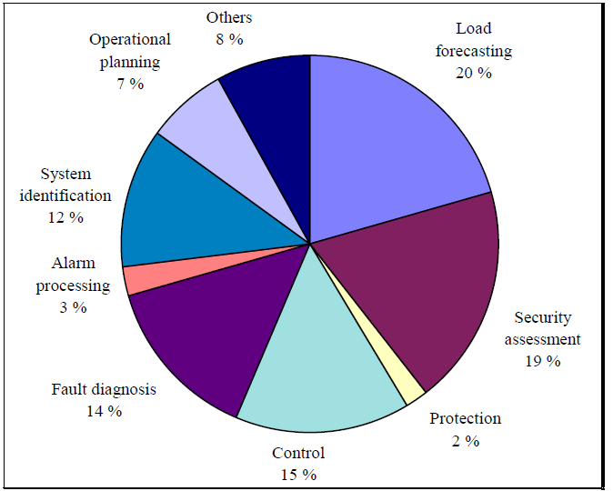
Figure 1.1: Neural networks applications at various areas of power systems [21].
From this figure, the security assessment of the power system obtained the utmost attention by the scientists and the researchers through their scientific papers. This field represents the most important area and the backbone for the rest of the power systems fields. The Artificial Neural Network (ANN) is a mathematical function designed to model the basic function of a biological neuron and it is invented to mimic the way in which the human brain executes a specific mission or task of interest. The Artificial Neural Network (ANN) have shown perfect promise as an intelligent method of predicting the security of large scale power system networks because the artificial neural network has high potential in terms of precision and speed. Besides that, an artificial neural network has significant ability to learn and builds a complex non-linear mapping through a group of input/output patterns or examples. In addition, the artificial neural networks had been magnificently implemented in the large scale power system networks compared to other techniques such as AC power flow and DC power flow [1, 4, 19, 22].
In recent years, many researchers have demonstrated the Multilayer Feed forward with a back propagation algorithm is appropriate to solve the problem of static security assessment. The multilayer feed forward with back propagation algorithm has high precision on account of the error between the actual and the desired output will be minimized to the lowest level as well as the implementation is very easy.
The back propagation algorithm is a powerful tool which is developed for training the multilayer artificial neural network to solve difficult problems and the back propagation algorithm consists of two passes through the multilayer neural network: the forward pass and the backward pass are shown below in figure 1.2.
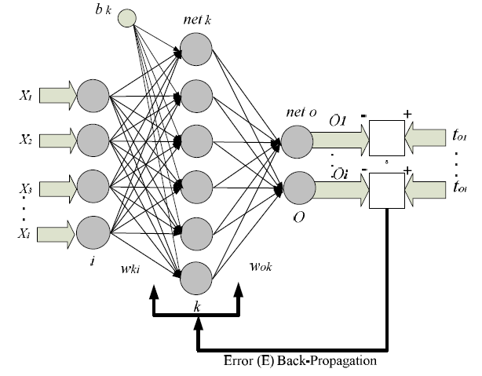
Figure 1.2: Architecture of the Back-propagation model [16].
In these two paths (the forward pass and the backward pass), the incoming information to the input layer is propagated ahead through the layers (hidden layer and output layer) until the actual output will be calculated. All connections among the layers of the network have weights. The architectures of the multilayer neural networks consist of many processing elements called neurons and these architectures are shaped by linking the neurons into all layers, these neurons at the layers are connecting with each other by weights. Each neuron consists of many inputs and one output. Each input is multiplied with its associated weight and the summation of all inputs with their associated weights will produce the output of that neuron. Then this value is sent through an activation function. This technique will be utilized in feed forward calculation until the signal will reach the output layer or final stage, where in it each output of an output neuron will be determined.
The actual output is subtracted from a desired output (target) to obtain the error of the multilayer neural network. This error is propagated backward though the network, the weights of the output layer and the hidden layer are continuously updated until to make the actual output very close to the desired output. The architecture of the multilayer neural network consists of input layer, output layer and at least one hidden layer between them. In general, the sigmoid activation function is preferable to use in back-propagation neural network because its properties of differentiable everywhere and introducing non linearity in the system [1, 4, 7, 21, 23, 24, 25, 26, 27, 28, 29, 30, 31].
The IEEE 9-bus system will be used to determine the static security assessment by using the feed forward back propagation neural network. The generated database from IEEE 9-bus system by the Newton-Raphson technique using Power World Simulator’s program will be utilized to train and test the artificial neural network. The generated database of IEEE 9-bus system will be produced from N-1 contingency analysis (outage a single transmission line) with variation the loads to generate different operating scenarios or various cases, these cases will be utilized in the training process and the testing process.
There are several problems by using artificial neural network to assess the security of power system. There are not fixed standards to determine the number of hidden layer and the number of the neurons in each hidden layer, too few neurons can lead to reduce the level of the training process or the training process will not be in the required path. If the number of neurons in the hidden layer was too many, this case can lead to remember just the original data (memorization).
The unfamiliar data (the various data that was not taken at the training process) can lead to fail the testing process during implementation by the artificial neural network. There is an obvious problem in the selection the values of the momentum factor and the learning rate coefficient where they have a significant role in the learning capability of the neural network. The values of the momentum factor and the learning rate coefficient should be between 0 and 1. These two parameters will be added to minimize the error function to the minimum and to accelerate the learning process as well as to prevent the artificial neural network from falling in the local minima’s problem. In this problem, the multilayer feed forward with a back propagation algorithm will stuck in a specific place and the value of the error function will not minimize to the desired value.
There is a problem in the spent time at the training process. Because the power system security assessment requires the large numbers of the training data to cover all possible scenarios for various disturbances, the feed forward back propagation neural network requires a long period of time for training these cases or scenarios.
In addition, there is another problem related with data sensitivity. This problem lies in an absence of the clear law to identify what kind of input data can be used to get the best outcomes in the output [1, 4, 23, 24, 25, 32, 33, 34, 35, 36].
To achieve the static security assessment of any power system, the operating status of that power system must remain at a normal state under predictable or unexpected circumstances. To achieve this, the proper identification and the rapid detection of the power system's operating statuses by feed forward back propagation neural network are going to utilize to forecast the vulnerable areas in the power system (the weak areas are the most susceptible for the insecure statuses (alarm state, emergency state and extreme emergency state)), where the detection of these areas will help the system operator to take rapid and preventive action which it helps to take the operating system back to the secure position and to avoid remaining the system at the unsafe situations that lead to the collapse or the total blackout for that system [7 ,37].

  - Literature Review
The main objective of an electric power system is to supply a continuous electrical energy to the costumers without interruptions and good quality. To achieve that, the static security assessment will be discussed. Because of the huge problems that associated with the traditional methods during their usage in the security assessment of any power system and to maintain the status of power system at safe status before and after contingency, many research have been published in the use of artificial neural networks to work around the problem of the static security assessment and these are summarized as:
In [1] the authors presented the application of different Neural Network (NN) models for classifying the power system states as secure/insecure. Because of the problems of Traditional technique in security assessment, making it infeasible for real time application. Pattern Recognition (PR) method is recognized as an alternative tool to solve the problem of the security assessment. The Neural Network (NN) models were experimented on 14 Bus, 30 Bus and 57 Bus IEEE standard test systems.
In [2], an Artificial Neural Network (ANN) to assess the static security of 8- buses test system was presented. The method was contrasted with that using of a nearest neighbour search. The Artificial Neural Network (ANN) was shown to perform noticeably better in term of real time, classification and data storage requirement.
The feed forward back propagation neural network to determine the security status of a power system was presented in [4].
In [6], the application of artificial neural network (ANN) in power system security assessment and the problems of conventional techniques were discussed.
In [7] the authors submitted the Artificial Neural Network to assess the steady state security of a power system. The ANN used is a feed forward multilayer network trained with a back propagation algorithm and it tested on 14-Bus IEEE standard test systems.
In [11], the feed forward back propagation neural network was utilized to assess the static security of a test system. Where this algorithm was experimented on the 5 bus and was verified on the IEEE-14 bus test system.
The application of Artificial Neural Network (ANN) for steady state monitoring of a power system was presented in [12]. To demonstrate the effectiveness of this system in steady state security assessment of a power system, the multilayer perception model with back propagation (BP) algorithm has been tested on the IEEE-14 Bus system.
The Multi-class Support Vector Machine (SVM) based Pattern Recognition (PR) technique for static security assessment in power systems was submitted in [14]. This method is tested on IEEE 57 Bus, 118 Bus and 300 Bus benchmark systems.
The design of Artificial Neural Network (ANN) to solve the problems of the static security assessment was clarified in [15].
In [16], the classification of power system states using an artificial neural network model Kohonen's self-organizing feature map was investigated. The estimate goal for this classification was to assess power system static security in real time application.
A new method of using query-based learning in neural networks to solve static security assessment problems in a power system was proposed in [17].
An Artificial Neural Network (ANN) based Pattern Recognition for static security assessment, transit security assessment and dynamic security assessment of the power systems were presented in [18].
In [31], An Artificial Neural Network (ANN) based external system equivalent approach was proposed for on-line voltage security assessment of power system.
In [36], an overview of the application of artificial neural networks to power system security assessment was illustrated. In this paper, the author explained various architectures of neural networks such as multilayered perceptron (the most popular choice), Hopfield and Kohonen networks as well as the extent of their potential in determining the static security was clarified.
In [38], an artificial neural network-based architecture which combines supervised and unsupervised learning for the static security assessment of the power systems was presented.
In [39] the authors used the Kohonen Neural Network to determine the static security assessment of a power system and this system was tested on the IEEE 30-bus system.
In [40], a neural-network-aided solution to the problem of static-security assessment of a large scale power system was proposed. It was based on a pattern-recognition technique where a group of neural networks was trained to classify the secure/insecure status of the power system for specific contingencies based on the pre-contingency system variables.
[41] Has presented in his Master thesis the application of artificial neural networks in the static security assessment. The objective of this research was to investigate the reliability of the Static Security Assessment (SSA) in determining the security level of power system from serious interference during operation. Therefore, back propagation Artificial Neural Network (ANN) was implemented to classify the security status in the test power system. To illustrate the proposed technique, 4 bus test system and IEEE 24 bus test system were considered.

  - Objectives of the Thesis

The objectives of this thesis are:

- To verify the appropriate architecture for used artificial neural network in static security assessment of the IEEE-9 Bus system.
- To develop the static state security assessment of power system using artificial neural network method.
- To achieve the performance of the technique in terms of accuracy and efficiency against conventional method such as Newton-Raphson technique.
- To detect the vulnerable areas (weak areas) and this is going to maintain the status of power system at safe position.
- To identify the power system's operating statuses correctly and that depends on the right choice of the parameters (number of hidden layers, numbers of neurons in each hidden layer, the values of the momentum factor (α) and the learning rate coefficient (η) for training the neural networks.
- To reduce the average time required by conventional method (Newton-Raphson technique).
- To utilize the outcomes of this work in real time application.
- To assist the trainees in the electrical stations to gain the required experience through the identification on the most popular N-1 contingency and its impact on the status of the power system.
- To identify subjects appropriate for further research on the topic.

  - Thesis Overview

The thesis consists of six chapters arranged as follow: The first chapter presents the introduction and literature review on the topic. The second chapter discusses the Artificial Neural Network (ANN) and its application. In addition, it discusses the back-propagation algorithm for training multilayer neural network and usage a sigmoid activation function in that algorithm. In the third chapter, the study is pointed toward the solution of the power flow problems by using Newton-Raphson technique, In addition. It presents the problem of a static security assessment and the power system's operating statuses.
The forth chapter discuses the application of artificial neural networks in the static security assessment as well as the procedures of the feed forward back propagation neural network to assess the static security and to illustrate the proposed technique, IEEE-9 Bus system is considered. In addition, it presents the power flow solution for IEEE-9 Bus system by Newton-Raphson method using Power World Simulator’s program.
The fifth chapter tabulates the experimental results and discussion of this thesis.
The sixth chapter shows the conclusions and suggestion for future work.

