CHAPTER FOUR
APLICATTION OF NEURAL NETWORK IN STATIC POWER SYSTEM SECURITY ASSESSMENT

  - Overview
With the escalation of the requirement for electrical power to reach the consumers at an continuous way and without interruptions, also in order to avoid dangerous situations that lead to the collapse of the system. In addition, the everlasting problems that faced the traditional methods made them useless for researchers and designers it therefore was necessary to find alternative methods to avoid these obstacles.
In this chapter, the usage of artificial neural network (ANN) in static security assessment as alternative technique is going to clarify. The static security assessment and its importance or its impact at the power system, also power system's operating statuses is going to discuss. IEEE 9-Bus System will be solved by Newton-Raphson method using Power World Simulator’s program. Training and testing the artificial neural network will be studied in this section.

  - Introduction
The security of power system is considered an extremely important concern in the designing and operating survey of the power system. A main aim and the essential objective of a power system analysis is to supply a continuous supply of energy with good quality in voltage and frequency to satisfy all the requirements of the consumer without violation in any limit of the operating system’s conditions [7, 14].
At the present time power system is the most complex control in the presence, because the large number of enormous ramifications and the wide spread between continents. Where these complications due to the growing economic and environmental pressures, therefore the power systems are forced to work under stressed operating conditions of the power system. So they are operated very close to their security confines. While a tremendous development made the limits of the power system security a fragile and easy to violate, so any small disturbance from the various emergency situations makes the system at the risk position and lead to system blackout or shut down. Therefore fast and accurate security assessment become a key issue to guarantee secure operating limits of power system, the term of security refers to the degree of reliability for that power system before and after various disturbances [1, 6, 14, 18, 22, 37].
Static security of any power system is defined as the ability of system to reach an operating state within the identified safety and supply quality after the contingency, which helps the system to stay within safety limits. As well as, technical and economic outcomes can be obtained by guaranteeing the security limits of the power system. Conversely, the inability of the system to operate in a safe way can lead to damage of power system’s equipment, loss of some components of the system, tremendous financial losses and in some cases, the loss of human lives. One of the most important reasons for the occurrence of such cases is the inability of the system operator at dealing with emergencies and unexpected rapidly [15, 39, 40].
Static security assessment is the process that has to be achieved regularly and periodically at a center control room in the power plant. Security assessment is the task performed to calculate whether, and to what range, system remains reasonably safe from sudden emergency situations (disturbances) that occur during system operation. If the state of the power system security is not apparently well recognized, then the system may shift to an undesirable state and it lead to the system collapse or blackout. Hence a term of the security assessment helps for warning the system operators and gives them enough time to take appropriate and effective action for that situation, for all these reason power system security plays a substantial role in the power system designing and operation.
The static security assessment (SSA) in the large-scale power system is considered a mathematically daunting task because the traditional methods involves the solution of some nonlinear models (full AC load flow) containing a tremendous number of variables which requires a very large memory size to store all of these variables. Therefore the security assessment mission may become computation-intensive, waste of time and infeasible in real time. As well as, the traditional techniques cannot get the high accuracy and the required speed. For all these reasons, these conventional techniques undermine the usage of static security assessment in real-time application [2, 14, 16, 17, 18, 19, 20, 22, 31, 36, 39, 74].
Scientists, engineers and researchers are concentrating their attempts to enhance the security of power system and reliability. In addition, accelerate the speed of detecting the emergency situations with high accuracy. As a result of these reasons artificial intelligent systems were used in static power system security assessment. In recent years and with evolution of artificial intelligent methods, various techniques have been submitted to overcome the problems and the troubles faced by traditional methods that are used in static security assessment.
Artificial intelligent techniques such as Fuzzy Logic, Self-Origination Feature Map and Artificial Neural Network (ANN) to increase the accuracy and the speed to be applied in large scale power system network, where the performance of these techniques are very high when was applied in determining the static security assessment.
In this thesis, Artificial Neural Network (ANN)-based Multilayer Feed forward with a back propagation technique is going to be employed as alternative approach to determine the static security assessment of power system. Artificial Neural Network (ANN) has shown excellent promise as means of forecasting the security of large-scale electric power systems. By Artificial Neural Network, security region can be performed by using the artificial neural network through examples; the training data can be gained from off-line simulation or from on-line operation, the amount of used data much less than those of the used data in traditional methods (Gauss Seidel iterative approach, Newton-Raphson technique, and fast decoupled power flow method) which helps to reduce the size of memory. In addition, the artificial neural network can be applied with success and a high speed at on-line security assessment.
Since the artificial neural networks (ANN) are fast in response time, ease of adaptation between the input and output data of power system as well as this method is founded to determine the status of the power system with the required speed particularly during the unsafe situations. Therefore the artificial neural network (ANN)-based multilayer feed forward with a back propagation technique become the best and most important candidate for on line application of power system [2, 14, 16, 19, 20, 22, 36, 38, 40, 75].

  - Static Security Assessment (SSA)

Power system security assessment is very important to determine whether, after a contingency (disturbance), the power system reaches a steady state operating stage and without exceeding or penetrating the boundaries of the power system security. Where these boundaries (constraints) ensure the survival of the power system in equilibrium and they consist of the limits of the transmission line flow as well as the upper and lower limits on bus voltage magnitude.
In steady state security assessment of the power system, it is very crucial to forecast the bus voltages and transmission line flows for various operating statuses of the power system. The power system security assessment can be classified into three major functions that are carried out in an operations control centre, which are system monitoring, contingency analysis and security constrained optimal power flow. In the system monitoring, it provides up-to-date measurement and information from all parts of the system through the telemetry system then analyzing them in order to identify and determine the system operating statuses. The power system operating statuses can be classified into Normal state, Alert state, Emergency state, Extreme Emergency state and Restorative state.
In state security assessment process, power flow equations are demanded to determine complete voltage angle and voltage magnitude for each bus bar connected to the network of that power system with corresponding to specified system operating conditions, as well as that, real powers and reactive powers at various transmission lines. The power flow is repeated and solved for different contingences (outage of the transmission line and the sudden increase in required load) and the results are compared or checked with the operational constraints of power system (thermal limits of the transmission lines and the limits of voltage magnitudes at various buses) in order to determine the security status of the power system.
The power flow equations (load flow analysis) will be solved by using the most popular method, which is known as Newton-Raphson (NR) technique. The reason for choosing this method due to the enormous speed of convergence as the iteration starts close to the required root.
The term of a contingency refer to the failure of any one piece of equipment. The outage of transmission line and increase the load are the most popular contingences that will be discussed in order to predict potential Systems outages and their impact on the system as a whole. After carrying out (N-1) contingency analysis, the load-flow equations are demanded to determine the new changes in the load flow for each emergency (contingency) situation at that power system.
In recent years, rapid security assessment is very crucial task to warn and enable the system operator to determine the status of the system very quickly as well as it can take the immediate remedial action to prevent from any interruption and the damages in the power system or customer facilities, where the harm in the operating system may cause highly collapse of system voltage as a result of shutdown of some parts or entire system. Therefore, Artificial Neural Network (ANN) will be used to predict bus voltages and line flows for various conditions of the power system. Many scientists and researchers have demonstrated that feed-forward with back propagation algorithm appropriate to be used in static security assessment. Because the feed forward back propagation neural network technique has great accuracy on account of the error between the actual output and the desired output will be decreased to the minimum, high speed in implementation, not complicated and easy in application. For all these reasons, the feed forward back propagation neural network algorithm represents the best choice and the most popular for a static security assessment [2, 4, 11, 36].

  - The Procedures for designing Artificial Neural Network in Static Security Assessment

Design of the Artificial Neural Network (ANN) involves the following steps:
- Collection database
- Selection of the Artificial Neural Network (ANN) structure
- Training the Artificial Neural Network (ANN) using the database
- Testing the Artificial Neural Network (ANN) using the database

    - Collection database

To create the database to be used in the training and testing the Artificial Neural Network (ANN), so an IEEE-9 bus system was taken as shown below in figure 4.1.

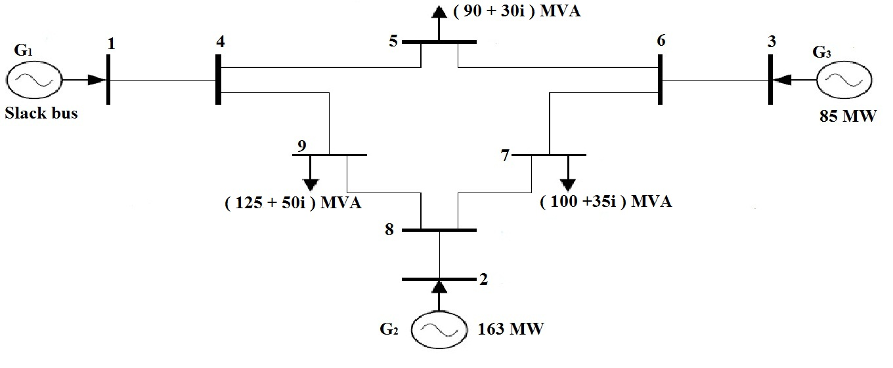
Figure 4.1: The topology of IEEE 9-Bus system [77].

From figure 4.1 that is described above, the IEEE - 9 bus system consists of nine buses, three generators at the first bus, the second bus and third bus, and three loads at the fifth bus, the seventh bus and the ninth bus. In addition, the IEEE - 9 bus system comprises of eight transmission lines connected between various buses which are the line between the fourth and fifth bus, the line between the fifth and sixth bus, the line between the sixth and seventh bus, the line between the seventh and eighth bus, the line between the eighth and ninth bus, the line between the ninth and fourth bus, the line between the third and sixth bus and the line between the second and eighth bus, while the line between the first and fourth bus is connected to the slack bus to determine the losses in whole transmission lines.

The bus data, generator data and branch data for the IEEE-9 bus system have been showed in table 4.1, 4.2 and 4.3 respectively [4, 12].
Table 4.1: Bus data for IEEE 9-bus system [77, 78].
Bus number | Bus type | Load MW | Load MVAR
1 | Slack | 0 | 0
2 | P-V | 0 | 0
3 | P-V | 0 | 0
4 | P-Q | 0 | 0
5 | P-Q | 90 | 30
6 | P-Q | 0 | 0
7 | P-Q | 100 | 35
8 | P-Q | 0 | 0
9 | P-Q | 125 | 50

Table 4.2: Generator data for IEEE 9-bus system [77, 78].

Bus number | Generator  MW | Generator MVAR | Q max | Q min | P max | P min | Voltage magnitude
1 | 0 | 0 | 300 | -300 | 250 | 10 | 1
2 | 163 | 0 | 300 | -300 | 300 | 10 | 1
3 | 85 | 0 | 300 | -300 | 270 | 10 | 1

Table 4.3: Brunch data for IEEE 9-bus system [77, 78]

From bus | To bus | Resistance (R) | Reactance (X) | Shunt charging (B)
1 | 4 | 0 | 0.0576 | 0
4 | 5 | 0.017 | 0.092 | 0.158
5 | 6 | 0.039 | 0.17 | 0.358
3 | 6 | 0 | 0.0586 | 0
6 | 7 | 0.0119 | 0.1008 | 0.209
7 | 8 | 0.0085 | 0.072 | 0.149
8 | 2 | 0 | 0.0625 | 0
8 | 9 | 0.032 | 0.161 | 0.306
9 | 4 | 0.01 | 0.085 | 0.176
Where the base power is 100 MV and voltage base is 345 kV [77]. The maximum limits of the apparent power (S) that can carry by the transmission line are shown below in table 4.4.

Table 4.4: The maximum limits of the apparent power

From Bus | To Bus | Maximum Apparent Power (MVA)
1 | 4 | 300
4 | 5 | 150
5 | 6 | 150
3 | 6 | 300
6 | 7 | 150
7 | 8 | 150
8 | 2 | 150
8 | 9 | 150
9 | 4 | 150

A large number of data is going to generate by Newton-Raphson (NR) power flow technique using Power World Simulator’s program, where these data will be created as a result of various emergency situations that occur during system operating under normal circumstances or normal operating conditions as shown below in following steps:

Step ₁: Build the IEEE 9-bus system with its data components (Bus data, Generator data, Brunch data and the maximum limits of the apparent power for transmission lines) by using Power World Simulator’s program.

Step ₂: By using Newton-Raphson (NR) power flow method in Power World Simulator’s program, the power flow for every transmission line (active and reactive power) will be calculated. In addition, the voltage at every bus bar is going to obtain.

Step ₃: Change all the active loads in the range (-10 MW to +10 MW) from the main loads, where the change in the main load will be at a rate (2 MW) from that range. At each change (2 MW) in that range (-10 MW to +10 MW), the Power World Simulator’s program is going to calculate the new load flow in every line and the voltage at every bus bar where all these procedures present the first case (case ₁).

Step ₄: (N-1) contingency will be presented by outage single transmission line and repeat (step ₃) where all these procedures present the second case (case ₂).

Step _{5:} Since the IEEE 9-bus system consists of eight transmission lines, so the (step ₄) is repeated for each transmission line of the IEEE 9-bus system to perform case ₃, case ₄, case ₅, case ₆, case ₇, case ₈ and case ₉ respectively. In addition, these nine cases will be used for training the Artificial Neural Network (ANN).

Step ₆: Reset these cases then change all the active loads in the range (-09 MW to +10 MW) from the main loads, where the change in the main load will be at a rate (4 MW) from that range. At each change (4 MW) in that range (-09 MW to +10 MW), the Power World Simulator’s program is going to calculate the new load flow in every line and the voltage at every bus bar where all these procedures present the first case (case ₁).

Step ₇: Repeat Step ₄ and Step ₅ but these nine cases will be used for testing the Artificial Neural Network (ANN).
To implement the first step (Step ₁), the IEEE 9-bus system will be simulated by using Power World Simulator’s program as shown below in the following procedures:

- Open the program and from the upper corner click “file”, then choose “New Case”.

- To insert buses, go to “Edit Mode” then click “Insert” and select “bus”. Insert the number and the name of that bus into “Bus Option”. Repeat this process for all buses (nine buses). Make the first bus as a slack bus through “Bus Option” and click “Bus Information” then select “System Slack Bus”.

- To insert generators, go to “Edit Mode” then click “Insert” and select “Generator”. Insert the Generator data into “Generator Option”. Repeat this process for all generators (three generators).

- To insert the transmission lines, go to “Edit Mode” then click “Insert” and select “Transmission Line”. Input the Brunch data and the maximum limits of the apparent power (MVA) into “Transmission Line / Transformer Option”. As a result, the IEEE 9-bus system was built as shown below in figure 4.2.

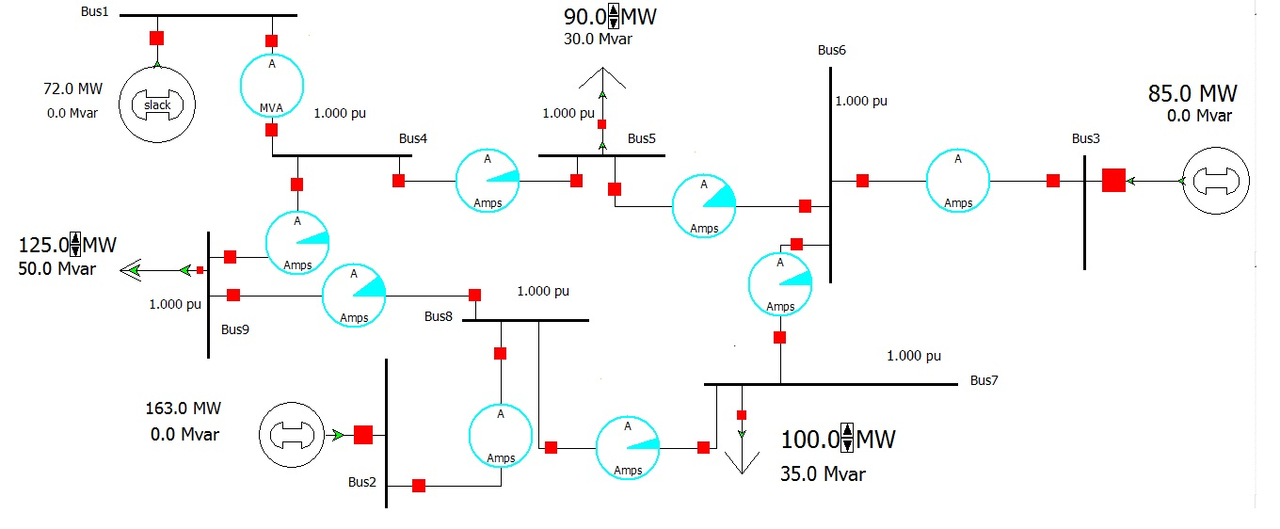

Figure 4.2: IEEE 9-Bus System by using Power World Simulator’s program.

To implement the second step (Step ₂), go to “Run Mode” then click “Simulation” from the upper left corner and select “Solve and Animate”. The power flow for every transmission line (active and reactive power) was calculated. In addition, the voltage at every bus bar and thermal limits of transmission lines were obtained as shown below in figure 4.3.

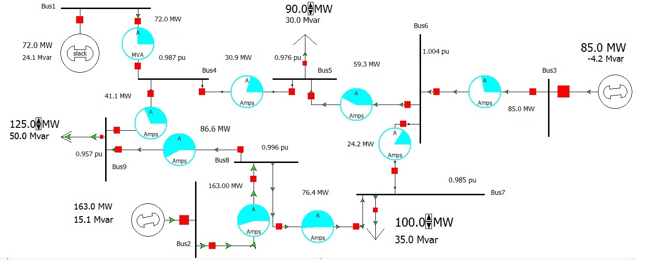
Figure 4.3: Diagram of IEEE 9-Bus system by Newton-Raphson method using Power World Simulator’s program.

To implement the third step (Step ₃), since the IEEE 9-bus system consists of three active loads (90 MW, 100 MW and 125 MW), so these changes in the loads will be (80 MW - 100 MW) for the first load, (90 MW – 110 MW) for the second load and (115 MW – 135 MW) for the third load with increase 2 MW each time. These procedures are implemented by going to the “Run Mode” then right click at the real load and choose “Load Field Information Dialog”. “Bus Field Options” is opened and change the first active load to 80 MW in the “Field Value”. In the “Load Field Information Dialog” go to the “Delta per Mouse Click” and change it to 2 MW. Repeat these procedures for the rest of the loads. Click “Simulation” from the upper left corner and select “Solve and Animate”. Record data and increase each load by click on it, again click “Simulation” from the upper left corner and select “Solve and Animate”. These processes is repeated until the changes in the loads reach the maximum level (100 MW for the first load, 110 MW for the second load and 1
35 MW for the third load) as shown below in tables (4.3, 4.4, 4.5 and 4.6) respectively:
Table 4.5: Real powers in MW (training data for case1)
Load at bus 5 | Load at bus 7 | Load at bus 9 | Line  1 – 4 | Line  2 – 8 | Line  3 – 6 | Line  4 – 5 | Line  5 – 6 | Line 6 – 7 | Line  7 - 8 | Line 8 - 9 | Line 4 - 9
100 | 110 | 135 | 102 | 163 | 85 | 45.5 | 54.9 | 28.9 | 81.9 | 81.1 | 56.5
98 | 108 | 133 | 96 | 163 | 85 | 42.6 | 55.8 | 28 | 80.8 | 82.2 | 53.4
96 | 106 | 131 | 90 | 163 | 85 | 39.6 | 56.6 | 27 | 79.7 | 83.3 | 50.3
94 | 104 | 129 | 84 | 163 | 85 | 36.7 | 57.5 | 26.1 | 78.6 | 84.4 | 47.3
92 | 102 | 127 | 78 | 163 | 85 | 33.8 | 58.4 | 25.2 | 77.5 | 85.5 | 44.2
90 | 100 | 125 | 72 | 163 | 85 | 30.9 | 59.3 | 24.2 | 76.4 | 86.6 | 41.1
88 | 98 | 123 | 66 | 163 | 85 | 28 | 60.2 | 23.3 | 75.3 | 87.7 | 38.1
86 | 96 | 121 | 60.1 | 163 | 85 | 25 | 61.1 | 22.4 | 74.2 | 88.8 | 35
84 | 94 | 119 | 54.1 | 163 | 85 | 22.1 | 62 | 21.5 | 73.1 | 89.9 | 32
82 | 92 | 117 | 48.2 | 163 | 85 | 19.2 | 62.8 | 20.5 | 72 | 91 | 28.9
80 | 90 | 115 | 42.2 | 163 | 85 | 16.3 | 63.7 | 19.6 | 70.9 | 92.1 | 25.9

Table 4.6: Reactive powers in MVAR (training data for case1)
Load at bus 5 | Load at bus 7 | Load at bus 9 | Line  1 – 4 | Line  2 – 8 | Line  3 – 6 | Line  4 – 5 | Line  5 – 6 | Line 6 – 7 | Line  7 - 8 | Line 8 - 9 | Line 4 - 9
100 | 110 | 135 | 25.9 | 16.3 | 7.3 | 11.6 | 18.4 | 23.5 | 11.5 | 15.9 | 34.1
98 | 108 | 133 | 25.4 | 16 | 7.6 | 12 | 18 | 23.5 | 11.5 | 15.5 | 34.5
96 | 106 | 131 | 25 | 15.8 | 7.8 | 12.4 | 17.6 | 23.6 | 11.4 | 15.1 | 34.9
94 | 104 | 129 | 24.6 | 15.5 | 8.1 | 12.8 | 17.2 | 23.6 | 11.4 | 14.8 | 35.2
92 | 102 | 127 | 24.3 | 15.3 | 8.3 | 13.2 | 16.8 | 23.7 | 11.3 | 14.4 | 35.6
90 | 100 | 125 | 24.1 | 15.1 | 8.5 | 13.5 | 16.5 | 23.7 | 11.3 | 14.1 | 35.9
88 | 98 | 123 | 23.9 | 14.9 | 8.7 | 13.9 | 16.1 | 23.7 | 11.3 | 13.8 | 36.2
86 | 96 | 121 | 23.8 | 14.7 | 8.8 | 14.2 | 15.8 | 23.8 | 11.2 | 13.5 | 36.5
84 | 94 | 119 | 23.8 | 14.5 | 9 | 14.5 | 15.5 | 23.8 | 11.2 | 13.1 | 36.9
82 | 92 | 117 | 23.8 | 14.4 | 9.2 | 14.9 | 15.1 | 23.8 | 11.2 | 12.8 | 37.2
80 | 90 | 115 | 23.9 | 14.2 | 9.3 | 15.2 | 14.8 | 23.9 | 11.1 | 12.5 | 37.5
Table 4.7: Thermal lines (training data for case1)
Load at bus 5 | Load at bus 7 | Load at bus 9 | Line ( % )  1 – 4 | Line ( % )  2 – 8 | Line ( % )  3 – 6 | Line ( % )  4 – 5 | Line ( % )  5 – 6 | Line ( % ) 6 – 7 | Line ( % )  7 - 8 | Line ( % ) 8 - 9 | Line ( % ) 4 - 9
100 | 110 | 135 | 35 | 55 | 28 | 31 | 39 | 25 | 55 | 54 | 44
98 | 108 | 133 | 33 | 55 | 28 | 29 | 39 | 24 | 54 | 55 | 42
96 | 106 | 131 | 31 | 55 | 28 | 28 | 40 | 24 | 53 | 56 | 41
94 | 104 | 129 | 29 | 55 | 28 | 26 | 40 | 23 | 53 | 56 | 39
92 | 102 | 127 | 27 | 55 | 28 | 24 | 41 | 23 | 52 | 57 | 38
90 | 100 | 125 | 25 | 55 | 28 | 22 | 41 | 23 | 51 | 58 | 36
88 | 98 | 123 | 23 | 55 | 28 | 21 | 42 | 22 | 50 | 58 | 35
86 | 96 | 121 | 22 | 55 | 28 | 19 | 43 | 22 | 50 | 59 | 34
84 | 94 | 119 | 20 | 55 | 28 | 18 | 43 | 21 | 49 | 60 | 32
82 | 92 | 117 | 18 | 55 | 28 | 16 | 44 | 21 | 48 | 61 | 31
80 | 90 | 115 | 16 | 55 | 29 | 15 | 44 | 21 | 48 | 61 | 30

Table 4.8: Voltage magnitudes at various buses (training data for case1)
Load at Bus 5 | Load at Bus 7 | Load at Bus 9 | V4 _{(P.U.)} | V5 _{(P.U.)} | V6 _{(P.U.)} | V7 _{(P.U.)} | V8 _{(P.U.)} | V9 _{(P.U.)}
100 | 110 | 135 | 0.987 | 0.974 | 1.003 | 0.983 | 0.995 | 0.957
98 | 108 | 133 | 0.987 | 0.974 | 1.003 | 0.983 | 0.995 | 0.957
96 | 106 | 131 | 0.987 | 0.975 | 1.003 | 0.984 | 0.995 | 0.957
94 | 104 | 129 | 0.987 | 0.975 | 1.003 | 0.984 | 0.996 | 0.957
92 | 102 | 127 | 0.987 | 0.975 | 1.004 | 0.984 | 0.996 | 0.957
90 | 100 | 125 | 0.987 | 0.975 | 1.004 | 0.985 | 0.996 | 0.957
88 | 98 | 123 | 0.987 | 0.976 | 1.004 | 0.985 | 0.996 | 0.958
86 | 96 | 121 | 0.987 | 0.976 | 1.004 | 0.985 | 0.996 | 0.958
84 | 94 | 119 | 0.987 | 0.976 | 1.004 | 0.986 | 0.996 | 0.958
82 | 92 | 117 | 0.987 | 0.976 | 1.004 | 0.986 | 0.996 | 0.958
80 | 90 | 115 | 0.987 | 0.976 | 1.004 | 0.986 | 0.996 | 0.958
The voltage magnitudes are not taken at the first bus, second bus and the third bus because the voltage magnitudes of theses buses are already known.
To implement the fourth step (Step ₄), go to “Run Mode” click on the circuit breaker to outage the specified transmission line. Click “Simulation” from the upper left corner and select “Solve and Animate” as shown in figure 4.4. Implement the procedures of the third step (Step ₃) where all these procedures present the second case (case ₂).

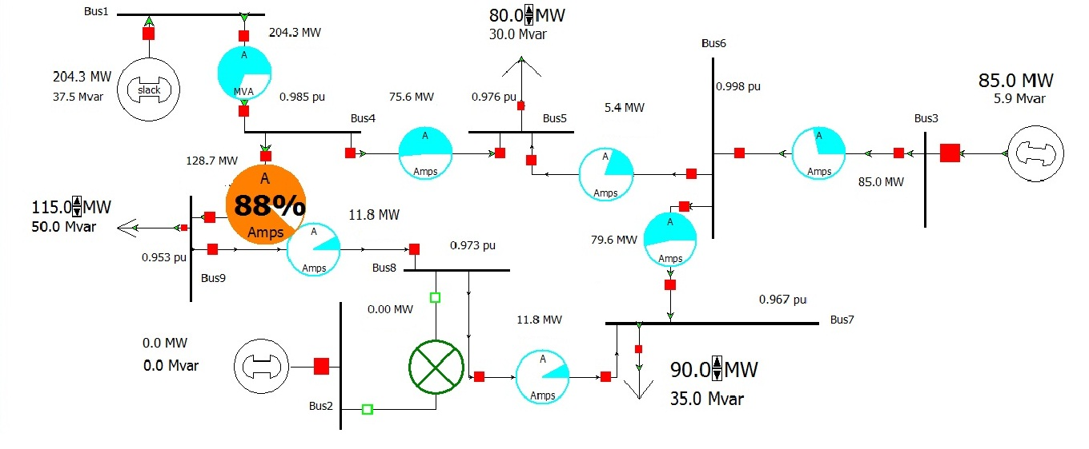
Figure 4.4: Diagram of the outage a single transmission line of IEEE 9-Bus system.

To implement the fifth step (Step ₅), separate the rest of the transmission lines of EEE 9-Bus system where this outage will be one by one to perform nine cases (case for each outage).
For the implementation of the sixth step (Step ₆), since the IEEE 9-bus system consists of three active loads (90 MW, 100 MW and 125 MW), so these changes in the loads will be (81 MW - 97 MW) for the first load, (91 MW – 107 MW) for the second load and (116 MW – 132 MW) for the third load with increase 4 MW each time. These procedures are implemented by going to the “Run Mode” then right click at the real load and choose “Load Field Information Dialog”. “Bus Field Options” will opened and change the first active load to 81 MW in the “Field Value”. In the “Load Field Information Dialog” go to the “Delta per Mouse Click” and change it to 4 MW. Repeat these procedures for the rest of the loads. Click “Simulation” from the upper left corner and select “Solve and Animate”. Record data and increase each load by click on it, again click “Simulation” from the upper left corner and select “Solve and Animate”. These processes are repeated until the changes in the loads reach the maximum level (97 MW for the first load, 107 MW for the second load and 132 MW for the third load). After repeating the fourth step, (N – 1) contingency will be presented as shown below in tables (4.7, 4.8, 4.9 and 4.10).

Table 4.9: Real powers in MW (testing data for case2)
Load at bus 5 | Load at bus 7 | Load at bus 9 | Line  1 – 4 | Line  2 – 8 | Line  3 – 6 | Line  4 – 5 | Line  5 – 6 | Line  6 – 7 | Line  7 – 8 | Line  8 – 9 | Line  4 – 9
97 | 107 | 132 | 257.6 | 0 | 85 | 101.8 | 2.9 | 87.8 | 20.9 | 20.9 | 155.8
93 | 103 | 128 | 245 | 0 | 85 | 95.6 | 1 | 85.9 | 18.7 | 18.7 | 149.4
89 | 99 | 124 | 232.4 | 0 | 85 | 89.4 | 1 | 83.9 | 16.6 | 16.6 | 143
85 | 95 | 120 | 219.9 | 0 | 85 | 83.3 | 2.9 | 82 | 14.5 | 14.5 | 136.6
81 | 91 | 116 | 207.4 | 0 | 85 | 77.2 | 4.9 | 80.1 | 12.3 | 12.3 | 130.3

Table 4.10: Reactive powers in MVAR (testing data for case2)
Load at bus 5 | Load at bus 7 | Load at bus 9 | Line  1 – 4 | Line  2 – 8 | Line  3 – 6 | Line  4 – 5 | Line  5 – 6 | Line  6 – 7 | Line  7 – 8 | Line  8 – 9 | Line  4 – 9
97 | 107 | 132 | 60.2 | 0 | 16.6 | 7.8 | 32.9 | 24.4 | 10.6 | 28.9 | 27.7
93 | 103 | 128 | 54.2 | 0 | 13.8 | 8 | 31.8 | 23.5 | 11.5 | 28.7 | 25.9
89 | 99 | 124 | 48.6 | 0 | 11.2 | 8.2 | 30.8 | 22.7 | 12.3 | 28.4 | 24.2
85 | 95 | 120 | 43.4 | 0 | 8.8 | 8.3 | 29.7 | 22 | 13 | 28.1 | 22.7
81 | 91 | 116 | 38.6 | 0 | 6.5 | 8.3 | 28.8 | 21.3 | 13.7 | 27.8 | 22.1

Table 4.11: Voltage Magnitudes per unit (testing data for case2)

Load at bus 5 | Load at bus 7 | Load at bus 9 | V4 _{(P.U.)} | V5 _{(P.U.)} | V6 _{(P.U.)} | V7 _{(P.U.)} | V8 _{(P.U.)} | V9 _{(P.U.)}
97 | 107 | 123 | 0.977 | 0.964 | 0.992 | 0.954 | 0.959 | 0.939
93 | 103 | 128 | 0.979 | 0.967 | 0.993 | 0.957 | 0.962 | 0.942
89 | 99 | 124 | 0.981 | 0.97 | 0.995 | 0.96 | 0.966 | 0.946
85 | 95 | 120 | 0.983 | 0.973 | 0.996 | 0.963 | 0.969 | 0.949
81 | 91 | 116 | 0.985 | 0.975 | 0.997 | 0.996 | 0.972 | 0.952

Table 4.12: Thermal lines (testing data for case2)

Load at bus 5 | Load at bus 7 | Load at bus 9 | Line  1 – 4  ( % ) | Line  2 – 8  ( % ) | Line  3 – 6  ( % ) | Line  4 – 5  ( % ) | Line  5 – 6  ( % ) | Line  6 – 7  ( % ) | Line  7 – 8  ( % ) | Line  8 – 9  ( % ) | Line  4 – 9  ( % )
97 | 107 | 132 | 88 | 0 | 29 | 68 | 22 | 60 | 16 | 24 | 108
93 | 103 | 128 | 84 | 0 | 29 | 64 | 21 | 58 | 15 | 23 | 103
89 | 99 | 124 | 79 | 0 | 29 | 60 | 21 | 57 | 14 | 22 | 99
85 | 95 | 120 | 75 | 0 | 28 | 56 | 20 | 56 | 13 | 21 | 94
81 | 91 | 116 | 70 | 0 | 28 | 52 | 19 | 54 | 12 | 20 | 89

The voltage magnitudes are not taken at the first bus, second bus and the third bus because the voltage magnitudes of theses buses are already given.
After repeating the fifth step (Step₅), the tested nine cases will be created and will be used to test the Artificial Neural Network (ANN).

    - Selection of the Artificial Neural Network (ANN) structure

The selection of an appropriate artificial neural network structure consists of input layer, hidden layer and output layer. In addition, the values of the momentum factor (α) and the learning rate coefficient (the learning step size (η)) and these important parameters are effecting on the learning capability of the network. A small amount of the learning rate coefficient (η) will make the learning process very slow.The large amount of the (η) will cause missing of the desired minimum, so an appropriate learning rate (η) will be chosen and a suitable momentum factor (α) will be selected to prevent the algorithm from falling in the hole.
The value of the desired Mean Square Error will be chose according to the importance of the subject and its usage in that particular area. From important elements that affect in finding the best mean square error is Epoch (the of training iteration), where the best mean square error is specified either it reaches the desired Mean Square Error or it reaches the maximum number of epoch. The process of the epoch is shown below in figure 4.5.
Start

Set Random Values of Weights

Set Desired Output
Input Data

Feed Forward Propagation

Calculate Errors

If Epoch = Maximum Iteration
End and take the Values
Yes

Propagate Errors Backwards

Update the Weights

Figure 4.5: The back-propagation neural network epoch.
An appropriate transfer function is going to select according to the characteristics of the database. The only significant problem is how to select the numbers of the hidden layers and numbers of neurons in each hidden layer. The number of the hidden layers will be defined according to the characteristics of the database and the degree of their complexity. The numbers of neurons in each hidden layer must be not too many even not very few. Where few numbers of neurons in the hidden layer will cause the algorithm do not training properly and too many numbers of the neurons in the hidden layer will cause the taken time for the training process will increase significantly. Therefore the numbers of the hidden layers and numbers of neurons in each hidden layer will be selected very carefully [8, 12, 32, 50, 75, 76].

    - Training the Artificial Neural Network (ANN) using the database

The generated database by the Newton-Raphson method using Power World Simulator’s program are going to use in the training process. The inputs to the artificial neural network will be the active and reactive powers of the first nine cases, while the outputs to the artificial neural network will be the voltage magnitudes and the thermal limits of the first nine cases.
After appropriate values of the momentum factor (α), the learning rate coefficient size (η), the desired Mean Square Error, number of iteration (epochs), transfer function and a number hidden layers will be selected. In addition, the numbers of neurons in every hidden layer are going to select very carefully. Because of the properties of non-linear problem, the sigmoid transfer function is going to use. These parameters will choose very carefully to achieve the proper and effective training process for the artificial neural network. The database will normalize within a domain from “0” to “1”. The data normalization will help to increase the time of the training process and easy to deal with these databases [4, 79].
The training process will implement by using MATLAB’s program. The procedures of the training process are shown below in figure 4.6.

Start
Reading Input Database, Desired Outputs and Parameters

Enter Random Weights

Start Feed Forward Back-Propagation algorithm and find the Actual Outputs
Calculate MSE

If MSE > Desired MSE
Yes

No
Save the Last Parameters
Display the Outputs and MSE and Errors

Stop the Training Process

Figure 4.6: Flow Chart of the Training Process.

    - Testing the Artificial Neural Network (ANN) using the database

After the training process is completed, the aartificial neural network is going to test with different loading conditions and N-1cotingency analysis (different nine cases).
The inputs to the artificial neural network will be the active and reactive powers of the second nine cases. By using the testing process, the artificial neural network is going to predict the voltage magnitudes and thermal lines. And the results are compared with the results of Newton-Raphson power flow in terms of accuracy. In addition, the testing process is use to determine the power system operating statuses (normal state, alert state, emergency state and extreme emergency state). These operating statuses are identified according to the limits of the bus voltage values and thermal line values as shown below in table 4.6.

Table 4.13: Power system's operating statuses
Operating Statuses | Voltage Magnitude (p.u.) Limit | Desired Output for Voltage Magnitude Limit | Thermal Line (TH) Limit (%) | Desired Output for Thermal Line Limit
Normal State | 0.91 < |V| < 1.0 | “NS” | < 80% | 0
Alarm State | - ≤ |V| < 1.1  or  0.85 < |V|≤ 0.91 | “AS” | 80% - 99% | 1
Emergency State | 1.1 ≤ |V| < 1.15  or  0.8 ≤ |V| ≤ 0.85 | “ES” | 100% - 109% | 2
Extreme Emergency State | 1.15 ≤ |V| < 1.2  or  0.8 > |V| | “EES” | > 110 % | 3

By using this table (4.6), the outputs of the artificial neural network (the voltage magnitudes and thermal lines) are going to classify under four operating statuses (normal state, alert state, emergency state and extreme emergency state) to help the system operator to operate any power system at properly and safely and to avoid the dangerous situations that lead to the collapse or the total blackout for that system. In addition, the outputs of the artificial neural network can be used to reveal the most susceptible areas for emergency situations and to forecast the vulnerable areas in the power system.
The testing process will implement by using MATLAB’s program. The procedures of the testing process are shown below in figure 4.7.
Start

Reading Input Database

Feed Forward Pass

Determine Outputs
Display Output Values and Find Errors

Terminate Testing Process

Figure 4.7: Flow chart of the testing process.

With the end of the testing process, the desired outputs and operating statuses will be calculated. In addition, the performance of the artificial neural network is calculated.

