IMPROVED SURGICAL SUCTION MACHINE

GRADUATION PROJECT SUBMITTED TO
THE BIOMEDICAL DEPARTMENT
OF
NEAR EAST UNIVERSITY

BY
ALI NASSER JABER
MONIR FAWZI WAHIDI

IN PARTIAL FULFILLMENT OF THE REQUIREMENTS
FOR THE BACHELOR DEGREE OF SCIENCE IN BIOMEDICAL ENGINEERING

NICOSIA 2015/2016

IMPROVED SURGICAL SUCTION MACHINE

GRADUATION PROJECT SUBMITTED TO
THE BIOMEDICAL DEPARTMENT
OF
NEAR EAST UNIVERSITY

BY
ALI NASSER JABER
MONIR FAWZI WAHIDI

IN PARTIAL FULFILLMENT OF THE REQUIREMENTS
FOR THE BACHELOR DEGREE OF SCIENCE IN BIOMEDICAL ENGINEERING

NICOSIA 2016

We hereby declare that all information in this document has been obtained and presented in accordance with academic rules and ethical conduct. We also declare that, as required by these rules and conduct, we have fully cited and referenced all material and results that are not original to this work.

Name, Last name:
ALI JABER
MONIR WAHIDI

Date 12/ 01/ 2016

ACKNOWLEDGEMENTS:

We want to thank our department’s dean Assoc.Prof.Dr. Terin Adali whom with her advices and knowledge gave us the opportunity to become a biomedical engineers
And we would like to thank our advisor Mr. Faith Nurcin for spending too much time helping and teaching us.
And tons of thanks and gratitude to the near east university and the whole academic staff who made this possible.
DEDICATION:

First of all we would like to dedicate this project to our beloved, to the holy land, the land of martyrs, PALESTINE.
To the rightful revolution, to the struggle and to the dignity of our people.
And for sure to our parents who raised us to become what we are now, whom without their help and support we wouldn’t be able to reach this level, thank you.

Ali Jaber –Monir Wahidi

ABSTRACT:

Our project aims to improve the normal surgical suction machine by solving the common problems it faces during operation such as clotting and bodily tissues which are stuck in the machines part, and since during an operation a second of time could be the difference between life and death so we chose this project with a will to help save lives.

Our main idea was to install a valve-less ‘peristaltic’ pump where the blood and fluids will not face any obstacles during its movement and a heparin pump which will make it impossible for the blood to clot anywhere inside the device.

Our goal is to provide an affordable well-functioning medical suction device and we hope this device reach to the whole world specially to the ones whom doesn’t get good health services because in our point of view our project will give the doctor a trust worthy medical device .

KEYWORDS: Surgical, Suction, Operation, Heparin, Pump, Peristaltic, Clotting

Table of contents

CHAPTER 1 : INTRODUCTION
  - INTRODUCTION………………………………………………………………….…10
  - INTERVIEW ………………………………………………………………………....10
  - MARKET RESEARCH ……………………………………………………………...11
  - LITERATURE REVIEW……………………………………………………………..11
  - CURRENT DEVICES ……………………….……………………………………….11

CHAPTER 2 : MATERIALS AND METHOD
2.1 difference between peristaltic and piston pump ……………………………………...13
2.2 Materials used...……………………………………………………………………....15
2.2.1 pumps used ……………………………………………………………………..15

CHAPTER 3 : RESULTS AND DISCUSSION
Results and discussion……………………………………………………………….……17

CHAPTER 4 : CONCUSIONS AND FUTURE ADVANCES
Conclusion and future advances ……………………………………………………….…18

REFERENCES ……………………………………………………………………….…19

LIST OF FIGURES

Figure 1 :Piston Pump 13
Figure 2 :Peristaltic Pump 14
Figure 3 :Actual pumps 15
Figure 4 :dimensional illustration ………………………...……………......……….…...16

CHAPTER 1: Introduction
1.1 Introduction:

During a surgery the surgeon cuts through tissues to reach the required place to operate and a lot of fluids are there inside the body such as blood or lymph, so the suction machine is used to remove those fluids from the operation area thus providing a clear view for the surgeon, the regular suction units use a piston pump to provide the suction power which we saw as a problem and from the knowledge we acquired from our studies decided to use the valve-less pump instead of the regular piston pump this type of pumps provide a stable and continuous flow of the liquids and has no valves in the liquid’s path thus no stopping problems . (Hammoudeh, 2013) .

1.2 Interview

In the summer practice, while we were in the hospital we talk with one surgeon, DR.Adham Hammoudeh and he explain to us the importance of the device and that’s it’s a device which no any open surgery can be done without it, and actually from him we took the idea of our project.
While he was talking he explained to us the advantages of this device, which is taking the blood and the liquids from the part that we want to make a surgery in , that make the surgery easier.
Then as he said that the tanks of the machine is big enough to big amounts of blood.
And also that its parts are easily available everywhere
and the last thing is that it have a simple working principle and also it can work on AC or DC current.
At the same time Dr hammoudeh explained to us the disadvantage of the device as well, which is the clotting of the blood, and tissues from the body inside the device parts
We remembered the pump we studied in the hemodialysis machine, which has no valves and provide continuous flow and constant pressure
So our idea was to put this kind of pump to the suction device along with a heparin pump to insure no clotting inside the device. (Hammoudeh, 2013).

1.3 Market Research:

Many companies produce the surgical suction device with various price range depending on the place of production and the capacity of the bottles
For example :
1- The Rocker Company:
- Place of origin: Taiwan
- Capacity: 1200 ml
- Price: 550 us dollar
2- Poweam:
- Place of origin: china
- Capacity: 2 x 2L
- Price: 500 us dollar
3- 9E- B:
- Place of origin: china
- Capacity: 1L
- Price: 100 us dollar
4- Vacuum Suction Machine:
- Place of origin: china
- Capacity: 500ml *2
- Price: 100-200 us dollar

1.4 Literature Review :

In medicine, devices are sometimes necessary to create suction. Suction may be used to clear the airway of blood, saliva, vomit, or other secretions so that a patient may breathe. Suctioning can prevent pulmonary aspiration, which can lead to lung infections. In pulmonary hygiene, suction is used to remove fluids from the airways.
surgery suction can be used to remove blood from the area being operated on to allow surgeons to view and work on the area. Suction may also be used to remove blood that has built up within the skull after an intracranial hemorrhage.
A suction unit is a device for removing liquids or gases by suction it from the patient. Professionals use it to remove mucus, serum or blood from a body cavity. Suction machine is used also for Home Care. Suctioning could remove fluids or mucus from airways. The potential of this machine could be in need also when you have a moist cough, and you’re unable to effectively clear secretions from the throat, or are having difficulty breathing.
  - Current Devices :
There are many medical aspirators on the market today with a wide variety of functions. In the $500-600 price range, Gomco provides a line of portable aspirators (Models G180, 405 & 300) that use diaphragm compressors to create vacuum ranges from 0-600 mmHg and flow rates of 30 liters per minute (lpm). Dimensioned at 12x9x12 in., these devices weigh around 14.5 lbs. Specialized stationary aspirators are available for uterine, thoracic drainage, endocervical and dental operations. Most are powered via 120V AC current and range in weight from 50-70 lbs. Thoracic and thermotic drainage pumps operate under low pressure and low flow conditions (0-50 cm H20, 2-3 lpm) to regulate drainage levels in post-operative care. Endocervical aspiration alternatively requires high pressure ranges (600 mmHg) and high flow rates (20-30 lpm) for brief intermittent use. (Allied Healthcare Products, Inc 2005) All of these designs, however, are inaccessible to a developing world hospital for several reasons. The most obvious limitation of these devices is their price; even the cheapest models exceed EWH’s projected 100 dollar budget. In addition, the specialization of current devices provides another budgeting concern. Most aspirators on the market are designed for a very specific function. A hospital that can only afford a single aspirator would need the broadest range of applications possible. Finally, these devices cannot be repaired with locally available parts and expertise. Advanced circuitry and specially manufactured parts render these devices irreparable in developing world hospitals. (gemco allied ,2006).

CHAPTER 2 :
MATERIAL AND METHOD

2.1 Difference Between Piston Pump And A Valve-Less Pump
The piston pump has valves, which are used to allow the flow from only one side of the pump and close the other while the piston is the piece, which its movement provides the force. see Figure 1 .
While the valve-less pump or peristaltic pump is a type of positive displacement pump used for pumping a variety of fluids. The fluid is contained within a flexible tube fitted inside a circular pump casing (though linear peristaltic pumps have been made). A rotor with a number of "rollers", "shoes", "wipers", or "lobes" attached to the external circumference of the rotor compresses the flexible tube. As the rotor turns, the part of the tube under compression is pinched closed (or "occludes") thus forcing the fluid to be pumped to move through the tube. Figure 2

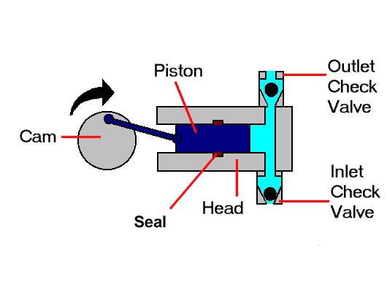
Figure 1 : Piston Pump (Piston Pump, n.d.)

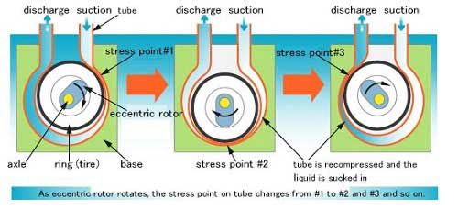
Figure 2 : Peristaltic Pump (Pristaltic pump, n.d).

2.2 Materials used:

we will craft the body of the machine while taking under consideration the size and power of the motor then we will connect the tubing and the parts which will press the tubes creating the pressure then we will add the motor and connect it to the circuit finally we connect the pump to the tanks .

our project has simple components we must have :
- Silicone tubes
- Connecting wires
- Pristaltic pump
- Body of the pump
- Liquid tanks

2.2.1 The pumps which we used:

we used two peristtaltic pumps with different number of rounds per second
1. 15000RPM peristaltic pump which provides the user with the power he needs it works on
12V DC which means it doesnt require alot of power to operate .

2. 5000 RPM peristaltic pump which will provide the pump with hiparin to ensure no clotting happens inside the pump .
see Figure 3
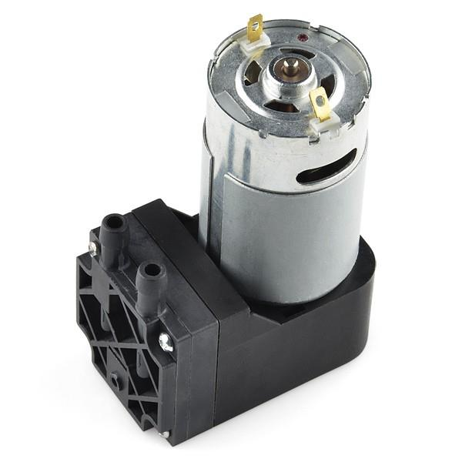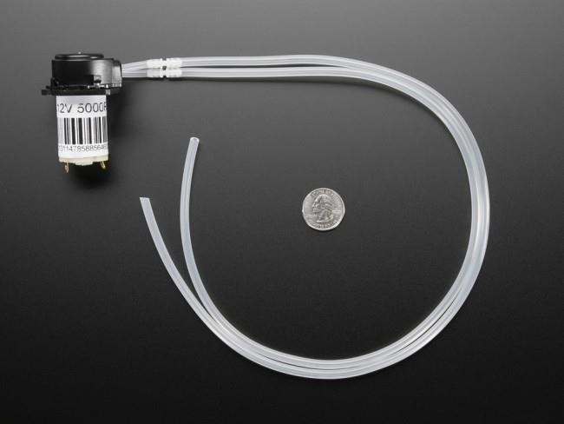

Figure 3: The actual pumps used in our project (robotistan.com, n.d.).

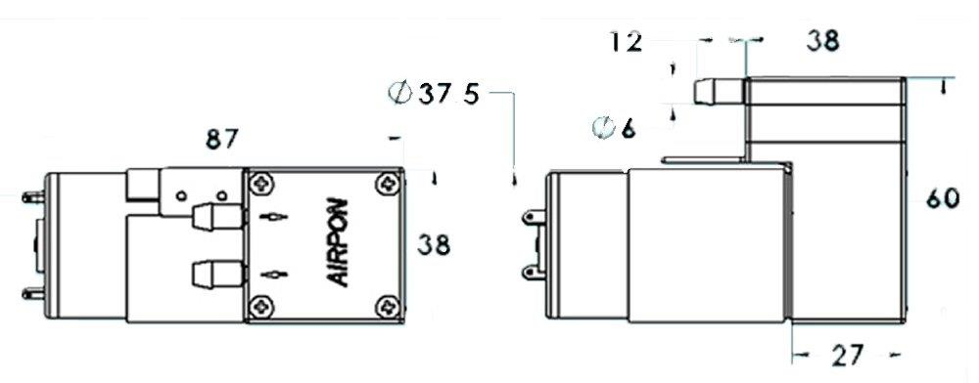
Figure 4: Dimensional illustration of the 15000 RPM pump (robotistan.com n.d).

Chapter 3 :
Results And Discussion

The machine is a small and compact machine it doesn’t take a lot of space in the surgery room, the main problem is the voice it makes during operation and the limited speed because of the tube capacity.
This project has a simple design its either squared or circular but the pump it self must be circular.
We were thinking of adding a sound absorbing foam around the motor but it will affect the motor’s movement so we will not use it.
The idea of using this was taken from the hemodialysis machine, which we studied and did presentation on in previous years.
This was the main idea of our project, to solve a problem, to do what engineers do, this simple solution for a problem that doctors face.

CHAPTER 4 :
Conclusions And Future Advances

The purpose of our project was to do solve a problem surgeons face during surgery which is the stopping of the suction device because of the clotting inside of the device we found a solution for this problem by changing the pumping system from a piston pump to a valve-less peristaltic pump and connecting a heparin pump to the tip of the suction tube so by those steps we insured no stopping because of the clotting.
We will try different types of silicone tubes to check the ones, which will provide the best suction.
Also we will try different motors and choose the one that will provide the greatest force,
the radius of the circular shape of the tube makes a difference so we have to choose the best one also.

References :

1- Allen GS, Coates NE (November 1996). "Pulmonary contusion: A collective review". The American Surgeon 62 (11): 895–900.
2- Valadka AB (2004). "Injury to the cranium". In Moore EJ, Feliciano DV, Mattox KL. Trauma. New York: McGraw-Hill, Medical Pub. Division. pp. 385–406
3- M.S.Dr.Adham Hammoudeh,”Al Shifa’a hospital surgerydepartment “interviewed 7-8-2013.
4- Dr. Michael E. DeBakey.(2005) "Methodist DeBakey Heart & Vascular Center". Retrieved 2010-06-27.
- Watson Marlow Pumps Group (December 2003) ,’ How They Work’ . Suction machine , accessed 06-15-2010.
- Gomco by, 2006, Allied Gomco Suction Equipment & Accessories Guide. Retrieved 5/9/2009 , From http://www.alliedhpi.com/images/z21-00-0000.pdf
- Hill, D. (2005). Duke engineering program improves hospital conditions in developing countries. Retrieved 4/12, 2007, from http://www.dukenews.duke.edu/2005/09/DEWH.html

