AERIAL RADIATION DETECTOR

A PROJECT SUBMITTED TO THE GRADUATE SCHOOL OF APPLIED SCIENCES OF NEAR EAST UNIVERSITY

By SOFEME SUNDAY HALVO AND CLINTON FREDDY BONGO

In Partial Fulfillment of the Requirements for the Degree of Bachelor of Science in BIOMEDICAL ENGINEERING

NICOSIA, 2016

AERIAL RADIATION DETECTOR

A PROJECT SUBMITTED TO THE GRADUATE SCHOOL OF APPLIED SCIENCES OF NEAR EAST UNIVERSITY

By SOFEME SUNDAY HALVO AND CLINTON FREDDY BONGO

In Partial Fulfillment of the Requirements for the Degree of Bachelor of Science in BIOMEDICAL ENGINEERING

NICOSIA, 2016

I hereby declare that all information in this document has been obtained and presented in accordance with academic rules and ethical conduct. I also declare that, as required by these rules and conduct, I have fully cited and referenced all material and results that are not original to this work.
Name, Last name: SOFEME SUNDAY HALVO
Signature:
Date: 26/05/2016
Name, Last name: CLINTON FREDDY BONGO
Signature:
Date: 26/05/2016

TABLE OF CONTENTS
ABSTRACT 1
CHAPTER 1: INTRODUCTION 2-3
1.2 Market survey 4-5
1.3 Concept of radiation 6
1.4 Types of nuclear radiation ………………………………………………….……..….7
1.5 Radioactive contamination and radiation detection ………………………………......8
CHAPTER 2: AERIAL RADIATION DETECTION..............................................................9
2.2 Working principle of ionization chamber …………………..................................10-11
2.3 Radiation measurements ……………………………………………………..……...12
CHAPTER 3: DESIGN COMPONENTS …………………………………………...…....13-18
CHAPTER 4: FUTURE PROSPECTS………………………………………………………19
CHAPTER 5: CONCLUSION……………………..…….……………………………………20
REFERENCES………………………………………………………………………………….21

ABBREVIATIONS:
AMU: Atomic mass unit
NaI: Sodium iodide
ARD: Aerial Radiation Detector
He: Helium
NS: Nano Seconds
Cu: Currie
SI: System of Units
RAD: Rate of dose
Gy: Gray
Sv: Sieverts
R: Roentgen
IDE: Integrated Development Environment

ABSTRACT

The aim of our project is to design an airborne unmanned radiation detector that will be able to detect the presence of radiation and analyze the radiation source, assessing the threat level from a safe controlled center. We aim to achieve that through the use of electrical components and software that will be fully discussed and explained in subsequent chapters. Our model of the Radiation detector aims at measuring both low levels of air and ground contamination or exposure.
In our world today, we face threats of nuclear disasters not just in event of world conflicts like the Hiroshima and Nagasaki Atomic bombings of August 1945, but also from equipment malfunctions of our nuclear plants by natural disasters such as the Fukushima Daiichi Nuclear disaster of March 2011 or man made mistakes. Both way, the threats are credible and from what we have learned from history, it brings along great number of deaths and long term biological effects on life. That is why even though we are hopeful that these events do not occur in the future, we have to prepare for these disasters or situations as difficult as it is for us to be able to control and prepared for such eventualities.
The first step in event of nuclear disaster or exposure is the detection of the radiation. This has to be done as dangerous as it is. Take Fukushima for example, volunteers young and elderly volunteered to take part in the cleanup efforts during the aftermath of the disaster. Placing them in this kind of situation is in fact without any doubt a danger to their health. As Biomedical Engineers we asked ourselves how we can best perform this important work of radiation detection without putting human lives at risk. We made researches, handed out questionnaires and made interviews to help us with our project question. The results obtained from the questionnaires.
Keywords: Ionizing radiation, Alpha particles, Beta rays, Gamma rays, Radioactive contamination, Radiation, Ionization Chamber;

CHAPTER 1

INTRODUCTION
After obtaining results from our distributed and filed questionnaires and interview, we set out to designing the prototype of our devices, the Aerial Radiation Detection Device (ARD). But for us to progress we was important that we know the researches and experiments carried out in this field and how best to improve it.
Literature Survey
On PubMed, one of the best available researcher databases, we were able to find a journal on the Aerial measurements of artificial radionuclides in Germany in case of a nuclear accident. An extract from the report is as follow; ‘’Gamma-ray spectrometric systems carried by helicopters prove to be indispensable for the surveillance of environmental radioactivity. The aerial measurements are an important tool for rapid and large-scale nuclide specific determination of soil contamination after an accidental release of radionuclides from a nuclear facility. Furthermore this technique is also applied for the determination of anomalies of elevated radioactivity of natural radionuclides, the detection of lost radioactive sources and geological mapping. For the measurements the helicopters are equipped with a NaI (Tl)-detector array and a high purity germanium-semiconductor (HPGe) detector. Especially with the HPGe-detector it is possible to clearly identify individual radionuclides. To improve and to guarantee the quality of this method several exercises with different fields of interest have been carried out during the last years. Thereby the main focus is on the improvement of the instrumentation, data handling and data analysis. The results of the airborne radionuclide measurements from the Black Forest which was performed in co-operation with the Swiss National Emergency Operation Centre are presented here. During this exercise the gamma dose rate, soil contamination due to 137Cs and the specific activities of natural radionuclides in soil were determined’’.
We also obtained another report for the Aerial radiation monitoring around the Fukushima Dai-ichi Nuclear Power plant using an unmanned helicopter. An extract from the report is as follows; ‘’ The Great East Japan Earthquake on March 11, 2011 generated a series of large tsunami that seriously damaged the Fukushima Dai-ichi Nuclear Power Plant (FDNPP), which resulted in the release of radioactive materials into the environment. To provide further details regarding the distribution of air dose rate and the distribution of radioactive cesium ((134)Cs and (137)Cs) deposition on the ground within a radius of approximately 5 km from the nuclear power plant, we carried out measurements using an unmanned helicopter equipped with a radiation detection system. The distribution of the air dose rate at a height of 1 m above the ground and the radioactive cesium deposition on the ground was calculated. Accordingly, the footprint of radioactive plumes that extended from the FDNPP was illustrated’’. These researches highlighted the importance of an unmanned aerial radiation detection device and the possibility of using different methods of measurements to achieve this purpose.

1.2 MARKET SURVEY

To get the prices and availability of our device on the market, we searched through the biggest online sales companies such as eBay and Alibaba but we discovered that most of the available devices in the market are hand held radiation detection devices ranging from 20 Dollars to as high as 2000Dollars. But that got as to ask why, was it because there was no demand?
After further research we discovered that there is in fact very high demand for unmanned aerial radiation devices more than we imagined in the military application and Nuclear Power plants. These institutions demand complex designed and expensive Unmanned Aerial Radiation Detection Devices and we immediately realized that how huge it can be if the general public or these institutions could get a supply of cheaper and effective Aerial unmanned radiation detection devices giving our project a good prospect and market opportunities.
Military demand for radiation detector devices will grow from $617 million currently to $731 million by 2018, and then to $868 million by 2022, predict analysts at market researcher Nano Markets in Glen Allen, Va.
Demand for radiation-detection devices in domestic security applications, meanwhile, will grow from $1.35 billion currently to $1.92 billion by 2022, analysts say in the report "Radiation Detection in Domestic Security and Military Markets, 2015-2022.
The military and security sectors are two of the fastest-expanding areas for radiation detection and attracting heavy investments, analysts say. The bulk of radiation detection demand is centered in health care and medical applications, but those markets also represent the sector's slowest growth rates.
One factor driving growth in the military and domestic security radiation-detect markets is the supposed increase in terrorist activity, and a need for radiation monitoring and control to help in confiscating illicit radioactive materials, maintaining tabs on emitted rays from known sources, and measuring radiation in the aftermath of terrorist activities, analysts say.
Some of the Area Radiation Devices present in the market include;

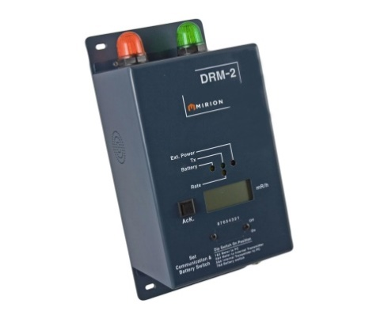
Figure 2: DRM radiation monitoring system

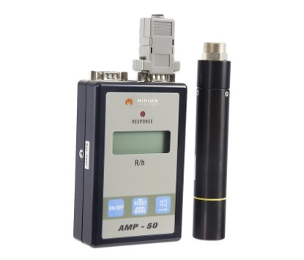

Figure 3: AMP radiation monitoring system

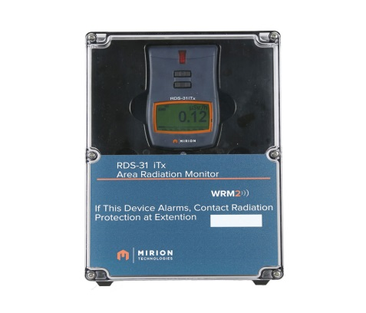

Figure 4: RPD-AM radiological posting display area monitor
1.3 THE CONCEPT OF RADIATION
Before we go into radiation detection we will first have to understand the concept of Radiation and the types of Radiation.
Radiation is energy that comes from a source and travels through some material or through space. Light, heat and sound are types of non-ionizing radiation. But the kind of radiation discussed in this project report is called ionizing radiation because it can produce charged particles (ions) in matter.
Ionizing radiation is produced by unstable atoms. Unstable atoms differ from stable atoms because they have an excess of energy or mass or both. Unstable atoms are said to be radioactive. In order to reach stability, these atoms give off, or emit, the excess energy or mass. These emissions are called radiation. The kinds of radiation are electromagnetic (like light) and particulate (i.e., mass given off with the energy of motion). Gamma radiation and X-rays are examples of electromagnetic radiation. Beta and alpha radiation are examples of particulate radiation. Ionizing radiation can also be produced by devices such as X-ray machines.
Radiation comes from many sources including cosmic rays from the universe, the earth, as well as man-made sources such as those from nuclear fuel and medical procedures. Radiation has been used in many industries including diagnostic imaging, cancer treatment (such as radiation therapy), nuclear reactors with neutron fission, radioactive dating of objects (carbon dating), as well as material analysis.
In a nuclear reactor, the radiation is formed due to the decay of radioactive isotopes, which are produced as part of nuclear reactions inside the reactor (Weisstein, n. d).

1.4 TYPES OF NUCLEAR RADIATION
There are three types of nuclear radiation which may be detected with a Geiger counter:
- Alpha Particles: Alpha Particles can be considered as a Helium nucleus. Helium has 2 protons and 2 neutrons in its nucleus. If both of its electrons were removed, the result would be an alpha particle. It is generally emitted from heavy elements such as uranium and thorium. Alpha particles only travel a few inches in the air, and can be stopped by a piece of paper. However, if ingested or inhaled, alpha particles can be hazardous. Special Geiger tubes with a mica window are necessary to detect them, as other windows will stop alpha particles.
- Beta Rays: Beta particles are high-speed electrons emitted from the nuclei of decaying radioisotopes. Since these are electrons, they have a negative charge and a small mass, approximated as 0 amu. They are more penetrating than alpha particles. They can pass through light elements, such as paper and aluminum (but only small thicknesses). Heavy clothing, thick cardboard or one-inch thick wood will provide protection from beta radiation.
- Gamma Rays: Electromagnetic waves, similar to light, but at a much higher energy. It has no charge, a very short wavelength and high energy. Gamma radiation is the most penetrating form of radiation considered in this section. Much more penetrating than alpha or beta radiations. High energy gamma rays can pass through several inches of metal. Note that X-Rays and Gamma Rays are really the same thing, the term X-Ray is used when the radiation is produced by electrons striking a material, such as in an X-Ray tube. To be protected from a gamma emitter, thick sheets of lead or concrete are required.
NAME | CHARGE | SYMBOL | SHIELD | DISTANCE TRAVELED
Alpha | positive | or  | paper or clothing | 2-4 cm
Beta | negative | or  | heavy clothing | 2-3 m
gamma | neutral |  | lead or concrete | 500 m
Figure 5: Table showing properties of the three types of radiation

1.5 RADIOACTIVE CONTAMINATION AND RADIATION DETECTION

Radioactive contamination, also called radiological contamination, is the deposition of, or presence of radioactive substances on surfaces or within solids, liquids or gases (including the human body), where their presence is unintended or undesirable.
Ionizing Radiation can be detected from the Ionizing events they produce. There are three major classes of Radiation Detectors base on this classification.
Ionization Counters (Ionization Chambers and Geiger Counters):
This type of Radiation detection can be accomplished by stretching a wire inside a gas-filled cylinder and raising the wire to a high positive voltage. The total charge produced by the passage of an ionizing particle through the active volume can be collected and measured. Different names are used for the devices based on the amount of voltage applied to the center electrode and the consequent nature of the ionizing events. If the voltage is high enough for the primary electron-ion pair to reach the electrodes but not high enough for secondary ionization, the device is called and ionization chamber. The collected charge is proportional to the number of ionizing events, and such devices are typically used as radiation dosimeters. At a higher voltage, the number of ionizations associated with particle detection rises steeply because of secondary ionizations, and the device is often called a proportional counter. A single event can cause a voltage pulse proportional to the energy loss of the primary particle. At a still higher voltage, an avalanche pulse is produced by a single event in the devices called Geiger counters.
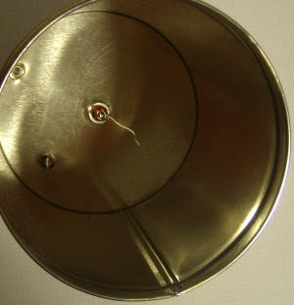
Figure 6: Ionization Chamber

2.1 AERIAL RADIATION DETECTION
The aerial radiation detection provides a safer platform for radiation detection instrumentation. This is made possible by the ability to miniaturize the radiation detection sensor system components and mount them on a drone.
The main advantage of using drone in radiation surveillance and detection is that dangerous missions can be carried out safely at remote locations. The operator can stay in the uncontaminated area while the radiation mounted detector is on mission. Other advantages are the relative cost of the drone platform compared to a full size manned aircraft and low operation, service and cost. A small-size drone can easily be transported in a car and takeoff and landings are possible at user selected areas at any given time or location.
Applications
The low weight, size and cost of the instrument combined with its capability for performing high spatial resolution aerial surveys and detection makes it highly applicable and versatile for deployment across the nuclear industry. It can be used in events like:
- Rapid response disaster monitoring of nuclear events, providing real-time data on spread, source and intensity. This could range from site incidents to terrorist events
- Routine monitoring of nuclear sites (internally and externally), mining operations and facilities
- Environmental monitoring for site decommissioning.
- Environmental monitoring of war zones for spent depleted uranium munitions
Since the operator may remain in uncontaminated areas the risk of exposure to ionizing radiation is minimal. This also means that a drone should be able to stay in the contaminated area longer than a manned vehicle, and thus more detailed analyses of the exposed area can be performed (Knoll, 1999).

2.2 WORKING PRINCIPLE
This instrument works on the principle that as radiation passes through air or a specific gas, ionization of the molecules in the air occurs. When a high voltage is placed between two areas of the gas filled space, the positive ions will be attracted to the negative side of the detector (the cathode) and the free electrons will travel to the positive side (the anode). These charges are collected by the anode and cathode which then form a very small current in the wires going to the detector. By placing a very sensitive current measuring device between the wires from the cathode and anode, the small current is measured and displayed as a signal. The more radiation which enters the chamber, the more current is displayed by the instrument. Many types of gas-filled detectors exist, but the two most common are the ion chamber used for measuring large amounts of radiation and the Geiger-Muller or GM detector used to measure very small amounts of radiation.
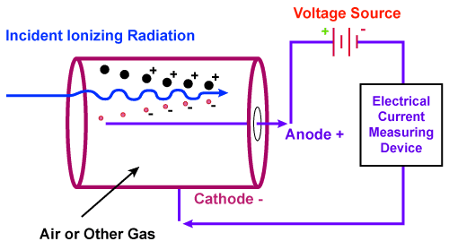
Figure 7: Ionization Chamber working principle
An airborne system designed for the detection of radioactive sources on the soil surface from a drone normally senses gamma rays emitted by the source. Gamma rays have the longest path length (least attenuation) through the air of any of the common radioactive emissions and will thus permit source detection at large distances. A secondary benefit from gamma ray detection is that nearly all radioactive isotopes can be identified by the spectrum of gammas emitted. Major gaseous emissions from fuel reprocessing plants emit gammas that may be detected and identified. Some types of special nuclear material (SNM) also emit neutrons which are also useful for detection at a distance.
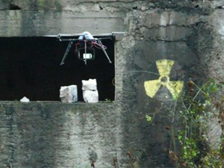
Figure 8: Aerial Radiation Detector device
A gamma ray detection system must be sensitive enough to allow rapid source location from a reasonable altitude with the expectation that sources of small activity will be found. Once a source is found, the system should be able to identify the source isotope by its characteristic gamma emission spectrum. The twin goals of high sensitivity (necessary to find sources) and very good energy resolution (for source identification) are difficult to achieve simultaneously with current detector technology. The aim of our project is to be able to achieve that at the minimum cost.

2.2 RADIATION MEASUREMENTS

The original unit for measuring the amount of radioactivity was the curie (Ci)–first defined to correspond to one gram of radium-226 and more recently defined as:
1 curie = 3.7x1010 radioactive decays per second [exactly].
In the International System of Units (SI) the curie has been replaced by the Becquerel (Bq), where
1 Becquerel = 1 radioactive decay per second = 2.703x10-11 Ci.
Absorbed dose
The absorbed dose, sometimes also known as the physical dose, defined by the amount of energy deposited in a unit mass in human tissue or other media. The original unit is the rad [100erg/g].
It is now being widely replaced by the SI unit, the gray (Gy) [1 J/kg], where 1 gray = 100 rad.
Dose Equivalent
The unit for the dose equivalent is the rem if the absorbed dose is in rads and the Sievert (Sv) if the absorbed dose is in grays. Thus, 1 Sv = 100 rem.
The measured range for aerial radiation monitoring system is from environmental radiation level to 104 Gy/h.
 | Radioactivity | Absorbed dose | Dose Equivalent | Exposure
Common Units | curie (Ci) | rad | rem | roentgen (R)
SI Units | Becquerel (Bq) | gray (Gy) | Sievert (Sv) | coulomb/kilogram (C/kg)
Figure 9: radiation measurement units

3.1 DESIGN COMPONENTS

Components that are used in this project are listed below, all the components were attached to drone that is shown below in Figure 10.
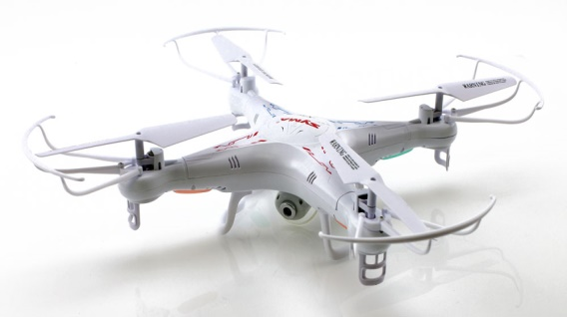
Figure 10: LS 127 quadcopter

LS 127 Quadcopter Specifications:
Remote Control: 2.4GHz Wireless Remote Control, Built-in LCD Display
Channel: 4-Channels
Control Distance: About 250m
Transmitter Power: 6 x 1.5V AA battery (not included)
Model Power: Built-in rechargeable battery
Charging Time: Approx. 120mins
Weight: 1.7kg

3.1 DESIGN COMPONENTS
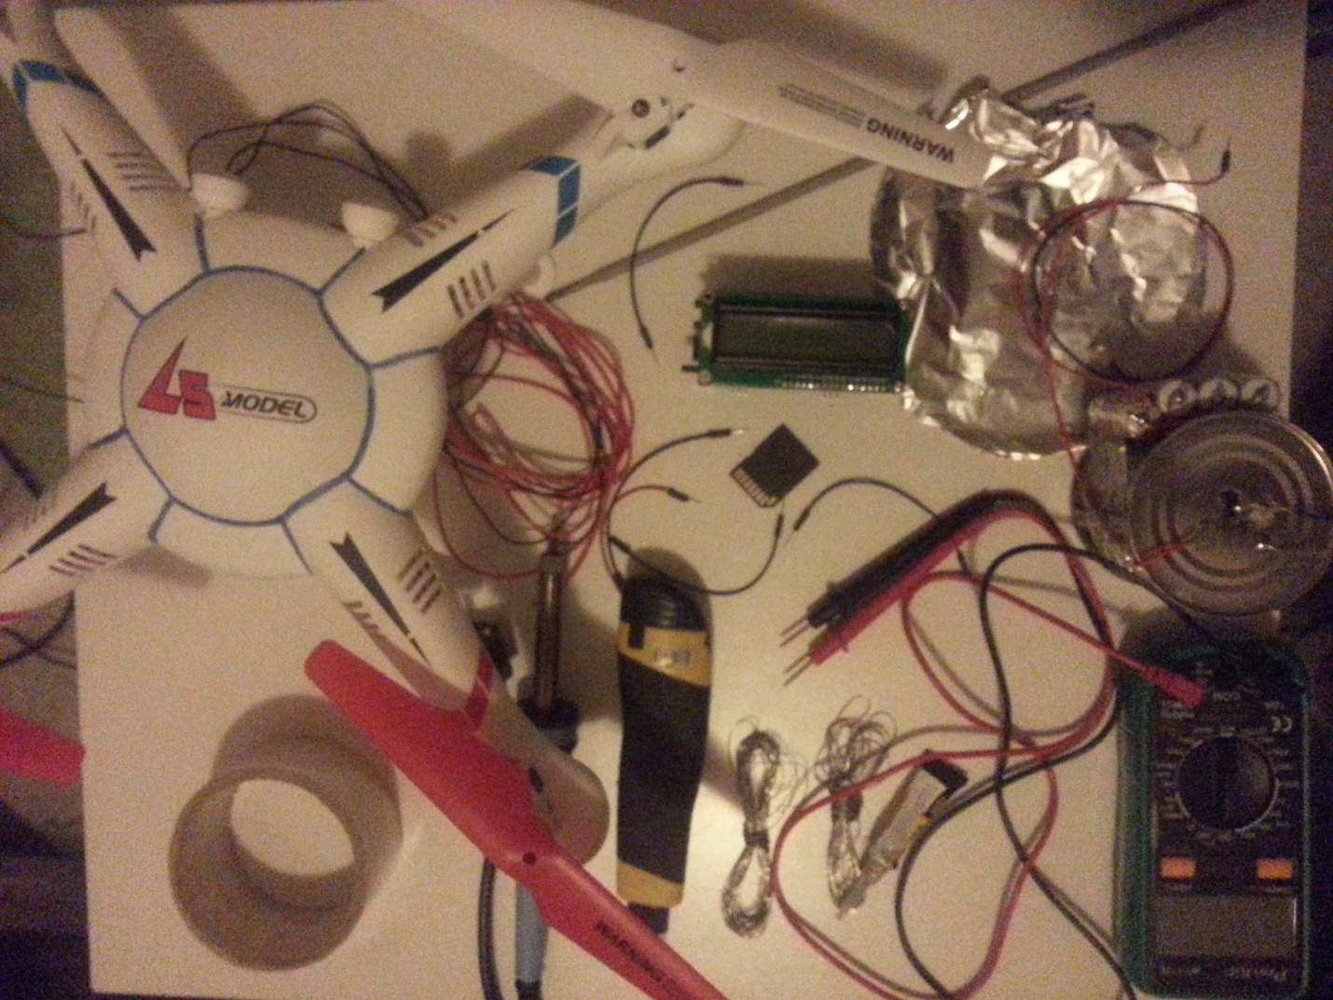
Figure 11: design components
Ionization Chamber:
- Empty Can (that is not coated on the inside making it conductive)
- 4.7kohm Resistor
- Connecting wires
- NPN Darlington Transistor BC517
- 9V Battery
- Super Glue
- Wire Cutter
- Soldering iron and solder
- Tape
- Aluminum foil to close the other end of the can to prevent stray radiation measurements.
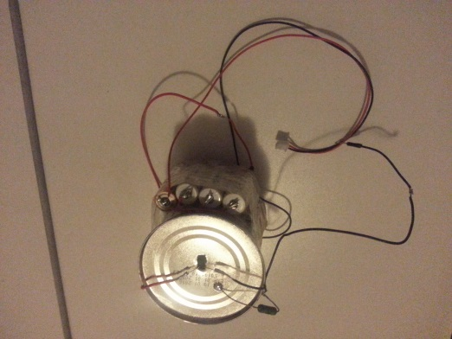
Figure 12: Ionization chamber
Radiation Detection Sensor Circuit:
Arduino Dosimeter Logger DIY Geiger counter Kit with LCD and SD-Logger-Shield
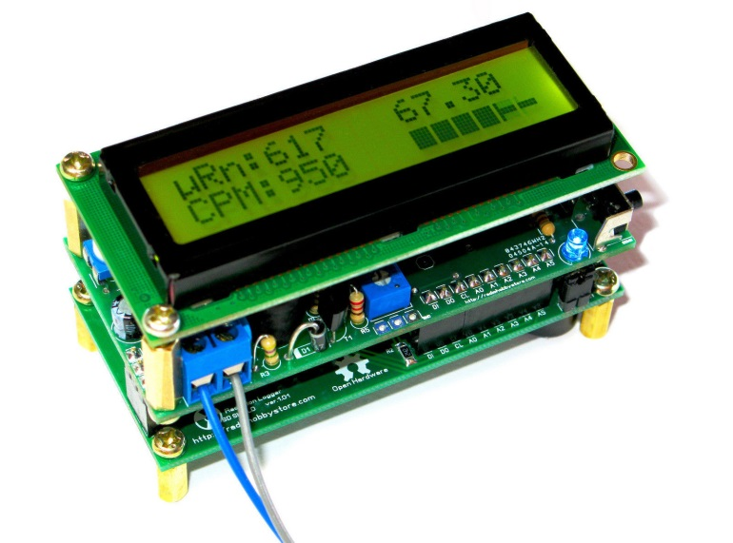
Figure 13: Arduino dosimeter logger DIY Geiger counter kit

This is open source code Geiger project based on Arduino IDE with SD card. It has the following components;
- Micro SD Card for storing and transferring data to the computer.
- Real time clock and date to correspond the data with time of measurement
- Smart backlight Control help to safe battery. Microcontroller will light on the LCD backlight by auto if CPM value reaches alarm settings.
- Clicker sound that similar to classic Geiger counters produced by buzzer. Additional 3-times short beeps produced when CPM level is high.
- Fast Bar graph on LCD with scale, configurable through software. Bar graph shows CPS (count per second) measurement. Not useful for background radiation, but can be excellent for search mode.
- Battery Indicator shows the level of battery.
After making the ionization chamber and the connecting the 5.1V battery to our Sensor circuit kit, the next thing to do is to format the Micro SD card. This is done to make it work with the format of the circuit. After formatting, you put it in the circuit.
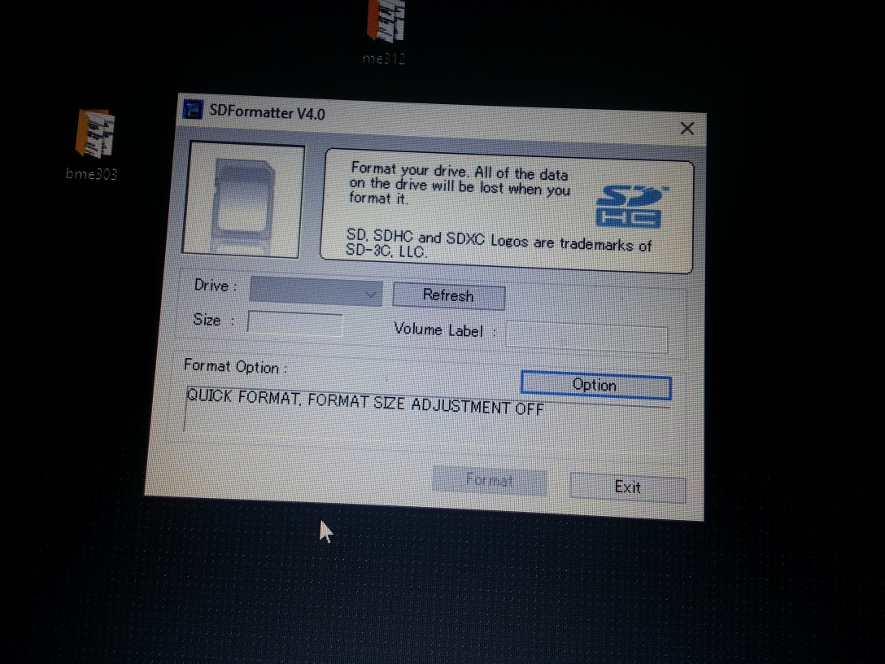
Figure 14: SD card formatter

The next step is to install the Arduino IDE and the install all the libraries from lib.zip. The next step is installing the USB-TTL drivers for our adapter. Open IDE, select Tools>Board>Arduino UNO. Select Tools>Programmer>AVRISP mkll). Set COM port where you connected your USB-TTL adapter. Install RTC CR2110 battery. Connect the board and then Open RTCsetup.ino, set your date and time and upload it into the board. Open Geiger.ino, modify parameters if required and upload it into the board. Disconnect the board from the computer and install micro SD card.
The next thing you do is to install the radiation logger to your PC for data output and assessment.
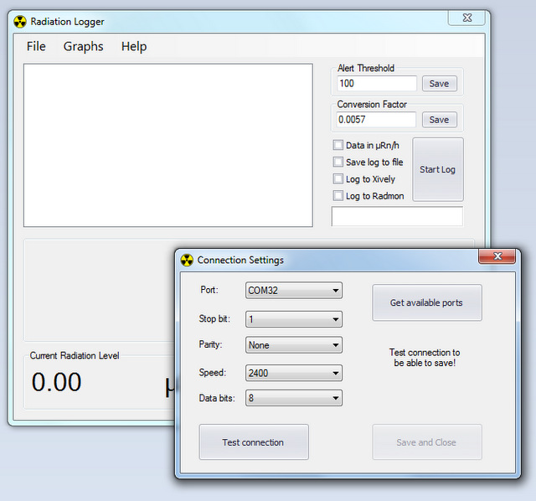
Figure 15: radiation logger
As our test source, we used a Welding rod also known as Thoriated Tungsten electrodes which has Thorium. Thorium (Th) is slightly radioactive with a long half-life and emits mainly alpha (α) particles, but occasionally some beta (β) and gamma (γ) radiation is emitted. Alpha particles cannot penetrate skin or even paper. However, they are harmful if released inside the digestive tract, or inside the lungs, where they act as a carcinogen.
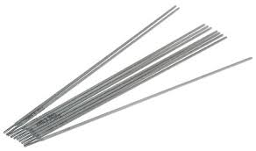
Figure 16: rods

After making the ionization chamber, setting and powering the Arduino sensor circuit and installing the relevant programs, the components are mounted on the drone and ready for flight and radiation measurement.
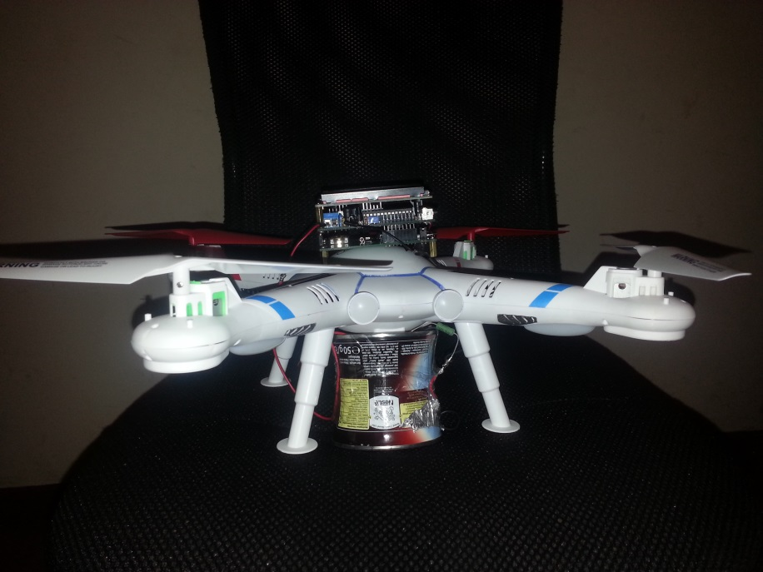
Figure 17: Aerial rad detector
Measurements with their date and time will be shown from the Micro SD card to the Radiation Logger as shown below;
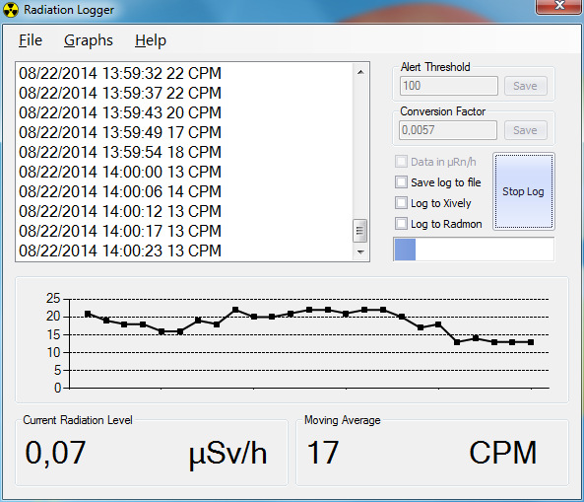
Figure 18: Radiation logger display output

CHAPTER 4

4.1 FUTURE PROSPECTS
The next decade will be about maximizing their current capabilities, recognizing the roles in which they can be the most useful, and integrating them into current methods.
The major problem faced when using an unmanned aerial radiation detection device is the weather; especially the wind. In the near future, that won’t be a problem
Unmanned Aerial Radiation devices can only fly for a limited time but in the future, there will be unmanned ARDs that live in the sky.
Considering the growing market and the increasing need and demand of Aerial Radiation Detection devices, it is expected, by some estimates, to double in value to nearly $12 billion a year by 2023, there is enthusiasm in the air for utilizing them in ways that a few years ago were still only the subject of white papers.
So therefore the issue of whether or not we are going to see advancement in this area is not a question as we are sure, it will gradually become one of the fastest growing markets.

CHAPTER 5

5.1 CONCLUSION
From our topic we can see that aerial radiation detection is not something that is very common because most at times an individual or a person uses a radiation detection device to go to the radiation zone and detect what type of radiation is there and sometimes it is risky because we can have an exposure from the suit and if the radiation is harmful it means the individual would be contaminated. And hence with this technology we are reducing the risk of being contaminated and rather if the radiation is harmful it is the drone that would be affected and not the individual.
With the advancement in technology, robots and devices are making work easier. Though many people will argue that technology takes the jobs of the working class and that in fact is true but in most situations, it minimizes our exposure to risk and sometimes saves time.
With the speed in technological change and era we are experiencing, there will be more innovations that will make life easier for us all.
This technology will help save lives and even though the flying would have to be taught to the personnel, it is worth it because at the end a life would be saved.

REFERENCES:
- Weisstein, Eric W. (n, d) "Radiation". Eric Weisstein's World of Physics. Wolfram Research. Retrieved 2014-01-11 from http://scienceworld.wolfram.com/physics/Radiation.html.
- Knoll, Glenn F (1999). Radiation detection and measurement (3rd ed.). New York: Wiley. ISBN 0-471-07338-5.
- Radiation Logger (n.d). Retrieved 7 may 2016 from http://www.rhelectronics.net/store/radiation-logger.html
- Radiation detector (n.d). retrieved 6 may 2016 from http://www.equipcoservices.com/support/tutorials/introduction-to-radiation-monitors/
- What is radiation (n.d) taken 6 may 2016 from http://hps.org/publicinformation/ate/faqs/whatisradiation.html

