INSTITUTE OF HEALTH SCIENCES

A PHARMACOGNOSTICAL EFFICACY OF FIVE PLANTS USED TRADITIONALLY FOR THE TREATMENT OF CANCER IN NORTHERN NIGERIA

MARYAM ISAH MUHAMMAD

PHARMACOGNOSY
MASTER THESIS

ADVISOR
Prof. Dr. Ali H. MERİÇLİ

NICOSIA, 2017

ACKNOWLEDGEMENT
Firstly, I would like to express my sincere gratitude to my advisor Prof. Dr. Ali Hikmet MERIÇLI for the continuous support of my master studies and related research, for his patient, motivations and immense knowledge. His guidance helped me in all the time of research and writing of this thesis. I could not have imagined having a better advisor and mentor for my master studies.
The struggles of Prof. Dr. Filiz Meriçli and Assist. Prof. Dr. Usama Alshana was also found to be very helpful, encouraging and supportive during my master program. Also worthy of note is the role played by the entire members of staff (academic and non-academic) of the Faculty, most importantly Mr. Azmi Hanoğlu and his colleagues (of the Pharmacognosy laboratory).
I also want to express million thanks to my parents, Alhaji Isah Muhammad (Abba) and Hajiya Rahma Abdallah (Umma), for their prayers, and moral and financial support throughout my studies; and to my uncles, brothers and sisters, Fatima, Akilu, Zahra, Ishaq, Ismail etc. I also owe you a bunch of appreciations: May Allah grant all of you sound health to see the result of the confidence you reposed in me.
I would also like to express my sincere gratitude to the Kano State Government especially during the tenure of Engnr. Dr. Rabiu Musa Kwankwaso for giving me this golden opportunity, (in the form of Scholarship), to further my studies.
I would also like to express my gratitude to Dr. Abdulkareem as a second reader of this thesis; I am gratefully indebted for his valuable comments on this thesis.
Thanks goes to Baha’uddeen Sa’id a Horticulture, Bayero University Kano, Nigeria, who helped me in collection and identifications of the plants, a very big thank you for your kind gestures towards the success of this work.
I must not forget the kind, special and generous cares and consideration I received from my dearest brother/friend Muhammad Dauda Aliyu, throughout my stay in Kibris, bunches of thanks QT.
Last but not the least, I would like to thank to my fellow friends for their cooperation and of course friendship.
DEDICATION
I dedicated this work to my beloved parents for their everlasting love and encouragement.

ABSTRACT
Medicinal plants are used traditionally in northern Nigeria in the management or control of cancer and many other diseases, but the scientific investigations of most plants are not being fully evaluated. In the first part of this thesis, the botany, chemistry, traditional use and pharmacological activities of five plants (Daniellia oliveri, Sclerocarya birrea, Ipomoea asarifolia, Ficus sur and Ficus sycomorus) were discussed. These plants have been used traditionally in northern Nigeria in the management of cancer disease. In the second part the cytotoxicity of the stem bark of Daniellia oliveri (Rolfe) Hutch.& Dalzie (syn. Paradaniellia oliveri Rolfe.) was investigated. The ethanolic extract of the stem bark of D. oliveri was prepared by Soxhlet extraction. The cell culture was maintained in RPMI-1640 medium, 10% FBS, 1% streptomycin and 1% glutamine at 37⁰C atmosphere in 5% CO₂.The cells were sub-cultured using 0.25% trypsin-EDTA solution (Biochrom, L2143). The extract was diluted in culture medium with dimethylsulfoxide (DMSO, Sigma-Aldrich) at different concentrations (5µg/ml, 10µg/ml, 20µg/ml, 50µg/ml and 100µg/ml). The cells were suspended in the medium and seeded in 96-well culture dishes at a density of 5 x 10⁴/mL cells. Extract dilutions were triplicated and incubated for 24 h. The viability of the cell was assayed by MTT assay. The result indicated that the extract of D. oliveri inhibited the growth of the cells in both dose and time-dependent manner, and the extract is more effective at 100µg/ml compared with other dilutions. These findings validate the traditional use of D. oliveri in the management of cancer in northern Nigeria.

Key words: Cytotoxicity, human colon carcinoma, Northern Nigeria, Daniellia oliveri, Sclerocarya birrea, Ipomoea asarifolia, Ficus sur and Ficus sycomorus.

Table of Contents
ACKNOWLEDGEMENT i
DEDICATION ii
ABSTRACT iii
TABLE OF CONTENTS iv
CHAPTER ONE
1.1 INTRODUCTION 1
1.2 CANCER 4
1.3 PREVALENCE OF CANCER IN NIGERIA 4
1.4 TYPES OF CANCER 6
1.4.1 BREAST CANCER 6
1.4.1.1 Symptoms 6
1.4.1.2 Causes of breast cancer 6
1.4.1.3 Preventions and control of breast cancer 7
1.4.2 LUNG CANCER 7
1.4.2.1 Symptoms 7
1.4.2.2 Causes of lung cancer 8
1.4.2.3 Preventions and control of lung cancer 8
1.4.3 PROSTATE CANCER 8
1.4.3.1 Symptoms 9
1.4.3.2 Causes of prostate cancer 9
1.4.3.3 Prevention and control of prostate cancer 10
1.4.4 CERVICAL CANCER 10
1.4.4.1 Symptoms 11
1.4.4.2 Causes of cervical cancer 11
1.4.4.3 Preventions of cervical cancer 11
1.4.5 COLON CANCER 12
1.4.5.1 Symptoms 13
1.4.5.2 Causes of colon cancer 13
1.4.5.3 Prevention of colon cancer 14
CHAPTER TWO
2.0 LITERATURE REVIEW 16
2.1 Daniellia oliveri (Rolfe) Hutch.& Dalzie 16
2.1.1 Distributions 16
2.1.2 Botany 17
2.1.3 Chemistry of the plant 18
2.1.4 Traditional uses 21
2.1.5 Pharmacological activities 22
2.2 Sclerocarya birrea {(A. Rich.)Hochst.} 26
2.2.1 Distribution 26
2.2.2 Botany 26
2.2.3 Chemistry of the plant 27
2.2.4 Traditional uses 29
2.2.5 Pharmacological activities 30
2.3 Ipomoea asarifolia (Desr.)Roem.& Schult. 32
2.3.1 Distributions 33
2.3.2 Botany 33
2.3.3 Chemistry of the plant 34
2.3.4 Traditional uses 35
2.3.5 Pharmacological activities 36
2.4 Ficus sur Forssk. 37
2.4.1 Distributions 37
2.4.2 Botany 37
2.4.3 Chemistry of the plant 39
2.4.4 Traditional uses 41
2.4.5 Pharmacological activities 42
2.5 Ficus sycomorus L. 44
2.5.1 Distributions 44
2.5.2 Botany 45
2.5.3 Chemistry of the plant 46
2.5.4 Traditional uses 48
2.5.5 Pharmacological activities 49
CHAPTER THREE
EXPERIMENTAL PART 51
3.0 MATERIAL AND METHODS 51
3.1 Plant collection, identification and authentication 51
3.2 Preparation of the powdered drug 51
3.3 Preparation of the extract 52
3.4 Cell line and cell culture 53
3.5 Cell viability and growth assays 53
CHAPTER FIVE
4.0 RESULTS 54
4.1 Cell viability and cytotoxicity 54
CHAPTER FOUR 55
4.0 CONCLUSION 56
REFERENCES 57

LIST OF FIGURES

Figure 1: Chemical structures of some useful plant-originated compounds with anti-cancer activity 3
Figure 2: Images showing stem bark, flowers, seed and leaves of D. oliveri 17
Figure 3: Chemical structures of some compounds isolated from D. oliveri 20
Figure 4: Images showing marula plant stem, leaves, and ripe and unripe fruits 27
Figure 5: Chemical structures of some compounds isolated from S. birrea 29
Figure 6: Image showing Ipomoea asarifolia leaves and flowers. 34
Figure 7: Chemical structures of some compounds isolated from I. asarifolia 35
Figure 8: Image showing cape fig tree’s leaves, ripe and unripe fruits, exudates and the seeds 38
Figure 9: Chemical structures of some compounds isolated from F. sur 41
Figure 10: Images showing common cluster fig, leaves, bark, ripe and unripe fruits 45
Figure 11: Chemical structures of some compounds isolated from F. sycomorus 47
Figure 12: Images showing extraction process, concentration of extract, and the extracts obtained 52
Figure 13: Images showing the MTT assay of the ethanol extract of D. oliveri stem bark 54
Figure 14: Effects of Daniellia oliveri extract cell viability of Colo-741 and Colo-320 cells. Colo-741 and Colo-320 cells were treated with different concentrations of Daniellia oliveri for 24 h. Viability was quantitated by MTT assay. 55

1.1 INTRODUCTION
Cancer is the second major cause of mortality worldwide (Amin et al., 2009). Statistically, there was approximately 8 million (57%) death as a result of cancer diseases and about 33 million cancer patients with an incidence rate higher in male than in females from less developed countries (IARC Global Can, 2012). However, World Health Organization (WHO) estimates show that about 11million cancer patients were diagnosed worldwide and by 2020 this estimate could rise to about 16million. WHO estimates indicated that more than 80% of the global populations depended on the herbal medicine for the management of most diseases., hence encourage people from developing countries (including Nigeria) to support the use of herbal medicine that were proven to be non-toxic (WHO, 1985; Farnsworth et al., 1985) subsequently National Agencies for Food, Drugs, Administration and Control (NAFDAC) intensify and standardize the usage of herbal drugs in some Nigerian markets.
Plants have been used for medicinal purposes long before recorded history. Medicinal plants in African societies were not being fully utilized compared to other traditional societies across the globe (e.g. China, India, and Greece). However, recent researches show that about 7500 different species were screened for anti-cancer activities in South Africa between 1999-2006 and 68% were found to contained active compounds (Fouche et al., 2008). Local healers from Nigeria plays an important role toward the management and control of most deadly diseases such as cancer, diabetes sickle cell anemia etc. and as such Nigerian government contributed a huge sum of money amounting to US$1billion for the development of traditional medicine, to encourage people to use natural herbs within the country and not to use costly imported drugs (Adelaja, 2006).
Most conventional therapies have been used and were believed to treat varieties of diseases. However, its high prices and side effects of medications encourage people from many developing countries to return to herbal medicine as alternative sources of therapy of diseases. For decades the three most populous cancer therapies, namely Surgical, Radiotherapy and Chemotherapy are used for cancer treatment. These therapies are believed to cure half of infected people and the other half of the patients do not benefit from the treatment or have a short period of survival (Eckhardt, 2002). Moreover, as reported by Amin et al, (2009) the convectional chemotherapies have many side effects to the extent that it only extends some few days to the patient’s lifespan. Therefore, there is still need for new therapy approaches with limited side effects and less expensive and affordable to everyone.
Medicinal plants are among a good alternative since they were believed to contain millions of phytochemicals with various pharmacological properties, and they are easy to access. The uses of medicinal plants as anticancer agent have been recognized since 1950s, but the scientific research started in the 1960s with the discovery of the first anticancer agent called Podophyllotoxin (a naturally occurring lignans) with its derivatives (Ectoposide and Teniposide) isolated from Podophyllum peltatum, it is commonly known as May apple or American mandrake (Podwyssotzki, 1880; O'Dwyer, 1985). The above investigation initiated the program of plant collection in U.S by National Cancer Institute (NCI), which led to the contribution to the existence of some more natural anticancer agents, including Taxol or Paclitaxel (polydeoxygenated diterpenoid) and its semisynthetic derivative Taxotere, first isolated from Taxus brevifolia bark (Wall and Wani, 1995). The National Cancer Institute (NCI) regarded Taxol as the best anticancer agent. Other anticancer agents, including Camptothecin a naturally occurring alkaloid with its derivatives Hycamtin (Topotecan) and campotosar (irinotecan) was also discovered from the stem wood of Chinese ornamental tree Camptotheca acuminata commonly known as tree of joy or tree of love, Vinca alkaloids (Vinblastine and Vincristine) and its analogues Vinorelbine and Vindesine isolated from Catharanthus roseus commonly known as Madagascar periwinkle (Cragg and Newmann, 2005). It is an important note to know that, currently, no single plant derived anticancer agent reached the stage of general use rather they are all still in the preclinical development level.
Many traditional herbalists from Nigeria and many developing countries have been managing cancer and other diseases for years back using medicinal plants, but most of this knowledge is not being fully investigated. Despite the rapid rate of deforestation and loss of biodiversity, this knowledge needs to be documented accurately for future use. In this research five common plants Daniellia oliveri, Ficus sur, Ficus sycomorus, Ipomoea asarifolia, Sclerocarya birrea from northern part of Nigeria were chosen to be discussed since various traditional healers claim these plants can be used to manage/control cancer and other infectious diseases.

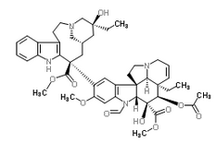
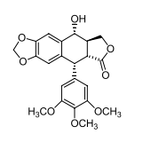
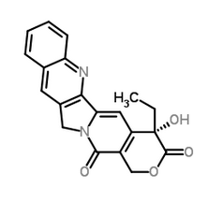
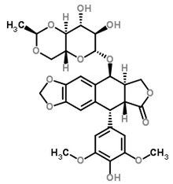
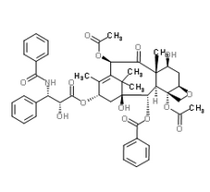
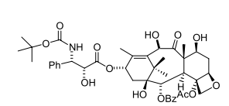
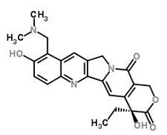
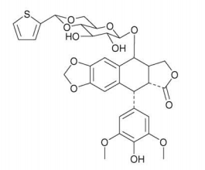
Vincristine
Podophyllotoxin
Camptothecin
Etoposide
Taxol
Taxotere
Topotecan
Teniposide

Figure 1: Chemical structures of some useful plant-originated compounds (with some semisynthetic derivatives) with anti-cancer potentials

1.2 CANCER
Cancer is a genetic and non-contagious disease affecting all categories of people around the world, with many people diagnosed yearly (Jamal et al., 2010; Sylla & wild, 2012). It is not one disease, but a collection of distinctive diseases. However, cancer is characterized by the abnormal, grow and division of cells as well as inadequate/inappropriate vascular supply resulting in the proliferation in an uncontrolled manner and in some cases dispersed to other tissues of the body.
At normal circumstance, the human body needs new cells to replace old and damage ones, therefore the cells grow and divide orderly to form new ones. This process breaks off when cancer cells are formed. The old and damaged cells continue to grow and survive and formation of new cells continues despite that the cells are not needed by the body. It, however, continues to divide without stoppage and form a tumor which may be malignant or benign tumor.
In 2002 reports from the World Health Organization (WHO) shows that there were 72.2 and the 76 death rate in male and female associated with cancer diseases, about 90.7male and 100.9 female per 10,000 cases (Globocan, 2002). The cancer incidence in Nigeria appeared to be low compare to United State and United Kingdom and was found to be higher in females. Similarly the incidence continues to increase as reported from another part of the world. The increasing incidence was due to poor awareness about the risk factors, changes in lifestyle etc.

1.3 PREVALENCE OF CANCER IN NIGERIA
Cancer is the second most deadly global disease causing death to both categories of people. Research shows that more than 12 m new cancer cases and about 8 million deaths were reported globally, from which 50% of these cases are from developing countries. In addition, the estimate shows that due to population growth and life expectancy by 2030 the cases will increase by 20% in Africa (Farlay et al., 2008; Lyerly et al., 2010; Boyle & Levin, 2008. However, twenty percent of African population and more than half of the population of West Africa, Nigeria as a whole constituted about fifteen percent cancer cases out of 681,000 estimated values of the new cancer cases (Sylla and Wild, 2012).
In 2012 about 102,100 new cancer cases and 71,600 cancer mortality rates was reported in Nigeria, it constituted 12% of the 847,000 estimated new cancer cases found in Africa in the same year. These values are inaccurate due to incomplete of information from limited population based cancer registries (Ahrens et al., 2014).
As reported by Farlay et al, (2008) about 100,000 cancer cases occur every day in Nigeria with the increase rate in fatality, and the incidence, prevalence and death rate. In Nigeria data coalation and documentation started by Ibadan Based Cancer Registry (IBCR). Data collection were mostly from hospital based cancer registries, death rate records, medical records, case series and IBCR been the first cancer registry in Nigeria (Parkin et al., 2003).
Ibadan Based Cancer Registry (IBCR) was created two years after Nigeria independence, located in the South-western part (inside University Hospital Collage Ibadan) of the country. The first three volumes of cancer incidence documentations were published in five continents (CIV) from 1960-1962, 1960-1965 and 1960-1969 immediately after the establishment of IBCR. However, due to some logistic problems this cancer registry collapsed from 1970s to 2000s (Parkin et al., 2000).
In order to revive and strengthen the crippled cancer registry, a programme was initiated called the Nigerian National System of Cancer Registry (NSCR) by the then Nigerian Federal Ministry of Health (FMOH) and the Institute of Human Virology Nigeria (IHVN). The programme is designed to reinforce the existing cancer registries and create new ones out of the provision of baseline training of the newly registries, educating, mentoring and, with the provision of computer apparatus to help to strengthen and support data management and analysis (Jedy-Agba et al., 2012).
In 2012 a reseach was conducted on invasive cancer cases and the data were obtained from two population cancer registries (IBCR and ABCR), and were collected and documented by IBCR. According to Jedy-Agba et al, (2012) between 2009-2010 the cancer cases in female (66.4%) is higher than in male (33.8%) with more prevalence of breast and cervical cancer among females and prostate cancer among males, IBCR research shows that breast cancer incidence rate were increasing substantially.

1.4 TYPES OF CANCER
Cancer is of many types, the most common ones include:

1.4.1 BREAST CANCER
Women breast is made up of two mammary glands, the lobules gland from which the milk are produced and the duct that transport the milk to the nipples. Breast tissue is consisting of connective tissue, lymph, nodes and blood vessels whereas the analogous organs found in men.
Breast cancer could be form from any tissue of the breast, but the most common one begins from the cell of the duct called carcinoma. Primary ductal carcinoma is when the unregulated cell growth started in the lining of the duct without spreading. Breast cancer can be invasive (metastasize to surrounding tissues) or non-invasive.
Women breast cancer is the major public health problem and the most common cancer in female globally, constituting about one ten of all the new cancer cases found yearly (Ferlay et al., 2010). It is the most deadly cancer disease among female with about 1.1 million cases diagnosed with more than 410,000 death worldwide (Ferlay et al., 2004). As reported by several investigators about 46,000 new cases of female breast cancer in the United Kingdom were reported yearly and more than 100,000 women in the country were expected in recent time (Love et al., 1991; Hunter et al., 2004).
In Nigeria breast cancer is the most common cancer among both the sexes, constituting about 31.7% of all the cancer cases.
1.4.1.1 Symptoms
Redness, feeling warm (because cancer cells block the lymph vessels of the skin) and swollen of the breast
1.4.1.2 Causes of breast cancer
It is difficult to know the causes of breast cancer. However there are certain risk factors that are associated with the breast cancer. They include:
- A family history of breast cancer
- Early menstruation before age 12
- Late menopause after age 55
1.4.1.3 Preventions and control of breast cancer
- Changing lifestyle or eating habit
- Avoiding things known to cause cancer
- Taking medicine to treat precancerous condition or to keep cancer from starting

1.4.2 LUNG CANCER
Human lung is one of the biological organs located in either side of the chest responsible for respiration. Lung cancer is the most leading cause of death among cancer related disease in both male and female with the estimation of about 1.18 million people death globally (Parkin et al., 2002). Since 1980s lung cancer remained the most commonly diagnosed cancer types with the estimated value of 1.35 million diagnosed annually (Parkin et al., 1993). In developed countries the incidence of lung cancer cases is relatively decreasing. However, between 1980s-1990s the incidence is increasing with about 31% to 49.9% (Parkin et al., 2002). Tobacco smoking is one of the most important risk factor responsible for lung cancer. Global estimation shows that 53% women and 15% men are Lung Cancer Never Smokers (LCNS) (Parkin et al., 2002). In United States and Europe lung cancer cases due to tobacco smoking constituted about 90% men and 75-80% women respectively and only 10% with lung cancer diseases were never smokers in US only (Parkin et al., 2002; Koo and Ho, 1990; Tyczynski et al., 2000; Subramanian & Govindan, 2007). Several literatures show little or no information about the total number of deaths occurs as a result of lung cancer in Nigeria.
1.4.2.1 Symptoms
Most lung cancers do not show any symptoms at early stage, but in some cases the early symptoms may show. The most common symptoms of lung cancer are:
- Weight loss and loss of appetite
- A cough that does not go away or gets worse
- Feeling tired or weak
- Coughing up blood or rust-colored sputum
- Chest pain characterized with deep breathing, coughing, or laughing
- Hoarseness
- Shortness of breath
- Infections such as bronchitis and pneumonia that don’t go away or keep coming back
1.4.2.2 Causes of lung cancer
- Tobacco smoking
- Exposure to radon
- Exposure to asbestos
- Air pollution
- Arsenic in drinking water
- Personal or family history of lung cancer
- Certain dietary supplements
1.4.2.3 Preventions and control of lung cancer
- Stay away from tobacco
- Avoid radon
- Limit exposure to cancer-causing chemicals
- Eat healthy diets.

1.4.3 PROSTATE CANCER
Prostate gland is one of the male mammalian gland located below the urinary bladder in front of the rectum, it surrounded the urethra. It controls the secretion of the urine and a fluid (part of the semen). According to National Cancer Institute US, prostate cancer is the second most common cancer type apart from skin cancer and the most common leading cause of death in men. Prostate cancer is less common in white men than in African-American.
It is the most common cancer type in Nigerian males, it accounts for 6.1-19.5% of all cancers and incidence is increasing. Current data from most parts of the country show it to be the third most common cancer except in Calabar where high figures was recorded for prostate cancer as the most common in both sexes accounting for 34.7% of all cancers. Earlier report from that center from 979 to 1988 had recorded 28.6% of all male cancers (Abdukareem, 2010).
The increase incidence has been attributed to introduction of Prostate-Specific Service (PSA) screening test which enable earlier diagnosis of cases. When compared to African-American men, Nigerian men are 10 times more likely to have prostate cancer and 3.5 times more likely to die from it. Environmental and most importantly, genetic factors have been incriminated as the reason for the geographic differences in incidence. The mean age in Nigeria varies between 60.5-71.4yrs. Most of the data showed no tendency towards younger age at presentation and patients present late with advanced disease (Abdukareem, 2009).
1.4.3.1 Symptoms
Early prostate cancer usually causes no symptoms. More advanced prostate cancers sometimes cause symptoms, such as:
- Problems urinating, including a slow or weak urinary stream or the need to urinate more often, especially at night
- Blood in the urine or semen
- Trouble getting an erection (erectile dysfunction or ED)
- Pain in the hips, back (spine), chest (ribs), or other areas from cancer that has spread to bones
- Weakness or numbness in the legs or feet, or even loss of bladder or bowel control from cancer pressing on the spinal cord
1.4.3.2 Causes of prostate cancer
Researchers do not know exactly what causes prostate cancer. But they have found some risk factors and are trying to learn just how these factors cause prostate cells to become cancer.
- Race
- Age above 40years
- Positive family history
- High fat diet and
- High serum androgens levels.
1.4.3.3 Prevention and control of prostate cancer
There is no proven prostate cancer prevention strategy. But the risk may be reduce by making healthy choices, such as exercising and eating a healthy diet

1.4.4 CERVICAL CANCER
The abnormal grows of cells on the cervix in an uncontrolled manner result in cervix cancer. The cervix is located at the lower part of the uterus that opens into the vagina. Cervical cancer can often be successfully treated at early stage (seen through a pap-test). It is the second most frequent malignancy among female in the world, with an estimates of 47 1,000 and 2 13,000 new cancer cases and deaths rate annually. The highest rate of cervical cancer is found in poor and rural areas of the globe (Mohar & Frias-Mendivil, 2000).
It has been reported that Latin America, Africa, India, and Eastern Europe are regions of high risk for cervical cancer. In contrast, countries from Western Europe, North America (excluding Mexico), and the Middle East represent areas of low risk for this disease (Alvarez-Gelves & Perez-Arias, 1986).
The death and incidence rate of cervical cancer is decreasing as soon as the introduction of the cytology screening campaign (pap-test) in developed countries. About 70% of cervical cancer cases were reduced in the United State (Devesa et al., 1995). These reductions was attributed with early diagnosis of precursor lesions and specific treatment of cervical cancer while the high risk was associated with the poor organized screening, lack of quality control measures and have limited resources that explain this high incidence(Lazcano-Ponce et al., 1996; Hill, 1975).
In Nigeria Cervical cancer is the second common type of cancer after breast among female. Records from ASR and ABCR at the IBCR indicated that there was an estimates of 36.0 per 100 000 and 30.3 per 100 000 incidence rate of cervical cancer respectively (Jedy-Agba et al., 2012).

1.4.4.1 Symptoms
Cervical cancer doesn’t usually cause symptoms until it’s in advanced stages. Also, women may think the symptoms are related to something else, such as their menstrual cycle, a yeast infection, or a urinary tract infection.
Examples of symptoms associated with cervical cancer include:
- abnormal bleeding, such as bleeding between menstrual periods, after sex, after a pelvic exam, or after menopause
- discharge that’s unusual in amount, color, consistency, or smell
- having to go to urinate more frequently
- pelvic pain
- painful urination
1.4.4.2 Causes of cervical cancer
Cervical cancer is caused by a virus called human papillomavirus (HPV). HPV is transmitted through sexual contact. There are various types of HPV and not all of them cause cervical cancer.
Most adults have been infected with HPV at some time. An infection may go away on its own. But sometimes it can cause genital warts or lead to cervical cancer. That's why it's important for women to have regular Pap tests. A Pap test can find changes in cervical cells before they turn into cancer. If you treat these cell changes, you may prevent cervical cancer.
- Pain in the lower belly or pelvis.
- Vaginal discharge that isn't normal.
- Bleeding from the vagina that is not normal, such as bleeding between menstrual periods, after sex, or after menopause.
- Pain during sex.
1.4.4.3 Preventions of cervical cancer
The Pap test is the best way to find cervical cell changes that can lead to cervical cancer. Regular Pap tests almost always show these cell changes before they turn into cancer. It's important to follow up with your doctor after any abnormal Pap test result so you can treat abnormal cell changes. This may help prevent cervical cancer.
If you are age 26 or younger, you can get the HPV vaccine, which protects against types of HPV that cause most cases of cervical cancer.
The virus that causes cervical cancer is spread through sexual contact. The best way to avoid getting a sexually transmitted infection is to not have sex. If you do have sex, practice safer sex, such as using condoms and limiting the number of sex partners you have.

1.4.5 COLON CANCER
The colon is another term for the large intestine; it is the lowest part of the digestive system. Inside the colon, water and salt from solid wastes are extracted before the waste moves through the rectum and exits the body through the anus
Colon cancer is formed when the cells in the large intestine growth and divide out of control to for a tumor. They are mostly originated from small, noncancerous (benign) tumors called adenomatous polyps that form on the inner walls of the large intestine. After the formation of malignant tumors, the cancerous cells may travel to other part of the body through the blood and lymph systems. These cancer cells can grow in several places, invading and destroying other healthy tissues throughout the body by a process called metastasis. Colon cancer is not necessarily the same as rectal cancer, but they often occur together in what is called colorectal cancer. Rectal cancer originates in the rectum, which is the last several inches of the large intestine, closest to the anus.
Colon cancer is the third most common cause of cancer death in the U.S., and it is the second most prevalent type of cancer. According to the American Cancer Society, there will be 95,270 new cases of colon cancer in the U.S. in 2016.
Colon carcinoma in traditional descriptions is not common among native Africans when compared to the incidence of the disease in the United State or United Kingdom (Irabor, 2012). However studies in Nigeria have shown that the incidence rate of this disease was increasing over the last 20 years (Irabor & Adedeji, 2009; Irabor et al., 2010). It was the 10th most common malignancy in men from the Ibadan cancer registry four decades ago (1960 to 1969), now holds as the fourth most common malignancy (Okobia, 2003). This shows an increasing incidence.
1.4.5.1 Symptoms
Cancer symptoms are quite varied and depend on where the cancer is located, where it has spread, and how big the tumor is.
It is common for people with colon cancer to experience no symptoms in the earliest stages of the disease. However, when the cancer grows, symptoms include:
- Diarrhea or constipation
- Changes in stool consistency
- Narrow stools
- Rectal bleeding or blood in the stool
- Pain, cramps, or gas in the abdomen
- Pain during bowel movements
- Continual urges to defecate
- Weakness or fatigue
- Unexplained weight loss
- Irritable bowel syndrome (IBS)
- Iron deficiency (anemia)
1.4.5.2 Causes of colon cancer
Although scientists do not know exactly what causes these cells to behave this way, they have identified several potential risk factors:
- Polyps
Colon cancer usually derives from precancerous polyps that exist in the large intestine.

- Genes - the DNA type
Cells can experience uncontrolled growth if there is damage or mutations to DNA, and therefore, damage to the genes involved in cell division.
Cancer occurs when a cell's gene mutations make the cell unable to correct DNA damage and unable to commit suicide. Similarly, cancer is a result of mutations that inhibit certain gene functions, leading to uncontrollable cell growth.
- Genes - the family type
Cancer can be the result of a genetic predisposition that is inherited from family members. It is possible to be born with certain genetic mutations or a fault in a gene that makes one statistically more likely to develop cancer later in life.
- Traits, habits, and diet
Age is an important risk factor for colon cancer; around 90 percent of those diagnosed are over 50. Colon cancers are more likely to occur in people with sedentary lifestyles, obese people, and those who smoke tobacco.
Diet is an important factor associated with colon cancer. Diets that are low in fiber and high in fat, calories, and red meat and processed meats increase the risk of developing colon cancer.
In fact, Western diets increase the risk of colon cancer compared with diets found in developing countries. Heavy alcohol consumption may also increase the risk of colon cancer. Being overweight and physically inactive are also risk factors for developing colon cancer.
1.4.5.3 Prevention of colon cancer
The American Cancer Society suggests screening tests, particularly colonoscopy, for early detection of colon cancer. Colonoscopy is the best method, because it will visualize the entire colon and can remove polyps during the procedure. Other screening tests include fecal occult blood tests (annually), stool DNA testing, flexible sigmoidoscopy (every 5 years), and CT colonography (every 5 years).
These frequency recommendations depend, however, on a person's particular risk of colon cancer due to other risk factors.
In general, physicians recommend standard preventive measures such as keeping a healthy weight, exercising, and increasing consumption of fruits, vegetables, and whole grains while decreasing saturated fat and red meat intake. In addition, people are recommended to limit alcohol consumption and quit smoking.

2.0 LITERATURE REVIEW
The botany, distributions, chemistry, traditional usage and pharmacological activities of five plants (Daniellia oliveri, Sclerocarya birrea, Ipomoea asarifolia, Ficus sycomorus and Ficus sur) are discussed below.

2.1 Daniellia oliveri (Rolfe) Hutch.& Dalzie
The genus Daniellia was first named in 1854 by W. F. Daniell with the first species collected from Sierra Leone namely ‘Daniellia thurifera’. According to de la Estrella et al. (2010) the genus is comprises of ten different species. Keay, (1958) recognized five species including D. oliveri, Daniellia thurifera, Daniellia ogea, Daniellia pynaertii and D. oblonga.
Among the genus Daniellia, Daniellia oliveri (Rolfe) Hutch.& Dalzie (syn. Paradaniellia oliveri Rolfe.) is the most common species that belongs to sub-family Caesalpinioideae and family Fabaceae. D. oliveri is commonly known as African copoiba balsam in English, while in Nigeria it is traditionally known by the three major languages in the country as ‘Maje’ in Hausa, ‘iya/ozabwa/agba’ in Igbo, ‘Emi iya’ in yoroba, ‘Oda’ in Igala, ‘Ukpilla’ in Igede and Ubakwa in Idoma (Dalziel, 1937; Aguoru & Anjira, 2013; Atolani &Olatunji, 2014).
2.1.1 Distributions
D. oliveri is a deciduous tree growing abundantly in several parts of African, and in amazon region of South America (Meggers et al., 1973; Balogun & Adebayo, 2009).
In Africa it is found abundantly in deciduous forest (starting from Senegal expanded to south Sudan and Sahel and Uganda) and in wooded savannah (de la Estrella, 2010). It was also reported to be found in Burkina Faso, in Gambia, in Ghana and in Benin Republic (Kabore, 2007; Dassou et al., 2014; & Boye et al., 2013).
The species is widespread in Nigeria, growing in the forest in south-western part of the country (Atolani and Olatunji, 2014). It is found abundantly in the northern part of Nigeria.

2.1.2 Botany
D. oliveri is a tall (15-20cm height) and slender tree. Its scaly bark is relatively light grey in colour with a white striped deep red slash and the leaves are peripinnate (pink to red colour during flowering period). Flowers (October to March) possess stigma surrounded by ten stamens with white to pale green petals and green sepals, fruiting is between Januarys to June (de la Estrella et al., 2010). Its trunk produces exudate in form of oleoresin.
Daniellia oliveri differentiated from other Daniellia species by petals size, the lateral petal of D. oliveri is relatively greater in size unlike in other species which is smaller in size and they possess thicker (5-6mm) seed which is obovate-elliptic compared in other species.
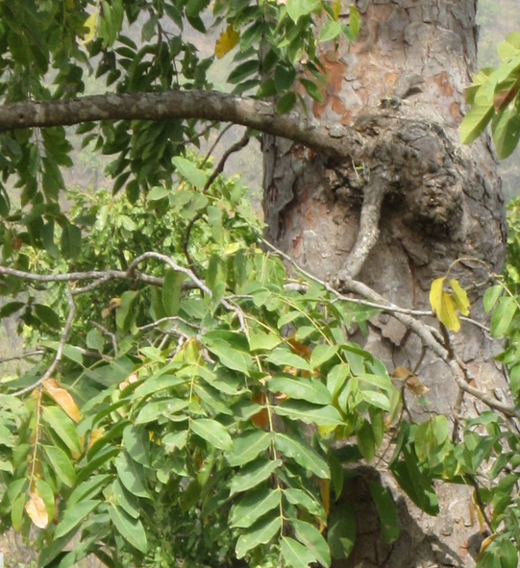
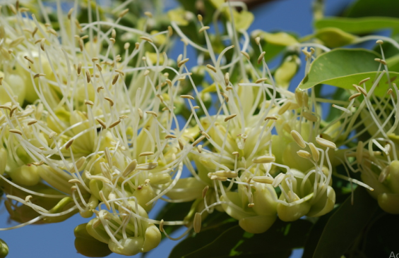
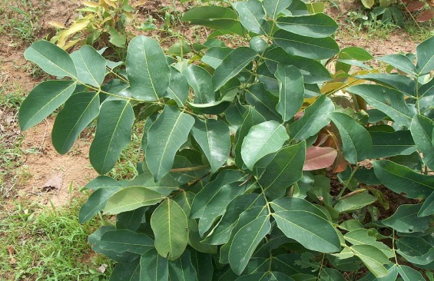
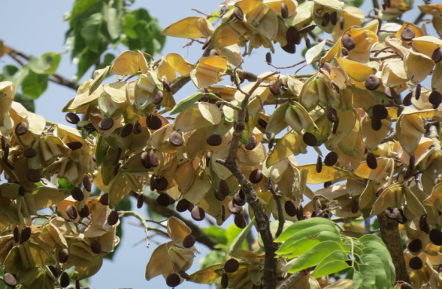
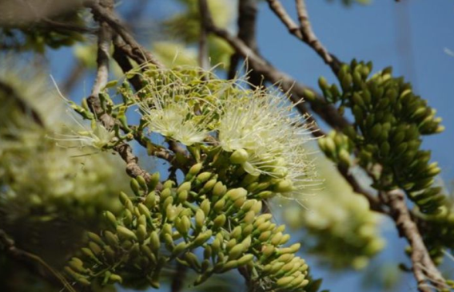
Figure 2: Images showing stem bark, flowers, seed and leaves of D. oliveri
2.1.3 Chemistry of the plant
Daniellia oliveri have been reported to contained carbohydrates (44.6% to 57%), crude protein (27% to 33.4%), lipid (9%), ash (4.17%) and crude fiber (0.60%) (Hassan et al., 2008). The seed of the plant is also rich in phytic acid (30.39mg/100g), K (680mg/100g), Ca (263mg/100g), oxalate (30.39mg/100g), hydrocyanide (6.0mg/100g), therefore the anti-nutrient content were found to be high, hence the seed may be recommended for human consumption (Obun and Adeyemi, 2012; Adubiaro et al., 2011). Phytochemical analysis revealed the presence of phenolic compounds (e.g. gallic acid, protocatechuic acid, caffeic acid, p-coumaric, coumarins and chlorogenic acid), anthocyanidins, polyphenolic, terpenoids, steroids, saponins, flavonoids, flavonols, tannins and phlobatannins from the stem bark of D. oliveri, (Muanda, 2009; Boye et al., 2013).
A furano-diterpene namely polyalthic acid was obtained from the oleoresin of D. oliveri using column chromatography fractions, and this compound was not significant against anti-glycation activity, therefore it may not contribute to the activity as reported in ethnomedicine (Alatoni & Olatunji, 2014).
Using GC-MS experimental analysis, twenty two compounds were detected, δ-Cadinene (42.92%), copaene (11.36%) and cis-muurola-4(14),5-diene (9.56%) were found to be the major constituents and they constituted for about 64% of the total compound present in the oleoresin of D. oliveri, these major compounds were responsible for the odour, anti-oxidant and low cytotoxic activities the exudates (Atolani & Olatunji, 2016).
Ahmadu et al, (2004) reported the presence of diterpenes (daniellic and oliveric acid) from the stem bark of D. oliveri.
Twenty-two different molecules were identified by gas chromatography from the hydroethanolic extract of the trunk bark of D. oliveri, ethanoate glycerol, procatechol and octadeca-9-enamide were found to be the major constituents, and the phenolic compounds were determined by staining and precipitation reactions, the extract were devoided from anthocyannins, coumarins, anthraquinones, quinones and volatile compounds whereas phenols, flavonoids, alkaloids, tannins, saponosides, sterols and terpines, reducing compounds, leuco-anthocyanins and mucilage were present and with the exception of condensed tannins and it yielded the highest inhibition than the ethanolic and aqueous extract (Alain et al., 2015).
Two triterpenoids lupane and oleanane - 9(11), 12- diene acid identified as Lup-20(29)-en-3-ol (Lupenol) and 3-acetoxy -9(11),12-diene-28-carboxyllic acid are presence in Dichloromethane leaves extract of D. oliveri (Ahmadu et al., 2014).
The n-butanol soluble part extract of the leaves of D. oliveri were reported to contain some flavonoids, tannins and sugar and absent of some alkaloids, steroids and saponins while the aqueous part contained flavonoids (rutin, narcissin and a quercitrin in combination with quercimetrin), tannins, saponins and sugar and absent of alkaloids and steroids (Ahmadu et al., 2004).
Flavonoids (catechin, orientin, homo-orientin, rutin, quercitrin, quercitrin-glucosyl and Quercitrin-dehydrate), polyphenolics (gallic acid, procatechic acid, chlorogenic acid, coumarins, p-Coumaric acid and caffeic acid) and vitamin c (ascorbic acid) were found to be present from D. oliveri root extract while absent of anthocyanidins (malvidins and delphinidin) (Muanda, 2009).
The phytochemical analysis of the aqueous root extract of D. oliveri revealed the presence of alkaloids, anthracene, glycosides, saponins and a trace amount of cyanogenic glycosides and tannins (Ezekwesili & Oybunugafor, 2015).

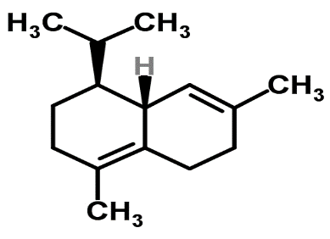
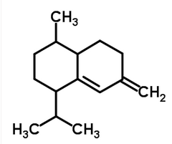
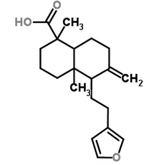
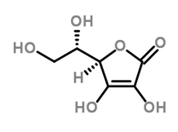
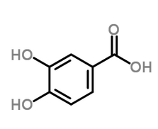
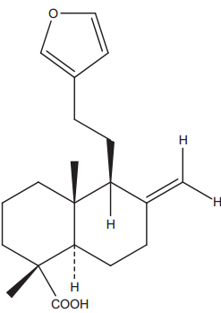
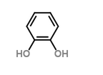
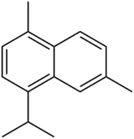
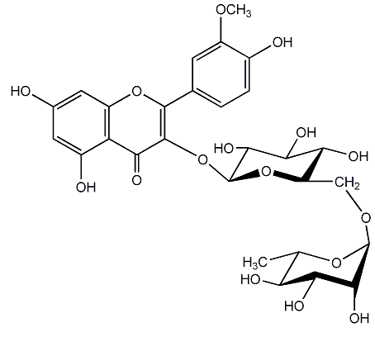
δ-Cadinene
Ethanoate glycerol
Cis-muurola-4(14),5-diene
Daniellic acid

Protocatechuic acid
Polyalthic acid
Procatechol
Narcissin
Cadalene

Figure 3: Chemical structures of some compounds isolated from D. oliveri
2.1.4 Traditional uses
D. oliveri serve as source of protein and energy to animal body, therefore it is used as fodder to livestock during dry season (Okunade et al., 2014). Its seeds are used as part of the ingredients for poultry feeds (Obun and Adeyemi, 2012). It has been use by local people in Savannas (Western part of Africa) as traditional fallows (Houehounha et al., 2010).
Parts of D. oliveri including leaves, stem bark, roots, exudes have been used traditionally for many years for the management of various diseases in many African countries.
Parts of D. oliveri are used by several harborists to treat various ailments such as gastrointestinal disturbances, bacterial infections, breast cancer, some vaginal diseases aphrodisiac, as diuretic, ear ache, syphilis, ringworm, typhoid fever, scrotal elephantiasis, dysentery headache and tuberculosis, backache, headache, yellow fever and as a mouthwash for toothache and tooth diseases (Hutchinson and Dalziel, 1964; Survey report, 1998 cited by Jegede et al., 2005; Coker and Ogundele, 2002; Ahmadu et al., 2003; Igoli et al., 2005; Ajibade et al., 2005; Nwaeze and Abariku, 2006; Jegede et al., 2006; Ahmadu et al., 2007; Iwueke, 2009; Ahmadu & Agunu, 2012; Yaya et al., 2016;). In Benin republic D. oliveri is used to manage gastrointestinal disturbances for livestock (Dassau et al., 2014; Ogni et al., 2014; Alain et al., 2015).
In Burkina Faso the stem bark of D. oliveri is used to treat gastrointestinal parasites, diarrhea and aphrodisiac, the leaves in combination with other herbs were used traditionally to treat malaria and some hepatoprotective problems, the leafy stems are used to treat pain during pregnancy and fatigue while the young leaves are used as chewing juice to treat coughs whereas the oil from its seed are used against skin beautification (Adama, 2010; Lamy et al., 2010).
Fresh grounded young leaves have been used to stop wounds bleeding and healing while leaf sap is taken orally by Tiv people in south-western Nigeria to treat cough (Coker and Ogundele, 2002). In northern part of Nigeria (Kano), decoction of the stem bark has been used for cancer treatments and gastrointestinal ailments (oral conversation, 2016). In northern Ghana part of D. oliveri is used traditionally to manage pain (Boye et al., 2013).
Leaves, stem and trunk of D. oliveri produces a liquid exudes in form of oleoresin which has been used in folk medicine for more than four hundred years (Gilbert, 2000). The oleoresin is a complex mixture of large amount of essential oil, non-volatile resinous substances and small amount of acidic substances. The oleoresin has been used traditionally as an anti-inflammatory agent, to treat skin diseases and urinary tract infections (Duke & Vasquez, 1994; Fluery 1997). The exudate is applied externally for skin diseases and itching skin (Burkill, 1997).
D. oliveri exudes has an effect on wound healing in Nigeria, for the treatment of migraine in Mali (Igoli et al., 2005; Ahua et al., 2007). In Gambia and Nigeria the oleoresin and bark of D. oliveri are used as mosquito repellent and act as an anti-wrinkle agent and used as part of the ingredient for cosmetics preparations (Igoli et al., 2005; Lamy et al., 2010).It is also used as an antiseptic, antibacterial, laxative, purgative, diuretic and hypotensive agent (Fleury, 1997). The stem bark is used in the management of cancer in northern Nigeria (Oral conservation, 2016).

2.1.5 Pharmacological activities
2.1.5.1 Cardiovascular activity
D. oliveri leaf extract shows some cardiovascular activity on rat (Balogun and Adebayo, 2007).
2.1.5.2 Cytotoxic activities
There was a promising cytotoxic effect of D. oliveri leaves extract on breast cancer and blood cancer as reported by Fadeyi et al, (2013) using human breast cancer cell line and T-cell Leukemia cell line.
The volatile diterpenes called oleoresin (δ-cadinene as the most abundant compound) obtained using GC-FID/GC-MS analysis from the D. oliveri exudates shows low cytotoxic activity on prostate cancer using human prostate cancer cell line, (Atolani and Olatunji, 2016).
2.1.5.3 Anti-diabetic activity
In 2008, Iwueke reported the effectiveness of the decoction extract of a mixture of D. oliveri and Sarcocephalus latifolius as an agent that decrease the blood sugar (anti-hyperglycemic activity) level in alloxan diabetic rat within six hours.
2.1.5.4 Anti-diarrheal activity
The leaves of D. oliveri and Ficus sycomorus (moraceae) show anti-diarrheal activity on rabbit jejunum and castor oil-induced diarrhea in mice (Ahmadu et al., 2007).
2.1.5.5 Anti-helminthic activities
The stem bark extract (decoction) of D. oliveri showed in-vitro anti-helminthic (ovicidal & larvicidal) activity on eggs, first stage larvae and adult of Haemonchus contortus (Adama et al., 2009), and Kabore et al, (2009) reported the anti-helminthic activity of aqueous leaves extract of D. oliveri on the same experimental organism.
2.1.5.6 Hepatoprotective activity
The leaves extract of Daniellia oliveri shows hepatoprotective activity on hepatotoxicity rat using carbon tetrachloride (CCL₄) (Onoja et al., 2015).
2.1.5.7 Anti-inflammatory activities
Due the presence of anti-oxidant agent (flavonoid) in the leaves Daniellia oliveri, the leaves extract possess anti-inflammatory activities (Yaya et al., 2016).
The stem bark extract of D. oliveri is effective against inflammations and this is in accordance of the work of Jegede et al (2006), were he tested the effectiveness of the ethanolic extract of the stem bark of D. oliveri using fresh egg albumin-induced oedema in rat paw.
The methanolic extract of the stem bark of D. oliveri exhibited anti-inflammatory activity (Onwukaeme, 1995).
2.1.5.8 Anti-microbial activities
The methanolic extracts of the leaves and stem bark of Daniellia oliveri showed higher anti-fungal (yeast and moulds) activity compared with the aqueous extract, with the lowest inhibition against Epidermophyton floccosum and Trichophyton interdigitale and highest against Candida albicans and Candida krusei (Coker and Ogundele, (2016).
The leaves of D. oliveri were screened for the anti-microbial activities using n-butanol soluble parts and four fractions of the aqueous extracts of the leaves. The result showed that the n-butanol soluble part exhibited higher activity than the aqueous fractions in all the tested bacteria (Staphylococcus aureus, Bacillus subtilis, Escherichia coli, Pseudomonas aeruginosa and Salmonella thyphi), while the column eluents of the n-butanol soluble part showed activity against Staphylococcus aureus. Only one Fraction were more potent against fungus (Tricophyton rubrum) and the other fraction against Pseudomonas aeruginosa, at the end this extracts were recommended to continue been used to treat urinary tract infections (Ahmadu et al., 2004).
The ethanolic and aqueous extracts of the leaves, stem bark and roots of D. oliveri were tasted for the anti-bacterial activities against Pseudomonas aeruginosa, Klebsiella pneumonia, Escherichia coli, Staphylococcus aureus and Shigella dysenteriae, the ethanolic extract showed more potency than the aqueous extract and the root extract were more potent than the leaves and stem bark extracts and activity were due to the presence of saponins, tannins and phenolic alcohol present in the extracts (El-mahmood et al., 2008).
Ethanol and hydroethanolic extracts of the trunk bark of D. oliveri exhibit anti-bacterial activity against Escherichia coli and Klebsiella pneumoniae (Alain et al., 2015).
2.1.5.9 Anti-nociceptive activities
At the doses of 50, 100 and 200mg/kg i.p, the ethanolic extract of the stem bark of D. oliveri showed significant anti-nociceptive activity (Jegede et al., 2006).
Also hexane extract of the stem bark of D. oliveri possess analgesic activity (Onwukaeme, 1995).
Determinations of the anti-nociceptive activity of the aqueous stem bark extract of D. oliveri was tested against murine hot plate and paw pressure pain models, the anti-nociceptive activity were found to be significant (Boye et al., 2013).
2.1.5.10 Anti-oxidant/anti-radical activities
Anti-oxidants are substances (radical scavengers) that help to prevent or reduced the oxidation of harmful chemicals caused by free-radicals (mutations, nucleic acid alterations, promotion of carcinogenesis and cellular damages), and this is because of their ability to react with phospholipids of biological membrane. The free radicals my also causes abnormalities such as inflammations, ischemia, mongolism, arthritis, anemia, dementia and asthma. The most active anti-oxidant compounds are flavonoids, some lignans, flavones, anthocyannins, phenols etc. According to many researchers flavonoids and flavones are the main constituents responsible for antioxidants and anti-radical properties (Potterat, 1997; Prior, 2003; Makari et al., 2008; Scalbert et al., 2005; Trease and Evans, 1989).
The oil from seed of D. oliveri could be used in the industries as nutritional oil or as raw materials and may serve as anti-oxidant agent, this is according to Danlami and David (2012), were he extracted the oil from D. oliveri seed using Soxhlet extractor and hexane as an extraction solvent, the anti-oxidant activity was measured with 1,1-Diphenyl-2-picrythydrazyl (DPPH).
Alain et al, (2015) reported the high anti-oxidant effect of ethyl acetate fractions and ethyl ether than the crude extract of D oliveri trunk bark using DPPH radical.
Determination antioxidant activity (in-vitro) from D. oliveri stem bark was observed using spectrophotometer (2, 2-diphenyl-1-picryldrazine photometric assay) and in vivo using malondildehyde and catalase level assay (Onoja, 2015).
Boye et al, (2010) also reported the anti-oxidant activity of aqueous extract of stem bark of D. oliveri, DPPH radical and ascorbic acid (standard) were used in his experiment. The ascorbic acid exhibit highest significant activity compared with DPPH radical.
Stem bark, root and the leave extract of D. oliveri possessed strong anti-radical scavenging activities using three different tests (phosphomolybdenum 2,2-diphenyl-1-picryl-hydrazyl and 2,2-azino-bis (3-ethylbenzothiazoline-6sulfonic), therefore the plant can be a renewable source of anti-oxidants for commercial and medicinal uses (Muanda, 2009).
2.1.5.10 Anti-pyretic activity
Hexane, ethyl acetate and methanolic stem bark extracts of D. oliveri shows no anti-pyretic activity (Onwukaeme, 1995).
2.1.5.11 Anti-spasmodic activity
The in vitro anti-spasmodic activity of D. oliveri leaves on n-butanol soluble part of the aqueous fraction of the ethanolic extract were investigated against three spasmogen of guinea pig ileum (Histamine, Barium chloride and Acetylcholine) and two spasmogen of Rabbit jejunum (Acetylcholine and Barium chloride) (Ahmadu et al., 2003).
2.1.5.12 Anti-ulcer activity
The methanolic extract of D. oliveri (stem bark) shows anti-ulcer activity (Onwukaeme & Udoh, 1999).
2.1.5.13 Anti-wrinkle activity
Oleoresin extract and extract containing oleoresin from D. oliveri were used in cosmetic preparation as it improved the appearance of the surface of the skin, and the activity were due to the presence of cadalene (1,6-dimethyl-4-(1-methyl) naphthalene derivative (Lamy et al., 2010).

2.2 Sclerocarya birrea (A. Rich.) Hochst.
Sclerocarya birrea subsp. caffra (Sond.) Kokwaro, Family: Anacardiaceae, commonly known as marula tree in English is a common and important tree in Africa with multifaceted uses recognized as a commercially, medicinally and culturally important plant species in the continent (Ojewole et al., 2010). S. birrea has been identified as one of the five fruit tree species that should be integrated in the domestication process in farming systems in Africa to support nutritional, health and income security (Jama et al., 2008). One of its unique characteristics is that during reproduction the male flower produces the pollen while the female flower gives rise to the fruit (Plantzafrica.com).
2.2.1 Distribution
S. birrea is native to deciduous, semi-arid and savannah areas of sub-Saharan Africa ((Borochov-Neori et al., 2008). It is widely distributed in bush land, rocky hills, wooded grasslands and riverine woodland areas (Ojewole et al., 2010).
In Africa marula tree is widely distributed in savannah regions expanding from Gambia to Nigeria in the west, Cameroon in central Africa and to Sudan and Ethiopia from east (Berhaut, 1971). Marula tree is widespread in northern part of Nigeria.
2.2.2 Botany
It is a medium-large sized, single-stemmed, deciduous tree reaching up to 20meters height and 1.2 meters in diameter (Njume et al., 2003; Gouwakinnou et al., 2011). Its trunk is erected, with grey to pale-brown and mottled stem bark (Ojewole, 2003). The leaves are pinnate and is divided into several leaflets, reaching to about 60 mm long each, it possess two colors, much paler below and dark-green at the top (Ojewole, 2003). Its flowers are dioecious and are produce in small oblong clusters bearing yellow petals and red sepals (Van Wyk et al., 1997). The fruit (sweet-sour) is small (as the size of plum), succulent however ripe between April and June and become pale yellow in color (Ogbobe, 1992), It is rounded and slightly flattened in shape up to 30mm in diameter. The fruit is aromatic and eatable.
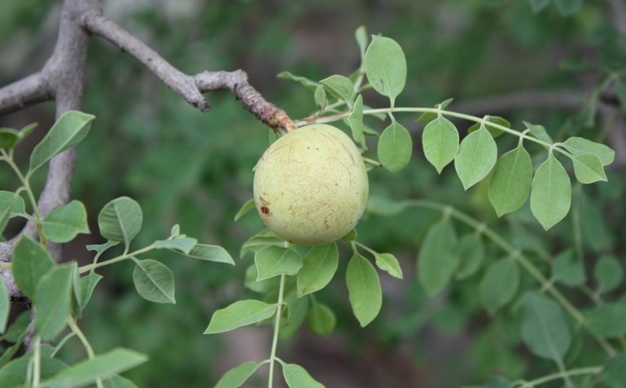
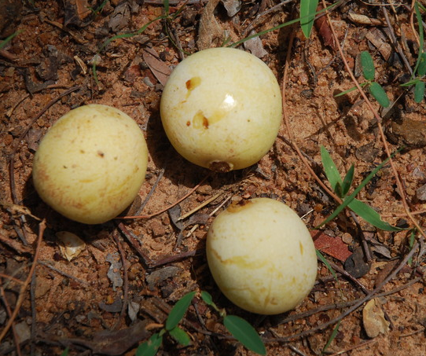
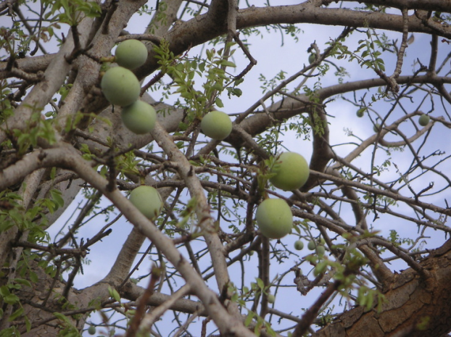
Figure 4: Images showing marula plant, stems, leaves, and ripe/unripe fruits.

2.2.3 Chemistry of the plant
It was reported that nutritionally marula fruit is rich in crude protein (3.1%) and carbohydrates (90.35%) while the seed kernel contained 50-60% oil, 47% fatty acid and 28-36% protein (Hassan et al., 2010; Glew et al., 2004; Moganedi et al., 2007). Marula seed on dry weight basis is rich in 24.8µg/g, 62.4µg/g and 42.10µg/g copper, zinc and magnesium respectively (Glew et al., 2004). However, low proportion of phenylalanine, leucine, lysine, and threonine are contained in the protein fraction of the seed (Glew et al., 2004). The plant seeds contain tocopherols and tocotrienols, which are used as natural antioxidants and a source of vitamin E (Kamal-Eldin et al., 2000; Kamal-Eldin &Andersson, 1997). The oil from the seed of S. birrea contains 67.2, 14.1 5.9% oleic, palmitic and linoleic acid respectively and 13.7 mg/100 g tocopherols (Mariod et al., 2004). Njume et al, (2011) identified five and 24 phyto-compounds from ethyl acetate: methanol: water and ethyl acetate extracts of S. birrea stem bark respectively using GC/MS experimental technique, however more than half of the compound are volatile compounds with terpine-4-ol (35.83%), pyrrolidine (32.15%), aromadendrene (13.63%) and -gurjunene (8.77%) being the most abundant compounds. About 36 different compounds were identified from the aqueous and methanolic extracts of S. birrea parts (leaf, stem bark and roots) using HPLC-MS analysis, twenty seven of the these compound were phenolics with flavonoid glycoside and galloylated tannins being the predominant compounds in the leaf and root/stem bark extracts (Russo et al., 2013). Ndhlala et al, (2007) reported the presence of phenolic compounds such as flavonoids, tannins and alkaloids in the bark of marula. Saponins, flavonoids and other phenolic compounds were presence in the water and methanolic extract of S. birrea bark, while sterols were presence only in the methanolic extract (Fotio et al., 2007). According to Mayo et al, (2010) the young stem methanol extract of S. birrea contained the highest contents of phenolic compounds, proanthocyanidins, gallotannins and flavonoids compared with the leaves extract.
(—) -Epicatechin-3-galloyl ester was identified from ethyl acetate and methanolic extracts of S. birrea bark (Peralta et al., 1992). Tannins, polyphenols and flavonoids were reported from the methanolic root extract of Sclerocarya birrea (Armentano et al., 2015).

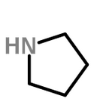
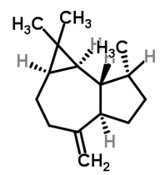
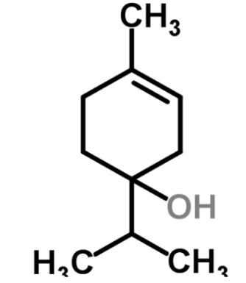
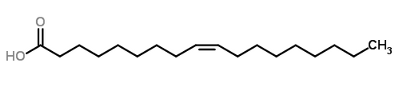
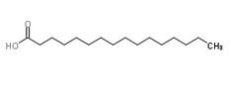
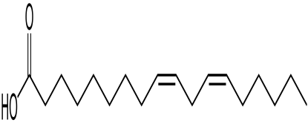
Pyrrolidine
Aromadendrene
Terpine-4-ol
Oleic acid
Palmitic acid

Linoleic acid

Figure 5: Chemical structures of some compounds isolated from S. birrea

2.2.4 Traditional uses
Sclerocarya birrea is a plant of multifaceted uses recognized as a commercially, medicinally and culturally important plant species in the continent (Ojewole et al., 2010). S. birrea has been identified as one of the five fruit tree species that should be integrated in the domestication process in farming systems in Africa to support nutritional, health and income security (Jama et al., 2008). One of its unique characteristics is that during reproduction the male flower produces the pollen while the female flower gives rise to the fruit (Plantzafrica.com).
This plant is well known and serves medicinally for different purpose in most part of African. In South Africa for example, marula is popular to many tribes such as Zulus, Vhavendas, Xhosas and Sothos (Masoko et al., 2008). As reported by many researchers the stem, leaves and roots of the plant were used in folk medicine to treat stomach-related morbidities and other illness including malaria, gastritis, peptic and stomach ulcer, dysentery, fever and diarrhea, headaches, body pains, toothache backache, infertility, childhood convulsion, hypertensions, inflammations) diabetic mellitus schistosomiasis and epilepsy in most part of region (Ojewole, 2007; Masoko et al., 2008; Eloff, 2001; Afolayan and Sunmonu, 2010; Braca et al., 2003;Watt and Breyer-Brandwijk, 1962; Pujol, 1993; Hutchings et al., 1996; Van Wyk et al., 2002). Gouwakinnou et al, (2011) reported the uses of parts of the plant e.g the leaves serve as fodder for livestock, the fruits are edible and are used for making jams and beers, while the nut is a source of oil and edible also. In Tanzania it is popularly known as malela or morogoro and its stem bark and roots decoction were used traditionally to treat oral and oesophageal candidiasis (Runyaro et al., 2006). In Cameroon the roots and stem barks are used traditionally to treat diabetics, pharyngitis, goiter and splenomegaly (Dimo et al., 2007; Mshana et al., 2000). People in Ghana use the leaves to treat snakebite and pruritus (Mshana et al., 2000).
In Nigeria S. birrea is commonly known as danya, it is highly valuable plant for its delicious fruits especially in the rural areas and its ethnomedicinal properties. The stem bark of D. oliveri is used in northern Nigeria in the management of cancer (Oral conservation, 2016).

2.2.5 Pharmacological activities
2.2.5.1 Anti-ageing
Due to the high contents of oleic acid and anti-oxidants the oil from the seed of this plant has been regarded as the cosmetic oil against human skin, the palmitic acid present in the oil provide a protective coating on the surface of the skin. The oil absorbs quickly, hydrates the skin, heals skin tissues, reduces redness, reduces trans-epidermal water loss, increases the smoothness of skin and conditions the hair (Gruenwald, 2006).
2.2.5.2 Anti-diabetic activities
Ojewole, (2003), Gondwe et al. (2008), Makom et al, (2010) and Dimo et al, (2007) reported the anti-diabetic activities of an aqueous/methanol/methylene chloride extracts of the stem bark of S. birrea on Wister rat treated with diabetic. The activity was determined by the action of the extracts (significant reduction of glucose level) on the diabetic rat. This report supported the traditional use of this plant by many African communities in the management of diabetic mellitus.
2.2.5.3 Anti-microbial activity
The acetone and aqueous extracts of the stem bark of S. birrea possess high activity against Helicobacter pylori compared with the control (metronidazole) (Njume et al., 2011), therefore the extract may contain important phytochemicals that may be a renewable source of anti-bacterial drug.
2.2.5.4 Secretagogue activity
Secretagogue activity of the bark of S. birrea were reported in 1992, the activity was due to the presence of (—) -Epicatechin-3-galloyl Ester (Peralta et al., 1992).
2.2.5.5 Anti-oxidant activities
The aqueous and methanolic extracts of marula plant exhibited good anti-oxidant activities (Russo et al., 2013; Fotio et al., 2009). Dichloromethane and methanol extracts of S. birrea cortex exhibited strong anti-oxidant activity (Mayo et al., 2010). Methanolic root extract possess anti-oxidant activity (Armentano et al., 2015).
2.2.5.6 Anti-inflammatory activity
The anti-inflammatory effect of an aqueous extract of the stem bark of S. birrea (SBAE) was evaluated in mice with diclofenac as reference drug, the result indicated that there is a 10-15times significant reduction of inflammation (acute) of the experimental animal (mice) compared with the control, thus lend credence to the suggested traditional use by the herbalist of the marula plant in the treatment and control of acute inflammation (Ojewole, 2004).
2.2.5.7 Analgesic activity
Ojewole, (2004) reported that the aqueous extract of the stem bark of S. birrea exhibited low analgesic activity on mice induced with electrical heat pain compared with the standard drug (diclofenac).

2.2.5.8 Acetylcholinesterase inhibitory activity
The methanol and dichloromethane extracts of marula stem bark produced dose-dependent Acetylcholinesterase inhibitory effects (Mayo et al., 2010).
2.2.5.9 Anti-convulsant activity
Ojewole, (2007) reported the anti-convulsive effect of an aqueous extract of the cortex of marula and his findings supported the uses of the plant in folkloric for the treatment of epilepsy and childhood convulsion.
2.2.5.10 Anti-cancer activity
The anti-proliferative and apoptotic activity of the acetone stem bark extract of S. birrea against Human Breast Cancer Cell Lines (MCF-7) was previously reported (Tanih & Ndip, 2013). The methanolic root extract of marula exhibited low cytotoxic effect against normal human dermal fibroblasts compared to hepatocarcinoma (HepG2) cells, therefore, it is suggested that the methanolic root extract of S. birrea is able to selectively increase intracellular ROS levels in cancer cells, promoting cell death. (Armentano et al., 2015).
2.2.5.11 Anti-helminthic activity
McGraw et al, (2007) reported the anti-helminthic activity of the methanol extract of the marula cortex against Caenorhabditis elegans (Nematode). This result validate the traditional use of S. birrea for skin infections.

2.3 Ipomoea asarifolia (Desr.)Roem.& Schult.
Ipomoea asarifolia (Desr.)Roem.& Schult. Family: Convolvulaceae (Nacro and Millogo-Rasolodimbi, 1993) is a creeping, glabrous succulent and perennial plant growing in waste land or sandy soil, river banks streams, low lying and inland valleys (Jegede et al., 2009).According to Martins et al, (2012) and Judd et al, (1999) the genus Ipomoea is the largest genus in the family comprising about 700 species growing in temperate and tropical areas of the globe and half of the genus are native to America and Asia. The genus represents 15 and 7 species in Nigeria and northeastern Brazil respectively (Hutchinson and Dalziel, 1968; Meira, 2008). However, about 34 species including I. asarifolia from forest-south, savanna-north, forest-savanna, forest and the savanna climatic zone of Nigeria were recently reported to represent the genus in the country (Ogunwenmo, 2003). Other species found in the genus includes: I. aquatic, I. batatas (L.) Lam, I. alba L., I. albivenia (Lindl.) Sweet., I. involucrata P. Beauv. & I. leptophylla Torr.
2.3.1 Distributions
The species is widespread in Tropical America and Brazil (especially in north and northeastern part) (Simão-Bianchini and Ferreira, 2012). It is native to pantropic found abundantly throughout West Africa expanding from Cameroun, Senegal, Mali, and Cape Verde Island to Tropical Asia (Hutchinson & Dalziel, 1963). According to Farida et al, (2012) the species is widespread throughout Africa, America and Asia.
2.3.2 Botany
Ipomoea asarifolia is commonly known as ginger-leaf morning-glory. Its stems are hollow and possesses a large red-purple/pinkish-purple flowers that bears same number (five) of anthers, filaments and a glabrous sepals with superior ovaries, pollen grains which is 32.3- 34.2µm in diameter is circular oblate spheroidal, radially symmetrical (Jayeola and Oladunjoye, 2012). Reproduction was observed from the stem shoots or from the seeds. In northeastern Brazil I. asarifolia is toxic to livestock (Döbereiner et al., 1960; Barbosa et al., 2005; Salles et al., 2011). In warm temperate zones most Ipomoea spp was regarded as troublesome weeds (Elmore et al., 1990).

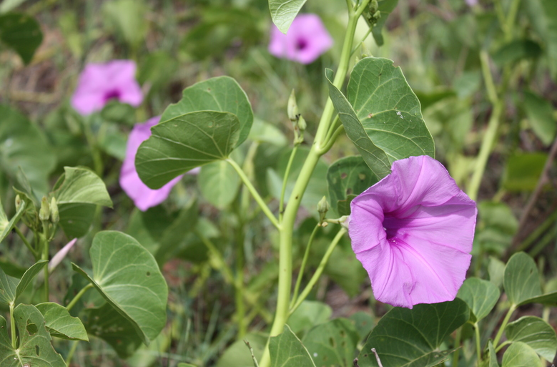
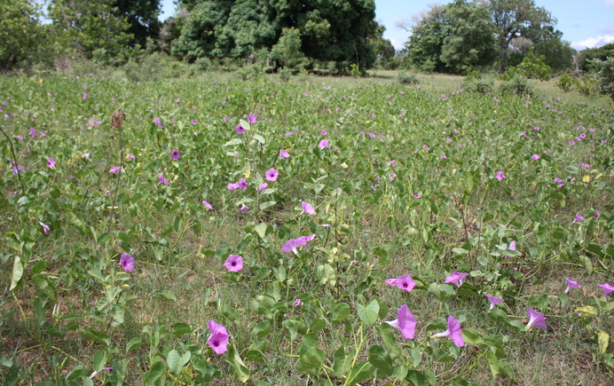
Figure 6: Image showing Ipomoea asarifolia leaves and flowers.

2.3.3 Chemistry of the plant
Phytochemical investigation of the leaf extract of Ipomoea asarifolia led to the identification of saponins, anthraquinones, phenols, tannin, alkaloid flavonoids e.g. rutin (Pale et al., 2003; Jegede et al., 2009; Aliyu et al., 2011; de Souza Lima el al., 2014). According to Jegede et al, (2009) Cardiac glycosides, flavonoid, volatile oil and terpenes were found to be absent in the leaf extract of I. asarifolia. Anthocyanins and volatile oil were found to be present in I. asarifolia extract (Pale et al., 2003). Jenett-Siems et al, (1994; 2004), Pale et al, (2003) and Kucht et al, (2004) identified ergoline alkaloids such as lysergic acid α-hydroxyethylamide, chanoclavine-I (I), lysergic acid amide, ergobalansine, ergobalansinine, lysergic acid ergometrine, isolysergic acid amide (IV) and elymoclavine (II) from the plant. Rutin, caffeic acid and chlorogenic acid were identified from the aqueous leaf extract of I. asarifolia by HPLC-DAD and LCDAD-MS analysis (Furtado et al., 2016). An animal poison called lectin was isolated from the leaf of I. asarifolia (Salles et al., 2011). In 1998 & 2003 Pale et al, identified four acylated anthocyanins from I. asarifolia flowers.

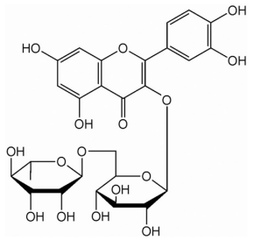
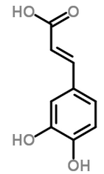
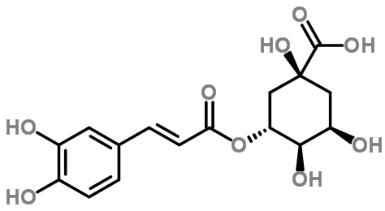
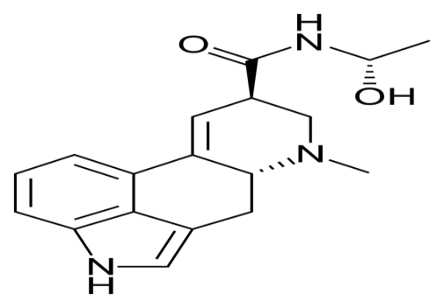
Rutin
Caffeic acid
Chlorogenic acid
Lysergic acid hydroxyethylamide

Figure 7: Chemical structures of some compounds isolated from Ipomoea asarifolia

2.3.4 Traditional uses
Ipomoea asarifolia is popularly known as salsa or salsa-brava in Brazil and the decoction of its leaves are used in ethnomedicine to treat diverse inflammatory disorders such of scabies and dermatitis, and for the treatment of syphilis, skin ulcers and external wounds (Furtado et al., 2016).
In Senegal, I. asarifolia is used traditionally to treat various gynecological ailments (including urinary problems during pregnancy, hemorrhage, abortifacient and ecbolic), also the plant is used to treat arthritis pain, neuralgia, headache, wound dressing, opthalmia (Aliyu et al., 2011).
In Nigeria it is traditionally known as ‘Duman-kaada’, ‘Duman-raafi’ or ‘Duman-kadu’ in Hausa (northern Nigeria), ‘Gboro-ayaba’, ‘Ododo-oko’ and ‘Ododo-amu’ in Yoruba (south west-Nigeria) (Burkill, 1985; Jegede et al., 2009) and it have been used for the treatment of various ailments such as diabetes, neuralgia, stomach ache and arthritic pain, dysmenorrhea, guinea worm sores and liver diseases (Jegede et al., 2009; Farida et al., 2012; Akindale et al., 2014). Hausa/fulani people from northern Nigeria uses this herb to treat feverish chills and rheumatic pains, guinea-worm sores, syphilis (Dalziel, 1937). Ipomoea asarifolia or in combinations of other herbs is used in northern Nigeria to manage cancer disease (oral conservation, 2016).

2.3.5 Pharmacological activities
2.3.5.1 Anti-inflammatory activity; The leaf extract of I. asarifolia exhibited a good anti-inflammatory activity (Jegede et al., 2009; Lawal et al.,2010; de Souza Lima et al., 2014; Furtado et al., 2016).
2.3.5.2 Anti-nociceptive activity; Leaves extract of this plant at the doses of 100, 200, 400 mg/kg i.p. exhibited a significant reduction of pain on the experimental organism (Jegede et al., 2009).
2.3.5.3 Tremorgenic syndrome; Fresh green leaves of I. asarifolia was analysed for a clinical sign (tremorgenic syndrome) on goats, at the end of the experiment the plant part contained undetectable amount of tremorgenic phytotoxins or mycotoxins called swainsonine which is less than 0.001% (Medeiros et al., 2003).
2.3.5.4 Anti-bacterial activity; Both water and methanol leaves extracts of the plant possessed anti-bacterial activity against E. coli, Staphylococcus aureus and pseudomonas aeruginosa at various Minimum inhibitory concentration (MIC) and the minimum bactericidal concentration (MBC) (Aliyu et al., 2011).
2.3.5.5 Analgesic activity; Lawal et al, (2010) reported the analgesic activity of the aqueous extract of the plant.
2.3.5.6 Anti-oxidant activity; Leaves, stem and root extracts of I. asarifolia possessed a significant anti-oxidant activities, with the IC₅₀ values 42, 50 and 65µL, respectively (Ene-Ojo & Onaolapo, 2010)
2.3.5.7 Hepatoprotective activity; Farida et al, (2012) reported the positive action of I. asarifolia leaves against CCl₄-induced liver damage in the experimental rat.

2.4 Ficus sur Forssk.
The genus Ficus from Moraceae family refers to all fig trees and it comprises of about 850 species including F. sycomorus, F. glomosa. Morethan 600 species are spreaded in Asia and Australia and about 100 differents species of Ficus are distributed in Africa (Friis, 1989). They can be found as intersex or as female (Peraza-Sánchez et al., 2002). One of the unique feature of some figs plant is they produced latex which has been used for childreen as chewing gum.It is one of the most important plants mentioned in the holy Qur’an. It grows spontaneously and propagates from its seeds. It mostly grows in the plains and at the riverside where the soil remains humid or wet, even during hot/dry season (Galil & Eisikowitch, 1974). Ficus sur Forssk. (Syn. Ficus capensis Thunb., Ficus mallotocarpa Warb, Sycomorus capensis (Thunb) Miq.)is a species member from Moraceae family commonly known as cape fig/broom-cluster in english found in grasslands, riverine forest, secondary scrub type and cape island, they are common in tropical Africa extending from Senegal to south Africa (Feleke and Brehane, 2005).
2.4.1 Distributions
They are mostly evergreen and widely distributed in tropical areas while some few species are found in semi-warm temperete areas (Halevy, (1989). In Nigeria Ficus sur is locally known by four different languages of Nigeria as uwaryara/dillu in Hausa, Opoto in yoruba, Rima bichehi in fulani, obada in edo and Akokoro in Igbo (Njoku-oji et al., 2016).
2.4.2 Botany
The leaves are green, alternate and broad, and posses a special fruits which are innocuous to human and are produced along the truk or in a branced raceme by a process called cauliflory.Cape figs posses heart or pear shapes inflorescense (figs) called syconium, and an apical opening called ostiole through which the pollinator entered.
They are monoecious with inconspicuous flowers whose sexes are produced within the syconium with the seeds and flowers produced within the syconia. Mutualistic relation ship occurs between one small insect called chalcid wasps (family; Agaonidae) and figs in the syconia (Janzen, 1979). Both the symbiotic patteners (wasp and figs) posses funtional system during pollination tte fig wasp is specie-specific to their host tree (Wiebes, 1964). Members of the genus Ficus depend completely on wasp for polination and the ontogenesis of the wasps is completed within the syconia.
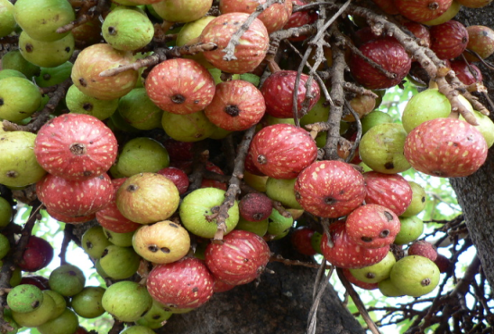
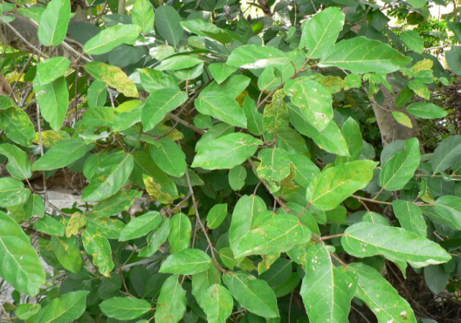
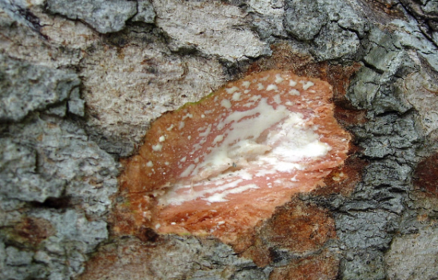
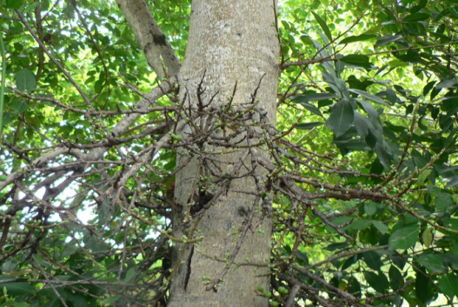
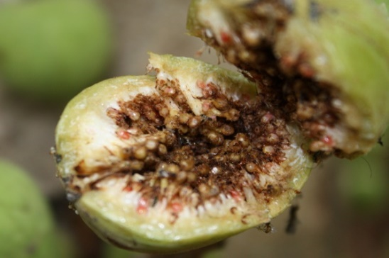
Figure 8: Image showing cape fig tree, leaves, ripe/unripe fruits, exudates and the seeds

2.4.3 Chemistry of the plant
Leaves of F. sur was reported to contain 66.45% dry matter, 11.80% protien, 0.698% calcium and 0.058% magnesium while the leaves plus soft twigs contained 7.33% crude protiens (Olubukola et al., 2013). The ethanolic stem bark extract of Ficus sur was reported to contained alkaloids, tannins, anthraquinones, phlobatannins, cardiac glycosides and sugars (Oyekele et al., 2008; Omonkhelin et al., 2009; Ojokuku et al., 2010; Ishola et al., 2013), while the ethanolic leaves and stem bark extract contained tannins, phytates, saponins, alkaloids,terpenoids, flavonoids and phenolics (Adebayo and Odeniyi, 2012). According to Umeokoli et al, (2013) the dried leaf, aqueous and ethanolic leaves extracts of F. sur were found to contained flavonoids, saponins, starch, lipids, reducing sugar, tannins, protein, starch, glycoside and anthraquinone.
According to Akomolafe et al, (2016) the total flavonoids & phenolic acids obtained from an aqueous leaves extract of F. sur using HPLC-DAD analysis were gallic acid, catechin, chlorogenic acid, ellagic acid, epicatechin and caffeic acid, quercetin, quercitrin, kaempferol and rutin. More than 30 compounds were extracted from the essential oil (leaves) of F. sur with carvacrol, α-caryophyllene, caryophyllene oxide and linalool as the major compounds (Muanda et al., 2010).
The chromatographic analysis of hexane extract of the latex of F. sur revealed the presence of two pentacyclic triterpenoids oleanane and ursene; there structures are elucidated by NMR experimental technique (Feleke and Brehane, 2005). The aqueous leaves extract of F. sur contained sterols and terpenes, carotenoids, alkaloids, flavones, anthracenosids, tannins, alkaloid salt, reducing compounds, flavonosides, anthracenosides, coumarin derivatives, cardenolides, anthocyannins and saponins while the absence coumarins, alkaloids bases, flavones Aglycones and anthacenosides aglycones (Ramde-Tiendrebeogo et al., 2012). Also 4, 4, 24-trimethyl-cholesta-8-en-3-β-ol a combination of campesterol, stigmasterol and β-sitosterol, stigmasterol 3-β-o`glucoside and β-amyrin, 4, 5,7-trihydoxy flavan-3-ol and α-amyrin were identified from the leaves ethanolic extracts of n-hexane and ethyl acetate fractions (Dallafa, 2005). Methanolic extract of the leaves of F. sur were tested and seven compound were identified including cis-oleic acid, 3-methyl-6-hepten-1-ol, palmitic acid, mequinol, isovelari acid with sorbic acid(38.36%) and benzene-1,2,3 triol (38.070%) as the major compounds (Igwe et al., 2016). According to Otitoju et al, (2014) alkaloids, anthocyanin, carotenoids, flavonoids, glycoside, oxalate and tannins were present in both the raw, cooked and shade dried leaves of F. sur.

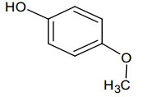
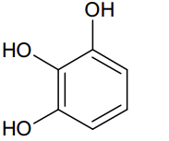
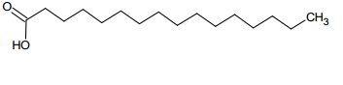
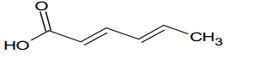
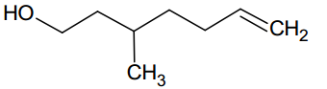
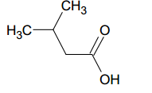
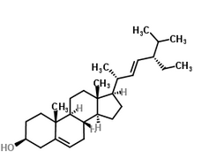
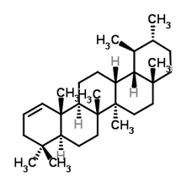
Mequinol
Benzene 1,2,3-triol
Palmitic acid
Sorbic acid
3-methyl-6-heptene-1-ol
Isovelaric acid
Stigmasterol Tocopherol
Uresene

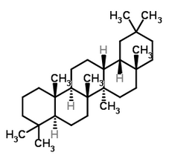
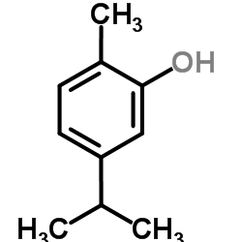
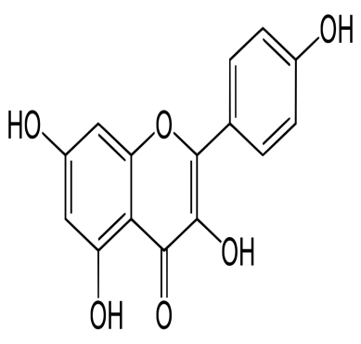
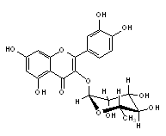
Oleanane
Carvacrol
Kaempferol
Quercitrin

Figure 9: Chemical structures of some compounds isolated from F. sur

2.4.4 Traditional uses
Cape figs may serve as source of food for man and animals, leaves are eaten as vegetables as it was reported to help for blood boosting (Otitoju et al., 2014) and also posses anti-sickling activity of red blood cells (Umeokoli et al., 2013). There fruits are edible for man and also for animals. Ficus sur is locally called “Omora” in Kenya and “Mkuyu” in Tanzania and the stem bark has been used traditionally to treat malaria and fungal infections (Muregi et al., 2003; Moshi et al., 2007). The root and bark are used in South Africa to treat tuberculosis (Madikizela et al., 2013).

Ficus sur are used traditionally in folkore from different part of the world for the treatment of different ailments depending on the region. Several investigators reported the uses of Ficus surin traditional African medicine in Sudan and in Nigeria it is used to treat leucodermia (R & L), swollen fect (R & L), leprosy (leaves and roots), epilepsy, wound dressing, tuberclosis, anaemia, sexually transmitted diseases, diarrhoea, chest infections, circumcision, rickets, oedema, respiratory disorders, emollient, dysentry, infertility in men and gonorrhrea (Nguyi, 1988; Sandabe & Kwari, 2000; Wakeel et al., 2004; Dafalla, 2005; Igoli et al., 2005; Kayode, 2006; Olowokedejo et al., 2008; Oyeleke, et al., 2008; Ishola et al., 2013).
In south eastern Nigeria Ficus sur is used traditionally in the management of haemolytic and sickle cell anaemia (Umeokoli et al., 2013). It is used in northern Nigeria to manage cancer and other diseases (Oral conservation, 2016).

2.4.5 Pharmacological activities
2.4.5.1 Anti-sickling activities
The anti-sickling activity of the leaves extract of F. sur was examined using blood samples from patients with sickle cell diseases, the result shows high action of the extract on sickle cell and anaemia diseases which confirmed the uses of it traditionally in the treatment of anaemia and sickle cells (Umeokoli et al., 2013; Mpiana et al., 2008).
2.4.5.2 Anti-microbial activities
Both the crude leaves and stem bark extracts exhibited anti-bacterial activity against Escherichia coli and Shigella spp and show no activity on Salmonella thyphi, the aqueous and methanolic leaves extracts exhibited the highest activities compared with stem bark extract, at the end of the experiment leaves extract was suggested to continued be used against this two pathogenic bacteria (Oyeleke et al., 2008). According to Igwe et al, (2016) the phytochemicals found in the methanolic leaves extract of F. sur were found to be effective against Escherichia coli, Staphylococcus aureus, Proteus vulgaris and Candida albicans). Both bacteria: E coli staphylococcus aureus Bacillus subtilis with no effect on Pseudomonas aeruginosa and fungi: Candida albicans, Aspergillus niger inhibit the highest activity on the leaves extract of F. sur using methanol-water extracts compared with water extract and other solvent extracts (Muanda et al., 2010). According to (Ramde-Tiendrebeogo et al, (2012) the aqueous leaf extract possess activities on E. coli and S. aureus while shows no activities on S. typhi.
Both folium, stem and bark parts of F. sur were examined in aqueous and ethanol extracts, the ethanolic bark extract possessed the highest activity on Staphylococcus aureus Pseudomonas aeruginosa and Candida albicans while Escherichia coli, Shigella dysenteriae, and Streptococcus faecalis on the leaves extract, and the mode of inhibition increases with the increase in the concentration of the extract (Adebayo-Tayo & Odeniyi, 2012).
2.4.5.3 Anti-radical scavenging activities
The aqueous extract of F. sur leaves has the ability to scavenged hydroxyl (OH), and nitric oxide (NO), and also undergoes Fe²⁺ lipid peroxidation and also has the ability to chelated Fe²⁺, and this is in accordance of the work of Akomolafe et al., (2016).
Aqueous leaves extract shows weak anti-oxidant activity compared with the control and the activity were due to the presence of flavonoids and tannins (Ramde-Tiendrebeogo et al., 2012).
2.4.5.4 Effect on Angiotensin-I-Converting Enzymes (ACE), Acetyl Cholinesterase (AChE) and Arginase
The extracts has the ability to restrain ACE (IC50 = 52.17), AChE (IC50 = 172.60 μg/mL) and arginase (IC50 = 112.50 μg/mL) activities all in dose-dependent manner, and the activities were due to the presence of phenolic compounds and it was the reason of the action of leaves extract of F. sur for the treatment of erectile dysfunction(ED) (Akomolafe et al., 2016).
2.4.5.5 Anti-inflammatory activities
The anti-inflammatory activities of F. sur leaves was reported by (Muanda et al., 2010& Akomolafe et al.,2016).
2.4.5.6 Anti-convulsant activities
Anti-convulsant effect of ethanolic stem bark was tested on albino mice using different models, the result revealed the a significant effect of the extract on the tested organism, there by supporting the usage of the plat part in management of epilepsies (Ishola et al., 2013).
2.4.5.7 Gastrointestinal activity
Cold water, hot water, methanolic and hexane extracts F. sur leaves possessed anti-ulcer, spasmolytic activities and gastrointestinal activity on rabbit jejunum, the hot water extract exhihibited the highest effect (Kunle et al., 1999).
2.4.5.8 Anti-malarial activities
Hexane extract of F. sur stem bark possesed activity against the tested organism (P. falcifarum) (Murege et al.,2003).
2.4.5.9 Anti-abortificient activity
Maceration technique were carriedout to obtained the ethanolic extract from the bark of F. sur , the extract was tested in vitro against uterus (rat) induced with stilbestrol for the abortificient activity, the positive activity was due to the precence of some active principals within the extract (Owolabi et al., 2008).

2.5 Ficus sycomorus L.
Ficus sycomorus is commonly called the sycamore fig or the fig-mulberry in English, it is one of the oldest cultivate plant used in Ayurveda and Chinese traditional Medicine as food and as medicine (Ephraim et al., 2008). Because of its even distribution in different parts of the globe, F. sycomorus is known by several names among different ethnicities, some of which are: baure (Hausa), barda (Somali), subula (Arabic), sicomoro (Spanish), umkhiwane (Zulu), figuier sycamore, sykomore (French) (Al-matani et al., 2014).
2.5.1 Distributions
Ficus sycomorus is native in tropical and subtropical regions of the globe (Pérez et al., 1999; Van Noort et al., 2007). In Africa, it is found abundantly in the Mediterranean basin of Egypt the species are found near streams in savannah area (Adoum et al., 2012). The species is found in abundance in northern part of Nigeria.

2.5.2 Botany
Ficus sycomorus is a short (ranging from 20m height and 6m wide) plant of the Moraceae, a family consisting of about 40 genera and over 1000 species found abundantly in Africa (Al-matani et al., 2016). It bears large fruit (23cm in diameter) which is buff-green to yellow or red in colour, it is gummy (with latex), when unripe; but juicy and sweet when fully ripe. A very tiny rounded seeds, numbering 30-1600 per fruit, are found in each fig. Leaves (14cm tall and 10cm broad) are heart-shaped, broad, and green in colour. They possess green-yellow to orange colour bark and the flowers are unisexual, cyclic, and greenish in colour and contain latex also (Romeh, 2013).It is refers to as sycamore in bible (Lansky et al., 2008). Flowering and fruiting occur throughout the year, attaining their peak from July to December (Southern Africa for example).
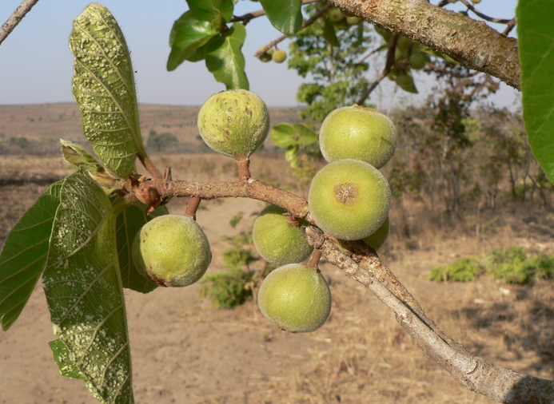
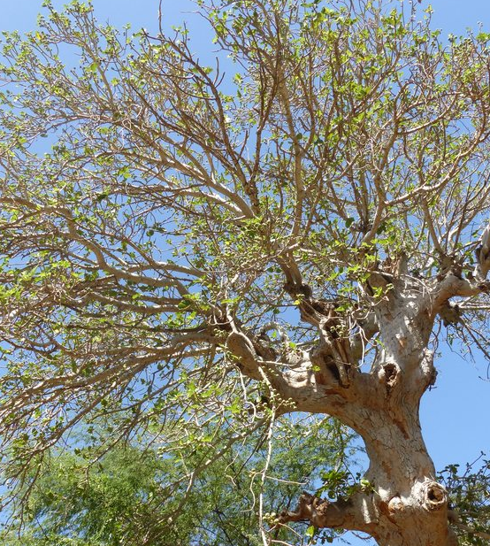
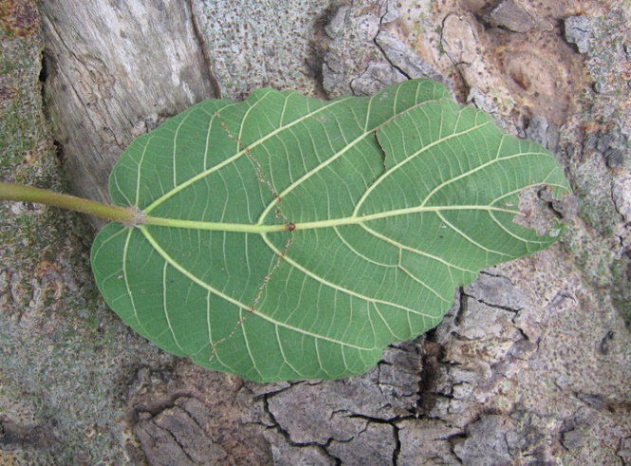

Figure 10: Images showing common cluster fig, leaves, bark, ripe and unripe fruits

2.5.3 Chemistry of the plant
Daniel & Dluya, (2016); Bello et al, (2013); Adoum et al, (2012); Ramde-Tiendrebeogo et al, (2012); Zaku et al, (2009); Sandabe et al, (2006); Hassan et al, (2005) reported that the methanolic extract of the stem bark of F. sycomorus contained alkaloids, flavonoids, phenol, glycosides, reducing sugars, resins, saponins, tannins, terpenoids, anthracenosides, anthocyanins, coumarins, carbohydrates and flavone aglycones. As reported by Keay, (1989); Umar & Azare, (2006) leaves were reported to contained calcium, zinc, iron, magnesium and phosphorus. The seeds of the plant were also found to be rich in carbohydrate, followed by crude fat; while proteins preceded moisture content in percentage abundance, as reported by Okoronkwo et al. (2014). In the same study, they found that the seeds are rich in essential elements such as Ca, P, and Mg, with relatively low amounts of Fe, Zn, and K; and traces of Na, and Cu. HCN (3.05$±$0.030%) and oxalate (2.85$±$0.029%) were also found to be present in relatively non-toxic amounts; but are said to be toxic in higher concentrations (Bello et al., 2008). 1, 2-benzenedicarboxylic acid, diisooctyl ester (45.06%), n-hexadecanoic acid/palmitic acid (7.67%), 3-hexen-1-ol, benzoate Z (4.57%), oleic acid (4.30%) and hexanedioic acid are some of the bioactive phytochemicals found in the leaves of F. sycomorus, and they were found to act as insecticides with higher toxicity than synthetic fumigants (Romeh, 2013).A leaf extracts contained psoralene, lupeol, β-sitosterol and β-amyrin (Abu-Mustafa et al., 1963). Quercetin, gallic acid, quercetin 3-O-Lrhamnopyranosyl (1→6)-β-D-glucopyranoside (Rutin), quercetin 3-O-β-Dglucopyranoside (isoquercitrin), quercetin 3,7-O-α-L-dirhamnoside, quercetin 3-O-β-D-galactopyranosyl(1→6)-glucopyranoside and β-sitosterol-3-β-Dglucopyranoside were the chemical compounds isolated from ethyl acetate and n-butanol fractions of the methanolic leaf extract of F. sycomorus (Salem et al., 2013).

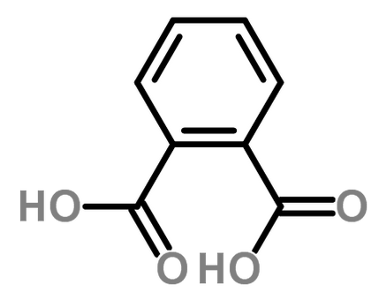
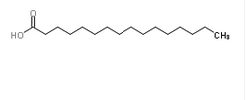
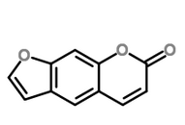
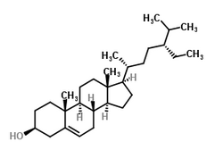
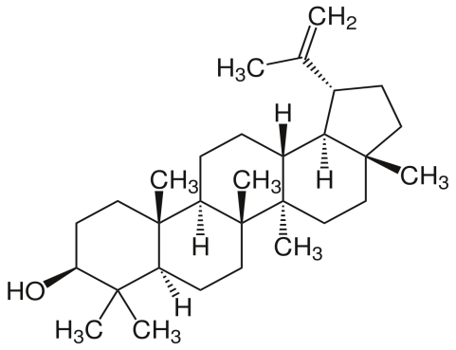
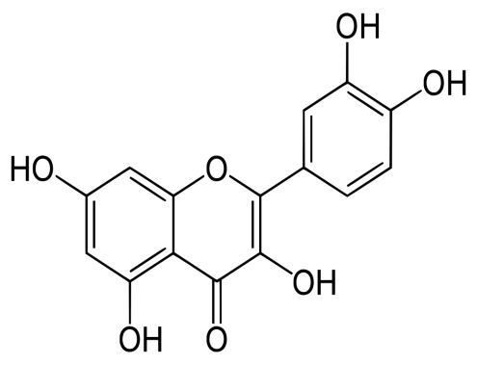
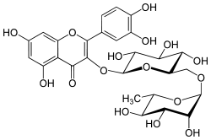
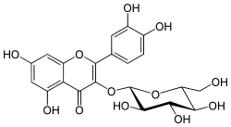
Phthalic acid
Palmitic acid
Psoralene
β-sitosterol
Ascorbic acid
Lupeol
Quercetin
Rutin
Iso-quercetin

Figure 11: Chemical structures of some compounds isolated from F. sycomorus.
2.5.4 Traditional uses
Industrially, the plant can serve as a source of charcoal, wood for furniture works, food (from the fruits), as well as wood for making canoes, mortars and pestles, etc. livestock eat its foliage (Dalziel, 1955).
In medicine, Ficus sycomorus is one of the medicinally utilized and useful plants. Herbal medical practitioners from Nigeria, Tanzania, Niger, Mali, Kenya, Somalia, South Africa, Guinea, Ethiopia and Ivory Coast uses the stem bark, fruits, roots and milky latex obtained from the plant for the treatment of various ailments such as chest infections and dysentery, jaundice, fungal infections, dysentery, cough, diarrhea, liver diseases, skin infections, epilepsy, tuberculosis, lactation disorders, in fertility, helminthiasis and sterility (Igbokwe et al., 2010; Adoum et al., 2012; Hassan et al., 2007; Sandabe et al., 2006; Hedberg and Staugård, 1989; Arnold & Gulumian, 1984). It is also said that the leaves of the plant serve as antidote against snakebites; and are also said to be effective against jaundice. The plant bark is also useful for the treatment of coughs and chest and throat complications. In Zaria, Nigeria, it was reported that hot water extract of the dried stem bark is infused by adult humans against diarrhea (Bello O. et al., 2013).The Hausa and Fulani tribes of Northern Nigeria utilize the stem-bark in the management of diabetes mellitus and cancer diseases (Adoum et al., 2012; oral conservation, 2016). F. sycomorus is also suspected to possess anti-diarrheal (Ahmadu et al., 2007) and anti-convulsant activities (Sandabe et al., 2003).
Outside the African continent, for the management of tuberculosis, the dried fruits are said to be taken orally by adults in Venda (Cyprus) (Arnold & Gulumian, 1984).
Lansky et al, (2008) parts of F. sycomorus including the fruits, bark, leaves, twig, young shoot/branches and latex have been used to treat tumors and some inflammatory disorders. It is used in northern Nigeria to manage cancer and other diseases (Oral conservation, 2016).

2.5.5 Pharmacological activities
2.5.5.1Anti-diabetic activity: According to Adoum et al, (2012), the methanol extract of the stem-bark of F. sycomorus possess anti-diabetic potentials at 250ml/kg, a property they suspected to be due to an improvement of insulin response to glucose level.
2.5.5.2 Anti-oxidant activity; Strong antioxidant activity was reported from the methanolic extract of F. sycomorus stem bark (Daniel & Dluya, 2016; Ramde-Tiendrebeogo et al., 2012).
2.5.5.3 Anti-malarial activities; Both stem bark and the leaves extracts of F. sycomorus exhibited a potent anti-malarial activity against P. falciparum (Sanon et al., 2003).
2.5.5.4 Anti-microbial activity; Adeshina et al. (2010) posited that the plant is a potent anti-microbial agent against ciprofloxacin-resistant Salmonella typhi. A significant activity of fruit extract of Ficus sycomorus was observed against tasted gram positive and gram negative bacterial strains Staphylococcus aureus, Escherichia coli, Haemophilus influenza and Proteus species (Al-matani et al., 2016). Mousa et al, (2013) & Hassan et al, (2006) reported the anti-fungal activities of the stem bark and fruit extracts of F. sycomorus and it was due to the presence of anthraquinone glycosides. The methanolic stem bark and the chloroform leaves extracts of F. sycomorus exhibited anti-bacterial activities against some pathogenic bacteria (Mousa et al., 1994; Salem et al., 2013; Dahiru and Dluya, 2016).
2.5.5.5 Cytotoxic activity; Ethyl acetate fruit extract of F. sycomorus exhibited the highest activity than chloroform, methanol, hexane, water and butanol extracts with the with LC₅₀ values of 86.09, 138.96, 281.83, 341.19, 463.44 mg/mL, respectively (Al-matani et al., 2016).
2.5.5.6 Toxicology In a study to assess the effect of prolonged oral administration of F sycomorus stem bark extract on testicular size of growing male albino rats by Igbokwe et al. (2010), they discovered that oral administration of the aqueous stem bark extract of the plant at 200-600mg/kg to male albino rats had no effect on their body weights, testicular size and scrotal diameter. Saidu et al, (2007) also reported, in a work on the effects of anthraquinone glycosides and aqueous ethanol extracts of F. sycomorus L. on rat liver and kidney functions, that the extracts could cause adverse effects to the liver and kidney at higher doses. Methanol extract of F. sycomorus at higher dosage (5000mg/kg) is safe (Adoum et al., 2012).
2.5.5.7 Effect on muscular activity Sandabe et al. (2006), aqueous stem bark extract of F. sycomorus has inhibitory effects on both the smooth and skeletal muscle contractions, and has vital phytochemicals of pharmacological importance. Zaku et al. (2009) also reported the muscle relaxant activity of the aqueous extract of the plant. In the same study, they reported the efficacy of the root-bark extract as a local anesthetic agent. They found that aqueous root-bark extract of the plant produced 50 and 58.3% local anesthetic effects at 30mg/ml and 100mg/ml, respectively; while the (conventional or synthetic) xylocaine produced 33.3 and 53.3% anesthesia at 0.3mg/ml and 1.0mg/ml, respectively. The result of a study by S. H. Garba et al, (2006) suggested that the aqueous root-bark extract of the plant is toxic at higher concentrations and amounts.

3.0 EXPERIMENTAL PART

3.0 MATERIAL AND METHODS
3.1 Plant collection, identification and authentication
The stem barks/leaves of Ficus sycomorus (commonly known as “baure” in Hausa language), Sclerocarya birrea (commonly known as “danya” in Hausa language) and the Ipomoea asarifolia (commonly known as “duman rafi” in Hausa language) were collected in Bayero University Kano, old campus-Nigeria in September, 2016. Whereas the stem barks of Daniellia oliveri (Rolfe) Hutch.& Dalzie (syn. Paradaniellia oliveri Rolfe.) sub-family Caesalpinioideae and family Fabaceae (commonly known as “maje” in Hausa language) with voucher specimen BUKHAN0268 and Ficus sur (commonly known as “dillu” in Hausa language) were collected in Sumaila, Kano-Nigeria in September, 2016. The plants were identified by Taxonomical means, documented and authenticated by Baha’uddeen Sa’id Adam at the Herbarium unit of the department of plant sciences, Bayero University, Kano- Nigeria. The parts were air dried in the herbarium, Bayero University Kano, Nigeria and exported to the department of Pharmacognosy, Near East University. T.R.N.C.
3.2 Preparation of the powdered drug
The stem bark of Daniellia oliveri was washed thoroughly and air-dried. The dried drug was grinded in to a fine powder using blender (WARING® COMMERCIAL BLENDER), and polymix (PX-MEC90D) dispersing and mixing machine. The powdered drug was transferred in to the clean and dried beaker labeled as D. oliveri powdered drug.

3.3 Preparation of the extract
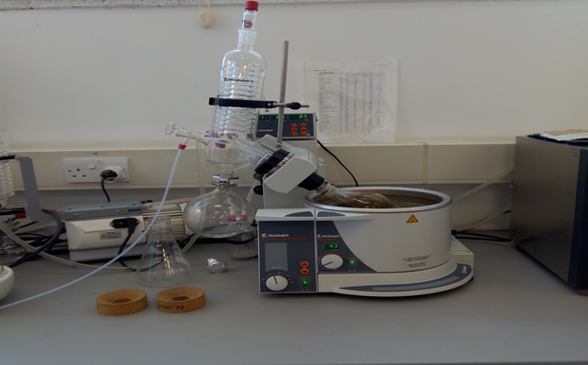
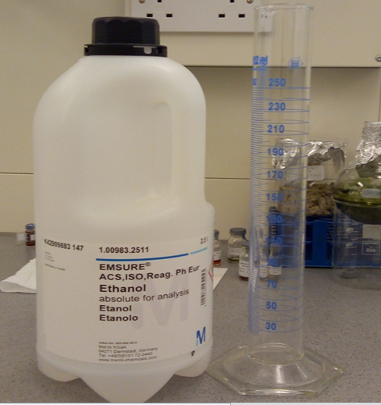
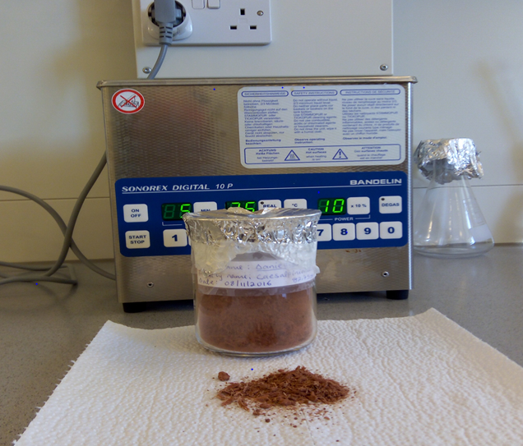
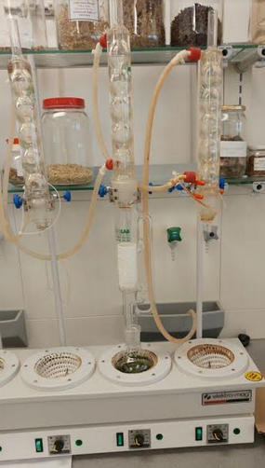
10g quantity of the powdered drug and 150ml of ethanol were used during Soxhlet extraction for about 3 h. Rotatory evaporator was used to remove the amount of ethanol present in the extract until dryness and then dissolve with tertiary butanol-water in the ratio of 1:3. The extract was further dried in a freeze dryer for 24-36 h (lyophylization process) and obtained 2.28g of pure dried extract. The crude extract was stored at room temperature until use.
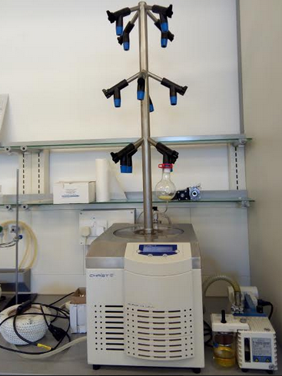
Figure 12: Images showing extraction process, concentration of extract, and the extracts obtained

3.4 Cell line and cell culture
Colo-320 (human colon adenocarcinoma established, ATCC catalogue: CCL 220) and Colo-741 cell lines (ECACC 93052621) are maintained in culture in RPMI-1640 medium (Biochrom, FG1215), 10% FBS (Capricorn Scientific, FBS-11B), 1% penicillin-streptomycin (Biochrom, A2213)and 1% glutamine (EMD Millipore, K0282).Cells were cultured in a humidified atmosphere at 37 °C in 5% CO₂. When the cells were 80% confluent, they were routinely sub-cultured using 0.25% trypsin-EDTA solution (Biochrom, L2143).
3.5 Cell viability and growth assays
Daniellia oliveri extract was diluted with dimethylsulfoxide (DMSO, Sigma-Aldrich) to 100 mg/ml. The extracts were further diluted in culture medium (5µg/ml, 10µg/ml, 20µg/ml, 50µg/ml and 100µg/ml). Colo-320 and Colo-741 cells were collected, suspended in medium and seeded in 96-well culture dishes at a density of 5 x 10⁴/mL cells in each cell with 100 µl medium. Negative control row neither contained any cells nor extracts and positive control row only had cells seeded in. Extract dilutions were triplicated. Both cell lines were incubated for 24 h.
The cell viability estimation was done by MTT assay, reduction of 3-(4,5-dimethylthiazol-2-yl)-2,5-diphenyltetrazolium bromide to a purple formazan product. MTT solution (Biotium, #30006) was heated to 37°C and then 10 µl were added to the each cell. After 4 h incubation at 37°C in 5% CO2, 200 µl DMSO was added to dissolve the formazan salts. The absorbance was measured at 570 nm with spectrophotometer (Versa Max, Molecular Device, and Sunnyvale, USA).

4.0 RESULTS
4.1 Cell viability and cytotoxicity
Colo-320 and Colo-741 cells were treated with Daniellia oliveri extracts for 24 h. The cell viability was determined as described above by MTT assay. Daniellia oliveri extracts inhibited the growth of Colo-320 and Colo-741 cells in a dose-and time-dependent manner (Figure 14). Our results showed that Daniellia oliveri extract at 100ug/mL were more effective in inhibiting Colo-320 and Colo-741 cell growth when compared with other dilutions (Figure 14).
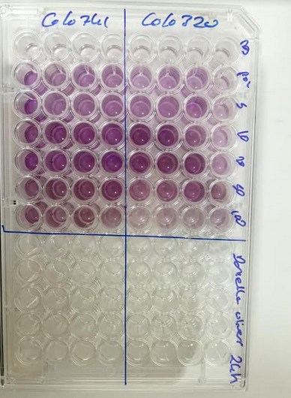
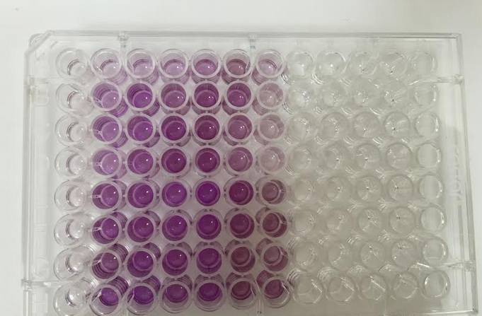
Figure 13: Images showing the MTT assay of the ethanol extract of D. oliveri stem bark

Figure 14: Effects of Daniellia oliveri extract cell viability of Colo-741 and Colo-320 cells. Colo-741 and Colo-320 cells were treated with different concentrations of Daniellia oliveri for 24 h. Viability was quantitated by MTT assay.

4.0 CONCLUSION
Despite to the traditional uses of all the five plants in the management of cancer in northern Nigeria, to the best of this research, three plants, D. oliveri, S. birrea and F. sycomorus were previously reported to possess cytotoxic/anticancer activity, which may support the use of these plants in the treatment of some cancer type. Several investigators have isolated various compounds from these plants, but all the isolated compounds are different from each other, therefore it is difficult to find the responsible compound for the activity.
For the experimental part the stem barks of Daniellia oliveri (Rolfe) Hutch.& Dalzie (syn. Paradaniellia oliveri ( Rolfe.) was investigated for cytotoxic activity. The result indicates that the ethanolic extract of D. oliveri inhibited the growth of the Colo 741 and Colo 320 cell lines in both dose and time-dependent manner, and the extract is more effective at 100µg/ml compared with other dilutions. These findings may support the suggested traditional use of the stem bark of D. oliveri in the management or control of cancer in northern Nigeria. Yet further investigations of all other plants will be investigated in the same way.

ACKNOWLEDGEMENT
I wish to heartily acknowledge Assist. Prof. Dr. Eda Becer of the Department of Biochemistry, Faculty of Pharmacy, Near East University, for hers kind assistance in cell culture experiment.

REFERENCES

Abu-Mustafa, E. A., El-Tawil, B. A. H., & Fayez, M. B. E. (1963). Constituents of local plants—IV.: Ficus carica L., F. sycomorus L. and F. salicifolia L. leaves. Phytochemistry, 3(6), 701-703.
Adama, K., Adama, B., Tamboura, H., Amadou, T., & Laya, S. (2009). In vitro anthelmintic effect of two medicinal plants (Anogeissus leiocarpus and Daniellia oliveri) on Haemonchus contortus, an abosomal nematode of sheep in Burkina Faso. African Journal of Biotechnology, 8 (18), 4690-4695.
Adebayo-Tayo, B. C., & Odeniyi, A. O. (2012). Phytochemical screening and microbial inhibitory activities of Ficus Capensis. African Journal of Biomedical Research, 15 (1), 35-40.
Adelaja, A. (2006). Nigeria boosts research into traditional medicine. Science and Development Network: news, views and information about science and technology and the development world.
Adoum, O. A., Micheal, B. O., & Mohammad, I. S. (2012). Phytochemicals and hypoglycaemic effect of methanol stem-bark extract of Ficus sycomorus Linn (Moraceae) on alloxan induced diabetic Wistar albino rats. African Journal of Biotechnology, 11 (17), 4095-4097.
Adubiaro, H. O., Olaofe, O., & Akintayo, E. T. (2011). Chemical composition, calcium, zinc and phytate interrelationships in Albizia lebbeck and Daniellia oliveri seeds. Oriental Journal of Chemistry, 27(1), 33-40.
Afolayan, A. J., & Sunmonu, T. O. (2010). In vivo studies on antidiabetic plants used in South African herbal medicine. Journal of Clinical Biochemistry and Nutrition, 47(2), 98-106.
Aguoru, C. U., & Anjira, S. (2013). Evaluating extracts of Daniella oliveri for antimicrobial activities in Benue state, North Central Nigeria. Ind J Sci Res Tech, 1, 12-17.
Ahmadu, A. A., & Agunu, A. (2012). Phytochemical and biological investigation of Daniellia oliveri leaves (Fabaceae). Planta Medica, 78(11), 149-158.
Ahmadu, A. A., Baba, H., & Agunu, A. (2014). Triterpenoids from Daniellia oliveri leaves, Hutch and Dalz (Fabaceae). Nigerian Journal of Pharmaceutical and Applied Science Research, 3(1), 10-14.
Ahmadu, A. A., Haruna, A. K., Garba, M., Sule, M. I., Pateh, U. U., Ebeshi, B. U., & Sarker, S. D. (2004). Flavonoid glycosides from the leaves of Daniellia oliveri. Nigerian Journal of Natural Products and Medicine, 8(1), 67-68.
Ahmadu, A. A., Zezi, A. U., & Yaro, A. H. (2007). Anti-diarrheal activity of the leaf extracts of Daniellia oliveri hutch and Dalz (Fabaceae) and Ficus sycomorus Miq (Moraceae). African Journal of Traditional, Complementary and Alternative Medicines, 4(4), 524-528.
Ahmadu, A. A., Zezi, A. U., Yaro, A. H. (2007). Anti-diarrheal activity of the leaf – extracts of Daniella oliveri Hutch and Ficus sycomorus. Afr. J. Trad. CAM, 4(4): 524- 528.
Ahmadu, A., Kaita, H. A., Garba, M., & Yaro, A. H. (2003). Antispasmodic actions of the leaves of Daniellia oliveri. Nigerian Journal of Natural Products and Medicine, 7(1), 13-15.
Ahrens, W., Pohlabeln, H., Foraita, R., Nelis, M., Lagiou, P., Lagiou, A., ...& Richiardi, L. (2014). Oral health, dental care and mouthwash associated with upper aerodigestive tract cancer risk in Europe: the ARCAGE study. Oral Oncology, 50(6), 616-625.
Ahua, K. M., Ioset, J. R., Ioset, K. N., Diallo, D., Mauël, J., & Hostettmann, K. (2007). Anti-leishmanial activities associated with plants used in the Malian traditional medicine. Journal of Ethnopharmacology, 110(1), 99-104.
Ajibade, L. T., Fatoba, P. O., Raheem, U. A., & Odunuga, B. A. (2005). Ethnomedicine and primary healthcare in Ilorin, Nigeria. Indian J Traditional Knowledge, 4(2), 150-158.
Akindele, A. J., Unachukwu, E. G., & Osiagwu, D. D. (2015). 90 Days toxicological assessment of hydroethanolic leaf extract of Ipomoea asarifolia (Desr.) Roem. and Schult. (Convolvulaceae) in rats. Journal of Ethnopharmacology, 174, 582-594.
Alain, K. Y., Valentin, W. D., Christian, K. T., Pascal, A. D., & Dominique, S. C. (2015). Phytochemical screening, antibacterial and anti-radical activities of Daniellia oliveri trunk bark extracts used in veterinary medicine against gastrointestinal diseases in Benin. International Journal, 3(10), 1190-1198.
Aliyu, M. S., Lawal, U., Tijjani, M. B., Doko, M. H. I., Garba, I., Kokya, H. A., ...& Ibrahim, M. M. (2011). Phytochemical and antibacterial properties of Leaf extracts of Ipomoea asarifolia. Nigerian Journal of Basic and Applied Sciences, 19(2).236-240.
Al-matani, S. K., Al-Wahaibi, R. N. S., &Hossain, M. A. (2015). In vitro evaluation of the total phenolic and flavonoid contents and the antimicrobial and cytotoxicity activities of crude fruit extracts with different polarities from Ficus sycomorus. Pacific Science Review A: Natural Science and Engineering, 17(3), 103-108.
Alvarez-Gelves, J. C., &Perez-Arias, E. (1986). Provincial cancer registry, La Plata. Cancer Occurrence in Developing Countries, 75.
Amin, A., Gali-Muhtasib, H., Ocker, M., & Schneider-Stock, R. (2009). Overview of major classes of plant-derived anticancer drugs. Int J Biomed Sci, 5(1), 1-11.
Arnold, H. J., & Gulumian, M. (1984). Pharmacopoeia of traditional medicine in Venda. Journal of Ethnopharmacology, 12(1), 35-74.
Atolani, O., & Olatunji, G. A. (2014).Isolation and evaluation of antiglycation potential of polyalthic acid (furano-terpene) from Daniella oliveri. Journal of Pharmaceutical Analysis, 4(6), 407-411.
Balogun, E. A., & Adebayo, J. O. (2007). Effect of ethanolic extract of Daniella Oliveri leaves on some cardiovascular indices in rats. Pharmacognosy Magazine, 3(9), 16-20.
Barbosa, J. D., Oliveira, C. M. C.D., Duarte, M. D., Peixoto, P. V., & Tokarnia, C. H. (2005). Experimental and natural poisoning by Ipomoea asarifolia (Convolvulaceae) in buffaloes and other ruminants. Pesquisa Veterinária Brasileira, 25(4), 231-234.
Bello Oluwasesan M., Zack Agbendeh, M., & Adikwu Jacob G. (2013). Comparative study of phytochemical screening of F. sycomorus L. stem bark extract and Piliostigma thoningii roots extract. Asian Journal of Plant Science and Research, 3(6), 69-73.
Berhaut, J. (1971). Flore illustree du Senegal... dicotyledones: tome 1. Acanthaceesa Avicenniacees.Dakar: Ministere du Developpement Rural 626p.Illustrations Geog, 5.
Borochov-Neori, H., Judeinstein, S., Greenberg, A., Fuhrman, B., Attias, J., Volkova, N., ...& Aviram, M. (2008). Phenolic antioxidants and antiatherogenic effects of Marula (Sclerocarya birrea Subsp. caffra) fruit juice in healthy humans. Journal of Agricultural and Food Chemistry, 56(21), 9884-9891.
Boye, A., Amoateng, P., Koffuor, G. A., Barku, V. Y. A., Bawa, E. M., & Anto, O. E. (2013). Anti-nociceptive and antioxidant activity of an aqueous root bark extract of Daniellia oliveri (Rolfe) Hutch.& Dalziel (Fam: Leguminosae [Fabaceae]) in ICR mice. Journal of Applied Pharmaceutical Science, 3(12), 36-45.
Boyle, P., & Levin, B. (2008). World cancer report 2008. IARC Press, International Agency for Research on Cancer.
Braca, A., Politi, M., Sanogo, R., Sanou, H., Morelli, I., Pizza, C., & De Tommasi, N. (2003). Chemical composition and antioxidant activity of phenolic compounds from wild and cultivated Sclerocarya birrea (Anacardiaceae) leaves. Journal of Agricultural and Food Chemistry, 51(23), 6689-6695.
Burkill, H. M. (1985). The useful plants of West Africa (tropical). Royal Botanic Gardens, Kew, 319.
Burkill, H.M. (1997). Leguminosae In: The useful plants of Tropical Africa. Crown Botanic. Garden. Ostend. Unit as Press. pp 95-98.
Coker, M. E., & Ogundele, O. S. (2016). Evaluation of The Anti-Fungal Properties of Extracts of Daniella oliveri. African Journal of Biomedical Research, 19(1), 55-60.
Cragg, G. M., & Newman, D. J. (2005). Plants as a source of anti-cancer agents. Journal of Ethnopharmacology, 100(1), 72-79.
Dafalla, H. A. A. (2005). Studies on the constituents of Ficus capensis (Thunb).Pak. J. Social Sci, 3, 751-754.
Dalziel JM (1937). Ceasalpiniaceae The useful plants of West Tropical Africa. Crown Agents, London 1,186 – 187.
Dalziel, J. M. (1937). The useful plants of tropical West Africa. Crown Agencies for the Colonies, London.
Dalziel, J. M. (1955). The useful plants of west tropical Africa. Crown Agent for Overseas Governments and Administration, Mill Bank, London, pp. 199.
Daniel, D., & Dluya, T. (2016).In vitro Biochemical Assessments of Methanol Stem Bark Extracts of Ficus sycomorus Plant . Jordan Journal of Biological Sciences, 9(1).63-68.
Danlami, U., & David, B. M. (2012). Physicochemical properties and antioxidant potentials of Daniella oliveri seed oil. Res. J. Eng. Applied Sci, 1, 389-392.
Dassou H.G., Ogni, C.A., Yedomonha, H., Adomou A.C., Tossou, M., Dougnon, J.T et Akoegninou A, (2014) Diversité, usages vétérinaires et vulnérabilité des plantesmédicinales au Nord-Bénin. Int. J. Biol. Chem. Sci 8(1): 189-210
Data from IARC GlobalCan (2012) (Access date; Sep/2016).
de la Estrella, M., Aedo, C., Mackinder, B., & Velayos, M. (2010). Taxonomic Revision of Daniellia (Leguminosae: Caesalpinioideae). Systematic Botany, 35(2), 296-324.
de Souza Lima, M. C. J., Bitencourt, M. A. O., Furtado, A. A., Rocha, H. A. O., Oliveira, R. M., da Silva-Júnior, A. A., ... & de Freitas Fernandes-Pedrosa, M. (2014). Ipomoea asarifolia neutralizes inflammation induced by Tityus serrulatus scorpion venom. Journal of ethnopharmacology, 153(3), 890-895.
Devesa, S. S., Blot, W. J., Stone, B. J., Miller, B. A., Tarone, R. E., & Fraumeni, J. F. (1995). Recent cancer trends in the United States. Journal of the National Cancer Institute, 87(3), 175-182.
Dimo, T., Rakotonirina, S. V., Tan, P. V., Azay, J., Dongo, E., Kamtchouing, P., & Cros, G. (2007). Effect of Sclerocarya birrea (Anacardiaceae) stem bark methylene chloride/methanol extract on streptozotocin-diabetic rats. Journal of Ethnopharmacology, 110(3), 434-438.
Döbereiner, J., Tokarnia, C. H., & Canella, C. F. C. (1960). Intoxicação experimental pela “salsa” (Ipomoea asarifolia R. et Schult.) emruminantes. Arqs Inst. Biol. Animal, Rio de J, 3, 39-57.
Duke, J. A., & Vasquez, R. (1994). Amazonian Ethnobotanical Dictionary. CRC press.
Eckhardt, S. (2002). Recent progress in the development of anticancer agents. Current Medicinal Chemistry-Anti-Cancer Agents, 2(3), 419-439.
El-Mahmood, A. M., Doughari, J. H. and Chanji, F. J. (2008). In vitro antibacterial activities of crude extracts of Nauclea latifolia and Daniella oliveri. Scientific Research and Essays, 3(3), 102-105.
Elmore, C. D., Hurst, H. R., & Austin, D. F. (1990). Biology and control of morning glory (Ipomoea spp.).Reviews of Weed Science, 5, 83-114.
Eloff, J. N. (2001). Antibacterial activity of Marula (Sclerocarya birrea (A. rich.)Hochst. subsp. caffra (Sond.) Kokwaro) (Anacardiaceae) bark and leaves. Journal of Ethnopharmacology, 76(3), 305-308.
Ene-Ojo A, S., & Onaolapo, G. S. (2010). Comparative in vitro antioxidant potential of different parts of Ipomoea asarifolia, Roemer & Schultes, Guiera senegalensis, JF Gmel and Anisopus mannii NE Brown. Brazilian Journal of Pharmaceutical Sciences, 46(2), 245-250.
Ephraim P, L., Helena M. P., Alison D. P., Robert A. N. (2008). Ficus species (Fig): Ethno-botany and potential as anticancer and anti-inflammatory agents. Journal of Ethnopharmacology, 119, 195-213.
Ezekwesili, C. N., & Ogbunugafor, H. A. (2015).Blood glucose lowering activity of five Nigerian medicinal plants in alloxan-induced diabetic wistar albino rats. Animal Research International, 12(2), 2150-2158.
Fadeyi, S. A., Fadeyi, O. O., Adejumo, A. A., Okoro, C., & Myles, E. L. (2013). In vitro anticancer screening of 24 locally used Nigerian medicinal plants. BMC Complementary and Alternative Medicine, 13(1), 79-88.
Farida, T., Salawu, O. A., Tijani, A. Y., & Ejiofor, J. I. (2012). Pharmacological evaluation of Ipomoea asarifolia (Desr.) against carbon tetrachloride-induced hepatotoxicity in rats. Journal of Ethnopharmacology, 142(3), 642-646.
Farnsworth, N. R., Akerele, O., Bingel, A. S., Soejarto, D. D., & Guo, Z. (1985). Medicinal plants in therapy. Bulletin of the World Health Organization, 63(6), 965-981.
Feleke, S., & Brehane, A. (2005). Triterpene compounds from the latex of Ficus sur I. Bulletin of the Chemical Society of Ethiopia, 19(2), 307-310.
Ferlay, J., Héry, C., Autier, P., & Sankaranarayanan, R. (2010). Global burden of breast cancer. In Breast Cancer Epidemiology. pp. 1-19.
Ferlay, J., Shin, H. R., Bray, F., Forman, D., Mathers, C., & Parkin, D. M. (2010). Estimates of worldwide burden of cancer in 2008: GLOBOCAN 2008. International Journal of Cancer, 127(12), 2893-2917.
Fleury, M. (1997). A propos de l'inheret medicinal du baume de Copahu [On medicinal role of Copahubalsan [sic]]. Acta Bot. Gallica, 144, 473-479.
Fotio, A. L., Dimo, T., Nguelefack, T. B., Dzeufiet, P. D., Lemba, E. N., Temdie, R. J. &Kamtchouing, P. (2009). Acute and chronic anti-inflammatory properties of the stem bark aqueous and methanol extracts of Sclerocarya birrea (Anacardiaceae). Inflammo-pharmacology, 17(4), 229.
Fouche, G., Cragg, G. M., Pillay, P., Kolesnikova, N., Maharaj, V. J., &Senabe, J. (2008).In vitro anticancer screening of South African plants. Journal of Ethnopharmacology, 119(3), 455-461.
Friis, I. in Flora of Ethiopia, Vol. 3, Hedberg, I.; Edwards, S. (Eds.), Addis Ababa and Uppsala University, Addis Ababa, Asmera, Ethiopia and Uppsala, Sweden; 1989; pp 271- 301.
Furtado, A. A., Torres-Rêgo, M., Lima, M. C., Bitencourt, M. A., Estrela, A. B., da Silva, N. S., & Zucolotto, S. M. (2016). Aqueous extract from Ipomoea asarifolia (Convolvulaceae) leaves and its phenolic compounds have anti-inflammatory activity in murine models of edema, peritonitis and air-pouch inflammation. Journal of Ethnopharmacology, 192, 225-235.
Galil, J., & Eisikowitch, D. (1974). Further studies on pollination ecology in Ficus sycomorus II. Pocket filling and emptying by Ceratosolen arabicus Mayr. New Phytologist, 73(3), 515-528.
Galvez, J., Zarzuelo, A., Crespo, M. E., Utrilla, M. P., Jimenez, J., Spiessens, C., & de Witte, P. (1991). Anti-diarrhoeic activity of Sclerocarya birrea bark extract and its active tannin constituent in rats. Phytotherapy Research, 5(6), 276-278.
Garba, S. H., Prasad, J., & Sandabe, U. K. (2006). Histomorphological effect of the aqueous root-bark extract of Ficus sycomorus (Linn) on the liver and kidney of albino rats. International Journal of Pharmacology, 2(6), 628-632.
Gilbert, M. (2000). Medicinal importance of Copaiba oil. J. Pharmacol, 4, 1159-1164.
Glew, R. S., VanderJagt, D. J., Huang, Y. S., Chuang, L. T., Bosse, R., & Glew, R. H. (2004). Nutritional analysis of the edible pit of Sclerocarya birrea in the Republic of Niger (daniya, Hausa). Journal of Food Composition and Analysis, 17(1), 99-111.
Gondwe, M., Kamadyaapa, D. R., Tufts, M., Chuturgoon, A. A., & Musabayane, C. T. (2008). Sclerocarya birrea [(A. Rich.)Hochst.][Anacardiaceae] stem-bark ethanolic extract (SBE) modulates blood glucose, glomerular filtration rate (GFR) and mean arterial blood pressure (MAP) of STZ-induced diabetic rats. Phytomedicine, 15(9), 699-709.
Gouwakinnou, G. N., Lykke, A. M., Assogbadjo, A. E., & Sinsin, B. (2011). Local knowledge, pattern and diversity of use of Sclerocarya birrea. Journal of Ethno biology and Ethnomedicine, 7(1), 8-17.
Green, E., Samie, A., Obi, C. L., Bessong, P. O., & Ndip, R. N. (2010). Inhibitory properties of selected South African medicinal plants against Mycobacterium tuberculosis. Journal of Ethnopharmacology, 130(1), 151-157.
Gruenwald, J. (2006). Anti-ageing nutraceuticals-Joerg Gruenwald considers existing and new botanicals used in anti-ageing products. Food Science Technology-Information Quarterly of the Institute of Food Science and Techn, 20(3), 50-51.
Hassan, L. G., Dangoggo, S. M., Hassan, S. W., Muhammad, S., & Umar, K. J. (2010). Nutritional and anti-nutritional composition of Sclerocarya birrea fruit juice. Nigerian Journal of Basic and Applied Sciences, 18(2), 222-228.
Hassan, L. G., Dangoggo, S. M., Umar, K. J., Saidu, I., & Folorunsho, F. A. (2008). Proximate, minerals and anti-nutritional factors of Daniellia oliveri seed kernel. Chem Class J, 5, 31-36.
Hassan, S. W. (2005). Antimicrobial screening, phytochemical analysis and toxicological studies on some medicinal plants (Doctoral dissertation, Ph. D. dissertation, UsmanuDanfodiyo University, Sokoto, Nigeria).
Hassan, S. W., Lawal, M., Muhammad, B. Y., Umar, R. A., Bilbis, L. S., Faruk, U. Z., & Ebbo, A. A. (2007). Antifungal activity and phytochemical analysis of column chromato-graphic fractions of stem bark extracts of Ficus sycomorus L (Moraceae). J. Plant Sci, 2(2), 209-215.
Hedberg, I., & Staugård, F. (1989). Traditional Medicine in Botswana: Traditional Medicinal Plants. Ipeleng Publishers.
Hill, G. B. (1975). Mortality from malignant neoplasm of the uterus since 1950. Statistical Report. World Health Organization, 28(8), 323-338.
Houehounha, R., Avohou, H. T., Gaoue, O. G., Assogbadjo, A. E., & Sinsin, B. (2010). Weed removal improves coppice growth of Daniellia oliveri and its use as fuelwood in traditional fallows in Benin. Agroforestry Systems, 78(2), 115-125.
http://www.chemspider.com/Chemical-Structure.454895.html?rid=3e23a56a-18a9-48df-93f5-af0c4ce805ae&page_num=0 (Accessed January 14 2017).
http://www.medicalnewstoday.com/articles/150496.php (Access date; 03/05/2017).
http://www.medicinalplantsinnigeria.com/group-d.html (Access date; 10/01/2016).
http://www.webmd.com/cancer/cervical-cancer/cervical-cancer-topic-overview#2 (Access date; 17/04/2017)
http://www.westafricanplants.senckenberg.de/root/index.php?page_id=14&id=539#(Access date;10/01/2017)
https://www.cancer.gov/about-cancer (Access date; 29/01/2017)
https://www.plantzafrica.com/plantqrs/sclerobirr.htm (Access date 01/01/2017)
Hunter, M. S., Grunfeld, E. A., Mittal, S., Sikka, P., Ramirez, A. J., Fentiman, I., & Hamed, H. (2004). Menopausal symptoms in women with breast cancer: prevalence and treatment preferences. Psycho‐Oncology, 13(11), 769-778.
Hutchings, A. (1996). Zulu medicinal plants: An inventory. University of Natal Press.
Hutchinson J, Dalziel JM (1954). Ceasalpiniaceae. Flora of West Tropical Africa. Crown Agents, London 1(1), 461 – 463
Hutchinson, J., & Dalziel, J. M. (1963). Flora of West Tropical African; Vol. 2, Crown Agents, London.
Igbokwe, N. A., Igbokwe, I. O., & Sandabe, U. K. (2010). Effect of prolonged oral administration of aqueous Ficus sycomorus stem-bark extract on testicular size of growing albino rat. International Journal of Morphology, 28(4), 1315-1322.
Igoli, J. O., Ogaji, O. G., Tor-Anyiin, T. A., & Igoli, N. P. (2005). Traditional medicine practice amongst the Igede people of Nigeria. Part II.
Igwe, K. K., Udeh, N. E., Madubuike, A. J., & Amuneke, C. C. (2016). Characterization and antimicrobial studies of Ficus capensis methanolic leaf extract. International Journal of Advanced Research in Science, Engineering and Technology 3(4), 1931-1941.
Irabor, D. O. (2012). Ethnic differences in colon and rectal cancer incidence in Nigeria: A case of dietary determinants?. East and Central African Journal of Surgery, 17(2), 70-73.
Irabor, D. O., Arowolo, A., & Afolabi, A. A. (2010). Colon and rectal cancer in Ibadan, Nigeria: an update. Colorectal Disease, 12(7Online), e43-e49.
Irabor, D., & Adedeji, O. A. (2009). Colorectal cancer in Nigeria: 40 years on. A review. European journal of cancer care, 18(2), 110-115.
Ishola, I. O., Olayemi, S. O., Yemitan, O. K., & Ekpemandudiri, N. K. (2013). Mechanisms of Anticonvulsant and Sedative Actions of the Ethanolic Stem-bark Extract of Ficus sur Forssk (Moraceae) in Rodents. Pakistan Journal of Biological Sciences, 16(21), 1287-1294.
Iwueke, A. V., & Nwodo, O. F. C. (2008). Anti-hyperglycemic effect of aqueous extract of Daniella oliveri and Sarcocephalus latifolius roots on key carbohydrate metabolic enzymes and glycogen in experimental diabetes. Biokemistri, 20(2), 63-70.
Iwueke, A. V., Nwodo, O. F. C., Shoyinka, V. S. O., & Joshua, P. E. (2009). Safety Evaluation of an Anti-diabetic Combined Aqueous Root Extract of Sarcocephalus latifolius and Daniella oliveri. Nigerian Journal of Biochemistry and Molecular Biology, 24(2), 37-42.
Jama, B. A., Mohamed, A. M., Mulatya, J., & Njui, A. N. (2008).Comparing the “Big Five”: A framework for the sustainable management of indigenous fruit trees in the drylands of East and Central Africa. Ecological Indicators, 8(2), 170-179.
Janzen, D. H. (1979).How to be a fig. Annual Review of Ecology and Systematics, 10, 13-51.
Jayeola, A. A., & Oladunjoye, O. R. (2012). Systematic Studies In Some Ipomoea Linn. Species Using Pollen And Flower Morphology. Annals of West University of Timişoara, Ser. Biology, Vol 15 (2), 177-187.
Jedy-Agba, E., Curado, M. P., Ogunbiyi, O., Oga, E., Fabowale, T., Igbinoba, F.& Osinubi, P. (2012). Cancer incidence in Nigeria: a report from population-based cancer registries. Cancer Epidemiology, 36(5), 271-278.
Jegede, I. A., Nwinyi, F. C., Ibrahim, J., Ugbabe, G., Dzarma, S., & Kunle, O. F. (2009). Investigation of phytochemical, anti-inflammatory and anti-nociceptive properties of Ipomoea asarifolia leaves. Journal of Medicinal Plants Research, 3(3), 160-165.
Jegede, I. A., Nwinyi, F. C., Muazzam, I., Akumka, D. D., Njan, A. A., & Shok, M. (2006). Micromorphological, anti-nociceptive and anti-inflammatory investigations of stem bark of Daniellia oliveri. African Journal of Biotechnology, 5(10).903-935.
Judd, W. S., Campbell, C. S., Kellogg, E. A., Stevens, P. F., & Donoghue, M. J. (1999). Plant systematics: a phylogenetic approach. Ecologia Mediterranea, 25(2), 215
Kabore, A., Tamboura, H. H., Belem, A. M., & Traore, A. (2007).Traitements ethno-vétérinaires des parasitoses digestives des petits ruminants dans le plateau central du Burkina Faso. International Journal of Biological and Chemical Sciences, 1(3), 297-304.
Kaboré, A., Tamboura, H. H., Traore, A., Meda, R., Kiendrebeogo, M., Gaston, B. A. M., & Sawadogo, L. (2010). Phytochemical analysis and acute toxicity of two medicinal plants (Anogeissus leiocarpus and Daniellia oliveri) used in traditional veterinary medicine in Burkina Faso. Archives of Applied Science Research, 2(6), 47-52.
Kabore, A., Traore, A., Tamboura, H. H., & Belem, A. M. G. (2009). Anthelminthic activity of Daniellia oliveri against Haemonchus contortus worms in Burkina Faso. International Atomic Energy Agency (IAEA, 41(14).8-11.
Kamal-Eldin, A., & Andersson, R. (1997).A multivariate study of the correlation between tocopherol content and fatty acid composition in vegetable oils. Journal of the American Oil Chemists' Society, 74(4), 375-380.
Kamal-Eldin, A., Görgen, S., Pettersson, J., & Lampi, A. M. (2000). Normal-phase high-performance liquid chromatography of tocopherols and tocotrienols: comparison of different chromatographic columns. Journal of Chromatography A, 881(1), 217-227.
Kayode, J. (2006). Conservation of indigenous medicinal botanicals in Ekiti State, Nigeria. Journal of Zhejiang University Science B, 7(9), 713-718.
Keay, R. W. J. (1958). Flora of west tropical Africa. Crown Agents for Oversea Governments and Administrations.
Keay, R. W. J. (1989). Trees of Nigeria. A revised version of Nigeria. Clarendon Press oxford, pp.291.
Koo, L. C., & Ho, J. H. (1990).Worldwide epidemiological patterns of lung cancer in nonsmokers. International Journal of Epidemiology, 19(1), 14-23.
Kucht, S., Groß, J., Hussein, Y., Grothe, T., Keller, U., Basar, S. & Leistner, E. (2004). Elimination of ergoline alkaloids following treatment of Ipomoea asarifolia (Convolvulaceae) with fungicides. Planta, 219(4), 619-625.
Kunle, O. O., Shittu, A., Nasipuri, R. N., Kunle, O. F., Wambebe, C., & Akah, P. A. (1999). Gastrointestinal activity of Ficus sur. Fitoterapia, 70(6), 542-547.
Lamy, C., Sauvan, N., Renimel, I., Andre, P., & Darnault, S. (2010).Use in the cosmetics field of an extract of an exudate of the plant Daniella oliveri, in particular as an anti-wrinkle agent. U.S. Patent No. 7,776,367. Washington, DC: U.S. Patent and Trademark Office.
Lansky, E. P., Paavilainen, H. M., Pawlus, A. D. & Newman, R. A. (2008). Ficus spp.(fig): Ethnobotany and potential as anticancer and anti-inflammatory agents. Journal of Ethnopharmacology, 119(2), 195-213.
Lawal, U., Ibrahim, H., Agunu, A., & Abdulahi, Y. (2010). Anti-inflammatory and analgesic activity of water extract from Ipomoea asarifolia Desr (Convolvulaceae). African Journal of Biotechnology, 9(51), 8877-8880.
Lazcano-Ponce, E. C., de Ruiz, P. A., López-Carrillo, L., Nájera-Aguilar, P., Avila-Ceniceros, R., Escandón-Romero, C., ...& Hernández-Avila, M. (1997). Validity and reproducibility of cytologic diagnosis in a sample of cervical cancer screening centers in Mexico. Acta Cytologica, 41(2), 277-284.
Lee KH, Xiao Z: Podophyllotoxins and analogs. In Anti-cancer Agents from
Natural Products. Edited by Cragg GM, Kingston DGI, Newman DJ. Boca Raton, Florida: Taylor & Francis Group; 2005:71–88.
Love, R. R., Cameron, L., Connell, B. L., & Leventhal, H. (1991). Symptoms associated with tamoxifen treatment in postmenopausal women. Archives of Internal Medicine, 151(9), 1842-1847.
Lyerly, H. K., Abernethy, A. P., Stockler, M. R., Koczwara, B., Aziz, Z., Nair, R., & Seymour, L. (2011). Need for global partnership in cancer care: Perceptions of cancer care researchers attending the 2010 Australia and Asia Pacific Clinical Oncology Research Development Workshop. Journal of Oncology Practice, 7(5), 324-329.
Madikizela, B., Ndhlala, A. R., Finnie, J. F., & Staden, J. V. (2013). In vitro antimicrobial activity of extracts from plants used traditionally in South Africa to treat tuberculosis and related symptoms. Evidence-Based Complementary and Alternative Medicine, 153(2), 386-391.
Makari, H. K., & Patil, R. (2008).In vitro antioxidant activity of the hexane and methanolic extracts of Cordia wallichii and Celastrus paniculata.The Internet J. Aesthetic and Antiaging Medicine, 1, 1-10.
Makom, N. I., Frigerio, F., Casimir, M., Ngueguim, T. F., Dongo, E., Kamtchouing, P., ...Maechler, P. (2010). Sclerocarya birrea (Anacardiaceae) stem-bark extract corrects glycaemia in diabetic rats and acts on beta-cells by enhancing glucose-stimulated insulin secretion. The Journal of Endocrinology, 205(1), 79-86.
Mariod, A., MATTHÄUS, B., & Eichner, K. (2004).Fatty acid, tocopherol and sterol composition as well as oxidative stability of three unusual Sudanese oils. Journal of Food Lipids, 11(3), 179-189.
Masoko, P., Mmushi, T. J., Mogashoa, M. M., Mokgotho, M. P., Mampuru, L. J., & Howard, R. L. (2008).In vitro evaluation of the antifungal activity of Sclerocarya birrea extracts against pathogenic yeasts. African Journal of Biotechnology, 7(20), 3521-3526.
Medeiros, R. M. T., Barbosa, R. C., Riet-Correa, F., Lima, E. F., Tabosa, I. M., De Barros, S. S., ...& Molyneux, R. J. (2003). Tremorgenic syndrome in goats caused by Ipomoea asarifolia in Northeastern Brazil. Toxicon, 41(7), 933-935.
Meggers, B. J., Ayensu, E. S., & Duckworth, W. D. (1973).Tropical forest ecosystems in Africa and South America. City of Washington.: Smithsonian Institution Press, 9-19.
Meira, M., David, J. M., David, J. P., Araújo, S. V., Regis, T. L., Giulietti, A. M., & Queiróz, L. P. D. (2008). Chemical constituents of Ipomoea asarifolia Meisn. (Convolvulaceae). Quimica Nova, 31(4), 751-754.
Moganedi, K. L. M., Colpaert, N., Breyne, P., Sibara, M. M., & Goyvaerts, E. M. A. (2007). Determination of genetic stability of grafted marula trees using AFLP markers. Scientia Horticulturae, 111(3), 293-299.
Mohar, A., & Frias-Mendivil, M. (2000). Epidemiology of cervical cancer. Cancer investigation, 18(6), 584-590.
Mousa, O., Vuorela, P., Kiviranta, J., Törnquist, K., Vuorela, H., & Hiltunen, R. (1992). Bioactivity of Certain Egyptian Ficus Species. Planta Medica, 58(S 1), 632-633.
Mshana, N. R., Abbiw, D. K., Addae-Mensah, I., Adjanohoun, E., Ahyi, M. R. A., Ekpere, J. A.,& Odunlami, H. (2000). Traditional medicice and pharmacopoeia.Contribution to thr revision of ethnobotanical and floristic studies in Ghana.Organization of African Unity/Scientific Technical & Research Commision, Accra.
Muanda, F., Kon, D., Dicko, A., Soulimani, R., & Younos, C. (2009). Phytochemical composition and antioxidant capacity of three Malian medicinal plant parts. Evidence Based Complementary and Alternative Medicine, 2011(2011), 45.
Muanda, N. F., Dicko, A., & Soulimani, R. (2010). Chemical composition and biological activities of Ficus capensis leaves extracts. Journal of Natural Products, 3(1), 147-160.
Muanda, N. F., Dicko, A., & Soulimani, R. (2010). Chemical composition and biological activities of Ficus capensis leaves extracts. Journal of Natural Products, 3(1), 147-160.
Nacro, M., & Millogo R, J. (1993).Plant estinctorialesetplantes à tanins du Burkina Faso. Amiens: ScientifikA vii, 152p.-illus..ISBN 2909894096 FrIcones Plant Records.Geog, 5.
Ndhlala, A. R., Kasiyamhuru, A., Mupure, C., Chitindingu, K., Benhura, M. A., & Muchuweti, M. (2007). Phenolic composition of Flacourtia indica, Opuntia megacantha and Sclerocarya birrea. Food Chemistry, 103(1), 82-87.
Nguyi, A. A. (1988). Tannins of some Nigerian flora. Niger. J. Biotechnol, 6, 221-226.
Njoku-Oji, N. N., Nwike, C. V., Dimkpa, U., Ifegwu, N. O., Anike, L. C., Maduka, S. O., ... & Uchefuna, R. C. (2016). Hematological Changes Following Oral Administration of Aqueous Leaf Extract of Ficus capensis in Albino Rats. International Blood Research & Reviews. 5(1), 1-7.
Njume, C., Afolayan, A. J., Clarke, A. M., & Ndip, R. N. (2011). Crude ethanolic extracts of Garcinia kola seeds Heckel (Guttiferae) prolong the lag phase of Helicobacter pylori: inhibitory and bactericidal potential. Journal of Medicinal Food, 14(7-8), 822-827.
Njume, C., Afolayan, A. J., Green, E., & Ndip, R. N. (2011). Volatile compounds in the stem bark of Sclerocarya birrea (Anacardiaceae) possess antimicrobial activity against drug-resistant strains of Helicobacter pylori. International Journal of Antimicrobial Agents, 38(4), 319-324.
Nwaeze, C.U. and Abariku, P.O. (2006). Antimicrobial activity of certain medicinal plants used in traditional medicine in Nigeria. Nigerian Journal of Microbiology. 6(12): 32-40.
Obun, C. O., & Adeyemi, O. A. (2012). Effects of raw and toasted Daniellia oliveri Rolfe seed meal as replacement for groundnut meal on the performance of broiler chickens. Revista Científica UDO Agrícola, 12(4), 947-954.
O'Dwyer, P. J., Leyland-Jones, B., Alonso, M. T., Marsoni, S., & Wittes, R. E. (1985). Etoposide (VP-16–213) Current Status of an Active Anticancer Drug. New England Journal of Medicine, 312(11), 692-700.
Ogbobe, O. (1992). Physico-chemical composition and characterisation of the seed and seed oil of Sclerocarya birrea. Plant Foods for Human Nutrition, 42(3), 201-206.
Ogni, C. A., Kpodekon, M. T., Dassou, H. G., Boko, C. K., Koutinhouin, B. G., Dougnon, J. T., ..& Akoegninou, A. (2014). Inventaire ethno-pharmacologique des plantesutili séesdansletraitement des pathologies parasitairesdans les élevagesextensifsetsemi-intensifs du Bénin. International Journal of Biological and Chemical Sciences, 8(3), 1089-1102.
Ogunwenmo, K. O. (2003). Cotyledon morphology: an aid in identification of Ipomoea taxa (Convolvulaceae). Feddes Repertorium, 114(3‐4), 198-203.
Ojewole, J. A. (2004). Evaluation of the analgesic, anti‐inﬂammatory and anti‐diabetic properties of Sclerocarya birrea (A. Rich.)Hochst. stem‐bark aqueous extract in mice and rats. Phytotherapy Research, 18(8), 601-608.
Ojewole, J. A. (2007). Anticonvulsant effect of Sclerocarya birrea (A. Rich.)Hochst.subsp. caffra (Sond.)Kokwaro (Anacardiaceae) stem-bark aqueous extract in mice. Journal of Natural Medicines, 61(1), 67-72.
Ojewole, J. A. O. (2003). Hypoglycemic effect of Sclerocarya birrea {(A. Rich.) Hochst.}[Anacardiaceae] stem-bark aqueous extract in rats. Phytomedicine, 10(8), 675-681.
Ojewole, J. A., Mawoza, T., Chiwororo, W. D., & Owira, P. M. (2010). Sclerocarya birrea (A. Rich) Hochst.[‘Marula’](Anacardiaceae): a review of its phytochemistry, pharmacology and toxicology and its ethnomedicinal uses. Phytotherapy Research, 24(5), 633-639.
Ojewole, J. A., Mawoza, T., Chiwororo, W. D., & Owira, P. M. (2010). Sclerocarya birrea (A. Rich) Hochst.[‘Marula’](Anacardiaceae): a review of its phytochemistry, pharmacology and toxicology and its ethnomedicinal uses. Phytotherapy Research, 24(5), 633-639.
Ojokuku, S. A., Okunowo, W. O., & Apena, A. (2010). Evaluation of the Chemical Composition of Khaya grandifoliola and Ficus capensis. Journal of Medicinal Plants Research, 4(12), 1126-1129.
Okobia, M. N. (2003). Cancer Care in sub-Saharan Africa–Urgent Need for Population–based Cancer Registries. Ethiopian Journal of Health Development, 17(2), 89-98.
Okunade, S. A., Olafadehan, O. A., & Isah, O. A. (2014). Fodder potential and acceptability of selected tree leaves by goats. Animal Nutrition and Feed Technology, 14(3), 489-498.
Olatunji, G. (2000). Diterpene lactone from the heartwood of Daniella oliveri. Cellulose Chemistry and Technology, 34(5-6), 505-507.
Olowokudejo, J. D., Kadiri, A. B., & Travih, V. A. (2008). An ethnobotanical survey of herbal markets and medicinal plants in Lagos State of Nigeria. Ethnobotanical Leaflets, 2008(1), 851-865.
Olubukola, A. I., Omorogiuwa, L. E., & Okunade, S. A. (2013). Chemical evaluation of some browse plants eaten by local breeds of goats in Edo State, Nigeria. The Pacific Journal of Science and Technology, 14, 406-412.
Onoja, S. O., Madubuike, G. K., & Ezeja, M. I. (2015). Hepatoprotective and antioxidant activity of hydromethanolic extract of Daniellia oliveri leaves in carbon tetrachloride-induced hepatotoxicity in rats. Journal of Basic and Clinical Physiology and Pharmacology, 26(5), 465-470.
Onwukaeme, D. N., & Udoh, F. (1999). Anti-ulcer activity of stem bark of Daniellia oliveri. Nigerian Journal of Natural Products and Medicine, 3(1), 39-41.
Onwukaeme, N. D. (1995). Pharmacological activities of extracts of Daniellia oliveri (Rolfe) Hutch. and Dalz. (Leguminosae).Phytotherapy Research, 9(4), 306-308
Owolabi, O. J., Nworgu, Z. A., Falodun, A. B. I. O. D. U. N., Ayinde, B. A., & Nwako, C. N. (2009). Evaluation of tocolytic activity of ethanol extract of the stem bark of Ficus capensis Thunb:(Moraceae). Acta Pol Pharm, 66(3), 293-296.
Oyeleke, S. B., Dauda, B. E. N., & Boye, O. A. (2008). Antibacterial activity of Ficus capensis.African Journal of Biotechnology, 7(10), 1414-1417.
Pale, E., Kouda-Bonafos, M., Nacro, M., Vanhaelen, M., & Vanhaelen-Fastre, R. (2003). Two triacylated and tetraglucosylated anthocyanins from Ipomoea asarifolia flowers. Phytochemistry, 64(8), 1395-1399.
Pale, E., Nacro, M., Vanhaelen, M., Vanhaelen-Fastré, R., & Ottinger, R. (1998). Acylated anthocyanins from the flowers of Ipomoea asarifolia. Phytochemistry, 48(8), 1433-1437.
Parkin D. M., Hamdi-Che ´rif M., Sitas F., Thomas J. O., Wabinga H., Whelan S. L. (2003). Eds.
Cancer in Africa, IARC Scientific Publication No. 153;http://www.iarc.fr/
en/publicParkin, D. M., Ferlay, J., Curado, M. P., Bray, F., Edwards, B., Shin, H. R., &Forman, D. (2010). Fifty years of cancer incidence: CI5 I–IX. International Journal of Cancer, 127(12), 2918-2927.
Parkin, D. M., Bray, F., Ferlay, J., & Pisani, P. (2005). Global cancer statistics, 2002.CA: A Cancer Journal for Clinicians, 55(2), 74-108.
Parkin, D. M., Ferlay, J., Curado, M. P., Bray, F., Edwards, B., Shin, H. R., & Forman, D. (2010). Fifty years of cancer incidence: CI5 I–IX. International Journal of Cancer, 127(12), 2918-2927.
Parkin, D. M., Pisani, P., & Ferlay, J. (1993). Estimates of the worldwide incidence of eighteen major cancers in 1985. International Journal of Cancer, 54(4), 594-606.
Peralta, J. G., Zarzuelo, A., Busson, R., Cobbaert, C., & de Witte, P. (1992). (-)-epicatechin-3-galloyl ester: a secretagogue compound from the bark of Sclerocarya birrea. Planta Medica, 58(02), 174-175.
Peraza-Sánchez, S. R., Chai, H. B., Shin, Y. G., Santisuk, T., Reutrakul, V., Farnsworth, N. R., ...& Kinghorn, A. D. (2002). Constituents of the leaves and twigs of Ficus hispida. Planta Medica, 68(02), 186-188.
Pérez, C., Canal, J. R., Campillo, J. E., Romero, A., & Torres, M. D. (1999). Hypotriglyceridaemic activity of Ficus carica leaves in experimental hypertriglyceridaemic rats. Phytotherapy Research, 13(3), 188-191.
Podwyssotzki, V. (1880). Pharmakologischestudienüber Podophyllum peltatum. Naunyn-Schmiedeberg's Archives of Pharmacology, 13(1), 29-52.
Potterat, O. (1997). Antioxidants and free radical scavengers of natural origin. Current Organic Chemistry, 1(4), 415-440.
Prior, R. L. (2003). Fruits and vegetables in the prevention of cellular oxidative damage. The American Journal of Clinical Nutrition, 78(3), 570-578.
Pujol, J. (1993). Naturafrica- The Herbalist Handbook. Jean Pujol Natural Healers’ Foundation: Durban.
Ramde-Tiendrebeogo, A., Tibiri, A., Hilou, A., Lompo, M., Millogo-Kone, H., Nacoulma, O. G., & Guissou, I. P. (2012). Antioxidative and antibacterial activities of phenolic compounds from Ficus sur Forssk. And Ficus sycomorus L.(Moraceae): potential for sickle cell disease treatment in Burkina Faso. International Journal of Biological and Chemical Sciences, 6(1), 328-336.
Romeh, A. A. (2013). Phytochemicals from Ficus sycomorus L. leaves act as insecticides and acaricides. Afr. J. Agric Res, 8, 3571-3579.
Russo, D., Kenny, O., Smyth, T. J., Milella, L., Hossain, M. B., Diop, M. S., ...& Brunton, N. P. (2013). Profiling of phytochemicals in tissues from Sclerocarya birrea by HPLC-MS and their link with antioxidant activity. ISRN Chromatography, 2013, 11.
Saidu, L. B. Y. (2007). Effects of Anthraquinone Glycosides and Aqueous Ethanol Extracts of Ficus sycomorus L.(Moraceae) on Rat Liver and Kidney Functions. Asian Journal of Biochemistry, 2(1), 136-141.
Salem, M. Z., Salem, A. Z. M., Camacho, L. M., & Ali, H. M. (2013). Antimicrobial activities and phytochemical composition of extracts of Ficus species: An over view. African Journal of Microbiology Research, 7(33), 4207-4219.
Salles, H. O., Vasconcelos, I. M., Santos, L. F. L., Oliveira, H. D., Costa, P. P. C., Nascimento, N. R. F., ... & Monteiro, H. S. A. (2011). Towards a better understanding of Ipomoea asarifolia toxicity: evidence of the involvement of a leaf lectin. Toxicon, 58(6), 502-508.
Sandabe U. K., Onyelili P. A., Chibuzo G. A. (2003). Sedative and anticonvulsant effects of aqueous extract of Ficus sycomorus L. (Moraceae) stem bark in rats. Veterinarski Arhiv. 73(2): 103– 110.
Sandabe, U. K., & Kwari, H. D. (2000). Some aspects of ethno-veterinary medicine among Kanuri and Bura of Borno State. The Quarterly Journal of Borno Museum Society, 44-45.
Sandabe, U. K., Onyeyili, P. A., & Chibuzo, G. A. (2006). Phytochemical screening and effect of aqueous extract of Ficus sycomorus L.(Moraceae) stem bark on muscular activity in laboratory animals. Journal of Ethnopharmacology, 104(1), 283-285.
Sanon, S., Ollivier, E., Azas, N., Mahiou, V., Gasquet, M., Ouattara, C. T., ...& Timon-David, P. (2003). Ethnobotanical survey and in vitro anti-plasmodial activity of plants used in traditional medicine in Burkina Faso. Journal of Ethnopharmacology, 86(2), 143-147.
Scalbert, A., Manach, C., Morand, C., Rémésy, C., & Jiménez, L. (2005). Dietary polyphenols and the prevention of diseases. Critical Reviews in Food Science and Nutrition, 45(4), 287-306.
Subramanian, J., & Govindan, R. (2007). Lung cancer in never smokers: a review. Journal of Clinical Oncology, 25(5), 561-570.
Survey Report (1998).Anti-tumor plant. Practice of Traditional Medicine in N/E Sub-region of Nigeria. Conducted by ATBU, Bauchi in collaboration with NIPRD, Abuja.
Sylla, B. S., & Wild, C. P. (2012). A million Africans a year dying from cancer by 2030: what can cancer research and control offer to the continent?. International Journal of Cancer, 130(2), 245-250.
Tanih, N. F., & Ndip, R. N. (2013). The acetone extract of Sclerocarya birrea (Anacardiaceae) possesses anti-proliferative and apoptotic potential against human breast cancer cell lines (MCF-7). The Scientific World Journal, 2013(2013), 7pp.
Trease, G. E. (1989). Trease and Evans Pharmacognosy: A Physicians guide to Herbal Medicine 13th Edition, Bailliere Tindall.
Tyczynski, J. E., Bray, F., & Parkin, D. M. (2003). Lung cancer in Europe in 2000: epidemiology, prevention, and early detection. The Lancet Oncology, 4(1), 45-55.
Umar, M. A., & Azare, B. A. (2006). Nutrient contents of some selected feeds. Biol. Environ. Sci. J. Trop, 3, 110-113.
Umeokoli, B. O., Onyegbule, F. A., Gugu, T. H., & Igboeme, S. O. (2013). Evaluation of the erythropoietic and anti-sickling properties of Ficus capensis leaf extract in the treatment of anaemia. Planta Medica, 79(13), pp 29.
Van Noort, S., Gardiner, A. J., &Tolley, K. A. (2007). New records of Ficus (Moraceae) species emphasize the conservation significance of inselbergs in Mozambique. South African Journal of Botany, 73(4), 642-649.
Van Wyk E-E, Van Oudshoorn B., Gericke N. (2002). Medicinal plants of south Africa, 2nd Ed. Briza publications: Pretoria 234.
Van Wyk, B. E., Oudtshoorn, B. V., & Gericke, N. (1997). Medicinal Plants of South Africa. Pretoria: Briza.
Wakeel, O. K., Aziba, P. I., Ashorobi, R. B., Umukoro, S., Aderibigbe, A. O., & Awe, E. O. (2004). Neuropharmacological activities of Ficus platyphylla stem bark in mice. African Journal of Biomedical Research, 7(2), 75– 78.
Watt, J. M., & Breyer-Brandwijk, M. G. (1962). The Medicinal and Poisonous Plants of Southern and Eastern Africa being an Account of their Medicinal and other Uses, Chemical Composition, Pharmacological Effects and Toxicology in Man and Animal. The Medicinal and Poisonous Plants of Southern and Eastern Africa being an Account of their Medicinal and other Uses, Chemical Composition, Pharmacological Effects and Toxicology in Man and Animal., (Edn 2).
WHO, 1985. The WHO traditional medicine programme: policy and implementation. International Traditional Medicine Newsletter1, 1–5.
World Health Organization (WHO). Challenges facing cancer control programmes. Http;//who.int/cancer/media/en/410.pdf.
Yaya, S. T., Claude, M. J., Sirabana, C. O. U. L. I. B. A. L. Y., Anthelme, N. B. S., & Flavien, T. R. A. O. R. E. (2016). Anti-inflammatory activity of the aqueous extract of Daniellia oliveri (Fabaceae).IAIM, 3(2), 1-9.
Zaku, S. G., Abdulrahaman, F. A., Onyeyili, P. A., Aguzue, O. C., & Thomas, S. A. (2009). Phytochemical constituents and effects of aqueous root-bark extract of Ficus sycomorus L. (Moraceae) on muscular relaxation, anaesthetic and sleeping time on laboratory animals. African Journal of Biotechnology, 8(21), 6004-6006.
Zerega, N. J., Clement, W. L., Datwyler, S. L., & Weiblen, G. D. (2005). Biogeography and divergence times in the mulberry family (Moraceae).Molecular Phylogenetics and Evolution, 37(2), 402-416.

