NEAR EAST UNIVERSITY
GRADUATE SCHOOL OF SOCIAL SCIENCES
ECONOMIC DEPARTMENT
MASTER’S PROGRAMME

MASTER’S THESIS

TRADE AND REAL GROSS DOMESTIC PRODUCT IN THE U.S.A

PESHAWA AKRAM MUSTAFA

NICOSIA
2017
NEAR EAST UNIVERSITY
GRADUATE SCHOOL OF SOCIAL SCIENCES
ECONOMIC DEPARTMENT
MASTER’S PROGRAMME

MASTER’S THESIS

TRADE AND REAL GROSS DOMESTIC PRODUCT IN THE U.S.A

PREPARED BY
PESHAWA AKRAM MUSTAFA
20143840

THESIS SUPERVISOR
ASST. PROF. DR. ERGIN AKALPLER

NICOSIA
2017
NEAR EAST UNIVERSITY
GRADUATE SCHOOL OF SOCIAL SCIENCES
Economics Master’s Program
Thesis Defence

Trade and Real Gross Domestic Product in U.S.A

Prepared by PESHAWA AKRAM MUSTAFA
(20143840)

We Certify the Thesis Is Satisfactory for the Award of the Degree of Master of Science in Economics

Examining Committee
Assoc. Prof. Dr. Hüseyin Özdeşer Chairman, Department of Economics
Near East University

Assist. Prof. Dr. Ergin Akalpler Supervisor, Department of Economics
Near East University

Assist. Prof. Dr. Turgut Türsoy Department of Banking and Finance
Near East University

Approval of the Graduate School of Social Sciences
Assoc. Prof. Dr. Mustafa Sağsan
Acting Director

DECLARATION
I declare that all these information has presented in this research paper according to academic rules and regulations of the graduate school of social science and i have cited as required by these rules and regulations the material and results in this research paper.
Name: PESHAWA AKRAM
Surname: MUSTAFA
Signature:
Date:

ACKNOWLEDGEMENT
All praise is for God, owner of all that exists. I would like to express my sincere gratitude to my supervisor, Assist. Prof. Dr. Ergin Akalpler, for his guidance and support throughout the course of this thesis, and jury members Assoc. Prof. Dr. Hüseyin Özdeşer and Assist. Prof. Dr. Turgut Türsoy. An addition my deepest appreciation also goes to my parents, I also want to thank the Erbil governorate administration for extending the time to finishing my study.

Dedicated to my loving family

ABSTRACT
This study research effects of trade enlargement on GDP by using annual data from 1975-2015 and employing each of the Unit root tests, Johansen Cointegration and Vector Error Correction Technique this study addresses the problems by investigating the impact of trade on GDP in the United States of America. And found that the short-run causal link between consumer price index and real Gross Domestic Product in the United States also we found that the relations among the variables in long run and the variables are non-stationary at level but in differences, all the variables such as (GDP, CPI, Exchange rate, export, and import) are stationary has not unit root. The American economy has trade deficit because importing goods and services are more than exporting goods and services it's a negative sign in the balance of payment because of the US economy needs increasing exports more than imports, therefore the Congress and Federal Reserve should follow some policy such as reducing tax on export goods and increasing tax on imports foreign goods while the value of dollar is very high and depreciation US currency supporting the export goods and services to abroad and decreasing importation on foreign goods, However, according to that relationship between exchange rates and import prices we have determined whether a decline in pass-through has indeed occurred.
Keywords: Trade, gross domestic product, USA, exchange rate, US dollar, export, import, Vector Error Correction Model, unit root test, Trans-pacific partnership

ÖZET
Bu araştırma gayrisafi yurtiçi hasılatının ticari etkilerini incelemektedir. 1975-2015 yılları arasındaki verileri ve ardışık birim kök testi, Johansen eşbütünleme, ve vektör otoregresyon tekniklerini kullanarak Amerika Birleşik Devletlerin’deki gayrisafi yurtiçi hasılat problemlerine yoğunlaşmaktadır. ABD’deki ticaret ve gayrisafi yurtiçi hasılatlarının arasında kısa vadeli sebepsel bağ olduğu ve uzun vadede değişkenlerin arasındaki ilişki ve değişkenler sabit değildir, farklı bakıldığında gayrisafi yurtiçi hasılatı, tüketici fiyat endeksi, kur farkı, ithalat ve ihracat içeren değişkenlerinin de birim kökünün olmadığı saptanmıştır. ABD ekonomisi kendi içerisinde ticaret açığı içermekte; bunun sebebi ise ithal edilen ürün ve servislerin ihraç edilen ürün ve servislerden daha fazla olmasıdır. Ödemeler bilançosuna bakıldığında bu negatif etki oluşturmaktadır çünkü ABD ekonomisinin ihtiyacı olan şey ihracat oranının artması. Bu nedenle Senato ve Federal Rezervler’in izlemesi gereken politikalar arasında ihraç edilen ürünler üzerinde vergi oranlarının düşürülmesi, ve ithal ürünlerde ise vergi oranlarının yükseltilmesi gibi politikalar izlenmelidir. Bununla birlikte, döviz kuru oranları ve ithal ürünlerin fiyatlarına karşılaştırdığımızda ikisinin arasında bir düz geçiş oluştuğu sonucuna varmaktayız.
Anahtar kelimeler: Ticaret, gayrisafi yurtiçi hasılatı, ABD, döviz kuru oranları, ABD doları, ithalat, ihracat, vektör otoregresyon tekniği, ardışık birim kök testi, Trans-Pasifik işbirliği

CONTENTS
Contents
DECLARATION i
ACKNOWLEDGEMENT ii
ABSTRACT iv
ÖZET v
CONTENTS vi
LIST OF FIGURES x
LIST OF TABLES xi
LIST OF ABBREVIATIONS xii
CHAPTER ONE 1
BACKGROUND OF THE STUDY 1
1.1 Introduction 1
1.2 Review of the Research 3
1.3 Report of Research Problem 4
1.4 Scope of the Research 4
1.5 Objective of the Research 4
1.6 Organization of the Research 5
CHAPTER TWO 6
TRADE AND REAL GROSS DOMESTIC PRODUCT 6
2.1 Introduction 6
2.2 Theoretical Literature 6
2.2.1 David Ricardo Model of the International Trade Theory 6
2.2.1.1 Ricardian Model Assumptions 6
2.2.1.2 The Ricardian Model of the Production Possibility Frontier 6
2.2.1.3 A Ricardian Numerical Example 7
2.2.1.4 Relationship Between Price and Wages 10
2. 2.1.5 Arguments for Trade: Comparative Advantage 11
2.2.1.6 Interpretation of the Trade Impact on the Gross Domestic Product in the United States on light the Ricardian Model 13
2.3 Balance of payments (BOP) 13
2.4 Trade Volumes, Trade Policy, and Growth 14
2.5 The Role of Monetary Policy with Floating and Fixed Exchange Rates 15
2.5.1The role of Dual Exchange Rates in Trade 16
2.5.2 The Role of the Balance of Payments Deficits and Surpluses in Trade 16
2.5.3 the role of Money and the Exchange Rate In The Long Run 17
2.5.4 the Role of Central Bank Intervention with Fixed Exchange Rates in Trade 17
2.5.5 The Role of Foreign Exchange Interventions with Floating and Fixed Exchange Rates in International Trade 20
2.5.6 The Role of Black Markets and Illegal Transactions in Trade 20
2.6 Strategic Trade Policy Versus Free Trade 21
2.6.1 Strategic Trade Policy 21
2.6.2 key Industries (Strategic sectors) 22
2.7 The role of Fiscal Crises Under Floating Exchange Rates in Trade 22
2.7.1 Floating Exchange Rates and Domestic-Currency Debt 22
2.7.2 Domestic-Currency Debt and Currency Unions: The Euro-Area Debt Crisis 23
2.8 Some Reasons for Trade and Why Trade Between Countries Occur? 23
CHAPTER THREE 25
TRADE DEVELOPMENTS IN THE U.S.A 25
3.1 Introduction 25
3.2 Government Spending and Budget Deficits 25
3.3 The Changing Structure of Government Spending 26
3.4 Do Dominant Players Exist? 26
3.5 What Is the Exchange Rate and Why Is the Exchange Rate Important for the United States and Florida Agriculture? 29
3.6 Is the International Role of the Dollar Changing? 31
3.7 Growing Importance of International Trade 33
3.8 How Does The U.S. Trade Deficit Affect U.S. Consumers and Businesses? 34
3.9 The U.S. Trade Deficit Impact on Changing Oil price 37
3.10 The President Barrack Obama and Trade Agenda 39
3.10.1 The Trans-Pacific Partnership 39
3.10.1.1 Supporting Jobs and Strengthening America’s Middle Class 40
3.10.1.2 TPP Benefits for U.S. Manufacturing 40
3.10.1.3 TPP Benefits for U.S. Agriculture 41
3.10.1.4 TPP benefits for U.S. Service Providers 41
3.10.1.5 TPP Benefits for Innovators and Creators 41
3.10.1.6 TPP Benefits for U.S. Small Businesses 41
3.10.1.7 TPP Keeping the internet free and open 41
3.10.2 Shaping Tomorrow's Global Economy 43
3.10.2.1 The Transatlantic Trade and Investment Partnership 43
3.11 The Dollar’s Decline and Exchange rate pass-through 44
3.12 The U.S. dollar strengthens against major world currencies 46
3.14 Shaping Globalization Through Trade Agreements 51
CHAPTER FOUR 53
RESEARCH METHODOLOGY & DATA ANALYSIS 53
4.1 Introduction 53
4.2 Variables and Data 53
2.3 Model Specification 53
4.4 Method of Estimation 54
4.5 Vector Error Correction Model (VECM) 55
4.6 Empirical of Research Paper 55
4.6.1 Unit Root Test Results 55
4.6.2 Johansen Cointegration Result 57
4.6.3 Error Correction Model Result 59
CHAPTER FIVE 63
SUMMARY, CONCLUSION & RECOMMENDATIONS 63
5.1 Summary 63
5.2 Conclusion 64
5.3 Recommendations 65
REFERENCES 66
APPENDIX I 71
Unit Root Test 71
APPENDX II 90
Johanson Cointegration Test 90
APPENDIX III 93
Vector Error Correction Model 93
APPENDIX IV 99
Test for Heteroskedasticity, Normality, and serial correlations 99
APPENDIX V 103
Growth Rates of Some Selected Variables in USA 1975-2015 103
APPENDIX VI 105
Data 105

LIST OF FIGURES
Figure 2.1 The relationship between cheese and wine with production possibility frontier 7
Figure 2. 2 The US and France production possibility frontier 8
Figure 2. 3 The production and consumption between the US and France 9
Figure 2.4 Wheat production in the USA and Canada 12
Figure 2.5 exports and imports of computers in the USA and Canada 12
Figure 2. 6 Central Bank intervention to maintain a fixed exchange rate 18
Figure 2. 7 Another Central Bank intervention to maintain a fixed exchange rate 19
Figure 3. 1 The U.S. Businesses with TPP countries 40
Figure 3. 2 The U.S. -EU Trade & Investment Relationship 44
Figure 4. 1 The Fluctuations in each of these Variables (exchange rate, CPI, export, import, GDP) 61

LIST OF TABLES
Table 2.1 The exogenous variables in both the US and France 7
Table 2.2 The production and consumption for the US and France with world total 8
Table 2.3 Production with specialization in the comparative advantage goods 9
Table 2.4 The consumption and production after trade 9
Table 3.1 Growth rates of some selected variables in the United States of America in 1975-2015 27
Table 3.2 Businesses activity between the 12 Trans-Pacific Partners 39
Table 3.3 A Bipartisan American Project 42
Table 4.1 The empirical result of unit root test 56
Table 4.2 The result of cointegration test 57
Table 4.3 Estimate of the (Identified) Long-run Equilibrium 58
Table 4.4 Vector Error Correction Model (VECM) Result 59

LIST OF ABBREVIATIONS

US United States
GDP Gross Domestic Product
FOREX foreign exchange
BOP Balance of Payment
PPP Purchasing Power Parity
MABP Monetary Approach to the Balance of Payments
bn Billion
EUR Euro
JPY Japanese Yen
MABP Monetary Approach Balance of Payment
ECB European Central Bank
PBOC People’s Bank of China
CAD Canadian Dollar
ECM Error Correction Model
VECM Vector Error Correction Model
USDA United States Department of Agriculture
QE Quantitative Easing
ECB European Central Bank
FXI Foreign Exchange Interventions
WTO World Trade Organization
UNIDO United Nations Industrial Development Organization
CPI Consumer Price Index
AMECO Annual Macro-Economic Cooperation Organization
ADF Augment Dickey-Fuller
MLC Maximum Likelihood Criteria
SIC Schwarz Information Criteria
AIC Akaike information Criteria
PP Philip Perron
ECM Error Correction Model
DM Deutsche Mark
SF Swiss France
FRB Federal Reserve Bank
GDP Gross Domestic Product
USA United States America
GBP British Pound
EUR Euro
NZD New Zealand Dollar
YUAN Chinese Currency
SGD Singapore Dollar
KRW Korean Won
MYR Malaysian Ringgit
MXN Mexican Piso
GNP Gross National Product
VAR Error Correction Model
EU European Union
UK United Kingdom
FX Foreign Exchange
OPEC Organization Petroleum Exporting Countries
ε Error term
M1 Amount of Money in Circulation
M2 Money in circulation plus demand Deposit
PPF production possibility frontier

CHAPTER ONE

BACKGROUND OF THE STUDY

1.1 Introduction
The export of commodities, of which primary products (food, raw materials, food products, minerals, and fossil fuels) constitute over three-quarters of the total, provides by far the most important source of foreign exchange earnings for the developing word. (Todaro, 1981). The dollar's history during the decade divided into three phases: First, between 1981-84, at that period the U.S. dollar appreciated sharply against major trading partners’ currencies. Second, in 1985-86, when the value of the dollar depreciated. Third, in 1987-90, at that period the fluctuating in the exchange rate compared to the former roller coaster seemed relatively constant.
In 1980 to February 1985, it's the modern magnitude of the upswing of the dollar nearly 59 % in the federal reserve bank's trade-weighted index, between 1980 to 1985 the exchange rate was a great issue. The American firms and businesses faced a bigger competition from cheaper imports of goods and services, and American exporters lost price competitiveness in world markets, in many analysts showed that the appreciation of the dollar permitting at least three years for the usual lag of in the international trade, effects of that appreciation to be the significant cause of the subsequent deterioration of the U.S. trade deficit, between 1982 to 1987 nearly $123 billion increased. ( Feldstein et al., 1994).
In theory, a weaker dollar should reduce demand for American imports, and increase demand for goods by raising the cost of foreign goods for American consumers and encouraging export to become more price-competitive abroad. Thus, the depreciation in the value of the dollar is a significant role in increasing the international trade competitiveness for the American producers. ( Jabara, 2009).
the exchange rate determination play an important role by Central Banks; they have the direct intervention such as buying and selling foreign currencies and indirect intervention to affecting the structures of the interest rate in the short run. (Jansen, 2011).
We have two main systems to determine the exchange rate between countries. First, fixed exchange rate system. Second, floating exchange rate system. After the collapse of the Breton Woods system in 1973, the floating exchange rate takes control in the world. the value of US dollar determined by supply and demand on the US currency in the market and major international banks. In many countries in the world are continuously using fixed exchange rate system such as Iraq and Lebanon. (Suranovic, 2012).
Most American people benefited from division labor and international trade by participating in the global community with the comparative advantage within which the groups and individuals sell what they can produce. Interests can gain from import restrictions between communities and nations. In new economic theory recognizes trade barriers might affect negatively on nations' interests in the world. in the open economy and open trade operated by maximizing welfare and economic efficiency to the standard of living in the world.
Free trade did not institute by postwar liberalization, visible and invisible of countries barriers in imports brought freer trade and contributing to the volume of international commerce and prosperity and growth.
The international economic with freer trade had stronger domestic support in different countries and regimes. With the internationalization of the American economy, trade increased and increasing more and more firms and workers to foreign competition and increasing total US output of goods.
This research paper tells the story of trade developments in the US and the role and record of the decades of American trade and businesses activity, and how they participated to increasing welfare and standard living for American people. (Destler, 2005).

1.2 Review of the Research
In our research paper found that the variables such as export, import exchange rate, and consumer price index have affected the GDP in the long run in the U.S. Moreover the R-squared is relatively high is 83 percent and adjusted R-squared is 76 percent. Additionally, the probability is 0.000 is a good sign and serial correlation test is equal 93 percent and heteroskedasticity white test is equal 52 percent an additional the heteroskedacticity breusch- pegan Godfrey is equal 24 percent. If increase CPI by one percent that affects to decrease GDP by (-0.227) percent, if increase exchange rate by one percent decreases the GDP by (-0.693) percent, if increase export by one percent also, increase the GDP by (4.478) percent. However, increase the import of one percent decrease the GDP by (-4.209) percent. In our research paper found that the US economy has current account deficit and imports are more than exports Moreover, the relationship between GDP and export is positive sign increasing the export leads to increase the GDP. However, the value of the dollar is very high that affects on American domestic products and shift of the American domestic demand to foreign products that affect on Balance of Payment deficit. Mcteer, B. (2008) in his paper "Impact of the foreign trade on the economy in the U.S" found out that imports exceed exports and in 2007, exports contributed to GDP by 12 percent and imports were 17 percent. Zhao, C. (n.d.) " How does the US trade deficit affect US businesses and consumers"? in his paper found out that the United States has trade deficit because the American import is greater than export an additional created a negative value into the US current account of balance of payments, Moreover, the foreign goods and services are cheaper than domestic goods and services, the American people can get foreign goods cheaper rather than buy American goods and services. Heim. J. J. (2009) " The real exchange rate and the U.S. economy 200-2008" in his paper found out that the effects of exports to GDP are positive.

1.3 Report of Research Problem
Some of the research paper are suffering from serial correlations in their estimation and a very low R2 and adjusted R2 while most of the variables are found to be insignificant, we have many ways to decrease the serial correlation one of these ways are to use the lag or difference value of the explanatory variables.
In most previous studies, lag length selection is not clearly defined criteria. But in our study will look into it. In our test found the variables to be non-stationary in level but indifference. In situations where the variables have stationarity I(1), Vector Error Correction Model is better suited if there is long run Cointegrating relationship or VAR if there is no long run relationship. Therefore, in our study will correct this problem by choosing the most suitable method of estimation.
Final, most previous studies, have failed to discuss of effects among variables in short run and long run. Both economic theories and empirical studies of other countries have shown the impact of trade on real GDP that there may be short-run impact while in the long run.

1.4 Scope of the Research
This research work is a time series study, with data covering the time period of forty-one years (41) that is 1975 to 2015 and it is solely focused on U.S.A. Therefore, our results and analysis may be limited to U.S.A alone. Caution must be taken when extending or applying our findings and policy prescription to other countries.

1.5 Objective of the Research
The objective of this research paper is understanding of the impact of the American trade on the real Gross domestic product in the United States. The main questions are:
- Do the role of the dollar changing in the international trade?
- The main objective of this study to determine both the short run and long run associations between American trade and real gross domestic product.
- Does trade cause growth?

1.6 Organization of the Research
This chapter is introductory and analysts each of these tasks, the objective of the research, scope, and organization of the research. Chapter two is the literature review. This section will discuss the theoretical background of the role of trade on gross domestic product. It will also review empirical literature on the trade and real gross domestic product. Chapter three is the trade developments in the United States of America. Chapter four is the methodology and result presentation. This section will discuss the methodological aspect of the study and the results and analysis. It presents the economic results of the estimations and provides theoretical, empirical, and contemporary analysis of our findings. Chapter five is the summary and conclusion. This chapter summarizes of our study and its major findings and conclusions. It will also recommend policy actions.

CHAPTER TWO

TRADE AND REAL GROSS DOMESTIC PRODUCT

2.1 Introduction
In this chapter focuses on the theoretical literature that related to trade and real gross domestic product (GDP). The aim of this chapter is to review theories about the trade and real GDP. In other sections of the chapter are organized as: section 2.2 discusses theoretical literature on trade and the processes in the policy transmission mechanism. Sections three, four, five, and six reviews arguments for trade: Comparative advantage, trade volumes, Trade Policy, and Growth, and the rest of the sections will also discuss exchange rate and policy effects with floating and fixed exchange rate mechanism.

2.2 Theoretical Literature

2.2.1 David Ricardo Model of the International Trade Theory

2.2.1.1 Ricardian Model Assumptions
1.We should have two countries, producing two kinds of goods and one factor of production such as labor 2. The markets are perfect competition 3. The homogeneously of goods in both countries 4. The costlessly of the transportation between countries 5. Homogeneously of labors within a country with different productivity across countries 6. The full employment of labors is assumed. 7. the maximize utility is important to the labors and consumers constraining to income. (Suranovic, n.d.).

2.2.1.2 The Ricardian Model of the Production Possibility Frontier
The production possibility frontier described by using two production function and one factor of production the labor we can write the production function as $Lc=aLc Q_{C }$& $Lw=aLw Q_{W}$ After plugging in the values of $Lc$ and $Lw$ we can get the equation of the production possibility frontier.
$aLc Q_{C}+aLw Q_{W}=L$
In this equation we have three exogenous variables $(aLc, aLw \& L)$ we can rewrite the production possibility frontier equation as a linear equation $(Y=mX+b)$, The production possibility frontier can be rewritten as $Q_{W}=\frac{L}{aLw}-\left[\frac{aLc}{aLw}\right] Q_{C}$. (Suranovic, n.d.).
Figure 2.1 The relationship between cheese and wine with production possibility frontier
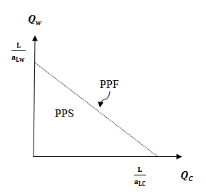
The straight line has connected by the two points are the quantity of wine and quantity of cheese it represents the combinations of wine and cheese. These points on the production possibility frontier line show that the transfer of labor resources from one industry into another and all labor remains employed. (Suranovic, n.d.).

2.2.1.3 A Ricardian Numerical Example
In the Ricardian model shows that countries can benefit from trade by using a numerical example we assume that the trade between two countries is benefitting from comparative advantage of goods in one country to another, for example, France, and the US have comparative advantage goods and trade. (Suranovic, n.d.). We suppose that the exogenous variables in both countries in the United States and France like bellow.
Table 2.1 The exogenous variables in both the US and France
United States | $aLc$=1 | $aLw$=2 | $L$ 24
France | $aLc$=6 | $aLw$=3 | $L$ 24

Figure 2. 1 The US and France production possibility frontier
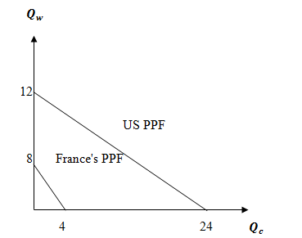
The US production possibility frontier lies outside France's production possibility frontier this means the US has an absolute advantage in both goods since the US production possibility frontier is flatter than France's production possibility frontier this shows that the US has the lower opportunity cost of cheese production. (Suranovic, n.d.). This table below shows the production and consumption level for the US and France with world total for each good.
Table 2.2 The production and consumption for the US and France with world total
Autarky Production/ Consumption
 | Cheese ($Ibs$) | Wine ($gals$)
US | 16 | 4
France | 3 | 2
World total | 19 | 6

Figure 2. 2 The production and consumption between the US and France
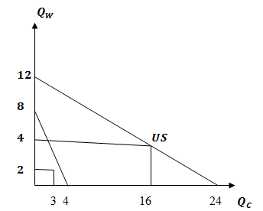
Table 2.3 Production with specialization in the comparative advantage goods
Production with specialization in the comparative advantage good
 | Cheese ($Ibs$) | Wine (gals)
US | 24 | 0
France | 0 | 8
World total | 24 | 8
After specializing of countries in comparative advantage of goods, the size of world output rises on each of goods cheese and wine, the size of cheese output increased from 19 to 24 pounds also the size of wine increased from 6 to 8 gallons. (Suranovic, n.d.).
Table 2.4 The consumption and production after trade
Consumption and production after trade
 | Cheese ($Ibs$) |  | Wine ($gals$)
 | Consumption | Production | Consumption | Production
US | 18 | 24 | 5 | 0
France | 6 | 0 | 3 | 8
World total | 24 | 24 | 8 | 8
In the table above shows that the American consuming wine nearly 5 gallons and producing zero it needs importation by 5 gallons from France and the size of Franc's consumption of cheese is 6 pounds and producing zero it needs importation by 6 pounds from the United States. (Suranovic, n.d.).

2.2.1.4 Relationship Between Price and Wages
The wine and cheese industries in both countries (in the US and France) are perfectly competitive. In the perfectly competitive market, the firms are free to enter and exit in the market to response the economic profit, when the firms continuously enter the market the supply of products will rise and decreasing the price of products while reduces the profit for the rest firms in the market if the firms continuously enter the market the size of economic profit decreasing to zero but when the economic profit getting negatively the firms close down and trying to find more profitable opportunity elsewhere. The reduction in the number of firms continuously leads to reduces supply on products which raises price and profit for the rest firms in the industry. (Suranovic, n.d.).
The profit is total revenue minus total cost. $πc= P_{c} Q_{c}- w_{c }L_{c}=0$ the price of cheese is Pc, the wage of workers is $w_{C }$, the total industry revenue is Pc Qc and the total industry cost is $w_{C }L_{C }$. (Suranovic, n.d.). We can get wage as function for everything else. $W_{c}=\frac{P_{c } Q_{c}}{L_{c}}$
The production function for cheese is $Q_{c}=\frac{L_{c } }{{aL}_{c}}$ plugging in above Qc
$W_{C}=\frac{P_{C}\left\{\frac{L_{C}}{a_{Lc}}\right\}}{L_{C}}= \frac{P_{C}}{a_{LC}}$
or just
$W_{C}=\frac{P_{C } }{a_{LC}}$ , $w_{W}=\frac{P_{w}}{a_{Lw}}$

2. 2.1.5 Arguments for Trade: Comparative Advantage
Trade theorists have tried to explain why nations engage in international trade for more than 200 years, what kinds of goods and services they trade, and how consumers and firms gain or lose from trade. The comparative advantage has rich implications about the gains from trade. Among the most powerful results are the following:
The countries can increase its welfare by trading because the world market provides an opportunity to buy some goods at relatively low prices. The smaller the country, the greater is this potential gain from trade. A country gains most by exporting commodities between countries that it produces using its many factors of production most intensively while importing goods whose production requires relatively more of scarcer factors of production.
Let’s assume that two countries, which can be called Mexico and the United States, both produce only two products, wheat, and computers, and use only one factor of production, labor, in the production process. The labor required to produce each product differs in the two countries, the United States is better off it buys wheat at home with less labor. In the United States, a computer sells for the equivalent of 5 tons of wheat, since each takes 20 labor-days to produce. In Mexico, however, one computer sells for 6 tons of wheat, since each takes 30 labor days to produce. Therefore, the United States is better off selling its computers in Mexico and receiving more wheat in return for home consumption. So, if labor is shifted away from farming and into computer production, U.S. Firms can produce enough computers to satisfy domestic demand and export to Mexico, and U.S. Consumers can use more wheat. But here is the most surprising result: Mexico also is made better off through the trade. Without trade, Mexico would have to produce 6 tons of wheat to buy one computer in the home market, by selling to the United States, however, Mexico needs to give up only 5 tons of wheat to get one computer. Thus, Mexico is better off by switching its labor into producing more wheat and selling them to the United States. The important point of this example and the core of comparative advantage is that both countries can gain from trade whenever the relative prices of commodities in each country differ in the absence of trade. (Perkins, Radelet, & Lindauer, 2006).
The return varies from one country to another by Costs and prices. The countries gain most cheaply goods by comparative advantage in trading, what in exchange, the countries receive cheaper goods from abroad than producing in at home to explain international economists, these mutual trade benefits of comparative advantage formulated by David Ricardo and Adam Smith, English classical economists of the late 18th and early 19th century.
Figure 2.4 Wheat production in the USA and Canada

Source: https://en.wikipedia.org/wiki/International_wheat_production_statistics
Figure 2.5 exports and imports of computers in the USA and Canada

Source: http://data.worldbank.org/indicator/BX.GSR.TOTL.CD
The theory tells that the World (that is, two-country) welfare is greatest when each country exports products whose comparative costs are lower at home than abroad and imports goods whose comparative costs are lower abroad than at home. International trade and specialization are determined by comparative costs, not absolute costs. Absolute cost comparisons require some standard unit, such as a common currency (for example, textiles $4 dollar a meter in China and $10 in the USA). But we cannot compare absolute costs without an exchange rate (such as a Chinese Yuan price of the USA Dollar). (Nafziger, 2006).

2.2.1.6 Interpretation of the Trade Impact on the Gross Domestic Product in the United States on light the Ricardian Model
The US has an absolute advantage and comparative advantage of goods that increase the world total production and consumption. The value of US dollar is very high compared with most major currencies that lead to the US balance of payment deficit that leads to import excess on exports. The corresponding export to GDP is 4.47 percent it means one percent increase in export the GDP increases by 4.47 percent. The corresponding import to GDP is (-4.20) percent it means one percent increases in import the GDP decreases by 4.20 percent the relationship between import and GDP is negative but the relationship between export and GDP is positive the exchange rate is a negative sign (-0.69) it means one percent increase in the exchange rate of US dollar against major currencies leads to decrease of GDP by 69 percent while the wages of labors in the US are very high compared with some developed and less developed countries it affects of price of American goods and the demand for American goods also, consumption affects the US GDP negatively (-0.22) it means one percent increase of American consumption leads to decrease of GDP by 22 percent. I based our research paper on David Ricardo model because the countries have a comparative advantage in producing goods and it's a basic of creating trade (exportation and importation) between countries to producing cheaper goods and receiving in both countries for less price and better quality.

2.3 Balance of payments (BOP)
By the intersection of the domestic market demand and supply curves for foreign currency and the price of a foreign currency is determined like the price of any commodity, in international transactions created the demand and supply for foreign currency, the demand and supply for a currency increasing from the flows related to trade and direct investment and portfolio investment. We can determine equilibrium exchange rates when the balance of payment is in equilibrium and exchange rates will shift the balance to imbalance and then will restore the equilibrium to the balance of payment. under purchasing power parity if prices abroad are not higher than at home, then domestic demand for foreign goods will increase and then the foreign currency will appreciate. An import creates a positive financial outflow and a negative financial inflow for the country, but export creates a positive financial inflow and negative financial outflow. If the country (A) in international transactions in the year 2014 consist of 80 million dollar import this operation creates a negative $80 million inflow But the importer could liquidate foreign assets worth $80 million to pay for this transaction. This operation creates a positive $10 million inflow to the country, thus, the balance of all financial flows must be equilibrated and the net balance will be zero. (Course Hero, n.d.).

2.4 Trade Volumes, Trade Policy, and Growth
the international trade based on geographic characteristics rather than on income, then they use trade as the measure to estimate the effect of per capital income, if the trade to gross domestic product increasing by 3 percent the income per person increasing by 1.5 percent and trade effect to income by increasing the productivity per input; in addition, trade encouraging physical and human capital accumulation. (Bryman, 2004).
The relationship between trade volume and growth, economists Jeffrey Frankel from Harvard University and David Romer from the University of California tackled the difficult issue of the direction of causality. A strong positive relationship between trade and rapid economic growth does not prove that the former is the cause of the latter: Rapid income and productivity growth, by increasing productive capacity and reducing costs, can make a country more competitive in world markets and lead to faster growth of manufactured exports. Also possible is that both export growth and economic growth are simultaneously caused by something else, such as improved macroeconomic policies, more stable political systems, reduced corruption, or increased savings. Frankel and Romer partially addressed the causality issue by tracing the portion of trade due to geographical characteristics (such as a country’s size, its location, and whether or not it is landlocked), which tend to be weakly correlated or uncorrelated with other possible determinants of growth. They show that this geographical component of trade has a large but only moderately significant positive effect on income, exporting countries have greater access to new machinery and technology that support growth, while faster economic growth provides the means to finance investments in infrastructure and education that support exports.(Perkins, Radelet, & Lindauer, 2006).

2.5 The Role of Monetary Policy with Floating and Fixed Exchange Rates
Appropriate using of monetary policy in controlling inflation depends on the type of exchange-rate regimes form a continuum with fixed (pegged) exchange rates and floating (flexible) exchange rates. The country attempts to maintain the value of its currency in a fixed relation to another currency under a fixed exchange rate system, the American currency, the value of the local currency is (pegged) to the dollar, this is done through intervention by the country’s monetary authorities in the market for foreign exchange and requires the maintenance of substantial international reserves.
Under freely floating rates, the authorities simply allow the value of local currency face to foreign ones to be determined by market forces. Further along, the continuum away from floating rates is the managed float, where the authorities are committed to defending no particular exchange rate, but they nevertheless intervene continuously at their discretion.
A country with steadily shrinking international reserves, might allow the value of its currency to depreciate against the value of other currencies; that is, allow the exchange rate to rise against other currencies.
Currency in circulation increases when additional foreign exchange becomes available (say, through increased export receipts) and decreases when foreign exchange becomes scarcer (say, through an increase in imports or capital outflows). This system assures that the country will not run out of foreign exchange. However, the main instrument of adjustment becomes domestic interest rates, which increase when foreign exchange becomes more available. Argentina, Hong Kong, Bulgaria, Estonia, Brunei, Djibouti, and Lithuania all have or have had currency boards. With “dollarization” one country adopts another country’s currency, as Panama did many years ago when it adopted the U.S. dollar as its currency. Most economists believe that currency boards and dollarization are appropriate in only a very limited number of developing countries that are small, very open to trade, and not vulnerable to large commodity price swings. (Perkins, Radelet, & Lindauer, 2006).

2.5.1The role of Dual Exchange Rates in Trade
Currency depreciation can have short-run costs, particularly, in an economy that adjusts gradually. shortages and Inflation may appear before consumers switch to replacements for foreign food and other consumer goods, before import and export substitution industries expand capability to take advantage of more favorable prices, and before buyers of imported inputs and capital goods can convey to domestic suppliers, these transitional problems have affected some economists to suggest a dual exchange rate, with the first a near market rate, used to reduce controls, increase exports and import substitutes, and increase ability; and the second, possibly the old rate overvaluing domestic currency, set to dampen short-run inflationary pressures from price inelastic foreign goods like industrial inputs, food, and capital goods (or their domestic substitutes shifting to exports) or to preserve foreign exchange commitments for foreign corporations repatriating interest and dividends (Kaldor,1984). however, dual rates preserve some price distortions, postpone resource adjustments, and encourage people to acquire foreign currency cheaply in one market and sell it expensively in the other still, dual exchange rates can support the consumption of the state elite, in Angola, elites imported luxury cars at the official exchange rate (a cheap kwanza price of both the U.S. dollar and thus foreign-made cars), whereas food was imported using foreign currency at the more expensive equivalent market rate. (Nafziger, 2006).

2.5.2 The Role of the Balance of Payments Deficits and Surpluses in Trade
The role of money is important in general macroeconomics and balance of payments especially, in the exchange rate, in 1970 the balance of payments presupposes fixed exchange rates in the world, Under fixed exchange rates system the balance of payments surplus its excess demand for money and hold in excess money but in the balance of payments deficit it's a process of decreasing supply of domestic money. The surpluses in the capital account and trade account reflect an increasing supply goods and services and securities also, a surplus in the money account reflects an increasing demand for domestic money.(Rabin & Yeager, 1982).

2.5.3 the role of Money and the Exchange Rate In The Long Run
When the exchange rate moving in the long run the countries and governments should replace every pair of old currency with one new currency suppose exchange every pair of old American dollar should replace by every pair of a new American dollar then, if the exchange rate dollar/euro had been 1.40 old dollars per euro before the reform, thereafter, the reform it would change to 0.70 new dollars per euro the US currency supply appreciates by halving from an exchange rate of 1.40 dollars/euro to 0.70 dollars/euro while the value of US dollar appreciate and the price of all American goods and services decreasing by half the relative prices of all foreign goods and services would be unchanged, it's 50 percent discriminations are appeared between all foreign goods and all domestic goods. Suppose, the increasing price of Japanese or Germany goods against American goods in international trade that is reflected in the balance of payment and increasing surplus because the price of American goods is low, it's leads increasing American exports more than imports in international trade. An increase in US money supply continuously leads to a proportional long-run depreciation of the US dollar against major world currency. Likewise, a decrease in US money supply continuously leads to a proportional long run appreciation of the US dollar against major world currency. (Krugman, Obstfeld & Melitz, 2012).

2.5.4 the Role of Central Bank Intervention with Fixed Exchange Rates in Trade
Most of the transactions in the world in different currencies will take place in the international banks, private market, and businesses in a fixed exchange rate system, all illegal transactions would not happen at the announced rate would have declared by the government. However, in floating exchange rate system the supply and demand maintain the equalizer the balance on the exchange rate and in fixed exchange rate system, the central bank has a big role to intervene in the private foreign exchange market and acting as a buyer and seller of the currency.
Suppose the United Stated of America establishes a fixed exchange rate to the another major currency like pound at the rate E$/£, we represent an initial equilibrium point in the private market foreign exchange which the demand (D£) and supply of pounds (s£) are equals at the fixed exchange rate system suppose for some reason demand for pounds on the private foreign exchange market rises from E$/£) to (D’£) in figure 2.1 ( Suranovic, 2012).
Figure 2. 6 Central Bank intervention to maintain a fixed exchange rate
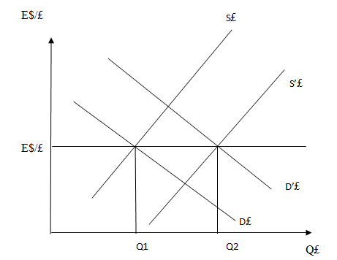
In the point (E$/£) shows that a fixed exchange rate and Q2 shows demand for pounds in the private market, also, Q1 shows the supply of pounds. in this figure above shows that the surplus demand for pounds in exchange for the American dollar. The American central bank needs to maintain a fixed exchange rate to satisfy the surplus demand by supplying extra pounds to the foreign exchange market.
If the government buying dollars and selling pounds in the foreign exchange market, this process would change the pound supply curve and shift from S£ to S’£. This process led to maintaining the equilibrium exchange rate automatically.
In figure 2.2 shows that the preserved a fixed exchange rate by central bank intervention. In which supply and demand for pounds equal at the fixed exchange rate. Suppose, the demand for pounds in the private foreign exchange market falls to (D’£).
At the fixed exchange rate the supply of pounds equal to Q1 and demand for pounds equal to Q2, there is an excess supply of pounds in exchange for American dollar in the foreign exchange market. ( Suranovic, 2012).
Figure 2. 7 Another Central Bank intervention to maintain a fixed exchange rate
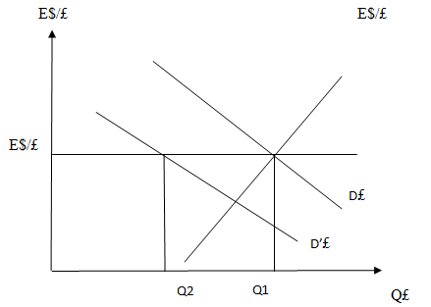
A surplus supply of pounds reflects a surplus demand for dollars in exchange for pounds. Central Bank of the United States of America can enter the Foreign exchange market and increase demand for the dollar and sell dollars in exchange for pounds. demanding more pounds and supplying more dollars, this would lead to changing the pound demand curve and shift from D’£ back to D£. During the government intervention in the foreign exchange market the equilibrium exchange rate automatically recovering at the fixed level.( Suranovic, 2012).

2.5.5 The Role of Foreign Exchange Interventions with Floating and Fixed Exchange Rates in International Trade
It is difficult to determine which foreign exchange intervention would affect the exchange rate because of, any shock that could face central bank, affect of currency away from its equilibrium point. In theoretical literature has identified some mechanisms through which interventions of the market fraction may impact on exchange rate. First, a portfolio balance channel, if there is imperfect substitutability foreign assets and domestic assets and the risk premium increases the supply of domestic assets. Thus foreign exchange interventions expand the number of domestic assets. Second, a microstructure channel. According to this mechanism frictions at a micro level can affect the extent to which information embedded in central bank operations assuming, an informational advantage exists. Third, an informational signaling channel, the foreign exchange intervention indicates to adjust its monetary stance, through the central bank, for example, reduce interest rates to prevent more appreciation of its currency.(Adler & Tovar, 2011).

2.5.6 The Role of Black Markets and Illegal Transactions in Trade
Black market form in response to trade in different aspects such as controls on currency transactions, administrative controls, Tariffs. Black market creates illegal currency and illegal trade creates demand on the illegal currency which is encouraging and increases supply on currency in the market and establishment of a black market if the central bank is unable to reply all the demand at the official price of foreign exchange. Which is the main sources of supply of illegal foreign currency its smuggling by exporting and importing currency illegally, the transformation of remittances through unofficial channels, transformation by government officials in exchange for bribes or favors and exchanges by foreign tourists.
In the black market, there are several factors affected on government authority for foreign exchange. First, the cost of government. Second, the loss of tariffs revenue. Third, the government corruption. fourth, the loss of income on foreign currency transaction. Illegal and black markets are important components in international trade and reflect on the size of the economy, governments, and depreciation in domestic currency. (Nafziger, 2006).

2.6 Strategic Trade Policy Versus Free Trade
in this new theory illustrated the relationship between strategy trade policy and free trade in the international trade.

2.6.1 Strategic Trade Policy
Barbara Spencer and James Brander (as cited in Orgun, 2012) noted that "between 1983-1985 creates an analysis of trade policy under perfect competition with introducing economies of scale and technology, and making specialization for products as the new basis for international trade, this kind of theory provided support for new mercantilism it's the most important part Spencer-Brander approach could be briefly described with a term "strategic trade policy". Krugman's study (as cited in Orgun, 2012) noted that "this new theory was a revolution in particular increasing returns into the picture and introducing imperfect competition does not alter the fundamental point that trade is a positive -sum game, that is carried on to countries' mutual benefit particularly, the new trade theory adds to the positive sum, because of increased competition in the international trade and enlarging market and allows better exploitation on the scale of economies, both due to comparative advantage". Spencer & Brander (as cited in Orgun, 2012 ) noted that "the strategic trade policy is different from the traditional case for free trade. The basis of quantitative knowledge of the relevant industries recommended by strategic trade policy ". Baldwin & Krugman's study (as cited in Orgun, 2012) argues that "the models generally tell us, first, the strategic trade policy for positive economics its trade flows and output are different from the productions of conventional trade theory". Basu's study (as cited in Orgun, 2012) noted that "the term strategic comes from the strategic interaction between firms as a result, firm concerning of some variables such as investment, price, and output it depends on the decisions of other firms, the characteristic of oligopoly is defined by the strategic interaction".
Silva's study( as cited in Orgun, 2012) noted that "strategic trade policies that encourage research and development with investment, the strategic interaction between firms creates an opportunity for government's action, the government has an opportunity to increase domestic welfare. promoting industries in order to get benefits and promoting the strategic interaction in oligopolist competition to shift profits to the domestic firm".

2.6.2 key Industries (Strategic sectors)
The national industries getting support from the international markets and governments because of limitation in economic resources leads to shifting economic activity from one sector to the another, the countries can gain the big share of the world market by high technology industries. (Orgun, 2012). Spencer's study (as cited in orgun, 2012) noted that "the trade policy has some targets such as:
- an oligopolistic structure
- the sector must have the more profits higher than the subsidy
- the sector must participate in the strong international competition".

2.7 The role of Fiscal Crises Under Floating Exchange Rates in Trade
"Economic stability needs fiscal stability if the governments borrows more than it is able to repay, thus, damaging the exchange rate regime, however, the nature of fiscal crisis and the options for dealing with it do differ under different regimes". (Hinterschweiger & Gagnon, 2011).

2.7.1 Floating Exchange Rates and Domestic-Currency Debt
Fiscal crisis under floating exchange rate regimes is moving slowly, the central bank has a big role to raises interest rates gradually, if the government debt increases to keep the stability of inflation and keep output close to potential levels slowing the potential growth rate in the economy belong to higher interest rates and transfer capital from productive projects to unproductive government debt by increasing interest on the debt and the tax burden on the government, therefore, the government must print the money to service the debt and must force the central bank to decrease inflation target, for example, if the target of inflation would fix in 3 percent, that is central bank's task to decrease inflation target from 3 percent to 2 percent. In general, ever-slower growth with either ever-higher taxes or ever higher inflation is unacceptable. (Hinterschweiger & Gagnon, 2011).

2.7.2 Domestic-Currency Debt and Currency Unions: The Euro-Area Debt Crisis
A fixed exchange rate regime distinguished from a currency union because government debt in the currency union is determined a currency beyond government's control, existing in a currency union regime such as Euro is much difficult than rejecting a fixed exchange rate because government's need to establishing new currency is difficult. The fiscal crisis in the currency union is keener than those countries have a choice of printing money to service their debts which the interest rate make the higher the burden on governments to services their debts, In this situations, the countries directly get out of the capital market. (Hinterschweiger & Gagnon, 2011).

2.8 Some Reasons for Trade and Why Trade Between Countries Occur?
Reason One: Differences in Resource Endowments
When the countries have different endowments of natural resources, the advantageous trade can occur between countries, The skill and abilities of a country's workforce measure by resource endowments, the natural resources available within (infrastructure, machinery, communication systems, minerals, and farmland). ( Suranovic, 2012).
Reason Two: Differences in Technology
The technological abilities differ between countries to produce goods and services by comparative advantage, the techniques process used to turn resources such as capital, labor, and land into output goods and services by technology. ( Suranovic, 2012).
Reason Three: Existence of Economies of Scale in Production
The advantageous trade happens between countries, needs to economies of scale in production. Economies of scale also known "increasing returns to scale" which decreasing the cost of production and increasing the scale of production. ( Suranovic, 2012).

Reason four: Differences in Demand
The demand for goods and services differ between countries and the role of comparative advantage in trade important to producing goods and services and exporting to different countries in the world, the individual's demands and them preferences differ on different products in different countries. for example, Canadian's demand on beer higher than Brazilian's demand, and the Japanese like fish more than Canadians or Americans would, the Chinese demand higher on rice than Americans, even all faced the same prices. ( Suranovic, 2012).
Reason five: Existence of Government policies
The changes in government tax and subsidy programs by the government lead to changes the prices charged for goods and services due to differences in government policies in different countries may advantage trade arise.( Suranovic, 2012).

CHAPTER THREE

TRADE DEVELOPMENTS IN THE U.S.A

3.1 Introduction
This research paper is a review of the history of the trade in the U.S. during 1975-2015, and discuss the economic theory of the trade development in the United States of America. We have used some tools affects on the trade independently such as exchange rate, consumer price index, oil price, export, import, and some political factors. The devaluation of the dollar in the 1971 and 1973 attempts to keep away the accumulation disequilibrium the years of "Bretton Woods" also the shrinkage in the 1970s led to the US monetary expansion, that is relations with the Carter administration. The devaluation began again in 1977-1978, with a new shape in the treasury secretary "Michael Blumenthal" this fluctuation in the dollar began with the monetary tightening by the federal reserve. "Chairman Paul Volker" declared to combat inflation in the 1970s by increasing interest rate to reducing inflation and motivated to return the dollar to international respectability for several years.
In 1980-1982 an appreciation happened in the US dollar by 28% in real terms and 29% in nominal term. The recession of 1980-1982 affected of the monetary contraction policy in the rise of the dollar. In the 1982-1984 the dollar appreciated by 14 percent in the real term, and 17 percent in the nominal term. In the Reagan administration in the 1970s budget deficit increased from 2 percent of GNP to 5 percent in the 1980s. (Feldstein et al., 1994).

3.2 Government Spending and Budget Deficits
The role of economic occurred in shaping the changes in the components of the government spending. We look at two aspects of budget policy, that were important during the decade in the United States. First, the reform in the social security. Second, reform in the Medicare and the tax treatment of health insurance. Then discuss the budget deficit itself and why it remains unsolved. The budget deficit and surplus are primary problems during decades, the budget deficit remains the significant negative legacy.
The President Ronald Reagan reduced taxes and non-defense spending in 1980, the tax cuts were much greater than expected by Ronald administration, and the spending non-defense cuts were much less than the Ronald and his advisers expected. The result of these process was an enormous budget deficit. The failure to correct the budget deficit reflects a complex mix factors such as political factors, personal factors, and economic factors. (Feldstein et al.,1994).

3.3 The Changing Structure of Government Spending
During the 1960-1970s the US structure of the federal government spending changed dramatically, the defense spending fell faster, while non-defense spending rose rapidly, these trends reversed in the 1980s.
In 1962, defense spending with other international programs fell from 10.5 percent of the gross domestic product. In the 1980s, increased the military spending to 5.6 percent by Vietnam war. In 1986, a substantial investment in the defense equipment happened were raised the defense share of Gross Domestic Product to 6.9 percent, in late 1990 declined again to 5.8 percent.
Outlays increased rapidly more than doubled in 1962 as a share of Gross Domestic Product from 3.0 percent to 6.9 percent in 1980, outlays included retirement, disability programs and social security and Medicare programs for the aged.
During the first two years of the Reagan administration, growth occurred rapidly to 7.8 percent as a share of GDP, then declined to 7.6 percent as a share of Gross Domestic Product in 1982, it was very fast real growth GDP. (Feldstein et al, 1994).

3.4 Do Dominant Players Exist?
The four most major traded exchange rates in the foreign exchange market in the United States of America are American dollar and Yen American dollar and pound sterling, US dollar and Deutsche Mark and US dollar with Swiss franc while the US dollar and Deutsche Mark and US dollar with Yen markets are dominated international transactions by nearly 25 percent and the American dollar and pound sterling are dominated markets by nearly 50 percent and the Swiss franc and US dollar are dominated markets by 60 percent these results related to the size of trading markets between these two countries.
the daily average turnover of American dollar and Deutsche Mark spot dealings in the New York market were 43.8 billion dollars, that is indicated by the Federal Reserve Bank of New York while on the US and Yen turnover was 30.5 billion dollar in April 1998 while the total daily average turnover of the dollar and pound sterling in transactions in the market was nearly 10.2 billion dollar, and American dollar with Swiss franc was 7.6 billion dollar. (Cheung & Chinn, 2001 ).
Table 3.1 Growth rates of some selected variables in the United States of America in 1975-2015
Year | Growth rate of export % | Growth rate of import % | Growth rate of real GDP % | Growth rate of Trade Weighted U.S. Dollar Index: Major Currency % 1973=100 | Growth rate of CPI %
1975 | 9.276 | -3.845 | -0.2 | 102.39 | 9.1
1977 | 4.981 | 21.288 | 4.6 | 106.1 | 6.5
1980 | 21.456 | 17.42 | -0.2 | 95.35 | 13.5
1981 | 5.915 | 6.369 | 2.6 | 104.76 | 10.3
1984 | 9.096 | 28.341 | 7.3 | 128.69 | 4.3
1985 | -2.718 | 1.761 | 4.2 | 133.55 | 3.5
1988 | 26.879 | 8.27 | 4.2 | 90.43 | 4.1
1989 | 12.836 | 2.974 | 3.7 | 94.29 | 4.8
1990 | 8.186 | 4.67 | 1.9 | 89.91 | 5.4
1993 | 3.777 | 9.01 | 2.7 | 89.9 | 3
1994 | 10.221 | 14.225 | 4 | 88.43 | 2.6
1997 | 10.257 | 9.478 | 4.5 | 93.93 | 2.3
1998 | -1.022 | 4.735 | 4.5 | 98.45 | 1.6
2001 | -6.755 | -6.324 | 1 | 107.87 | 2.8
2002 | -4.937 | 1.785 | 1.8 | 106.18 | 1.6
2005 | 10.65 | 13.863 | 3.3 | 83.86 | 3.4
2006 | 14.422 | 10.785 | 2.7 | 82.61 | 3.2
2009 | -17.974 | -25.861 | -2.8 | 77.67 | -0.4
2010 | 21.043 | 22.668 | 2.5 | 75.39 | 1.6
2011 | 15.805 | 15.414 | 1.6 | 70.87 | 3.2
2012 | 4.419 | 3.091 | 2.2 | 73.6 | 2.1
2015 | -7.316 | -4.589 | 2.6 | 90.97 | 0.1

Source: Link: (https://fred.stlouisfed.org).

3.5 What Is the Exchange Rate and Why Is the Exchange Rate Important for the United States and Florida Agriculture?
The exchange rate is the price of one currency expressed in another currency. The exchange rate between the US dollar and the Japanese yen is 1 dollar equal 104 yen, for exchanging each dollar against Yen, you receive 104 yen. Moreover, the exchange rate between the dollar and Euro is one American dollar equals 0.89 Euro, for each dollar you exchange, you received 0.89 Euro. the changing in exchange rate basis on daily changing; thus, this rate we have written it shows daily rate not monthly or yearly because the rate of the exchange rate is not constant, the rates used here are only for illustrative purposes. The rates can be found online at the Federal Reserve Board. (Board of Governors of the Federal Reserve system, 2017).
The important of the exchange rate is doing all international transactions for purchases of goods and serves between countries, and transfer funds between countries lead price comparison of similar goods, nearly 25 percent of the American cash farm income comes from exportation while the American trade agriculture has a big role for the American farm economy.
agriculture as dependent on abroad markets increased 50 percent of the wheat crop produced exported abroad, according to the United States department of agriculture (USDA), nearly 33 percent of the tobacco, cotton crops, and soybean while corn crop vegetables and animals and fruits products are dependent on abroad. In 1991-2003 the value of vegetables and fruits increased by 55 percent from $4.4 million to $6.8 million.
The competition of the US agricultural exports high abroad, and at home, if the US dollar depreciates while, it makes imports more expensive, allowing to producing commodities domestically to compete with foreign markets is a better chance. While a strong American dollar has a negative effect on the American farming sector, but the weak American dollar has a positive effect on the US farming sector.
Although Florida compared with another states such as California, Iowa, Indiana, or Illinois, have an important role in the gross revenues of producers, nearly 17 percent $1.2 billion of Florida’s gross farm cash income is coming from exports. Overseas sales of vegetables and fruits share by 62.4 percent. The weak of US dollar has benefited for Florida's farmers in two ways:
1. through a weakness in the American dollar increases the demand for export of goods, and increase domestic revenues.
2. through a weakness in the American dollar increases the price for import of goods, which supports domestic products to produce goods and services better to compete in the market.
In general agribusinesses and local farmers can get benefits from the weakness of the dollar but weakness in the value of the American dollar continuously could be bad for the United States and Florida agriculture. While the increases the cost of the commodities imported such as inputs energy and fertilizers and an increase in the foreign oil prices could erode any gains that the US and Florida agriculture could receive from a weak US dollar, if the value of the US dollar depreciate the government must intervene to the market to increase the interest rates to control the inflation, while increasing the cost of capital would cause badly to the farmers in the United States of America. (Evans, 2005).

3.6 Is the International Role of the Dollar Changing?
The U.S. dollar is the most important currency in the world by many measures. It plays a central role in international trade and finance. Many countries have adopted an exchange rate regime that anchors the value of their home currency by the dollar. Dollar holdings figure prominently in official foreign exchange (FX) reserves—the foreign currency deposits and bonds preserved by governments and monetary authorities. And in international trade, the dollar is largely used for invoicing and settling import and export transactions in the world.
However, the dollar’s preeminence as a cross-national currency had questioned among countries last decades. The emergence of the euro in 1999 as a global competitor and main currency fueled the debate over the dollar’s international role. Thus, the global shortage of dollars during the financial market crisis placed exceptional strains on international firms needing to support their dollar- denominated assets and led to calls for changes in the international monetary system. Many developing countries have proposed that for certain transactions the dollar is replaced with a type of “world” currency based on International Monetary Fund special drawing rights. In addition to this, participants at the April 2009 meeting of the Group of Twenty finance ministers raised questions about the dollar’s preeminence as a reserve currency, also people’s Bank of China Governor Zhou Xiao Chuan has pressed for a shift away from U.S. currency in various activities.(Goldbergs, 2010).
The dollar’s international status helps isolate the U.S. economy from foreign shocks, contributes to the international transition of U.S. shocks and monetary policy effects, and reduces transaction costs in trade and finance. For foreign economies, using the dollar in reserves and in international transactions typically results in greater sensitivity of trade, asset values to exchange rate movements between their currencies and the dollar, and inflation. Furthermore, dollar banknotes---physical bills of different denominations—used abroad provide businesses and some foreign households with the more stable store of value and a sounder transaction currency, especially during periods of disorder overseas.(Krugman, 1980).
A dollar is the main form of cash currency around the world. The share of U.S. dollar banknotes evaluated to be held outside the United States of America is substantial. Roughly 75 percent of hundred-dollar notes, 60 percent of twenty-dollar notes and 55 percent of fifty-dollar notes are held abroad, while around 65 percent of all American banknotes are in circulation outside the country. Almost $580 billion in physical U.S. currency outstanding was circulation overseas at the end of March 2009, The stability of the U.S. dollar leads to an attractive currency in countries that are experiencing volatile economic and political conditions or that have histories of such risks.(Hellerstein and Ryan 2009). The international debt markets are another area in which the dollar serves as a prominent currency. (Coeurdacier and Martin, 2007).
Also, The dollar plays an important role in the cross-border foreign currency liabilities of banks in countries. (McGuire and von Peter 2009). The previous discussion has spelled out the potential impact of dollar appreciation on the U.S. price via the prices of commodities and manufactures. The recognition that exchange-rate changes affect inflation in the Unites States of America is surely not new. There was the abundant discussion of the issue in the literature during the 1950s and in1960s. (Dornbusch, 1986).

3.7 Growing Importance of International Trade
Since the 1960s the world trade has been an important role for economic growth in the international trade, and the size of world merchandise exports increased from 2 trillion American dollars in 1980 to 5 trillion American dollars in 1996, also, the size of world exports of commercial services increased from 402 billion American dollars in 1980, but in 1996, 1.2 trillion American dollars. Increasing world exports of manufactured goods from 189 billion American dollars to 2.1 trillion in 1970 to 1990. The American exports are the strongest international trade economy between countries. American exports increased to 611 billion dollar and exports of services nearly 224 billion American dollars and American imports nearly 799 billion of goods and 150 billion American dollars of services.
American exports are more than 20 percent of U.S. Economic growth and provide nearly 11% of the US Nation’s jobs is important to create Jobs also recognize that imports and wealth for U.S. Wholesalers, service providers, distributors, resellers, and others. (Rondinelli, Johnson, Jr. & Kasarda, 1998).

3.8 How Does The U.S. Trade Deficit Affect U.S. Consumers and Businesses?
Cowen & Tabarrok (as cited in Charles Zhao, n.d.) noted that ''the questions we are looking for to answer are what is trade deficit and where does it come from? the trade deficit is a yearly summary of all the economic transactions between countries in the world".
Colander (as cited in Charles Zhao, n.d.) noted "American imports of goods and services produced in abroad and bought by American Consumers is named trade deficit. Trade deficit defines all U.S. Imports of goods and services produced in a foreign country and bought by U.S. Consumers it refers to all goods that are shipped into the U.S., even if the American-owned companies are produced while in the first quarter of 2014, the US trade deficit was $87.3 billion.
All production of goods and services represents the American business sector that produced in the United States of America, then, American workers sell them workforce to return to wages and benefits. The American Producers sell products or services to foreign countries and make exportation, For example, if Microsoft Company sells them products to another company in another country it makes an exportation that will be recorded in the current account of the U.S. Balance of Payments. That country receives products from Microsoft company, which makes an importation, will be recorded in the current account of the Balance of Payments, it's the differences between two countries products one country as an export, and another country as an import.
The American population and other American economic entities such as municipal governments, public and private other U.S. Economic entities businesses, State, Federal, municipal governments. The American consumers are economic entities that purchase goods and services from domestic and international markets for example, if the American ministry buys 70 planes from local producers and 150 tanks from an Italian product; in both situations, the first purchase is a local spending and the second is an import of Italian products.
American imports are more than exports, the American people import more goods from abroad than selling abroad the United States, That is a negative sign of total value into the current account of United States' Balance of Payments.
Why is importation more than exportation in the United States of America? because products from abroad are cheaper than American products and American consumers can get more of foreign products rather than buy American products, and the American people unable produce all that it needs, in 2013 nearly 80 percent of American imports are goods and services imported from abroad nearly 2.268 trillion American dollars.
The American trade deficit will happen if the domestic manufacturers producing goods abroad. but the finished American products from abroad shipped to inside country its account as an import, if raw materials are shipped abroad to the United States, then it’s counted as the US export while an expansionary monetary policy leads to increase income and contractionary monetary policy leads to decrease income these increase and decrease income reflects on trade deficit to become larger and smaller".
What are the effects of the American trade deficit? some specific variables such as real GDP, unemployment, exchange rate, inflation, the standard of living, dependence on national security, and foreign countries these are factors effects of the trade deficit in the United States.
The real GDP represents by an economic mathematically equation Y=C+I+G+(X-M), The real GDP (Gross domestic product) represents the U.S. Domestic production minus the impact of inflation. The real Gross Domestic Product is represented by an economic mathematically equation Y=C+I+G+(X-M), where: Y= real gross domestic product; C=Consumer price index; I= investment; G= Governmental expenditure; X= Exports; M= Imports; and, X-M= Net exports. Using that equation, if we keep C, I, and G stable, and if imports (M) are lower than exports (X), Which mean we get a trade surplus, then (Y) Gross domestic product will rise. On the contrary, if imports (M) are more than exports (X), which means we have a trade deficit, then the real gross domestic product will decrease, and raising the rate of unemployment, have reflected on the trade deficit, which shifts the American consumption directly to buying foreign products.
American people can get benefit from trade deficit by buying cheaper of goods and services at lower prices in short run, while the standard of living of American people will rise but in long run, the American people will lose them jobs and outsourced to another country. (Zhao, A. n.d.).
Bloomberg, L.P (as cited in Charles Zhao, n.d.) noted that "a country that maintains a structural trade deficit against another country such as U.S.A and Canada shows a significant dependency against that country for particular imported goods and services, the political and economic factors effects the trade deficit dependency between the two countries involved".
NSF review, 2006 (as cited in Charles Zhao, n.d.) noted that "generally, countries tries to avoid of using foreign products owing to its national security, may sometimes it’s unavoidable. The trade deficit created by importations of goods and services for national security purposes creates a risky international exchange and increases national insecurity".

3.9 The U.S. Trade Deficit Impact on Changing Oil price
The US oil and natural gas industry have been growing despite the sluggishness of the all US economy. The oil and natural gas extraction industry has achieved annual growth of 6.9% through 2015, compared to the overall real GDP growth of 2.6% in 2009 the oil and gas extraction industry alone had accounted for 7% of total investment in the United States it created 150000 jobs in 2011, 9% of all jobs created in the United States in that year and the energy industry accounted for about 4% of gross domestic product in the United States of America. (https://www.chevron.com/worldwide/united-states).
In 2014 and 2015 fall the price of oil and natural gas and decreased the size of energy imports, the US financial contribution became smaller overall American trade deficit while these situations continued until May of 2016 and the size of energy imports decreased in the United States trade deficit. It was difficult to stabilizing oil price in 2016 and 2017. The fluctuations in the oil and natural gas prices will affect the inflation and economic growth in the United States.
Some factors have affected oil prices such as decreasing of economic growth in Asia especially slowdown in Chinese economy while events in the Middle East, an increasing American natural gas production, decreasing the sanctions on the Iran, and the prospects of a resumption again of Iranian oil production.
The American economic growth slowed at the end of 2015, which affected both the size and price of oil imports while the economic growth slowdown in the European countries, Asia, and among some developing countries such as China, Russia, Japan, Brazil and many other countries are facing significant economic challenges.
Typically, sometimes increasing the price of oil and natural gas in the summer months and fall in the winter while decreasing the size of economic growth in the United States and other countries in 2009 while the demand for oil reduced sharply and caused oil prices to fall from the heights they reached in July 2008.
The impact of Atlantic hurricanes on the production of oil in the Gulf of Mexico and droughts in the mid-western U.S. that can affect oil prices and reduce the production of corn and, therefore, the accessibility of ethanol, which puts upward pressure on gasoline prices. Social insecurity and instability in the Middle East affected international oil markets in 2011.
The slowdown in global economic growth reduced the demand for oil while the price of oil imports decreased while the American oil and natural gas production increased while the size of energy imports decreased.
Higher prices for oil imports supporting the economic growth and improving the energy efficiency and search to find more supplies of energy and find the alternative source of energy while lower energy costs getting both consumers and producers better conditions lower energy prices stimulating producers to invest more of energy sources while decreasing oil price that shifts to increasing the consumer's real incomes and supporting consumers to increase saving and reduce debts.
The roles of Congress are significant through its making economic policy and its oversight the big role over the Fed, could face the dilemma of weak economic growth, falling prices and deflation, and stagnant tax revenues.
Traditionally, the weak economic growth will be addressed through decreasing interest rates to decreasing credit and to stimulate producers to invest and increasing government spending.
While lower imported energy prices reduce the energy component of the trade accounts, the total value of exports and imports is determining by some factors, such as the domestic balance of saving and investment, and relative growth rates in demand for exports and imports, and exchange value of the dollar in the international markets.( Jackson, 2016).

3.10 The President Barrack Obama and Trade Agenda
''The president’s trade agenda tries to stimulate the economic growth and increasing job opportunity and strengthen the middle class in the U.S.A. Trade policy successfully done right services of American people: farmers and ranchers, workers and families, innovators and entrepreneurs, and all size of businesses''. (The President's trade agenda, 2016, p. 1).

3.10.1 The Trans-Pacific Partnership
The president’s trade agenda tries to increase jobs and strengthen the middle class by seeking to promote growth in the U.S.A. By reducing the tax on foreign American exports, enforcing U.S. Trade rights and raising global standards. The trans-pacific partnership is a central part of the obama's economic strategy. The benefit of TPP has raised wages for American workers and make economy larger by over $130 Billion a year in 2030. Why is TPP important for American workers and American businesses? For some reasons below. (The President's trade agenda, 2016).
Table 3.2 Businesses activity between the 12 Trans-Pacific Partners
Australia | Canada
Japan | Malaysia
Mexico | Peru
Unites States | Vietnam
Chile | Brunei
Singapore | New Zealand
Source: (The President's trade agenda, 2016).

Figure 3. 1 The U.S. Businesses with TPP countries
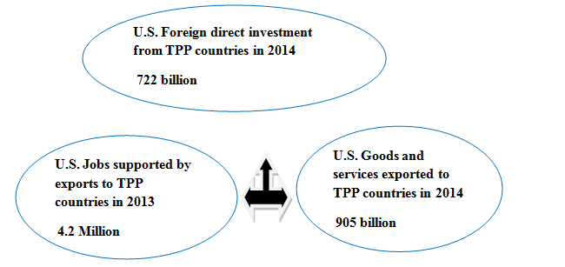Source : (The President's trade agenda, 2016).

3.10.1.1 Supporting Jobs and Strengthening America’s Middle Class
President Obama has called “Middle-Class Economics” but the U.S. Can support high wage jobs and create a strong connection between trade, growth, and jobs. By opening the markets in the future when everybody can get their fair share and there is a significant relationship between exportation and job opportunity while the American exportation supported American Jobs by an estimated 11.7 million in 2014 since 2009-2014 increased 1.8 million jobs, Obama supported the American industrial sector has added over 650,000 jobs, the TPP supported exports auto industry of made in America Cars, vehicles and auto machines parts the TPP eliminates foreign taxes on exports of made in the auto machines parts, that including countries such as Vietnam’s 70% tariff on autos machines and %25 on auto parts and eliminating Malaysia’s 30% tariff on American autos and 25% tariff on auto parts and the United States with Japan bilateral agreement, the TPP has a very strong and accelerated dispute settlement procedures between U.S. And Japan on autos. (The President's trade agenda, 2016).

3.10.1.2 TPP Benefits for U.S. Manufacturing
The opportunity of jobs are growing in the American manufacturing and added over 900000 manufacturing jobs in February 2010 it was a big helping to expand manufacturing exports. Eliminates the foreign goods and services taxes of import tariffs on American manufactured that exported to TPP countries by 70% on autos and 35% on information and communication technology products. (The President's trade agenda, 2016).

3.10.1.3 TPP Benefits for U.S. Agriculture
America is very strong in the agricultural sector. Every dollar of the agricultural sector that exports to abroad stimulated by $1.27 in businesses activity and economy in 2014. The U.S. Agricultural exports totaled nearly $137 billion in 2015, its almost 35%., The trans-pacific partnership will increase annual net farm income in the United States By $4.4 billion. (The President's trade agenda, 2016).

3.10.1.4 TPP benefits for U.S. Service Providers
The U.S. Led the world with $711 billion in service exports nearly two-thirds of the U.S. Economy in 2014. Services exports such as film and music, data analytic, logistics, design, architecture, legal and other professions. (The President's trade agenda, 2016).

3.10.1.5 TPP Benefits for Innovators and Creators
Nearly 40 million of American people jobs are dependent on innovation and creativity while the trans-pacific partnership rules will promote exports and protect American innovation and creativity for stimulating and fostering American’s future economic growth. (The President's trade agenda, 2016).

3.10.1.6 TPP Benefits for U.S. Small Businesses
Small businesses have a significant role in the American economy while in recent decades, nearly 300,000 small businesses its two-thirds account of net new private sector jobs. Through exportation and participation in supply chains, the United States supported millions of American jobs across the 50 States export goods to foreign destinations. (The President's trade agenda, 2016).

3.10.1.7 TPP Keeping the internet free and open
The trans-pacific partnership will safeguard the future economic growth for TPP'S countries, the Obama administration supported for the preservation of the global internet as a digital economy in the 21st century, and benefits for consumers, businesses, and people throughout the world. (The President's trade agenda, 2016).

Table 3.3 A Bipartisan American Project
1974

1979
1985
1993
1994
2002
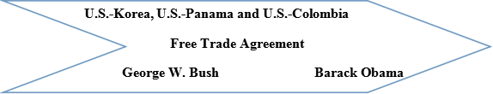
2011
2015
2015
Source: (The President's trade agenda, 2016).
https://ustr.gov/sites/default/files/2016-Trade-Policy-Agenda.pdf

3.10.2 Shaping Tomorrow's Global Economy
Globalization is a result of the fluctuation in the economic growth between the countries by dropping the cost of transferring goods, and container fleets have grown rapidly while air cargo has become faster and more efficient. (The President's trade agenda, 2016).

3.10.2.1 The Transatlantic Trade and Investment Partnership
The United States are negotiating with the European Union for access to nearly two-thirds of the global economy, that will give the United States unfettered the United States has a strong relationship with the European Union the size of trade and investment are the largest in the World, and the European Union is a single largest buyer of American goods and services, Through The transatlantic trade and investment partnership, the United States of America Created the strengthen relationship by eliminating barriers to exports on both sides of the Atlantic. The transatlantic trade and investment partnership provide a historic opportunity to modernize the United States and European Union trade relationship and strengthen the broader transatlantic partnership. (The President's trade agenda, 2016).

Figure 3. 2 The U.S. -EU Trade & Investment Relationship
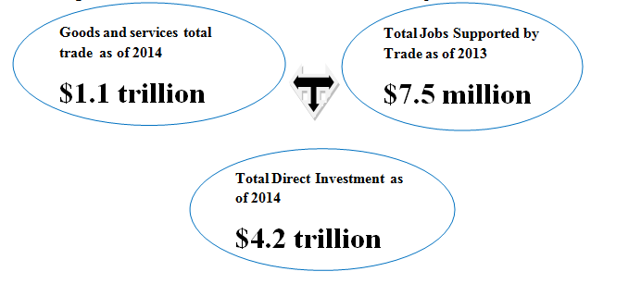
Source: (The President's trade agenda, 2016).

3.11 The Dollar’s Decline and Exchange rate pass-through
The depreciating in the dollar against an import-weighted index of currencies is estimated nearly 15 percent in the United States of America from 2002 to 2005, while American import prices measured in dollars increased nearly 8 percent. The total changes in the dollar had been transmitted to American import prices nearly 50 percent with absent changes in the global conditions in the recent years.
According to these fluctuations happened in the exchange rate, import prices in the industrial countries such as United States of America, France, and Japan have become less responsive to changing of exchange rate since the 1990s. The exchange rate pass-through fallen 30 for the United States of America and the pass-through dropped, for France nearly 80 Percent, and nearly 40 % percent for Japan.
In past few years, the value of dollar depreciated against the major currencies in the world. In principle, the depreciation of the dollar's value would help to improve U.S. trade deficit by adjusting the relative prices of American goods and foreign goods. The depreciation in the value of dollar stimulated foreign producers to keep their profits by raising the value of the dollar of their exports to the United States. One possible interpretation of the American experience is that the change of exchange rate “pass through” and response to the degree of the changes in the value of the country's currency impact on the changes in the price of exports and imports. While the process of pass-through is not complete for example, the devaluation of the US currency by 20 percent will lead to an increase in the price of imports by less than 20 percent.
The US economy benefits from declining of exchange rate pass-through for two reasons. First, is important to correct the US trade imbalance if the changes of the American dollar have less response to changes in import prices then, leads to a larger devaluation of the American dollar will be formed to decrease the size of the imbalance.
Second, the role of pass-through is significant for the stability of domestic prices. Low of import prices affect of decreasing the inflation rate and stimulating the domestic producers to keep their prices competitive.
by increasing import prices, and reflects on depreciation of the dollar could create inflationary pressures in the American economy. (Hellerstein, Daly & Marsb, 2006).
The monetary policy will soon tighten in the United States of America, Japan, and Europe and then If the price import effects of the dollar's appreciation will push the inflation rate in the US, the appreciations of the US dollar have both direct and indirect impacts on import prices, consumer price index, and the appreciation of the US dollar have affected quickly of the price of goods produced abroad, In addition, the appreciation of the US dollar will raise the price of exports goods on foreign currency then the dollar will appreciate and import price will shift the global demand for American goods and services to foreign goods and services produced abroad.
In general, more than 95 percent of all goods and services coming to the America are priced in the US dollar, not in foreign currency then will any change in the price of US dollar affects of the import price for at least 6 months, but the impact on US dollar exchange rates fluctuations are very small then that supporting the US exchange rate stability in the international trade and standardizing commodities, such as petroleum products, non-petroleum product, and agricultural goods.
the shifting demand for the foreign products, foreign manufacturers, electronic products, machines, and cars may increase their prices, while the changing of the exchange rate effects on the American consumers then the consumers responds depend on capacity utilization, but continually changing in exchange rates, probably producers will respond better.
The declining exchange rate pass-through to import price in the America and other countries in last 40 years that will lead to declining in global inflation which has decreased exchange rate volatility and has boosted central bank credibility.
The high inflation abroad might affect of an appreciation of the US dollar and the appreciation of the UD dollar will have not a permanent that would affect on American consumer price index but it would not cause deflation, that would require a tightening of monetary policy in the United States of America. (Humpage, 2015).

3.12 The U.S. dollar strengthens against major world currencies
In December 2014 and 2015, the weighted rate of the foreign exchange value of the American dollar rose nearly 11.8 percent against the major currencies index, The U.S. employment reports and a healthy economy led to increased expectations in the US (Fed) Federal Funds interest rate some international factors have affected the appreciation of the value of the dollar relative to other currencies the main factors were instability in the Middle East, decreasing economic growth in China, and decreasing global growth and demand for the commodities, these global and domestic fluctuations led to increasing the value of the American dollar, and decreasing the value of the major currencies, because of resulting poor performing in the global economy and expansionary monetary policy.
In 2014, the Euro-zone economy faced decreasing of output and lacking employment growth. The quantitative easing strategy (QES) was a tool by European Central Bank (ECB), the Bank of England, the Bank of Japan, and the U.S. Federal Reserve to create money by buying government bonds, the debt then finding a better mechanism to invest in economic and job growth. The European Central Bank set an inflation target nearly 1.5 percent and increase in the Euro zone’s Gross Domestic Product.
The central bank committed to putting money into the system each month around 60 billion Euros, but previously committed 13 billion Euros in 2015, the European economy and the expansionary monetary policy (Fed) faced the big weakness by the depreciation of the Euro against the American dollar which weakened 13.2 percent in 2015.
in 2012, Prime Minister Shinzo Abe elected, after that, the Bank of Japan instituted an “Abenomics” that was nicknamed of monetary stimulus program in an effort to reverse the direction of deflation and stagnation, the Prime Minister Shinzo Abe kept low prices and wages and for facing the effect of deflation and targeted inflation by 2 percent, and supported to increase prices and profits for businesses, and getting a bigger share of earnings on to workers, Shinzo Abe was expected the expansionary policy to devalue the yen and supporting to decreasing the price of exports, in 2013, the Japanese's currency declined against the American dollar by 33.9 percent, but some of the plans remained unsuccessfully such as wages have remained constant, and the target of inflation has not got the 2 percent.
In 2015, the Chinese economy faced a slowdown in economic growth and a weaker volatile stock market and export sector, the central bank to determine the value of the Yuan currency changed the exchange rate policy and the central bank in China sells and buys Yuan to promoting the export sector and to keep its value relative to other currencies steady, The Yuan currency devaluation by (1.9 %), Yuan currency remained low for 4 years and was the biggest fall in the Chinese's currency since a big devaluation in 1994.
The low oil prices were affected by Canadian economy, and the Canadian currency is closely bound to the American dollar. In Canadian economy, exports have a large trace comparatively to other major economies.
Demand for Canada’s export restricted by Weak global growth. Exports share to total Canadian economic output by 25.1 percent, and exports share to total Chinese economic output by 13.3 percent, the United States by 8.4 percent and Japan by 12.9 percent. Oil export share to Canadian economy by 19 percent of aggregate exports. The demand and price for oil declined steeply that promoted the value of the Canadian currency decreased to very low level in 13 years. (Reed, 2016).
The Trump administration will be characterized by supporting businesses, economic growth, and stronger corporate profitability to the American economy. The American Federal Reserve tightening of monetary policy through 2017, and which to practically implement policies by Trump administration such as tax cuts, fiscal spending.
The expectations for American dollar and Euro have remained under pressure as investors concentrate on diverging growth and monetary policy trends between Euro-zone and the America. Political belief that more weakness of Euro will be persistent and Euro-zone risk may increase, while the risk of the UK shocks may fall back, and American dollar and pound sterling will be more liable in future.
The New-Zealand's currency and Australian currency are both tradings at comparatively “rich” levels versus the Canadian currency. The depreciation of the value of Chinese currency will extend into 2017. Nearly 80-90 percent of Indian onshore cash liquidity conditions have improved.
The Singapore dollar (SGD), the Korean won (KRW), and the Malaysian ringgit (MYR) are the most weaken currency to Fed rate hikes in 2017. Meanwhile, we have cautious of the risk of Indonesian currency rupiah of local government bonds, being squeezed lower given high foreign ownership.
Under the Tramp administration, the Taiwanese currency (dollar) suffered cross-strait tensions between U.S. and Taiwan. The Brazilian economy got the lowest level instability, while Mexico and American strategy relationship had been doubting, particularly with regarded to trade and investment. The Mexican Peso (MXN) is a very weak currency among the 24 emerging- market currencies in the world. However, the doubt between Trump’s policies and Mexico is not predictable particularly, remaining the Mexico's currency (peso) under pressure, or at least volatile. (Osborne et al., 2017).
3.13 The Role of Monetary Policy and Exchange Rate On the US trade
The role of monetary policy moving shifts in monetary policies both in the United States and outside have characterized the years since 1979. The effects of these shifts on exchange rates are difficult to quantify, but it seems likely that ideas about future U.S. monetary policy have played a key role since the mid-1970, especially in contributing to the dollar’s appreciation in 1979-82 and its earlier sharp devaluation in 1977-79. In the fall of 1979, the dollar, having depreciated in real terms about 10 percent relative to its 1976 peak, was widely regarded as undervalued. In remembering, monetary factors seem to have been critical in causing the dollar’s nominal devaluation over this period. Despite hastening domestic inflation, the Federal Reserve surpassed its reported m1growth targets in 1977, 1978, and 1979. As Robert Solomon observes, by the second half of 1979, “there was some question whether the Federal Reserve was losing control”. The events in the 1977-79 are that the dollar’s nominal devaluation exceeded its real devaluation. On this view, the real depreciation that did happen was primarily temporary, the result of slowness in domestic prices. From January 1977 to September 1978, U.S. nominal interest rates rose pointedly, although German and Japanese rates declined, another sign that the dollar’s depreciation over that period was being fed by inflationary expectations.
Restrictive measures taken by the United States in October 1978 increased nominal dollar interest rates further. Monetary growth abroad, especially in Germany and Japan, accelerated pointedly between 1977 and 1978. But the acceleration was largely a response to the dollar’s devaluation and happened against a background of falling consumer price inflation. In those two years, foreign central banks acquired a massive $70.4 billion in claims on the United States through foreign exchange intervention. Attempts were made to sterilize these dollar purchases, but their net effect on foreign money supplies was still expansionary. At the time, the emergence of record current account imbalances-a U.S. deficit, German and Japanese surpluses was viewed as an important factor in explaining the dollar’s impetuous fall. The importance that was then connected to current account developments appears now to have been excessive. Strong increases in U.S. investment in 1977 and1978 more than offset the current account’s influence on U.S. wealth.
Furthermore, purchases of dollar assets by foreign central banks may have offset any portfolio- balance effects of the U.S. deficit on the dollar’s value. It has been suggested that the primary exchange rate effect of the 1977-78 current account inequalities was a “news” effect. According to this view, the market interpreted the changed configuration of external balances as evidence of a demand shift away from U.S. goods requiring a real depreciation of the dollar.
In the end, 1979 change in Federal Reserve operating procedures, which increased the central bank’s emphasis on monetary targets at the expense of interest rate targets, appears to have signaled a turning point in market expectations about the future course of the United States monetary policy.
The dollar’s real devaluation from its 1976 level came to an end during 1980. A keen slowdown in U.S. monetary growth from the fourth quarter of 1980 to the fourth quarter of 1981, together with the election of a Republican administration believed to be committed to disinflation, lent credibility to the declared new course for monetary policy, in late1980 the dollar started its recent phase of appreciation as U.S. interest rates surged above interest rates in Germany and Japan. As was noted earlier in the review of recent macroeconomic developments, the reduction in average annual U.S. monetary growth since 1979 has not been large. However, it is not only current money, but also anticipated money, that influences today’s exchange rate.
The October 1979 changes may well have led to an extreme downward revision of money growth expected to occur in the future. Evidence on the link between monetary announcements and subsequent changes in asset prices is consistent with the hypothesis that Federal Reserve monetary targets gained credibility as a result of the October 1979 change in operating procedures.
Against the backdrop of a weakening dollar, the Federal Reserve declared in July 1985, after two-quarters of surprisingly rapid M1 growth, an upward revision and rebasing the monetary targets it had set February. A previous midyear change had occurred in July 1983 but had no dramatic effect on the dollar’s value. (Obstfeld, 1985).

3.14 Shaping Globalization Through Trade Agreements
After President Obama took office, the American economy getting more stronger but despite that, there is more to do, day after day, the American economy developed quickly and flows of goods, ideas, and information, the economic development in the US continued especially, the technology and logistics steadily reduced the international transactions costs of trade, year by year the global container shipping fleet getting more expansion, and the more expansion of the global internet, deployment new fiber-optic cables, and moving goods and information getting easier around the world and reducing tariffs and costs. Trade liberalization has added $13000 to average income to each American family. It's important for Americans people because they spend a big proportion on tradable goods, such as food, and clothing.
Tariff are the relatively low rate of 1.5 percent and all imports coming in free duty by 70 percent because the U.S. has a large open economy and the tariffs on imports of consumers goods have a disproportionate effect on low- income Americans.
A world of cheaper shipping and cheaper costs and high technology eased access to global customers goods, the American farmers and small business provided the cheapest and best goods for millions of customers of American families in the world. The American people focuses on innovation, creativity and internet services plays to the strength position in the United States.
Everywhere from advanced manufacturing and online entertainment bringing the change and instability, that is why American people sought to change the shape of globalization through international trade agreements, the American efforts which cut over 18000 taxes on exports that are why they have pursued the Trans-Pacific Partnership and writes strong rules for the digital economy. it is why the Americans people worked hard to access greater secure to the European market through the transatlantic trade and investment partnership. The U.S. trades and investments relationships are very large in the world. These trade policies offer a positive vision of the global economy for American leadership, this vision very important because in the absence of American leadership and Guidance the world probably to turn to an alternative policy that leads to American at a permanent disadvantage. (Forman, 2017).

CHAPTER FOUR

RESEARCH METHODOLOGY & DATA ANALYSIS

4.1 Introduction
This analysis explained step by step in this empirical analyses and the methodology that steps procedures and processes of achieve our objective of the work are discussing.

4.2 Variables and Data
The time series data will be applying to the conduct of the research work and the variables, are the real gross domestic product, exchange rate, import of goods, export of goods & CPI. The data on real GDP, import, and export of goods and CPI, and exchange rate were collected from the AMECO from 1975-2015.

2.3 Model Specification
GDP= α+ β1exchange-rtae (-0.69) + β2export (4.47) + β3import (-4.20)+ β4CPI (-0.22) + ε …………..1
Y= α+ β1 x1 + β2 x2 + β3 x3 + β4 x4 + ε
Y = Gross Domestic Product
x1 = Exchange rate
x2 = Exports
x3 = Imports
x4 = CPI
ε =Error term
The corresponding export to GDP is 4.47 percent it means one percent increase in export the GDP increases by 4.47 percent. The corresponding import to GDP is (-4.20) percent it means one percent increases in import the GDP decreases by 4.20 percent the relationship between import and GDP is negative but the relationship between export and GDP is positive the exchange rate is a negative sign (-0.69) it means one percent increase in the exchange rate of US dollar against major currencies leads to decrease of GDP by 69 percent while the wages of labors in the US are very high compared with some developed and less developed countries it affects of price of American goods and the demand for American goods also, consumption affects the US GDP negatively (-0.22) it means one percent increase of American consumption leads to decrease of GDP by 22 percent.

4.4 Method of Estimation
For the purpose of this study, we shall employ each of Johnson cointegration technique, unit root test, and VECM, explain the long run and short run relationship Variables, such as Gross domestic product and Trade. The method estimation is contingent upon the following requirements; are the variables integrated at the level? That is they must be stationary in first difference and nonstationary in level. Secondly, the cointegration relations among the variables exist, all variables would make an adjustment to restore back equilibrium. In the case where all the variables are stationary in first or second difference but no cointegration relationship exists among them. The strength of this method of the Vector Error Correction Model it is an equation model analysis which all variables as potentially consequently addressing the problem of endogeneity our model. There are two tests that need to be conducted before estimating the Vector Error Correction Model while the unit root test and in testing for unit root process, we shall do two test statistics that are (ADF) test and (PP) test.
After establishing the order of integration found that all the variables are integrated at I(0), after that we shall test for cointegration, This test informs us whether the long-run relationship exists among the variables. Several techniques for testing for cointegration between series of non-stationary data have employed in empirical studies of this nature. Then Johanson approach it's tested for cointegration and long run relations among the variables. We say there is long run cointegrating relationship among our variables if these tests statistics are more than critical values at 5 percent level in conduct the cointegration test, there is need to select an optimal lag order in order to conduct this test there are basically two ways to choose the lag order these are via information criteria such as SIC (Schwarz information Criteria), ML (Maximum Likelihood Criteria) AIC (Akaike information Criteria), or by selecting lag length Criteria to whiten the residuals, the econometric views (Eviews 9.5) and Microsoft Excel and Word 2010 are the computer packages used for data processing in this study.

4.5 Vector Error Correction Model (VECM)
An error correction model shows the equilibrium relationship among the variables in the long run. Despite, the relationship between non-stationary but cointegrated variables should base on an error correction model. Hence, if the variables are found to be cointegrated, it shows that they have a stable long-run equilibrium relationship, while a short-run disturbance among the variables is corrected or adjusted back towards equilibrium by the error correction mechanism.

4.6 Empirical of Research Paper
In empirical of research covers the result and analyzing the impact of trade and GDP in the United States of America. The sample period runs from 1975-2015 the first three observations are reserved for the lagged explanatory variables in the normalized equation and Vector Error Correction Model (VECM).

4.6.1 Unit Root Test Results
In this study we use ADF and PP test at the level and first difference; we conduct the test for the variables by assuming three different specifications on the random walk model both the (ADF) and (PP) standard test for stationarity the summary of this result display in table 4.1.1

Table 4.1 The empirical result of unit root test
Variables | Constant, Linear Trend |  | Remark | FIRST DIFFERENCE Constant, Linear Trend |  | remark
 | ADF | PP |  | ADF | PP
GDP | -3.424729 | -2.114367 | I(I) | 3.968976 | -4.641653 | I(0)
 | 0.0630 | 0.5224 |  | 0.0185 | 0.0034
CPI | -3.518070 | -2.332736 | I(I) | -4.399135 | -4.259560 | I(0)
 | 0.051 | 0.4076 |  | 0.0062 | 0.0089
EXCHANGE RATE | -2.278718 | -1.641671 | I(I) | -3.784568 | -3.712625 | I(0)
 | 0.4351 | 0.7581 |  | 0.0282 | 0.0332
EXPORT | -3.151209 | -2.597898 | I(I) | -4.378085 | -4.125153 | I(0)
 | 0.1092 | 0.2833 |  | 0.0065 | 0.0124
IMPORT | -3.084678 | -2.581770 | I(I) | -4.647462 | -4.444043 | I(0)
 | 0.1240 | 0.2902 |  | 0.0032 | 0.0055

This analysis implies that an examiner is needed to see cointegration in the model or test for cointegration, is it the variables cointegrated?. This test for cointegration is needed to establish whether the variables are converging, in the long run, we can See the Johansen cointegration result from the table 4.1.2.

4.6.2 Johansen Cointegration Result
In Johansen cointegration test shows that there is a long-run relationship between the variables and all the variables cointegrated in order one (at most 1) in the model. The result of this model (Johansen cointegration) suggests that there is evidence of cointegration in order one among the variables.
We proceed four tests values from Trace statistic and Max-Eigen statistic test was greater than their critical values at 5 percent significance level the test is conducted by using the lag length selection is based on sequentially modified LR test statistic information criterion.
Table 4.2 The result of cointegration test
Hypothesized No. of CE(S) | Trace Test |  | Maximum Eigen Value
 | Test value | Critical value 0.05 | Test value | Critical value 0.05
None * | 82.83772 | 69.81889 | 41.00387 | 33.87687
At most 1 | 41.80385 | 47.85613 | 22.43442 | 27.58434
At most 2 | 19.36943 | 29.79707 | 12.13477 | 21.13162
At most 3 | 7.234658 | 15.49471 | 6.951811 | 14.26460
At most 4 | 0.282847 | 3.841466 | 0.282847 | 3.841466
NOTE: Trace test indicates 4 cointegrating also, Maximum-Eigen value test indicates also 4 cointegrating at the 5% level in the model. Lag length selection is based on LR, lag order is 1 2. We, therefore, proceed to analyze the Johansen Cointegrating to make sure of the long-run relationship between the variables. This is presented in table below.

Table 4.3 Estimate of the (Identified) Long-run Equilibrium
Variable | GDP | CPI | EXCHANGE RATE | EXPORT | IMPORT
Co integrating Vector | 1.000000 | -0.227234 | -0.693091 | 4.478280 | -4.209082
S.E |  | 0.17348 | 0.18135 | 0.74858 | 0.74776

The result from the equation above identifies the long run equilibrium in the model if increase CPI by one unit that affects to decrease GDP by (-0.227) unit, if increase exchange rate by one unit decrease the GDP by (-0.693) unit, if increase export by one unit also, increase the GDP by (4.478) unit, if increase the import by one unit decrease the GDP by (-4.209) unit this supported by both Trace test and Max-Eigen test which depicts the presence of cointegration in the variables there is the explanatory variables have used in our model (CPI, Export, Import, and Exchange Rate) to the other side of the equation, the normalized equation indicates that long-run relationship among the variables, meaning that there is almost one cointegration model and our five variables are cointegrated and have long-run association ship, or in long-run they move together, so we can not reject null hypothesis and we reject alternative. In another word, Export, Import, exchange rate, and CPI affects growth negatively in the long run.

4.6.3 Error Correction Model Result
At the beginning of this chapter, we have determined the order of cointegration among the variables. The error correction model has determined the short run dynamics of the cointegration equation to their long run dispositions. In Table 4.4 below depicts the result of the short run dynamic based on VECM and the speed of adjustment coefficient.
Table 4.4 Vector Error Correction Model (VECM) Result
Vector Error Correction Estimates with RGDP as the dependent Variable
Date: 04/25/17 Time: 08:29
Sample (adjusted): 1978 2015
Included observations: 38 after adjustments
Variables | Coefficient | Standard. Error | T. Statistic | Probability
C | 8465019 | 3657039 | 2.31472 | 0.0288
D(GDP(-1)) | 1.820770 | 0.335494 | 5.427132 | 0.0000
D(GDP(-1)) | -0.502775 | 0.305987 | -1.643128 | 0.1124
D(CPI(-1)) | -0.636590 | 0.184798 | -3.444779 | 0.0020
D(CPI(-2)) | 0.015519 | 0.223132 | 0.069550 | 0.9451
D(EXCHANGE  RATE(-1)) | -0.025733 | 0.027518 | -0.935119 | 0.3583
D(EXCHANGE RATE(-2)) | 0.013580 | 0.023748 | 0.571823 | 0.5724
D(EXPORT(-1)) | -0.048117 | 0.034693 | -1.386954 | 0.1772
D(EXPORT(-2)) | 0.040665 | 0.041222 | 0.986469 | 0.3330
D(IMPORT(-1)) | 0.052629 | 0.038962 | 1.350802 | 0.1884
D(IMPORT(-2)) | -0.051888 | 0.044288 | -1.171611 | 0.2520
ECM(-1) | -0.005116 | 0.008087 | -0.632638 | 0.5325
R-squared | 0.833878
Adj-R-squared | 0.763596
F-statistic | 11.86469
Prob F(statistic) | 0.000000

From the above table, as extracted from the VECM estimate, the coefficient of error correction model has a negative sign and statistically significant at 5% level. And the speed of adjustment relatively high. In our result shows nearly 51% of the deviation is far from the equilibrium point, it will be corrected in the first year, while the remaining 49% will be corrected in the second year. In another word, it will take about two years for any deviation to be corrected and equilibrium restored. The result of the short run relationship reveals that CPI at lag one is found to be negative and insignificant while at lag two CPI is found to be positive and significant. Again, we found exchange rate to be significant at lag one and lag two. Also, export is found to affect economic growth negatively at lag one and positively at lag two both are significant. final, import is found to promote economic growth at lag one and significant but at lag two negatively significant. The power of our explanatory variables in explaining changes in the dependent variable is high as evident by the value of the R2 (83). Therefore, the short run relationship in this result is in tandem with the medium term trade conduct in the USA which uses a medium term to correct for the shocks or any distortions on the target objectives of maintaining economic growth.

Figure 4. 1 The Fluctuations in each of these Variables (exchange rate, CPI, export, import, GDP)

CHAPTER FIVE

SUMMARY, CONCLUSION & RECOMMENDATIONS

5.1 Summary
In this research paper aimed to re-investigating the relationship between trade and gross domestic product in the United States of America and analyze the impact of trade on economic growth while in chapter one and chapter two focused on the background of the study and a number of theories and the conflicting theoretical propositions in this study have left many questions and linkage between trade and economic development, Chapter three focused at trade in the United States of America its conception and implementation for the achievement of the macroeconomic objective. A strand of the literature argued that trade has a positive relationship with economic development and another strand of the literature argued that trade has a negative impact on GDP while the third strand of the literature was inconclusive as to whether the trade has a positive or negative impact on GDP, Chapter Four discussed the methodology adopted in order to empirically test the hypothesis and analyze the results while Unit root test was conducted to ascertain the stationarity of our variables and they were found to be stationary at first difference and non-stationary at level. The Vector error correction used because cointegration was found to exist between the variables in the model. Also used to examine the relationship that exists between economic development, trade, exchange rate, and other supporting macroeconomic variables in the United States of America.

5.2 Conclusion
From the resulting estimate, the following major findings were observed:
- The Export, import, exchange rate, and CPI affect real GDP in the long run in the United States of America.
- In the short run, policy rates found to impact on real GDP positively.
- The coefficient of the speed of adjustment significant and relatively high.
- R-squared is relatively high is 0.83 percent
- Adjusted R-squared is 0.76
- The probability is 0.000 is a good sign
- In our result shows nearly 51% of the deviation is far from the equilibrium point it will be corrected in the first year, while the remaining 49% will be corrected in the second year.
- there is no short run and long run causality except consumer price index in the short run.
- Jarque-Bera probability equal 0.64
- Serial correlation test is equal 0.93
- Heteroskedasticity White test is equal 0.52
- Heteroskedasticity Breusch- pagan-Godfrey test is equal 0.24
- Mcteer, B. (2008) in his paper "Impact of the foreign trade on the economy in the U.S" found out that imports exceed exports and in 2007, exports contributed to GDP by 12 percent and imports were 17 percent. Zhao, C. (n.d.) " How does the US trade deficit affect US businesses and consumers"? in his paper found out that the United States has trade deficit because the American import is greater than export an additional created a negative value into the US current account of balance of payments, Moreover, the foreign goods and services are cheaper than domestic goods and services, the American people can get foreign goods cheaper rather than buy American goods and services. Heim. J. J. (2009) " The real exchange rate and the U.S. economy 200-2008" in his paper found out that the effects of exports to GDP are positive. In our research paper found that the US economy has current account deficit and imports are more than exports Moreover, the relationship between GDP and export is positive sign increasing the export leads to increase the GDP. However, the value of the dollar is very high that affects on American domestic products and shift of the American domestic demand to foreign products that affect on Balance of Payment deficit.

5.3 Recommendations
Based on our result which shows that trade action of each of these variables have negatively on GDP except export, while the government increase exchange rate, import, consumer price index, that leads to decrease the GDP, but increasing export have positively on GDP. Therefore, we advise the US authority to increase the export because that affect the US gross domestic product positively.

REFERENCES
Adler, G., & Tovar, C. E. (2011). Foreign Exchange Intervention: A Shield against
appreciation Winds?. International monetary fund. 11(165), 1-26. Retrieved from
http://www19.iadb.org/intal/intalcdi/PE/2011/08593.pdf
Board of Governors of the federal reserve system. (2017, June 1). Foreign exchange
rates-G.5.Retrievedfrom
https://www.federalreserve.gov/releases/G5/current/default.htm
Bryman, A. (2004). Social research method. Second Edition, Oxford University Press.
https://www.amazon.co.uk/Social-Research-Methods- Bryman-second/dp/B00CF67TZG
Cheung, Y. W., & Chinn, M. D. (2001). Currency traders and exchange rate dynamics: a
survey of the US market. Journal of International Money and Finance, 439-471.
Retrieved from https://people.ucsc.edu/~cheung/JIMF/Survey-US_JIMF2001.pdf
Colander, D. (2008). Complexity and the history of economic thought. Middlebury
College economics discussion paper, No. 08-04. Retrieved from
https://www.scribd.com/document/304862541/Colander-2008-Complexity-and-the-History-of-Economic-Thought
Congressional research service. (2016, August 16). U.S. trade deficit and the impact of
changing oil prices, Specialist in International Trade and Finance (publication No.
CRS-7-5700). Jackson, J. K. Retrieved from
https://fas.org/sgp/crs/misc/RS22204.pdf
Course Hero. (n.d.). Structural models of exchange rate determination. Chapter IV, Fina
7360, p. 18. Retrieved from https://www.coursehero.com/file/11297698/ln4/
Cowen, T., & Tabarrok, A. (2012). Modern Principles: Macroeconomics, Worth
publishers; second edition. Retrieved from
https://www.amazon.co.uk/Modern-Principles-Macroeconomics-Tyler-%20Cowen/dp/1429239980
Dornbusch, R. (1986). Inflation, Exchange rates, and Stabilization, Princeton
University, No. 165. Retrieved from
https://www.princeton.edu/~ies/IES_Essays/E165.pdf
Destler, I. M. (2005). American trade politics, (fourth edition). Retrieved from
Retrieved from https://www.amazon.com/American-Trade-Politics-Fourth-Destler/dp/0881323829
Evans, E. A. (2005). Understanding Exchange Rates: A weakening US Dollar----good,
bad, or indifferent for Florida farmers and agribusiness, FE546
http://edis.ifas.ufl.edu/pdffiles/FE/FE54600.pdf
Forman, M. A. (2017, January 7). U.S. trade policy in the obama administration.
Retrieved from
https://obamawhitehouse.archives.gov/sites/whitehouse.gov/files/documents/USTR%20Exit%20Memo.pdf
Filho. F. F. (1996). Keynesians”, monetarists, new classicals and new Keynesians: A
post Keynesian critique, (pp. 63-75). Retrieved from
https://www.scribd.com/document/9015768/keynesians-Monetarists-New-Classicals
Frankel, J. A., Bergsten, C. F., Mussa, M. L., and Feldstein, M. (1994). American
economic policy in the 1980s, exchange rate policy (pp. 293-366).University of
Chicago press. Retrieved from http://www.nber.org/chapters/c7756.pdf
Feldstein, M., Mussa, M., Volcker, P. A., Tobin, J., Fullerton, D., Walker, C.E., and
penner, R. (1994). American economic policy in the 1980s, The University of
Chicago press, Ltd, London. Retrieved from http://www.nber.org/chapters/c7751.pdf
Goldberg, L. S. (2010). Is the international role of the dollar changing? Current Issues in
Economics and Finance , 16( 1), 1-6. Retrieved from
https://www.newyorkfed.org/medialibrary/media/research/current_issues/ci16-1.pdf
Heim, J. J. (2009) The real exchange rate and the U.S. economy 2000-2008. Retrieved from http://www.economics.rpi.edu/workingpapers/rpi0905.pdf
HinterschWeiger, M., & Gagnon, J. E. (2011). Flexible exchange rates for a stable world
economy, Washington DC, Peterson institute for international economics, (PP. 209,
2010). Retrieved from
https://books.google.iq/books?id=nAntvbMey2AC&pg=PA207&lpg=PA207&dq=%22+THIS+BOOK+FOCUSES+ON+MONETARY+POLICY+AS+THE+PRIMARY+TOOL+FOR+DOMESTIC+ECONOMIC+STABILIZATION-THAT%22&source=bl&ots=cIYEq0nmkX&sig=azCIMME1wzh8ufSowZsChs7Ci48&hl=en&sa=X&redir_esc=y#v=onepage&q&f=false.
Humpage, O. F. (2015, March 24). Exchange-rate pass-through and U.S. prices. Federal
Reserve Bank of Cleveland. Retrieved from
https://www.clevelandfed.org/newsroom-and-events/publications/economic-trends/2015-economic-trends/et-20150324-exchange-rate-pass-through-and-us-prices.aspx
Hellerstein, R., Daly, D., & Marsb, C. (2006). Have U.S. import prices become less
responsive to changes in the dollar?. Current Issues in Economics and
Finance , 12(6), 1-6. Retrieved from
https://www.newyorkfed.org/medialibrary/media/research/current_issues/ci12-6.pdf
Jansen, J. H. (2011, June). Integrated exchange rate model (IERM) and Chinese Yuan &
US dollar, HAN business publication 6, 17-30. Retrieved from https://www.researchgate.net/publication/271075513_Intergrated_Exchange_Rate_Model
Krugman, P. R., Obstfeld, M., & Melitz, M. J. (2012) International Economics theory & policy, Ninth edition, Retrieved from
https://dl1.cuni.cz/pluginfile.php/265896/mod_resource/content/1/Krugman,%20Obstsfeld_International%20Economics.pdf
Linda S. Goldberg. (2010). Is the international Role of the Dollar Changing? Federal
Reserve bank of New York. Current issue 16( 1). Retrieved from
https://www.newyorkfed.org/medialibrary/media/research/current_issues/ci16-1.pdf
Mcteer, B. (2008, December 10) The impact of foreign trade on the Economy. The New York Times. Retrieved from
https://economix.blogs.nytimes.com/2008/12/10/the-impact-of-foreign-trade-on-the- economy.
Nafziger, E. W. (2006 ). Economic development, fourth edition, Cambridge University press. Retrieved from
https://books.google.com.cy/books?id=nVchumHhM7UC&printsec=frontcover&source=gbs_ge_summary_r&cad=0#v=onepage&q&f=false
Obstfeld, M. (1985). Floating exchange rates: experience and prospects. Columbia
University (pp. 411, 412, 413). Retrieved from
https://www.brookings.edu/wp- content/uploads/1985/06/1985b_bpea_obstfeld_cooper_krugman.pdf
Orgun, B. O. (2012). Strategic Trade Policy Versus Free Trade, okhan university.
Procedia- Social and Behavioral 58, 1283-1292. DOI:
10.1016/j.sbspro.2012.09.1111
Osborne, S., House, B., warren, A., Holt, D., Theoret, E., Clarke, A., Suarez, E. (2017,
June). Global economics and foreign exchange strategy, foreign exchange outlook. Retrieved from
http://www.gfx.gbm.scotiabank.com/Chart_Feed/fxout.pdf
Perkins, D. H., Radelet, S., & Lindauer, D. L. (2006 ). Economics of Development, sixth
edition. (pp 508,509, 5010). Retrieved from
https://www.amazon.com/Economics-Development-Sixth- Dwight- Perkins/dp/0393926524
The president's trade agenda. (2016). Executive office of the President, office of the United States Trade representative, pp. 1-55. Retrieved from
https://ustr.gov/sites/default/files/2016-Trade-Policy-Agenda.pdf
Rabin, A. A., & Yeager, L. B. (1982). Monetary approaches to the balance of payments
and exchange rates. Essays in international finance, (No.148), 1-23.
Retrieved from https://www.princeton.edu/~ies/IES_Essays/E148.pdf
Reed, K. (2016 ). Impact of the strengthening dollar on U.S. Import prices in 2015.
Beyond the numbers, 5(12), 1-6. Retrieved from
https://www.bls.gov/opub/btn/volume-5/pdf/impact-of-the-strengthening-dollar-on-us-import-prices-in-2015.pdf
Rondinelli, D. A. Johnson, Jr. J. H. Kasarda, J. D. (1998). The changing
forces of urban economic development: Globalization and city
competitiveness in the 21st century. A Journal of Policy Development and
Research, 3( 3), 71-100. Retrieved from http://www.nsl.ethz.ch/displus/140/docs/article4.pdf
Suranovic, S. (2012). Policy and theory of international finance. Retrieved from
https://2012books.lardbucket.org/pdfs/policy-and-theory-of-international-finance.pdf.
Suranovic, S. (n.d.) International trade theory and policy. Retrieved from
http://internationalecon.com/Trade/Tch40/T40-0.php
Todaro, M. P. (1981). Economic development in the third world. 2nd edition.
Retrieved from
https://www.amazon.com/Economic-Development-Third-Michael- Todaro/dp/0582295327
US International Trade Commission. ( 2009, May). How do exchange rates affect import
prices? Recent economic literature and data analysis (Publication No. ID-21)
Washington, DC: 20436, Jabara, C. L.
Retrieved from https://www.usitc.gov/publications/332/ID-21.pdf
Zhao, C. (n.d.). How does the U.S trade deficit affect U.S businesses and consumers?.
the New York University stern school of businesses class of 2018. Retrieved from
https://www.ncbfaa.org/Scripts/4Disapi.dll/userfiles/uploads/Charles_Zhao_-_trade_deficit_paper_2015.doc.pdf

APPENDIX I

Unit Root Test
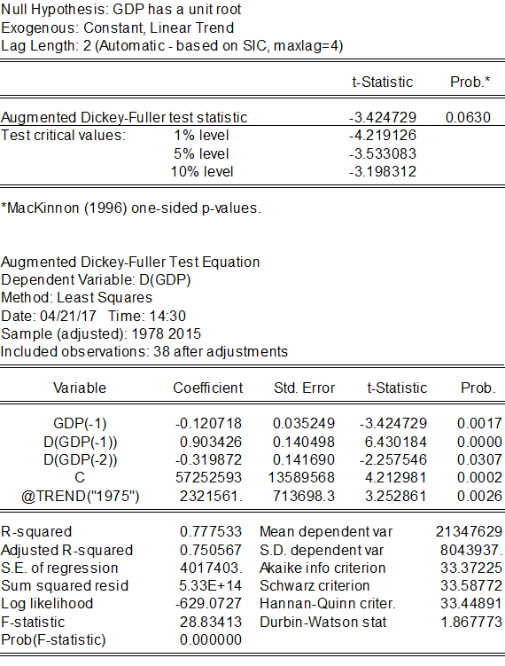
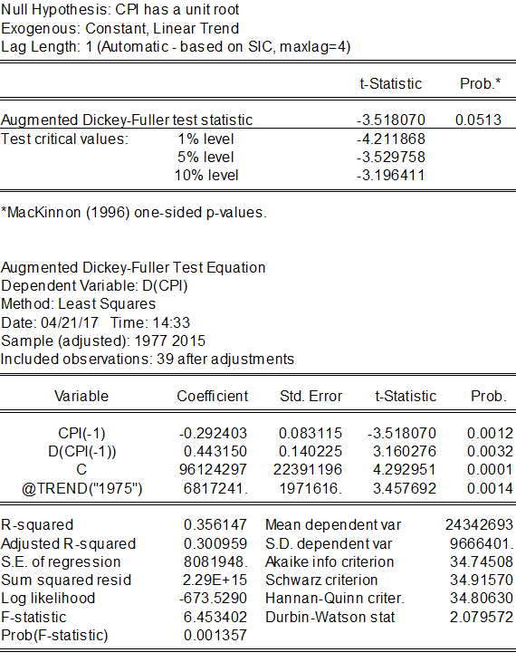

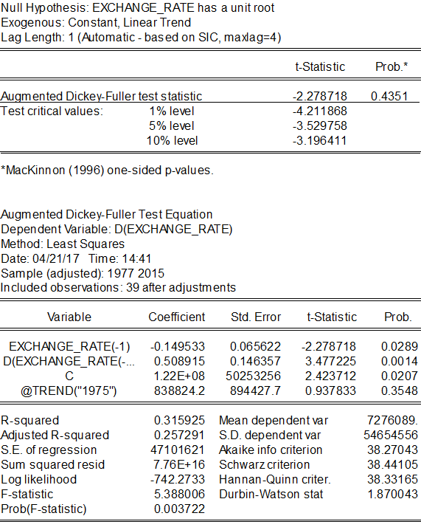

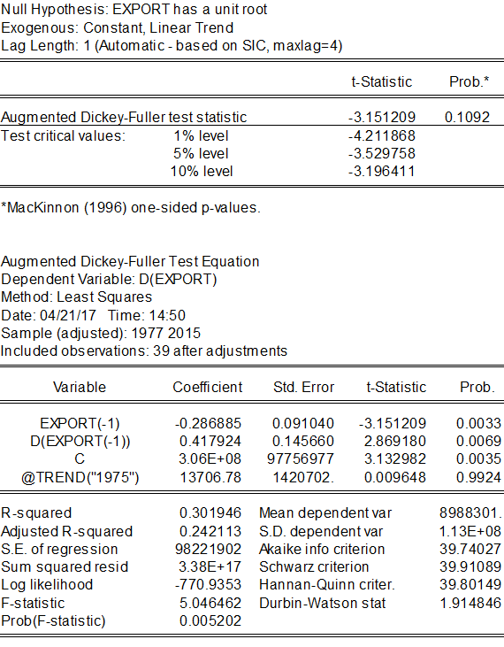

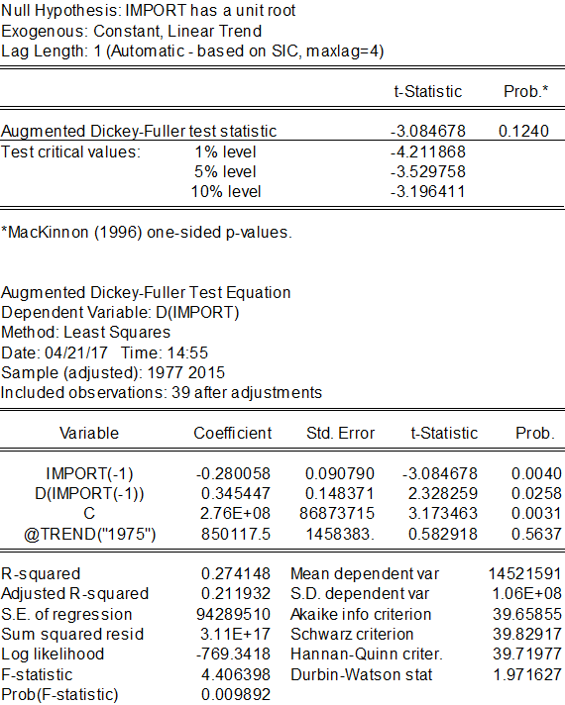

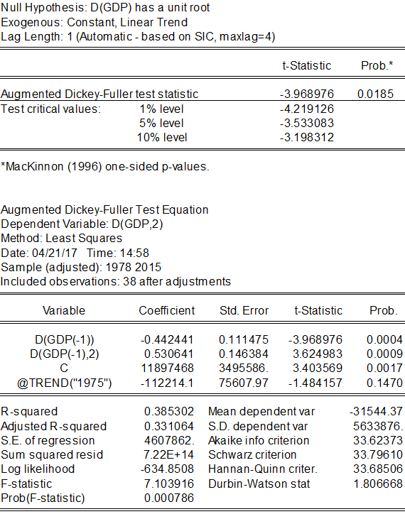

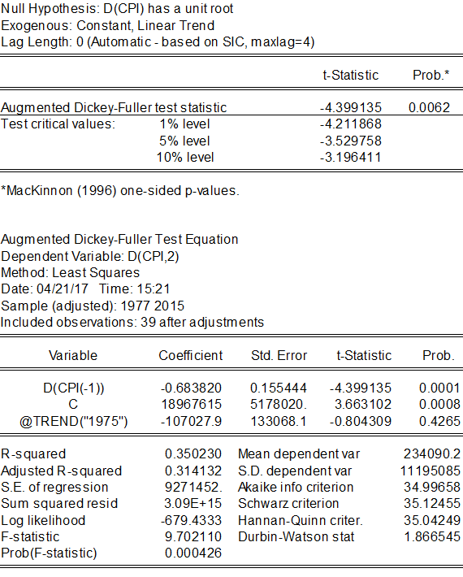

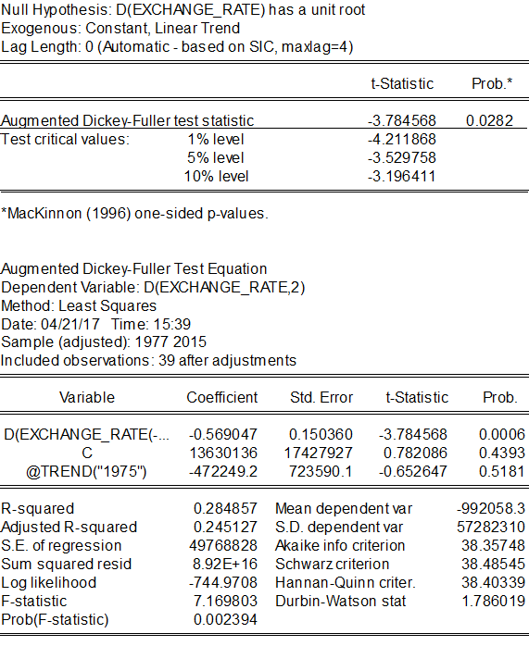

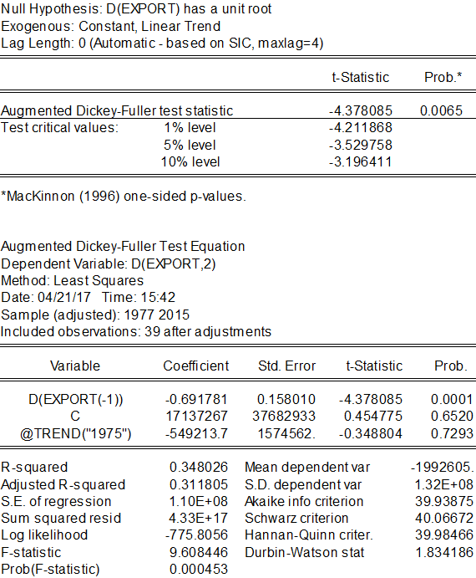

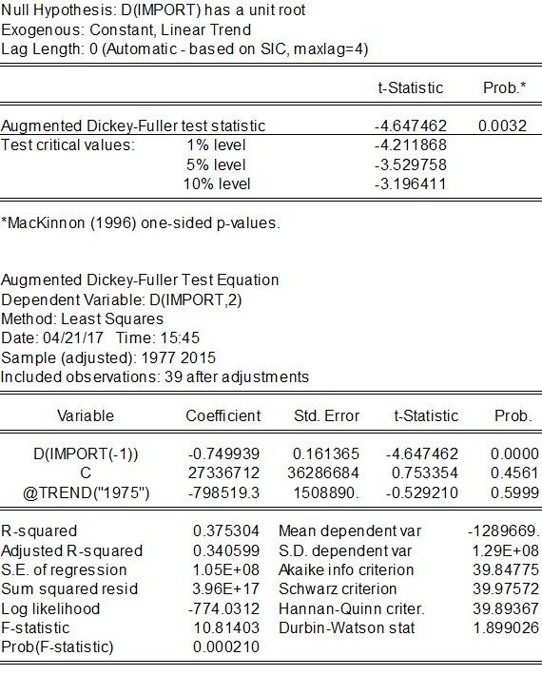

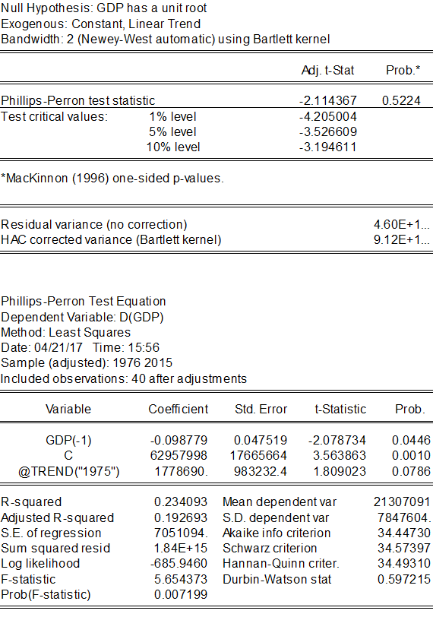

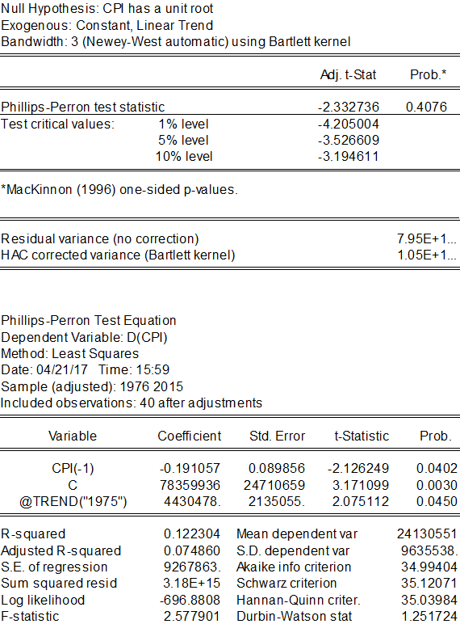

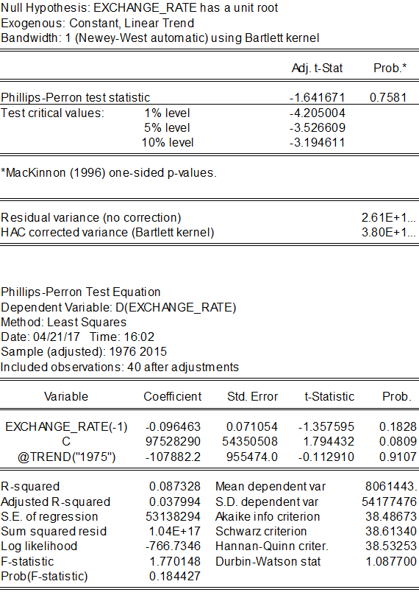

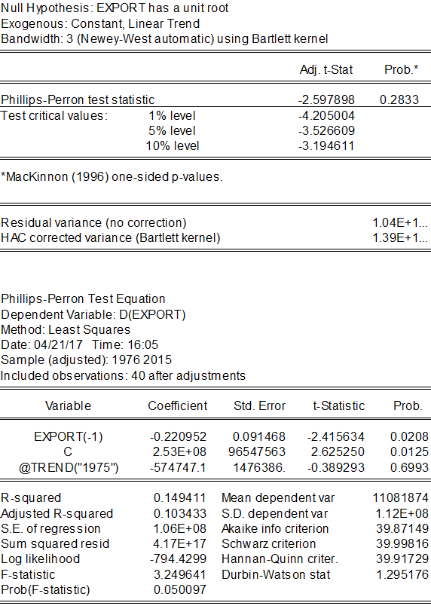
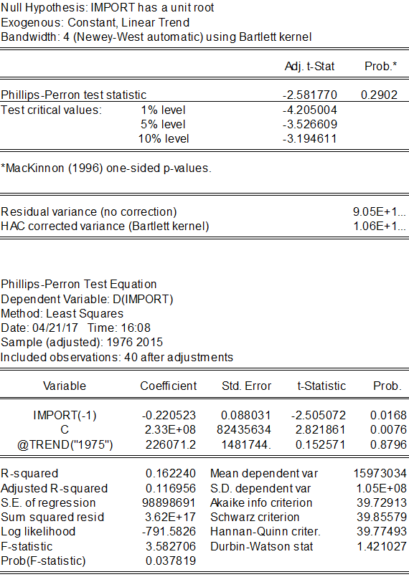

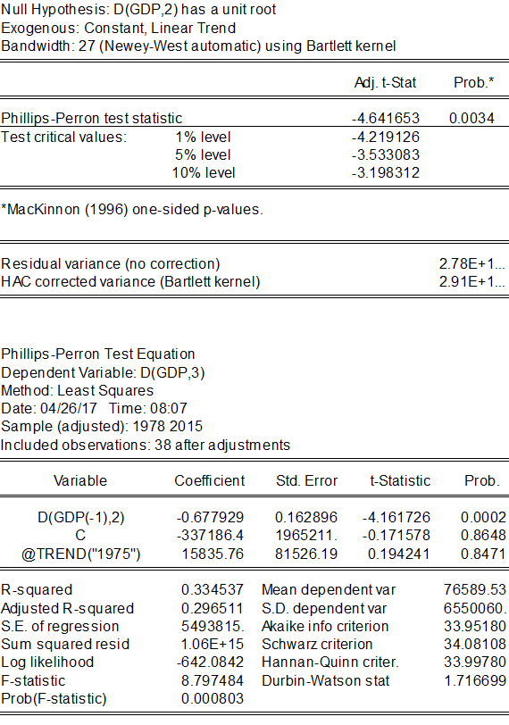

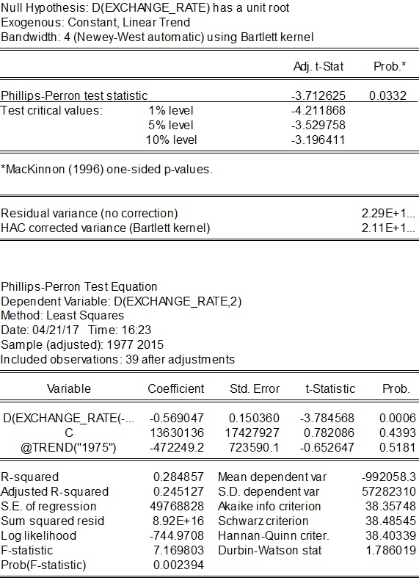
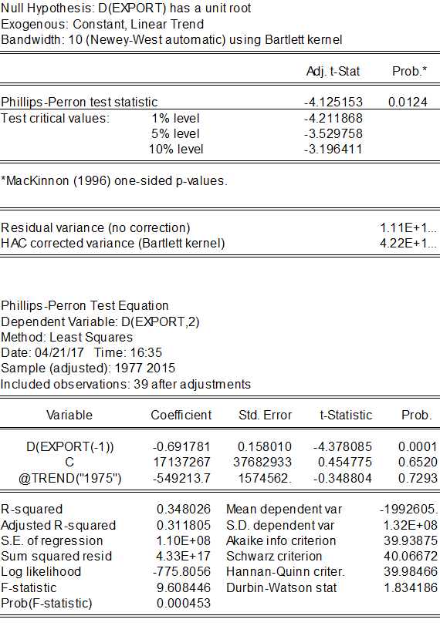
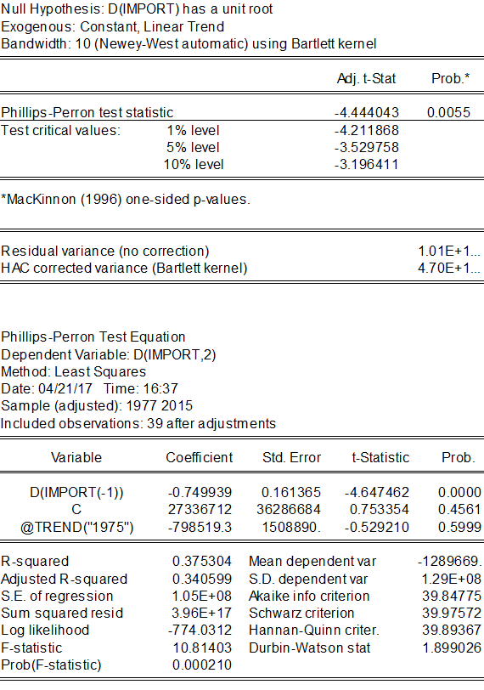

APPENDX II

Johanson Cointegration Test

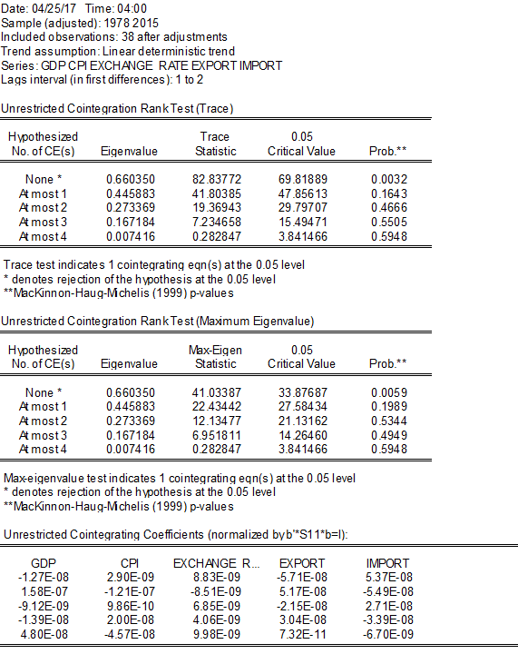

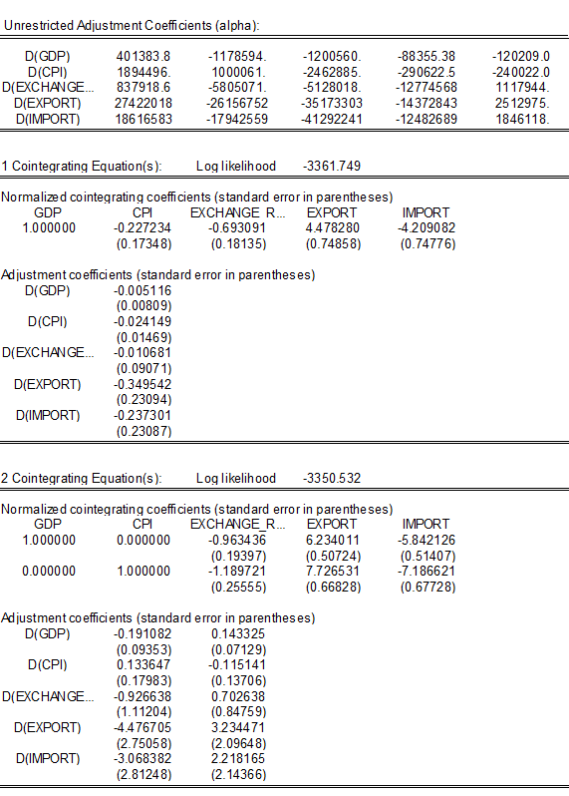

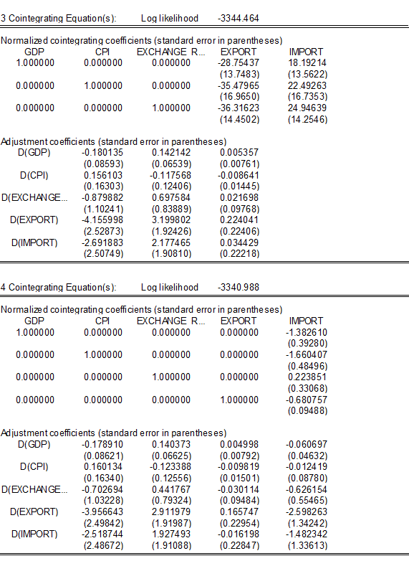

APPENDIX III

Vector Error Correction Model

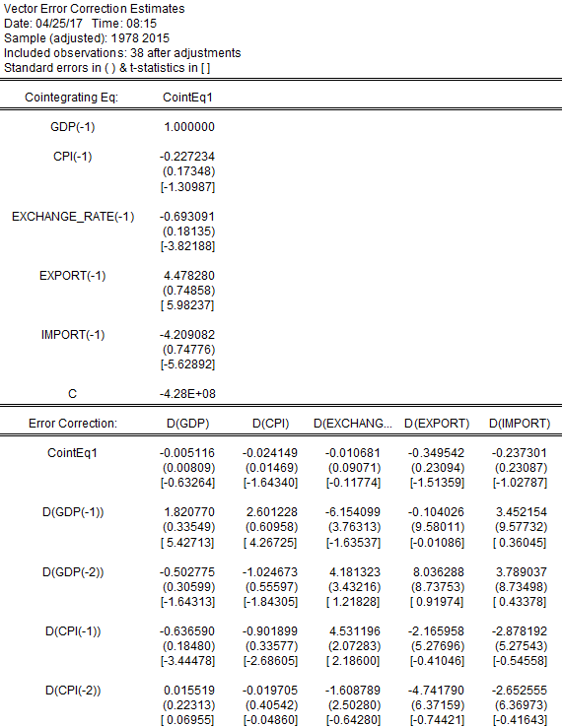

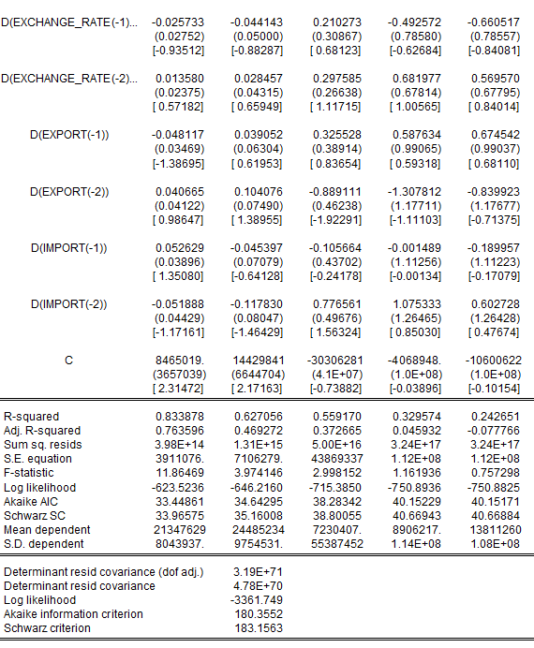

D(GDP) = C(1)*( GDP(-1) - 0.22723396875*CPI(-1) - 0.693091444827*EXCHANGE_RATE(-1) + 4.47828049739*EXPORT(-1) - 4.20908157367*IMPORT(-1) - 427893753.158 ) + C(2)*D(GDP(-1)) + C(3)*D(GDP(-2)) + C(4)*D(CPI(-1)) + C(5)*D(CPI(-2)) + C(6)*D(EXCHANGE_RATE(-1)) + C(7)*D(EXCHANGE_RATE(-2)) + C(8)*D(EXPORT(-1)) + C(9)*D(EXPORT(-2)) + C(10)*D(IMPORT(-1)) + C(11)*D(IMPORT(-2)) + C(12)

D(CPI) = C(13)*( GDP(-1) - 0.22723396875*CPI(-1) - 0.693091444827*EXCHANGE_RATE(-1) + 4.47828049739*EXPORT(-1) - 4.20908157367*IMPORT(-1) - 427893753.158 ) + C(14)*D(GDP(-1)) + C(15)*D(GDP(-2)) + C(16)*D(CPI(-1)) + C(17)*D(CPI(-2)) + C(18)*D(EXCHANGE_RATE(-1)) + C(19)*D(EXCHANGE_RATE(-2)) + C(20)*D(EXPORT(-1)) + C(21)*D(EXPORT(-2)) + C(22)*D(IMPORT(-1)) + C(23)*D(IMPORT(-2)) + C(24)

D(EXCHANGE_RATE) = C(25)*( GDP(-1) - 0.22723396875*CPI(-1) - 0.693091444827*EXCHANGE_RATE(-1) + 4.47828049739*EXPORT(-1) - 4.20908157367*IMPORT(-1) - 427893753.158 ) + C(26)*D(GDP(-1)) + C(27)*D(GDP(-2)) + C(28)*D(CPI(-1)) + C(29)*D(CPI(-2)) + C(30)*D(EXCHANGE_RATE(-1)) + C(31)*D(EXCHANGE_RATE(-2)) + C(32)*D(EXPORT(-1)) + C(33)*D(EXPORT(-2)) + C(34)*D(IMPORT(-1)) + C(35)*D(IMPORT(-2)) + C(36)

D(EXPORT) = C(37)*( GDP(-1) - 0.22723396875*CPI(-1) - 0.693091444827*EXCHANGE_RATE(-1) + 4.47828049739*EXPORT(-1) - 4.20908157367*IMPORT(-1) - 427893753.158 ) + C(38)*D(GDP(-1)) + C(39)*D(GDP(-2)) + C(40)*D(CPI(-1)) + C(41)*D(CPI(-2)) + C(42)*D(EXCHANGE_RATE(-1)) + C(43)*D(EXCHANGE_RATE(-2)) + C(44)*D(EXPORT(-1)) + C(45)*D(EXPORT(-2)) + C(46)*D(IMPORT(-1)) + C(47)*D(IMPORT(-2)) + C(48)

D(IMPORT) = C(49)*( GDP(-1) - 0.22723396875*CPI(-1) - 0.693091444827*EXCHANGE_RATE(-1) + 4.47828049739*EXPORT(-1) - 4.20908157367*IMPORT(-1) - 427893753.158 ) + C(50)*D(GDP(-1)) + C(51)*D(GDP(-2)) + C(52)*D(CPI(-1)) + C(53)*D(CPI(-2)) + C(54)*D(EXCHANGE_RATE(-1)) + C(55)*D(EXCHANGE_RATE(-2)) + C(56)*D(EXPORT(-1)) + C(57)*D(EXPORT(-2)) + C(58)*D(IMPORT(-1)) + C(59)*D(IMPORT(-2)) + C(60)

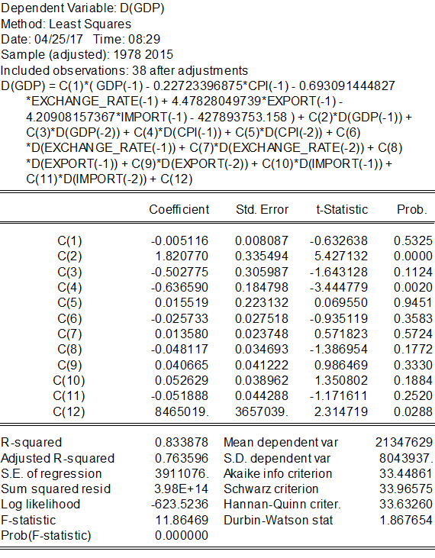

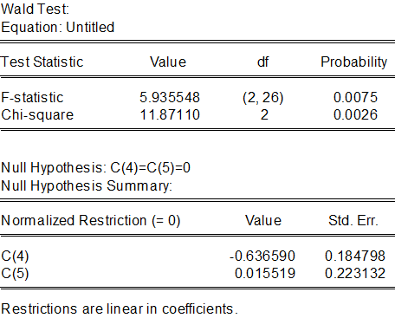

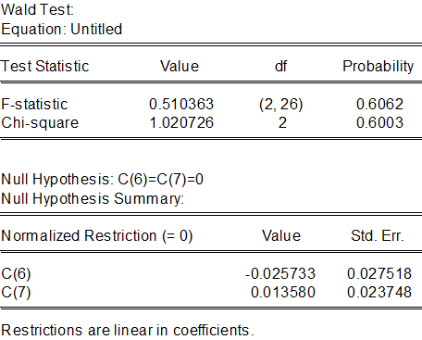

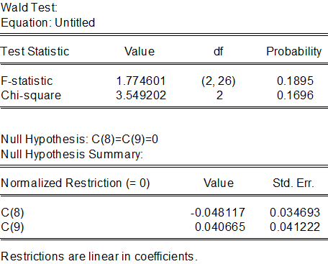

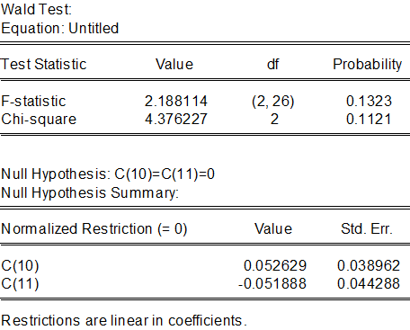

APPENDIX IV

Test for Heteroskedasticity, Normality, and serial correlations

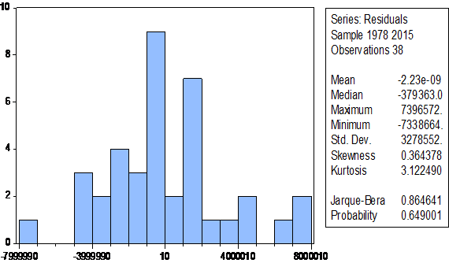
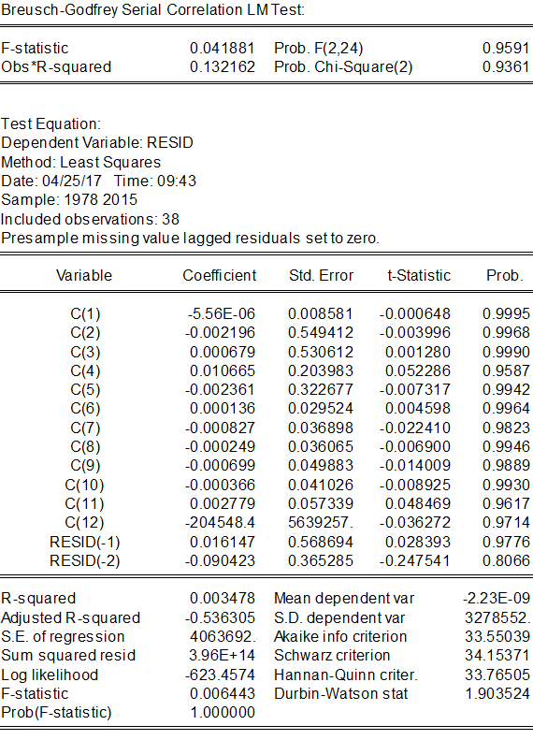

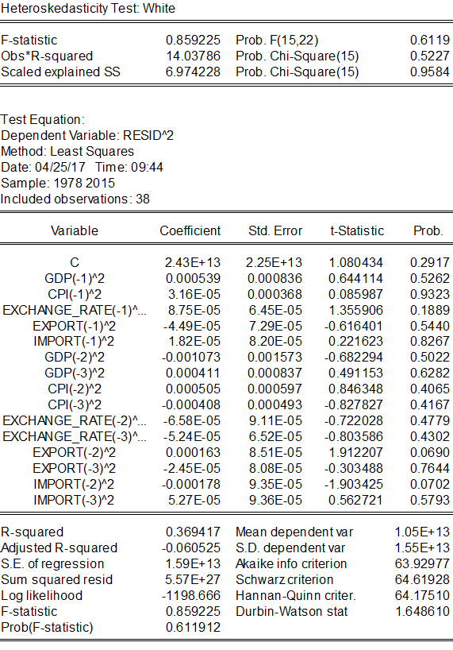

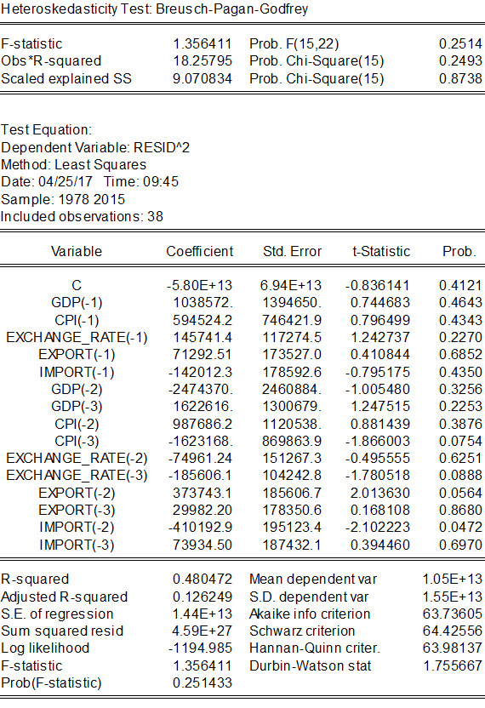

APPENDIX V

Growth Rates of Some Selected Variables in USA 1975-2015
Year | Growth rate of export % | Growth rate of import % | Growth rate of real GDP % | Growth rate of Trade Weighted U.S. Dollar Index: Major Currency % 1973=100 | Growth rate of CPI %
1975 | 9.276 | -3.845 | -0.2 | 102.39 | 9.1
1977 | 4.981 | 21.288 | 4.6 | 106.1 | 6.5
1980 | 21.456 | 17.42 | -0.2 | 95.35 | 13.5
1981 | 5.915 | 6.369 | 2.6 | 104.76 | 10.3
1984 | 9.096 | 28.341 | 7.3 | 128.69 | 4.3
1985 | -2.718 | 1.761 | 4.2 | 133.55 | 3.5
1988 | 26.879 | 8.27 | 4.2 | 90.43 | 4.1
1989 | 12.836 | 2.974 | 3.7 | 94.29 | 4.8
1990 | 8.186 | 4.67 | 1.9 | 89.91 | 5.4
1993 | 3.777 | 9.01 | 2.7 | 89.9 | 3
1994 | 10.221 | 14.225 | 4 | 88.43 | 2.6
1997 | 10.257 | 9.478 | 4.5 | 93.93 | 2.3
1998 | -1.022 | 4.735 | 4.5 | 98.45 | 1.6
2001 | -6.755 | -6.324 | 1 | 107.87 | 2.8
2002 | -4.937 | 1.785 | 1.8 | 106.18 | 1.6
2005 | 10.65 | 13.863 | 3.3 | 83.86 | 3.4
2006 | 14.422 | 10.785 | 2.7 | 82.61 | 3.2
2009 | -17.974 | -25.861 | -2.8 | 77.67 | -0.4
2010 | 21.043 | 22.668 | 2.5 | 75.39 | 1.6
2011 | 15.805 | 15.414 | 1.6 | 70.87 | 3.2
2012 | 4.419 | 3.091 | 2.2 | 73.6 | 2.1
2015 | -7.316 | -4.589 | 2.6 | 90.97 | 0.1

APPENDIX VI

Data
obs | CPI | EXCHANGE_RATE | EXPORTS | IMPORTS | GDP
1975 | 275196133 | 620994935 | 669616476 | 521680700 | 341286439
1976 | 291053160 | 659685210 | 762347691 | 594260005 | 360023331
1977 | 309979288 | 668697185 | 774455175 | 635774190 | 382360199
1978 | 333509069 | 616263413 | 733289857 | 607507465 | 409204875
1979 | 371361325 | 602698530 | 771414818 | 666004480 | 442976473
1980 | 421489989 | 604178532 | 832669921 | 827336885 | 482933587
1981 | 464968932 | 677371159 | 1111415177 | 1088834189 | 528010925
1982 | 493613882 | 803822712 | 1252060575 | 1190634209 | 560776790
1983 | 509470909 | 890173529 | 1368116721 | 1255760764 | 582909309
1984 | 531466139 | 975270868 | 1556331003 | 1406992103 | 603600102
1985 | 550392267 | 1045191937 | 1528799003 | 1397444602 | 622903845
1986 | 560622606 | 931769786 | 1146960071 | 1059248572 | 635467484
1987 | 581083285 | 872382661 | 1002629294 | 967590619 | 651687267
1988 | 605124583 | 849155694 | 1042199324 | 989485488 | 674502950
1989 | 634281051 | 890604309 | 1133371238 | 1091763735 | 700730183
1990 | 668552688 | 857609918 | 970921434 | 962029948 | 726656857
1991 | 696686122 | 857741405 | 997006841 | 969793433 | 750826434
1992 | 717658318 | 848255149 | 936353881 | 920642527 | 767948472
1993 | 739142031 | 882501897 | 1032036705 | 1009317549 | 786224056
1994 | 758068159 | 883218928 | 1027040540 | 1000769138 | 802961112
1995 | 779551872 | 896076928 | 956099198 | 934413063 | 819710818
1996 | 802570136 | 950615601 | 959399686 | 938081546 | 834681665
1997 | 820984747 | 1029755258 | 1044586614 | 1007074937 | 848962729
1998 | 833772671 | 1097015331 | 1023343476 | 957236141 | 858171912
1999 | 852511755 | 1094030692 | 1062053948 | 1008001885 | 870427650
2000 | 881728411 | 1146474466 | 1246806863 | 1224515001 | 890205586
2001 | 906496063 | 1210105906 | 1278277525 | 1226863873 | 910601329
2002 | 921000000 | 1199175658 | 1201871257 | 1141729966 | 924594081
2003 | 942000000 | 1090485685 | 1025244504 | 983119744 | 943071045
2004 | 967000000 | 1019451047 | 966374868 | 937900115 | 968922821
2005 | 1000000000 | 1000000000 | 1000000000 | 1000000000 | 1000000000
2006 | 1032258065 | 992605817 | 1025708337 | 1033694510 | 1030741277
2007 | 1061658987 | 943409707 | 971608252 | 980866990 | 1058095928
2008 | 1102421915 | 903984763 | 949848163 | 1018414631 | 1078765640
2009 | 1098499744 | 959723293 | 934278322 | 943153477 | 1087068741
2010 | 1116518178 | 929558141 | 1032373479 | 1059165230 | 1100227368
2011 | 1151761393 | 880030979 | 1058017353 | 1097978268 | 1121834951
2012 | 1175596519 | 914754642 | 1151278158 | 1196486210 | 1141447826
2013 | 1193312389 | 943506212 | 1112012494 | 1148018916 | 1157804109
2014 | 1215431627 | 943452668 | 1097871796 | 1138319870 | 1172431913
2015 | 1240418173 | 943452668 | 1112891423 | 1160602069 | 1193570095

