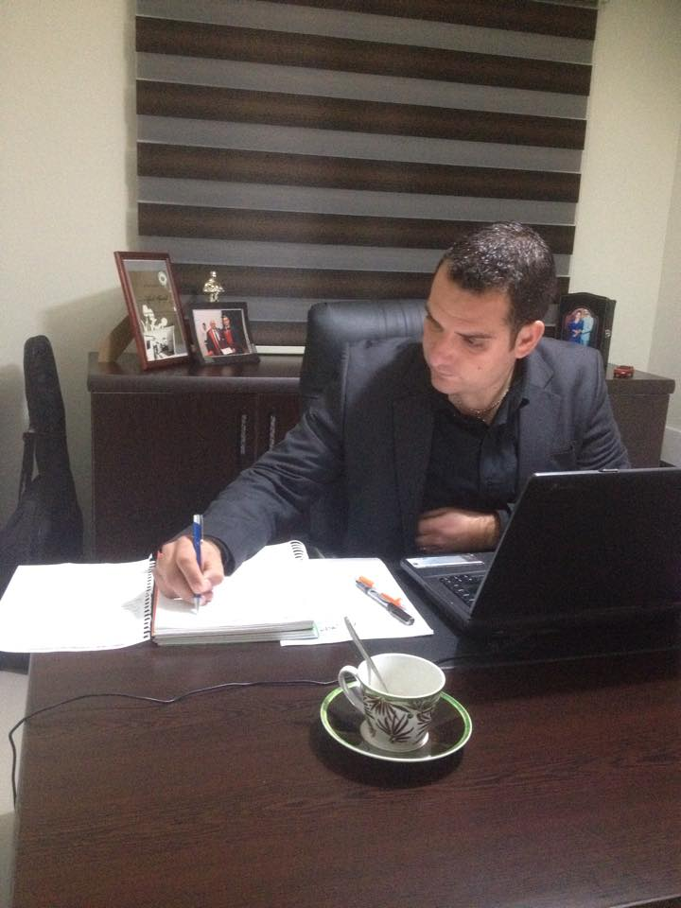

Ahmet HAMDİ
October 23, 1986 due to the Bostanci village Güzelyurt was born. He is currently residing in Güzelyurt connected Yayla village. His father, machinist, his mother a housewife. He completed his primary and secondary education in Güzelyurt. The high school in Güzelyurt Commercial High School in 2003. He completed the accounting department with a good degree.
Near East University Faculty of Economics and Administrative Sciences Faculty of the company he graduated in 2008. The Higher Education was completed in February 2013. In particular during the school year has prepared himself and of the thesis and organizations that would benefit the country in general and the Güzelyurt district. 2014-2015 academic year spring semester of the marketing department at the Near East University Faculty of Economics and Administrative Sciences began working as a part time lecturer. In August of 2014, is married and joined World of married.

