FORM
Resim: | 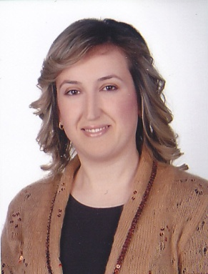
Ünvan: | Uzman
İsim: | AYŞEGÜL
Soyisim: | AKÇAM
E-posta: | akcamaysegul@gmail.com
Bağlı Olduğunuz Bölüm | Zihin Engelliler Öğretmenliği Bölümü

Biography (en): Ayşegül Akçam was born in 1980 in Nicosia. She graduated in Erenkoy Lycee in 1997. After graduating from the Turkısh Language and Literature Department at Near East University, she continued her postgraduate studies in the Department of Ottoman Paleography at the same university.During her Master education studies, she also worked as a lecturer at the Ataturk Education Faculty. She had Master’s degree in 2006. Her research interests include literacy area, family education, scientific research teqnique. She is married and she has two children.

