FORM
Picture: | 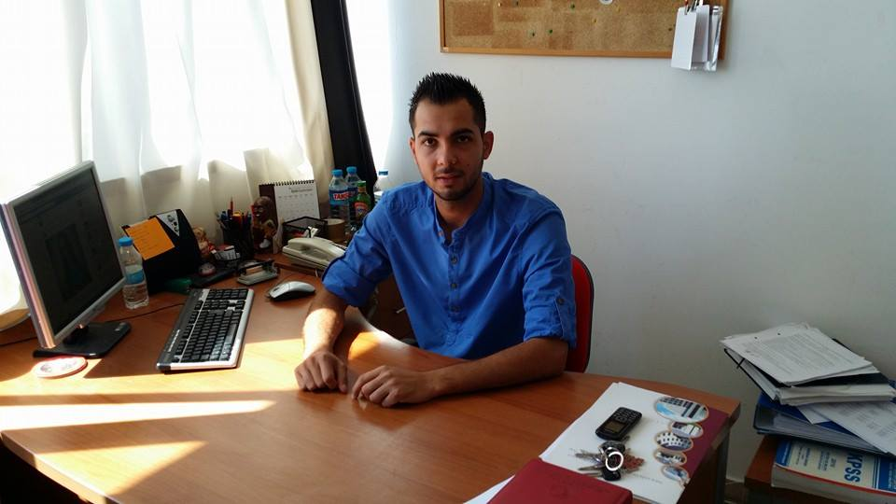
Title: | Msc, Lecturer
Name: | CAHİT
Surname: | NURİ
E-Mail: | cahit.nuri@neu.edu.tr
Deparment | Teaching The Mentally Handicapped

Biography (en)
Lecturer Cahit Nuri was born in 1990 in Ortaköy. He graduated from the Social Sciences department in Güzelyurt Kurtuluş Lisesi in 2007. After graduating from the Department of Guidance and Counseling in Near East University, he continued his postgraduate studies in the Department of Special Education in the same university has a master's degree . During his Med studies, he also worked as a research assistant at Department of Education of Mentally Retarded, focusing on quantitative research. Determination of self- efficacy, emotions and burnout state of teachers serving in the special education field in terms of different variables was the first quantitative study carried out in this department.
Following graduation master’s degree from the Near East University in 2014 , he started working as a lecturer in the Department of Education of Mentally Handicapped Children. After completing MSc , in 2014 began to studies PhD in the Department of Special Education .

