Assist. Prof. Elbrus Imanov
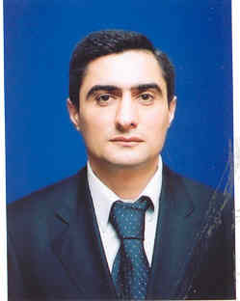
He was born in Baku, Azerbaijan on June 4, 1966. In 1973 he went to middle school and he graduated from the middle school in 1983. The same year, he entered Azerbaijan Technical University. After one year of the education in the University he went to serve in army. After 2 years he came back to continue his education in the University. He graduated this University in 1990.

Afterwards he worked in machine building factory for 3 years. Then he entered the post-graduate department in Azerbaijan State Oil Academy. The same year he started to work in International Technology and Management University, where he worked for 3 years as director of education department.

In 1996 he started to work and teach in ’Odlar Yurdu’ University as a vice-dean. In 2001 he defended his PH.D dissertation under the title ‘Development of planning, navigation and control systems for intelligent robot’.
In 2001-2004 he worked as a vice-dean, assistant professor in Faculty of ‘Informatics’, and vice head of department in ‘ Odlar Yurdu’ University Baku, Azerbaijan .
In 2004-2005 he worked as Instructor of MBA Program of Georgia State University (USA) and ‘Odlar Yurdu’ University .

In 2005 he went to USA for teaching training, teaching experience in MBA program (Azerbaijan – USA) of Georgia State University.
He has been working as Assist. Prof. in Computer Engineering department of Near East University since September, 2005

