English Lecture Notes
Sport and Graphic Design Departments
Prepared by: Dr. Fatemeh Nouban
2015- 2016

Introductions
Hi, I am Mary | answer: Hi Mary, I am John
Hello, my name is Mary | answer: Hello Mary, I am John
I am Mary. How are you? | answer: My name is John
Hi, how are you? I am Mary | answer: Hi, I am John
Hello, I am Dr. Smith | answer: How do you do
Hello I am John Smith | answer: Nice to meet you, Peter Brown
Hello, I am John Smith | answer: Pleased to meet you, Peter Brown

Introductions cont’d
Introduction: Hi, I am Ann.
How do you do? | Hi Ann, I am Steve | Steve
Introduction: Hello, I am Mr. Smith.
How do you do? | Hi, I am John. | Nice to meet you Smith.
Introduction: Hi, My name is Janet.
How do you do? | Hello Janet, I am Peter. | How are you Ms. Janet?
Introduction: Hi, I am Peter.
Hi, I am James. | Are you? | How do you do?
Introduction: Hello, My name is Dr. Jones.
Hi, I am Jake. | Hi Jones, I am Anna. | How are you Dr. Jones?
Introduction: Hello, I am Jane.
Hi Jane, my name is John. | How do you do Jane? | Hi Ms.

Introductions cont’d

George is introducing Dr. Smith to Peter Brown. What are the right words? If the answer is right, mark Yes. If not mark No.

George says: "Peter Brown, this is Dr. Smith."
Yes No
George: "Mr. Brown, you meet Dr. Smith."
Yes No
Dr. Smith says:  Dr. Smith: "Hi Peter."  Yes No  Dr. Smith: "How do you do?"  Yes No |  | Mr. Brown says:  Mr. Brown: "Hello, You are Dr. Smith."  Yes No  Mr. Brown: "It's a pleasure to meet you."  Yes No

Introductions cont’d

Here are some introductions. What are the right answers? If the answer is right, mark Yes. If not mark No.

Introduction: Hi, I am Ann.
Answer: How do you do? Yes No
Introduction: Hi, I am Paul.
Answer: How do you? Yes No
Introduction: Hello, my name is Mr. Blake.
Answer: How do you do? Yes No
Introduction: Hello, my name is Jane.
Answer: Hi Jane, I am Frank. Yes No
Introduction: Hi, I am Steve.
Answer: How are you Mr. Steve? Yes No
Introduction: Hello, I am Dr. Brown.
Answer: How are you, Dr. Brown? Yes No

Verb to be

Full Forms of the verb to be

I | am | a student.
He | is | a teacher.
She | is | a journalist.
It | is | a book.
We | are | mechanics.
You | are | pilots.
They | are | policemen.

The verb to be - exercise
Choose the correct form of the verb to be - am/is/are.

- It cold today.
- I at home now.
- They Korean.
- There a pen on the desk.
- My name Nikita.
- We from Ukraine.
- That right.
- I OK, thanks.
- Clara and Steve married.
- She an English teacher.

Write the following words in order to make positive sentences with the verb to be.

1 am twenty-five years I old.
2 We Venezuela. are from
3 a and name is I'm student. My Anton
4 is my This book.
5 a nice today. day It's
6 Her brother's name Paul. is
7 an engineer. John is
8 is Johansson. My name husband's
9 students class. my twelve There in are
10 of at is top the the My address new letter.
Vocabulary of Numbers
Look at these numbers, and mark the number with the same name.

1. 5  five four eight |  |  | 2. 9  five nine six
3. 2  ten one two |  |  | 4. 6  seven nine six
5. 7  seven ten nine |  |  | 6. 3  eight three six
7. 8  five four eight |  |  | 8. 1  one nine seven

Which number is it?
Look at these numbers, and write their names in the space below.

1. 7 |  | 2. 1
3. 5 |  | 4. 8
5. 9 |  | 6. 3
7. 10 |  | 8. 4

Reading

Read the passage and answer the questions

The Evans family at work
Paul Evans is a maths teacher. He is thirty-nine years old. He’s at school now. His address is 34 King Street, Bristol. His wife Penny is at work in her office. She is a bank manager. Her phone number at work is 830 97 71. They have two children; Mark and Jane. Mark is ten and Jane is seven. They are at school.

Q1. What’s Paul’s job?
________________________________________________________

Q2. How old is he?
________________________________________________________

Q3. Where is he now?
________________________________________________________

Q4. What is his address?
________________________________________________________

Q5. Where is Penny?

________________________________________________________
Q6. What is her job?
________________________________________________________

Q7. What’s her phone number at work?
________________________________________________________

Q8. How old are the children?

________________________________________________________

Countries and Nationalities

The Nationality is where you are from, and the Country is the place that you live there.

Example - Countries
Tom lives in England.
Mary travelled to Japan last year.
I'd love to visit Turkey.

Example – Languages
English is spoken around the world.
Mark speaks fluent Russian.
I wonder if she speaks Portuguese.

*Important Note: All countries and languages are always capitalized in English.

Example - Nationalities
He drives a German car.
We went to our favorite Japanese restaurant last week.
The Swedish prime minister is coming next week.

Important Note: Unlike other adjectives, all nationalities used as adjectives are capitalized in English.

Important Notes
- All country names are unique. They are not similar to language or nationality names.
- Language and nationality names are often, but not always similar. For example: French - the language, and French the nationality are the same in the case of France. However, English - the language, and American - the nationality are not the same in the case of The United States.
- All countries, languages and nationalities are always capitalized in English. This is because country, language and nationality names are proper names of countries, languages and nationalities.

The chart below shows the Country, Language and Nationality of some countries.

 | Country | Language | Nationality
 | France | French | French
 | Greece | Greek | Greek
ends in '-ish'
 | Britain | English | British
 | Denmark | Danish | Danish
 | Finland | Finnish | Finnish
 | Poland | Polish | Polish
 | Spain | Spanish | Spanish
 | Sweden | Swedish | Swedish
 | Turkey | Turkish | Turkish
ends in '-an'
 | Germany | German | German
 | Mexico | Spanish | Mexican
 | The United States | English | American
ends in '-ian' or '-ean'
 | Australia | English | Australian
 | Brazil | Portuguese | Brazilian
 | Egypt | Arabic | Egyptian
 | Italy | Italian | Italian
 | Hungary | Hungarian | Hungarian
 | Korea | Korean | Korean
 | Russia | Russian | Russian
ends in '-ese'
 | China | Chinese | Chinese
 | Japan | Japanese | Japanese
 | Portugal | Portuguese | Portuguese

Days of the week

The days of the week in the right order - starting from Monday!
Monday
Tuesday
Wednesday
Thursday
Friday
Saturday
Sunday
*Days of the week begin with a capital letter, e.g. Monday Not Monday.

Days of the week
Put the letters for each day of the week in the right space.

Months of the Year
Month 1 - January
Month 2 - February
Month 3 - March
Month 4 - April
Month 5 - May
Month 6 - June
Month 7 - July
Month 8 - August
Month 9 - September
Month 10 - October
Month 11 - November
Month 12 - December

Questions
You can ask different questions about something that you see. Look at these questions, and look at the kinds of answers that you can get
Do you like your cat?  Yes, I do. | Is your cat black?  No, he is not. | Where is your cat?  He is in the house.
Who is he?  He is a clown. | Why do you like him?  Because he is funny. | What is his name?  Mr. Chuckles.
Are both dogs his?  No, one dog belongs to Suzy. | Which dog is his?  The dog with short fur and no tail. | Can I play with him?  Yes, you can.

Questions cont’d
Look at the question words listed below, and then look at the sentences underneath. Which word goes at the start of each sentence?

WHERE
WHO
ARE
WHY
WHAT
IS
HOW
DO

1. ........... is she happy?
2. ........... is the name of this street?
3. ........... you OK?
4. ........... your brother ill?
5. ........... is the bus stop?
6. ........... wrote this book?
7. ........... tall is your sister?
8. ........... you know this person?

Questions cont’d
What is the best question word to use at the start of each of these sentences? Look at each sentence and select one of the choices underneath .

1. ...... is the name of your father?
Do | What | Where
2. ...... you want to visit me next week?
Are | Why | Do
3. ...... that your cat?
How | Is | Are
4. ...... do you live?
Is | Who | Where
5. ...... is your neighbour?
Do | Who | Why
6. ...... are you angry?
Why | Are | Is
7. ...... they hungry?
Are | Do | What
8. ...... are you?
Do | Why | How

Questions cont’d
Statement : | You are tired.
Question : | Are you tired?
Answer : | Yes, you are OR No, you are not

Statement : | I am sleepy.
Question : | Am I sleepy?
Answer : | Yes, I am OR No, I am not

Statement : | She is slim.
Question : | Is she slim?
Answer : | Yes, she is OR No, she is not

Statement : | He is fat.
Question : | Is he fat?
Answer : | Yes, he is OR No, he is not

Statement : | We are noisy.
Question : | Are we noisy?
Answer : | Yes, we are OR No, we are not

Statement : | They are rude.
Question : | Are they rude?
Answer : | Yes, they are OR No, they are not

Questions cont’d
Look at these questions and the answers. Then decide what the missing question word is. Write it into the space in the sentence.

Question: | 1. is your favourite colour?
Answer: | My favorite colour is blue.
Question: | 2. do they live?
Answer: | They live in London.
Question: | 3. is she not at school?
Answer: | Because she is ill.
Question: | 4. you like jazz?
Answer: | Yes, I do.
Question: | 5. is the President of the United States?
Answer: | Mr. Bush is the President of the United States.
Question: | 6. this your book?
Answer: | No, it is not.
Question: | 7. they invited to the party?
Answer: | Yes they are.

*colour British spelling
*color American spelling

Reading
Read the following dialogue and answer the questions listed below.
Peter's Family
Susie: Do you live in the red house at the end of the road?
Peter: Yes, I live in that house with my parents and my sister.
Peter: We also have a cat and a dog.
Susie: Do you take your dog for a walk every day?
Peter: No. My father takes the dog for a walk every Monday, Tuesday and Sunday.
Peter: And I take the dog for a walk every Wednesday, Thursday and Friday.
Susie: Who takes the dog on Saturday?
Peter: On Saturday we all go to the park and the dog comes with us.
Susie: Do you help with the housework?
Peter: My mum and my sister do the housework and cooking but I clean my room

Q1. Does Peter live in a house?
________________________________________________________

Q2. What is the color of Peter’s house?
________________________________________________________

Q3. Does Peter have a rabbit?
________________________________________________________

Q4. How many days a week does Peter take his dog for a walk?
________________________________________________________

Q5. Who is taking peter’s dog for a walk on Friday?
________________________________________________________

Numbers 11-20
11 | = | Eleven |  | 16 | = | Sixteen
12 | = | Twelve |  | 17 | = | Seventeen
13 | = | Thirteen |  | 18 | = | Eighteen
14 | = | Fourteen |  | 19 | = | Nineteen
15 | = | Fifteen |  | 20 | = | Twenty

Look at these numbers, and mark the number with that name.

1. 12  sixteen twelve nineteen |  |  | 2. 15  fifteen twenty eleven
3. 11  seventeen eleven sixteen |  |  | 4. 20  twelve thirteen twenty
5. 18  seventeen eleven eighteen |  |  | 6. 13  nineteen thirteen fifteen
7. 17  eighteen sixteen seventeen |  |  | 8. 14  nineteen thirteen fourteen

Find the numbers. They go up and down and backwards.
O | S | N | T | S | M | Y | J | V | S
X | S | E | I | G | H | T | E | E | N
J | N | V | V | N | G | H | R | U | O
N | E | E | T | E | N | I | N | O | T
S | E | L | R | T | N | R | P | C | W
Q | T | E | N | E | E | T | X | I | S
C | F | O | U | R | T | E | E | N | O
Z | I | Y | G | Y | I | E | O | E | V
G | F | W | T | W | E | N | T | Y | N
Y | T | L | H | E | V | L | E | W | T

Number crossword
Look at the numbers and write their names in the spaces, putting one letter in each space.

1 down - 17 3 across - 15  2 down -16 5 across - 20  4 down - 12 7 across - 19  5 down - 13 8 across - 18  6 down - 11 9 across - 14 |  |  |  |  |  |  |  |  |  |  |  |  | 1
 |  |  |  |  |  |  |  |  |  | 2
 |  | 4 |  |  |  |  |  | 3
 |  |  |  |  |  |  |  | 6
 |  |  |  |  | 5
 |  |  |  | 7
 | 8
9
Usage definite and indefinite articles
a/an and the
We use;
- a = indefinite article (not a specific object, one of a number of the same objects) with consonants
She has a dog.
I work in a factory.
- an = indefinite article (not a specific object, one of a number of the same objects) with vowels (a,e,i,o,u)
Can I have an apple?
She is an English teacher.
- the = definite article (a specific object that both the person speaking and the listener know)
The car over there is fast.
The teacher is very good, isn't he?
- The first time you speak of something use "a or an", the next time you repeat that object use "the".
I live in a house. The house is quite old and has four beDr.ooms.
I ate in a Chinese restaurant. The restaurant was very good.
- DO NOT use an article with countries, states, counties or provinces, lakes and mountains except when the country is a collection of states such as "The United States".
He lives in Washington near Mount Rainier.
They live in northern British Columbia.
- Use an article with bodies of water, oceans and seas -
My country borders on the Pacific Ocean
- DO NOT use an article when you are speaking about things in general
I like Russian tea.
She likes reading books.
- DO NOT use an article when you are speaking about meals, places, and transport
He has breakfast at home.
I go to university.
He comes to work by taxi.

Choose the correct word or phrase to complete the English grammar question. Each question has only one correct answer.
Q: We stayed in ___ hotel near the city center.
the
a
an
Q: ____ book was written by Jane Anders.
The
A
An
Q: I had ____ exciting vacation in Spain.
the
a
an
Q: He bought ____ new car last weekend.
the
a
an
Q: My father is ____ director of this company.
the
a
an

Q: I live in ____ house in Small city.
the
a
an
Q: _____ hotel I'm at is on the other side of town.
The
A
An
Q: Is there ____ hospital near here?
the
a
an
Q: _____ students will soon arrive.
The
A
An
Q: I think that is _____ intelligent choice.
the
a
an

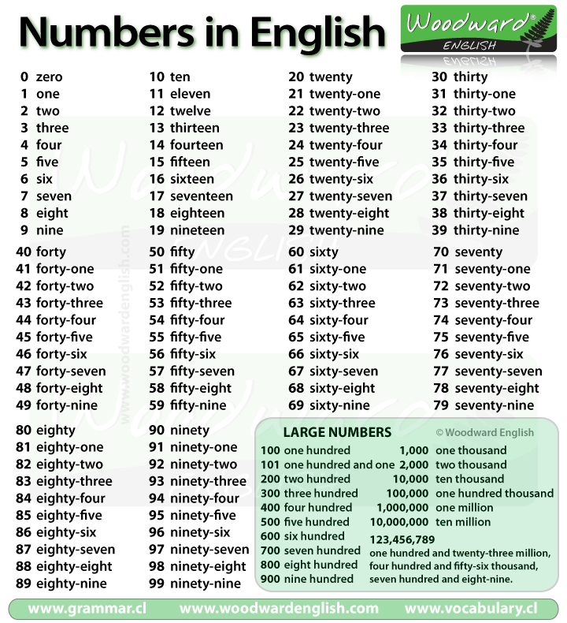

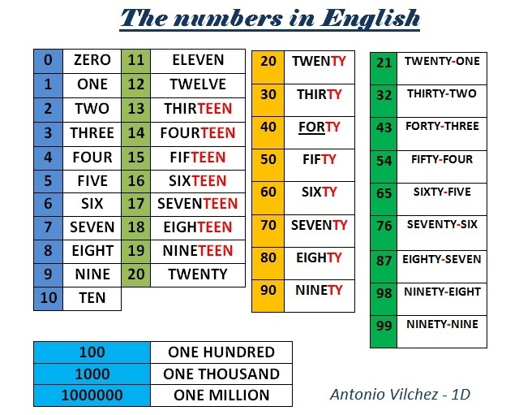

Reading

Read the passage and answer the questions.

A famous family

Julio Iglesias is from Spain. The world’s Number one Spanish singer in the 70s and 80s, with songs like Begin the Begunie, he is now the father of a famous famil. The three children from his marriage in the 1970 to actress Isabel Preysler- 2 sons and a daughter- are now all famous too.

His daughter, Chaveli, ıs a TV presenter in the United States. His son’s names are Julio Junior and Enrique: Julio Junior is a model, actor and singer. His songs are in English and Spanish.

Enrique Iglesias is also a singer. His home is in Miami, Florida. He’s got two Porche cars at home!!

Answer with full sentence.

Q1. Where is Julio Iglesias from?
________________________________________________________

Q2. How many children has he got?
________________________________________________________

Q3. Who is Isabel?
________________________________________________________

Q4.what was Isabel’s surname?
________________________________________________________

Q5. How many cars has Enrique got?
________________________________________________________

Q6. What are Chaveli and Julio Junior’s job?
________________________________________________________

Q7. Where is Enriqu’s home?
________________________________________________________

Telling the Time
There are a number of ways to tell time in English. For example, 8:15 can be expressed as:
- eight fifteen
- a quarter past eight
- fifteen past eight
Learn how to tell time in English by first reading a paragraph with a number of examples. Next, study the rules. Finally, take the follow-up quiz to test your knowledge.
My Day
I usually get up at a quarter past seven - that's seven fifteen in the morning. I have breakfast at eight o'clock and then take the bus to work at half past eight. I usually arrive at work at a quarter to nine. Sometimes, the bus is late and I arrive at about nine. My morning is usually pretty busy and I like taking a coffee break at twenty to eleven if possible. I then work to lunchtime at noon. In the afternoon, I usually have another break at three fifteen. I usually finish work at a quarter to five and arrive home around six in the evening. At night, I usually go to bed at eleven o'clock.
Look at the rules for telling time in English.
Use "past" to say times after the hour until half past, or 30 minutes past the hour. | Use "to" to say times before the hour from 31 minutes until the full hour.
Use "o'clock" only at the full hour. Example: It's eight o'clock | To avoid using "past" and "to", say the time by hour and then minutes. Example: It's seven twenty-five.
When speaking about the different times of the day use in the morning, in the afternoon, in the evening | Be careful! Use at night NOT in the night

Telling the Time cont’d
Practice telling the times in the pictures below, click on the arrow to see the possible answers:
Reading
Read the following dialogue and answer the questions listed below.
In the Office

Peter Jones: Good Morning Ann.
Ann Smith: Good Morning Mr. Jones.
Peter Jones: How about a cup of coffee?
Ann Smith: I will make it now.
Peter Jones: And can you tell me what meetings I have this week?
Ann Smith: I will bring the diary.
Ann Smith: Okay, this afternoon you have a meeting with your accountant at 5 pm.
Ann Smith: On Wednesday, you are going to London. Don't forget your train leaves at 9.30 am.
Peter Jones: Okay, what time is my meeting in London?
Ann Smith: At 11.30. And on Thursday Ms. Vonn wants to talk to you.
Peter Jones: Who is Ms. Vonn?
Ann Smith: She is our new project manager. She starts next week.

Q1. Did Peter ask for a cup of tea or coffee?
______________________________________________________
Q2. What is Peter asking from Ann?
______________________________________________________
Q3. Who is peter meeting this afternoon?
______________________________________________________
Q4. What time will Peter’s meeting start in London?
______________________________________________________
Q5. Who is Ms. Vonn?
______________________________________________________

Possessive Adjectives
My, Your, His, Her, (Its), Our, Your, Their

Possessive adjectives are used to show possession. For example:
Tom is a dog lover. He takes his dog Spike everywhere!
In this case, it is clear that 'his' refers to Tom because of the context. Possessive adjectives are always placed in front of the noun they modify. Here is a list of possessive adjectives:

I - my dog
You - your cat
He - his book
She - her car
It - its color (NOT it's!)
We - our dog
You - your house
They - their farm
Read the passage and, then write about your family

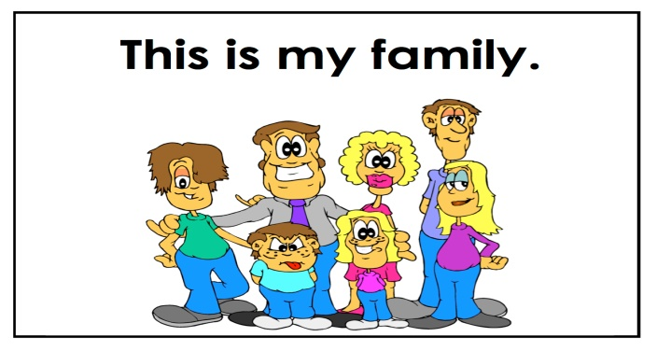

My name is kate. I’m from Ohio in the United States. My father’s name is Marty, and my mother’s name is Amy. I have a brother and a sister. Their names are Brett and Karen. We have a dog. Its name is Brandy.

Now write about your family.

------------------------------------------------------------------------------------------------------------------------------------------------------------------------------------------------------------------------------------------------------------------------------------------------------------------------------------------------------------------------------------------------------------------------------------------------------------------------------------------------------------------------------------------------------------------------------------------------------------------------

Describing Your Family
Read the following description of a family.
Jack is married to Alice. She is his wife and he is her husband. They have a daughter and son. The son's name is Henry and the daughter's name is Lisa. They live next to Alice's parents, Harry and Marjorie. Harry is Alice's father and Marjorie is her mother. Harry is Jack's father-in-law and Marjorie is his mother-in-law. Henry is Harry's grandson and Lisa is Marjorie's granddaughter. Alice has a sister and a brother. Her sister's name is Mary and her brother's name is Frank. Frank has two children, David and Sherrie. Sherrie is Alice's niece and David is Alice's nephew. Alice is their aunt and Jack is their uncle.

Look at the possessive chart. Complete the story above using the correct possessives (my, your, son's, Jack's etc.).
I | my
You | your
He | his
She | her
It | its
We | our
You | your
They | their
Jack | Jack's

Jack is married to Alice. She is his wife and he is husband. They have a daughter and son. The name is Henry and the name is Lisa. They live next to Alice's parents, Harry and Marjorie. Harry is Alice's father and Marjorie is mother. Harry is Jack's father-in-law and Marjorie is mother-in-law. Henry is grandson and Lisa is Marjorie's granddaughter. Alice has a sister a brother. sister's name is Mary and her name is Frank. Frank has two children, David and Sherrie. Sherrie is Alice's niece and David is Alice's nephew. Alice is aunt and Jack is uncle.

Directions
Description of the directions shown on the map.
1. Take the first right.
2. Take the second right.
3. Go straight
4. Turn at the first left... then
5. ... take the next right.
Next to and opposite

The seat is next to the tree. | The yellow house is opposite the grey house.
Types of junctions
Crossroad |  | T-junction

Directions

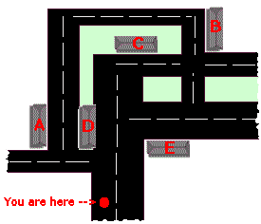
Look at the map, and then read the directions below. When you know where you can find the buildings (A-E) write them into the directions.
A - Hospital
B - Post Office
C - Bank
D - Supermarket
E - House
1. Take the first left. The building on the corner on your right is the .
2. The building opposite the supermarket is the .
3. Take the first right. The building on your right is a .
4. Take the second right. The building on your left is the .
5. Take the second right. Turn left at the next crossroad. The building on your right is the
Reading
Read the following dialogue and answer the questions listed below.
Birthdays

Peter: Hello Janet.
Janet: Good morning Peter.
Peter: And what is this?
Janet: Ah, this is my daughter's birthday present. Her birthday is next week.
Peter: And when is your son's birthday?
Janet: That is not for a while. His birthday is only in August.
Janet: But Mark's birthday is in April so I need to think about his present soon.
Peter: And when is your birthday?
Janet: Oh, my birthday is in December just before Xmas so of course nobody remembers.
Peter: My birthday is in June, when we are always on holiday. So my family often forgets my birthday too.

Q1. Is today peter’s birthday?

Q2. Did he buy a present?
______________________________________________________________________________
Q3. When is mark’s birthday?
______________________________________________________________________________
Q4. When is Janet son’s birthday?
______________________________________________________________________________
Q5. When is Janet’s birthday?
______________________________________________________________________________

The Weather
Look at the pictures for clues and put these weather words into the correct gaps: hot, raining, windy, sun, sunny, blowing, cloud, rain, wind, cloudy, rainy, shining, and cold.

The sun is today.
- It is today.
- The earth needs the .
- The weather is great today. It's nice and .

- The wind is today.
- It will be tomorrow.
- The strong will come from the south.

- It will tomorrow.
- The weather will be next week.
- The will come from the north.
- The temperature will be very - 5 below freezing.

- It is hard today.
- It will tomorrow.
- It will probably be for the whole day tomorrow.

- I hope it won't be tomorrow.
- Look at that

Demonstratives

This - That - These - Those - Here - There
Demonstrative adjectives indicate which thing or group of things you are talking about. In English, there are four forms according to the number of items and where they are located in relation to the speaker.
It's important to learn this and these for objects that are close at hand. This is used for singular objects, and ‘these’ is used for plural objects. This and these are often used with the 'here' to indicate that the object is near. For example:
This is my bag here.
These are my friends in this room.
That is used for singular objects, and ‘those’ is used for plural objects that are located away from the speaker. That and those are often used with the 'there' to indicate that the object is away from the speaker. For example:
That is my car parked over there.
Those are my apple trees at the back of the garden.
Here is a chart to give a quick overview of the use of these important words:
Close or Far? | Singular | Example | Plural | Example
Close = here | This | This is my car here in my Driveway. | These | These are my friends sitting at the table here.
Far = there | That | That is Tom's house over there. | Those | Those are my classmates sitting over there.
Exercise
Complete the sentences using this, that, these, those, here and there.
- Could you bring me that chair over _____?
- Here are _____ pictures.
- Can you see _____ building next to the bank?
- Is _____ piece of pie over there for me?
- _____ are three boys sitting on the bench.
- I would like some of _____ cookies on that shelf.
- _____ bicycles over there are expensive.
- These dolls on the table _____ are very old.

Demonstratives cont’d

We use this (singular) and these (plural) to refer to something that is here / near.
Examples:
- This is my car. (singular)
- These are our children. (plural)
We use that (singular) and those (plural) to refer to something that is there / far.
Examples:
- That is our house. (singular)
- Those are my shoes. (plural)
Note that the verb changes (i.e. singular / plural) depending on the pronoun that you use.
You can also use Demonstrative Pronouns by themselves:
- Did you do that?
- I'd like to buy these?
- Which of those would you like?
*It's important to learn this and these for objects that are close at hand. This is used for singular objects, and ‘these’ is used for plural objects. This and these are often used with the 'here' to indicate that the object is near. For example:
This is my bag here.
These are my friends in this room.

*That is used for singular objects, and ‘those’ is used for plural objects that are located away from the speaker. That and those are often used with the 'there' to indicate that the object is away from the speaker. For example:
That is my car parked over there.
Those are my apple trees at the back of the garden.

Here is a chart to give a quick overview of the use of these important words:
Close or Far? | Singular | Example | Plural | Example
Close = here | This | This is my car here in my Dr.iveway. | These | These are my friends sitting at the table here.
Far = there | That | That is Tom's house over there. | Those | Those are my classmates sitting over there.

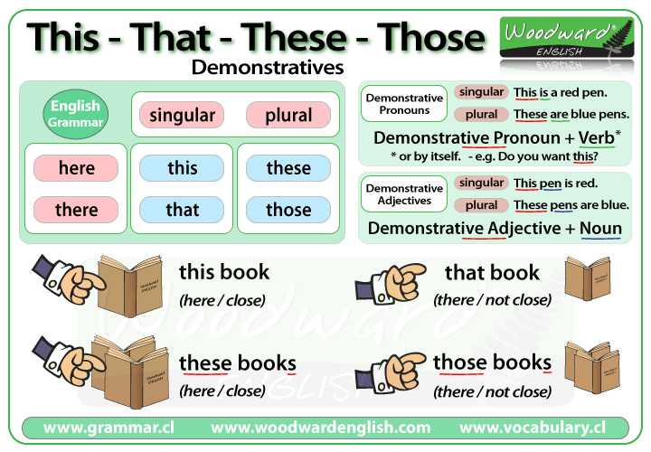

Present Simple
1. Let's start with how verbs are made.
Verbs are made from two parts. There is an auxiliary, and a main part.
Together the auxiliary and the main part make the tense of the verb.
For example:
“I am thinking” . Am is the auxiliary, thinking is the main part of the verb. Together they make the tense. Here, the tense they make is the present continuous.
(Remember auxiliaries do not have any meaning as words. They just tell us more about the verb. There is a verb do, but gramatically it is different from the auxiliary do.)
Once the auxiliary and the main part have made a verb, the verb has a time, and it has an aspect. We usually describe verbs by their time, aspect and voice.
The present simple
In this part of the course we are going to look at verbs with the present time, using the simple form. That is, the present simple active.
For example:
(i) I speak English
(ii) I do not speak Albanian.
The Voice
Like all verbs, the present simple has two parts – an auxiliary and a main part. The auxiliary is do and the main part is the infinitive form of the verb speak. But if you look at example (i) you will see that the auxiliary do is not there. But it is there in example (ii).
This is because the. When we use the 'simple form', we do not use do with positive statements.
For example:
I like ice cream.
Even though we don’t use the auxiliary do in positive statements, we use it in negative statements
I do not like ice cream
We also use the auxiliary do with questions:
Do you like ice cream?
And with affirmations
Yes, I do like ice cream.
*so that is the important thing to remember about the present simple. When you make a positive statement (I Dr.ink beer in summer) you don’t use the auxiliary. Any other time you use the simple, and it is not a positive statement, you use do. (I don’t like winter. Do you like winter?)
Present Simple cont’d
Remember, the present simple is in two parts. We have looked at some of the things to remember about it. Now we must look at the time part, which is the present.
The main thing to remember about the present time in English is the third person singular. In English the third person singular pronoun is he, she or it.
When we use a verb with the present time and she, he or it as the subject, the auxiliary finishes with s.
For examples:
Does he like ice cream? It does not look easy. Yes, she does speak English.
Also with any noun that is singular:
That car does not go very fast. Does that cake taste good?
But with the present simple there is a problem. I have told you that -
(i) Auxiliaries must end with s for the third person singular.
(ii) Positive statements using the simple voice do not have auxiliaries.
So what happens when you need to use rules (i) and (ii) together? The auxiliary must have s, but you don’t use it? In fact, that’s almost right. A positive sentence in the simple voice doesn’t use an auxiliary, but it does use s, and because we have to put the s somewhere, we put it on the end of the main part of the verb.
For example:
He does not live in Oxford. (see where the s is on the end of the auxiliary?)
He lives in London. (no auxiliary, but the s has moved.)
Remember: if there is an auxiliary, the s goes on the auxiliary (e.g. does). If there is no auxiliary the s goes on the end of the main part (e.g. lives). You only need the lives in a third person present singular verb.
* that is the theory. The good news is that all the other verbs are easier. Only the present simple is so complicated. But now we know how to form the present simple, the next question is when do you use it?
2. Ok, when do we use it?
First, we must look at when you do not use it. You do not use the present simple for talking about things at this moment. For that we use the present continuous.
For example:
I am studying English”, I am surfing the internet.
We use the present simple for things that are true for a long time, or always
For example:
I live in England; I read a lot of books; coffee tastes good”.
Because we often use the present simple to describe things, one of the most important uses of the present simple is with adjectives.
For example:
I am English; That book is interesting: The coffee is good.
Because we use the verb to be so much in the present simple, it is very, very irregular. (Words that are used a lot are often irregular). It does not use an auxiliary, even in negatives, questions and affirmations. And it changes:
I am. He/she/it is. We are. You are. They are.
(But you will notice that even the verb to be keeps to the rule that third person present singular ends in s – is).
So to finish let’s look at some present simple verbs in a short paragraph. Look at how the present simple is used.
“My name is Tara. I live in London which is the capital of England. We eat eggs for breakfast every day. My sister doesn’t like eggs. Do you like them? I do. We go to the local school. It rains a lot, so we often take an umbrella to school. The students at my school speak English, but we study German and French too. They are difficult. I don’t like science, but I do like history. What do you like?”

Invitations, suggestions, offers
Invitations:
Do you want to come to my party tomorrow?
Can you come to my party tomorrow?
I would like to invite you to my party tomorrow.
Thank you, I would like to come
OR
Thank you, but I cannot come.

Suggestions:
Why don't we go to the cinema?
How about going to the cinema?
Shall we go to the cinema?
Yes, let's go
OR
No, how about the pub instead?

Offers:
Would you like some tea?
Can I pour you some tea?
May I offer you some tea?
Yes, thank you.
OR
No, thank you.

Food and Drink Vocabulary List

Eating and enjoying a meal together gives you the opportunity to speak English and enjoy yourself. The relaxing atmosphere of sharing a meal together helps the conversation flow. Cooking and shopping for the food to prepare the meal is English is almost as much fun. There are many words you need to learn in order to speak about food, purchase food, cook food and more. This guide to food vocabulary will help you express not only different types of food, but also how you prepare and cook them, and what sort of food containers there are when you go shopping.
Food and Drink vocabulary list: food items and Drinks.
Beverages / Drinks | soda | coffee | water | tea | wine
Dairy | milk | cheese | butter | cream | yoghurt
Dessert | cake | cookies | chocolate | ice-cream | brownies
Fruit | apple | orange | banana | grapes | pineapple
Grains / Starches | wheat | rye | cereal | toast | bread
Meat / Fish | beef | chicken | lamb | salmon | Trout
Vegetables | beans | lettuce | carrots | broccoli | egg plan

Adjectives used to describe Food
acidic
bland
creamy
fatty
fruity
healthy
nutty
oily
raw
salty
sharp
sour
spicy
sweet
tender
tough

Vocabulary for the Supermarket
Preparing Food | Cooking Food | Utensils
chop | Bake | blender
peel | Fry | frying pan
mix | Steam | colander
slice | Boil | kettle
measure | Simmer | Pot
Departments | Staff | Nouns | Verbs
dairy | stock clerk | aisle | push a cart
produce | Manager | counter | reach for something
dairy | Butcher | cart | compare products
frozen food | fishmonger | display | scan items
Containers for Food
bag | sugar | Flour
box | cereal | crackers
carton | eggs | Milk
can | soup | Beans
jar | jam | mustard
package | hamburgers | noodles
piece | toast | Fish
bottle | wine | Beer
bar | soap | chocolate

Reading
Read the passage:
I live in the country and there is a large garden round my house. I have got a lot of bees in this garden and they make honey for me. It is very good honey because there are a lot of flowers in my garden and the bees make their honey from these flowers. I collect the honey on Sundays. I wear a net over my face and cover my hands because the bees can sting me. On Mondays, I put the honey in the jars and take it to the market. I put a small table at the side of the street and put my jars of honey on it. Then I shout “Honey! Beautiful honey!”. People buy honey from me because it is not expensive. I can sell all my honey in a short time.

Are these True or False? Correct the false ones:
  - I sell my honey on Sundays. ( )
-----------------------------------------------------------------------------------------
  - My honey is cheap.( )
----------------------------------------------------------------------------------------
  - I sell my honey in pots.( )
----------------------------------------------------------------------------------------
  - The bees make their honey from the flowers in the park.( )
----------------------------------------------------------------------------------------
  - I cover my hands with a net.( )
----------------------------------------------------------------------------------------
  - I sell my honey in a shop in the town.( )
---------------------------------------------------------------------------------------
  - My honey has a very good taste. ( )
---------------------------------------------------------------------------------------

