HÜSEYİN ÖZÜN YAMAÇ

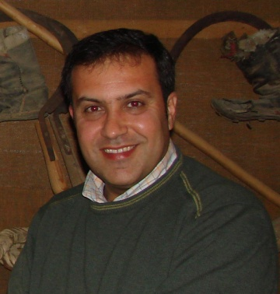
He was born in Nicosia on 11 May 1967. His father was the first press of the country's Voice, Bayrak Radio and Television.He was retired . His mother is a house wife.
He completed Ataturk Primary School in Nicosia, After graduating from secondary school of Şht Huseyin Ruso Nicosia, he graduated from LTL.
He had a undergradutıon degree at the University of Eastern Mediterranean and completed his master's degree at Near East University.
After completing his military service in 1994 as a reserve officer was appointed in 1996as a public servant. In 1996-2000 he worked as a practical compartmentss int he Ministry of Finance, Revenue and Taxation Department. He promoted Money on the foreign exchange department in the years 2000-2004 and contınue his career .
He was admited by Undersecretariat of the Ministry of Finance, Compliance with the European Union in 2004-2008 the Ministry of Public Reform trainer and educator and practitioner in the Performance Evaluation of public servant.
Since 2008, He has worked for the Ministry of Finance, the Prevention of Laundering Proceeds of Crime Act within the framework of international standards,methods of administration in our country and the financial sectors in North Cyprus, the Financial Action Force (FATF) recommendations and serves as the implementation and monitoring methodologies.

He has been to The European Union, AML (Anti Money Laundering) regime in Northern Cyprus within the framework of the implementation and execution of the program prepared by the European Union Acquis preparation specialist. and North of Cyprus in accordance with the International Action Plan and ensure the complete execution of its tasks
He has been Badminton Federation of Turkish Cypriot member of the Board of Directors since 1996and since 2005 chairman of the Badminton Federation.
Since 2006, He has been member of charities KemalSaracoglu Foundation. He is married and has a son.

