Chapter One
Introduction to structural steel design
The structural design of buildings requires the determination of the overall proportions and dimensions of the framework and the selection of the gross sections of individual members.
An economical structure requires an efficient use of materials and construction labor. Savings can often be realized by using more material if it results in a simpler, more easily constructed project. At the present time, materials account for one-third or less of the cost of a typical steel structure, where as labor costs can account for 60% or more.
A good design requires preparing several alternative designs and their costs. In this course, emphasis will be on the design of individual structural steel members and their connections. The structural engineer must select and evaluate the overall structural system in order to produce an efficient and economical design.
Loads
The forces that act on a structure are called loads; dead loads and live loads. Wind exerts a pressure or suction on the exterior surfaces of a building, and because of its transient nature, it properly belongs to love loads.
Earthquake loads are another special category and need to be considered only in those geographic locations where there is a reasonable probability of occurrence.
Design Specifications
These specifications give more specific guidance for the design of structural members and their connections. They present the guidelines and criteria that enable a structural engineer to achieve the objectives mandated by a building code. Design specifications represent what is considered to be good engineering practice based on the latest research. They periodically revised and updated. Design specifications are written in a legal format by nonprofit organizations.
The specifications of most interest to the Structural steel designer are those published by the following organizations:
- American Institute of Steel Construction (AISC). This specification is provided for the design of structural steel buildings and their connections.
- American Association of State Highway and Transportation Officials (AASHTO).
- American Iron and Steel Institute (AISI). This specification deals with cold-formed steel.
- American Standard for Testing Materials (ASTM)
- British Standard (BS)
- Euronorm
- Uniform Building Code (UBC) is used for loading cases.
- American Petroleum Institute (API).
Structural Steel
The characteristics of steel that are of the most interest to structural engineer can be examined by plotting the results of a tensile test.
Engineering stress-strain curves of steel are obtained as follows:
A rod with cross section area A is pulled in tension by a force P, as shown below. The rod length is L before the force is applied, and L + ΔL after the force is applied. The stress is f = P/A and the strain is ε = ΔL/L.
When the tension is small, then the stress is proportional to strain (Hooke's law). If the tension load is released, then the rod will go back to its original length. The proportionality constant is the modulus of elasticity E. For all types of structural steel, E = 29,000 ksi (kips per square inch).
When the tension becomes sufficiently large, then the steel begins to have permanent deformation. This means that when the tension load is released, the rod will be longer than the original length L. The stress level where the permanent deformation begins is called the yield stress, Fy. In the two most commonly used structural steel types, Fy = 36 ksi for A36 steel and Fy = 50 ksi for A572 Grade 50 steel.
When the rod is deformed further, the stresses are first nearly constant, but then begin to increase again. The constant stress range is called the plastic range. The range at which the stresses increase again is called the strain-hardening range. The stresses will increase, but will eventually reach a peak value, which is called the ultimate stress, Fu. After the stress reaches Fu, further deformation in the rod will result in decreased stress until the rod finally breaks.
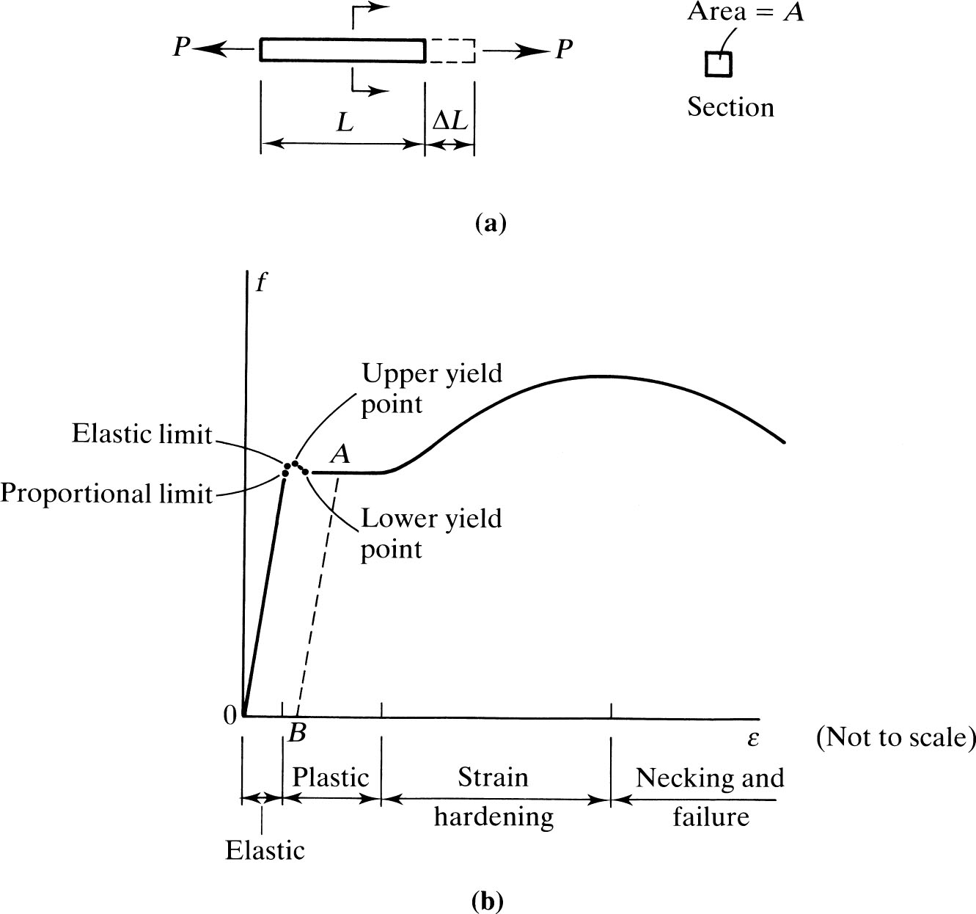
The following graph shows an idealized version of the actual stress - strain curve.
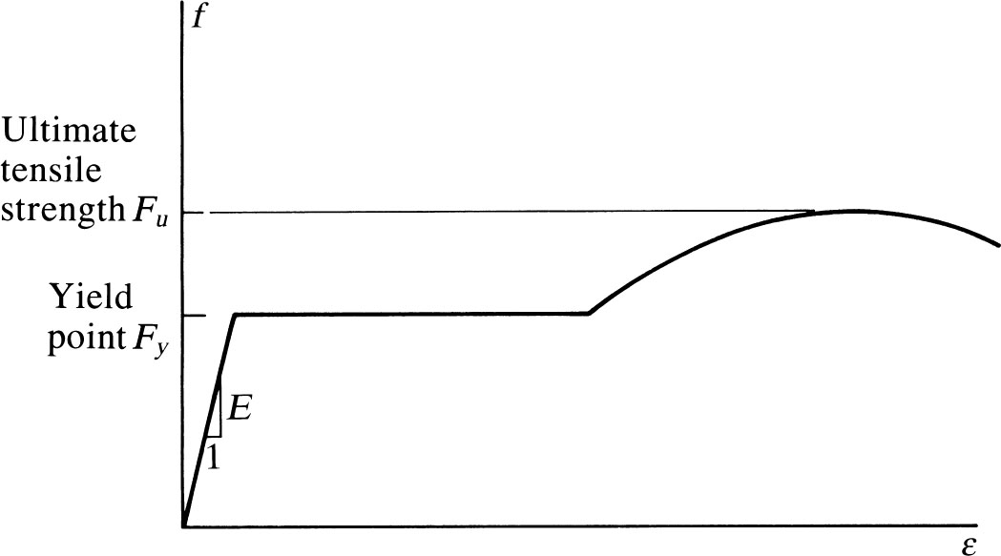
The following figure shows a typical stress – strain curve for high – strength steels, which are less ductile than the mild steels

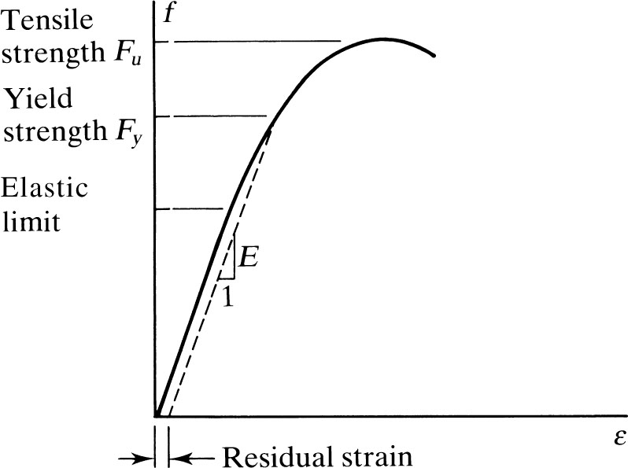

Types of Structural Steel
Designated by the letter “A” followed by the American Society for Testing and Materials (ASTM) designation number. The principal types of structural steel include:
  - A36 carbon structural steel
  - A572 high-strength low-alloy structural steel
  - A588 corrosion-resistant high-strength low-alloy structural steel.
  - A992 High strength low alloy steels for W shapes beams only

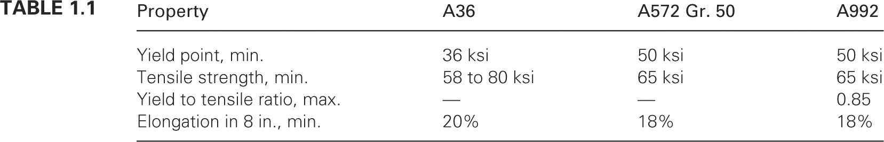

Standard Cross – Sectional Shapes
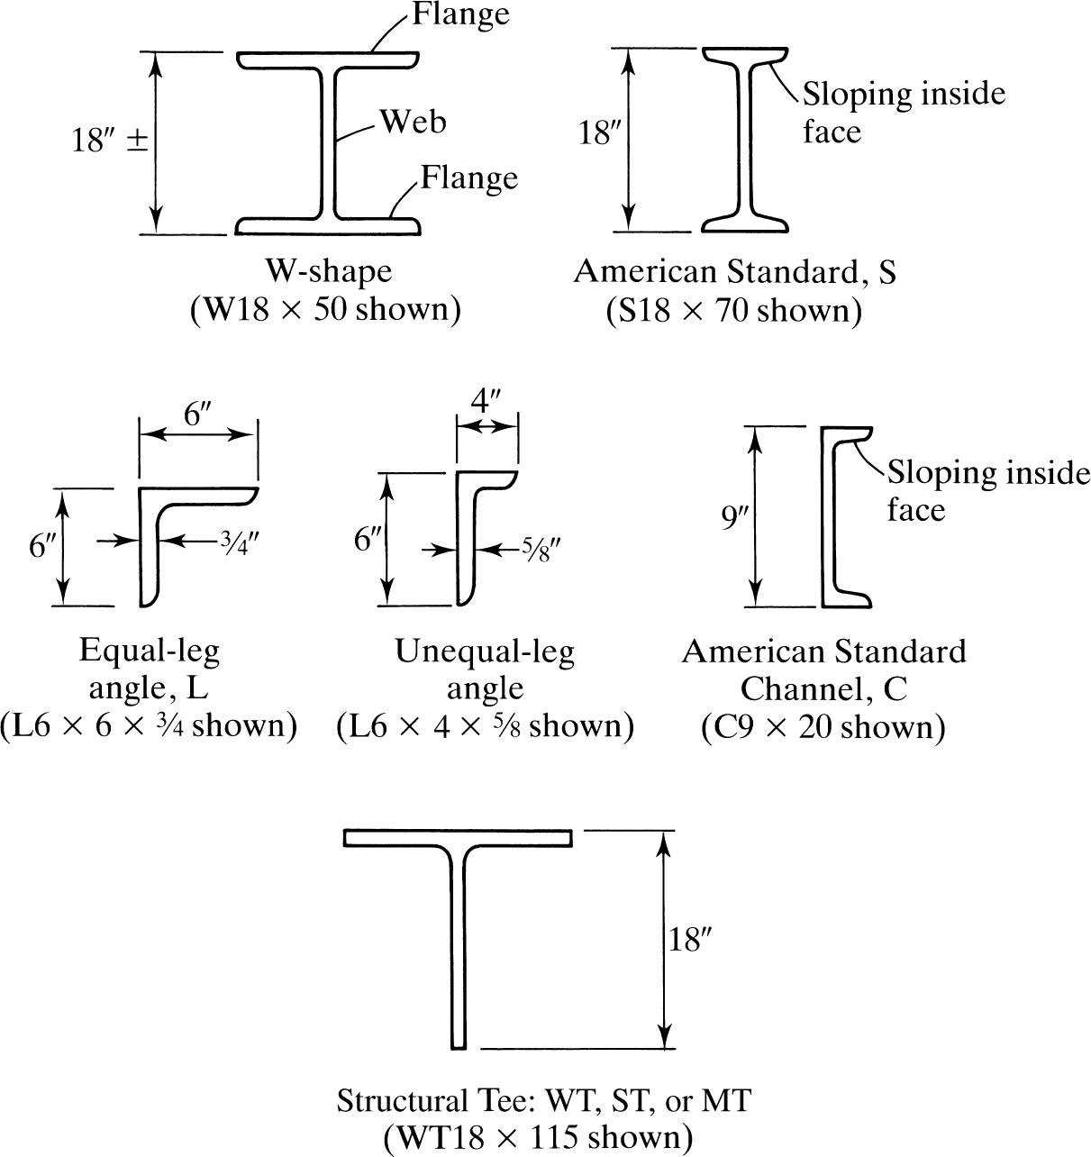

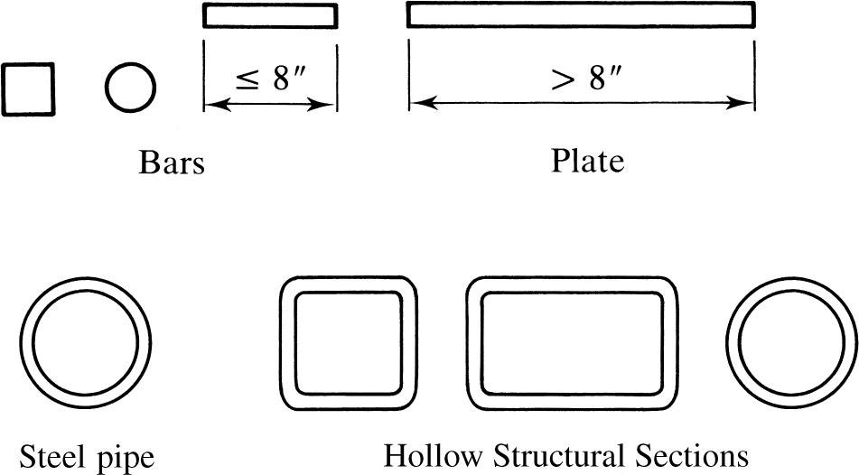

Built up sections
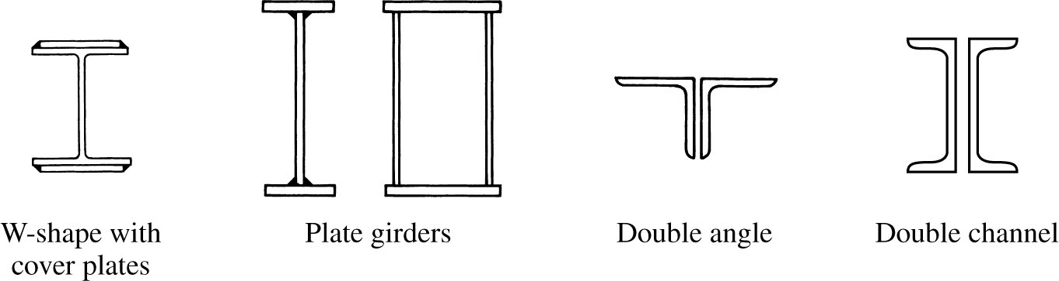

Principles of LRFD
Philosophies of Design
Three philosophies of design are in current use:
- Working Stress Design (called by AISC as Allowable Stress Design (ASD).
- Plastic Design (PD).
- Limit states design (called by AISC as Load and Resistance Factor Design (LRFD).
Working Stress Design (or Allowable Stress Design (ASD))
- Service loads are calculated as expected in service.
- Linear elastic analysis is performed.
- A factor of safety (F.O.S.) of the material strength is assumed.
- A design is satisfied if the Maximum stress < Allowable Stress.
- Case specific, no guarantee that our design covers all cases.
Plastic Design (PD)
- Service loads are factored by a “load factor”
- The structure is assumed to fail under this loads thus, plastic
hinges will form under this loads “plastic analysis”
- The cross section is designed to resist the moments and shear
forces obtained from the plastic analysis

Load and Resistance Factor Design (LRFD)
During the past 20 years, the general “limit states design” approach has continued to gain acceptance for steel design.
Limit states are those conditions of a structure at which it ceases to fulfil its intended function, strength and serviceability.
Both the loads acting on the structure and its resistance (strength) to loads are variables that must be considered.
In general, a thorough analysis of all uncertainties that might influence achieving a “limit state” is not practical, or perhaps possible. The current approach to a simplified method for obtaining a probability-based assessment of structural safety uses first-order second-moment reliability methods.
In general, the expression for the structural safety requirement may be written as:
- design strength
Left hand side represents the resistance, or strength of the component or the system. Right hand side represents the load expected to be carried.

LRFD Specification is based on the followings:
(1) Probabilistic models of loads and resistance;
(2) A calibration of the LRFD provisions to the 1978 edition of the ASD Specification for selected members; and
(3) The evaluation of the resulting provisions by judgment and past Experience aided by comparative design office studies of representative structures.

AISC Load combinations for LRFD method
AISC considers the following load combinations in design
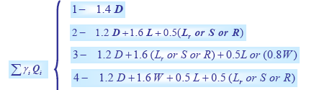
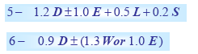
- Dead loads (D)
- Live loads (L)
- Roof load (Lr)
- Snow load (S)
- Rain loads (R)
- Wind Loads (W)
- Earthquakes (E)
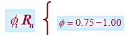

Advantages of LRFD method
- LRFD is another “tool” for structural engineers to use in steel design.
- Adoption of LRFD is not mandatory but provides a flexibility of options to designer.
- ASD is an approximate way to account for what LRFD does in a more rational way. The use of plastic design concepts in ASD has made ASD such that it no longer called as an “elastic design” method.
- Using multiple load factor combinations should lead to economy.
- LRFD will facilitate the input of new information on loads and load variation as such information becomes available. Considerable knowledge of the resistance of steel structure is available. On the other hand our knowledge of loads and their variation is much less. Separating the loading from the resistance allows one to be changed without the other if that should be desired.
- Changes in overload factors and resistance factors are much easier to make than change the allowable stress in ASD method.
- LRFD provides the framework to handle unusual loads that may not be covered by the Specification. The design may have uncertainty relating to the resistance of the structure, in which case the resistance factors may be modified.
- Economy is likely to result for low live to dead load ratios.
- Safer structures may result under LRFD because the method should lead to a better awareness of structural behaviour.

Guide to the AISC Manual
The AISC Manual for Steel Construction is a comprehensive set of tables, charts, diagrams, and design rules used in professional practice. In the 15 weeks of this course, it is possible only to cover a small, but most important, portion of the AISC Manual. A very brief description of the AISC Manual is given below.

Part | Description
1 | Dimensions and Properties
2 | General Design Considerations
3 | Tension Members
4 | Compression Members (Columns)
5 | Flexural Members (Beam and Girders)
6 | Members Subject to Combined Loading (Columns)
7 | Design Considerations for Bolts
8 | Design Considerations for Welds
9 | Connection Elements
10 | Simple Shear Connections
11 | Design of Flexible Moment Connections
12 | Design of Fully Restrained (FR) Moment Connections
13 | Design of Bracing Connections and Truss Connections
14 | Design of Beam Bearing Plates, Column Base Plates, Anchor Rods and Column Splices
15 | Design of hanger Connections, Bracket Plates and Crane – rail Connections
16 | Specifications and Codes
17 | Miscellaneous Data and Mathematical Information

