# ANATOMY OF STEEL FRAMES DESİGN #
# CONNECTİONS KİNDS #
- hinge connection
- fixed connection
- semi-fixed connection
# STRUCTURAL STEEL DESİGN #
# CHAPTER 1 #
# INTRODUCTION TO STEEL STRUCTURES DESIGN #
* The structural design of buildinges requires the determination of the overal proportions and dimensions of the frameworkand the selections of the individual members
* A good design requires preparing several alternative designs and their cost emphasis will be on the design of individual structural steel members and their connections
* The structural engineer must select and evaluate the overal structural system in order to produce on efficient and economical design

$$U.C=\frac{f_{a}}{F_{a}}+\frac{f_{bx}}{F_{bx}}+\frac{f_{by}}{F_{by}}≤1$$
$F_{a}$: allowable axial stress
$F_{bx}$:allowable bending stress in ‘x’ directioanal
$F_{by}$:allowable bending stress in ‘y’ directioanal
$f_{a}$:applied axial stress
$f_{bx}:$applied bending stress in the ‘x’ directioanal
$f_{by}$: applied bending stress in the ‘y’ directioanal

EXAMPLE
If U.C= 0.4 safe but not economical
If U.C= 0.6 safe but not economical
If U.C= 1.25 not safe
If U.C= 1 safe and economical O.K
If U.C= 0.98 safe and economical
acceptable for engineers
If U.C= 0.95 maybe acceptable for some not important works
%2 tolarance O.K for engineering

0.98 O.K 1.02 O.K

# LOAD #
* The forces that act can a structure are called loads. Dead load(D.L), live load(L.L), wind load(W.L), earthquake load, temparature load, external load, internal load.
* Wind exerts as a pressure or suction on the exterior surface of a building
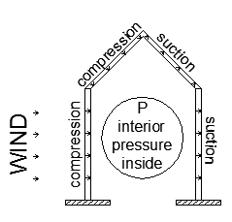
1) Exterior pressure (compression and suction)
2) Interior pressure

# GABLE FRAME #

P = pressure wind
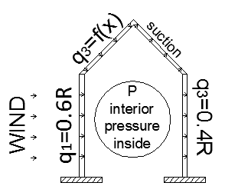
Wind = Wind effects the surface of building, it is not a function of weight of buildings, therefore the buildings, having light structures and large surface such as factories structures (gable frames) are designed mainly for wind rather than Earthquake
* For elevated tanks also wind is important (when the tank is empty)
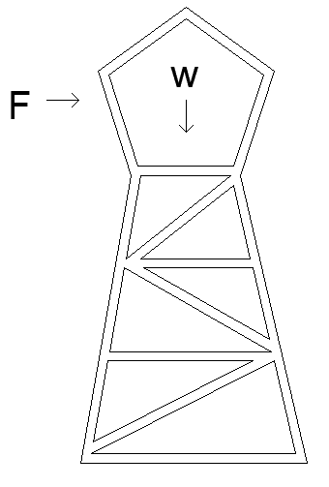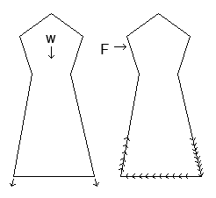

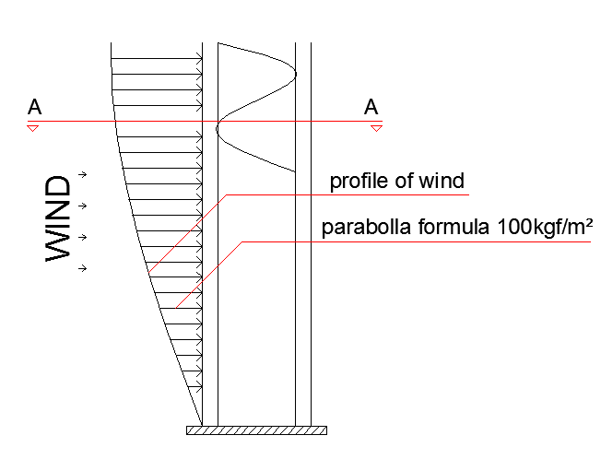
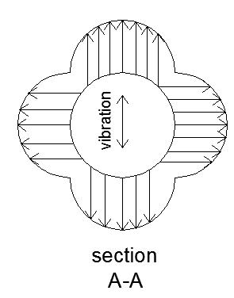

How we apply the wind force on the buildings ?
The wind force is calculated by considering the exposed suface(A) and the wind pressure(R)

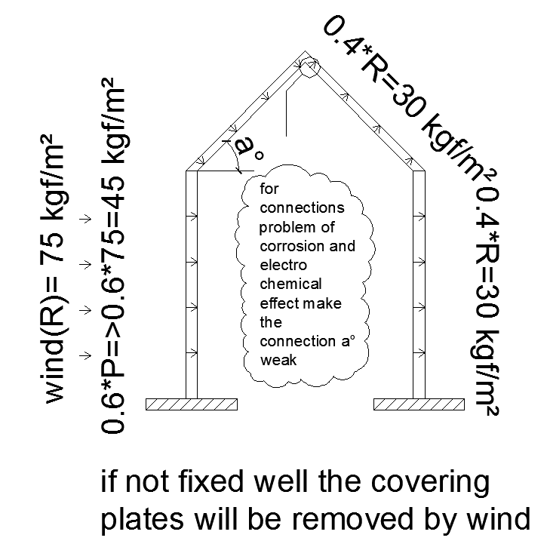

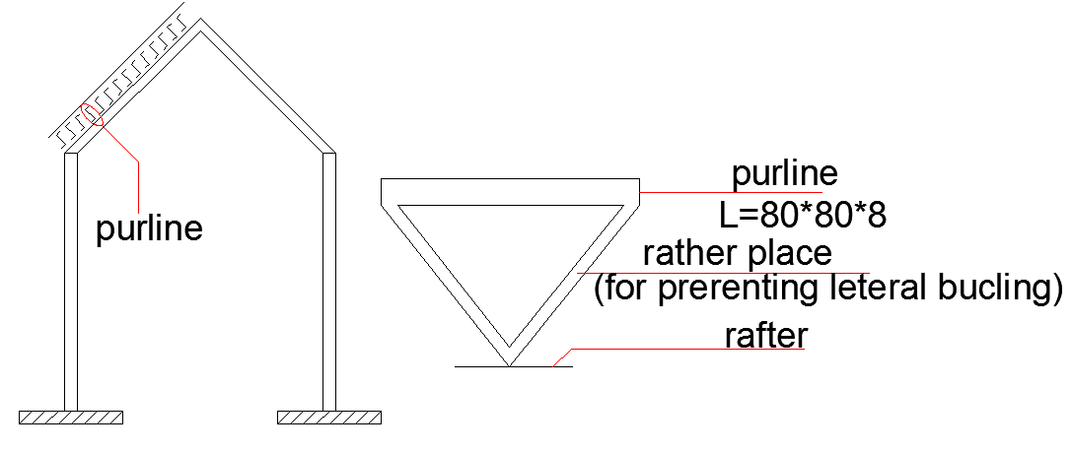

Earthquake : Loads are another special category and need to be considered only in those georaphic locations where there is a reasonable probability of occurence .
# B) ORİGİN OF EARTKQUAKE #
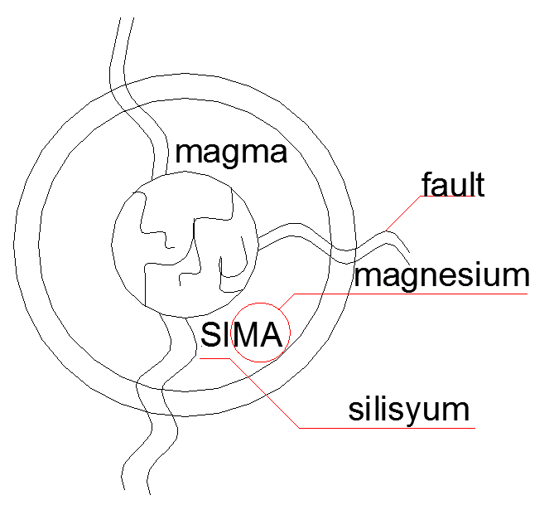
Tectonic & breaking
Earth section like a boiled
* Plate tectonic theory was proposed by wegner
* Depending on the locations of building and the center of eathquake
* The earthquake vertical and horizantal components effects varry.
* Normally in normally building we calculate the building again just the horizontal component of earthquake

* Vertical components of earthquake in spital of Armenia and Bom of Iran destraoyed the cities.
* In Bom the vertical accelaration of earthquake was 0.95g
* We design building for horizontal component of earthquake
component of earthquake
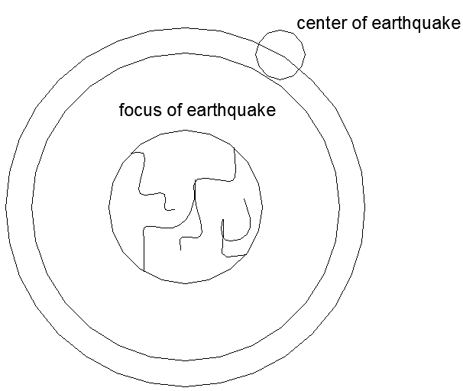
* In normally building the vertical component of earthquake is reglected.
* The earthquake load depends on the weight of the building
F = m * a (Newton’s 2 law)
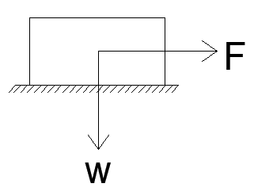
Earthquake load(E.L) = m * a = $\frac{w*a}{g}$
a = acceleration
w = weight of building
g = gravitions accelerations(9.81 $m/{s^{2}}$)
$\frac{a}{g}$ = a factor between 0.08 to 0.15

* Different codes recommend diffrent formulas for earthquake force
# IN GENERAL #
E.L = S W I Z K = W
S Z S K
A set of factors
* Different factore depend on different phenomena
- soil condiction
- structral system
- importance of building
W = weight
I = Important factor
Z = zone factor
I = 1 for normal buildings
I =1.25 for hospitals, fire stations,schools
Note
* Exterior walls are dead loads
* Interior walls are live loads
# DEAD LOAD #
* Premanent loads, such as the weight of beams colums,ceilings, external walls.
# LIVE LOAD #
* The load than can be moved. Such as the weight of people, desk, table, chairs, interior walls (partitions).
# THE AMOUNT OF LOAD ON BUILDING
* In different codes and standards the amount of loads is different but normal values in buildings are as fallow.
* Dead load is calculating by considering the values and the specific gravity of materials.
e.q for concrete we have
concrete = Ȣ=2500 ${kgf}/{m^{3}}$ or 2.5 ${ton}/{m^{3}}$
steel = Ȣ=7800 ${kgf}/{m^{3}}$ or 7.8 ${ton}/{m^{3}}$
for water = Ȣ=1000 ${kgf}/{m^{3}}$ or 1 ${ton}/{m^{3}}$

Live load = According to the codes we have

# DESIGN LOAD #
CONCRETE LOAD => due to tanks
Max live load : 75 tons
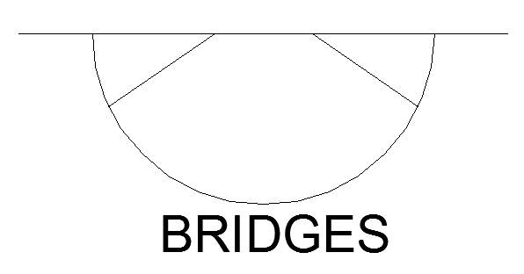
# WIND LOAD #
Wind pressure
75${kgf}/{m^{2}}$ for velocity wind 100 ${km}/h$

100${kgf}/{m^{2}}$ for velocity wind 120 ${km}/h$
# EARTHQUAKE LOAD (E.L) #
* Normally horizat force of earthquake are applied on normally building.
* The range of horizontal force
(0.08 to 015)*the weight of building
# SNOW LOAD #
For normally snow = 150 ${kg}/{m^{2}}$
For heavy snow = 200 ${kg}/{m^{2}}$
As minimum weight = 25 ${kg}/{m^{2}}$

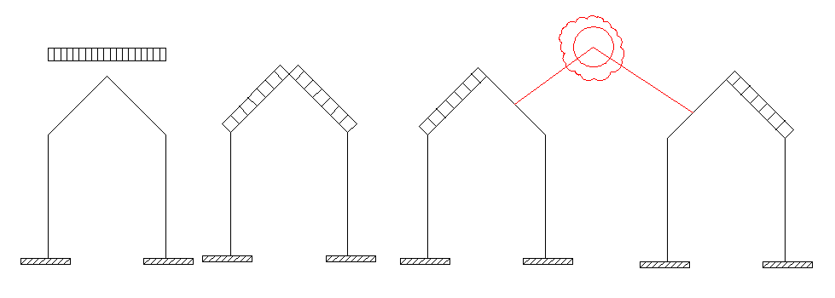
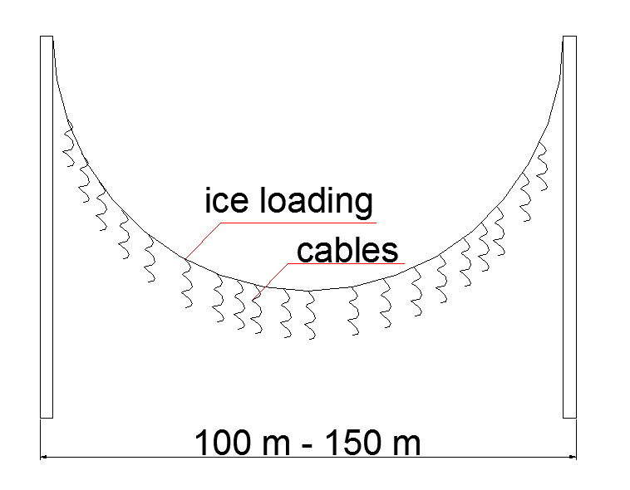
#EXAMPLE #
A two storey building which has only one room at each floor is given (imaginary case without any stairs corridors...) given some estimation about loads and total load applied on this building considered the building is built as classroom an situated in cyprus and we have floors are constructed by R/C slab
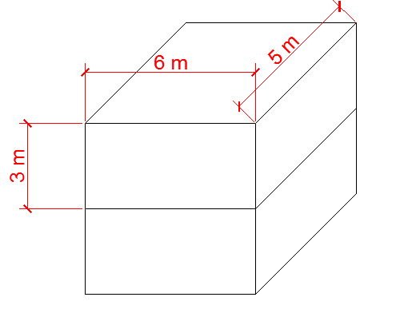
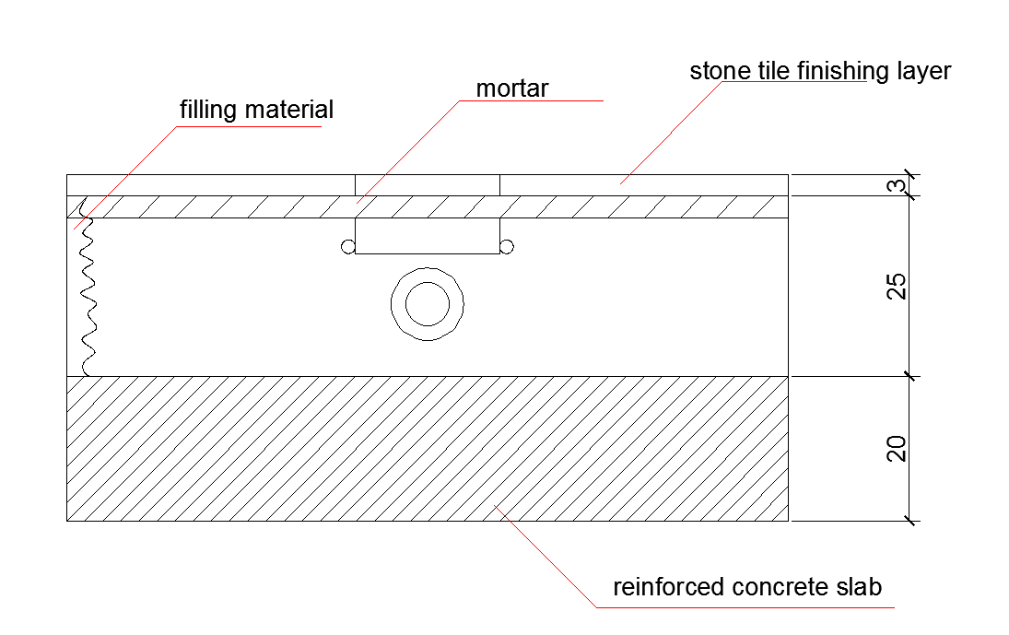
Section of roof or floor (rough section not exceed)

# SOLUTION #
- For R/C slab
Ȣ = 2500 ${kgf}/{m^{3}}$

2.5 ${ton}/{m^{3}}$ * 0.2 m * 1 m * 1 m
0.2 = Thickness
0.2 m * 1 m * 1 m = Volume
1 m = Always we should consider
500 kg = 500 ${kgf}/{m^{2}}$
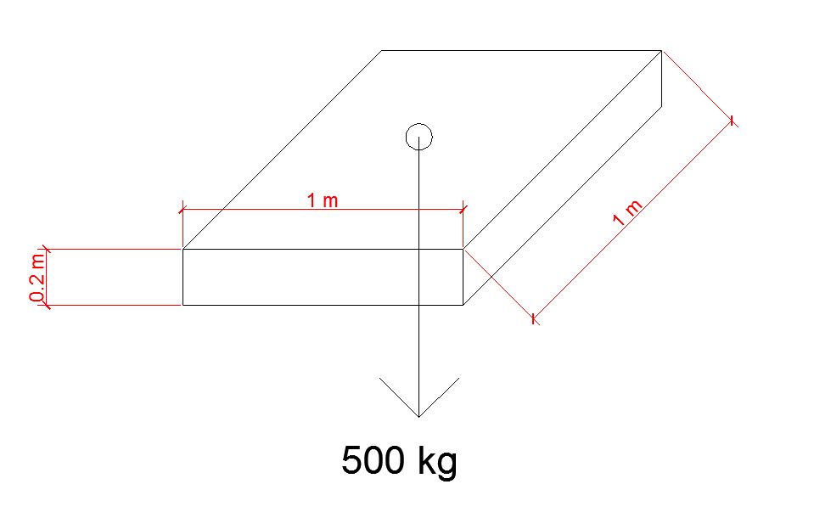
- For filling materials and the other elements in this layer
Ȣ = 1400 ${kgf}/{m^{3}}$ (generally)
1400 ${kgf}/{m^{3}}$ * 0.25 m *1 m *1 m
350 kg = 350 ${kgf}/{m^{2}}$

- For tile (finishing layer)
Ȣ = 2200 ${kgf}/{m^{3}}$
2200 ${kgf}/{m^{3}}$*0.03 m *2 m *2 m
66kg = 66 ${kgf}/{m^{2}}$
- DEAD LOAD
500 ${kgf}/{m^{2}}$ + 350 ${kgf}/{m^{2}}$ + 66 ${kgf}/{m^{2}}$
= 916 ${kgf}/{m^{2}}$
Considering other details like beams take
Dead load = 1000 ${kgf}/{m^{2}}$ = 1 $t/{m^{2}}$

- LIVE LOAD (L.L) = 300 ${kgf}/{m^{2}}$ = 0.3 $t/{m^{2}}$
- WIND LOAD(W.L) = 100 ${kgf}/{m^{2}}$= 0.1$t/{m^{2}}$
# TOTAL LOAD #
- DEAD LOAD
- First floor= 1$t/{m^{2}}$ * area
=1$t/{m^{2}}$ * 5 m * 6 m
= 30 ton
- Second floor = 1$t/{m^{2}}$ * area
=1$t/{m^{2}}$ * 5 m * 6 m
= 30 ton
- LIVE LOAD
- First floor= 0.3$t/{m^{2}}$ * area
=0.3$t/{m^{2}}$ * 5 m * 6 m
= 9 ton
- Second floor= 0.15$t/{m^{2}}$ * area
=0.15$t/{m^{2}}$ * 5 m * 6 m
= 4.5 ton
3) WIND LOAD
- FROM NORTH
- First floor = 0.1$t/{m^{2}}$ * area
= 0.1$t/{m^{2}}$ * 3 m * 6 m
=1.8 ton
- Second floor = 0.1$t/{m^{2}}$ * area
= 0.1$t/{m^{2}}$ * 3 m * 6 m
= 1.8 ton

- FROM WEST
- First floor = 0.1$t/{m^{2}}$ * area
=0.1$t/{m^{2}}$ * 3 m * 5 m
= 1.5 ton
- Second floor = 0.1$t/{m^{2}}$ * area
=0.1$t/{m^{2}}$ * 3 m * 5 m
= 1.5 ton
- SNOW LOADING (S.L)
- First floor = no weight
- Second floor = 0.15$t/{m^{2}}$ * area
=0.15$t/{m^{2}}$ * 5 m * 6 m
= 4.5 ton
- EARTHQUAKE LOAD (E.L)
- Total dead load = 30 t + 30 t
= 60 ton
- Total live load = 9 t + 4.5 t
= 13.5 ton

- for calculating total weight in calculation of earthquake according to the rules and standart %20,%30,%50 of live load is considering (because the reason is when the earthquake comes the posibility to have every room to be full is very low)
Wearthquake = D.L + %30 L.L
W = 60 t +0.3 * 13.5 t
= 64.05ton
V=base shear of earthquake
V=k*w
k=0.08 to 0.15 (according to exact calculation)
take for cyprus and our building condition
k=0.10 V = k * W
= 0.1 * 64.05 t
= 6.405ton

# DESIGN SPECIFICATIONS #
* There specifications give more specific guidence for the design of structural members and their connections
* They present the guide lines and criteria that enable a structural engineer to achieve the objective mandated by building code
* Design specification represent what is considered to be good engineering based on the latest research
* They periodically revised and updanted.Design specification are written in a legal format by nonprofit organizations.
* The specification of most interested to the structural steel design are those published by the following organizations.
1) AISC = American Institute of Steel Consruction
2) AASHTO = American Association of State Highway and Transportation Officials
3) AISI = American Iron and Steel Institute
4) ASTM = American Standart for Testing Materials
5) BS = British Standart
6) Eronorm
7) UBC = Uniform Building Code (for loading case)
# STRUCTURAL STEEL #
* The characterities of steel that are of the interest to structural engineer can be examined by platting the results of a tensile test.
* Engineering stress-strain curves of steel are obtained as fallows.
* A res with cross section area A is pulled in tension by a force P, as shown below
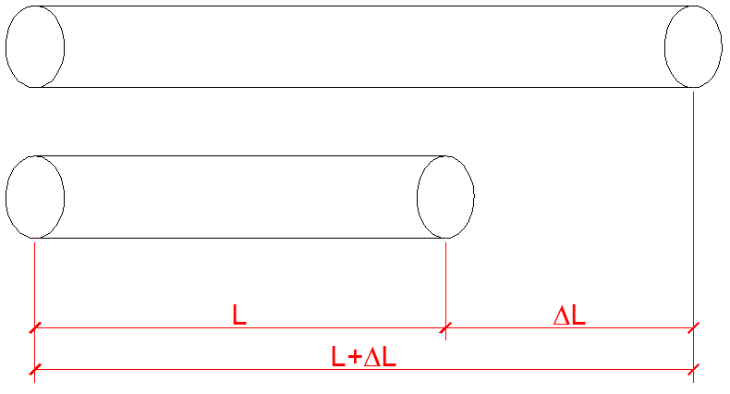

* The red lenght is L before the force is applied and L+ΔL after the for applied f=$P/A$
And the strain Є=${ΔL}/L$ when the tension is small, then the stress is propertional to strain (HOOKER’s law) . If the tension load is released then the rod will go back to σ =E* Є
σ = stress
E = modulus of elasticity (young modulus)
Є = strain
A bar (rod) has a lenght of (10cm) before appling a tensile force of (30 ton) and has lenght of (11 cm ) after applying this force the section is a circular section with radius of (20 mm). Calculate strees and strain P = 30 ton r = 20 cm
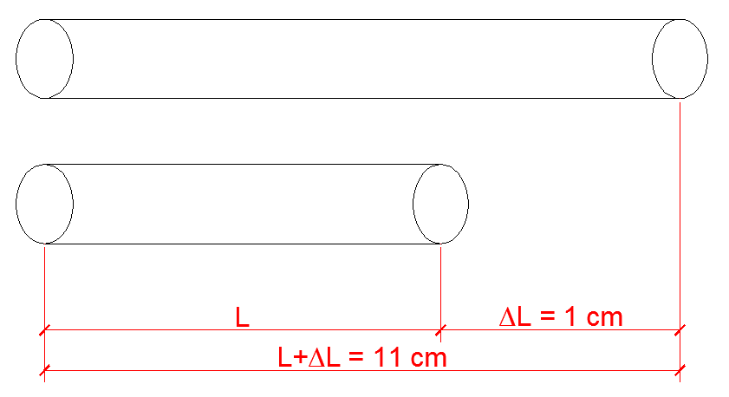
Stress = σ = f =$P/A$ $A=πr^{2}$
$A=π*{ (2 cm)}^{2}$ = 12.57${cm}^{2}$
σ = $\frac{30 ton}{12.57 {cm}^{2}}$ = 2386.6 ${kgf}/{{cm}^{2}}$
strain = Є = ${ΔL}/L$ = $\frac{1}{10}$ = 0.1
when the tension is small then the strees is propotional to strain (HOOK’s LAW)
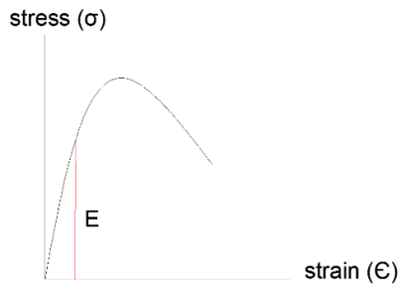
# HOOK’s LAW #
σ =E* Є
E = tan aº
σ = stress
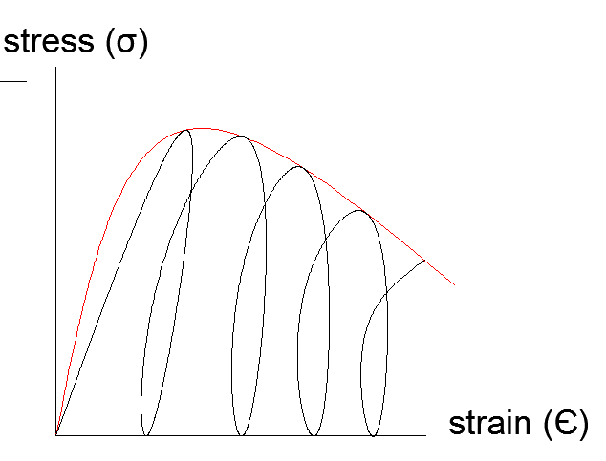
E = elasticity modulus
Є = strain

For concrete

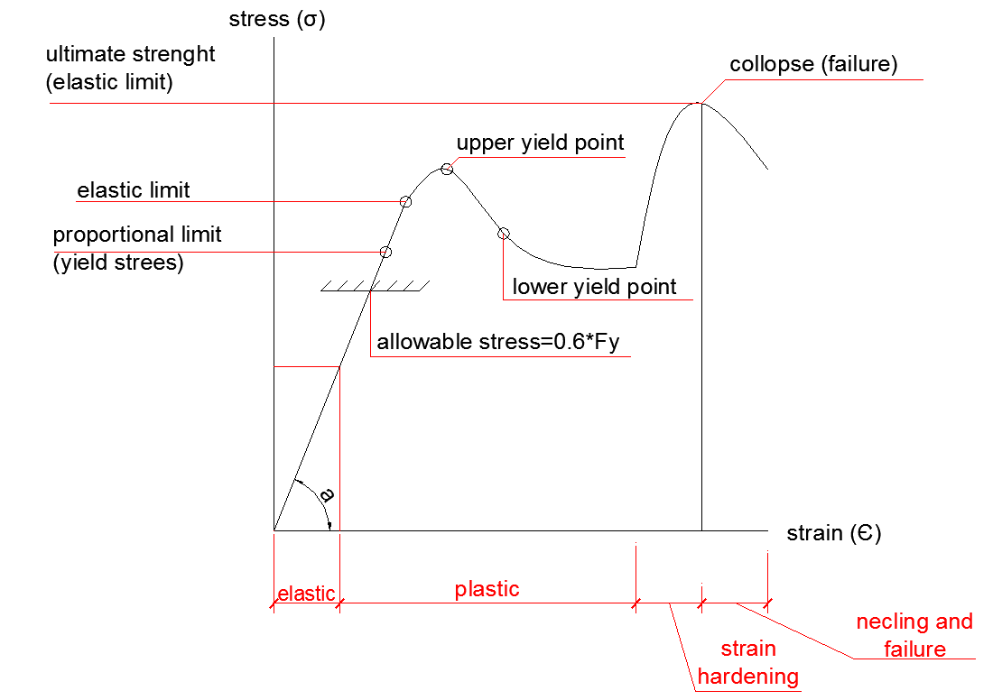

tanӨ=$\frac{σ}{Є}$ $ΔL$ = E * Є
* It is original length the propertionality constant is the modulus of elasticity E. For all types of structural steel (per square inch)
E= 29000kis (kips)
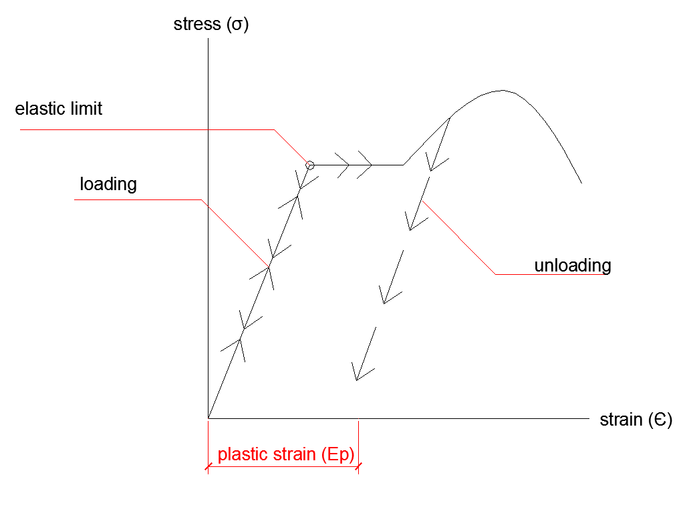
E=2.1*${10}^{6}{kgf}/{{cm}^{2}}$
In linear portloading & unloading have the same trasectory.

* When the tension becomes sufficienty large then steel begins to have permanent determination. This means that when the tension bad is released, the rod will be larger than the original length
* The stress level where the permanent determination begins is called the yield stress, Fy .
* In the two most commonly used structural steel types
Fy = 36 ksi for A36 steel and Fy=50ksi for A572 grade steel

* When the rod is deformed further the stresses are first nearly constant but then begin to increaseagain.The constant stress range is called the plastic range.The range of which the stress will increase but will eventually reach a peak value which is called the (strain )
* The stress will increase, but will eventually reach a peak value which is called the ultimate stress Fu
* After the stress reaches Fu, futher deformation in the rod will result in decreased stress until the rod finally breaks.
# Note #
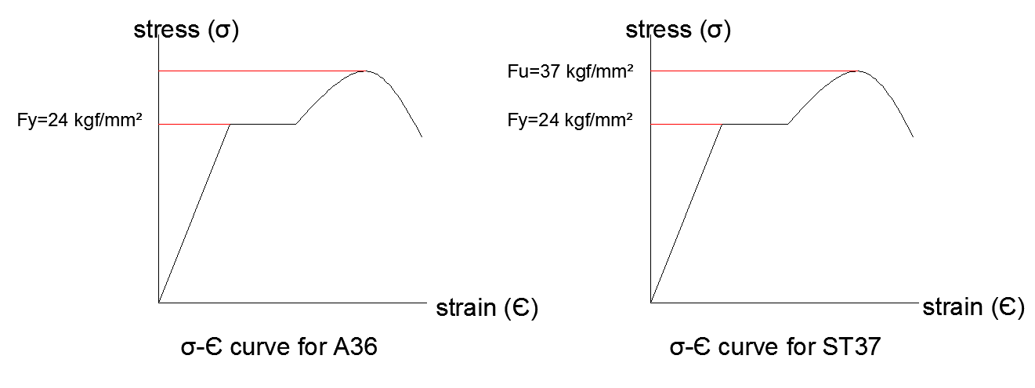
*Tthe following curve shows an idealizing version of all actual stress-strain curve
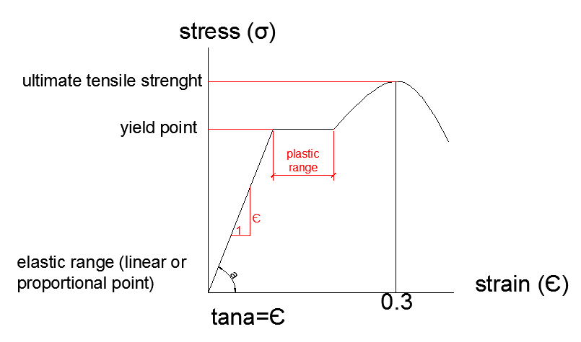
* The following figure shown a typical stress-straincurve for high strenght steels , which are less ductile than the mild steels.
Mild steel Ductile
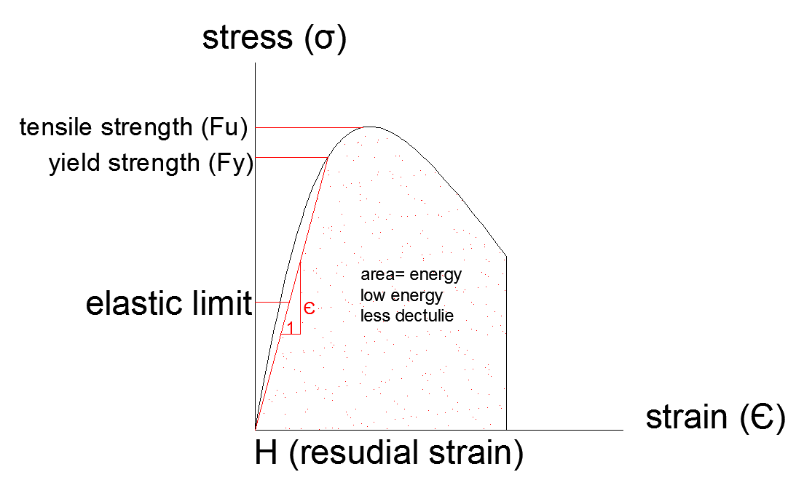
High strength steel britle(less ductile)

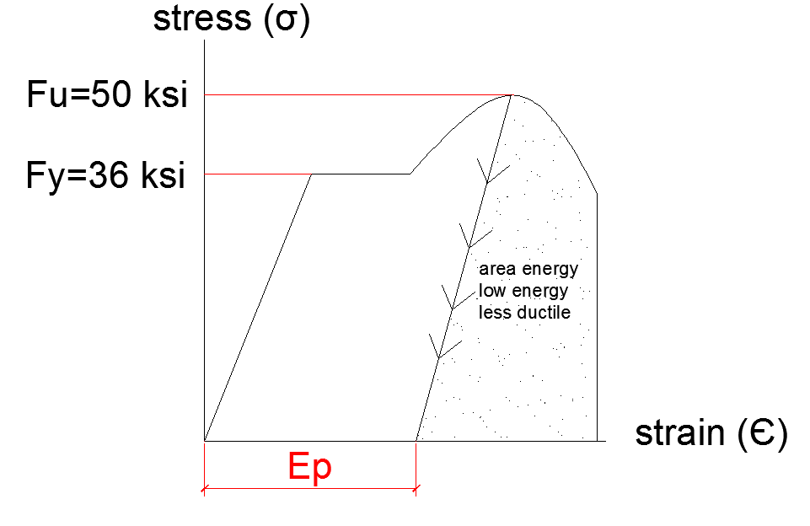
# TYPES OF STRUCTURAL STEEL #
* Designated by the lette ‘A’ followed by the American Society for Testing and Materials (ASTM)designation number . The principal types of structural steel include
* A36 carbon structural steel
* A572 high –strength low-alloy structural steel
* A588 corrosion-resistant high strength low-alloy structural steel.
* A992 high strenth low alloy steels for W shapes beam only Table 1.1
Property | A36 | A572 gr50 | A992
Yield strees min (Fy) | 36ksi | 50ksi | 50ksi
Tensile strength min (Fu) | 58to80ksi | 65 ksi | 65ksi
Yield to tensile ratio max. |  |  | 0.85
Elongation in 8 in min | %20 | %18 | %18
Kips = per square inch
FV = ultimate strength
Fy = ${FV}/{Fy}$
Є =${ ΔL}/L$

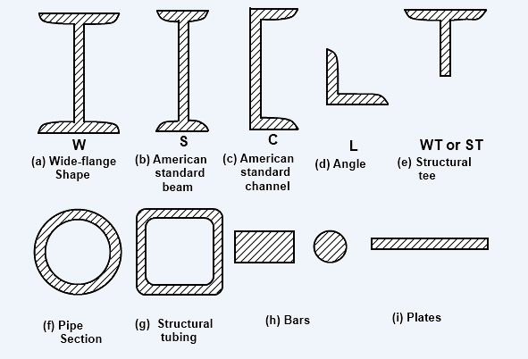
# PHILOSOPHIES OF DESIGN #
Three pholosophies of design are in current use
* Working stress design called by AISC as allowable stress design (ASD)
* Plastic Design(PD)
* Limit states design (called by AISC as load and resistance factor design(LRFD)
* Working stress design (WSD)(ASD) allowable strees design
* Service load are calculated as expected in service
(load factor = 1) (D.L + L.L )
# Linear elastic analysis is performed #
* A design is satisfied if the maximum stress < allowable stress
* Case specific , no guarente that our design covers all cases
# PLASTİC DESIGN #
* Service load are factored by a load factor.
1.4 + D.L + 1.7 L.L (USD in concrete design )
* The structure is assumed to fail under this load thus plastic hinges will from under this loads plastics analysis
* The cross section is designed to resist the moments and shear forces obtained from the plastic analysis

# LIMITATIONS
1) No FOS of the material is consideral neglecting the uncertainly in material strength
2) Arbitrag choice of total FOS (factor of safety)
risk
Safety hazard
Near missed
* Steel in tension = 1.67
* Steel in compression =1.92
# LINEAR ELASTIC #
*A factor of safety (FOS) of the material strength is assumed (usually 3-4)
Safety factor in general
* For fluxural (bending)
$1/{0.6}$*$1/{0.66}$=1.52 $1/{FB}>$1.67
Safety factor = $\frac{actual strees}{allowable stress}$ = $\frac{Fy}{Fy*0.6}$ = 1.67
In columns we have bucling suddenly unstability and collaps
In beams by increasing the loads value, first two hinges (plastics hinges) are generated at supports of fixed support beam , further increase in load generateds.
The third hinges (called plastic hinges) and the three plastics hinges perform the collapse mechanism
ASD | Case 1  Normal case | Load factor = 1
 |  | *stresses is limited to < allowable stress (0.6 * Fy)
 | Case 2  Emergency case | * Load factor = 1
Stresses < allowable stress
(0.6 * Fy * 1.33)
If you applied safety factor onloading not on stresses | Case 1 = D.L + L.L
 | Case 2 = 0.75 (D.L + L.L + W.L) in this case , stresses is compared with 0.6 * Fy

# LOAD AND RESISTANCE FACTOR DESIGN #
* During the past 20 years, the general ‘limit states design’ approach has continued to gain acceptance for steel design.
* Limit states are those conditions of a structure at which it cases to fulfil its intended function strenght and service ability.
* Both the loads acting on the structure and its resistance (strength) to loads are variables that must be considered .
* In general a through analysis of all uncertainties that might influence achieving a ‘limit state’ is not practical or perhaps possible. The current approach to simplified method for obtainig
a probability based assessmen of structural safety uses first order second moment reliability methods
* In general the expression for the structural safety requirement maybe written as:

ØRn = design strength
Ø = Reduction formula
ØRn $>$ $\sum{ɣ_{i}Q_{i}}$
$Q_{i}$ = Loads
$ɣ_{i}$ = Load factory
n = Nomina (ultimate)
* Left hand side represents the resistance or strength of the component or the system, right hand side represents the load expected to be carried
# THE (AISC) (LRFD) SPECIFICATION IS BASED ON THE FOLLOWING #
1) Probabilistic models of loads and resistance
2) A calibration of the LRFD provisions to the 1978 edition of the ASD specification for selected member.
3) The evaluation of the resulting provisions by judgement and past experience aided by comperative design office studies of represantation structures.
LOAD COMBINATIONS FOR LRFD METHOD
AISC consideres the following load combinations in design
$$\sum{ɣ_{i}Q_{i}}$$

1) 1.4*D (Load combination)
2) 1.2D+1.6*L+0.5(L or S or R)
3) 1.2D+1.6 (L or S or R)+0.5L or 0.8W
4) 1.2D+1.6W+0.5L+0.5(L or S or R)
5) 1.2D+1.0E+0.5L+0.25
6) 0.9D+1.3W or 1.0E
- Dead load - Snow load
- Live load - Rain load
- Roof load - Wind load
- Snow load - Earthquakes
# ADVANTAGES OF LRFD METHOD #
* LRFD is another ‘tool’ for structural engineers to use in steel design
* Adaption of LRFD is not mandotary but provides a flexibility of option to designer
* ASD is an approximate way to account for what LRFD does in a more rational way. The use plastic design concepts in ASD has made ASD such that it no longer called as an ‘elastic design’ method.
* Using multiple load factor combinations should lead to economy.
* LRFD will facilitate the input of new information on loads and load variation as such information becames available.
* Considerable knowledge of the resistance of steel structure is available. On the other hand our knowledge of loads and their variation is much less.
* Seperating the loading from the resistance allows are to be changed without the other if that should be desired.
* Changes in overload factors and resistance Ø are much easier to make than change the allowable stress in ASD method
* LRFD provide the frameworks to handle unusal loads that may not be covered by the specification.The design way have uncertainly relating to the resistance of the structure in which case the resistance factor maybe modified.
* Economy is likely to result for low live to do dead load ratio.

* Safe structures may result under LRFD because the method should lead to a better awareness of structural behaviour.
# GUIDE TO THE AISC MANUEL #
* The AISC manuel for steel construction is comprehensive set of tables charts,diagrams and design rules used in professionals practise. In the 15 weeks of this course it is possible only to cover a small but most important, portion of the AISC manuel . A very brief description
r= $\sqrt{\frac{I}{A}}$
r = gyration radius
A = area
I = moments of inertia

section modulus
S = $\frac{I}{C}$ $y_{max}$ = c = $\frac{h}{z}$
Z = Plastic modulus of steel

D+L
D+(L or S or R)
D+0.75L+0.75(L or S or R)
NOTE = 0.75 for temporary loads like
D$±$ (W or 0.7E)
D+0.75(W or 0.7E)+0.75L+0.75(L or S or R)
0.60+ (W or 0.7E)
Snow load increase of %33 in allowable stress is allowed for

# EXAMPLE #
If σa = 0.6 * Fy (for permanent loads) then 1.33 Ȣa = 1.33*0.6 * Fy is allowed for temporary loads or a factor 0.75 is multiplied to snowload.
DESIGN START
# ANALYSIS OF TENSION MEMBERS #
* The tension members are found in bridges trusses towers bracing system tie vods
* The selection of section to be used as tension member are one of the simplest problems encounted in design
# ALLOWABLE TENSILE STREES #
* A due tile member (steel member) without fracture to a tensile load can resist without fracture load larger then its gross-cross- section area times its yield or allowable stress depend on the stiation
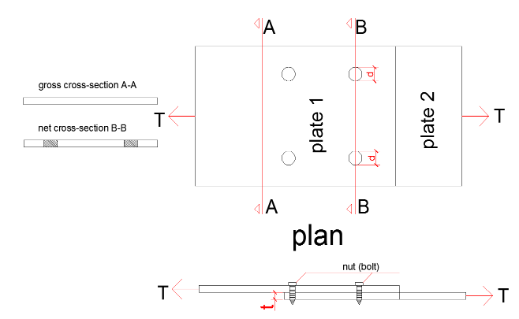
For gross cross section
* Gross area = Ag= b*t
For net cross section
* Net area = Ae = ( b – 2 * d ) * t

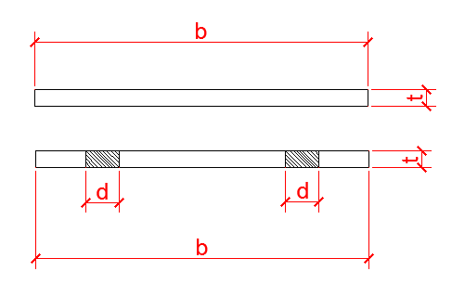
In general tensile allowable stress = 0.6 * Fy
Where Fy is yield stress
Force = stress * area
F = σ * A
σ = Allowable load
$T_{1}$= 0.6 * Fy * Ag (for gross section)
$T_{2}$ = 0.5 * Fu * Ae (for net section)
Fu = ultimate strength
Ag = gross section
Ae = net section area
T = Min [ $T_{1 }, T_{2}$]
Force=stress*area

# EXAMPLE for Welding #
Two plates are attached to each other by using bolting system (as shown in the figure). Find the allowable tensile force applied on the plate.
Plates are mode of steel ST-37 (Fy = 2400 kgf/cm²)
t = 25mm b = 30cm
Short on welding
Different types of welding w ewill see later.
AWS: American Welding Society: Butt wled, Fillet Weld

AWS-D.1.1: The code number
Type of welding: Fillet weld
D = Dimension of weld
Crack at 45°
D * cos45° = 0.707D
For normall (mild) steel ST-37
Fy=2400 ${kgf}/{{cm}^{2}}$ ± 100 ${kgf}/{{cm}^{2}}$
Take Fy = 2300${kgf}/{{cm}^{2}}$
Allowable tensile stress in shear = 0.4 Fy
Allowable stress in weld = 0.4* 2300${kgf}/{{cm}^{2}}$
Allowable stress in weld = 920${kgf}/{{cm}^{2}}$
Allowable force in weld = 0.4 * fy * 0.707 D

Allowable force in weld = 0.4*2300${kgf}/{{cm}^{2}}$*0.707*D
Allowable force = 650D for a lenght of 1 cm of weld
Allowable force = 650 * D * L for the lenght of L
L = Length
D = Dimension
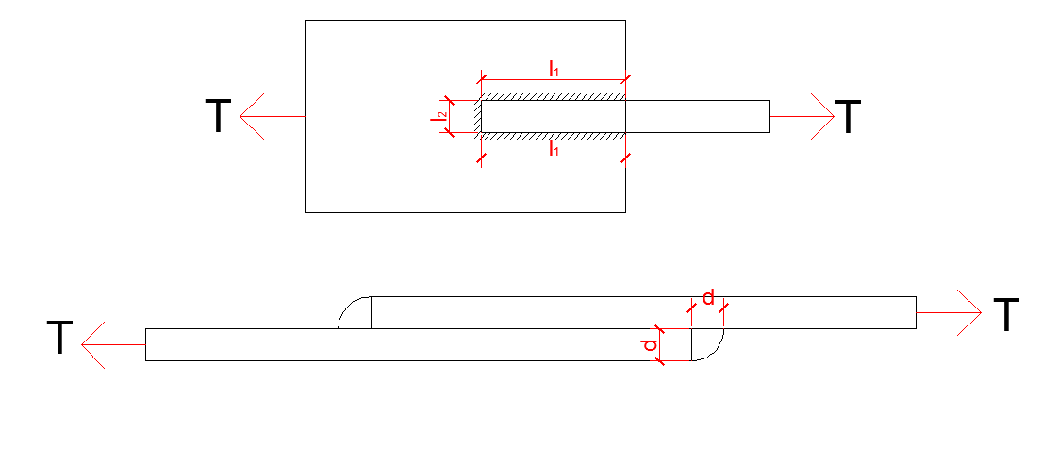
# EXAMPLE #
To join two plate as shown in the figure, the fillet welding is used. Find the lenght of welding , if the deimension of welding is 10 mm, steel type: ST-37
D = 10 mm = 1 cm
P = 650D * L
20000 kgf = 650 *1cm* ( 2 $l_{1}$ + 5)
$l_{1}$ = 12.88 cm
(the unit in the formula kgf and cm)
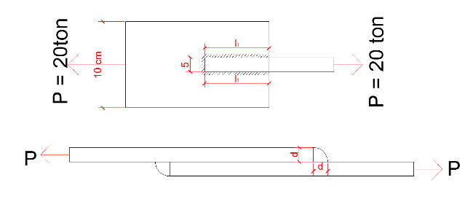
L = 2 $l_{1}$+5 cm => 2 * 12.88 cm + 5 cm = > l = 30.70 cm

# DESIGN OF BEAM UNDER BENDING MOMENTS ( FLEXURE ) #
- we should identify the condition of beam for followings
1) compact section
2) lateral bracing
- We will observe different conditions
1) Beam is laterally supported and it has compact section
allowable stress Fb = 0.66 * Fy
2) Beam is laterally supported but it has not compact section
allowable stress Fb = 0.6 * Fy
3) Beam is not laterally supported and has not compact section
allowable stress Fb < 0.6 * Fy
* Fy = yield stress
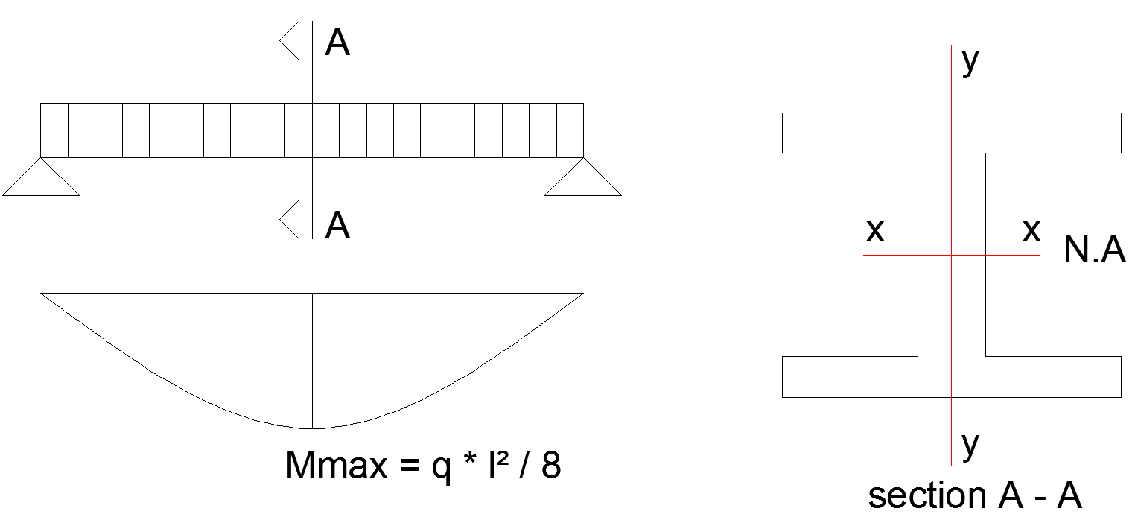
- Actual (Applied) stress = σ = fb = $\frac{M*Y }{I}$ , fb = $\frac{M*C }{I}$
Y = Ymax = c
M = Applied bending moment
C = Distance between N.A. and extreme fiber of the section
I = Moment of inertia
fb = Actual stress due to bending
b = Bending moment
- fb ≤ Fb
Fb = allowable stress
if $\frac{I}{C}$ = S
fb = $\frac{M*C }{I}$ = fb = $\frac{M}{S}$
S = Sectional modulus
M = Applied bending moment
fb = Applied (actual) stress
S = W (In some books)
#NOTE#
For any section I,S,.... can be found from the tables of section profiles
fb = $\frac{M*C}{I}$ = $\frac{M}{S}$
for design fb = Fb => Fb = $\frac{M}{S}$ => S = $\frac{M}{Fb}$
input = M and Fb
output = S => go to table of profiles
- find the section
# EXAMPLE #
Select a beam section for the span and loading shown in the figure , assuming full lateral support provided for the compression flange by the floor . Allowable bending stress is 24 KSI
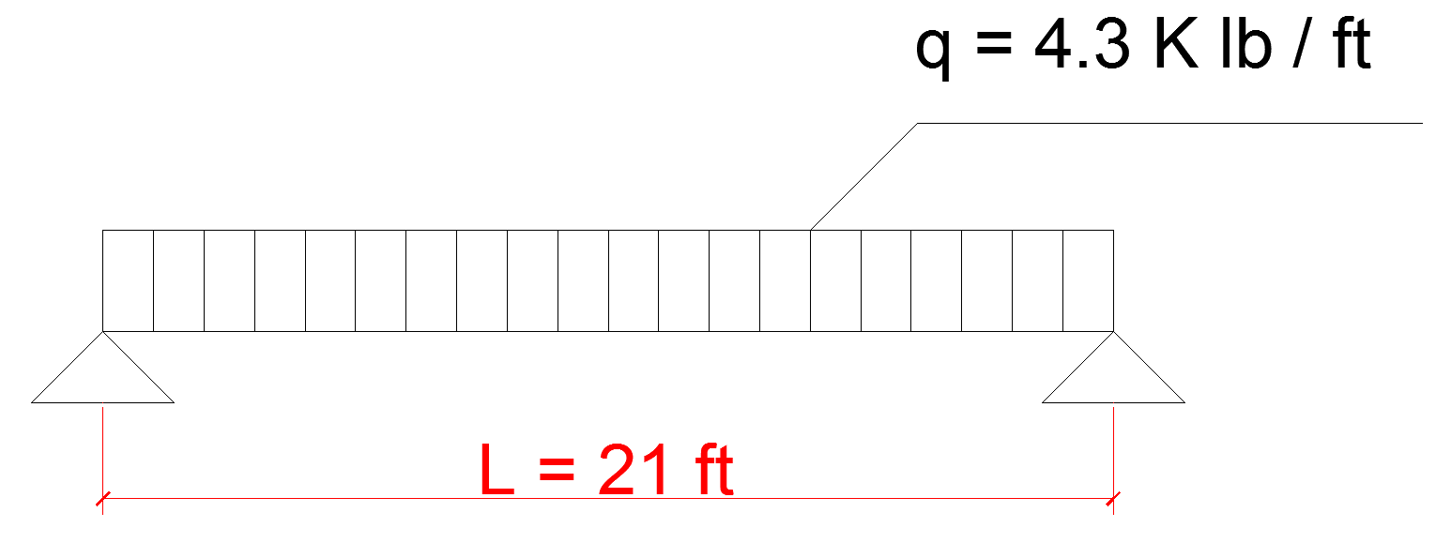

# SOLUTION #
Fb = 24 ksi (Kips per square Inch)
fb = $\frac{M*C}{I}$ = $\frac{M}{S}$
for design fb = Fb => Fb = $\frac{M}{S}$ => S = $\frac{M}{Fb}$
input = M and Fb
output = S => go to table of profiles and find the section
assume weight of beam = 62 ${lb}/{ft}$ = 0.062 ${Klb}/{ft}$
$q_{n}$ = 4.3 ${Klb}/{ft}$ + 0.062 ${Klb}/{ft}$ = 4.362 ${Klb}/{ft}$
$M_{max}$ = $\frac{q* l^{2}}{8}$ = $\frac{4.362{Klb}/{ft} * {( 21 ft )}^{2}}{8}$
$M_{max}$ = M = 240.46 ft * Klb
S = $\frac{M}{Fb}$ = $\frac{240.46 ft * Klb}{24 ksi}$ = $\frac{240.46 ft * Klb*12 }{24 ksi}$ = 120.23 ${in}^{3}$ = 120.23 (2.54)³ = 1970 cm³
ksi = per square inch killo pound per square inch
from table = USE W 21 x 61 (120.23 ${in}^{3})$ or USE IPE450 (S = 2006 cm³)
or W 24 x 56 (127 ${in}^{3})$
from table = we find the weight of and check the assumption mode 62 ${lb}/{ft}$ is OK or not ?
# COMPACT SECTION #
- A compact section is capable of devoloping it is plastic moment capacity before any local buckling occurs.
- To qualifiy as compact a section must meet the requirement of section B 5.1 of the A.S.D. specification.
- Normally all W and S shape of A36 steel and a large percentage of those shapes made from higher strength steel are compact
- For noncompact laterally supported section the A.S.D. specification requires a reduction in Fb below ( 0.66 * Fy ) while for laterally supported compact section the allowable stress is equal to 0.66 * Fy

- The proportions necessary for a section to be classed as compact section are specified by the A.S.D. and are summarized in the following paragraphs.
# FLANGES
- Limitation are given by A.S.D. for the width – thickness ratio ($b/{tf}$) for both unstiffend and stiffend compression beam flanges .
- For the usual hot – rolled (made by factory) section such as W section the flanges are unstiffend while may very well be stiffend for certain build up sections (made by welded plates)
- The A.S.D. specification requires that the width of an unstiffened projecting element of a compression flange divided by it is thickness ( that is $b/{2ft}$ ) not exceed ${65}/{\sqrt{Fy}}$
- For stiffened element the width thickness ratio ( $b/{tf}$ ) may not be greater than ${190}/{\sqrt{Fy}}$ where b is actual width of the stiffened element
- Fy = yield stress
Kips = killo pound per inch square $({Klb}/{{in}^{2}}$)
# WEB #
- In addition to the flange requirements the depth thickness ratios ( $d/f$ ) of compact sections are not permitted to exceed certain values
- This values are ${640}/{\sqrt{Fy}}$ [ 1 – 3.74 ( ${fa}/{Fy}$ ) ] when to ${fa}/{Fy}$ ≤ 0.16 and ${257}/{\sqrt{Fy}}$ when
${fa}/{Fy}$ > 0.16
- The term to represents the stress caused by a concurrent axial load ( if any )
- The limitations of web and flange sizes are calculated for different yield stress values and tabulated in table 8.1
- These values are as given in table 5 of the ‘ Numerical values ’ part of the A.S.D specification immediatelly after their Appendix. Nearly all W and S
- section are compact when made of A36 steel , while a large proportion of the same shapes are compact if Fy is 50 ksi

Yield stress Fy KSI |  | 36 | 42 | 46 | 50 | 60 | 65
Unstiffened flanges  $${65}/{\sqrt{Fy}}$$ |  | 10.8 | 10.0 | 9.6 | 9.2 | 8.4 | 8.1
Stiffened flanges ${190}/{\sqrt{Fy}}$ |  | 31.7 | 29.3 | 28.0 | 26.9 | 24.5 | 23.6
WEB | $${640}/{\sqrt{Fy}}$$for normal beams with low axial force or zero axial force when  ${fa}/{Fy}$ < 0.16 | 106.7 | 98.8 | 94.4 | 90.5 | 82.6 | 79.4
 | ${257}/{\sqrt{Fy}}$ when  ${fa}/{Fy}$ > 0.16 | 42.8 | 39.7 | 37.9 | 36.3 | 33.2 | 31.9

- It is obvious from the values shown in table 8.1 that the higher the yield stress of a particular section the more likely it is to be noncompact . It is quite simple to determine the yield stress above which the flange of a particular section is noncompact as it is for the web. For instance , if the maximum width – thickness ratio of an unstiffened flange is equated to ${bf}/{2tf}$ and solved for Fy , the result which is referved to as F ’y is
${fa}/{Fa}$ < 0.16 | ${65}/{\sqrt{Fy}}$ = $\frac{bf}{2tf}$
 | Fy = F ‘y = ${( \frac{65}{{bf}/{atf}} ) }^{2}$

- A similar derivation for the web when it is subject to combined bending and axial stress with ${fa}/{Fa}$ > 0.16 fallows
${fa}/{Fa}$ < 0.16 | ${257}/{\sqrt{Fy}}$ = $\frac{d}{tw}$
 | Fy = F ‘y = ${( \frac{257 tw}{d} ) }^{2}$
- If the yield stress in question is >f ‘y , the flange in noncompact , and if > Fy’’’ the web is noncompact . The previously mentioned allowable – stress selection table , has the noncompact shapes clearly indicated by showing the value of Fy’ for the each section . In part 1 of the manuel values of Fy’’’ are tabulated
( As are F’y values ) for W ,S , M and HP sections.
- The 7th edition of the A.S.D manuel contained Fy’’’ values computed for the depth – thickness ratio of beam webs when fa was zero
- The values of F’’y are no longer shown , because they are all higher than 70 KSI and plastic behavior is not recognized by A.S.D specification for such steels.
- If Fy > 70 KSI the maximum value of Fb permitted is
0.6 * Fy , which is the lower stress range for noncompact section any way.
- If the web is noncompact , the maximum allowable bending stress permitted by the A.S.D is 0.6 * Fy
- If however the web is compact and the flange has at.
${bf}/{2tf}$ > ${65}/{\sqrt{Fy}}$ but less than ${95}/{\sqrt{Fy}}$ it is said to be partially compact
- For partially compact section a linear transtion in Fb between 0.66 * Fy and 0.6 * Fy is provided by A.S.D equation F1 – 3 . The purpose of this formula is to avoid some of the abruptness of the transition from on allowable stress of 0.66 * Fy to 0.6 * Fy . The transition does not apply to steels with Fy > 65 KSI or to hybrid girders
- The partially compact section equations is
Fb = Fy [ 0.79 – 0.002 (${bf}/{2tf}$ ) $\sqrt{Fy}$] ( A.S.D equation F1 - 3 )
should a doubly symmetric I and H shape be bent about its minor or y_axis and should ${bf}/{2tf}$ > ${65}/{\sqrt{Fy}}$ , but less than ${95}/{\sqrt{Fy}}$ ,

- the allowable bending stress is to be computed with the expression
Fb = Fy [ 1.75 – 0.005 (${bf}/{2tf}$ ) $\sqrt{Fy}$] ( A.S.D equation F2 - 3 )
- Example 8.3 illustrates the calculations necessary to determine the allowable bending stress and the resisting moment of a noncompatible section.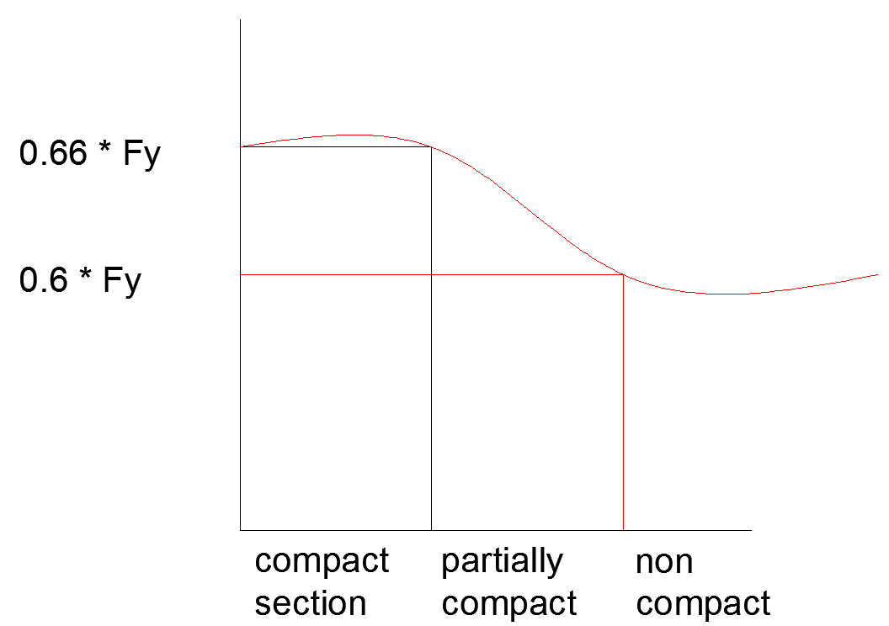
# EXAMPLE 8.3 #
Compute the resisting moment of W12 x 65 with
- Fy = 36 KSI
- Fy = 50 KSI
Assume the section has full lateral support for compression flange
# SOLUTION #
- Fy = 36 KSI
using W12 x 65 (d = 12.12 in , tw = 0.390 in Sx = 87.9 $m^{3}$
bf = 12 , tf = 0.605 in ) and checking ‘compact section’ requirements
- for flange
$\frac{bf}{2tf}$ = $\frac{12}{2*0.605 }$ = 9.92 < 10.8 OK ( from table )
Fy = 36 ${65}/{\sqrt{Fy}}$
- for web
$\frac{d}{tw}$ = $\frac{12.12}{0.390}$ = 31.08 < 106.7 OK ( from table )

since conditions 1 and 2 for flange and web is OK
The section is compact section = allowable stress Fb= 0.66 * Fy
For design 1 purpose since we put fb = Fb => M = $M_{R}$
Fb = $\frac{M_{R}}{Sx}$ =>
$M_{R}$ => Fb * Sx = ( 0.66 ) * ( 36 ) * ( 87.9 ) = 2089 in * kips
$\frac{2089}{12}$ in * kip = 174 ft * k
- Fy = 50 KSI
checking compact section requirement
$\frac{bf}{2tf}$ = $\frac{12}{2*0.605 }$ = 9.92 > 9.2 N.G ( from table )
therefore the flange is noncompact
$\frac{d}{tw}$ = $\frac{12.12}{0.390}$ = 31.08 < 90.5 OK ( from table )
applying A.S.D. equation
Fb = Fy ( 0.79 – 0.002 $\frac{bf}{2tf}$ $\sqrt{Fy}$ )
Fb = 32.49 KSI < 33 KSI (0.66 * 50 KSI = 33 KSI )
( it was compact then 0.66 * Fy )
Mr = Fb * Sx = ( 32.49 ) * ( 82.9 ) = 28.56 in * k = 238 ft*k
# NOTE #
- The A.S.D manuel can be wed to quickly determine if a section is compact as fallows
from manual
F’y = 43.0 KSI > 36 KSI but < 50 KSI
Therefore the flange is noncompact for Fy = 50 KSI
Therefore the web is compact for both steels

# LATERALLY UNBRACED BEAMS #
- The A.S.D specification present three expression ( F1 – 6 ,
F1 – 7 , F1 – 8 ) for determining the ($F_{B}$ , allowable bending fiber stressesin beams for which continious lateral support is not provided )
- The expression are applicable to rolled shapes , plate girders and built up members having an axis of symmetry in the plane of web.
- Depending upon the proportions of the member and the unbraced length , the designer will substitue in Eqn
F1 – 6 and F1 – 8 or into F1 – 7 and F1 – 8 and use the large value so obtained provided the results is not a quarter than the maximum permissible value of 0.6 * Fy
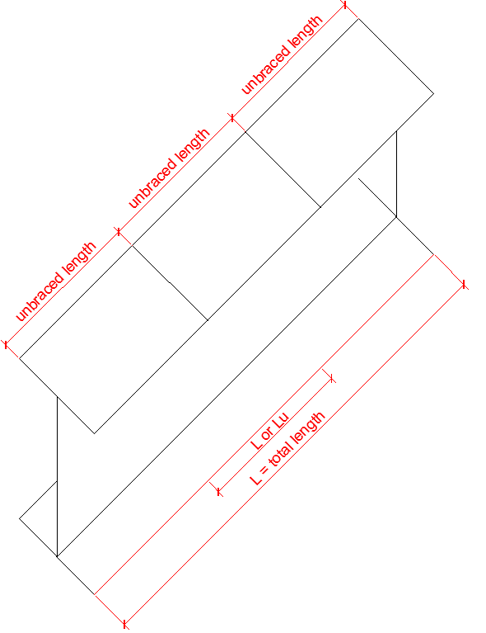

# condition 1
if $\sqrt{\frac{102* {10}^{3}*Cb }{Fy}}$ ≤ $L/{r_{T} }$≤ $\sqrt{\frac{510 * {10}^{3}*Cb }{Fy}}$
then
Fb = Max [ Fb from eqn F1 – 6 and F1 – 8 ] ≤ 0.6 * Fy
Eq. 1 – 6
Fb = ${[2/3-Fy* {L/{r_{T}})}^{2}]}/{\left( 1530* {10}^{3}*Cb \right)*Fy }$
Eqn 1 – 8
Fb = ${12*{10}^{3}*Cb }/{{L*d}/{Af}}$
Fb =$\frac{12* {10}^{3} Cb}{\frac{Ld}{Af}}$

# condition 2
if
$L/{r_{T}}$ ≥ $\sqrt{\frac{510 * {10}^{3}*Cb }{Fy}}$
L = unbraced length
$r_{T}$ = gyration radius of compression poat of beam section
Then
Fb = Max [ Fb from eqn F1 – 7 and F1 – 8 ] ≤ 0.6 * Fy
Eqn 1 – 7
Fb = ${170*{10}^{3}*Cb }/{{(L/{r_{T}})}^{2}}$
Eqn 1 – 8
Fb = ${12*{10}^{3}*Cb }/{{L*d}/{Af}}$
- The lateral shuckling strength of a beam can be estimated by taking into account the tarsional resistance of the beam about its longutudional axis and the lateral bending resistance expression is however to complicated for practical engineering use. For compression flange there is risk of lateral buckling
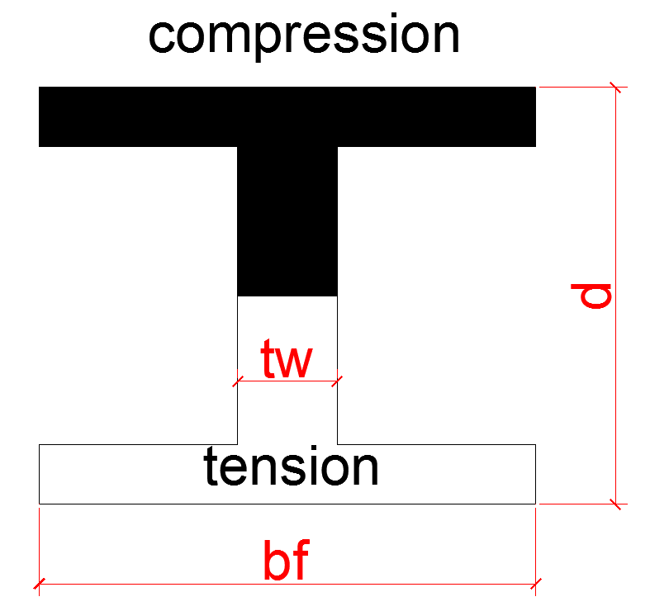
- for shallow thick walled section the resistance to torsion about the longitudiral axis and the lateral buckling resistance one the most important factor.

- for these case ASD equation F1 – 8 is considered to give a reasonable approximation of an allowable buckling stress.
- In the expression that fallow , L is the distance between points of lateral support
- d is the beam depth
- Af is the flange area
- should the beam under consideration be a cantilever the unsupported length can be conservatively assumed to equal the actual length
- The allowable bending compression stresses permitted by the ASD specification for sections loaded in the plane of their webs and having an axis of symmetry in their webs equal the large value computed by equation F1 – 6 or F1 – 7 and F1 – 8 as described in the following paragraphs except not more than 0.60 * Fy
- The procedure for determing allowable stresses also applies to compression on extreme fiber of channel bent about their major axes.
- when $L/{r_{T}}$ ≥ $\sqrt{\frac{510 * {10}^{3}*Cb }{Fy}}$
we use
Fb = ${170*{10}^{3}*Cb }/{{(L/{r_{T}})}^{2}}$ and , when the compression flange is solid and approximately rectangular in cross section and its area is not less than of the tension flange.
- Fb = ${12*{10}^{3}*Cb }/{{L*d}/{Af}}$
A.S.D equation F1 – 8
In this case , these expression L is the unbraced length of the compression flange.
- $r_{T}$ = is the radius of gyration of compression flange plus one third of the compression web area taken about an axis in the plane of the web.
- Cb = is a moment coefficient that is include in the formulas to account for the effect of different moment gradients on lateral torsional buckling. In other words , lateral buckling maybe appreciably affected by the end restraint and loading conditas of the member.
- L = unbraced length of compression flange of beam.

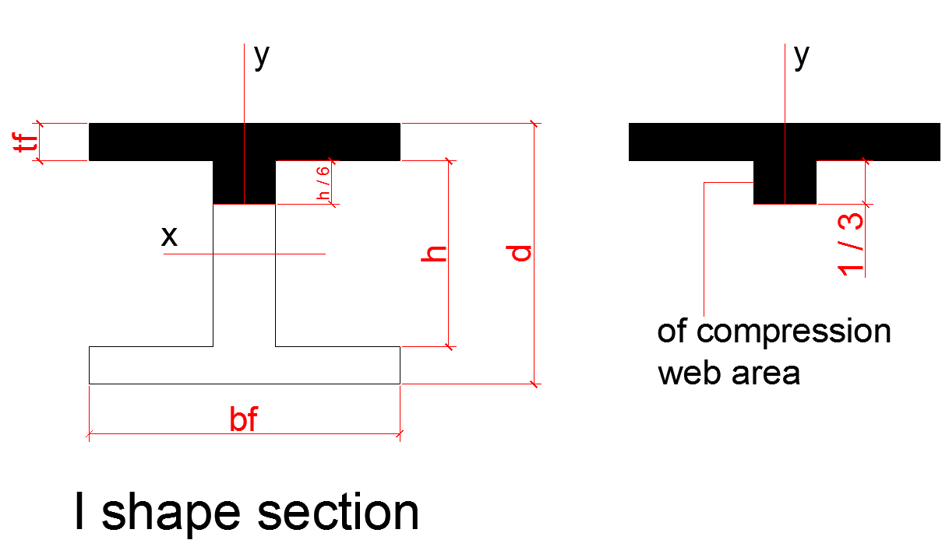
r = $\sqrt{{I_{}}/A}$
$r_{T}$ = $\sqrt{{Iy }/{ A}}$
$r_{T}$ = $\sqrt{{1/2*Iytotal }/{ Area of flange+ 1/6 of total area of web }}$

- The value of Cb is determined from the expression to fallow in which ( $M_{1}$ is the smaller ) and
( $M_{2}$ the longer ) of the bending moment of the unbraced length taken about the strong axis of the member.
- Should the moment at any within the unbraced length he longer than the and moments ( Cb shall be taken as 1.0 the ratio ${M_{1}}/{M_{2}}$) is considered positive if $M_{1}$ and $M_{2}$ have the same sign (reverse carvature bending ) and negative , if they have opposite sign (single carvature bending )
Cb = 1.75 +1.05 ( ${M_{1}}/{M_{2}}$ ) + 0.3 + ${( {M_{1}}/{M_{2}} ) }^{2}$ ≤ 2.3

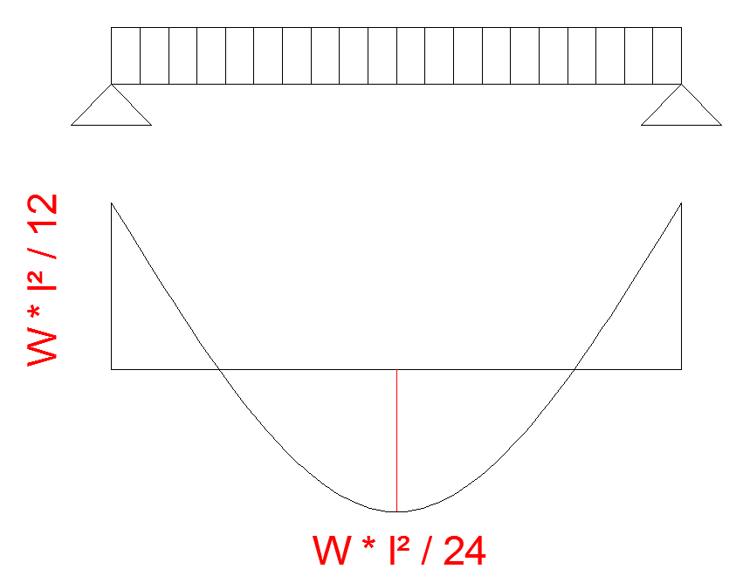
in this example ( fixed supported beam )
smaller = $M_{1}= \frac{W* L^{2}}{24}$
greater $M_{2}= \frac{W* L^{2}}{12}$
- Cb is equal to 1.0 for unbraced contilives beams and for beams and for beams that have moment over an appreciable part of their unbraced span equal to or larger than the larger of the segments and moments.
- The ASD manuel provides information that greatly simplifies the application of these complex lateral support equations
- Of particular use are the Lc , Lu values which are provided in the beam and column sections of the manual
- In section F1 – 1 of the A.S.D specification it is stated that for flanged beams the distances between points of lateral bracing should not exceed 76 ${bf}/{\sqrt{Fy}}$ or
${20 000}/{\left( d/{Af} \right)*Fy }$
- if the members are to be assumed to have adequate lateral bracing. The least of these two values is refferred to as Lc
Lc = min | 76 ${bf}/{\sqrt{Fy}}$
 | $${20 000}/{\left( d/{Af} \right)*Fy }$$

- should distance between points of lateral bracing be grater than Lc
- The ASD says that the allowable bending stress must be reduced from 0.66 * Fy with the appriate formula but in no case may it exceed 0.60 * Fy when these formula are used however there is arange in which they give a value above 0.60 * Fy for each beam there is an unbraced length for which the controlling formula yields an allowable stress exactly equal to 0.60 * Fy . This length is called Lu through at the manuel
- based on this information its possible make the
Lu = allowbale stress ( Fb = 0.66 * Fy )
- If the unbraced length ≤ Lc = 0.66 * Fy
If the unbraced length > Lc ≤ Lu = Fb = 0.60 * Fy
If the unbraced length > Lc > Lu = Fb < 0.60 * Fy

# EXAMPLE #
Determine the allowable bending stress Fb in a given
W33 x 130 for simple span 10 , 13 , 20 and 30 ft without lateral support use A36 steel and the ASD specification
(A36 = Fy = 36kips )
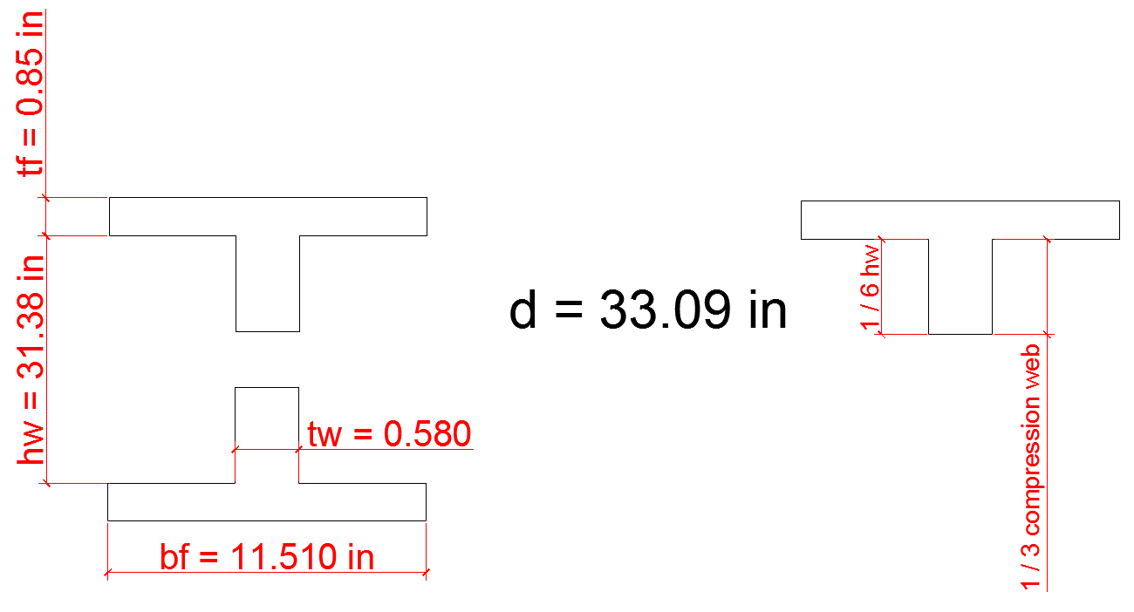
Iy = 218 $d/{Af}$ = 3.36
# computing proporties of the sections
Af + $\frac{1}{6}$ * Aw = ( 11 510 * 0.855 ) + ( $\frac{1}{6}$ * 31.38 * 0.580 )
= 12 .87 ${in}^{2}$
11 510 = bf
0.855 = tf
31.38 = hw
0.580 = tw
$r_{T}$ = $\sqrt{{1/2*Iyy }/{ Area of ( Af + 1/6 Aw ) }}$
Iyy = inertia of section

$r_{T}$ = $\sqrt{{1/2*2.18 {in}^{4} }/{12.87 {in}^{2} }}$ = 2.91 in
approximate
Iy to any tee section $\frac{1}{2}$ Iy for whole section

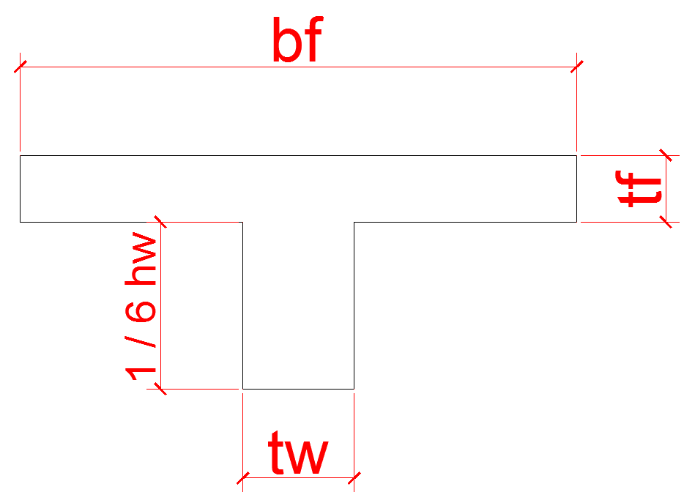
- If we don’t have table we can calculate the moment of inertia
Iyy = ( F + $1/3$ Cw )
From
Iyy = $\frac{1}{12}$ * tf * ${( bf )}^{3}$ + $\frac{1}{12}$ * $\frac{1}{6}$ hw * ${( tw )}^{3}$

- more exact value of $r_{T}$ are given in the A.S.D manuel
$r_{T}$ = 2.88 in
- for this section Cb = 1.0 since moment in span exceeds value at both ends
# case 1
- L = $L_{unbraced}$ = 10 ft
Lc = min | 76 ${bf}/{\sqrt{Fy}}$ | 76 ${11 510 in}/{\sqrt{36}}$  = 145. 79 in
 | $${20 000}/{\left( d/{Af} \right)*Fy }$$ | $${20 000}/{\left( {33.09}/{11 510*0.855} \right)*36 }$$= 165 . 2 in
- Lc = 145.79 in
Lc = 145.79 in * $\frac{1}{12}$ $\frac{ft}{in}$ = > Lc = 12.1 ft
- Lc = 12.1 ft > Lu = 10 ft
- therefore Fb = 0.66 * Fy => Fb = 24 KSI

# case 2
- L = $L_{unbraced}$ = 13ft
Lu = 13.8 ft from manuel
12.1 ft < 13 ft < 13.8 ft
Lc < $L_{unbraced}$ < Lu
- therefore Fb = 0.60 * Fy = 22 KSI
# case 3
- L = $L_{unbraced}$ = 20ft
$L_{unbraced}$ > Lu = 13.8 ft
- therefore one must use formula as
$\sqrt{\frac{102* {10}^{3}* Cb}{Fy}}$ ≤ $L/{r_{T} }$≤ $\sqrt{\frac{510 * {10}^{3}*Cb }{Fy}}\sqrt{\frac{102* {10}^{3}* 1.0}{36}}$ ≤ ${12*20}/{2.88 }$≤ $\sqrt{\frac{510 * {10}^{3}*1.0 }{36}}$use equation F1 – 6 , F1 – 8
Fb = ${[2/3-Fy* {L/{r_{T}})}^{2}]}/{\left( 1530* {10}^{3}*Cb \right)}]*Fy$ ≤ 0.60 * fy
Fb = ${[2/3-36*({83.3)}^{2}]}/{\left( 1530* {10}^{3}*1 \right)}]*36$ = 18.1 KSI
Fb =$\frac{12* {10}^{3}* Cb}{\frac{Ld}{Af}}$ = $\frac{12* {10}^{3}*1 }{\frac{20*12*33.09}{11 510*0.855 }}$
Fb = 14.9 KSI
Fb = Max [ ${Fb}_{1}$ , ${Fb}_{2}$ ] = Fb = 18.1 KSI
# case 4
- L = $L_{unbraced}$ = 30ft
$L/{r_{T} }$ = ${12*30 }/{2.88 }$ > $\sqrt{\frac{510 * {10}^{3}*1.0 }{36}}$
125 > 119
- use equation F1 – 7 , F1 – 8
Fb = ${170*{10}^{3}*1 }/{{( 125 )}^{2}}$
Fb = 10.88 ( F1 – 7 )
Fb = ${12*{10}^{3}*1 }/{{30*12*33}/{11 510*0.855}}$
Fb = 9.9 KSI ( F1 – 8 )
- Fb =max ( F1 – 7 , F1 – 8 ) = Fb = 10.88 KSI

# EXAMPLE #
A simply support beeam under dead load of 850 ${kgf}/{m^{2}}$ and live load 250 ${kgf}/{m^{2}}$ is given the spacing between adjacent beam and this beam are 5 m and 6 m .This steel beam is embeded in concrete slab and is lateraly supported by this slab, L = 5.7 m . The beam steel type is ST – 37 (37 is the ultimate strength in ${kgf}/{{mm}^{2}}$ ) .This section is a compact section
# SOLUTION #
For ST – 37: Fy = 2400 ${kgf}/{{cm}^{2}}$
Fu = 3700 ${kgf}/{cm^{2}}$
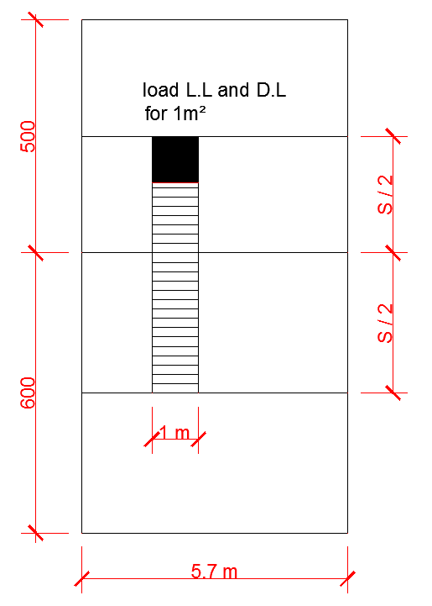
S = $\frac{S}{2}$ + $\frac{S}{2}$
q = ( D.L + L.L ) * S
S = spacing between beams
D.L = 850 ${kgf}/{m^{2}}$
L.L = 250 ${kgf}/{m^{2}}$

W = D.L + L.L = 850 + 250 = 1100 ${kgf}/{m^{2}}$
q = W * S = W * ( $\frac{S}{2}$ + $\frac{S}{2}$ )
= 1100${kgf}/{m^{2}}$ * ( $\frac{5m}{2}$ + $\frac{6m}{2}$ ) = 6050 ${kgf}/m$
$M_{max}$ = $\frac{{q*l}^{2}}{8}$ = $\frac{{6050 *( 5.7 )}^{2}}{8}$ = 24570.6 kgf * m
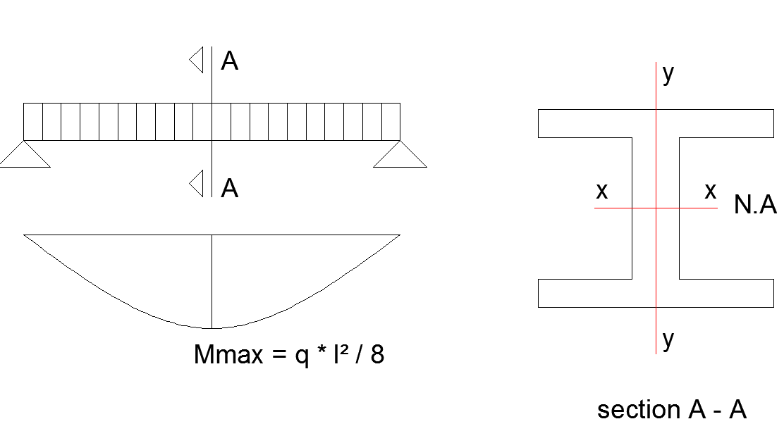
$σ_{max}$ = $\frac{M_{max} * C }{I}$ = $\frac{M_{max} }{S}$ => Fb = $\frac{M_{max} }{Sx-a}$
- S = $\frac{ I }{C}$
- Fb = 0.66 * Fy because the section is compact and the beam is laterally supported ( it is braced completely )
- Fb = $\frac{M_{max} }{Sxx}$ = Sxx = $\frac{M_{max} }{Fb}$ = $\frac{M_{max} }{0.66*Fy}$
- L , Lu , Lc compact section baced ,
Fb = 0.66 * Fy
Fb = 0.6 * Fy
Fb < 0.6 * Fy
Sxx = $\frac{24570.6*100 kgf*cm}{0.66*2400 {kgf}/{{cm}^{2}}}$
Sxx = 1551 ${cm}^{3}$
- Sxx = 1551 * ${(\frac{1 in}{2.54} )}^{3}$
Sxx = 94.65 ${in}^{3}$ ( we find table bu degerden kucugun en buyugunu aldik )
- USE W18 x 55
S = 98.3 ${in}^{3}$

# NOT = if you want to select double profile by choosing C = $\frac{d}{2}$
( d is selected by us ) then we calculate I and via the profiles table we find the section
- $\frac{Ixx}{d/2}$ = $\frac{Mmax}{0.66*Fy}$ take d = 30 cm
take d = 30 cm => $\frac{Ixx}{{30}/2}$ = $\frac{24570.6*100}{0.66*2400}$
Ixx = 23267 ${cm}^{4}$
- Ixx for I profile = $\frac{23267}{2}$ = 11 633 ${cm}^{4}$
- Ixx = 11 633 ${cm}^{4}$ = 11 633 $( {\frac{1 in }{2.54})}^{4}$
Ixx = 279.5 $≅$ 280 ${in}^{4}$
- USE 2 W12 x 35
Sxx = 2 * 45.6 ${in}^{3}$
Ixx = 2 * 285 ${in}^{4}$
# note #
- In this example since the beam is suppose to be embeded in concrete slab we use directly
Fb = 0.66 * Fy
- In general case we should limit the stress ( fb ) to ( Fb ) which we should find from two related formula [ F1 – 6 , F1 – 8 or F1 – 7 , F1 – 8 ]
# SHEAR STRESS IN BEAMS #
- In design of beam bending moment has more effection the flanges and shear force has more effect on the web.
- In other hand when we design an I section beam the flanges are designed mainly on bending moment phenomenan and web is designeed mainly on shear force phenomenon .
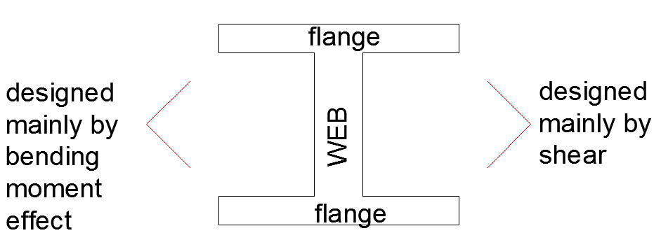

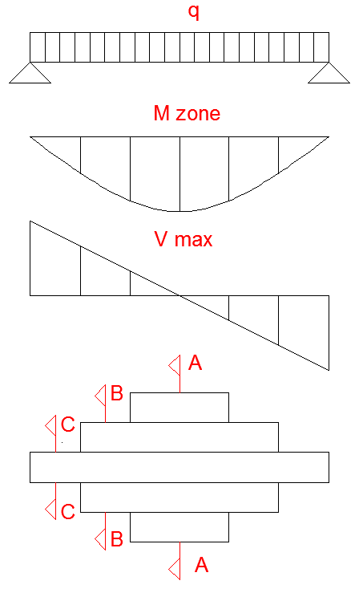

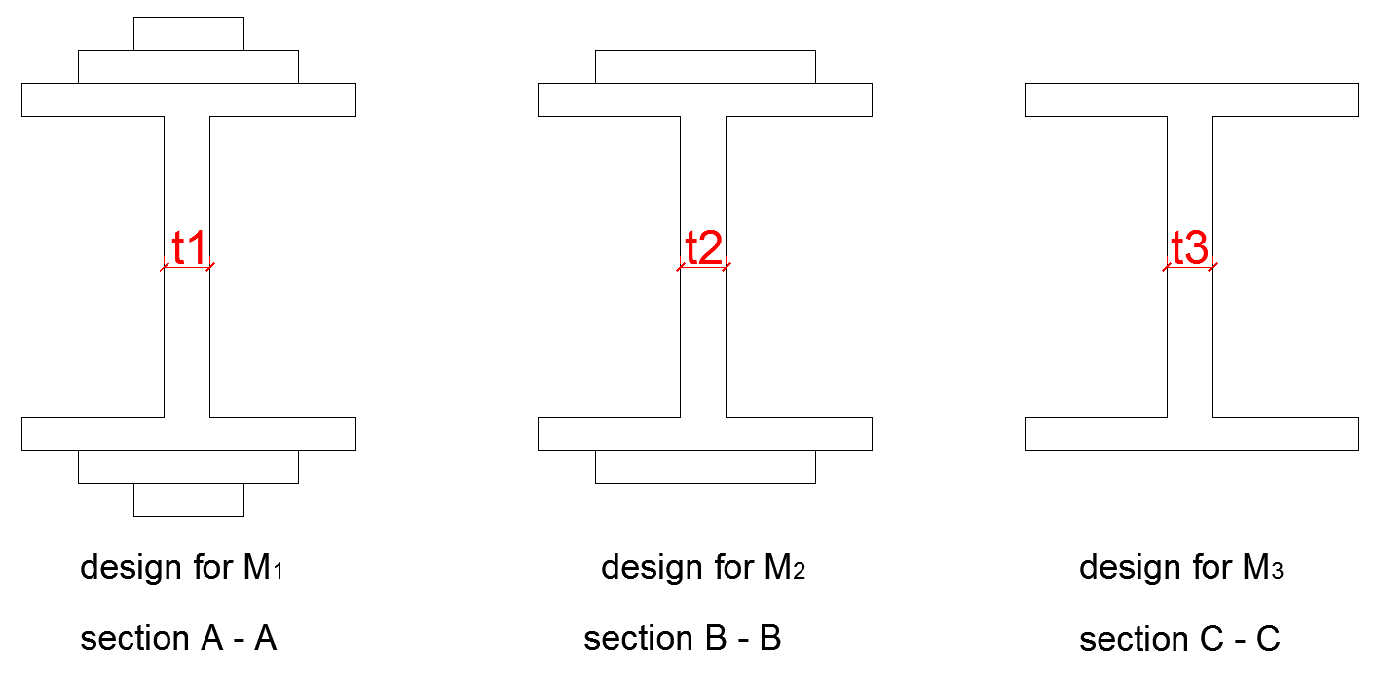
$t_{1}$ > $t_{2}$ > $t_{3}$ because the web thickness is designed by shear force
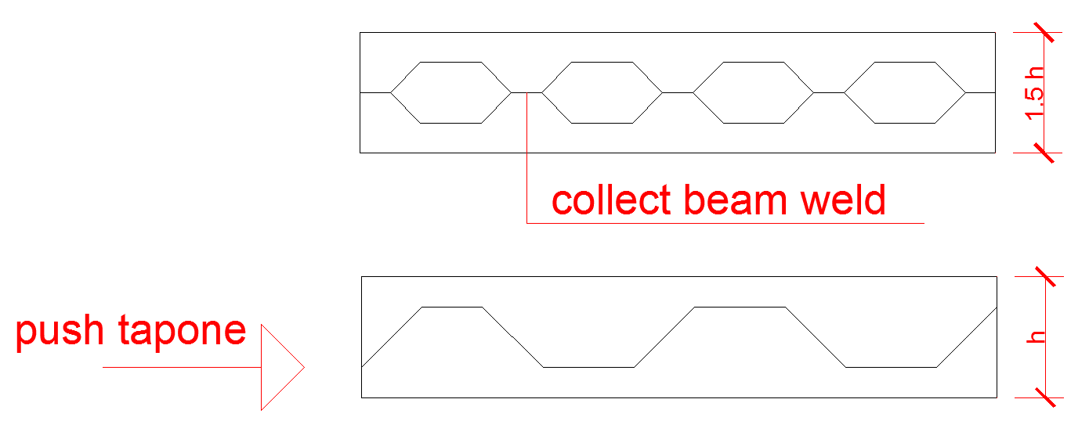

# SHARE STRESS FORMULA AND ABRIVIATION #
# SHARE STRESS ON BEAMS
fb = $\frac{M*C }{I}$

τ= $\frac{V*Q}{I*t}$
τ = share stress
V = share force
Q = first moment ( static moment ) section upto N.A
I = moment of inertia of entire section
tw = t = thickness of web
Q = $\int_{0}^{h/2}{( b , by)}*y$
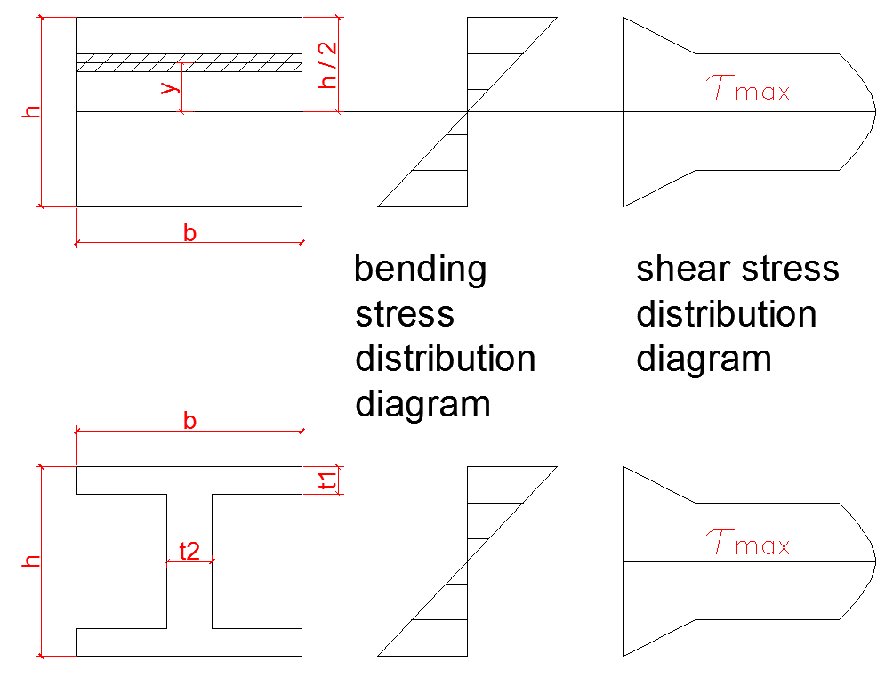
- normally in steel section design we use a simple formula
T = $\frac{V}{Aw}$ where Aw is the area of the web

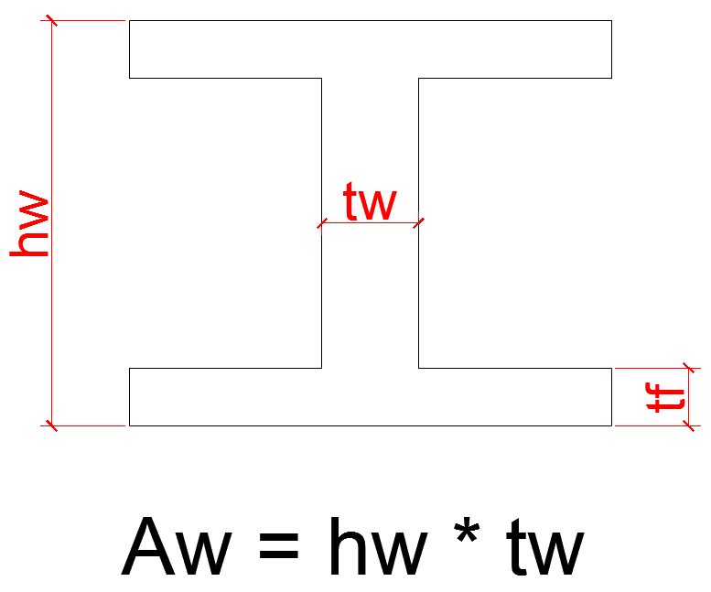
allowable share stress = 0.4 * Fy
tw = thickness of the check web check
# REMINDER
- Allowable shear stress = 0.4 * Fy
- allaowable tensile stress = 0.6 * Fy
- Allowable bending stress = 0.66 * Fy
(compact section + laterally braced
- Allowable bending stress = 0.6 * Fy
( compact section + laterally braced )
- Allowable bending stress < 0.6 * Fy
- Actual (applied ) shear stress
fv = $\frac{V}{Aw}$
- Allowable shear stress
Fv = 0.4 * Fy = $\frac{V}{Aw}$
- $\sqrt{\frac{120* {10}^{3}*Cb }{Fy}}$ ≤ $L/{r_{T} }$≤ $\sqrt{\frac{510 * {10}^{3}*Cb }{Fy}}$
- then Fb = Max [ F1 – 6 , F1 – 8 ]
Fb = ${[2/3-Fy* {L/{r_{T}})}^{2}]}/{\left( 1530* {10}^{3}*Cb \right)*Fy }$≤ 0.6 * Fy
Fb = ${12*{10}^{3}*Cb }/{{L*d}/{Af}}$ ≤ 0.6 * Fy

- ıf $L/{r_{T}}$ ≥ $\sqrt{\frac{510 * {10}^{3}*Cb }{Fy}}$Fb = Max [ F1 – 7 , F1 – 8 ] ≤ 0.6 * Fy ≤ 0.6 * Fy
F1 – 7 = Fb = ${170*{10}^{3}*Cb }/{{(L/{r_{T}})}^{2}}$ ≤ 0.6 * Fy
F1 – 8
Fb = ${12*{10}^{3}*Cb }/{{L*d}/{Af}}$ ≤ 0.6 * Fy
- Reviewing bending of beams ( M.K.S similar to SI units )
- compact section Fb = 0.66 * Fy
- laterally supported beam = Fb = 0.60 * Fy
- Laterally partially supported beam or nonsupported beam
- if $\sqrt{\frac{72* {10}^{5}*Cb }{Fy}}$ ≤ $L/{r_{T} }$≤ $\sqrt{\frac{360 * {10}^{5}*Cb }{Fy}}$
Fb = Max [${Fb}_{1}$ , ${Fb}_{2}$ ] ≤ 0.6 * Fy
${Fb}_{1}$ = ${[2/3-Fy* {L/{r_{T}})}^{2}]}/{\left( 1075* {10}^{5}*Cb \right)*Fy }$≤ 0.6 * Fy

${Fb}_{2}$ = ${84*{10}^{4}*Cb }/{{L*d}/{Af}}$ ≤ 0.6 * Fy
- ıf $L/{r_{T}}$ ≥ $\sqrt{\frac{360 * {10}^{5}*Cb }{Fy}}$
Fb = Max [${Fb}_{3}$ , ${Fb}_{2}$ ] ≤ 0.6 * Fy
${Fb}_{2}$ = ${84*{10}^{4}*Cb }/{{L*d}/{Af}}$ ≤ 0.6 * Fy
${Fb}_{3}$ = ${120*{10}^{5}*Cb }/{{L*d}/{Af}}$ ≤ 0.6 * Fy
- Rewiewing shear force on beams
Actual share stress
τ = fv = $\frac{V*Q}{I*t}$
practically we use
τ= fv = $\frac{V}{Aw}$ = $\frac{V}{h*tw}$
Allowable share stress
Fv = 0.4 * Fy if $\frac{h}{tw}$ ≤ $\frac{380}{\sqrt{Fy}}$

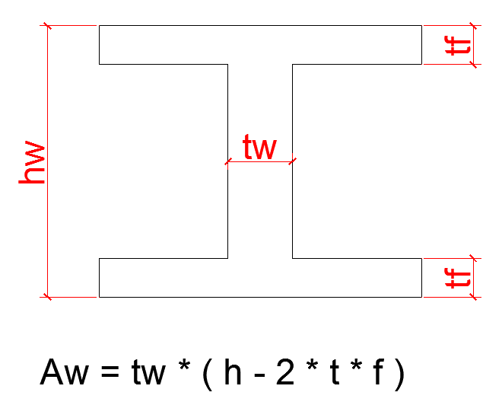
- Reviewing bending moment and shear force diagram
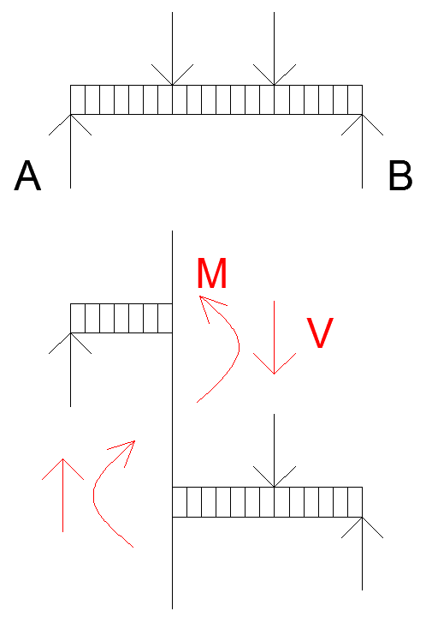
# EXAMPLE #
Find the bending moment and shear force diagrams for the shown beam

# SOLUTION #
# STEP 1 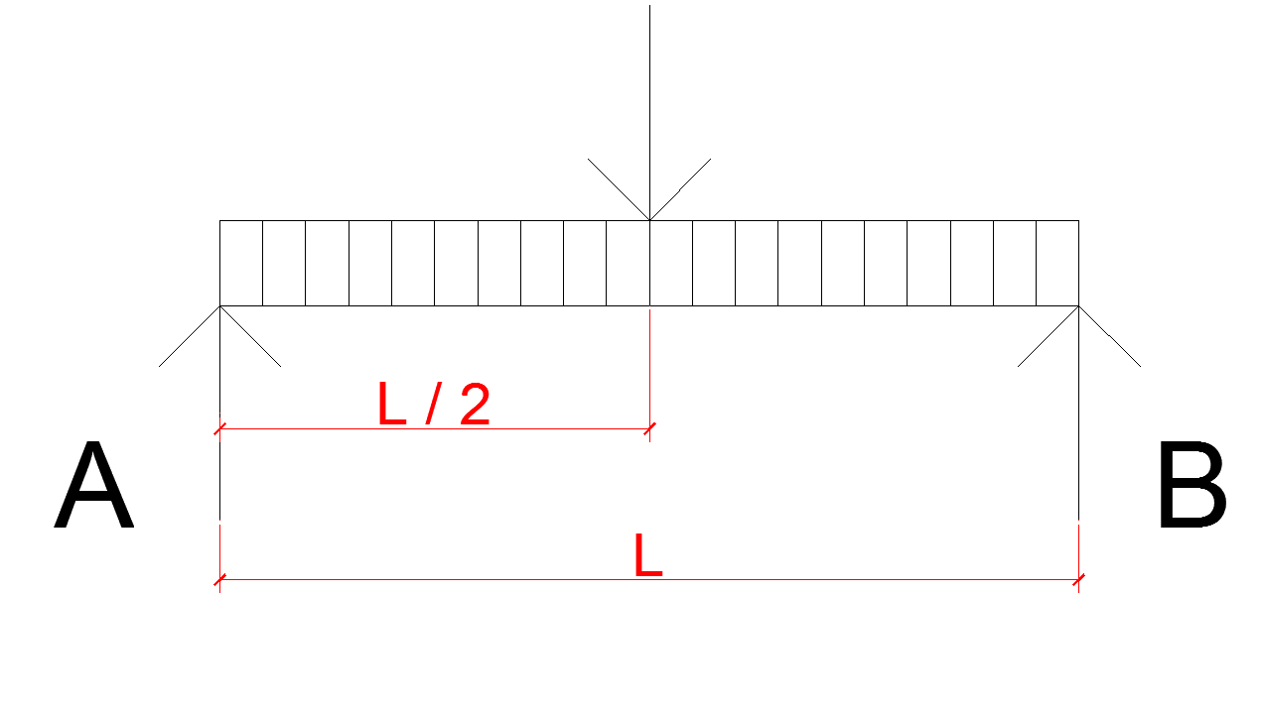
- Finding reaction
$\sum{M_{A}}$ = 0 => + B.L – p * $\frac{L}{2}$ = 0
B = $\frac{p}{2}$
$\sum{F_{y}}$ = 0 => A + B – P = 0 => A + $\frac{p}{2}$ – P = 0
A = $\frac{p}{2}$
# STEP 2
- Bending moment diagram by cutting
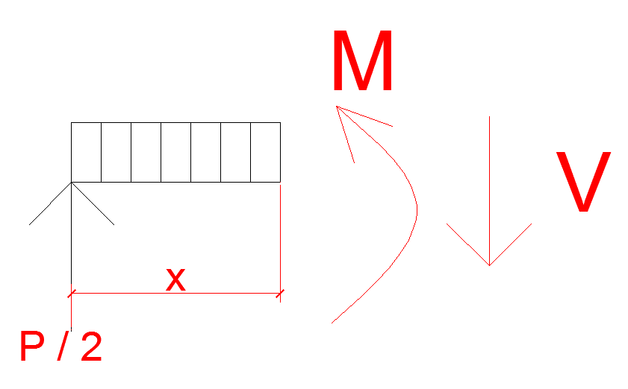
$\sum{{Mc}_{1}}$ = 0 => - $\frac{P}{2}$ * x + M = 0 => M = $\frac{P*x}{2}$

$\sum{F_{y}}$ = 0 => $\frac{p}{2}$ – V = 0 => V = $\frac{p}{2}$ 0 ≤ x ≤ $\frac{L}{2}$

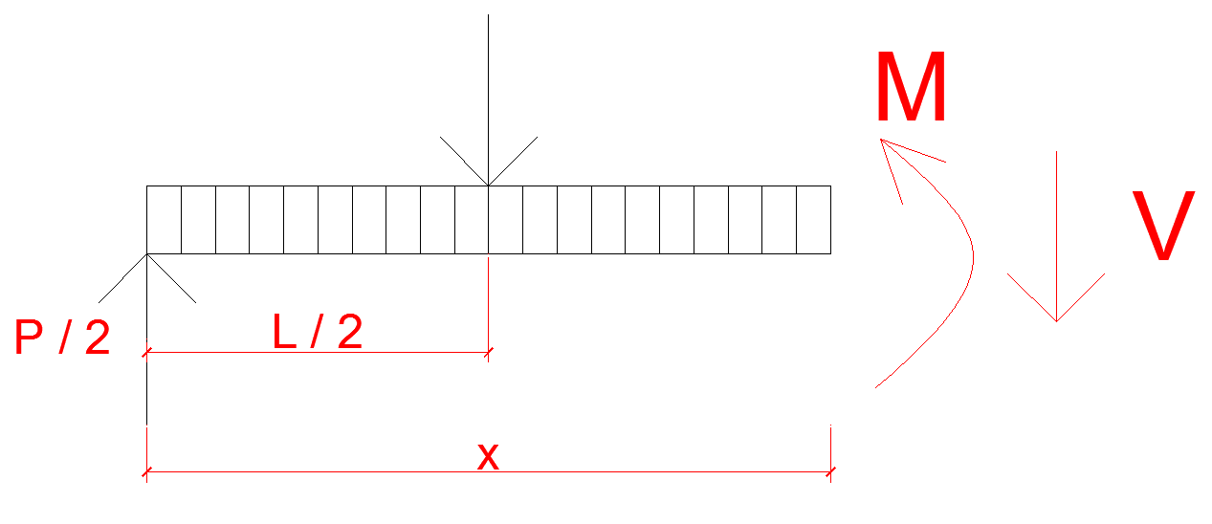
- $\sum{{Mc}_{2}}$ = 0 => - $\frac{P}{2}$ * x + p ( x - $\frac{L}{2}$ ) + M = 0 =>
M = - $\frac{P}{2}$ ( L – x )
$\frac{L}{2}$ ≤ x ≤ L
$\sum{F_{y}}$ = 0 => $\frac{p}{2}$ – V – P = 0 => V = - $\frac{p}{2}$ $\frac{L}{2}$ ≤ x ≤ L
# EXAMPLE #
Find the shear force diagram for the shown beam
- Reaction = A = B =1.5 due to symmetry half of total load on each support
- For shear force diagram we follow the direction of external force ( supports reaction + applied force )
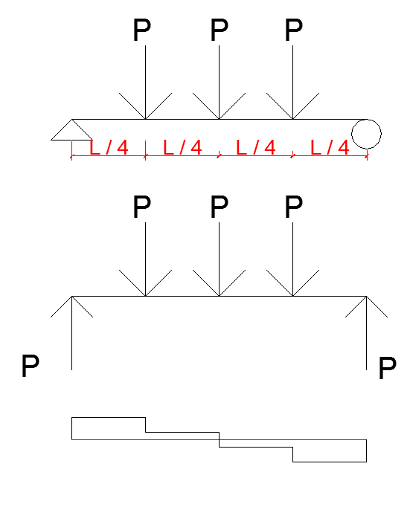

# EXAMPLE #
- Final shear force diagram for the shown beam

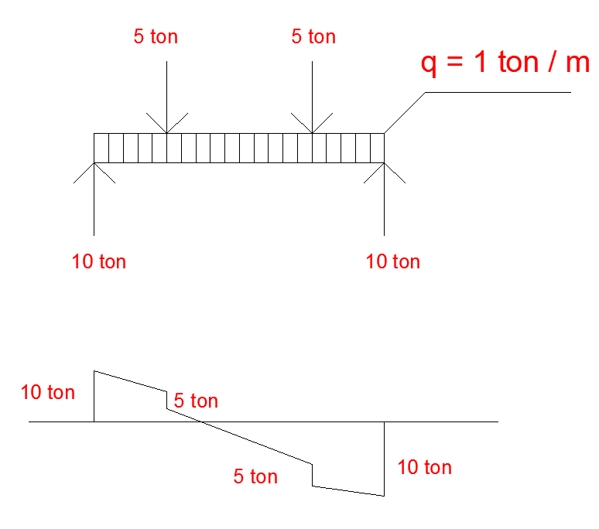
$\frac{5+5+10*1}{2}$= 10 ton
by symmetry $\frac{10}{2}$ + $\frac{2*5 }{2}$
# EXAMPLE #
Design and control the beam section shown in the figure for bending and shear. The beam is laterally supported at the point which the concentrated load are applied.
# SOLUTION #
Reaction because of symmetry
$R_{A}$ = $R_{B}$
$\frac{4.4 t/m *17.1 m*34 ton*34 ton }{2}$
= 71.62 ton
shear force diagram we following the direction of the force
finding bending moment diagram
- finding bending moment diagram
- by cutting
$\sum{{Mc}_{1}}$ = 0 => M = $R_{A}$ * x – q * x * $\frac{x}{2}$
M = - 2.2 $x^{2}$ + 71.62 x
0 ≤ x ≤ 6.1 m

- $\sum{{Mc}_{1}}$ = 0 => x * $R_{A}$ + 34 ( x – 6.1 ) + q * $\frac{x^{2}}{2}$ + M
M = - 2.2 $x^{2}$ + 37.62 x + 207.4
6.1 ≤ x ≤ 11 m
x = 6.1 m
$M_{D}$ = - 2.2 ${( 6.1 )}^{2}$ + 71.62 * 6.1
$M_{D}$ = 355.02 t * m
x = 8.55 = ${17.1}/2$
$M_{E}$ = - 2.2 * ${( 8.55 )}^{2}$ + 37.62 * 8.55 + 207. 4
$M_{E}$ = 368.225 t * m = $M_{max}$
- Estimation of the section high of beam
h = $\frac{L}{8}$ = $\frac{1710}{8}$ = 214 cm
take hw = 200 cm , h = 204 cm
- wetry plate girder section
Note = to find thickness of web and flanges thickness and dimensions we should control some code’s criteria ( here we dont refer to them just we check the bending moment and shear force on the section )
sekil
- shear stress control
$τ_{max}$ = $\frac{Vmax }{Aw}$ = $\frac{Vmax }{hw*tw }$ = $\frac{71.62*1000 kgf}{200 cm 0.6 cm }$
$τ_{max}$ = fv = 596 ${kgf}/{{cm}^{2}}$ ( applied shear stress )
- Allowable share stress
Fv = 0.4 * Fy => Fv = 0.4 * 2400 ${kgf}/{{cm}^{2}}$
Fv = 960 ${kgf}/{{cm}^{2}}$
fv < Fv ( 596${kgf}/{{cm}^{2}}$ < 960 ${kgf}/{{cm}^{2}}$ ) OK
- Bending moment control
to find the formula used for Fb , first you should find $L/{r_{T} }$ in which L is unbraced length of the beam and $r_{T}$ is gyration radius of compression
( flange + $\frac{1}{6}$ of web weight ) about y axis.
$r_{T}$ = $\sqrt{\frac{Iy}{A}}$ take = b = 30 cm

- to calculated Ixx for the bending moment
sekil
# for 1
$I_{ x_{1} x_{1}}$ = $\frac{bf*{tf}^{3}}{12}$ = $\frac{60cm *{\left(2 cm \right)}^{3}}{12}$
# for 2
$I_{ x_{2} x_{2}}$ = $\frac{bf*{tf}^{3}}{12}$ = $\frac{60cm *{\left(2 cm \right)}^{3}}{12}$
# for 3
$I_{xx}$ = $\frac{tw*{hw}^{3}}{12}$ = $\frac{( 0.6 cm )*{( 200 cm )}^{3}}{12}$
$I_{\begin{aligned}xx \\ total\end{aligned}}$ = $I_{ x_{1} x_{1}}$ + $\frac{Af}{{( h/2 )}^{2}}$ + $I_{ x_{2} x_{2}}$ + $\frac{Af}{{( h/2 )}^{2}}$ + $I_{xx}$
$I_{\begin{aligned}xx \\ total\end{aligned}}$ =[ $\frac{60cm *{\left(2 cm \right)}^{3}}{12}$ + ( 60 * 2 * (${102-1 )}^{2}$ ] * 2 + $\frac{( 0.6 cm )*{( 200 cm )}^{3}}{12}$
$I_{\begin{aligned}xx \\ total\end{aligned}}$ = 2848320 ${cm}^{4}$
* reminding from strength of metarial moment of inertia for rectangular section
sekil
$I_{xx}$ = $\frac{b*h^{3}}{12}$ $I_{yy}$ = $\frac{h*b^{3}}{12}$
$I_{x'x'}$ = Ixx + A * $d^{2}$ $I_{y'y'}$ = Iyy + A * $d^{2}$
- Finding $r_{T}$ ( for T )
Since Iyy for this shapes is about Iyy on the entire section divided by 2 , sometimes instead of exact calculation of Iyy for T we use Iyy of entire section divided by 2 .
Iyy = [ $\frac{2 cm *{\left(60 cm \right)}^{3}}{12}$ ] * 2 + $\frac{( 200 cm )*{( 0.6 cm )}^{3}}{12}$
Iyy = 72004 ${cm}^{4}$ for entire section I
$\frac{1}{2}$ Iyy = $\frac{72004}{2}$ =>
Iyy = 36002 ${cm}^{4}$ ( for half of section )
- Normally $\frac{1}{2}$ Iyy is accepted to be applied in calculation of $r_{T}$ because there is just a small difference between $\frac{1}{2}$ Iyy and Iyy calculated for SEKIL

- Direct calculation of Iyy for shape
Iyy = [ $\frac{2 cm *{\left(60 cm \right)}^{3}}{12}$ ] * 2 + $\frac{( {200}/6 cm )*{( 0.6 cm )}^{3}}{12}$
Iyy = 36001 ${cm}^{4}$
at it be obsevivied 36001 ${cm}^{4}$ are very close to each other therefore using $\frac{1}{2}$ Iyy of entire section simplifies the calculation
- Area for T
A = ( 60 cm ) * ( 2 cm ) + ( 0.6 cm ) * ( $\frac{200}{6}$ cm )
A = 140 ${cm}^{2}$
$r_{T}$ = $\sqrt{\frac{Iyy}{A}}$ = $\sqrt{\frac{36002}{140}}$
$r_{T}$ = 16.03 cm
- Allowable stress calculation Fb
a) for the middle span
L = 4.9 m ( unbraced length )
$\frac{L}{r_{T}}$ = $\frac{4.9*{10}^{2}}{16.03}$ = 30.55
Cb = 1 ( because the bending moment at the middle is bigger than the bending moment at two ends of middle spam bending moment )
i.e Mmax > 355.02 t * m
$\frac{72* {10}^{5} Cb}{Fy }$ = $\frac{72* {10}^{5}*1}{2400 }$ = 54.77 > $\frac{L}{r_{T}}$
Fb = 0.6 * Fy
$\frac{360 * {10}^{5} Cb}{Fy }$ = $\frac{360 * {10}^{5}*1}{2400 }$ = 122.47
Fb = 0.6 * Fy = 0.6 * 2400 ${kgf}/{{cm}^{2}}$
Fb = 1440 ${kgf}/{{cm}^{2}}$
Fb = $\frac{M}{Sxx}$ , Sxx = $\frac{Ixx}{C}$ = $\frac{Ixx}{h/2}$ = $\frac{2848320 {cm}^{4} }{102 cm }$
Fb = $\frac{368.255* {10}^{5}}{{2848320}/{102}}$
Fb = 1319 ${kgf}/{{cm}^{2}}$ < Fb = 1440 ${kgf}/{{cm}^{2}}$ O.K

- for the span of ( 6.1 )
L = 6.1 m ( unbraced length )
$\frac{L}{r_{T}}$ = $\frac{6.1 m*100 cm }{16.03}$ = $\frac{610 cm}{16.03}$ = $\frac{L}{r_{T}}$ = 38.02
Cb = 1.75 + 1.05 + $\frac{M_{1}}{M_{2}}$ + 0.3 * ${(\frac{M_{1}}{M_{2}})}^{2}$ ≤ 2.3
Cb = 1.75
Fb = $\sqrt{\frac{72* {10}^{5}*Cb }{Fy}}$ = $\sqrt{\frac{72* {10}^{5}*1.75 }{2400}}$ = 72.45 > $\frac{L}{r_{T}}$ = 38.02
Fb = 0.6 * Fy
$\sqrt{\frac{360 * {10}^{5}*Cb }{Fy}}$ = $\sqrt{\frac{360 * {10}^{5}*1.75 }{2400}}$ = 162
fb = 0.6 * Fy = 0.6 * 2400 => Fb = 1440 ${kgf}/{{cm}^{2}}$
Fb = $\frac{M}{Sxx}$ = $\frac{M_{2}}{Sxx}$ = $\frac{355.02 * {10}^{5} {kgf}/{{cm}^{2}} }{{2848320 {cm}^{4}}/{102 cm }}$
Fb = 1271.3 ${kgf}/{{cm}^{2}}$ < Fb = 1440 ${kgf}/{{cm}^{2}}$ O.K
- for a such plate girder as a built of section , some stiffners at some location for protecting the beam web againist web crippling , web yielding and some problem for web plates should be calculated and be used which we will see later
# EXAMPLE #
- A W18 x 55 consisting of a steel with Fy = 45 KSI used for the span and load of the shown figure.Is this section satifactory according to the A.S.D specification if the continious lateral support is provided by a reinforced concrete slab ?
The beam dimension are shown in the next figure
# SOLUTION #
considering symmetry for ( load and shear )
Ax = 0 = $\sum{Fx}$

- since A.I.S.C applies 90% of negative moment due to probable rotation at fixed supports , the negative moment is multiplied by 90%and positive moment will be increased proportionally
$\sum{M_{A}}$ = 0 =>
C * 50 + B * 25 – 20 * 37.5 – 20 * 12.5 – 1.2 * 50 * 25
B + 2C = 100
- by using deflection and force method or displacement method we find another equation and find reaction.
Continious lateral support
Fb = 0.66 * Fy = 29.7 KSI
Max negative M for design
= 0.4 * 187.5 = 168.8 ft * Klb
Max positive M for design
125 + 0.10 * $\frac{0 + 187.5}{2}$
= 134.4 ft * Klb
Maximum M = 168.8 ft * Klb
Fb = $\frac{12*168.8 }{98.3}$ = 20.6 KSI < 29.7 KSI OK
for design of steel beam according to AISC , 90% of fixity is considered for fixed support
- Lateral support at 12.5 ft intervals considering the 12.5 ft atends
# control 1
Cb = 1.75 + ( 1.05 ) * $\frac{0}{125}$ + 0.3 * $\frac{0}{125}$ => Cb = 1.75
$r_{T}$ = $\sqrt{\frac{Iyy}{A}}$
Iyy =[ $\frac{0.630 *{\left(7.530 \right)}^{3}}{12}$ ] * 2 + $\frac{160.85 *{\left(0.390 \right)}^{3}}{12}$
$\frac{Iyy}{2}$ = 22.455
A = 7.530 * 0.630 + 0.390 * $\frac{16.85}{6}$
A = 5.83 ${in}^{2}$
$r_{T}$ = 1.95 in
$\sqrt{\frac{102* {10}^{3}*1.75 }{45}}$ ≤ ${12*12.5}/{1.95 }$≤ $\sqrt{\frac{510 * {10}^{3}*1.75 }{45}}$
63.0 ≤ 76.9 ≤ 140.8

Fb = Max [ F1 – 6 , F1 – 8 ]

${Fb}_{1}$ = [ $\frac{2}{3}$ - $\frac{45* {(76.9)}^{2}}{1530* {10}^{3}*1.75}$ ] * 45 = 25.5 KSI < 0.6 * Fy
${Fb}_{2}$ = $\frac{12*{10}^{3}*1.75 }{12*12.5*3.82 }$ = 36.6 KSI > 0.6 * Fy
Fb = 27 KSI
fb = $\frac{12*134.4 }{98.3 }$ = 16.40 < 27 KSI OK
# control 2
DB or BE
Cb = 1.75 + 1.05 * ($\frac{125}{187.5}$ ) + 0.3 * $({ \frac{125}{187.5} )}^{2}$
2.58 > 2.30
- Cb = 2.30
$\sqrt{\frac{102* {10}^{3}*2.30 }{45}}$ ≤ ${12*12.5 }/{1.95 }$≤ $\sqrt{\frac{510 * {10}^{3}*2.30 }{45}}$
72.2 ≤ 76.9 ≤ 161.5

Fb = Max [ F1 – 6 , F1 – 8 ]
${Fb}_{1}$ = [ $\frac{2}{3}$ - $\frac{45* {(76.9)}^{2}}{1530* {10}^{3}*2.30}$ ] * 45 = 26.6 KSI < 0.6 * Fy
26.6 < 27 KSI OK
${Fb}_{2}$ = $\frac{12*{10}^{3}*2.30}{12*12.5*3.82 }$ = 48.2 KSI > 0.6 * Fy = 27 KSI N.G
Fb = $\frac{12*168.8}{98.3}$ = 20.6 KSI < 27 KSI OK
section satisfactory

#DEFLECTION CONTROL FOR DESIGN OF STEEL BEAMS#
- The deflection of steel beams are usually limited to certain maximum values
- Standart American practice for building has been to limit service live load deflections to approximately $1/{360}$
of the span length . This deflection is supposedly the largest value that ceiling joists can deflect without causing cracks in underlying plaster.
Plaster | Due to live load | crack | Therefore most of code controls deflection for live load
§ ≤ $\frac{L}{360}$ due to live load but for some cases that machinery exist on the floor
§≤ $\frac{L}{1500}$ to ≤ $\frac{L}{2000}$

- The $1/{360}$ deflection is only one of many maximum deflection values in use because of different loading situation where precies and delicate machinery is supported maximum deflection maybe limited to $1/{1500}$ or $1/{2000}$ of the span length
- $\frac{§}{360}$ ≤ $\frac{L}{360}$ ( for the L.L not considering D.L )
- Deflection
§=$\frac{S*q*L^{4}}{384 E I}$
E = Elasticity modulus
I = moment of inertia
§= deflection

# EXAMPLE #
In example 8.1 a W21x62 (Ixx = 1330 ${in}^{4}$) was selected to support a total uniform load of 4.362 $K/{ft}$ including its own weigh for a 21 ft span.
complete the total deflection at the centerline of the beam
q = 4.3 + 0.062
q = 4.362 $K/{ft}$
q = 4362 ${lb}/{ft}$ = $\frac{4362}{12}$ ${lb}/{in}$
§=$\frac{S*q*L^{4}}{384 E I}$ = $\frac{5*4362*{(21*12 in)}^{4}}{384* 12*(29* {10}^{6}psi )( 1330 {in}^{4} )}$
§ = 0.495 in
# EXAMPLE #
A simply support beam under dead load of 850 ${kgf}/{{cm}^{2}}$ and live load of 250 ${kgf}/{{cm}^{2}}$ is given the spacing between adjacent beam and this beam are 5m and 6m. This steal beam is embeded in concrete slab and is laterally supported by this slab L = 5.7 m.The beam steel type is ST – 37 W18x55
D.L = 850 ${kgf}/{{cm}^{2}}$
L.L= 250${kgf}/{{cm}^{2}}$
Sx = 98.3 ${in}^{3}$ , L = 5.7 m
- spacing
$\frac{S}{2}$ + $\frac{S}{2}$ = 5.5 m
q = 250 ${kgf}/{{cm}^{2}}$ * 5.5 m =
q = 1375 ${kgf}/m$ = 13.75 ${kgf}/{cm}$
S = $\frac{I}{C}$ => I = S * C => I = 98.3 ${in}^{3}$ * $\frac{18.11 in}{2}$
I = 890.1${in}^{4}$ = 37045 ${cm}^{4}$
§=$\frac{S*q*L^{4}}{384 E I}$ = $\frac{5*13.75kgf *{( 570 cm )}^{4}}{2.1* {10}^{6}{kgf}/{{cm}^{2}}*370.48 {cm}^{4}*384}$ =0.24 cm
$\frac{§}{L}$ = $\frac{0.24 cm}{570 cm}$ = 0.00042 = $\frac{1}{2346}$ < $\frac{1}{360}$ OK

