Assoc. Prof. Dr. Murat TEZER
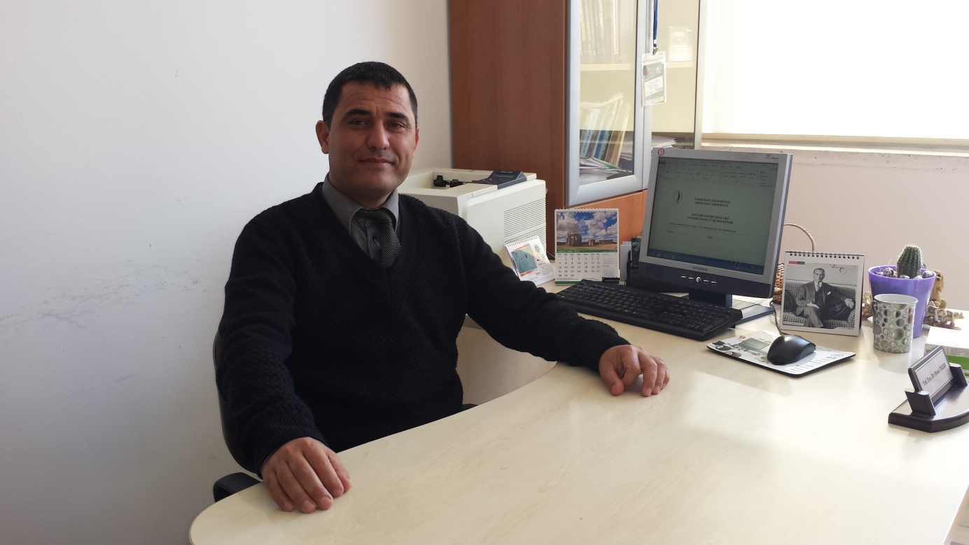
He was born in Nicosia in 1972. After completing his primary education, he completed his high school at Nicosia Turkish Lycee in the year of 1990. In the same year he started to Hacettepe University at Ankara for BA and graduated in 1994. He completed his MA (1996) and Ph.d (2003) at the Faculty of Arts and Sciences, Applied Mathematics and Computer Sciences Department of Eastern Mediterranean University . He gave his Ph.d.thesis about “Cycle Decompositions And Labeling of Graphs” in 2003. Between the years 1994 and 2003 he worked as full time instructor in the same university. Between the years in 2010-2014 he worked as a project advisor and project assistant at Yeniyüzyıl Kindergarten, Karaoğlanoğlu Primary School, Göyeli Primary School, Çamlıbel Primary School, Şehit Hüseyin Ruso Secondary School, Yeşilyurt Primary School in Northern Cyprus and Kurtuluş Lycee and under the grant program supported by the European Union and also gave these school teachers Smart Board lessons. He gives inservice training courses(statistical software SPSS, further evaluation and assessment) to the teachers these working in schools affiliated to the Ministry of Education.
To the numerous national and international scientific meetings and conferences he participated in and worked as vice organizer in some of them. More than 50 publications he published and cited in many publications in international journals. He directed more than 20 master or doctoral thesis advisor. After starting as a research assistant at Eastern Mediterranean University in 1994 then he attended as assistant professor doctor at the Near East University in 2003 and attended as an associate professor in 2015. Between the years 2003-2010 he worked as vice head of Computer Education and Instructional Technology in Faculty of Education at the Near East University In 2008 he prepare the needs for Mathematics Education Departments. After the acceptance of departments he became the head of the Department of Elementary and Secondary Mathematics Education Department in 2009. He is also head of Secondary Science and Mathematics Education Department, Vice-Dean of the Education Faculty of Near East University and as well as executive board member of the Cyprus Educational Sciences Association. He is married and has two children and speaks English.

