CHAPTER ONE

INTRODUCTION TO GRAPHIC COMMUNICATION

Objectives: At the end of this chapter students should be able to:
♦ Define graphic communication
♦ Mention types of drawing
♦ Explain the difference between different types of drawings
♦ Mention some of the applications of technical drawings

Drawing
A drawing is a graphic representation of an object, or a part of it, and is the result of creative thought by an engineer or technician. When one person sketches a rough map in giving direction to another, this is graphic communication. Graphic communication involves using visual materials to relate ideas. Drawings, photographs, slides, transparencies, and sketches are all forms of graphic communication. Any medium that uses a graphic image to aid in conveying a message, instructions, or an idea is involved in graphic communication. One of the most widely used forms of graphic communication is the drawing.
Technically, it can be defined as “a graphic representation of an idea, a concept or an entity which actually or potentially exists in life. Drawing is one of the oldest forms of communicating, dating back even farther than verbal communication. The drawing itself is a way of communicating all necessary information about an abstract, such as an idea or concept or a graphic representation of some real entity, such as a machine part, house or tools. There are two basic types of drawings: Artistic and Technical drawings.

Artistic Drawings
Artistic Drawings range in scope from the simplest line drawing to the most famous paintings. Regardless of their complexity, artistic drawings are used to express the feelings, beliefs, philosophies, and ideas of the artist. In order to understand an artistic drawing, it is sometimes necessary to first understand the artist. Artists often take a subtle or abstract approach in communicating through their drawings, which in turn gives rise to various interpretations. (see figure 1)
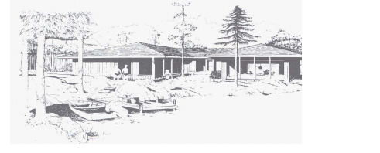
Figure 1 Artistic drawings

Technical Drawings

The technical drawing, on the other hand, is not subtle, or abstract. It does not require an understanding of its creator, only an understanding of technical drawings. A technical drawing is a means of clearly and concisely communicating all of the information necessary to transform an idea or a concept in to reality. Therefore, a technical drawing often contains more than just a graphic representation of its subject. It also contains dimensions, notes and specifications. (See figure 2)
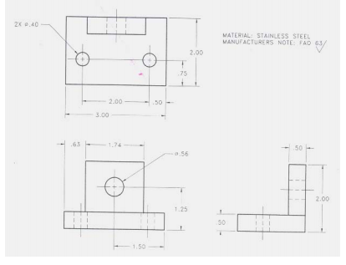
Figure 2: Technical Drawings

Types of Technical Drawings
Technical drawings are based on the fundamental principles of projections. A projection is a drawing or representation of an entity on an imaginary plane or planes. This projection planes serves the same purpose in technical drawing as is served by the movie screen. A projection involves four components
- The actual object that the drawing or projection represents
- The eye of the viewer looking at the object
- The imaginary projection plane
- Imaginary lines of sight called Projectors
The two broad types of projections, both with several subclassifications, are parallel projection and perspective projection.

Parallel Projection;
Parallel Projection is a type of projection where the line of sight or projectors are parallel and are perpendicular to the picture planes. It is subdivided in to the following three categories: Orthographic, Oblique and Axonometric Projections.
♦ Orthographic projections: are drawn as multi view drawings, which show flat representations of principal views of the subject.
♦ Oblique Projections: actually show the full size of one view.
♦ Axonometric Projections: are three-dimensional drawings, and are of three different varieties: Isometric, Dimetric and Trimetric.

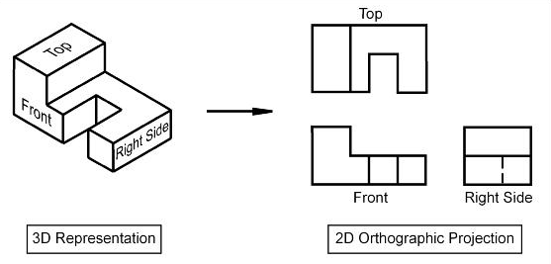
Figure 3: Ortohgraphic Projection

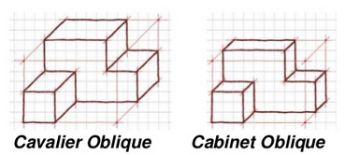
Figure 4: Types of Oblique Projections

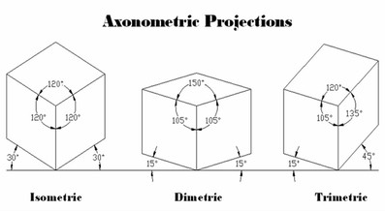
Figure 5: Types of Axonometric Projections

Perspective Projection;
Perspective projections are drawings which attempt to replicate what the human eye actually sees when it views an object. There are three types of perspective projections: Onepoint, Two-point and Three-point Projections.
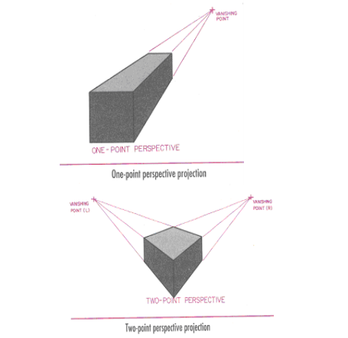
Figure 6: 1 Point and 2 Point Perspective Projections

Purpose of Technical Drawings
To appreciate the need for technical drawings, one must understand the design process. The design process is an orderly, systematic procedure used in accomplishing a needed design. Any product that is to be manufactured, fabricated, assembled, constructed, built, or subjected to any other types of conversion process must first be designed. For example, a house must be designed before it can be built.

Application of Technical Drawing
Technical drawings are used in many different applications. They are needed in any setting, which involves design, and in any subsequent forms of conversion process. The most common applications of technical drawings can be found in the fields of manufacturing, engineering and construction. For instance, Surveyors, civil engineers, sanitarians use technical drawings to document such works as the layout of a new subdivisions, or the marking of the boundaries for a piece of property. Contractors and construction personnel use technical drawings as their blue prints in converting architectural and engineering designs in to reality.

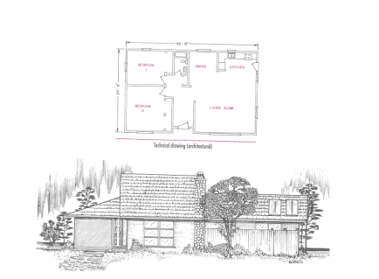
Figure 7: Technical Drawing (Architectural)

CHAPTER TWO

DRAWING EQUIPMENTS AND THEIR USE

Introduction
To record information on paper instruments and equipments are needed. Engineering drawing is entirely a graphic language hence instruments are essentially needed. Drawing must be clear, neat and legible in order to serve its purpose. Hence it is extremely important for engineers to have good speed, accuracy, legibility and neatness in the drawing work.

Important Drawing Equipments
All drawings are made by means of various instruments. The quality of drawing depends to a large extent on the quality, adjustment and care of the instruments

Drawing Paper
Drawing paper is the paper, on which drawing is to be made. All engineering drawings are made on sheets of paper of strictly defined sizes, which are set forth in the U.S.S.R standards. The use of standard size saves paper and ensures convenient storage of drawings. Now a day, A3 and A4 are the most commonly used paper sizes. The U.S.S.R standard establishes five preferred sizes for drawings as tabulated bellow:

Table 1: Drawing Paper Standards and Dimensions
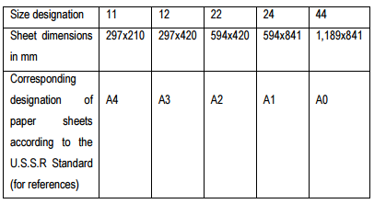
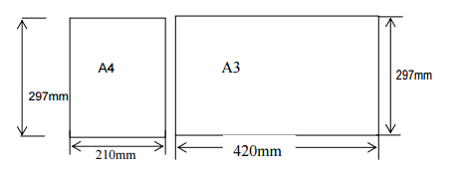
Figure 1: A4 and A3 Standard Papers

Title block; is a rectangular frame that is located at the bottom of the sheet. It is recommended that space should be provided in all title blocks for such information as description of title of the drawing, dates, designer (drawer), and name of enterprise or educational institute, size (scale)
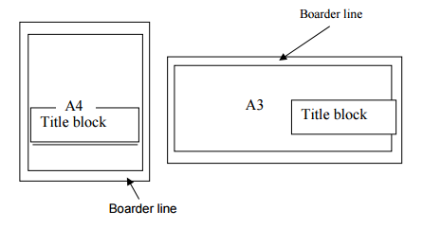
Figure 2: Construction of Border lines and Title Block

Table 2: Sample for Title Block
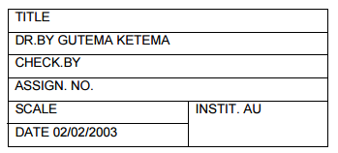

T-Square
It is used primarily to draw horizontal lines and for guiding the triangles when drawing vertical and inclined lines. It is manipulated by sliding the working edge (inner face) of the head along the left edge of the board until the blade is in the required position.
Figure 3: T-Square

Triangles (setsquares)
They are used to construct the most common angles (i.e. 30⁰ , 45⁰ , 60⁰ ) in technical drawings. The 45⁰ x 45⁰ and 30⁰ x 60⁰ triangles are the most commonly used for ordinary work. They are shown in the fig. 4 below.
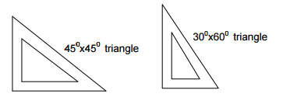
Figure 4: Set Squares

French curve
It is used to draw irregular curves that are not circle arcs. The shape varies according to the shape of irregular curve.
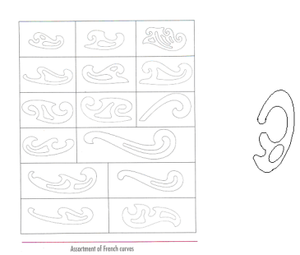
Figure 5: French Curve

Protractor
It is used for laying out and measuring angle.
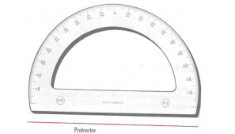
Figure 6: Protractor

Scale (ruler)
A number of kinds of scales are available for varied types of engineering design. Figure fig 2.7 Scales with beveled edges graduated in mm are usually used.
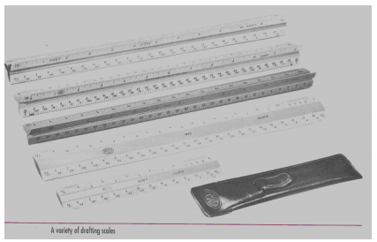
Figure 7: Scales/Rulers

Pencil
The student and professional man should be equipped with a selection of good, well-sharpened pencil with leads of various degrees of hardness such as: 9H, 8H, 7H, and 6H (hard); 5H& 4H (medium hard); 3H and 2H (medium); and H& F (medium soft). The grade of pencil to be used for various purposes depends on the type of line desired, the kind of paper employed, and the humidity, which affects the surface of the paper. Standards for line quality usually will govern the selection. For instance,

♦ 6H is used for light construction line.
♦ 4H is used for re-penciling light finished lines (dimension lines, center lines, and invisible object lines)
♦ 2H is used for visible object lines
♦ F and H are used for all lettering and freehand work.

Table 3: Grade of pencil (lead) and their application
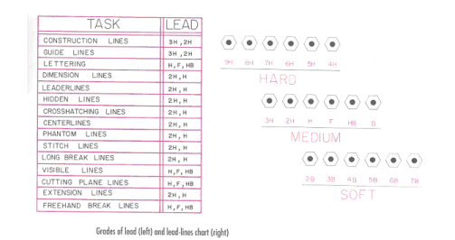

Compass
It is used to draw circles and arcs both in pencil and ink. It consists of two legs pivoted at the top. One leg is equipped with a steel needle attached with a screw, and other shorter leg is, provided with a socket for detachable inserts.

Divider
Used chiefly for transferring distances and occasionally for dividing spaces into equal parts. i.e. for dividing curved and straight lines into any number of equal parts, and for transferring measurements.
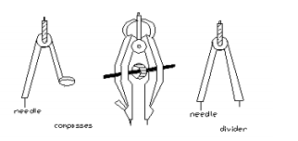
Figure 8: Compass and Divider

Template
A template is a thin, flat piece of plastic containing various cutout shapes. It is designed to speed the work of the drafter and to make the finished drawing more accurate. Templates are available for drawing circles, ellipses, plumbing’s, fixtures etc. Templates come in many sizes to fit the scale being used on the drawing. And it should be used wherever possible to increase accuracy and speed.
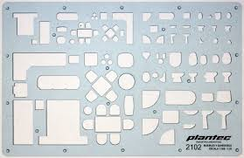
Figure 9: Architectural Templete

Other Technical Drawing Equipments

Drawing board; is a board whose top surface is perfectly smooth and level on which the drawing paper is fastened.
Sticky Tape/ Clippers; They are used to stabilise the drawing paper onto the drawing board or table.
Clinograph (Adjustable set square); its two sides are fixed at 90⁰ and the third side can be adjusted at any angle.
Rubber or eraser; extra lines or curves which are not required in the drawing are to be rubbed out or erased. Hence a rubber or eraser are required in the drawing work. Erasers are available in many degrees of hardness, size and shape.
Eraser shield; it is an important device to protect lines near those being erased. It is made up of thin metal plate in which gaps of different widths and lengths are cut.
Tracing paper; it is a thin transparent paper. Figures below it can be seen easily and traced out in pencil ink.
Drawing ink; it is used for making drawings in ink on tracing paper.

CHAPTER 3

LETTERING AND LINES

Letter Styles
Letter styles are generally classified as Gothic, Roman, Italic and Text. They were all made with speedball pens, and are therefore largely single-stroke letters. If the letters are drawn in outline and filled in, they are referred to as “filled- in” letters. The plainest and most legible style is the gothic from which our single-stroke engineering letters are derived. The term roman refers to any letter having wide down ward strokes and thin connecting strokes. Roman letters include old romans and modern roman, and may be vertical or inclined. Inclined letters are also referred to as italic, regardless of the letter style; text letters are often referred to as old English.
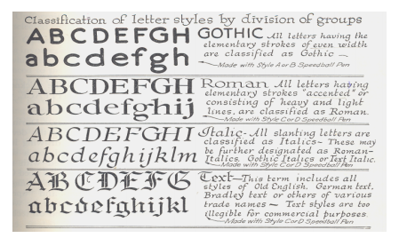
Figure 1: Classification of letter styles

Depending up on the spacing between words and thickness of strokes, letters may be classified as follows.
♦ Extended and Condensed Letters
To meet design or space requirements, letters may be narrower and spaced closer together, in which case they are called “Compresed” or “Condensed”letters. If the letters are wider than normal, they are referred to as “Extended”letters
♦ Light Face and Bold Face Letters
Letters also vary as to the thickness of the stems or strokes. Letters having very thin stems are called Light Face Letters, while those having heavy stems are called Bold Face Letters.

Technique of Lettering
“Any normal person can learn to letter if he is persistent and intelligent in his efforts.” While it is true that” Practice makes perfect,” it must be understood that practice alone is not enough; it must be accompanied by continuous effort to improve. There are three necessary steps in learning to letter:
1. Knowledge of the proportions and forms of the letters, and the order of the strokes.
2. Knowledge of composition- the spacing of the letters and words.
3. Persistent practice, with continuous effort to improve.
Guide Lines
Extremely light horizontal guidelines are necessary to regulate the height of letters. In addition, light vertical or inclined guidelines are needed to keep the letters uniformly vertical or inclined. Guidelines are absolutely essential for good lettering, and should be regarded as a welcome aid, not as an unnecessary requirement.
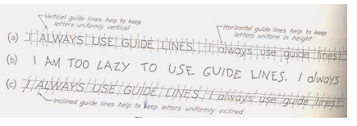
Figure 2: Guide Lines
Make guidelines light, so that they can be erased after the lettering has been completed. Use a relatively hard pencil such as a 4H to 6H, with a long, sharp, conical point.

Guidelines for Capital Letters
On working drawings, capital letters are commonly made 3mm high, with the space between lines of lettering from ¾ th to the full height of the letters. The vertical guidelines are not used to space the letters (as this should always be done by eye while lettering), but only to keep the letters uniformly vertical, and they should accordingly be drawn at random.
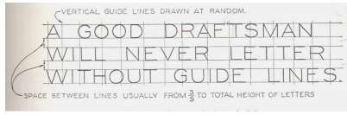
Figure 3: Guide lines for capital letters
A guideline for inclined capital letters is somewhat different. The spacing of horizontal guidelines is the same as for vertical capital lettering. The American Standard recommends slope of approximately 68.20 with the horizontal and may be established by drawing a “sloped triangle”, and drawing the guidelines at random with T-square and triangles.
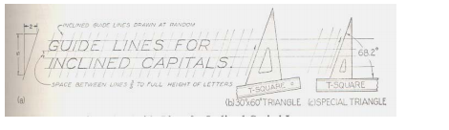
Figure 4: Guide lines for inclined capital letters

Guidelines for Lower-Case Letters
Lower-case letters have four horizontal guidelines, called the cap line, waistline, and base line and drop line. Strokes of letters that extend up to the cap line are called ascenders, and those that extend down to the drop line, descenders. Since there are only five letters (p, q.g, j, y) that have descenders, the drop lines are little needed and are usually omitted. In spacing guidelines, space “a” may vary from 3/5to 2/3 of space “b”. The term single stoke or one stoke does not mean that the entire letter is made without lifting the pencil. But the width of the stroke is the width of the stem of the letter.

Spacing of Letters
Uniformity in spacing of letters is a matter of equalizing spaces by eye. The background area between letters, not the distance between them, should be approximately equal. Some combinations, such as LT and VA, may even have to be slightly overlapped to secure good spacing. In some cases the width of a letter may be decreased. For example, the lower stroke of the L may be shortened when followed by A. Words are spaced well apart, but letters with in words should be spaced closely. Make each word a compact unit well separated from the adjacent words. For either upper case or lower-case lettering, make the spaces between words approximately equal to a capital O. Avoid spacing letters too far apart and words too close together.

Lettering in Maps
Letters are generally used on maps as follows:
♦ Vertical capital: name of states, countries, towns, capitals, titles of the map etc
♦ Vertical lower case: name of small towns, villages, post offices etc.
♦ Inclined capital: name of oceans, bays, gulfs, large lakes, rivers etc.
♦ Inclined lower case: name of rivers, creeks, small lakes, ponds, marshes and springs

Conventional Lines

Each line on a technical drawing has a definite meaning and is drawn in certain ways. There are certain conventional lines recommended by American Standard Association. According to the standard,” three widths of line;, thick, medium, and thin are recommended… exact thickness may vary according to the size and type of drawing…”
There should also be a distinct contrast in the thickness of different kinds of lines, particularly between the thick lines and thin lines.
In technical drawings, make construction lines so light that they can barely be seen, with a hard sharp pencil such as 4H to 6H. For visible lines, hidden lines, and other “thick” lines use relatively soft pencils, such as F or H. All thin lines except construction line must be thin, but dark. They should be made with a sharp medium grad pencil, such as H or 2H.

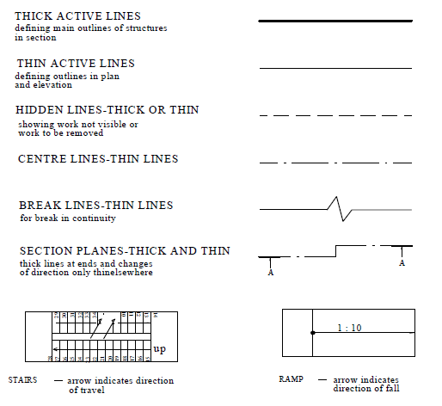
Figure 5: Line Styles

CHAPTER 4

DIMENSIONING AND SCALING

Dimensioning
The purpose of dimensioning is to provide a clear and complete description of an object. A complete set of dimensions will permit only one interpretation needed to construct the part. Dimensioning should follow these guidelines.
1. Accuracy: correct values must be given.
2. Clearness: dimensions must be placed in appropriate positions.
3. Completeness: nothing must be left out, and nothing duplicated.
4. Readability: the appropriate line quality must be used for legibility.

♦ Dimension line is a thin line, broken in the middle to allow the placement of the dimension value, with arrowheads at each end (figure 1).
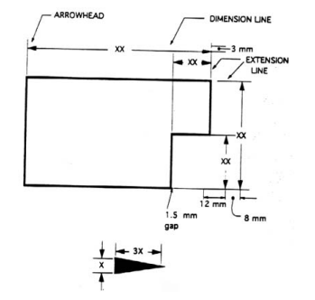
Figure 1: Dimensioning Drawing

♦ An arrowhead is approximately 3 mm long and 1 mm wide. That is, the length is roughly three times the width.
♦ An extension line extends a line on the object to the dimension line. The first dimension line should be approximately 12 mm (0.6 in) from the object. Extension lines begin 1.5 mm from the object and extend 3 mm from the last dimension line.
♦ A leader is a thin line used to connect a dimension with a particular area (figure 2).
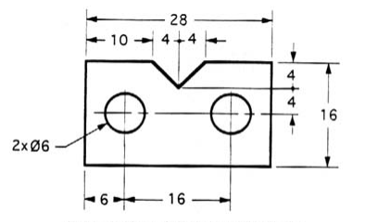
Figure 2: Example Drawing with a leader
A leader may also be used to indicate a note or comment about a specific area. When there is limited space, a heavy black dot may be substituted for the arrows, as in figure 8.1. Also in this drawing, two holes are identical, allowing the "2x" notation to be used and the dimension to point to only one of the circles.
In order to get the feel of what dimensioning is all about, we can start with a simple rectangular block. With this simple object, only three dimensions are needed to describe it completely (figure 3). There is little choice on where to put its dimensions.
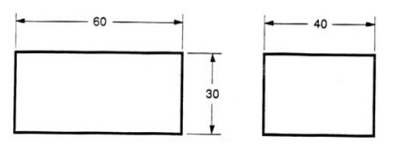
Figure 3: Dimensioning simple object

We have to make some choices when we dimension a block with a notch or cutout. It is usually best to dimension from a common line or surface. This can be called the datum line of surface. This eliminates the addition of measurement or machining inaccuracies that would come from "chain" or "series" dimensioning.
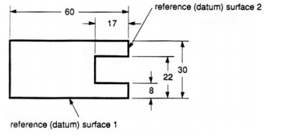
Figure 4: Surface datum example-1
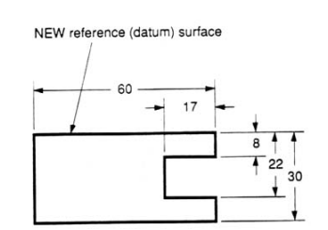
Figure 5: Surface datum example-2
In figure 6 we have shown a hole that we have chosen to dimension on the left side of the object. The Ø stands for "diameter".
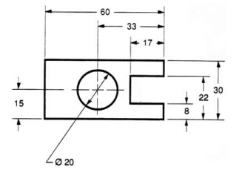
Figure 6: Example of a dimensioned hole

When the left side of the block is "radiuses" as in figure 7, we break our rule that we should not duplicate dimensions. The total length is known because the radius of the curve on the left side is given. Then, for clarity, we add the overall length of 60 and we note that it is a reference (REF) dimension. This means that it is not really required.
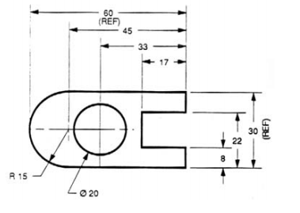
Figure 7: Example of a directly dimensioned hole
Somewhere on the paper, usually the bottom there should be placed information on what measuring system is being used (e.g. inches and millimeters) and also the scale of the drawing.

Scaling
Plans are usually "scale drawings", meaning that the plans are drawn at specific ratio relative to the actual size of the place or object. Various scales may be used for different drawings in a set. For example, a floor plan may be drawn at 1:50 (1:48 or 1/4"=1'-0") whereas a detailed view may be drawn at 1:25 (1:24 or 1/2"=1'-0"). Site plans are often drawn at 1:200 or 1:100.
Scale is a nuanced subject in the use of engineering drawings. On one hand, it is a general principle of engineering drawings that they are projected using standardized, mathematically certain projection methods and rules. Thus, great effort is put into having an engineering drawing accurately depict size, shape, form, aspect ratios between features, and so on. And yet, on the other hand, there is another general principle of engineering drawing that nearly diametrically opposes all this effort and intent—that is, the principle that users are not to scale the drawing to infer a dimension not labeled. This stern admonition is often repeated on drawings, via a boilerplate note in the title block telling the user, "DO NOT SCALE DRAWING."
The explanation for why these two nearly opposite principles can coexist is as follows. The first principle—that drawings will be made so carefully and accurately—serves the prime goal of why engineering drawing even exists, which is successfully communicating part definition and acceptance criteria—including "what the part should look like if you've made it correctly." The service of this goal is what creates a drawing that one even could scale and get an accurate dimension thereby. And thus the great temptation to do so, when a dimension is wanted but was not labeled. The second principle—that even though scaling the drawing will usually work, one should nevertheless never do it—serves several goals, such as enforcing total clarity regarding who has authority to discern design intent, and preventing erroneous scaling of a drawing that was never drawn to scale to begin with (which is typically labeled "drawing not to scale" or "scale: NTS"). When a user is forbidden from scaling the drawing, s/he must turn instead to the engineer (for the answers that the scaling would seek), and s/he will never erroneously scale something that is inherently unable to be accurately scaled.
Some scale examples;
Real Scale; 1:1
Magnifiying Scale; 2:1, 5:1, 10:1 etc..
Diminishing Scale; 1:2, 1:5, 1:10 etc..
No matter what scale is to be used, always the real dimension of the object or the structural element has to be written down in the drawing.
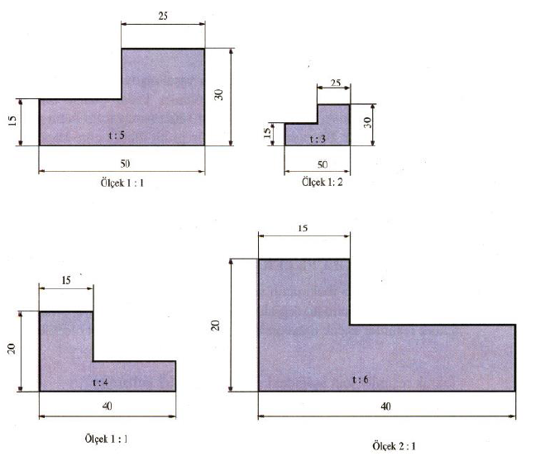
Figure 8: Example of scaling objects

CHAPTER 5

GEOMETRIC CONSTRUCTION

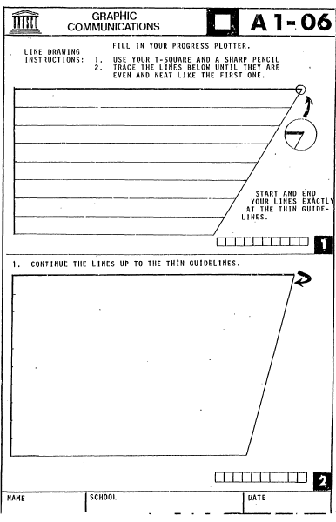
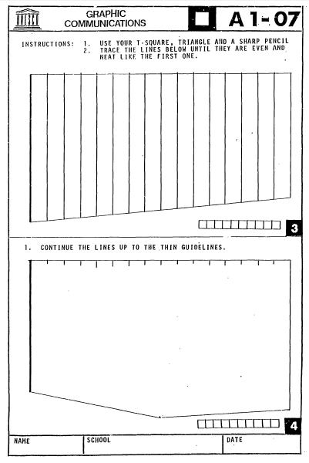
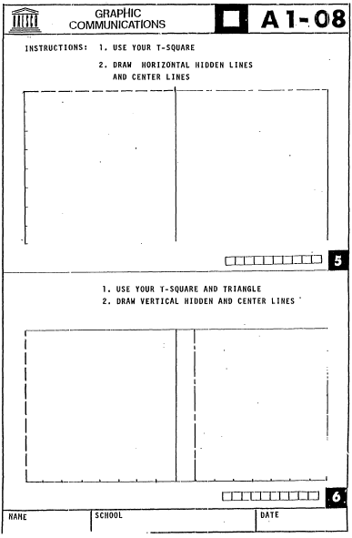
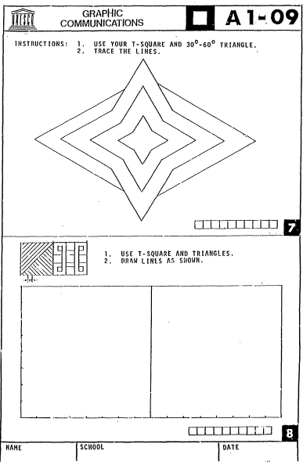
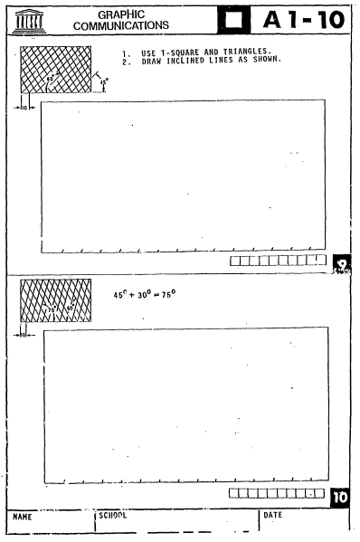

CHAPTER 6

FOLDING OF DRAWING PRINTS

The intent of folding large architectural or engineering drawings is to allow the lower portion of the title block to be visible without having to open the entire sheet. This allows a stack of drawings to be filed and then easily identified by the sheet number and drawing title.

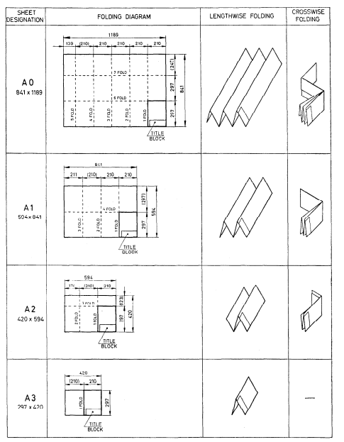
Figure 1: Folding of Drawing Prints

CHAPTER 7

ORTHOGRAPHIC DRAWING

Orthographic projection is a means of representing a three-dimensional object in two dimensions. It uses multiple views of an object, from points of view rotated about the objects centre through increments of 90 degrees. Equivalently, the views may be considered to be obtained by rotating the object about its centre through increments of 90 degrees. The views are positioned relative to each other according to either of two schemes: first-angle or third-angle projection. In each- the appearances of views may be thought of as being “projected” onto planes that form a transparent “box” around the object.

Primary or Principal Planes of Projection
When drawing a number of views of an object, the object is viewed through a plane of projection from a point at infinity, thereby obtaining an accurate outline of the visible face of the object. However, the projection of one face will not provide an overall description of the object; other planes of projection must be used. Establishing an object’s true height, width and depth requires a front, top and side views, which are called the principal planes of projection. The three principal (or primary) planes of projection are known as the vertical, horizontal and profile planes. The angles formed between the horizontal and the vertical planes are called the first, second, third and fourth angles as shown in the diagram below. For practical purposes only the first and third angle is used.
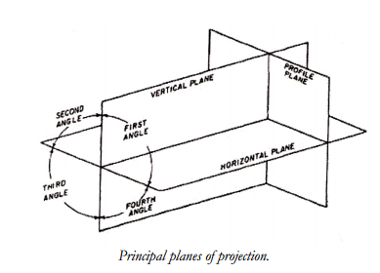

First Angle Projection
In first angle projection, each view of the object is projected in the direction (sense) of sight of the object, onto the interior walls of the box.
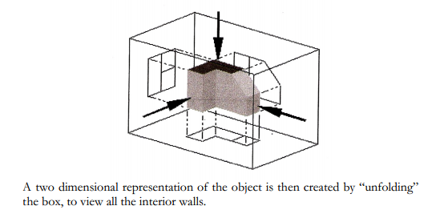
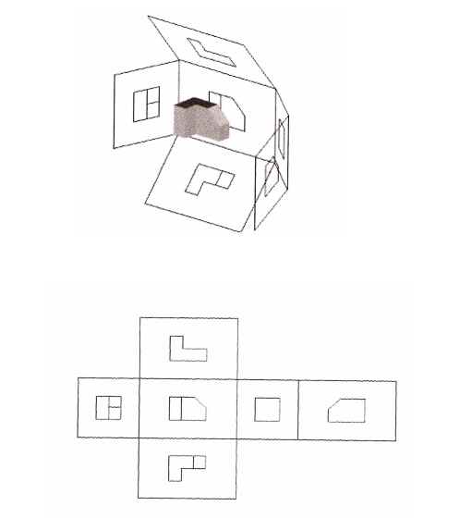
The pictorial drawing, see Fig. 1, indicates the shape of the component with a single view.
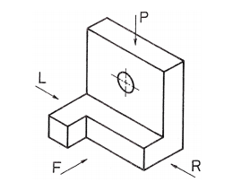
An orthographic drawing indicates the shape of a component by using a number of views each looking at a different face of the component. Usually, however, three views are shown in order to clarify internal and external detail:
1. A Front view
2. A Plan view
3. A Side view

1. The front view, or front elevation (Fig. 2), represents what is seen when looking at the front of the component in the direction of arrow F.
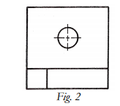
2. The plan view (Fig. 3) represents what is seen when looking at the top of the component in the direction of arrow P at 90° to arrow F.
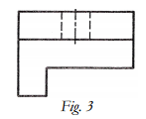
3. A side view, or side elevation (Fig. 4 and 5), represents what is seen when looking at the side of the component in the direction of either arrow R or arrow L. Theses arrows are at 90° to both arrow F and arrow P.
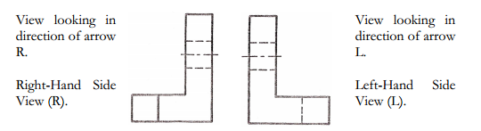

The separate views of the component are combined to form a complete orthographic drawing as shown below. The front and side views are drawn in line with each other so that the side view may be “projected” from the front view and vice versa. The plan view is drawn in line with and below the front view. In other words, the plan is projected from the front view.
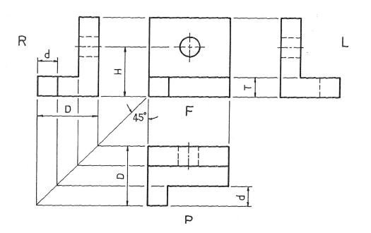

Points to note when making a drawing using first angle orthographic projection:
1. Corresponding heights in the front view and side view are the same. For example, the height of the hole from the base, H, is the same in both front and side views. The thickness of the base, T, is the same in both front and side views.
2. Widths in the side view correspond to depths in the plan. For example, the total width, D, in the side view is the same as the total depth, D, in the plan. The width, d, is the same in both plan and side views. Projection of widths from side view to plan is made easier by using the 45º swing line as shown above.
3. The plan view is usually projected below the front view. It can be above but this would be called an “inverted” plan.
4. The R.H. side view is shown on the L.H. side of the front view.
5. The L.H. side view is shown on the R.H. side of the front view.
Note: Drawings should be read (or interpreted) by viewing from the R.H. side or bottom R.H. corner of the drawing.

Exercises:
Ex 1;
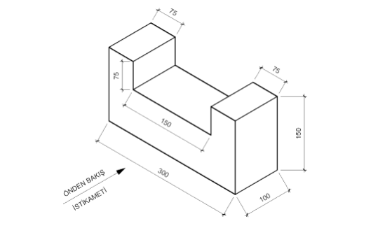
Dimension x2

Ex 2;
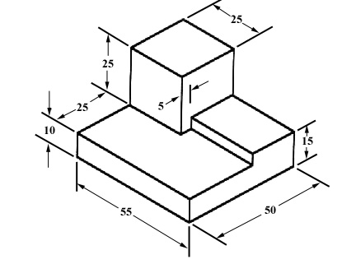
Ex 3;
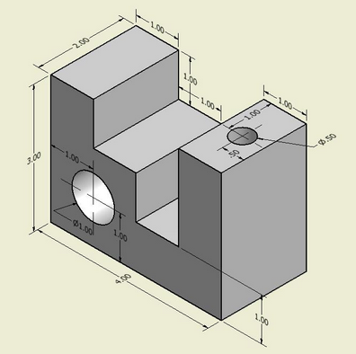
Dimension x2
Ex 4;
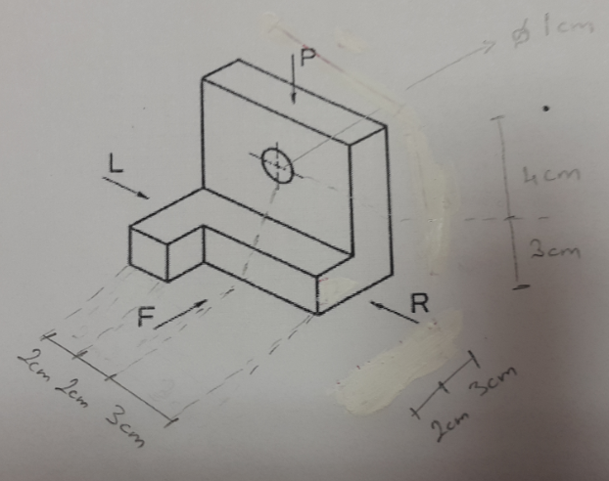

Ex 5;
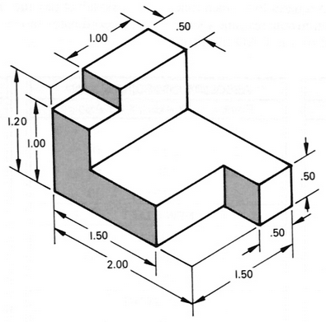
Dimension x2

Ex; 6
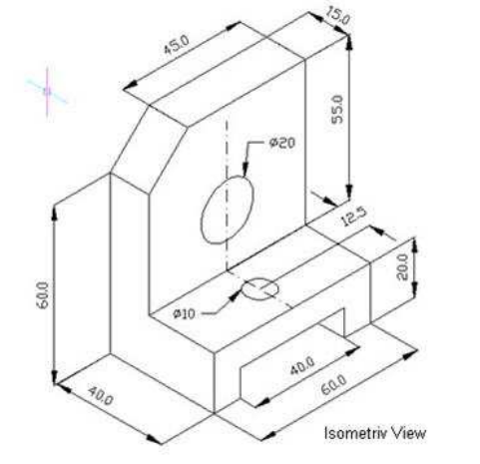
Dimension x2

CHAPTER 8

ISOMETRIC DRAWING

We live in a three-dimensional (3D) world and representing that world largely done on two-dimensional (2D) media such a paper.
Isometric Drawing
The representation of the object in figure 1 is called an isometric drawing which a type of parallel projection that represents all three dimensions in a single image. This is one of a family of three-dimensional views called pictorial drawings. In an isometric drawing, the object's vertical lines are drawn vertically, and the horizontal lines in the width and depth planes are shown at 30 degrees to the horizontal. When drawn under these guidelines, the lines parallel to these three axes are at their true (scale) lengths. Lines that are not parallel to these axes will not be of their true length.
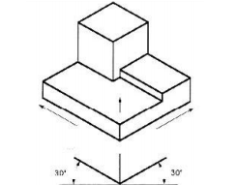
Figure 1: Isometric Drawing

Any engineering drawing should show everything: a complete understanding of the object should be possible from the drawing. If the isometric drawing can show all details and all dimensions on one drawing, it is ideal. However, if the object in figure 1 had a hole on the back side, it would not be visible using a single isometric drawing. In order to get a more complete view of the object, an orthographic projection may be used.

Orthographic to Isometric Orthographic drawings are common in engineering. Visualizing or creating the Isometric View is a critical engineering skill. To draw the isometric view from orthographic view, the reading, understanding and sketching skills must be practiced.
Hints for Isometric Sketching
• Identify major features and overall dimensions
• Use clean, crisp strokes
• Do not use straightedges or scales when sketching
• Start by drawing a bounding box, using construction lines
• Only measure dimensions along the primary axes
• Do not directly transfer angles from a multiview to a pictorial
• Use light construction lines to locate vertices and edges
• Sketch faces roughly in this order:
- Normal faces on the perimeter of the bounding box
- Normal faces in the interior of the bounding box
- Inclined faces
- Oblique faces
- Darken all object lines

Example I: Given the orthographic view as follow:
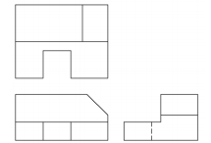
1. Set up Isometric Axis using 1 vertical line and 2 lines at 30 degrees from horizontal
2. Estimate the overall width height and depth of the object, and sketch the edges of a block that would completely enclose the object
3. Sketch the outline of the front face using lines parallel and equal in length to the two previous height and width edges
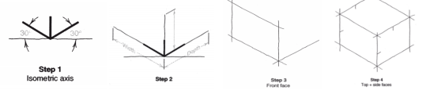
4 Sketch the outlines of the top and side faces using the same basic procedure as used for the front face. Begin sketching start/end points of major features
5 Begin darkening major features as they are developed. Locate start/end points of additional and smaller features.
6 Locate and sketch start/end points for non-isometric lines such as the angled surface. Sketch and darken the non-isometric features
7 Completed Isometric View
