**TRNC Near East University, School of Tourism and Hotel Management, THM 221 Travel Agency and Tour Operating Course lecture notes for 2nd year students**

**Compiled by Mustafa Köprülü**

**Introduction:**

The travel agency concept was born after the industrial revolution. Travel, became merchandised and in easy reach of an emerging working class. Cox and Kings and Thomas Cook were the pioneers of mass travel. Mass Travel – travel involving large number of people. The modern travel agency first appeared in the second half of the 19th century. Cox & Kings and Thomas Cook are the longest established travel companies in the world.Travel agencies became more popular with the development of commercial aviation, starting in the 1920s.

A travel agency is a private retailer that gives travel advice and sells travel and tourism related services to the public on behalf of suppliers such as airlines, hotels, cruise lines, car rentals, railways, and package tours in order to earn commission.In many cases the services of the travel industries can include the sale of insurance, travel guide books, public transport timetables, car rentals, and sometimes foreign currency exchange.

**The role of travel agents:**

A travel agency's main function is to act as an agent, selling travel products and services on behalf of a supplier. Consequently, unlike other retail businesses, they do not keep a stock in hand. A package holiday or a ticket is not purchased from a supplier unless a customer requests that purchase. The holiday or ticket is supplied to the agency at a discount. The profit is therefore the difference between the advertised price which the customer pays and the discounted price at which it is supplied to the agent. This is known as the commission.Traditionally, travel agencies' main source of income is, commissions earned for bookings of car rentals, cruise lines, airlines, hotels, railways, sightseeing tours and package tours. A fixed percentage of the main element of the price is paid to the agent as a commission. Travel agencies are also called “Travel Management Companies”

For example, in a travel agency, the selling price of an airline ticket to a client from Ercan to İstanbul is 500.-TL. The airline company actually had made a discount to the travel agency and provided the airline ticket for 460.-TL. The travel agency thansold the ticket for 500.-TL to the client and earned 40.-TL (8%) commission.

The traditional linkage: Draw table: Supplier-----Travel Agents-----Consumer

A reservation is a request made to any supplier for a particular service (i.e. ticket, hotel room). All reservations are subject to availability. A confirmation is a written reply from the supplier that the reservation for a particular service is accepted and will be delivered to the client by the supplier. Travel agency's main function is to act as an agent selling travel products and services on behalf of a supplier unlike other retail businesses,they do not keep a stock in hand.

They sell the inventory got on discount and acquire profit, include the sale of in-house insurance, travel guide books, timetables, car rentals, and dealing in the most popular holiday currencies.





**Setting up and running a travel agency:**

Most of the travel agents are located in major city centers. They need to be sited close to the center of the shopping district. Location of the travel agency is still one of the most important aspects. Street level shop is very important. Usually one side of a major shopping street-often the sunny side-always attracts more people. Car parking possibilities should be considered, because it is a big advantage.Anyone thinking of opening a travel agency will have to consider the benefits of buying an existing agency, or forming a new one. When buying an existing travel agency we talk about its book value. Book value is its actual cash value of the net assets. We talk about “Goodwill” when a person tries to buy an existing travel agency, but pays more than its book value of the net assets. In accounting, goodwill is an intangible asset and refers to the difference between the book value of a company and its purchase price. Purchase price = book value + goodwill. Goodwill is an intangible asset and represents the reputation, brand names, customer lists, unique market position of the travel agency.

Some of the main costs of a travel agency are; Personnel (salaries, health insurance, pensions, staff travel, training) establishment (rent, water, lighting, heating, insurance, cleaning) administration (computers, telephone, postage, printing and stationery, advertising, publicity, publications) financial and legal (credit cards, bank charges, accounting, legal fees, bad debts)



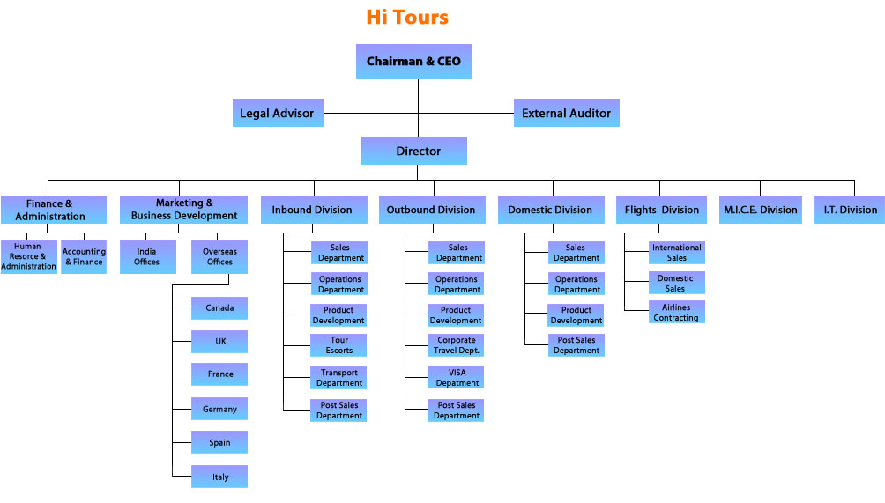

**Travel agency skills and competences:**

Two of the most important things for a travel agency to be successful are good management and good service. Good management: Costs are kept under control, staff are motivated, actively search new business. Good service: clients are satisfied.

Activities of the staff in a travel agency:

* Advising potential travelers on the destinations and suppliers
* Making reservations
* Planning itineraries (a detailed plan for a journey-times and methods of travel, a list of places to visit and things to do)
* Calculating fees of airline, hotel, etc.
* Issuing tickets and vouchers
* Communicating with suppliers and the customers
* Preparing and displaying travel brochures
* Dealing customer complaints

Staff, customer contact skills are:

* Language skills
* Personal and social skills
* Sales skills.

The sales sequence is:

* Establish rapport: Communicate well
* Investigation: Learn their needs
* Presentation: Present the product to the client
* Commitment: Get clients take action to buy

**Travel Agency Appointments and Memberships:**

In many countries especially in the EU, governments require licensing control over travel agencies. In many countries, there are certain legal requirements to set up a travel agency. In most cases the travel agencies have to become a member of a certain legal body. In many cases, agencies pay membership fees to these bodies and associations. In UK for examplemembership of Association of British Travel Agents (ABTA) is not compulsory, but 90% of UK travel agents are members because ABTA protects the system with an insurance system. Visit [www.abta.com](http://www.abta.com). In Turkey travel agencies must become a member of Association of Turkish Travel Agencies (TURSAB) in order to operate. In TURSAB the membership fee is 32.675.-TL. Visit http://www.tursab.org.tr/en.Similarly in In TRNC every single travel agency must to become a member of Cyprus Turkish Travel Agents Association(KITSAB) in order to operate. In TRNC the KITSAB membership fee is 15,000.-Euros. Visit [www.kitsab.org](http://www.kitsab.org) or [www.kitsab.com](http://www.kitsab.com).

**The role of tour operators:**

Tour operators, purchase separate elements of transport, accommodation and other services and combine them into a package and then sell this package directly or in directly to consumers.

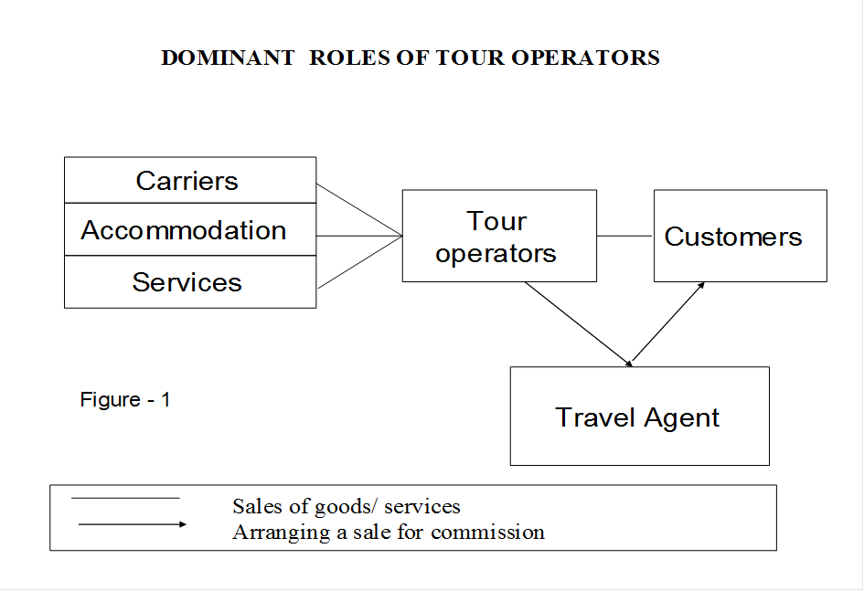

Tour operators are sometimes called as wholesalers because they purchase services in bulk and then break the bulk. (They buy in large quantities in order to sell in small quantities.)

The service whichtour operators provide is to buy in bulk, and thus, get considerable discounts from the suppliers which could not normally be matched by the customer buying directly. The tour operator is then able to assemble and present to the customer a package-the “inclusive tour”-which is both convenient to purchase and competitively priced.

**Package tours** : Package tour is sometimes referred to as “inclusive tour”. An inclusive tour programme is composed of a series of integrated travel services, each of which is purchased by the tour operator in bulk and resold as part of a package at an all-inclusive price. Inclusive tour is package tour and it is a package holiday, where the price includes travel, hotel accommodation, ground transfers, meals and other services such as visiting a museumetc… and is cheaper than it would be if each item were bought separately.

What’s typically not included? Spa treatments, tours and excursions, motorized water sports and golf, private lessons, phone calls and souvenirs.

**Types of Packages:** The types of packages available in today’s market are vast and varied. This ensures all consumers’ needs and desires are met. Package tours can be further broken down into specific tour types. Tours available range from Special-interest tours, Adventure tours, City or Regional tours, Group tours and Fully Escorted tours.

* Special-interest tours are designed around a particular interest area which could include arts, food and wine, sport, cultural or agricultural. Specialist tours may include an expert or celebrity guide who relates to the theme of a tour (e.g. a gardening expert accompanying a garden tour, or an art expert accompanying an art tour).
* Adventure tours are designed to allow the consumer to participate in their area of interest for the length of the tour and more experience based. They generally are physical and require a certain level of fitness, however, can sometimes be modified to meet your needs depending on the other travelers. Some examples of this tour type include diving, rock or mountain climbing, horse riding, skiing or cycling.
* City/regional tours normally last for one full day or less. They follow a fixed itinerary and will visit areas of interest in a specific place, whether that is historic, religious or cultural, refreshments or meals are often included.
* Group tours also follow a fixed and pre-arranged itinerary. They often only take place depending on the number of travelers i.e. they require a certain number of travelers in order to go ahead or it becomes a financial cost rather than profitable. It is also worth noting there are a maximum number of travelers on group tours too, as determined by the mode of transport – a 56 seater coach can accommodate no more passengers and therefore the number limit is defined. Group tours are generally always escorted or a tour guide service is provided.
* Fully escorted tours are often a good idea for solo travelers and especially women travelling alone. This type of tour offers a sense of security or overcomes language and cultural barriers. Also, these types of tours are often somewhat educational, the escort providing local, historical and cultural knowledge or insight gives the consumer are more worthwhile experience and understanding of the country (place) visited.

**Advantages and Disadvantages of Packaged Tours**

From both a travel agent’s and a consumer’s perspective, package tours provide a number of advantages, which often outweigh the disadvantages.

**Advantages for the consumer:**

* Cost saving and budgeting - the price of a trip when organised as a package is generally less as travel agencies bulk buy their package deals and therefore can sell the tours at a lower and more competitive rate. This is an instant cost saving benefit for the consumer, as the discount travel agencies receive is generally passed on to the consumer. Also, as the tour often includes all meals or trips for example, this reduces any uncertainty about the additional costs and allows the consumer to budget properly for costs associated with their travel. For example, if airport pick-ups or taxi transfers are pre-booked and paid for beforehand there is no potentially expensive surprise when travelling to the accommodation on arrival at the destination.
* Responsibility is on the operator - the lack of responsibility on the traveler is an advantage. If something goes wrong, e.g. a flight is delayed, resulting in the traveler missing a connecting flight, it is not the traveler’s responsibility to arrange a new ticket. The responsibility lies with the airline or tour operator. In a certain respect, travelers can relax knowing if something goes wrong, someone else is there to solve the problem.
* Convenience and time-saving - this is definitely the most convenient way to arranging a vacation or tour. The travel agency deals with all the arrangements relating to airlines, hotels, transfers directly through the tour provider. This saves the consumer the effort and the time of contacting each company/service individually.
* Social - this is frequently a main reason why people may opt to travel on a package tour. The chances of social interaction are higher, allowing the fostering of short or long term friendships. People regularly choose a tour which ensures they are socialising with people of a similar age, for example, young people who like to party may opt for an 18-30 party group tour, some adults may choose to stay in accommodation which caters to the needs of children and will opt for a family tour or some people may choose to go on adult only tours to avoid children completely!

* Quality of service - tour operators (those who provide the travel agency with the tour package) spend a great deal of time assessing the airlines, hotels, sight-seeing operators etc, which they use to make up the tour package. By doing so they ensure a high standard of quality and the consumer can have peace of mind. Tour companies are eager to meet their own business needs and so they ensure that the most frequented areas of interest (cultural or geographical) are included in their tour, thus meeting the needs of the consumer.

**Advantages for the travel agent:**

 Agent commission - travel agents normally receive 10% commission on all tours they confirm. Clearly the financial incentive means travel agencies find it extremely advantageous to sell tour packages and not solely flights and/ or accommodation.

* Savings in time and cost – in order for a travel agent to put together all the components of a package tour, this would take extensive communication with the different service providers, initially to check rates and availability and then to send through deposits and secure bookings. By using a tour provider, the travel agent only needs to makes one call, send one email or use an online booking system once to confirm the tour package. Clearly this saves a great deal of time, freeing up the agent to work for other consumers, thus increasing sales and commission.
* Wide variety of package tours available - this means the travel agent can always make suggestions on tours which match the needs of the consumer. The high number of very different packages available allows people with possibly lower budgets to still enjoy tours.

**Disadvantages for the consumer:**

* Inflexibility - when a traveler purchases a tour they commit to follow the itinerary, flight schedule and accommodation arrangements. Generally they are unable to change or reschedule their tour and whilst on the tour they cannot change their plans as they wish. For example, they must be at a point of pick-up at a certain time and if they are not there they delay the rest of the tour (if they are booked onto a group tour that may create problems and possibly complaints from other travelers). Also, if travelers have any special requirements, again for example, dietary requirements, but they are out camping in the bush overnight, the tour provider may not be able to meet their needs but substituting the food provided. It is the responsibility of the travel agent at the time of booking to ensure all possible issues are raised and the traveler’s needs are addressed due to the inflexible nature of a tour package

**Disadvantages for the travel agent:**

* Control - travel agents have little or no say over the tour operator’s choice of services, restaurants, accommodation or attractions included in a tour package. As a result they must ensure they carefully choose the correct package which provides a high standard of quality, or is the most appropriate for the particular market. Also the business of tour packages and the number of tour providers is vast. This makes is very difficult for all travel agents to become and remain knowledgeable of all the available tour ‘products’ and so extensive time must be spent researching choices and selecting the best one for the consumer.

The saving in time and money a travel agent saves a consumer is invaluable. Contacts in the industry regarding reservations and availability then acquiring the best prices to suit an individual cannot be overlooked when considering travelling.

Travel agencies receive 10% commission on most packaged tours; however if the agency has a preferred product arrangement with a certain company this amount could be higher. As a commission is taken out before forwarding the final payment to the tour operator, the agency is able to receive the reward for its effort without delay.

Tour operators and wholesalers often reserve the right to alter their itineraries for various reasons such as weather, strikes or the outbreak of fighting in a particular area. Any price changes that might occur prior to departure are likely to be passed on the client.

**Tour operators:** Tour opeartors are like wholesalers, and travel agents are the retailers. A tour operator makes the package holidays up and the travel agents sell them on. A tour operator formulates a tour package by combining different travel services required by a tourist and sells directly or indirectly to the passenger for exampleair-ticket, accommodation, sightseeing, meals, guide and escort, airport transfers. Tour operator designs, develops, markets and operates packaged travel and tourism products and tours. Tour operators sell through travel agents and/or directly to consumers.

**Functions of Tour Operators:**

•Conceptualize, plan and develop tour packages

•Negotiates with suppliers of travel services

•Assemble and integrate the various travel components into a single tour package

•Delivers the tour package

**Inbound Tour Operators**: Are the tour opeartors who receive travelers also known as receptive tour operators. Inbound tour operators receive travelers from another country that are traveling into the country where the tour operator operates. Example, a British/UK Inbound Tour operator would sell trips to USA travelers coming into the UK.

**Outbound Tour Operators**: Are the tour operators who send travelers from the country they operate in to another country. Example, a British/UK Outbound Tour Operator would sell trips to UK travelers looking to go to the USA.

## Domestic Operators: Are the tour operators who organise tours for residents visiting destinations within their own country's boundaries who travel for tourism purposes.

**Responsibilities of the tour operator:**

A tour operator is completely responsible for the services rendered to the customers during the holiday. He ensures that all the services mentioned in the package holiday are made available to customers. He is also responsible for conveying any delay or cancellation of flight, as well as making alternative arrangements for stay and departure.

**The preparation that is needed:** The main preparation needed for creating a package holiday is to have the best knowledge of the destination for which the package is being developed. A Tour Operator must be completely aware of different types of services available including alternatives if needed. Apart from this, he must also make himself aware of government policies and regulations with reference to tourists and travel to foreign countries.

[Fixed costs](http://www.traveltrust.co.uk/LinkClick.aspx?link=112&tabid=82) are, as the name suggests, those costs that you will incur regardless of how much business you do. A typical example would be office space or salary costs of permanent members of staff. While all costs are actually variable over time, the essence is to include those costs which it is very difficult to remove and that don’t vary widely according to how much business you do.

|  |  |
| --- | --- |
| Fixed Cost Item | Estimated Cost |
| Salaries (including yours) |  |
| Office lease |  |
| Utility bills, like the phone and broadband internet connection |  |
| Interest and repayment on start up cost borrowing |  |
| Trade association membership fees |  |
| Banking services |  |
| Professional Indemnity Insurance |  |
| Web hosting |  |

[Variable costs](http://www.traveltrust.co.uk/LinkClick.aspx?link=112&tabid=82), as you might have guessed by now, are costs which change according to how much business you do. If you make ten times as many bookings you would expect the variable costs to go up by ten. Typical examples include marketing costs and the supplier costs involved in fulfilling a booking.

|  |  |
| --- | --- |
| Variable Cost Item | Estimated Cost |
| Sales and marketing literature production and postage |  |
| Marketing campaign spend |  |
| Cost of Sales (supplier costs for each booking) |  |

**Fixed Costs**

Fixed costs are normally not effected by changes in sales volume. They are said to have little direct relationship to the business volume because they do not change significantly when the number of sales increases or decreases.

The term fixed should never be taken to mean static or unchanging,but merely to indicate that any changes that may occur in such costs are related only indirectly or distantly to changes in volume.

***Examples of Fixed costs are:***

* Land, Building Taxes to government.
* Wages to employees.
* Travel Agency or Tour Operator employees health premium.
* Out sourced services contracted for fixed amount in a month eg:- security services.
* Yearly maintenance contract fees for all equipments, machineries and software's.
* Fixed internet, telephone plans.
* Advertising cost.
* Yearly external auditing cost.
* Payroll- the total amount of money that a company pays to its employees.
* Provision.
* In house moves / satellite TV.
* Music entertainment.
* Reservation expenses.
* Subscription - Newspaper, magazine etc.
* Human resources.
* Sales & marketing.
* Interest on loan.
* Other fixed charges etc.

**Variable Costs**

Variable costs are clearly related to business volume. As business volume or sales increases, variable costs will increase; as business volume or sales decreases, variable costs should decrease as well.

***Examples of variable costs are:***

* Food, beverages, cleaning supplies.
* Stationeries used.
* Printing supplies.
* Entertainment.
* Telephone & Fax.
* Transportation.
* Other operating supplies.
* Administration & General.
* Human resources.
* Sales & Marketing.
* Management Fees etc.

**Fixed Costs**

Fixed costs occur no matter what your sales or production level. This includes items such as rent, insurance, office facilities, business licenses and wages for full-time, permanent employees. Note that these expenses are the cost of opening the doors each month. You must pay these expenses just to stay in business. The reason wages are included as fixed costs is that you must assume you need a set number of permanent employees to run your business.

**Variable Costs**

Variable expenses rise and fall with sales and productivity. Examples of variable expenses are sales commissions, shipping and delivery charges, materials and supplies, wages for temporary workers and bonuses. These expenses are seldom the same from month to month or year to year.

Suppose that the fixed cost of flying a 140-seat plane from Germany to İstanbul and back is 27,000.-Euro (that includes capital costs, fuel, crew’s wages etc.) Suppose also that the additional, or variable, cost per passenger is 26.-Euro. (to cover administrative expenses such as writing the ticket, and providing in-flight refreshments, extra fuel for each passenger and so on). If the airline budgets a small profit and estimates that at a price of 275.-Euro it can expect to sell 110 seats, than the cost and pricing looks like this.

If 110 passengers show up:

Fixed cost: 27,000.-Euro

Variable costs: 110 X 26.-Euro: 2,860.-Euro

Cost of return flight: 29,860.-Euro

Sell of 110 tickets at 275.-Euro: 30,250.-Euro

Profit: 390.-Euro

|  |  |  |  |  |  |
| --- | --- | --- | --- | --- | --- |
| Pax | Fixed costs | Variable costs | Total costs=FC+VC | Total revenues | Profit or Loss |
|  | 27,000.-Euro | 1x26=26.-Euro | 27,026.-Euro | 1X275=275.-Euro | -26,751.-Euro |
|  | 27,000.-Euro | 2x26=52.-Euro | 27,052.-Euro | 2x275=550.-Euro | -26,502.-Euro |
|  | 27,000.-Euro | 3x26=78.-Euro | 27,078.-Euro | 3x275=825.-Euro | -26,253.-Euro |
| 108. | 27,000.-Euro | 108x26=2,808.-Euro | 29,808.-Euro | 108x275=29,700.-Euro | -108.-Euro |
| 109. | 27,000.-Euro | 109x26=2,834.-Euro | 29,834.-Euro | 109x275=29,975.-Euro | 141.-Euro |
| 110. | 27,000.-Euro | 110x26=2,860.-Euro | 29,860.-Euro | 110x275=30,250.-Euro | 390.-Euro |
| 111. | 27,000.-Euro | 111x26=2,886.-Euro | 29,886.-Euro | 111x275=30,525.-Euro | 639.-Euro |
| 200. | 27,000.-Euro | 200x26=5,200.-Euro | 32,200.-Euro | 200x275=55,000.-Euro | 22,800.-Euro |

If only 108 passengers show up:

Fixed cost: 27,000.-Euro

Variable costs: 108 X 26.-Euro: 2,808.-Euro

Cost of return flight: 29,808.-Euro

Sell of 108 tickets at 275.-Euro: 29,700.-Euro

Loss: 108.-Euro

Total costs = Fixed costs + Variable costs

Break-even point: A situation where there is neither profit nor loss. (Total costs equal total revenues.)

Profit (or loss) = Total revenues − Total costs

Fixed costs are the same whether an airline company sells or does not sell a seat.

However, variable costs increase as the quantity of seats sold increase.

Just one less passenger showing up means the sales drop by 275.-Euro, while the cost drops by only 26.-Euro.

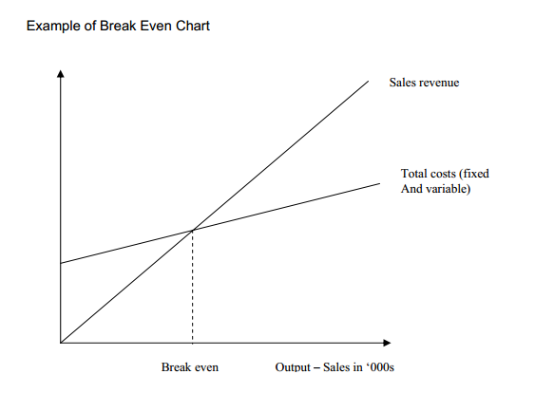

Consequently running an airline company proves to be a very risky business.

At that point the tour operators become very useful to airline companies. Because tour operators guarantee to pay the airline company the cost of seats weather there are enough customers or not.

The tour operators need airlines because they want to buy in bulk to get huge discounts. The Airlines need tour operators because they want to estimate the number of passengers in their plane with the greatest possible accuracy.

Tour operators, who operate their own airlines or secure a whole plane, would use the below formula to calculate its seat cost per return flight.

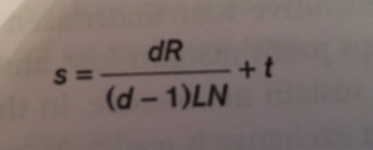

S=Unit seat cost per return flight

D=Number of airline departures

R=Aircraft cost per rotation

L=Load factoror “passenger load factor”: It measures the capacity utilization of airlines.(number of seats occupied/total number of seats in the plane)or (occupancy rate)

N=Number of seats per flight

T=Airport tax per passenger

Charter: Is the business of renting the whole aircraft. A charter flight is not a scheduled flight.A charter flight is a flight in an aircraft in which all the seats are paid by a tour operator and then sold to their customers, usually at a lower cost than that of a scheduled flight.

In the context of mass tourism, charter flights have got a specific meaning of a flight whose only function is to transport holidaymakers to tourist destinations.

Although charter airlines typically carry passengers who have booked individually or as small groups to beach resorts, historic towns, or cities where a cruise ship is awaiting them, sometimes an aircraft will be chartered by a single group such as members of a company, a sports team, or the military.

Scheduled flights are aircrafts that are scheduled to fly a particular route at a particular time on a regular basis, daily, weekly, etc. And will fly with only one passenger on board and theoretically with none on board.

Consider an aircraft of 250 seats contracted on a charter for 30 departures. The rotation cost is calculated at 50,000.-Euros, the load factor is 90%, the airport tax is 5.-Euros. Calculate the cost of seat per return flight.

S=(30x50,000/29x,09x250)+5=235.-Euros

Consider an aircraft of 100 seats contracted on a charter for 11 departures. The rotation cost is calculated at 40,000.-TL, the load factor is 100%, the airport tax is 10.-TL. Calculate the cost of seat per return flight.

S= (11x40,000/10X1X100)+10=450.-TL

**Voucher:** Vouchers are used in the [tourism](https://en.wikipedia.org/wiki/Tourism) sector primarily as proof of a named customer's right to take a service at a specific time and place. Service providers collect them to return to the tour operator or [travel agent](https://en.wikipedia.org/wiki/Travel_agent) that has sent that customer, to prove they have given the service. So, the life of a voucher is as below:

1. Customer receives vouchers from tour operator or travel agent for the services purchased
2. Customer goes to vacation site and forwards the voucher to related provider and asks for the service to be provided
3. Provider sends collected vouchers to the agent or operator that sends customers from time to time, and asks for payment for those services
4. Uncollected vouchers do not deserve payment

**Tour guides:** A person who guides visitors in the language of their choice and interprets the cultural and natural heritage of an area which person normally possesses an area-specific qualification usually issued and/or recognised by the appropriate authority. Tour guides work in the travel industry, giving guided tours to groups of visitors.

They are experts on the history of the location and offer their tour groups interesting or enlightening information about points of interest at nature attractions, historic sites, museums, scenic locations, and other travel destinations. Guides may give walking tours, bus tours, or even lead river tours on a boat. Often hired by visitors' bureaus or travel companies, tour guides are typically residents of the region in which they give tours. Regardless of the specialization of the tour guide, some fundamental responsibilities apply to all positions. Their primary responsibility is to make sure the tour is as safe as possible for the entire group. They will monitor the group's activities to ensure everyone complies with the site's or guide's safety regulations. In some cases, they may have to provide first-aid or emergency services to visitors. Tour guides typically plan itineraries as well. They will research thoroughly prior to giving the tour and be prepared and organized for each step of the process, from greeting visitors upon arrival to arranging transportation between locations. Guides are also required to perform clerical duties, collect fees, and in many cases, promote gift shops and sell souvenirs. Most importantly, tour guides must be experts in their area of concentration. They must be able to answer specific questions about locations, their history, amenities, and artifacts. Effective communication skills are absolutely essential for a successful career in the industry. In addition, tour guides must be highly organized, punctual, and ethical. They need to have exceptional time-management skills and be able to throughly research related information. The ability to speak multiple languages, while not essential, is an asset for many tour guides.

**10 Qualities Every Tour Guide Should Have**

Part of running a successful food tour company has nothing to do with business at all, but the people involved. A hugely important aspect of running a business in the tourism sector is having people on your team who will inspire travelers and locals to come back and tell their friends.

Thanks to our fantastic team of tour guides for Chicago Food Planet Food Tours, we’ve been able to do just that. Because it takes the right kind of person to be a tour guide, we’ve made note of some of the qualities that make for a successful guide.

**1. Strong Communication Skills**

Being a guide is all about having strong communication skills. It’s ok to be a quiet person, but if you have to communicate with new people on a daily basis, you just have to be able to do it well. On a basic level guides should be great at projecting their voices across a group, and be able to do so in a clear and easy to understand way. On an interpersonal level, being great at knowing how to communicate well with people is a huge asset. This leads us to skill #2…

**2. Personable & Outgoing**

This skill takes communication to the next level. Guides shouldn’t just be able to communicate well, they have to be great conversationalists with outgoing personalities; what we call the “Star of the Show” quality, which isn’t something you can teach. There can be a bit of social awkwardness when a new group of strangers show up, and a guide should be able to break that immediately to help people feel comfortable talking to each other and their guide. This ensures later on they feel open to add comments or add questions along the way.

**3. A Memory Like a Steal Trap**

Tour guides need to retain a lot of stats and facts when walking people around a city- but they also need to be a great story-teller. Guides simply can’t get the information wrong, spend extra time trying to remember it or spend the whole tour reading from a piece of paper. Their memory should be so good, that it seems as if they’ve just always known these facts when they recite them. But most of all, the story needs to sound like it’s their own.

**4. Improvisational Skills**

We’re not demanding your guides put on an improv show, but the ability to change things up on the fly and play off the energy of the group is important. Attendees will likely have additional questions or comments along the way. These things shouldn’t throw your guide for a loop, they should be able to adjust their script as needed. Sticking too closely to it, could end up making your guests feel like there’s no room for them to say anything at all.

**5. Just Enough Enthusiasm**

Just as guides will often play off the energy of the group, your attendees will likely feed off the energy of their guide. Your guide has be enthusiastic about the thing they’re talking about, but not so enthusiastic that they fail to sound genuine.

**6. Humor**

Just like being outgoing and enthusiastic, humor can be the perfect tool to cut any tensions and as always add an extra layer of entertainment for guests.

**7. Punctuality**

Punctuality is a can’t do without quality for tour guides. If your guide isn’t on time to meet arriving attendees at the meet up location there will be confusion, frustration and unhappy tour goers.

**8. A Keen Sense of Direction**

Outside of the fact that your tour guides should know where they’re going, they should also be able to help direct guests. At least on our tours for Chicago Food Planet Food Tours, we start and end in different locations. Often guides have to be prepared to give some general directions to help people get to where they need to be when the tour is complete.

**9. The Knowledge Of A Local**

Anyone can memorize and recite facts. Though it’s not a requirement, some of the best guides are locals themselves. What’s great about this quality is that in addition to the planned facts and statistics, they can bring their own knowledge, experience and personal anecdotes to the tour. This can make a tour feel particularly special for guests who are looking for a genuine experience outside the typical tourist attractions.

**10. Passion For Their City**

Last but certainly not least, true passion and interest can take a tour from typical to outstanding. Anyone can point and recite facts, but those who really love what they do can pass that passion onto tourists and locals to make them feel it too. Plus those with passion for their city, bring their own experience to the tours they give.

**When Do You Need a Tour Guide?**

**1. When you have very little time.**  
A knowledgeable guide can give a laser focus to any sightseeing visit, and this may never be so valuable as when you have very little time in one place. This is a very common occurrence in modern life -- hence the popular "36 hours in..." features in the New York Times every week. If you don't have a copy of the Times' recommendations, or you want to go off the beaten path they have cleared, the right guide can give you a customized and thrilling blitz through the destination of your choice.

**2. When visiting ports on a cruise.**  
Talk about having very little time! After a recent cruise in South America, traveler Judie House wrote to tell me that rather than follow the hordes coming off the ship to the same shops, she hired a tour guide in advance, with instructions to get her and her companion away from large groups and into nature for their half-day stay in port. The guide showed up at the ship ahead of time with a comfortable car, and proceeded to drive her and her companion up into the hills to a remote and little-known waterfall, followed by a lunch at a village eatery, all with nary a fellow cruiser in sight. They were back at the port in plenty of time to reboard comfortably, and House said it felt like they had been away for days, not mere hours.

**3. When revisiting a place.**

If you are visiting a location you have visited countless times before -- like your in-laws' home town or the same city you have been visiting since you were a kid -- hire a guide who can give you an offbeat look at a familiar place. Even if you've visited [New York](http://www.independenttraveler.com/destinations/mid-atlantic/new-york-city), [San Francisco](http://www.independenttraveler.com/destinations/california/san-francisco) or [Paris](http://www.independenttraveler.com/destinations/europe/paris) countless times, a talented guide with a heap of local knowledge will have something to offer.

**4. When visiting dangerous or chaotic locations.**  
If your destination has a reputation for dangerous or unpredictable street life -- a trip I took to Tangier comes to mind -- hiring a good tour guide can not only save you time, but also keep you safe and out of tight spots.

**5. When visiting extremely popular locations.**

A good tour guide will always know the best hours to visit attractions, when prices are best, which places you can skip, how to avoid rush hour, what is closed or under construction, and any number of tricks and tactics that will help you get the most out of travel to a heavily visited location. You can also inquire if the guide has special access or rates. A good guide might bring you to the Grand Canyon early in the morning before the crowds arrive, or arrange for a private, after-hours tour of the Vatican.

**6. On long stays.**  
When you are staying for more than a few days in the same location -- let's say you have a two-week vacation rental in [London](http://www.independenttraveler.com/destinations/europe/london) -- consider hiring a tour guide for the first couple of days to help you get your bearings early in your trip ... or perhaps merely to get all the touristy stuff out of the way. Alternately, you can hire a guide late in your stay when you have exhausted most of the obvious attractions and want to seek out a deeper, more informed or more intimate knowledge of a place.

**7. When visiting historic destinations.**  
In places that are exceptionally rich in historical or cultural significance, an educated tour guide can offer a depth of experience and knowledge to which no guidebook, audio guide or plaque-reading will come even close. A good guide can explain the stories behind the complex carvings on an Indian temple, or veer away from the canned history of Thomas Jefferson to describe what life at Monticello was really like.

**8. On an adventure trip.**  
Safaris, mountain climbing, scuba diving, deep-sea fishing, white-water rafting ... unless you are an absolute expert at your chosen adventure, hiring a guide may be a matter of life and death. White-water rafting down the Colorado or piloting a fishing boat back to port in a storm are not like hiring a rowboat in Central Park, and no one should treat it as such. Even if you are an old hand at the particular skill in question, it's still a good idea to hire a guide who knows the local area and can help you navigate an unfamiliar place.

**9. When language barriers are likely to be severe.**  
When visiting a place where you do not speak the language and the locals are extremely unlikely to speak yours -- for most of our readers, that will mean places where exposure to the English language is minimal -- a local tour guide who does speak your language can be invaluable in countless ways. When choosing a guide, try to chat with the guide on the phone to determine how strong his or her command of your language really is.

**10. To hand off the logistics of travel.**

The hassles of obtaining tickets, making reservations, checking operating hours, figuring out options when you have problems -- all of this is easy stuff to a good tour guide. If you are on vacation and don't want to have these mundane tasks on your plate while traveling, a tour guide may be a good option.

**11. When you don't want to drive.**  
There are any number of reasons not to want to drive while traveling -- you don't want to spend your vacation getting lost, you can't read the road signs, you're not confident driving on the opposite side of the road, your spouse is a terrible copilot and you just want to have fun instead of arguing -- hiring a tour guide to do the driving for you can save you a lot of headaches and unwanted distractions.

**12. On hikes or a nature trip.**

On a boat trip in Costa Rica a few years ago, we took the launch into the jungle, where a guide who knew our captain was waiting for us. This guide could find quarter-inch-long camouflaged frogs in such abundance that it felt like a Disney World ride with planted robotic animals. To the uninformed eye, the forest around you can seem like a pleasant bunch of trees, but an experienced nature guide can point you to the teeny little poison dart frog on a branch, identify that raucous bird cry overhead or even keep you out of the way of poisonous animals and plants.