FORM
Resim: | 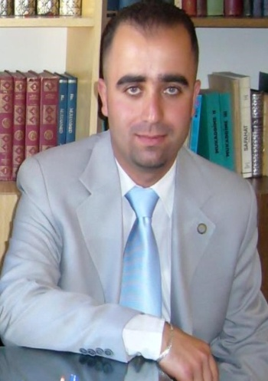
Unvan: | Asist. Prof. Dr.
İsim: | Mustafa
Soyisim: | Yeniasır
E-posta: | mustafayeniasir@hotmail.com
Bağlı Olduğunuz Bölüm | Turkish Education - Turkish Language and Literature Teaching

Biography (en):
He was born in Lefkoşa, the capital of TRNC in 1980. He had his primary education in Çamlıbel Aysun Primary School between the years 1987 – 1992. Then he went to Güzelyurt Şehit Turgut Secondary School. In 1997 he graduated from Güzelyurt Kurtuluş High School and started to Eastern Mediterranean University, the Faculty of Arts and Sciences, to the Department of Turkish Language and Literature. After completing the four years undergraduate program he continued his studies with a master program at Instutition of Social Sciences, the Department of Turkish World Literature at Ege University in 2001.
In 2003 he completed the master program with his thesis on “Osman Türkay’s Life and Writings About Him” and he started to a doctorate program at the same department. In 2010 he completed his doctorate education with a dissertation on “National Feelings in the Poetry of Huseyin Cavid and Özker Yasin.”
He has been working as lecturer in the department of Turkish Education, the Ataturk Education Faculty at the Near East University since 2006-2007 academic year. Since 2009, he has been a Vice Chairman at Turkish Education. He has been doing in the Chairman of the Department of Turkish Language and Literature Teaching since 2013.

