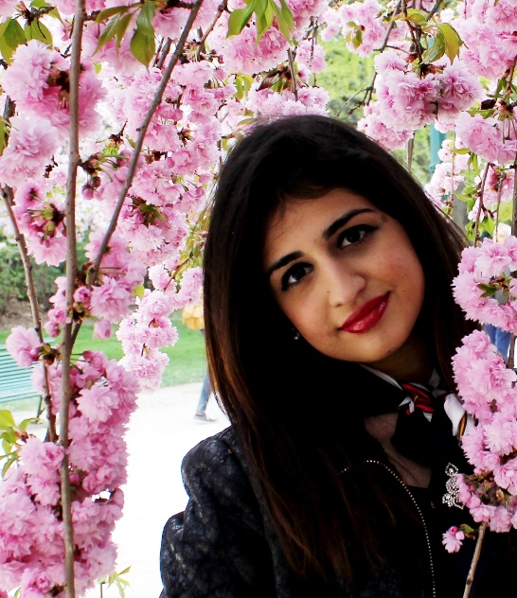
Nihal Soganci
Was born November 8th 1991 in Nicosia, Cyprus. After finishing high school in Nicosia at Turk Maarif College, started university in 2009 at University of Surrey in England. In July 2011, she started to work at the leading energy company Electricite de France Headquarters in Paris at the Corporate Strategy Department. After working there for a year, she received her BA in Languages and Translation specialising in French Translation and Russian in 2013. She was awarded the EDF French prize for best performance in French. In 2014, she received her MSc in International Public Policy from University College London with final research project in Conflict Resolution carried out with 50 Turkish Cypriot and Greek Cypriot participants. In the 2014-2015 academic year, Soganci started teaching Public Policy and Public Administration at Near East University as a part-time member of staff which is still ongoing. She also works as a freelance translator and interpreter. Apart from her native language Turkish, Soganci speaks English, French, Greek and Russian.

