FORM
Resim: | 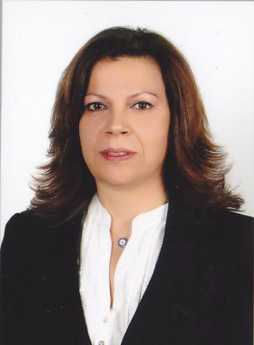
Ünvan: | Uzman
İsim: | NÜKET
Soyisim: | GÜNDÜZ
E-posta: | nuketgunduz@hotmail.com
Bağlı Olduğunuz Bölüm | Zihin Engelliler Öğretmenliği Bölümü

Biography (en):
Nüket Gündüz was born in 1960 in Nicosia. She graduated from GCE Science Department in Türk Maarif College in 1978. She was awarded a scholarship for studying Humanistic Transformative Mediation Training and Peace building, Conflict Resolution Program in 1998. Later she was also awarded a scholarship for a short term program in George Washington University titled “Cypriot Women in Business Program” in 2000 and Mediation in Practice in 2001. After accomplishing the necessary training and practice in Mediation she was appointed as a Mediator and trainer in North Cyprus Mediation. After in 2009 she graduated from English Language Teaching Department at Near East University in 2009. She was awarded a scholarship in 2010 for a bi-communal 2 year project “Mediation and Negotiation Skills as Forces for Development” from EEA Grants conducted in Norway and Cyprus. She continued her postgraduate studies at the same university in Graduate School of Educational Sciences Department of English Language Teaching and graduated in 2012. Her PhD studies started in 2012 and still ongoing at Near East University in the Department of Curriculum and Instruction. She is currently working as a lecturer in Educational Sciences Faculty.

