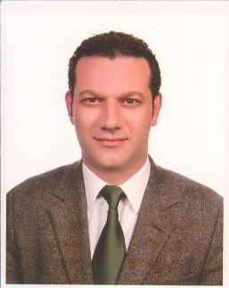
Asst.Prof.Dr.Rifat Reşatoğlu
Biography
He was born in Nicosia, Cyprus. After completing his high school education, he continued his undergraduate studies in the department of Civil Engineering. After graduating from the Civil Engineering department of the Eastern Mediterranean University in 1997, he continued his education there as a Research Assistant for two years. Then, he obtained his Master’s degree in 1999. He worked as a Project designer for one year. In 2000, he started to work at Cyprus International University as a lecturer. Then, he awarded the state grant in 2001 and started his PhD. Research in Çukurova University, Turkey. He obtained his PhD in the Civil Engineering (Structural Mechanics) Department, in 2005. He has had five articles published in international refereed journals, eight papers presented at international conferences and symposiums , one memorandum in national refereed journal and published one international book so far. In 2010, he was nominated in European Council of Civil Engineers as a participant in the meetings by Cyprus Turkish Chambers of Civil Engineers. He has been a member of Cyprus Turkish Chambers of Civil Engineers since 1997. Asst.Prof.Dr. Rifat Reşatoğlu is currently a full-time lecturer in Near East University since 2005, married and has two children.

