UZM. SELMA KORKMAZ AUTOBIOGRAPHY
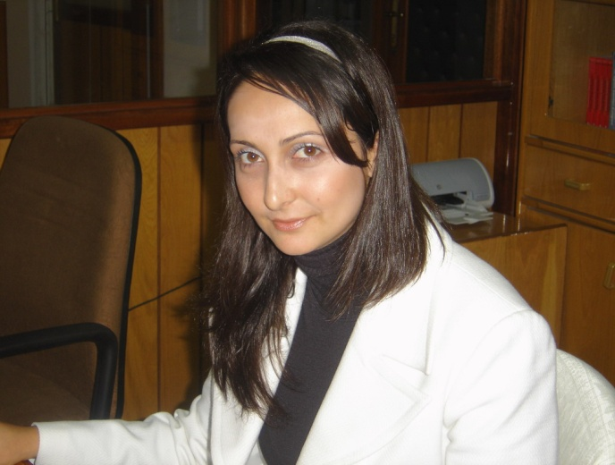

Specialist Selma Korkmaz was born on 6th of April 1982 in the village of Yeşilyurt in Lefke. She went to the primary school in Güneşköy where she resided. She had her secondary education at the Secondary School of Şehit Turgut which is located in Güzelyurt and her high school education at the High School of Kurtuluş which is located at the same region too.
She completed her Bachelor Degree of Turkish Language and Literature at the Near East University in 2003. She had her Masters Degree in Archiving and Ottoman Paleography at the Graduate School of Educational Sciences at the same university in 2005. She has been doing her PhD at the Graduate School of Educational Sciences Educational Programs and Instruction at the Near East University since 2013.
She has been working as a faculty staff in Department of Turkish Education at Ataturk Faculty of Education, Near East University since 2005. She is married with two children.
She has given courses in Bachelor degree such as Ottoman Turkish I, Written Explanation, Spoken Explanation, Writing Techniques, Development of the Turkish Cypriot Culture, Community Service Applications, Effective Communication etc.

