CIRRICULUM VITAE
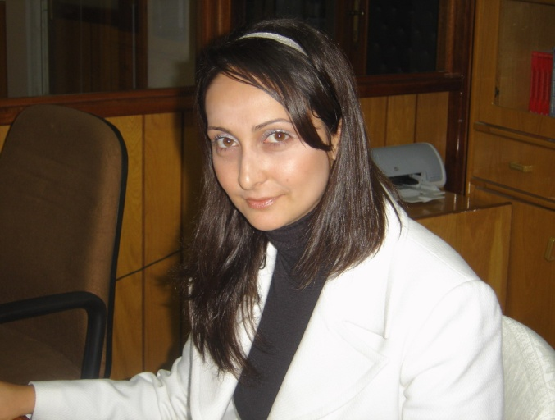

- Name - Surname : Selma Korkmaz
- Date of Birth –Birth of Place : 06/04/1982 - Yeşilyurt
- Title : MA
- Educational Status
Degree | Major | University | Year
Bachelor | Turkish Language and Literature | Near East University | 2002-2003
Masters | Department of Archiving and Ottoman Paleography | Near East University | 2003-2005
PhD | Educational Programs and Instruction | Near East University | 2013-

- Academic Titles:
University Lecturer Near East University 2005-
- Masters and Ph.D. Thesis Administrated
- Publications
7.1. Articles Published In International Journals (SCI & SSCI&Arts And Humanities)
7.2. OtherArticlesPublishedIn International Journals:
- Korkmaz Selma, Writing Skills of the Children Raised in Family and Nursery Environment, International Journal of Languages’ Education and Teaching, UDES 2015, Mannheim-GERMANY, 2424-2439.
7.3. Procedures Presented In The International Scientific Meetings And Published In The Proceedings:
- Korkmaz Selma, Folk Elements Nevzat Yalcin’s Book “Newer, Closer”, XXIV. KIBATEK International Literature Symposium, Ankara, March-2013.
- Korkmaz Selma, “Hijab in Cypriot Folk Songs”, XIX. International Turkish Culture Symposium, Macedonia, 02-06 May 2014. (Papers were presented but not published.)
- Korkmaz Selma, Writing Skills of the Children Raised in Family and Nursery Environment, 1st International Symposium on Language Education and Teaching, Nevşehir Hacı Bektaş Veli Üniversitesi, Nevşehir, 28-30 May 2015.
7.4. Written International Books Or Book Chapters:
  - Articles Published In National JournalsWith Referees
  - PresentationsMadeInNational Scientific Meetings And Published In Proceedings:
  - Other Publications:
  - Abstracts Of Articles Presented And Published Proceedings:
  - Editorial In International Publications:
- YARAŞIR Ömer, Mustafa YENİASIR, Selma KORKMAZ, Fuzuli In The Turkish Culture And Arts”, The First International Symposium Of Poets And Authors Of The Turkish World, Proceedings, 28-31 May 2008, Near East University, Nicosia, (July 2009 Edition)
- National& International Projects:
  - Turkish Cypriot Family according to the Archive Documents
  - Interaction between Turkish Cypriot and Greek Cypriot Communities according to the Archive Documents
  - Turkish Cypriot Materialistic Culture according to the Archive Documents
- Administrative Duties
- Membership to International Institutions
- Rewards
- Please, fill the table below for the courses given at level of Bachelor and PhD within the last two years.
Academic Year | Semester | Name of the Course | Weekly Hours | Number of  Students
2012-2013 | Fall | Writing Techniques  Community Service Applications  Written Explanation (Turkish Language I)  Development of the Turkish Cypriot Culture  Understanding Techniques II: Listening Education | 3  3  2  2  4 | 28  16  14  21  9
 | Spring | Spoken Explanation I  Effective Communication  Teaching Practice  Narrative Techniques I: Speaking Education | 2  2  5  4 | 14  15  20  12
2013-2014 | Fall | Writing Techniques  Community Service Applications  Written Explanation (Turkish Language I)  Development of the Turkish Cypriot Culture  Understanding Techniques II: Listening Education | 3  3  2  2  4 | 25  18  12  10  20
 | Spring | Spoken Explanation I  Effective Communication  Teaching Practice  Narrative Techniques I: Speaking Education | 2  3  5  4 | 25  26  10  18

