MAXİLLOFACİAL TRAUMAS
INTRODUCTION
Maxillofacial traumas can cause physical injuries in both soft and hard (bone) tissues. As a result of this ,inflammation, pain, swelling, loss of function , damage of tissue continuity will occur.
In maxillofacial traumas ecchimosis, laceration and abrasion also occur.
MANAGEMENT ( abrasion,ecchimosis,)
Abrasion result in the loss of the epithelial layer of the skin . This kind of injury is very painful due to the exposed nerve endings.
As a management, the dirt and other small particles should be cleaned from the wound by washing with a soap solution under local anaesthesia. The wound should be irrigated with saline, then covered with a layer of antibiotic and finally dressed with gauze.
MANAGEMENT (laceration
Lacerations may be produced by either blunt and sharp trauma. They may be associated with injury of the underlyıng vessels, nerve and bones. These type of wounds are usually highly contaminated with dirt, piecess of glass, bony splinters etc.
Laceration wounds should be cleaned , foreign material should be removed and wound is closed.
Cardinal findings of ınflammatıon
As a result of trauma bone and tooth fractures and dislocations may also be seen.
Inflammatory response may be seen in maxillofacial traumas.The cardinal findings of inflammation are :
Pain (dolor)
Swelling (tumor)
Heat (calor)
Redness (rubor)
Loss of function (functio lasea)
There are many findings of facial injuries.Because facial region is responsible for the senses of sight,smell,taste and hearing.
In addition, eating, drinking,speech and communication are affected.
Most patients with maxillofacial injuries are generally young .Because they sometimes make mistakes ( over maximum speed, use alcohol,use telephone while driving,)
THE CAUSES OF
MAXILLOFACIAL INJURY
Alcohol-related trauma
Violence and fights
Gun-shut wounds
Fall from a height
Fall by slipping on the ice (in winter)
Fall (due to epilepsy, hypotension,fainting)
Varıous accidents (Industrıel , Home, sports injury, road traffic)
Iatrogenic causes (during tooth extraction –fracture of maxıllary tuberosıty, mandibular fracture)
Pathologic fractures
Causes of pathological fractures
FİBROUS DYSPLASIA
PAGET
OSTEOGENESİS IMPERFECTA
OSTEOPETROSIS(Alber’s Schönberg)
HYPERPARATHYROIDISM
INFECTIONS(osteitis, osteomyelitis,syphılıs ,tuberculosıs)
CYSTS
ATROPY
IRRADIATION NECROSIS
RACHITISM
OSTEOMALACIA
OSTEOPOROSIS
TALASEMIA
CAUSES OF MAXILLOFACIAL INJURIES
The causes of maxillofacial injury reflect the culture of the country where the accident was occur.
For example motor vehicle and industriel accidents occur in the developped countries, while fights , violence and altercations generally occur in undevelopped countries.
In Diyarbakır which is in the south east of Turkey ,falling from the roof of the house and gun- shut wounds are seen more .
In Erzurum which is in the eastern part of Turkey, jaw fractures can be seen due to animal kicks ,falls by sliding on the ice, and fights.
Even in England physical violence tend to be the most common aetiologia in the occurance of maxillofacial traumas ,followed by road traffic accidents and falls
Nowadays the facial injuries increased., because speed of the motor vehicles and their numbers increased. Further more people generally do not obey all the traffical rules. In Turkey people still do not like to obey safety precautions unfortunately.
Safety precautions against maxillofacial injuries
A patient who suffer from maxillofacial ınjury, should be taken to the hospital . as soon as possible
He /she is examined for airway first.
If the patient is unconscious, the bone and dental fragments , saliva,hematom, in the mouth should be cleaned.
Endotracheal tube should be placed if necessary.
There have been taken a lot of preventive measures on the vehicles and roads by automative ındustry and security:
Safety belts, and air bags are important equipments.

Safety belts give a signal if they are not used.
But some drivers who have not any knowledge, connect its ends to the socket. So it does not give a signal. It is terrible and dengerous behavior.
If the otomobile stops suddenly the passengers in front of it ,strike the rearvıew mırror, stearing wheel, and front glass and therefore head and brain injuries may be seen .The more serious the facial injury, the more likely is brain injury.
Preventıon of maxillofacial traumas
Some efforts determined to reduce risk of head injuries :
1.To construction safer roads
2.To compulsory use of seat- belt
3.Pre school education , education in any ages
4. Alcohol consumption should be forbidden while driving
6. Telephone should not be used while driving
7. Motocycle drivers should be used helmet
8. Boxers should be used mouth guard while boxing match
9. Chıldren should not be seated in the front of the car
10. In nowadays aır bags was put in the cars for decrease harmful effects of injury
Basic principles of menagement of severe maxillofacial ınjuries
1.Preservation of life
2.Maintenance of function
3.Restoratıon of appearance (aesthetics)
INVESTIGATION OF THE PATIENT IN MAXILLOFACIAL INJURIES
A-General examınatıon and fırst aid
B-Local examınatıon
A-General examination (emergency care)
Keep the airway open
Take measures during transportation of the patient
Menagement of hemorhage
Take measures against shock and syncope
Diagnosis and treatment of brain injuries
Prevention of infection
Causes of airway obstructıons
Inhalatıon of blood clot ,vomit, salıva,thick mucus,broken teeth bone and dentures,
Hemorhage,particularly nasal hemorhage
In bilateral mandibular fractures through the canine region, the tongue may fall back to occlude the airway,
In maxillary injuries the palate can be displaced down and back to occlude the pharynx.
Measures at the accident site and during transport
The patient should be placed on a stretcher lying on his side or on his stomach
Transportation of the patient should not be undertaken until first aid has been succesfully completed.
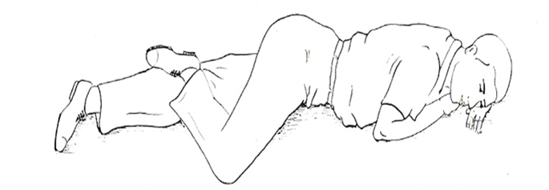
First AID
All blood clot ,saliva, thick mucus, foreign bodies, should be cleared from the oral cavity by digital exploration or by using cotton swabs if available,
A tracheostomy may be indicated in extensive maxillofacial injuries,
Supine position should be avoided
Management of hemorrhage should be done
Temporary immobilization should be done by one of the classical bandages,
These bandages can be placed quickly and with simple materials
They prevent further displacement and enhance hemostasis and analgesia.
Temporary hemostasis and temporary immobilization
Barrel,Funda maxillae,spatula dressing,head-jaw bandages can be used for this purpose.
Temporary hemostasis
If bleeding occur from any vessel , some measures apply to stop bleeding.
Digital pressure is generally used to stop bleeding during the transportation of the patient. Pressure bandages genarally are insufficient to control bleeding from larger arteries,
Definitive hemostasis should be obtained in the hospital.
Digital compression point in facial artery bleeding
There are some points on the arteries in order to stop bleeding . For example if bleeding occure from the facial artery ,digital pressure is applied to the point in front of the masseter muscle.
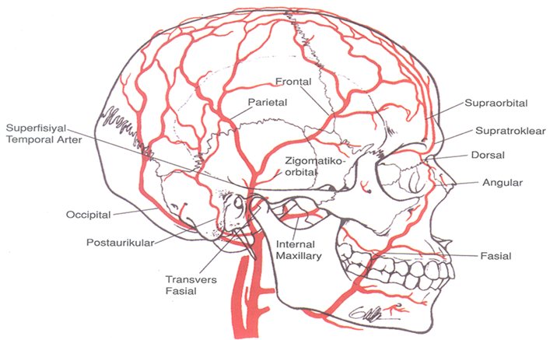
In superficial artery bleeding,digital compression point is in front of the ear
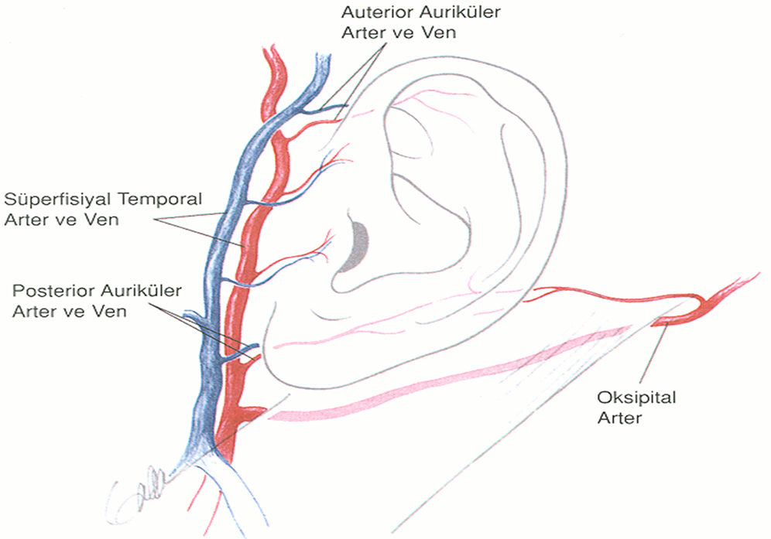
From lingual artery bleeding ,digital compression point is under the angulus mandible or on the a. carotis externa
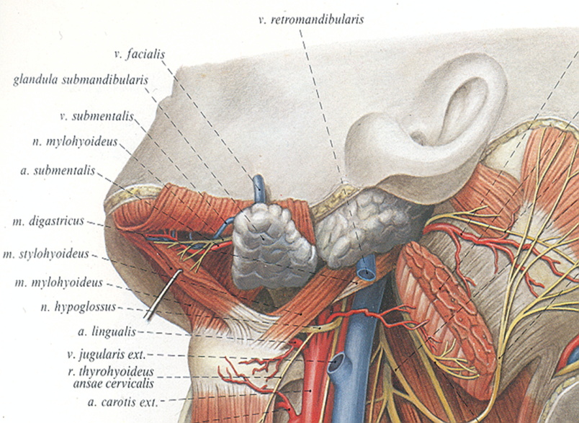

Definitive control of hemorrhage
Ligation of the vessels
Anterior-posterior nasal tamponade
Reduction and fixation of the fractures
Blood transfusion
SYNCOPE
The most common medical emergency encountered in the dental clinic is syncope.
Syncope is defined as the transient loss of consciousness
It can be psychogenic resulting from fright, anxiety, or tiredness
Nonpsychogenic causes include prolonged standing and dehydration.
Sign and symptoms of syncope
Pallor
Nausea
Dizziness
Cold sweat
Loss of conscious
Low blood pressure
Pulse rate remains normal but the volume weak and thready
The pupils are dilated and rolled up.
MANAGEMENT OF SYNCOPE
1.The patient should be laid down in supine position with the head lower than the heart and the feet (Trendelenberg) .In order not to aspırated of vomit,the necessary measures should be undertaken
2. Airway is checked,
3. Dentures removed,
4. Tight clothing loosened,
5. The room is ventilated
6. However if the fall in the blood pressure persist ,oxygen is given and a physician must be consulted.
Complications of brain injuries in maxillofacial traumas
Complications of brain injuries are:
1.Cerebrospinal fluid leakage
2.Neurologic findings
3. İnfections
1.Cerebrosinal fluid leakage ( CFL)
In the early stages leakage of CSF may be obscured by hemorrhage, but any clear watery discharge from the nose is suspect.
CSF contains sugar but little protein,this is important sign.
It must be differantiated from the nasal mucus or lacrimal fluid.
CSF must be identified by protein electrophoresis and by accurate measurement of the glucose
Causes of cerebrospinal fluid leakage (CSF)
Fractures of middle cranial fossa (from ear)
Fracture of lamina cribriformis of ethmoid bone (from the nose)
Fractures with dural laceration CSF leakege may occur,
In the cases of CSF leakage there is the risk of menengitis
If there is anosmia (demage sense of smelling), it may be the sign of CSF leakage
In the leakage of CSF suspicion:
The leak usually persists for about a week and the risk of menengitis is greatest within the first fortnight.
If there is a risk of menengitis, prophilactic antimicrobials are needed.
The patient should be rest and a neurosurgical opinion should be required.
In the menengitis ,the patient is given sulphonamids as an antibacterial
2.Neurologic findings
Pupil size and reaction must be checked,
A dilated and fixed pupil generally indicates rising intracranial pressure and is a serious sign.Fixed pupil means unreactive to light.Severe facial oedema may however make examination of the eyes difficult.
A fixed dilated pupil can also be caused by local damage to the optic and oculomotor nerves and must be differantiated from brain damage,
Neurologic findings from brain damage, may come to light by clinical and radiological examination.
If intracranial hematoma exists, vomiting and headache may occur,
If general anaesthetics and sedatives and analgesics are given, the level of consciousness may also deteriorate.
Morphin as an analgesic should not be given to unconscious patients Because:
1. Morphin may hide the findigs of high intracranial pressure,
2.The objective evaluation of the level of consciousness may be disappear.
3.Morphin depress respiration center.
3.İnfections
Menengitis
Osteomyelitis
Tetanus
Actinomycosis
MENENGİTİS:
Menengitis is an important infective complication of maxillofacial injuries,
It can also result from lacerations of the scalp,
İnfection from the lacerated scalp can reach the brain via the emissary veins.
Menengitis will occur mostly in the fractures with dural laceration and in the cases of CSF leakege,
The sign and findings of menengitis are severe headache, nausea, vomiting, drowsiness, pain and stiffness in the neck.

OSTEOMYELİTİS
Osteomyelitis is an infection involving all the layers of the bone in which widespread necrosis may occur,
Osteomyelitis of the mandible is usually dental or traumatic in origine,
In the development of osteomyelitis, some conditions such as highly virulent organism,low resistance of the patient,and lack of drainage are needed.
In the line of fracture ,teeth and foreign bodies can cause osteomyelitis,
Today antibiotic therapy has reduced the incidence of acut osteomyelitis.
TETANUS
The tetanus is caused by clostridium tetani,
Clostridium tetani is a gram positive organism and highly resistant to heat and disinfectants.
Clostridium tetani spores are usually found in soil and dust, particularly where there is faecal contamination
Tetanus ,clinical signs
Tetanus is most likely to follow contaminated deep woonds,
C.tetani produces tetanospasmin,a neurutoxin, responsiple for the muscular spasm.
Masseteric spasm is early sign of the disease and as a result of this, trismus occur.
Spasm of the facial muscles causes retraction of the angles of mouth and,clenched teeth.
This appearence called “risus sardonicus
When the spinal muscles are severely affected, “opisthotonus results.
ACTİNOMYCOSİS
Actinomycosis is rare,and usually affects the soft tissues of the angle of the mandible,face and neck.
It is usually bluish in colour and tends to form multiple sinuses .
Sometimes the disease occurs as a mixed infection.
Complicatıons in 227 patients who experienced maxillofacial trauma(Our results) *
38 patients otorrhea
162 patients rhinorrhea
13 patients otorrhea,rhinorrhea
13 patients intracranial hematoma
11 patients menengitis
4 patients CSF
79 patients contussıo cerebri
11 patıents subarachnoidal hemorrhage
48 patients neurological problems
21 patients death.
Complicatıons in 227 patients who experienced maxillofacial trauma(Our results) *
*Kadıoglu HH, Onder A, Aydın IH, Tuzum MŞ, Takçı E. Maxillofacial traumas. A clinical analysis. 1st Mediterranean Congress of Oral and Maxillofacial Surgery, Athens, 1991.
These results are belong to the Oral Surgery and Neurosurgery Departments of Atatürk University and presented by Dr. Tüzüm at the 1st Mediterranean Congress of Oral and Maxillofacial Surgery, Athens, 1991.
LOCAL EXAMINATION OF MAXILLOFACIAL INJURIES
Dento-alveolar injuries
The fractures of the mandible
Fractures of the middle third of the facial skeleton
Soft tissue injuries (abrasion, contussion,laceration)
Dento-alveolar injuries
Uncomplicated crown fractures
Complicated crown fractures,
Displacement injuries (luxation,avulsion,intrusion,concusion),
Root fractures,
Alveoler fractures
Uncomplicated crown fractures
This fracture is limited to the enamel and dentin without pulp exposure

Displacement injuries
1. Concussion
2.Subluxation
3.Luxation
4.Avulsion
5. Intrusion
Displacement injuries (concussion)
Concussion is a minor injury to the periodontal tissues without malposition or mobility of the teeth. The blood supply to the pulp is rarely affected.
Vitality may be negative in the early days of the trauma, but this can be misleading. Because the nerve of the tooth is damaged but blood vessels can be intact. Therefore teeth may be fed So your decision must be clear after ten days . If the tooth is necrotic you must remove it
Displacement injuries
(Subluxation)
Subluxation results from injury to the periodontal tissues with a slight increase in mobility , but without malposition of the teeth.
The blood supply to the pulp may be affected.
Luxation
A luxated tooth has been displaced such that the coronal part of the tooth is often displaced palatally / lingually and the apical part of the tooth is displaced labially.
Clinical examination of dento-alveolar ınjurıes
On inspection, oedema and ecchimosis on the lips may be seen,
The mucosa is checked for hematomas and abrasions; it is to be borne in mind that lingual hematomas are more suspect of mandibular fracture
Pulp vitality testing immediately after the accident is of limited importance.A negative reaction does not indicate to pulp necrosis.The tooth may response any stimuli for after days or weeks.The tooth may be in a shock. This condition is caused by reversible edema of the myelin sheats of the sensory nerves.
In the examinatıon of unconscious patients with missing teeth, radiographs of the abdomen and thorax should be examined to determine whether a missing tooth has been aspirated or swallowed.
MANDIBULAR FRACTURES
The mandible is the largest heaviest, and strongest bone of the face,
It is prone to injury because of its prominent position in the facial skeleton,
The mandible is strongest at its center and weakest at its ends,where it often breaks easily with indirect traumas.
Classification
1. According to Anatomic Location
2. Kazanjian Classification
3. Types of Fracture
Classifications
(1. According to Anatomic Location)
There are some weak points of mandible. So fractures occur at this points easily:
Symphysis
Parasymphysis
Body
Angulus
Ramus
Condyl
Coronoid
Dentoalveolar

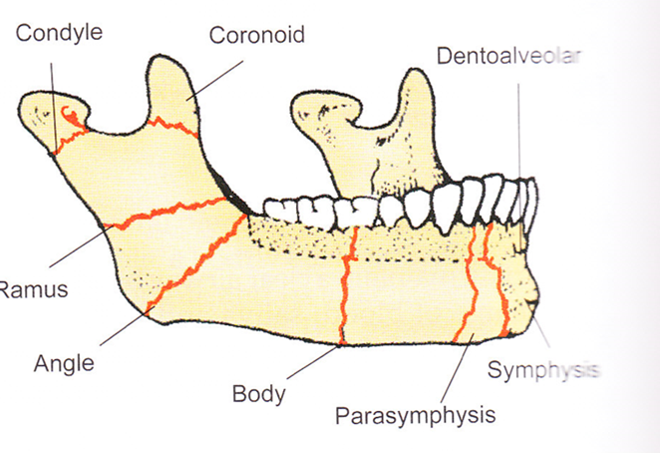

2.Kazanjian Classification
Class I
Class II
Class III
Kazanjian Class I: Teeth are present on both sides of the fracture line
Class II: Teeth are present on one side of the fracture line
Class III : Bone fragments are edentulous
Kazanjian classification helps in treatment planning.
3. (According to Types of Fracture
Simple (closed) fracture
Compound fracture (open)
Communited fractures
Greenstick fracture
Pathologic fracture
1.Simple (closed) fracture :
In these fractures there is no tear in the soft tissues .
These fractures do not communicate with the exterior or the interior. Such a fracture does not produce a wound open to the external environment either through the skin, mucosa or periodontal membrane.
2. Compound fracture (open) :
This fracture has communication with the external environment through skin or with the internal environment through mucosa or periodontal membrane. All the fractures involving the tooth bearing area of the mandible is accepted as open fractures.
3.Communited fractures:
A fracture in which the bone is splintered or crushed into multiple pieces. These types are generally due to a greater degree of violence. Gunshot wounds can produce these fractures.
4.Greenstick fracture : It is a variant of simple fracture , seen in children . A fracture in which one cortex of the bone is broken and other cortex being bend.
5. Pathologic fracture:
Pathologic fractures occur in that part of the mandible which is weakened by a pathology , e.g.cyst, tumor, osteomyelitis etc.
ANATOMY
The mandible is the single largest and strongest bone of the face.
It is a tubular bone which is bent in a «U» shape at the center. It has two flat processes called «ramus». Each ramus has two processes (condyl and coronoid)
Strong muscles of mastication are attached to the mandible.

Muscles attached to the mandible are:
Lateral pterygoid (at the condylar neck)
Temporalis ( at the coronoid)
Medial pterygoid (on the inner part of ramus)
Masseter ( on the outher part of ramus)

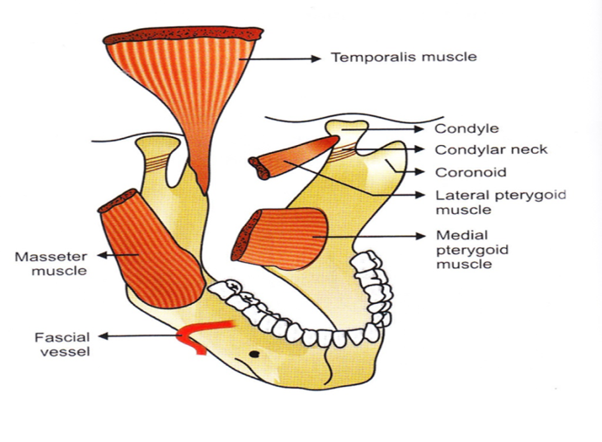 Displacement
Bony fragments change their position by some factors. This is called «displacement»
Displacement depends on following factors:
1. Direction and intensity of the traumatic force,
2. Site of fracture,
3. Direction of the fracture line,
4. Muscle pull,
5. Presence or absence of teeth.
According to the Direction of Fracture and
Favourability for Treatment
a. Horizontally favourable fracture.
b. Horizontally unfavourable fracture.
c. Vertically favourable fracture.
d. Vertically unfavourable fracture
Horizontally favourable line of fracture at the angle of the mandible
The direction of fracture line is important for resisting the muscle pull. When the muscle pull resists the displacement of the fragments, then the fracture line is considered as favourable.
This line of fracture prevents the displacement of fragments by masseter and temporalis muscles.
Horizontally
unfavourable line of fracture at the angle of the mandible
If the muscle pull distracts the fragments away from each other, resulting in displacement, then the fracture line is considered as unfavourable.This fracture line does not prevent the pull of masseter muscle.
Vertically unfavourable line of fracture
If fracture line is the direction of the muscle pull , the backward fragment is displaced by lateral and medial pterygoid muscles pull. This is called as Vertically unfavourable fracture.
Vertically favourable line of fracture
If the fracture line prevents the muscle pull, lateral segment locked by the medial segment. So lateral fragment does not displaced. This is called «vertically favorable fracture
Frequency of mandibular fractures
There are some weak points of mandible:
Symphysis
Body
Angulus
Ramus
Condyl
Cor onoid
Dentoalveolar
A number of studies showed that mandibular fractures mostly occur at the symphysis, angulus,condyle, and body.
Dr. Şenol Tüzüm (1990,Athens) reported the angulus, symphysis ,body and condyl fractures were the mostly occur (in order of frequency

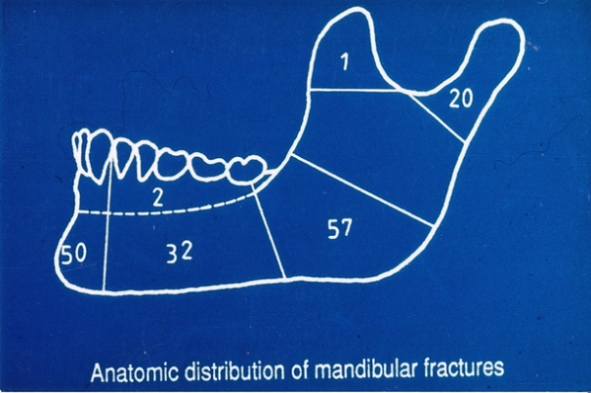
Location: Tüzüm’s study (1992)
Angulus % 57
Symphys % 50
Body % 32
Condyl % 20
Dento alveol
Coronoid % 1
--------------------------------------------------------------------------------------------------------------------
Fonseca and Olson’s study (580 cases)
Condyl % 29,1
Angulus % 24,5
Symphysis % 22
Body % 16
Dentoalveolar % 3,1
Ramus % 1,7
Coronoid % 1,3
Sign and symptoms of Mandibular Fractures
1. Swelling and ecchymosis
2. Loss of function
3. Halitosis
4. Deformıty of bony contour
5.Anaesthesia in the lower lip and chin
6. Derangement of occlusion
7. Crepitus and abnormal mobility
8. Ecchymosis in the buccal and lingual sulcus and haematom in floor of the mouth
9.Pain
Management of teeth in line of fracture
A tooth can be a source of infection if the socket is in the fracture line. Before the age of antibiotics, such teeth had usually to be extracted because of the danger of osteomyelitis. But today it is not often necessary now.
If a tooth in the fracture line, is necessary for fixation we do not extract it until primary callus formation has begun.
If teeth are so loose as to be useless for fixation, or if their vitality is in doubt, they should be extracted.
According to Killey and Kay; Indications for removal of a tooth from fracture line is as follows:
1.Absolute indications
A.Vertical fracture of the root
B. Pre-existing periapical lesion
C. Luxation and subluxation of the tooth from the socket
D. Acute pericoronitis
E. Infection of the fracture line
F. Teeth that prevent reduction of fractures should be removed
2. Relative indications
Advanced caries
Advanced periodontitis
Tooth which serves no function
Teeth involved in untreated fractures which are presented more than 3 days after injury.
Teeth which need to be retained in the fracture line
If tooth in the line of fracture is intact but showes no mobility or infection , can be protected with antibiotic coverage.
A second molar in the posterior fragment should be protected in order to prevent superior displacement of the posterior segment.
If possible the cuspids must be save ,because they are important teeth for normal occlusion.
Oral and Maxillofacial Examination
The clinician should know the cause of trauma. Because this knowledge lead him/her about the type of injury and how to manage.For example, if trauma had caused by sharp objects ,nerves and vessels might be injuried.A blunt trauma most likely results in fracture of facial skeleton.
The oral examination should follow the order:
Soft tissues
Nerves
Skeleton
Dentition
Soft tissue examination
The oral and pharyngeal soft tissues should be checked for lacerations and penetrating injuries.
The tongue is examined also. The tongue is often lacerated
If bleeding is present, it should be controlled immediately.
The Stenson’s and Warton’ ducts and salivary flow should be examined.

Neurological examination
The nerves commonly injured during maxillofacial trauma are:
Inferior alveolar nerve: An injury to the inferior alveolar nerve results in anaesthesia of the side involved.
Lingual nerve: Injury to lingual nerve results in anaesthesia and parasthesia of the anterior two thirds of the tongue.In addition since the chorda tympani fibres are carried by the lingual nerve. Therefore alteration in taste appear.
Facial nerve: Functions of this nerve can be evaluated in a conscious patients by using to muscles of facial expression.
Infraorbital nerve: In the Le Fort II fractures infraorbital nerve is damaged.
Olfactory nerve: Injury to this nerve results from fracture of the mid face that involve the cribriform plate of ethmoid.
Oculomotor nerve: Presence of dilated pupil indicates oculomotor nerve damage.
Skelatal examination
If lımited mouth opening an anterior open bite, and preauricular pain is present, bilateral subcondylar fracture is thought.
Sublingual hematoma is the most common sign indicatıve of mandibular fracture
Ecchymosis behind the ear is known as Battle’ s sign . This sign is indicative of basilar skull fracture involving middle cranial fossa.
Pain in and around preauricular or masseteric area indicates injury to the condyl or the mandibular angle and deviation of the mandible on opening the mouth indicates the presence of condylar fracture.
The surgeon should look for orbital or periorbital injuries which manifest itself as subconjunctival hemorrhages.
TMJ injuries or middle cranial fossa injuries manifest as bleeding from external auditory canal
Zygoma and maxilla are evaluated.
Bleeding spots in the buccal fold and class III malocclusion indicate a maxillary fracture.
The lower border of the mandible is palpated for any step deformity.
Infraorbital rim is palpated for the presence of step deformity which may indicate either an isolated fracture of zygoma or a Le Fort II level injury
Bimanuel examination showes whether crepitus exist or not,
Whether occlusıon derange or not,
If lingual heamatome is present ın ınspectıon, the suspicion of mandibular fracture exıst.
Occlusal derangement is an important key in diagnosis and treatment of jaw fractures,
If continiuty of teeth alignment is not broken but occlusion is disturbed, the fracture is thought to be out of teeth alignment.
Mandibular fractures can be combined with fractures of the midfacial region.
In unilateral condylar fractures,while mouth opening, deviation occurs towards the affected side.
In bilateral fractures,anterior open bite occurs.
Coronoid proc. Fractures are rare and ecchimosis is seen intra-orally.
RADIOLOGIC EXAMINATION
Radiologic examination is essential for the diagnosis of jaw fractures
We see fracture line and it's relation to maxillary sinüs and inferior alveolar nerve,teeth etc.
X-ray is important for forensic medicine
Radiologic investigations in maxillofacial injuries
Posterior- anterior jaw radiography (PA
Lateral oblique jaw graphies
Periapical graphies
Occlusal graphies
Condylar head tomography
Panoramic graphies ( OPG)
Water’ sinüs
CT Scan
Submentovertex
NUTRİTİON İN PATİENTS WİTH MANDİBULAR FRACTURES
One of the major problems of patients intermaxillary fixation made is nutrition .
Patients who underwent intermaxillary fixation need at least stay of 45 days at this manner
Patients with maxillofacial injuries are fed liquid nutrients more
Meanwhile oral hygiene should be taught, if necessary, rubber rondels should be replaced at least once per week., and the remaining food between wires should be removed with pressurized water .
During the procedure of replacement of rubbers the patient uses jaw joint for a short time
By DOİNG THİS PROCEDURE especially ankylosing in condyle fractures is prevented and the risk of infection is reduced (m.şenol tüzüm)
Condyle fractures
Classification
- Unilateral, bilateral
- Intracapsular, extracapsular
- Lindahl’s Classification
- MacLennan’s Classification

Lindahl’s clasşification
1.Level of condyl fracture
A. Head of the condyle
B. Condylar neck
C. Subcondylar
2. Mandibular segment and condylar segment relations
3. The relationship between the glenoid fossa and the head of the condyle
MacLennan’s Classification
Type I Nondisplaced
Type II Fracture Deviation
Type III Fracture Displacement
Type IV Fracture Dislocation
Type V Extracapsular
Signs and symptoms of condylar fracture:
- TMJ region and the tip of the chin there may be lacerations, abrasions, bruising and hematoma formation
- Swelling on the temporomandibular region
- Bleeding from external ear
- Ecchymosis of the skin below the mastoid process on the fractured side.This also occurs with fracture of base of skull known as “Battle’s sign”
- When the mouth is opened ,deviation would be towards the fracture sides
- Beans (anterior open bite) occur in bilateral condylar fracture
- Crepitation over the fractured join due to the irregular fracture ends sliding over one another
Mid-facial and base of the skull fractures
The classification of facial fractures
- Lower third-Mandibular fractures
- Middle third-midface FRACTURES
- Upper third)-frontal-frontal sinüs fractures
Midface, middle third FRACTURES
- Fracture of Maxilla
- Fracture of Zygoma
Maxillary Fractures
French surgeon Rene 'Le Fort (1869-1951), was revealed as the weak line of facial bone and according to these lines,he was divided the fractures into three types: LeFort I,II and III
Many classifications have been made in the maxilla fracture apart from LeFort:

Erich Classification
- Horizontal fracture (Le Fort I,Guerin)
- Pyramidal (Le Fort II)
- Transverse (Le Fort III, craniofacial dysjunction )
Le Fort I kırıklarında belirtiler
- Slight swelling of the upper lip
- Ecchymosis is present in the buccal sulcus beneath each zygomatic arch
- Occlusion is disturbed with variable amount of mobility in the tooth bearing segment (maloclusion)
- Sometimes the mouth remains open
- Percussion of the upper teeth ,will give a typical “CRACKED –POT” sound
- Bilateral epistaxis
Fracture lines of LeFort I (Low level,Güerin, horizontal)
It separates the palate and tooth bearing segment ,bilaterally from the mid-face
- This horizontal fracture runs above the nazal fossa
- Along the lateral Wall of the antrum from the anterior nasal apertura
- Below the zygomatic butress (behind the tuberosity)
- Across the lower 1/3 of pterygoid lamina
- Then through lateral Wall of nose
- Lower 1/3 of nasal septum
- To join the lateral fracture behind the tuberosity
LeFort II fractures: Sign and symptoms
1.Bilateral circumorbital ecchymosis , associated with rapid swelling of the eyelids ,making their examination difficult.
2. Subconjunctival ecchymosis generally occurs associated with the fractured side.
3.There can be enophtalmus
4.There is development of gross edema of the face giving “moon face” appearance
5.Diplopia is usually present and ocular movements may be limited
6. İncrease in the intercanthal distance
7. If fracture involves cribriform plate , there will be cerebrospinal rhinorrhea
8. Fracture of the nasal bones will cause nasal bleeding
9. Tapping of the teeth will give a typical “cracked pot” sound
10. Occasionally there may be a dish-face deformity
11. Foetor –oris is present
12. There may be step deformity at the infraorbital margin
13.The infraorbital nerve is usually injured, leading to paresthesia or anesthesia of the cheek
Fracture lines
Fracture lines run below the zygoma also these lines form a pyramidal shaped
- The fracture runs through the mid portion of nasal bone
- Frontal process of maxilla
- Then into the orbit , the lacrimal bone
- O n the floor to cross the infraorbital margins
- Along anterior Wall of antrum slightly medial or through the infraorbital foramen
- Turns along lateral Wall of antrum below the zygomaticomaxillary suture
- Fracturing pterygoid lamina at middle third
- Nazal septum
This type of fracture separates the middle block from the base of the skull

Le Fort III
Sign and symptoms
The facial skeleton and skull are separeted from each other
- Ecchymosis around the face and eyes
- Sirkumorbital bilateral edema, periorbital ecchymosis, and therefore difficult to open eyes
- Eye movements is limiting because of bilateral subconjunctival hemorrhage
- As there is a fracture line running between the frontal and nasal bones , also there is fracture of the ethmoid bone there is flattening of the nose
- There is an increase in the intercanthal distance
- IF the cribriform plate of ethmoid bone is breaken then cerebrospinal rhinorrhea occur
- The fracture of the orbital walls cause an increase in the orbital volüme, resulting into enophtalmus
- These fractures are generally associated with fracture of zygomatic arches
- The fractures of the facial skeleton lead to a lot of edema that cause moon-shaped face
Fracture lines
- Fracture runs near frontonasal suture, then along frontomaxillary suture
- Ethmoid bone, including cribriform plate is fractured
- It runs along the medial Wall of the orbit fracturing
- Under the optic foramen
- Up to infraorbital fissure
- From the posterior limit it runs in two directions
- Along the lateral Wall of the orbit to fracture frontozygomatic suture
- Backwards along the pterygomaxillary fissure
- To fracture the roots of pterygoid lamina

TREATMENT OF JAW FRACTURES
history
The treatment of jaw and facial fractures continued to be from an early age
Papyrus which is found in 1862 by Edwin Smith is considered to be the oldest documents related to surgery. THIS papyrus is mentioned from the fracture of the upper and lower jaw, lips, and soft tissue injury and the dislocation of the jaw.
Hippocrates, has described bandage made with two leather straps to fix jaw
Roman Celsus used Hippocrates method in the treatment of fractures. Today, the concept of occlusion in the diagnosis and treatment of jaw fractures is first examined by the physician Vesalius.
Splints for the treatment of jaw fractures between teeth used for the first time by Gunning. In this method, the upper and lower jaw teeth are completely covered by rubber. Nutrition of the patient from the front opening is provided.
In 1877 Gilmer ued surgical ligatures. for intermaxillary fixation
In 1922 Ivy described efficient and easy method for intermaxiller fixation
The essence of jaw fracture treatment includes the following elements:
- Reduction
- Fixation
- Preventing infection
Modern treatment of jaw fractures
Dentulous mouth
- Conservative methods (acrylic,arch bar)
- Surgical methods
Edentulous mouth
- Various methods suspended
- The fracture fixation utilizing a patient's own prosthesis
REFERENCES
Lars Andersson,.Karl-Erik Kahnberg,. M Antony Pogrel.:Oral and Maxillofacial Surgery ,Wiley-Blackwell,2010.
Jonathan Pedlar,.John W Frame.:Oral and Maxillofacial Surgery, Churchill Livingstone,2001.
U J Moore.:Principles of Oral and Maxillofacial Surgery, sixth edith.,2011.
Eberhard Kruger .,Wilfried Schili.:Oral and Maxillofacial Traumatology,Vol.2, Quintessence,1986.
Geeti Vajdi Mitra.:Illustrated Manuel of Oral and Maxillofacial Surgery,Jaypee,2009.
Neelima Anil Malik.:Textbook of Oral and Maxillofacial Surgery Jaypee, 2012.
James R Hupp.,Edward Ellis,Myron R Tucker.: Contemporary Oral and Maxillofacal Surgery, Mosby,fifth edit.,2008.
Tüzüm MŞ.:Çene kırığı tesbitinde kullanılan akrilik ve ark teli şinelerinin mukayesesi,doktora tezi, Erzurum 1974.
Tüzüm MŞ.: Kalsitonin’in kırıklarda kallus oluşumuna etkisinin deneysel incelenmesi, doçentlik tezi, Erzurum,1979.

