TEMPOROMANDIBULAR JOINT DISORDERS

Anatomy and biomechanics of temporomandibular joints

Masticatory system is a functional unit of the body chewing, swallowing and speech function is responsible for.

This system, together with the relevant organs and tissues, masticatory muscles, salivary glands and facial muscles all at once form "stomatognathic system"

**The stomatognathic system elements**

Skull, mandible, hyoid bone, clavicula, sternum, masticatory muscles, ligaments,dentoalveolar structure, temporomandibular joint (TMJ), vascular and lymphatic systems.

**Dentition and supporting tissues**

Human dentition consists of 32 permanent teeth. .Each tooth is divided into two parts as crown and root . Crown is part seen on the gingiva. Root is located in the alveolar bone. Root is hold into alveolar bone by numerous connective tissue fibers. These fibrils is called as "periodontal ligament" . Periodontal ligament is connected not only between the bone and root tightly, but also provides the force uniformity during function

**Temporomandibular Joint (TMJ)**

This joint is considered as"compound" JOİNT. There are three bones in the compound joints. However TMJ has two bones. In temporomandibular joint articular disc acts as a third bone.

Temporomandibular joint, is composed of temporal bone, mandible, articular disc ligaments and muscles

Articular disc is a fibrous structure that divides the joint into two space. Lower cavity allows for rotation. Therefore it is called "ginglimoid. . Upper space allows the"slide" movement. Therefore it iş called “arthroidal”. All of the joint "ginglymoarthrodial" joint name given. Articular disc HAS NO blood vessels nerves.

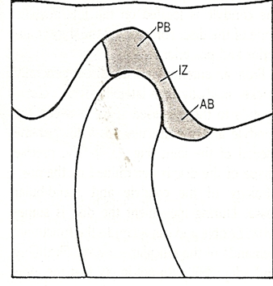 It is divided into three zones according to the thickness. Central portion is thin and "intermediate zone" is called. At the back and the front of the intermediate zone is thicker.

Iz (intermediate zone)

PB (posterior border)

AB (ANTERİOR BORDER)

Articular disc is attached to the rear of a loose connective tissue containing blood vessels and nerves

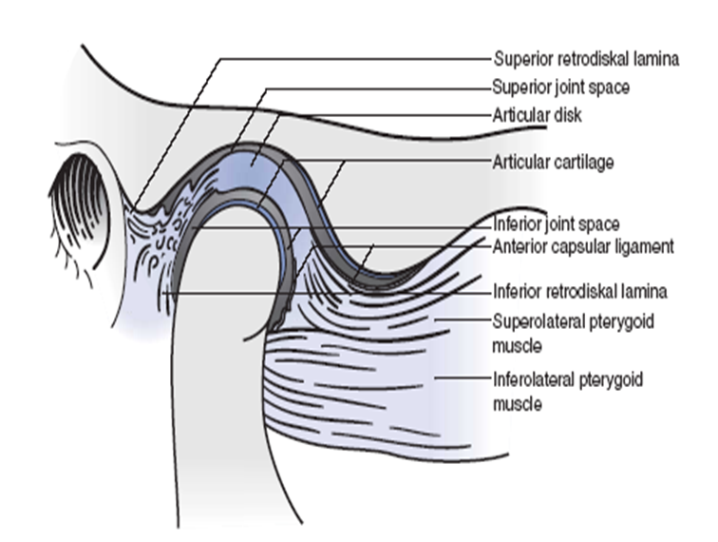 This tissue is called "retrodiskal tissue". Upper border of this tissue is called superior retrodiscal lamina. Superior retrodiskal tissue contains elastic fibers. . The lower border of the retrodiskal tissue is called "inferior retrodiskal lamina" . Inferior retrodiskal lamina consists of collagen fibrils and elastic fibers does not contain. Retrodiskal tissue coupled with a large venous plexus posteriorly, while the condyle moves forward, this layer is filled with blood.

Articular disc, mandibular fossa and articular surfaces of condyle are consists of dense fibrous connective tissue, hyaline cartilage does not exist. There are several advantages of the presence of fibrous connective tissue in the articular surfaces. Abrasion invisible RELATED WİTH age. In addition, the ability to be repaired is too much than hyaline cartilage

**Synovial membrane and fluid**

Articular disc divides the joint into two distinct cavities.The upper or superior cavity is bordered by the mandibular fossa and the superior surface of the disc. The lower or inferior cavity is bordered by the mandibular condyl and the inferior surface of the disc. The internal surfaces of the cavities are surrounded by a synovial lining. This lining, produces synovial fluid, Which fills both joint cavities. This synovial fluid serves three purposes: 1.Because the articular surfaces of the joint are nonvascular, the synovial fluid acts as a medium for providing metabolic requirements to these tissues. Free and rapid exchange exists between the vessels of the capsule, the synovial fluid, and the articular tissues.

2. The synovial fluid also serves as a lubricant between articular surfaces during function. 3.The articular surfaces of the disc, condyle, and fossa are very smooth, so abrasion with friction during movement is minimized.

**Synovial fluid lubricates the articular surfaces by way of two mechanisms:**

Synovial fluid lubricates the articular surfaces by way of two mechanisms. The first is called boundary lubrication, which occurs when the joint is moved and the synovial fluid is forced from one area to other place of the cavity

A second lubricating mechanism is called weeping lubrication This refers to the ability of the articular surfaces to absorb a small amount of synovial fluid.. Under compressive forces, therefore, a small amount of synovial fluid is released. This synovial fluid acts as a lubricant between articular tissues.

This second mechanism does not work in moving joints

**Ligaments**

Ligaments are obliged to protect the joints .It is made of collagen connective tissue. Ligaments do not actively participate to the joint's movement

There are 3 functional ligaments which support actions of the joint. These are:

1. Capsular ligament
2. Collateral ligaments
3. Temporomandibular ligament

There are also two accessory ligaments. These:

4-Sphenomandibular ligament

5.- Stylomandibular ligament

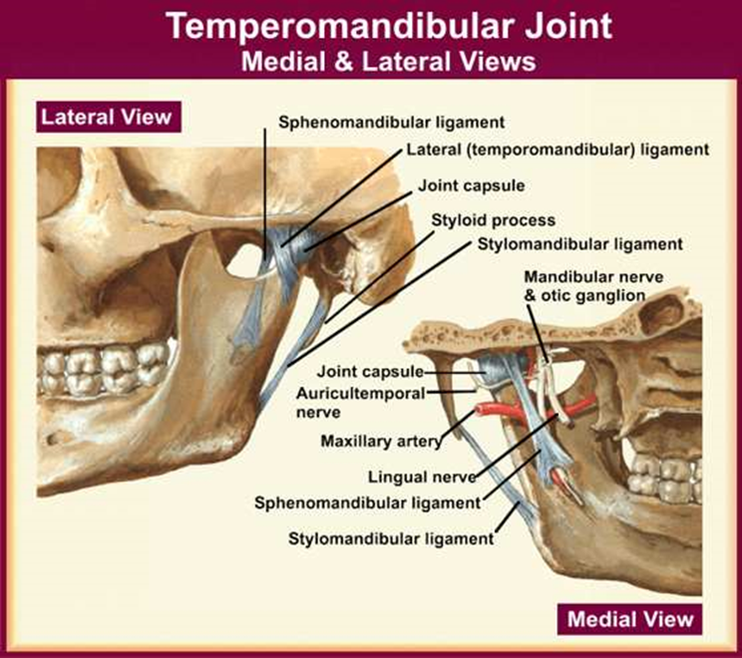

**Masticatory muscles**

**•** Temporalis

• Maasseter

• Pterygoideus internus

• Pterygoideus externus

• Digastricus

**Temporomandibular joint disorders and treatments**

**Causes**

Bruxism

Chewing gum, as a habit

Malocclusion

Traumas at the joint area

Anxiety and stress

Bad position such as compressed phones between the shoulder and head

Iatrogenic reasons ( FOR EXAMPLE ,conditions caused by the dentist- high fillings, incorrect vertical dimension of complete dentures)

**Common symptoms of TMJ** **disorders**

1. Pain. Pain ,in the temporomandibular joint disorders are the most prominent complaints. Pain is felt in the joint area, in the ear, over the temporal fossa and maxilla. as a dull pain .
2. To be sound in the joint (clicking,crepitus)
3. Limitation in opening the mouth.(trismus)
4. Swelling
5. Dizziness
6. FEELİNG fullness in the ear (It is caused by the Eustachian tube )
7. Tinnitus

**Types of TMJ Disorder**

**TMJ disorders are grouped under three main headings:**

1. Muscle disorders
2. Derangement disorders
3. Degenerative disorders

**Muscle disorders:** These disorders are disorders of the muscles that control jaw joint. In particular, they give symptoms as pain in the neck and shoulder muscles. This type of pain is known as ''myofascial pain ". Pain due to muscle disorders are the most common joint disorder.

**Derangement disorders**

Such disorders are jaw dislocations, disc displacement, and

bone injuries

**Degenerative disorders**

These are disorders in the form of arthritis. These disorders may occur due to abrasion or tearing.

**Diagnosis**

Reason for that is unclear, diagnosis is difficult.

History is taken before. The patient's physical examination is done after taking a history. Then, referring to radiographic examination. Periapical radiographies can not always diagnose TMJ disorders. Arthrography, MRI, transradiography, or other graphics, such as CT scan may be necessary

**Examination**

Full physical examination includes a review of the masticatory system. Head and neck; are examined with the inspection.and palpation for the asymetry of soft tissues and muscle hypertrophy.

Masticatory muscles are also systematically examined. Muscles are examined in terms of whether the sensitivity or spasm or trigger points.

Palpation of Masseter Muscle

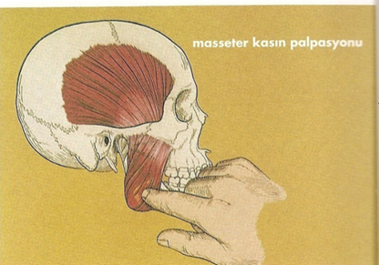

Palpation of Temporalis

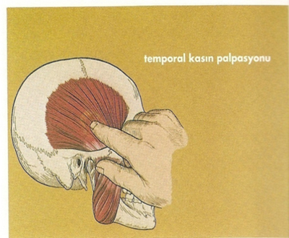

Palpation of Medial pterygoid muscle. Fort his, forefinger is placed 45 degrees inclination to the 2 cm rear of lower third molar

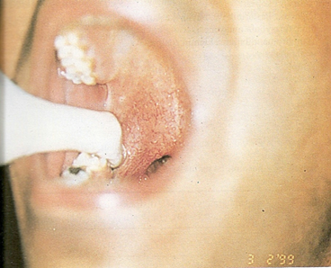

Palpation of the medial pterygoid muscle extraorally. It is performed by applying pressure with fingers TO THE inner side of angulus mandible

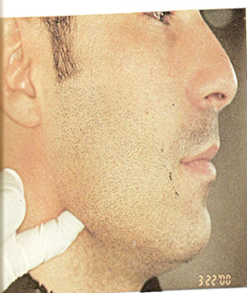

Lateral pterygoid muscle palpation is done as follows: Patient is asked to slide the lower jaw to the palpation side.

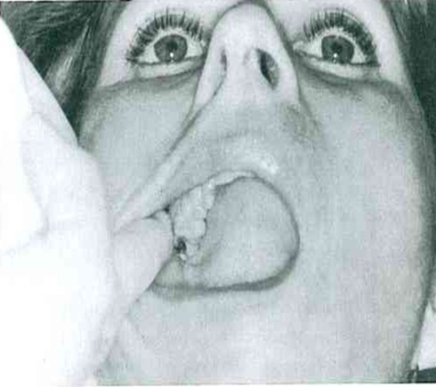

**Palpation of TMJ (MOUTH OPEN POSİTİON)**

While mouth open and closed little finger inserted into the external auditory canal sound joints are investigated. If the patient has pain when opening the mouth noted.

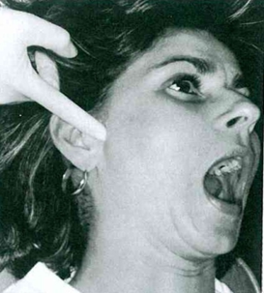

**Important TMJ disorders**

Myofascial PAIN Dysfunctıon Syndrome

Disc dısplacement disorders (Derangements of the Condyle-Disc Complex)

Degenerative joint disorders

Ankylosis

Neoplasia

Infectıon

**Myofascial PAIN Dysfunctıon Syndrome**

Myofascial pain dysfunction syndrome,is a common discomfort. of the temporomandibular joint

This disease is caused by the incorrect use of the muscles. This abnormal muscle function occur frequently by squeezing the teeth during the day and night.

It has a multifactorial etiology of this syndrome.

Clicking, locking of the jaw , limiting movements all in one create the “myofascial pain dysfunction syndrome”

This syndrome is associated with bruksizm.

**Trismus**

The state is unable to complete mouth opening. Persistent trismus can result from intra-articular fibrosis, or trauma, infection, and rheumatoid arthritis. Mouth opening exercises is done in mild cases.

**Derangements of the Condyle-Disc Complex**

The three types of derangements of the condyle disc complex are disc displacement, disc dislocation with reduction, and disc dislocation without

reduction. These conditions may represent a progression along a continuum and will be presented as such here.

**Disc displacement**

**Normal disc condyle relationship**

Normally the temporomandibular joint makes hinge and sliding moves (rotation,translation). Disc normally is found between the condyle and mandibular fossa in the closed position

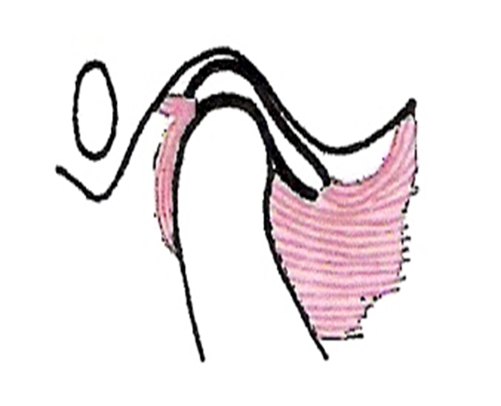

While the normal function of the joint, articular surfaces is not touch to each other. Because thin disc made of cartilage move.between the bones that makes the joint .

Disc is kept in place by muscles.

If the mastication process is not properly,works impairment occurs in the joint. As a result of this, disc Is pushed forward. In this case, the disc will not continue to task as a cushion. Bone surfaces of the joint touch to each other, Pain begins in the joint.

Associated with the abnormal condyle-disc movement is a click, which may be felt just during opening (single click) or during both opening and closing (reciprocal clicking).

**Disc Dislocation with Reduction**.

If the inferior retrodiscal lamina and discal collateral ligaments become further elongated and the posterior border of the disc sufficiently thinned, the disc can

slip or be forced completely through the discal space. Because the disc and condyle no longer articulate, this condition is referred to as a disc dislocation.

If the patient can so manipulate the jaw as to reposition the condyle onto the

posterior border of the disc, the disc is said to be reduced.

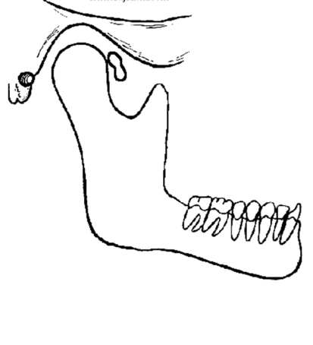

**Disc Dislocation without Reduction**

As the ligament becomes more elongated and the elasticity of the superior retrodiscal lamina is lost,recapturing of the disc becomes more difficult.

When the disc is not reduced, the forward translation of the condyle merely forces the disc in front of the condyle



disc

Condyl

**Ankylosis:**

Sometimes the intracapsular surfaces of the joint develop adhesions that prohibit normal movements. This is called ankylosis. When ankylosis is present, the mandible cannot translate from the fossa, resulting in a restricted range of movement. Ankylosis can result from fibrous adhesions in the joint or fibrotic changes in the capsular ligament. On occasion a bony ankylosis can develop in Which the condyle actually joins with the fossa.

Causes. The most common source of ankylosis is macrotrauma. This trauma causes tissue damage resulting in secondary inflammation.Trauma may also cause hemarthrosis or bleeding within the joint that can set up a matrix for the

development of fibrosis. Another common source of trauma is TMJ surgery. Surgery often produces fibrotic changes in the capsular ligament, restricting

mandibular movement. Osseous ankylosis is more commonly associated with a previous infection.

**Degenerative joint disease**

**Arthrosis deformans:** Arthrosis deformans is the most common disease of the TMJ.The lesion may occur in young patients,but most patients are women between 20-30 years of age. It is not clear why the lesion is predominantly seen in female patient.Clicking of the joint is usually the primary manifestation of the disease.In the course of years clicking may be accompanied by pain and limitation of movement. Patients complain of pain when opening the mouth maximally,radiating to the temporomandibular region,to the ear,to the mandible or neck. The lesion is predominantly unilateral.

In the initial stage the radiographs often Show no alterations.Generally radigraphic defects are only to be seen after a long period of pain and limitation of movement.

The causes of the lesion are , unilateral chewing habit, bad masticatory habits, and malocclusion, bruxism,loss of teeth

**Rheumatoid Arthritis :** Rheumatoid arthritis of the TMJ usually occurs only when the disease is already diagnosed in other joints (hands, feet). When both temporomandibular joints (pain, stiffness, no clicking ) are involved, the symptoms vary simultaneously as those in other joints . The disease is nearly always bilateral.

Stiffness may be treated by mouth-opening exercises and the application of heat.

**jaw dislocation**

Luxation of the mandibular joınt may occur in patients with flaccit ligaments or shallow articular fossa when they open the mouth maximaly (yawning,, intubation for general anaesthes vomiting, throat examining, bronchoscopy, dental treatments )

Repositioning should be done as soon as early.

**TREATMENT**

1. Conservative methods
2. Patients are warned to make double-sided chewing.
3. If necessary, it can be made to use the bite plate at night
4. It is important to rest the chin ,should avoid chewing gum, hard things should not be eaten and should not force to open up more.
5. The physician may recommend some exercises Which can be done at home
6. fillings should not be high, the vertical size in dentures must be normal
7. The patient should be learn how to open the mouth
8. Drug therapy
9. Pain killers
10. Muscle relaxants
11. Corticosteroids
12. Other Treatments (physiotheraphy_TENSE, arthrocentesis)
13. Surgical therapy

**REFERENCES**

1. Esengün Yengin.: Temporomandibular rahatsızlıklarda teşhis ve tedavi,İstanbul Üniversitesi Dişhekimliği Fakültesi Yayını, No :19,İstanbul,2000,

2.W.R.Tildesley.:Oral Medicine,third edith.,Oxford University Press,1989,

3. J.R.Moore.,G.V.Gillbe.:Principles of Oral Surgery,third edith.,1981.

4. Boering.:Diseases of the Oral Cavity and Salivary Diseases, John Wright and Sons Ltd.,1971.

5. Steven L., Kraus P T.:TMJ Disorders Management of the Craniomandibular Complex

Churchill Livingston,1988.

6. Okeson.. Management of Temporomandibular Disorders and Occlusion,second edith.,The C.V.Mosby Comp.,1989.