Advanced Coverage

Learn advanced techniques for covering the action in each scene

Basic coverage includes covering a scene in a master shot and individual close-ups of each actor, along with any required inserts to tell the story. Although this is virtually a fail-proof system for covering a scene, there are many more shot options when planning your coverage.

Oners
Check out these movies, which were shot almost exclusively in one single take:
Russian Ark
The Rope
One option is to cover the entire scene in one single shot, called a “oner.” A oner, like a master shot, covers the entire action without any cutaways in a simple shot, or as a complex, choreographed move. Oners are most typically a walk ’n talk- which covers two actors walking together while the camera tracks with them.

Some directors use oners as a way of saving time from having to shoot individual coverage on each actor. While the may save time on set, it will lock you in to the shot. If the story changes and you need to edit out a line of dialogue, or if the pacing feels too slow, there's nothing you can do to change the shot... unless you shoot separate cutaways as a back-up. Whenever you shoot a oner, always shoot additional coverage to bridge the edit if you need to trim a section out or connect two or more takes together.

Some directors plan elaborately choreographed oners in which the camera and actors both execute a carefully-planned shot. Although the oner may be incredible, again protect yourself with a bridge shot in case you need to change the oner in post.

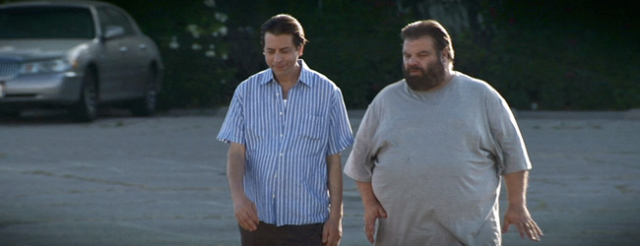

Oners are most commonly used for "walk-n-talk" shots. You see these a lot in television crime shows where two detectives are walking next to each other on the sidewalk, discussing the case. Although it's easy to shoot the entire scene in a oner, always shoot a bridge shot in case you need to trim or edit the shot in any way.

Psychology of Coverage
When you’re determining the angles and shot sizes for a scene, look at the story to help you determine what type of coverage is most appropriate. Even the most subtle change in the frame - whether the shot is an over-the shoulder or a clean single, a shot in which the actor’s eyeline is close to the camera axis or far away - can have a significant psychological effect on the audience.

Some questions to ask yourself when determining the shots in a scene:
- What is the speed of the scene? Are you coming in fast from a point of action, or is it a slower emotionally-driven scene?
- How can your coverage affect the audience? If you want to create the sense of isolation, do you want to use long, static shots? Or if the scene is an intense fight between two lovers, maybe you want to stay in tight close-ups, with the camera Steadicaming around the characters to increase the tension.
- How will the scene be edited? As is the case when you're planning your coverage, always consider how the scene will be cut, and where in each shot you will cut.

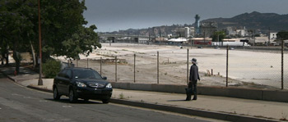

In the sample scene above, we didn't establish the environment until the third shot into the scene. The wide master serves two parts of the story; it gives the viewer a chance to see where the scene takes place and it continues the action of the scene as the car pulls up. Good establishing shots are integrated into the coverage of the action of the scene.
Establishing Shots
One type of shot is an establishing shot, which reveals the geography of the location in which the scene is about to take place. Only use establishing shots if it furthers the story and don’t slow down the pacing.

Ask yourself these questions:
- Do you really need an establishing shot? If the scene takes place in a restaurant, are there enough clues in the body of the scene to indicate it's a restaurant?
- Can you incorporate the actors? If you absolutely need to have an establishing shot, can you shoot the scene so the characters are talking while they enter the building? How can you incorporate the establishing shot into the action?
- How does is affect the pacing? Make sure the establishing shot doesn't adversely affect the pacing of the story. If it does, cut it out.

Opening Visual of the Scene
As you develop your coverage, think about how you want to visually begin each scene. What is the first thing you want the audience to see? If it's an action scene, do you want to cut right into a handheld shot of a man rolling off the hood of a car as he races to cross the street? Or perhaps if you want to establish a more romantic mood, do you want to start on a close-up of a bouquet of flowers, then dolly past them to reveal a couple having dinner? Let the story and the pacing of the scene dictate your opening visual.

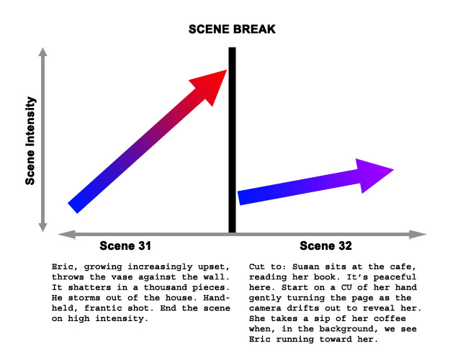

Pacing and Rhythm
Ultimately, your shot list must reflect the rhythm of the scene, which should always be derived from the subtext of the story. By this time you should have already broken down the script, so you know the emotional intensity of each character at the end of the current scene, as well as their emotional state at the beginning of the new scene. Use their emotional state to help you determine where the camera is positioned, the frame size and how to move the camera.

Time Restrictions
Although you can be as creative as you want on paper, good directors have to be aware of the time and budgetary restrictions of real-life production. Always plan to shoot a scene that can be shot within the time and resources available. A wise director will indicate which shots are "optional," meaning if you don't get the shot, it won't adversely affect your ability to edit the scene. These shots, which may involve a complicated set-up - dolly, crane or steadicam for example - can be shot if time allows.

Getting Enough Coverage
Although a wise director will step on set with a clear vision of how to cover the action in each scene, he will further cover himself by shooting as many options as possible of each set-up, then decide in the editing room how to piece the scene together.
The movie you set out to make is rarely the same movie that leaves the editing room, so always shoot more coverage than you think you'll need. The editorial changes in the story may require different shots than you initially thought.
The process of making a movie actually involves making three movies - the first is made when the script is written. Virtually limitless in its look and scope the movie exists as an interpretation of the script in the minds of the cast and crew, each envisioning a different look and feel.

The second variation is created when the movie is shot on set - the actors give a face and a personality to the characters, the production designer creates the environment and the director of photography sets the tone with the lighting. All these creative contributions result in a movie that may or may not be close to your original vision.

The third version of the movie takes shape in the editing room when the script is thrown aside in favor of assembling the footage that was shot. Moving scenes, reordering shots and cutting entire sequences can drastically change the story as it was originally conceived both in the script and on set. Thus, the third version of the film is born.

Knowing the story may be revised and changed in the editing room, it’s wise to prepare for these changes in advance. Shoot as much coverage of each scene as possible so the editor can try different versions in the editing room. This is especially important if the edited version of the movie deviates from the original script. The shots you thought were scraps or outtakes suddenly become critical in stitching together the revised story.

This isn’t a license to point and roll the camera in every direction, rather to thoughtfully cover the action in ways to protect the edit.

Here are some tips to cost-effectively increasing the amount of coverage on set:
- Shooting as much coverage as possible doesn’t necessarily mean adding additional set-ups, but rather shooting variations of the frame size in each set-up. Once you have a take you like, shoot a close-up of the same take, then shoot a long shot of that take. You may want to cut lines out of a scene, and if that cut can’t be covered with a reaction shot, it’s possible to jump cut from a medium to a close-up of the actor. If continuity is consistent, the edit should be virtually invisible to the audience.
- Always shoot clean reaction shots. Especially when shooting over the shoulder shots, back the foreground actor out of the frame and shoot the main actor’s reaction shot cleanly. It’s difficult to perform the same action twice, especially in a lengthy scene such as a dinner scene. When did he pick up the wine glass? When did she take a bite of the bread. Intercutting between shots with inconsistent continuity is jarring and distracting. By shooting clean reactions, the editor can always use this shot to bridge an edit of two shots of the other character.

