Basic Coverage

Learn basic coverage techniques to shoot your scene

Preparing for the Edit
Believe it or not, the editing of a movie begins well before you shoot the first frame. Filmmaking is a tedious process of shooting a scene numerous times from many angles using only one camera, and it’s important to consider in pre-production, how these shots will be edited together. In the editing room, the editor assembles shots so the action in the scene appears to have had occurred only once, and was covered by multiple cameras positioned around the set. This can be tricky because the quality of the edit depends heavily on how well the footage was shot on location.

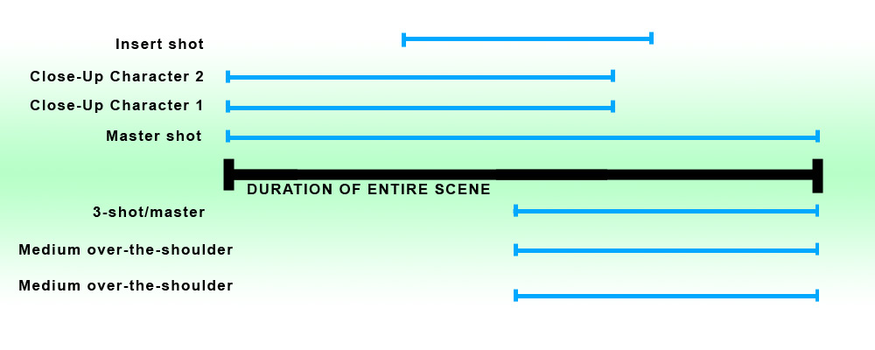
At any given time, the editor should have multiple shots and angles from which to choose, so always shoot as much of the scene from each camera angle.

When on set, always shoot for the edit by envisioning how every shot will be cut together. A great way to ensure continuity between shots is for the actors to perform the scene in its entirety and cover as much of the scene as possible from each camera set-up. The more rehearsed the actors, the more consistent their performance from take to take; the more consistent the performance, the better the continuity of the footage.

Although editing is the process of assembling footage shot in the field into a meaningful, logical sequence, smart directors and cinematographers will determine how to edit the shots together before stepping foot on set. Shooting for the edit will help you better achieve your vision, control costs by eliminating extraneous set-ups and streamline the editing process.

Shooting for the edit covers several aspects:
- Planning camera angles and movements - During pre-production, think about the relationship between each of the shots in the shot list and how they will ultimately cut together. Storyboarding the shots, or using software that allows you to animate each shot will help you visualize the flow the each scene.
- Plan to maximize the coverage in every camera set-up - If working on a tight budget, shooting each camera set-up from a wide shot, a medium shot and a close-up will instantly triple the options available to the editor.

When planning coverage, be deliberate. While you should maximize how much of the scene you shoot in each set-up, only shoot what you need. Remember - you need to make your day.

One technique I employ when planning my camera angles is to place the camera where an observer would be compelled to look during a scene. As I block the actors, I take note of where my natural human tendency is to look. If I feel the need to look at a character’s face in a certain moment, odds are I will need to cover him in a close-up. If I am pulled to stand back and watch an entire action unfold, I will think about covering that part of the scene in a wide shot.

The camera is really an extension of the audience, so treat it as such. Pretend as though you were taking an audience member by the hand as the scene unfolds around you and walking him or her to different parts of the set to experience the action unfolding. What would be the best vantage point to see the action? Where would the audience member stand? How close or how far would he or she be? All these answers can translate directly into the positioning of the camera.

Basic Coverage Template
A common approach to blocking the camera positioning of a scene is:
- The master shot - The master shot is a wide shot that covers the entire action of the entire scene so completely that even if you didn’t shoot any other angles, the audience would be able to understand what the scene is about. The master is the universal safety shot and can always be cut to if there’s a problem with any other shots or if you run out of time on set. For example, if a couple is having dinner at a restaurant, the master shot includes the two actors, the waiter, and the table in the shot for the entire scene.
- Medium shots of each character - Especially in a dialog scene, plan a closer single or over-the-shoulder shot of each actor. In our sample scene, there would be three medium shots: one of the man, one of the woman, and one of the waiter, each covering the entire scene.
- Plan for any insert shots - Inserts are shots that cover action already covered in the master shot, but are closer and draw the audience’s attention to an action or detail. For example, an insert shot may be of the man pouring wine into the woman’s wine glass or a close-up of the woman’s hand as she temptingly caresses her wine glass.
- Determine specialty shots - Once you determine the basic coverage of the scene, write down any special dolly, steadicam, handheld, or jib arm shots. In this example, we may want to shoot a dolly in from a two-shot of the actors into the waiter as he arrives, breaking up a tense moment between the dining couple.
- Cat-in-the-window shot—These shots are usually of unrelated people or objects in a scene that can be cut to at any time during the scene, like a cat sitting in the window, watching the action unfold. In our restaurant scene, it’s a shot of a waiter waiting in the corner of the room, watching our couple dine, or a nondescript shot of another couple dining. These unconnected shots save the editor in the event there is a continuity problem or an editing issue. An editor will cut one of these shots into a scene to help bridge what could be a jarring edit, jump cut, or lapse in continuity, so always shoot a couple shots like this for each scene.

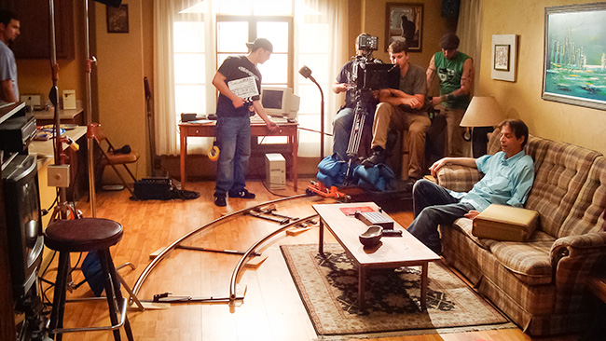

Coverage Tips
Keep the following tips in mind when planning the coverage for a scene:
- Work with an experienced line producer or first assistant director to determine how long it will take for each camera set up. Many first-time directors underestimate the amount of time it takes to set up a shot and subsequently end up running over schedule.
- If you’re confident that you can shoot the basics to cover the scene, then you can consider adding specialized moves like a dolly or jib shot. Beware that setting up dolly track and a jib arm is very time intensive, requiring time not only to set up the equipment, but also to rehearse, set starting and stopping positions, pull focus, and coordinate with the actors and boom operator.
- When planning camera angles, think about what you want the audience to learn from each angle. There needs to be a reason the camera is positioned and framed in a certain way.
- Treat the camera as though it’s an actual member of the audience that you’re personally taking around the set and show them exactly what you want them to see. What would they feel inclined to look at? What do you want them to see? Where do you want them to be looking?
- Aside from the master shot, a scene is told through a number of different shots. Not every shot needs to tell the complete story. For example, in a conversation scene, dedicate one shot to focusing on one character’s close-up. Then, reposition the camera to cover the other actor’s close-up. In the editing room, you will then have the option of cutting to either character and can make that creative decision then.
- The best way to learn about camera coverage is not only to do it, but to follow in the footsteps of the people who are doing it right. Study the cinematography in movies to determine the placement of lights, why certain camera angles were chosen and how these choices impacted the emotional content of the story.
- The best way to learn coverage is to get in the editing room to see how well your footage cuts together. Try shooting several small sequences and then edit them to see what shots work and what shots don’t.

Scene Study
The following is a breakdown of coverage from a scene in the film, "Time and Again." You can watch the entire scene in the video theater above.

 | 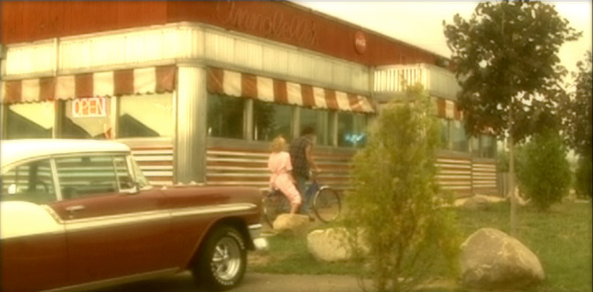 |  | The first shot of the scene is an establishing shot, which includes the characters. Not only does this shot introduce the whereabouts of the scene, but is adds motion and rhythm by featuring the two main characters entering the frame.
 |  |  | Although this isn't the way the scene was finally edited, we first shot a wide master shot of the entire scene. In the final edit though, we only used it at the beginning of the scene and chose to work in close-ups through the end.
 | 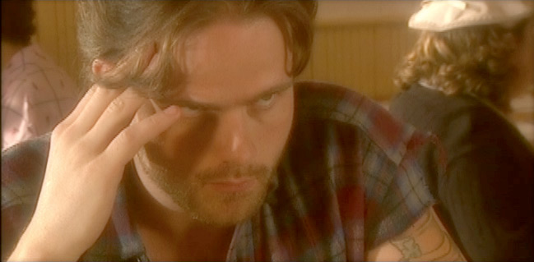 |  | Our next bit of coverage is a close-up on Bobby Jones. We shot the entire scene from this angle, so we could cut to it at any time.
 | 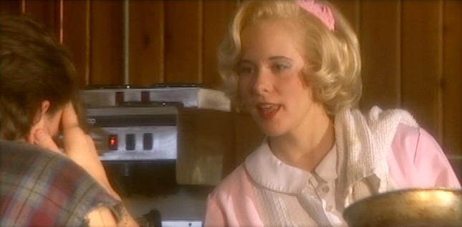 |  | We then shot a reverse angle of Awanda, again covering the entire scene from this angle.
 | 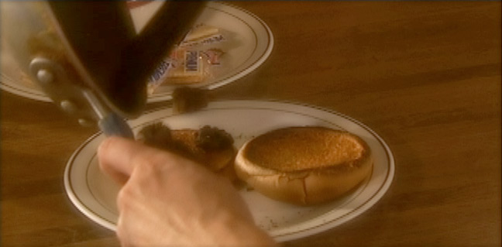 |  | Finally, we shot inserts - such as this shot of Awanda's burnt lunch.

