Beginning a Project

Learn how directors approach a script and prepare a project before stepping onto the set

Directing During Pre-Production
Your role during preproduction includes three main areas of focus: study the script to determine the tone, theme, and style of the movie; rehearse the actors so they can play convincing characters based on the your vision; and work with the crew as they prepare the technical and artistic elements of the movie.

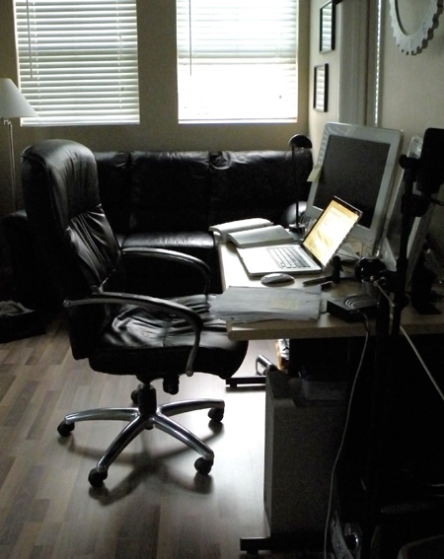Setting Up Your Space
- The first step in being able to work efficiently and truly focus on the script is to have a quiet, controlled space.
- When setting up your space, find a quiet space you can call your work environment, and only use it for work. This will help you get in the proper frame of mind every time you enter this space.
- Get rid of any distractions. Turn the TV off, get away from the kids, turn off your cell phone... You will need to focus 100% on translating the story from the written word to what the audience sees on screen, and it will require your full attention.
- Set aside a specific block of time each day when you are the most focused- perhaps early in the morning or at night before bed
- Be prepared with a pencil, eraser, ruler and a set of markers or colored pencils. You'll be using these when you begin breaking down the script and planning coverage.
Reading the Script
As a director, either you will direct a script that has been written by another writer or you may have written the script yourself. In both instances, it is essential to become intimately familiar with the story before moving into preproduction with the cast and crew.

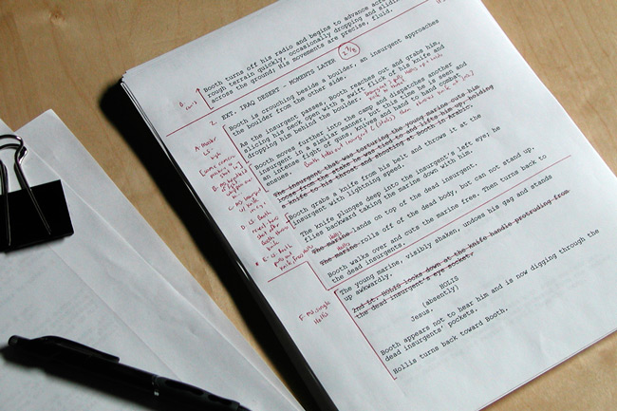If you are given a script, read the script enough times so you have a complete understanding of the story arc and how every individual scene ties in with the greater story. Figure out how each scene needs to be paced, how each scene is going to start and stop, and what story elements need to be conveyed in each scene by writing notes to yourself in the margin of each page. For example, if a scene foreshadows a future plot point, one of your notes for that scene may read “scene necessary to foreshadow John’s theft of the car at the end of the story by establishing his need to steal paper clips.” As you read through the script, make sure every scene tightly drives the story forward and consider cutting any scenes that are superfluous.

Once the story plot points are mapped out, identify the story’s deeper meaning, subtext, and overall theme so you understand how every scene and every moment supports and develops toward that theme. Most good scripts have several layers of meaning, and it’s your job to identify these because they will be the foundation for the actors’ performances. For example, in a story in which the theme is how family is stronger than worldly hardship, one scene may be about loss, whereas the next may be about vindication. Understanding the themes of each scene and how it ties into the overall theme is critical in directing the performances, style, and pacing of the movie.

Write down any notes you have about each scene - shot ideas, blocking notes, character directions, where a character is coming from in the previous moments, dramatic intensity - so when you get to the set, you don't have to remember everything when the pressure is on.
Once you’ve read and identified the plot points and subtexts, begin studying the personality traits, motivations, subtexts, and histories of each of the characters and develop a clear understanding of each character’s behavior. This is the foundation for beginning to work with the actors. Unless you know each character’s role in the story, how can you expect to direct the actors? I do this by taking a blank sheet of paper for each character, listing each scene number along the side if the paper, and listing the motivation and subtext of the character in each scene. The description is usually only a few words, like, “Awanda’s goal is to take Bobby home. All she can think about is sex,” or “Bobby wants to go to Awanda’s trailer so he can get washed up. He has no intention of doing anything else.”

If you wrote the script yourself, you should already have a good idea about the motivations, plot, and character arcs. Beware, however, because you may be so familiar with the story that you may miss plot holes or confusing areas because of your deep familiarity with the subject. Try to read the script with fresh eyes as if you are an audience member seeing the movie for the first time.

Going through the script and breaking down each of these elements is important because, invariably, the cast and crew will ask you questions like:
- What is this scene about?
- How does it fit into the scene that came before and the scene that comes next?
- What is my character’s motivation in this scene – why does she act this way?
- What is the driving subtext of this line of dialog?
- Why am I saying this? Is this how my character really feels?
- What do I really want and am I speaking the truth or masking it?
- How should I say this line and what is my character implying by saying this line?
- How would you like the lighting and cinematography to serve the theme?

