Blocking

Learn where and how the actors should move on the set

Blocking is all about how the actors move and how the camera moves on set.

Blocking is the process of determining the actors’ positions and movements around the set, affording the camera the most interesting angle, finding the most aesthetically pleasing part of the set to shoot and factoring in lighting and sound requirements. As a result, the more experienced you are in how the technical aspects of production work, the more effective you will be at blocking a scene so it meets every department’s requirements. Odds are this is the first time your cast and crew are seeing the set, and may have some ideas on how and when the actors and camera should move during the scene. Listen to their suggestions and feel free to make small changes in blocking, but keep in mind that major changes in blocking may require additional time to light and can put you behind schedule. Aside from minor adjustments on set, most of this work should have been done during preproduction. When the cast and crew arrive on set, the day should be about carrying out the details of the plan, not figuring things out for the first time. The more time you spend preparing in preproduction, the more smoothly the shoot will go.
When you're planning the actor's blocking, ask yourself the following four questions:
- WHY is the actor moving?
- WHERE is the actor moving?
- WHEN is the actor moving?
- WHY is the actor moving?
Determining these motivating factors will help you create realistic, organic blocking.
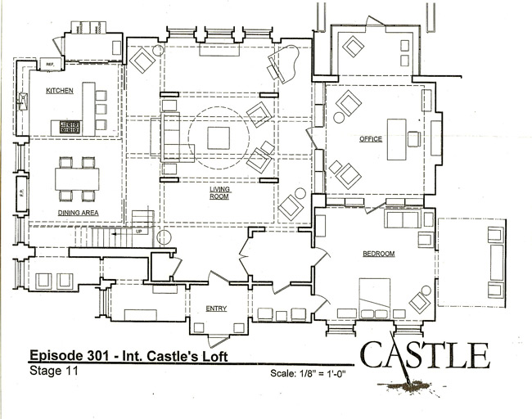

When you begin mapping the actors' blocking, ask the art department for blueprint of the set. You can map the blocking of the actors and camera.

WHY is the Actor Moving?
The most important question to ask is why is a character should move. It sounds so simple, but the reasons why run deeply into what the character’s thinking. On a simple level, a character can simple walk to the refrigerator to get the milk because the scene involves her making a milkshake. In a more complex scene in which a wife has just learned her husband cheated on her, the husband wants to move closer to her as he tries to apologize. The wife, already positioned on the opposite side of the room, counters his move, always making sure something -a couch, a table - is in the way, prohibiting them from getting close to each other. By using the blocking to physically separate the couple, you’re tapping into the psychological distancing underscored in the context of the scene.

WHERE is the Actor Moving?
Once you establish why the blocking is motivated, the next step is to determine where the actors move in the actual physical space of the set. Every time an actor stops and starts, a mark is placed on the floor, to help ensure the actors stop at the same place every time for framing, lighting and focus. When determining the actor’s marks, a good director not only considers the actor’s motivation, but a number of other technical and aesthetic factors.
For example, do you need to consider the direction of the light source when planning the blocking? If you’re shooting outside and the sun is low in the sky, do you want to block the actors so the sun always works as a rim light? Or perhaps on a set with a wall of windows, do you want to block the action so the light from the windows serves as the key light?

Secondly, how will the background look in the frame? Will the blocking of the actor afford you the best view of the location or set? Do you need to modify the blocking if you need to shoot around undesirable elements on the set? What if the set simply isn’t that big? How can you frame the set to tell the story?

- Assist the actors in finding their marks by using gaffer’s tape to set T-marks on the floor to identify specific starting and stopping points for actors.
- Set marks on the floor to determining where the camera should stop and start if a dolly or crane is being used. This helps the camera operator correctly frame the shot consistently in each take, the 1st AC consistently pull focus to keep the actors sharp, and the dolly grip time the speed and stopping position of the dolly with ease.

Blocking for the Set
Thirdly, how does the blocking work for camera coverage? For example, in a television show shot on a limited schedule, the director may want two actors to walk around each other to add visual interest to the scene. When the actors change position, they remain on the same axis, so the cameras and lighting don’t have to change.

Many directors will figure out the blocking of a scene using a floorplan of the set or location on which to draw the movements of the actors and camera.

- Consider how you will block a scene when scouting a location, even using your accompanying crew members as stand-ins. Before you commit to a location, its important to ensure it works for the actors’ movements, the camera and lighting placement and all other technical and aesthetic needs of the scene. Although there are small refinements on the day of the shoot, the rough blocking should have been determined early in the preproduction phase.

Starting Mark
When you begin the scene, your first job is to decide where the characters start. What is their stating mark. To help determine where this starting mark is, look at the script. Are there any clues? In many instances, the answer is obvious - INT. FRED’S APARTMENT - DAY - Fred and Vinnie walk in with bags of groceries. It’s clear that the scene should start with Fred and Vinnie entering the front door. Other times, you many need to look at the contextual clues to determine where the character is coming from in the moments before the scene takes place.

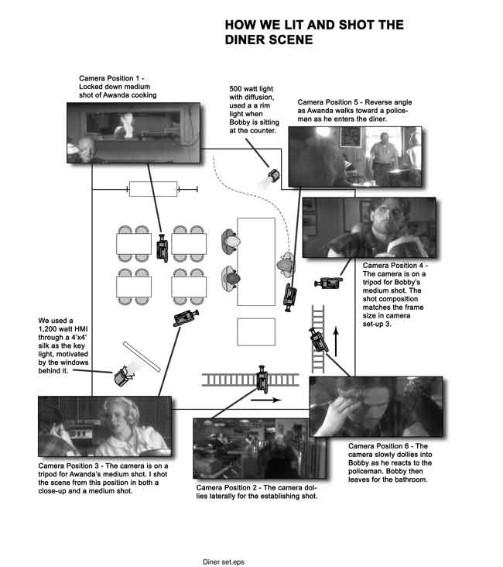

WHEN Does an Actor Move?
A scene is shot multiple times, from different angles usually with only one camera. Edited together later, these shots must appear seamless as though the event occurred once and was captured by multiple cameras. To sell this temporal continuity, the actors must perform the same movements dozens of times for each camera set-up. One way to do this is to give the actors cues in the scene as to when to move. This cue can be a line of dialogue, a word, or an action occurring in the scene.

- Give the actors blocking cues. For example, “Stand up when you say ‘I thought you already took care of that.’ Your cue to stand is on the word ‘care.’” Work with the script supervisor to ensure the actors maintain continuity with their blocking and dialogue.

Once the blocking has been established on set, the 2nd assistant camera will put colored tape marks on the floor so actors know where to stop.

HOW does an Actor Move?
The fourth component of good blocking is to determine how an actor moves from one point to the next. Look for contextual cues in the story - is the character anxious, happy, pensive, concerned… determining the emotional content will give you the tools to guide the actor’s movements.

Macroblocking vs. Microblocking
We can look at blocking in two ways - the first, macroblocking, is the broad movements of a character - he enters through the far door and sits on the couch, across from his wife. Microblocking, are all the small moments that happen inside the macroblocking - when he walks in the door, he may throw his wallet and keys on the table - the way he does this will give the audience clues as to what he’s feeling in the moment. He takes off his jacket and throws it on the back of the couch as he walks to it. When he hits down, he grabs a newspaper to shield himself from his wife. A wise director will direct the macroblocking for the sake of story, camera coverage and lighting, but allow the actor to develop the microblocking for his or her own character.

Ultimately, good blocking feels kinetic and real – all while addressing the technical needs of the production. Work closely with the actors, the director of photography and the 1st assistant director to find a balance between performance and the technicalities of shooting the performance within the allotted timeframe.

