Continuity and Script Notes

Learn how to maintain continuity and create script notes.

Continuity
If the script supervisor did his job properly on set, the editor shouldn't have any major issues with continuity in the editing room. The worst problem is when there was no script supervisor. This forces the editor to edit around continuity rather than for the emotion of the scene.

We have all seen movies where two people are sitting on a couch talking to each other and in one shot, the guy’s arm is on the back of the couch and in the other shot, his arm is across his lap. These errors, called “continuity errors,” occur because scenes in a movie are shot out of order and are assembled later. For example, in a scene where a man and a woman are having dinner, the first shot is a long master shot where we see both the man and the woman and all the action of the scene. The cast and crew will shoot the scene from the beginning to the end, multiple times, from this one camera angle until the director is happy with the shot. When they are finished, the actors leave the set and the crew repositions the camera for the man’s close up. The Gaffer changes the lights, the Set Decorator re-dresses the part of the set that is visible in the new camera angle and the Production Sound Mixer repositions the microphone, just to name a few of the activities that occur between camera setups. Once the camera, lighting, audio and the set are ready, the actors return to the set and the director films the entire scene again, framing only the man in a close up. After shooting several takes and making minor adjustments to the performance, the crew again moves the equipment, this time preparing for the woman’s close up. And the process begins again.
The Editor must then take these three different camera angles and edit them together so that it appears as though they occurred once and that the moment was covered by multiple cameras. Continuity errors occur when the actors change their performance, either intentionally or by accident, or if a crew member accidentally moves a prop or a set piece.

Avoiding continuity errors is the responsibility of the Script Supervisor, who notes the position of people and objects, changes in dialogue, camera coverage, or anything else that may not be continuous from one shot to the next. Even though the Script Supervisor is watching, there may still be a continuity error that he or she misses.

Script Notes - The Facing Page

When the script supervisor begins work on a production, she will create a script notebook with the script page on the right, and the script notes on the left, facing page. On this facing page, the script supervisor will log several important bits of information including:

- The scene number - the script notes identify the scene, set-up and take number for each shot.
- Circled takes - The script supervisor will circle which takes the director prefers so the editor know which take to use first. It's not uncommon to circle two or more takes, as each may have different elements the director likes.
- Sound - Indicates what type of sound is recorded for the take, if its MOS (no audio recorded), or sync sound.
- Time - The script supervisor uses a stopwatch to time the duration of each shot, from the moment the director calls "Action" to when he calls "cut."
- Description - This area allows for a brief description of the action happening in the frame. The shorthand used establishes screen direction, the shot size, the movement of the actors, the actor's eyelines, and any other pertinent details of the shot. These notes are often referenced later when the following scene is shot - sometimes days or even weeks later. The notes help the actors know that they're entering from the correct side of the screen, and that screen direction is maintained.
- Technical notes - The script supervisor notes any technical issues such as an out of focus shot or any audio anomalies like a barking dog or an airplane that ruined the shot. Additionally, positive notes are recorded, especially when the camera operator feels they succeeded in getting a complicated shot.

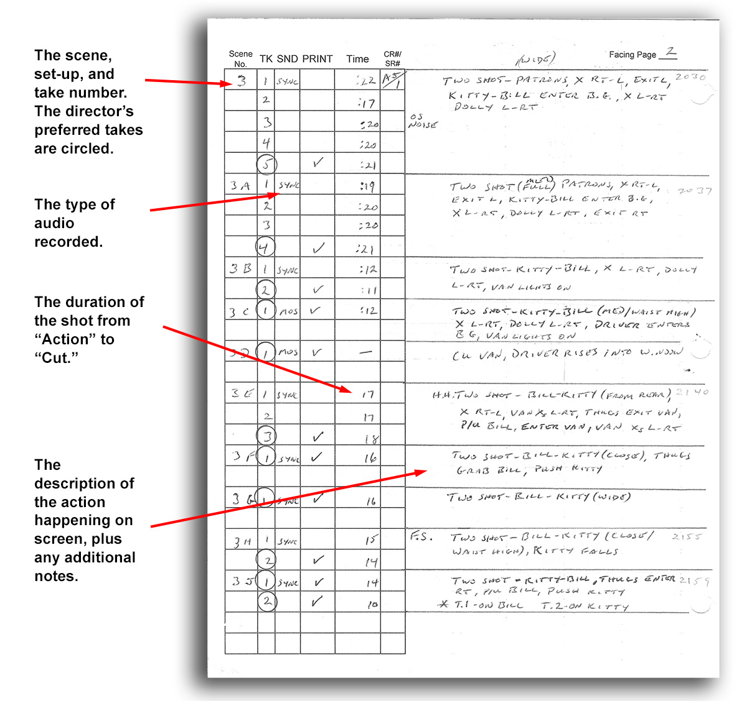

Script Notes - The Script Page

On the script page itself, the script supervisor notes how much of the scene is covered by each camera set-up. This is done several ways:
- The script supervisor will draw a single vertical line through the scene with a small horizontal line at either end to indicate where the shot starts and stops. This makes it easy for anyone reviewing these notes to see what parts of the scene were covered by what shot.
- Next to each line is the scene number and set-up letter, which is circled to indicate what the coverage is.
- Next to the scene number is a brief description of the shot itself: CU phone, ECU eye, LS Fred, MS OTS Mary.
- The script supervisor will use a squiggle through any dialogue that appears off-camera. There are three variations on this:
  - A straight line through dialogue - indicates dialogue spoken on camera by the actor.
  - A straight line with a squiggle around it - Dialogue spoken by someone out of focus or not the main focus of the shot.
  - A squiggle only - Indicates dialogue spoken off-camera.
